Making Material Knowledge:

Process-led textile research as an active source for design innovation

Abstract
This paper explores the notion of “Textile Thinking” during a cross-disciplinary research case study exploring material boundaries. The Material Boundaries project was designed to consciously experiment beyond the unknown and generate a deeper understanding where ceramic begins and textiles end as well as the transitional space in between them. This led to the development of a collection of new hybrid materials and a series of spatially applied textile design outcomes. The project took risk-taking to the extreme by firing material hybrids in a kiln, often “producing” nothing but traces of textile dust. This paper presents the journey of the reflective mapping process, illustrating the key stages of the research, which led to the discovery of new material properties applying traditional ceramic processes to high tech textiles. The findings identify risk-taking and “unlearning” as essential strategies to invite valuable set-backs as well as happy accidents. Essential key stages of an open – ended process-led textile research are portrayed as:
Mapping New Terrain
Unlearning and Play
Navigating Material Evaluation
Selective Design Developments

Informed by the experience of applying ceramic making processes to textile materials the differences and similarities of the two disciplines are discussed. As textiles can consist of a wide range of diverse materials ranging from jute to plastic, fine-tuning of material qualities lies at the core of the design and research development. Here the intrinsic knowledge of the behaviour of different textile components informs the selection of the material. Additionally adaptability and flexibility is a key textile quality whilst ceramics often need to achieve perfect stability – ironically achieved out of elastic clay material.
The findings identify core areas of “textile thinking” and explore its unique creative capital for design research and development as an additional creative impulse for generic design thinking. The authors explore the role of material “playtypes” to complement and inform the development of design prototypes, facilitating a more playful and open-ended material research approach. This paper concludes by suggesting methods and processes to invite more risk taking into textile research and investigates how tacit knowledge about materials can be integrated and communicated within the framework of design research. It defines materials as an active source of information and identifies the intricate knowledge making through hands on textile thinking.

Keywords: process-led textile research, textile thinking, unlearning, hybrid materials, playtypes, tacit knowledge

Introduction
This paper explores “unlearning” through open-ended research and attempts to map the distinctive characteristics of “Textile Thinking”. The authors portray their journey through a collaborative research project, which originated in Summer 2014 from a mutual interest in process-led research as well as ceramics. The aim of Material Boundaries was to develop new textile/ceramic hybrid materials and to explore new possibilities of process-led textile design methods in order to inform research and teaching practice. Unlearning is defined as putting aside existing textile assumptions to go beyond known parameters whilst engaging with process rather than set end results. Using the Material Boundaries project as a case study this paper discusses methods for inviting more risk taking into textile research and investigates the specific characteristics of textile thinking as based around impermanent material qualities opposed to ceramic thinking centered around physical properties changing from flexible to permanence. It defines materials as an active source of information, identifying the value of tacit knowledge and making through “hands on” textile thinking. The authors introduce the term of “playtypes”, as lateral material experiments to explore new material properties and “prototypes” as a method to develop design outcomes, and define the combination of both as a new methodology to encompass textile and product design thinking.

Context

Hybrid materials
In 2014 Central Saint Martins (CSM) organised a graduate exhibition Restless Futures, which initiated debate and posed questions around emerging issues in design. Expanded Boundaries was one of the four themes of the exhibition and the Material Boundaries project was partly born from reflection on the exhibition manifesto which predicted that methods and concepts of design would be “… taken into other areas as catalysts and vehicles for new collaborative ways of thinking and acting” (Restless Futures 2014).
Over the past few years, textiles have rapidly expanded into an interdisciplinary practice. Here, the broadening of disciplines allows for textile design and textile thinking to be used for new collaborative ways of making. These merging and uncertain boundaries create a space for innovative opportunities: “More notably it is in the cross fertilisation of materials where a new breed of designers are evolving. Materiologists are those designers who are happy to cross boundaries, explore the unexplored and are driven by materiality” (Wagner, 2014: 7).
New materials are getting increasingly “smarter” and adaptable with great potential to inform future lives. At the same time it is no coincidence that the interest in raw haptic materiality has grown in a world increasingly shaped by enhanced digital technologies. Re-establishing a relationship between material, maker and user has seen a desire for connectedness emerging, which has “driven the way for new interpretations of Materiality, as opposed to merely applying materials as an afterthought” (Lefteri 2014: unknown).
Textiles and ceramics both have, as part of their cultural DNA, some of the most raw, low-tech physical origins, for example, silted earth dug up from riverbeds or sheared sheep skin (Miodownik 2013). Through chemical and mechanical processes they can evolve respectively into the most sophisticated porcelain or high tech woven Tweed fabric. “Disseminating information extensively and beyond the scope of the obvious applications is a precondition for discovering new applications. Such dissemination requires a new approach on the part of manufacturers and designers” (Material World 2 2006: 23). Whilst manufacturers take on this new approach and experiment with yarns and clay to solve specific design and production problems, the authors began from a position of curiosity: using the making process as a way of thinking through material to create new material hybrids. The liminal space between textiles and ceramics where these two disciplines come together forms the focus of their project and has become the case study for this paper.

Risk and uncertainty
The opportunity offered by a project that inserts notions of “risk”, “uncertainty” and “failure” into the outcomes is an interesting one. At the outset of the project the authors were not as concerned with the design applications as they were to initiate playful material experiments whilst using textile thinking as a cross-disciplinary lens on the utilisation of ceramic qualities and processes. Therefore, the initial research question: “Where do textiles end and when do ceramics begin?” was left deliberately open to develop a deeper material understanding through process-led research, noting that a design project that is “too planned” (Osmond et al. 2008: 250) does not challenge existing design clichés, while a research enquiry without any inbuilt systematic reflection lacks rigour and direction (Bolton 2015: 279).
Although experts in their fields of textile design, neither author had previous experience of ceramic design. Both are very familiar with digital and analogue printing methods, pattern design development and colour mixing, which often involves chemical dye processes or mechanical repeat printing. As textile printers their design thinking very often is based around two-dimensional fabric outcomes and the creation of specific haptic surface properties through for example the use of flocking or laser cutting. Their exploration started as a playful challenge to see how textile materials would react to the extreme temperatures required in the firing of ceramics.
Textile design is constantly expanding into a more interdisciplinary practice and educators need to keep abreast if they want to teach their students emerging skills. Time to develop new research is often limited, which makes it challenging to maintain and develop deeper subject knowledge in order to evolve an optimal curriculum. “The most useful learning in the modern world is learning about the process of learning, an internalisation of the experience of change” (Brockbank & McGill 2007: 209). The authors set themselves the task of doing what they expect their students to do, to understand and experience the value of risk taking and unlearning and to gain insight into the value that textile thinking can bring.

Tacit knowledge
“Tacit knowledge can be defined as skills, ideas and experiences that people have in their minds and are, therefore, difficult to access because (they) … may not necessarily be easily expressed” (Chugh 2015: 128). Igoe describes this particular type of knowledge, stating that “Textile design encompasses teachings from the broader disciplines of design, technology, art and craft, indicating that textile design disciples have formed both a personal and collective tacit understanding of a specific blend of knowledge” (2010: 3).
The discipline of textiles crosses over into many other design areas as well as into the field of material science and, as a result, is well positioned to affect the liminal space between disciplines. The application of textile processes offers the opportunity to manipulate materials in unfamiliar ways or within new contexts. The possibility to create new material “hybrids” and to highlight the valuable, distinctive and tacit knowledge that textile designers can bring to other disciplines is of particular significance. Polanyi describes this in The Tacit Dimension, when he states “we can know more than we can tell” (1967: 4).
Design knowledge has been defined as designing activities in which designers, their creative processes, and resulting artefacts are involved. This knowledge is considered a “designerly way of knowing” (Cross 2007: unknown). This paper examines contemporary material making and attempts to communicate the internal and external intelligences of textile thinking.

Project description

Mapping New Terrain

Phase 1
The starting point of the project was the authors’ enthusiasm to experiment and to explore an open-ended research outcome together. With their minimal knowledge of ceramic processes the main aim was to see how textile materials would transform under high temperature and fuse to create unexpected outcomes, compared with the relatively immediate and controllable process of textile making. This led to research into fire-resistant textile materials and a cautious start testing silica material and its bonding qualities with porcelain slip.
Clay becomes a ceramic when it has been fired above 573°C, a process known as Alpha Beta Quartz Inversion. However, most textiles cease to exist at 100°C and even “flameproof” materials seldom withstand the ten hour-long firing in the kiln. Using a number of small test samples and three different temperature settings between 600 and 1200°C, the first round of tests, as seen in Figure 1, resulted in findings that the porcelain slip did not adhere easily to the textiles and at the same time the silica fabric could hardly tolerate temperatures above 600°C. Often the test firing produced nothing but dust fragments. During this phase informal short technical inductions from the ceramic technicians were invaluable in order to build up basic knowledge and progress the project. The overall project progress mapping phases 1–7, is shown below in Figure 13.

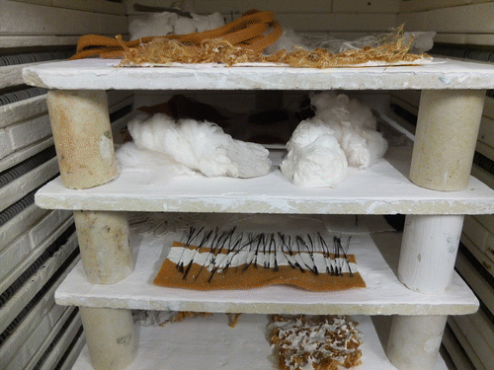

Figure 1 Kynol and basalt test samples coated with porcelain prior to the firing process.

Unlearning and play

Phase 2
The first review of the surviving materials tests identified the need to expand the selection of materials to include high tech textiles that could withstand temperatures above 600°C and stimulate new fusion recipes. As the authors became more specific in their material choices they were able to apply their newly acquired material knowledge and experiment with a number of material combinations, for example silica rope and clay, basalt tape and porcelain slip. These playful explorations resulted in a series of material experiments or “playtypes”.
The “playtypes” were key to the progress of subsequent tests and revealed that the more fibrous paper clay could enhance the cohesion between textiles and ceramics as well as develop a better amalgamation of the two materials. The open-ended nature of the project made it difficult to set boundaries due to the infinite possibilities of the research direction. Existing textile knowledge helped structure phase two more systematically according to known textile properties, materials and construction processes. Through quantitative lateral testing (the process by which a range of materials are systematically tested against each other) all of the following materials were systematically combined using familiar textile processes, for example screen printing and knotting as illustrated in Figure 2:

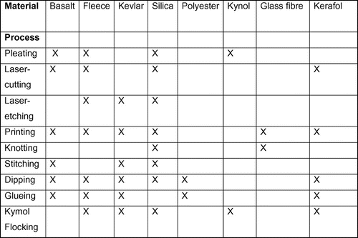

Figure 2 Systematic combination of textile processes and materials.

Fibre and material: basalt, kiln-fusing fleece, Kevlar, silica, resin coated polyester, Kynol, glass fibre, Kerafol;
Process: rope making, knotting, weaving, pleating, twisting, stitching, mark making, screen printing, laser etching, laser cutting, gluing, dipping, flocking;
Ceramic material: porcelain slip, paper clay, paper clay slip, Endecca Once Fired slip.
This framework gave scope to explore larger quantities of lateral experiments as opposed to a small number of in depth technical tests, without getting lost in too many possibilities. Over 80 test sample “playtypes” were produced in phase 2 compared with 24 samples in phase 1, see Figure 3.

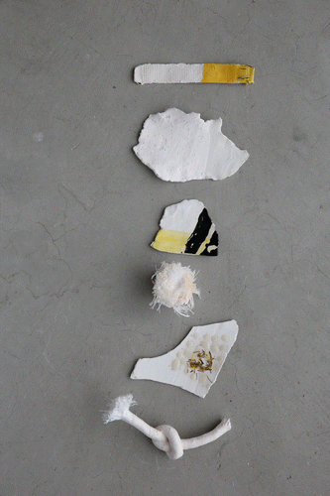

Figure 3 Playtypes showing knot, print and adhesion experiments with basalt and silica.

Navigating material evaluation

Phase 3
As the project evolved it became apparent that photography would be a key editing tool to manage the emerging research strands of the project. The fragile nature of the work meant that photographic records of all processes and results before and after firing became invaluable. This led to a continuous testing cycle, starting with material sourcing and making processes as well as photographic documentation, followed by systematic reflective review after each workshop session, in order to select materials and techniques to progress to phase 3 of the project, as shown in Figure 4.

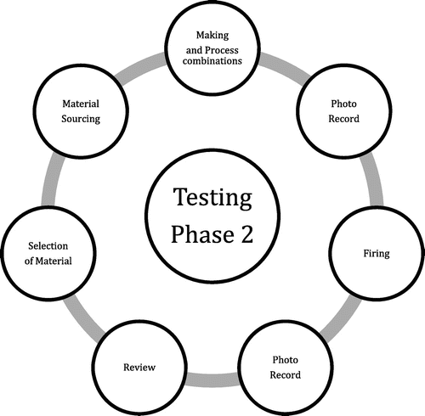

Figure 4 Systematic reflection through photographic documentation.

At this point a first critique with a senior lecturer from Ceramic Design was arranged to obtain additional professional feedback on the phase 2 test samples. This proved to be invaluable in furthering knowledge of ceramic terminology and of the possibilities afforded by process-led design research.
The review recognised phase 2 research as a valid method for exploring chemical reactions. However it became clear that until this point 3D shapes had not been considered in the investigation and to do so could add further ceramic potential to the project. The review resulted in a selection of basalt, silica and once fired clay materials, which generated the most durable fusion of clay and textiles after the firing process whilst at the same time preserving the haptic qualities of the selected materials.

Phase 4
The authors decided that, in order to gain feedback on the project to date, it would be advantageous to build in a participatory knowledge exchange workshop. Key to this workshop was the idea of co-learning how to use slip casting as a method to explore 3D textile hybrid forms. The workshop placed all participants in the same position of exploring a new technique without any prior knowledge or existing hierarchies and allowed for an experience of hands on making. The workshop day included a “Show and Tell” session of existing findings and material properties, a crash course in the history of ceramics, as well as a demonstration of slip casting. After this, participants were free to use any of the materials provided with any textile technique, as long as it was used in combination with clay or slip casting, see Figure 5. The session ended in a mini presentation of all participants’ products and direct feedback on the project to date. The feedback outlined the successful elements of the project, the value of co-learning and highlighted the qualities that a “textile” approach can bring to ceramics. It was noted that our developments to date had been largely two-dimensional. Looking to expand on this led to the development of a more three-dimensional approach incorporating yarn construction into the slip casting process.
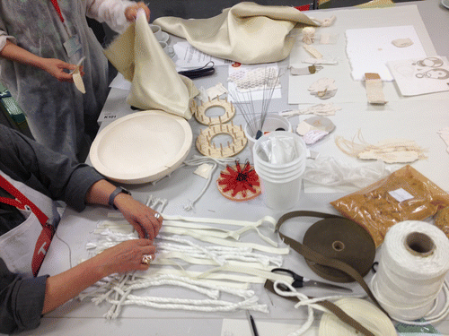

Figure 5 Handling of material during the participatory workshop during phase 4.

Selective design developments

Phase 5
With a textile background it was hard to ignore the importance of colour, both as a tool for experimentation and as a means to unify the design approach through a distinct colour scheme. As in earlier phases of the project a similar high-risk approach was taken to investigating how the materials and colour might work together. A “direct glazing” approach was explored, working intuitively onto the raw textile and unfired clay surfaces. In this phase of the process textile sensibilities and tacit knowledge were used to exploit the differences between surface properties of clay and textile through the use of matt and shiny glazes, as shown in Figure 6. Heat resistant materials were embedded into the clay for structural and visual effect. Additionally, textile printing methods were used for the decoration of hybrid materials, deliberately expanding on existing ceramic rules. Glazing was used as glue to trap basalt fibres to create a new “flock effect” and glaze was applied to the basalt taping to bond layers of rope together. A deliberate decision was made to choose “synthetic” primary glaze colours, “sun shine” yellow, glossy black and “glacier white”, in order to create contrast with the natural earthy colours of the clay.
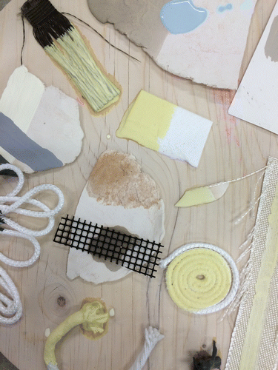

Figure 6 Glaze and bonding experiments during phase 5.

Phase 6
Reflecting on the most successful experiments in the earlier phases of the project, the authors continued to explore the potential afforded by the fusion of clay, silica and basalt. At this point textile thinking became key in order to investigate and develop the inherent properties and functions of the selected materials as well as for consideration of how these materials might be used out of context. For example, using expressive making actions such as knotting in the process and utilising colour and surface qualities as core methods to drive the final design outcome.
The functional and haptic aspect of the flexible silica ropes offered innovative design outcomes when used in combination with rigid paper clay and glaze. Here the inherent properties of the materials suggested the form but textile thinking, i.e. the manipulation of these materials through knotting and coiling, offered new design possibilities.
At this stage an imagined product scenario began to take shape. The potential context of the work began to inform the scale and subsequent material developments. As a result, the proposed design outcomes moved away from pure material hybrids and a more product-orientated approach was considered. Modular options were explored in order to both work around the limited space in the ceramic kiln and to visualise potential product applications. Here rough prototyping through a “physical visualization process” helped inform future direction and led to a number of constructed textile components. Different knotting techniques were explored to create outcomes suitable for a spatial environment, see Figure 7.

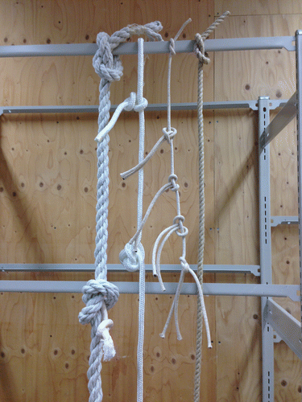

Figure 7 Knotted prototypes for spatial application.

A cross-disciplinary review from ceramic colleagues ensured that the project maintained an innovative angle and that any new knowledge created was both new to textiles and within the discipline of ceramics.

Phase 7
Along with the collection of early experimental “playtypes” illustrating the process of the research, the authors created three final design outcomes, which successfully displayed the conclusions to the project in artefact form. These material hybrids brought together materials and processes from both disciplines, referencing key qualities such as glazing and soft frayed yarn qualities. The final artefacts were exhibited in the Real Dirty Blue exhibition held at the Lethaby Gallery, CSM.
The flexibility of textiles and the rigidity of ceramics were evident in the final outcomes:
Combining the ropes and cords of varying thicknesses with clay/porcelain and glaze whilst maintaining
flexible haptic qualities;
Working with basalt ribbons to create stiff modular pieces;
Exploring the hardening properties of fired basalt to create a rigid structure with the use of porcelain
to visibly highlight the fragility of the artefact.

Additionally the “playtypes” and early material samples work as a “handling library” illustrating both the progression of the project and the multitude of hybrid possibilities achievable, illustrated in Figure 8.
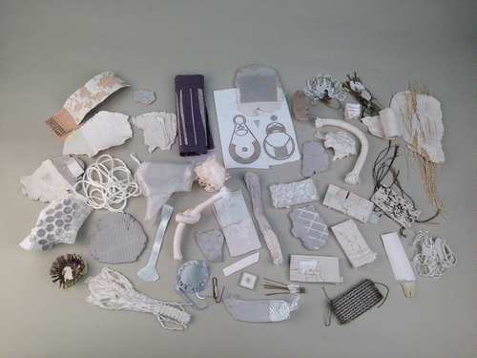
Figure 8 Playtypes and test samples as material handling library.
The authors identified that the project would benefit from additional cross-disciplinary input from Industrial Design or Architecture and are currently exploring further design outcomes and contexts for the fusion of ceramic and textile qualities such as interior/exterior cladding, see Figures 9 and 10.

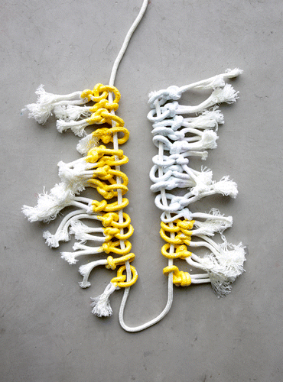
Figure 9 Hybrid knot artefact.
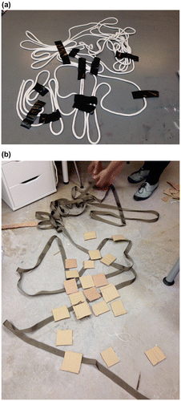

Figure 10 Prototypes during physical visualisation process in phase 6.

Discussion
The following discussion aims to unpick the findings of the case study in relation to existing definitions of design research in order to articulate distinctive attributes of textile research and its value to other design areas.
Recent papers by Igoe (2010) and Morrow (2014) describe a lack of written evaluation of contemporary textile practice: “… the aesthetic coherence or ‘beauty’ of an artifact can sometimes belie its cleverness, masking the complexity of the processes from which they result and making it seem somewhat indulgent. Building an explanation … therefore becomes quite crucial.” (Morrow 2014: 461). The authors intend to make their tacit textile knowledge more explicit in order to add to the discourse on research methods in the context of process-led material design. Consequently this discussion outlines the value of tacit knowledge and explores methods of textile prototyping as well as the differences and commonalities between textile and ceramic approaches. Finally it defines specific elements of textile thinking and contextualizes them in relationship to overall design thinking.

Material fiction
The authors deliberately did not set themselves a user-centred design problem but instead embarked on a journey of “material fiction”, imagining a potential chemical reaction between fabric and clay through process-led design research.
The hands-on and open-ended nature of “material boundaries” enabled the unearthing of new material knowledge through a lateral and immediate approach to making. Additionally this tacit “textile intelligence” was enhanced through systematic photographic documentation, interdisciplinary reviewing and reflective writing, which captured inherent findings, as shown in Figure 11. Here, interdisciplinary material research provides an excellent test bed for further opportunities to apply textile thinking in order to discover advanced material possibilities that can resolve and enhance user-centred design issues.
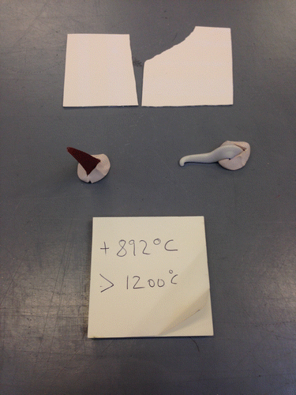
Figure 11 Systematic documentation of different clay/ textile combination before the firing process.

Carter’s (2004) conception of “material thinking” offers a view on active materials in creative processes. According to Carter, materials are neither passive nor instruments, but interact with the maker’s artistic intelligence when hands, mind, and eyes are connected in a creative process (Carter 2004). New material knowledge is made through direct material manipulation, providing a deeper, hands-on, understanding of design practice itself.
Dewey (1925) considered experience and action as knowledge that could be summarized, for example in the axiom “doing is knowing”. This resonates with Sanders and Stappers recent descriptions of the changing role of making in the design process, where “…making activities are used as vehicles for collectively (i.e. designers and co-designers together) exploring, expressing and testing hypotheses about future ways of living” (2014: 6). They describe probes, prototypes and toolkits as three approaches to making and define their positioning within the design process (2014). Sanders and Stappers base their research framework on “designing for” and “designing with”, within the parameters of
led by design
user as partner
led by research
user as subject. (2014: 8)

Arguably their framework is based in a product design context, as the authors would add material “playtypes” in the first phase of process-led textile design research followed by probes and prototypes in the later phases. Horváth describes the three main types of research direction as theory, phenomenon or product based enquiry. In the context of this paper his definition of phenomenon-driven design research is particularly relevant and distinguishes two main area: “design inclusive research”, which uses prototypes as hypotheses; and “research through design” (2007: 6) which uses prototypes as tools for exploration. Figure 12 describes the different stages of “research through design”, which include explorative info collection before problem analysis and design development.
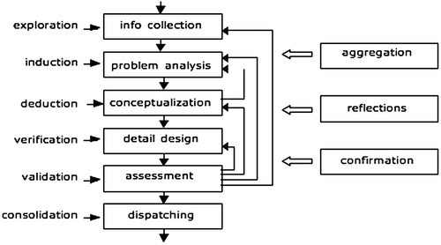

Figure 12 Horváth’s diagram of the process of research through design (2007).

Additionally Kane, Matthews and Moriarty propose a textiles-based definition relevant for the context of the Journal of Textile Design Research and Practice as:
research informed by textiles and textile design;
research through textile designing and making; or
research for textile design education. (2013: 6).

The authors of this paper have observed open-ended material research very much based on “designing through” and “designing with”, using experimental process scenarios to generate speculative material qualities before their application to user-led design outcomes. Additionally information collection (Horváth 2007) in the context of this project has been the experimental tacit material exploration through the use of “playtypes” before the definition of a design “problem”. This paper argues that tacit textile knowledge goes beyond a purely aesthetic or haptic approach and can play a key role in all four areas of design research as outlined by Sanders and Stappers (2008).

“Playtypes” and prototypes
Morrow describes her method as working with maquettes as neutral third parties to stimulate “discussions (…) to overcome issues of differing cultures and professional language, allowing each contributor to reveal their interpretation, preferences and imaginations” (Morrow: 461). Whereas this paper identifies “playtypes” as a method to experiment with material properties and prototypes as a method to develop design outcomes, and defines the combination of both as a new methodology to combine textile and design thinking. During the Material Boundaries project phases 2–5 the authors used “playtypes” and systematic reflective photography as a way to record the process and trigger new ideas. This was later complemented by prototyping during phase 6.
Heimdal and Lenau state that “the designer needs to see the object, not just hear a description of it.” (2010: 12). In order to read the technical as well as semantic meaning of a physical object a number of properties need to be considered. Using “playtypes” and prototypes during research activities “also reveals the importance of the semantic meanings different stakeholders read in physical objects, and that this has an influence on the inspirational effect of the given physical object.” (Heimdal and Lenau 2010: 12).
The open and playful interaction with the material at the beginning of the process triggers new design associations and helps to stimulate new textile possibilities. During phase 2 of the Material Boundaries project the authors developed a method of material “speed dating” – systematically combining as many different raw materials as possible in order to quickly test which would survive the hot temperatures in the kiln. For example dipping silica rope in different types of slip to find out the most durable clay coating that would adhere to the textile base. Figure 13 outlines the different research phases of this case study from initial research to final artefacts – using “playtypes” and prototypes as methods to develop material and product ideas.
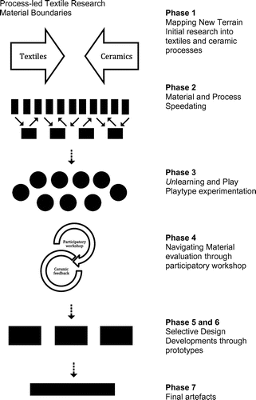

Figure 13 Material boundaries: process-led research flow diagram.

This paper argues that intuitive design “playtypes” enhance the initial stages of material research through systematically inviting risk-taking and tacit knowledge. Morrow describes this stage as: “What looked on the surface to be samples of hybrid materials (…) were in fact representations of ideas, proposals and possibilities (2014: 457)”. In that sense “playtypes” are material prototypes used in open-ended process-led textile research without a product or user in mind.
In contrast product design prototypes are often seen as an applied tool to explore a future product or service. Stappers defines the roles of prototypes as:
a way to experience a future situation;
a way to connect abstract theories to experience;
a carrier for (interdisciplinary) discussions;
a prop to carry activities and tell stories;
a landmark for reference in the process of a project. (2007: 84).

For this project the authors have used material “playtypes” as the main vehicle to develop new material knowledge before moving into a more user–centred stage of the design process. These material “playtypes” have been used to
investigate new material properties
test different technical processes
play with construction of shapes
experience aesthetic qualities
develop a sense of scale for the project
refine the execution of craftsmanship

In addition “playtypes” were used in what Stappers describes above as methods
to carry activities and tell stories
to carry interdisciplinary discussions
for reference in the process of a project. (2007: 84)
Whilst “playtyping” was applied in the early stages, user and product-oriented prototypes were utilised to stimulate physical visualisation to develop the shape and scale of the final hybrid artefacts as well as to create modular prototypes. These were used to communicate the direction of product ideas and to establish a sense of spatial momentum. “Having to explain prototypes, (its) goals, technical principles, and examples of how it worked each time for a different audience played an important role in gaining insight, and gave interesting feedback and connections from different perspectives” (Morrow 2014: 167).

In that sense the prototypes helped to envision the application and utilisation of the initial material research findings.
Brassett states that “Design is an activity which should always seek to create value whilst recognizing and participating in the socio-cultural context in which it operates …” (2011:7). Whilst the importance of socio-responsiveness in textile design is fully acknowledged, this paper argues that material thinking can inform the designer prior to the formulation of a socio-cultural driven design problem, as new materials offer possibilities that design thinking without material handling would not have brought about. It is this “… intuition of the unthought known” (2011: 118) that Gormley describes and wherein much of the magic of innovation lies.

What is textiles thinking?
During the project some of the differences and similarities between textiles and ceramic thinking became evident. The following chapter attempts to map out boundaries as well as common ground in order to stimulate future interchange and articulate the specific parameters of textile thinking in the context of this project.
Many of the differences between ceramic and textile thinking relate to the inherent properties of the materials. Both areas operate very much in the field of research through design as described by Horváth with different physical phenomena as triggers for inquiry (2007). Key to ceramics is a feeling of permanence along with an almost total resistance to discolouration or corrosion, the fragility and brittleness of the material being the only bar to its immortality. This is in contrast to textiles, many of which are relatively impermanent, will fade, disintegrate and can be refashioned and repurposed. Textiles consist of a wide range of diverse materials ranging from jute to silk as well as plastic to wool. The fine-tuning of adaptable material qualities lies at the core of the design development. Here the intrinsic knowledge of the behaviour of different textile components – will it shrink or will it scratch? – often informs the selection of the material as it might be worn directly on the body or used within a more permanent spatial environment. In comparison, the ceramic designer deals with a multitude of clay and porcelain properties and textures that need careful consideration, for example when selecting a material for a cup. However within ceramics the variety of surface qualities that can be maintained is more limited than in textiles, where a wide range of haptic surfaces can be created through different processes such as jacquard weaving, hand-knitting and industrial finishing techniques.
Similarly the process of applying colour to ceramic is restricted through the firing process, even though there are countless glazes and clay types available. This is in contrast to the multitude of colouration techniques and qualities achievable through the construction, dyeing and printing of textiles, which can be re-purposed at any stage of the design process. Here a different sense of timing becomes a distinctive characteristic for each specialist design process.
Whilst flexibility is a key textile quality, ceramics often need to achieve perfect stability, ironically achieved out of elastic clay material. Once fired it often needs to stand upright in a form that can be reproduced. Ceramic design has a strong focus on the construction of outlines and shapes as the material becomes stiff and robust after the firing process.
Ceramic thinking therefore has the irreversible transformation of clay particles at its core. Fundamentally, this aims to produce a sense of permanency. This is of less relevance to the textile designer whose intention is to create materials that can drape, stretch, cover or hang. Here textile design focuses on the micro-scale construction of the material itself –for example in a woven double-cloth or a fragile lace structure.
Both disciplines offer the opportunity to explore a sensory approach to design in the choice of materials, finishes or glazes and have the potential to embody the handwriting of the designer within the use of the relevant materials. This may be through a particular material sensibility or a more direct approach through “mark making” or “form-making”.
Textiles and ceramic materials both carry associations with craftsmanship and have long cultural traditions. The design process in both disciplines explores these associations from a material and a conceptual point of view and integrates technical as well as tacit knowledge into the process of design.
Each discipline carries with it the need for a considered material selection and offers potential in the design process to explore and question the cognitive material associations held by the material. Manzini articulates material selection as key to how a product appears and at the same time how this appearance defines the user experience (1989).

Unlearning as part of the design process
As part of their investigations the authors looked to challenge material associations. During this project a number of unfamiliar situations occurred, such as material bonding qualities or unknown firing processes, shrinkage, and colour changes, which required continuous reflection in action. Additionally, careful planning of experiments and testing ensured that the authors were able to build upon acquired reflective material knowledge and developed new techniques, such as glazing directly onto unfired silica fabric.
“Intentional, methodical creative productions can test a variety of ideas in practice and openly demonstrate the researcher’s way of improving his or her professional practice” (Scrivener and Chapman 2004: 4). The multitude of new ceramic opportunities and the authors’ lack of ceramic technical skills led to a need to refer back to existing textile expertise. At this point risk taking through unlearning textile knowledge was enhanced through “safe” existing skills. For example textile manipulation, construction and use of print processes. As Morrow says, “The mistake is to associate innovation with new territories and to underestimate the value of mining the existing” (2014: 462). Additionally Salustri and Rogers state that, “Once we have learned to do something in a certain way, we will tend to do that thing the same way forever, or until a ‘better’ way presents itself (and sometimes, not even then). In this way, we will tend to not try other ways to do a thing because we have learned one way of doing it” (2008: 299).
Even though the authors had a great deal of shared textile experience it was important to “unlearn” this knowledge: putting aside existing textile assumptions to go beyond known parameters. The cross-fertilisation of materials, in combination with a variety of processes and concepts, provided numerous opportunities for unlearning. For example, the authors deliberately worked with yarns that displayed unsuitable haptic textile qualities before the firing process, as they discovered that the yarn quality would transform after the exposure to the kiln. The transformation process through firing meant that all material qualities were constantly adrift. The scale of transformation and the danger inherent in the lack of control of the ceramics process felt daring in comparison to textile processes, where material qualities can gradually be developed, altered and restored. This unlearning was a necessary part of the project, ignoring set rules of textile practice and applying textile thinking to unfamiliar materials and processes to invite creative risk-taking, happy accidents and often improvisation. More often than not, uncertainty, led to a shift in direction and the development of a new axis of thought. Embracing “uncertainty” has definitely been a key threshold in progression of the project. McDonnell states that “a designer must be in possession of Keats’s Negative Capability (Gittings and Mee 2002), the ability to be at ease with working in a state of partial knowledge, to be at ease with uncertainties and contradictions” (2012: 56). The authors agree with this view, whilst recommending the integration of a specialist knowledge at the second stage of an “uncertainty” project, in order to evolve partial knowledge into new knowledge. During Material Boundaries it became apparent that textile construction and the visibility of techniques such as knotting and stitching could act as a valuable quality to complement the experimental hybrid developments. After a phase of unlearning and partial knowledge, the authors developed a range of new materials that they struggled to develop further without additional ceramic skills. Revisiting their textile skills enabled the authors to apply the playful and experimental findings of phase one into the more complex final artefact outcomes.
Cross-disciplinary material design in particular can invite uncertainty as well as the risk of losing direction in new subject encounters. In general, identifying and selecting materials is an open-ended process with no singular solution and it is important for designers constantly to challenge this equilibrium, to force materials and processes to their limits, to take risks. However, for designers and educators there is a continual need to evolve critical working processes through combining partial knowledge with existing expertise, whilst looking to bring an unexpected element into the mix.
Working across disciplines offers great advantage to the designer as one is presented with unfamiliar materials and processes and confronted by the need to “un-learn” existing knowledge in order to acquire new perspectives. This of benefit for both innovating ones own discipline as well creating tangible new hybrid practices.

Conclusion
This paper has revealed the value of process-led design research with no predetermined outcomes and of unlearning through material “playtypes” whilst embracing partial knowledge.
Materials frontiers provide invaluable design impulses for researchers, designers, educators and students. Developing a confidence in exploring materials, in a “hands on” and an open-ended approach should be a key early part of the design process. In order to positively navigate future projects the authors make the following recommendations:

- Treating materials as an active source of design information to invite the making of tacit
knowledge through direct material handling;
- Encouraging more research opportunities that include unlearning and partial knowledge as an
essential part of design investigation;
- Integrating the role of material “playtypes” in open-ended research;
Articulating textile thinking further to communicate its specific methods to other disciplines.

The above findings highlight the intricacy of inter-disciplinary research and how this creative complexity brings uncertainties and opportunities to the design process. With an estimated 70% of all technical innovations linked to new material developments Creative Industry Workshop (2010) it would be desirable to expand the traditional role of textile designers to be part of a wider field of research, in terms of material development as well as practice-led design research. Often the lack of resources and interconnectivity between disciplines prevent a greater exchange of tacit knowledge during the first stages of research. This is particularly relevant for textiles, which offers a wealth of opportunities to inform both material as well as user-centred design outcomes. Tacit textile knowledge is built through the ability to engage actively with materials and there is a need for designers to acquire material knowledge through direct handling and experimentation and to be able to observe the changes that materials undergo through various processes. Therefore the combination of both analogue and digital research methods are vital to understand and drive design outcomes. It would be desirable to expand access to “hands-on” analogue workshop facilities and create more resources that nurture and invite open-ended cross-disciplinary and process-led research. “It is vital that Design Research protects that space for conceptual thinking, messy making and utopian visions, from which more refined research objectives can emerge” (Morrow 2014: 463).
Finally, this paper outlines the value of textile thinking and its particular approach to understanding and developing ideas, processes and qualities, as well as outcomes. Here explicit and tacit textile knowledge is influential to designing new material properties and advancing visual, structural and haptic potential through colour, texture and material construction. Additionally textiles are deeply embedded in the socio-cultural fabric of society and therefore offer unique narratives to enhance user-centred as well as participatory design approaches.
Whilst this paper specifically articulates textile thinking, the authors also experienced the value of ceramic thinking in dialogue with their own discipline. Utilising tacit “trans-specialist” design thinking combined with explicit generic design thinking has been highly instrumental in the design of new hybrid research outcomes. The authors believe there is a need to initiate further direct dialogue between specialists from different disciplines in order to exchange tacit design knowledge and develop a broader design vocabulary.

Funding
This work was supported by CSM as well as the Textile Future Research Centre, University of the Arts London.

Acknowledgements
This paper was conceived while the authors were respectively a Course Director and an Associate Lecturer on BA (Honours) Textile Design at CSM, University of the Arts London.
The Hybrid Materials project was only possible with funding support from CSM as well as the Textile Future Research Centre, University of the Arts London. We would also like to thank Andy Allum, Helena Britt, Natsai Chieza, Peter Close, Carole Collet, Simeon Featherstone and Duncan Hooson in particular for their invaluable enthusiasm, inspiration and support.

References

Bolton, S. (2015). The Visual Thinking Method. In P. Rodgers and J. Yee (eds) The Routledge Companion to Design Research. Oxon: Routledge, pp 277-291.

Brassett, J. (2011). The uncertainty project: managing uncertainty in innovation education. In: Cumulus 2011, Crossing Talents: Transversaility in Design, 19-21 May 2011, Straté College, Paris. (Unpublished).

Brockbank, A & McGill, I. (2007). Facilitating reflective learning in higher education (2nd ed.). Maidenhead: SRHE and the Open University Press.

Carter, P. (2004). Material Thinking: The Theory and Practice of Creative Research. Carlton. Victoria: Melbourne University Publishing.

Chugh R. (2015). Do Australian Universities Encourage Tacit Knowledge Transfer? In Proceedings of the 7th International Joint Conference on Knowledge Discovery, Knowledge Engineering and Knowledge Management, pp 128-135.

Creative Industry Workshop (2010) Report Website. [Internet] (http://ec.europa.eu/research/industrial_technologies/pdf/creative-industry-workshop-report_en.pdf [9.5.2016]

Cross, N. (2007). Designerly Ways of Knowing. Basel/Boston/Berlin: Birkhauser Verlag.

Dewey, J. (1925). Experience and Nature. New York: Kessinger.

Gittings, R. and Mee, J. (eds) (2002). John Keats Selective Letters. Oxford: University Press.

Gormley, A. (2007). Thinking about Naoto Fukusawa. In F. Naoto (ed) Naoto Fukusawa. London: Phaidon.

Heimdal, E.J. & Lenau, T.A. (2010). 'Physical tools for textile creativity and invention' DUCK Journal for Research in Textiles and Textile Design, vol 1, no. 1 pp.1-14
Accessed through Website. [Internet] http://www.lboro.ac.uk/microsites/sota/duck/volume1.htm [26.10.2016]

Horváth, I. (2007). Comparison of three methodological approaches of design research. Accessed through Website. [Internet] https://www.designsociety.org/publication/25512/comparison_of_three_methodological_approaches_of_design_research [12.05.2016]

Igoe, E. (2010). 'The tacit-turn: textile design in design research' DUCK Journal for Research in Textiles and Textile Design, vol 1, no.1 pp. 1-11.

Kane,F., Matthews J. and Moriarty, L. (2013). Journal of Textile Design Research and Practice, 1 (1).. London: Bloomsbury, pp. 5-8.

Lee, J. (2014). Material Alchemy. Amsterdam: BIS Publishers.

Lefteri, C. (2014). Materials for Design. London: Laurence King.

Manzini, E. (1989). The Material of Invention. London: The Design Council.

Material World 2 (2006). Material World 2 Innovative Materials for Architecture and Design. Basel: Birkhauser – MateriO.

McDonnell, J. (2012). Accommodating disagreement: A study of effective design collaboration. Design Studies, 33 (1) pp. 44-63. [Internet] (http://ualresearchonline.arts.ac.uk/3892/ ) [21/10/16]

Miodownik, M. (2013). Stuff Matters. London: Penguin.

Morrow, R . (2014). The Routledge Companion to Design Research. ed. / Paul Rodgers; Joyce Yee. Abingdon: Taylor and Francis, pp. 454-464.

Osmond, J., Turner, A. & Land, R. (2008). Threshold Concepts and Spatial awareness in Transport and Product Design. In R. Land, J. Meyer and J. Smith (eds), Threshold Concepts in the Disciplines. Rotterdam: Sense Publishers, pp. 243-258.

Polanyi, M. (1967). The Tacit Dimension, University of Chicago Press: Chicago, 4.

Real Dirty Blue (2016) Website. [Internet] http://www.arts.ac.uk/csm/whats-on-at-csm/lethaby-gallery/lethaby-gallery-past-exhibitions/real-dirty-blue/ [9.5.2016].

Restless Futures (2014) Website. [Internet] http://www.arts.ac.uk/csm/whats-on-at-csm/restless-futures/ [16.4.2016].

Salustri, F. & Rogers, D. (2008). ‘Some Thoughts on Terminology and Discipline in
Design’ in Undisciplined! Proceedings of the Design Research Society Conference
2008 Sheffield, p. 299.

Sanders, E. & Stappers, P. (2014). Probes, toolkits and prototypes: three approaches to making in codesigning. CoDesign: International Journal of CoCreation and the Arts, 10 (1): pp. 5-14.

Sanders, E. & Stappers, P. (2008). Co-creation and the New Landscapes of Design. CoDesign: International Journal of CoCreation and the Arts, 4 (1): pp. 5-18.

Stappers, P.J. (2007). Doing Design as part of doing research. In Michel, R. (Ed) Design Research now. Basel: Birkhäuser, pp. 81-91.

Scrivener, S. & Chapman, P. (2004). The Practical Implications of Applying a Theory of Practice Based Research: A Case Study. Working Papers in Art and Design. [Internet] http://www.herts.ac.uk/__data/assets/pdf_file/0019/12367/WPIAAD_vol3_scrivener_chapman.pdf [03/08/15].

Wagner, P. (2014). Foreword. In J. Lee, Material Alchemy, 7-9. Amsterdam: BIS Publishers.

Anne Marr

Anne Marr is currently Course Leader, BA Textile Design at Central Saint Martins College (CSM) and acting Deputy Director of the Textile Future Research Centre, University of the Arts London (UAL). Anne is interested in trans-disciplinary design and has been working collaboratively with architects, artists and designers. Research areas of interest include: socio-responsive textiles, urban fabric, experiential material knowledge, hybrid materials, design education. a.marr@csm.arts.ac.uk

Rebecca Hoyes

Rebecca Hoyes is a design practitioner and Associate Lecturer on BA Textile Design at Central Saint Martins, University of the Arts, London. Her work combines an interest in both digital production and handcraft techniques and explores the resonance between modernity and tradition. Research interests include: craft and design as a means of collaboration, cultural heritage, digital craft, hybrid materials. r.hoyes@csm.arts.ac.uk

