Farm as Studio
Artists in Residence at Freightliners Farm
3rd - 8th April 2017

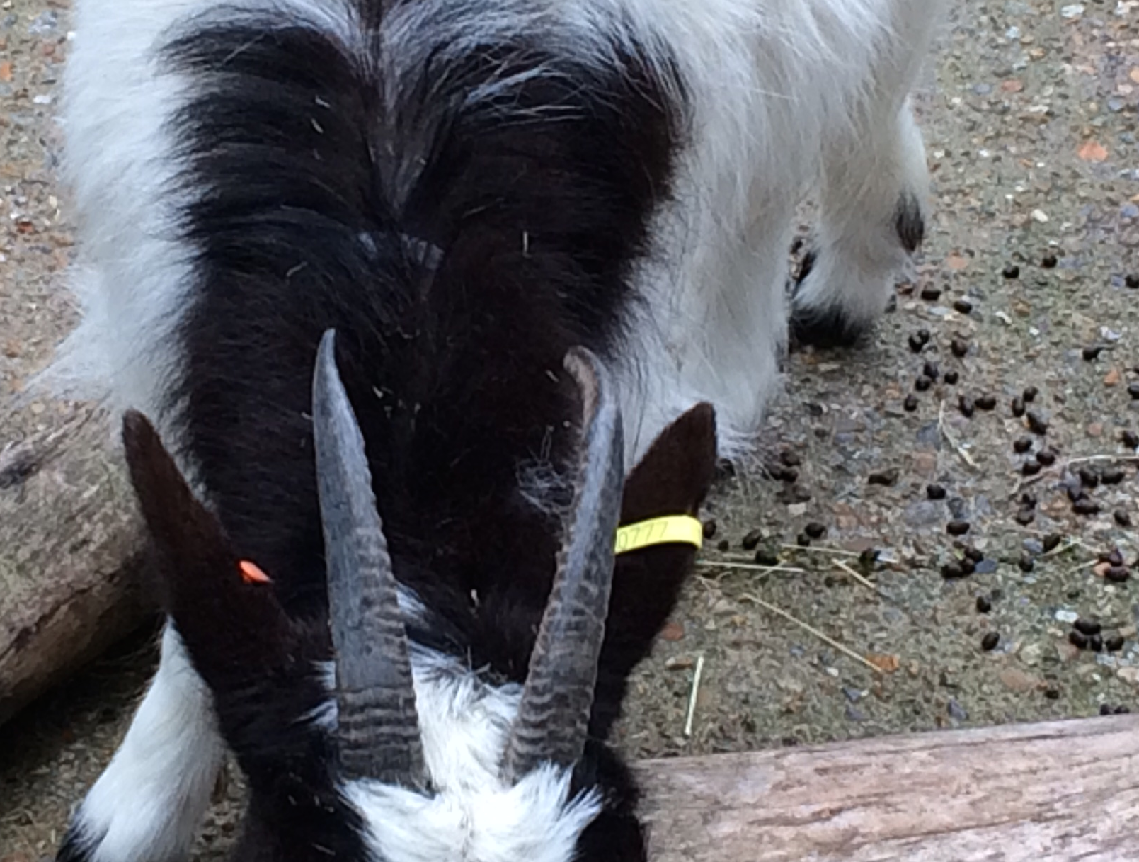

This week five artists are working in the farm using it as a temporary outdoor studio. You may come across the artists in different parts of the farm in the process of developing work - sometimes apparently doing nothing, sometimes busy trying things out, messing around, responding to the richness of the site and using materials / structures / spaces they find.
In this experimental week, the artists’ presence will not disrupt the everyday workings of the farm. There will be a small event at a later date to celebrate whatever has happened and give interested visitors a sense of how these artists engaged with Freightliners.
Farm as Studio is part of a research project funded by Central Saint Martins School of Art exploring site responsive art practices and intended to nurture connections between the art school and neighbouring organisations.
For any further information please email m.bannerman@csm.arts.ac.uk or talk to the Freightliners team.

