Designing Fast & Slow. Exploring fashion textile product lifecycle speeds with industry designers
Professor Rebecca Earley (2017)

Abstract

This research aimed to discover more about circular design opportunities; in particular, what products should be created to travel quickly through a cycle, and which ones should travel slowly. Whilst much has been written about design for product longevity most of it focuses on pioneering SME’s rather than larger industry stakeholders. Current Industry tools provide quantitive information to evaluate a complex range impacts, but speed of the lifecycle is not considered. In order to address this lack, workshops were designed to use four typologies derived from previous LCA research – a polyester shirt, an outdoors jacket, a t-shirt and some jeans. 24 redesigned concepts were created over a four-month period with 56 industry stakeholders, explored through materials, business models and user mindsets lenses. The resulting concepts created speed-based insights which extended beyond individual garment scenarios, to include systems and user perspectives towards a more progressive view of product cycles for fashion.

Introduction

Whilst much has been written about slow fashion and product longevity (Fletcher 2010; Rissanen 2011; Cooper 2010) and the ambition to create products that we are more emotionally attached to (Chapman 2009), much of it focuses on pioneering SME’s rather than larger industry stakeholders (Connor-Crabb, Miller, Chapman 2016). Current Industry tools provide quantitive information to evaluate impacts (Sustainable Apparel Coalition 2012), but these are limited in detail, scope and perspectives. Speed of the lifecycle is not considered.

In order to address this lack workshops were designed and took place in three cities, using four typologies from phase 1 LCA research (Roos et al, 2015) – a polyester shirt, an outdoor jacket, a t-shirt and some jeans. 24 redesigned concepts were created over a four-month period with 56 industry stakeholders, resulting in insights around both fast garment and slow garments, explored within the framework of materials, business models and user mind-sets, building on original research from phase 1 of the Mistra Future Fashion programme.

Working through workshops with many different stakeholders gives the research original and timely insights into where the problems are, as well as the concepts and ideas from both the research team and the stakeholders that most excite and inspire. The workshops require the stakeholders to be both professional and personal – to be designers and users – by drawing upon their experience in making textiles and products, as well as owning and using them. Fashion textiles design research approaches allow the tacit knowledge of the group to be drawn out, along with personal reflections from garments experienced to date.

The tasks used four Phase 1 garment typologies – a polyester shirt, an outdoor jacket, a t-shirt and some jeans – and extended the design concepts for these regular items into ones with different speeds. Product speeds were determined by playing ‘cards’ or ‘tickets’ with teams. Data Collection approaches included the creation of 4 post-it notes wall spaces that noted the object analysis and design improvement ideas; and 4 Speedometer posters that noted the same garments having been designed within specific fast and slow timeframes. Sound files and written notes were also created by the facilitators.

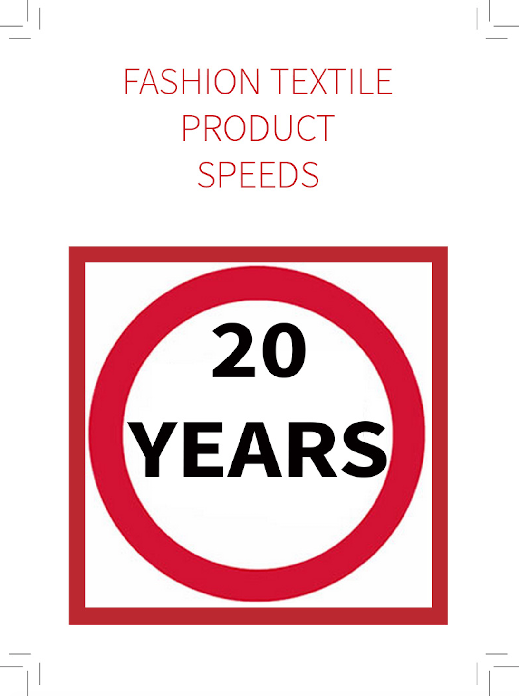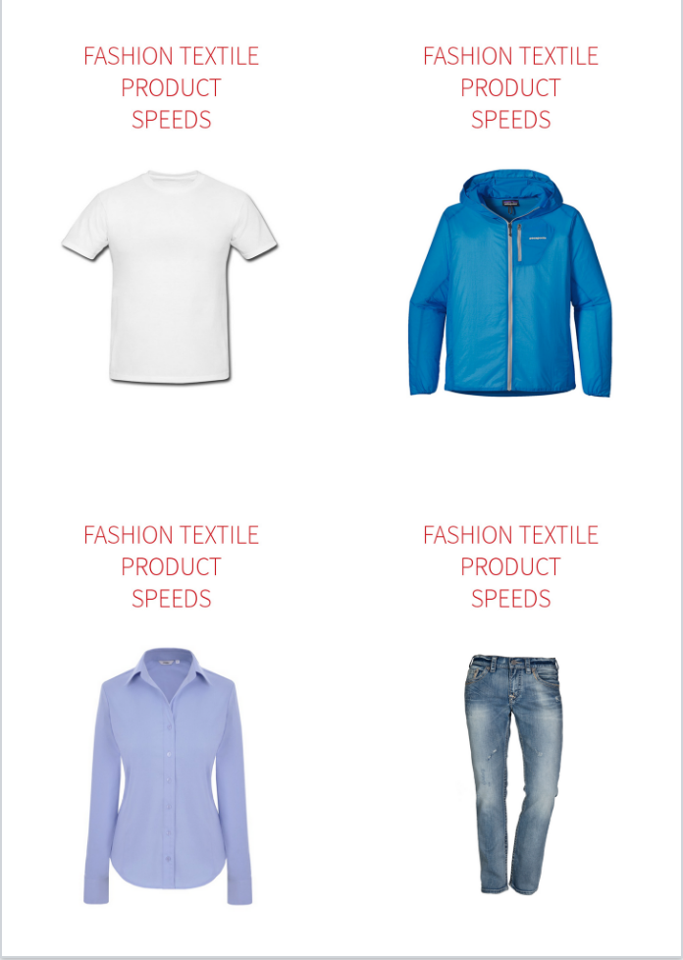
Figure 1. Speeding Ticket (left) and Garment Typologies Cards (right) (Earley 2016)

Framework: Materials, Models, Mindsets

These three interconnected themes emerged from stage 1 MFF research which frames sustainable fashion textile design in a new way: material, product and process innovation; social, systemic and economic concepts; and, the self and shifting mindsets and habits.

Previous research revealed that textile and fashion designers needed to be trained to think and create within a full framework of sustainable design concepts (Earley et al 2016). For circular design, designers need to be able to combine complex technical techniques together with new materials, processes and product design ideas to improve the use and disposal potential of the product. A set of design strategies in the form of cards were developed to help work in this context (Earley 2010), designed as a framework for thinking through and mapping sustainability issues. Using these cards, the researchers developed a training course which used lifecycle understanding and design thinking approaches. Participants of the course were asked to evolve innovative concepts for the design, and disposal, of fashion and textiles. Case study research, informed by discussions at stakeholder companies, enabled the team to design and build a toolbox for delivering professional training programmes and educational experiences to designers and teams in companies of all scales. (Earley et al 2016).

Workshops asked participants to use the tools to reflect on and evaluate existing fashion products, and to propose ideas to improve them. Tactility was a key approach and current ‘best selling’ garments were used in workshops with brands. At one company the development and testing of the tools led to an improvement in daily decision-making around sustainable design of up to 7%. Product redesign outcomes, created using a pre and post Higg Index score (Sustainable Apparel Coalition 2012), varied from 1% to a 41% improvement; with the most significant changes being made in creating recyclable garments using recycled fabrics. (Earley et al 2016).

Three themes emerged that framed the varied and layered approach to designing for circularity which can act at all levels of industry and society and with different driving forces. These encompass all aspects of design and celebrate the material, relational and personal challenges which need to be solved in order to achieve circular goals.

Fast & Slow Redesign Workshops

The overlapping and inner areas of this framework (fig 2) demand that we develop sophisticated inter- and trans-disciplinary relationships. Science, industry, design, policy making and end users can work together through the workshop to guide the development of more holistic approaches. Design researchers working in the fashion textile company needs to redesign the product and its performance in the workplace and social domain; whilst also considering the relationship between habit, mindset and actions of individuals in the workplace/social domain. The individual designer needs to be familiar with the context of lifecycle design, habit and mindset change, whilst also having a platform/space for exploring the ‘self’ – leading to a greater empathy for others and socially as well as environmentally considerate design outcomes. (Earley et al 2016)

Full Day. The workshop aimed to challenge participants on their understanding of the circular textiles economy, through exploring its application in the fashion industry and learning what industry leaders are doing, before using their experience to redesign products around different lifecycle timeframes – from fast to slow. The day included using TED’s The TEN (Earley & Politowicz 2010), based on the product typology card selected by each group. After this the facilitators gave a slide talk about the notion of fast, and intentionally speeding up a product’s lifecycle. A task was then given which was based on each group selecting a Speeding Ticket, which gave them a specific time frame to aim for. After sharing insights around this fast product, another slide talk gave a perspective about slowing down the circular lifecycle. Groups then selected a second Speeding Ticket which gave them the slow pace to aim for, and the design ideas were then shared for a final time.

Half Day. Paying professionals were invited to attend a five-day sustainable fashion course in Manhattan. 32 of the participants took part in the four-hour workshop, which ran twice, on two consecutive days. For this second workshop we adapted the one-day format, reducing it down to four-hours. The Garment Typology Cards and the Speeding Tickets were used, as well as blank post-it notes and large sheets of white paper to record the ideas by hand using sketches and words.

90-minutes. This was a tailored workshop session for a large Swedish brand. It was a one-day session, reviewing a full range of sustainable design approaches within an existing company framework, based on their current Corporate Social Responsibility (CSR) efforts. The session was titled Manifesto Making: Sustainable Design Thinking. Within this full day, 90-minutes was given over to redesigning a best selling product to be fast or slow. The day was attended by ten employees who were all part of the in-house Sustainable Design Working Group.

Across these three workshops, design ideas were gathered from 56 experienced industry designers, educational professionals and emerging researchers. Early insights from these sessions are presented here, focusing on the fast and slow redesign work.

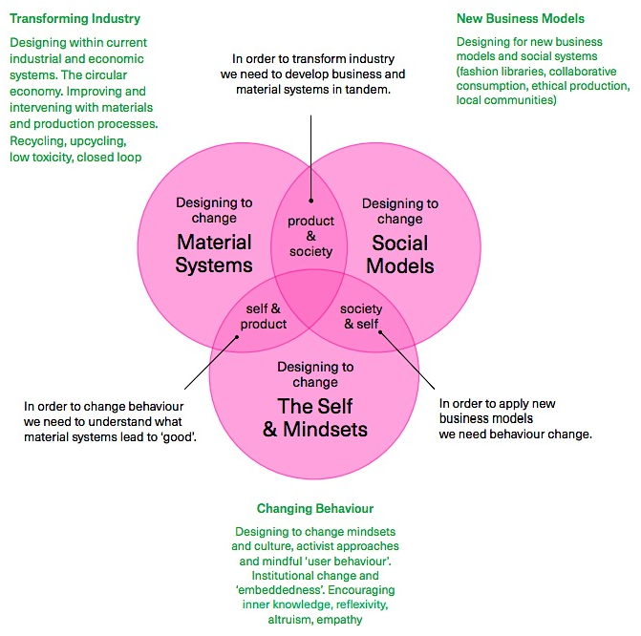
Figure 2. The Materials, Models and Mindsets framework (Earley et al, 2016)

Table 1. Table showing which design concepts were created in which city over what period of time. The design concepts column also shows what ‘Speeding Ticket’ was given.
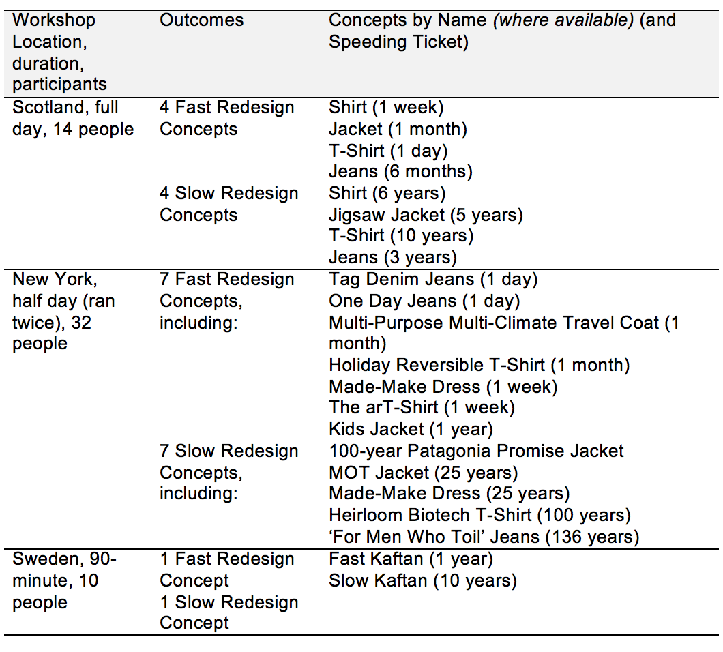

Design Ideas for Fast Clothes

Fast Polyester Shirts. The participants explored both the single user and multiple user concepts. As polyester is a hardwearing fabric the idea of disposability was not explored, but rental, loaning and customizing models were instead discussed. The most original ideas here were the Maid-Make Dress, which extended the shirt into a polyester bridesmaid dress, worn for the weeklong celebration that then becomes a fashionable/on trend item through technical textile redesign services (fig 3: top left).

Fast Outdoor Jackets. Participants explored both the single user and focused on compostibility with added value. One concept was a product that adapts for the user according to different and extreme climate changes and conditions during one month of intensive travel (Multi-Purpose Multi-Climate Travel Coat (1 month)) (fig 3: top right).

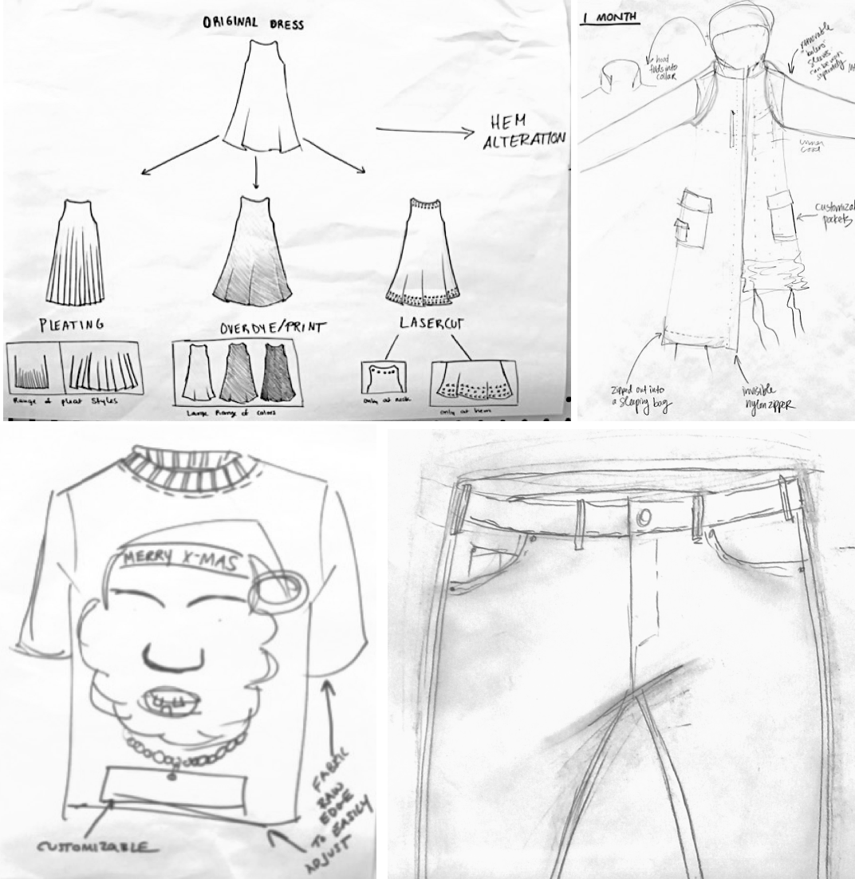
Figure 3. Design concepts for fast clothes, clockwise from top left: Maid-Make Dress, Multi-Purpose Multi-Climate Travel Coat, One Day Jeans, Holiday Reversible T-shirt

Fast T-Shirts. Participants generally worked with one user for particular social contexts, with composting possible at the end of the day. The arT-Shirt was a 1-week product for the ‘conscious and creative’ consumer made from post-consumer recycled paper and sewed up with decorative biotech thread. This was seen to be a ‘no guilt’ product which at the end of life the consumer can compost it, or use it as a paper bag or a container for seedlings. It was an item that could be easy to personalize in order to transform it from a ubiquitous mass-produced product to something very original. The Holiday Reversible Tee was a novel garment was designed as a Christmas T-Shirt, worn for one month every year by a single user (fig 3, bottom left).

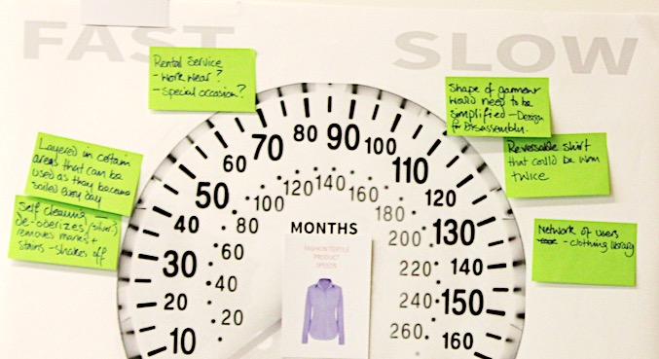
Figure 4. Speedometer worksheet mapping ideas for fast and slow polyester shirt design

Fast Jeans. Participants explored radical new material and production ideas or the potential for the brand to encourage the user to return the item after a year so they can sell a rebranded ‘aged’ version. Tag Denim: Add Ur Mark jeans was an idea for a circular subscription denim service. Users have ownership of these jeans for just one day and leave their mark in place – ‘tagged’ like a graffiti wall. The wearing of jeans becomes about community, connectedness and kudos; customisation and personalization through collaboration, these could be jeans for the digital community.

In the half-day workshop, after a morning session in the main conference session of talks and panel discussion on the subject of Biotech Innovation, the ideas for fast life jeans were particularly strong. The ‘One Day Jeans’ team produced four ideas for environmentally friendly, reusable, ‘recompostable’, zero impact fast fashion denim - all using radical materials and processes including: Paper Denim Jeans; 3D garment built by bacteria (Lee 2014; Yao 2015); Electroloom Liquefied Fibre (electroloom.com) and 3D printed using starch and sugar.

Design Ideas for Slow Clothes

Slow Shirts. Participants developed product ideas for a single user of ten or 25 years, with a strong focus on classic design and branding as the way to extend the life of the product. These participants asked asked: Can polyester be a luxury material? Would this product not be better in cashmere/wool, linen, or merino? If it is polyester and if we have 50 years of oil left – can we make a product that goes up in value over time as the material becomes rarer?

Slow Outdoor Jackets. For the slow time frame the ideas remained with a kidswear product for a single user of five years, enabling the garment to be transformed by the user during this time – growing as the nursery school child grows; product and material ideas extended into business models that included the sale of component parts for the jacket. The Jacket for the Future: The 100 year Patagonia Promise concept envisioned to gather data from the users over time, allowing improvements to be made, according to a contract between user and brand.

The ‘Jigsaw Jacket’ was a garment with detachable and interchangeable (disassembly) parts, based on a kids’ poncho, monomaterial and made from recycled plastic. The product grows as you wear it – users can order component parts. This perhaps can be provided for nursery school environments to last a child the whole time they are there. A fun garment that kids can draw and erase the surface of – more interactive than regular clothes. Has an aspect of educational learning in the garment which promotes creativity and understanding of design and olds away to form a rucksack

Slow T-Shirts. These ideas remained with a product for a single user of ten years, enabling the garment to be transformed by the user during this time through over-dyeing. The ideas also focused on consumer care, like providing guidelines for how and how often it should be washed – with anti-bacterial coatings used to support the idea that it should be less frequent than ‘normal’ t-shirts.

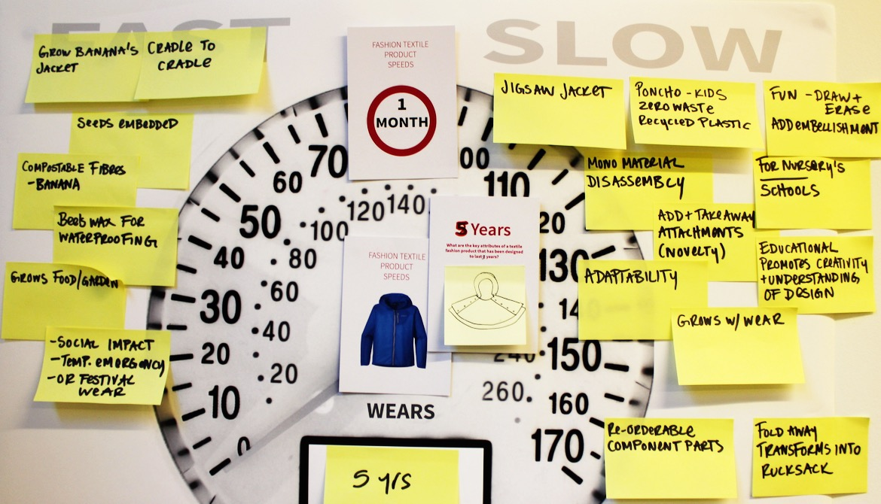
Figure 5. The Outdoor Jacket redesigned using the Speedometer worksheet – design ideas differ for lifetimes of 1 month to 5 years. The Jigsaw Jacket is monomaterial, designed for disassembly, multifunctional and proposed for a primary school context where physical growth of the user is rapid.

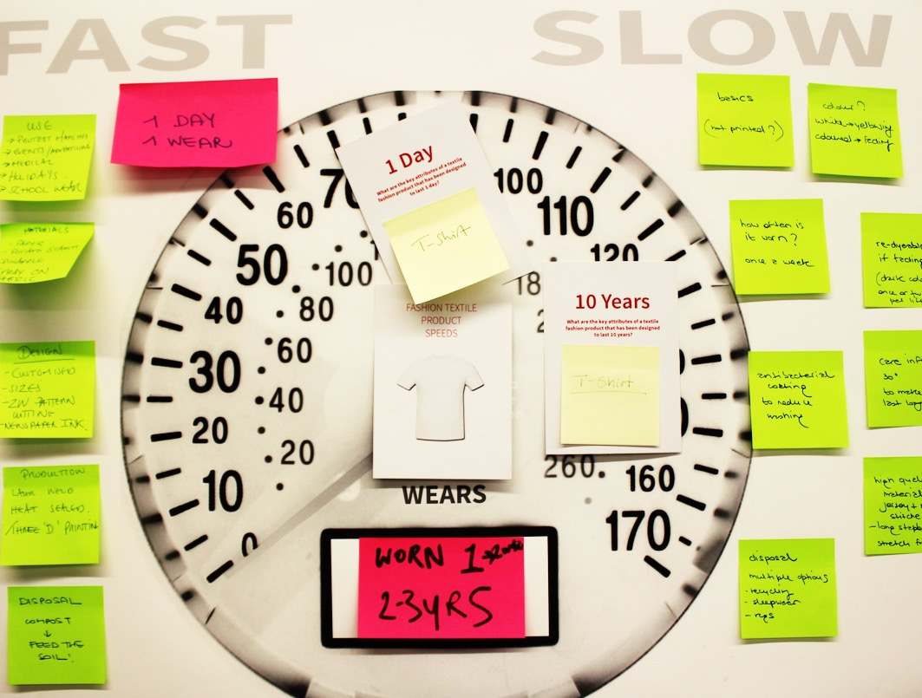
Figure 6. The T-Shirt Speedometer showing design concepts that redesigned a two to three-year garment cycle into a much shorter one – a single day – and a longer one of ten years.

The ‘Heirloom Biotech Tee’ was a forever t-shirt concept that self generates and keeps you and the earth healthy. Created using bio designed materials it produces self-regenerated repairs. No washing is needed, just hang in the sun and living bacteria regrows by eating dirt and sweat. This monomaterial and zero waste plain t-shirt can also be DIY design using biomaterials that you grow yourself. User can bring T-shirt back to store to incubate if they don’t wish to regrow it yourself (receiving a fee). This is a garment that never gets old - a new kind of molecular heritage, the bacteria lives on helping immunity defences.

Slow Jeans. Participants explored product for a single user of twenty years, fulfilling the function of a very high-quality cotton jeans of classic style and cut, from a heritage brand that gives added value through its UK production, library, repair and remake service. One final detail here was the idea that other users could wear-in the jeans for a while before the main user receives them, reducing the need for finished processes.
‘From for Men that Toil to People Who Care’ - these jeans focus exclusively on the historical context of the oldest denim jeans in the world. “The oldest pair of jeans is 136 years old”. This concept directly draws the user’s attention to historical precedence and encourages longevity ambitions. Like the Levi’s remake of these jeans, this concept makes a more commercial version that focuses heavily on marketing and education. People wear jeans an average of 3.5 times a week and own 8.6 pairs. As an antidote to short life habits with jeans this concept creates something of a competition for users to own jeans for the longest amount of time.

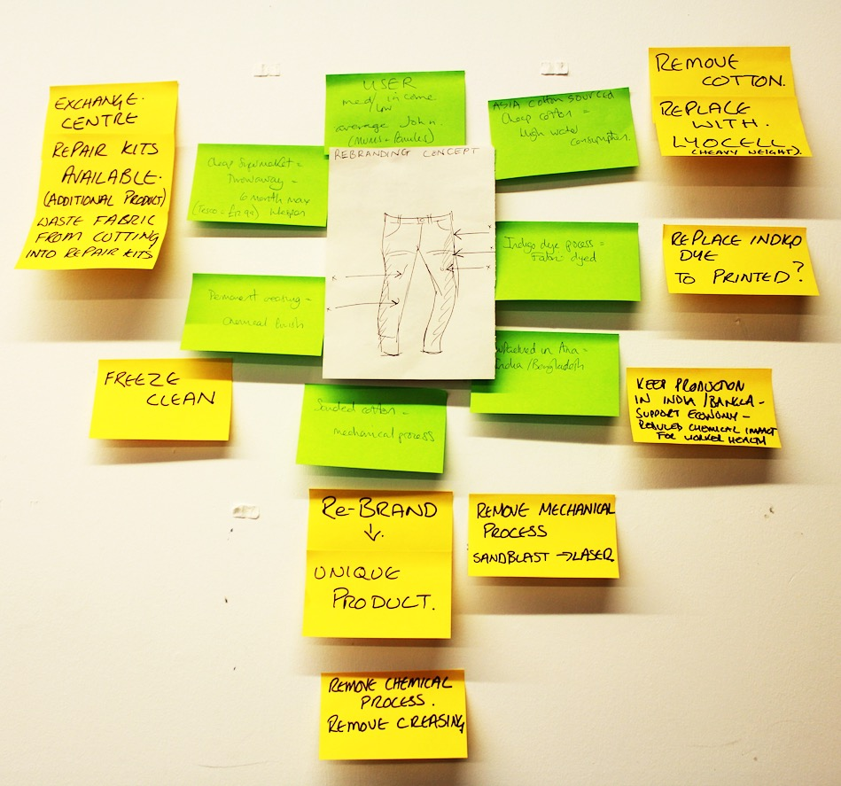
Figure 7. The denim jeans redesigned here to replace indigo-dyed cotton with heavy-weight printed Lyocell; uses a rebranding approach to extend use by recirculating product between users, and suggests ‘freeze cleaning’ rather than laundering.

Key Insights

Future Fast Materials, Models and Mindsets

Fast Materials. It was hard for participants to imagine fast materials, as they are not currently common in fashion textiles (unlike the medical sector). It was often felt that finishing details and textile applications could provide change to the material and product as required – strong opportunities here for textile design. The end of life is always the starting point for short life design - greatest potential for biodegradable materials found here; also for kidswear. These products can be highly practical and multifunctional. Potential for innovation is high in this field – including 3d processes, plug and play and liquid fibre technology, and biomaterials like algae and bacteria.

Fast Models. Slow products could provide adaptable models for short use experiments – ‘fast from slow’ products for different users. These were imagined by thinking of services that extend the potential for multiple lives and uses. Thinking about these products in existing companies’ models limits the possibilities however. It was noted as important to find the niche product and market to justify the spend on something that won’t last, or be with you for long, e.g. the bridesmaid dress concept (fig 3, top left). Unisex design might help extend the use phase, or make it used more often; the same could be true of the idea of the product being highly adaptable and customizable.

Many of the ideas discussed would operate outside of traditional retail, e.g. subscription, library, etc. It was felt to be important to be very specific about length of time for the product, and/or the number of uses. Which is it? It was found to change the design brief quite dramatically. The participants asked if one model for a fast product could include prior use - adding value through previous wears? Can there be kudos in this? Could this be a Limited Edition model?

Fast Mindsets. Participants often imagined more products and applications for a youth market than for mid or ageing users here, but these products should serve an identified need: could be a campaign - ideal format for activism, messaging and communication. This could work well with a ‘declutter’ or dematerialized approach to living, “living lightly”. Creating for the user is key for fast products – knowing how they act, what they know and what they want to do. A potential barrier might be a stigma around fast clothes – marking you out through the context of use, e.g. a discussion around emergency jeans for rape victims.

An important final point for fast product concepts was to be clear about the exploitation of people in the supply chain. “We don’t want people to be exploited, but we don’t want to lose our freedom of expression either.” The demand and real opportunity here is for ethical production models for short life products – which means designing to bring value and positive benefits to a community, or for automated production to meet the need for speed.

Future Slow Materials, Models and Mindsets

Slow Materials. “We have them now but we don’t use them” - an observation that the lack of industry interest in prolonging the life of clothing inhibits the increased usage of materials that are already known as durable. Design needs to be very aware of ‘classic’ – well tried and tested styles that already have a strong track record as being fit for purpose.
Technology could also be key here, with the discussion centering around many kinds of updatable elements, ‘soft wear’ that could keep a garment attached to the latest technology, e.g. health monitoring or temperature control. Embedded technology and detachable / updateable elements could be key.

Materials could be designed to: not get moth holes; not pill; not snag; not stain; not be static and to drape well and not sweat. They could be designed to be: lightweight; provide sun protection; disease repellent and support wellbeing. The participants recognised that we could use blends for best performance here because we will be able to chemically recycle them in 20 years’ time. We could design suitable materials for our changing climate conditions – a product might help us cope with change.

Slow Models. Repair becomes an art form here that comes with a desirable narrative. This was considered essential for long life models. Connections to artisanal craftsmanship could be key to enhancing product lifespan – a heightened sense of value, respect, tradition and history. The product could be highly adaptable over long periods of time, in cases where the product remains with the same user.

Products could change as you age - grow as you grow - evolve as your tastes change. They could be collectibles – not trend related but classic in style or Boro mended (Koide and Tsuzuki 2009), or both. Slow models could inform how fast products could aim to look. They could work like time capsules – clothing as anthropological tools for the future.

These products need to come from companies that have developed very different business models – one where they meet very different customer needs than they currently do. Some models may strategise to prolong existing products; some may seek to make radical new products. Services are key here – the business model needs to develop these in innovative new ways.

Slow Mindsets. This focused on the idea of ‘fine wine design’ - where the ageing of the product is key to its user value. It was found to be important to consciously make visible or invisible the narrative of the product – opinions differed around this. Some like ‘old’, whereas some like ‘new’ looking things. The user needs to have access to a broader range of offers and be used to accessing services instead of buying products. “Slow demands a total paradigm shift”.

Next Steps

The design concepts produced during the sessions point towards insights beyond the individual garment scenarios. Both fast and slow product speeds need new materials and technological advances; service design needs to be further developed for fashion markets along with a significant change in user habits. Fast and slow speeds are both possible and potentially beneficial – environmentally, economically and socially – to large industry stakeholders as well as more niche enterprises. New LCA tools need to be developed to more accurately support the design of these product concepts destined for closed loop fashion contexts.

Finally, we felt our workshops - in facilitating collective opportunities for different sorts of sharing and empathic knowledge, about the thoughts and feelings of others - had real impact. The fast and slow exercises we set up encouraged understanding of self and others and so appeared to operate as an empathy “thing” (defined as “socio material assemblies that deal with events and other matters of concern” (Gamman & Thorpe, 2016)) to be further explored to aid better understanding of what role empathy may have in behaviour change.

The next phase of this research will explore product speed ideas in greater detail at a large fashion brand during 2017, involving a broader set of researchers from within and without the Mistra Future Fashion programme. The ‘Design Researchers in Residence’ project will aim to develop two new garments for the brand – a fast garment and a slow garment – which will be evaluated and steered through the development of new LCA design tools. The models for the fast and slow products in an applied context will be shared with member brands in the consortium through a ‘Value for Others’ series, at which the framework and tools will be demonstrated and tested further with a wider group of Swedish industry stakeholders.

References

Chapman, J. (2009). Design for (Emotional) Durability. Design Issues 25(4): pp.29–35.
Connor-Crabb, A., Miller, K., Chapman, J. (2016) Design Strategies for the Eternal Reoccurrence of the New, Fashion Practice, London: Berg.
Cooper, T. (2010). Longer Lasting Products: Alternatives to the Throwaway Society. Farnham: Gower.
Earley (2016). Design Tool. Unpublished
Earley et al (2016) Project Report. <accessed 28.12.16>
Earley & Politowicz (2010). Design Tool. <accessed 28.12.16>
Fletcher, K. (2010) Slow Fashion: An Invitation for Systems Change. Fashion Practice, Volume2 Issue2.
Gamman, L., and Thorpe, A. (2016) combined definition of “empathy" with that of “things” at a workshop for the Design Research Society, Brighton, (referencing A.TELIER Project (2011). Design Things. Cambridge, MA: MIT Press).
Koide Y., and Tsuzuki K. (2009). Boro, Rags and Tatters from the Far North of Japan, Japan::Aspect Corp

Lee (2014) Microbes are the factories of the future, in Dezeen, https://www.dezeen.com/2014/02/12/movie-biocouture-microbes-clothing-wearable-futures/ <accessed 28.12.16>

Rissanen, T. (2011). Designing Endurance. In Shaping Sustainable Fashion: Changing the Way We Make and Use Clothes, edited by A. Gwilt and T. Rissanen. London: Earthscan.

Roos, S., Sandin, G., Zamani, B., Peters, G. M. (2015). Environmental assessment of Swedish fashion consumption. Five garments—sustainable futures. Mistra Future Fashion, Stockholm, Sweden.
Sustainable Apparel Coalition (2012). Higgs Index, http://apparelcoalition.org/the-higg-index/ <accessed 13.12.16>

Yao (2015) How Lining Yao adapted bacteria into living clothing and biomaterials, in Wired, http://www.wired.co.uk/article/lining-yao-wired-2015 <accessed 28.12.16>

Acknowledgements: UAL Research, Dr Kate Goldsworthy and the Mistra Future Fashion programme researchers; participants at workshops in Glasgow, New York and Gothenburg; Sass Brown, FIT New York.

