Slippages between the picture plane and the painting surface. An analysis, through my paintings, of specular highlights, proximal spaces and the Lacanian gaze.
By
Donal Moloney

Thesis submitted in fulfilment
of the requirements of the
University of the Arts London
for the degree of Doctor of Philosophy
September 2015

Abstract

The aim of this practice-based research project is to examine how specular highlights and proximal spaces, when perceived through the Lacanian gaze, might confound our perception of Cartesian perspectivalism in representational painting. I will analyse and question such a combination of specific visual characteristics identified within three of my paintings and related theories of looking. Specifically, these include Hal Foster’s (1996: 138) reading of the ways in which the Lacanian ‘gaze’ disrupts Cartesian perspectivalism, Norman Bryson’s (1990: 71, 79) writing on the reversal of the ‘Albertian gaze’ and Arthur Faisman and Michael S. Langer’s (2013: 1) definition of ‘specular highlights’.
By analysing and mapping theoretical concerns that come from close readings of three of my paintings I will investigate whether or not our perception of Cartesian perspectivalism can be somewhat confounded by these specific visual characteristics. I will also discuss how overloading the viewer with an excessive use of specular highlights could disrupt any underlying narratives within the paintings. This will be done by subsequently re-examining these theoretical concerns back through my painting practice, forming what Dean and Smith (2009: 19) have termed an ‘Iterative Cyclic Web’. My hypothesis is that these three paintings may be nexus for a particular oscillation between different ways of looking contained within the paintings I will discuss: looking through the surface, looking across the surface and a form of being looked at from inside the surface.
This thesis will be underpinned by two interconnected elements. Firstly, there will be an exhibition of selected paintings I have made, together with painting experiments and supporting material. Secondly, chapters in this text will outline the theoretical analysis of my painting practice and the subsequent studio-based analysis of questions derived from the theoretical analysis. This thesis as a whole will closely follow a practice-based research methodology drawn from Katie MacLeod’s (2000: online) writing on ‘revealing a practice’. I will move back and forth between practice and writing as a method for analysing and developing a multifaceted response to my research question.

Contents

Abstract 2
Contents 3
Introduction 5
Background to research project 5
Objectives 11
Methodology 14
Hypothesis 16
Chapter 1: Practice Review 17
1.1 Introduction 18
1.2 Imagery development: from object, to the inkjet and onto the painting 19
1.3 ‘Shrines’ 21
1.4 ‘Reliquary’ 25
1.5 ‘Cave Floor’ 29
1.6 Conclusion 32
Chapter 2. Reflecting sight: Alberti’s window, Wollheim’s twofoldness and the Lacanian gaze as a multifaceted scopic field 35
2.1 Introduction 36
2.2 Scopic regimes 36
2.3 Cartesian perspectivalism and Alberti’s window 37
2.4 Twofoldness 41
2.5 Hal Foster’s writing on the ‘Lacanian gaze’ 44
2.5 Conclusion: Multiple Scopic Regimes 48
Chapter 3. Reflecting light and space: The affect of painted depictions of specular highlights, proximal space and trompe l’oeil on Cartesian perspectivalism. 50
3.1 Introduction 51
3.2 Stephen Hanley’s concept of ‘specular objects’ in Van Eyck’s paintings 51
3.3 Norman Bryson’s concept of the ‘proximal’, ‘anti-Albertian’ space and ‘gestures’ in Francisco de Zurbarán’s still life paintings. 54
3.4 Trompe l’oeil Painting: blending real and depicted space 57
3.5 Conclusion 64
Chapter 4. The Art of Describing and the pan 66
4.1 Introduction 67
4.2 The ‘Art of Describing’ as an alternative scopic regime to Cartesian perspectivalism 67
4.3 The Detail and the ‘Pan’; disrupting Cartesian perspectivalism 72
4.3 The ‘Pan’ in Vermeer’s paintings: drawing attention to the surface 76
4.5 Conclusion 81
Chapter 5: Painting experiments 82
5.1 Introduction 83
5.2 Painting experiments: from object, to the inkjet and onto the painting 83
5.3 Q.1: Can the picture plane be repositioned from a ‘window’ metaphor to a ‘mirror’ metaphor through an increased use of specular highlights in my paintings? 85
5.4 Q. 2. Does the specular highlight, when considered as a pan, continue to disrupt Cartesian perspectivalism when its use is increased? 91
5.5 Conclusion 96
Conclusion 98
Bibliography 106
Illustration Bibliography 115
List of Illustrations 120
Illustrations 124

Introduction

Background to research project

This practice-based research project emerged out of a curiosity about particular aspects within my own painting practice. Between 2007 and 2012, five years prior to commencing this PhD, I made intricately detailed easel sized paintings that explored how the activity of painting can be channelled and transformed through sculpture, photography, weaving and video. Furthermore, I explored how this channelling could return back to painting (2010, Figure 1), (2010, Figure 2). My painting practice has often involved making sculptures from a variety of materials and using photographs of these sculptures as source material for my paintings. In parallel with this interest in ‘slippages’ between media, I was also concerned with the idea of compressing fantastical and bizarre imagery, both found and invented, into shallow, pictorial spaces. I was interested in how the narratives began to break down in the overloaded and fractured spaces I created. This was tempered by what I perceived to be a tension between the quick and gestural methods involved in making the source imagery and the slow, procedural, yet simultaneously gestational painting processes I used. I was interested in considering how my paintings could contain an array of divergent processes from the more gestational and metamorphic on the one hand, to the mechanical and procedural on the other.
These paintings, created between 2007 and 2012, raised questions about my practice which led to the commencement of this practice-based research project. The complex and multifaceted ways of looking that these paintings sought to evoke became a central concern in my practice. These paintings, whilst relatively small (no bigger than 1 metre x 1 metre), were always intensely detailed and partly photorealistic. A consideration of how this use of dense detail could be perceived by the viewer was the main impetus for commencing this practice based PhD.
During the three years of this PhD research, I have made a series of paintings, three of which I have made close readings of. I chose three paintings in order to narrow the focus of my research. This close reading of three specific paintings, through various theoretical lenses, has led to an original and focused perspective, both on the paintings themselves and the theoretical lenses used to analyse the paintings. This is important, I believe, because it repositions these three paintings, the theoretical perspectives employed and other artists’ paintings that I will discuss. I will argue that the three paintings I made might contain or embody a number of specific theoretical perspectives, allowing them to interconnect. The ways in which the three paintings hold particular theories together is my original contribution to knowledge. This research methodology has been partly drawn from MacLeod (2000: online) and Bolt’s (2007: 31) writing on ‘revealing’ a ‘practice’ which I will discuss in the methodology section of this introduction.
Light and space became very important areas of investigation within my painting practice. I became concerned with depicting a multitude of objects, crammed together, in a confined space. Rather than appearing carefully composed in a deep space the objects look as if they have been scattered on top of one another in a shallow one. Instead of looking through the painted surface at objects behind the picture plane the objects appeared to activate the space in front of the painting’s surface, almost projecting out into the space the viewer occupies. There appears to be an inversion or blocking of the vanishing point. This marked a shift in my painting practice in terms of how I treated the depiction of space. My use of light in these paintings also shifted from the depiction of natural light to a more florescent form of light that I invented rather than transcribed from the photographic source material I used. The light in my paintings began to appear as if it was emerging from the objects themselves rather than reflecting off or illuminating an object’s surface.
Upon commencing this PhD, my paintings also became denser as I started to invent detail rather than always derive it from the photographic source material I used More often than not, this invented detail intermingled with the specular highlights I painted from the photographic source material I was using. My use of ‘specular highlights’ is derived from Arthur Faisman and Michael S. Langer’s (2013: 1) use of the term as ‘mirror reflections of light sources’ that illuminate a particular surface. I found that the specular highlights usually appeared quite abstract, like television static or snow. I began to improvise more detail into the interference pattern created by this static. I decided to focus more on my use of white paint, which I was using to depict highlights. Initially, I was interested in this aspect of my paintings because of the laborious effort it took to depict the highlights. I was also interested in how the detail appeared to somehow visually contain an aspect of time through an incredibly slow and protracted process of creating an image.
Through the initial stages of this research project, I moved away from an investigation of laborious and protracted painting processes towards an analysis of how differing modes of perception or ways of seeing might be proposed by such paintings. I focused on the ways in which I was depicting light within very compacted spaces filled with objects layered on top of one another. It soon became clear that the specular highlights acted as an image within an image or a mirror reflection of a light source. I then began to focus my research on how specular highlights affect the reading of the space within a representational painting somewhat similarly to the Lacanian (1987) gaze, which I will discuss at the end of this section.
However, painting specular highlights was only one aspect of my practice. In order to uncover what way of looking they might propose I would have to simultaneously research other key aspects of my painting practice. Two of the most prominent aspects of my paintings I identified were the representation of very shallow spaces or ‘proximal space’ as well as a form of disruptive detail known as a ‘pan’ (Bryson, 1990: 71) (Didi-Huberman, 2005: 252). By ‘proximal space’, I am specifically referring to Norman Bryson’s (1990: 71, 79) writing on Francisco de Zurbarán’s still life painting’s reversal of the ‘Albertian gaze’. By the ‘pan’, I am referring to Georges Didi-Huberman’s (2005: 252) writing on a particular form of detail that is disruptive towards, rather than descriptive of, the representational system of Johannes Vermeer’s paintings such as View of Delft (1660-61, Figure 3) .
Whilst painted representations of specular highlights depicted within a proximal space began to form a crucial thread that ran throughout my thesis, I had to differentiate this aspect from glitter which, visually, strongly resembles specular highlights. It was primarily the representation of a form of glitter that is static within, rather than scintillating across, the painting’s surface, that was central to my research question. Whilst real glitter on a flat surface would also be optical, it scintillates and is animated differently by the viewer moving across, towards and away from the surface. Whilst, as I will discuss in the following chapters, painted representations of specular highlights also change optically depending on viewing distances, they do not sparkle or glint in the same way as actual glitter. In my paintings, I have depicted images of specular highlights which resemble glitter, rather than fixing glitter on to a flat surface. However, my paintings began to strongly evoke such a surface on first sight, so it became more important to differentiate my paintings of specular highlights from the cultural associations of glitter itself.
Culturally, both shine and glitter are closely associated with ‘glamour’, ‘bling-bling contingency’ whilst simultaneously being an ‘ephemeral novelty’, as well as standing for a ‘disposable fascination’ (Aranda, Holert, Vidokle & Wood, 2015: online). This view of shine and glitter is closely associated with fleeting, cheap and mass-produced objects and surfaces. Leddy (1997: 269) notes how artists Jeff Koons (1994-2008, Figure 4) and Hein Steinbach (1986, Figure 5) ‘play on the effect of sparkle and shine and its relation to our consumer culture’. The sole function of the glitter could be said to be its ability to distract our vision with attractive and scintillating surfaces. Glitter is often added to the object or the object is laboriously polished so as to produce the shiny effect. Leddy (1997: 259) also notes how the ‘sparkle’ of glitter is often associated with ‘negative terms such as ‘glitzy’ and ‘gaudy’’. Glitter, it must be noted, is often closely associated with ‘surface appearances’ which could be considered ‘aesthetically superficial’ (Leddy, 1997: 259-260). This ‘superficiality’, combined with the passing ‘ephemerality’ of sparkle as a form of beauty that is fleeting, not ‘eternal and unchanging’, makes glitter somewhat devalued aesthetically (Leddy, 1997: 260).
Painted representations of glitter or specular highlights are quite different. By representing specular highlights, my paintings are one step removed from what one could argue is a perceived cheapness often associated with glitter. The white which appears to glisten on my paintings, in the form of thousands of white brushstrokes, is created over an extensive period of time. Specular highlights are invested with many hours of patient looking and interpretation during the making of my paintings. Furthermore real glitter is continually animated by the relative position of the viewer, whilst painted representations of specular highlights are static. This, together with the distance the painting provides between real and depicted glitter, marks it as quite different from actual glitter in works such as Andy Warhol’s Diamond Dust Shoes (1980-81, Figure 6) or Robert Pruitt’s Untitled (2007, Figure 7).
However, there is an optically seductive aspect to the flickering of glitter that might remain an undercurrent of the specular highlights in my paintings. Initially, the viewer might be drawn in by the painting as a ‘window’ metaphor. Subsequently, they might be drawn to the illusion of sparkle, only to be pushed out by the mirroring effect of reflective surfaces. Finally, they might be brought back to the painting’s surface as they comprehend the illusion of specular highlights (Alberti, 1967: 56). This is a way of looking that simultaneously invites the viewer in and reflects and expels their gaze. Throughout this research project, I have been focused on researching this ‘push and pull’ way of looking which might be activated by the painting of specular highlights, rather than by glitter and shine’s relation to our consumer culture’ (Leddy, 1997: 269). By representing specular highlights through paint, I propose that the cheapness often associated with glitter is partly supplanted with an idea about mirroring vision closely associated with the Lacanian (1987) gaze which I will discuss in more detail at the end of this section. I will argue that these paintings ask the viewer to consider how they make him/her look in a number of different ways simultaneously.
The paintings I make are primarily about overloading and dazzling the viewer with visual information. They are images of excess and overabundance that are, at the same time deliberately ambiguous. I want the viewer to be perpetually lost, as if in a visual maze of manmade and natural forms. Each painting asks the viewer to invent their own narrative from the visual elements that are compressed into the paintings.
The motive for making these paintings is to examine what happens when one combines an underlying and understated, yet simultaneously dense, fantastical narrative with a blinding ‘overglow’ of light (Gombrich, 1976: 17). The point is not to create paintings that can be deciphered but to create paintings that slowly reveal fragments of a narrative through the use of microscopic detail that concurrently reveals and disrupts what one sees. In doing so, I am interested in examining what happens when light that illuminates a dense collection of objects can simultaneously break down and fracture the surface of the depicted objects. This ‘overglow’ of glittering light could be viewed as adding an element of magic or enchantment to the objects, as well as disrupting any underlying narrative. In this way, my paintings could be interpreted as modern equivalents of what Bryson (1989: 228- 229) called ‘rhopography’ (Gombrich, 1976: 17). ‘Rhopography’ is, according to Bryson (1989, 228- 229), the depiction of things such as ‘waste and detritus’ that ‘lack importance’ or are overlooked. As with trompe l’oeil painting, ‘no coherent purpose brings them together in the place where we find them’ (Bryson, 1989: 229).
The paintings aim to function like mirrors, making the viewer reflect on the ways in which they combine disparate visual elements simultaneously. In other ways, the paintings could be seen as a visual trap whereby they appear, at first sight, to be an incredibly detailed image of something concrete which then slips away and leaves the viewer having to fill in the gaps in the narrative.
Like Marlene Dumas’ Waiting (For Meaning) (1988, Figure 8), my paintings ‘offers cues without closure and a mixture of truth and untruth, the result being that half the work-guesswork-is the viewer’s, and the artwork is full of holes yet airborne’ (Herbert, 2014: 34). My paintings also bear similarities to how Dumas’ paintings relate to photography: ‘something specific cracked open, its physical and epistemological contours blurred, made over into a site for projection while retaining, for useful contrast, something of its former fixed presence’ (Herbert, 2014: 36). I interpret the ways in which I translate photographs into paintings using many specular highlights as a visual noise that simultaneously retains part of the image’s content whilst blocking out or eroding other aspects of it. Perhaps this slows down the perception of the image and makes it a ‘site for projection’ in a similar way to Dumas (Herbert, 2014: 36). As Herbert (2014: 36) states: ‘The point is the existential crawlspace created: space to arrive somewhere by yourself, not seeing things fall into place but seeing them fall away, or to feel accommodated to never arriving’ (Herbert, 2014: 44). Again, there is no answer immediately suggested by my paintings. Instead, the viewer is caught up in the inherent contradiction within the painting, whereby detail is used to camouflage meaning rather than to reveal it. The aim of the paintings is not to provide a statement or an answer but to encourage the viewer to question what they are looking at, why it was depicted in this way and how it was made.
In relation to the representation of specular highlights, and for the purposes of this research project, I am primarily concerned with Hal Foster’s (1996: 138) theory of the Lacanian ‘gaze’. The Lacanian gaze incorporates the scopic regime Cartesian perspectivalism but then partly reverses it. From my initial research, I began to identify overlaps between the ways in which the Lacanian gaze operated and how depictions of specular highlights might structure vision within painting. My aim was, thus, to investigate whether or not our perception of Cartesian perspectivalism is confounded when specular highlights and proximal spaces are perceived through the Lacanian gaze. In particular, I became concerned with the specular highlight as a disruption of a ‘singular’ and ‘static’ Cartesian perspectivalism with the scopic regime of the gaze (Jay, 1988: 7). I decided to focus on this ‘conundrum’ or complicated way of looking, whereby the act of looking becomes channelled by a way of looking emanating from the represented object (Foster,1996: 141) (Jay, 1988: 7).
In starting this practice based research project I was cognizant that the concept of a scopic regime may be thought of as an ideological construct. The idea that a painting could be looked at in one singular way, at one particular time in history, could be seen as a limited stance on painting and not representative of the multiple ways one can look at, with or through, a painting. Cartesian Perspectivalism, for example, may be only one of many ways of looking at a painting. Jay (1988: 3) speculates that, when one thinks of the concept of a scopic regime there may be ‘several, perhaps competing ones’ at play in a ‘visual culture’. I will argue that it is not just the ‘modern era’ where many scopic regimes interact on a ‘contested terrain’ (Jay, 1988: 4). Painting, one could argue, has never been ‘a harmoniously integrated complex of visual theories and practices’ (Jay, 1988: 4). To think of scopic regimes in terms of hierarchy would be to suggest that one way of looking follows or is dominated by another and this is to oversimplify the paintings I will discuss.
Furthermore, one could argue that Cartesian Perspectivalism was an ideological construct or a ‘hegemonic, visual model’ (Jay, 1988: 4). In relation to this Patin and McLerran (1997: 139) discuss the relationship of the concept of the scopic regime to ideology, noting that Cartesian Perspectivalism ‘may be complicitous with the bourgeois ideology of the isolated and self-sufficient subject, a subject that fails to recognize both its intersubjectivity and its embeddedness in the historical world of signification’. The concept of a singular scopic regime, I will argue, can be seen as ideological and excludes many other ways of looking at a painting. Perhaps the use of the specular highlight in my paintings opens up Cartesian perspectivalism to connect with many other ways of seeing such as the Lacanian gaze. By disrupting and displacing Cartesian perspectivalism perhaps the Lacanian gaze, suggested through the depiction of specular highlights, creates slippages between several interlinked ways of seeing. The depiction of specular highlights, one could argue, undermines the ideology of Cartesian perspectivalism.

Objectives

I use a combination of art theory, examples of artists’ work and my own art practice to investigate and analyse my research question: In what ways might painted representations of specular highlights and proximal spaces, when perceived through the Lacanian gaze, confound our perception of Cartesian perspectivalism in representational painting? Beginning in Chapter One, I outline the development of my painting practice in order to identify overlaps between visual characteristics and areas of related artistic discourse and theory. Taking these visual characteristics within my paintings as a starting point, I firstly describe and contextualise key aspects of my paintings. This serves as a method of identifying crucial areas of research that need further in-depth investigation and analysis in the subsequent chapters; two, three, four and five. Through this method of outlining the processes by which these paintings were made, together with a visual analysis of the paintings from a number of key viewing distances, I unpack and reveal some of the ways of looking that the paintings might propose and what theory could be derived from them. This process of dissecting the paintings is one method I employ to further specify my response to my research question. The overall aim of this chapter is to question my paintings from a number of different theoretical positions in order to begin to construct connections between the practical and theoretical aspects of this practice-based research project. The questions raised and incongruities identified in this chapter, between the painting practice and their theoretical analysis, serves to direct the focus to key areas of research I will undertake in the subsequent chapters.
In Chapter Two, I look in-depth at what I perceive to be a point of visual slippage between conceptions of the picture plane and the painting surface. I begin by outlining Alberti’s (1967) conception of Cartesian perspectivalism and the ways in which it applies to Jay’s (1998) concept of a scopic regime. In doing so, I define various readings of the picture plane and the painting surface with the intention of looking for points of intersection between the two, rather than positioning them as mutually exclusive. In researching these points of intersection, I look at and critique in detail, Wollheim’s (1980) concept of ‘twofoldness’. In doing so, I identify ways in which ’twofoldness’ might destabilise Alberti’s (1967) conception of Cartesian perspectivalism, through a way of looking that might allow for a simultaneous perception of the picture plane and the painting surface. In parallel, I outline Nanay’s (2005) critique of Wollheim’s (1980) writing on ‘twofoldness’. In addition, I focus on the ways in which Foster’s (1996) writing on the Lacanian gaze similarly destabilises Alberti’s (1967) conception of Cartesian perspectivalism. In particular, I focus on Foster’s (1996: 142) writing on the gaze as a ‘conundrum’ within Richard Estes’ paintings. Rather than eliminating Cartesian perspectivalism from the representational system of a painting, I aim to draw conclusions about the ways in which a particular painting can allow for an engagement with the picture plane which incorporates a hybrid of Cartesian perspectivalism, twofoldedness and the Lacanian gaze. I argue that it is possible for multiple scopic regimes to be contained within a single painting; a form of complex looking that could be compared to a ‘conundrum’, as outlined by Foster (1996: 141).
In Chapter Three, I look at how painted depictions of reflected light may also create slippages between the picture plane and the painting surface through a suggestion of a slippage between real and implied space. By building on a particular combination of scopic regimes (namely Cartesian perspectivalism, twofoldness and the gaze), I focus in detail on how paintings of reflected light might facilitate or encourage the slippage between the different scopic regimes I mentioned in Chapter Two. By focusing on Hanley’s (2009: online) analysis of painted depictions of light in Van Eyck’s paintings together with Bryson’s (1990: 71) concept of ‘proximal’ space and ‘gestures’ in Francisco de Zurbarán’s still life paintings, I begin to outline how painters have long considered methods of partly reversing the vanishing point in painting in order to interfere with Cartesian perspectivalism. In parallel, I discuss how specific trompe l’oeil paintings by Cornelius Norbertus Gijsbrechts similarly blend and confuse real and depicted space through an ‘invasion’ into, rather than an ‘evasion’ from, the viewer’s space of looking (Truebek, 2001: 7). The combined analysis of specific paintings by Van Eyck, Zurbarán and Gijsbrechts serves to underpin a number of slippages which I perceive might occur at the point of intersection between the picture plane and the painting surface. My overall aim in this chapter is to outline a particularly active rather than a static way of looking, which can occur when painted representations of light are shown in shallow or ‘proximal’ pictorial spaces (Bryson, 1990: 71). This form of looking, activated by slippages between the picture plane and the painting surface, could be said to emerge outwards from the painting itself to meet the viewer’s gaze.
In Chapter Four, I discuss Svetlana Alpers’ (1983) ‘The Art of Describing’ as an alternative scopic regime to Cartesian perspectivalism. I use an analysis of Alpers’ alternative scopic regime to re-orientate a conception of the picture plane from the window metaphor (Cartesian perspectivalism) towards a foregrounding of painting’s surface akin to mapping and surveying. In addition, I analyse Didi-Huberman’s (2005: 269) writing on the ‘pan’ and Gowing’s (1952: 22) writing on the ‘pointillé’ as an affront or disruption to the Cartesian perspectival system. I also analyse how the ‘pan’ and ‘pointillé’ might encourage another way of looking across the surface rather than through the surface to the representation of depth. Having taken the idea of the ‘pan’ and the ‘pointillé’ as visual characteristics present within my own paintings, I discuss ways in which they might resist and disrupt narrative and encourage the viewer to engage directly with the painting’s materiality. By differentiating the ‘pan’ from the descriptive detail I outline how the ‘pan’ can interfere with representation by coexisting with the detail, and encouraging slippages between the picture plane and the painting surface, which runs in parallel with those slippages discussed in Chapters Two and Three. Specifically, I analyse the specular highlight within Johannes Vermeer’s paintings as a ‘pan’ that slips from the represented space in the picture plane on to the painting’s surface and towards the viewer’s gaze.
In Chapter Five, I look in detail at how theory discussed in Chapters Two, Three and Four highlighted new questions about the paintings that I outlined and discussed in Chapter One. I use these new questions to devise a number of painting experiments, through which I reflect upon and respond to the new research questions. This method of creating new painting experiments derived from the theoretical analysis posited in Chapters One, Two, Three and Four serves to refocus and respond to my initial research question in greater depth. Through this methodology of using theory to destabilise and question the practice and, then, through using the practice to destabilise and question the theory I arrive at a focused, yet multifaceted, approach to answering my research question. One of the main areas I examine within this chapter is whether the painting as ‘window’ metaphor, derived from Cartesian perspectivalism, can be supplanted with, or conjoined to, a painting as mirror metaphor (Alberti, 1967: 56). I compare these painting experiments with Pointon’s (1999) writing on links between diamonds and the Lacanian gaze in order to attempt to construct a metaphor for viewing painting that incorporates mirroring, as well as the Albertian (1967: 56) ‘window’. In addition, I also discuss Sjåstad’s (2014) writing on the ‘tache’ within the painting experiments which, I argue, have no representational system to disrupt and, therefore, collapse in on themselves. This combination of scopic regimes, looking through the surface, on the surface and a form of looking emanating or reflecting from the surface, is partly contained, I suggest, in the paintings that form part of this practice-based research project.
In the conclusion, I summarize and outline my findings concerning the relationship between theory and practice discussed in Chapters One, Two, Three, Four and Five. I outline my original contribution towards new knowledge, why it is consequential and what use it might be to future researchers in the field.

Methodology

The methodology for this practice-based research project emerged out of starting to make the paintings I discuss in Chapter One and researching areas I believe to be closely aligned with the paintings themselves. My research methodology is drawn partly from Katie MacLeod’s (2000: online) writing on ‘revealing a practice’. Similar to MacLeod’s (2000) methodology, I use my analysis of theory to partly ‘destabilise’ the paintings I make. My aim was to then create further paintings to ‘destabilize’ the theory I have analysed so that practice and theory ‘exacts a radical rethinking’ of the other, rather than acting as an ‘illustration’ of each other (MacLeod, 2000: online). Incongruities between both theory and practice are used to highlight further areas of research, in order to arrive at a focused approach to answering my research question.
MacLeod’s (2000: online) practice-based research methodology bears similarities to Bolt’s (2007: 31): ‘Rather than just operating as an explanation or contextualisation of the practice, the exegesis plays a critical and complimentary role in revealing the work of art’. Bolt (2007: 33) continues: ‘through the vehicle of the exegesis, practice becomes theory generating’. For my practice-based research, my aim is to use continual reflection on my painting practice, as outlined by Bolt (2007: 34), as a means to compile a specific amalgamation of theories to research: ‘The task of the creative exegesis is to extend on existing domains of knowledge through its reflection on those shocking realisations that occur in practice’. Rather than simply contextualizing my painting practice, the exegesis will be a ‘forum to reconfigure theoretical positions’, enabling a ‘discursive’ element to emerge from practice (Bolt, 2007: 33). This can then be re-routed back into new painting experiments as a means of discovering new insights into the research question.
Bolt’s (2007) interlinking of theory and practice closely aligns with Dean and Smith’s (2009: 19) model for practice-led research called ‘The Iterative Cyclic Web’ (2009, Figure 9). This model focuses on a simultaneous development of academic research alongside practice-led research. The researcher can ‘move’ between the research and practice in iterative ‘cycles’ which leads to ‘research-led practice’ which tests prior research and practice (Dean & Smith, 2009: 19). I have partly modelled my research methodology on this ‘Iterative Cyclic Web’, which works like a reflective ‘feedback loop’ between practice and research (Dean & Smith, 2009: 19) (Brown & Sorensen, 2009: 164). Painting practice will suggest, challenge and develop theory and vice versa in an iterative process of creating a practice and theory hinge, which will become the response to the research question. The research project, as a whole, outlines this ‘correspondence’, together with its consequentiality (Goddard, 2007: 113).
Similarly, Elo (2009: 22, 19), writing on the relationship between art practice and research, states that the point where they are ‘touching’ or are ‘exposed to each other’ can be a place of ‘dialogue’. Elo (2009: 24) describes the ‘challenge of the Janus-faced researcher...to tune the medium of theory to match the level of the work of art, thereby transforming it also into a medium of practice- or vice versa’. The artist/researcher must position themselves at a midpoint between research and practice, alternating between the two and channelling one through the other. Mäkelä (2009: 32) describes ‘making’ in practice-based PhDs as a ‘vehicle for gaining better understanding of the research topic, and the products of making’. The relationship between art practice and research can be dialogic, with the hinge between the two being where the contribution to knowledge may be located. In other words, ‘theory and practice reorganise themselves’ (Hannula, Suoranta & Vadén, 2005: 103).
Through the ‘problematization of some artistic practice’, ‘using earlier theoretical discussions’ relating to the artistic practice’, together with an ‘explication of the basis of her own thinking’, and a ‘description and analysis of her own work’, the artistic researcher ‘arrives at the theoretical analysis of her practice’, before ‘finally transferring her conclusions back into practice’, according to Hannula, Suoranta & Vadén (2005: 105). Through a process of ‘bringing forth the object as a work of art’, the artistic researcher ‘must rely, at least partly, on earlier debates and research on the subject in order to adequately analyse the practice of her field’ (Hannula, Suoranta & Vadén, 2005: 110, 103). Furthermore, in relation to questioning artistic practice and then re-questioning it in light of research: ’the end result cannot be a direct reply to some pre-established question, or even a definite success, but rather presents productive additional questions and a tentative yet brave untangling of failures’ (Hannula, Suoranta & Vadén, 2005: 114). The artworks must be in a ‘dialogical relationship with the written academic research’, as Keinonen (2006: 55) points out.
Rather than looking back on paintings that I produced using a ‘retroactive approach’ as Mäkelä (2006: 74) did in her doctoral thesis, whereby the artworks are only analysed after their production, my writing and painting take place simultaneously. However, I have adopted an aspect of Mäkelä’s (2006: 65) ‘circularity’ regarding ways in which I channelled my practice through research after each set of painting experiments, in order to build a ‘bridge between art and research’ (Mäkelä, 2006: 76). This ‘circularity’ forms an ‘anchoring practice that enables a dialogue between the fields of art and research’, according to Mäkelä (2006: 65). The process of making the paintings in this practice-based research project is made explicitly transparent. Choices and decisions made are clearly outlined. Overall, the dialogic relationship between my practice and research serves to define and redefine my research question continuously throughout this thesis.

Hypothesis

Particular paintings I discuss might facilitate a visual slippage that appears to occur at the point where the painting surface and picture plane intersect. My hypothesis is that, at this point, there may be a particular oscillation between different ways of looking: looking through the surface, looking across the surface and a form of being looked at from inside the surface. The particular oscillation I am concerned with may be facilitated by an interplay between depictions of specular highlights in a proximal picture space which, in turn, may activate the Lacanian ‘gaze’ or may be channelled by it. This gaze may set up a relationship between the picture space and the painting surface, one continually channelling the other. In other words is our perception of Cartesian perspectivalism confounded when specular highlights and proximal spaces are perceived through the Lacanian gaze? Concurrently, there may also be a slippage between depicted space and real space, perhaps facilitated by depicted light and real light in the viewer’s space. Together, such a combination of scopic regimes suggested in my paintings may propose new and particular ways of perceiving the painted image rather than the scopic regime as an ideological and singular ‘visual model’ (Jay, 1988:4). The primary aim of this literature and practice review is to identify how this particular grouping of scopic regimes could combine within my paintings.

Chapter 1: Practice Review

Chapter 1: Practice Review

1.1 Introduction

The purpose of this practice review is to outline the development of my painting practice within this research project. In doing this, I demonstrate how the process of beginning to contextualise my painting practice, by examining related areas of artistic discourse and theory, has helped to develop and test my hypothesis (1.4). I also demonstrate how contextualizing my painting practice has helped to uncover further questions and areas to research through practice.
Firstly, I outline the ways theory has emerged from an examination of specific visual characteristics from three paintings: Shrines (2013, Figure 10), Reliquary (2014, Figure 11) and Cave Floor (2015, Figure 12). These include surface preparation, imagery development, as well as how different viewing distances reveal a number of theoretical aspects that can be drawn out from the paintings. Through this investigation of my paintings, I outline how I began to make connections between different theorists’ positions with respect to my examination of the visual characteristics of my paintings.
I conclude by outlining specific areas of research and questions that emerged from connections I made between varying critical positions. These areas of research and questions will be analysed in depth in Chapters Two, Three and Four, as a means of identifying incongruities between different theorists’ positions and my painting practice. These incongruities will serve to create more focused questions to be examined within further painting experiments in Chapter Five.
This method of continually moving back and forth between practice and theory serves to further specify my examination of my research questions. This methodology is closely tied to MacLeod’s (2000: online) writing on ‘revealing a practice’. As I have discussed in the introduction, I will use the written work to partly ‘destabilise’ the artwork and vice versa, so that one ‘exacts a radical rethinking’ of the other, rather than acting as an ‘illustration of it’ (MacLeod, 2000: online).

1.2 Imagery development: from object, to the inkjet and onto the painting

The images I use in my paintings are mainly derived from photographs I take of objects I create in my studio. Using a range of materials such as: plaster, plasticine, clay, string, paint, wood, plastic and varnishes, I make what could be thought of as multicoloured, almost iridescent, playful objects (2013, Figure 13). These are made quickly and originate from very simple ideas, initially recorded as thumbnail sketches and descriptive notes, such as ‘series of overlapping mountains’ or ‘two trees made from plasticine’ (2013, Figure 14). I subsequently combine these objects together and photograph them. I edit these photographs on image editing programmes such as Adobe Photoshop. The majority of the editing involves altering the contrast and saturation of colours, as well as collaging elements of the photographs of objects together.
Following this image editing process, I make inkjet prints of a number of separate images in a variety of sizes. I then experiment with the placement of each image on the canvas. I do this in order to establish what may become an interim composition, rather than the final composition. At this early stage in the painting’s development, I leave areas of the canvas empty, allowing room for changes that happen inevitably during the painting process. I simultaneously collect other images from magazines and the internet that are partly a response to the photographs of objects I have created (2013, Figure 15). These have included water bubbles, animal eyes, flames and metal forms, all of which reflect or emit light in different ways. I begin to add these images to the paintings, once I have created an interim arrangement of forms. This process begins to suggest further interim compositions, leading to the painting’s final composition. This method of generating an artwork cumulatively and in stages has close affinities with Pigrum’s (2005: 1-3) four registers of ‘transitional practice’ (the transferential, the transformational, the transpositional and the transgressional), which are each characterised by varying degrees of ‘indeterminancy’ and ‘provisionality’.
The dimensions of the paintings I currently make, such as Shrines (2013, Figure 10), are between 32cm x 43cm and 47cm x 59cm. They are painted on polyester canvas, stretched over MDF board. The surface is carefully prepared to create an extremely flat finish. This is achieved by priming the canvas with approximately 18-20 layers of acrylic primer. Each layer is finely sanded in between coats. The last five coats of primer are wet-sanded once dry to achieve a polished surface, free of any uneven textures or raised passages.
The smooth, polished finish I aim to achieve using this process is close to the surface of hot-pressed illustration board. The primer is first brushed into the weave of the canvas in layers 1-15, before using a squeegee to completely fill in the gaps between the warp and the weft of the canvas. A brush is used to apply the final layers of primer once the warp and the weft have been filled in completely. Once this process is complete, the surface has a mirror-like smooth texture and appearance. From particular angles, the surface reflects light back off its surface, rather than absorbing it. Summers (2007: 136) describes the ‘white ground’ on which Van Eyck paints as ‘a reflective surface, but it is also light on which any visible mark becomes dark by contrast’. In a similar way, the painting surface I prepare could be said to depict and reflect light simultaneously. By creating such a smooth surface, I can also trace highly detailed images directly from inkjet prints using carbon paper. For these combined reasons, it is important for me to keep the smoothness of the original substrate as I construct the paintings through many layers of transparent glazes.
In order to transfer images from the inkjet prints, I place a sheet of carbon paper between the inkjet print and the smooth canvas surface. Using a pointed embossing tool, I scour the outlines and the minutiae of details of the depicted objects within the inkjet print. This presses on to the carbon paper below and leaves a trace of the image on the canvas’s surface. I trace as much visual information as possible: from the outline of an object, the border between two colours, slight changes in tone, as well as very small details on the object’s surface (2015, Figure 16). Using the inkjet as a guide, I redraw the entire image over the visible tracing with brown paint and a sign painter’s rigger brush. I do this primarily in order to edit the traced line drawing by slightly manipulating forms and detail (2015, Figure 17). Once I have created a linear outline using this process, I glaze the tracing with a semi-transparent coat of red acrylic paint, followed by a semi-transparent coat of green paint (2015, Figure 18). This is a means of creating a sepia brown ground colour which acts as a mid-tone for the subsequent tones I apply.
Following this stage, I begin to model the forms, using the inkjet as a guide. I use approximately twelve tones, from very dark brown, through approximately ten incremental tonal steps, to white (2015, Figure 19). This also acts as another intermediate stage, where I further manipulate the forms from the inkjet print. At this point, I also begin to add real and invented details. This stage of the painting process involves an uncovering of another register of visual information in the inkjets, through looking closely and scrutinising their variegated surfaces. These may include slight misregistration between the ink and the paper during the printing process, minute bleeding of colours, as well as areas where the ink has worn away due to accidental scuffing (2015, Figure 20). Once I have painted a monochrome brown interpretation of the inkjet, I begin to layer between twelve to fifteen different transparent colour glazes over this monochrome underpainting (2015, Figure 21). These are mixed by approximating the colours from the inkjet and considering how they might interact with the sepia-toned underpainting. As before, forms are continually adjusted and further details added as colour is introduced to the painting.
Following this stage of adding colour, I began to focus on the how light strikes the debossed outlines caused by tracing from the inkjet prints (2015, Figure 22). The matt inkjet prints I paint from have a high degree of Lambertian reflectance. Lambertian reflectance is the property of a surface that reflects light equally, regardless of the viewer’s position in relation to the light source (Mobley, 2014: online). A surface with a high degree of Lambertian reflectance does not produce specular highlights, as its matt surface absorbs light equally across its surface, rather than reflecting light at particular points. However, when I trace an image by puckering the inkjet with a sharp drawing tool, it gives the inkjet an inverted relief, a form of reverse embossing called debossing, whose texture creates miniscule specular highlights on the inkjet’s surface. By also painting these specular highlights, I am, in a sense, adding reflections of light sources that do not exist in what the print depicts, but physically on the inkjet’s surface as in this detail from Reliquary (2014, Figure 11).

1.3 ‘Shrines’

In the following three sections, I outline a brief development of each painting followed by a theoretical analysis of the painting from three differing viewing distances: from afar, close up and at the surface. I use this method to analyse and draw out particular shifts that happen as one looks at and interprets the painting from a series of viewing distances. My aim is to articulate a particular oscillation between different ways of looking contained within the paintings I will discuss: looking through the surface, looking across the surface and a form of being looked at from inside the surface.
Firstly, I outline how I created Shrines (2013, Figure 10). I began by making a number of shapes out of clay, such as multicoloured egg forms, painted plaster leaves, snakes and small multi-layered marker drawings (2013, Figure 23). I assembled all of these objects together in a heaped mound against a vertical board with flowers. I made a series of photographs of the assemblage from a number of different angles. I adjusted the photographs in Photoshop and printed them out as inkjet prints. I subsequently traced the image on to the canvas using carbon paper. I painted the image in monochrome sepia followed by glazes of colour, similar to the process outlined in 1.2. I then created more flower and sculpture arrangements and photographed them. As before, I printed the photographs as inkjet prints and traced them on to the canvas. Eventually, the top portion of the painting was the only blank space left. I then collected thirty to forty images from the internet (flames, squirting water, eyes, and so on) and painted these on top of the previous images I had painted. This was a means of adjusting and balancing the overall composition. I subsequently painted the blank background space in cobalt blue. I then painted specular highlights throughout the image, especially in the darker areas. At times, I was inventing the specular highlights, but more often I was painting light reflecting off the debossed mark on the inkjet where I had traced outlines and details.
When Shrines (2013, Figure 10) is viewed from afar, at a distance of approximately ten feet, it resembles some form of undergrowth against a blue sky. Remaining at this viewing distance begins to imply that the depicted scene is some form of still life painting or even a collaged image assembled from individual photographs. What is clear from this viewing distance is that the depicted objects have been pressed right up against the picture plane, close to the viewer’s space of looking. This proximity between depicted and real space is partly reminiscent of trompe l’oeil painting. In relation to this, Jimenez (2013: 58) discusses the ways in which objects in Gijsbrechts’ Trompe l’oeil Letter Rack with an Hourglass, Razor and Scissors (c. 1664, Figure 24) ‘hangout of the picture plane and invade our physical space’. Gijsbrechts ‘tricks’ us into ‘seeing’ this illusion where ‘the objects are outside rather than inside the picture plane’. Jiminez (2013: 59) highlights Grootenboer’s (2005: 54) assertion that Gijsbrechts’ paintings might ‘turn perspective inside out...the vanishing point and the point of view are made to coincide’. Jiminez (2013: 59), in paraphrasing Grootenboer (2005: 53), notes that this is similar to Brunelleschi’s perspective demonstration with a mirror whereby ‘the one eye that looks through the peephole encounters its own gaze at the other end (the vanishing point) of perspectival depth’ (2015, Figure 25). The vanishing point and the eye somewhat invert or reflect one another. As Jimenez (2013: 59) states: ‘Rather than being invited into the picture, our perspectival gaze is in both cases forced instead to bounce off the picture plane’. Jimenez (2013: 59) highlights Grootenboer’s (2005: 54) writing on this distinctive overlapping of gaze and vanishing point to further illustrate this point: ‘the vanishing point to which the viewer’s eye is directed, can never be reached-or, for that matter, seen- and collapses with the point of view from which seeing is made possible’. Jimenez (2013: 59) notes that whilst we think we are looking at a ‘perspectival painting’ our ‘perspectival gaze’ is not allowed to settle ’at its natural resting place’ which for Jimenez (2013: 59) is the ‘vanishing point’. What happens instead in trompe l’oeil paintings is that our ‘perspectival gaze’ is reversed by the painting and ‘violently thrust back at us’. Thus, as Jimenez (2013: 59) points out, the ‘surface’ of trompe l’oeil painting plays host to an interplay between two separate yet, in this case, linked perspectives: ‘the perspective that is hollowed out in a forward direction from the painting’s interior, and the perspective the viewer holds from outside the painting’. This bears certain similarities to Foster’s (1996: 138) writing on the Lacanian gaze, which I will discuss in more detail in Chapter Two. From a viewing distance of several feet away, Shrines (2013, Figure 10) clearly depicts objects that block the horizon where one would expect to locate the vanishing point. It could be argued that this, together with their proximity to the picture plane, partly reverses the positions of the vanishing point and the gaze.
As the viewer moves closer to the painting’s surface, approximately two to three feet away, many smaller images in the lower portion of the painting become visible (2013, Figure 26). Below the crammed collection of flowers, there is smaller vegetation including: leaves, oranges, flames, air bubbles, jets of water and other fragments of painted clay objects (2013, Figure 27). There are also dark recessed spaces, some of which contain animal eyes. It is not clear whether they are disembodied eyes or, perhaps, some creature hiding from the viewer approaching the painting. The combination of air bubbles floating up from the thicket, combined with the flames, suggests some form of narrative between life forms active within the thicket. This can also be seen in Richard Dadd’s painting The Fairy Feller’s Master-Stroke (1855-64, Figure 28). However, in Shrines (2013: Figure 10), the narrative remains open and unclear, despite the intense detail.
In relation to this, Baudrillard (1988: 54) notes that the lack of ‘syntax’ in trompe l’oeil painting is ‘juxtaposed by the mere chance of their presence’. Bryson (1989: 229) also notes this lack of ‘syntax’ in trompe l’oeil painting. This generates a ‘void’ around the objects which ‘creates their strangeness’, according to Baudrillard (1988:54). This ‘alimentary rubbish’, coupled with the ‘banality’ of these objects is what causes them to be almost devoid of narrative, as Baudrillard (1988: 54) points out. Baudrllard (1988) and Bryson (1989: 228) note that in trompe l’oeil painters often explore this ‘rhopography’ over ‘megalography’, or things that ‘lack importance’ over things deemed more significant. For still life or trompe l’oeil to depict that which is ignored, or the ‘waste’ that megalography might generate or ‘exclude’, there is a focus on what is usually cast aside. By representing such detritus as worthy of depiction, still life or trompe l’oeil painting could be said to challenge a ‘concept of ‘importance’ or a sense of hierarchy (Bryson, 1989: 229). Bryson (1989: 28) states that still life painting eschews the traditional narratives of history painting: ‘Still life is the world minus its narratives, or better, the world minus its capacity for generating narrative interest’. What remains in such paintings is not conventional narrative, or what Bryson (1989: 229) calls ‘the drama of greatness’, but a different narrative altogether; one in which ‘the (human) subject is physically expelled’. Baudrillard (1988: 54) also notes that this ‘banality’ is what ‘could retrace the haunting memory of a lost reality, something like a life anterior to the subject and its coming into consciousness’.
In focusing on waste, trompe l’oeil painting appears to confront the viewer, or, at the very least, the viewer’s gaze is ignored and not welcomed in to the picture plane of trompe l’oeil painting. Bryson (1989: 229) notes that trompe l’oeil expels ‘the human subject from the world’, through how it ‘pretends that objects have not been prearranged into a composition destined for the human eye: vision does not find the objects decked out and awaiting, but stumbles into them as though by chance’. Objects depicted in trompe l’oeil painting are not depicted ‘awaiting human attention’, but suggest that the represented objects were ‘abandoned’ according to Bryson (1989: 229). In addition, Bryson (1989: 229), together with Baudrillard (1988), see this lack of narrative or connection to the viewer as causing a sense of ‘vertigo or shock: it is as though we were shown the appearance the world might have without a subject to perceive it, the world minus human consciousness, the look of the world before our emergence into it, or after our death’ (Bryson, 1989: 230). The objects depicted in trompe l’oeil painting ‘lose their warmth of connectedness with the human sphere: a kind of heat-death spreads out through the matter, and divorced from use things revert to entropy and absurdity-suspended and waiting, disregarded’.
In Shrines (2013, Figure 10), I also depicted objects in a way that appears somewhat randomly assembled, as if by chance. There is a tension between the attention to detail and the apparent lack of attention to narrative. The removal of what Bryson (1989: 229) calls ‘importance’ from the painting could, I would argue, invite the viewer in. This occurs as a result of the strangeness of focusing on the banal or what Truebek (2001: 8), when discussing trompe l’oeil paintings, calls a lack of a ‘controlling framework of meaning’. Rather than narrative ‘absorbing’ details the opposite occurs in trompe l’oeil painting, as Truebek (2001: 8) points out.
When the viewer moves close to the surface of Shrines (2013, Figure 10), he or she will notice the addition of specular highlights to each depicted object, caused by a number of different light sources (2013: Figure 29). Similarly, the contrast between the smoothness of the painting’s surface and the depiction of variously textured objects becomes pronounced. The use of minute brushstrokes and layering, together with the ways in which light reflects off different areas of paint and is absorbed more by particular colours, further suggests the construction of the painting itself. However, even at this close distance, it is difficult for the viewer to identify the objects represented, especially the fragments of sculptures.
In thinking about combinations of proximal and distant viewing positions, Truebek (2001: 8) notes that, as John Haberle’s A Bachelor’s Drawer (1890-94, Figure 30), ‘mimics the real’, we, as viewers, ‘mimic him’ where he stood, in front of the canvas making the painting itself. As Truebek (2001: 8) outlines, we are drawn into a ‘reading distance’ by the painted scraps of paper. It is worth noting that we also mimic the position of the bachelor character that Haberle has created. This is also the case when we view Lucy McKenzie’s ‘Quodlibet X’, (2010, Figure 31). These shifts in viewing distances and between our position before the canvas, together with the artist’s implied position before it, suggest an unstable ‘point of view’. This is an idea Truebek (2001: 8) borrows from Jonathan Crary’s (1992) ‘Techniques of the Observer’. The instability one feels or the ‘dizzying sensation of being lost in the chaos of details’ encourages one, according to Truebek (2001: 8), to move ‘back again to “gain perspective”’. Similarly, when viewing Shrines (2013: Figure 10) from a distance, one has to move closer to see the details. However, when one does not find a coherent narrative close to the surface, one might move away again in order to see the painting as a whole. Truebek (2001: 8) notes that we may be moving away from the painting’s surface, partly because we sense that we have been ‘taken in, pulled as puppets across and down the picture plane’ from one detail to another. In our attempts to ‘make sense’ of Haberle’s painting, Truebek (2001: 8) notes that we ‘need to provide it with the inverse perspective it lacks’ and ‘become the horizontal axis suppressed by the painting’s verticality’. So, instead of ‘temporality and narrative’ being situated within the ‘formal dimensions of the painting’, Truebek (2001: 8) suggests that they ‘return’ as ‘the independent construction of the moving viewer’, who takes up various viewing distances towards and away from the painting. In moving from afar to moving up close to the painting’s surface, the illusion of narrative in Shrines (2013, Figure 10) could be said to appear, then disappear, only to re-emerge through the viewer’s movement towards and away from the painting’s surface. According to Truebek (2001: 8), the trompe l’oeil painting ‘seeks out that viewer to supply the meaning it does not provide’, in a sense presenting a ‘gesture towards communication and dialogue’. Shrines (2013, Figure 10), it could be argued, encourages three simultaneously interlinked ways of looking: looking through the surface, looking across the surface and a form of being looking at from inside the surface.

  - ‘Reliquary’

The starting point for Reliquary (2014, Figure 11) was a thumbnail sketch (2013, Figure 34) depicting a number of overlapping mountains. From this, I created a number of large mountain-shaped forms out of paper mâché, wood, rope and wire (2013, Figure 32). I then attached hundreds of small plaster shapes to the forms and painted them individually in a variety of colours. I photographed the mountain forms from over twenty five different viewpoints. My aim was to assemble and overlap many different viewpoints of the mountain forms. Before overlapping, I would make it appear that these mountain forms receded into the distance by desaturating the furthest away mountain and raising the saturation of the closest mountain using Photoshop. I then made inkjet prints of these adjusted photographs and traced them onto canvas. I proceeded to paint the images in a monochrome sepia tone (as discussed in 1.2).
I subsequently decided that I wanted the mountains to appear as if they were viewed from inside a dark cave. To create an image of an outer cave wall, I used Photoshop to darken twenty five to thirty images of smaller objects I made. I printed them as inkjet prints and arranged them around the overlapping mountain shapes (2013, Figure 33). I proceeded to paint each of the six mountain shapes and the outer cave wall with glazes of colour and specular highlights, as I had done with Shrines (2013, Figure 10). Simultaneously, I began collecting numerous images from the internet, such as rings of metal, smoke clouds and keyholes. I printed these as small inkjets, before tracing them on to the canvas. What started out as a painting looking out of a cave entrance at overlapping mountains subsequently looked like a painting of a view looking upwards or downwards through an opening that frames a large, multicoloured form.
When viewing Reliquary (2014, Figure 11) from afar, a distance of approximately ten feet or more, it is very difficult to see what the painting depicts. Rather than overlapping mountains of cave walls, the viewer might only notice the shift from the central, multicoloured form to the darker framing that surrounds it. It might also be possible to see the four flower forms. Overall, from this viewing distance, the painting might look like an abstract pattern of small areas of colour applied next to one another in a very shallow pictorial space. At this viewing distance, Reliquary (2014, Figure 11) could also resemble a pile of coloured rocks or even a cosmic explosion bursting out from the centre of the painting towards the viewer. It is very difficult to identify forms at this viewing distance, partly because of the all over weighting of detail. Furthermore, the large variety of colours almost cancel each other out into the slightly overall red tone of the painting. The viewer cannot see the specular highlights at this viewing distance, but they do cause a white haze across the entire painting, again making it difficult to identify what is being looked at. However, it might also be possible to interpret the painting as a view orientated downwards in to an opening in the ground, with glowing coloured rocks below. It is not clear whether the viewer’s vision is orientated upwards, downwards or outwards. Similar to Shrines (2013, Figure 10), one may be drawn closer to the painting’s surface in order to understand what it might depict.
Clearly visible at a closer viewing distance to the painting’s surface are a variety of objects such as: flowers, leaves, metal ropes and branches, keyholes, boxes, metal spheres, cubes, twigs, rings, smoke, tree stumps, flint spearheads, several spherical orbs and rocks (2014, Figure 35). At this viewing distance, a viewer might also be able to see miniscule white dots on almost every form depicted. They appear to represent reflected light, but they could also be interpreted as a dusting of snow or of other white substances. It appears to be more concentrated in the forms towards the top half of the painting, suggesting, perhaps, snow-capped mountains. At this viewing distance, it is difficult to detect what type of light is present in the painting, what it might symbolise or even how it might disrupt ways of looking at Reliquary (2014, Figure 11).
In relation to this, Bolt (2004: 124) discusses the idea of ‘glare’ as ‘too much light’ which disrupts ways in which we see. Bolt (2004: 124-125) implies that ‘nothing is revealed’ by such light, in contrast to light being something that illuminates, reveals or ‘unveils’, rather than conceals. Bolt (2004: 132) compares two different definitions of the word ‘glare’. Used as a verb, ‘to glare’ means to stare with a particular intensity. However, when used as a noun, glare suggests a light that is somewhat blinding. Both are very different according to Bolt who states that, as a verb, a glare ‘fixes’, yet, as a noun, the glare ‘undoes fixity and creates dispersion’ (Bolt, 2004: 132). This ‘fixing’ and ‘dispersion’ might simultaneously be at play in the excessive depictions of specular highlights in Reliquary (2014, Figure 11). The ‘glare’ of the Lacanian ‘gaze’ might be at play within the specular highlight’s reflection of our act of looking at the painting. Yet, perhaps it is dispersed all around our space of viewing, rather than directly towards us. In relation to this, my research is specifically concerned with Foster’s (1996: 138) writing on the Lacanian ‘gaze’ and Richard Estes’ paintings, rather than other readings of the gaze such as Foucault’s (1991: 220) or Copjec’s (1994: 13). The ways in which ‘the structuring of the visual is strained to the point of implosion, of collapse onto the viewer’ in Estes’ paintings (Foster, 1996: 142) might be said to bear similarities to the glare of the blinding light depicted in Reliquary (2014, Figure 11). I will discuss Foster’s (1996: 138) writing on the Lacanian ‘gaze’ in more depth in Chapter Three.
One way in which this ‘glare’ can disrupt our vision is the way in which it flips ‘background’ into ‘foreground‘ due, in part, to a lack of ‘moisture’ in the air, which would usually filter out the red spectrum of light in the Australian landscape, as Bolt (2004: 131) points out. A similar compression of background and foreground appears to occur in Reliquary (2014, Figure 11). For Bolt (2004: 131), the background in the Australian Landscape sometimes appears to ‘jump over the foreground’ and ’the rules of linear and aerial perspective would not work’. Bolt (2004: 133) believes that it is a light that brings about a sort of uncertainty in terms of vision, through its ‘dazzling brilliance’. Bolt (2004: 137) also remarks that the ‘dazzling glare of the Australian light necessitates a downward look and attention to the patterns and rhythms of the ground’. The shift from looking out and towards the horizon to looking down and on to a flat ground is somewhat comparable to the uncertain orientation of one’s vision suggested by Reliquary (2014, Figure 11). Reliquary (2014, Figure 11) might imply a downward looking perspective on to a flat arrangement of objects. In appearing to shift between a view looking outwards to a view looking downwards, perhaps the painting of a profusion of specular highlights suggests looking away from a glaring light source. It is unclear what the light source is precisely. According to Baxandall (1995: 5) ‘The visible brightness of radiance/irradiance is commonly called luminance/illuminance’. Rather than a ‘point’ source or an ‘ambient’ light, the light source in Reliquary (2014, Figure 11) appears to be quite strong and ‘diffuse’ (Baxandall, 1995: 5). Perhaps there are multiple ‘point-like’ light sources (Baxandall, 1995: 5).
When one is very close to the surface of Reliquary (2014, Figure 11), one can see white dots or specular highlights on almost every form depicted (2014, Figure 36). The specular highlights look very different as one moves towards and away from the painting’s surface. From a distance, the white marks somewhat blend into the rest of the forms. When one moves close to the painting’s surface, one arrives at a viewing distance from which one can see the specular highlights as distinct from the forms behind them; as white marks of paint (2014, Figure 37).
When viewed from a distance of several metres, these specular highlights could be seen to tint, rather than completely fracture, the picture plane. However, when viewed up-close, the specular highlights transform into depictions of reflected light, before materialising as white dots of paint. In this way, such representations of specular highlights could be viewed as a form of ‘invisible facture’, in the sense that, as paint, they are visible only at close range, not from a distance (Shiff, 2001: 132). In relation to this, Bryson (1983: 92) describes ‘Western representational painting’ as an ’erasive medium’. In order to look through the surface to the space depicted within the painting, Bryson (1983: 92) notes that ‘What it (paint) must first erase is the surface of the picture-plane’, as well as ‘cover its own tracks’. My painting of specular highlights in Reliquary (2014, Figure 11) resides somewhere between Shiff’s (2001: 132) concept of ‘invisible facture’ and Bryson’s (1983: 92) writing on paint as, potentially, an ‘erasive medium’. Whilst my painting of specular highlights are visible only from close range, once you become aware of them, they draw one’s attention to the painting surface. Rather than holding you at the surface, they can be erased somewhat by stepping back from the painting’s surface. In shifting one’s position of looking, from focusing through the picture plane and then on to the painting’s surface, the viewer may be able to orchestrate their experience with the painting through several interlinked ways of looking. However, one may become simultaneously aware of how the specular highlights reflect these ways of looking.

1.5 ‘Cave Floor’

In making Cave Floor (2015, Figure 12), I began by making a number of varnished plasticine rainbow arcs, clay heads and several oval forms (2014, Figure 38). Once I had photographed these forms and printed them as inkjet prints, I transferred them onto canvas one at a time. I simultaneously transferred a number of images of crystals onto the canvas and worked outwards, overlapping one on top of another. I allowed the composition of the images to develop slowly, rather than being planned out beforehand. I subsequently painted smaller images I sourced from the internet, such as: smaller crystals, intricate rock formations, glass orbs, ornate rings, wizards’ wands, dynamite fuses, flowers, cacti and reflective metal cloud shapes. Most of the images were of objects that emitted or reflected light.
When viewing Cave Floor (2015, Figure 12) from afar, one might be able to identify the rainbow arcs, as well as some of the larger crystal and rock formations. It would be difficult to identify other forms at this viewing distance, as one can only see fragments due to the pervasive use of overlapping. This overlapping strongly resembles an image of objects recorded using the short focal length of a flatbed scanner’s lens. This crammed arrangement of forms and use of stacking or layering is quite evident, even at this viewing distance.
This use of overlapping and superimposition has several historical precedents, prior to the advent of collage and the flatbed scanner. Panofsky (1991: 48) notes that at the ‘close of antiquity (2nd to 6th century)...the freely extended landscape and the closed interior space began to disintegrate’. By this Panofsky (1991: 48) means that: ‘The apparent succession of forms into depth gives way again to superposition and juxtaposition.’ The ‘coherent spatial system’, by which the individual elements of a painting follow, is ‘transmuted’ into ‘forms’ which conform to the picture plane. Panofsky (1991: 48) notes that they are ‘leveled’, often appearing in ‘relief against a gold or neutral ground’. This signals a ‘disintegration of the perspectival idea’, as Panofsky (1991: 48) points out. Panofsky (1991: 49) states that the Abraham mosaic from San Vitale in Ravenna (c.547, Figure 39) does not follow the idea of the painting as a window on to the world. Instead, the painting as ‘edge’ to be ‘filled’, which the pictorial elements, such as the landscape, must cohere to, are as follows:
The principle of a space merely excised by the picture’s edge is now beginning to give way to the principle of the surface bounded by the picture’s edge, a surface that expects not to be seen through but rather filled (Panofsky, 1991: 48).
According to Panofsky (1991: 49) ’the former vista or “looking through” begins to close up’. Space in painting has ‘been transformed into a homogenous and, so to speak, homogenizing fluid, immeasurable and dimensionless’. This echoes images produced nowadays using the short focal length of the flatbed scanner’s lens. Even in Byzantine art there is ’a tendency to follow through with the reduction of space to surface’ (Panofsky, 1991: 49).
Panofsky’s (1991) idea of the surface being filled with forms, rather than making them appear to recede into space, has close affinities to Steinberg’s (1975) writing on the ‘Flatbed Picture Plane’. Steinberg (1975) signalled a shift that happened around 1950 in the work of Jean Dubuffet and Robert Rauschenberg, whose work did not ‘simulate vertical fields, but opaque flatbed horizontals’ (Steinberg, 1975: 84). The surface was no longer the Albertian (1967: 56) window, but shallow, flat surfaces that could act as some form of dumping ground to collect information. There was a shift in the ‘subject matter of art...from nature to culture’ (Steinberg, 1975: 2). As Steinberg (1975: 84) asserts:
They no more depend on head-to-toe correspondence with human posture...The flatbed picture plane makes its symbolic allusion to hard surfaces such as tabletops, studio floors, charts, bulletin boards-any receptor surface on which objects are scattered, on which data is entered, on which information may be received, printed, impressed-whether coherently or in confusion.
Steinberg (1975: 89) further notes how Rauschenberg orientated objects on his canvases so as to elicit horizontality rather than verticality. In Rauschenberg’s Bed (1955, Figure 40): ‘The consistent horizontality is called upon to maintain a symbolic continuum of litter, workbench, and data-ingesting mind’. This idea that the picture plane could resemble something that was once flat and is now vertical, along with the idea of it as a repository of ‘data’ and ‘information’ that is collected, bears close ties with Cave Floor’s (2015, Figure 12) tight compression of objects (Steinberg: 1975: 84). As Steinberg (1975: 84) notes: ‘the painted surface is no longer the analogue of a visual experience of nature but of operational processes’.
As one moves closer to Cave Floor (2015, Figure 12), one might be able to identify specific objects, such as: wizards’ wands, twigs, shoelaces, dynamite fuses, metal cloud forms, glass orbs, rainbow coloured discs, geometric shapes, curling plant forms, plasticine flowers, metal beads, rings and doughnut shapes (2015, Figure 41). One might also be able to see small sparklers, reflections in the glass orbs and carvings on the wizards’ wands.
As a whole, Cave Floor (2015, Figure 12) strongly resembles a vertical image on a computer monitor created by dumping an assortment of objects onto a flatbed scanner. Furthermore, the process of making Cave Floor (2015, Figure 12) simultaneously has parallels with how the scanner produces an image. In Cave Floor (2015, Figure 12), I was not only painting from an image of reflective and light emitting objects, but I was also depicting miniscule reflections of light shimmering off the inkjet’s surface (2015, Figure 42). This can also be seen in Neil Gall’s Seen and Not Seen (2013, Figure 43), where he paints light reflecting off creases in the crumpled magazines he paints from. In Cave Floor (2015, Figure 12), light reflects from the space in which I made this painting off the inkjet’s surface. However, I did not make a strict copy of this light reflecting from the inkjet prints. This is because, whenever I moved in relation to the static inkjet print, the light source reflected differently off the debossed texture created during the tracing process. The reflected light visually activates the static matt inkjet print by animating it with shimmering lines and dots of reflected light, when viewed very closely. Painting these tiny reflections of light could be compared to a form of improvisation. In relation to this, Richard Shiff (2001: 147) states that the ‘digital’ in Chuck Close’s work refers to:
Any system of making that depends on the discrimination of discrete units. Whether set within a grid or not, the digital translation of a section of one image into the section of another, by means of a discrete mark, amounts to the synthesising of averaging of the values of the first image in order to arrive at the value or values of the second. This process is similar to computer scanning.
Similar to Close’s gridding process (1975, Figure 44), I shift or scan back and forth between my inkjet reference image and my painting. In this process of scanning, I am ‘averaging’ (Shiff, 2001: 147) what I see through the picture plane of the inkjet and what is on its surface; glittering reflections of light. There is also a parallel averaging in the opposite direction, between the painted marks and the specular highlights I choose to paint from the inkjet.
According to Shiff (2001: 151), Malcolm Morley’s painting process (1998, Figure 45) is similarly analogous to a ‘scanning device’. The grid in both Close and Morley’s paintings, or the employment of tracing in Cave Floor (2015, Figure 12) functions, somewhat, as an ‘organisational aid’ that anchors the image part by part, so that it can be scanned somewhat indifferently to the next section of the grid (Shiff, 2001: 151). Trace and grid could both be said to function as a ‘digitising element’ (Shiff, 2001: 146). Whilst I do not use the scanner in the process of making my paintings, they end up echoing or looking similar to images made using the short focal length of the flatbed scanner’s lens.
Perhaps, like Close and Morley, Cave Floor (2015, Figure 12) could be said to discretely or implicitly ‘stress’ how so much of what we see and experience today is mediated by technology (Shiff, 2001: 154). As Shiff (2001: 140) notes: ‘Much of our contemporary visual environment has been created by electronic scanners, rasters, and sets of interchangeable pixels’. Devices such as scanners ‘display a gridded disdain for hierarchy; they are equipped to translate any visual order into any other’, according to Shiff (2001: 140). Furthermore, Shiff (2001: 154), when writing about Close’s use of photographic models, states: ‘To work from such a model is to stress how artistic media and the media of mechanical reproduction structure the data of our experience, as if nature were nowhere to be found. Nature is not the origin’. The same might be said about how Cave Floor (2015, Figure 12) resembles, and is constructed similarly to, images produced using the short focal length of the flatbed scanner’s lens.
When Cave Floor (2015, Figure 12) is viewed from a distance, the multitude of colours in many small areas mix optically and partly cancel each other out. This is in contrast to artists such as Georges Seurat’s use of pointillism in Circus Slideshow (1887-88, Figure 46), whereby the primary colours in the painting are often made to combine at a particular viewing distance into an ‘optical mixture’ to produce secondary colours (Broude, 1974: 581). Conversely, in Cave Floor (2015, Figure 12), the more the viewer stands back from the painting, the more the individual colours fragment and dissolve into one another, rather than combining optically into secondary mixtures. Unlike Seurat’s Circus Slideshow (1887-88, Figure 47), the more closely one looks at Cave Floor (2015, Figure 12), the clearer the image becomes. However, the following quote by Greenberg (1943: 169) on Seurat’s paintings could be applied to Cave Floor (2015, Figure 12), as it, too, oscillates between depth and flatness at different viewing distances: ‘(The surface) vibrates outward (as if to) spring toward the spectator instead of drawing his eyes on into the depths of the picture’. Shiff (2001: 141) also notes this projection of Seurat’s dot, which functions similarly to my use of the specular highlight: ‘It is as if the relatively large scale of the dot in relation to the dimensions of the surface were pressing the grain of the emulsion forward, forcing it outward in an action contrary to perspective recession’. Whilst the dot in Seurat’s paintings might need a certain viewing distance in order to be read as part of a bigger representational system, Cave Floor (2015, Figure 12) needs to be looked at from a proximal viewing distance in order for anything to discernibly appear in the painting. Nevertheless, it also appears to contain, as in Shrines (2013, Figure 10) and Reliquary (2014, Figure 11), interlinked ways of looking: looking through the surface, looking across the surface and a form of being looked at from inside the surface.

1.6 Conclusion

In examining the visual characteristics of these three paintings, I identified a number of areas that I research in more depth in the Chapters Two, Three and Four. These include ways in which trompe l’oeil, the Lacanian (1987) gaze, specular highlights and intense detail can interfere with Cartesian perspectivalism and begin to reverse or block the vanishing point. These areas appear to interfere with Cartesian perspectivalism through various means of drawing attention to the painting’s surface and to the viewer’s space of viewing. In the three paintings discussed, these included how elements of trompe l’oeil confront the viewer in Shrines (2013, Figure 10), specular highlights shifting from tinting to fracturing the picture plane in Reliquary (2014, Figure 11), to the appearance and process of the flatbed scanner’s lens across the painting’s surface suggested by Cave Floor (2015, Figure 12)
From this process of connecting my paintings to theorist’s positions, a number of questions have consequently emerged. Firstly, do the ways in which specular highlights interfere with perspective and the picture plane, calling attention to the painting’s surface, encourage the viewer to scan across and up and down the painting’s surface? Furthermore, regarding the depiction of invented specular highlights in my paintings, do I cause the viewer to be ‘registered’, as Rose (1986: 190-191) notes, by my addition of specular highlights to the surfaces I depict? The depiction of specular highlights in my paintings form a core thread of investigation throughout Chapters Two, Three and Four.
At this stage, I also have a number of tentative hypotheses to test in the subsequent chapters. As I have deduced, specular highlights can block off and fracture an area, or several points, on the surface of an object. Krisps (2010: 93) notes that this interferes with perception in another way, by replacing what can be seen with a visual representation of the very medium that makes it visible in the first place: ‘namely light’. If Krisps (2010: 93) interpretation of the Lacanian gaze is that reflected light ‘breaks down’ perception, what occurs when one paints a specular highlight? Does a painting of specular highlights open up a site for multiple scopic regimes to exist simultaneously? In my paintings, it could be argued that visual noise is added to the images I paint from in the form specular highlights represented by white dots and lines. This visual noise, in the form of an excessive depiction of specular highlights, could symbolise a particular method of interfering with ‘perception’ (Krisps, 2010: 93). My paintings of reflected light serve, in one way, to block out sections of the depicted objects in the inkjet prints. Lacan (1987: 74) calls this way that light disrupts the picture plane, the ‘function of the stain’. Whilst blocking out vision to a degree, the web of white dots, or ‘stain’, across the painting’s surface, could also, partly flatten and unify it pictorially (Lacan, 1987: 74). Love’s (2012) research into drawings of dust on photographic prints explores a similar oscillation between flatness and depth. However, it is unclear where the specular highlights are located in my paintings; on the surface of the depicted objects or on a screen between our eyes and the objects themselves or elsewhere. My hypothesis is that the ambivalence of the location of these specular highlights creates a slippage in ways of looking, or focusing, both through and on the surface of the painting and perhaps even a way of looking emanating, or reflecting off, the painting itself.
Following Chapters Two, Three and Four, I unpack the areas of research, questions and hypotheses mentioned at the start of this conclusion. Subsequently, in Chapter Five, I focus on further incongruities between different theorists’ positions and my painting practice, which developed throughout the main body of this thesis.

Chapter 2. Reflecting sight: Alberti’s window, Wollheim’s twofoldness and the Lacanian gaze as a multifaceted scopic field

Chapter 2. Reflecting sight: Alberti’s window, Wollheim’s twofoldness and the Lacanian gaze as a multifaceted scopic field

2.1 Introduction

The primary aim of this chapter is to look in depth at particular slippages that may occur at the point where the picture plane and the painting surface intersect. Firstly, I outline the concept of a scopic regime. Secondly, I look at one specific scopic regime, Cartesian perspectivalism, and, in particular, Alberti’s (1967: 56) concept of the picture plane as an ‘open window’. Thirdly, I investigate how Wollheim’s (1980) concept of twofoldness and Foster’s (1996) writing on the Lacanian gaze might facilitate slippages between different scopic regimes associated with representational painting. Throughout this chapter, I look at how aspects of Cartesian perspectivalism, twofoldness and the gaze might combine to form amalgamations of scopic regimes within a scopic field. This serves as a foundation for my hypothesis that there may be a particular oscillation between different ways of looking contained within particular paintings I discuss: looking through the surface, looking across the surface and a form of being looked at from inside the surface.

2.2 Scopic regimes

The term ‘scopic regime’ is often accredited to Metz (1982) in his differentiation between cinema and theatre. According to Campbell and Power (2010: 3), Metz (1982) argues that ‘a given sensory regime...(is) hegemonic in a particular historical period’. Similarly, Campbell and Power (2010: 3) build on Gregory’s (2003: 224) idea that each particular period in history produces its own ‘visibility’ which, in a sense, organises how we see. Whilst the use of ‘scopic’ was derived from Lacan’s (1998: 72) ‘scopic field’, as well as from feminist film theory (Mulvey, 2009), Caplan (2011) views Metz (1982) as building on the ‘psychoanalytic basis of the concept’. Caplan (2011) also views Metz (1982) as developing the idea of the ‘scopic regime’ as opposed to a ‘scopic field’.
Jay (1998) followed on from Metz’s (1982) idea of a scopic regime in order to see what might be the historical foundation of a contemporary scopic regime. Jay (1988: 16) defines a scopic regime as a ‘model of vision’. This aligns with Patterson’s (2007: 34) definition of a scopic regime as a ‘theory and practice of vision’. As Jay (1988: 3) points out in his essay ‘Scopic Regimes of Modernity’, there may not be one ‘unified “scopic regime” of the modern’ but ‘several, perhaps competing ones’. Jay (1988: 4) highlights three main scopic regimes starting with ‘Cartesian perspectivalism’. This scopic regime emerged from ‘Renaissance notions of perspective’ and ‘Cartesian ideas of subjective rationality in philosophy’. Jay (1988: 4-5) draws on the writings of Ivins Jr (1946) and Rorty (1979) to show ways in which Leon Battista Alberti’s (1967) writing on the picture plane permeated through to modern ideas about vision.

2.3 Cartesian perspectivalism and Alberti’s window

Jay (1988: 4-5) notes that ‘Cartesian perspectivalism’ is the somewhat dominant scopic regime of ‘modernity’, because it most closely aligns with a very direct ‘experience of sight valorised by the scientific world view’. Jay highlights Erwin Panofsky’s (1991) critique of the ‘assumed equivalence between scientific observation and the natural world’. However, Cartesian perspectivalism remained a dominant scopic regime due, in part, to ways in which Alberti‘s (1967) Della Pictura outlined methods of translating three-dimensional space on to a two-dimensional flat surface.
Central to Cartesian perspectivalism’s relationship to representational painting is the concept of the picture plane. The picture plane can be thought of as an imaginary, vertical, transparent window through which we see into the space depicted by a painting. This representation of space within this window is often depicted using linear perspective. As Friedberg (2006: 35) notes: ‘As a representational system, linear perspective was a technique for reproducing the space of what was seen on the virtual plane of representation’. My definition of the picture plane comes from Alberti’s (1967: 56) treatise on linear perspective called Della Pictura: ‘I inscribe a quadrangle of right angles, as large as I wish, which is considered to be an open window through which I see what I want to paint’. When discussing Alberti’s (1967) Della Pictura Friedberg (2006: 28) notes:
The “picture” was a surface, a plane that intersected the visual pyramid of sight at its perpendicular axis. The picture plane was thus imagined as a flat vertical surface between the artist (and viewer) and the scene depicted. The planar surface of the painting formed a material support for the painting’s virtual representation.
For Alberti (1967: 43), a ‘plane’ is where a ‘figure (is) located...so the eye can see it’. A ‘figure’ for Alberti (1967: 19) is a ‘point...which cannot be divided into parts’. Points can be extended into lines for Alberti (1967: 44) and ‘More lines, like threads woven together in a cloth, make a plane’. The painting’s ‘surface’, according to Alberti (1967: 45) would: ‘rest like a skin over all the surface of the plane’.
Alberti (1967: 51) also defines the picture plane as ‘transparent and like glass’:
They should know that they circumscribe the plane with their lines. When they fill the circumscribed places with colours, they should only seek to present the forms of things seen on this plane as if it were of transparent glass. Thus the visual pyramid could pass through it, placed at a definite distance with definite lights and a definite position of centre in space and in a definite place in respect to the observer. Each painter, endowed with his natural instinct, demonstrates this when, in painting this plane, he places himself at a distance as if searching the point and angle of the pyramid from which point he understands the thing painted is best seen.
Clark (1944: 8) notes that Alberti ‘believes that he sees a section of a pyramid of vision from which the rays converge on the eye’. Alberti’s (1967: 56) ‘open window’ is a vertical section of a pyramid imaginatively projected from the eye of the observer/painter. Ivins (1973: 10) also refers to Alberti’s idea of the picture plane as a combination of a ‘central projection and section’. This ‘section’ is formed from an imaginary plane similar to ‘transparent glass’ (Alberti, 1967: 51). Friedberg (2006: 29) notes that Alberti’s (1967: 51) use of transparency to describe how we look at paintings implies that there ‘are rays of vision passing-as if they were rays of light-through the picture plane toward a vanishing point’. On the other hand, Alberti (1967: 45) also noted that: ‘visual rays...carry the form of the thing seen to the senses’. I will return to similar discussions of exchanges between sight and light through the picture plane in the preceding chapters.
Panofsky’s (1991: 27) interpretation of the Albertian (1967: 56) ‘window’ states that we negate the painting’s surface, which thus becomes ‘reinterpreted’ as a ‘picture plane’. Panofsky (1991: 27), in his opening for Perspective as Symbolic Form, quotes Dürer: ‘Perspective is a Latin word which means ‘seeing through’’. Panofsky (1991) uses Dürer‘s definition of perspective throughout this text. The ‘geometrical construction’ created in the ‘Renaissance’ that Panofsky (1991: 27-28) refers to is as follows: ‘I imagine the picture-in accord with the “window” definition-as a planar cross section through the so-called visual pyramid: the apex of this pyramid is the eye, which is then connected with individual points within the space to be represented’. Panofsky’s (1991: 55-56) definition of a ‘picture plane’ is a ‘surface’ that we look ‘through’, rather than look at or are blocked by: ‘We are meant to believe that we are looking into space, even if that space is still bounded on all sides...Upon this picture plane is projected the spatial continuum which is seen through it and which is understood to contain all the various individual objects’. The viewer, as Panofsky (1991) points out, either sees the surface or illusion, not both simultaneously.
’Seeing through’ the picture plane, or its transparency, is something that painting shares with ‘the window and the velo’, according to Friedberg (2006: 40). Whilst the picture plane is ‘materially opaque’, it is paint which transforms it into a transparent plane (Friedberg, 2006: 40). This transparency is only ‘metamorphic’, a ‘virtual representation’, as Friedberg (2006: 40) points out. The picture plane coexists with the painting’s surface and, together, they mark the point of contact between the real space occupied by the viewer and the illusionistic space within the painting.
Friedberg (2006: 5) also notes that the window ‘metaphor’ operates as ‘an opening in architectural space’, as well as being ‘an analogue for the perspectival frame of the painting’. Friedberg (2006: 15) contrasts Alberti’s (1967: 56) ‘window’ metaphor with Brunelleschi’s ‘mirror’ experiment (2015, Figure 25). In 1425, Brunelleschi devised an experiment designed to demonstrate a correlation between ‘perspectival painting’ and the two-dimensional reflection of an image in a mirror. In this experiment, the viewer held a panel painting of the Baptistery of San Giovanni of Florence close to one eye, with the painted surface facing away from him/her and peered through a small hole in the panel. With one’s back to the Baptistery and with one’s other hand outstretched, the viewer held up a mirror. This mirror reflected the panel painting of the Baptistery within the surrounding space. One could, therefore, align both the painting and the reflected image of the Baptistery in the mirror, so that they closely overlapped. Hence, the painted image would fit into the surrounding perspectival system: ‘The mirror served as a verifier of the “truth” in perspective’ (Friedberg, 2006: 15). Damisch (1994: 63) notes that the mirror can be a ‘short cut’ towards depicting space, or ‘a means of transferring to a plane the outlines of figures subject to diminution that bypasses the difficulties and awkwardnesses entailed by “rational” construction’. However, the mirror’s ‘opacity, reflected light, and inverse image’ produces ‘substitutive, deceptive, illusory vision’, whilst Alberti’s (1967: 56) window’s ‘transparency, transmitted light, and seemingly unmediated image’ creates ‘direct, veridical, unmediated vision’, according to Friedberg (2006: 15). Friedberg (2006: 15) stated that both the metaphor of the window and of the mirror ‘imply very different epistemological consequences’ for painting.
Masheck (1991: 35) argues that ‘Alberti’s all too famous Renaissance idea of a painted image as window like does not simply apply to the (overall) surface of a painting, assumedly framed’. Masheck (1991: 35) states that Alberti’s (1967: 56) ‘open window’ only refers to the ‘rectangle’ inscribed in the surface, not to the entire surface itself. Masheck (1991: 35) is keen to scrutinize assumptions relating to Alberti’s concept of the picture plane, stating that ‘the given conventionally flat format’ of a painting support ‘neither entails nor implies Alberti’s “window”’. Masheck (1991: 35) states that only ‘if’ one draws a rectangle on the painting’s surface ‘may’ one decide to treat the ‘drawn rectangle’, not the entire ‘surface’, like a window. Masheck (1991: 35, 37) observes that the painting’s surface is not a window to begin with, but an ‘invented, imposed figure, by no means an implicit structure’. Masheck (1991: 35) suggests that Alberti’s window is a ‘construct’. Whilst the idea of Alberti’s (1967: 56) ‘window’ may be relevant to aspects of thinking about the picture plane, it should not be applied to all painting, but should be considered in conjunction with other scopic regimes pertinent to each particular painting.
Masheck (1991: 35) also warns one not to conflate Alberti’s (1967: 56) ‘window’ with his metaphor for the picture plane being ‘transparent and like glass’ (Alberti, 1967: 51). Masheck (1991: 36) notes that glass, at the time Alberti wrote Della Pictura, was not entirely transparent. A window in Alberti’s time would not provide an ‘undistorted, transparent view’ (Masheck, 1991: 36). Masheck (1991: 37) states that Alberti has ‘specified it (the window) as open’ rather than ‘closed’. Since Alberti (1967: 56) notes that his ‘window’ is ‘open’, we must treat his idea of the picture plane as ‘transparent and like glass’ if we consider that glass in Alberti’s time of writing Della Pictura was not entirely transparent. The usefulness of the glass metaphor to Alberti may have been in closely aligning what one sees through the window with what one inscribes on the painting’s surface, in order to reconstruct a three-dimensional view observed through the glass on a flat, two-dimensional surface.
Masheck (1991: 38, 39) also outlines how Gombrich’s (1977) ‘Art and Illusion: A Study in the Psychology of Pictorial Representation’ and John White’s (1972) ‘The Birth and Rebirth of Pictorial Space’ had ‘proliferated’ and assumed a direct connection between painting’s supposed primary purpose of ‘illusionistic representation’ and Alberti’s ‘window’ metaphor. Masheck (1991: 39) was more in agreement with Danto’s (1989: 317) interpretation of Alberti’s (1967: 56) ‘window’: ‘We look through the surface at the scene situated in the illusory space, as if through a window. Indeed, the entire technology of painting was bent upon making the experience of seeing something through a window and seeing something in a painting perceptually indistinguishable’. Danto’s (1989: 317) use of ‘as if’ allows us to draw parallels between looking through a window at a scene with making a painting, yet simultaneously appears to allow scope for other ways of looking. This could be said to reinterpret the relationship between the ‘window’ and the painted surface. Therefore, this becomes less about difference and more about a permeability or a slippage between the two.
Alberti’s (1967: 56) concept of the picture plane as an ‘open window’ outlines a method of translating three-dimensional space onto a two-dimensional, flat surface. This also opens up ideas about the ways in which rays of light and sight appear to pass through this ‘window’, as they are projected from one side of the picture plane to the other, from our eyes to the vanishing point (Alberti, 1967: 56). As I have discussed previously, Cartesian Perspectivalism may be an ideological construct which does not fully encapsulate how many scopic regimes interact on a ‘contested terrain’ (Jay, 1988: 4). In the next section, I examine in detail, ideas comparable to both Panofsky’s (1991: 27) ‘seeing through’ the transparent picture plane and to Danto’s (1989: 317) looking, ‘as if’ through a window. In so doing, I consider more complex ideas concerning the oscillating between differing modes ways of perceiving the picture plane and the painting surface.

2.4 Twofoldness

The relationship between the picture plane and the painting surface is one of interrelatedness, rather than disconnect, as noted by a number of theorists. Many argue that to think of one as independent of the other is to think of the experience of looking at painting in reductive terms. The relationship between the picture plane and the painting surface could, instead, be thought of as a dynamic one, each continually shifting and channelling the other.
Firstly, I will begin with a more reductive example. Alloa (2011: 8) references Sartre’s (2004) somewhat oversimplified theory about how we perceive the image and the surface of a painting as separate. Sartre’s writing on the relationship between image and surface in a painting involves the viewer having to negate or ‘deny’ the surface, in order to see the image beyond it (Alloa, 2011: 8). One can look at the surface and how it is constructed using a ‘perceptive attitude’ or, on the other hand, one can shift one’s focus to the image in an ‘imaging attitude’ (Alloa, 2011: 8). However, Sartre (2004) posits the theory that one cannot see both simultaneously. Similarly, Panofsky (1991: 27) suggests that, when we look at the space depicted in a painting, we distance ourselves from or negate the material qualities of the painted surface, in order to see through it:
We shall speak of a fully “perspectival” view of space not when mere isolated objects, such as houses or furniture, are represented in “foreshortening,” but rather only when the entire picture has been transformed-to cite another Renaissance theoretician-into a “window,” and when we are meant to believe we are looking through this window into a space. The material surface upon which the individual figures or objects are drawn or painted or carved is thus negated, and instead reinterpreted as a mere “picture plane”.
Alloa (2011: 8) contrasts Sartre’s (2004) theory of two separate ‘attitude(s)’ with Merleau-Ponty’s less binary theory, whereby ‘an image does not emerge despite its material support, but thanks to it’ (Merleau-Ponty cited in Alloa, 2011: 8). Merleau-Ponty suggests a way of looking that is similar to Alloa’s (2011:7) concept of ‘oscillating’ between ways of looking, whereby the image and the support channel one another. They are inseparable, rather than independent.
Whilst Alloa (2011: 7) critiqued Wollheim’s (1980: 224) concept of ‘twofoldness’ as a ‘reduction’ of the manifold ways of looking at representational painting, it is, nonetheless, a crucial component of the concept of ‘oscillating’, through many ways of looking simultaneously. Wollheim (1980: 224) describes one particular way in which we perceive paintings as ‘seeing in’. ‘Seeing in’, according to Wollheim (1980: 224), involves ‘twofoldness’. Wollheim (1987: 46) notes that: ’I am visually aware of the surface I look at, and I discern something standing out in front of or (in certain cases) receding behind, something else’. For one to experience ‘twofoldness’, one sees both the represented object and the ‘medium of representation’ (Wollheim, 1980: 224) (Nanay, 2005: 248). As Nanay (2005: 248) argues: ‘Whenever we look at a painting and see something in it, according to Wollheim, we are simultaneously aware of the canvas and the represented object’. For Nanay (2005: 251) Wollheim’s (1980: 224) ‘twofoldness’ involves ‘being aware simultaneously of two aspects of one single experience, namely the ‘recognitional and configurational aspects’.
One of Nanay’s (2005: 251) main arguments is that Wollheim’s (1980: 224) ‘twofoldness’ is not the simultaneous experience of two separate elements of a painting: what is painted and the way it is painted, but twofoldness is ‘two different aspects of one single experience’. This concept of ‘twofoldness’, drawn from his book ‘Painting as an Art’, 1987, differs from Wollheim’s (1980) earlier conception of twofoldness, which involves looking at a painting in two different or separate ways, rather than looking at two different elements that make up one ‘experience’ (Nanay, 2005: 251). One is inseparable from the other. As Nanay (2005: 251) points out Wollheim’s (1980: 224) concept of ‘twofoldness’ shifts between two ways of looking; ‘the simultaneous visual awareness of the surface and of the represented object on the one hand and the simultaneous visual awareness of the represented object and the way it is represented on the other’ (Nanay, 2005: 248). Nanay is suggesting that Wollheim’s use of twofoldedness alternates between two different concepts. Wollheim (1980) alternates between the viewer knowing that there is a surface which facilitates the representation of an object and vice versa, as well as how the construction of that painted surface facilitates the viewing of the represented object and vice versa. The difference between the two definitions of twofoldness is that one sees the represented object through the surface in the former and through the painted image’s construction in the latter. Nanay (2005: 248) notes that the first is a ‘necessary condition for the perception of pictorial representations’, whilst the latter is a ‘necessary condition for the aesthetic appreciation of pictures’. Both Nanay (2005: 252, 248-249) and Walton (2002: 33) agree that interpreting or experiencing a representational painting might involve aspects of Wollheim’s (1980: 224) concept of ‘twofoldness’, but it is not a ‘necessity’: ‘The aesthetic experience of a picture cannot be described without bringing in the twofoldness of this experience’ (Nanay, 2005: 248-249).
Nanay (2005) illustrates the discrepancies between Wollheim’s two different definitions of twofoldness with two examples. Firstly, Nanay (2005: 251) states that cracks in a painting, such as in Petrus Christus’s The Portrait of a Young Woman (1470, Figure 48), are properties of the painting’s surface, rather than of the ‘way’ that the face was painted: the ‘brushstrokes’ etc. This, according to Nanay (2005: 251), is one such occasion, where an element of the painting’s surface might be differentiated from the ways in which the represented object was constructed. One is ‘visually aware’ of the ‘surface’ and not the ‘represented object’, when looking at cracks in a painting (Nanay, 205: 251). Whilst the ‘brushstrokes’ are part of the construction of the ‘represented object’ and the canvas, the cracks are solely ‘properties of the surface’. (Nanay, 2005: 251). This is an example of Wollheim’s concept of twofoldness as a simultaneous awareness of the represented object and of the painting’s surface, rather than of the way it was painted.
Secondly, Nanay (2005: 251) notes that ‘part’ of the way in which ‘something is represented’ is not part of the ‘canvas’. She uses the example of the viewer’s recognition of a violin in a Cubist painting, such as Georges Braque’s Violin and Palette (1909, Figure 49). In order to recognise the violin in the Cubist painting, we must see past the surface to identify that we are looking at the representation of a violin. In this case, the way the violin is represented ‘supervenes on the properties of the surface’, without being itself part of the surface. Both Nanay’s example of the cracks and the violin exemplify two different conceptions of twofoldness.
Levinson (2001), like Nanay (2005), agrees with aspects of Wollheim’s (1980) twofoldedness but not that it is applicable to all painted representations. Whilst Levinson (2001: 28-29) does agree with Wollheim that twofoldness, defined as simultaneously seeing the representation and how it was represented, is part of the aesthetic aspect of painting, he argues that Wollheim’s (1980: 224) ‘twofoldness’ is not applicable to all painted representations. According to Levinson (2001: 229), whilst it may be true that we see the ‘marks’ that make up an image of something, we do not have to ‘attend to’ or ‘notice’ or enter into a process of ‘consciously focusing on the picture’s surface or patterning’ in order to perceive the object. What Levinson (2001) points out is that, in some paintings, the image may significantly foreground itself against the medium through which it was represented. Nanay (2005: 250) points out that Levinson (2001) does agree that, in order to acknowledge the ‘aesthetic qualities of a painting’, twofoldness may be necessary, but it is ‘not necessary for just recognizing something as being depicted’. However, as Nanay (2005: 255) points out, Wollheim gives two different definitions of twofoldness. This might make it difficult to know where the focus of Levinson’s (2001) critique of Wollheim is situated. Nanay (2005: 254) objects to Levinson’s (2001) critique, if it is addressed at Wollheim’s definition of twofoldness as the simultaneous perception of the represented object and the ways in which it was painted. Her objection is that ‘in order to appreciate a picture aesthetically, one really does need to be attending to, taking notice of, or consciously focusing on the brush strokes and the composition’. Nanay does acknowledge that Levinson’s (202: 229) statement may be more applicable to Wollheim’s definition of twofoldness as the simultaneous perception of the surface of a painting and what it represents.
Returning to Alloa’s (2011: 6) critique of Wollheim’s (1980: 224) concept of ‘twofoldness’, he paraphrases it thus: ‘Images are neither fully transparent with respect to their referential object nor totally opaque, exposing their material qualities of the medium’. Even in paraphrasing Wollheim’s concept of twofoldness, Alloa (2011: 6) notes a certain permeability between image and medium; one is seen with the other, never as entirely separate. Alloa (2011: 7) subsequently questions Wollheim’s (1980) theory of twofoldness: ‘Isn’t Wollheim’s ‘bivalence’ theory yet another reduction to a static simultaneity of what is, phenomenologically speaking, constantly oscillating?’ What Alloa (2011) is suggesting is that to pin down how we oscillate between the representation of something and the painting’s surface is to lose out to more manifold ideas about looking on and through the painting’s surface over time. Perhaps, rather than a twofold relationship between surface and representation or a painting’s construction and representation, there may need to be open connections and extensions from Wollheim’s twofoldness, in order to incorporate other ways of seeing. These might include other ways of perceiving, such as seeing ‘with’ or through images, which is a concept Alloa (2011: 8) borrows from Merleau-Ponty. For example, Alloa (2011: 10) quotes Husserl’s ‘perceptive imagination’ and how the image’s support ‘excites’ the image. According to Alloa (2011: 10), a painting’s materiality is not a ‘purely neutral projective surface’. Rather, there may be ways in which the surface ‘contrasts’ with the image or sometimes ‘openly conflicts’ with it. For Alloa (2011: 10) ‘images generate gazes’, if we are ‘seeing-with’ them.

2.5 Hal Foster’s writing on the ‘Lacanian gaze’

Whilst twofoldness suggests a way of looking that can incorporate both the material surface of the painting, as well as the image it represents, the scopic regime of the ‘gaze’ presents another way of looking that might interconnect with twofoldness. If twofoldness is about seeing the picture plane and the picture surface as one visual experience; seeing one together with the other, the lacanian gaze suggests a particular slippage at the point where the two intersect. At this point, there may be an exchange between the viewer looking through to the represented object and the object which itself appears to look back at the viewer.
For the purposes of this research project, I am specifically concerned with Hal Foster’s (1996: 138) use of the Lacanian gaze. The Lacanian gaze is a scopic regime that incorporates Cartesian perspectivalism, but then partly reverses it. There are discrete overlaps between Foucault’s (1991: 220) ‘panoptic’ gaze, Joan Copjec’s (1994: 13) feminist critique of the gaze and Foster’s (1996: 138) analysis of Lacan’s (1998: 67) concept of the gaze. However, my research is specifically concerned with how Foster develops a mode of perception associated with the surfaces of photorealist paintings, seen through Lacan’s gaze. Whilst not entirely photorealist, there are particular visual similarities between my own paintings and how we might perceive the surface of photorealist paintings. The interaction between ‘luscious sheen’ (Foster, 1996: 142), the gaze and the surface of photorealist paintings that Foster (1996) outlines may involve a dynamic form of vision which creates continual visual shifts between the picture plane and the painting surface (Foster, 1996: 142).
Hal Foster’s (1996: 142) analysis of Richard Estes’ photorealist paintings is primarily concerned with ‘the tangled lines and lurid surfaces of capitalist spectacle’, as well as ‘the luscious sheen’ that they depict. Foster links Estes’ layering of transparent, opaque and reflective surfaces with Jacques Lacan’s seminar on the ‘gaze’ (Foster, 1996: 138). As Foster (1996: 142) points out, Lacan ‘challenges the old privilege of the subject in sight and self consciousness...as well as the old mastery of the subject in representation’. To illustrate the ‘gaze’, Lacan recounts an event from his youth in which he notices a sardine can floating on the sea, which is sparkling or ‘aglint in the sun’ (Foster, 1996: 139). According to Foster (1996: 139), Lacan finds himself ‘fixed in a double position’ by the sardine can, which seems to look back at him ‘at the level of the point of light, the point at which everything looks back at me is situated’ (Lacan cited in Foster, 1996: 139). Lacan overlays his theory of the gaze onto Cartesian perspectivalism (2011, Figure 50). Foster (1996: 139) notes that this complicates how we look at objects:
This seen as (s)he sees, pictured as (s)he pictures, the Lacanian subject is fixed in a double position, and this leads Lacan to superimpose on the usual cone of vision that emanates from the subject another cone that emanates from the object, at the point of light, which he calls the gaze.
In the first cone of vision, Lacan has placed the image halfway between the geometrical point and the object. This image, according to Levine (2008: 80), can also be thought of as ‘where the easel of the painter might stand’ and exemplifies Alberti’s ‘paradigm of linear perspective’. Levine (2009: 80-81) notes that Lacan’s view of Alberti’s ‘paradigm’ was of a ‘geometrical mapping of three-dimensional space rather than an adequate understanding of the libidinal dynamic of embodied vision.’ Levine (2008: 81) states that Lacan proposed that the second cone of vision comes, not from the viewer, but from ‘the emanating power of the point of light, which seems to flow outward from the object in the world toward the subject’. This light ‘illuminates’ the viewer and makes them ‘a picture to be seen’, according to Levine (2008: 81). As we view an object Lacan proposes that the rays of light from the object move out towards us and make us a picture on the screen, which is merged with the image halfway along the overlapping cones.
Elkins (2007: 22) describes the sardine can in Lacan’s anecdote about the gaze as ‘a kind of eye, a looking thing’. As Elkins (2007: 22) states, Lacan is using his anecdote to illustrate ‘the chiasmatic or crossed nature of vision: the way that the gaze proceeds from the subject and also to the subject from “outside”’. Lacan, Elkins (2007: 22) notes, is ‘transformed into a “picture,” looked at by a “point of light”’. As viewers, we both view the object and are pictured by its ‘point of light’ (Foster, 1996: 139). Hal Foster notes that the subject is, not only ‘pictured’ by the gaze of the object, but ‘photographed by its light’ (1996: 139).
Both Elkins (2007) and Foster’s (1996: 139) concept that the viewer is looked at and ‘photographed’ by the gaze from the light of reflective surfaces might also occur when we look at representational paintings. This superimposition of looking and being looked at seems to occur frequently, and perhaps at times overwhelmingly, for the viewer in Richard Estes’ paintings. In particular, Foster (1996: 142) notes that in Estes’ ‘Double Self-Portrait’ (1976, Figure 52): ‘the structuring of the visual is strained to the point of implosion, of collapse onto the viewer’. The depiction of reflective and transparent surfaces layering on top of one another creates a ‘double perspective’, causing one to ‘feel under the gaze, looked at from many sides’ (Foster, 1996: 142). There is a suggestion here by Foster that light, as well as linear perspective, is bounced back from inside the picture plane, through the painting’s surface and into the viewer’s space. The viewer’s gaze, I would argue, reflects diffusely in a multitude of directions through the depiction of mirror-like surfaces in Estes’ painting and back through the picture plane repeatedly.
According to Foster’s (1996: 142) analysis of Estes’ paintings, the ‘complete perplexity’ of whether one is looking at glass, reflective chrome surfaces, inside the shop or the reflection of the street behind is a ‘visual conundrum with reflections and refractions of many sorts’. Foster (1996: 142) uses Estes’ paintings Union Square (1985, Figure 51) and Double Self-Portrait (1976, Figure 52) to illustrate how, we, as viewers may feel looked at by the gaze from a number of different levels within the paintings. Estes’ paintings, such as Union Square, pressure the ‘Renaissance paradigm of linear perspective’ or Cartesian perspectivalism (Foster, 1996: 142). As Foster (1996: 142) points out, the gaze ‘converges on us more than extends from us’ in Estes’ paintings. This is because ‘in front of these paintings one may feel under the gaze, looked at from many sides...an impossible double perspective’ (Foster, 1996: 142). Foster (1996: 142) notes that Double Self-Portrait (1976, Figure 52) ‘pressures...a baroque paradigm of pictorial reflexivity like (Diego Velázquez’s) Las Meninas’ (1656-57, Figure 53). Similarly, Parmiggiani (2007: 70) states that Estes manages to force ‘reality and illusion’ to ‘contaminate’ one another, which also has the effect of ‘stunning us’. This disorientation, which is similar to Foster’s (1996: 141) use of ‘conundrum’ earlier, may also cause viewers of the paintings to think that ‘we have lost our bearings of what can be actually seen and of what is artistical invention, of what is in front of us or is behind us, inside or outside the place’ (Parmiggiani, 2007: 70). This disruption of a ‘singular’ and ‘static’ Cartesian perspectivalism by the scopic regime of the gaze may appear as a ‘conundrum’, because the act of looking becomes channelled by a way of looking, emanating from the represented object (Jay, 1988: 7) (Foster, 1996: 141). As we continue to look, the ‘tangled lines and lurid surfaces’ of Estes’ paintings ‘often distend, fold back, and so flatten pictorial depth’, according to Foster (1996: 142). This sense of a tangled, complicated scopic regime echoes Jay’s (1988: 16-7) discussion of a ‘baroque’ scopic regime. Although Estes’ paintings do not completely align with this scopic regime alone, there are overlaps with the ‘dazzling, disorientating, ecstatic surplus of images in baroque visual experience...(emphasising) its rejection of the monocular geometricalization of the Cartesian tradition’, together with the ways in which the Baroque ‘revels in the contradictions between surface and depth’.
Foster’s suggestion of light emitting from the painting surface and a similarly reflected gaze draws attention to the particular interplay at the point where the picture plane and the painting surface intersect. Whilst this complex series of transactions, through Estes’ painted surfaces, imply an ‘implosion’ of the space depicted by the painting, in Foster's (1996: 142) opinion, it never completely collapses. By continually animating the interplay between the remnants of Cartesian perspectivalism and Lacan’s gaze, back and forth between the picture plane and the painting surface, Estes’ depictions of reflective surfaces suggest a combination of scopic regimes that are interwoven and dynamic, rather than singular and static. This dynamism appears to discreetly apply pressure on any one scopic regime in Estes’ paintings, in order to mediate other scopic regimes through the painting’s smooth, perhaps slippery, surface. The smooth surfaces of Estes’ paintings, with their self-effacing brushwork, could be said to mediate this ‘double perspective’ quite seamlessly (Foster, 1996: 142). This may partly be due to the way in which the surface treatment erases the surface itself, smoothing the transaction between the viewer and the gaze. In looking at the painting surface, the viewer looks through the picture plane, only for his/her gaze to be reversed back through the picture plane towards himself/herself. Cartesian perspectivalism might be somewhat entwined with and reversed by the gaze.

  - Conclusion: Multiple Scopic Regimes

As we have seen, there are several scopic regimes that, arguably, interconnect with Alberti’s (1967) concept of Cartesian perspectivalism..As we address a painting, many ways of looking may be suggested through dynamic slippages between the picture plane and the painting surface, which could be simultaneously channelled by the scopic regimes of Cartesian perspectivalism and the Lacanian gaze. Particular paintings could be said to somehow hold these multiple scopic regimes, in place for the viewer to orchestrate.
Regarding multiple, rather than singular scopic regimes, both Jay (1988: 16) and Pattison (2007: 34) have noted that a more contemporary ‘model of vision’ may, in some ways, work against a ‘detached, disembodied Cartesian perspectivalism’, towards a ‘multi-perspectivalism’ and away from Cartesian Perspectivalism as an ideological construct. However, according to Patterson (2007: 35), the ‘Cartesian idea of sight continues to underlie many of the assumptions many Western people have about sight’. Jay (1988: 4) suggests that there may have been theories of perception that incorporated single scopic regimes in the past. These are now ‘repressed’, but can be ‘discerned’ in modern ideas about scopic regimes. Jay (1988: 4) calls ‘modernity’ a ‘contested terrain’ in which many different scopic regimes relate and respond to one another. Jay (1988: 4) is keen to stress that this relationship between scopic regimes is dynamic, rather than a ‘harmoniously integrated complex of visual theories and practices’.
In conclusion, Jay (1988: 18) notes that, since the twentieth century, Cartesian perspectivalism has not been replaced entirely by other scopic regimes. Whilst it has been ‘denaturalized and vigorously contested, in philosophy as well as the visual arts’, it still somewhat continues to be part of the scopic field of vision. Jay (1988: 20) is keen to stress an alternative to a ‘hierarchy’ of scopic regimes and proposes a ‘plurality of scopic regimes now available to us’. As Jay (1988: 20) points out ‘In so doing, we won’t lose entirely the sense of unease that has so long haunted the visual culture of the West, but we may learn to see the virtues of differentiated ocular experiences’. This, Jay (1988: 20) notes, will halt us from falling for the ‘fiction of a “true” or ideological vision and revel instead in the possibilities opened up by the scopic regimes we have already invented and the ones, now so hard to envision, that are doubtless to come’. Particular examples of painting I have discussed might suggest that we should replace the notion of individual scopic regimes with the idea of the scopic field, containing multiple scopic regimes. These examples may encourage a particular oscillation between different ways of looking through the surface, looking across the surface and a form of being looked at from inside the surface.

Chapter 3. Reflecting light and space: The affect of painted depictions of specular highlights, proximal space and trompe l’oeil on Cartesian perspectivalism.

Chapter 3. Reflecting light and space: The affect of painted depictions of specular highlights, proximal space and Trompe L’oeil on Cartesian perspectivalism.

3.1 Introduction

Whilst the combinations of scopic regimes I have discussed suggest a slippage between different ways of looking at the point where the painting surface and the picture plane intersect, painted depictions of reflected light, proximal spaces and trompe l’oeil paintings might also encourage slippages between the picture plane and the painting surface. These slippages might function similarly to my discussion concerning the gaze in Chapter Two, encouraging or stimulating another form of looking coming out of the painting towards the viewer. In this chapter, I analyse these slippages and, subsequently, look at how they might align with the slippages between scopic regimes discussed in Chapter Two.

3.2 Stephen Hanley’s concept of ‘specular objects’ in Van Eyck’s paintings

Closely aligned to Foster’s (1996: 138-144) writing on the Lacanian gaze is Stephen Hanley’s (2009: online) analysis of specular highlights in Jan Van Eyck’s Virgin and Child with Canon Joris van der Paele (1436, Figure 54). Whilst there is a reflection of the viewer’s gaze suggested by Foster (1996) in Richard Estes’ paintings, I will discuss how Van Eyck’s painting appears to reflect both the light and the space of the viewer’s position in front of the painting. In doing this, I investigate how the slippage I discussed between the picture plane and the painting surface, through the Lacanian gaze and twofoldness (Wollheim, 1980), could be joined or channelled by a similar slippage or transaction between real and depicted light and space. This builds on the scopic regime of Foster’s gaze, discussed in Chapter Two, by outlining the ways in which looking at depictions of reflected light may imply a reflection of the space in which the viewer observes the painting.
Firstly, I will define what a specular highlight is, before outlining how they might function in Jan Van Eyck’s Virgin and Child with Canon Joris van der Paele (1436, Figure 54). A specular highlight is a luminous point of light that reflects off an object’s surface. The brightness and the quantity of specular highlights, or ‘specularites’, depends upon the texture of the surface, its glossiness, the amount of illumination and the position of the spectator relative to it (Faisman, Langer, 2013: 1). They are ‘mirror reflections of light sources’ that illuminate the particular surface (Faisman, Langer, 2013: 1). Depending on whether a surface is concave or convex, the image of the reflected light will be a virtual one which lies behind or in front of it. In this respect, Madary (2008: 8) notes that specular highlights ‘misrepresent’, if they are considered as a ‘perspectival property’. Madary (2008: 8) states that the reason they ‘misrepresent’ is because they appear to be on the surface of an object. Yet, ‘according to physics’, they are usually either in front of or behind the object, acting as virtual images of the light source (Madary, 2008: 8). It is worth noting here that, before one paints an image of a specular highlight, it could already be a distorted image of reflected light. Rather than facilitating the representation of a homogeneously structured space, specular highlights have a tendency to fracture the scopic regime of Cartesian perspectivalism.
In relation to this, Hanley (2009: online) notes that the depiction of ‘specular objects’ in Jan van Eyck’s Virgin and Child with Canon Joris van der Paele (1436, Figure 54) activates the viewer's awareness of how light might operate in a painting. The light from the viewer's own space in front of the painting appears to ‘implicitly’ illuminate the painted scene ‘in pictorial terms’ from the ‘upper left’, as Hanley (2009: online) points out. However, in ‘material terms’, the light from the viewer’s space in front of the painting also ‘implicitly’ makes the painted objects visible, as it passes through smooth, thin layers of paint to create effects of light, shade, colour and texture (Hanley, 2009: online). Hanley (2009: online) states that the ground on which the paint is layered is itself ‘reflective’, with the painting, as a whole, being ‘a kind of spotless mirror’ and ‘equivalent to a reflection’. The smooth painting surface created through an even application of paint ‘manipulates’ real light to produce pictorial light (Hanley, 2009: online). This light from the viewer’s space, not only appears to illuminate the scene, but it also functions to ‘re-create’ the effects of light on various surfaces (Hanley, 2009: online). In doing both, Virgin and Child with Canon Joris van der Paele (1436, Figure 54) could be said to suggest a slippage between real and depicted space and light at the point of contact between the picture plane and the smooth treatment of the painting surface. This particular slippage also occurs in both William Daniels’ Untitled (2013, Figure 55) and Matthew Weir’s Cogwheels (2010, Figure 56). The viewer, I would argue, oscillates between viewing ‘pictorial’ and ‘material’ light in these paintings (Hanley, 2009: online).
The armour and helmet of St George, in this painting, reflects distorted images of objects and figures within the painted scene, whilst his shield reflects the implied space in front of it through the picture plane, which is now occupied by the viewer (1436, Figure 57). This reflection also includes a figure, which could be Van Eyck himself. Hanley (2009: online) calls this a reflection of an ‘implied space’ outside the painting; the space where the viewer is situated. In one sense, this raises the question as to whether there is a slippage, a mismatch or an impossible superimposition, through the picture plane, between the reflected space that Van Eyck paints and the space that the viewer occupies. Likewise, Summers (2007: 115) notes that the ‘illumination’ in Van Eyck’s Ghent Altarpiece (1432, Figure 58) ‘identifies the virtual space of the paintings with the space and light of the observer, the space and light from which it is seen’. This might also suggest that the viewer becomes caught up in a matrix of ‘material’ and ‘pictorial’ light, or what Summers (2007: 115) calls ‘the unification of natural and depicted light’, at the point where the picture plane and the painting surface meet (Hanley, 2009: online). Furthermore, the smooth treatment of the painting’s surface allows for real light to penetrate through the picture plane and appear to illuminate the depicted space, both in pictorial and material terms. Whilst there is a sense of light from the viewer’s space passing through the picture plane in one direction in the Ghent Alterpiece (1432, Figure 58), there is also a suggestion of this light and space from the viewer’s space reflecting off the painted armour in the Virgin and Child with Canon Joris van der Paele (1436, Figure 54) and the black mirror-like surface in the background of The Annunciation Diptych (1435-1440, Figure 59).This inversion of light and space from the viewer’s position back out through the picture plane recalls the Lacanian gaze.
Paintings of specular highlights do not reverse the light from the viewer’s space in the same way as Van Eyck’s painting of St. George’s shield (1436, Fig. 45) does. This is because they are too small and bright to contain a distorted image. What they appear to reflect is light, more than space. Painted specular highlights could be viewed as distorted misrepresentations of mirror reflections of the light source, which appear to illuminate the scene, contained within the picture plane. However, in looking at a painted specular highlight, one might also infer that it is an image of a light source, corresponding to one’s own space of viewing, rather than to the space depicted within the picture. Both ways of looking at specular highlights might be thought of as inseparable, rather than distinct. It could be surmised that the viewer is, somehow, caught between a painted representation of light and the real light source that makes the painted surface visible. Perhaps the smooth treatment of the painting’s surface, almost like a transparent gateway between real and depicted space, functions as a conduit for these transactions, between real and implied light, back and forth through the picture plane. As our viewing slips between the picture plane and the painting surface, perhaps, so does our registration of the locations of light within a painting. As Hanley (2009: online) noted, Van Eyck’s use of a ‘range of specular objects that respond dramatically to effects of light’ creates a ‘particular aesthetic, engaging the viewer’s sensitivity to the function of light’.
As with Foster’s (1996: 141) use of ‘conundrum’ to describe the painted reflections in Estes’ paintings, Hanley outlines another example of how the viewer could be disorientated by the interaction between several simultaneous, scopic regimes. There appears to be a similarity or overlap between the reflection of the viewer’s gaze in Estes’ paintings and the reflections of light in Van Eyck’s paintings. A similar reversal of one’s gaze, coupled with the blurring of boundaries between real and implied light and space, suggests a form of mirroring made possible by a smooth point of contact between the picture plane and the painting surface.

3.3 Norman Bryson’s concept of the ‘proximal’, ‘anti-Albertian’ space and ‘gestures’ in Francisco de Zurbarán’s still life paintings.

In continuing to examine the plurality of ‘scopic regimes’ that could ‘co-exist simultaneously’ within my paintings, it is important to consider particular paintings containing what Norman Bryson (1990: 71) calls ‘proximal space’ (Patterson, 2007: 34). In such paintings, there is a friction, or pressure, caused by depictions within the frame. This pressure appears to push against the picture plane. Such a ‘proximal’ space is echoed in my own paintings, as well as in Max Ernst's Garden Inhabited by Chimeras (1936, Figure 60), in Andy Harper’s painting of thickets such as The God Particle (2008, Figure 61), in Giorgio Morandi’s Still Life (1947, Figure 62) and in Ellen Altfest’s Rock, Foot, Plant (2009, Figure 63). There is something fundamental to my research about the way that both Ernst and Harper cram information into a shallow pictorial space. It is as if the gaze and the reflected light that I discussed earlier operate similarly to the ways in which the vanishing point is inverted out towards the viewer in such proximal spaces.
The mode of address that Ernst and Harper’s paintings present may have affinities with Bryson’s (1990: 71) writing on the ‘anti-Albertian’ nature of Francisco de Zurbarán's and Michelangelo Merisi da Caravaggio’s still life paintings. Bryson (1990: 71) gives a number of reasons to illustrate how both painters work against Alberti’s (1967) system of linear perspective, counteracting, to a degree, ‘the idea of the canvas as a window on the world, leading to a distant view’. In Zurbarán's still life paintings, the vanishing point, which is central to Alberti’s thesis on perspective, is ‘absent’, according to Bryson (1990: 71). It is blocked, somewhat, by the wall directly behind the arranged still life. The wall in Zurbarán’s paintings behaves like the black space caused by the short focal length of the digital scanner’s sensor. In restricting the depth of the painting, Zurbarán creates a compacted space, which brings every object close to the picture plane.
By blocking the vanishing point, the wall in Zurbarán’s paintings constructs an intimate space, rather than a deep one. Bryson's view is that Zurbarán ‘proposes a much closer space, centred on the body’ (1990: 71). Bryson (1990: 71) calls this ‘spatial value’ within Zurbarán’s paintings ‘nearness’. Bryson (1990: 71) further states that the wall behind the still life objects that has blocked or ‘suppressed’ any space beyond the table is crucial to the construction of ‘nearness’. ‘Gestures’, rather than successive levels of perspectival space, partly constitute this ‘nearness’ or ‘proximal space’, in paintings such as Metalware and Pottery (1660, Figure 64) (Bryson, 1990: 71). Unlike the ways in which the linear perspective of the Renaissance or the ‘floors of Dutch interiors’ supply the ‘basic co-ordinates’, Zurbarán’s paintings use a different unit to read or measure space, according to Bryson (1990: 71-72). The ‘units’ in question are ‘bodily actions’, recorded as ‘gestures’ (Bryson, 1990: 72). By ‘gestures’, Bryson is not only referring to the ‘gestures of eating, of laying the table’, but also, to ‘the gestures which create the (depicted) objects out of formless clay and metal’ (Bryson, 1990: 71). Bryson (1990: 71) notes that ‘every vessel records and dramatises the history of its manufacture’. The pottery in Metalware and Pottery (1660, Figure 64) is strongly suggestive of the turning wheel on which the vessel was created and the hands that formed the clay into the vessel shape (Bryson, 1990: 71). The ‘softness’ and ‘slipperiness’ of the clay has been ‘registered’ by handmade depressions in its surface and the ‘flopping curves of its handles’ (Bryson, 1990: 71).
In relation to the ‘units’ of measurement being ‘bodily actions’ or ‘gestures’, Bryson (1990: 72) states that the ‘unit of direction’ in Zurbarán’s still life paintings ‘is not the line, as in Albertian or perspectival painting, but ‘the arc, since bodily movements always curve’. The ‘unit of interval’ is based on ‘relative degrees of rotation’, rather than on measurement through ‘depth and distance’. As Bryson states (1990: 72), ‘gesture is always a matter of turning’. This is implied by the differing angles of the handles in the vessels in Metalware and Pottery (1660, Figure 64). They all point in different directions. Bryson's (1990: 72) view is that this creates ‘the idea of form as something rotary’ and the ‘product of the body’. Rather than using perspectival lines to indicate distance, Bryson (1990: 71) suggests that the proximity of handmade objects to the picture plane can create a different sense of depth within the painting, by suggesting an area ‘centred on the body’. Bryson’s idea of curving perspective, a part reversal of the scopic regime of Albertian linear perspective, is comparable to Foster’s concept of the Lacanian gaze. Foster (1996: 142) argues that the Lacanian gaze is partially embodied in the painted reflective surfaces of Estes’ paintings and how they encourage us to look through the painting’s surface but simultaneously ‘feel under the gaze’. Both reversals of the viewer’s gaze encourage the viewer to oscillate back and forth between the picture plane and the painting surface. One’s gaze is repeatedly reciprocated. Furthermore, Bryson’s (1990: 71) concept of ‘nearness’ invites looking at an intimate distance from the painting. One might be compelled to match this ‘nearness’, suggested within the painting, with a similarly proximal viewing position (Bryson, 1990: 71).
Together, Bryson’s (1990: 71) concepts of ‘gestures’, ‘nearness’ and ‘proximal space’ begin to suggest a particular pressure on the picture plane. This pressure appears to cause the scopic regime of Albertian linear perspective to invert itself outwards into the space that the viewer occupies. In relation to this, Bryson (1990: 79) notes that the objects in Caravaggio’s Basket of Fruit, (1599, Figure 65) appear to push forward in such a way as to reverse the ‘Albertian gaze’. Bryson (1990: 80) interprets this as inverting the vanishing point from behind the picture plane to ‘in front of it, in the space where the viewer stands’. Rather than moving back in space, the basket ‘projects’ outwards. (Bryson, 1990: 79).
A similar inversion of the ‘Albertian gaze’ is suggested in Zurbarán’s Metalware and Pottery (1660, Figure 64) (Bryson, 1990: 79). In this painting, all of the vessels rest at the same distance from the picture plane. Bryson (1990: 74) notes that a more varied composition would lead the eye to the background of the depicted space through the foreground and middle ground. According to Bryson, (1990: 74) this aspect of the ‘High Renaissance’ composition is a ‘mark of welcome’ for the viewer’. However, in Zurbarán’s still life, the viewer is not welcomed, because ‘the equidistance of the objects from the viewing position instead pushes the viewer out and keeps the objects at arm’s length’ (Bryson, 1990: 74). This can also be seen in Zurbarán’s painting Still Life with Lemons, Oranges, Cup and a Rose (1633, Figure 66), where the ‘depth of field is shallow to a degree’ (Bryson, 1990: 72). This ‘frontality’, created by all of the objects being arranged together, on a common plane, somewhat acknowledges the viewer’s presence (Bryson, 1990: 74). Bryson's (1990: 74) belief is that this composition is ‘theatrical’, as the gesture of placing each object at an equal distance from the viewer appears to await the ‘spectator’s gaze’. Moreover, Bryson (1990: 74) notes that the composition of objects ‘self consciously expects the spectator’s gaze, or more advertently turns towards it’. However, the viewer is met with ‘impassiveness’, as Bryson (1990: 74) points out. Bryson’s analysis of the gaze in Zurbarán’s painting as, somehow, acknowledging and returning the viewer’s act of looking through the picture plane, has particular affinities with Foster’s (1996) assessment of the gaze in Estes’ paintings and Hanley’s writing on specular highlights in Van Eyck’s paintings. In the examples of Estes, Zurbarán and Van Eyck already discussed (Foster, 1996: 139), the viewer’s gaze is addressed through a form of reflection.
In many senses, Zurbarán’s paintings are impenetrable for any viewer wishing to look back in to them. This is similar to Max Ernst's Garden Inhabited by Chimeras (1936, Figure 60). Furthermore, Zurbarán’s paintings encourage a shallow focus that is just beneath the painting’s surface. The lack of a vanishing point, together with its inversion by the black wall, alongside the ‘gestures’, ‘nearness’, ‘frontality’ and the ‘arc’ as the ‘unit of direction’, all combine to partly invert Albertian linear perspective (Bryson, 1990: 71-72, 74). This inversion is reminiscent of Foster’s theory of the gaze, whereby our own looking is mirrored by the painting. This exchange between the viewer’s space and the space within the painting also echoes Hanley's analysis of reflected light within Van Eyck’s paintings. Throughout these paintings, the smooth treatment of the painting’s surface facilitates various slippages between the viewer’s act of looking, light and space. This smoothness enables an interchangeability between the picture plane and the painting surface, perhaps even a partial absorption of the painting surface into the picture plane altogether.

3.4 Trompe l’oeil Painting: blending real and depicted space

Particular trompe l’oeil paintings could be said to function in a similarly ‘anti Albertian’ manner to Zurbarán’s still life paintings. Rather than representing a ‘proximal’ space, many trompe l’oeil paintings, such as Gijsbrechts’, appear to project out of the picture plane through the painting’s surface and in to our own space of viewing. In this sense, there is a particular blending of real and depicted space that is channelled through the painting’s quite often smooth surface and the particularly shallow inverted picture plane. Whilst the vanishing point appears to become inverted towards the viewer and the objects appear to invade the viewer’s space, our act of looking into the picture plane could, I would argue, be mirrored in a similar way to Lacan’s gaze, or confronted in some way. In this section, my aim is to examine closely how trompe l’oeil paintings encourage slippages of real and depicted space, through the picture plane and painting surface dynamic previously discussed.
Baudrillard (1988: 53) defines trompe l’oeil painting as having a number of set characteristics that distinguish it from still life painting. They are:
..the vertical field, the absence of a horizon and any kind of horizontality...a certain oblique light that is unreal (that light and none other), the absence of depth, a certain type of object...a certain type of material, and of course the ‘realist’ hallucination that gave it its name.
Furthermore, there is also ‘no nature...no countryside or sky, no vanishing point or natural light’ in trompe l’oeil painting, according to Baudrillard (1988: 55).
Trompe l’oeil painting’s roots can, partly, be traced back to the story of the competition between Zeuxis and Parrahasois. The competition, described in Pliny’s Natural History, was to paint the most convincing illusion (Koester, 1999: 8). Zeuxis’s contribution to the competition was a painting of grapes so realistic that birds tried to feed from them. In contrast, Parrahasois painted a curtain so realistic that Zeuxis believed it was real and concealed the painting that Parrahasois had made. Zeuxis tried to move the painted curtain aside to reveal Parrahasois’ painting. Whilst Zeuxis’ painted illusion had fooled birds, Parrahasois had won, as a result of deceiving Zeuxis.
Danto (1992: 4) noted that part of the reason why Parrahasois defeated Zeuxis was due to the ‘shallowness of the pictorial space’ needed to depict a curtain. According to Danto (1992: 4), ‘surface and background almost coincided’. Danto (1992: 4) sees an ‘irony’ in how ‘flatness might trigger illusion’, particularly when flatness ‘excludes precisely the device that was prompted to insure an effect of spatial depth, namely fixed-point perspective’. However, since ‘flatness excludes the horizon’, ‘fixed-point perspective’ and the ‘mechanism of parallax’, the illusion of flatness will ‘survive the viewer’s motion’ around the painting (Danto, 1992: 4).
Human figures are rarely depicted as part of trompe l’oeil compositions. To do so would ‘compromise the illusion’, as Siegfried (1992: 27) notes. This is because figures in paintings often imply action, movement and narrative, through the depiction of a frozen moment, whilst trompe l’oeil paintings depend on appearing somewhat in sequence with the temporal continuum of real space outside of the picture plane. Trompe l’oeil painting depends on objects within the painting appearing completely static, as they would in real life. For this reason, artists often represented objects on a one to one scale and were somewhat ‘impartial’, in the sense that they did not increase or decrease the scale of the objects that they depicted, according to Otrange Mastai (1976: 9).
It could be argued that being somewhat ‘impartial’ gives trompe l’oeil painting the capacity to partly blend real and depicted space (Otrange Mastai, 1976: 9). Trompe l’oeil painting often sought to deceive the viewer into thinking that it is not a painting they are looking at, but a fragment of reality. Likewise, Sterling (1981: 152) noted that a trompe l’oeil painting sets out to make us forget the fact that it is a painting. It continually aspires to be a ‘fragment of reality’ (Sterling, 1981: 152). The game that trompe l’oeil plays on the viewer is presenting one with this ‘fragment of reality’, before one realises that it is a representation one is looking at and not, in fact, reality (Sterling, 1981: 152). Baudrillard (1988: 58) notes that what is important is not so much the seamless blend with reality, but the aftermath of realising you are looking at a representation and not reality itself:
In trompe–l’oeil it is never a matter of confusion with the real: what is important is the production of a simulacrum in full consciousness of the game and of the artifice by miming the third dimension, throwing doubt on the reality of that third dimension in miming and outdoing the effect of the real, throwing radical doubt on the principle of reality.
Otrange Mastai (1976: 19) notes that the ‘special character’ of a trompe l’oeil painting ‘deals not with suggestion but with “fact”’. Cropping objects would disrupt the special illusion trompe l’oeil seeks to achieve. According to Otrange Mastai (1976: 19), objects must be depicted ‘whole and complete’, if the artist is to partly avoid the ‘flat, two-dimensional surface’. An example of what Otrange Mastai (1976: 19) called a ‘self-contained’ trompe l’oeil is Gijsbrechts’ paintings of letter racks, such as Trompe l’oeil Letter Rack with an Hourglass, Razor and Scissors (c. 1664, Fig. 20). In this particular painting, there is a strong equivalence between the shape and flatness of the rectangular canvas and the depicted letter rack. This can also be seen in Lucy McKenzie’s Quodlibet XXVII (Unlawful Assembly I) (2013, Figure 67). Gijsbrechts, like McKenzie, subtly blends real and depicted space. The thin red ribbon holding the letters, combs and various small objects in place across the letter rack’s surface highlights its flatness and rectangular shape. The thin red ribbon also criss-crosses through the painting’s centre and links the corners and edges. This further highlights the letter rack’s flatness. The thin curtain highlights the flat surface of the letter rack. The use of a curtain, which appears to be able to cover the thin objects attached to the ribbon, without any protrusions, further reinforces the shallowness of the depicted space, which appears to be almost devoid of recessional depth. The curtain has been pinned to the side to reveal most of the letter rack and slightly crops the right-hand side of the painted frame, together with various letters. In overlapping the painted frame by appearing to rest on it, the curtain, again, subtly reinforces the shallow pictorial space between the surface of the letter rack and the frame, which is marginally closer to us. Gijsbrechts’ use of the ribbon, curtain and the frame combine to describe different degrees of flatness depicted within the letter rack, creating a sophisticated blend of real and depicted space.
As we have seen, Giljsbrechts subtly substitutes the actual canvas with the depiction of a letter rack, making the objects within it function, in a sense, as part of a real letter rack, rather than a painting of one. This is reinforced by the letter rack blocking the vanishing point. Similarly, the painted frame suggests that the letters project slightly out and in to the viewer’s space, rather than retreating back in to recessional depth. The frame does this, mainly, as Koester (1999: 25, 26) notes, by casting small shadows on to the letter rack. In relation to this, Otrange Mastai (1976: 176) notes that the objects depicted in a trompe l’oeil painting must ‘be of sufficiently low relief to avoid a drastic change of focus’. Each element of Gijsbrechts’ letter rack painting corresponds to Otrange Mastai’s (1976: 176) requirement for a painting to be a trompe l’oeil. In fact, Gijsbrechts’ painting corresponds so closely to the various requirements that are necessary for a painting to function as a trompe l’oeil that Koester (1999: 26) has suggested that the painting is actually a trompe l’oeil painting of a trompe l’oeil painting. This is because real curtains were used in the seventeenth century to cover and protect paintings from dust and fading. In Trompe l’oeil Letter Rack with an Hourglass, Razor and Scissors (c. 1664, Fig. 20), the viewer is ‘uncertain whether the trompe l’oeil is of a painting with its protective curtain drawn back to allow it to be viewed, or whether the purpose of the drapery is to separate our space from another space’ (Otrange Mastai, 1976: 187). The same has been said of Gijsbrechts’ ‘Vanitas’ paintings such as Vanitas Still Life (c. 1659, Figure 68), where the peeled back canvas could also be a trompe l’oeil of a trompe l’oeil painting (Otrange Mastai, 1976: 163).
Another example of what Otrange Mastai (1976: 19) called a ‘self-contained’ trompe l’oeil is Jan Van Eyck’s The Annunciation Diptych (1435-1440, Figure 59). The painting depicts two figures carved from stone and set in front of a frame containing a reflective black surface or ‘a dark, glossy ground (as if on black glass)’, as Otrange Mastai (1976: 80) notes. The sculpted figures cast a shadow on to the frame behind, as well as being reflected in the black surface contained within it. They appear, as does Gijsbrechts’ paintings of letter racks, to project slightly into our own space, whilst reflecting in the dark glass behind them. Otrange Mastai (1976: 80) notes that the sculpted figures in The Annunciation Diptych (1435-1440, Figure 59) have ‘crossed the “space curtain” and come over in their entirety into our own sphere’. The painting could be said to depict another picture plane in the form of the reflective black surface behind the sculptures. This doubling of picture planes, one being the painting itself and the other being the depiction of a reflective black surface behind the sculpted figures is similar to Gijsbrechts’ supposed portrayal of a trompe l’oeil painting covered by a curtain (Koester, 1999: 26). Van Eyck’s use of reflective surfaces in The Annunciation Diptych (1435-1440, Figure 59) also echoes his painting of armour in Virgin and Child with Canon Joris van der Paele (1436, Figure 54), in how it reflects an ‘implied space’ outside of the painting where the viewer is situated (Hanley, 2009: online). Again, Van Eyck’s paintings, I would argue, raise the question as to whether there is a slippage, or a mismatch here, between reflected space and the space that the viewer occupies.
Although not entirely trompe l’oeil, Zurbarán’s still life paintings, such as Metalware and Pottery (1660, Figure 64) do contain a compressed or shallow pictorial space, similar to the paintings by Gijsbrechts and Van Eyck which I have discussed. Sterling (1981: 96) even notes the ‘frieze-like’ composition of Zurbarán’s still life paintings. He also comments on how the objects depicted in Zurbarán’s still life paintings ‘appear to be caught between the impenetrable background and the full glare of light-rooted to the spot’ (Sterling, 1981: 96). The ‘harsh tenebrist lighting’ in Zurbarán’s paintings appears to stop the objects from escaping out into our own space entirely, according to Bryson (1990: 74). Similarly, the objects in Gijsbrechts’ Trompe l’oeil Letter Rack with an Hourglass, Razor and Scissors (c.1664, Fig. 20) and the statues in Van Eyck’s The Annunciation Diptych (1435-1440, Figure 59) appear to be fixed between the flat backgrounds behind them and the light illuminating them from our space of viewing.
Truebek (2001: 2) discusses the ‘descriptive perspective’ or ‘absence of perspective’ that trompe l’oeil employs. This can also be seen in Helene Appel’s Plastic Sheet (2) (2013, Figure 69). Unlike Cartesian perspective, ‘trompe l’oeil seeks to present, rather than represent’, in Truebek's view (2001: 2). There may be a connection between Bryson’s (1990: 61) writing on ‘Rhopography’, ‘quodlibet’ and trompe l’oeil paintings. Baudrillard’s (1988: 53) writing on trompe l’oeil focuses on ‘the exclusive presence of banal objects’ and on trompe l’oeil’s presentation of objects, rather than on representation (Siegfried, 1992: 28). Bryson notes that ‘Rhopography’ in still life painting is ‘the depiction of those things which lack importance’. Their banality is what makes them appear part of reality, as if we just came across them, cast aside, rather than looking through the picture plane at a representation.
‘Quodlibet’ is translated from its original Latin in to English as ‘what you please’ (Siegfried, 1992: 28). The connection between objects in quodlibet trompe l’oeil paintings can appear ambiguous and even meaningless. Siegfried (1992: 29, 30) notes that the ‘quest for meaning may be endless’ due to the ‘reticent or resistant set of images’. This lack of ‘syntax’, Siegfried (1992: 29, 30) writes, may put the viewer in an ‘active position’ in piecing together a narrative and may even make us ‘pay attention to the act on interpretation’ in a particular way. Often these ‘quodlibet’ paintings depicted closets or letter racks, dumping grounds for the odds and ends of daily life, such as scraps of paper, combs and quills. Siegfried (1992: 29) notes that the ‘tension’ that this creates in quodlibet trompe l’oeil paintings, such as Gijsbrechts’, depends on the ‘factuality of depicted objects and the ambiguity of their meaning’. Baudrillard (1988: 54) states ‘They are all blank empty signs, speaking an anticeremonial and antirepresentation’. In a sense, Bryson’s (1990: 61) writing on ‘Rhopography’, together with quodlibet trompe l’oeil painting and Baudrilards’s (1988: 54) writing on ‘antirepresentation’ in trompe l’oeil painting connects to Truebek’s (2001: 2) writing on the ‘absence of perspective that trompe l’oeil employs’. The ordinary, commonplace ‘quodlibet’ objects could be said to aid the reversal of the vanishing point, by making the paintings more about presentation than representation (Siegfried, 1992: 28). Baudrillard’s (1988: 58) position is similar to Trubek’s (2001):
Instead of objects ‘vanishing’ panoramically before the scanning eye (where priority is given to some centralised disposition of the world, the privilege of the ‘panoptic eye’), here it is the objects that by a kind of ‘interior’ relief ‘fool’ the eye (‘trompent l’oeil)- not in that they give us to believe in a real world that does not exist, but in that they counteract the privileged position of the gaze.
However, as Trubek (2001: 2) notes, after one has been firstly tricked by what appears to be ‘a perspective from the real’ and then realises the artifice of a trompe l’oeil painting, ‘the viewer attains perspective upon recognising its absence’. In order for trompe l’oeil to function in such a way, it must first ‘suppress’ a Cartesian ‘single-point perspective’. In this respect, Trubek (2001: 2) notes that ‘trompe l’oeil reveals realism’s participatory valences, its ability to mobilize viewers precisely as it immobilizes and stills the real’. Regarding this mobilization of the viewer, Siegfried (1992: 27) similarly notes that trompe l’oeil ‘emphasises the act of interpretation on the part of the viewer who is being deceived by the ‘trick of the eye’’. This mobilization of the viewer to switch between two modes of perspective highlights another particular slippage between the picture plane and the painting surface. Trubek (2001: 2) describes this slippage as the ways in which the ‘paintings apparently picture a melting of inside/outside distinctions,’ or ‘blend the real and representation’. This ‘blend’, as Trubek (2001: 2) points out is temporary, as, ‘when the viewer realizes the painting’s deceit, the gap between reality and illusion widens, and the real becomes ever more elusive’. Siegfried describes the trompe l'oeil as operating like a ‘boomerang’, regarding how it first appears as an innocuous fragment of reality, before it subsequently reveals itself to be an illusion ‘turning back on itself’ (Siegfried, 1992: 28). Perhaps this could be thought of as a slippage between the real space of the viewer and the depicted space of the painting.
In discussing such slippages between the real space of the viewer and the depicted space within the painting, Schwartz (2001: 717) notes that the ‘Alberti Window metaphor’ can make it ‘difficult to separate’ real and depicted space, as it can suggest some form of continuum between the two. In Schwartz's (2001: 717) view, such a ‘blending of real and depicted space’ is what happens in trompe l’oeil paintings. This ‘blending’ ‘rests on abnegating the viewer’s appreciation of the painting surface’.
Trompe l'oeil painting, therefore, invades the viewer’s own space and pushes one away from the picture plane. Unlike other forms of representational painting which may appear ‘transparent’ in their ‘mode of signification’, trompe l'oeil’s ‘system of representation’ is ‘closed and self-referential’, according to Siegfried (1992: 28). Milman (1990: 14) notes that, unlike paintings that recreate the appearance of three-dimensional space through an ‘evasion’ beyond the picture plane, trompe l’oeil painting uses an ‘invasion of the spectator’s space’.
Trubek (2001: 7) states that, in order for trompe l’oeil to function in spite of the mobility of the viewer, one must ‘compromise’, using ‘less rigorous types of construction’. This, then, ‘allows a certain freedom of vision’. Trubek (2001: 7) states that this is because, with such a depiction ‘the semblance of reality is removed by the slightest movement on the part of the spectator’. According to Trubek (2001: 7), this will allow for an ‘invasion of the spectator’s space’, rather than an ‘evasion from it’. Trubek (2001: 7-8) notes that this ‘invasion’ of the viewer’s space, caused partly by trompe l’oeil’s lack of ‘horizon or narrative’, serves to make the viewer ‘animated’; at once, our space of viewing is ‘invaded’, but, simultaneously, we are given ‘freedom of movement’. Sterling (1981: 152) also notes that trompe l’oeil painting sets up a ‘continuity between the space figured in the painting and the real space in which the spectator stands’. This ‘continuity’ can be investigated through viewing how the object ‘project(s) out aggressively beyond the frame, towards us’, in a sense activating and inhabiting the space in front of the ‘picture surface’ (Sterling, 1981: 152). Crucial to trompe l’oeil’s ‘invasion of the spectator’s space’, Sterling (1981: 152) states, is ‘a smoothly blended, invisible execution', whereby the viewer’s perception of the painting’s surface is almost denied (Milman, 1990: 14). This recalls Bryson’s (1983: 92) writing on paint as an ‘erasive medium’. This oscillation between different viewing might make the viewer aware of ‘their status as viewer’, notes Trubek (2001: 8). Perhaps this relates back to Trubek’s (2001: 2) statement that ‘trompe l’oeil reveals realism’s participatory valences’.
As we have seen, the trompe l’oeil painting can, I would argue, partly reverse the vanishing point. Trubek (2001: 5) outlines aspects of perspective that trompe l’oeil must overcome, if it is to create an illusion. Firstly, the painting must ‘overcome binocular parallax’. This echoes Danto (1992: 4), who similarly notes that trompe l’oeil eliminates the ‘mechanism of parallax’. This is when parallel lines converge on a distant horizon at a vanishing point. To avoid this, one places a vertical plane in front of any horizon, in a sense, blocking it out and ‘preventing the eye from projecting backwards’ (Trubek, 2001: 5). By doing this, one creates a more compressed space, where there appears to be a ‘merged’ background and foreground. According to Trubek (2001: 5), this is why successful trompe l’oeil paintings are almost always ‘vertically organised’. Trubek (2001: 5) also emphasizes how ‘perspective is directed outward rather than “behind” the painting’ in such vertical compositions. Similarly, Goudie (2013: 58) notes Baudrillard’s (1988) claim that trompe l’oeil painting is ‘premised on the inversion of the Renaissance perspectival framework of representation’. Baudrillard (1988: 58, 60) states that recessive space is inverted and ‘thrown forward’ in trompe l’oeil painting. Goudie (2013: 60) notes that what Baudrillard (1988: 58, 60) is underlining is that trompe l’oeil presents a challenge’ to a ‘way of looking at and thinking about representation’.
Trubek (2001: 7) discusses how the trompe l’oeil painting can cause the viewer to become or replace ‘the horizontal axis’, which was ‘repressed by the painting’s verticality’. This, Trubek (2001: 7) notes, is the point at which ‘perspective is (re) gained’. Whilst, as I have discussed, perspective is somewhat absent from a trompe l’oeil painting, Trubek (2001) is making the point that, we, as viewers, somehow, become the horizontal axis that trompe l’oeil suppresses, in order to retain the effect of the real, rather than the illusionary. For Trubek (2001: 7), the ways in which this perspective in trompe l’oeil acts is not a ‘controlling’ one that affords the viewer a ‘distanced view’. It is a ‘participatory’ form of perspective that allows a different way of looking at paintings than ‘single-point perspective’ (Trubek: 2001, 7). Perhaps Trubek (2001: 7), in calling trompe l’oeil paintings ‘participitory’, is suggesting that they offer the viewer ‘greater mobility in front of the canvas that entails a certain address to the viewer’. The illusion of reality partially remains, even when the viewer deviates from a frontal position in relation to the painting to a more oblique and acute angle.
Trompe l’oeil painting addresses the viewer’s gaze in a particular way by challenging its ‘privileged position’, as Baudrillard (1988: 58) points out. Baudrillard (1988: 58) continues: ‘The eye instead of being the source of the exhibited space is nothing more than the interior vanishing point at which the objects converge’. Here, Baudrillard again states that the trompe l’oeil painting is ‘an opaque mirror held before the eye’. Baudrillard (1988: 55) notes that the ‘worn planks’ of trompe l’oeil paintings function somewhat like a ‘mirror’. This is how they cause the painting, in part, to be non-transparent and opaque, reflecting back on to the viewer, similar to how a mirror would reflect our image. Like Lacan’s (1987) writing on the gaze, Baudrillard (1988: 58) notes that ‘it is things that see you like your own hallucinated interiority, with that light that comes to them from elsewhere and that projected shadow which nevertheless never gives them any genuine third dimension’.

  - Conclusion

Specular highlights disrupt Cartesian perspectivalism and function in a somewhat similar way to the Lacanian gaze, perhaps suggesting a slippage of reflected light and space through the picture plane. The ambivalence of the location of specular highlights creates a slippage in ways of looking, both through and on the painted surface and perhaps, even, a way of looking emanating, or reflecting off the painting itself. The particular oscillation I am concerned with may be facilitated by an interplay between depictions of specular highlights in a proximal picture space, which, in turn, may activate the Lacanian ‘gaze’, or be channelled by it, or function in a similar way to it. Together, specular highlights, proximal space and trompe l’oeil painting could be said to encourage slippages between the picture plane and the painting surface and to propose a way of looking that combines and continually oscillates between both Cartesian perspectivalism and the Lacanian gaze. In the paintings I have examined throughout this chapter, one is encouraged to look through the surface, look across the surface and perhaps be looked at from inside the surface itself.

Chapter 4. The Art of Describing and the pan

Chapter 4. The Art of Describing and the pan

4.1 Introduction

This chapter builds on the introduction to specular highlights in Chapter Three and how they might be seen to disrupt Cartesian perspectivalism. Firstly, I summarize the scopic regime outlined by Svetlana Alpers (1983) as ‘The Art of Describing’. I look in depth at ways in which this scopic regime could challenge the perception of depth in Cartesian perspectivalism with a reorientation of vision on to, rather than through, the painting’s surface. In so doing, I also focus on several criticisms of Alpers’ (1983) ‘The Art of Describing’.
I discuss how Didi-Huberman’s (2005: 269) concept of the ‘Pan’ and’ Gowing’s (1952: 22) reading of the ‘pointillé’ appear, at first, to aid the description of depicted form, but subsequently, disrupt both narrative and Cartesian perspectivalism, through drawing attention to the painted surface. In particular, I analyse various interpretations of Johannes Vermeer’s use of the pan, as a painted element that might confound Cartesian perspectivalism.
In doing so, I investigate how the pan could be interpreted as functioning similarly to the Lacanian gaze, by appearing to project out of the depicted space towards, on to and, perhaps, through the painting’s surface.

4.2 The ‘Art of Describing’ as an alternative scopic regime to Cartesian perspectivalism

Through his outlining of a ‘contestation’ and several ‘internal tensions’ within Cartesian perspectivalism, Jay (1988: 10-12) identifies a second scopic regime defined as ‘The Art of Describing’ by Svetlana Alpers (1983). Jay (1988: 11) notes Bryson’s (1983: 112) use of Vermeer as an example of a ‘possible uncoupling’ of the painter and the viewers’ viewpoint, whose connection was crucial to Cartesian perspectivalism. The differences between Cartesian perspectivalism’s ‘privileged, constitutive role of the monocular subject’ and the ‘Art of Describing’s’ focus on the ‘prior existence of a world of objects depicted on the flat canvas’ were considerable (Jay, 1988: 12). Rather than the viewer being central to the conception of the world, as in Cartesian perspectivalism, The ‘Art of Describing’ indicates a world ‘indifferent to the beholder’s position in front of it’. Jay (1988: 12) highlights Alpers’ (1983: 44) summary of the difference between Cartesian perspectivalism and The ‘Art of Describing’:
...attention to many small things versus a few large ones; light reflected off objects versus objects modelled by light and shadow; the surface of objects, their colors and textures, dealt with rather than their placement in a legible space; an unframed image versus one that is clearly framed; one with no clearly situated viewer compared to one with such a viewer. The distinction follows a hierarchical model of distinguishing between phenomena commonly referred to as primary and secondary: objects and space versus the surfaces, forms versus the textures of the world.
In this quotation, Alpers (1983: 44) was referring to differences between Jan Van Eyck’s Madonna with the Canon van der Paele (1436, Figure 54) and Domenico Veneziano’s Madonna and Child with Saints (1445, Figure 70). In relation to this, Alpers (1983: 244) notes that the Italian artists were concerned with ‘lux (light emitted by the eyes to explore the world)’ and the Dutch artists were interested in ‘lumen (light given off by objects)’. This could also be described as the ‘extramission’ and ‘intromission’ of light (Alpers, 1983: 244).
Alpers (1983: 45) makes another distinction between Italian and Dutch painting; ‘on the one hand the picture considered as an object in the world, a framed window to which we bring our eyes, on the other hand the picture taking the place of the eye with the frame and our location thus left undefined’. Pirenne (1970: 138) noted that the distinction between both modes of picturing was that, in the Italian model, a painting was a ‘substitute for the world’ and, in the Dutch model, the painting was considered a ‘replica of the world’. Dutch painting’s mirroring of the world and replacing of the eye makes the viewer, in one sense, without a viewing position or ‘nowhere’, according to Alpers (1983: 47).
As Jay (1988: 13) himself summarises, The ‘Art of Describing...casts its attentive eye on the fragmentary, detailed, and richly articulated surface of a world it is content to describe rather than explain’, making ‘a fetish of the material surface instead of the three-dimensional depths’. The viewer is not ‘outside the painting gazing on a theatricalised scene from afar, it (Dutch painting) placed the viewer inside the scene as an ambulatory presence’ (Jay, 1994: 61). Dutch painting was ‘far less hierarchical in its refusal to privilege deep focus over surface texture, far more “democratic” in its equal attention to the entire canvas’ (Jay, 1994: 61). The ‘Art of Describing’ alters the Cartesian privileging of the viewer’s position by releasing the viewer from the fixity or positioning of the vanishing point. This places the viewer in the scene, or perhaps, on the surface, rather than outside of it (Alpers, 1983). Dutch painting, one could argue, incorporates the viewer in to the space of the painting, through a repositioning of their eye from outside of the painting, as in Cartesian perspectivalism, to the eye on the painting’s surface.
Whilst Italian painting in the Renaissance was a ‘narrative art’ based on the ‘texts of the poets’, according to Alpers (1983, xix), Dutch art, by contrast, was focused on describing the surface of things. This has close ties to Bryson’s (1990: 61) distinction between ‘megalography’ and ‘rhopography’, which he derived from Sterling (1981: 27). I discussed ’rhopography’ in Chapter Three, in relation to ‘descriptive perspective’s’ possible reversal of the vanishing point in trompe l’oeil painting (Trubek, 2001: 2) (Siegfried, 1992: 28). ‘Megalography’ was the representation of ‘legends’ and things of immense importance, whilst ‘rhopography’ was the representation of ‘trivial objects’ and unimportant detritus (Bryson, 1990: 61). Bryson (1990: 61) observes that, in rhopography, narrative is also ‘banished'. This suggests a switch from seemingly important narratives to ordinary objects and surface description. As Stumpel (1984: 580) noted for Alpers (1983, xix), the meaning in Italian painting lies in the Albertian window and in the space or ‘substitute world’ depicted ‘behind the surface’ of the painting. Conversely, for Alpers, meaning in Dutch painting lies ‘on the surface’ or ‘maybe is the surface itself’ (Stumpel, 1984: 580). Alpers (1983: xxv) states that, in Dutch painting there ‘is a formidable sense of the picture as a surface (like a mirror or a map, but not like a window) on which words along with objects can be described’. As Jay (1988: 13, 20) states: ‘Dutch art savours the discrete particularity of visual experience and resists the temptation to allegorize or typologize what it sees’. The eye is wedded to both the surface of the painting and to the depiction of surfaces, through an absence or a shift in narrative.
Alpers (1983) observes that, unlike Alberti’s (1967: 56) window, the world extends in all directions beyond the frame of Dutch painting. Alpers (1983, 137) continually uses the ‘map’, rather than the window, as the model for Dutch art. Whilst the Italian model that Alberti described contains the grid or ‘velo’ (Jay, 1988: 6), Alpers’ (1983) ‘Art of Describing’ contains a different grid. As Alpers (1983: 138) points out, the ‘Ptolemaic grid’ differs from the perspectival grid, in that it is not necessarily meant to be ‘looked through’ like the ‘velo’, because it ‘assumes a flat working surface’ that does not require ‘the positioned viewer’ (Jay, 1988: 6). In this way, the eye is not located in front of the painting, as in Alberti’s ‘velo’, but, perhaps, on the painting’s surface, at the distance points which correspond to the eye level of figures within the painting (Jay, 1988: 6) (Alpers, 1983: 53). In a sense, the ‘projection is...viewed from nowhere’, in a similar way to how, when we look at a map, we have no fixed point of viewing, according to Alpers (1983: 138). Furthermore, Alpers (1983:53) notes that this ‘distance point construction’ of perspective that the Dutch used was a ‘geometric way to transform or transfer the world onto a working surface without the intervention of an Albertian picture’. The difference between Alberti’s and Ptolemy’s method of constructing perspective was, as Alpers (1893: 138) states, a ‘matter of pictorial conception’. Like mapping or ‘surveying’, Alpers (1983: 138) notes that in the ‘Art of Describing’, the ‘viewer’s position or positions are included within the territory he has surveyed’. However, Somani (2007: 36) notes that the ‘Art of Describing’ seems to be more a ‘variation’ rather than an ‘alternative’, with respect to the ocularcentrism of ‘Cartesian perspectivalism’.
Alpers (1983: xxiv) partly criticises Panofsky’s (1953) interpretations of images in Dutch art. Alpers (1983: xxiv) claims that Panofsky conflates Dutch and Italian painting, because of his ‘Italian bias’ and iconographical approach. According to Alpers (1983: xxiv) Panofsky does ‘often achieve a balance between the claims for surface representation and for meaningful truth’. However, Alpers disagrees with Panofsky that Northern European painters ‘hid their meanings beneath realistic surfaces’. On the contrary, Alpers (1983: xxiv) locates the meaning of Northern European paintings as neither ‘beneath’ nor ‘hidden’ by their surfaces, but as being ‘lodged in what the eye can take in-however deceptive that might be’. Alpers (1983: 229) notes that the ‘emblematic interpretation’ of Dutch art by De Jongh (1967) is similarly reductive. As Alpers (1983: 229) clarifies, De Jongh (1967) suggests that the realistic painting of objects and ‘scenes’ in Dutch art was a means of obscuring or veiling meaning. The real meaning is not on the surface, but deciphered through the ‘hidden meanings’ concealed beneath it, according to De Jongh (1967) (Alpers, 1983: 229). As Alpers (1983: 229) and De Jongh (1967) point out, Dutch art feigns realism as its primary function, as this realism is not a ‘mirroring of the world’, but a mode of entering into meanings concealed beneath the painting’s surface. On the contrary, Alpers' (1983) opinion is that the interpretation of Dutch art is as complex and layered as De Jongh (1967) suggests, but it needs to be analysed on its own terms and not those derived from the interpretation of Italian art or emblems. In Alpers' (1983: 229) view, ‘meaning’ in Dutch art is located in its ‘careful representation of the world’. De Jongh’s (1967) location of meaning beneath the surface ‘insists on a gap between the surface and the meaning of works’, according to Alpers (1983: 231). The preparation, construction and attention to the painting’s surface by Dutch painters might require careful consideration, when assessing where the meaning lies in Dutch painting (Alpers, 1983: 231). Alpers (1983: 231) notes that ‘The great effort that Dou, for example, put into making his brushless, clear surfaces is one version of the painterly transformation of attention to the surface of the page’. Alpers' (1983: xx) view differs from De Jongh’s (1967) opinion, due to her interest in the painting’s surface, rather than solely in what is depicted beyond it. Furthermore, Alpers notes that De Jongh's distinction between Italian art as a narrative art and Dutch art as descriptive is not ‘absolute’.
According to Alpers (1983: 70, 73), the difference between Dutch and Italian painting occurred, partly as a result of the influence of Robert Hooke’s development of the microscope and Johannes Kepler’s model of the eye on Dutch painting. Kepler’s work on the functioning of the eye, lenses, mirrors and the camera obscura had a direct impact on how Dutch artists created their paintings (Alpers, 1983: 70, 73). Alpers (1983: 71) notes that Kepler’s work influenced Dutch painters to think about the ‘image making property of light’, through their depictions of ‘reflecting jewels, various textures, light, glass, glass vials, and eyeglasses’. For example, Alpers (1983: 71) states that, in Van Eyck’s Virgin and Child with Canon Joris van der Paele (1436, Figure 54) altarpiece, ‘each illuminated, shiny, reflecting surface makes an image’. In parallel, Hooke made a connection between the ‘recording of...visual observations’ and ‘true knowledge’ (Alpers, 1983: 73). In Hooke’s ‘Micrographia’, he links the ‘attentive’ and ‘faithful’ eye to the ‘craft of the recording hand’. As Alpers outlines, the main difference between Dutch and Italian painting is that, in the Netherlands, knowledge was garnered, mainly, through the study of the eye and how perception and light connect on surfaces to create images.
In further clarifying her generalisation of ‘the descriptive pictorial mode’ as ‘realistic’, Alpers (1983: xxi) notes that the ‘figures’ in Caravaggio’s Crucifixion of St. Peter (1601, Figure 71), Velázquez’s The Waterseller of Seville (1618-22, Figure 72), Vermeer’s Woman holding a balance (1662-63, Figure 73) and Manet’s Le Dejeuner sur l’Herbe (1862-63, Figure 74) have been ‘suspended in action to be portrayed’. A ‘tension’ arises from the ‘suspended action’ of these works, in how they are, on the one hand, presumed to narrate something, but, simultaneously display a focus on describing the surface of things (Alpers, 1983: xxi). Alpers (1983: xxi) notes that there may be an ‘inverse proportion’ between narrative and surface description in these paintings, with description increased at the cost of the narration of ‘action’. In relation to this, Alpers (1983: xxi) cites Panofsky’s (1953) writing on Van Eyck’s paintings. Panofsky (1953: 182) describes how Van Eyck’s ‘eye operates as a microscope and as a telescope at the same time’. This refers to how the painting can be viewed differently from a distance and very close up. The viewer is ‘compelled to oscillate’ between both viewpoints (Panofsky, 1953: 182). Van Eyck’s paintings are ‘static’ and ‘quiet’, more about a particular stillness than any movement, action or narrative, if compared to ‘Italian Art’ according to Alpers (1983: xxi) (Panofsky, 1953: 182). From the telescope’s viewpoint, something seems amiss in the stillness of the figures, which draws one's attention to the surface, as we investigate the painting further, in a mode akin to using a microscope. Similar to Trubek’s (2001: 7) writing on a ‘participatory’ form of ‘perspective’ and, in particular, trompe l’oeil paintings, Panofsky (1953) has underlined a movement between viewpoints that might make one acutely aware of ‘their status as viewer’ (Trubek, 2001: 8).
Alpers (1983) could be said to conflate the scopic regime of the ‘Art of Describing’ with the paintings she discusses on a number of occasions. Alpers’ (1983: xxi) statement that ‘Italian Art’ was a narrative art and Dutch painting was devoid of narrative may be an oversimplification and too binary, in Biazostocki (1985: 524), Burke (1983: 686) and Stumpel's (1984: 580) view. Whilst in the Italian Art of the Renaissance, many paintings were often based on written texts, it would be an overly simplistic to state that this applied to all Italian Art at the time. It is also too generalized to state that all Dutch seventeenth century painting was devoid of narrative. Didi-Huberman (2005: 242) also critiques Alpers' (1983) scopic regime of the ‘Art of Describing’. He notes ways in which Alpers (1983) states that ‘the eidos of Dutch seventeenth-century painting’ is located in the connection between the ‘episteme of the seventeenth-century; pictorial cutting-up is the scientific dismemberment of the visible world, its exhaustive description’, together with the ‘material clause’, paint. Didi-Huberman (2005:240, 241) agrees with Alpers' (1983) point that some paintings tell no story. They are simply a ‘view’. However, in terms of its descriptive potential, painting can never be ‘exact’, according to Didi-Huberman, only perhaps ‘rigorous or accurate’. This is as a result of paint’s ‘opaque’ materiality. In Didi-Huberman's (2005: 242) opinion, Alpers (1983) is, therefore, guilty of ‘prejudging’ painting as ‘painting equals depicting’. Didi-Huberman (2005: 245) also criticises Alpers' (1983) assumption about the ‘Vermeriann ‘subject’, when discussing View of Delft (1660-61, Figure 3). Didi-Huberman (2005: 245) relates this criticism to Alpers’ (1983: 35) somewhat naive privileging of ‘the eye’ as somewhat separate from the ‘human observer’; a ‘purity of the gaze’. To disconnect the eye from the observer is to ignore the relationship between the two, making the relationship between the painting and the viewer reductive. Whilst Alpers' (1983) ‘Art of Describing’ may partially operate as an alternative scopic regime to Cartesian perspectivalism, Alpers' (1983) generalized interpretation of Cartesian perspectivalism remains problematic.

4.3 The Detail and the ‘Pan’; disrupting Cartesian perspectivalism

Didi-Huberman (2005: 230) notes that the detail in painting operates in three ways: ‘proximity, partition, addition’. In order to get ‘closer’, one must ‘cut up’ the whole into details by blocking out the rest of the painting, through an intimate viewing distance to the painting’s surface. The final part of Didi-Huberman’s (2005: 229-230) theory of viewing painting ‘in detail’ describes how one brings all of the ‘cut up’ pieces together (addition), in a sense ‘accounting for them’. This ‘operation’ is ‘exactly symmetrical’ to the previous two operations of ‘proximity’ and ‘partition’, as Didi-Huberman (2005: 230) notes. This is a ‘triply paradoxical operation’, whereby it seems ‘as if “whole” existed only in bits, provided that these can be added up’ (Didi-Huberman, 2005: 230). This suggests that one looks at the painting as a whole, then in detail and then as a whole again, but this time through adding up the partitioned details. In Didi-Huberman's (2005: 350) view, the detail ‘puts into question’ the whole and vice versa. Didi-Huberman (2005: 233) states that the detail in a painting ‘poses one question above all others: where to look from?’ This puzzling aspect of the detail or the ‘aporia of the detail’, as Didi-Huberman (2005: 236) describes it, comes from the fact that, in order to look closer at the depicted ‘matter and form’ through a ‘close-up gaze’, the forms become fragmented and dissolve back into their material base; paint. This ‘close-up gaze’ produces only ‘interference’ and ‘obstacle’ (Didi-Huberman, 2005: 236). Didi-Huberman (2005: 236, 230) acknowledges the ‘artificial’ nature of this three point operation of ‘proximity, partition, addition’. The viewer is unable to cut up the whole through the ‘close-up gaze’, partly because of painting’s pronounced materiality at this viewing distance (Didi-Huberman, 2005: 236). The three point operation Didi-Huberman (2005: 230) outlines cannot provide us with a clearer understanding of the whole through the accumulation of details seen up close: ‘Painting never stops opposing its indistinct material, precisely in counterpoint to its figurative and mimetic vocation’ (Didi-Huberman, 2005: 236).
Schor (1987: xxvi) highlights a certain paradox of the detail in the reading of texts:
To read in detail is, however tacitly, to invest the detail with truth-bearing function, and yet as Reading in Detail repeatedly shows, the truth value of the detail is anything but assured. As the guarantor of meaning, the detail is for that very reason constantly threatened by falsification and misprision.
Although Schor (1987) is discussing texts, perhaps this threat of ‘falsification’ is similar to Didi-Huberman’s (2005) idea that the detail is an ‘interference’ that disrupts the whole. In his analysis of Schor’s (1987) writing, Firat (2008: 25) notes that the detail can be understood as an integral part of the meaning of a painting, yet simultaneously, it ‘fails to master a narrative’. In other words, the isolated detail, without other details of the painting, is incapable of carrying the painting’s narrative. For Firat (2008: 25), this ‘ambivalence’ in the detail, as it fluctuates between ‘guaranteeing’ and ‘falsifying’ meaning, links the detail to the viewer’s position as the ‘producer of meaning’. The detail’s ‘instability’ is what might open a painting’s narrative to multiple readings, according to Firat (2008: 25). This echoes Trubek’s (2001: 7) writing on a ‘participatory’ form of ‘perspective’ in particular trompe l’oeil paintings.
Firat (2008: 25-26) discusses the role of the detail that falls outside the focal point of a painting. This detail might become partly ‘marginal’ and ‘insignificant‘, which could influence its ‘almost total invisibility’, perhaps making it a less significant element in its ‘participation in the production of meaning’. This, Firat (2008: 26) notes, makes the detail ‘semantically and semiotically ineffective’. This is because, as Firat (2008: 26) states, it ‘fails to attract the viewer’s eye’. This is, of course, dependent on the particular painting being discussed, but, in some cases, according to Firat (2008: 26), ‘the image as a whole overrides the detail through the cultural code being employed to such an extent that the viewer no longer mediates the detail’. The ‘semantic overload’ in such an image would result in the ‘semantic neutrality of the detail’ (Firat, 2008: 26). Such details become ‘visual filler’ or ‘noise’, relating in a ‘parasitical’ way to the painting as a whole (Firat, 2008: 26). What seems to be common to Didi-Huberman (2005), Schor (1987) and Firat’s (2008) writing on the detail is the way in which it is continually channelled through the whole and vice versa. The whole and the detail are interlinked, forming and re-forming one another through different viewing distances. The detail does not, in itself, communicate the narrative of the painting, but together with other details, it can. On its own, the detail often appears to be neutralised by the whole, but it can shift the reading of the painting as a whole if its ‘ambivalence’ partly interferes with it (Firat, 2008: 25).
When specifically discussing miniature paintings, Firat (2008: 24) examines details within the paintings, which do not directly correspond to the texts they are supposed to illustrate. This ‘incongruity’ between the detail and the whole (the story being illustrated) might open the painting to a ‘productive encounter’ with the viewer. In such cases the viewer is given surplus details that do not precisely conform to the text itself (Firat, 2008: 24). Firat (2008: 45) notes that such details may not divulge much about the whole, but they reveal a ‘new whole, a new visual story that does not accord with the iconographic textual sources’. This is another example of a detail that interferes with the whole, rather than being fully absorbed into it.
Didi-Huberman (2005: 269) notes the difference between a detail in a painting and what he terms a ‘pan’: ‘The detail is a semiotic object tending toward stability and closure, while the pan, by contrast, is semiotically labile and open’. These pans of paint are also called ‘panni’ in Italian; ‘occasions fulgurating self-presentations of paint itself’ (Didi-Huberamn, 2005: 257). For Firat (2008: 44), Didi-Huberman’s reading of the detail ‘entails a semantic closure’. Whilst the detail has the ‘transparence of the iconic sign’ and is connected to ‘description and attribution’, the pan is more opaque and connected with ‘uncertainty’, which Didi-Huberman (2005: 269) notes, ‘disturbs the figure’. The detail can ‘detach itself’, whilst the pan ‘stains’, revealing a ‘process’ or a ‘not-yet’ (Didi-Huberman, 2005: 268-269). Firat (2008: 44) notes that Didi-Huberman (2005) treats the pan as ‘symptoms of the process of painting that disrupt the image’s coding within the frame’. In summing up the difference between the detail and the pan, Didi-Huberman (2005: 269-270) states that the detail:
tends toward something like a secondary elaboration of the image, in other words, toward a work of stoppage that enables the assignment of definite meanings and a logical organization of the phases of a historia; whereas a pan is an index of a moment that is more latent-a potential figure-and more metaphorical.
For Didi-Huberman, the ‘pan’ looks like the detail, but, on closer inspection, it works in a different, perhaps converse way. Unlike the detail, the ‘pan’ does not add up to the illusion created by the rest of the painting. It does not represent something outside of itself, as it is not mimetic or ‘iconic’, as Sjåstad (2014: 78) points out. Didi-Huberman (2005: 248) notes that ‘it is a work of an effect of painting as a coloured material, not as a descriptive sign’.
The pan has close associations to Roland Barthes’ (1981: 45) concept of the ‘punctum’. Firat (2008: 27) notes that Barthes' ‘Punctum’ and its relation to the ‘Studium’ is analogous to the relationship of the detail to the whole. The studium, according to Firat (2008: 27), is the aspect of the image we see, which does not interrupt the image as a whole. Details are ‘muted’ by the studium (Firat, 208: 27). Barthes' (1981: 52) view is that the studium contains a ‘contract arrived at between creators and consumers’. The function of the studium is dependent on this ‘contract’, which is culturally ‘coded’ (Firat, 2008: 27) (Barthes, 1981: 52). The studium is uninterrupted and direct, ‘the meaning of which can be taken in at a glance’ (Firat, 2008: 27). Therefore, as Firat (2008: 27) states, the details, through the function of the studium, are ‘muted’ by the whole. Firat (2008: 27) discusses what happens when the viewer reads the image ‘through’ its details, giving it ‘primacy’ over the whole. This elevates the detail from a ‘marginal’ position, as the detail is ‘created’ or ‘found’ by the viewer, not the artist (Firat, 2008: 27). Such an interpretation of the painting elevates the detail above the studium. This gives the viewer the capacity to move the ‘meaning of the image in new directions’ (Firat, 2008: 27). The punctum is similar, in certain ways, to Didi-Huberman’s writing on the detail and the pan, in that it unsettles the whole or the studium. The punctum is open to a more ‘personal’ reading than the studium (Firat, 2008: 28). According to Firat (2008: 28), the punctum has a capacity that ‘strips the image of its historical and cultural specificity’. It remains a detail, yet affects the entire interpretation of the painting. Through the punctum, one can ‘re-narrativize the studium’ (Firat, 2008: 29). In a sense, the punctum could be believed to puncture the image, allowing the viewer to bring their own memories and experiences to the interpretation of the image. Firat (2008: 29) states that the punctum has the capacity to ‘de-narrativize the image’. Through the punctum, the viewer replaces the ‘historical or cultural specificity’ of the painting with a more personal reading (Firat, 2008: 28).
Didi-Huberman (2005: 268) notes that one seeks out the detail, but one comes across the pan ‘haphazardly, unexpectedly’. Sjåstad (2014: 80) observes that Didi-Huberman’s (2005: 268) ‘pan’, Barthes' ‘punctum’ and Schapiro’s ‘image substance’ connect to his concept of the ‘tache’. Sjåstad (2014) writes about the ‘tache’, which closely resembles the ‘pan’ in that it, too, is a detail that disrupts the whole, rather than forming part of it. As Didi-Huberman (2005: 268) notes, the ‘pan’, unlike the detail, ’does not so much delimit an object as produce a potential: something happens, gets through, extravagates in the space of representation, and resists “inclusion” in the picture because it makes a detonation or intrusion in it’. Similarly, the ‘tache’ is ‘an attack on the whole’, as Sjåstad outlines (2014: 78). Unlike a painted detail, it is not ‘detachable’ and cannot be easily related to the rest of the painting: ‘A detail is an icon, and a tache an index. The two operate semiotically differently’ (Sjåstad, 2014: 78). Sjåstad (2014: 80) states that, whilst the detail is a ‘relatively stable semiotic object’, the tache ‘is open and labile’. This directly echoes Didi-Huberman’s (2005: 269) observation that the pan is ‘semiotically labile and open’. Sjåstad (2014: 80) points out that ‘the tache interrupts and destroys a traditional way of reproducing: it stands as an incompleteness in the relationship between original and copy and word and thing. It is a collapse of both symbolic and narrative meaning’.

4.3 The ‘Pan’ in Vermeer’s paintings: drawing attention to the surface

Didi-Huberman (2005: 252) discusses one particular section of Vermeer’s The Lacemaker, (1665, Figure 75) to illustrate his concept of the ‘pan’. Whilst detail is usually used to ‘describe an object’, the tassels in The Lacemaker (1665: Figure 75) disrupt other details in the scene, going ‘against the grain of representation’ (Didi-Huberman, 2005: 252). The tassels declare their materiality in a particular way, lacking the ‘calculation’ of the other threads in the scene, caused by a ‘brush that has lost its capacity for precision, for formal control’ (Didi-Huberman, 2005: 254). This ‘intrusion’ in the representational system of the painting is a ‘stain and an index rather than...a mimetic or iconic form in Peirce’s sense’. This is ‘a pan of paint’, according to Didi-Huberman (2005: 254). In separating itself from the rest of the representation and drawing attention to its materiality, this particular pan brings the painting’s surface to the attention of the viewer.
Both the thread between The Lacemaker’s fingers and this pan/red thread on the left of the painting are connected ‘insofar as the existence of the first thread, the precise and detailed thread, ‘imperils us if we want to recognize “the same thing” in the second thread, the thread that is imprecise and colored’. Didi-Huberman (2005: 225), writing on Alpers’ (1983: 31) analysis of the threads in The Lacemaker (1665, Figure 75), notes how she interprets the threads as ‘confused’. This ‘pan of red paint unsettles, even tyrannizes, the representation’ and makes one uncertain of the textures, from cloth to wood, as we unravel this representation into its constituent material parts (paint), as Didi-Huberman (2005: 256) points out. These ‘moments of intrusive color’ or pans appear elsewhere in Vermeer’s paintings (Didi-Huberman, 2005: 256). Areas where paint is less illusionistic and asserts its materiality can cause that part of the painting to become ‘de-perspectivized’ into ‘pure color’ (Didi-Huberman, 2005: 257). I see this as a moment when the pan draws one’s attention away from the represented space and closer towards the painting’s flat surface. An example of this are areas of fabric in Vermeer’s The Art of Painting (1665-68, Figure 76) and Christ in the House of Martha (1655, Figure 77), where the details are ‘clouded, metamorphosed-a quasi state’ (Didi-Huberman, 2005: 257). The surface is then, in a sense, hard to ignore and this, in turn, taints subsequent readings of the represented space. As Didi-Huberman (2005: 254) summarises: ‘It unravels madly before us, like a sudden affirmation, without apparent calculation, of the picture’s vertical and frontal existence. Its outline seems to wander; its very schema makes a stain’.
Didi-Huberman (2005 259) notes that the hat in Girl with a Red Hat (1665, Figure 78) can be read as ‘shadow, fleece, flame, or milk; lip or liquid projection’ in a form of ‘suspended visibility’. To think of the hat as only a detail ignores how it merges with other forms and resembles a ‘lip’ or a ‘wing’ or a ‘coloured flood’ of paint (Didi-Huberman, 2005: 259). In this sense, this ‘pan’ of red paint ‘imposes itself’ as ‘material paint’ (Didi-Huberman, 2005: 259), like a rupture within the painting’s otherwise cohesive representational system. The hat, like the threads in The Lacemaker (1665, Figure 75) might initially resemble a detail, due to its surrounding forms, but, subsequently, the hat emerges as a pan of paint that draws one’s attention to the painting’s surface. As I have discussed, the detail and the pan in these paintings are different pictorial elements, according to Didi-Huberman (2005: 267, 268), because the detail is a part of the entire painting, whilst the pan infects or ‘stains’ the painting, becoming inseparable from it, unlike the detail, which ‘is divisible from the “remainder”’. Whilst the detail has ‘hid itself, and that, once discovered, exhibits itself discretely and allows itself to be definitely identified (in the detail)’ the pan ‘does not permit identification or closure; once discovered, it remains problematic’ (Didi-Huberman, 2005: 268). Therefore, the pan ‘resists “inclusion”’ in the painting’s representational system, perhaps disrupting Cartesian perspectivalism (Didi-Huberman: 2005: 268). As such, the pan ‘is a symptom of paint within the picture’, more material and surface than illusion and depth (Didi-Huberman, 2005: 261). Didi-Huberman (2005: 271) related Lacan’s concept of the gaze to his theory of the pan in painting. Like the gaze, the pan ‘presents a front to us...looks at us-when we look’. The Lacanian gaze and the pan are closely intertwined in many of Vermeer’s paintings.
Gowing’s (1952) writing on the white accents of paint in Vermeer’s paintings closely aligns with Didi-Huberman’s (2005) writing on the pan. Throughout many of Vermeer’s paintings, there are profusions of specular highlights or ‘pointillé’, as described by Gowing (1952: 22). Gowing (1952: 22) calls Vermeer’s use of ‘pointillé’ a ‘visual paradox’. This, he notes, is due, in part, to the fact that, on one level, the specular highlights show a minute attention to detail in describing how light falls on an object's surface. On another level, Vermeer’s use of specular highlights ‘spread and blend’, in one sense distorting the object of our vision (Gowing, 1952: 22). In Vermeer’s View of Delft (1660-61, Figure 3), the pointillé becomes ‘disconnected from the substance on which it lies’ and, instead, could be said to create a ‘glittering, irrelevant commentary on light’ (Gowing, 1952: 128). It appears that the pointillé moves from the surface of the depicted objects out to the painting’s surface. In some particular cases in Vermeer’s paintings, the ‘pointillé loses its function of representation...(it) gains its independence’ (Gowing, 1952: 111). Gowing’s (1952: 111) description of the shift of the pointillé, from ‘representation’ to ‘independence’, suggests it becomes a pan of paint as its materiality becomes foregrounded. Moreover, the pointillé in Vermeer’s Girl Reading a Letter at an Open Window (1657-59, Figure 79) appears on surfaces that would not normally reflect light, according to Gowing (1952: 111): ‘Granules of light are scattered irrespective of the textures on which they lie’. Gowing (1952: 142) notes that, in much of Vermeer’s paintings ‘wherever modelling approaches a palpable continuity there is a scattering of irrelevant light to contradict it’. These pointillé or specular highlights, which are depicted on the surface of the objects in many of Vermeer’s paintings, slip out of the picture plane and on to the surface of the painting itself, during the process of viewing the painting.
The abstractness of Vermeer’s pointillés in relation to the rest of his paintings is pointed out by Franits (2001: 24) in Vermeer’s Art of Painting (1665-68, Figure 76). The chandelier has highlights or ‘pointillés’ in the form of ‘small, flat rectangular planes’. According to Franits (2001: 24) ‘the abstraction evident in these objects became a dominant feature in Vermeer’s late paintings as he tended to concentrate on patterns of colours on objects at the expense of describing their textures’. Similarly, when discussing the pearl in Vermeer’s Girl with a Pearl Earring (c. 1665, Figure 80), Snow (1979: 19) notes that the light reflecting from its surface has almost erased the pearl, which has been ‘reduced by the light to scarcely more than a transparent, liquid glimmer’. Light, it seems, in this painting, has the capacity to dissolve what one sees or partially screen it from sight. That which makes the scene visible, namely light, can also reach its limit and conceal, rather than reveal textures. This recalls Bolt’s (2004: 124, 132) discussion of ‘glare’ in Chapter One as something which undoes ‘fixity and creates dispersion’. In his discussion of Vermeer’s painting of an orb in Allegory of Faith (1670-72, Figure 81) Arasse (1998: 344) notes that the orb does not reflect the room in which the painting was created in a focused way. Instead, the orb ‘presents what has made the representation possible: that is, light, made visible by means of pictorial brush strokes, and color itself, before it becomes form and representation. What we see are only blobs of color; what these reflections make visible is the pictorial medium itself, in its specific opacity’ (Arasse, 1998: 344). To a degree, we see the pointillés' disrupting representation, declaring their materiality, whilst drawing our attention to the painting’s surface.
In relation to Franits’ (2001: 24) discussion of the pointillés as abstract, Gowing (1952: 46) compares Vermeer’s paintings to ‘mosaics’, where each defined area of the composition appears somewhat flattened and ‘embedded’ into the surface. Steadman (2001: 158) comments on this mosaic quality of Vermeer’s paintings, which Gowing (1952) identifies as both ‘perplexing and paradoxical’. This is due, in part, to the appearance of depth and flatness in the same image; ‘a perfect perspectival illusion of depth coexisting with an effect of surface flatness which can suggest mosaic or marquetry’. Steadman (2001: 158) quotes Malraux (1951: 478) to further this point about the simultaneous flatness and depth in Vermeer’s paintings: ‘we are struck by their lay-out in large planes perpendicular to the spectator’.
Steadman (2001: 31) notes that a ‘highlight takes the shape of the light source which it reflects-although transformed to an extent where the surface is not flat’. Therefore, the shape and intensity of the highlight depends upon the intensity of the light source and the angle, which it strikes a surface at, as well as its texture. Depending on the texture of the surface of the object reflecting the light source, the shape of the highlight will be more or less distorted. The camera obscura, which Vermeer is reported to have used, will then create another distortion, as the reflected highlights strike the glass pane and transform, regardless of their original shape, into circles which Vermeer imitated in his paintings. Alpers (1983: 34) notes how Kepler indicated that the camera obscura had ‘errors built in’ and ‘distorted’ light rays. Rather than representing a source of light, a specular highlight may misrepresent it to a degree. As Steadman (2001: 32) points out: ‘what in reality was a rectangular or quadrilateral highlight reflecting a window-pane could appear on the camera screen as a circular blob of light’. Steadman (2001: 144) also notes that Vermeer may have been painting what he saw ‘only on the screen, not in the real world’. As Wadum (1998: 201-202) notes, Vermeer may even have been adding much more light to the painted scene than the windows and other sources of illumination could provide. This may have been an influencing factor in terms of Vermeer’s employment of many light reflecting objects. These objects appear to amplify the light that would be seen normally with the naked eye (Wadum, 1998: 202). 'The reflections all may seem natural, but in fact Vermeer is creating intriguing situations, as there often seem to be more light sources than those we recognize at first’. Wadum (1998: 202) uses the example of polished nails in the seat of Vermeer’s painting, The Music Lesson (1662-65, Figure 82). The nails appear to reflect two light sources, one of which does not illuminate the other objects in the room, perhaps suggesting an invention of one on the part of Vermeer or ‘unseen windows’, according to Wadum (1998: 203). Yet again, Vermeer’s distortion of light sources, perhaps combined with the use of a camera obscura, disrupts representation and might also draw attention to the painting’s surface.
Frantis also explores Vermeer’s use of excessive specular highlights, especially on objects that usually absorb light, rather than mirror it. Franits (2001: 18) discusses Vermeer’s use of ‘pointillés’ as adding a ‘tactile quality’ to objects, such as bread, which would not normally reflect light as much as metal or glass. What is curious is Franits’ (2001: 18) suggestion that there are more pointillés than would be seen with the naked eye: ‘In fact, the chunks (of bread) are encrusted with so many pointillés that these dots of paint seem to exist independently of the forms that they describe’. This suggests another plane that these white dots might exist on, perhaps the plane of the painting’s surface, rather than the imaginary plane of the interior depicted in the painting. In doing so, the depiction of specular highlights might draw attention to the painting’s surface. Townsend (2008: 84), like Didi-Huberman (2005), notes that the pan, (which we could consider Vermeer’s specular highlights to be) ‘in its self-containedness’, as a passage of paint, rather than a detail of a larger whole, ‘can expand to dominate the whole picture’. Similarly, for Pollock (2007: 56), the detail is ‘the discrete part of the whole’, whilst the pan ’is a mysterious fragment which is the irruption of the materiality of painting, an accident in the painting which shows nothing more than the progress of figuration itself’. Pollock (2007: 56) notes that the pan ‘may be termed a symptom, because it is the expression of the loss of representational value’. The pan may be a symptom of the process of constructing the painting, which becomes disruptive towards the representational function of the rest of the painting in highlighting the painting’s surface.
Saint (2013: 173) also notes that Didi-Huberman’s concept of the pan ‘can defy explanation and integration into a coherent whole’. Rather than having the ‘mimetic’ transparency of the detail, the pan is opaque and pronounces its own materiality (Saint, 2013: 173). The pan ‘signals a hidden structure at work’ (Saint, 2013: 174). When discussing Vermeer’s probable use of a camera obscura, Mayor (1946: 20) noted that his use of ‘highlights on objects in the immediate foreground’ fracture and ‘break up into dots like globules’. This serves to make them out of focus and create a sense of distance between them and objects that are further away. Major (1946: 20) also notes that the ‘dots’ appear to be ‘swimming on ground glass’. This suggests that they are, perhaps, located somewhere other than on the objects themselves. It could be said that they are located on the painting surface or just through the picture plane, or on the transparent glass of the camera obscura itself. This could suggest an overlapping of light from two spaces; light transformed by the camera obscura that captures the image itself and also, the light from the space that Vermeer is painting. This recalls Bryson’s (1990: 71) concept of ‘proximal space’ and how trompe l’oeil painting almost appears to project out in to our space of viewing, drawing attention to the painting’s surface.

4.5 Conclusion

As a scopic regime, Alpers' (1983) ‘Art of Describing’ goes some way to provide a way of thinking about the ways in which we perceive detail in representational painting. By reorientating the viewer away from perceiving depth, as in Cartesian perspectivalism, to surface, Alpers (1983) outlines an alternative scopic regime.
In relation to this scopic regime, the ‘pan’ as a ‘stain’ could be interpreted as an aspect of a painting that resists any clear reading and, thus, disrupts a narrative that may be depicted throughout the painting as a whole (Didi-Huberman, 2005: 268-269). This could encourage the viewer to oscillate between a perception of depth and to simultaneously engage with a painting’s surface and materiality. The ‘pan’ is not descriptive like the detail, but is a disruption within the painting. It interferes with Cartesian perspectivalism.
The specular highlights could be viewed as both related to the pan, as well as being depictions of reflected light sources. There is a slippage between the detail and the pan; between the picture plane and the painting’s surface. The location of the specular highlight is difficult to determine, as it tends to move between the depicted space and the painting’s surface, depending on the viewing distance. Like the Lacanian gaze, I have suggested how the ambivalence of the pan might disrupt Cartesian perspectivalism and encourage slippages between different ways of looking: onto the surface, through the surface and a way of looking, emanating from within the painting’s surface.

Chapter 5: Painting experiments

Chapter 5: Painting experiments

5.1 Introduction

A number of questions have arisen from analysing my previous paintings, Shrines (2013, Figure 10), Reliquary (2014, Figure 11) and Cave Floor (2015, Figure 12) in Chapter One. I subsequently examined these questions in depth in Chapters Two, Three and Four. Nevertheless, new questions emerged about these paintings, through the writing of these three chapters. These questions were centred on my use of excessive specular highlights and the particular ways in which they might confound our perception of Cartesian perspectivalism. In order to investigate these new questions, I explored and examined them through a new body of paintings. Through this new body of paintings and accompanying analysis, I experiment with and respond to these new questions. The questions are as follows:
Q1. Can the picture plane be repositioned from a ‘window’ metaphor to a ‘mirror’ metaphor through an increased use of specular highlights in my paintings?
Q2. Does the specular highlight, when considered as a pan, continue to disrupt Cartesian perspectivalism when its use is increased?
In relation to these questions, I devised a number of painting experiments, whereby I can explore these issues in practice and reflect analytically on the painted outcomes. I decided to make a number of watercolour paintings on paper of small objects I have constructed in isolation against a white ground. I will also amplify my use of specular highlights in these paintings. This will serve as a method of investigating a possible ‘mirror’ metaphor for painting. It will also serve as a method of examining how the pan might or might not continue to disrupt Cartesian perspectivalism through increasing the depiction of specular highlights.

5.2 Painting experiments: from object, to the inkjet and onto the painting

Firstly, I created a number of small objects from self-hardening clay, paint and varnish (2014: Figure 83). The forms were roughly based on head, hand, flora and fauna forms and were made to appear deliberately ambiguous. I photographed the small objects and edited them on Photoshop to increase their saturation and tonal contrast. I printed the images out as inkjets. I used a tracing projector and pencil to trace the inkjets onto paper. I did not trace the images using carbon paper, as I wanted to experiment with using watercolour, which would not adhere to the carbon paper imprint as well as acrylic paint. I projected and traced the outlines of the objects, as well as areas of defined light and dark, as well as changes in colour. Afterwards, I still outlined or debossed every detail in the inkjets, as I had done in previous paintings. This was so that the inkjet still reflected specular highlights, which I could use to paint from. I realised that I could retrace the debossed lines repeatedly and add extra debossed lines, which did not correspond to the tracing of visual information within the inkjet. This was in order to experiment with adding many more specular highlights to the paintings than I had done previously.
In painting from the debossed inkjets using watercolour in paintings such as WC1 (2014: Figure 84), I made a number of changes from previous paintings in acrylic, in terms of my painting process. I did not use any underpainting, in order to make the depicted objects appear more transparent or bleached out, rather than solid and opaque. I also refrained from using black or any dark tones, so as to keep the tonal range narrower. Furthermore, I painted isolated pairings of forms on white, unprimed paper, rather than cramming forms together as I had done previously. I did this for two reasons. Firstly, I wanted to examine whether the objects would still push forward against the picture plane in a less crammed space and imply a form of mirroring of the viewer’s gaze or not. Secondly, by adding many more specular highlights to a predominantly transparent medium, watercolour, I wanted to investigate whether it would appear as if light was shining through the objects from the white background and how this might affect the Lacanian gaze. In doing so, I would also investigate in what ways the pan might operate differently in previous paintings through an increased use of specular highlights.
The process of painting from the inkjets using watercolour was quite similar to the process used to make Shrines (2013, Figure 10), Reliquary (2014, Figure 11) and Cave Floor (2015, Figure 12). I employed nine to ten different colours, before using white to paint the specular highlights that were depicted within the image itself, as well as on the debossed surface of the inkjet. Like Shrines (2013, Figure 10), Reliquary (2014, Figure 11) and Cave Floor (2015, Figure 12), there is no horizon depicted in any of the watercolour painting experiments, such as WC2 (2014, Figure 85). However, unlike in Shrines (2013, Figure 10), Reliquary (2014, Figure 11) and Cave Floor (2015, Figure 12), there are no elements such as flowers or keyholes to suggest a sense of scale one could use to measure these forms against. In some cases, the objects appear to be floating and, in other watercolours, they appear to be falling. This is not to say that the objects are orientated or relate to the white background in a very specific way. They could also be views of the objects from above, perhaps on a flat white surface. This is similar to Reliquary (2014, Figure 11), which might be said to depict a view from above or from below, as if it were a scanned image.

5.3 Q.1: Can the picture plane be repositioned from a ‘window’ metaphor to a ‘mirror’ metaphor through an increased use of specular highlights in my paintings?

In some ways, the watercolour experiments resemble Shrines (2013, Figure 10), Reliquary (2014, Figure 11) and Cave Floor (2015, Figure 12). This resemblance is based upon one imagining the white background to be a bleaching light that dissolves the objects in Shrines (2013, Figure 10), Reliquary (2014, Figure 11) and Cave Floor (2015, Figure 12), one by one, leaving only two objects. The painted objects emerge from in-between this wall of light, advancing towards us, which is so overpowering that it shines through the objects, rather than turning them into darkened silhouettes. The gaze of the painting, perhaps suggested by the whiteness of the page, could be seen to shine towards us, maybe even picturing us together with these floating objects. Perhaps we are even more ‘pictured’ by the gaze of the object and ‘photographed’ or blinded ‘by its light’ (Foster, 1996: 139) than we may have been in Shrines (2013, Figure 10), Reliquary (2014, Figure 11) and Cave Floor (2015, Figure 12). The white background suggests specular highlights, combining to create a wall of light that disrupts what we see. I wanted to push my use of specular highlights to the limit, seeing how many I could add to the objects before they became completely erased. It began to look as if light was radiating from inside the objects, as if they were fluorescent, rather than light deflecting from their surface. This increased use of specular highlights was a conscious attempt to understand how this might alter the embodiment of the Lacanian gaze. This investigation was crucial to my research. Central to the research questions I devised at the start of the chapter are the ways in which the gaze might be further embodied by an increase in specular highlights.
Whilst making the watercolour painting experiments, I realised that the increased use of specular highlights made the depicted objects appear somewhat jewel-like, because of the way that they glistened and sparkled. Pointon (1999: 1) discusses how diamonds ‘attract the eye and serve as a metaphor for the gaze in Lacanian psychoanalysis’. Whilst the gaze ‘cannot be seen’ by the subject it is ‘nonetheless represented-and can hence be apprehended-within the conditions or medium of light as with a jewel that glitters’ (Pointon 1999: 5). Pointon (1999: 2) notes that Lacan ‘invokes the jewel’, following his anecdote about the gaze and the sardine can glinting in the sea that I discussed in Chapter Two. In his anecdote, Lacan (1987: 96) summed up his theory of the gaze using the jewel as an example: ‘In short, the point of the gaze always participates in the ambiguity of the jewel’. This ‘ambiguity’ relates to how the gaze causes the jewel to be unstable. Our gaze reflects and simultaneously allows us to gaze upon the jewel. This ambiguity also echoes my discussion in the previous chapter regarding ‘ambivalence’, in relation to the detail (Firat, 2008: 25). The ‘instability’ of the detail outlined by Firat (2008: 25) is, perhaps, reflected in the ‘ambiguity’ of the jewel (Lacan, 1987: 96).
Something else that links my watercolour paintings, such as WC3 (2014: Figure 86), with jewels, is how white light enters jewels, but emerges through ‘dispersion‘ and is transformed into a spectrum of colours, due to the diamond’s ‘refractive index’ (Pointon, 1999: 3). The forms I paint in the watercolour paintings appear somewhat like melted jewels of different colours, as if white light passing through them from the background has transformed into a multitude of colours. In relation to this Pointon (1999: 4) notes that what is important in Lacan’s metaphor is that, when light enters jewellery, it ‘emerges ‘transformed’ in a similar way that our act of looking does, through such objects. Pointon (1999: 4) reminds the reader that, for Lacan, the gaze is ‘an opaque mirror’, something that is not part of our vision, but ‘is situated outside the body’. The jewel and, perhaps, by extension, my watercolour experiments, have the capacity to somewhat embody the gaze. As Pointon (1999: 4) notes: ‘For Lacan, this image of the jewel encapsulates the (shaping) transformative character of the gaze which, unlike the look, interpolates the subject (I see only from one point, but in my –unconscious existence- I am looked at from all sides)’.
Whilst my paintings are not physical jewels transforming and refracting real light, they are images which might pictorially suggest this action of light. Whilst a jewel's transformation of real light could draw attention to the action of the gaze, my watercolour painting experiments might not ‘embody the gaze’ in the same way as real jewels do (Pointon, 1999). However, the watercolours could emphasize how light, in ‘pictorial’ and ‘material terms’, creates a slippage between real and depicted space, through the painting’s surface (Hanley, 2009: online). The specular highlights in these watercolour paintings have a relationship to real and depicted space, embodying this connection through the painting’s surface, at the point of the specular highlight. This slippage might open up a relationship between the space that the viewer occupies and the space within the painting which, perhaps, allows for the gaze of the object to pass through to us, in the form of a painted specular highlight. The watercolour paintings embody the Lacanian gaze in a less direct way than a jewel might. Through a window metaphor of painting, we encounter these watercolour paintings as an ‘opaque mirror’ (Baudrillard, 1988: 58) through an increased depiction of light within them.
The jewel and, perhaps, by extension my watercolour paintings, might make one aware that Cartesian perspectivalism can be transformed, or made ‘unstable,’ by the gaze’s mirroring of our act of looking, represented by a glistening form of light. ‘The ambiguity of the jewel is that it both occludes and mirrors, hides and reveals: the light it gives off through refraction and reflection makes it appear the object of my look/eye, but its glittering impenetrability recalls the opacity of the gaze’ (Pointon, 1999: 5). The gaze is represented as an ‘opaque mirror’ through the jewel’s ‘glittering impenetrability’ (Pointon, 1999: 4-5). In relation to my watercolours, the white space around the depicted objects gives no point of reference for one to focus on. It is blank and empty, both infinite and opaque. In contrast, the sparkling objects stand out and appear to push forward against the white background. However, the sparkle and glisten of the objects, represented by the specular highlights, ‘mirrors’ our gaze, perhaps subtly reinforcing the ‘opacity’ of the painting itself, rather than its transparency, not unlike Alberti’s ‘window’ metaphor (Pointon, 1999: 5). As I mentioned in a previous chapter, Summers (2007: 136) describes the ‘white ground’ on which Van Eyck paints as ‘a reflective surface, but it is also light on which any visible mark becomes dark by contrast’. In a similar way, the white paper surface depicts and reflects light simultaneously, perhaps acting as a mirror, as well as a window. In this way, the watercolour paintings might contain within their structure, a metaphor for the gaze, as the jewel did for Lacan; a similar ‘play of opacity and transparency’ (Pointon, 1999: 2). The position of the jewel at the centre of Lacan’s scopic regime of the gaze might be extended to consider the role of specular highlights in my watercolour paintings, indicating a mirroring aspect within painting that conjoins with the metaphor of a painting as a window.
It is worth noting how depictions of actual mirrors disrupt Cartesian perspectivalism. When discussing Van Eyck’s Arnolfini Portrait (1434: Figure 87), Białostocki (1977: 62) notes how the mirror (1434: Figure 88) at the back of the painting ‘shows more than is depicted in the painting itself’, because of a use of one-point perspective. Białostocki (1977) appears to suggest that the painting of the mirror is somewhat separate from the rest of the painting’s representational system. This has particular echoes with my discussion, in the previous chapter, of the pan as a stain that interferes with Cartesian perspectivalism and the painting as a whole (Didi-Huberman, 2005: 268-269). Paintings of mirrors appear to offer another point of view from the back of a room and show us more of the scene than we could see from a static viewpoint. Depictions of mirrors could be said to perform like the eye of the painting itself or to operate like the Lacanian gaze, giving us a view from the back of the room, allowing us to see from a viewpoint within the painting, as well as to view what is behind us. This painting of a mirror broadens what we can see throughout the rest of the painting. The mirror’s reflection is, in this example, most likely to be Van Eyck himself in the act of painting the depicted scene. Other than its symbolic associations within the painting or as a device to create ‘complete...reproductions of the three-dimensional world’, the mirror in the Arnolfini Portrait (1434: Figure 87) is a ‘second image, a picture within the picture’ (Białostocki, 1977: 63). Białostocki (1977: 63) links the reflected space in Van Eyck’s Arnolfini Portrait (1434: Figure 87) with his painting, Virgin and Child with Canon Joris van der Paele (1436: Figure 54) where Van Eyck is reflected in the armour. Białostocki (1977: 63) notes that Van Eyck has ‘enriched the representation’ by suggesting, through painting a reflection, ‘something that is lacking within the picture but is implied as existing outside the represented space-his own image’.
In other similar uses of mirrors in fifteenth and sixteenth century paintings, the ‘mirror completes (and) explains’, as well as serving to ‘interconnect’, the rest of the composition (Białostocki, 1977: 66). The mirror is an ‘instrument of knowledge’, giving a view of the ‘complete interior’ (Białostocki, 1977: 66, 71). Such paintings, containing depictions of mirrors, suggest both a window onto the world, as well as implying a broadening of what we can see in a single glance within a represented scene. This might be a broadening of the space that the viewer imagines themselves to be in. However, not all depictions of mirrors broaden our concept of the space as much as Van Eyck’s Arnolfini Portrait (1434: Figure 87). In Hans Melming’s Last Judgement (1467-71: Figure 89), whilst the foreground of the depicted scene is reflected in the armour of St. Michael, showing us his view of the scene, this only reflects what we can already see within the painting, not that which is outside of it. The same occurs in the reflection of the ‘crystal sphere’ that Christ sits on, similarly giving us his ‘point of view’ (Białostocki, 1977: 64). However, these reflections contain only that which is within the depicted scene, not that which is opposite the picture plane. In his Diptych of Maarten Nieuwenhove (1487: Figure 90), Melming uses the mirror (1487: Figure 91) as a device which ‘links together what is represented separately on the two wings of the diptych’ (Białostocki, 1977: 65). Rather than acting like an eye, as the mirror in the Arnolfini Portrait (1434, Figure 87) does, the paintings of specular highlights in my watercolour paintings might suggest many small glances of the object’s gaze. Depiction of mirrors can ‘interconnect’ areas of compositions in Van Eyck's and Melming’s paintings. Perhaps my depictions of specular highlights ‘interconnect' my watercolour paintings with ideas about the gaze (Białostocki, 1977: 71) through an implied reflection of light from real to depicted space.
Whilst not depicting mirror reflections, the specular highlights in my watercolours reflect mirror images that are distorted in a particular way. In relation to this, Gombrich (1976: 3), when discussing the glossy reflections on a hat, describes the ‘lustre’ as being:
...composed of mirror images distorted by the threads and curvature of the tissue, and as with all mirror images the place where we see such highlights will depend not only on the incidence of the light rays, but also on our position. Strictly speaking we do not even see highlights in the same place with both eyes.
Gombrich (1976: 4) notes that ‘the strength of the highlight...becomes an important indicator of the shape of the object as well as of its texture’. ‘Reflections’ of ‘highlights’ from objects can be a determining factor in what we perceive to be, or the ‘impression’ we receive of an object’s ‘texture’. This ‘distorted’ mirror image of light that becomes ‘reduced and blurred’ also occurs in my watercolours (Gombrich, 1976: 3, 6). The sculpted objects I make are quite textured, before they are covered in a variety of colours and eventually varnished to increase their glossiness. In reality, the objects I paint from, sparkle as the viewer moves around them, depending on the light source. They do not reflect their environment in any overt way, but they do reflect the strongest points of light which illuminate them. However, I eventually paint from a static inkjet that has been debossed. Sjåstad (2014: 4) noted that Rood (1903) states an ‘impression was the time it took for the flickering something you see out there to be stabilized as a uniformed appearance’. However, my paintings of specular highlights, constructed through using a debossed inkjet, could be said to capture many impressions of light flickering from the inkjet’s surface over an extended period of time, again suggesting many small glances of the object’s gaze.
In contrast to a flickering form of light, Gombrich (1976: 4) uses the term ‘gleam’ to refer to the light that reflects consistently off the rounded pearl, which produces a fixed highlight, unless we drastically alter our viewing position. This differs from a diamond or my sculpted objects, which are more multifaceted and textured, producing a continually shifting series of specular highlights or sparkle. Dieter Roelstraete (2010: 5) also uses the term ‘gleam’ to describe a particular reflection of light from a smooth surface. Roelstraete's (2010: 5) ‘gleam’ describes the shiny reflective surfaces of windows and chrome in photorealist paintings which, he maintains, made reference to ‘the consumerist frenzy of the 1960s commodities boom’ in America. Leonardo da Vinci distinguished between illumination and ‘lustre or gleam’, according to Gombrich (1976: 19). Gombrich (1976: 20) states that it is Northern European, rather than Italian artists, who first explored ‘lustre, sparkle and gleam’ to ‘convey the peculiar character of materials’, rather than simply ‘revealing form in ambient light’. As I have discussed in the previous chapter, Alpers (1983: 244) also notes how Italian artists were concerned with the ‘extramission’ of light and Dutch artists with the ‘intromission’ of light.
Gombrich notes (1976: 4) that ‘it is only motion that fully brings out the effect we call “glitter”’. Gombrich (1976: 4) describes how the jeweller who wants a ‘diamond to scintillate’ breaks its surface into many ‘facets’, which will reflect the light at every movement of the observer. In my watercolour paintings, I record the ‘glitter’ created by the debossed marks on the inkjet's surface. In relation to my increased use of debossing on the inkjet’s surface, Gombrich (1976: 17) uses the term ‘overglow’ to describe excessive, rather than ‘subtle’, use of highlights. This echoes Snow (1979) and Bolt’s (2004) discussion of glare in Chapter Four. Gombrich (1976: 29) also notes that Alberti condemned the ‘excessive use of white’, in a similar way that he condemned using ‘real gold’ in paintings to indicate gleam. Gombrich (1976: 29) states that ‘gleam or glitter’ was a ‘problem’ for Alberti, as an overuse of white would ‘exhaust’ the ‘range brightness’ in paintings. Gombrich (1976: 30) thought that the ‘criss-cross of flitting reflections on the surface of things appeared like a random noise,’ which was ‘disregarded’ by ‘Florentine painters’, because of their preference for ‘form’. My watercolour paintings contain an ‘overglow’ that is only visible at a close viewing position in relation to the painting’s surface. These specular highlights, which I paint by looking at the inkjet’s surface, change every time I moved my head whilst painting them. These highlights overlay many views of the inkjet, as I construct the image (Gomrich, 1976: 4). This is what makes their surfaces appear to be something similar to glitter.
Gombrich (1976: 19) notes that, as far back as Leonardo da Vinci, artists understood that the ‘’highlight’’ was a ‘little mirror image’, which could ‘turn and change according to the change of the beholder’s eye’. Highlights are partially determined by the reflective surface of the object, together with the position of the viewer. For Gombrich (1976: 19), the ‘lustre’ or ‘highlight’ is potentially present all across the illuminated section of the object. It is the viewer’s position in relation to the illuminating light source that determines the highlight. Gombrich (1976: 20) notes that Van Eyck’s Virgin and Child with Canon Joris van der Paele (1436: Figure 54) is ‘all done with mirrors’, because ‘sparkle is composed of mirror images’. If we were to move around the scene of this painting, the ‘sparkle’ would change, unlike if we were to move around the scene painted by Veneziano’s Madonna and Child with Saints (1445, Fig. 54). In relation to this painting, Gombrich (1976: 20) postulates that light would remain the same as it is and it would, therefore, be full of ‘illumination, not lustre’.
Gombrich (1976: 11-12) describes ‘white as an advancing colour’. Furthermore, Gombrich (1976: 23-24) traces the term ‘highlight’, discovering its meaning as the ‘brightest light’, as well the word being suggestive of a ‘relief’ or a ‘protrusion’. The example that Gombrich (1976) uses is of a depiction of ‘layered rock formations’, where ‘lustre or gleam’ is used to make the rock edges ‘come forward’ into the ‘foreground’. White paint, used to depict light on these rock formations, can slip into looking like depictions of ‘snow’, as Gombrich (1972: 12) states. Gombrich (1976: 16) himself notes that these effects of light, namely ‘lustre, glitter and gleam’ are ‘elusive’. The elusiveness of the highlight echoes Firat’s (2008: 25) writing about the ‘ambivalence’ of the detail and Trubek’s (2001: 7) writing on a ‘participitory’ form of ‘perspective’, in particular trompe l’oeil paintings. This suggests slippages between different ways of looking: onto the surface, through the surface and a way of looking, emanating from within the painting’s surface.
To conclude, my increased use of specular highlights has foregrounded the idea that the metaphor of painting as a window can be partly repositioned or conjoined with the metaphor of a painting as a mirror. By isolating the depictions of objects I painted from my watercolour experiments, this began to suggest jewels, which evoked ideas associated with the Lacanian gaze. This reflection of our act of looking might intertwine with or be channelled by a slippage between ‘pictorial’ and ‘material’ light (Hanley, 2009: online). By increasing the use of white specular highlights, the painting reflects much more of the viewer’s act of looking than Shrines (2013, Figure 10), Reliquary (2014, Figure 11) or Cave Floor (2015, Figure 12) can.

5.4 Q. 2. Does the specular highlight, when considered as a pan, continue to disrupt Cartesian perspectivalism when its use is increased?

Firstly, I will outline some differences between my use of the pan in my watercolour painting experiments and in previous paintings, such as Shrines (2013, Figure 10). The small objects I made, such as Head Shaped Maquettes (2014: Figure 83), are made from self-hardening clay. I pressed and scored the clay onto a small cylinder of cardboard, until I had a richly textured surface that vaguely resembled a head. I painted the head shape white before repainting it in a wide variety of colours. I then applied several coats of varnish, so that the form became glossy. I subsequently photographed this object and created a watercolour from a debossed inkjet image of it. In one sense, I was making a painting of a painted object, which, in itself, was arguably covered in pans of paint. On the other hand, the maquette is a three-dimensional object in space. Even though I attempted to copy the inkjet, the image I created appears quite abstract, almost as if it was created without any reference to photographic reference material. In painting the specular highlights that reflected off the object’s shiny glossy surface, perhaps I was painting a pan of paint on top of a pan of paint that was on the object itself. Previously, when I have painted specular highlights on to images, such as flowers, the highlight acted as a pan and infected the rest of the representational system. When I painted a specular highlight in these watercolours of semi-abstract objects, the highlight did not infect the representational system in the same way, as the same level of representation does not survive the translation from clay model, to inkjet, to watercolour painting. If the highlight or pan does not infect the representational space, does it, in a sense, harmonize with it?
Some of the watercolours do contain the solidity or weight one would expect from a textured piece of clay. However, the addition of paint to the clay surface disrupts this sense of solidity in the depiction of light and shade and this, in part, flattens it, once photographed and printed as an inkjet print. The painting of specular highlights does make the object appear to be a form that reflects a bright light source, illuminating its glossy surface. However, there are so many specular highlights that they appear, at times, to be physical parts of the objects themselves, like a dusting of snow, rather than being light reflecting off the clay forms. Set against the white backgrounds, the depicted objects also appear to be in the process of being enveloped in the harsh, bright white space, almost as if the white space were shining through the objects and consuming them in light. The entire watercolour painting appears to reside in-between representation and a collection of pans of paint. This raises the question regarding how these paintings might test the limits of writing on the pan by Didi-Hubermann (2005) and other theorists.
In relation to the pan, Kenneth Clark (1963: 29) used the term ‘Tachisme’ to describe paintings made from what he called ‘blots’. He differentiated this from paintings that depended on what he called the ‘diagram’, with ‘blots’ being somewhat purely visual presentations of the medium and the ’diagram’, based on ‘rational statements made in visual form’ (Sjåstad, 2014: 11). Reed (2003: 56) states that the ‘Tache’ is a ‘mark, stain, spot, patch, dot, blot, blotch, splotch, daub, blemish, flaw, bruise, macula, stigmata’. The ‘Tache’ is particularly prevalent in the work of Manet, the Impressionists and Cézanne, all of whom rejected the ‘academic finish’ according to Sjåstad (2014: 12). In their work, the brushstroke was ‘presented directly, as patches or blots, then indirectly as legible signs’ (Sjåstad, 2014: 12). Sjåstad (2014: 12) identifies Alexander Cozens with the ‘blot’ and Victor Hugo with the ‘tache’. Sjåstad (2014: 12) uses the term ‘tache’ to refer to a ‘physical, visual appearance’, as well as ‘operating as a sign that is on the verge of being a non-sign’. Sjåstad (2014: 13) writes that ‘everything can be turned into a tache if you move far enough away or close enough’. Sjåstad (2014) appears to be making a link between the viewing distance of a painting and how the ‘Tache’ manifests itself, when the elements of the painting fragment or break away from somewhat more legible or descriptive areas of the depicted scene, object or image.
Sjåstad (2014: 15) notes that the tache is at the intersection in ‘mimesis’ between painting what you ‘know’ to be there and what your ‘sense impression’ detects before you. Sjåstad (2014: 18) comments that the tache is ‘painting’s reality’ or ‘what Jacques Lacan calls the point de capiton (the anchoring point) in its purest form’. The ‘point de capiton’ is the ‘point at which the signified and the signifier are knotted together, between the still floating mass of meanings that are actually circulating’ (Lacan, 2013: 268). Sjåstad (2014: 18) states that the tache can make a ‘natural and familiar situation...uncanny’, because it does not ‘belong’ or have anything in common with the rest of the representation. Źiźek (1991: 90) calls this the ‘phallic stage’ of looking at a painting, as the tache ‘sticks out rather than fitting into the rest of the composition (Sjåstad, 2014: 18). Źiźek (1991: 91) uses Lacan’s writing on the skull in Holbein’s Ambassadors (1553, Figure 92) as an example of the ‘phallic’ quality of the tache: ‘A meaningless stain that ‘denatures’ it, rendering all its constituents ‘suspicious’ and thus opens up the abyss of the search for a meaning-nothing is what it seems to be, everything is to be interpreted, everything is supposed to possess some supplementary meaning’. The tache in a painting such as Holbein’s Ambassadors (1533: Figure 92) becomes ‘an uncanny or puzzling image, sticking out and interfering with the harmony of the given situation’ (Sjstad, 2014: 19). The specular highlight in my watercolour experiments is quite different from the skull in Holbein’s Ambassadors (1553, Fig. 77). Whilst the highlight in Shrines (2013, Figure 10) could be called a ‘point de capiton’ (Lacan cited in Sjåstad, 2014: 18), I am not sure whether the highlight in my watercolours makes the rest of the painting ’uncanny’ in the same way as is the case in Holbein’s Ambassadors (1553, Fig. 77). As I have mentioned, the highlight in the watercolour paintings might harmonize with, rather than interrupt the rest of the representation. This is because there is not any concrete Cartesian perspectivalism to interrupt. The entire painting, perhaps even the white background, could be viewed as a surface covered in taches.
Sjstad (2014: 19) defines the ‘tache’ as ’formless, a failure, and a disturbance. It is the ur-sign-the true mark of paint (the proof of the reality of paint)’. In relation to this, Sjstad (2014: 19) quotes Bertrand Russell’s (1914: 78) writing about how we look through a dirty window pane:
It might be objected that a dirty pane of glass, for example, is visible, although we can see things through it. But in this case, we really see a spotted patchwork: the dirtier specks in the glass are visible, while the cleaner parts are invisible and allow us to see what is beyond.
Sjåstad (2014: 19) notes that this observation by Russell (1914: 78) highlights the ‘distance’ between us, as viewers, and what we see. According to Sjåstad (2014: 19), the dirty window pane makes us ‘realise we do not see the world directly even if it seems we do’. We always are at a remove from what we see and this changes what we do see, to a degree. This dirty window pane shares parallels with the specular highlights that I paint. They could be said to highlight the surface of the painting and suggest a ’distance’ between the material form of the painting, as a surface, and the depicted object seen through the picture plane (Sjåstad, 2014: 19). This ‘distance’ generates a form of visual interference with what is seen (Sjåstad, 2014: 19). Sjåstad (2014: 32) quotes Elkins’ (1996: 576) writing on the ‘blot’ as ‘visual babble’, which does not necessarily form part of ‘the developing narrative’, nor is it ‘fully meaningless’. It is rather, a ‘stubborn, silent object’. Sjåstad (2014: 32) notes that the ‘blot’ is a ‘resistance to being a sign’.
Sjåstad (2014: 36) explores the link between his theory on the tache and particular paintings of waves. This link may help to clarify my watercolour paintings of glossy clay objects. Painting waves cross over between ‘figuration and abstraction’ (Sjåstad, 2014: 36). Rood (1903) notes that ‘the reflecting power of water is constantly used by artists as a most admirable means of duplicating in a picture a chromatic composition, and easily affords an opportunity, by slight disturbance of its surface, for the introduction of variations on the original chromatic design’. The surface of water’s distorting capacity is similar to my process of making a clay object, where I paint the clay surface in different colours, varnish it, photograph it and make a watercolour from a debossed inkjet. Like the waves, my objects are adaptable, through my process of using watercolour, to ‘tache painting and abstraction’ (Sjåstad, 2014: 36). Nobody knows exactly what a wave or the clay objects I make look like. Therefore, like with Christian Krohg’s paintings of waves, I have quite a sense of freedom between depicting what I see and inventing details. Between the inkjet image and the properties of the watercolour, as well as the ever-changing specular highlights on the inkjet’s debossed surface, I can explore many ways of making an image.
Sjåstad (2014: 36) notes that, in Christian Krohg’s painting The Shoal (1897, Figure 93) (Sjåstad, 2014: 35), a ‘white tache is both an icon as sea foam, and an index as tache’. It is an example of an ‘icon-index crossing’, according to Sjåstad (2014: 36). This ‘crossing’ suggests a simultaneous experiencing of the ‘icon’ and tache that bears similarities to Wollheim (1980: 224) and Nanay’s (2005: 251) writing on twofoldness. In Krohg’s painting of sea foam, there is no clash between icon and index, but an ‘interzone’ (Bundgård, 2004: 57). Bundgård (2004: 57) also calls it a ‘metaicon’, where, according to Sjåstad (2014: 38), ‘the brushstroke is in-between something else and part of something else’ or one could call them ‘icon-indexes’. Therefore, the tache, besides being part of a narration within the painting, also ‘points to nothingness’ and ‘non-narrativity’ (Sjåstad, 2014: 39). As Sjåstad (2014: 40) points out, the ‘wave-both the actual and the painted-thus became an image and a symbol of modernity’. Rather than being intact taches or pans, I interpret my use of the specular highlight in my watercolour experiments as being an ‘interzone’ or a ‘metaicon’, in a similar way to Krohg’s wave paintings (Bundgård, 2004: 57).
For Sjåstad (2014: 63), Manet was one of the first painters for whom painting was ‘no longer a transparent window or a clean mirror; it is covered in dirty spots impossible to wash away’. The tache in Manet’s painting is part of his ‘repertoire of unstable and confusing sign-events’ (Sjåstad, 2014: 63). Manet’s brushwork appears to disrupt the painting as a ‘window’ or as a ‘clean mirror’, the ‘spots’ being a ‘visualization of blind spots in philosophy, discourses, and language as such;- it can represent the realization that the world does not add up...painting cannot represent the world mimetically’ (Sjåstad, 2014: 63). Sjåstad (2014: 63) notes that ‘Manet’s paintings visualize this discursive tachisme with its focus on the instable and uncertain’. For Sjåstad (2014: 63), the tache appears to be perpetually digressing or rambling from one ‘blind spot’ to another, making it a ‘sign that interrupts and produces confusion’. Perhaps, by interrupting Cartesian perspectivalism, the tache could stand for the impossibility of mimesis and the ‘confusion and ‘blind spot(s)’ produced by other forms of communication (Sjåstad, 2014: 63).
As Sjåstad (2014: 66) notes a ‘tache is a painterly mark existing somewhere between a clear and indistinct shape’. One type of tache in Manet’s painting resembles a ‘blot’ when seen close up, but assembles along with other taches into ‘an icon’ when seen from a distance (Sjåstad, 2014: 66). Sjåstad (2014: 66) uses the ‘flower bouquet’ in Manet’s painting Olympia (1863: Figure 94) as an example of this, where a set of ‘messy dots’ assembles, from a distance, into discernible flowers. However, Sjåstad (2014: 66-67) notes that the tache does not always assemble into an ‘icon’ at the right viewing distance, like some ‘perceptual game’. This can be seen in Manet’s painting View of the Universal Exposition (1867: Figure 95), whereby background, middle ground and foreground are all painted ‘blotchily’, in a ‘quasi-illusionistic’ collection of taches (Sjåstad, 2014: 67). In this case, the function of the tache, according to Sjåstad (2014: 75), is to ‘ensure some kind of illegibility’ and ‘create resistance in the flow of meaning’. Perhaps this latter use of taches is closer to my use of specular highlights in my watercolour paintings.
Sjåstad (2014: 78) makes a link between his writing on the tache and Naomi Schor’s (1987: 32) writing on the ‘detail’ in painting that can ‘subvert an internal hierarchical ordering’ and make a painting somewhat ‘illegible’. However, unlike the detail, the tache is not ‘detachable’ from the whole, because it is an ‘index’ and not something ‘clear’ and ‘measured’ like an ‘icon’, which the detail might be said to be. Sjåstad (2014: 78) also cites Didi-Huberman’s (2005: 268) writing on the detail as a point where the viewer looks for ‘hidden’ meaning’. Sjåstad (2014: 79) also refers to Didi-Hubermann’s (2005: 255-256) analysis of the ‘pan’ in Vermeer’s The Lacemaker (1669-70, Figure 75), as I have discussed earlier. Sjåstad (2014: 78) likens the ‘pan’ to the tache in Manet’s paintings. Sjåstad (2014: 80) notes that the tache ‘interrupts and destroys a traditional way of reproducing; it stands as an incompleteness in the relationship between original and copy...It is a collapse of both symbolic and narrative meaning’. However, Sjåstad (2014: 80) points out that, after Manet, the tache no longer ‘interrupts’ and becomes a ‘sign’ and ‘part of semiosis’. After, Cézanne, the tache moved from being ‘something visually uncertain’ to ‘become visually certain and stable’ (Sjåstad, 2014: 96). The tache as a ‘mark on the canvas’ has ‘become something between the infinite view and the stable body’ (Sjåstad, 2014: 86). When discussing Cézanne’s ‘painterly mark’ or tache, Sjåstad (2014: 89) states that it stands for Cézanne’s ‘crossing’ or him ‘being in-between his body’s physical space and the visual space of his world’. Sjåstad (2014: 89) cites Shiff's (1991: 43), Merleau-Ponty's (1945) and Bois’ (1998: 37) writing on an intertwining of vision and touch into a way of seeing that is less ‘distanced’ and more ‘proximate’ to and intertwined with the viewer’s body.
Sjåstad (2014: 92) compares Cézanne’s mark-making and Bergson’s (2002: 171) writing on time and the ‘mutability of vision’:
Let us take the most stable of internal states, the visual perception of a motionless external object. The object may remain the same, I may look at it from the same side, at the same angle, in the same light; nevertheless the vision I now have of it differs from that which I just had, even if only because the one is an instant older than the other.
This aligns closely with my watercolour paintings of inkjet prints. Even though the image remains static and was mapped onto the painting’s surface, the debossed highlights are like Cezanne’s brushstrokes which ‘represent a different moment’ (Sjåstad, 2014: 92).
Sjåstad (2014: 112) notes that Seurat’s paintings are mostly made up of ‘non-strokes’ or ‘dots’. In relation to this, Sjåstad (2014: 102) discusses the tache made by Seurat as a ‘neo-tache’. Sjåstad (2014: 102) defines this tache as ‘a mark not made by chance, but planned; it is not painted in a fast manner, but slowly dotted in; it does not interrupt the painterly field, it covers the entire field’. This neo-tache is closely aligned with the specular highlights I paint in the form of a white dot or a line. This, then, raises the idea that Cartesian perspectivalism may not be eliminated entirely, but, in a sense, shapes each pan, which are woven across its surface, but still contain echoes of the Cartesian picture plane.

5.5 Conclusion

By considering questions that arose from analysing Shrines (2013, Figure 10), Reliquary (2014, Figure 11) and Cave Floor (2015, Figure 12) in Chapters Two, Three and Four, I generated two interlinked questions, which then formed the basis of the practice and analysis that instigated this chapter on ‘painting experiments’. The painted specular highlight in my watercolour paintings does not perform the same way it did in Shrines (2013, Figure 10), Reliquary (2014, Figure 11) and Cave Floor (2015, Figure 12). The painted secular highlight has nothing to disrupt, as it is surrounded by pans. Perhaps the pans fold in on themselves, creating, as previously stated, a representational system that is superimposed on to Cartesian perspectivalism.
These watercolour paintings build on and broaden Didi-Huberman’s writing on the pan. What appears to happen to the pan, when it is set into a system of pans, is that it does not project towards the viewer. The pan seems to collapse in on itself, one pan folding into another. In doing this, the whole painted surface could become a pan and could hover against the white backgrounds and project towards the viewer in a different way than in previous paintings.

Conclusion

Conclusion

The primary aim of this practice-based thesis was to examine how specular highlights and proximal spaces, when perceived through the Lacanian gaze, might confound our perception of Cartesian perspectivalism in representational painting. The aim of this investigation emerged through questions that I had developed, in relation to my own painting practice. In order to fully investigate this area of research, I identified key visual characteristics in three specific paintings I made over the course of this PhD. This was a method of narrowing the focus of my research to a number of key issues. The most important of these visual characteristics were painted representations of specular highlights and proximal spaces. Whilst my paintings corresponded, somewhat, to Cartesian perspectivalism, my hypothesis was that there was an aspect of the Lacanian gaze that surfaced, at times, in the reading of the paintings, or perhaps, aspects of the paintings themselves embodied the Lacanian gaze. What became clear was that the Lacanian gaze would have to be investigated, in parallel to my analysis of specular highlights and proximal spaces. In relation to this, I sought to investigate whether there was a particular oscillation, suggested by or contained within the paintings themselves, between ways of looking at the surface, through the surface and a form of looking, emanating from the surface itself. Rather than research the practice solely from a theoretical perspective, I also examined theoretical investigations through my painting practice. This method of ‘revealing a practice’ (MacLeod, 2000: online), as well as Dean and Smith’s (2009: 19) ‘Iterative Cyclic Web’ formed crucial aspects of how I approached examining the relationship between the Lacanian gaze and my representation of specular highlights and proximal spaces. My initial hypothesis emerged from my ongoing painting practice and was tested through the watercolour paintings in Chapter Five. Theory and practice were constantly interlinked throughout this practice-based research project. The three paintings themselves functioned as a nexus for the amalgamation of the theories discussed. This amalgamation of theories, embodied within the paintings, is my original contribution to knowledge.
It was clear, early in this research project, that there was a strong connection between painted representations of specular highlights and proximal spaces. Whilst the paintings themselves often depicted bizarre combinations of images it was the way I represented reflected light within in a shallpw pictorial space that connected one painting to the other. In order to analyse both of these aspects of my paintings, I undertook an extensive literature review of writing, connected to these aspects of my paintings, as well as to both historical and contemporary examples of paintings that bore particular similarities to my paintings. To investigate the experience of looking at these paintings more fully, I divided my analysis into three viewing distances (from afar, close up and at the surface), in order to fully articulate the overlaps between specific theories and the paintings themselves. This method served to highlight a number of connected areas I would research in more depth in the intervening chapters. They were the concept of multiple scopic regimes, the Lacanian gaze, proximal spaces and the pan. A thorough analysis of these areas was needed in order to explore the range of theories present or embodied by the paintings and how did they interact with one another.
This initial research came from my painting practice, but subsequently generated further questions that were refocused back through painting experiments as a method of refining them. For example, the abundance of specular highlights in Reliquary (2014, Figure 11) was to become the impetus for testing more focused research questions through the watercolour experiments. What I discovered and argued towards the end of Chapter Five was that the painting experiments I had done were capable of holding many scopic regimes simultaneously and never fully made a split from Cartesian perspectivalism. What became more important were the particular ways in which Cartesian perspectivalism had been ruptured or conjoined to other scopic regimes and theories of looking, within a wider scopic field. Cartesian perspectivalism, in particular, was very susceptible to contamination by both its construction and what the painting itself depicted. Rather than being a transparent window, the painting could simultaneously draw attention to its surface. This simultaneity or twofoldness describes how one looks through the picture plane as well as across its surface. The viewer is not fully absorbed into either, but is positioned at the fulcrum between the two, splitting one's attention between perception of depth and material. However, this combination of ways of looking was too reductive to simply apply to my paintings. The Lacanian gaze, as it became clear, was at play within my depictions of reflective surfaces. Rather than there now being three different ways of looking, occurring simultaneously, it appeared that the Lacanian gaze was permeating twofoldness in a particular way, rather than being somewhat disconnected from it. The Lacanian gaze appeared to be moving alongside the oscillation between image and material in twofoldness, but then seemed to break through the painting’s surface and confront the viewer. Not only does the Lacanian gaze interrupt Cartesian perspectivalism, but I would argue that it also appears to disrupt twofoldness. The slippage between image and material in twofoldness becomes perpetually dynamic when the Lacanian gaze permeates it continually. This interaction between the Lacanian gaze and twofoldness, I have argued, confounds Cartesian perspectivalism by adding what Foster (1996: 141) called a ‘conundrum’ to the scopic field. For example, in Shrines (2013, Figure 10), Reliquary (2014, Figure 11) and Cave Floor (2015, Figure 12), one is encouraged, I would argue, to move between image, surface and the gaze continually, with particular viewing distances eliciting different interactions between all three. However, what was revealed through this chapter was that one cannot look at these three paintings in one way for long before this is conjoined with another way of looking. The research primarily done in this chapter led to the new research question I devised in Chapter Five, whereby I wanted to test out whether the metaphor of a painting as a window could be supplanted by the metaphor of a painting as a mirror. As I have argued, the mirror metaphor is equally open to being supplanted by the remnants of Cartesian perspectivalism, with few exceptions.
The particular twofoldness, within the depiction of a shallow space in my paintings, pushes image and material very close together. This may be partly due to the direct tracing technique used throughout these paintings together with the carefully constructed, almost photographic quality, of the paintings themselves. I would argue that image and material almost touch or prop one another up in the examples of my paintings. This blocking and reversal of the vanishing point, towards the viewer, is almost identical to how the Lacanian gaze operates within my paintings, through the depiction of specular highlights. However, I would argue that the aspect of twofoldness within the paintings, similarly, channels the gaze and proximal space’s rupture of the painting’s surface. Whilst twofoldness is a simultaneous apprehension of image and material as one’s vision balances on a fulcrum between the two, the gaze and proximal space allows one to refocus between what is through, across and emanating from within the picture plane. The Lacanian gaze and twofoldness are more dynamic elements within the scopic field of my paintings, rather than a form of double vision which twofoldness, arguably, is. Rather than being separate components within the scopic field, I would argue that they infect and contaminate one another and are, themselves, contaminated by remnants of Cartesian perspectivalism. This creates an ever-changing visual tension, with the static, immobile, material quality of the paintings. The three paintings' stillness could be said to draw attention, in a particular way, to this dynamism between different forms of looking within the scopic field that I have outlined.
Together with proximal space, the use of detail within my paintings Shrines (2013, Figure 10), Reliquary (2014, Figure 11) and Cave Floor (2015, Figure 12) was another element of the paintings that was revealed as reversing the vanishing point, similarly to the Lacanian gaze and the use of proximal space. Rather than detail that is connected to the rest of the representational system, my focus was based on the pan, which stains or infects Cartesian perspectivalism, by presenting traces of the material that constructs the illusion itself; paint. The particular pan I focused on in my paintings was the painted specular highlight, which revealed its materiality at a viewing distance close to the painting’s surface. Whilst the pan, in the form of a specular highlight, might relate closely to the concept of twofoldness (being simultaneously image and material), I have argued that it is very closely related to the Lacanian gaze. I would even argue that the representation of a specular highlight comes close to embodying the Lacanian gaze. It is a visual element of the painting which is within the picture plane, on the painting’s surface and appears to project out in to the viewer’s space. Specular highlights appear to be encouraged out by the proximal space I depicted in Shrines (2013, Figure 10), Reliquary (2014, Figure 11) and Cave Floor (2015, Figure 12). As I mentioned, painted specular highlights are poised between the illusion of reflected light and a tiny white mark of paint, similar, in ways, to Wollhein (1980) and Nanay’s (2005) description of twofoldness. The pan, together with the Lacanian gaze and proximal space, appears to strongly interrupt the viewer’s position at the fulcrum between image and material as twofoldness. As it is impossible to definitively place the representation of the specular highlight in my paintings either in, on, or coming off the painting’s surface, specular highlights may be thought of as a mobile, visual conduit that connects twofoldness and the Lacanian gaze. This was another significant finding made, during my practical and theoretical investigations. Since the painted specular highlight shifts in location, depending on viewing distances, and the painting might encourage an engagement with several viewing distances, then it is arguably the propulsion or momentum, which is behind the particular oscillations between different ways of looking, encapsulated by the paintings, Shrines (2013, Figure 10), Reliquary (2014, Figure 11) and Cave Floor (2015, Figure 12). The quantity of detail in these paintings could be what makes them complicated to both look at and interpret. The ambivalent location of the painted specular highlight, I would argue, is what causes slippages between the picture plane, painting surface and the viewer’s space of looking.
By focusing towards the end of this research project on specular highlights and a particular, excessive use of them in my watercolour paintings, I sought to examine whether Cartesian perspectivalism could be supplanted with another scopic regime altogether. Two questions interlinked by probing this idea of excessive specular highlights from two different perspectives. I used Lacan’s (1987) writing on the jewel to see how much my watercolour experiments might embody the Lacanian gaze. Perhaps, rather than completely fragmenting and dissolving Cartesian perspectivalism, the watercolour paintings could be said to draw even more attention to how Cartesian perspectivalism underlies these paintings, through the depiction of ‘overglow’ (Gombrich, 1976: 17). Rather than replacing Cartesian perspectivalism, the paintings might picture or capture a moment, before the entire composition is dissolved by a bleaching light in the form of the white paper background. The decisive moment in which these objects are made to appear might interrupt a clearer form of Cartesian perspectivalism, but it does not erase it and replace it with a form of vision, emanating entirely from within the picture plane. I would argue that one requires the picture plane's sense of depth, beyond the painting’s surface, in order for the Lacanian gaze to function in representational painting. Cartesian perspectivalism and the Lacanian gaze are linked. It is like Lacan’s anecdote. Without the sardine can glinting, there is nothing to suggest that we are, ourselves, looked at as we look. What I have indicated so far is a particular amalgamation of ways of looking that may be encapsulated by representational paintings which depict specular highlights within proximal spaces. This applies to the second research question I investigated in Chapter Five, which sought to investigate what happened to the pan, when there was no Cartesian perspectivalism to disrupt.
Whilst it is clear that the specular highlight does perform very differently in the watercolour experiments, it does not entirely replace Cartesian perspectivalism. The inverse of the relationship of the pan to the whole, in Vermeer’s paintings, is what becomes apparent, whereby the pan is discreet, but eventually infects the rest of the painting. I would argue that in the watercolour experiments it is Cartesian perspectivalism that infects the pan, which is predominant. This was one of the most significant discoveries of this practice-based research project. Through analysing these watercolour experiments, it became clear to me that the use of pans or taches appears to have superimposed, rather than erased, Cartesian perspectivalism entirely. Whilst it is difficult to see any traces of perspective in the absence of the vanishing point, there still remains an echo of the photographic source material, even if it is only a fragment, underlying the field of taches. Whilst the forms appear to be dissolving, they still convey a certain solidity, which I argue is the echo of Cartesian perspectivalism, beneath the painting’s surface.
As I mentioned in the introduction, the overloading and dazzling of the viewer, through an excessive use of specular highlights, might disrupt the perception of an underlying and somewhat fantastical narrative within my paintings. As modern equivalents of what Bryson (1989: 228-229) called ‘rhopography’, the paintings function like mirrors, encouraging the viewer to reflect on ways in which they combine elements within the paintings, in order to construct a narrative. On the one hand, the paintings could be viewed as fantastical and, on the other hand, the ‘overglow’ could be interpreted as a visual trap that interrupts what one sees (Gombrich, 1976: 17). As Herbert (2014: 36) notes about the ambiguity in Dumas’ paintings, perhaps my use of specular highlights, as a form of visual noise, could similarly be considered a ‘site for projection’. Perhaps there is no answer immediately suggested by my paintings and the viewer is caught up in the inherent contradiction within the paintings, whereby detail is used to camouflage meaning, rather than to reveal it. The paintings could be construed as propositional, in that they ask the viewer to question what he or she is looking at. Furthermore, ways of looking are simultaneously revealed and obscured, through numerous slippages between the painting's surface and the picture plane.
There are a number of implications regarding what has been revealed by this research project. Firstly, this thesis proposes ways in which to conceptualise how we perceive painted specular highlights in representational paintings, both historically and contemporaneously. In particular, the research proposes how the Lacanian gaze might be embodied by representational paintings that depict proximal spaces. In addition, the thesis outlines a new way of perceiving representational paintings that incorporates a particular rupture of the picture plane by the pan. Through this rupture, an oscillation between three different ways of looking is opened up: looking through the surface, looking across the surface and a form of being looked at from inside the surface. I have done this by bringing together aspects of several theoretical positions, including Lacan’s (1987) gaze, Wollheim’s (1980) concept of twofoldness and Bryson’s (1990: 71) concept of ‘proximal space’. I have also used three key examples of my own painting practice, together with paintings by artists including Estes, Zurbarán, Van Eyck, Vermeer and Gijsbrechts. Together, the close readings of these three paintings I made map out how specular highlights might open up a site for multiple scopic regimes to exist simultaneously and to varying degrees. What has emerged as significant, throughout the process of this research project, is that Cartesian perspectivalism is, in a sense, inextricably bound to scopic regimes, such as the Lacanian gaze. This was unexpected at the early stages of the research project, because I had assumed that one erased the other completely. However, it became clear that multiple scopic regimes can exist simultaneously. As I discussed earlier, rather than being an ideological construct, Cartesian perspectivalism could be said to interact with other scopic regimes on a ‘contested terrain’ (Jay, 1988: 4). Painted depictions of specular highlights might be a catalyst that creates slippages between several interlinked scopic regimes and undermines the ideology of Cartesian perspectivalism. Such a ‘model of vision’ moves away from the ideological construct of a ‘detached, disembodied Cartesian perspectivalism’, and towards a ‘multi-perspectivalism’ (Jay, 1988: 16) (Pattison, 2007: 34). In representational painting scopic regimes can even lie beneath the surface and exist with other scopic regimes that appear, at first, to contradict one another. It is this paradox of seemingly opposing scopic regimes, existing simultaneously, that emerged throughout the writing, as well as through the practice elements of this research project. Discovering this paradox was one of the most significant findings of this research. As I discussed in earlier chapters, Jay (1988: 4) is keen to stress that the relationship between scopic regimes is dynamic, rather than a ‘harmoniously integrated complex of visual theories and practices’. In relation to this, point Patterson (2007: 35) notes that the ‘Cartesian idea of sight continues to underlie many of the assumptions many Western people have about sight’. Both Jay's (1988) and Patterson’s (2007) theories about multiple scopic regimes echo what this practice-based research has revealed about the combination of particular elements within representational paintings.
I claim that my original contribution to knowledge has emerged as a result of amalgamating various theories, centred around painted representations of specular highlights, proximal spaces and the Lacanain gaze, through a close reading of three of my paintings, Shrines (2013, Figure 10), Reliquary (2014, Figure 11) and Cave Floor (2015, Figure 12). I argue that the three paintings that I made and discussed could be said to contain or embody this amalgamation of theories, which I have articulated through this close reading of the paintings. The paintings, I have argued, are a place where these specific theories connect. Using a research methodology of ‘revealing’ a ‘practice’, drawn from the writings of MacLeod (2000: online) and Bolt (2007: 31), I have made connections with various theories through the paintings discussed, in a sense thinking of the paintings as a hinge or nexus between the theories themselves. This amalgamation and embodiment is my original contribution to knowledge.

Bibliography

Alberti, L.B. (1967) On Painting, translated with an introduction and notes by John R. Spencer. London: Routledge and Kegan Paul.
Alloa, E. (2011) ‘Seeing-in, Seeing-as, Seeing-with: Looking through Pictures’, Image and Imaging in Philosophy, Science, and the Arts, Proceedings of the 33rd International Wittgenstein Symposium, 1(1), pp. 179-190.
Alpers, S. (1983) The Art of Describing, Dutch Art in the Seventeenth Century. Chicago: University of Chicago Press.
Aranda, J., Holert, T., Vidokle, A. and Wood, B. K. (2015) ‘Editorial-Politics of Shine’, E-flux, 1(61). Available at: <http://www.e-flux.com/journal/editorial-politics-of-shine/> (Accessed on 12th October 2014).
Arasse, D. (1998) ‘Vermeer’s Private Allegories’, in Gaskell, I. and Jonker, M. (eds) Vermeer Studies. New Haven: Yale University Press, pp. 341-349.
Barthes, R. (1981) Camera Lucida: Reflections on Photography. London: Cape.
Baudrillard, J. (1988) ‘The Trompe-l’Oeil’, in Bryson, N. (ed) Calligram: Essays in New Art History from France. Cambridge: Cambridge University Press, pp. 27-52.
Baxandall, M. (1995) Shadows and Enlightenment. New Haven: Yale University Press.
Bergson, H. (2002) Henri Bergson: Key Writings. London: Continuum.
Białostocki, J. (1977) ‘Man and Mirror in Painting: Reality and Transience’, in Lavin, I. and Plummer, J. (eds) Studies in Late Medieval and Renaissance Painting in Honour of Millard Meiss. New York: New York University Press, pp.61-72.
Biazostocki, J. (2005) ‘The Art of Describing. Dutch Art in the Seventeenth Century by Svetlana Alpers’, The Art Bulletin, 67(3), pp. 520-526.
Bois, Y. A. (1998) ‘Cezanne: Words and Deeds’, October, 84(Spring), pp. 31-43.
Bolt, B. (2004) Art Beyond Representation: The Performative Power of the Image. London: I.B. Tauris.
Bolt, B. (2007) ‘The Magic is in Handling’, in Barrett, E. & Bolt, B. (eds) Practice as Research, Approaches to Creative Arts Enquiry. London: I.B. Tauris, pp. 27-34.
Broude, N. (1974) ‘New Light on Seurat’s “Dot”: Its relation to Photo-Mechanical Color Printing in France in the 1880’s’, The Art Bulletin, 56(4), pp. 581-589.
Brown, A.R. and Sorensen. A. (2009) ‘Integrating Creative Practice and Research in the Digital Media Arts’, in Dean, R.T. & Smith, H. (eds) Practice-led Research, Research-led Practice in the Creative Arts. Edinburgh: Edinburgh University Press, pp.153-165.
Bryson, N. (1983) Vision and Painting: The Logic of the Gaze. New Haven: Yale University Press.
Bryson, N. (1989) ‘Chardin and the Text of Still Life’. Critical Inquiry, 15(2), pp.227-252.
Bryson, N. (1990) Looking at the Overlooked; Four Essays on Still life Painting. London: Reaktion Books.
Bundgård, P.F. (2004) Kunst: Semiotiske beskrivelser of ӕstetisk betydning og oplevelse. Denmark: P Haase and Søns Forlag.
Burke, P. (1983) ‘The Art of Describing. Dutch Art in the Seventeenth Century by Svetlana Alpers’, The Journal of Modern History, 55(4), pp. 684-686.
Campbell, D. and Power, M. (2010) ‘The Scopic Regime of Africa’, in McDonald, F., Hughes, R. and Dodds, K. (eds) Observant States: Geopolitics and Visual Culture. London: I.B. Tauris, pp. 167-195.
Caplan, P. (2011) Lingering Scopic Regimes. Available at: <http://theinternationale.com/blog/2011/01/lingering-scopic-regimes/> (Accessed on 2nd October 2014).
Clark, C. (1944) Leon Battista Alberti On Painting, Annual Italian Lecture of the British Academy 1944. Oxford: The University Press.
Clark, K. (1963) ‘The Blot and the Diagram’, Encounter, 20(January), pp. 28-35.
Copjec, J. (1994) Read My Desire: Lacan against the Historicists. Harvard: MIT Press.
Crary, J. (1992) Techniques of the Observer. Massachusetts: MIT Press.
Damisch, H (1994) The Origin of Perspective. London: The MIT Press.
Danto, A.C. (1989) ‘Art: Sienese Painting’, The Nation, 6th March, pp. 317-320.
Danto, A.C. (1992) ‘Trompe L’oeil’, The Nation, 4th May, p. 606.
Dean, R.T. and Smith, H. (2009) ‘Introduction: Practice-led Research, Research-led Practice-Towards the Iterative Cyclic Web’, in Dean, R.T. & Smith, H. (eds) Practice-led Research, Research-led Practice in the Creative Arts. Edinburgh: Edinburgh University Press, pp. 1-40.
De Jongh, E. (1967) Zinne- en minnebeelden in de schilderkunst van de zeventiende eeuw. Amsterdam: Stiching Openbaar Kunstbezit.
Didi-Huberman, G. (2005) Confronting Images: Questioning the Ends of a Certain History of Art. Pennsylvania: The Pennsylvania State University Press.
Elkins, J. (1996) ‘What Do We Want Pictures to Be? A Reply to Mieke Bal’, Critical Inquiry, 22(3), pp. 590-602.
Elkins, J. (2007) The End of the Theory of the Gaze. Available at: <http://www.jameselkins.com/images/stories/jamese/pdfs/the-visual-gaze.pdf> (Accessed on 2nd March 2015).
Elo, M. (2009) ‘Passages of Articulation: Art and Research Touching’, in Nimkulrat, N. and O’ Riley, T. (eds) Research Reflections and Connections on the Relationship between Creative production and Academic Research. Helsinki: University of Art and Design Helsinki Publications, pp. 19-28.
Faisman, A. and Langer, M.S. (2013) ‘Qualitative Shape from Shading, Highlights, and Mirror Reflections’. Journal of Vision, 5(10) pp. 1-16.
Firat, B.O. (2008) Disorienting Encounters: Re-reading Seventeenth and Eighteenth Century Ottoman Miniature Paintings. PhD thesis. Amsterdam School for Cultural Analysis PhD Thesis, [Internet]. Available from: <http://dare.uva.nl/document/2/59867> [Accessed on March 5th 2015].
Foster, H. (1996) The Return of the Real. London: The MIT Press.
Foucault, M. (1991) Discipline and Punish; The Birth of the Prison. London: Penguin.
Franits, W.E. (2001) ‘Johannes Vermeer: An Overview of His Life and Stylistic Development’, in Franits, W.E. (ed) The Cambridge Companion to Vermeer. Cambridge: Cambridge University Press, pp. 8-26.
Friedberg, A. (2006) The Virtual Window: From Alberti to Microsoft. London: MIT Press.
Goddard, S. (2007) ‘A Correspondence between Practices’, in Barrett, E. and Bolt, B. (eds) Practice as Research, Approaches to Creative Arts Enquiry. London: I.B. Tauris, pp. 113-122.
Gombrich, E.H. (1976) The Heritage of Apelles: Studies in the Art of the Renaissance. Oxford: Phaidon.
Gombrich, E.H. (1977) Art and Illusion: A Study in the Psychology of Pictorial Representation, Volume 5. London: Phaidon.
Goudie, A. (2013) ‘The Wax Portrait Bust as Trompe-l’oeil? A Case Study of Queen Maria Carolina of Naples’, Oxford Art Journal, 36(1), pp. 55-74.
Gowing, L. (1952) Vermeer. London: Faber and Faber.
Greenberg, C. (1943) ‘Seurat, Science, and Art: Review of Georges Seurat by John Rewald’, in O’ Brian, J. (ed) Clement Greenberg: The collected essays and criticism. Vol. 1, Perceptions and Judgements 1939-1944. Chicago: The University of Chicago Press, pp. 167-169.
Gregory, D. (2003) ‘Emperors of the Gaze: Photographic Practices and Productions’, in Schwartz, J.M. and Ryan, J.R. (eds) Space in Egypt, 1839-1914 in Picturing Place: Photography and the Geographical Imagination. London: I.B. Tauris, pp. 195-225.
Grootenboer, H. (2005) The Rhetoric of Perspective: Realism and Illusionism in Seventeenth-Century Dutch Still-Life Painting. Chicago: The University of Chicago Press.
Hanley, S. (2009) ‘Optical Symbolism as Optical Description: A Case Study of Canon Van der Paele’s Spectacles’, Journal of Historians of Netherlandish Art, 1(1). Available at: <http://www.jhna.org/index.php/optical-symbolism-as-optical-description-a-case-study-of-canon-van-der-paeles-spectacles> (Accessed on 12th March 2014).
Hannula, M., Suoranta, J. and Vadén, T. (2005) Artistic Research-theories, Methods and Practices. Finland: Academy of Fine Arts, Helsinki, & Sweden: University of Gothenburg/ArtMonitor, Gothenburg.
Ivins Jr, W.M. (1946) Art and Geometry: A Study of Space Intuitions. Massachusetts: Harvard University Press.
Ivins, W.M. (1973) On the Rationalization of Sight. New York: Da Capo Press Inc.
Jay, M. (1988) ‘Scopic Regimes of Modernity’, in Foster, H. (ed) Vision and Visuality. Seattle: Bay Press, pp. 3-23.
Jay, M. (1994) Downcast Eyes: the Denigration of Vision in Twentieth-Century French Thought. California: University of California Press.
Jimenez, A.C. (2013), An Anthropological Trompe L’Oeil for a Common World: An Essay on the Economy of Knowledge. New York: Berghahn Books.
Keinonen, T. (2006) ‘Fields and Acts of Art and Research’, in Mäkelä, M. & Routarinne, S. (eds) The Art of Research, Research Practices in Art and Design. Helsinki: The University of Art and Design Helsinki, pp. 40-49.
Koester, O. (2000) Painted Illusions: The Art of Cornelius Gijsbrechts. London: National Gallery Company Limited.
Krisps, H. (2010) ‘The Politics of the Gaze: Foucault, Lacan and Zizek’, Culture Unbound, Journal of Current Cultural Research, 2(6) pp. 91-102.
Lacan, J. (1987) The Four Fundamental Concepts of Psycho-Analysis. Harmondsworth: Penguin.
Lacan, J. (2013) The Psychoses: The Seminar of Jacques Lacan. London: Routledge.
Leddy, T. (1997) ‘Sparkle and Shine’, British Journal of Aesthetics, 27(3), pp. 259-273.
Levine, S. Z. (2008) Lacan Reframed: Interpreting Key Thinkers for the Arts. London: I.B. Tauris.
Levinson, J. (2001) ‘Wollheim on Pictorial Representation’, in Gerwen, R. (ed) Richard Wollheim on the Art of Painting: Art as Representation and Expression. Cambridge: Cambridge University Press, pp. 28-38.
Love, J. (2012) Dust: exploring the relationship between contemporary modes of viewing the printed photographic image. Unpublished PhD thesis. Chelsea College of Art and Design.
MacLeod, K. (2000) ‘The Functions of the Written Text in Practice-based PhD submissions’, Working Papers in Art and Design, 1(1). Available at: <http://www.transart.org/wp-content/uploads/group-documents/79/1372333275-Macleod-functionsofthewrittentext.pdf> (Accessed 12th March 2014).
Madary, M. (2008) ‘Specular Highlights as a Guide to Perceptual Content’, Philosophical Psychology, 21(5), pp. 629-639.
Mäkelä, M (2006) ‘Framing (a) Practice-led Research Project’, in Mäkelä, M. & Routarinne, S. (eds) The Art of Research, Research Practices in Art and Design. Helsinki: The University of Art and Design Helsinki, pp. 60-85
Mäkelä, M. (2009) ‘The Place and The Product(s) of Making in Practice-Led Research’, in Nimkulrat, N. and O’ Riley, T. (eds) Research Reflections and Connections on the Relationship between Creative Production and Academic Research. Helsinki: University of Art and Design Helsinki Publications, pp. 29-38.
Malraux, A. (1951) Le Voix du Silence. London: Secker and Warburg.
Masheck, J. (1991) ‘Alberti’s “Window”: Art-Historiographic Notes on an Antimodernist Misprision’, Art Journal, 50(1), pp.34-41.
Mayor, H. (1946) ‘The Photographic Eye’, The Metropolitan Museum of Art Bulletin, 5(1), pp. 15-26.
Metz, C. (1982) The Imaginary Signifier: Psychoanalysis and the Cinema. Indiana: Indiana University Press.
Milman, M. (1990) Trompe L’oeil Painting (The Illusions of Reality). New York: Rizzoli.
Mobley, C. (2014) Measures of Reflectance. Available at: <http://www.oceanopticsbook.info/view/radiative_transfer_theory/level_2/measures_of_reflectance> (Accessed 13th March 2014).
Mulvey, L. (2009) Visual and Other Pleasures. Basingtoke: Palgrave Macmillan.
Nanay, B. (2005) ‘Is Twofoldness Necessary for Representational Seeing?’, British Journal of Aesthetics, 45(3), pp. 248-257.
Otrange Mastai, M.L. d’ (1976) Illusion in Art Trompe L’Oeil: A History of Pictorial Illusionism. New York: Abaris books.
Panofsky, E. (1953) Early Netherlandish Painting, 2 Volumes. Massachusetts: Harvard University press.
Panofsky, E. (1991) Perspective as Symbolic Form. New York: Zone Books.
Parmiggiani, S. (2007) ‘The Sensuousness of the Real’, in Parmiggiani, S. and Solana, G. (eds) Richard Estes/ comisarios=curators. Milan: Skira, pp. 9-26.
Patin, T. and McLerran, J. (1997) Artwords: A Glossary of Contemporary Art Theory. Greenwod Publishing Group.
Pattison, S. (2007) Seeing Things: Deepening Relations with Visual Artefacts. London: SCM Press.
Pentcheva, B.V. (2006) ‘The Performative Icon’. The Art Bulletin, 88(4), pp. 631-655.
Pigrum, D. and Stables, A. (2005) ‘Qualitative Inquiry as Gegenwerk: Connections between Art and Research’, International Journal of Qualitative Methods, 4(4), pp. 1-15.
Pirenne, M.H. (1970) Optics, Painting and Photography. Cambridge: University Press.
Pointon, M. (1999) ‘Valuing the Visual and Visualizing the Valuable: Jewellery and its Ambiguities’, Cultural Values, 3(1), pp.1-27.
Pollock, G. (2007) Conceptual Odysseys: Passages to Cultural Analysis. London: I.B. Tauris.
Reed, A. (2003) Manet, Flaubert, and the Emergence of Modernism: Blurring Genre Boundaries. Cambridge: Cambridge University Press.
Roelstraete, D. (2010) ‘Modernism, Postmodernism and Gleam: On the Photorealist Work Ethic’, Afterall: A Journal of Art, Context and Inquiry, 24(Summer), pp. 5-15.
Rood, O. (1903) Student’s Text-Book of Color, or Modern Chromatics, with Applications to Art and Industry. New York: D. Appleton and Company.
Rorty, R. (1979) Philosophy and the Mirror of Nature. Princeton: Princeton University Press.
Rose, J. (1986) Sexuality in the Field of Vision. London: Verso.
Russell, B. (1914) Our Knowledge of the External World. London: George Allen and Unwin Ltd.
Saint, N. (2013) ‘Didi-Huberman, Georges. Art Historian, Philosopher’, in Murray, C.J. Encyclopedia of Modern French Thought. London: Routledge, p. 174-175.
Sartre, J.P. (2004) The Imaginary: A Phenomenological Psychology of the Imagination. London: Routledge.
Schor, N. (1987) Reading in Detail: Aesthetics and the Feminine. London: Methuen.
Schwartz, R. (2001) ‘Vision and Cognition in Picture Perception’. Philosophy and Phenomenological Research, 62(3), pp. 717-719.
Scrivener, S. (2009) ‘The Roles of Art and Design Process and Object in Research’, in Nimkulrat, N. and O’ Riley, T. (eds) Research Reflections and Connections on the Relationship between Creative Production and Academic Research. Helsinki: University of Art and Design Helsinki Publications, pp. 69-80.
Shiff, R. (1991) ‘Constructing Physicality’, Art Journal, 50(1), pp. 42-47.
Shiff, R. (2001) ‘Realism of Low Resolution: Digitisation and Modern Painting’, in Smith, T. (ed) Impossible Presence: Surface and Screen in the Photographic Era. Chicago: The University of Chicago Press, pp. 125-156.
Siegfried, S.L. (1992) ‘Boilly and the Frame-up of “Trompe l’oeil”’, Oxford Art Journal, 15(2), pp. 27-37.
Sjåstad, O. (2014) A Theory of the Tache in Nineteenth-Century Painting. Surrey: Ashgate Publishing Limited.
Snow, E.A. (1979) A Study of Vermeer. California: University of California Press.
Somani, (2005) ‘On the ‘Scopic Regime’’, Proceedings of the Workshop of the European Science Foundation, Milan, Italy, 7-8 April. Available at: <http://www.ledonline.it/leitmotiv/Allegati/leitmotiv050502.pdf> (Accessed on 3rd March 2015).
Steadman, P. (2001) Vermeer’s Camera, Uncovering the Truth behind the Masterpieces. Oxford: Oxford University Press.
Steinberg, L. (1975) Other Criteria: Confrontations with Twentieth Century Art. Oxford: Oxford University Press.
Sterling, C. (1981) Still Life Painting, From Antiquity to the Twentieth Century. London: Harper and Row.
Stumpel, J. (1984) ‘The Art of Describing- Dutch Art in the Seventeenth Century by Svetlana Alpers’, The Burlington Magazine, 126(978), pp. 580-581.
Summers, D. (2007) Vision, Reflection and Desire in Western Painting. Carolina: The University of North Carolina Press.
Townsend, G. (2008) Proust's Imaginary Museum: Reproductions and Reproduction in À la Recherche Du Temps Perdu. Switzerland: Peter Lang.
Trubek, A. (2001) ‘American Literary realism and the problem of Trompe l’Oeil Painting’, Mosaic: A Journal for the Interdisciplinary Study of Literature, 34(3), pp.35-54.
Wadum, J. (1998) ‘Contours of Vermeer’, in Gaskell, I. and Jonker, M. (eds) Vermeer Studies. New Haven: Yale University Press, pp. 201-223.
Walton, K.L. (2002) ‘Depiction, Perception, and Imagination’, Journal of Aesthetics and Art Criticism’, 60(1), pp. 27-35.
White, J. (1972) The Birth and Rebirth of Pictorial Space. London: Faber and Faber.
Wollheim, R. (1980) Art and its Objects. Cambridge: Cambridge University Press.
Wollheim, R. (1987) Painting as an Art. Princeton: Princeton University Press.
Źiźek, S. (1991) Looking Awry. An Introduction to Jacques Lacan through Popular Culture. Cambridge: MIT Press.

Illustration Bibliography

Altfest, E. (2009) Rock, Foot, Plant, [Online image]. Available at: <http://whitecube.com/artists/ellen_altfest/> [Accessed 24th June 2015].
Appel, H. (2013) Plastic Sheet (2), [Online image]. Available at: <http://www.theapproach.co.uk/artists/appel/1> [Accessed 24th June 2015].
Braque, G. (1909) Violin and Palette, [Online image]. Available at: <http://www.guggenheim.org/new-york/collections/collection-online/artwork/673> [Accessed 24th June 2015].
Caravaggio, M.M.D. (1599) Basket of Fruit, [Online image]. Available at: <http://www.caravaggio-foundation.org/Still-Life-with-a-Basket-of-Fruit.html> [Accessed 13th April 2014].
Caravaggio, M.M.D. (1601) Crucifixion of St. Peter, [Online image]. Available at <http://www.caravaggio.org/the-crucifixion-of-saint-peter.jsp> [Accessed 24th June 2015].
Christus, P. (1470) The Portrait of a Young Woman, [Online image]. Available at: <http://www.wga.hu/html_m/c/christus/2/woman.html> [Accessed 24th June 2015].
Close, C. (1975) Don (Maquette), [Online image]. Available at: <http://www.moma.org/collection/object.php?object_id=95689> [Accessed 24th June 2015].
Dadd, R. (1855-64) The Fairy Feller’s Master-Stroke, [Online image]. Available at: <http://www.tate.org.uk/art/artworks/dadd-the-fairy-fellers-master-stroke-t00598> [Accessed 13th April 2014].
Daniels, W. (2013) Untitled, [Online image]. Available at: <http://www.luhringaugustine.com/artists/william-daniels#/images/2/> [Accessed 9th June 2015].
Dean, R.T. & Smith, H. (2009) ‘Introduction: Practice-led Research, Research-led Practice-Towards the Iterative Cyclic Web’, in Dean, R.T. & Smith, H. (eds) Practice-led Research, Research-led Practice in the Creative Arts, Edinburgh University Press, p. 19, illus.
Dumas, M. (1988) Waiting (For Meaning), [Online image]. Available at: <http://www.museen-nord.de/Objekt/DE-MUS-076017/lido/947> [Accessed 9th June 2015].
Ernst, M. (1936) Garden Inhabited by Chimeras, [Online image]. Available at: <https://www.flickr.com/photos/harleart2010/5242419537/> [Accessed 13th April 2014].
Estes, R. (1967) Telephone Booths, [Online image]. Available at: <http://www.afterall.org/journal/issue.24/modernismpostmodernism.and.gleamon.the.photorealist.work.ethic > [Accessed 13th April 2014].
Estes, R. (1976) Double Self-Portrait, [Online image]. Available at: <http://www.moma.org/collection/artist.php?artist_id=1764> [Accessed 13th April 2014].
Estes, R. (1985) Union Square, [Online image]. Available at: <http://www.artnet.com/usernet/awc/awc_workdetail.asp?aid=139829&gid=139829&cid=15766&wid=144245&page=40> [Accessed 13th April 2014].
Eyck, H. & Eyck, J.V. (1432) Ghent Altarpiece, [Online image]. Available at: <http://closertovaneyck.kikirpa.be/#home/sub=altarpiece> [Accessed 13th April 2014].
Eyck, J.V. (1434) Arnolfini Portrait, [Online image]. Available at: <http://www.oneonta.edu/faculty/farberas/arth/arth214_folder/van_eyck/arnolfini.html> [Accessed 24th June 2015].
Eyck, J.V. (1436) Virgin and Child with Canon Joris van der Paele, [Online image]. Available at: <http://vlaamseprimitieven.vlaamsekunstcollectie.be/en/research/webpublications/madonna-with-canon-joris-van-der-paele> [Accessed 13th April 2014].
Gall, N. (2013) Seen and Not Seen, [Online image]. Available at: <http://www.davidnolangallery.com/artists/neil-gall/#/images/14/> [Accessed 17th June 2015].
Gijsbrechts, C. N. (c. 1659) Vanitas Still Life, [Online image]. Available at <http://caitboo.com/?p=935> [Accessed 24th June 2015].
Gijsbrechts, C. N. (c. 1664) Trompe l’oeil Letter Rack with an Hourglass, Razor and Scissors, [Online image]. Available at: <http://barokinvlaanderen.vlaamsekunstcollectie.be/en/collection/trompe-l%E2%80%99oeil-letter-rack-with-an-hourglass-a-razor-and-scissors> [Accessed 23rd June 2015].
Harper, A. (2008) The God Particle, [Online image]. Available at: <http://www.artinamericamagazine.com/reviews/andy-harper/#image-4860> [Accessed 13th April 2014].
Holbein, H. (1533) The Ambassadors, [Online image]. Available at: <http://www.nationalgallery.org.uk/paintings/hans-holbein-the-younger-the-ambassadors> [Accessed 24th June 2015].
Koons, J. (1994-2008) Baroque Egg with Bow (Turquoise/Magenta), [Online image]. Available at: <http://www.wsj.com/articles/SB124216109431712193> [Accessed 23rd June 2015].
Manet, E. (1862-63) Le Dejeuner sur l’herbe, [Online image]. Available at: <http://www.musee-orsay.fr/index.php?id=851&L=1&tx_commentaire_pi1%5BshowUid%5D=7123> [Accessed 24th June 2015].
Manet, E. (1863) Olympia, [Online image]. Available at: <http://www.musee-orsay.fr/en/collections/works-in-focus/search/commentaire_id/olympia-7087.html> [Accessed 24th June 2015].
Manet, E. (1867) View of the Universal Exposition, [Online image]. Available at: <http://albertis-window.com/2014/02/manets-pavilion-and-the-1867-exposition-universelle/> [Accessed 24th June 2015].
Manet, E. (1873) The Railway, [Online image]. Available at: <http://www.nga.gov/content/ngaweb/Collection/art-object-page.43624.html> [Accessed 13th April 2014].
McKenzie, L. (2010) Quodlibet X, [Online image]. Available at: <http://www.galeriebuchholz.de/exhibitions/mckenzie-2011/> [Accessed 17th May 2015].
McKenzie, L. (2013) Quodlibet XXVII (Unlawful Assembly I), [Online image]. Available at: <http://theartistsinstitute.org/episode/episode-one-the-novel/> [Accessed 17th May 2015].
Meister von San Vitale in Ravenna, (c. 547) The Abraham mosaic, [Online image]. Available at: <http://employees.oneonta.edu/farberas/arth/arth212/san_vitale.html> [Accessed 25th June 2015].
Memling, H. (1467-71) The Last Judgement Triptych, [Online image]. Available at: <http://mng.gda.pl/zbiory/sztuka-dawna/hans-memling/?lang=pl> [Accessed 24th June 2015].
Memling, H. (1487) Diptych of Maarten Nieuwenhove, [Online image]. Available at: <http://www.wga.hu/frames-e.html?/html/m/memling/3mature6/33nieuw.html> [Accessed 24th June 2015].
Morandi, G. (1946) Still Life, [Online image]. Available at: <http://www.tate.org.uk/art/artworks/morandi-still-life-n05782> [Accessed 19th June 2015].
Morley, M. (1998) Mariner, [Online image]. Available at: <http://www.tate.org.uk/art/artworks/morley-mariner-t07746> [Accessed 3rd June 2015].
Pruitt, R. (2001) Untitled, [Online image]. Available at: <https://paddle8.com/work/rob-pruitt/66386-untitled> [Accessed 13th April 2015].
Reid, A. (2011) ‘Jacques Lacan’s diagram of the gaze (image)’, http://thedigitalage.pbworks.com/w/page/22038979/FrontPage, 24/04/2011, Available at: <http://thedigitalage.pbworks.com/w/page/22039143/Reassembling%20Flatland> [Accessed 24th June 2015].
Romero, P. (2015) ‘Brunelleschi’s mirror experiment (image)’, http://leonardosapprentice.com/, 3/10/2013, Available at: <http://leonardosapprentice.com/2013/10/03/point-of-perspective/> [Accessed 24th June 2015].
Seurat, G. (1887-88) Circus Slideshow, [Online image]. Available at: <http://www.metmuseum.org/collection/the-collection-online/search/437654> [Accessed 24th June 2015].
Sjåstad, O. (2014) A Theory of the Tache in Nineteenth-Century Painting, Ashgate Publishing Limited, p. 35, illus.
Steinbach, H. (1986) Security and Serenity #2, [Online image]. Available at: <http://www.nytimes.com/2013/01/13/nyregion/a-review-of-once-removed-sculptures-changing-frame-of-reference-at-yale-university-art-gallery.html?_r=0> [Accessed 23rd June 2015].
Velázquez, D. (1618-22) The Waterseller of Seville, [Online image]. Available at: <http://www.wga.hu/html_m/v/velazque/02/0201vela.html> [Accessed 24th June 2015].
Velázquez, D. (1656-57) Las Meninas, [Online image]. Available at: <http://www.wga.hu/html_m/v/velazque/08/0801vela.html> [Accessed 24th June 2015].
Veneziano, D. (1445) The Madonna and Child with Saints, [Online image]. Available at <http://www.wga.hu/html_m/d/domenico/venezian/4magnol.html> [Accessed 24th June 2015].
Vermeer, J. (1655) Christ in the House of Martha and Mary, [Online image]. Available at: <https://www.nationalgalleries.org/collection/artists-a-z/v/artist/johannes-vermeer/object/christ-in-the-house-of-martha-and-mary-ng-1670> [Accessed 24th June 2015].
Vermeer, J. (1657-59) Girl Reading a Letter at an Open Window, [Online image]. Available at: <http://www.essentialvermeer.com/catalogue/girl_reading_a_letter_by_an_open_window.html#.VYrJQ_lViko> [Accessed 24th June 2015].
Vermeer, J. (1660-61) View of Delft, [Online image]. Available at: <http://www.essentialvermeer.com/catalogue/view_of_delft.html#.VYrIwvlViko> [Accessed 24th June 2015].
Vermeer, J. (1662-63) Woman Holding a Balance, [Online image]. Available at: <http://www.nga.gov/content/ngaweb/Collection/art-object-page.1236.html> [Accessed 24th June 2015].
Vermeer, J. (c. 1662-65) The Music Lesson, [Online image]. Available at: <http://www.essentialvermeer.com/catalogue/music_lesson.html#.VYrLCPlViko> [Accessed 24th June 2015].
Vermeer, J. (c. 1665) Girl with a Pearl Earring, [Online image]. Available at: <http://www.essentialvermeer.com/catalogue/girl_with_a_pearl_earring.html#.VYrKMPlViko> [Accessed 24th June 2015].
Vermeer, J. (1665-66) Girl with a Red Hat, [Online image]. Available at: <http://www.essentialvermeer.com/catalogue/girl_with_a_red_hat.html#.VYrHyflViko> [Accessed 24th June 2015].
Vermeer, J. (1665-68) The Art of Painting, [Online image]. Available at: <http://www.essentialvermeer.com/catalogue/art_of_painting.html#.VYrGw_lViko> [Accessed 24th June 2015].
Vermeer, J. (1669-70) The Lacemaker, [Online image]. Available at: <http://www.essentialvermeer.com/catalogue/lacemaker.html#.VYrGH_lViko> [Accessed 24th June 2015].
Vermeer, J. (c. 1670-72) The Allegory of Faith, [Online image]. Available at: <http://www.essentialvermeer.com/catalogue/allegory_of_faith.html#.VYrKjvlViko> [Accessed 24th June 2015].
Weir, M. (2010) Cogwheels, [Online image]. Available at: <http://www.alisonjacquesgallery.com/artists/38-mathew-weir/works/9075/> [Accessed 24th June 2015].
Worhol, A. (1980-81) Diamond Dust Shoes, [Online image]. Available at: <http://www.gagosian.com/exhibitions/september-23-1999--andy-warhol/exhibition-images> [Accessed 1st April 2015].
Zurbaran, F.D. (1660) Metalware and Pottery, [Online image]. Available at: <https://www.museodelprado.es/en/the-collection/online-gallery/on-line-gallery/obra/still-life/> [Accessed 13th April 2014].

List of Illustrations

Figure 1: Donal Moloney (2010) Web [Acrylic and graphite on board]. 53 x 68cm. 124
Figure 2: Donal Moloney (2010) Scribbling [Acrylic, graphite and ink on board]. 40 x 50.5cm. 125
Figure 3: Johannes Vermeer (1660-61) View of Delft [Oil on Canvas] 98.5 x 117.5cm. The Hague: Mauritshuis. 126
Figure 4: Jeff Koons (1994-2008) Baroque Egg with Bow (Turquoise/Magenta) [Mirror-polished stainless steel with transparent colour coating] 212.1 x 196.9 x 152.4cm. Private Collection. 127
Figure 5: Haim Steinbach (1986) Security and Serenity #2 [Plastic laminated wood shelves, four blue glitter lights, two white Makio Hasuike toilet brushes and two black Makio Hasuike toilet brushes] Left: 76.2 x 78.7 x 33cm; Right: 76.2 x 78.7 x 33cm. Yale University 128
Figure 6: Andy Worhol (1980-81) Diamond Dust Shoes [Synthetic Polymer paint, silkscreen ink and diamond dust on canvas] 228.6 x 177.8cm. Gagosian Gallery 129
Figure 7: Robert Pruitt (2007) Untitled [Enamel paint and glitter on canvas] 25.4 x 25.4cm (Diptych). Rafel de Cardenas Auction. 130
Figure 8: Marlene Dumas (1988) Waiting (For Meaning) [Oil on canvas] 50 x 70cm. Museen Schleswig-Holstein and Hamburg. 131
Figure 9: Hazel Smith & Roger T. Dean (2009) A model of creative arts and research processes: the iterative cyclic web of practice-led research and research-led practice, in Dean, R.T. & Smith, H. (2009) ‘Introduction: Practice-led Research, Research-led Practice-Towards the Iterative Cyclic Web’, in R.T. Dean & H. Smith (eds) Practice-led Research, Research-led Practice in the Creative Arts, Edinburgh University Press, p. 19, illus. 132
Figure 10: Donal Moloney (2013) Shrines [Acrylic on canvas on board] 42 x 52cm. 133
Figure 11: Donal Moloney (2014) Reliquary [Acrylic on canvas on board] 47 x 59cm. 134
Figure 12: Donal Moloney (2015) Cave Floor [Acrylic on canvas on board] 32 x 43.5cm. 135
Figure 13: Donal Moloney (2013) Maquettes for painting [Photograph] 21 x 26cm. 136
Figure 14: Donal Moloney (2013) Sketchpad page [Ink on paper] 14 x 18cm. 137
Figure 15: Donal Moloney (2013) Collection of images from the Internet [Photograph] 17 x 21cm. 138
Figure 16: Donal Moloney (2015) Floret graphite outline [Graphite on canvas on board] 15 x 21cm. 139
Figure 17: Donal Moloney (2015) Floret brown outline [Acrylic and Graphite on canvas on board] 15 x 21cm. 140
Figure 18: Donal Moloney (2015) Floret green and red glaze [Acrylic and Graphite on canvas on board] 15 x 21cm. 141
Figure 19: Donal Moloney (2015) Floret monochrome underpainting [Acrylic and Graphite on canvas on board] 15 x 21cm. 142
Figure 20: Donal Moloney (2015) Source image for Cave Floor [Inkjet on paper] 3 x 5cm. 143
Figure 21: Donal Moloney (2015) Floret colour glazes [Acrylic and Graphite on canvas on board] 15 x 21cm. 144
Figure 22: Donal Moloney (2015) Floret (finished) [Acrylic and Graphite on canvas on board] 15 x 21cm. 145
Figure 23: Donal Moloney (2013) Maquette for Shrines (Detail) [Photograph] 13 x 18cm. 146
Figure 24: Cornelis Norbertus Gijsbrechts. (c. 1664) Trompe l’oeil Letter Rack with an Hourglass, Razor and Scissors [Oil on canvas] 101.9 x 83.4cm. Belgium: Museum voor Schone Kunsten, Ghent. 147
Figure 25: Romero, P. (2015) ‘Brunelleschi’s mirror experiment (image)’, http://leonardosapprentice.com/, 3/10/2013, Available at http://leonardosapprentice.com/2013/10/03/point-of-perspective/, [Accessed 24th June 2015]. 148
Figure 26: Donal Moloney (2013) Shrines (Detail) [Acrylic on canvas on board] 42 x 52cm. 149
Figure 27: Donal Moloney (2013) Shrines (Detail 2) [Acrylic on canvas on board] 42 x 52cm. 150
Figure 28: Richard Dadd (1855-64) The Fairy Feller’s Master-Stroke [Oil on canvas] 54 x 39.4cm. London: Tate Britain. 151
Figure 29: Donal Moloney (2013) Shrines (Detail 3) [Acrylic on canvas on board] 42 x 52cm. 152
Figure 30: John Haberle (1890-94) A Bachelor’s Drawer [Oil on canvas] 50.8 x 91.4cm. New York: The Metropolitan Museum of Art. 153
Figure 31: Lucy McKenzie (2010) Quodlibet X [Oil on canvas, metal, glass] 80 x 91.5 x 65.5cm. Köln: Galerie Buchholz. 154
Figure 32: Donal Moloney (2013) Mountain form 1 (Detail) [Inkjet on paper] 26 x 27cm. 155
Figure 33: Donal Moloney (2013) Dark cave wall study [Inkjet on paper] 3 x 14cm. 156
Figure 34: Donal Moloney (2013) Sketch book page (Detail) [Ink on paper] 14 x 18cm. 157
Figure 35: Donal Moloney (2014) Reliquary (Detail 1) [Acrylic on canvas on board] 47 x 59cm. 158
Figure 36: Donal Moloney (2014) Reliquary (Detail 2) [Acrylic on canvas on board] 47 x 59cm. 159
Figure 37: Donal Moloney (2014) Reliquary (Detail 3) [Acrylic on canvas on board] 47 x 59cm. 160
Figure 38: Donal Moloney (2014) Rainbow Arcs [Varnished plasticine] 12 x 19cm. 161
Figure 39: Meister von San Vitale in Ravenna (c. 547) The Abraham mosaic [Mosaic] 8 meters diameter approx. Italy: San Vitale in Ravenna. 162
Figure 40: Robert Rauschenberg (1955) Bed [Oil and pencil on pillow, quilt, and sheet on wood supports] 191.1 x 80 x 20.3cm. New York: Museum of Modern Art. 163
Figure 41: Donal Moloney (2015) Cave Floor (Detail) [Acrylic on canvas on board] 32 x 43.5cm. 164
Figure 42: Donal Moloney (2015) Debossed inkjet (detail) [Inkjet on paper] 6 x 7cm. 165
Figure 43: Neil Gall (2013) Seen and Not Seen [Oil on gesso panel] 65.4 x 49.5cm. New York: David Nolan Gallery. 166
Figure 44: Chuck Close (1975) Don (Maquette) [Ink, pencil and masking tape on gelatine silver print on paperboard] 16.5 x 14cm. New York: Museum of Modern Art. 167
Figure 45: Malcolm Morley (1998) Mariner [Oil on Canvas] 295 x 374.8cm. London: Tate Gallery. 168
Figure 46: Georges Seurat (1887-88) Circus Slideshow [Oil on Canvas] 99.7 x 149.9cm. New York: The Metropolitan Museum of Art. 169
Figure 47: Georges Seurat (1887-88) Circus Slideshow (Detail) [Oil on Canvas] 99.7 x 149.9cm. New York: The Metropolitan Museum of Art. 170
Figure 48: Petrus Christus (1470) The Portrait of a Young Woman [Oil on Oak] 29 x 23cm. Berlin: Gemäldegalerie, Staatliche Museen zu Berlin. 171
Figure 49: Georges Braque (1909) Violin and Palette [Oil on Canvas] 91.7 x 42.8cm. New York: Solomon R Guggenheim Museum. 172
Figure 50: Reid, A. (2011) ‘Jacques Lacan’s diagram of the gaze, http://thedigitalage.pbworks.com/w/page/22038979/FrontPage, 24/04/2011, Available at < http://thedigitalage.pbworks.com/w/page/22039143/Reassembling%20Flatland>, [Accessed 24th June 2015]. 173
Figure 51: Richard Estes (1985) Union Square [Oil on canvas] 96.22 x 226.11cm. New York: Marlborough Gallery. 174
Figure 52: Richard Estes (1976) Double Self-Portrait [Oil on canvas] 60.8 x 91.5cm. New York: Museum of Modern Art. 175
Figure 53: Diego Velázquez (1656-57) Las Meninas [Oil on canvas] 318 x 276cm. Madrid: Museo del Prado. 176
Figure 54: Jan van Eyck (1436) Virgin and Child with Canon Joris van der Paele [Oil on oak panel] 141 x 176.5cm. Bruges: Groeninge Museum. 177
Figure 55: William Daniels (2013) Untitled [Oil on board] 110 x 104cm. New York: Luhring Augustine Gallery. 178
Figure 56: Matthew Weir (2010) Cogwheels [Oil on canvas mounted on board] 55 x 41cm. London: Alison Jacques Gallery. 179
Figure 57: Jan van Eyck (1436) (Detail), Virgin and Child with Canon Joris van der Paele [Oil on oak panel] 141 x 176.5cm. Bruges: Groeninge Museum. 180
Figure 58: Jan and Hubert van Eyck (1432) Ghent Altarpiece [Oil on panel] 350 x 460 cm. Ghent: Saint Bavo Cathedral. 181
Figure 59: Jan van Eyck (1435-1440) The Annunciation Diptych [Oil on panel] 39 x 23cm each (Diptych). Madrid: Museo Thyssen-Bornemiszaelgium. 182
Figure 60: Max Ernst (1936) Garden Inhabited by Chimeras [Oil on canvas] 41 x 56cm. Bonn: Ambassador and Mrs. Wilhelm Haas. 183
Figure 61: Andy Harper (2008) The God Particle [Oil on linen] 109.85 x 180.34cm. New York: Danese/Corey gallery. 184
Figure 62: Giorgio Morandi (1946) Still Life [Oil on canvas] 37.5 x 45.7cm. London: Tate Britain. 185
Figure 63: Ellen Altfest (2009) Rock, Foot, Plant [Oil on canvas] 36.6 x 22.9cm. London: White Cube. 186
Figure 64: Francisco de Zurbaran (1660) Metalware and Pottery [Oil on canvas] 46 x 84cm. Madrid: Museo del Prado. 187
Figure 65: Michelangelo Merisi da Caravaggio (1599) Basket of Fruit [Oil on canvas] 31 x 47cm. Milan: Biblioteca Ambrosiana. 188
Figure 66: Francisco de Zurbaran (1633) Still Life with Lemons, Oranges and a Rose [Oil on canvas] 62.2 x 109.5cm. California: The Norton Simon Foundation. 189
Figure 67: Lucy McKenzie (2013) Quodlibet XXVII (Unlawful Assembly I [Oil on canvas] 90.1 x 59.6cm. Artist’s collection. 190
Figure 68: Cornelis Norbertus Gijsbrechts (c. 1659) Vanitas Still Life [Oil on canvas] 84.4 x 78.1cm. Boston: Museum of Fine Arts. 191
Figure 69: Helene Appel (2013) Plastic Sheet (2) [Watercolour on linen] 191 x 116cm. London: The Approach Gallery. 192
Figure 70: Domenico Veneziano (1445) The Madonna and Child with Saints [Tempera on wood] 209 x 216cm. Florence: Galleria degli Uffizi. 193
Figure 71: Michelangelo Merisi da Caravaggio (1601) Crucifixiion of St. Peter [Oil on Canvas] 230 x 175cm. Rome: Santa Maria del Popolo. 194
Figure 72: Diego Velázquez (1618-22) The Waterseller of Seville [Oil on Canvas] 105 x 80cm. London: Apsley House. 195
Figure 73: Johannes Vermeer (1662-63) Woman Holding a Balance [Oil on Canvas] 42.5 x 38cm. Washington: National Gallery of Art. 196
Figure 74: Edouard Manet (1862-63) Le Dejeuner sur l’herbe [Oil on Canvas] 208 x 265.5cm. Paris: Musee d’Orsay. 197
Figure 75: Johannes Vermeer (1669-70) The Lacemaker [Oil on Canvas] 24.5 x 21cm. Paris: Louvre. 198
Figure 76: Johannes Vermeer (1665-68) The Art of Painting [Oil on Canvas] 130 x 110cm. Vienna, Kunsthistorisches Museum. 199
Figure 77: Johannes Vermeer (1655) Christ in the House of Martha and Mary [Oil on Canvas] 160 x 142cm. Edinburgh: National Gallery of Scotland. 200
Figure 78: Johannes Vermeer (1665-66) Girl with a Red Hat [Oil on Panel] 23.2 x 18.1cm. Washington: National Gallery of Art. 201
Figure 79: Johannes Vermeer (1657-59) Girl Reading a Letter at an Open Window [Oil on Canvas] 83 x 64.5cm. Dresden, Gemaldegalerie. 202
Figure 80: Johannes Vermeer, (c. 1665) Girl with a Pearl Earring [Oil on Canvas] 44.5 x 39cm. Netherlands: Mauritshuis, The Hague. 203
Figure 81: Johannes Vermeer (c. 1670-72) The Allegory of Faith [Oil on Canvas] 114.3 x 88.9cm. New York, Metropolitan Museum of Art. 204
Figure 82: Johannes Vermeer, (c. 1662-65) The Music Lesson [Oil on Canvas] 74.6 x 64.1cm. London: Royal Collection, St. James’ Palace. 205
Figure 83: Donal Moloney (2014) Head-shaped Maquettes [Acrylic and varnish on clay] 4x3cm. 206
Figure 84: Donal Moloney (2014) WC1 [Watercolour on paper] 32x35cm. 207
Figure 85: Donal Moloney (2014) WC2 [Watercolour on paper] 32x35cm. 208
Figure 86: Donal Moloney (2014) WC3 [Watercolour on paper] 20x24cm. 209
Figure 87: Jan van Eyck (1434) Arnolfini Portrait [Oil on oak panel] 82.2 x 60cm. London: National Gallery. 210
Figure 88: Jan van Eyck (1434) Arnolfini Portrait (Detail of mirror) [Oil on oak panel] 82.2 x 60cm. London: National Gallery. 211
Figure 89: Hans Memling (1467-71) The Last Judgement Triptych [Oil on wood] 223.5 x 72.5cm. Gdansk: Muzeum Narodowe. 212
Figure 90: Hans Memling (1487) Diptych of Maarten Nieuwenhove [Oil on oak panel] 52 x 41.5cm (each). Bruges: Memlingmuseum, Sint-Janshospitaal. 213
Figure 91: Hans Memling (1487) Diptych of Maarten Nieuwenhove (Detail of mirror) [Oil on oak panel] 52 x 41.5cm (each). Bruges: Memlingmuseum, Sint-Janshospitaal. 214
Figure 92: Hans Holbein (1533) The Ambassadors [Oil on oak] 207 x 209.5cm. London: National Gallery. 215
Figure 93: Christian Krohg (1897) The Shoal [Oil on Canvas] 144.5 x 200.5cm. Bergen: KODE Arts Museum of Bergen. 216
Figure 94: Edouard Manet (1863) Olympia [Oil on canvas] 130.5 x 190cm. Paris: Musee d’Orsay. 217
Figure 95: Edouard Manet (1867) View of the Universal Exposition [Oil on canvas] 108 x 196cm. Oslo: The National Museum of Art, Architecture and Design. 218

Illustrations

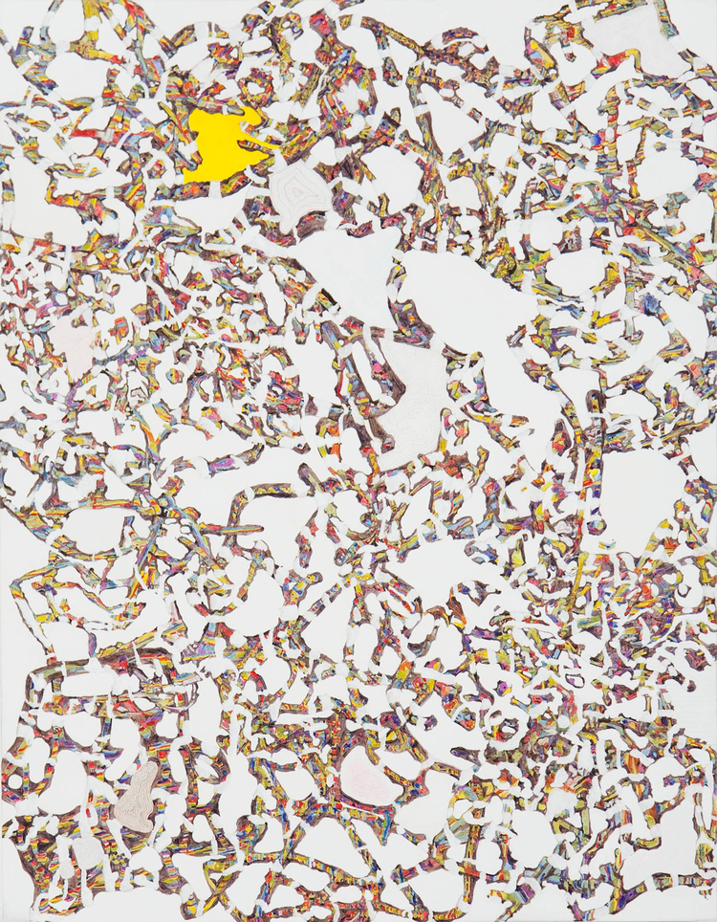
Figure 1: Donal Moloney (2010) Web [Acrylic and graphite on board]. 53 x 68cm.

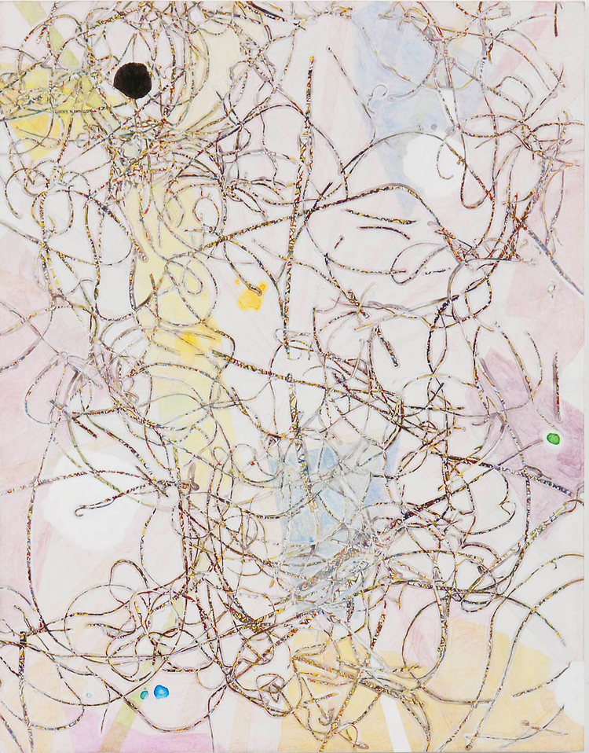
Figure 2: Donal Moloney (2010) Scribbling [Acrylic, graphite and ink on board]. 40 x 50.5cm.

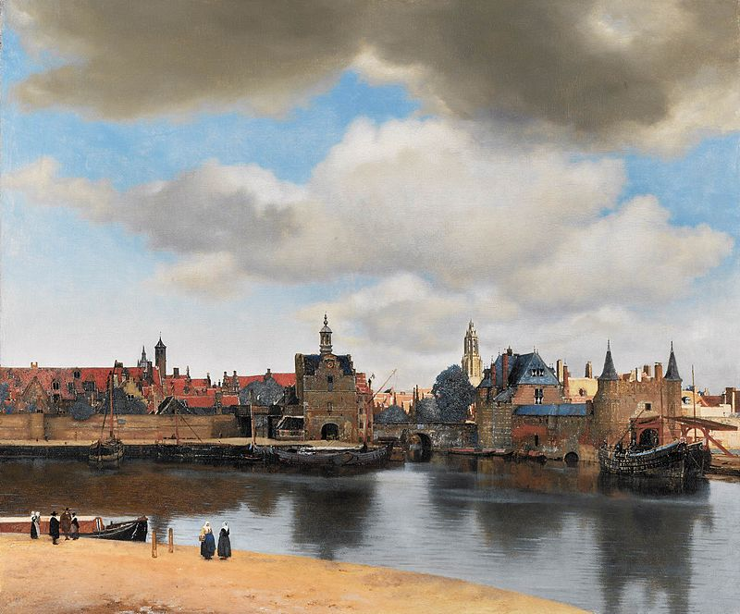
Figure 3: Johannes Vermeer (1660-61) View of Delft [Oil on Canvas] 98.5 x 117.5cm. The Hague: Mauritshuis.

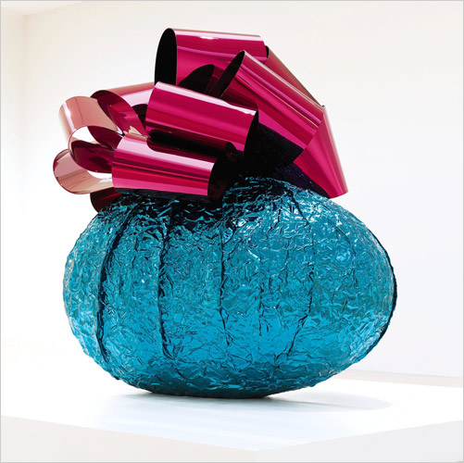
Figure 4: Jeff Koons (1994-2008) Baroque Egg with Bow (Turquoise/Magenta) [Mirror-polished stainless steel with transparent colour coating] 212.1 x 196.9 x 152.4cm. Private Collection.

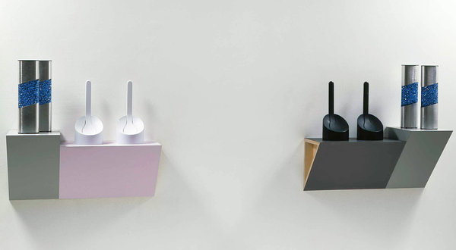
Figure 5: Haim Steinbach (1986) Security and Serenity #2 [Plastic laminated wood shelves, four blue glitter lights, two white Makio Hasuike toilet brushes and two black Makio Hasuike toilet brushes] Left: 76.2 x 78.7 x 33cm; Right: 76.2 x 78.7 x 33cm. Yale University

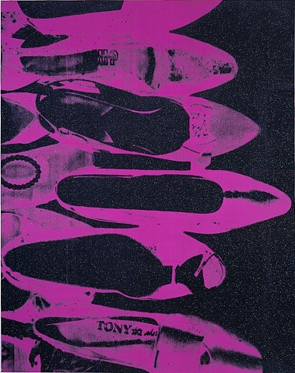
Figure 6: Andy Worhol (1980-81) Diamond Dust Shoes [Synthetic Polymer paint, silkscreen ink and diamond dust on canvas] 228.6 x 177.8cm. Gagosian Gallery

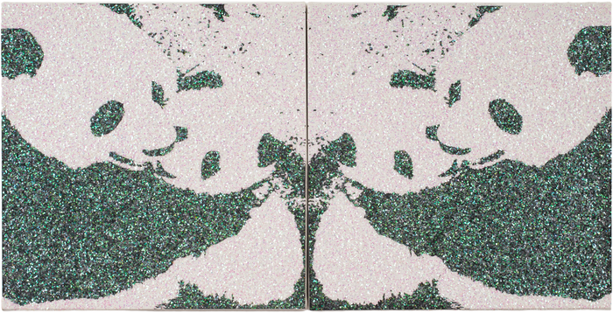
Figure 7: Robert Pruitt (2007) Untitled [Enamel paint and glitter on canvas] 25.4 x 25.4cm (Diptych). Rafel de Cardenas Auction.

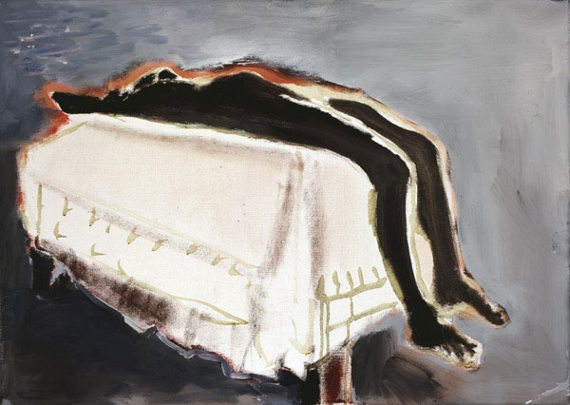
Figure 8: Marlene Dumas (1988) Waiting (For Meaning) [Oil on canvas] 50 x 70cm. Museen Schleswig-Holstein and Hamburg.

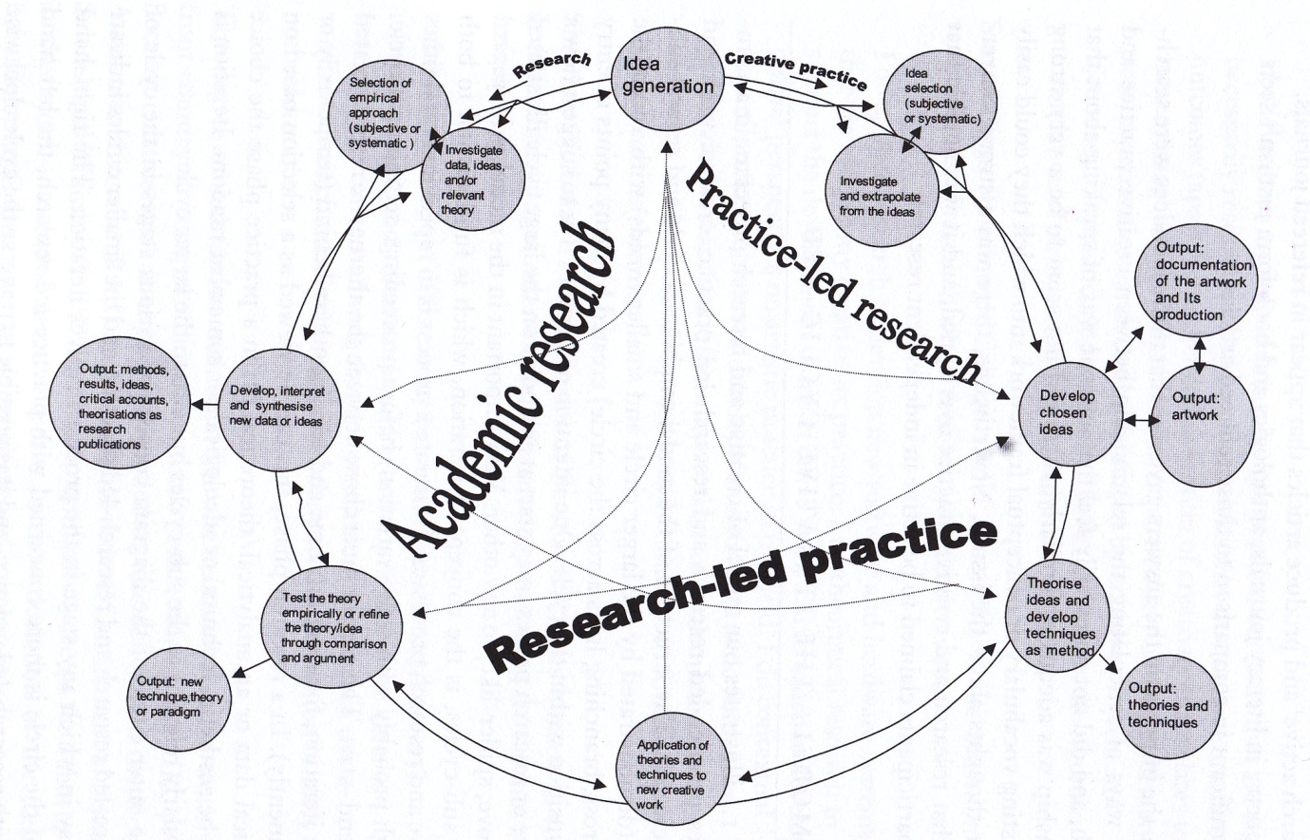
Figure 9: Hazel Smith & Roger T. Dean (2009) A model of creative arts and research processes: the iterative cyclic web of practice-led research and research-led practice, in Dean, R.T. & Smith, H. (2009) ‘Introduction: Practice-led Research, Research-led Practice-Towards the Iterative Cyclic Web’, in R.T. Dean & H. Smith (eds) Practice-led Research, Research-led Practice in the Creative Arts, Edinburgh University Press, p. 19, illus.

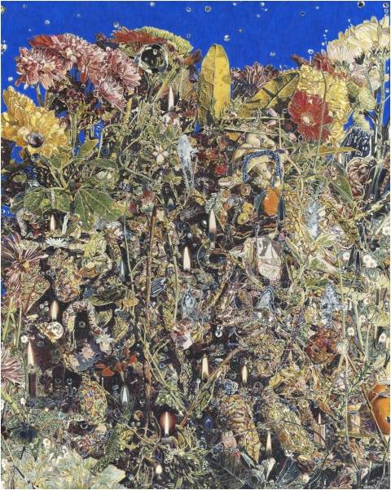
Figure 10: Donal Moloney (2013) Shrines [Acrylic on canvas on board] 42 x 52cm.

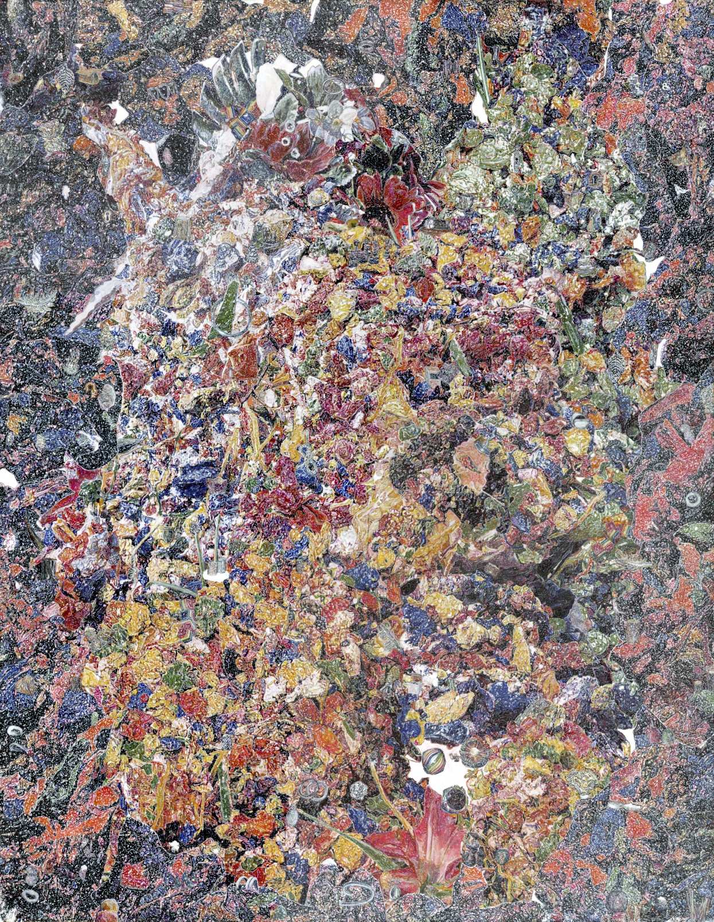
Figure 11: Donal Moloney (2014) Reliquary [Acrylic on canvas on board] 47 x 59cm.

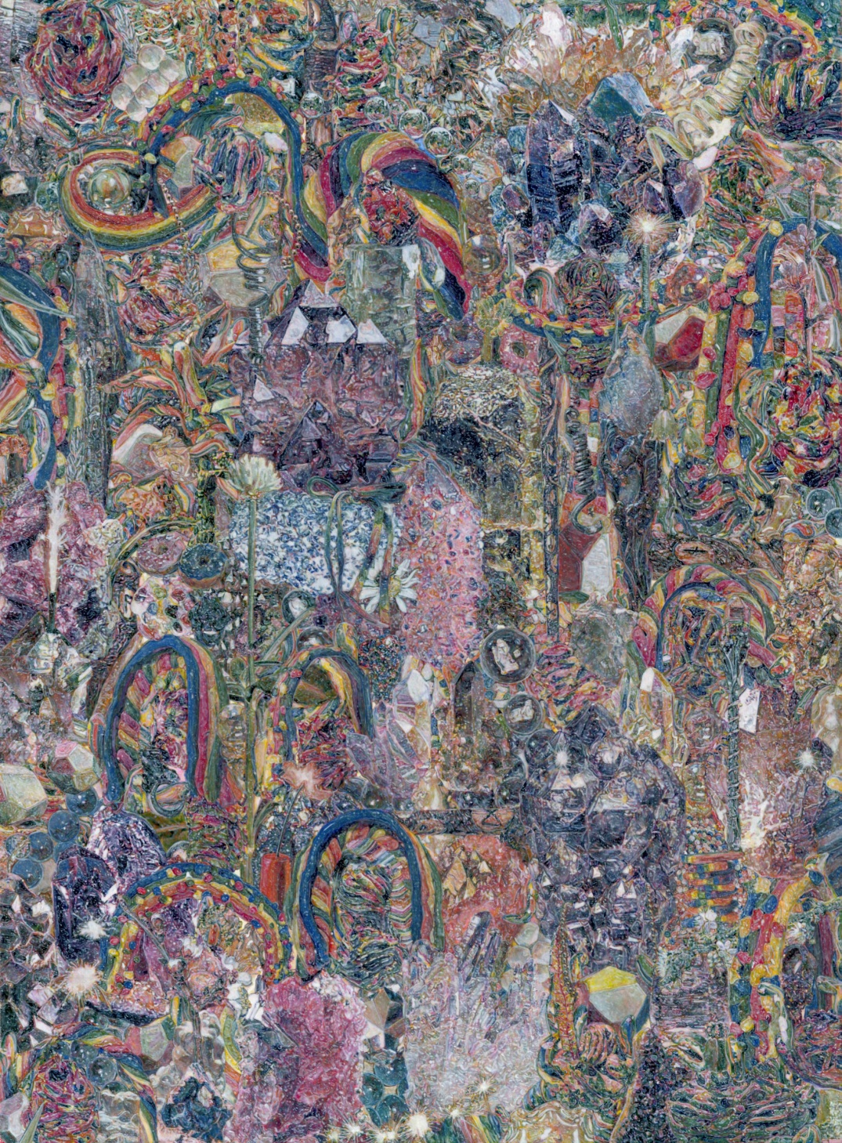
Figure 12: Donal Moloney (2015) Cave Floor [Acrylic on canvas on board] 32 x 43.5cm.

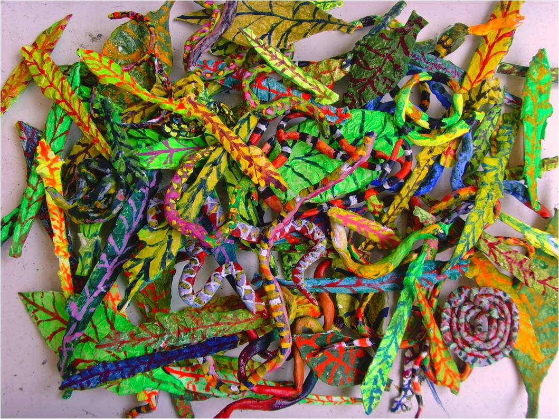
Figure 13: Donal Moloney (2013) Maquettes for painting [Photograph] 21 x 26cm.

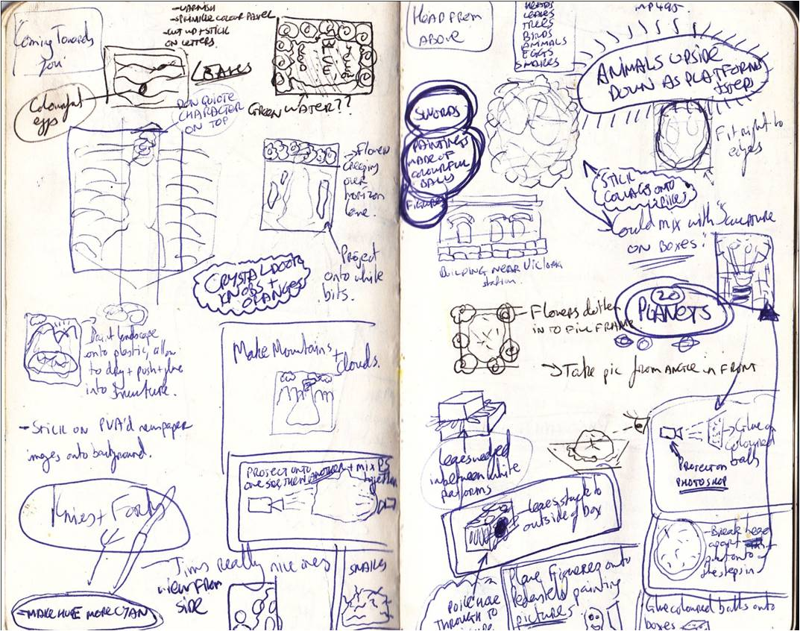
Figure 14: Donal Moloney (2013) Sketchpad page [Ink on paper] 14 x 18cm.

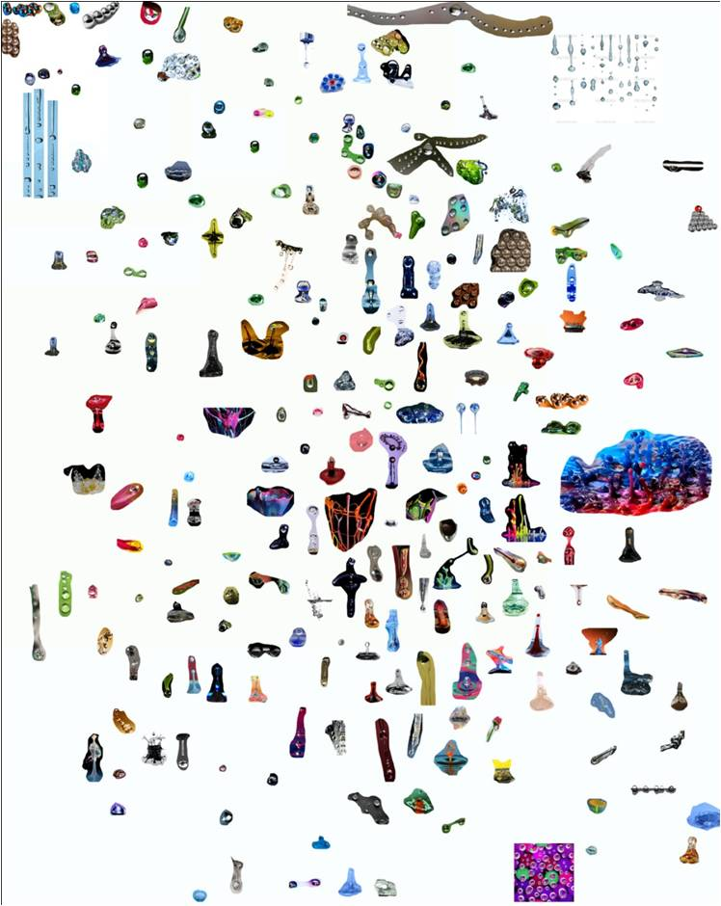
Figure 15: Donal Moloney (2013) Collection of images from the Internet [Photograph] 17 x 21cm.

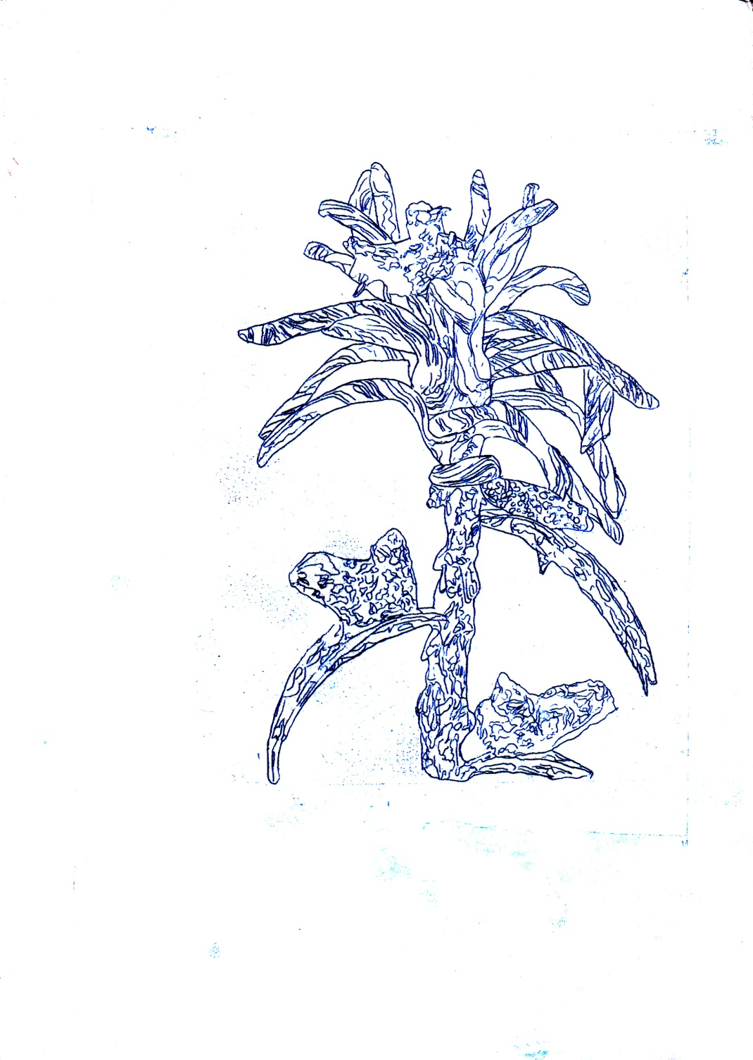
Figure 16: Donal Moloney (2015) Floret graphite outline [Graphite on canvas on board] 15 x 21cm.

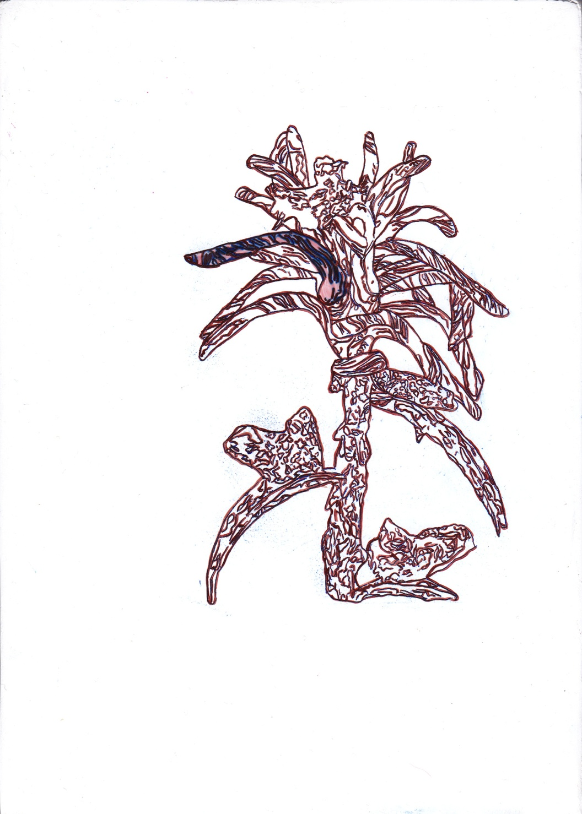
Figure 17: Donal Moloney (2015) Floret brown outline [Acrylic and Graphite on canvas on board] 15 x 21cm.

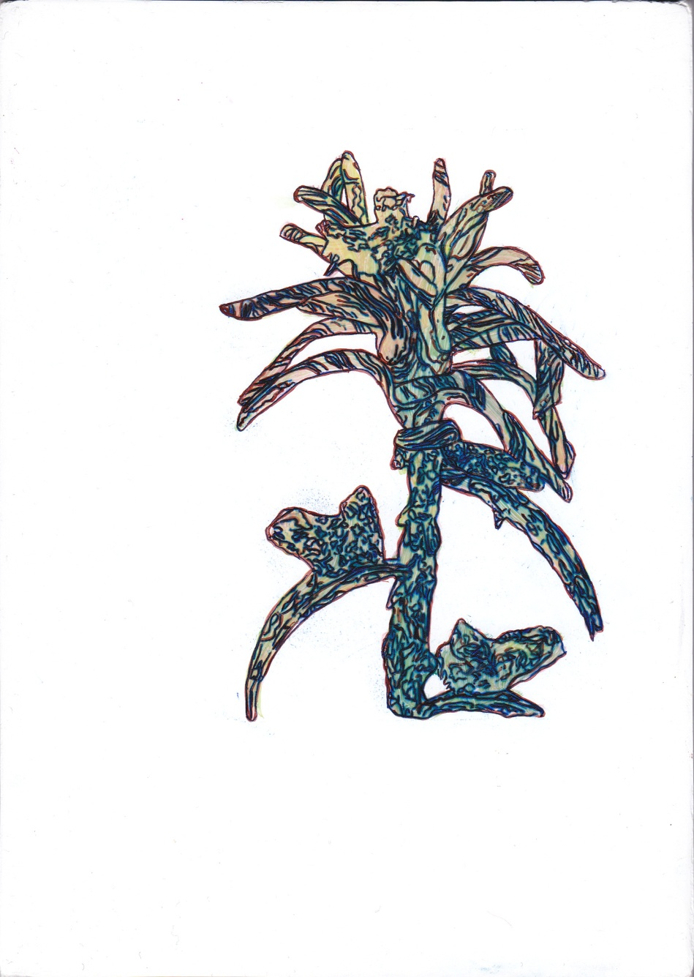
Figure 18: Donal Moloney (2015) Floret green and red glaze [Acrylic and Graphite on canvas on board] 15 x 21cm.

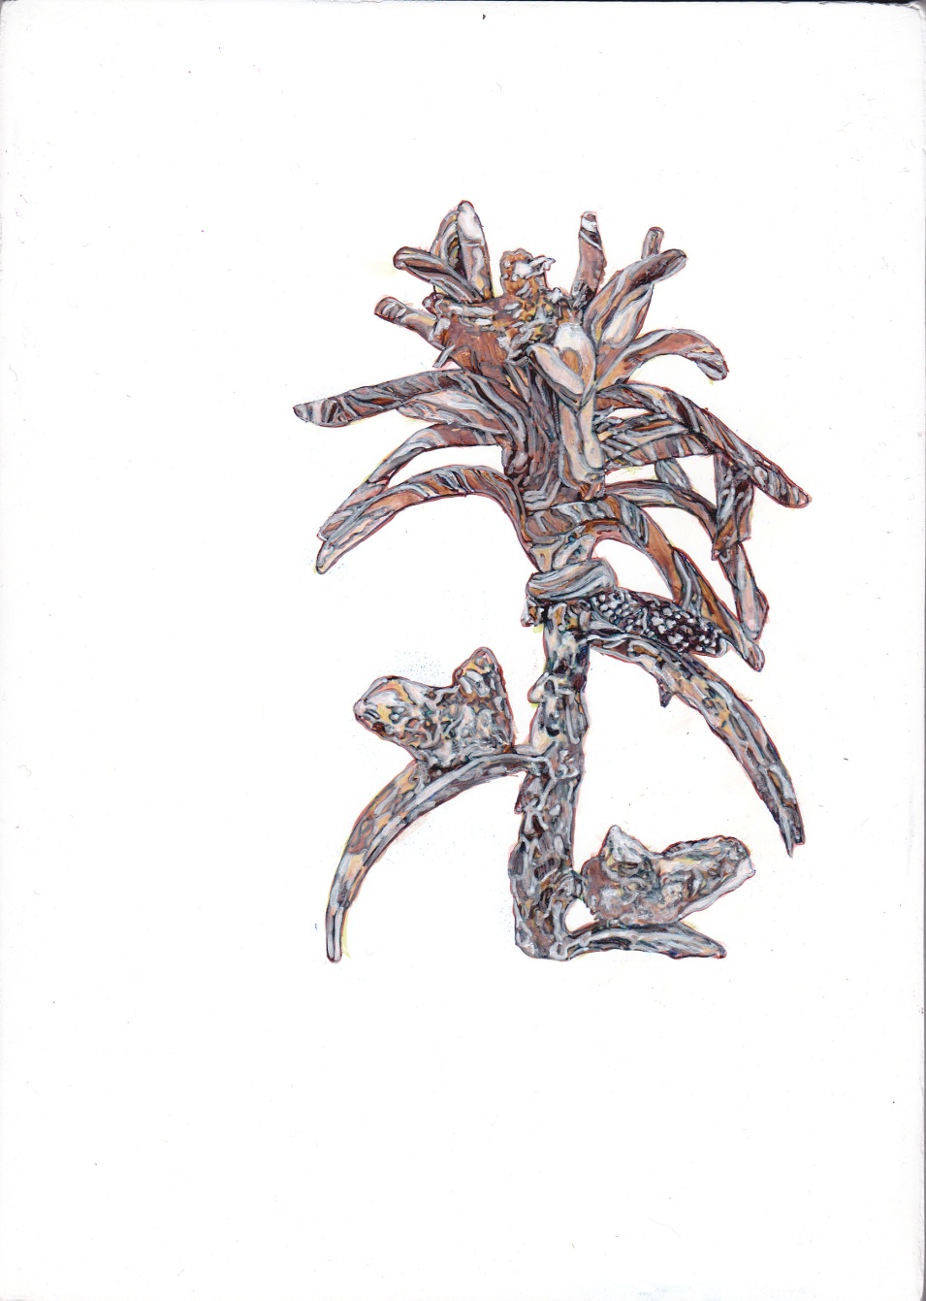
Figure 19: Donal Moloney (2015) Floret monochrome underpainting [Acrylic and Graphite on canvas on board] 15 x 21cm.

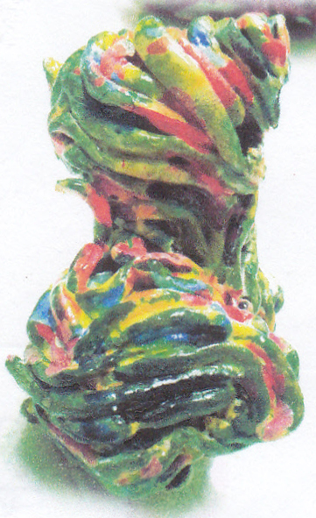
Figure 20: Donal Moloney (2015) Source image for Cave Floor [Inkjet on paper] 3 x 5cm.

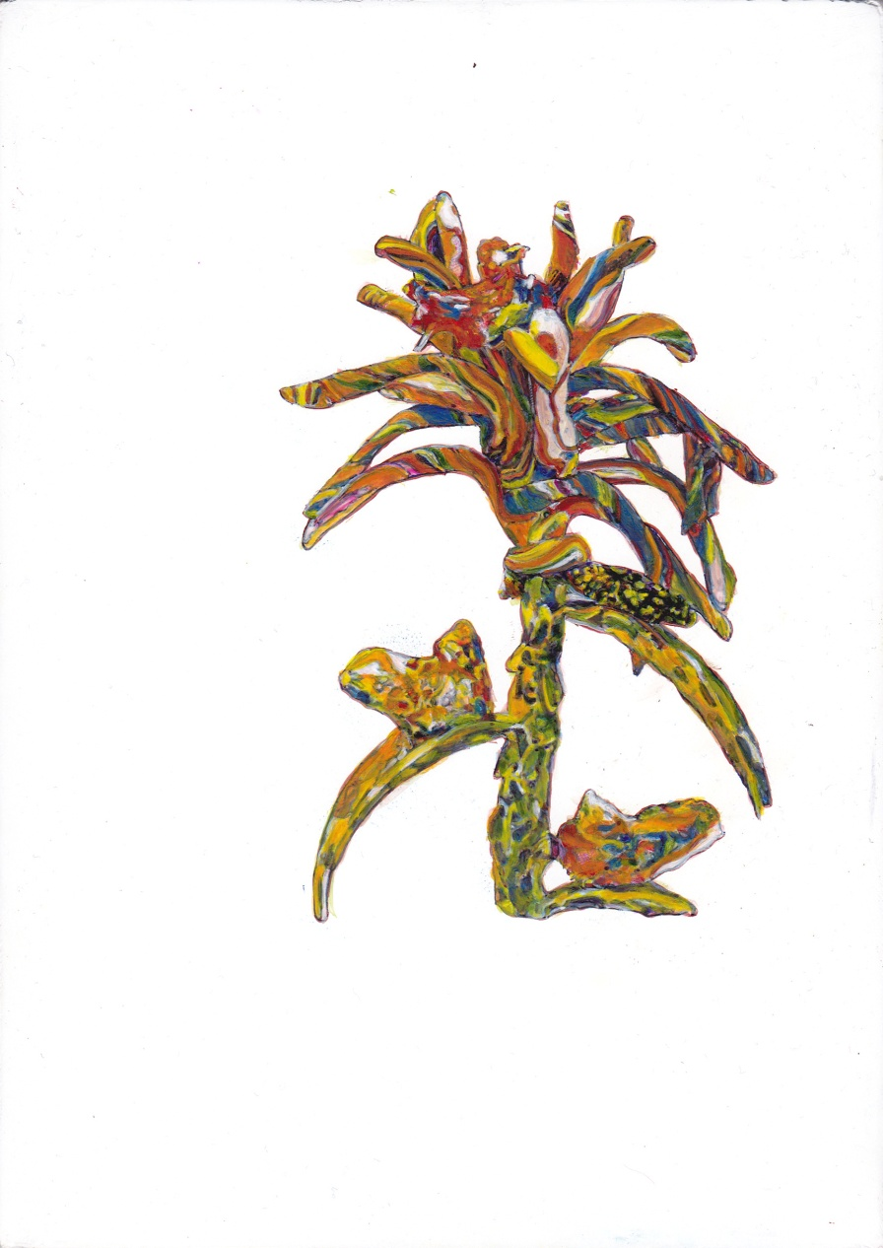
Figure 21: Donal Moloney (2015) Floret colour glazes [Acrylic and Graphite on canvas on board] 15 x 21cm.

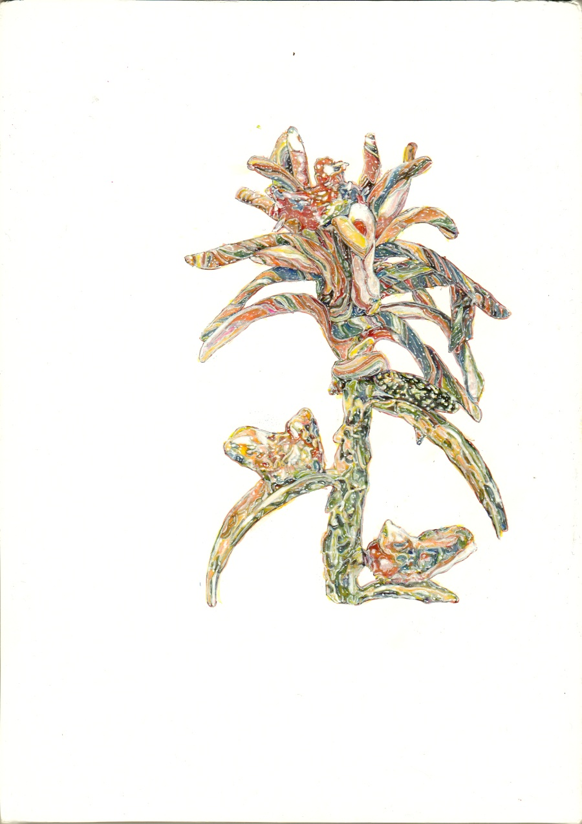
Figure 22: Donal Moloney (2015) Floret (finished) [Acrylic and Graphite on canvas on board] 15 x 21cm.

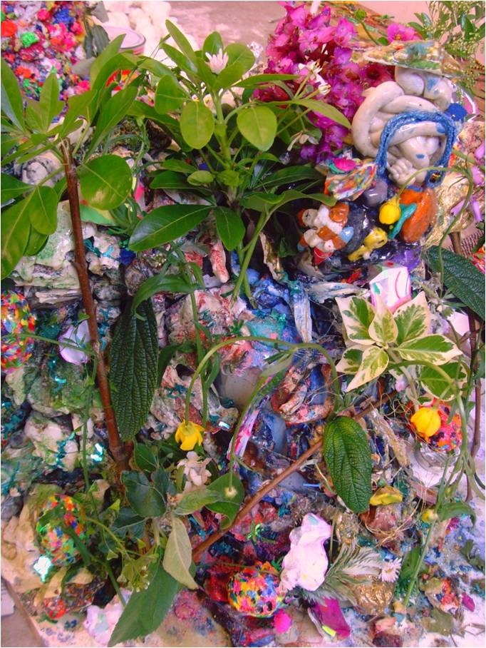
Figure 23: Donal Moloney (2013) Maquette for Shrines (Detail) [Photograph] 13 x 18cm.

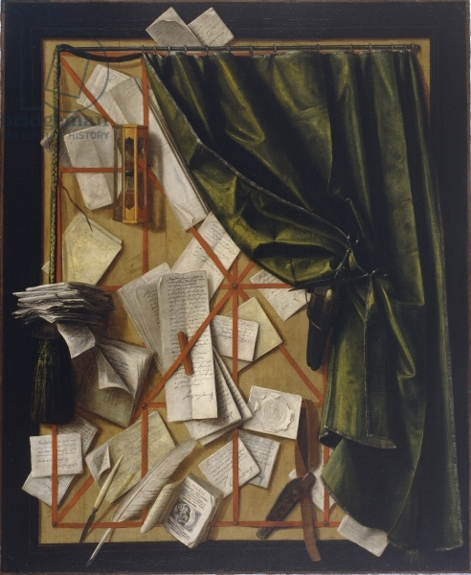
Figure 24: Cornelis Norbertus Gijsbrechts. (c. 1664) Trompe l’oeil Letter Rack with an Hourglass, Razor and Scissors [Oil on canvas] 101.9 x 83.4cm. Belgium: Museum voor Schone Kunsten, Ghent.

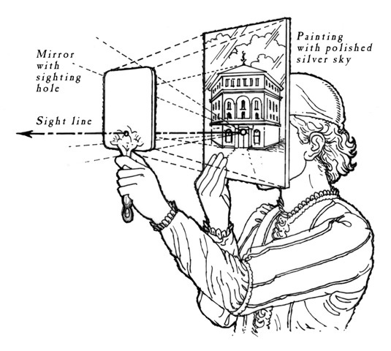
Figure 25: Romero, P. (2015) ‘Brunelleschi’s mirror experiment (image)’, http://leonardosapprentice.com/, 3/10/2013, Available at http://leonardosapprentice.com/2013/10/03/point-of-perspective/, [Accessed 24th June 2015].

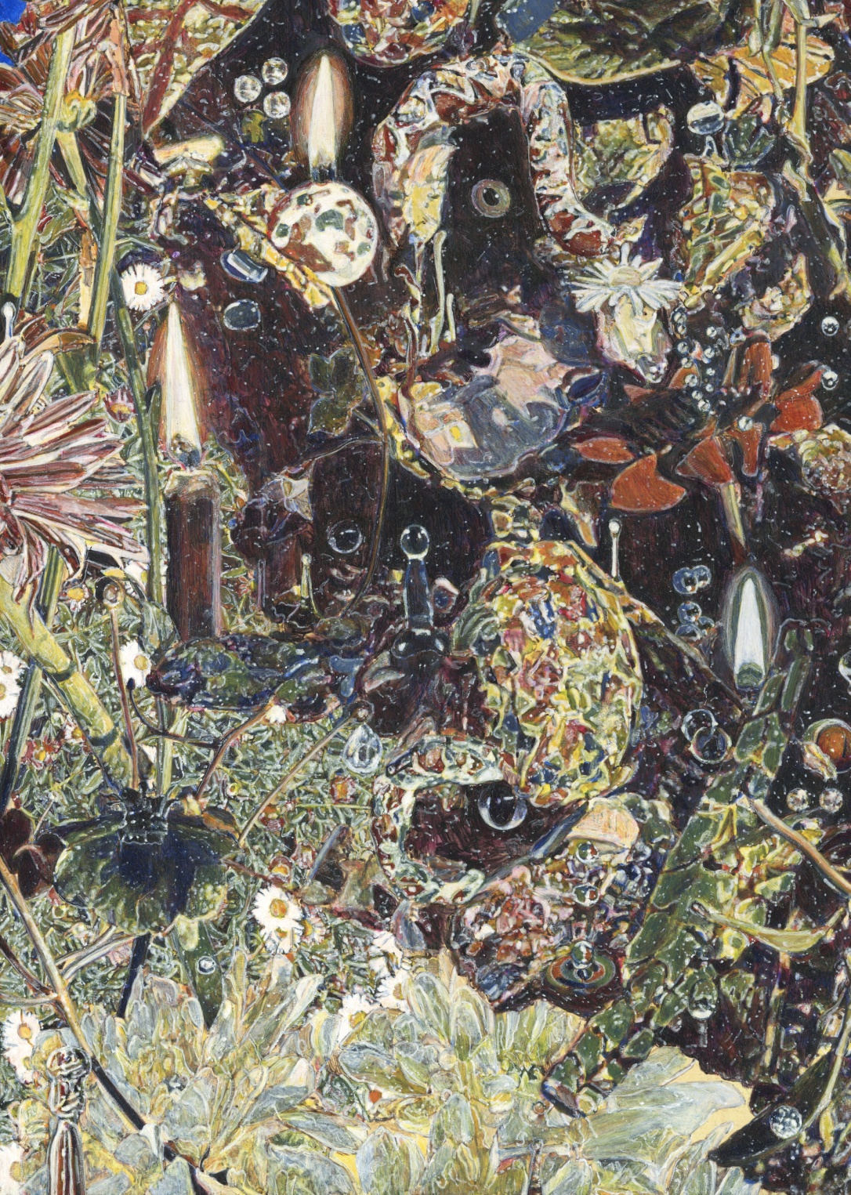
Figure 26: Donal Moloney (2013) Shrines (Detail) [Acrylic on canvas on board] 42 x 52cm.

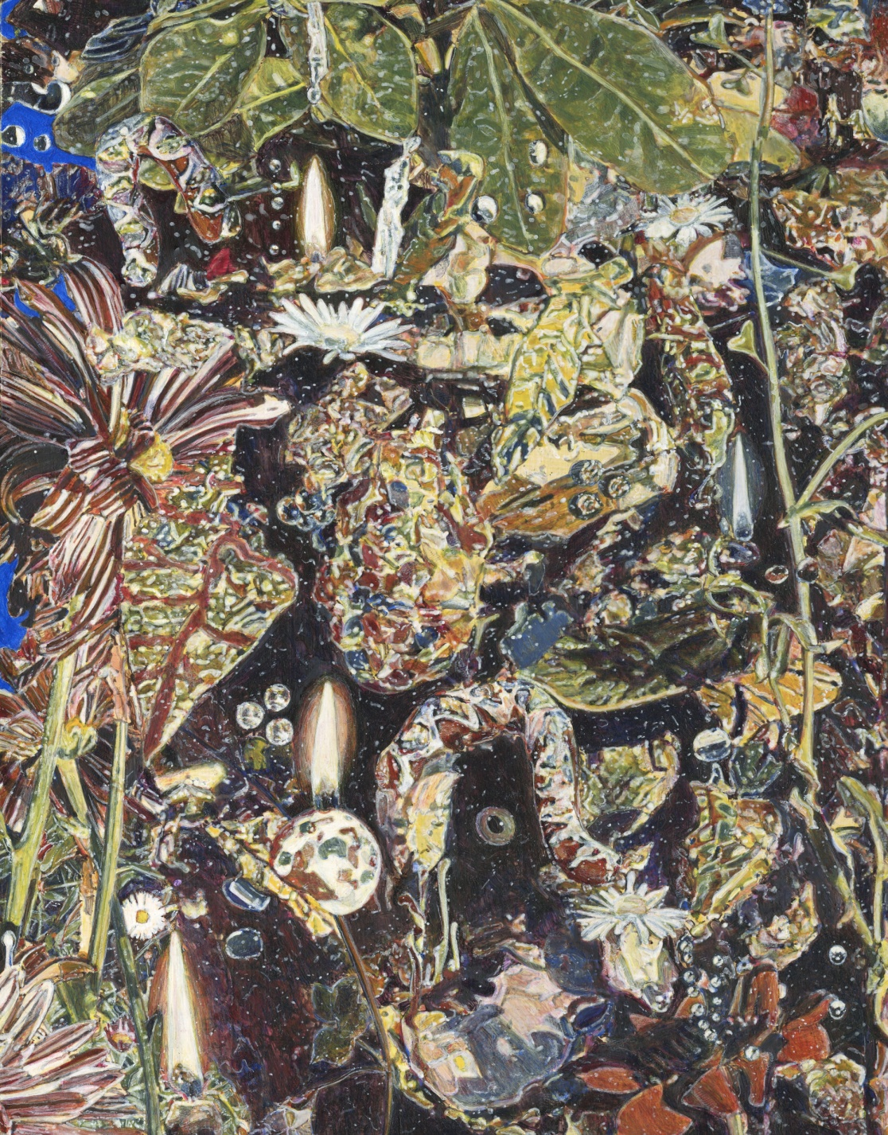
Figure 27: Donal Moloney (2013) Shrines (Detail 2) [Acrylic on canvas on board] 42 x 52cm.

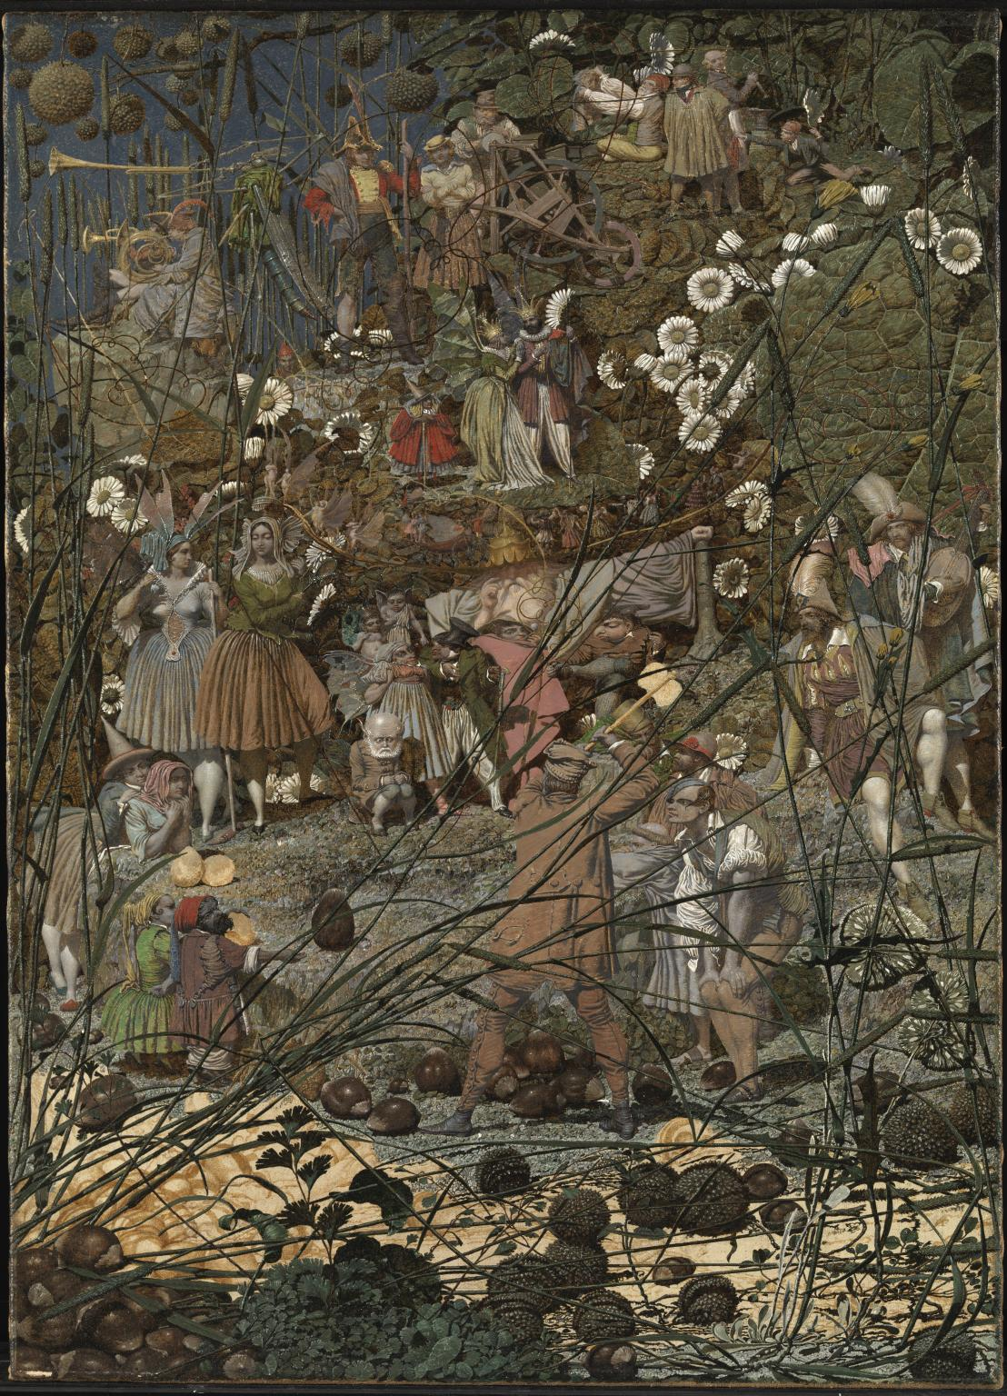
Figure 28: Richard Dadd (1855-64) The Fairy Feller’s Master-Stroke [Oil on canvas] 54 x 39.4cm. London: Tate Britain.

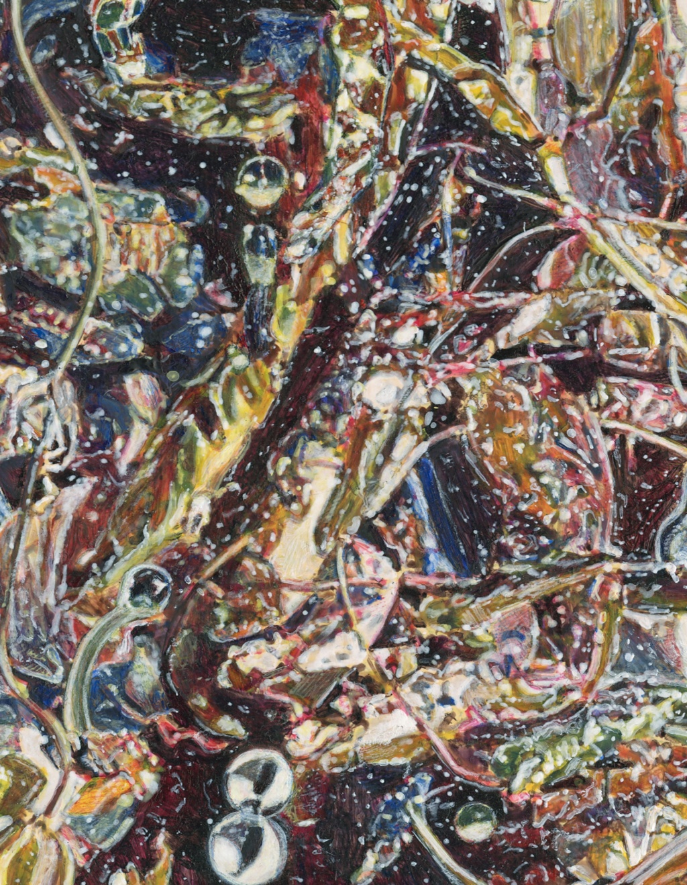
Figure 29: Donal Moloney (2013) Shrines (Detail 3) [Acrylic on canvas on board] 42 x 52cm.

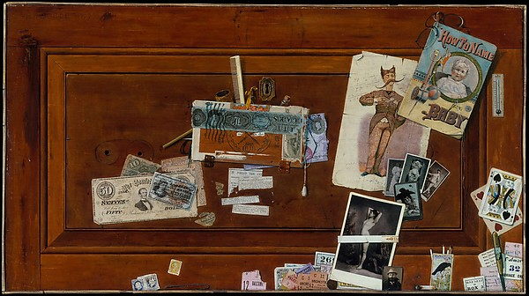
Figure 30: John Haberle (1890-94) A Bachelor’s Drawer [Oil on canvas] 50.8 x 91.4cm. New York: The Metropolitan Museum of Art.

.

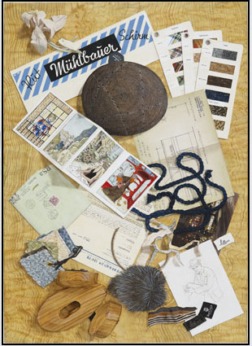
Figure 31: Lucy McKenzie (2010) Quodlibet X [Oil on canvas, metal, glass] 80 x 91.5 x 65.5cm. Köln: Galerie Buchholz.

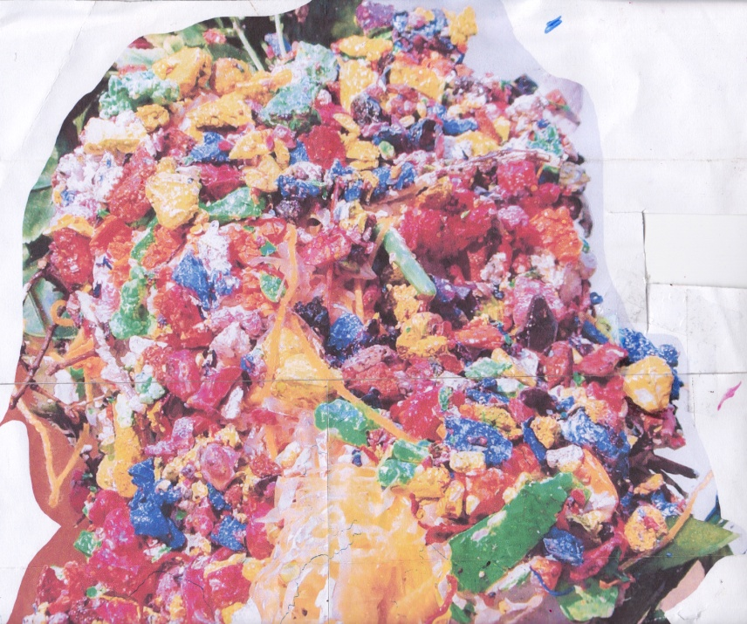
Figure 32: Donal Moloney (2013) Mountain form 1 (Detail) [Inkjet on paper] 26 x 27cm.

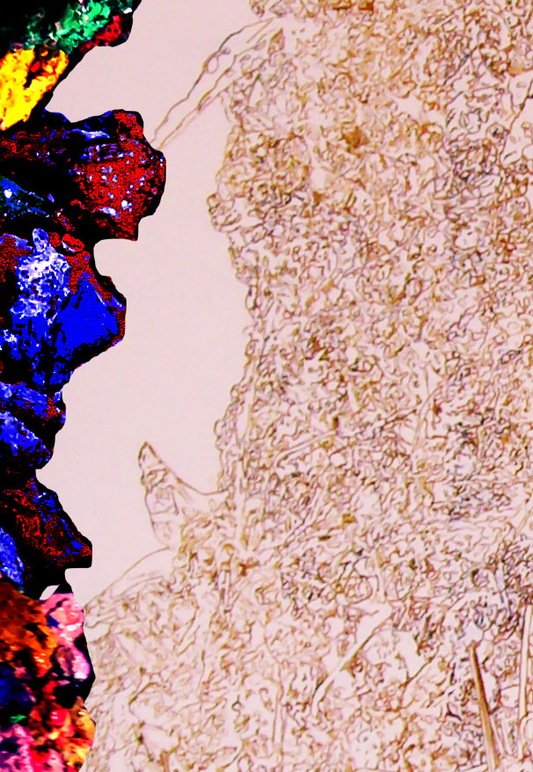
Figure 33: Donal Moloney (2013) Dark cave wall study [Inkjet on paper] 3 x 14cm.

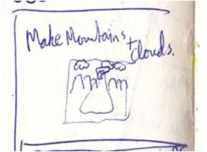
Figure 34: Donal Moloney (2013) Sketch book page (Detail) [Ink on paper] 14 x 18cm.

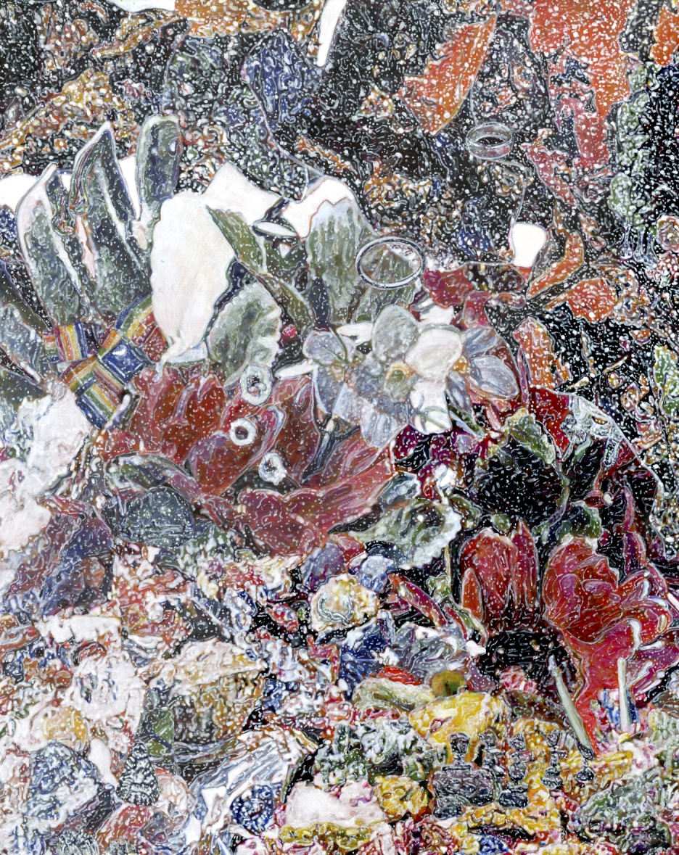
Figure 35: Donal Moloney (2014) Reliquary (Detail 1) [Acrylic on canvas on board] 47 x 59cm.

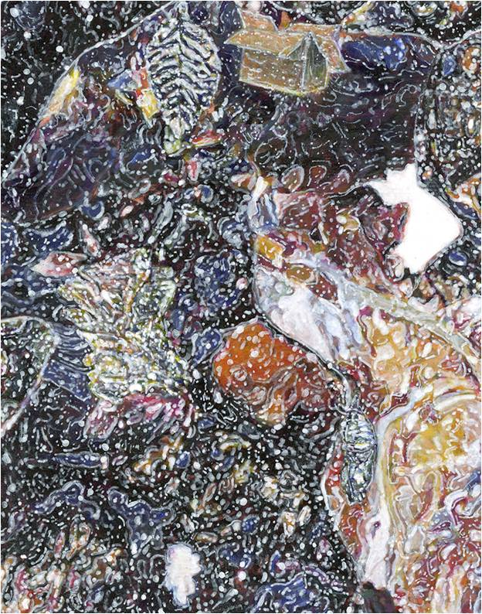
Figure 36: Donal Moloney (2014) Reliquary (Detail 2) [Acrylic on canvas on board] 47 x 59cm.

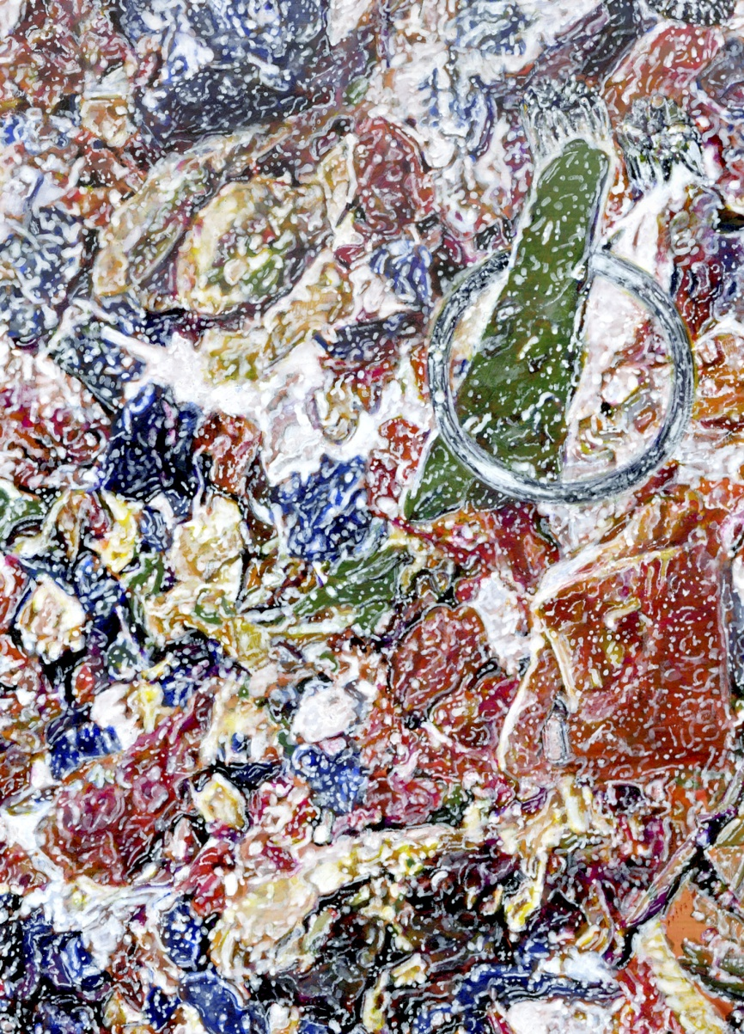
Figure 37: Donal Moloney (2014) Reliquary (Detail 3) [Acrylic on canvas on board] 47 x 59cm.

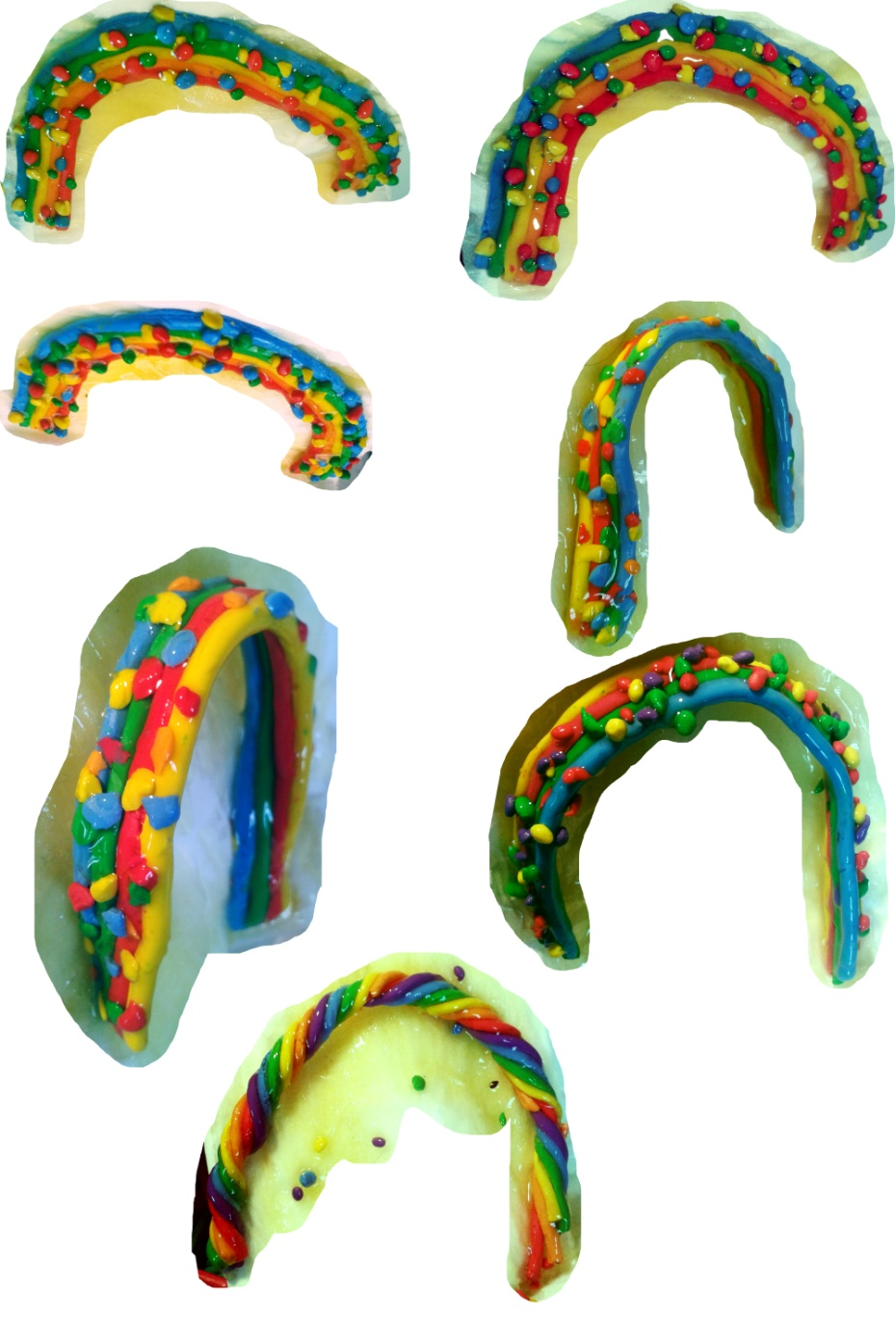
Figure 38: Donal Moloney (2014) Rainbow Arcs [Varnished plasticine] 12 x 19cm.

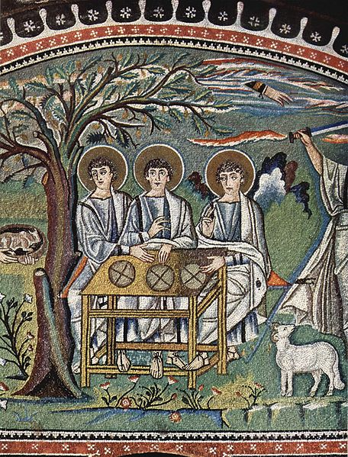
Figure 39: Meister von San Vitale in Ravenna (c. 547) The Abraham mosaic [Mosaic] 8 meters diameter approx. Italy: San Vitale in Ravenna.

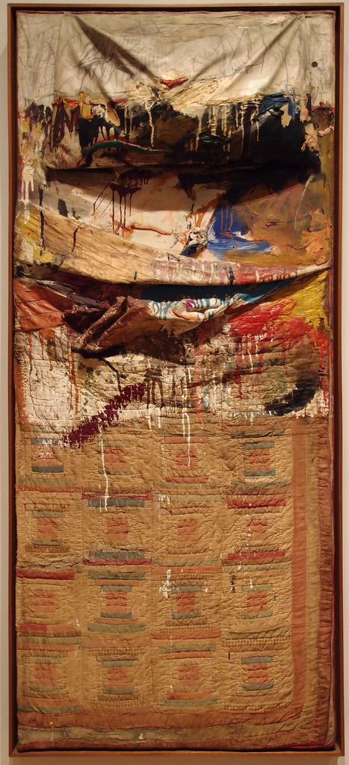
Figure 40: Robert Rauschenberg (1955) Bed [Oil and pencil on pillow, quilt, and sheet on wood supports] 191.1 x 80 x 20.3cm. New York: Museum of Modern Art.

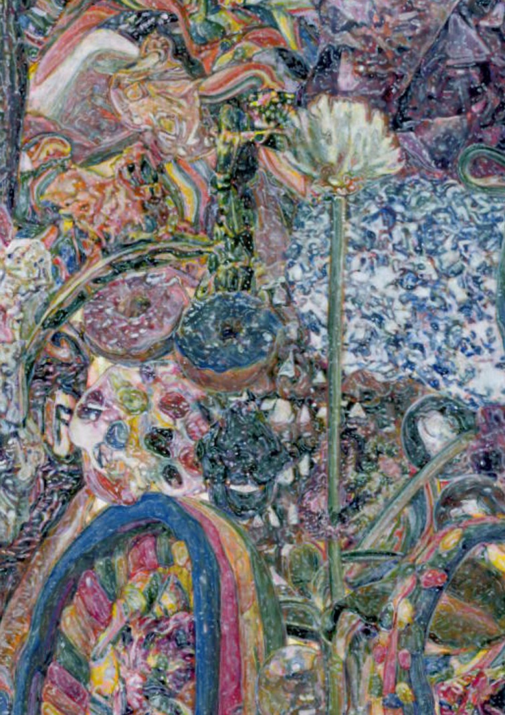
Figure 41: Donal Moloney (2015) Cave Floor (Detail) [Acrylic on canvas on board] 32 x 43.5cm.

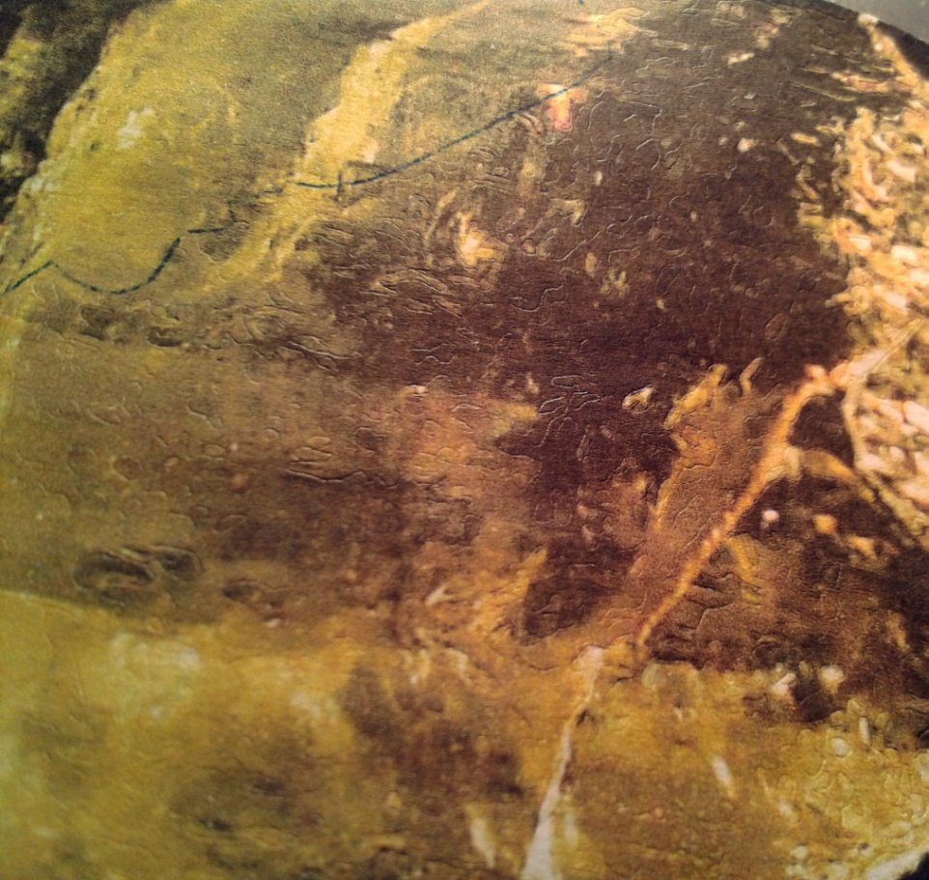
Figure 42: Donal Moloney (2015) Debossed inkjet (detail) [Inkjet on paper] 6 x 7cm.

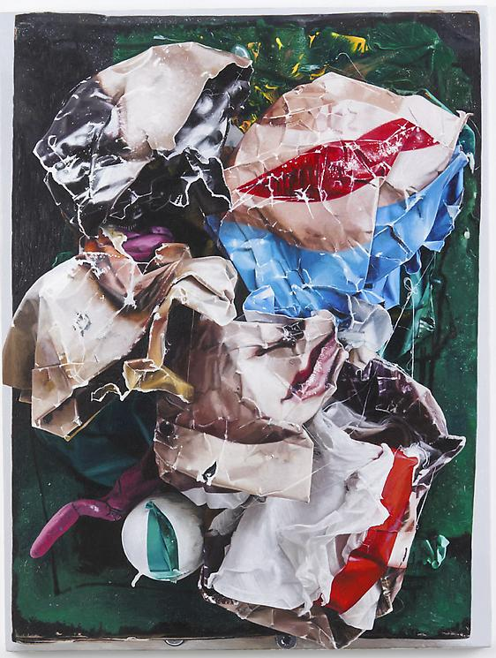
Figure 43: Neil Gall (2013) Seen and Not Seen [Oil on gesso panel] 65.4 x 49.5cm. New York: David Nolan Gallery.

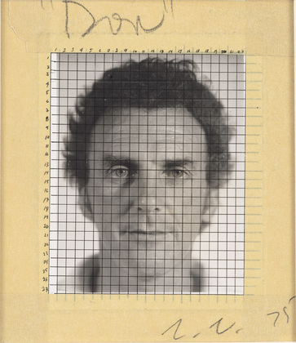
Figure 44: Chuck Close (1975) Don (Maquette) [Ink, pencil and masking tape on gelatine silver print on paperboard] 16.5 x 14cm. New York: Museum of Modern Art.

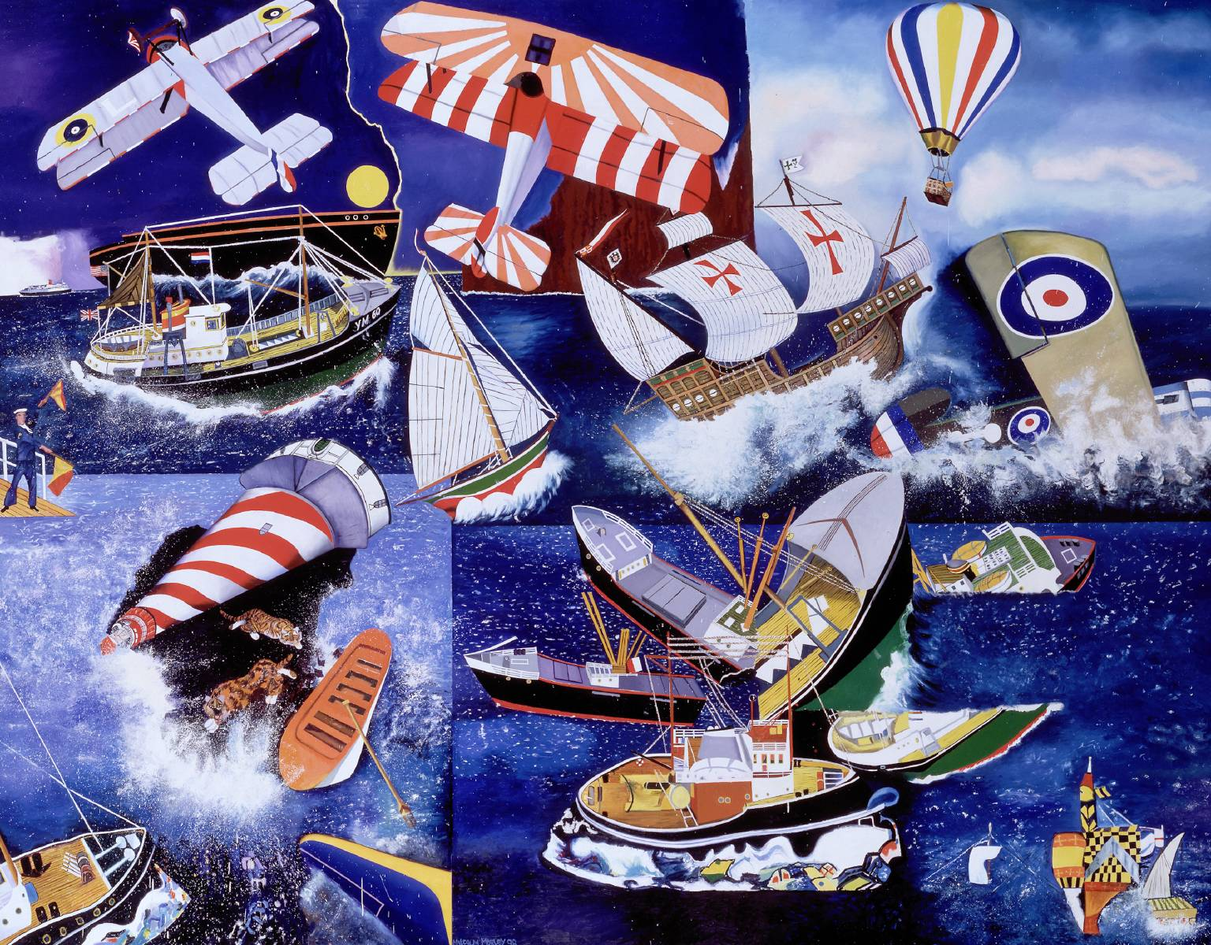
Figure 45: Malcolm Morley (1998) Mariner [Oil on Canvas] 295 x 374.8cm. London: Tate Gallery.

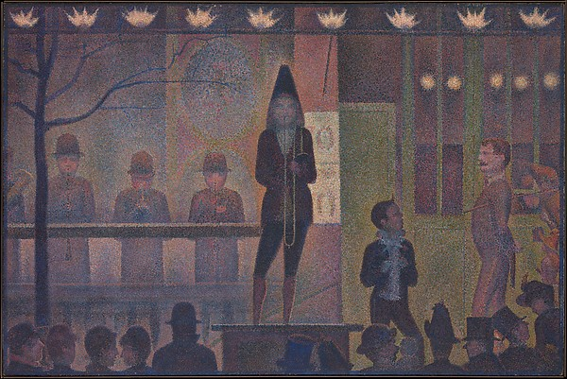
Figure 46: Georges Seurat (1887-88) Circus Slideshow [Oil on Canvas] 99.7 x 149.9cm. New York: The Metropolitan Museum of Art.

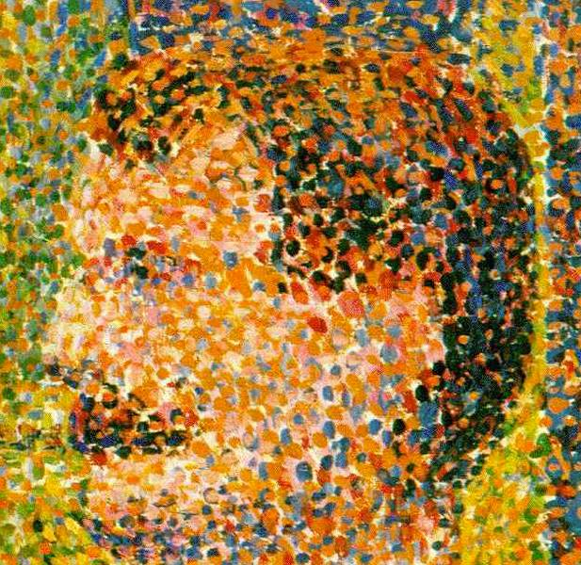
Figure 47: Georges Seurat (1887-88) Circus Slideshow (Detail) [Oil on Canvas] 99.7 x 149.9cm. New York: The Metropolitan Museum of Art.

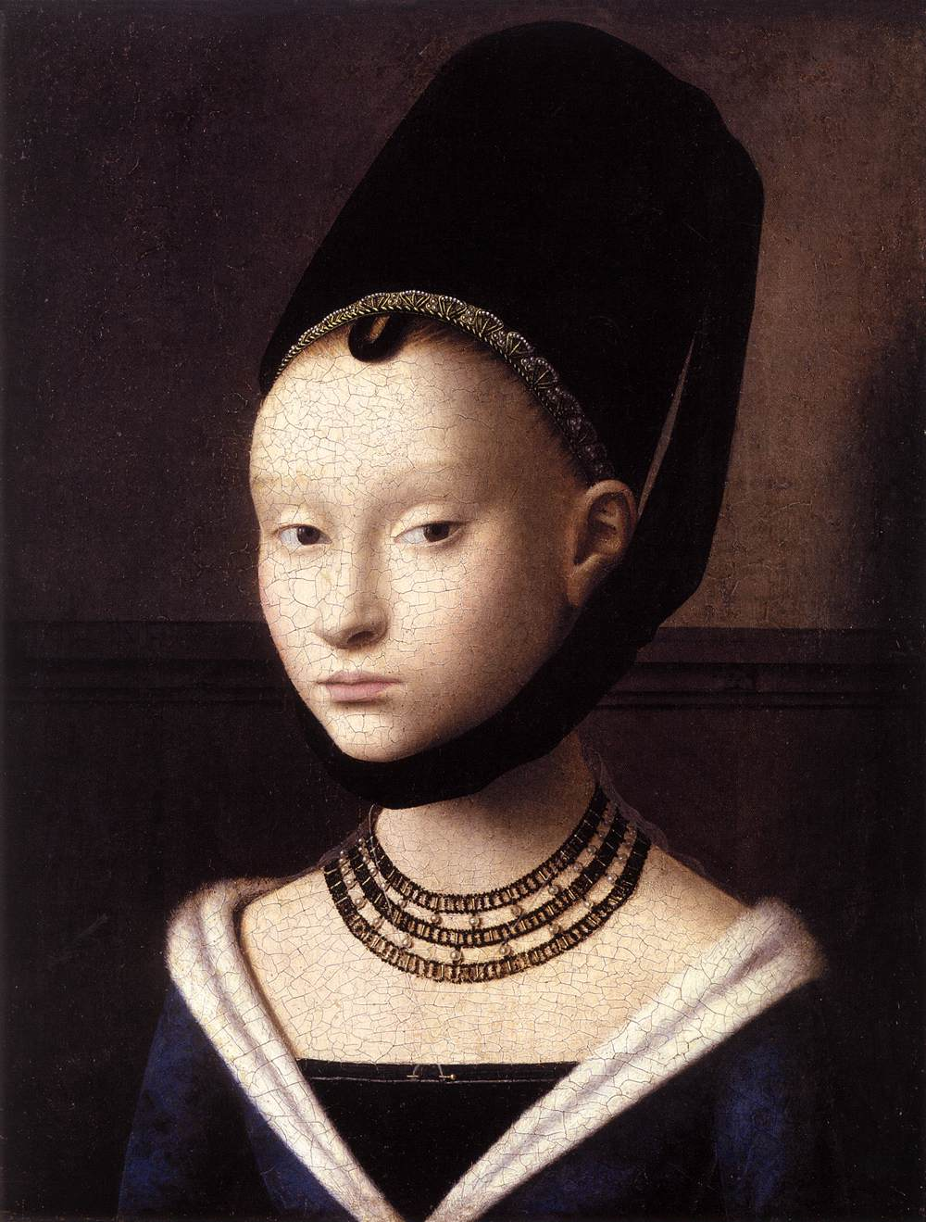
Figure 48: Petrus Christus (1470) The Portrait of a Young Woman [Oil on Oak] 29 x 23cm. Berlin: Gemäldegalerie, Staatliche Museen zu Berlin.

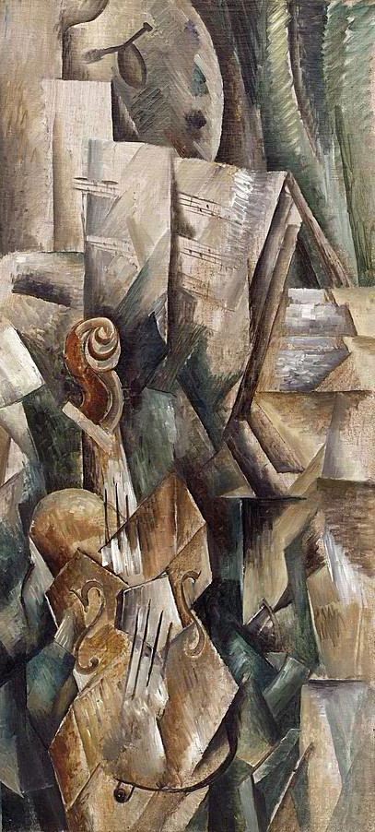
Figure 49: Georges Braque (1909) Violin and Palette [Oil on Canvas] 91.7 x 42.8cm. New York: Solomon R Guggenheim Museum.

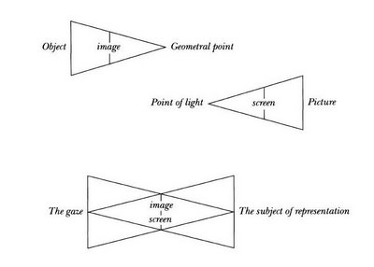
Figure 50: Reid, A. (2011) ‘Jacques Lacan’s diagram of the gaze, http://thedigitalage.pbworks.com/w/page/22038979/FrontPage, 24/04/2011, Available at < http://thedigitalage.pbworks.com/w/page/22039143/Reassembling%20Flatland>, [Accessed 24th June 2015].

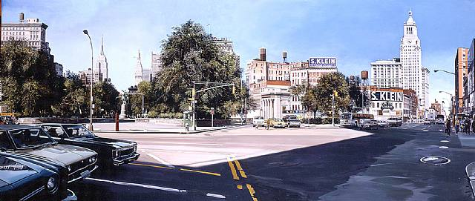
Figure 51: Richard Estes (1985) Union Square [Oil on canvas] 96.22 x 226.11cm. New York: Marlborough Gallery.

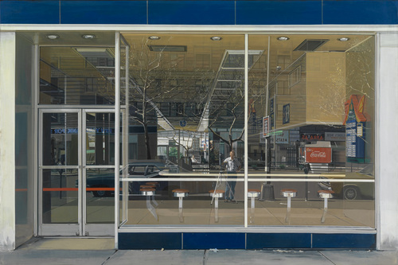
Figure 52: Richard Estes (1976) Double Self-Portrait [Oil on canvas] 60.8 x 91.5cm. New York: Museum of Modern Art.

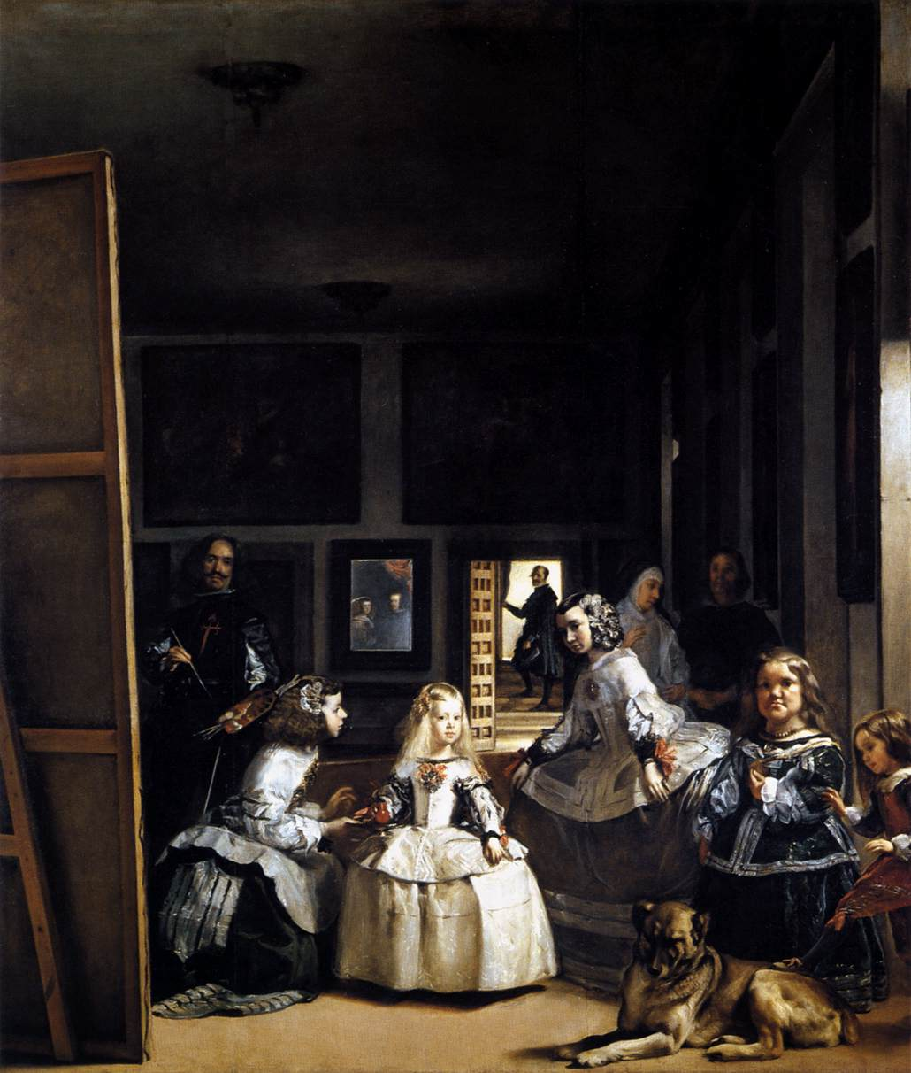
Figure 53: Diego Velázquez (1656-57) Las Meninas [Oil on canvas] 318 x 276cm. Madrid: Museo del Prado.

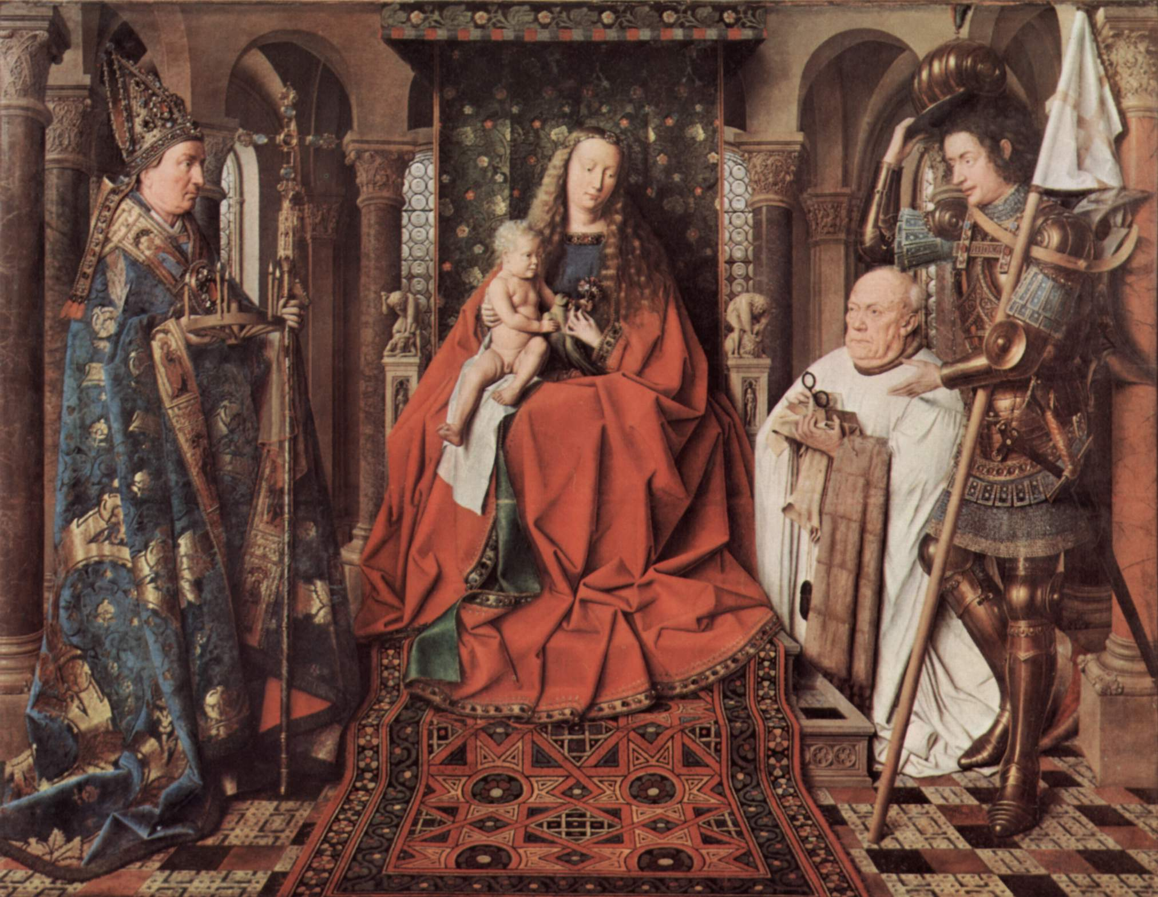
Figure 54: Jan van Eyck (1436) Virgin and Child with Canon Joris van der Paele [Oil on oak panel] 141 x 176.5cm. Bruges: Groeninge Museum.

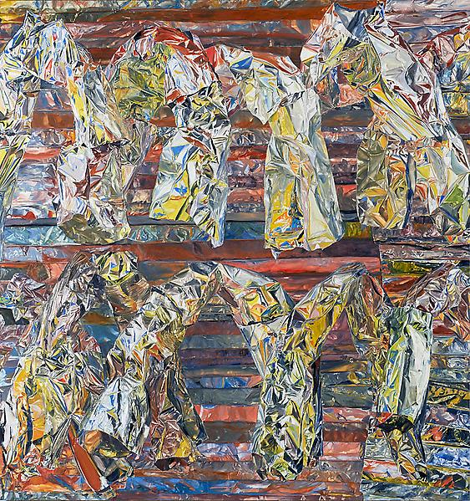
Figure 55: William Daniels (2013) Untitled [Oil on board] 110 x 104cm. New York: Luhring Augustine Gallery.

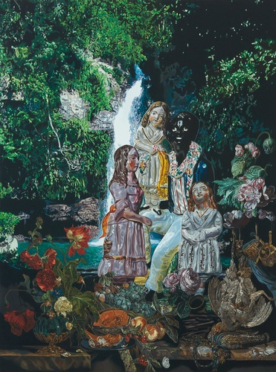
Figure 56: Matthew Weir (2010) Cogwheels [Oil on canvas mounted on board] 55 x 41cm. London: Alison Jacques Gallery.

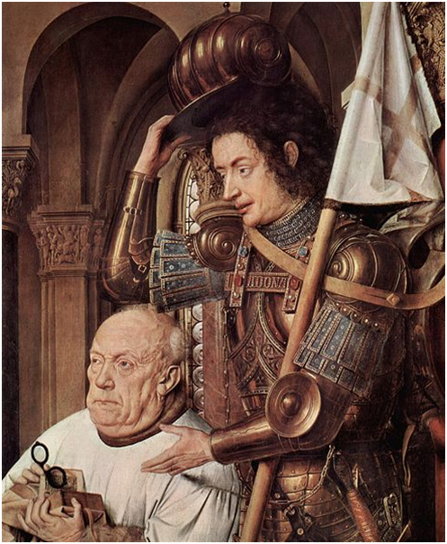
Figure 57: Jan van Eyck (1436) (Detail), Virgin and Child with Canon Joris van der Paele [Oil on oak panel] 141 x 176.5cm. Bruges: Groeninge Museum.

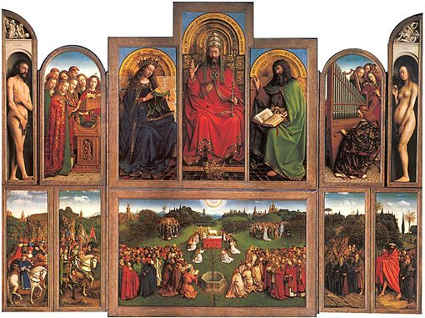
Figure 58: Jan and Hubert van Eyck (1432) Ghent Altarpiece [Oil on panel] 350 x 460 cm. Ghent: Saint Bavo Cathedral.

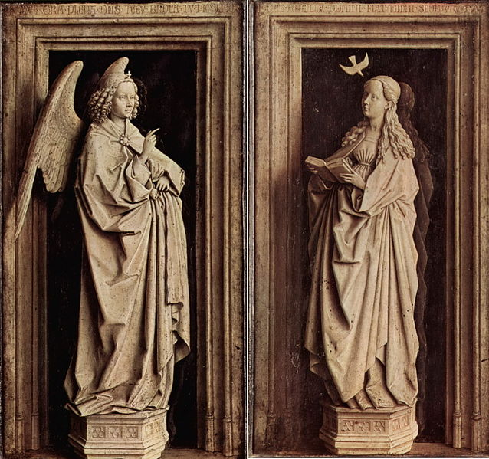
Figure 59: Jan van Eyck (1435-1440) The Annunciation Diptych [Oil on panel] 39 x 23cm each (Diptych). Madrid: Museo Thyssen-Bornemiszaelgium.

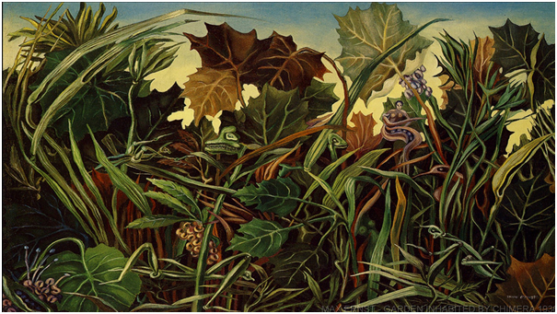
Figure 60: Max Ernst (1936) Garden Inhabited by Chimeras [Oil on canvas] 41 x 56cm. Bonn: Ambassador and Mrs. Wilhelm Haas.

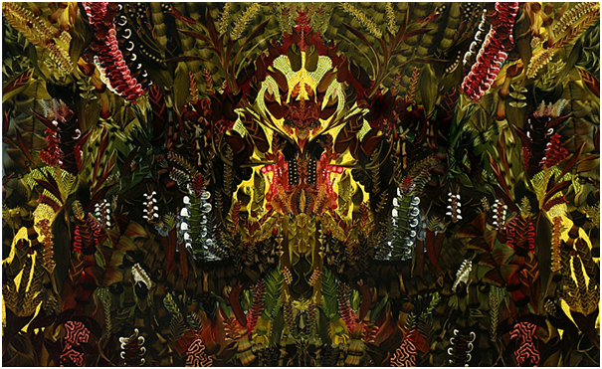
Figure 61: Andy Harper (2008) The God Particle [Oil on linen] 109.85 x 180.34cm. New York: Danese/Corey gallery.

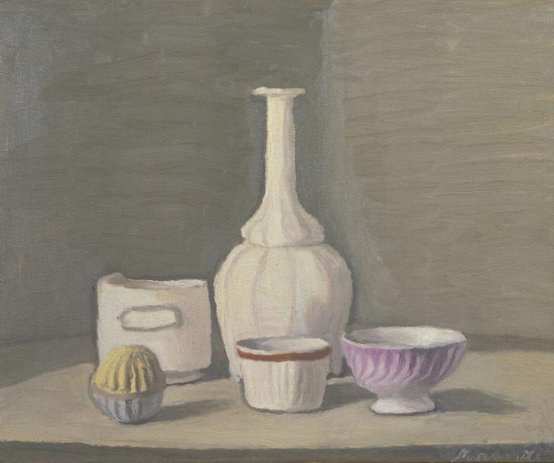
Figure 62: Giorgio Morandi (1946) Still Life [Oil on canvas] 37.5 x 45.7cm. London: Tate Britain.

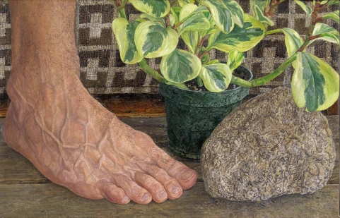
Figure 63: Ellen Altfest (2009) Rock, Foot, Plant [Oil on canvas] 36.6 x 22.9cm. London: White Cube.

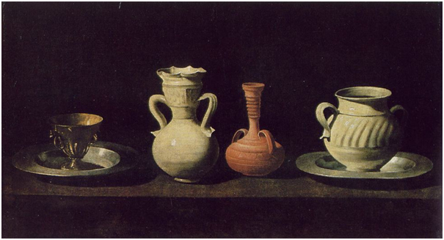
Figure 64: Francisco de Zurbaran (1660) Metalware and Pottery [Oil on canvas] 46 x 84cm. Madrid: Museo del Prado.

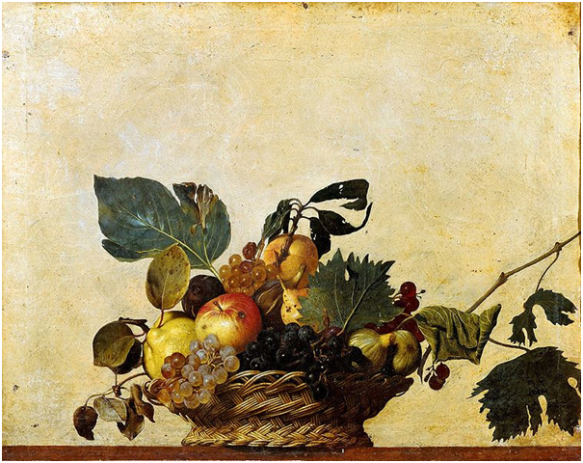
Figure 65: Michelangelo Merisi da Caravaggio (1599) Basket of Fruit [Oil on canvas] 31 x 47cm. Milan: Biblioteca Ambrosiana.

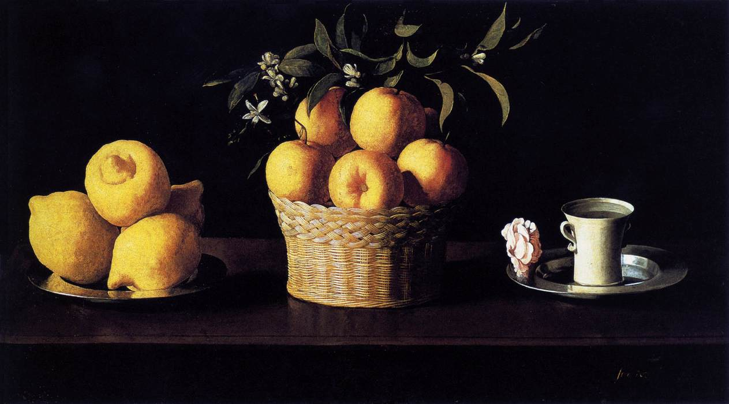
Figure 66: Francisco de Zurbaran (1633) Still Life with Lemons, Oranges and a Rose [Oil on canvas] 62.2 x 109.5cm. California: The Norton Simon Foundation.

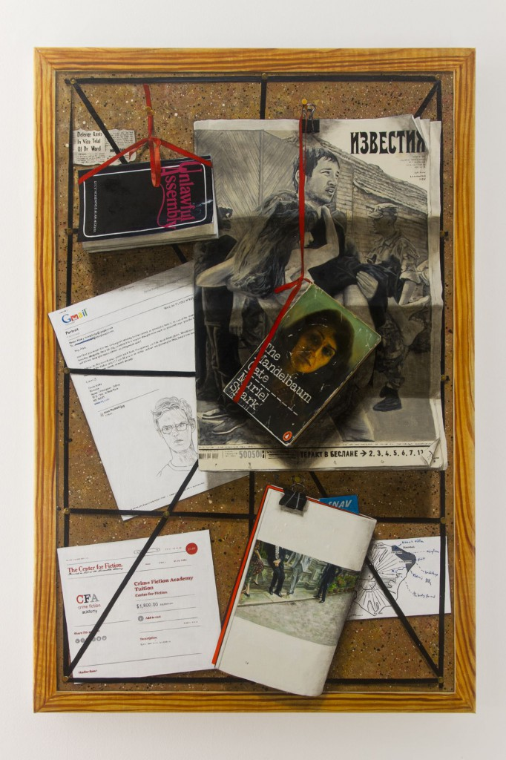
Figure 67: Lucy McKenzie (2013) Quodlibet XXVII (Unlawful Assembly I [Oil on canvas] 90.1 x 59.6cm. Artist’s collection.

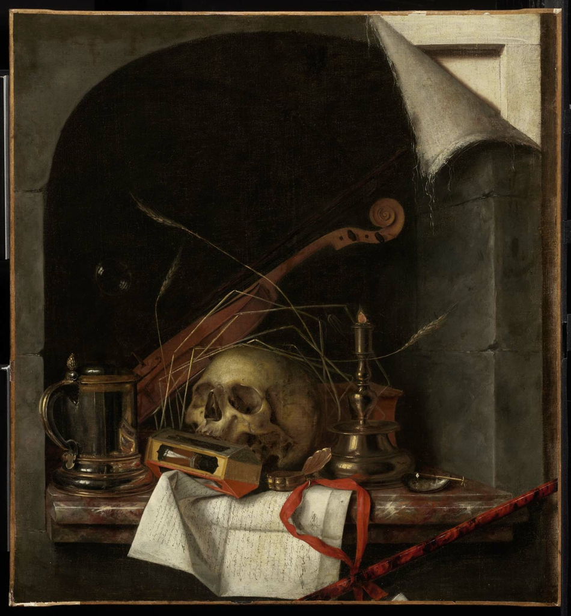
Figure 68: Cornelis Norbertus Gijsbrechts (c. 1659) Vanitas Still Life [Oil on canvas] 84.4 x 78.1cm. Boston: Museum of Fine Arts.

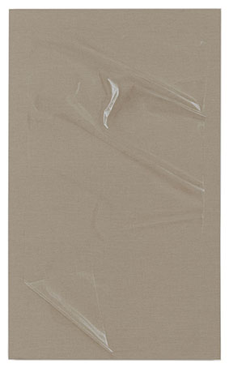
Figure 69: Helene Appel (2013) Plastic Sheet (2) [Watercolour on linen] 191 x 116cm. London: The Approach Gallery.

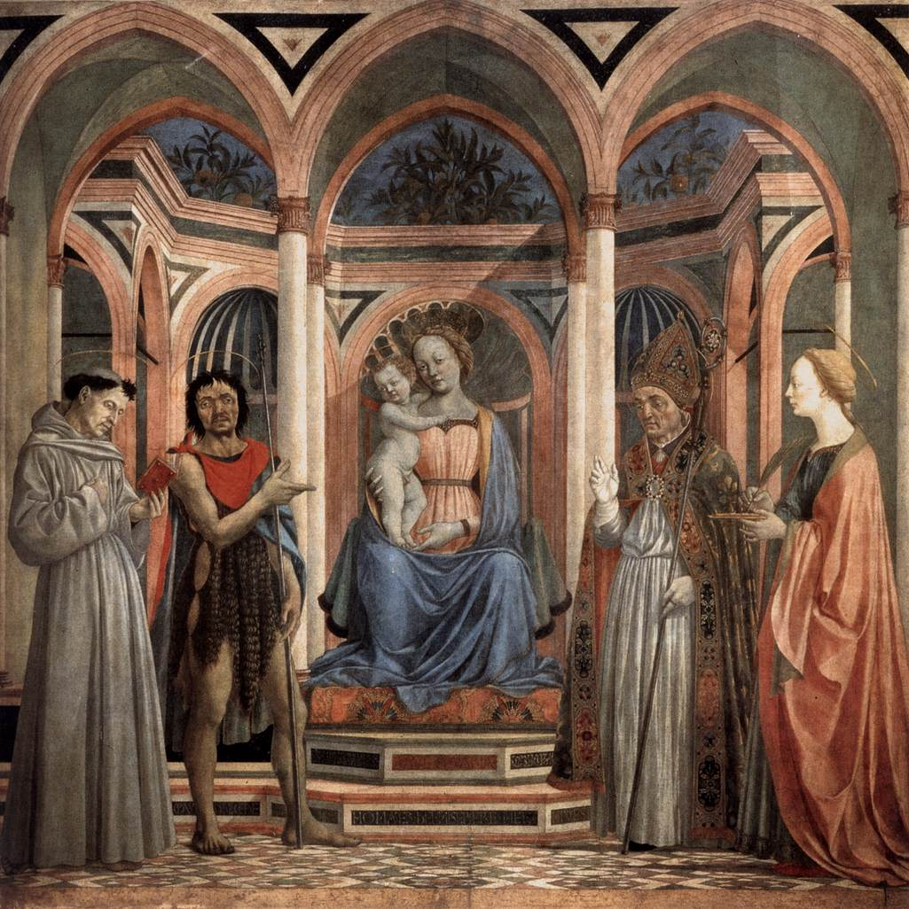
Figure 70: Domenico Veneziano (1445) The Madonna and Child with Saints [Tempera on wood] 209 x 216cm. Florence: Galleria degli Uffizi.

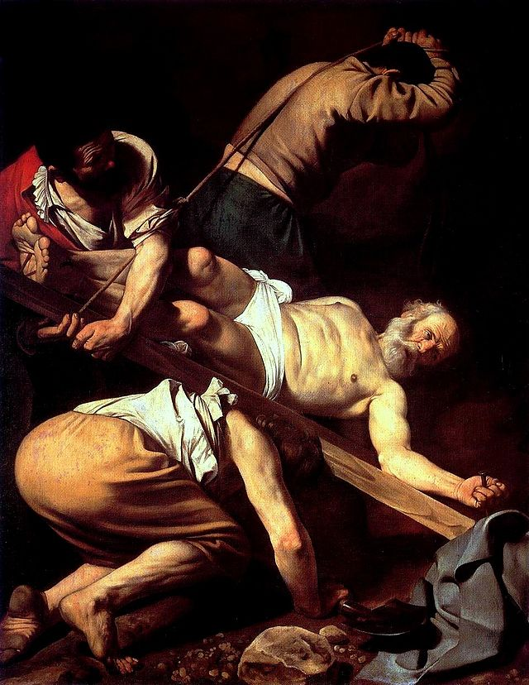
Figure 71: Michelangelo Merisi da Caravaggio (1601) Crucifixiion of St. Peter [Oil on Canvas] 230 x 175cm. Rome: Santa Maria del Popolo.

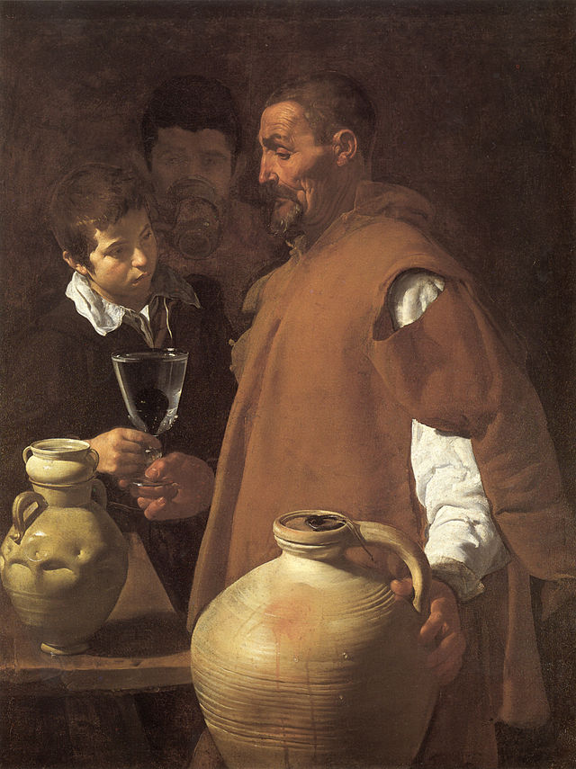
Figure 72: Diego Velázquez (1618-22) The Waterseller of Seville [Oil on Canvas] 105 x 80cm. London: Apsley House.

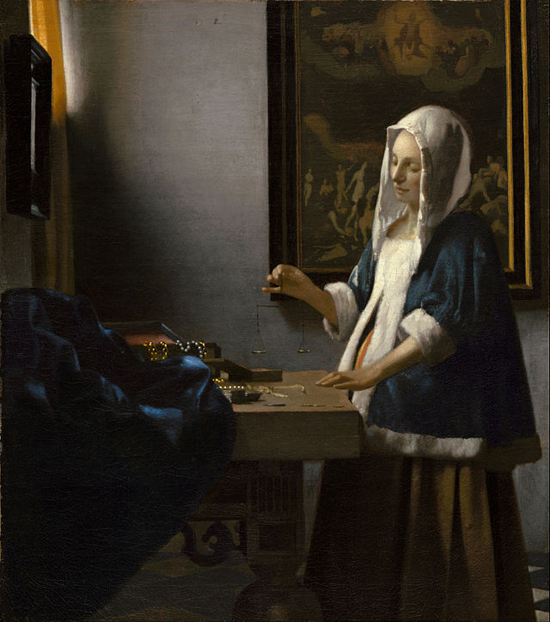
Figure 73: Johannes Vermeer (1662-63) Woman Holding a Balance [Oil on Canvas] 42.5 x 38cm. Washington: National Gallery of Art.

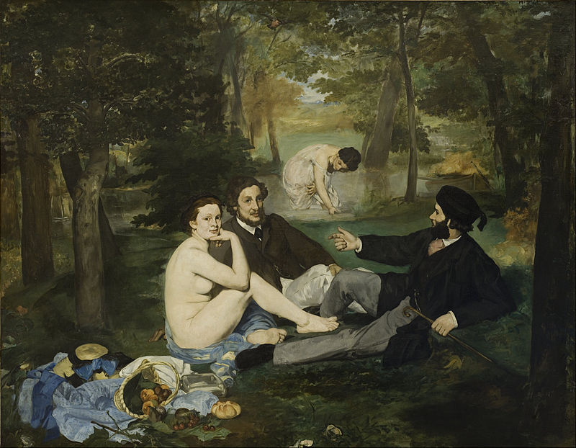
Figure 74: Edouard Manet (1862-63) Le Dejeuner sur l’herbe [Oil on Canvas] 208 x 265.5cm. Paris: Musee d’Orsay.

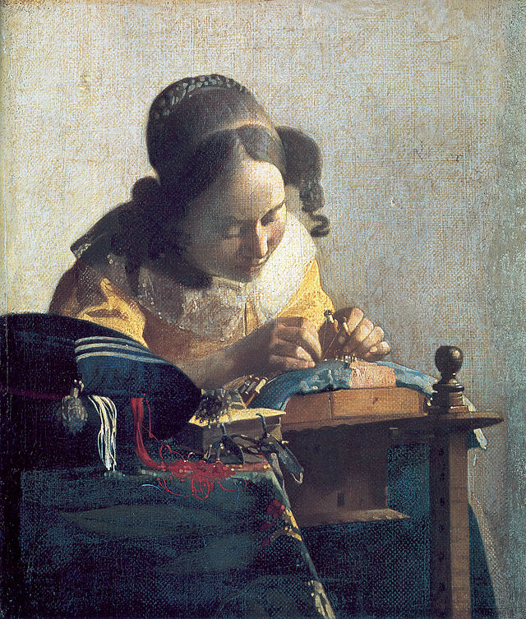
Figure 75: Johannes Vermeer (1669-70) The Lacemaker [Oil on Canvas] 24.5 x 21cm. Paris: Louvre.

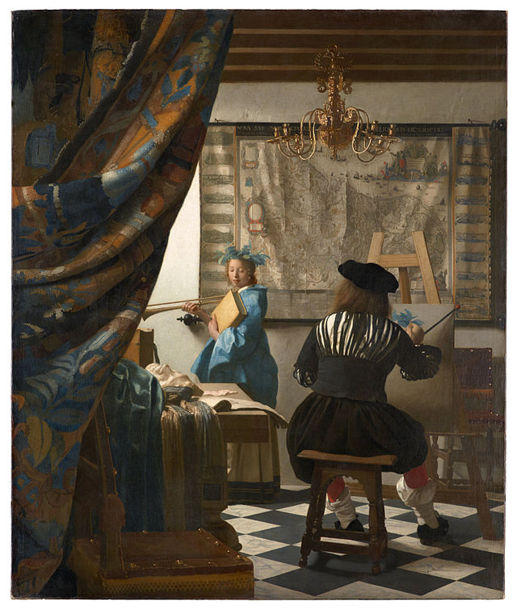
Figure 76: Johannes Vermeer (1665-68) The Art of Painting [Oil on Canvas] 130 x 110cm. Vienna, Kunsthistorisches Museum.

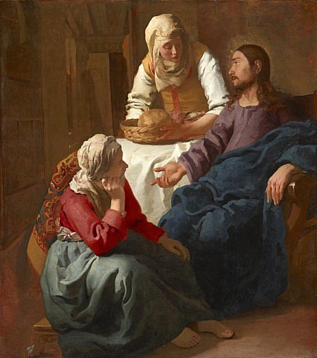
Figure 77: Johannes Vermeer (1655) Christ in the House of Martha and Mary [Oil on Canvas] 160 x 142cm. Edinburgh: National Gallery of Scotland.

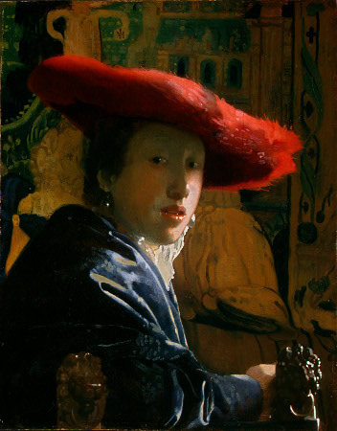
Figure 78: Johannes Vermeer (1665-66) Girl with a Red Hat [Oil on Panel] 23.2 x 18.1cm. Washington: National Gallery of Art.

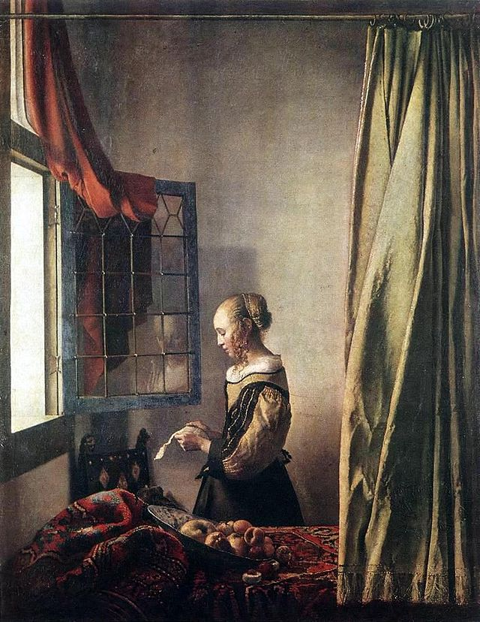
Figure 79: Johannes Vermeer (1657-59) Girl Reading a Letter at an Open Window [Oil on Canvas] 83 x 64.5cm. Dresden, Gemaldegalerie.

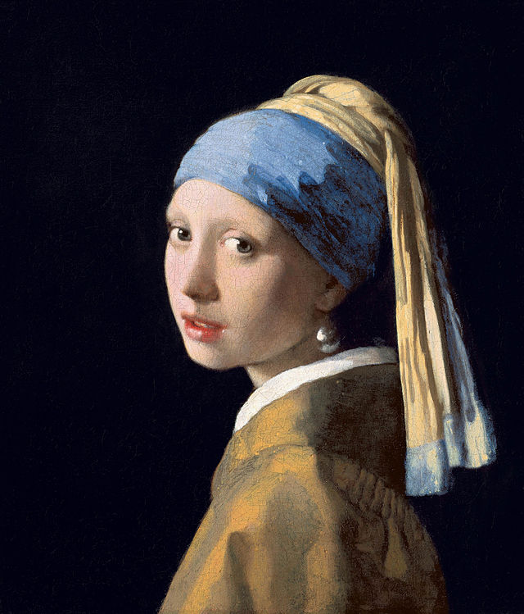
Figure 80: Johannes Vermeer, (c. 1665) Girl with a Pearl Earring [Oil on Canvas] 44.5 x 39cm. Netherlands: Mauritshuis, The Hague.

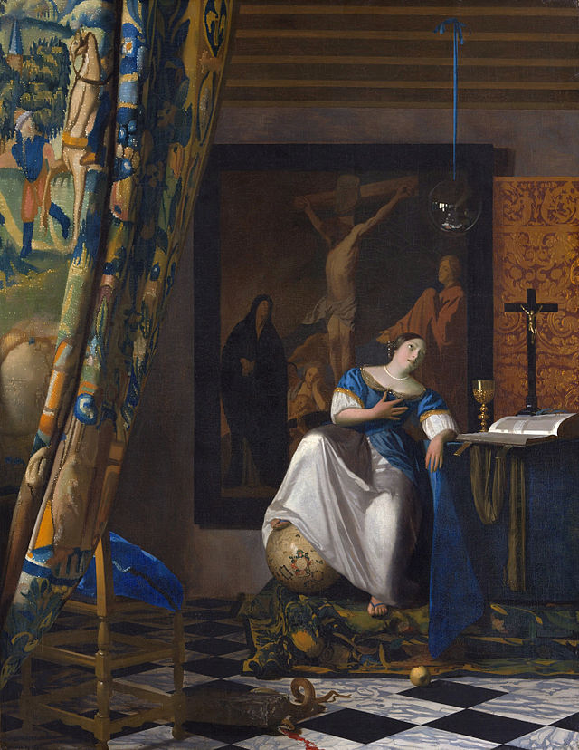
Figure 81: Johannes Vermeer (c. 1670-72) The Allegory of Faith [Oil on Canvas] 114.3 x 88.9cm. New York, Metropolitan Museum of Art.

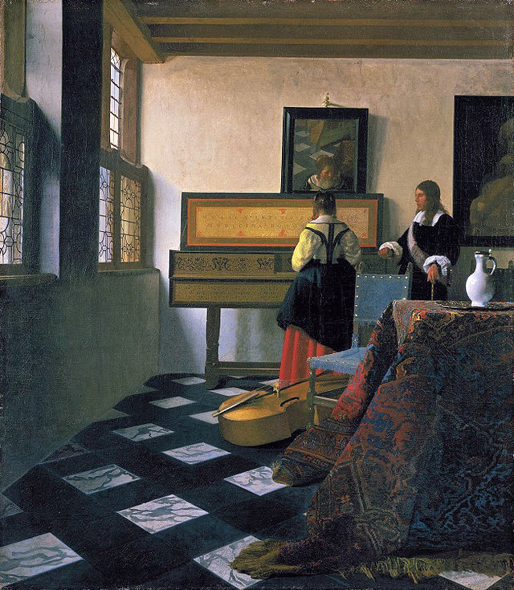
Figure 82: Johannes Vermeer, (c. 1662-65) The Music Lesson [Oil on Canvas] 74.6 x 64.1cm. London: Royal Collection, St. James’ Palace.

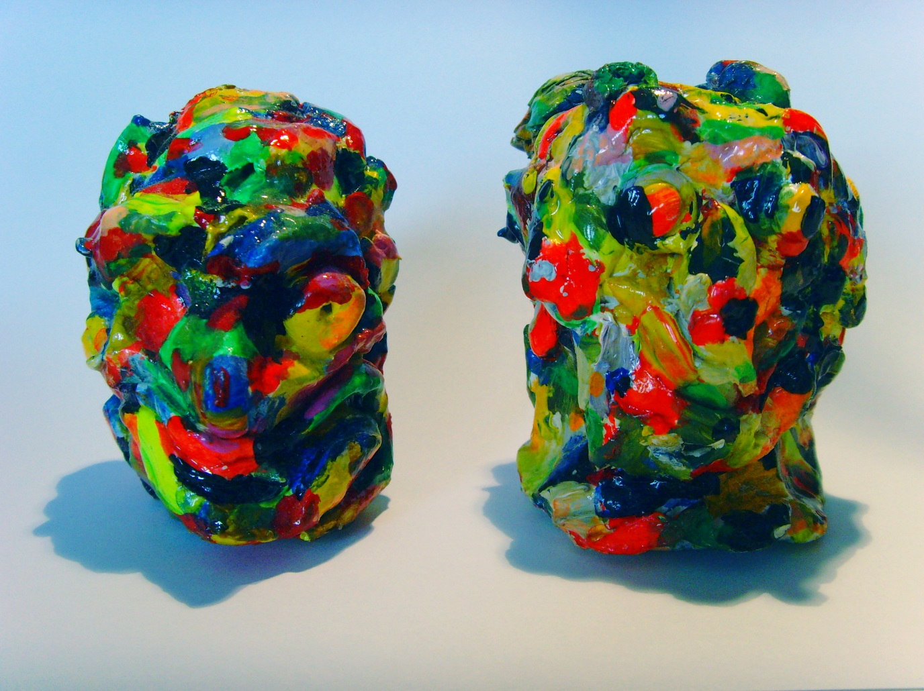
Figure 83: Donal Moloney (2014) Head-shaped Maquettes [Acrylic and varnish on clay] 4x3cm.

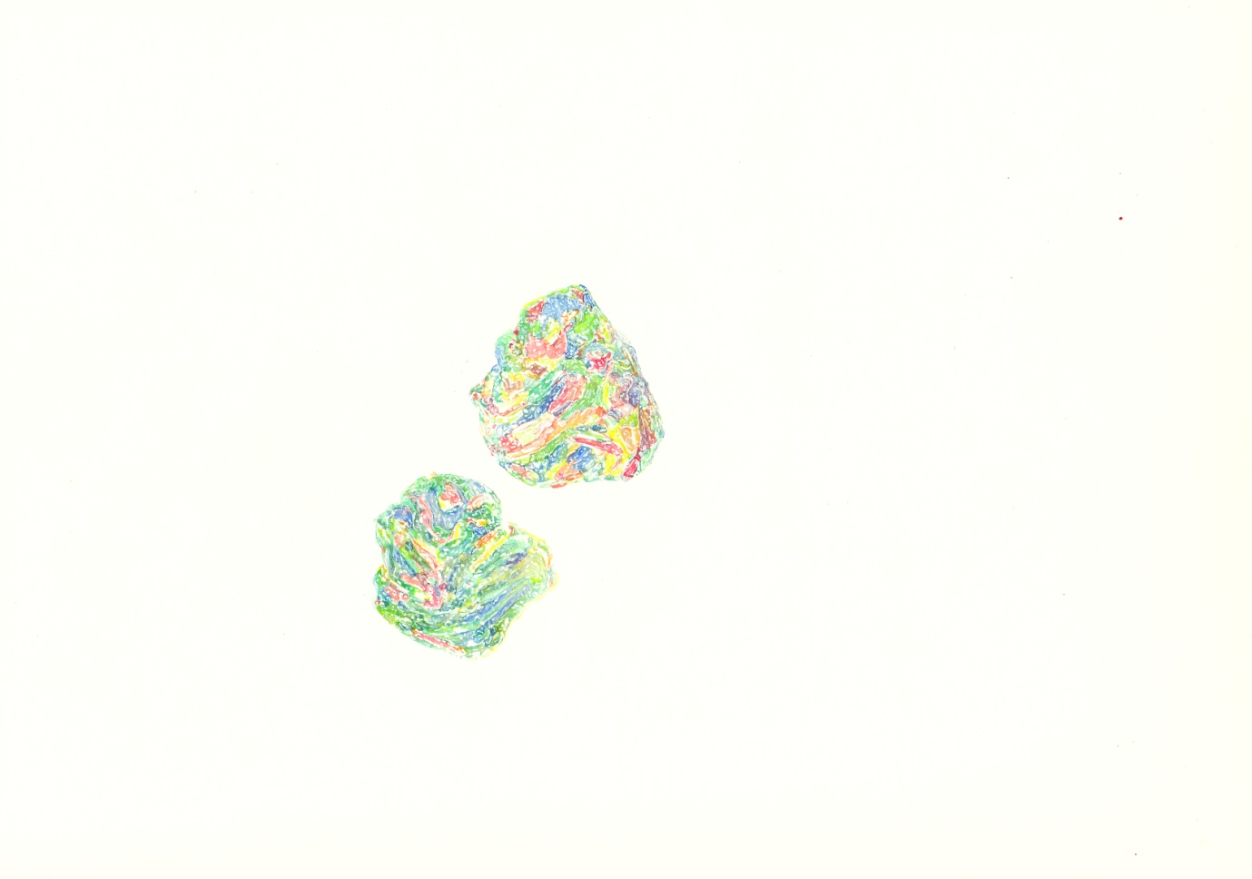
Figure 84: Donal Moloney (2014) WC1 [Watercolour on paper] 32x35cm.

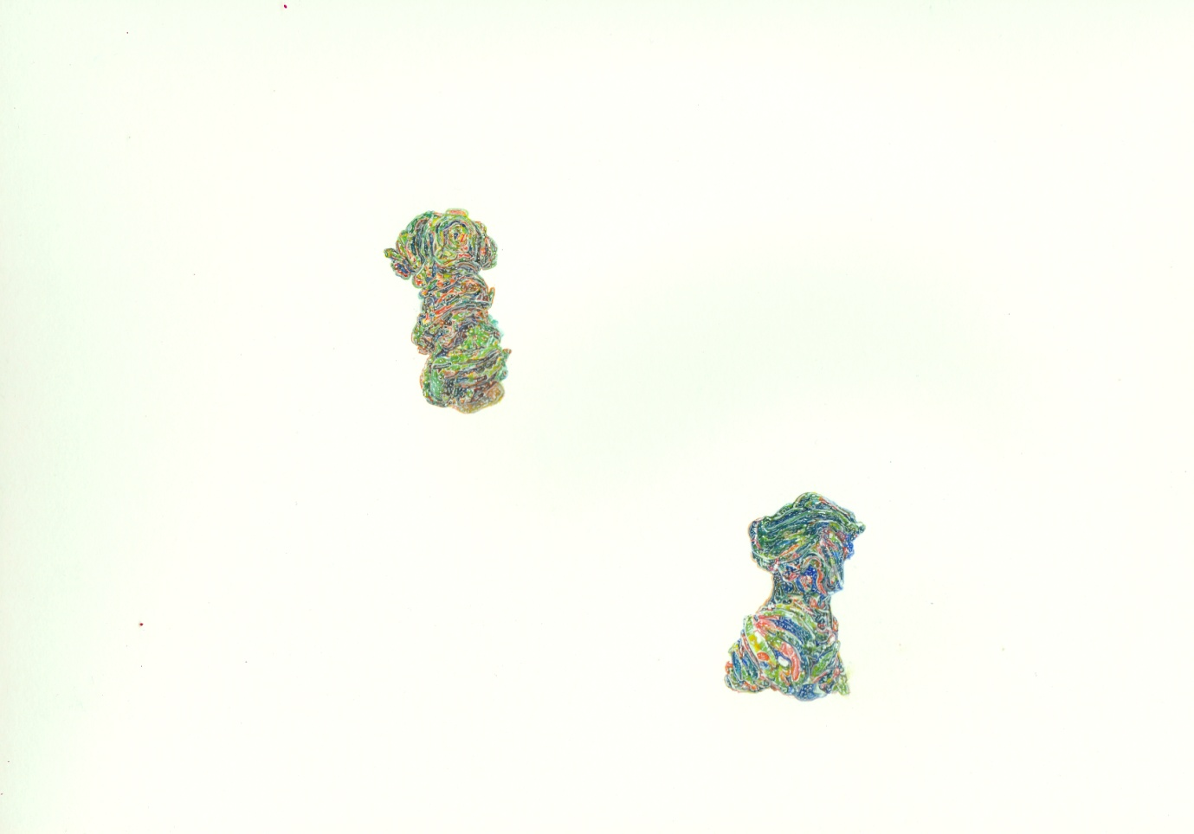
Figure 85: Donal Moloney (2014) WC2 [Watercolour on paper] 32x35cm.

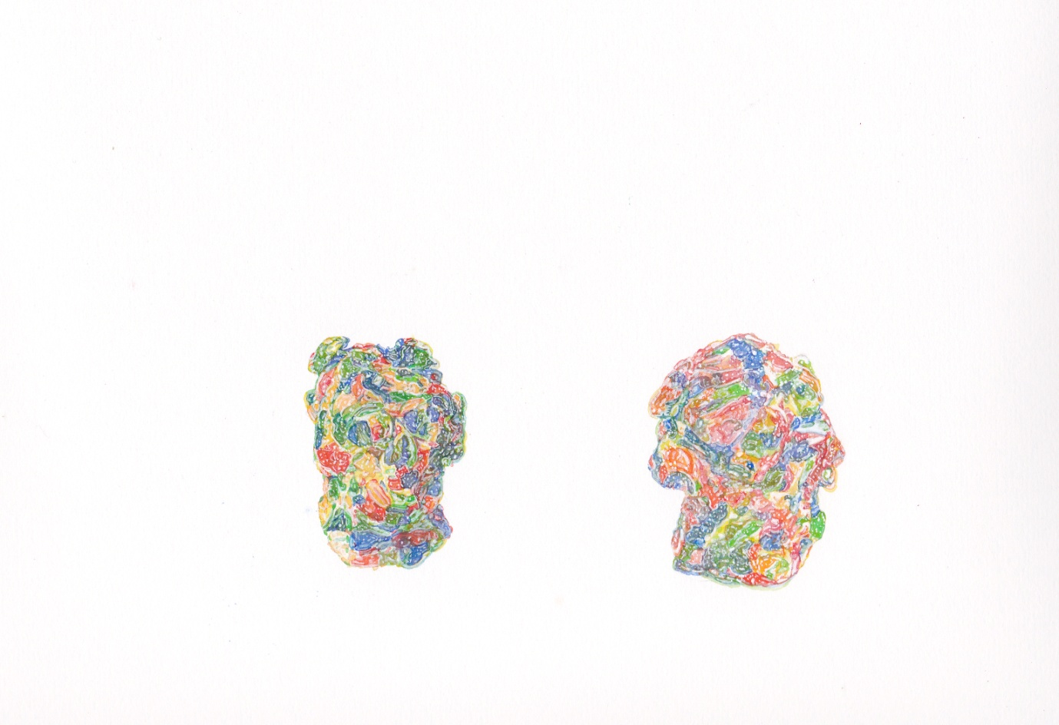
Figure 86: Donal Moloney (2014) WC3 [Watercolour on paper] 20x24cm.

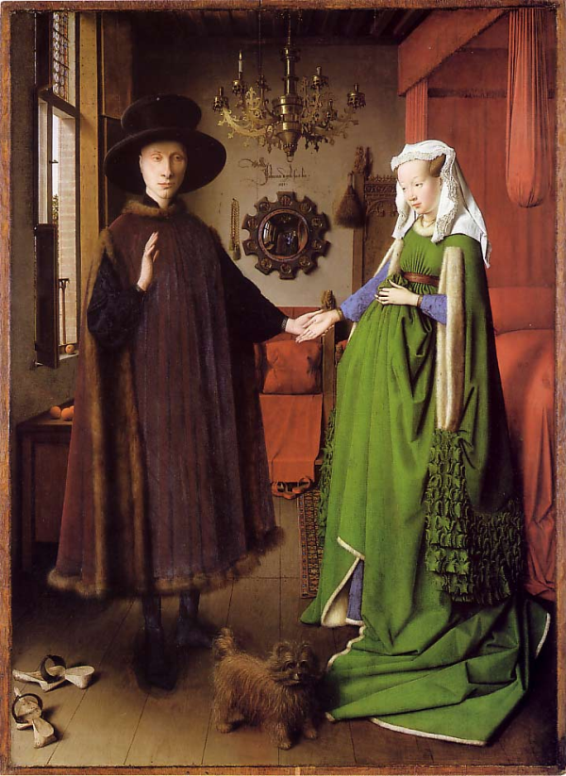
Figure 87: Jan van Eyck (1434) Arnolfini Portrait [Oil on oak panel] 82.2 x 60cm. London: National Gallery.

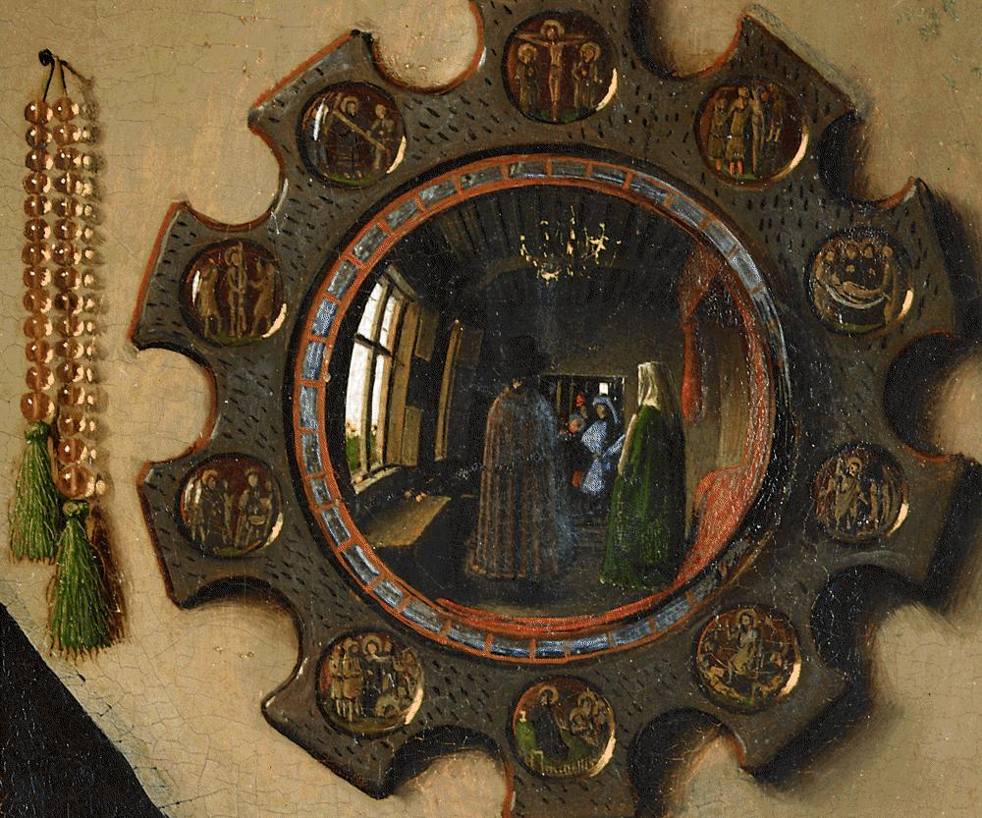
Figure 88: Jan van Eyck (1434) Arnolfini Portrait (Detail of mirror) [Oil on oak panel] 82.2 x 60cm. London: National Gallery.

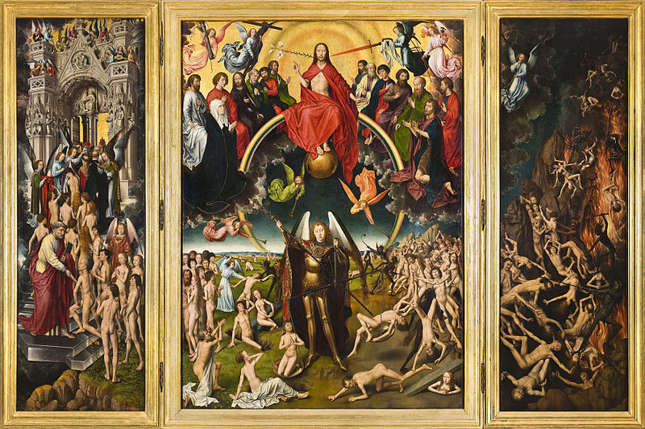
Figure 89: Hans Memling (1467-71) The Last Judgement Triptych [Oil on wood] 223.5 x 72.5cm. Gdansk: Muzeum Narodowe.
.

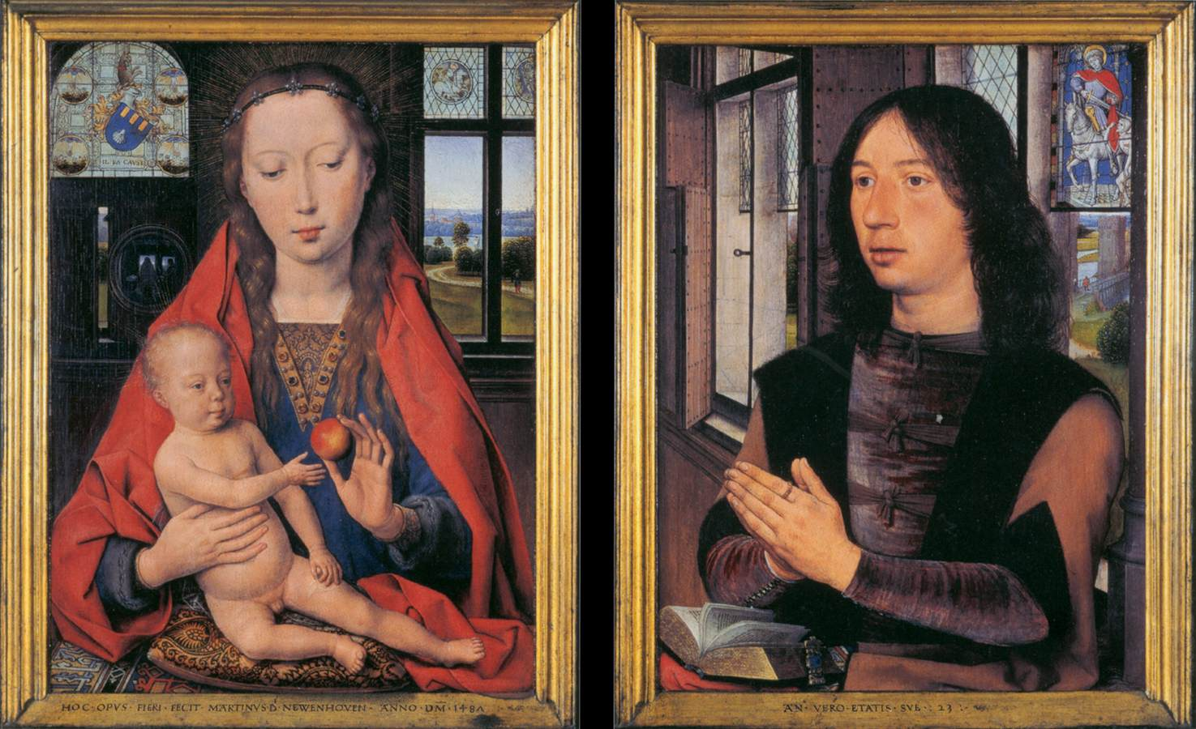
Figure 90: Hans Memling (1487) Diptych of Maarten Nieuwenhove [Oil on oak panel] 52 x 41.5cm (each). Bruges: Memlingmuseum, Sint-Janshospitaal.

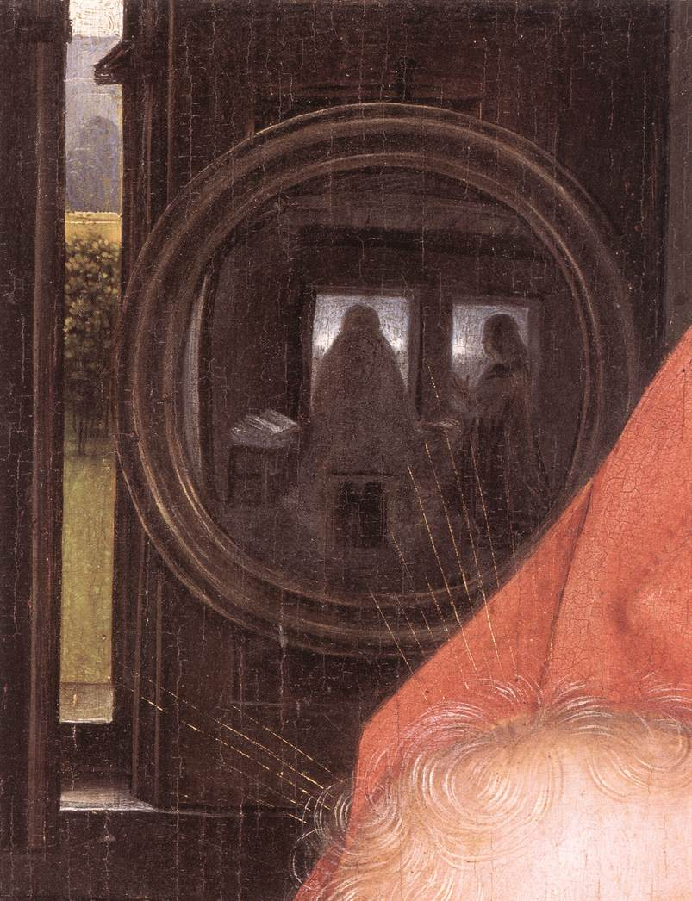
Figure 91: Hans Memling (1487) Diptych of Maarten Nieuwenhove (Detail of mirror) [Oil on oak panel] 52 x 41.5cm (each). Bruges: Memlingmuseum, Sint-Janshospitaal.

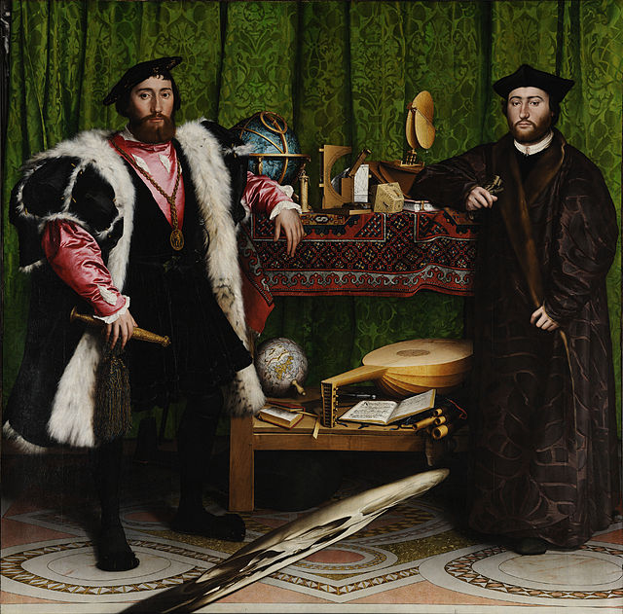
Figure 92: Hans Holbein (1533) The Ambassadors [Oil on oak] 207 x 209.5cm. London: National Gallery.

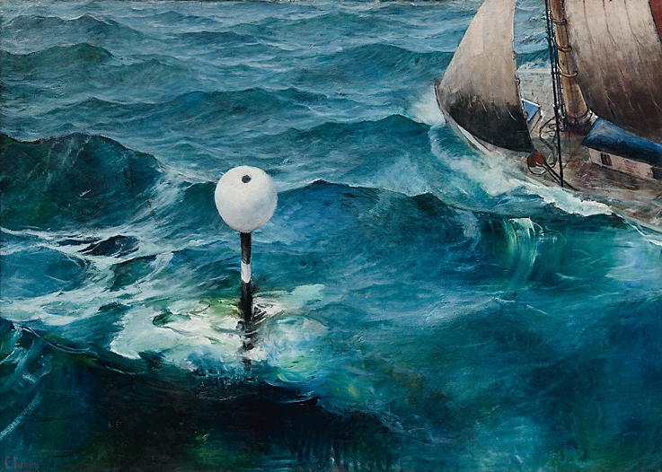
Figure 93: Christian Krohg (1897) The Shoal [Oil on Canvas] 144.5 x 200.5cm. Bergen: KODE Arts Museum of Bergen.

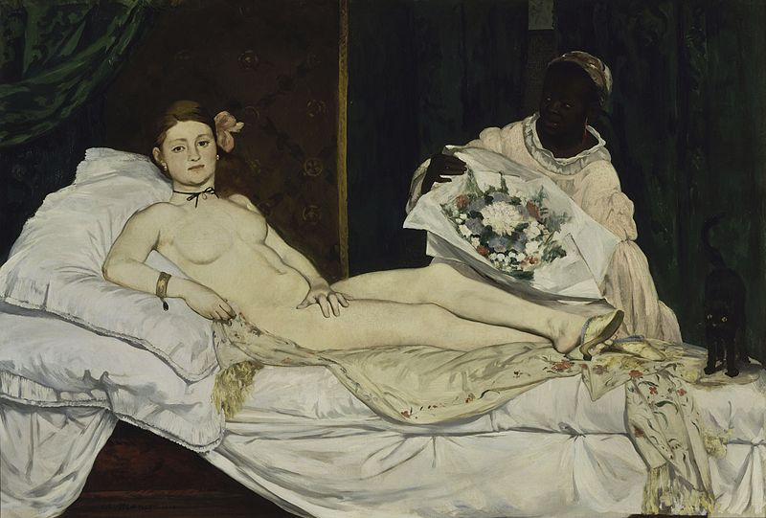
Figure 94: Edouard Manet (1863) Olympia [Oil on canvas] 130.5 x 190cm. Paris: Musee d’Orsay.

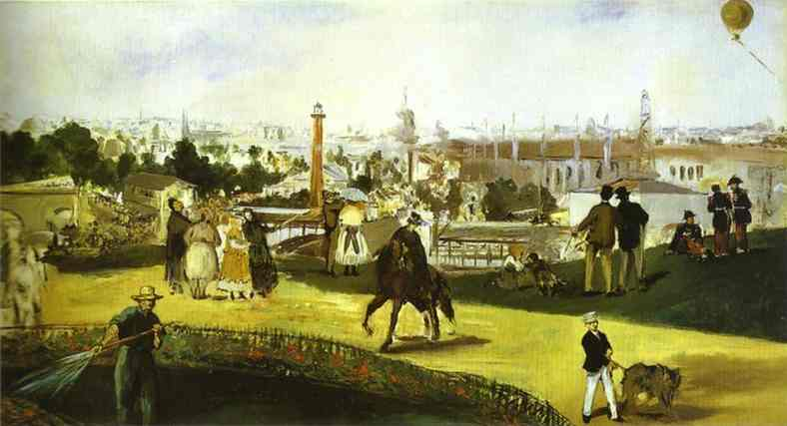
Figure 95: Edouard Manet (1867) View of the Universal Exposition [Oil on canvas] 108 x 196cm. Oslo: The National Museum of Art, Architecture and Design.

