The fabric of belonging
Place-based textile community engagement
Anne Marr
University of the Arts London, Central Saint Martins, TFRC, United Kingdom

ABSTRACT: This article discusses how textile making can enhance the mental health and wellbeing of homeless and vulnerably housed residents as well as stimulating greater community exchange. The author uses the London-based ‘Home and Belonging’ arts programme as an action research case study to explore new methods for place-based textile engagement activities and how they can be utilised to enhance the social capital of urban neighbourhoods. As part of the programme a group of homeless and vulnerably housed residents mapped their personal journeys, explored their local neighbourhood and created a collection of upcycled chairs as well as bespoke textile designs. The positive effect of communal making activities becomes evident through visual data collection which demonstrates the increased confidence and self-esteem of the participants leading to reduced isolation as well as increased community engagement. The paper concludes to recommend the importance of community visibility in order to facilitate holistic urban fabric exchange.

INTRODUCTION

‘Home and Belonging’ is a bespoke arts-based programme delivered in partnership with Crisis Skylight Brent (CSB) – part of Crisis, one of the biggest charities addressing homelessness in the UK – and Central Saint Martins (CSM), University of the Arts London. The project was funded through the Brent Council Voluntary Sector Initiative Fund and will be running until September 2018. This paper portrays the findings of the first project phase from October 2016 to July 2017.
The aim of the Home and Belonging project is to improve the lives and wellbeing of homeless and vulnerably-housed residents in the London Borough of Brent, building their resilience whilst supporting them to participate in the wider community. The project encouraged Crisis service users in expressing narratives of their own experience of community belonging, whilst nurturing a variety of soft, transferable skills as well as providing opportunities to creatively participate in local regeneration activities. Main project objectives are:

- to improve the mental health of homeless and vulnerably housed residents by reducing their isolation, increasing their confidence and self-esteem through textiles as a vehicle for purposeful learning and self-expression

- encouraging local community engagement to give homeless and vulnerably housed residents a voice to respond to the changing nature of their neighbourhood, bringing greater arts provision into the borough and promote community cohesion and integration through public events.

The Home and Belonging team set up new textile classes tailored to the needs of homeless and vulnerably-housed residents in Harlesden, Brent. 12 different workshop activities were offered, ranging from college visits to story telling, print-making, photography and tapestry. During the first year, the main programme engaged participants in making textile artwork, adopting environmentally-friendly ideas and showcasing their work in order to test out different place-based neighbourhood activities. About 25 homeless and vulnerably housed beneficiaries and 500 members of the wider community engaged with public exhibitions and community events during phase 1.
The following paper will portray the context of Home and Belonging, outline new methods of textile engagement, and analyse its findings in order to recommend transferable tools and successful approaches to community enhancement through urban fabric interventions. The author aims to question the traditional understanding of ‘urban fabric’ by extending its boundaries to include more textile-based approaches to respond to societal needs and create more empathetic urban communities.

2. BACKGROUND

An outline of the different Home and Belonging project partners as well as the current context of homelessness in the London Borough of Brent.

2.1 Crisis Skylight Brent

Crisis is an UK wide charity organisation which offers education and training about housing, employment and health for people who are currently homeless, have experienced homelessness in the past three years or are in immediate danger of losing their homes and don’t have a partner or a family member to support them. Crisis Skylight Brent (CSB) was funded in April 2016, when it evolved out of a previously existing local self-help group called LIFT. CSB had no experience in delivering art and design classes and the project coordinator had to set up new workshop facilities. However CSB already had an active local network with earlier LIFT service users, which was utilised for the Home and Belonging project recruitment.

2.2 Central Saint Martins

Central Saint Martins (CSM) is a multi-disciplinary art college located in Kings Cross in central London and is part of the University of the Arts London (UAL). The author of this paper and initiator of the Home and Belonging project is the Course Leader for BA Textile Design as well as a senior researcher based at the Textile Futures Research Community (TFRC) based at CSM. The TFRC Urban Fabric research area explores sustainable and innovative textile design to enhance urban environments and their positive impact on daily life.

2.3 Local Context

The Home and Belonging project took place in Harlesden in the London Borough of Brent, in one of the top 5% of the most deprived areas in the UK.
The employment rate in Harlesden is 59.3% (UK Census 2011), which is significantly lower than the London and National levels which is 70%. The proportion of those claiming job seekers allowance is particularly high at 18.3% compared to 3.6% nationally in 2014.
Homelessness and housing insecurity are key issues facing many Harlesden residents. Brent is in the national top 10 local authorities for the number of rough sleepers and has the second highest rate in London. There are currently 3,000 people in temporary accommodation in Brent, and from 2010/15 there was a large growth in homelessness acceptances (amongst the highest levels in the country) with an increase from just over 300 acceptances in 2010/11 to around 850 in 2014/15. The London based CHAIN database shows that London rough sleeping levels have risen by 104% to 8,096 since 2010 (CHAIN annual report 2015/16). This surge is primarily due to a decrease of tenancies in the private rented sector, and Brent’s recent submission to the House of Lords CLG Committee signalled that it expects ‘this pattern [of increasing homelessness] to worsen significantly over the next few years as Local Housing Allowance is frozen for 4 years whilst market rents will almost certainly increase.’ Homelessness. Communities and Local Government Committee (2016).
Like many London neighbourhoods, Harlesden is experiencing constant urban development changes – resulting in increased property prices and shifting demographics. The area has currently a population of 17,500, an increase of 40.43% since 2001 (UK Census 2011). There is a local concern about the effects of these changes, particularly on those most vulnerable in the area and the Home and Belonging project aims to test a place-based neighbourhood approach to help address these issues. Whilst Harlesden has many environmental challenges, at the same time it has a lively community, which manifests itself in the diverse and vibrant economic and cultural folklore of its High Street. Local residents have recently initiated the Harlesden Neighbourhood Forum to enable residents and business owners in Harlesden to begin to play a more active role in their community to tackle common issues such as fly tipping.
Furthermore the project responds to a gap in local arts and cultural provision: Harlesden has no community arts facilities or programmes, and an alternative arts programmes at St Mungo’s residential home had to close in 2016 due to lack of funding.

2.4 Health and Wellbeing

Health is a gauge of the physical and social fabric of our communities and of our individual journeys through life directly mirroring the nurturing opportunities as well as deep challenges along the way (Harkins 2016). Research indicates a strong link between homelessness and ill health as well as substance abuse. Poor mental and physical health is both a cause and consequence of homelessness. People who have experienced homelessness are over twice as likely to report a physical health issue then the general public. 44% of homeless people have a mental health diagnoses, in comparison with 23% of the general population (Health Needs Audit, 2016). Homelessness is often a very stressful experience (I was all on my own, 2015), leading to loneliness, lack of self-esteem and raised suicide rates, which are nine times higher than in the general population (Homelessness Kills, 2012). Additionally 41% use drugs and alcohol to cope with mental health issues (The unhealthy state of homelessness, 2014). In 2015/16, 45% of the people who accessed Crisis services identified themselves as having or having had mental health issues, a figure echoed at a local level at Crisis Brent.

3. URBAN FABRIC

Urban fabric is commonly used as a term to describe the physical aspect of urban design and streetscapes, often, however, excluding economic and sociocultural qualities. Following on from the idea of place attachment by recalling the past (Lynch 1972; Altman and Low 1992) Antonovosky identifies one’s place identity as influencing the meaning and significance attributed to place (1987). This project attempts to extend the traditional perception of urban fabric in order to include a wider range of social, cultural and environmental attributes to holistically interweave hard tangible and softer intangible strands of spaces. Settings rich in place icons such as churches or parks, may evoke a stronger local relatedness and sense of community (McMillan and Chavis, 1986). Currently 85% of people in the UK agree that the quality of the built environment influences the way they feel. (Creative Health Report 2017). This creates a fine balance between a healthy community, a healthy environment and personal wellbeing. Additionally helping to create an environment creates closer community attachment. People will therefore manage and maintain it better, reducing the likelihood of vandalism, neglect and the subsequent need for costly replacement (Wates, 2014).

3.1 Social Capital

Inner city areas like Harlesden constantly change both physically and culturally, which makes it difficult for residents to anchor themselves in a local community. Lynch explores the relationship of time and place and how residents benefit from a deeper understanding of their urban surroundings: “Instances of environmental transformations are common. On one hand, people must endure them, and we see their efforts to preserve, create, or destroy the past, to make sense out of rapid transition, or to build a secure sense of the future. On the other hand, the initiators and regulators of change (….) struggle with these transformations in another way, straining to comprehend and control them.” (Lynch, 1972:3). A positive local association as well as the weaving-together of people in communities develops social capital as “a resource based on trust and shared values” (Gauntlett, 2011:133). Creating a collective place identity nurtures social capital and community identity. Social capital enables a community to resolve problems more easily because members know that they can rely on each other: “It fosters awareness of the ways in which our fates are interlinked, and encourages us to be more tolerant, less cynical, and more empathetic.” (Gauntlett, 2011:147).

3.2 Community engagement
Art acitivities have achieved positive outcomes for homeless people including reducing isolation, promoting social networks, self-esteem and communication skills, as well as therapeutic benefits: they can specifically benefit mental health issues by addressing isolation and supporting relaxation and daily routines.
Making workshops have been commonly used as a ‘process-led’ praxis in textile design. However, in the context of urban fabric research, communal making becomes a communication tool to establish new synergies between people and places, and enhance the social capital of a community. Wates (2014) identifies a number of benefits of community engagement such as empowerment and community feedback as neccessary to inform holistic urban design solutions. At the same time “an impressive and growing research suggests that civic connections help make us happy, wealthy, and wise. Living without social contact is not easy.” (Putnam, 2000:287).
Working alongside a group of makers automatically creates an open forum for exchange: sharing the process of learning and creating a textile establishes an immediate rapport within the group. Gauntlett describes the personal value of group making “…people often spend time creating things because they want to feel alive in the world, as participants rather than viewers, and to be active and recognized within a community of interesting people” (2011:222). Textile making is experienced as a positive act as it enables the maker to express their identity through ideas, colours, material and techniques. Makers benefit as they “internalise their learning, making it part of themselves, and relate it to their real life.” (Brockbank and McGill, 2007:42). The Home and Belonging project aim is to enhance both making skills as well as personal wellbeing through textile workshops and to present and communicate emerging design products and personal narratives in a wider community context.

4. RESEARCH METHODOLGY

This project was set up as an action research case study in order to explore the participatory and experimental nature of the project and generate an open dialogue amongst participants and facilitators, based on the theoretical research methods framework from Reason and Bradbury (2001). Action research is appropriate for this study because of its focus on social interaction and experimental approach. Utilising qualitative measures, data for this study were collected in the following ways:

- written and photographic diary
- interviews with project participants
- visual check in/out data during workshops
- questionnaires and enrollment data
- review of contextual information and literature.

5. PROJECT TIMELINE

5.1 Scoping and Recruitment

The main objective for Crisis Brent was to set up a new integrated arts programme in Harlesden, whilst the author was particularly interested in exploring new methods of textile engagement within inner city communities.
Over a period of three month both institutions set up the general logisitics and visited similar existing art workshops at Crisis headquarters in Central London. It was highly beneficial to learn from the already existing good practice and the tutors gave valuable tips on the shared parameters of working with Crisis members. However it emerged that the external set up was also quite different. Crisis Brent had only a 15 sqm office room available to host art classes and other meetings, in comparsion to the 100 sqm custom-built art studio space at Crisis headquarters. Whilst participants at the established art classes in central London come from many different London Boroughs, Crisis Brent had strong local connections, with all service users living in Brent, offering unique community insights.
In order to promote the new programme, and recruit more Brent participants, the arts co-ordinator set up a number of small outreach acitivities in local hostels and community hubs, as well as distributing leaflets. This led to a first taster workshop with seven participants to test out preferred textile activities and scope areas of special interest. Participants were invited to try out 20 minute rotations of weaving, wood block printing and badge making. Non of the textile acitivities required any further knowledge and all materials were provided. The feedback from the initial sessions then led to the selections of the main workshop activities as well as the most suitable timings for sessions to be accessible a large number of people.

5.2 Workshop Programme

Over a period of four months CSM academics and applied-arts practitioners delivered 12 two hour long workshops on Wednesday afternoons, as well as two CSM site visits and additional drop in sessions on Tuesdays. In the first 6 months 25 crisis members participated in the programme: eleven were female and fourteen were male; four were Asian/ Asian British background, ten Black / Black British, nine White/ White British as well as 2 from other ethnic backgrounds. The participants were between 25 and 65 years of age.
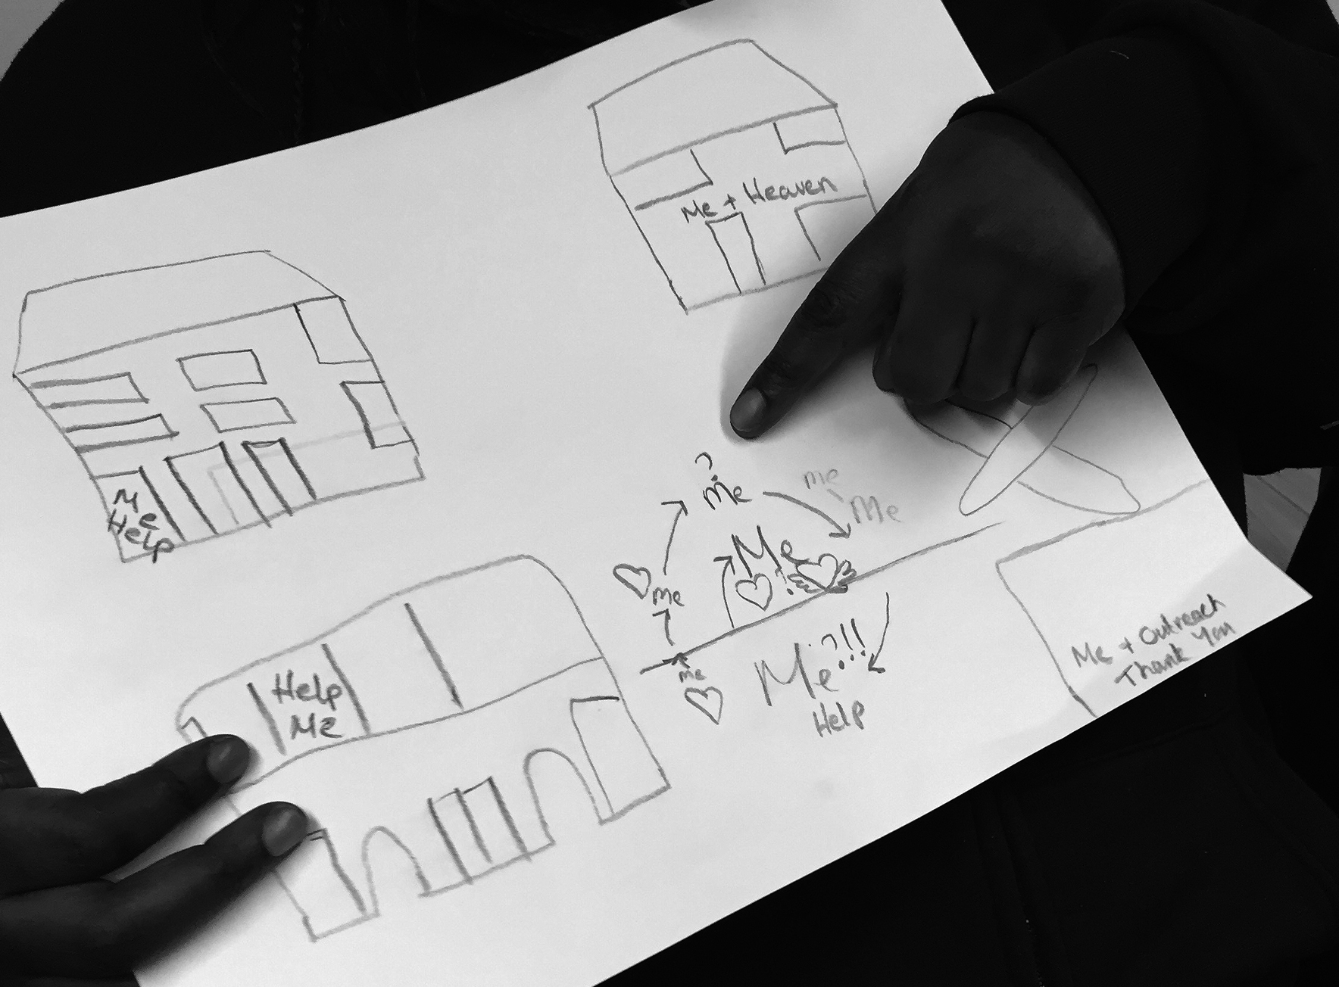
Figure 1. Mapping of personal belonging: hostel bed layout

Session 1: Creative Explorations
General introduction and creative mapping of personal journeys as well as experience of local neighbourhood.
Acitivities: brainstorming and collaging, exploring the colours, sounds and smells of Harlesden. Secondary and primary research generation for later sessions as well as show and tell group work.

Session 2: Field trip to Central Saint Martins
Visit to the CSM museum and textile workshop tour.
Activities: Show and Tell, object handling session, student tours and demonstration in the weave and knit workshops.

Sessions 4-5: Tapestry Weaving
Transformation of fly-tipped furniture into 3D tapestry objects and personalised chairs.
Activities: Selection of individual colour schemes, large and small scale tapestry weaving, embellishment, painting and decorating.

Sessions 6-7: Digital Design
Digitial image making responding to Harlesden’s vibrant High Street folklore.
Activities: research, photography, graphic design and heat transfer printing.

Sessions 8-12: Analogue Design
Analogue image making and T-Shirt slogan development inspired by local observations. Certificate award ceremony
Activities: research, stencilling, typography, drawing and painting as well as heat transfer and screen printing processes.

Session 13: CSM Degree Show Visit
The programme ended with a visit to CSM to look around the degree show in order to reflect and relate the textiles outcomes of the Home and Belonging project to a wider art and design context.
Actvities: Project presentations by CSM students.

Additional drop in sessions
Due to irregular attendances, overwhelmingly enthusiastic responses as well as time-consumingly intricate work, the Crisis arts co-ordinator arranged additional optional drop in sessions on Tuesdays to extend the workshop access times. These were also vital in order to churn out a ‘collection’ of refined designs for the pop up shop and exhibition.

5.3 Project exhibition and dissemination

Figure 2. Community Pop Up shop in Harlesden
At the end of the project the organisers arranged a pop-up shop showcasing the Home and Belonging designs as part of a local community event bringing different local stakeholders togther such as the Harlesden Town Garden team as well as the
Neighbourhood forum. The event was attended by about 150 members of the community as well as the Mayor of Brent, and the public were invited to leave feedback about local urban planning initiatives.

Additionally, CSM researchers curated an exhibition based around Urban Fabric showcasing two London-based academic research projects as well as the Crisis project outcomes. For a month Crisis T-Shirts and embellished tapestry chairs were exhibited in the CSM Window galleries, attracting a diverse audience of students, and academics as well as at least 500 members of the general public.

6. FINDINGS

Throughout the workshop programme qualitative and quantitative data has been collected via 25 participant ‘enrolment’ forms. Additionally the pro-ject has been monitored through feedback sessions, photographic diaries, emoji check-ins and course evaluation forms, which were completed by seven participants at the end of the programme.

6.1 Strong attendance and retention

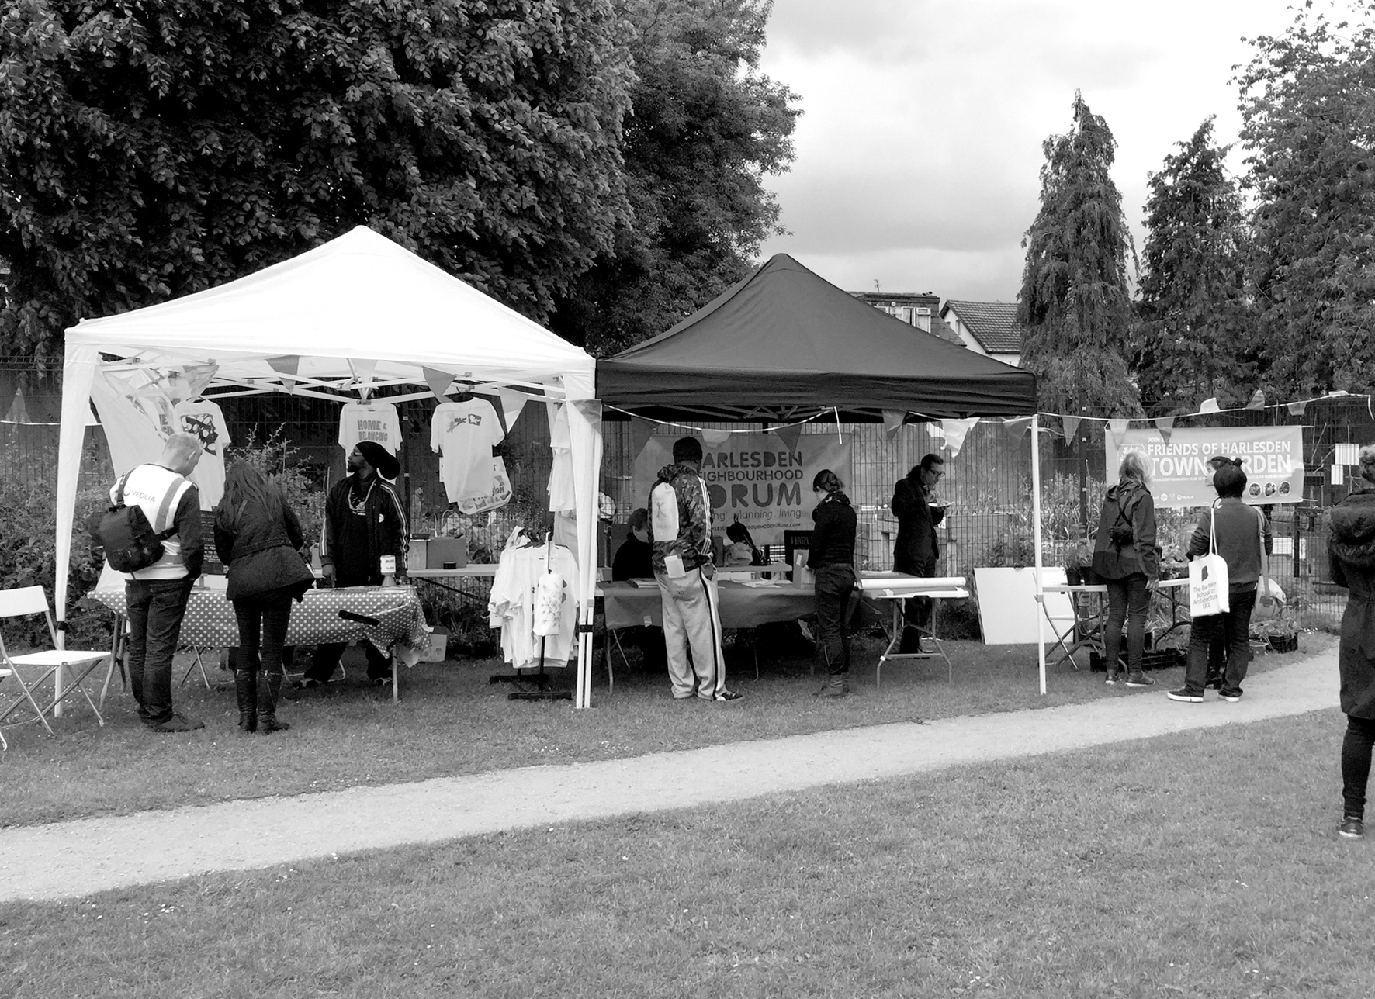
Key to the project’s success was the locally based arts co-ordinator whose continued presence and positive support acted as a proactive agent to gel the group. This led to high group retention rates with eight members attending 85% of workshop sessions, demonstrating their strong commitment to the project. An additional group of nine participants attended three or more sessions whilst six participants only came once. Orginally the tutors were planning to brief all members at the beginning of each session, however, due to differing personal circumstances as well as mentoring appointments people popped in and out during the afternoon. At the same time participants got very absorbed in the making process and worked well beyond the two hour slot to finish ambitious projects. In response, the organisers extended the course hours, added a drop in session on Tuesdays and changed group briefings to the middle of the workshop. There was certainly no lack of enthusiasm: some participants took voluntary ‘homework’ with them or completed work for others.

The workshop took place in a small office space with all participants working alongside each other on a communal table. Whilst this constrained the making of large scale work, at the same time it encouraged lively conversations and a natural integration of new members into the group. It was noted how much more sociable and convivial the workshop in Brent was in comparision to the spacious but more individualistic set up at the Crisis headquarters in central London. The Home and Belonging project benefitted from the shared local background of the participants as well as the communal table layout in the workshop space as it nurtured common ground amongst the participants.

6.1.1 Universal textiles communication

In respose to their weekly observations as well as participants’ feedback on the day, tutors adapted course content throughout the duration of the programme. Whilst none of the participants had any previous knowledge of textiles, it was observed that all of them expanded their colour, composition and technical skills. The intricate hand co-ordination of tapestry weaving and the complexity of digital design applications were experienced as most challenging by some members. Whereas heat-transfer press printing, drawing and painting appealed to newcomers and advanced participants because of their immediate accessibility and ‘instant’ results.
At CSM, textiles generally attract a predominately female audience and it was promising to see an even gender balance in the group. Textiles are particularly accessible because of their universal presence in daily lives both as clothing and home interiors. During the workshops it was observed how individual material and colour selection can be utilised as a powerful design tool to express cultural identity. For example, two participants worked almost exclusively in red-green-yellow Jamaican colour schemes whilst another participant focussed on ‘minimal’ black and white arabic typography.
The group invented a specific collaging technique by recycling small colourful cut-off shapes of heat transfer paper and printing them onto T-Shirts and hard surfaces. This design was later called ‘Harlesden Camouflage’ as it resembled traditional camouflage patterns but with an Urban colour scheme. These camouflage designs were also very well received at the public pop up shop events and sold out quickly. In addition to their growing textile design skills, participants have also gained transferable knowledge such as time management, team work and presentation skills.

6.2 Self-esteem and the creation of a safe space

Participants have overwhelmingly reported an increase in confidence, self-esteem and in their social connections since taking part in the Home and Belonging sessions. This is a direct result of the supportive and open atmosphere at Crisis Brent, which created a safe space to build strong group identity and ownership. Clifford and Herrmann observe: “unless your group already know each other prior to the project, time must be spent fostering a sense of ‘the group’ whereby barriers are broken down, they share common ideas, concerns and goals and individuals gain a sense of belonging.” (1999). Even though the group consisted of a diverse mix of generations, cultural backgrounds as well as gender it was observed that textiles were a material that all could relate to. Staff had been impressed by participants’ enthusiasm throughout the programme and how they built effective working relationships with one another. In response to the course evaluation question ‘What have you enjoyed most?’ participants stated:
- Gaining new art skills
- Expressing myself through art
- Getting to know people
- Looking at things I hadn’t noticed before
- Looking at art
- Everything!
100% of the participants who responded to the feedback form stated that:
- Their relationships with other people and their trust in others have improved.
- Their confidence and self-esteem have improved
- Their time management / motivation and skills with working in a group have improved.
Furthermore, all participants apart from one have given their full consent to using their image / artwork for future promotional purposes. This was not the case at the beginning of the project, and demonstrates an increase in self-esteem and trust.

6.2.1 Visual feedback on personal well-being

It was noticed that some participants had difficulties expressing themselves through written English and at the same time the group voiced a general questionnaire and paperwork fatigue. In response, the author developed a new visual evaluation method to elicit deeper feedback on participants’ experience of each session. Participants were encouraged to check in and out of each workshop by choosing a printed emoji sign (happy, sad, frustrated etc.) that best described their mood at that time and put it up on a board. This proved a very well received communication tool, and the emojis became a comfortable and accessible expression of the mental state of each participant. The majority of the group progressed from sadness, cautiousness or frustration to happy emoji signs by the end of the class. Participants also invented additional personal emoji signs as well as adding words like ‘unity’ to the board. This method has been positively received by other partner organisations, which have also implemented it to inform their evaluation reports.

Figure 3. Emoji check in and check out

6.3 Outreach and community exchange

Course feedback forms show that 100% of participants feel more engaged in their community. Existing Crisis members who also access partner organisations quickly promoted the textile workshops to other clients. This self-promotion is how the majority of new clients from external addiction support schemes came to join the group. Additionally four participants have signed up to be community researchers and other participants volunteered to take part in promoting the project to other homeless and vulnerable people. Four participants are still involved in Crisis Brent’s neighbourhood planning work and have creatively contributed to the design and delivery of neighbourhood forum events.
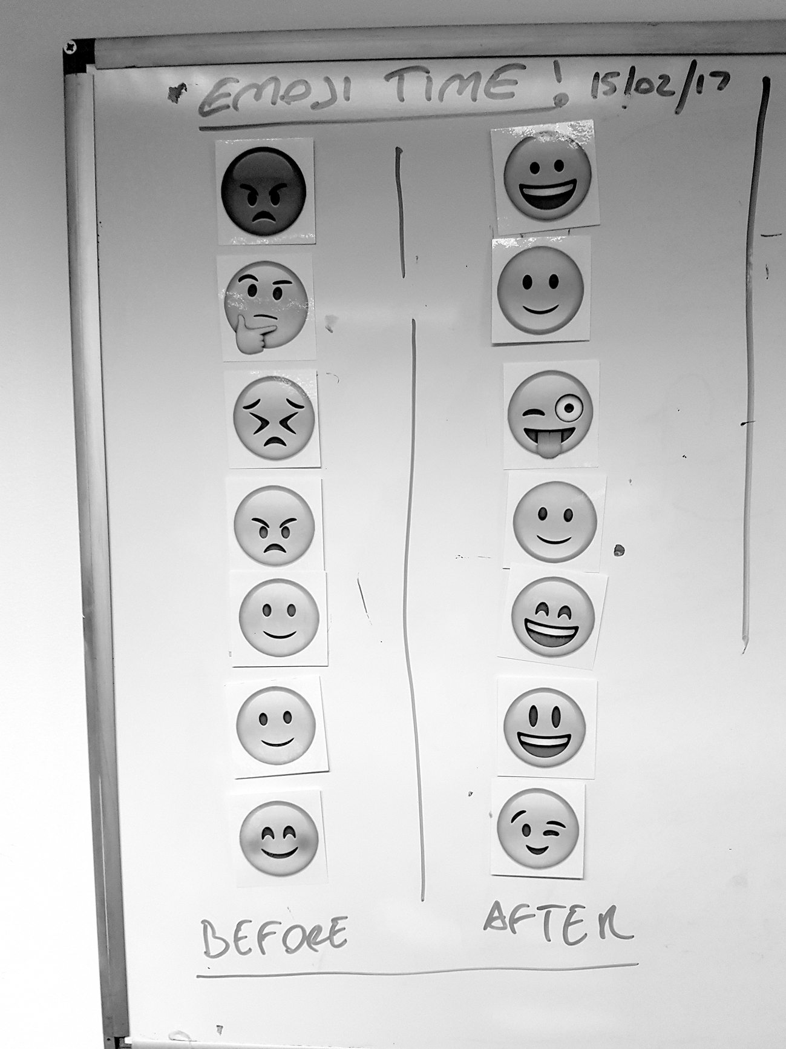
The pop up shops in Harlesden and at Central Saint Martins evidenced the importance of bringing different stakeholders together. In particular as they provided a relaxed set up to connect participants to a diverse audience, invite exchange and promote their designs. It was significant for the participants to have a physical presence through their textiles and find an open-minded audience for their stories. Many of the printed textiles displayed personal messages such as: “Sorry not my Problem”, “Love”, “Messy by Design”, “Be” and “Do it with Passion”. People who bought the products openly related to a specific narrative by wearing and displaying an authentic Home and Belonging voice. This correlates to Couldry’s findings on the importance of a voice as a form of agency and the act of taking responsibility for the stories one tells: “For a voice to be meaningful, people need opportunities and tools for self-expression but they also need to be heard.” (2010).

7. CONCLUSION AND RECOMMENDATIONS

7.1 Textile transformations

The author acknowledges the limited scale and particular environment in which the Home and Belonging research was conducted. At the same time the findings of this project correspond strongly with other recent reports and the unique value of textile engagement is clearly transferrable to related sectors. An all-party inquiry into health and wellbeing strongly evidences the benefits of creative activities and concludes with a recommendation to establish a more strategically aligned approach: “We recommend that leaders from within the arts, health and social care sectors, together with service users and academics, establish a strategic centre, at national level, to support the advance of good practice, promote collaboration, coordinate and disseminate research and inform policy and delivery...” (Creative Health: the Arts for Health and Wellbeing Report 2016). Thorpe and Gamman, who have been working with inmates on a number of design projects in prisons, have also identified multi-layered advantages for individual citizens as well as society: “…the use of creative activities and tools is a means for the accumulation and transmission of social knowledge. It influences the nature, not only of external behavior, but also of mental functioning of individuals.” (2015). The specific findings of the Home and Belonging project echo these recommendations as well as highlighting the benefits of locally embedded textile interventions to enhance the social fabric of an urban environment. This has led to the following recommendations for place-based textile community activities:

Textile Workshops
- Set up early outreach / recruitment activities to reach participants from different feeder institutions and offer taster sessions to gauge interest
- Create a ‘safe space’ to enable open exchange and conversations
- Encourage a responsive and flexible course set up for reciprocal learning (including tutors)
- Include a range of materials and colours to reflect the culturally diverse aesthetic preferences of all participants
- Design ‘instant’ making activities that are accessible for all abilities as well as study visits to introduce a wider context
- Invite critical reflection and the expression of personal local narratives through new forms of textile communication

Community Engagement
- Increase local opportunities and spaces for cohesion and integration amongst homeless and vulnerably housed residents and other community members
- Expand interdisciplinary approaches to bring different partner institutions together
- Create more opportunities for co-design: to share feedback, listen to diverse voices and develop a holistic local urban fabric design approaches.
- Integrated provision of services to homeless and vulnerably housed residents with the innovative use of applied arts for community wellbeing

Textiles have much to offer in order to deliver community engagement as a transactional and mutual process and bring all stakeholders to the table. This is especially valuable for fluctuating communities to co-design a place identity reflecting multiple cultural narratives from past and present experiences. There is much scope for place-based textiles to respond to societal or urban needs, enhance wellbeing and create more empathetic neighbourhoods.

Acknowledgements

The Home and Belonging project was only possible with funding support from Brent Council, Crisis and the University of the Arts London. A very special thanks to all collaborators: Atara Fridler, Sumathi Pathmanaban, Gabriel Parfitt, Chryssi Tzanetou, Peter Close, and last but not least to all participants for their invaluable enthusiasm, inspiration and feedback.

References
Altman, I. and Low, S.M. (eds) 1992. Place Attachment. Hu-
man behavior and environment, Vol.12. New York: Plenum Press
Antonovsky, A. 1987. Unravelling the Mystery of Health:
How People Manage Stress and Stay Well. San Franciso: Jossey: Bass
Brockbank, A and McGill, I. 2007. Facilitating reflective
learning in higher education (2nd ed.). Maidenhead: SRHE and the Open University Press
Clifford, S., Herrmann A. 1999. Making a Leap - Theatre of
Empowerment. London: Jessica Kingsley Publishers
CHAIN Annual Report 2015/16. Weblink
https://data.london.gov.uk/dataset/chain-reports
[ 20.7.2017]
Creative Health: the Arts for Health and Wellbeing Report.
2016. Short Report. Weblink
http://www.artshealthandwellbeing.org.uk/appg-inquiry/
[ 20.7.2017]
Couldry, N. 2010. Why Voice Matters, Culture and Politics af-
ter Neoliberalism. London: Sage Publications
Gauntlett, D. 2011. Making is Connecting. Cambridge: Polity
Press
Harden A., Sheridan K., McKeown A., Dan-Ogosi I., Bagnall
A.M. 2015. Evidence Review of Barriers to, and Facilita-
tors of, Community Engagement Approaches and Practices
in the UK. London: Institute for Health and Human Devel-
opment, University of East London
Harkins, C. 2014 Creative Health Report, Glasgow: Centre for
Population Health
Health Needs Audit. 2015. Weblink
http://www.homeless.org.uk/facts/homelessness-in-
numbers/health-needs-audit-explore-data [15.07.2017]
Homelessness, Third Report. 2016. Communities and Local
Government Committee. Weblink.
https://publications.parliament.uk/pa/cm201617/cmselect/cmcomloc/40/40.pdf [17.7.2017]
Homelessness Kills. 2012. Crisis Report. Weblink
https://www.crisis.org.uk/ending-homelessness/homelessness-knowledge-hub/health-and-wellbeing/homelessness-kills-2012/ [24.07.2017]
I was all on my own. 2015. Weblink
https://www.crisis.org.uk/ending-homelessness/
homelessness-knowledge-hub/health-and-wellbeing/i-was-all-on-my-own-2015/ [17.7.2017]
Lynch, K. 1972. What Time Is This Place? Cambridge: MIT
Press
MacCallum, D., Moulaert, F., Hillier, J. and Vicari Haddock,
S. 2009. Social Innovation and `Territorial Development. Farnham: Ashgate Publishing
McMillan, D.W. and Chavis, D.M. 1986. Sense of Community:
a definition and theory. Journal of Community Psychology Volume14:6-23. Hoboken: Wiley
Putnam, R.D. 2000. Bowling Alone, the collapse and revival of American community. New York: Simon and Schuster paperbacks
Reason, P., Bradbury, H. (eds) 2001. Handbook of Action Re-
search: Participative Inquiry and Practice. London: Sage Publications
The unhealthy state of homelessness. 2014. Weblink
http://www.homeless.org.uk/sites/default/files/site-attachments/The%20unhealthy%20state%20of%20
homelessness%20FINAL.pdf [ 20.7.2017]
Thorpe, A., Gamman L. 2015. Could design help to promote
and build empathetic processes in prison. In Jonas, W., Zerwas, S. von Anshelm, K. (eds), Transformation Design, Perspectives on a new Design Attitude. 83-100. Basel: Birkhäuser
UK Census 2011.2011.
https://www.ons.gov.uk/census/2011census [17.7.2017]
Wates, N., 2014. The Community Planning Handbook
Oxon: Routledge

Photo Credits
Figures 3 by Gabriel Parfitt; Figures 1 & 2 by Anne Marr

