Title : Passages of Inscription

Susan Trangmar
Central Saint Martins University of the Arts London
s.trangmar@csm.arts.ac.uk

Abstract
‘Passages of Inscription’ arises from the making of my film ‘UNFOUND’, commissioned to mark the

centenary of the Battle of the Somme which took place during the First World War in 1916. Two

questions concerned me in the making of the film: how could my approach to such a historically

burdened subject avoid the closures of institutional historical memory and how then could I deal with

the difficulty of any adequate representation. My answer was to frame the landscape of the Somme in

the present through a series of durational image and sound episodes which eschew narrative

development and denoument, instead focusing upon incidental details of daily life, seasonal change

and industrial presences which encroach upon the Somme cemeteries. Stitched into these episodes are

still images of text inscriptions on individual grave headstones, which themselves require constant re-

engraving against the erosion of time. This structure is intended to give the viewer ‘breathing

space’ to reflect upon the continuous production of multiple histories infused with subjective

experience.

This essay assembles a selection of personal writings and commentary on mediatisation of the war,

written during the making of the work. The writing moves between sites connected to WW1 in

southern England and the landscape of the Somme. Through an intertwining of printed text, carved

inscription and photographic images, the style of the essay proposes that processes of memorialisation

are produced through media which are themselves intrinsically subject to interruption, lacunae and

illegibility. The essay concludes by suggesting that it is the material process of re-inscription itself

which expands contextual reference and significance.

Introduction

In 2015, I was invited by the French photographic artist agency Diaphane to make a work addressing the landscape of the Somme in Picardy, Northern France, the territory upon which the Battle of the Somme took place between 1 July and 17 November 1916, during the First World War.

History tells us that ‘The Great War’ as played out in Northern Europe was a war of attrition in which opposing forces ‘dug in’ and fought over a fixed territory, often gaining or losing only a few yards at a cost of hundreds of lives. This was the first industrialized war of the twentieth century, employing strategies of rationalization in which human lives were used simply as material to be spent.
The first day of The Battle of the Somme was a catastrophic defeat for the allied forces, 85,000 British, Commonwealth and French troops were killed or wounded and at the end of the six months, over one million combatants overall had been killed or wounded without any real gain in territorial terms. It was a war in which General Haig, the Commander of the British forces stated, ‘The nation must be taught to bear losses.’

The subject of the First World War has been thoroughly mythologized, weighed down by the burden of some millions of words and images in commentary and analysis, and commemorative anniversaries are problematic, as if once a nation has gone through certain rituals of remembrance, it can then lay those public memories to rest and forget, until the correct time for remembering comes around. Indeed, such memorialization brings with it the pressure to ‘arrive on time’ as if something might otherwise be lost forever. Further, to talk of remembrance based upon conflict over territory is to ally it with ownership and control. The subject as a site of differential meanings brings with it therefore, over-determining ideas of what to memorialize might mean.

Nevertheless, the challenge was accepted and the short film UNFOUND was made. But the process of research and artistic production raised many more issues than the film could deal with according to the bracketed life span allotted to its making which it was assumed, would produce a work of remembrance in itself. This essay therefore is the re-writing of a journey which crosses paths with a multitude of other journeys.

Passages Between

IMAGE 1
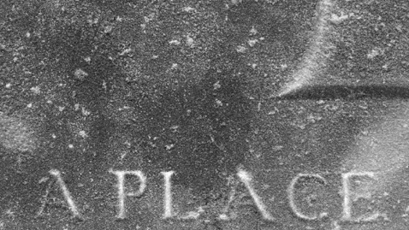

When I was a child, from where we lived a small white temple could be seen far off across the valley. Standing out against the bare Sussex Down land, it was a place of fascination and mystery. For me and my playmates the beacon was a focus of pilgrimage, but attempting to travel there in ignorance and on foot, our destination was always frustrated by unforeseen valleys, barbed wire fences and electricity pylons. In practice, the journey was never as straightforward as we imagined.

We knew this place only as the ‘Chhatri’ or the Indian memorial, and had no real understanding of its significance or the suffering represented by it. Later, I knew it to be the site of cremation for those Indian soldiers of the Commonwealth who served and died during the First World War. The romantic childhood fantasies inspired by the sight of this far off shrine were then linked by me to the Orientalist fantasia of the Royal Pavilion in Brighton which served as a hospital for the wounded Indian troops brought back to England. From here, the dull thuds of shellfire from not much more than a hundred miles away would have reached the ears of the local population.

My grandfather, born in Brighton in 1890 will serve in northern France with the Royal Sussex Regiment from 1914, but it is not known when he was de-mobilized, as no further records can be traced. What is known is that he will go on to marry my grandmother in 1922 and my father will be born in 1923. My grandfather will die in 1931 of complications arising from mustard gas poisoning. Other than a wedding photograph, there will be no further photographs of him, apart from one which shows his face among a crowd at a football match sometime in the 1920s. My father will not speak of his father throughout his life. This is a not uncommon story.

From Sussex, begin in the town of Albert in Picardy, through which countless Allied forces going up the front line in 1916 will march. Albert is a town which by 1914 will already have been rebuilt a number of times, being on the route of successive invasions over the centuries. Largely destroyed in the war, it will again be destroyed in the Second World War and once again be rebuilt. Having suffered industrial decline, by 2016 it will depend for employment on the nearby Airbus factory, services and (mainly British) tourists visiting so called ‘Poppy Country’, the sites of battle and burial in the Somme. Albert is a town largely passed over and passed through. The terraced houses of its small streets are trimmed with lacy curtained windows shielding the interior from exterior view.

IMAGE 2
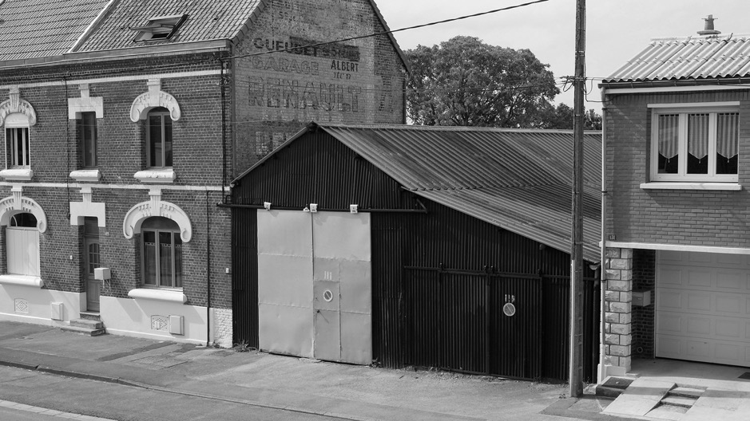
To visit in order to ‘view’ does not guarantee what is seen, or indeed that anything meaningful is seen which challenges ones expectations or understanding. So why do we choose to make a personal physical connection between an historical event and the place in which it happened? As visitors, we may wish to acquire some knowledge of context and facts objectively speaking, but it’s also as if by visiting the memorial site some primitive instinct leads us to make a ritualized link with an event in the past, as if the act of returning and standing on the spot could establish personal connection, and grant some kind of perspective. The connection made may act as a form of closure, or the desire for continuity and secure presence guaranteed by such rituals may become a matter of tradition, a pilgrimage unhesitatingly repeated which reinforces the pre-established narrative as a territory of remembrance. It is also the case that the meanderings of personal memories aroused by visiting the site fuse with the formulations of collective memories and official narratives leading to representations previously un-thought, unspoken, unwritten.

IMAGE 3
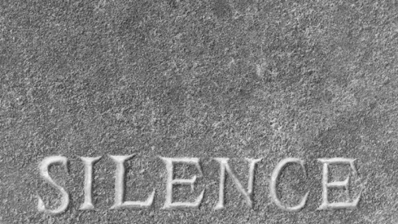

Make a first visit with the arrival of Spring, fertile and green. Roadside signs to the sites are well situated and can be read easily enough. The cemeteries themselves, to the uninformed eye so arbitrarily dotted within the landscape, appear incongruous either in their intimate serenity or their exposed, stark brutality. ROSSIGNOL WOOD. SUNKEN ROAD. OWL TRENCH. Entering each enclosure, there is always a sense of crossing a boundary. The efflorescence of nature creeps up to the external perimeter, ready to reclaim the ground, or else agricultural production spares a few centimeters of bare terrain before the marshalling begins, long ranks of headstones lined up in military formation. GUARDS. QUEENS. GUNNERS.

Walk up and down the lines inspecting each headstone, feeling the imperative to take note of every single inscription, even though this is impossible. The more names are read, the less the imagination is able to make sense of the scale of destruction they represent. The accounting for lives lost piles up as a monstrous accumulation of wasted potential; the repetition of the essential fact is exhausting. While the individual reproduction of each and every headstone with its measured naming of facts and acts intends to emphasize both heroic sacrifice and the folly of war, mass formation acts to dull and abstract, reinforcing a failure of comprehension. There is so much unsaid and unsayable here. Within the retaining walls which demarcate each site as an absence in presence, industrial efficiency and carefully designed spatial geometries monumentalize and petrify.

IMAGE 4
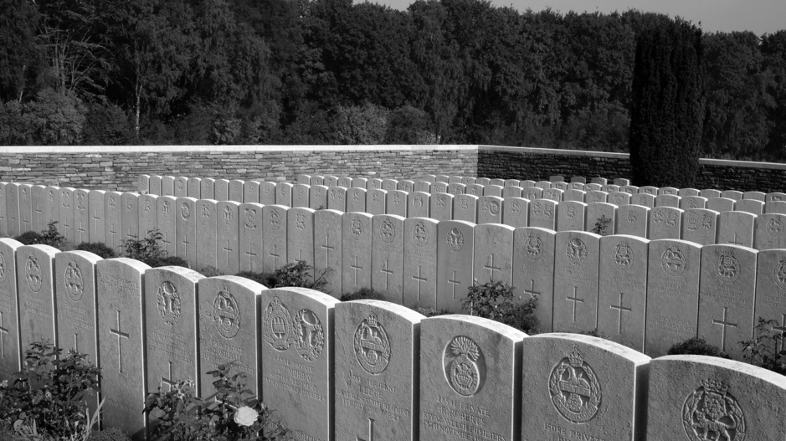

The inability on the part of the army commanders to account for the scale and impact of the damage inflicted by the war in terms of the Somme landscape alone, and to confront the reality they had created, will be voiced by The British Official History at the end of 1916 which confesses it is unable to describe the conditions on the Somme, ‘Our vocabulary is not adapted to describe such an existence, because it is outside experience for which words are normally required.’ (Dakers 171). While the phrase that ‘a sight is beyond words to describe’ is a commonplace, the bureaucratic requirement for such description at the time would raise uncomfortable questions about the purpose of the exercise, and the failure of the official response to acknowledge the human consequences. Indeed, throughout the war, public relations will require censorship and careful composition of any official descriptions. This will be extended to the censorship of soldiers’ letters by their superior officers, of newspaper reports and the banning of photographs taken in the field other than by the official war photographers. Between what is seen and what is pictured lies the unspoken. At the same time, as the war proceeds and the War Graves Commission hastens to identify and mark the sites of the dead, guide maps are already being prepared for the public; by the end of the war commercial guided tours will have been organized not only for the bereaved, but also the curious tourist. Counter narratives by artists and poets will take some time to filter into the public consciousness and there will be a more general public silence for a decade before the mass publication of accounts, memoirs and analyses. In the case of servicemen and women, combatants and non-combatants, this will often last much longer. For many the national patriotic narrative of victory together with the urgent need (both personally and collectively) to rebuild and move on is so powerful that contesting oral narratives of personal experience will struggle to find a context or a willing audience for meaningful expression.

IMAGE 5
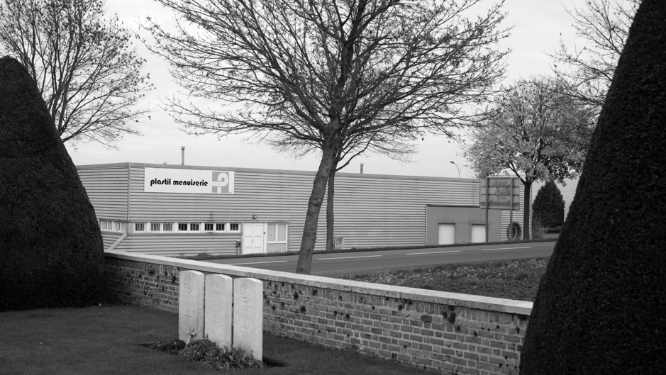
Instead, in the immediate years following the Armistice, such intense patriotic feeling will seek to redeem the damage wrought by the conflict through the commissioned national memorial, transforming destruction into glorious sacrifice. The imperative for collective memorialisation will come to serve the cause of nationalism, provide a focus for individual bereavement and stand in for the lapses that individual and collective memory is subject to over time.

For many, the depth of suffering demands forgetfulness as the only kind way to carry on. Even so, a casual word or arresting sight may trigger the return of the shock and an explosive reaction. For others, to repeat is an unconscious compulsion and there is no rest until the individual trauma is beyond living memory. And living memory is not tied to an individual, the shocks experienced by a single body resonate and are elaborated through all that body subsequently comes into contact with, all it changes and is changed by. And so on.

IMAGE 6
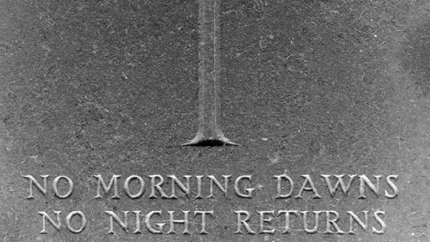

Arrive in the early morning before the tourist bus which deeply scores and churns up the mud of the narrow track. There is always a sense of expectation, and always it is the same and yet different, recognizable yet unrecognizable, as in the recall of a dream. After rain, the sun today burns down upon the exposed hilltop. The morning light already harsh and blinding, stencils carved white stone against the dark bulk of yew hedges. The stillness is oppressive and even the air seems to sweat. Upon leaving, the car wheels thickly encrusted with mud refuse to get a grip. The only way out of this is a long slow reversal some few hundred yards in first gear. The cawing of rooks, the isolation of the spot, the panic of getting stuck so far out and being left behind.

IMAGE 7
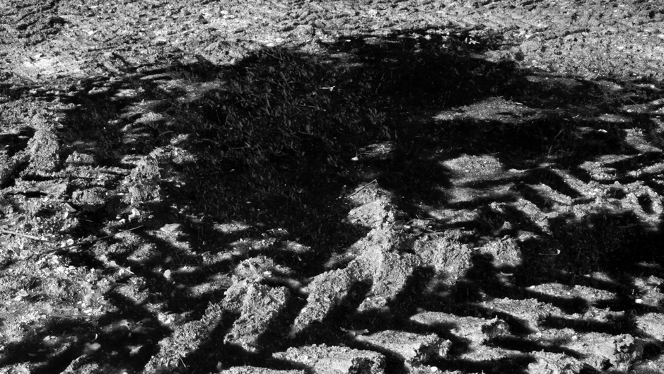

The ambition of the War Graves Commission when planning the cemeteries for the dead will be to give equal recognition to individuals killed - each to be identified as far as is possible by a standardized headstone inscribed with name, rank, regiment number, date of death and age, if known. In the past, most soldiers had been left to die where they fell on the battlefield with no marked grave or formal symbolic recognition with which grieving family and friends could identify. The exercise of making individual headstones, while recognizing the devastating loss of an individual life, is also a consequence of a bureaucratic accounting rationale. The tablet registers the pre-existence of a living body as a textual body, although in many cases the remains of the body are not physically proximate to the headstone. Standard epitaphs will be suggested by the authorities, but if an identification is possible, and the bereaved have the emotional strength, the luxury of education or money, the commission will allow personal epitaphs to be added, subject to censorship. It is these personal epitaphs that interrupt the authority of identification and directly address the visitor today. The design of the type face for inscription will be carefully thought out to allow for maximum legibility of the words at a certain correct distance.

IMAGE 8
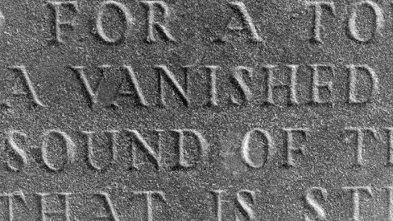

Look outwards for respite, see beyond the cemeteries the intensively worked landscape, knowing that scattered material remnants of the violence still infuse the soil, surfacing over time and dissolving on the air perhaps, or even now finding their way back to an intimacy within our own bodies. Everyday sounds come to the ear, of tractor, the clatter of bicycle and bark of dog. The choking call of a pheasant from the other side of the hooded valley disturbs the air. Sounds travel far, such is the scope of the space. But within the boundary of the cemeteries there is always an atmosphere of silence.

IMAGE 9
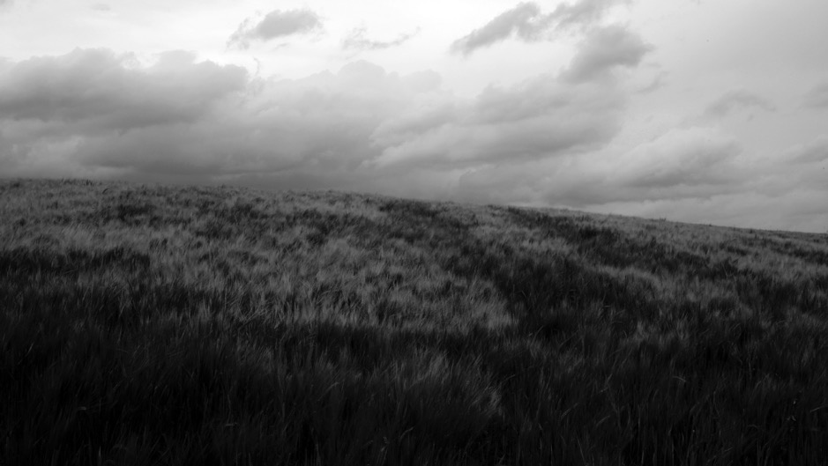
Walk. Some walks lead to dead ends, or peter out. Some walks arrive abruptly, others lose themselves in the walking. The more it is walked, the more the landscape seems to complicate. New folds and wrinkles in the contours of the land open up as day by day the sunlight falls differently, as plants flower and die, as crops are harvested and carried away. The lie of the land expands and contracts under the immense and indifferent skies. The seasonal elements and the routines of agriculture are the only things that remain common to one hundred years ago. Are the horizon’s curves even the same? While the wind cuts across the plateaus and snags in the valleys, rain whips and sun dessicates, so the earth shifts or is shifted, dust settles incrementally.

IMAGE 10
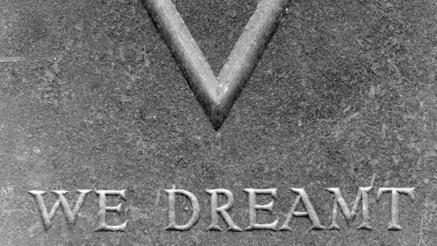
At the onset of war in 1914, West Indians from the Caribbean will volunteer to serve and many will pay their own sea passage across the Atlantic to Britain. Many serve as labourers being considered unfit to serve in battle. On arrival, between late October 1914 and the end of January 1915, poor billeting conditions on the South Downs at Newhaven and the harshness of the English weather will lead to the death of nineteen men. Their lives cut off in the alien climate of England, they will not make it to the Somme battlefield or to any other. One hundred years later on a bright autumn day in 2015, my father and I will visit the cemetery in the small Sussex town of Seaford where they are buried, and read the inscriptions on the headstones. FEVRIER DENNIS. FEVRIER NELSON. Many of these headstones give no indication of age, the names alone giving some indication of the lonely distance travelled.

IMAGE 11
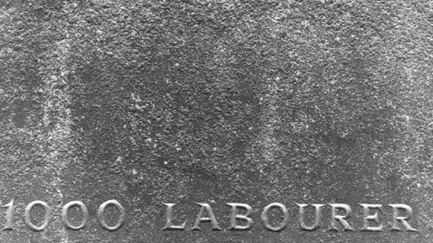

Join the commemoration ceremony in the cemetery outside the town. Another Autumn, another grey, still day. The town brass band strikes up and the notes seem to palpably vibrate in the air in preparation for the lingering silence which follows. The interval allows the fullness of the present to percolate. A murmuring withdrawal leads to a carnivalesque procession through the town streets, the walls echoing to exuberant music and barking dogs. The cafes are full. The hills and woods beyond resound with the shots of the annual Chasse.

IMAGE 12
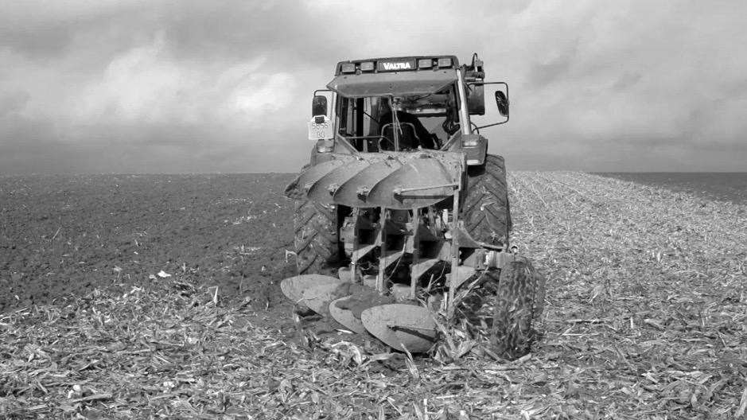
Watch, listen, feel the radiance of light upon the body and the movement of things. Wait for a lorry blocking the track to be loaded with mangolds. It is unusual to come into contact with local inhabitants here. So watch, listen, wait. After the lorry has departed, receive unasked for from the farmer, the rusted fuse of a bombshell. An unwelcome souvenir. The shock of the object lodges itself in the otherwise unremarkable event as a disturbance to the banality of everyday routine, a troubling gift which reinforces knowledge of the landscape as a territory subject to violence.

IMAGE 13
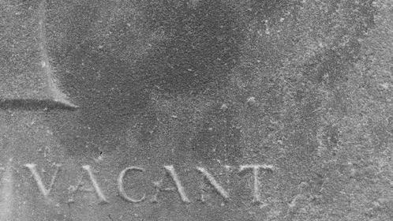

Paul Fussell writes on the ritual of the morning and evening stand-to in the trenches:
‘Twice a day everyone stared silently across the wasteland at the enemy’s hiding places and considered how to act if a field –gray line suddenly appeared…Twice a day everyone enacted this ritual of alert defense that served to dramatize what he was in the trench for and that couldn’t help emphasizing the impossibility of escape.’ (Fussell 55)

And Freud remarks in ‘Reflections Upon War and Death’:

‘Our own death is indeed, unimaginable, and whenever we make the attempt to imagine it we can perceive that we really survive as spectators’. (Freud 122)

That is, it is a scene from which we are excluded.

Take the track up to the brow of the hill, where the professional storytellers gather. The scene, so overpowered by its framing as a ‘theatre of war’, that the spectator is inevitably drawn to position herself on the threshold (or parapet) gazing upon a distant prospect. The horizon an impossible limit and the space between here and there a no man’s land, void of meaning because of the potential horror it holds. It is the framing at a distance which holds the scene together and which makes the apprehension of this void possible.

IMAGE 14
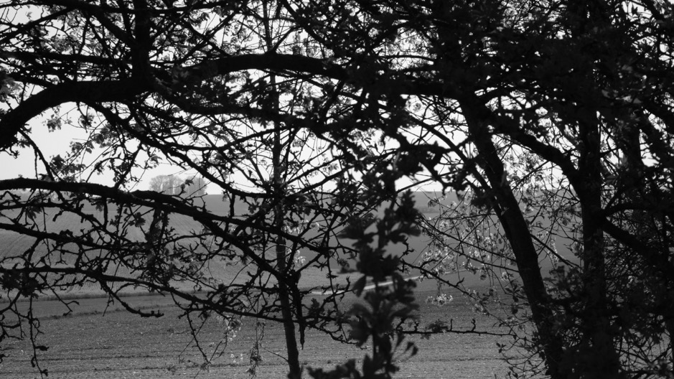

A common experience of people caught up in threatening or dramatic events is one of detachment, as if watching a film, and the First World War was the first war in which photographic media was fully embedded in its planning, execution and dissemination. The industrialized production and circulation of film and photographic footage constructed a specific image of war for consumption by the population at home, and also for the combatants themselves, theatricalizing and spectacularizing it as if they were outside the event. On the fiftieth anniversary of the Great War in 1968 my grandmother and I on our walk over the Downs at Ovingdean come across a staged film set, a swathe of white crosses spread over the familiar hillside, strangely placed, and to my uncomprehending eyes simply an impressively cross stitched pattern upon the green. A photograph taken at Shoreham Docks, 1917: my great-grandmother stands amongst a group of women working for the war effort. Grim, unsmiling faces. A network of contradictory images collide.

IMAGE 15
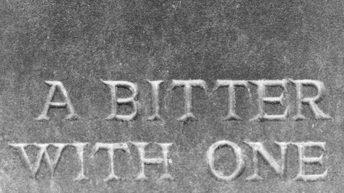

At home, revisit the video recordings. They show empty roads spinning out to the horizon, shadowed copse lined valleys, an urban street, cows in a field, smoke from a factory, no signs of drama, no hidden stories waiting to be told. Only the ongoing present…

IMAGE 16
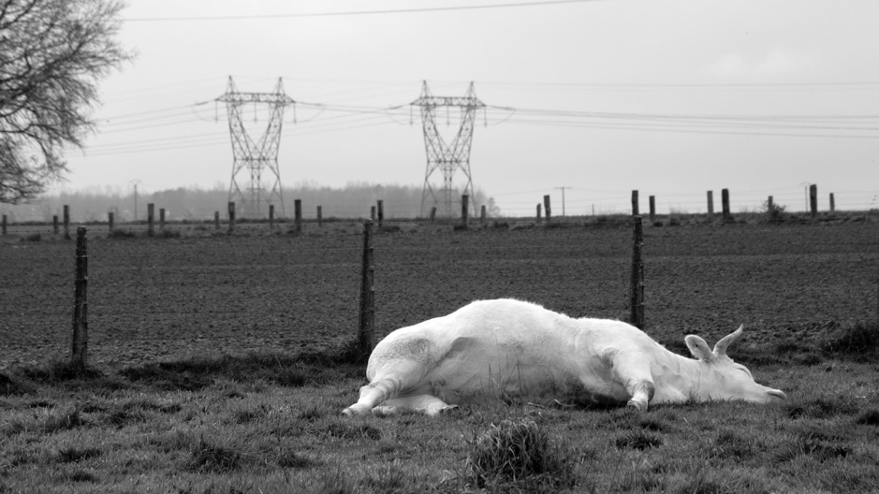

Take up a position in the open, visible to all. Wait, look, listen. Leaves are falling fast from the trees. The leaf gathering machines have fallen silent during the workers’ lunch break. Stand apart from the camera which is recording a play of light and dark of variable intensities, an interval open to the contingencies of a world in motion, to the porosity of time. While there is nothing to see here of what was once known as Devils Wood, another wood has grown in its place. Here both is, and is not, there.

IMAGE 17
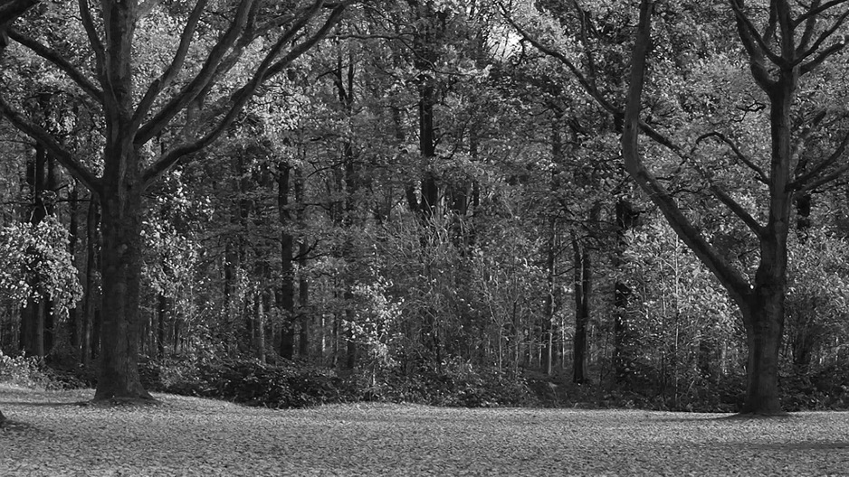

Words appear as images formed by light grazing the surface of an engraved headstone. The reflected light surface and shadowed cut of the engraving converge at a moment in time defined chronologically according to the passage of the sun. Legibility depends upon surface incised to a predetermined, precise depth and angle so as to harness the sun’s rays. The word ‘shadows’ shadows its own presence as a series of letters cast in shadow by the sun’s progress across the tablet. An infinite number of shadows are possible. As light fluctuates so does the clarity of the word.

IMAGE 18

The public memorial inscription, born of an archaic impulse to conserve and project a future, acts as a mark of time’s distance. While the inscription operates through an expectation of material endurance, on the surface of the headstones, some pockmarked with myriad fossils, the once exacting legibility of the engraving is gradually eroded as the force of the elements work their own way into the etched stone surfaces, scouring, scorching and blurring the keenness of edges, undoing what has been done.

IMAGE 19
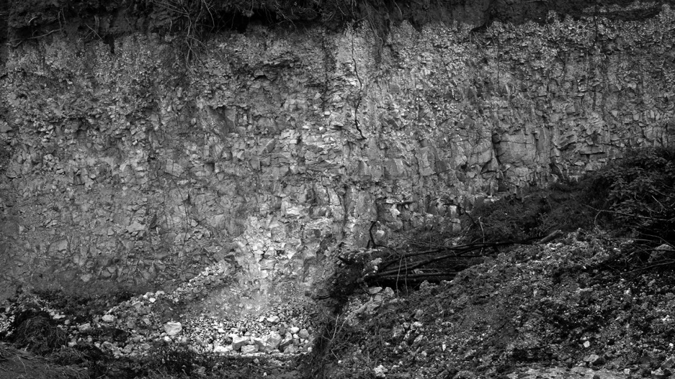

Stop. Go back. A site keeps returning as a memory, but it is hard to place on a map. Return along winding, anonymous roads. Eventually, in poor light, the spot is recognized. The ground has fallen away abruptly to form what may have been a quarry or otherwise excavated ground and a heap of spoiled crops lie rotting in the shade of the low cliff. A green pool has gathered in the depression of the ground. There is no good reason to stay here apart from an inner compulsion to see again the sheared off face of the chalk cliff, its fissures and seams run through with streaks of minerals and soil cascading down. It hangs there, unexplained, an uncanny presence.

IMAGE 20
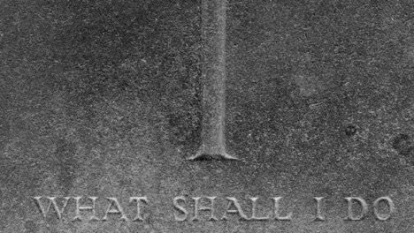

In the exposed fields and the Commonwealth War Graves engraving factory at Arras, the cycle of inscription and re-inscription of headstones goes on. The work stretches on into an unclear future. Patiently carved and re-carved both by human hand and programmed cutter, an existence is hollowed out of the stone as the drill with precise delicacy cuts a curving line here, a full stop there. There is always space for EIN UNBEKANNTER. The pressure of the touch must be just so to achieve the shape of the movement and so it is in the cut of the letter that the force of the signifier is felt. This is careful work, time taken, energy expended. The nature of the stone gives it resistance, while yielding to pressure, and the letter cuts both ways, becoming through resistance at the same time as giving way. The invisible is made visible before fading, and re-inscribed, never returns identically. Rather, each act of re-inscription while recalling something of the one before, re-marks anew in its materialization. In this process the force of inscription gains its power not simply through mechanized instrumentality, an effort to resuscitate the past through naming, but in the movement of the incision spelling out remembrance as temporal trace in and of the present opening onto the future. In its reading and interpretation, the word is both itself and other than itself, both speaking and silent.

IMAGE 21
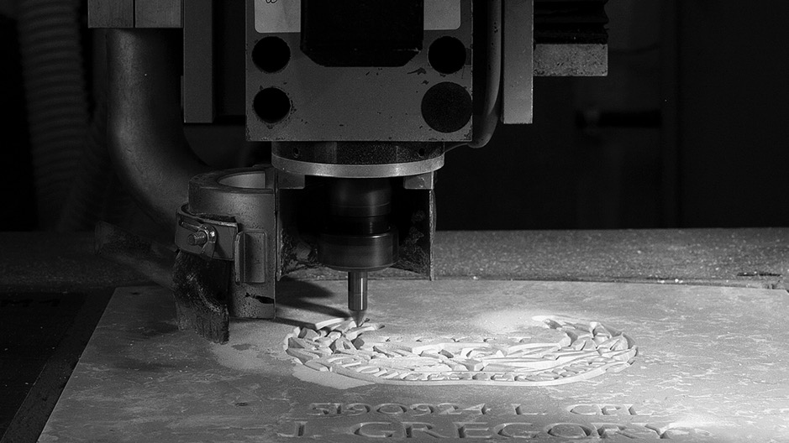

In the almost Spring of 2017 I will stand on the edge of a South Downs grave to scatter a handful of sand upon the lowered coffin. As I do so, I lean forward and see the steep chiseled sides of the grave carved out of solid chalk, the compressed fossils of billions of sea creatures. The question of inscription lies open.

5275

Notes ‘UNFOUND’ the film (2016) was commissioned by Diaphane.org. The publication ‘UNFOUND’ with downloadable DVD version of the film is available from Diaphane Editions, www.diaphane-editions.com; info@diaphane.org. The sound and image recordings for the film were made during site visits to the Somme area between July and November 2016, dates which mark the commencement and cessation of the first Battle of the Somme in 1916.
‘Together with patience, the nation must be taught to bear losses. No amount of skill on the part of the higher commanders, no training, however good, on the part of officers and men, no superiority, however great, of arms and ammunition, will enable victories to be won without the sacrifice of men's lives…Three years of war and the loss of one-tenth of the manhood of the nation is not too great a price to pay in so great a cause.’ A letter sent to the editors of the main British newspapers by Sir Douglas Haig, May1916.www.nationalarchives.gov.uk/education/greatwar/transcript/g4cs3s1t.html (Catalogue ref: WO 256/10) (Catalogue ref: WO 256/10)
Sikh and Hindu soldiers who died in the Brighton military hospitals were cremated at a remote site on the Downs just outside Brighton. The Chhatri (memorial) on the site was unveiled by the Prince of Wales on February 21, 1921. Brighton and Hove Black History booklet http://www.blackhistory.org.uk/projects/black- and-asian-soldiers-during-ww1/ (accessed 21 September 2016). For an analysis of the Chhatri as a reworked and transformed site of remembrance from a post-colonial perspective, see Ashley (2016).
The Royal Pavilion was one of several military hospitals in Brighton, Sussex. It was converted to care for wounded Indian soldiers brought back from the Front. www.http://brightonmuseums.org.uk/royalpavilion/history/ww1-and-the-royal-pavilion/ (accessed 21 September 2016).
For just a few well known examples of the explosion of what has come to be known as the field of memory studies, see: Halbwachs, Maurice. ‘On Collective Memory’ (1992) which concerns the interdependence of individual and collective memory; for an examination of the myriad forms of contemporary historical consciousness see Lowenthal, David. ‘The Past is a Foreign Country’ (1985) and Lowenthal, David. ‘The Past is a Foreign Country Revisited’ (2015); for investigation of the importance of unofficial, popular memories of the past in the construction of history see Raphael, Samuel. ‘Theatres of Memory’ (1994).
By 1918, the tourist industry had already begun to organize tours of the battlefields of Northern France. Michelin, which manufactured tyres and road maps, published its first Illustrated Michelin Guide to the Battlefields series in 1919. Murphy (2015). Thomas Cook started organizing trips from 1919 onwards.
For example, the Welsh artist David Jones’ prose poem In Parenthesis, is a personal account of his experiences serving in the Somme and Ypres 1915 - 16. It is an example of the recounting of experience through use of the vernacular as well as standard English interweaving a complex pattern of mythological and literary war references into the narrative structure of the contemporary war. Jones (1937).
Marc Auge in his book Oblivion argues that the beauty of the great military cemeteries arouses an emotion ‘born from the harmony of forms, from the impressive spectacle of the army of the dead immobilized in the white crosses standing at attention’ and that the ‘vanished evidence’ cannot be found ‘except on condition of forgetting the geometric splendor of the great military cemeteries…’ . What this ‘vanished evidence’ might be and how it might become visible, is unclear; Auge’s argument is concerned with the necessity of forgetting in the constitution and exercise of memory. (83).
The font is copyright of Commonwealth War Graves Commission. It was designed by McDonald Gill, brother of Eric Gill. 10The War Office initially tried to discourage men from the Caribbean enlisting, were reluctant to allow them to engage in actual combat and even threatened to repatriate them until the intervention of King Edward V who insisted that Caribbean soldiers should be formed into the British West Indian Regiment, a number of whose battalions served in France and Flanders (Bourne 65).The 1st British West Indian Battalion was formed at Seaford, East Sussex in September 1915. The British Expeditionary force was heavily dependent upon labour forces recruited from the Commonwealth and China to undertake maintenance, transport and construction work and after the war clear the battlefields and re-inter the dead. Near Arras in the Pas-de- Calais is situated Ayette Indian and Chinese cemetery containing soldiers and labourers, some named and some identified by number only.
For an overview of developments in photographic recording of the war see: Roberts, Hilary. ‘Photography’ 1914-1918-online. International Encyclopaedia of the First World War, edited by Ute Daniel, Peter Gatrell, Oliver Janz, Heather Jones, Jennifer Keene, Alan Kramer and Bill Nasson. Translated by Reid, Christopher. Issued by Freie Universitat Berlin, Berlin 2014 -10-08. DOI: 10.15463/ie1418.666. (accessed 29 November 2016).
The most famous example is ‘The Battle of the Somme’ released on 10th August 1916, only a few weeks after the beginning of the battle. The Observer newspaper reported on its attraction to serving soldiers as well as the general population: ‘So great has been the public interest in the British official pictures of “The Battle of the Somme” and the French series entitled “The Offensive on the Somme”, that the management of the Polytechnic Hall, Regent-street, has decided to continue the exhibition of the films indefinitely. Wounded soldiers are specially invited, and any hospital may secure reserved seats for the evening displays. Numbers of wounded soldiers frequently come to view scenes in which they themselves have taken part…The absorption with which the soldiers from the military hospitals watch the stirring scenes in which their own regiments and comrades took part testify that they are living over again the most intense moments of their lives.’ The Observer, 24 September 1916.
The scene we gazed upon was the set for the closing sequence of “Oh! What A Lovely War” dir. Richard Attenborough (1969). This satirical musical film of the First World War, based upon the original 1963 stage production, was filmed largely in the environs of Brighton and the Sussex Downs. In re-constructing the site of death ‘back home’ in the form of a memorial, it was not only a work critical of the war; in sealing a gap between ‘here’ and ‘there’, this scene acted as a form of redemption in the cause of national identity. The landscape of the Sussex Downs repeatedly served as an icon of British (English) identity and patriotism during WW1 and WW2.
‘Devil’s Wood’ is the name given to the wood by the soldiers who fought there, it is otherwise known as Delville Wood. It was the scene of fierce fighting during July 1916, leading to very high numbers of casualties and leaving almost no tree standing. Since then a wood has been re-established in its place. Delville Wood is a cemetery without marked graves.
English translation: ‘UNKNOWN’.

