Fashion, Sustainability and Luxury: an interplay through design.

Abstract

A discourse in sustainability, applied through fashion in the context of luxury involves a lexicon with emotional and rational descriptors. Its premise concerns our ability to live well with each other in our only home, nature. The study of sustainability crosses scientific, art, design and humanities disciplines, whilst fashion, a discipline in its own right, also draws on diverse domains of study. Fashion represents a distinctive trait of being human, our ability to form individual expressions, make social connections and construct infrastructures in society in material and economic Luxury signifies that which is rare and exquisite. It is a subject of study relevant to a number of disciplines, as its explores a socially, environmentally, economically and culturally bound set of ideas and objects.

The interplay of sustainability, fashion and luxury is contingent on our perceptions and intentions. This plays out in culture, business practice and education, shaping and responding to the conditions of life. This chapter explores ways in which design as problem-solving and possibility creating can navigate this interplay. It considers what luxury-fashion might look like when viewed through a sustainability lens, drawing on examples mapped across points of change in the fashion system. As we dig deeper into nature’s most precious elements and flagrantly cross human and planetary boundaries, this research indicates ways in which design as problem solving and possibility creating can contribute to the meta contemporary challenge; one of realizing co-operation between people in nature. The micro scale of this research draws on findings gathered through a partnership between researchers at Centre for Sustainable Fashion, a University of the Arts, London research centre (CSF), students at London College of Fashion (LCF) and sustainability team members at Kering, a world leading luxury fashion company, home to the design houses of Gucci, Stella McCartney, Bottega Veneta, St Laurent and other luxury associated names.

Introduction

‘the real act of discovery consists not in finding new lands, but in seeing with new eyes.’
Marcel Proust

The Anthropoceneis the increasingly recognized term used to describe our current ecological epoch. It is defined by the significant impact that our human activities are having on the earth’s geology, ecosystems, and climate change. It names humans as home wreakers, through our actions as citizens, communities, industries, governments and societies, destroying vital elements of the earth, the (only) place where we reside.

This is not news. Over the centuries, our relationship with nature has been a focus of artists, philosophers, scientists, religious spokespeople and every-day conversations. Since the Industrial Revolution, these messages have turned increasingly towards outright concern. These accounts include poets and storytellers such as Christina Rossetti in writing Hurt no Living Thing and Dr Seuss’ Lorax who speaks for the trees. They are joined by activists and scientists, such as John Muir founder of the Sierra Club and Rachel Carson in writing Silent Spring. These voices celebrate and question our relationships in nature. Fashion, as artistic, cultural, social and livelihood practice, has been a part of this dialogue. The Fur, Fin and Feather Folk (1889) forerunners to the Royal Society of the Protection of Birds (RSPB), published postcards and pamphlets as well as staging anti-feather protests with placards, in the late nineteenth century.
Recent revelations of scientists including Rockstrom et al show that planet earth has boundaries, which we are trampling over. The agreed consensus on climate change in scientific terms is, however, yet to reach a social consensus. How we live is out of synchronicity with what we know. The earth has been absorbing our actions, but we are on a knife edge of climate change and deepening social inequality, in the words of singer-songwriter Marvin Gaye, we need to ask, What’s Going On?

We are hitting the environmental ceiling of a safe operating space for humanity, the concentration of CO2 in the atmosphere, ocean acidification and the stratospheric ozone are already at danger level, and other boundaries are close to being crossed too. In the last 50 years, we have moved from the conditions of 10,000 years of the Holocene, plunging ourselves deep into the Anthropocene. What we do in the next 50 years, will determine life on earth for the next 10,000 years. This stark revelation and Gaye’s question summons more philosophical than scientific considerations of what we are doing and have done and how we define progress and success, as individuals, communities and societies. Fashion is a vivid means for us to play out these interactions as what we make and wear shapes and responds to personal and collective intentions and perceptions in vital and substantial ways.

Problem solving and Possibility realizing

The dominant response to the recognized current state of things is to consider what is happening in nature as a problem that needs fixing. Many of us enjoy a role as problem-solvers and indeed professional designers are recognized for such capabilities. It is no surprise then, that designers, of fashion, buildings, transport and the design discipline at large, are being called upon to develop innovative ideas to solve the problem of the Anthropocene. Designers (amongst others) are challenged to find ways to keep within agreed temperature rise limits whilst breaking records in terms of recognized factors of economic success. In response, groundbreaking ideas are being designed and applied, thanks to a range of calls to action through government funding, industry led competitions, educational initiatives and localized community action.

Designers however are uniquely poised to both problem-solve and also possibility realise. The former tending towards a technical-rational approach to evolve forward from where we are, the latter opens a broader critical consideration of transformation design based on an imagining of other ways of living. This involves alternative ways of seeing the world and of seeing the cause and effect of our interactions within it.

These two approaches, might initially appear to be at odds with one another, seeking different goals and engaging different kinds of thinking:

One pursues sustainable development, tangible, efficient, time-bound actions, predominantly using a model of problem solving that is defined by consumption, based on a world view that the economy is at the heart of things.

The other pursues prosperity as our ability to live well with each other within nature’s boundaries, using a model of possibility realising that is based on a world view that nature is at the heart of things.

At present, there is a lack of balance between the former, seemingly most doable approach and the latter, not widely recognized one. Each relate to profoundly felt beliefs and aspirations. Each holds most value when accompanied by the other. This necessitates a two-way listening and learning between these approaches, to recognize their relational contribution to sustainability. There is a need to develop ways in which those working within deeply entrenched systems of production and consumption, learn from those who are outside of some of those systems and vice versa. Such a discourse involves co-learning between those who pursue an approach that is based on a taking on of nature, an often techno-centric approach to sustainability and those who pursue a more eco-centric approach. Great thinkers sit in both domains, but the consumption led dominance of most business and government agendas foregrounds the techno-centric, leaving little space to imagine other goals.

The scientific method is a pattern of problem-solving behavior employed in finding out the nature of what exists, whereas the design method is a pattern of behavior employed in inventing things of value, which do not yet exist.
Gregory

The kind of co-operation necessary in 21st century is far beyond anything that our species has ever before accomplished. I suggest that this is the greatest challenge and possibility of our times.
Fashion, as an element of each of our personal lives and millions of professional lives, involves activities and relationships where our intentions can be delightfully and impactfully played out. For fashion design therefore, the challenge becomes – how do we solve problems and create possibilities that can collectively help us to live well together in nature?

Design for Sustainability

Questions of intention and action in nature are a subject of enquiry in the burgeoning field of Design for Sustainability. Its characterization of design as a mode of social, economic, cultural and environmental change, draws on an extensive tradition of design, with scholars such as Victor Papanek, Nigel Cross, Ivan Illich and Stuart Walker drawing attention to design as a process of re-consideration of the present as part of the creation of shared futures.

Such reflexive design practices often involve a critical consideration of the western-modernist foundations of design and its power dynamics, realized though material product creation and its determining effects on society and nature. Design relates to what we have, what we do, and how we think about things. This is exemplified in Manzini and Margolin’s recent open letter to the design community: Stand up for Democracy, asking for responses relating to design of, for, in and as democracy in our now difficult and dangerous times.

Designers are frequently asked to solve urgent problems by looking inwards, to focus on an existing product or service and to make it better, lighter, leaner. Design for Sustainability asks thorny questions about what we think, believe and hope for, questions that designers are not often asked. It looks holistically at the connections between things, as well as inwards at the details within product parts.

Inward-looking problem-solving often takes a path of technical or technological innovation, relating to the materials used in a product, or in the mechanism of a product itself. This can yield quantifiable and impressive results, water saved, waste diverted from landfill and harmful chemicals banned from production. But, as John Thackara, in his lecture at the Design Museum, looked round the room and simply asked; what do we want to sustain? If the answer is earth’s systems as a whole, then we must look simultaneously inwards and outwards in the process of design.

Fashion Design for Sustainability

Fashion design for sustainability is becoming an increasingly recognized discipline in its own right. Since its conception in 2008, is has been the focus of research at Centre for Sustainable Fashion, (CSF) where a community of designers, researchers, tutors, students and industry practitioners explore ways for fashion to contribute to sustainability in cultural, environmental, social and economic terms.

Fashion plays a significant part in creating and enabling infrastructures of business and society through relationships, skills and materials relating to the body. Fashion is an indicator of our times, lives and locations. Its current manifestations of progress predominantly involve garments that are perceived as of little sustained value, whilst increasing our precariousness and exacerbating inequality. What we are currently saying about ourselves through our clothes might be viewed in historical terms as out of step, lacking trait, following a mantra of wanting more, now, without thought for the implications of our decisions, the future or even our own real prosperity. It might be said sustainability can be a means to revive fashion in its role in adorning our bodies in ways that celebrate who we are, what we know and what is of value.

Within fashion and sustainability, problem solving and possibility creating can exist at a range of scales. The limelight is often at product and process level, reducing environmental strain per garment. For large businesses, going beyond a change within product specification does not feel like an option, as the well-established system of consumption based success, is what many livelihoods rely upon and many stakeholders take a keen interest in. To realize possibilities of growth in human and nature-based wellbeing in qualitative rather than quantitative terms, would seem, in the eyes of many as falling back, as everyone else around grows apace. However, improvements in product technology and product service systems without changes in the goals of the system are taking us down a path of diminishing returns, an ultimate dead-end. As production gets leaner, whilst continuing to increase in size, so the system becomes increasingly vulnerable and overall increase in output still means that impacts continue to rise. Those who are broadening out their gaze to include what moves us as people as well as economically are wrestling with less tangible measures of success, but it is here that opportunities to transform the fashion system abound.

Through a revised set of fashion design methods, based on sustainability principles and fashion related considerations, new iterations of transformation design, social design and participatory practice can foster co-operation between people within fashion’s professional and citizen practices.

Luxury as context and application

The design houses within Kering include some of fashion’s highest profile luxury related processes, skills, materials and products. Luxury becomes, therefore, a distinctive element of the context and place of application of ideas in the Kering-CSF partnership. By applying our exploration to the subject of luxury, we can facilitate enquiry that explores what we value through what we have, what we do, and how we think about things. This context conscious design process is applied to the exploration of

- Ideas about what is recognized as aspirational
- How luxury fashion could evolve both within and outside its current system

‘Rethinking luxury is a necessity to adapt to our changing world while responding to the concerns of new generations of luxury clients.
Marie-Claire Daveu, Chief Sustainability Officer, Kering 2025 Sustainability Strategy

Luxury, at its root, describes that which is rare and exquisite. Ideas and objects of luxury are socially, environmentally, economically and culturally interpreted by each generation, according to what is considered to be of great value in a particular period. These interpretations are influenced by the dominant social and cultural beliefs of a time.

Luxury isn't just a question of expensive and beautiful things - it feeds into ideas about democracy, patriotism, social harmony, our values and our relationships with the divine.
Dr. Michael Scott

This expansive description of luxury and its changing recognition over a long time span, from the Greeks to modern day, is further described by Scott. The Greeks and Romans saw luxury as a barometer of social status and virtue, however, by the Middle Ages, it had become pejorative, indicating lustful self-indulgence that could damage your soul. The Industrial Revolution later provided access to a range of aspirational items, previously far from reach, for a wider proportion of the population. This heralded the means for luxury to break through class barriers. The manufacture of textiles produced a broadening of the scope of what could be made and worn. Over the centuries, luxury has come to be recognized as purposeful artistic endeavor towards the creating of something of beauty, through time and skill applied and dedicated to its intended audience. It has also been described in more rational terms, as exemplified in the prescriptive Animal Products list in the 1851 exhibition, where luxury is listed in terms of productions, industrial resources, manufactures and commerce of all countries.

The business of luxury involves the production of exceptional objects, which demonstrate an extraordinary investment in time, quality of materials and skills in making. Through the author’s discourse with a wide group of academics, students and luxury industry luminaries, over the course of the CSF/ Kering partnership to date, luxury fashion items have been broadly described in relation to

place (where something is made, or a significant item/ experience-related event takes place)
contents (processes, skills and materials involved)
rarity (irreplaceable nature of the item/ experience- not necessarily that a few only were made)
intention (what it seeks to achieve)
integrity (how hard has it tried to achieve its aims and dealt with unintended consequences that might occur through its existence)

These personal reflections identify re-curing themes in presentations and semi-structured conversations. Looking around us, however, we can see, firsthand, that luxury has become unhooked from these descriptions. It has been commoditized, and the word used as an adjective to describe all manner of goods and services.. The relatively recent trouncing of some of the inherent characteristics of luxury - the time-honed skills, processes and dedicated intent to honor all of the elements involved in its creation and enjoyment - has hollowed luxury out, leaving only a packaged sales descriptor. In fashion, luxury apparently spans mass produced plastic key rings to a bark tanned, hand-made bag. What we want to sustain, is demonstrated through what we seek, make, wear and laud in terms of luxury fashion. So what does this idea that success is based on consumption, with little regard to the quality of what is being consumed reveal about the goals and aspirations of 21st century societies? Ideas about luxury can be an held by everyone. In re-thinking luxury fashion, we need to ask ourselves and each other about what we hold as precious and what we really want to sustain.

Luxury, fashion and sustainability

In order to explore a multi-faceted problem solving and possibility creating approach to sustainability and fashion design, researchers at CSF and sustainability team leaders at Kering, have developed a distinctive academia-industry partnership. This is a collaboration built on mutual learning, curiosity in each other’s work and a hope to create positive change together.

Kering and CSF acknowledge that our current student-design community represent the citizens and professional designers of the future. The partnership involves a joint commitment to help cultivate the skills, creativity and imagination that are critical in evolving and transforming the business of fashion towards sustainability. In the words of Kering’s Chairman and Chief Executive Officer, Francois-Henri Pinault,

‘We will look to the next generation, to you, for new, inspired ideas and solutions to embed sustainability in our products and throughout our supply chains. Your skills and creativity in merging business, design and sustainability will be essential to move the industry forward because the business model of the future must be one that is sustainable.’

François-Henri Pinault, October 2014 at London College of Fashion (LCF)

Through the co-creation and co-delivery of an educational programme, students at LCF, engage in a values-led and knowledge-based Fashion Design for Sustainability discourse with researchers and industry practitioners. This involves a material and process led problem solving of the challenges inherent in the current fashion system, cross-referenced with a participatory design led creation of possibilities for a fashion system that places nature, its human, animal and plant life, at the heart of its economy. Through action research carried out alongside the programme, data gathered has been analysed to identify ways in which this dual approach to design manifests itself. The findings have been mapped across locations of change in the fashion system. Previously published research from this project, also led by this chapter’s author, focuses on competencies for sustainability literate fashion graduates capable of creating change within and of the fashion system. This chapter, by contrast, demonstrates interventions that this dual problem-solving and possibility creating approach to design has produced towards change within and beyond fashion’s currently recognized practices.

The partnership contains two foundational cornerstones:
- Co-created MA course curriculum: to nurture talented fashion professionals capable of sustainability led innovation that can change the fashion industry
- Mentoring and Awards at BA and MA levels: to identify students who can respond to sustainability challenges faced by Kering and their design houses and through them, to develop a generation of sustainability led innovators.

The substance of the programme is as follows:
- Co-created curriculum based on seven Pedagogic Principles for Fashion Education for Sustainability (futures thinking, critical and creative thinking, participation and participatory learning, systematic thinking, interdisciplinarity, informed decision making and place-based learning) It is delivered over a 15-week period as a credit bearing MA course module.
- The awards programme is based on problem-based briefs set by two of Kering’s luxury design houses and CSF researchers each year. The team identifies and mentors students in the design, business and media schools at LCF over a 6-month period.

The aims of the programme are to:
- inform and inspire students to develop new imaginative and innovative practices in fashion relevant in a global context.
- enable students to innovate, engage in developmental processes and form collaborative working practices.

Over the first three years of the partnership, students from a total of 17 different Masters courses, have undertaken the co-created course, which has attracted almost 500 applications for the 40 places per year. Over the same time period, the awards programme has attracted 1050 initial registrations, 235 reaching full application stage with shortlisted students representing 31 different courses. Those reaching the final stage qualify for one of two awards, either fixed term paid roles within one of Kering’s design houses, or a bursary to enable further development of the project.

Thematic Review
A thematic review of curriculum and awards student submissions has been carried out of submissions presented during a three-year period 2014-7, based on a sample of fifty student projects. Project analysis explored subject focus, from material to culture making and intervention in terms of scale, from decisions about sourcing of a specific element within a product, to communicating values and beliefs. Findings were grouped to form vignettes, grouped into five areas and documented in percentage terms to evidence the relative occurrence of each type of project (fig 1
The findings evidence that developmental work in the area of materials and processes forms the largest percentage (30%) of the submissions. There is however, a broad range of projects populating the five themes that span change in relation to the contents, construction, economies, infrastructures and cultural understanding of luxury fashion through a sustainability lens.
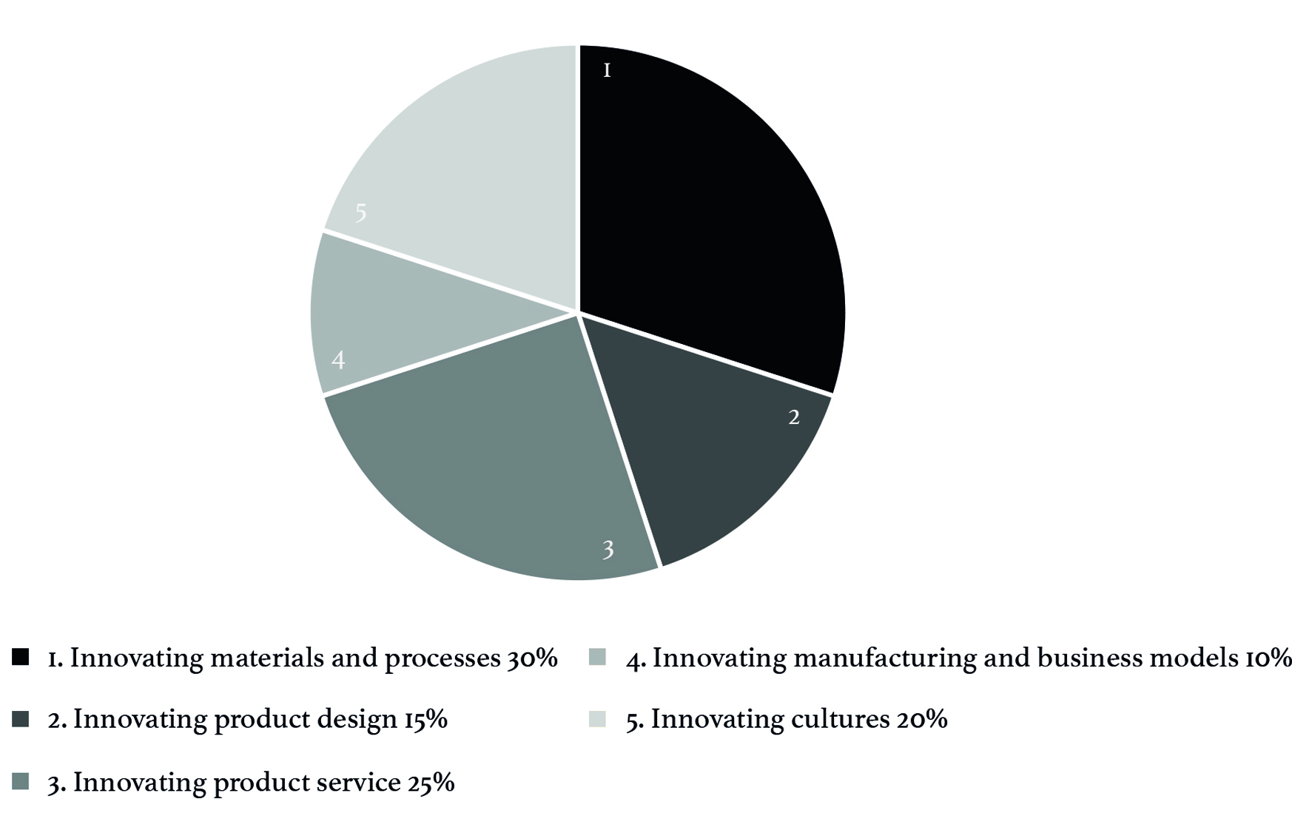
Fig.1 Emerging themes

Innovating materials and processes forms the largest proportion (30%) of projects, with a diverse range of sourcing locations, from the ocean to the kitchen. The types of materials being developed range from a revision of core fashion materials such as leather, through to experimental new material forms and materials that have not previously been applied to fashion. In each case, the application of the material is considered in product terms. The intentions behind these innovations range from resourceful mindsets, saving unused parts of precious skins and other luxury materials from being swept into the bin, to procuring discarded resources from other industries.

One example, an Awards’ finalist’s work, explores the development of apple pulp from British orchards into a material form. This developing of unused elements of food into luxury material demonstrates resourcefulness and cross industry collaboration.

Another project explores a material means for the wearer to contribute to a carbon-neutral lifestyle, (fig 2) through conceptualizing a product using material that grows, absorbing CO2 and producing oxygen in the process.

Fig.2 Dianjen Lin, Winner Stella McCartney Award

These projects seek to solve problems of diminishing resources, waste and emissions whilst also contributing to the distinction of luxury as a valuing of precious resources, looking towards ways in which luxury might become more synonymous with sustainability.

Innovating product design projects consider value in terms of silhouette, aesthetics, ergonomics, feasibility and viability of products in sustainability terms. Examples include an extending of a product’s life, through initial design and / or through in use design adaptations, often involving the customer.

At the vintage clinic a piece is assessed, renovated or otherwise repaired for a continued active life, raising its potential re-sale price and extending the value of the piece.
Another project takes an iconic luxury style (a leather luggage item) and develops a design for adaptability approach to enable worn elements of the piece to be replaced, rather than the entire piece becoming redundant. ‘Worn’ here is defined in both visible material deterioration terms and also in perception terms, where a colour or design no longer fits in or appears pleasing due to other stylistic elements of change happening around it.

Whilst a much smaller category than materials and processes (15%) these projects involve design considerations relating to land use and biodiversity loss, waste and consumption. They also consider the integrity of luxury in terms of time spent in making, caring and useful life of products.

Innovating product service related projects account for 25% of submissions reviewed. Creating change beyond the contents and creation of product involves a wider connecting of constituent parts and infrastructures beyond fashion’s direct activities. Some of the projects overcome problems of access to these wider systems through the use of digitally enabled networks and interactions. Students can be taste-makers and taste-watchers and as such, tap into mediums of fashion communication to create a new vocabulary around sustainability and luxury based on what they value and what concerns them. Time is a recurring element within projects in this category, as an element of luxury, it frames sustainability as an aspiration to which many people can directly relate.

An example project – entitled ‘Susiety,’ shares inspirational stories of sustainability culture, defined by the value of time, including the time that nature takes to create materials and the time that it takes to hone the skills of craftsmanship. These considerations are the basis for reflecting, de-constructing and re-constructing what luxury really looks like. This is interpreted, as the ‘suss’ in Suseity, this colloquial term, meaning to discover the true nature of something, is derived from an abbreviation of suspect or suspicion, used to examine what luxury really looks like and consists of.

This and other projects in this category, seek to interrogate issues relating to sustainability including equality, pollution, water stress, consumption and waste from the perspective of the millennial, the first generation to be growing up with an awareness of human induced climate change, created by our consumption of fashion amongst other things.

Innovating manufacturing and business models, accounts for 10% of projects reviewed, attracting submissions responding to a clear ambition to find ways to slow down the pace of consumption. Taking a holistic view of sustainability, the intention here is to reduce resource consumption by reducing demand for more pieces, to raise the quality of luxury fashion. This challenges growth in production and speed of obsolescence as the precursor to its success.

One project explores the value of craftsmanship and seeks to enhance the experience of luxury through anticipation as a means to extend the enjoyment of a luxury item. By connecting fashion design to business model design, this group project proposes a series of ‘tasters’ to invite customers to consider an item and make a commitment to it, before its production starts. Based on the model of luxury where customers select a material, colour and details and then wait for months for the piece to be made, this project suggests a commitment deposit to be used to microfinance small fashion sustainability projects between the initial order being placed and its delivery. The customer receives updates on the product during its creation alongside updates on the impact of the investment in human terms.

Projects at this scale involve organizational networks of businesses, Non-Governmental Organisations (NGOs) and others, involving unpredictability that is usually seen as a risk to business, to be eliminated where possible. Investment of this kind necessitates monitoring that goes against the grain of usual business practice. It involves human-level trust and tolerance which might not be recognized as important by stakeholders. Prototyping some projects offers possibility realizing that can be informed by industry experience and insights into potential unexpected consequences, whilst not dampening thinking and progressing learning for all involved. Such modelling takes values based intentions relating to sustainability and connects them with knowledge and experience, to create ways to venture beyond currently accepted practice, in ways that are doable, feasible and viable for all concerned.

‘Existing players are not going to make major disruptive moves in the industry. Real disruption comes from these (referring to students on in the CSF/ Kering co-created course) groups. Success likelihood is low, but it will come from the outliers not the mainstream. What is a fundamentally different way of doing fashion? Technology and transport have enabled this to be more efficient, but it hasn’t fundamentally changed the system. How do we find the new? It can’t just be versions of the old’

Michael Beutler, Sustainability Operations Director, Kering.

Innovating cultures beyond fashion consists of bold, ambitious projects exploring ways to change hierarchical systems within business at large. This includes exploration into ways to create a more even power balance between production and consumption locations, through mapping cause and effect of actions within teams, between designers and technicians and across product creation cycles.

With an intention towards greater wellbeing, through understanding, insight and empathic connection, projects such as the Frame Game, (fig 3.)create tools for use in large and small businesses and communities. An exploration of ideas of greatness and care, often left out of organizational training, staff development and review, are recognized as ways to effect positive change for employees, for society and simultaneously for the business itself in productivity and other terms.

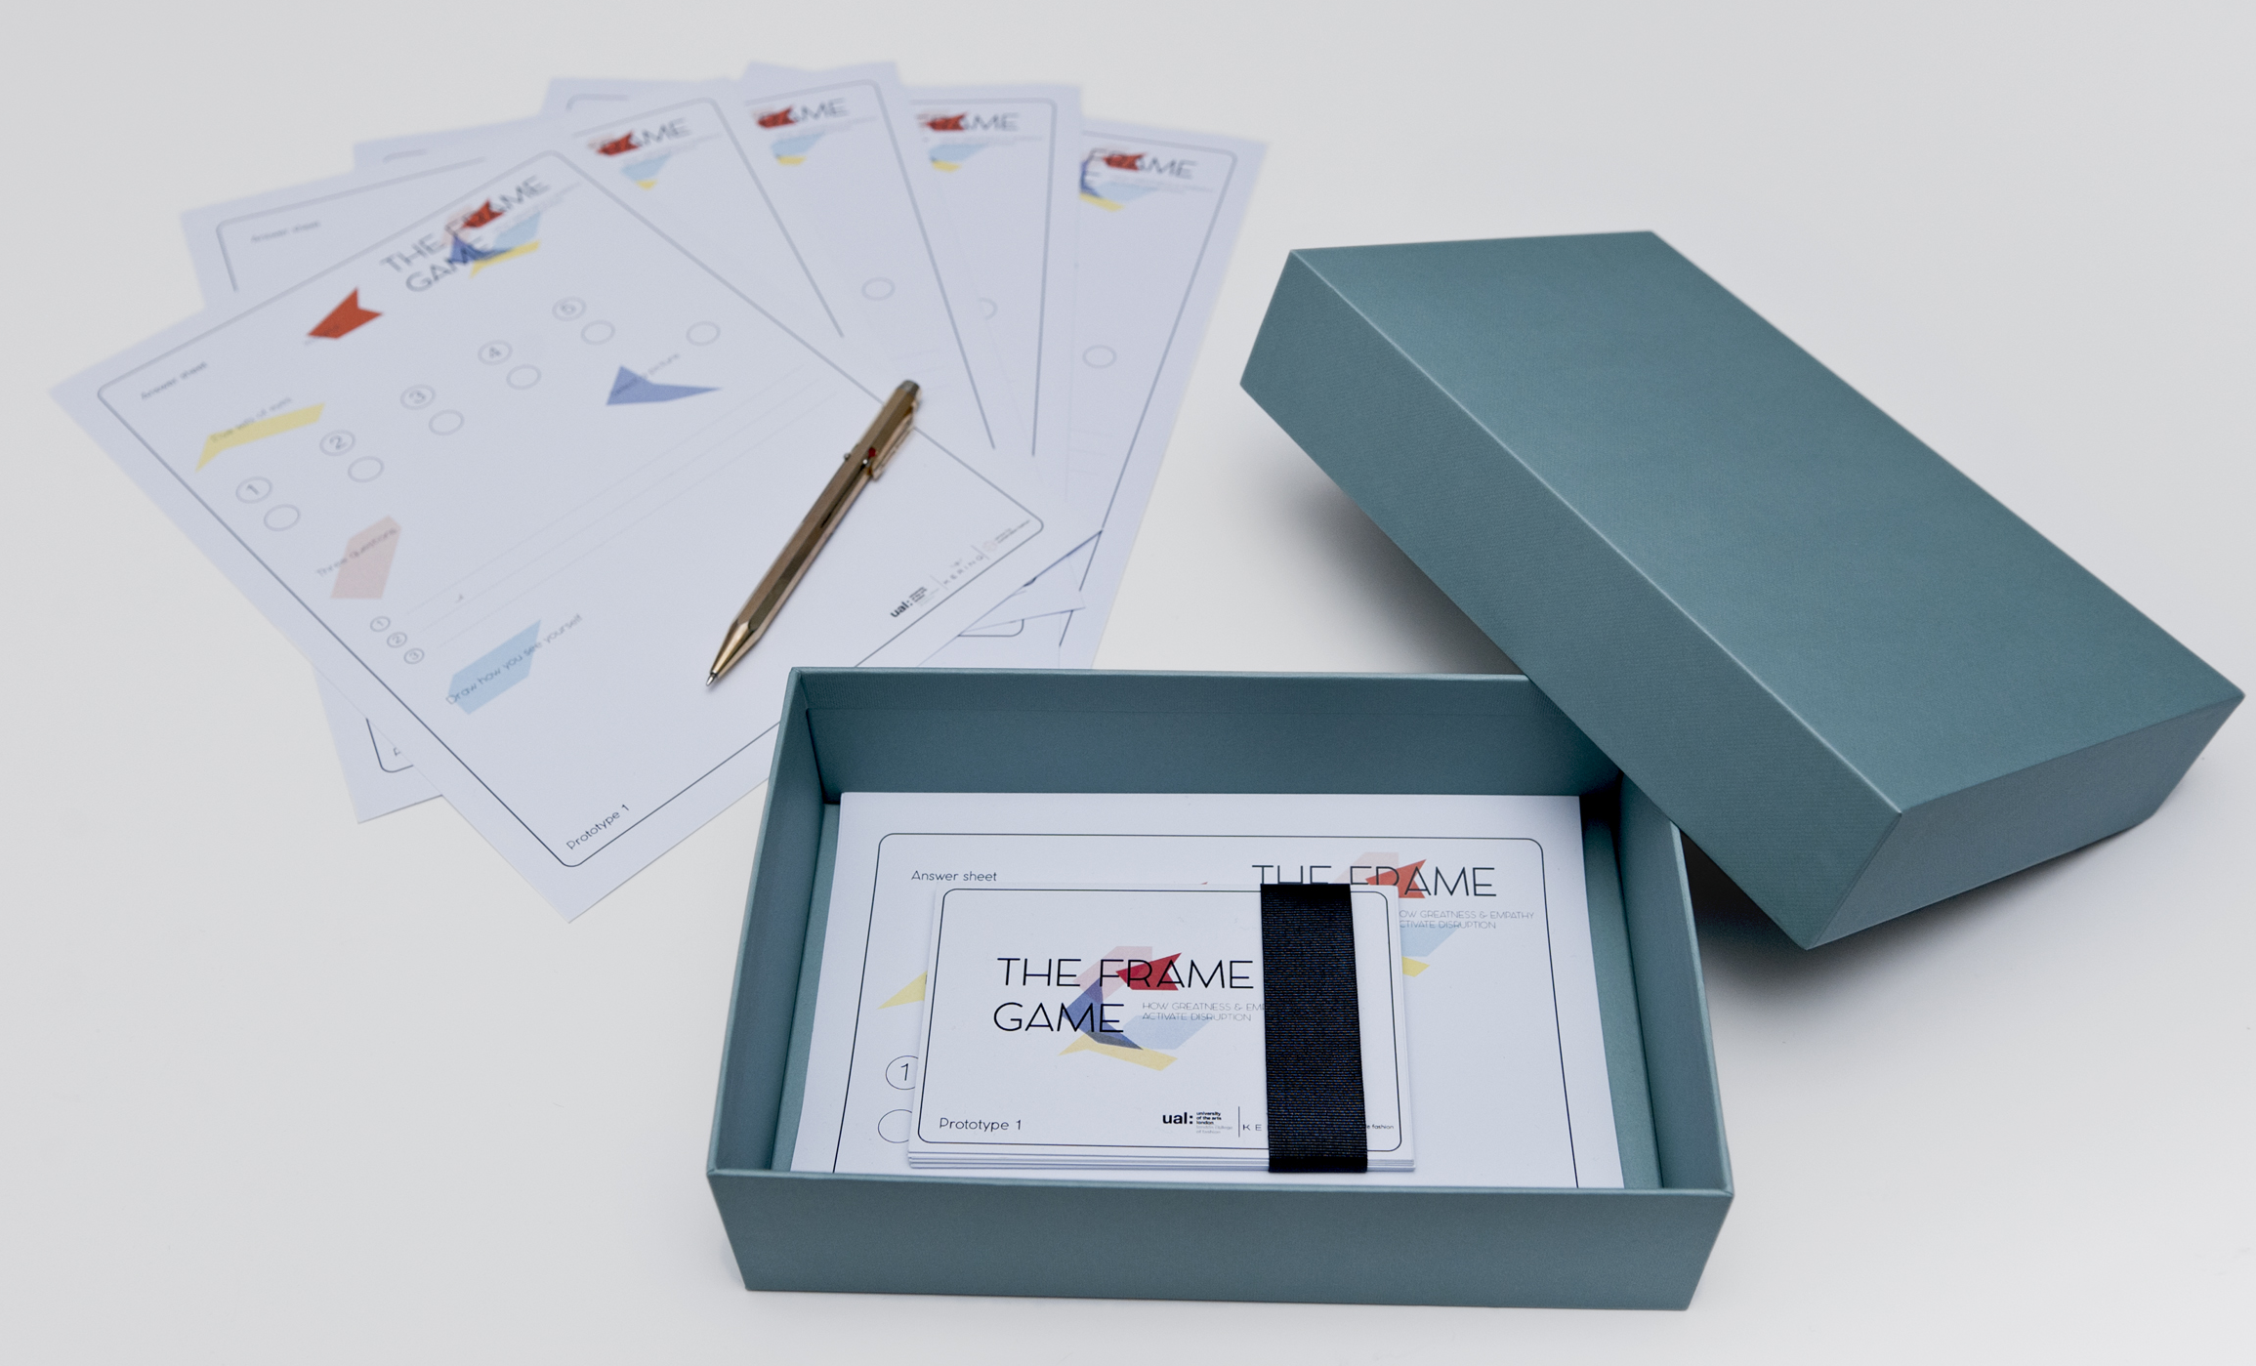
Fig. 3 The Frame Game Curriculum group project

Another project is proposed in the bio-kitchen, where customers become makers of their own biosynthetic materials, made from algae, which they offer to a skilled artisan to transform into a range of small luxury products.

Submissions at this level of possibility realizing account for 20% of the submissions reviewed and many are recognized as exemplary in both academic and industry terms. Project submissions are often deemed unsatisfactory if they do not include final prototypes, proof of concept and tangible realization. Fashion industry professionals can rarely afford the time to consider ideas that are far from applicability in the short term. Still in early iteration stage, the recognition of these projects by academia and industry evidences change in thinking is taking place within each of these spheres.

Sustainability as Aspiration

An aspiration of luxury, fashion and sustainability can influence future-acceptable practice in societies and in business. As the significant proportion of submissions under the theme innovating cultures demonstrates, connecting luxury, fashion and sustainability, contributes to a cultural movement that is more visual, artistic, spiritual and emotion-led than the dominant scientific, rational view that has presided in western culture since the Enlightenment. Luxury thus becomes synonymous with values of sustainability and together they become an aspiration for fashion. Through luxury, value is created and maintained by foregrounding a sense of time; to hone and practice skills for the making and maintaining of something, an honouring of material elements, their origin and significance in our only world, where we live together, on earth.

A direction for change

The research findings were further analysed through a systems lens, to map scales of change within each theme and to map them relationally. From changes in decisions about materials selection, to interventions at the scale of culture and world view, a dress on a body, is viewed in terms of its timeliness in cultural terms that relate to its social, economic and ecological networks.

As this mapping of themes across systems shows (fig. 4) these projects represent change across the luxury fashion system. Problem-solving within existing products, where materials and process innovation and product design is re-considered, is taking place alongside possibility realizing that involves change beyond the usual remit of the fashion professional. This involves engagement of a wider set of people, economic, political, cultural societal systems.

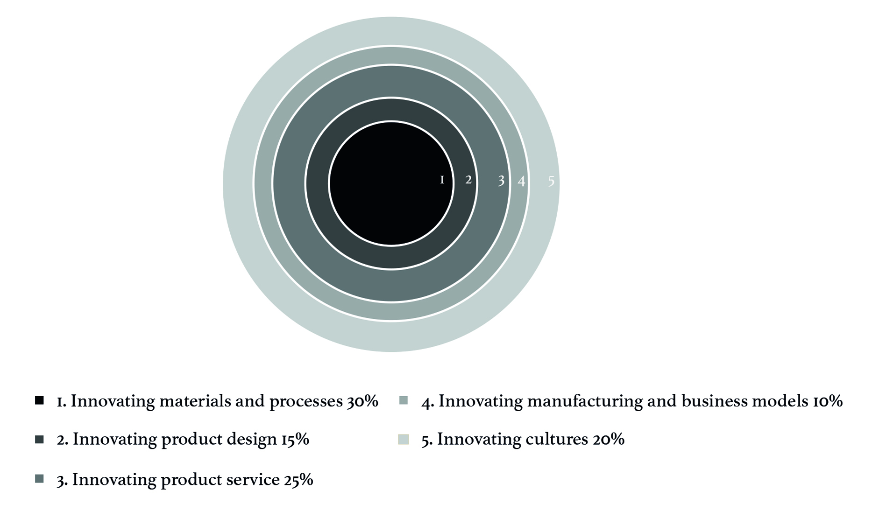

Fig 4. Mapping of themes across scales of systems change
Whilst this small study is not generalizable, the unprecedented nature of this academic-industry co-creation programme in fashion, luxury and sustainability, offers findings that are distinctive and original due to the scope and breadth of Kering as an international luxury fashion business and of CSF as the home of the only worldwide research centre dedicated to the exploration of fashion design and sustainability. Through wider discourse involving research expertise in the wider networks of the centre and with readers of this chapter, this locating of a set of ideas for problem solving within the existing fashion system and a re-connecting of the wider systems within which fashion operates, can be taken forward in new ways. This opens a space for consideration and sometimes uncomfortable conversations about whether, through fashion’s education and professional practice, we are able to hone the skills of co-operation needed for a flourishing luxury fashion system. This research evidences both evolution and transformation, through an approach that recognizes each one and their collective importance in change towards sustainability.
For researchers, exploring fashion design for sustainability in terms that Capra describes as a social paradigm consisting of a constellation of concepts, values, perceptions and practices, shared by a community to form the basis on which that community organizes itself the potential livelihoods of the graduates whom they support, starts to expand towards a range of new and exciting roles. The purpose of higher education has long been the subject of great debate, amplified more recently by its increasing commodification in the UK. Universities have a role in contributing to knowledge and in creating space for the exploration of self and contribution to society. The means for the creation of an autonomous life through livelihoods is also central to a university’s ambition.
Sterling describes the purpose of education as four-part its socialization role being to re-inforce societal and cultural practices to promote citizenship, its vocational role being to train people for employment, its liberation role being to develop individual potential and its transformative role in contributing to a fairer society and better world. Through this academia-industry partnership, luxury becomes the context, fashion the subject and sustainability a lens that can connect and cross-reference these elements.
This consideration of sustainability in the context of luxury relates to material choices, how things are made and also to a deeper consideration of our aspirations. Luxury has a direct relationship to aspiration; if sustainability becomes an element of aspiration, then what is conceived and realized in material and product form becomes what is sought after and is socially celebrated in wider societal cultures and practices.

‘The case for transformative learning is that learning within paradigm does not change the paradigm. Whereas learning that facilitates a fundamental recognition of paradigm and enables paradigmatic reconstruction is by definition transformative.’ Sterling, S. (2003)

The findings of this research suggest that a critical consideration of context and a cognizance of the parameters within which industry currently operates can generate evolutionary and transformational thinking and practice within a connected group of designers and makers in academia and industry. By taking a pluralistic approach, honouring each contribution, whilst critically considering its scope, sustainability thinking can anticipate and shape changes taking place. Problem-solving to mitigate our current impacts as well as possibility creating through a new way of seeing ourselves in the world are both needed as pragmatic and philosophical contributions towards sustaining human and non-human nature and to simultaneously sustain fashion and luxury as elements of value in our lives.

It is an exciting time to be a graduating designer as the imperative for change is great and the limits of established formats is being acknowledged. For researchers, tutors and heads of colleges too, this is a time for bold commitment, in creating the spaces to challenge, reflect on and prepare for a world that our graduates and our research ideas can shape. It is clear that a new modernity will not be birthed within the current context of business, through a hackathon, at a leadership summit or over dinner as a perfect or complete theory, but will emerge from discourse and conflict amongst a diverse range of participants, a multiplicity of ideas, hopes, visions and innovations.

Whilst the fashion industry will not take a complete direction change overnight, it is on a road that it didn’t build single-handedly, signposted towards economic growth. The Kering-CSF partnership evidences academia and industry co-creation of new paths and signposts towards new forms of prosperity, transformed cultures and awe-inspiring fashion garments.

The technological, product, socio-economic, societal and biosphere systems within which we live and work are interdependent systems, with points of intervention that can create product based and system wide changes. Those working towards tangible changes within the system, through to those starting from a new paradigm can collectively make a positive difference to the conditions of life, if and when the role of each is recognized. Problem-solving without possibility realizing might slow down our unsustainability, but is not enough to sustain us. Possibility creating without problem solving might imagine new ways to flourish but can lack the traction that it needs to shift us from our current mindsets, infrastructures and locations.

‘Every design project exists in both a physical-biological world (there people live and things are made and used) and a socio-cultural world (where people interact and things assume meaning)’ Julier 2006

Whilst the evidence of innovative ideas and their potential application is clear through the findings of this research, there is a need to return to the question at the heart of our unsustainability, can we collaborate? This does not mean consensus, but rather the ability to acknowledge difference, to commit to co-evolving and co-transforming in the world. This enables a space for dissensus whilst keeping connected to the world as it is lived. The practices of sustainability applied through this partnership create a heuristic model where those involved make their own discoveries. It offers, rather than a tool or a guide, a co-learning system where rational and scientific knowledge is combined with creative and intuitive thinking.

Proust, M. first published 1923, (2000) La Prisonnière (À la recherche du temps perdu #5). London: Folio.
Gaffney, O. (2015) ‘Walking the Anthropocene’. Out of Eden Walk. 2015-03-16 [Online].
Rossetti, C. first published 1862, (1923) Goblin Market, The Prince’s Progress and Other Poems. London: Humphrey Milford Oxford University Press.
Seuss, Geisel T. first published 1971, (2004) The Lorax. London: Harper Collins.
The Sierra Club is a grassroots environmental organization, founded in 1892
Carson, R. first published 1962, (2000) Silent Spring. London: Penguin Classics.
Ehrman, E. (2018) Fashioned from Nature. London: V&A publishers.
Galaz, V. (2015) ‘Anthropocene and planetary boundaries’ in Pattberg, P.H. [Ed.] Encyclopedia of Global Environmental Governance and Politics. Northampton, MA, USA: Edward Elgar Pub: 3–8.
Ritz. D. (1991) Divided Soul: The Life of Marvin Gaye. London: Omnibus Press.
Rockstrom, J. (2017) ‘World Development Within Planetary Boundaries Lecture’ [Online] Available at: https://www.cusp.ac.uk/event/planetary-boundaries/ (Accessed 12th November 2017)
The Paris Agreement (2015) https://treaties.un.org/doc/Publication/CN/2016/CN.735.2016-Eng.pdf (Accessed 10th September, 2017)
Burns, C, Cottam, H, Vanstone, C, Winhall, J. (2004) ‘Transformation Design. PAPER 02’. Design Council, [Online] Available at: http://www.cihm.leeds.ac.uk/document_downloads/REDPAPER02TransformationDesign.pdf [Accessed 1 December 2017]
Gregory, S.A. (1966) The Design Method. London: Butterworths.
Hoffman, A. (2015) How Culture Shapes the Climate Change Debate. Redwood, CA: Stanford University Press.
Papenack, V. (1972) Design for the Real World. New York: Pantheon Books.
Cross, N. (2006) Designerly ways of knowing, London: Springer.
Illich, I. (1975) Tools for Conviviality. New York: Fontana.
Walker, S. (2006) Sustainable By Design. London: Earthscan
Manzini, E. and Margolin, V. (2017) ‘Desis network open letter’ [Online]. Available at: http://www.desisnetwork.org/2017/04/11/open-letter/ (Accessed 17th May. 2017).
Thackara, J. (2013) ‘The Design Museum and PUMA Annual Sustainable Design Lecture’ [Online] Available at: http://www.curvelive.com/Blog/2013/October/Sustainable-Design-Lecture (accessed 4th January 2018)
The Pulse of Fashion Report. (2017) Boston, MA: Boston Consulting Group.
Kering 2025 Strategy Crafting Tomorrow’s Luxury [Online]. Available at: http://www.kering.com/en/sustainability/2025-strategy (Accessed 04th January 2018).
Guilty Pleasures; Luxury in Ancient Greece And the Medieval World (2011) BBC 4 Luxury season [Online]. Available at: https://vimeo.com/25556379 (Accessed 04th January, 2018)
as above
Christie, A. (2011) ‘Nothing of intrinsic value: The scientific collections at the Bethnal Green Museum’. V&A Online Journal, Issue No. 3 [Online]. Available at http://www.vam.ac.uk/content/journals/research-journal/issue-03/nothing-of-intrinsic-value-the-scientific-collections-at-the-bethnal-green-museum/ (Accessed 10th December, 2017).
Anna Zegna, speaking at Shaping a Creative Future, symposium Prada, Milan March, 2017.
Pinault, F. H. (2014) ‘Inaugural Kering Talk, London College of Fashion, October 2014’ [Online] Available at: http://sustainable-fashion.com/projects/lcfxkering/ (Accessed 30th October, 2017)
Williams, D. and Toth Fejel, K. (2016) ‘The Will and the Skill in Education for Sustainability’ in Handbook of Theory and Practice of Sustaiable Development in Higher Education, Vol. 4. Springer World Sustainability Series. Cambridge, MA: MIT: 79-94.
Williams, D and Stevenson, N, (2012) in Williams, Dilys (2016) Transition and Transformation in Fashion Education for Sustainability. In: Engaging Stakeholders in Education for Sustainable Development at University Level. Springer.
DIANJEN LIN explores the development of a material prototype, which uses blue-green algae and wool, to produce garments with photosynthetic or pollution-filtering properties.
The Vintage Clinic concept connects artisans and clients to restore, customise and co-create pre-own products
https://en.oxforddictionaries.com/definition/suss
Kering and CSF partnership report years 1-3 (2017) unpublished.
The Frame Game concept is a toolkit for agency within the workplace, towards the creation of disruptive innovation
Capra, F. Luisi, P (2014) The Systems View of Life: A Unifying Vision Cambridge University Press
Collini, S. (2012) What are Universities For?. London: Penguin.
Sterling, S. (2001) Sustainable Education: Re-visioning learning and change. Cambridge: Green Books for The Schumacher Society.
Sterling, S. (2003) PhD Thesis: Whole Systems Thinking as a Basis for Paradigm Change in Education: Explorations in the Context of Sustainability, University of Bath. p7. Available at: http://www.bath.ac.uk/cree/sterling/sterlingthesis.pdf (Accessed 04th January 2018).
Julier, G. (2016) ‘From Visual Culture to Design Culture’. Design Issues, Vol. 22, 1: 64-76. (Cambridge, MA: The MIT Press).

