Abstract
Landscape historian WG Hoskins is widely credited as a pioneer of landscape and local history. His 1955 book The Making of the English Landscape and the guide books and television series he wrote and contributed to, played an important part in making a historical narrative available to a wide variety of people. The Making of the English Landscape has never been out of print, and although many of Hoskins’ other publications, such as Touring Leicestershire (1948) and the Shell Guides to Leicestershire and to Rutland, published in the 1960s, are now little read, they are an integral part of Hoskins’ highly personal and scholarly methodologies.

Hoskins’ work was radical – with so much of England damaged after the Second World War, Hoskins and his collaborator, photographer F.L. Attenborough, gave ruination a context and insisted on the timelessness and permanence of the English landscape. This essay explores the first moves in a research project by Val Williams and Corinne Silva to retrace the footsteps of Hoskins and Attenborough, initially through the 1948 guidebook Touring Leicestershire.

This article describes the way in which the authors have approached Hoskins- and how they are remodeling his landscape tours as part of a series of women’s’ road trips. Much of this early research is intended to embed the researchers within the practices of Hoskins and Attenborough while making new pathways, to discover the visual embodiments of change in the urban and rural landscape and in so doing to explore the notion of collaboration and interdisclipinarity. Taking as a cue the partnership and bonds of friendship between Hoskins and Attenborough, the work sets out to explore the possibilities of this in a modern and radically changed academic and cultural landscape.

Author Biographies

Corinne Silva is a distinguished artist and Research Fellow at the University of the Arts London, whose recent works include Wandering Abroad, Leeds Art Gallery, UK (2009), Imported Landscapes, Manifesta 8, Murcia, Spain (2010) and Garden State, The Mosaic Rooms, London, and Ffotogallery, Wales. (2015). Her monograph Garden State was published in 2016. In 2018 and 2019 she will be included in exhibitions at IVAM Institut Valencià d'Art Modern, Spain, and Zarya Center for Contemporary Art, Vladivostok.

Val Williams is a writer and curator and UAL Professor of the History and Culture of Photography. Her projects include the exhibitions ‘How We Are’ at Tate Britain, ‘Martin Parr’ at the Barbican Art Gallery, ‘Daniel Meadows Early Photographs’ at the National Media Museum and the 2018 Tish Murtha retrospective at the Photographers Gallery. She is currently co-curating a new exhibition around photography and the British seaside at Turner Contemporary.

Lines in the Landscapes: Ruins and Reveals in Britain
Val Williams and Corinne Silva

Introduction

This collaborative project, Lines in the Landscape: Ruins and Reveals in Britain, is a journey into the British landscape, in which the authors retrace the steps of landscape historian W.G. Hoskins and academic and photographer Frederick Attenborough in Leicestershire against a background of journeys through Leicester and the hinterlands of south and east London, experimenting with new ways of researching and producing art. The motorists’ guidebook to Leicestershire that Hoskins and Attenborough compiled in 1948, and the emerging interest in localness and oral history in 1950s and 60s Britain is at the core of the project. Then as now, both operated as entry points into the landscape, directing visitors to particular locations and informing tastes. This essay is a meditation on the routes we will take following Hoskins and Attenborough. We are setting out ideas at the beginning of a project, rather than conclusions at its end, sketching out the paths that our journey together will take and where they confer, and differ, with Hoskins and Attenborough. In a time of specialist and carefully guarded disciplines, monitored by academia, the art word, the press and a host of others, we are working to transcend barriers and to understand the nature of collaboration.

Figures 1 and 2
Hoskins’ illustrated book The Making of the English Landscape was first published in 1956 and has remained in print ever since. In the 1970s, it was required reading, along with Willmott and Young’s ‘Family and Kinship in East London’, Kingsley Amis’s ‘Lucky Jim’ and Philip Larkin’s poems, all giving clues about the paradoxical and transforming post-war country that Britons lived in. Journalist Ray Gosling’s radio and TV programmes, and re-runs of Charles Parker’s’ documentary ‘Radio Ballads were equally attractive to a generation which had grown up during post -war austerity, economic and social change in the 1960s and industrial decline in the 70s. The urge to develop new narratives around contemporary British history, using the relatively new technologies of recording and televising, as well as the traditional ones of print, became manifest in numerous ways, particularly so in the new independent documentary photography, which had emerged from radical changes in photographic education, a new government- driven regionalism and the use of state funding for ‘new’ art forms. The photographer Daniel Meadows, making a photographic tour around England in a double decker bus in the early 1970s, remembers how he was influenced by Gosling’s love of the ‘ordinary’ and by his social and cultural archaeology. Meadows and fellow photographer Martin Parr were inspired to document a Salford street by their shared interest in the ITV series Coronation Street.

Our research on Hoskins and our ideas about the ways in which this speculative research will be made are both in their early stages. We are working in the archives of Leicester University where the Hoskins papers are cared for and have begun to explore the photographs made by Attenborough. After having seen Attenborough’s photographs only as poor reproductions, it has been enlightening to see the original plates and to be able to consider them alongside the colour photographs of the British landscape being produced by the contemporaneous? photographers of Country Life magazine or the heroic mountainscapes made by William Arthur Poucher. We have made the first of our road trips in Leicestershire.

Writing, photography and broadcasting were all part of a growing interest in the ‘ordinary’, in everyday rituals and hidden lives, which developed in the late 1960s and 1970s. Made manifest across the arts and media, from John Osborne’s kitchen sink drama to Paul Thompson’s founding of the Oral History Society in 1971 and the later publication of his highly influential work on oral history ‘The Voice of the Past (1978) in which he wrote:
Through history ordinary people seek to understand the upheavals and changes which they experience in their own lives: wars, social transformations like the changing position of youth, technological changes like the end of steam power, or personal migration to a new community. Family history especially can give an individual a strong sense of a much longer personal lifespan, which will even survive their own death. Through local history a village or town seeks meaning for its own changing character and newcomers can gain a sense of roots in personal historical knowledge. Through political and social history taught in schools, children are helped to understand, and accept, how the political and social system under which they live came about, and how force and conflict have played, and continue to play, their part in that evolution.

Figures 3 and 4

These new social narratives of the post-war years were often personally motivated and highly opinionated. These were no neutral observations on the history of the British landscape, but were written with a style and tone that carried the force of their authors’ often adversarial positions. When Shell reinvigorated its pre-war guidebook series, designed for adventurous, culturally minded motorists, in the late 1950s and 60s, the publications were infused by the voices of their authors (one of whom included W.G. Hoskins), who frequently decried the ways that both suburbia and the industrial had despoiled their idea of the English landscape. Shell Guide editor John Betjeman and principal Shell guide photographer (and subsequent editor) John Piper, together with many of the writers and historians engaged to edit the guides, critiqued the modernising forces that were re-shaping the British countryside. For Hoskins, the industrial present was a horrifying despoliation. In ‘From Chilterns to Black Country,’ which was published in 1951 as the fifth in a series of small volumes ‘About Britain’ edited by the passionate conservationist Geoffrey Grigson, to coincide with the Festival of Britain, Hoskins wrote:

The Potteries should not be avoided by anyone who wishes to know Britain. Their ugliness is so demonic that it is fascinating to look upon it from the marginal hills, especially from the ridge that runs just east of Tunstall and Burslem. It is a picture of the uninhibited workings of the Industrial Revolution in its worst period: hundreds of bottle-shaped kilns, black with their own dirt of generations, massed in groups mostly on or near the hidden canal, with square miles of blackened streets of little black houses, and chapels, churches, spires and towers, tall chimneys of iron and steel works steam from innumerable railways lines that thread their way through the incredible tangle of junctions: as a spectacle, it should never be missed’.

For the British public, one of the most dramatic and influential manifestations of the new post-war narrative was perhaps theatre director Peter Hall’s 1974 reworking of Ronald Blythe’s oral history recorded in 1969 as ‘Akenfield: Portrait of an English Village’. Hall’s film, with music by Michael Tippett, cinematography by Ivan Strasburg and the parts played by local people using their own improvised dialogue, was an entirely new cinematic experience. Although the cinematography in Akenfield is placid and beautiful, the narrative is harsh and shocking – no good old days, as villagers remember the trenches of WW1 and the servitude of agricultural labour. Akenfield was shown on BBC TV in 1975 after premiering at the London Film Festival the year before, where it had attracted large audiences and contributed to the growing popularity of local and oral histories.

Figures 5, 6, and 7

Hoskins and Attenborough began working together in the late 1940s and their first known collaboration was for ‘Touring Leicestershire’, published by the City of Leicester in 1948. They had met as academics in Leicester and began a creative partnership that lasted until Attenborough’s death. Though Attenborough worked with other authors, and Hoskins, from time to time, with other photographers, they shared professional, friendship and familial bonds which were to be central to their working relationship. Collaborations between writers and photographers – though never clear-cut and substantially under-documented – have been interesting in many ways- what is the balance between the visual and the written? Do photographs dictate text or vice versa? Collaborations of interest include those between photographer Percy Hennell and Geoffrey Grigson, photojournalist Margaret Bourke White and writer Erskine Caldwell, Walker Evans and James Agee, artist/photographer Paul Nash and John Betjeman. In our planned research around the partnership of Hoskins and Attenborough and others, we intend to explore the possibilities of collaboration and interdisciplinary research.

Figures 8 and 9

While W.G. Hoskins is well known as a historian, Attenborough’s achievements as a photographer have remained obscure, perhaps because of his status as an ‘amateur’ photographer, and accentuated by the poor printing of many of his photographs in Hoskins’ books. In the first edition of The Making of the English Landscape, published by Hodder in 1955, Attenborough provided seventeen of the eighty plates, outnumbering any other single contributor. Many more photographs were needed for this larger book than Attenborough had made for Touring Leicestershire – as an amateur photographer, it was unlikely that he could have provided all the photographs that Hoskins needed. The collaborative bond between Hoskins and Attenborough was clearly a strong one, and Hoskins did not appear to have worked with any other specific photographer, being content to source additional photographs from agencies and companies. Later, in the 1960s, photographs by John Piper appeared in Hoskins’ Shell Guides and we hope to trace correspondence between them as the research proceeds. Interestingly, a rare second edition of Touring Leicestershire, published in 1971, saw the cover photograph (Attenborough’s austere view of church and hills) changed to a young couple consulting a map. Revised by Russell McClelland, then publicity officer of the city of Leicester, there are a number of occasions where McClelland replaced Attenborough’s photographs with his own- attempting perhaps to soften Hoskins’ and Attenborough’s vision of Leicestershire as a gaunt and mysterious landscape.

Together, Attenborough and Hoskins sought out the places that Hoskins had established as central to his reading of the landscape; Hoskins needed this intimate connection between text and photography that stock library photographs could not provide. Precise, located photography made in collaboration was important to Hoskins, as it enabled him to use an image to illustrate his observations in a way that the reader could easily understand- people were used to looking at photographs – wartime magazines such as Picture Post had championed the use of good photography, and formed the basis of photojournalism in Britain in the post-war years. When Attenborough made a photograph of three hawthorn trees and a hedge, Hoskins captioned it ‘The landscape of parliamentary enclosure in Rutland, on the road from Empingham to Exton. Here oolitic limestone walls take the place of quickset, but hawthorn trees are planted at intervals and are at their best in late May. The photograph also shows the grass verge that is characteristic of by-roads laid out by the enclosure commissioners.’

Figure 10

Hoskins was known to be a particularly poor photographer, while Attenborough was a highly skilled amateur. Hoskins could not drive, while Attenborough was a keen motorist. Together they made a pragmatic and imaginative team, though we are given very few glimpses of their relationship.

Attenborough’s photographs were badly reproduced in the first edition of The Making of the English Landscape, and the quality did not improve in the subsequent Pelican paperback editions published from 1971 and reprinted almost every year for the next decade. As part of our project we have examined some of the original glass plates, and the quality is high. Again, this posed a question for us- as we used a variety of photographic technologies to record our journeys, from the most basic of the smart phone to sophisticated photography kit. When the BBC published Hoskins’ English Landscapes in 1973, no Attenborough photographs were used. Instead, included in the selection were seventeen photographs by the distinguished landscape photographer Edwin Smith, whose elegiac photographs of the English landscape as a place of beauty and mystery have continued to engage with the English imagination. This contributed to Attenborough’s work disappearing from view.

Touring Leicestershire 1948

‘Touring Leicestershire’ is a 52-page stapled book published by the City of Leicester in 1948. Eight motor tours of Leicestershire were included, along with a list of bus companies, hotels and cafes. The landscape which Hoskins describes is, on the one hand, remote and beautiful (what he described as a ‘milder Dartmoor’), and on the other, as he and Attenborough travelled to the industrialised parts of the county, ‘ugly, commonplace and ruined’. The collision of the ruined landscape, the result of what Hoskins saw as industrial folly, and which he encountered in the Black Country in the 1950s, and a landscape of ruins, which was fascinating and full of clues to the past, was to be a constant tension in Hoskins’ work. Attenborough was able to capture this in his photography as he pictured the remoteness of the Leicestershire Hills and the edge of Rutland, the expanses of heathland, the fragmenting buildings, the ridges and furrows of medieval farming. Hoskins’ chronicle of the disintegration of medieval village life is one of disease and intense political change, as villages disappeared during the plague years, and farming changed dramatically during the periods of the Enclosures. In Touring Leicestershire, there are no indications of Hoskins and Attenborough’s politics, but in the Shell Guides that Hoskins edited later, on Rutland (in 1963) and Leicestershire (in 1970) Hoskins expresses his anxiety about pylons and increasing traffic, as well as some disdain about the cheap materials used for building new council houses.

Figures 11 and 12

Attenborough’s photographic work seems to have predated his collaborations with Hoskins – in 1945, he provided twenty -five photographs of architectural details for Nikolaus Pevsner’s King Penguin book ‘The Leaves of Southwell’. These beautiful photographs were finely printed in photogravure, perhaps the only time that Attenborough’s photographs received the reproduction quality that they deserved.

In Touring Leicestershire, Hoskins divides the county into two distinct halves: the 'rural and untouched by industry’ and the west ‘industrialised: hosiery and boot-and-shoe villages and small towns crowd on the landscape'. He notes that it is one of the wealthiest regions of England, and that the local ‘buses are everywhere full of prosperous-looking work-people (especially on Saturdays journeying towards the local cinema or market) but the landscape has been ruined in the process’. Signs of Leicestershire’ s historical wealth are everywhere on Hoskins’ routes- from the grand buildings of Leicester itself to the manor houses and mansions of the countryside. The granite industry provided (and continues to do so) a significant economic boost to the area around Mountsorrell; the modern tourist industry was founded in Leicester (by Thomas Cook) and the hosiery, boot and shoe and engineering industries brought prosperity to the region. Leicester still seems to thrive- its ‘Golden Mile’ of predominantly Asian restaurants and shops has become a destination, the University quarter is leafy and sedate, it is the HQ of the clothing firm NEXT and household goods retailer Dunelm, Triumph motorcycles and Walkers crisps.

Hoskins and Attenborough’s journeys into the eastern regions for Touring Leicestershire were expeditions into a quiet (and seemingly completely unpopulated) landscape of hedgerows, fields, forest and ruins. Apart from the noise made by Hoskins’ and Attenborough’s motor car, silence must have been near complete. Hoskins is at pains to emphasise the lack of public transport in east Leicestershire ‘but after all, this is precisely what has kept so much of it quite unspoilt’. There is an evocative air of mystery around Hoskins’ and Attenborough’s journeys as they happen upon ruins and arrive at deserted villages. Difficulties, wrong-turnings and lengthy meanderings are all part of the process of their ‘touring’. In Tour 3, ‘[Kirby] Hall is difficult to find but will amply reward all the effort of finding it’. It was approached through the industrial spoil of the Midlands: ‘The titanic works of Corby are well in view here, and the winding country road runs for some way between the great dumps of waste from the iron ore quarrying, an example of ‘robber economy at its worst.’ In Tour 5, they seek out Ragdale Old Hall ‘a melancholy ruin, gutted and broken, but still retaining much of its original beauty’. As Hoskins notes in his 1970 Shell Guide to Leicestershire, Ragdale Old Hall was demolished some ten years after he visited.

Figures 13 and 14

People are entirely missing from Attenborough and Hoskins’ travelogue – there are no interesting locals, no suspicious farmers, no decaying aristocrats. These are eerily empty landscapes. The style of travel writing that depends on random meetings and informative conversations has no place in these journeys across an empty landscape. Like the Shell Guides of the 1930s, Touring Leicestershire was about atmosphere and mystery, and much of this was created by the mood of Attenborough’s photographs. Very little attention was given to creature comforts, though Hoskins, in one of the Shell Guides went to some lengths to describe the delights of wine drinking on a grassy verge- only pausing to caution drivers against falling asleep. As John Betjeman, had learnt during his time at the Architectural Review and later, in the early 1930s, as editor of the first Shell Guides, photography was much more than illustration – it went to the heart of the place, conjured up mystery, created narrative. Attenborough’s photographs, even more than Hoskins’ words, are what make Touring Leicestershire much more than a guidebook for motorists. The subjects of his images haunt the pages like spectres, ghosts from the past; ruined mansions, deserted hills, ominous trees, silent streams. They offer a post- war vision of ruination and silence, a landscape devoid of life, traumatically still. The Wreak Valley, High Leicestershire, the ruins of Ragdale and Ashby Castle. Architectural and visual traces of lives past are everywhere in Hoskins and Attenborough’s journeys – the ghostly remains of monasteries, deserted medieval villages, the outlines of ancient strip farming – all indicated a harsh and dramatic rural history. Attenborough’s photographs were of all that was left, the bare bones of history and were thoughtful and rich in association and symbol. When John Piper’s photographs appeared extensively in Hoskins 1970 edition of the Shell Guide to Leicestershire they resembled Attenborough’s in their quiet presence, redolent with secrets.

Hoskins and Attenborough

The histories of Hoskins and the Attenborough family are fascinatingly intertwined. They encompass the rise of local history and of both scholarly and popular education. They were intimately involved with the growth of television and non- fiction paperback publishing. Hoskins began his teaching career at the University College Leicester in 1931, where Attenborough was Principal from 1931-1951. Hoskins also taught evening classes at the Vaughan Working Men’s College. He became Reader in English Local History at University College Leicester in 1938, and in 1948, Head of Department of the Centre for English Local History. Significantly, Attenborough was also the parent of Richard, David and John Attenborough. David was to play a central part in Hoskins’ later career as a TV historian. When The Making of the English Landscape was first published, Hoskins had moved to Oxford University, where he was Reader in Economic History, but his connection to Leicester remained strong, becoming Hatton Professor of English History in 1965 and continuing his relationship with the Attenboroughs after F.L.’s death in 1973.

Figure 15

When David Attenborough became Controller of BBC 2 in the 1960s, he was instrumental in the commissioning of Hoskins to make a series of programmes about the landscape, screened in 1976 and 1978 as Landscapes of England. They were produced by Peter Jones who became interested in the natural world while working at Granada in the 1960s, and who later became a producer of Horizon, a successful TV series which played an important part in the popularization of science. Landscapes of England was, in its time, a radical view of English rural history formed through local history studies and a close reading of the landscape. Twelve films were made, in two series of six. Hoskins’ relationship with the Attenborough family, together with the success of The Making of the English Landscape undoubtedly accounted for his emergence as a TV historian of landscape and local history. Like Hoskins, David Attenborough was a popularizer; early in his career he presented Zoo Quest, and in 1969 he commissioned Civilization, Kenneth Clarke’s hugely popular series on the History of Art.

Figures 16 and 17

Figures 18 and 19

Roadtrips

For Hoskins, understanding rural architecture was a route towards deciphering history. He also knew how to read ditches, heaths, hedgerows and copses, and his books and television programmes explore what these clues in the urban and rural landscapes revealed about the shaping of the land and its populations. Though later geographers (and as Hoskins himself happily admitted, some of his own students) have critiqued Hoskins work, his status does not seem to have suffered unduly and his work is still in print.
Figures 19, 20, 21 and 22

The authors have come together to work on this new research project in the spirit of this radicalism, but from a contemporary and feminist perspective. Women’s voices are notably missing from the radical chorus of the 1950s and 60s as exemplified by, among others, Hoskins, Gosling, and Thompson.

As described, Hoskins and Attenborough, like many photographers and writers, made road trips and some of our work will follow that well-trodden route. The women’s road trip is not a recent phenomenon. Journey makers include the photographer Margaret Bourke White who travelled across the American dustbowl in the 1930s. Berenice Abbot’s 1954 photographic US Route 1 road trip from Maine to Florida was made a year before Robert Frank’s seminal photobook The Americans, but was never published. Though The Americans remains one of the central pillars of post war documentary photography, Berenice Abbott remains a marginal figure. Other women’s road trips include Susan Lipper’s 1993 to 1999 photographic road trip, published as Trip, Simone de Beauvoir’s 1947 America Day by Day, and Rebecca Solnit’s numerous explorations across Ireland and the USA, chronicled in publications such as Infinite City and A Book of Migrations. The notion of the journey from place to place, from innocence to experience, underlies these lengthy journeys just as it does the shorter explorations undertaken by Hoskins and Attenborough in Touring Leicestershire or John and Myfanwy Piper motoring around Devon with John Betjeman, preparing Shell Guides. Our planned retracing of the Hoskins/Attenborough road trips has, unlike theirs, or the Pipers’, a very speculative outcome. For Hoskins and Attenborough to ponder on what their journeys meant, as a set of relationships, or of self-discovery and the making of identity, would without a doubt, seemed preposterous to them. For us, it is integral. Hoskins makes no small talk in Touring Leicestershire, he visits the sites of antiquity with gravity and a sense of deep allegiance to the past. A ruined church sits in the middle of a field, a decaying Georgian mansion looms at the end of an unmade road in the heart of hunting country, the rolling acres of a country park were once the home of a short-lived queen. Hoskins’ relationship was with the land and with the past, fuelled by the fear of change. For Simone de Beauvoir, her trip to America at the beginning of 1947 (just a year before Hoskins and Attenborough published Touring Leicestershire) was ‘the extraordinary adventure of becoming a different me’. [ de Beauvoir, S. America Day by Day. Victor Gollancz. London 1947.PP 18, in the 1998 edition.] If Hoskins and Attenborough were mapping territory that they were clearly already familiar with, our journey across Leicestershire brought constant surprises. The Georgian house which Hoskins describes so enthusiastically is now decayed and collapsed in parts. We met the elderly owner and toured the deserted rooms, taking photographs. She talked about hunting and land and longed for the past. Every morning, we made an Instagram post about our journey of the previous day, and reflected on our project. We talked with a woman walking her neighbour’s dog about the incidence of ‘dogging’ at Groby Pool, and how the car park there is mentioned in a guide to gay meeting places in the East Midlands (‘particularly busy in the afternoons’). We saw a group of men and women clustered at a gate waiting for the hunt to pass, and, like Simone de Beauvoir in post -war New York, we were transported to a different world and were unwillingly entranced by the certainties of these country people. We were out of place, but no-one gave us a second look. An ancient abbey high up in the bleak Leicestershire hills had become a Christian retreat and we wandered through the gardens, finding a hut with armchairs and books and a walled vegetable garden. Everywhere there seemed to be possibilities. Where Hoskins was brisk, we wandered, taking wrong turns, retracing our steps, finding peculiar objects- a scarlet basque at the edge of a field, an ancient dog in a derelict house. Hoskins and Attenborough searched for traces of the past, and we searched for traces of them- tantalizingly out of reach. Our road trips were conversational, excited; we had never taken a journey together before- like most academics we dwell inside, colliding on corridors, fleeting meetings on the hoof. These journeys help us to establish what terms mean within the scope of our project - landscape, habitat, comradeship, collaboration.
Figures 23, 24 & 25

Hoskins liked localness, and even though he travelled the country, his most compelling and passionate work was produced in the Midlands, which played such an important part in his career. Before embarking on the Leicestershire roadtrips, we explored our own localness by make excursions around London looking at post-war sites such as South London’s newly built Kidbrooke Village, with its ‘village hall’, school and local amenities, which replaced the enormous Ferrers housing estate, made problematic by the social engineering of Greenwich Council and the lack of a bus service, before it was eventually demolished. Will these new ‘villages’ one day be deserted and obscured like the ones that Hoskins and Attenborough discovered in the English countryside or will they become strong and effective communities? We realised that localness is a central part of how we understand landscape – we are driven by a desire to map, to have agency, to be legitimate explorers in an already explored landscape. To make new discoveries, we need to bring ourselves into the project; Hoskins and Attenborough appeared to exclude personality from process, but research will perhaps bring further elucidation on the relationship between the two travellers.

Figures 26, 27 & 28

Another new London ‘village’ to be explored is Greenwich Millennium Village, with its stirring advertising slogan of ‘The New Settlers’ (all-white families in covered wagons) which, despite the advertising, has begun to comfortably mellow in its older parts into a slightly shabby multicultural personalized space. And there is the doomed Elephant and Castle with its disappeared Heygate Estate and its soon to be demolished Shopping Centre and Coronet Cinema, the Queen Elizabeth Olympic Park, the Lakeside Centre and the lakes, towers and wild environs of Thamesmead as it makes some uneasy but exciting transitions. Sutcliffe Park in Kidbrooke which has mutated from a gloomy ‘rec’ ground into an ecological zone, the immovable and idiosyncratic Mudchute Farm, Walthamstow Wetlands, Croydon and many more essentially localized London spaces. As Hoskins traversed Leicestershire, Rutland and the Black Country he found deserted villages and Roman villas, signs of the Black Death, vast heathlands and the remnants of castles, viewed through a lens of post-war austerity and a fascination with the almost-gone.

At the site of the new Kidbrooke Village, vestiges of the old Ferrers Estate cling on – a gateway cloaked by undergrowth, some bits of brutal concrete. But some of the places which informed this research have already re-formed – just beyond Kidbrooke Village, the old featureless municipal and menacing Sutcliffe Park, has, because of flood level work, become an intriguing wetland. Gone is the mysterious secret garden with its pond and apple tree orchard, destroyed by the work beginning on the site of a new IKEA store in Greenwich.

Figures 29 & 30

Hoskins argued that geologists only read one layer of the land, revealing, “only the bones of the landscape, the fundamental structure that gives form and colour to the scene and produces a certain kind of topography and natural vegetation. But the flesh that covers the bones, and the details of the features, are the concern of the historian, whose task it is to show how man has clothed the geographical skeleton...” We are interested in the flesh, the surfaces of things, grass, glass, brick, paving. Architecture and the built environment are the context in which most other material culture is used, placed, and understood. To read architecture is to read its surfaces, its forms and its materials. Surfaces are neither shallow nor superficial. The body and the earth and all other material substances meet at their surfaces.

Figure 31

In Conclusion

We are looking for new ways to read and explore these surfaces. This collaboration acknowledges how we will use this research to discover new personal strategies and methodologies. To open ourselves to a set of new disciplines, to see what can be done. We are attempting to dissolve the boundaries between skills and predilections. In 2018, along with our continued explorations of London ‘villages’, we have begun to retrace the journeys that Hoskins and Attenborough made in Leicestershire by taking road trips by car. Each route must take no longer than a day, and along the way, we have explored the notion of collaboration and published a journal of our trip via social media (Instagram ruins_and_reveals). Hoskins’ and Attenborough’s Leicestershire may have changed, some of it may well remain. Distanced by gender, by time, by class and by interests, our discoveries will surely be very different from theirs.

Figure 32

Photographs and texts published via Instagram are becoming our homage to The Making of the English Landscape and our way of disseminating our work. Less refined perhaps, but capable of reaching audiences globally and disrupting the way that landscape is viewed across systems, networks and histories. Social media has become a natural home for the visual and the written, and sharing ideas is no longer for the privileged few able to travel and network. The local has become international. In the spirit of Hoskins, we will use this as a means to connect with a wide audience of observers and participants. Though some high-profile academics use social media to communicate with a larger and more diverse audience, it is surprising how many avoid it. Our intention to use Instagram as a means dissemination has been met with surprise, by some in our academic networks, but discussing and illustrating our work via social media gives us the ability to converse with others and to use these conversations to shape the research to come. While we would not claim to be democratizing the project - as we are only too aware that social media networks are as bounded by class and culture as any others- we see this as a positive and fluid way of conversing and networking. We do not know the middle or end of this project. As, up to now, project-based practitioners working from an idea to funding to realization to outcome and finally impact, we are convinced that there must be a greater range of ways of working within and outside our own disciplines and that process is as important as product. Our connection with Hoskins and Attenborough is a tenuous but sincere one; we are intrigued by their combined histories and want to explore how historian and photographer worked together and to find out how we too can discover, or even just imagine, the new ruins of Britain.

Instagram: ruins_and_reveals
www.corinnesilva.com
www.valwilliams.uk

Acknowledgements
Dr Richard Jones, Centre for English Local History, University of Leicester

List of Illustrations

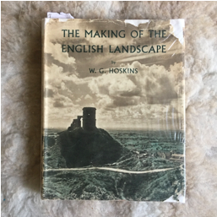
Figure 1 The Making of the English Landscape, W.G. Hoskins, 1948, first edition. Photograph by Corinne Silva

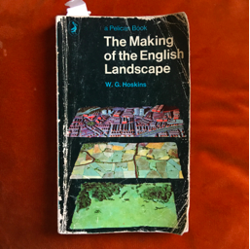
Figure 2 The Making of the English Landscape, W.G. Hoskins. Photograph by Corinne Silva

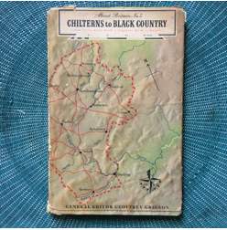
Figure 3 About Britain No 5: Chilterns to Black Country, W.G. Hoskins. Photograph by Corinne Silva

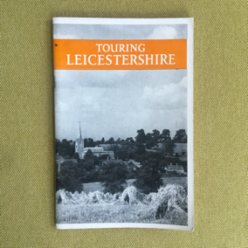
Figure 4 Touring Leicestershire, W.G. Hoskins, first published 1948. Photograph by Corinne Silva

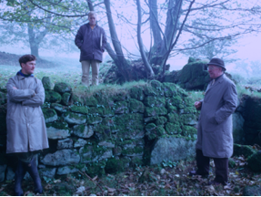
Figure 5 Hoskins and companions, Cornwall, date unknown, photographer unknown.
Centre for English Local History, University of Leicester (we have been given permission to use these images. Agreed wording: “shown with permission of the Centre for English Local History, University of Leicester”).

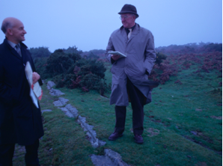
Figure 6 Hoskins and unknown companion, Cornwall, date unknown, photographer unknown. Centre for English Local History, University of Leicester (we have been given permission to use these images. Agreed wording: “shown with permission of the Centre for English Local History, University of Leicester”).

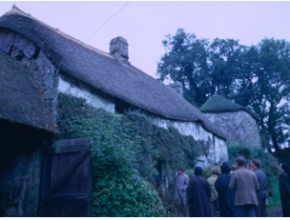
Figure 7 W.G. Hoskins and group, Cornwall, date unknown, photographer unknown.
Centre for English Local History, University of Leicester (we have been given permission to use these images. Agreed wording: “shown with permission of the Centre for English Local History, University of Leicester”).

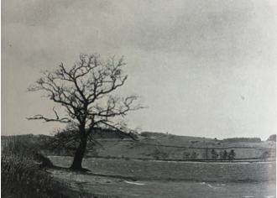
Figure 8 Cropston Reservoir. F. L. Attenborough, date unknown. Reproduced in Touring Leicestershire, WG. Hoskins.

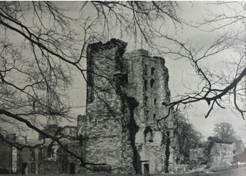
Figure 9 Ashby Castle: Lord Hastings’ Tower. F. L. Attenborough, date unknown. Reproduced in Touring Leicestershire, WG. Hoskins.

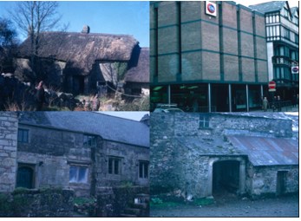
Figure 10 W.G. Hoskins, location and date unknown
Centre for English Local History, University of Leicester (we have been given permission to use these images. Agreed wording: “shown with permission of the Centre for English Local History, University of Leicester”).

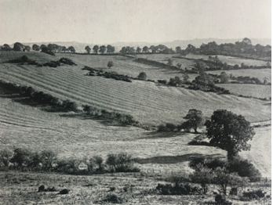
Figure 11 The pattern of Ridge and Furrow seen from Burrough Hill: A Fosilised Medieval Field System Preserved under Grass. F. L. Attenborough, date unknown. Reproduced in Touring Leicestershire, WG. Hoskins.

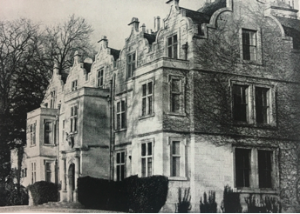
Figure 12 Carlton Curlieu Hall: Seventeenth Century opulence based on sheep and cattle pastures. F. L. Attenborough, date unknown. Reproduced in Touring Leicestershire, WG. Hoskins.
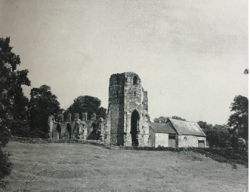
Figure 13 The Ruins of Ulverscroft Priory in the Heart of “The Forest”. F. L. Attenborough, date unknown. Reproduced in Touring Leicestershire, WG. Hoskins.

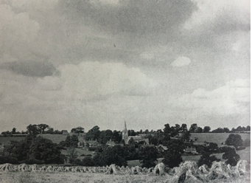
Figure 14 Hungerton: The true Leicestershire scene. F. L. Attenborough, date unknown. Reproduced in Touring Leicestershire, WG. Hoskins.

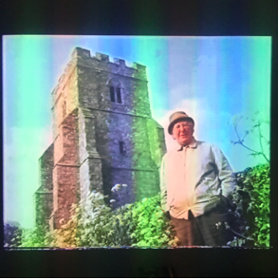
Figure 15 Screengrab of W.G. Hoskins presenting Landscapes of England
(currently unavailable online)

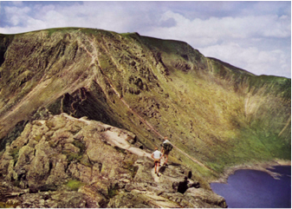
Figure 16 Photograph by Walter Arthur Poucher, 1960s

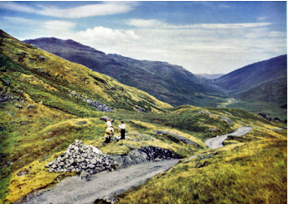
Figure 17 Photograph by Walter Arthur Poucher, walkers on Hard Knott Path, 1960s

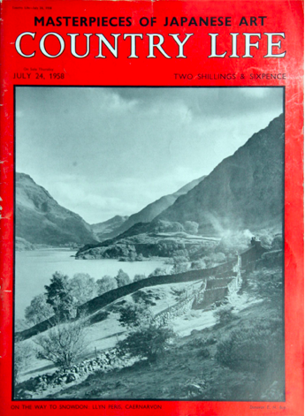
Figure 18

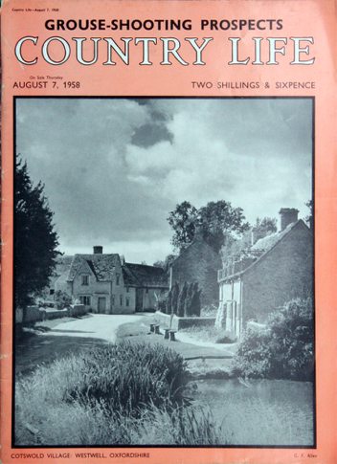
Figure 19

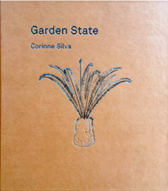
Figure 19 Garden State monograph by Corinne Silva, 2016, published by The Mosaic Rooms and Ffotogallery.

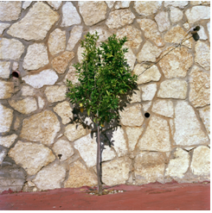
Figure 20 Untitled, from the series Gardening the Suburbs, photograph by Corinne Silva 2014

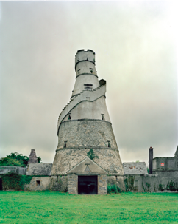
Figure 21 Famine Follies, Distractions & Occupations, photograph by Corinne Silva, 2017

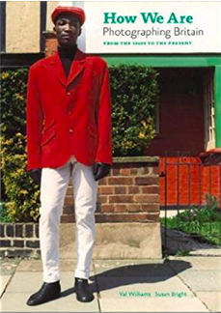
Figure 22 Cover of catalogue for 2007 Tate Britain exhibition, curated by Val Williams and Susan Bright

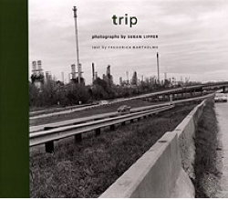
Figure 23 Trip Susan Lipper, first published 1999

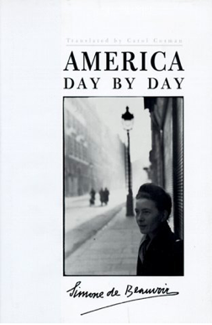
Figure 24 America Day by Day, Simone De Beauvoir, first published 1948

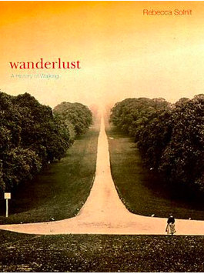
Figure 25 Wanderlust, Rebecca Solnit

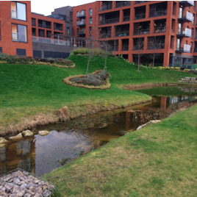
Figure 26 Kidbrooke Village. Photograph by Val Williams, 2017

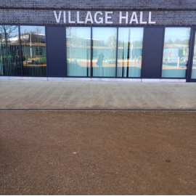
Figure 27 Kidbrooke Village Hall. Photograph by Val Williams, 2016

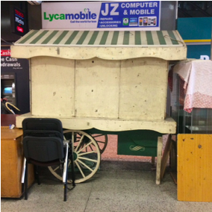
Figure 28 The Elephant and Castle Shopping Centre. Photograph by Val Williams, 2017

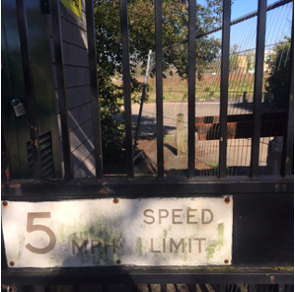
Figure 29 Fragment of Ferrers Estate after demolition. Photograph by Val Williams, 2016

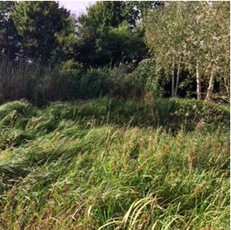
Figure 30 Secret Garden, North Greenwich, now destroyed for new IKEA site.
Photograph by Val Williams, 2017

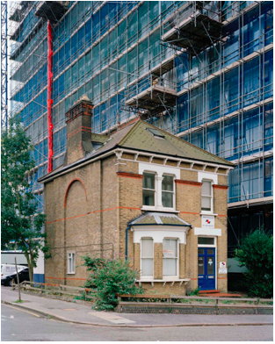
Figure 31 Croydon. Photograph by Corinne Silva, 2013

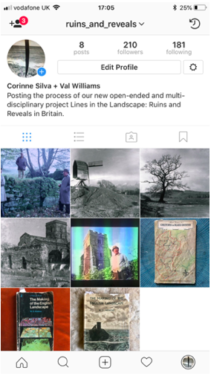
Figure 32 ruins_and_reveals Instagram page, Corinne Silva and Val Williams

Interview with Alan Dein, British Library Oral History of British Photography.
Williams, Val. Martin Parr Photographic Works. Phaidon. 2002.
Thompson Paul: The Voice of the Past. OUP. 1988
Hoskins, W.G. ‘About Britain No 5’. Collins. ed. Grigson. 1951
About Britain No 5. Chilterns to Black Country. pp28
Touring Leicestershire pp7
Touring Leicestershire pp7
Touring Leicestershire pp11
Touring Leicestershire pp24
Touring Leicestershire pp23
Shell Guide to Leicestershire. Faber & Faber. 1970 pp90
The Making of the English Landscape

