Choreosonic Wearables in Performance

Michèle Danjoux

DAP-Lab (Design and Performance Laboratory [http://people.brunel.ac.uk/dap/]) was established in 2004 for interdisciplinary collaborations. I started this with a colleague, Johannes Birringer who is a choreographer and filmmaker working in the field of digital performance. Through the convergences of our disciplines; fashion and performance, we began to examine how the performing body behaves with and through media, in programmed or interactive environments that can affect multi-sensorial perceptions. In our work, garments and wearable performance design are also positioned as media and extensions of the performing body. As Marshall McLuhan noted in The Mediums is the Massage: An Inventory of Effects, “all media are extensions of some human faculty – psychic or physical” (1967: 26).

Firstly, as a designer working within such digital performance contexts, I will explain my work and philosophy, where garments and wearables are explored for their sensorial impacts on dancers’ bodies and the performance-making process. Secondly, I will introduce some of the sounding prototypes I have designed (incorporating technologies) for choreosonic performance – TatlinTower, GraveDigger, RedMicro Dress and Futurian, which aim to influence choreographic and compositional strategies in multi-media environments through their intertwinement with performer and process. I conclude with a link to a short film featuring an interactive and wearable dance duet from DAP-Lab’s choreosonic performance for the time being premiered at the Lilian Baylis Studio, Sadlers Wells in 2014. Here, I also reflect on the idea of corporeal noise in our work, where the notion of sounding, originating from the dancer’s body in partnership with another performer, connects to the noise genre of sound art.

Wearables in Performance

My particular philosophy as a designer relates to design-in-motion. I depart from any static notion of design to a more dynamic approach - looking specifically at movement scenarios that emerge through palpable exchanges or interchangeability between garments and their wearers. I also enjoy assessing the impacts of the moving body on the dynamics of design, but am presently less interested in the morphing characteristics of the garments, and more in their performative dimension, as enablers of transformation in both wearers and their multi-media environments. In my work, interactive technologies are applied to wearable performance design and garments for sensory augmentation and transformation of the body within real-time, interactive, audio-visual performance contexts. My emphasis is on wearable design within the performance environment as sensory tool we embody, proposing that the garments and accessories we place on our bodies become a part of us and we simultaneously pour them back into our environments through movement and expressive behaviours. As Michael Polanyi once stated:

We use instruments as an extension of our hands and they may serve also as an extension of our senses. We assimilate them to our body by pouring ourselves into them…
(Polanyi 1958: 31).

Extending what Polanyi wrote over half a century ago, the new mobile, wireless performance technologies and sensing systems available extend our senses. They also present provocations to theatrical conventions, as real-time processes favour improvisational techniques rather than through-composed choreographies. Body-worn technologies extend this notion one stage further, in their intimacy to the wearer. One key questions I am addressing together with my collaborators, within DAP-Lab, is: 1) How can we alter the emergence of movement through the introduction of wearables early in the performance-making process? In addressing this question, I observe and analyse the effects and affects of garments and accessories integrating technologies, on the moving body.

At DAP-Lab, we have grown to understand wearables not just as extensions of the performing body but also of the scenographic space specifically in terms of sound and image. Sound creation through the design of wearables in performance challenges assumptions about musical composition for performance as well as a notion of choreography reserved for the creation and organization of physical movement in space. A second question we ask at DAP-Lab is: How can we alter compositional processes through the use of sounding or choreosonic wearables in real-time improvisation with design?

In conventional theatre, costumes are introduced late in the performance-making process, in fact, they are generally presented almost at the end, at the point of dress rehearsal. I prefer to allow costume to be a vital part of performance-making by bringing it in at the start of the process to see how it might enable things to move in an improvisational way, adding new forms of expanded expressivity to the performer-wearer or providing strategic encumbrances to challenge the performer’s reaction to constraints. Performance is thus stimulated through improvisation and the discovery of new movement in relation to the garment - linking gesture and sound. According to Jaques-Dalcroze, a teacher and performer famous for his movement studies in Dalcroze Eurhythmics:

Each emotive state leaves traces within us that lay down ‘physical circuits’ which stay in our memory. This is where the impulses that turn into gestures, attitudes, and movements are organized.
(Lecoq in Bradby: 2006, p. 6).

I like to think about garments or wearables offering those impulses and that, through physical touch and their interactive potentials, they can help to transform body language or gestures in motion. The integration of body-worn technologies into costuming, for interactive narrative and dance performance, I suggest significantly alters the role of costume within the performing arts.

Musicians and Wearables

A great influence of mine has been the work of sound artists and musicians. They have long experimented with wearable technologies, sensors, and actuators as ways of controlling sound and video in their performance environment through gesture in their desire to move away from the static laptop scenarios of electronic music. Musicians such as Laetitia Sonami have built an entire performance practice using interactive sensor-packed gloves as an instrument for musical composition. The glove for her is first and foremost designed as interface and controller - the sensors and actuators all highly visible. She reflects on its unfolding as instrument stating:

I think it becomes an instrument when the software starts reflecting and adapting the limitations and possibilities of the controller and your musical thinking ideas are more a symbiosis between the controller, the software and the hardware.
(Sonami 2010: 229).

My main concerns here however are not with musical thinking that foregrounds the notion of the controller and functional wearables. Rather, my interests lie in a design thinking that generates a form of distributed agency, where experiential wearing enables a dancer-performer to become a particular movement and sounding character through a process of intertwinement between body and design-in-motion. I will present this idea through showing a series of choreosonic prototypes I have developed in the context of DAP-Lab’s interactive dance theatre opera entitled for the time being.

Inspiration

Inspired by the experimental Russian Futurist opera Victory over the Sun premiered at the Luna Park Theatre in St. Petersburg in 1913, DAP-Lab’s for the time being was a free adaptation of the original libretto and an experiment in its own right exploring the sound of movement or choreosonic performance. The wearables and performance that I introduce below evolved over a two-year period and involved iterative processes of design development. The first version of the work was shown in 2012, as part of Watermans International Festival of Digital Art, London. We then went into the second phase of development involving a two-week residency at Interaktionslabor in Germany in summer 2013 (http://interaktionslabor.de/lab13/index.htm). The expanded version of the work was performed in 2014, at the Lilian Baylis Studio, Sadler's Wells, London. The original 1913 opera, was a collaboration between avant-garde artists during a time of revolution and social reform in Russia – a rebellious period that sought to dispose of established values – ushering in a new experimental era for Russian art. This was reflected in Victory over the Sun, where the central theme focused on the abolishment of an old order and the establishment of a new regime. An idea that inspired me as I contemplated paradigm shifts relating to the garment’s new role in the performance-making process, contributing to the emergence of movement and sound composition.

The painter Kasimir Malevich designed a series of geometric costumes for an original 1913 cast of many characters – Nero and Caligula, Traveller, Sportsmen, Man with Bad Intentions, Motley Eye, Aviator, Trouble Maker, Enemy, New Man, Member of the Chorus, Reader etc. The visual aesthetics for these idiosyncratic characters generally interested me less than those produced by fellow artist El Lizzitsky a decade later in 1923 – a series of architechtronic visualisations for an unrealised mechanical version of Victory over the Sun. However, the geometric forms – square body, rectangular arms, triangular skirt of Malevich’s Pallbearer character in black and red proved inspirational for my RedMicro Dress (discussed below). Essentially, this prototype utilised the same geometric characteristics in its construction – square bodice, angular shoulder line, circular cut skirt (rather than triangular) for more dynamics of form. Additionally, and as the name suggests, the primary colour for the dress was red, a saturated and pure hue, sharply contrasted with black. Furthermore, my wearable design prototypes took their inspiration from architectural visualisations of this era such as Tatlin's Tower (1920), and the developments in sound transmission witnessed in the early part of the twentieth century. For the quality of sound content, I drew upon the evolution of noise music at the start of the last century.

The Prototypes

Below, I introduce four prototypes: TatlinTower, Gravedigger, RedMicro Dress and Futurian –electro-acoustic instruments for choreosonic choreographies. These wearable design concepts all incorporate sound generating technologies. They are activated by the performer in motion and are fully integrated into the sonic movement scenarios of the performance – holistically embedded into the performance-making process of DAP-Lab’s for the time being.

TatlinTower

In TatlinTower, the circuitry and sound were designed in collaboration with musician John Richards. The headdress was based on inspiration from Tatlin's Tower as the name suggests. My initial idea was to place a microphone on the top of the headgear, so the dancer-wearer could transmit and receive sound. The double helix formation of the headdress is made from spring metal. It incorporates a small rotating motor at the apex of the tower, which can be controlled by a sensor that the dancer holds in her hand. The mechanical energy that is generated beats against the spiral structure of the headdress and is picked up by a small piezo, which translates the energy into its electrical ‘volts’ form. This can then be transmitted as sound through a black-box amplifier on the stomach area of the dancer (fig.1). A big concern in my work is understanding how it feels for the dancer to wear the objects or the garments on their body and how that impacts the way she begins to move and the emergence of character. With this prototype, there is a lot of weight for the dancer to carry in motion. I wanted the dancer to work with complex objects and shapes on her body to discover new relational movements to the wearable, rather than make it easier for her to perform familiar moves.

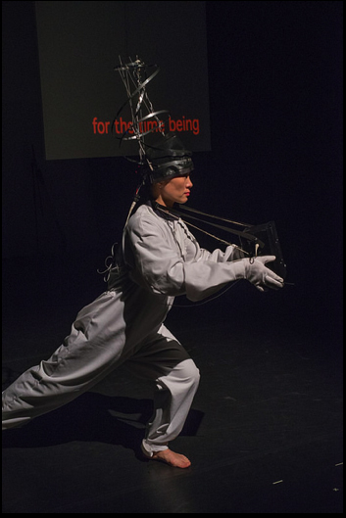
Figure 1. for the time being, Sadler’s Wells, London,
2014. Dancer Helenna Ren performing radio transmissions
in TatlinTower, a wearable electroacoustic instrument.
(Photo © DAP-Lab).

One of the dancers who performed the TaltinTower, Vanessa Michielon, commented on her improvisations in the wearable instrument stating:

I am working with two distinct objects which are connected but possess a specific identity. This makes me play with the idea of the distance between these extremities because the head acts as a receiver and the box an emitter. I improvise thinking about the path of an invisible signal traversing my body, I vary the distance between the hands and the head, and I play with the idea of disconnecting body parts.
(Michielon 22 February 2014 email).

TaltinTower was worn at the start of for the time being as the audience were entering to take their seats, all one could hear initially were the tiny sounds of the beating spring. As the scene progressed, the dancer performed the wearable in the space, gradually moving towards a static microphone which picked up her small sounds and transmitted them to our musicians. The musicians could then begin to distort the sound originating from the dancer, generating and emitting new sonic textures into the space – adding reverb and other altering effects.

Gravedigger

The second prototype entitled Gravedigger, incorporates a Kinect interface. Here the body-garment is integrated into an immersive environmental system, instead of technologies located directly on the performer. The design appropriates existing technologies for performance, in this case the motion-tracking systems and infra-red camera of the Kinect. This particular design looks to translate and update Lissitzky’s 1923 GraveDigger. With this prototype, I was keen to take something historical and bring it up to date through the use of technology but without losing the identity of the original. I began to explore the relationships of the technologies to the sarcophagus form of the GraveDigger. The older version of Kinect, which we were using at the time, needs the T-pose to start mapping the body. If we were to hide the skeleton inside the sarcophagus form, we could confuse the system and allow the performer to decide at what point she would reveal her form and begin interacting. The sarcophagus shape meant she had to shuffle from one side of the stage to the other. She altered her orientation to make the costume visible from different angles as she moved to her space of interaction – a small square marked on the stage. In the square she could begin to emerge from the sarcophagus, the camera then seeing her begins to map her movements as she makes gestures that manipulate the digital sun on screen behind her (fig. 2).

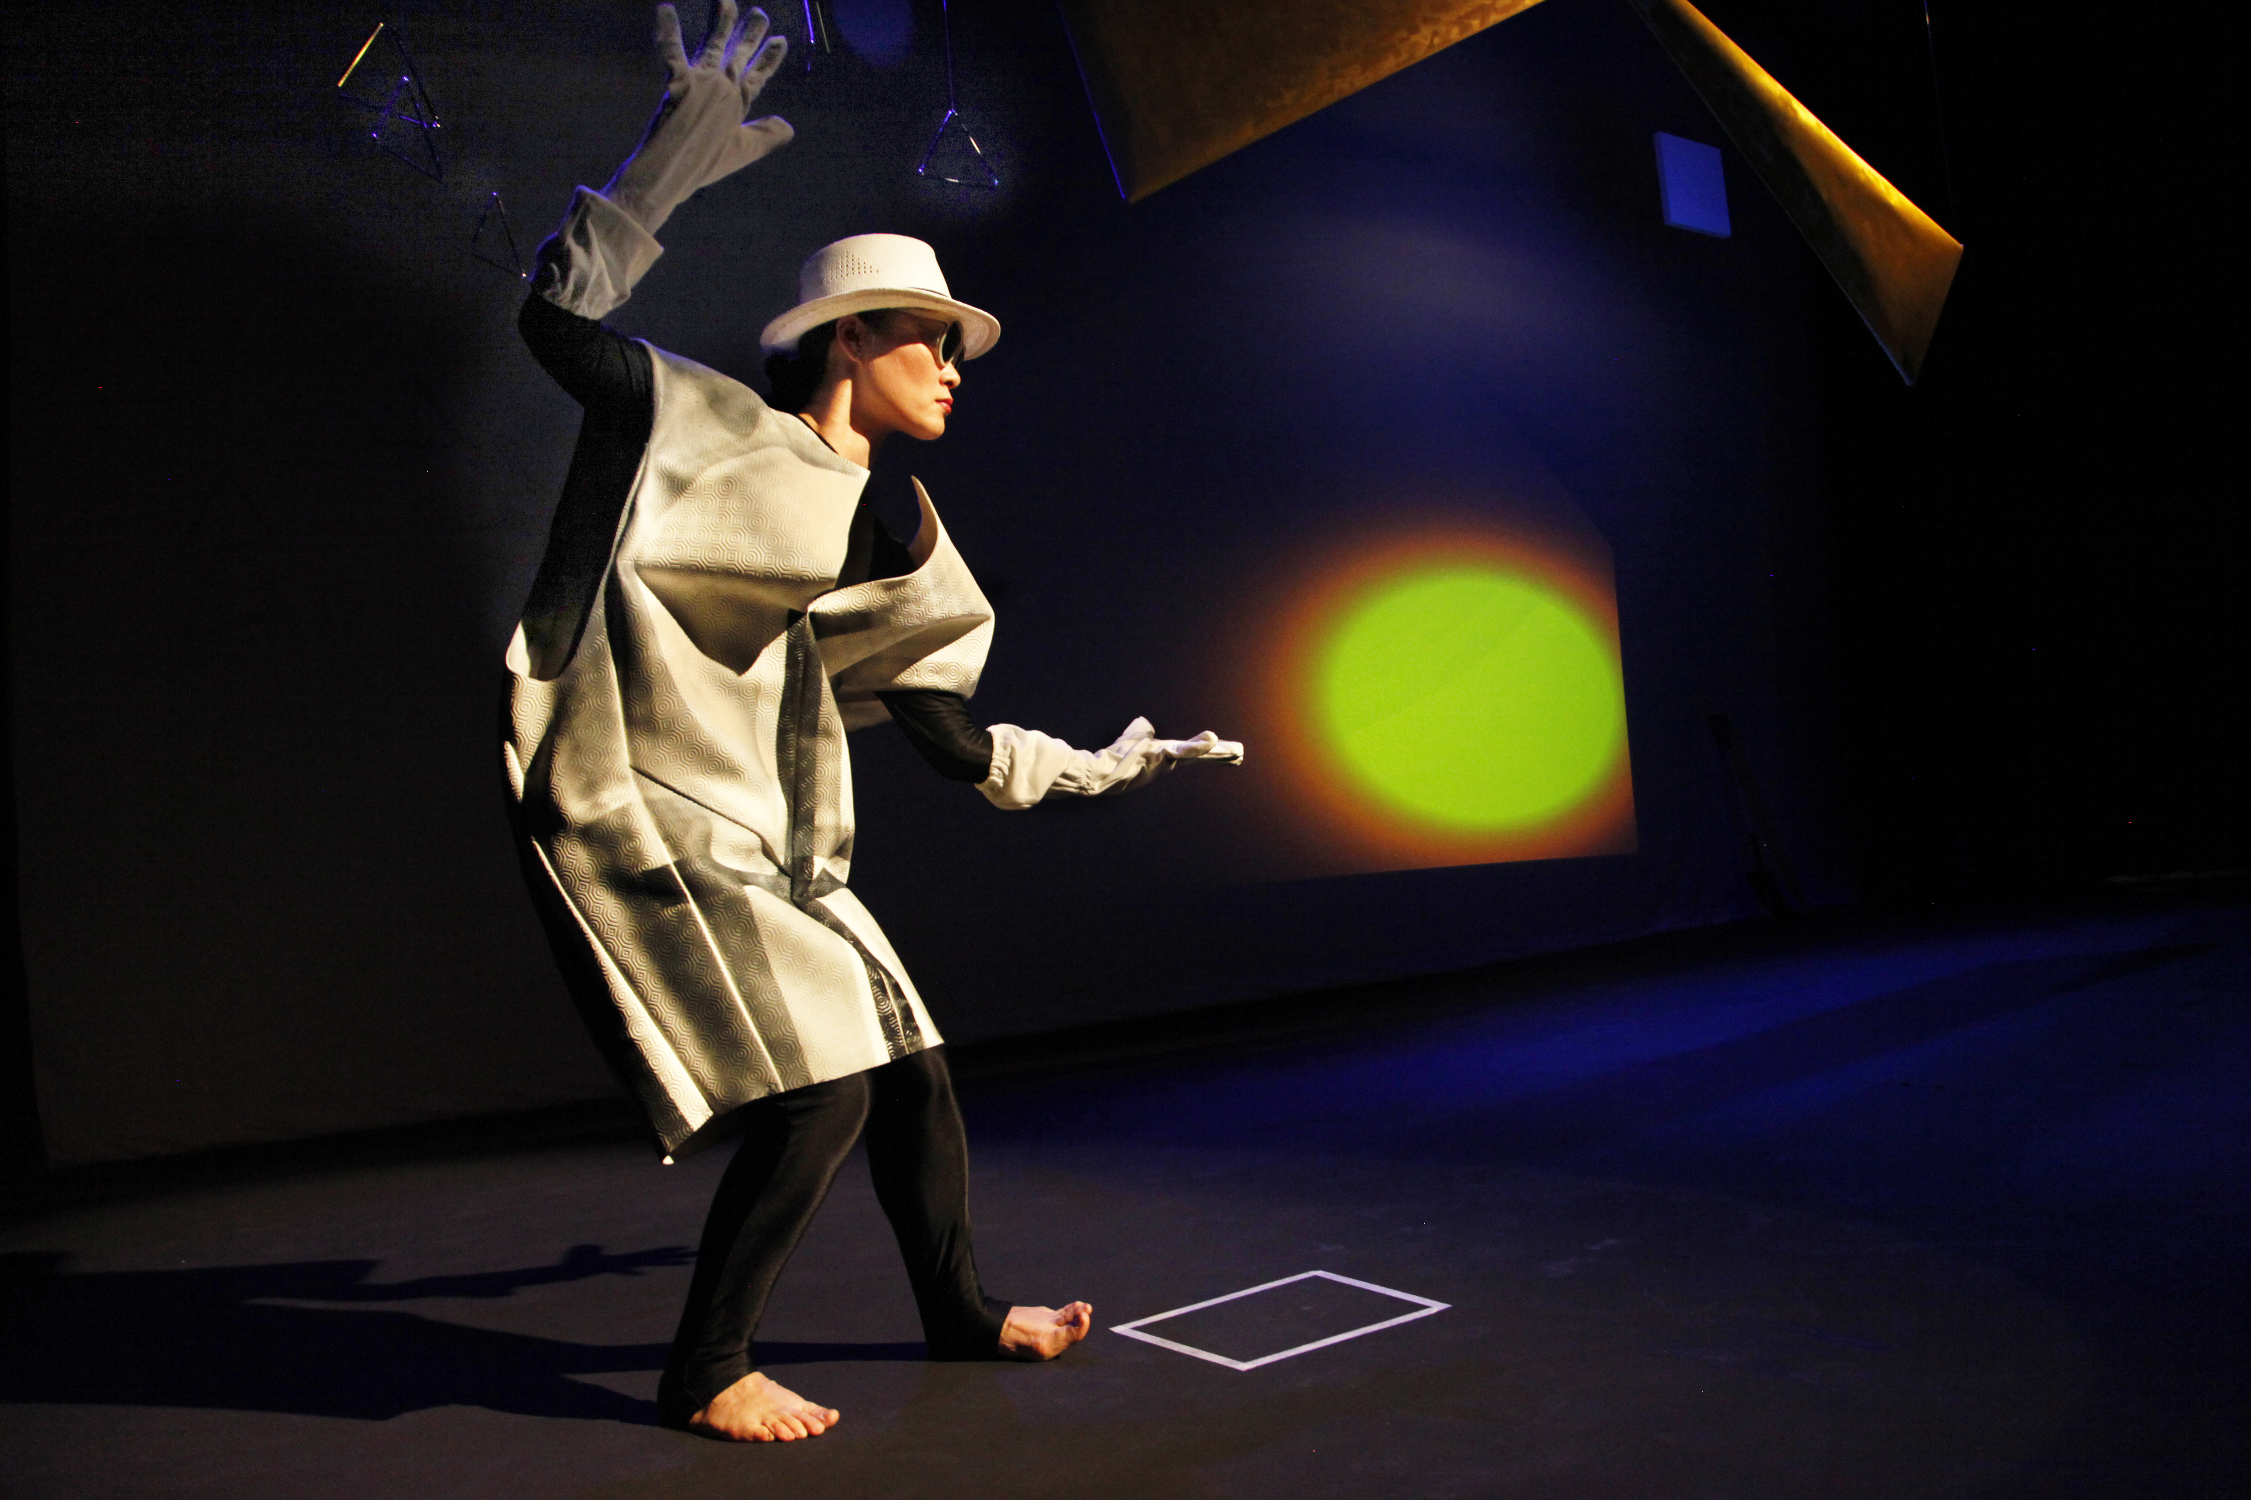
Figure 2. for the time being, Sadler’s Wells, London, 2014. Dancer
Helenna Ren as GraveDigger enacts the role of sun-trapper in the
‘Killing of the Sun’ scene. (Photo © DAP-Lab).

One of the previous speakers at the symposium talked about how Kinect could be used to animate an avatar, in this case, the sun is the avatar and the dancer is manipulating the sun. Simultaneously, she is manipulating the sound of pulsing, relating to an iconic moment in the opera where the sun is captured and killed. We wanted to think about the sensations the sun would be feeling as it was placed under stress, and produced the sound of a throbbing heart and building pulsations. The dancer plays with this intensity of sonic response, and as she explores without looking at the screen, she learns through gesture and aurality rather than employing vision, how to capture the sun, and bury it inside her sarcophagus-body.

RedMicro Dress

RedMicro Dress, the third prototype, as I previously mentioned, takes inspiration from Malevich’s Pallbearer character. I took his idea of geometric silhouette, loosely interpreting but without directly copying, in the design of this prototype. RedMicro Dress integrates a wearable microphone system with wireless transmitter into the garment which in the context of the moving dancing body becomes dynamic. The microphone is placed on the upper back shoulder, positioned in such a way as to render it unusable by the wearer in any conventional sense. It is placed there for a partnering scenario – to invite another to interact with the wearer. I am intrigued by the idea of two bodies interacting – one body initiating movement and sounding in another body. RedMicro Dress is a weighty dress, made from neoprene and leatherette. The materiality is intended, as well as the technologies, to impact on the wearer's body in motion. I was particularly interested in working with dancers because they are trained in such a way as to be attentive to how they feel in their bodies, more so than normal bodies who haven't received their somatic training. The dancer, Vanessa Michielon, shared how she felt in this instance about the touch of the dress in motion providing me with valuable insights into her sensations of experiential wearing. She noted:

In a still position I feel the subtle pressure of the costume around my waist and it invites me to contract my abdominals and to keep a straight position in my back, concentrating on my verticality. When I bend or extend the elbows, the fabric makes sounds and this suggests me to perform this task more often than I usually would do. Furthermore, the fact that the costume is tight-fitting on the elbows suggests keeping the arms straight, to minimise the pressure, or to bend them to feel the strongest tension. Since elbows are the focus, I use them as motors and I try to maximise their distance, thus opening up the back and also using the space behind me. Sometimes the movement propagates through the whole body, sometimes it just remains in the elbows thus isolating the rest of the body.
(Michielon 13 March 2014 email)

Futurian

The intimate entwinement of body and instrument is pushed further in a later scene towards the end of Act Two. In this scene, a second wearable sounding character, the Futurian (the fourth and final prototype I introduce here), enters into the proximal relationship of the RedMicro Dress performer. Michielon in red executes a repeated series of revolutionary poses, arms held straight and elbows rotating as she explains in her quote, while the Futurian approaches – a science fiction instrument adorning her chest and two small speakers attached to her lower back (fig. 3).

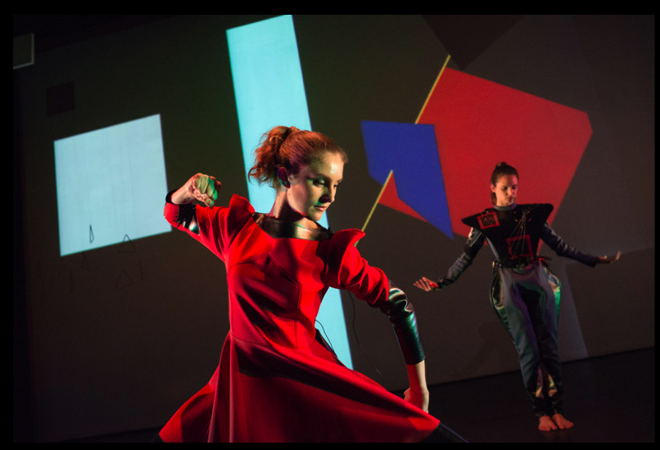
Figure 3. for the time being, Sadler’s Wells, London, 2014. Dancer Vanessa Michielon in RedMicro Dress performing a duet with Aggeliki Margeti the Futurian in background wearing sounding chest plate with interactive circuitry, incorporating proximity and light sensors. (Photo © Hans Staartjes).

The Futurian prototype is equipped with microcircuitry on the chest plate, once again designed with musician John Richards, and metal strings allowing the wearer to play the wearable instrument and generate sound. It is equipped with proximity and light sensors which sense the presence of the other performer body, altering the sound quality or pitch. The sounding of the Futurian it is picked up by the dynamic microphone worn by Michielon in the RedMicro Dress and transmitted to our collaborating musician Oliver Doyle who can work with the sounds further – distorting and amplifying them to create a whole noise experience. As previously mentioned, the sound aesthetic I have favoured has tended to move towards the noise genre in sound arts. I have looked a lot at background noise, and cracked media - where instruments and playback devices are progressively destroyed and thus become altered and dysfunctional. This notion of becoming flawed interests me in my designs more than perfection particularly in terms of sound aesthetics and our use of technologies. The duet between the two dancers wearing my prototypes explores the retro avant-garde, or retro-garde – the idea of looking back, of taking things in analogue as well as digital and combining them to create hybrid scenarios.

By way of conclusion, I would like to show a small excerpt from an interactive duet between the Futurian character and RedMicro Dress, close to the end of DAP-Lab’s for the time being performance (http://youtu.be/oXBW4oWyK0k). This is to enable you to experience the sound generated through their partnering. The discordant and dysfunctional sound from the chest plate gives a sense aurally of the way things were sonically in for the time being. In my presentation of my ideas and DAP-Lab’s work in for the time being, I have tried to show how costume concepts can be fully synthesised into interactive and narrative performance. I have also implied how such performance, if it embeds historical subtexts into the characters and their actions, can point far beyond any technical interface design to social meanings of entwinement, an opening up to other voices and affective experiences. I would add that by looking at the notion of corporeal noise – the noise coming from the body – and the body being able to shift and change that sound in space, the idea of the generative comes through, not in the computational sense but in the performative sense. The case studies thus also reveal how costumes might use multiple sensorial methods including sounding characteristics for the unfolding of character and movement choreography in space, obtaining a richer multidimensional and sometimes ironic textured and sculptural quality that takes them beyond the purview of fashion wearables and theatrical costume design.

References
Bradby, D., ed. (2006), Theatre of Movement and Gesture: Jacques Lecoq, Abingdon: Routledge.

McLuhan, M., (1967/1996) The Mediums in the Massage: An Inventory of Effects, with illustrations by Quentin Fiore, Berkeley: Gingko Press Inc.

Michielon, Vanessa (2014), private e-mail correspondence, 22 February.

Michielon, Vanessa (2014), private e-mail correspondence, 13 March.

Polanyi, M. (1957), The Study of Man, Chicago: University of Chicago Press.

Sonami, L., (2010), in Rodgers, T., (ed.), Pink Noises, London: Duke University Press.

