

Open Secrets: Stories from the V&A Archive, Friday Late,
25 February, 2011

What was it like to work at the V&A in the 1950s and 1960s? What was it like to live in the Museum then? Does anything ever go wrong? How do curators go about ‘object spotting’ for the collections? How do they go about organising the galleries? Some answers to these questions are revealed in extracts from the V & A oral history, an on-going project begun in 2009.

The Stories: Tracks 1-10 (30 mins)

1. [2:16 mins] Elizabeth Knowles reminisces about joining the Museum in the late 1960s, discovering the work of the Circulation department, which closed down in 1976.

2. [2:03 mins] Philip and Jean Winter describe their flat and everyday protocol in the V&A to which they moved in 1955 on the appointment of Philip Winter as the Museum Superintendent, the most senior post, after the Director. (The Secretariat Entrance is at the eastern end on Brompton Road.)

3. [2:52 mins] The late Barbara Morris describes V&A Christmas parties and the personalities who made them great, but leading eventually to a ban on departmental parties in the late 1960s.

4. [3:52 mins] In 1953 a systematic series of thefts was uncovered. Barbara Morris, who went with the Keeper of Circulation, Peter Floud, to the culprit’s house, talks about the theft. For the complete story see The V&A Online Journal, Issue 2, Autumn 2009, available at http://www.vam.ac.uk/res_cons/research/online_journal/journal-2-index/index.html

5. [3:39 mins] Anna Jackson recalls “the most exciting find ever”, a story that begins when she was involved in transferring object records to an early electronic catalogue ROLO, c.1990. (Building work is being carried on outside the office during the interview.) The incense burner (188:1-1883) can be seen in the Toshiba Gallery.

6. [4:39 mins] Liz Miller reflects on the ‘tingle factor’ of ‘object spotting’ exciting acquisitions for the print collection, c.1990.

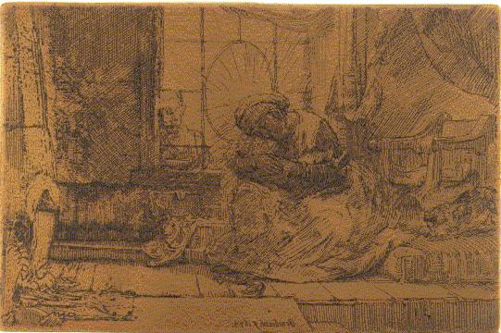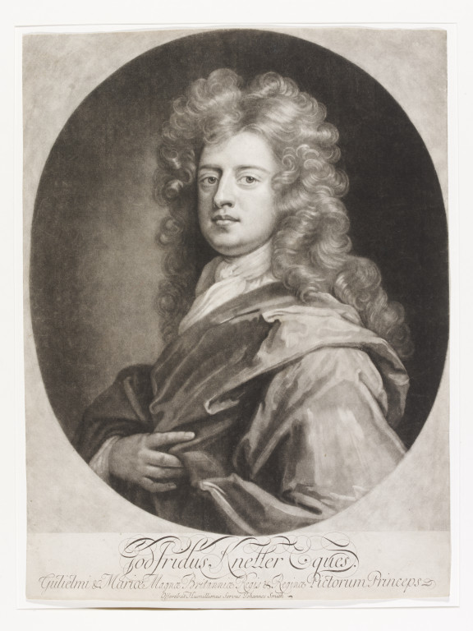
John Smith, mezzotint, c.1694 (E.1114-2008)
Rembrandt, etching plate, 1654 (E.655-1993)

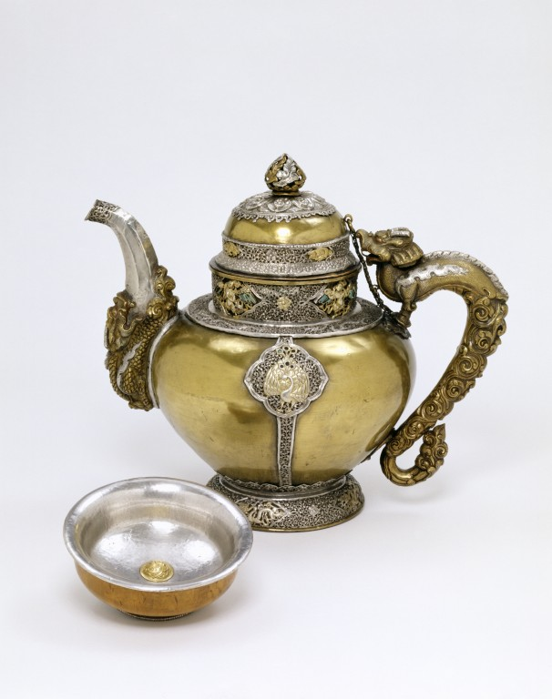
7. [3:23 mins] John Clarke describes his first research trip to India in the mid-1980s, discovering craftsmen working in a tradition that had not changed for centuries.

Teapot; silver, silver-gilt with inset of turquoise; Indian (Hemis Monastry, Ladakh); c.1850. (IM.112-1927)

8. [2:47 mins] John Mallet reminisces about the former layout of the Ceramics Galleries (Level 6), that like the atom bomb had been referred to as “the ultimate deterrent”.

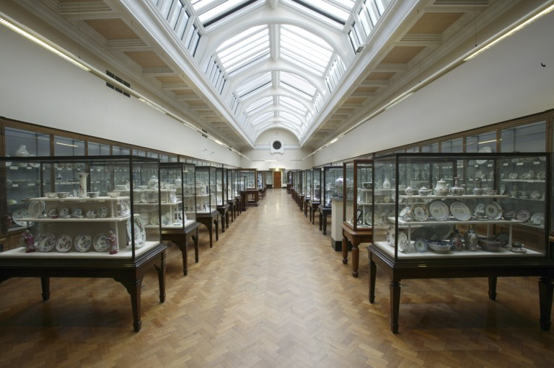

9. [3:07 mins] “Blandness is not an option!” was the slogan that underpinned the design and curation of the British Galleries (Level 4) which opened after years of planning in 2001. Christopher Wilk describes the teamwork involving the historian, John Styles.

10. [0:48 secs] Liz Miller sums up why the V&A is wonderful. [Final track]

Further Information

The V&A and the Camberwell/Chelsea/Wimbledon Graduate School at the University of the Arts London fund the project jointly. For more information about the project, please contact Linda Sandino, CCW/V&A Senior Research Fellow l.sandino@vam.ac.uk

Interviewers:

Anthony Burton, V&A Senior Research Fellow Emeritus: (P. & J. Winter, Track 2).

Dr. Matthew Partington, University of the West of England Bristol/V&A Senior Research Fellow: (E. Knowles, Track 1).

Dr. Linda Sandino, CCW Graduate School, University of the Arts/V&A Senior Research Fellow: (J. Clarke, Track 7; A. Jackson, Track 5; J. Mallet, Track 8; L. Miller, Tracks 6 and 10; B. Morris, Tracks 3 and 4; C. Wilk, Track 9.)

Acknowledgements:

With thanks to Rachel Crossley, Christopher Marsden, Liz Miller and Helen Woodfield.

