**Fixing the World through Open Design**

**Anthony Quinn**

In my convoluted role as educator, designer, maker and writer,I have been slowly watching an evolution within design practice. This view has grown out of piecing together clues, including Fixperts, Sugru and Faraworkshop, like one of those Scandinavian super cool, overly taciturn detectives.

The final piece in the puzzle arrived approximately a year ago. My students on the BA Ceramic Design course at Central Saint Martins were in open revolt over an Intellectual Property agreement written by the University’s lawyers to protect them in a live project with clients. In the furore that followed it dawned on me that the problem was not the fine detail committed to print, but the fundamental premise that in an art school-client collaboration the client gets first refusal. This refers to the exclusivity period that the clients get in relation to the students’ work whilst deciding whether to develop it or not. The students were more interested in sharing their ideas via twitter, facebook or blogs than waiting to see if the client will actually take on their idea. In reflecting on this storm in a teacup I realised that this small act of fury represented a much bigger, more profound issue.

The traditional premise of design education is based on a commercial paradigm: students are taught the skills of the profession with the intention of moving into that profession upon graduation. My hypothesis is that this is what art schools think the students want but is not actually a position that reflects the sensibilities of a new generation of designers. This mismatch in intentions prompted the following enquiry. This is something of a personal positioning exercise: I don’t profess to have all the answers but I do have a number of observations, which have resulted in a lot of questions.

**Sharing, Branding and Identity**

So, where to begin?

Let’s start with this idea of sharing your ideas and your work. The open source community grew out of programming and software, the term ‘hacking’ was designated by the community to describe the act of improvisation and tweaking of work by other community members. It was expected that other members would build upon your ideas and make new iterations. Crucially, this was recognised as a good thing! Almost exactly as the art school was realizing the potential capital return on Intellectual Property, the programming community, with the advent of the nascent Internet, was recognising the importance of being open! Universal software such as Linux and Mozilla’s Firefox has grown out of this hacking process.

Recently, on a train journey with Julia Rowntree of the independent arts group Clayground Collective, I was talking about how one of my own projects needed an early adopter, a big brand. Julia stopped me saying “I really hate that word *brand!* You know it derives from branding cattle and slaves!” Further enquiry, proved this to be true. Our modern use of the word is predated by the slavery definition by a few hundred years or so. How can we forget such a powerful association? How can we countenance what it predicts? Brand slavery!

I read somewhere that our loyalty to brands is akin to a feudal loyalty. We would bare arms for our brand, emblazon ourselves with statements like “my iphone is better than your galaxy”, etc. Why? What’s the big attraction? Sure, brands incentivise our loyalty with various freebies and communities, but these incentives have little impact on the balance sheet. So what makes us so loyal? This is an important question to our overall quest; we need to understand what most of us buy into in order to understand what the open design communities are rejecting. The most obvious pay off for the acolyte is the so called brand cache, the halo effect of association with a brand is so emotionally deep rooted that it’s almost impossible to recognise it in oneself.

I whip out my super slick iPad or my Kindle in a coffee shop on Old Street and I enjoy the ripples of recognition in the room, People like me! Of course I can see the hipsters of Hoxton in the coffee bars purposefully dressing down and being anti label in their carefully aged Chuck Taylors but as Kevin Rowland of Dexys’ Midnight Runners said “If you’re so anti fashion, why not wear flares, instead of dressing down all the same”. This affiliation is a cultural shorthand allowing me to communicate across language and express my sensibilities by association. Whether we like this or not it is a powerful phenomenon and one which the new generation of designers seem to be increasingly averse to.

**Politics and Creativity**

Creative Commons and Copyleft are interesting acts of cultural and brand sabotage. They offer protection to the designer from the pervasiveness of branding by declaring that the design’s copyright is open to reproduction and customisation within certain parameters. This is a sort of protection that is out in the open by allowing editions and improvements. It is up to the designer to determine the terms of engagement such as a ‘non-commercial’ license, essentially allowing use providing you don’t make a profit, or the ‘share alike’ licence which allows use provided your outcome is shared in the same way as the original author.



Hack Chair (2009) Ronan Kadushin

Israeli designer Ronan Kadushin’s *Hack* chair (2009) was an attempt to make an industrial design archetype that could be easily reproduced and hacked by subsequent designers. Ronan released the files on the open Internet using creative commons licensing (share alike and non commercial) with the invitation “please copy. But if you want to make a business out of it then call me and we’ll discuss royalties. It is my intellectual property after all; that’s the bottom line” (Kadushin, 2011).

These attitudes towards the ownership of IP and the right to copy or hack a design have a direct correlation to the wider apolitical zeitgeist. Edward Snowdon, Occupy, Hillsborough Justice Campaign and Change.org each in their own way repudiate the status quo. Their approach, much like creative commons, is to take refuge in the open, to use publicity as both a shield and weapon. In the same way that art schools have lost track of their students’ attitudes then governments have lost track of the popular consensus. Whoever thought that mass surveillance and phone hacking (that word again, deservedly negative) were in the public good, or that we are all *actually* in this together have profoundly misunderstood the enabling power of the internet, the sense of community it can provide through forums and social media.

It is almost as if government agencies felt they were a step ahead, but they were actually a heartbeat behind. The ability of special interest groups to mobilise via the World Wide Web probably represents its greatest opportunity. Occupy, in direct opposition to most western governments, claims to represent the 99% as opposed to the vested interests of the 1%, the businesses and banks. This wider political context permeates our open design communities. A new generation of designers is leveraging the Internet, to break the traditional design trajectory.

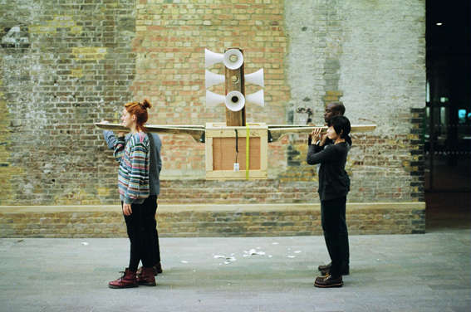

The Ark of Many Voices (2012) Marco Monterzino

The *Ark of Many Voices* (2012) by Italian-born designer Marco Monterzino is a powerful testament to giving people a voice; his processions through London and Rome in which people express their opinions through the megaphone are visceral unscripted reactions against a powerlessness engendered by a patrician class devoid of empathy for their communities. The *Ark of Many Voices* transforms Dunne and Raby’s critical design into a defiant act of *designed* criticism! Monterzino gives the community a voice and the means with which to make their voice heard. This can be placed in direct opposition to Cody Wilson’s *Liberator* (2013), the world’s first 3d Printed Gun. Wilson made the rather spurious argument that his 3d printed weapon was an illustration of the US government’s inability to enforce gun control. Defense Distributed present their philosophy as fundamentally libertarian, but in reality are somewhere to the extreme right of the Tea Party with Solid works training. Not at the same party as Occupy, with their V for Vendetta-inspired Guy Fawkes anonymity. In a nod to the gallery, the V&A has decided the Liberator is so important it must have one. As Stephen Knott has described:

The purchase seems deliberately designed to court controversy in the rhetorical sphere, while presuming perfection of the 3D printer’s power to print a working gun at the click of a button. There is little mention of the expertise within the company, which underemphasizes the difficulties of production in favor of a smooth, uncomplicated message.

(Knott, 2014)



The Liberator (2013) Cody Wilson/Defence Distributed

It wasn’t always thus! These acts of rebellion and provocation both to the governments and vice chancellors have taken some time to take root. The paradigm had been established for some time before Naomi Klein alerted us to the perils of brand think in 2000’s *No Logo*. Hers was the first in a drip feed of ideas that slowly created rising damp in the modernist concrete foundations of design. In 2002 William McDonough and Michael Braungart introduced us the utopia that is ‘Cradle to Cradle’, the very act of designing recyclability into a product from the start rather than an afterthought. Though Einar Wiig a Norwegian design historian recently posed the question, *is cradle to cradle a desperate attempt to prop up the existing broken economic model?* It is a wonderfully enlightened and transgressive position to proclaim C2C is in hock to the system. Yet when we consider it logically, C2C is in opposition to the idea of Fixperts or the Faraworkshop, both of which establish a post-manufacturing, ethical position of fixing, improvisation and upcycling.

In *Domus* design curator Paolo Antonelli in her essay series ‘states of design – critical design’, (Antonelli, 2011) introduced the ideas of the former director of Xerox Park, John Seeley Brown, in which he proposes a new educational model - *Learning 2.0. (Seely Brown, 2009)* Seeley describes an evolution from instruction to participation, wherein we learn through doing and we learn from each other. He describes a pedagogical shift from the sage on the stage, where learning is one shot, linear and de-contextualised to a peer community based learning, where it is exponential, continuous and situated. This reminds me of Lave and Wengers *communities of practice (2000)* in which the idea of legitimate peripheral participation, simply translated, as *it’s ok not to know* or *you can learn on the job,* acts as a fundamental declaration of engagement.

It strikes me that legitimate peripheral participation could be said to be a cornerstone of all of our open design communities. Its central tenet, that you will grow closer to the core of the community and therefore more adept are you the more you participate in its activity, is the driving philosophy of all of these open communities. Eric Meyer and Ray Land (2003) posit that in order to move closer to the centre of a community you must engage with a threshold concept; once mastered, it is transformative in that you cross a threshold from which you can’t return. Unfortunately coming from a craft background I am not sure I buy this! Things take time to master, skills need to be practiced, tools to be used again and again. Meyer and Land describe this process as troublesome knowledge, ideas that you need to really work through to get to grips with. Seeley Brown goes on to suggest that the last thing we need is a change of attitude, we need to be “listening with humility and an open mind”. So a return to this word “open”, we can overcome any obstacle, however troublesome, if we join a community and work our way into its centre through being open and listening to each other.

It is this mix of practice makes perfect, openness, attitude and humility that links all of the open design communities.

**Community and Craft in Fixperts**

There seem to be two divergent strands in our open design communities, one group advances the idea of an intellectual connoisseurship, where-in the outcome may look rough around the edges but the positioning of the activity is a coherent manifestation of critical design. Monterzino’s ark is hewn from scrap but the idea is higher order, Fixperts and Faraworkshop both rely on an integrity of craft and skill and a lithe design awareness and fundamental all encompassing philosophy. Whereas Sugru, How Do and Be Kind Rewind/Sweding revel in amateurism, in the ad hoc and the improvisational spirit in all of us.

What I find particularly interesting about Fixperts is the make up of the community and the attitude to solving the fixpartner’s problem. The challenge is solved through a mixture of empathy and ingenuity. Solutions may look ad-hoc or clumsy but in reality they have been built in a true user centred co-design spirit, with a strong sense of the improvisational ‘make do and mend’ ethos that requires little or no budget, the idea is to fix not buy. You only have to look at the fixfilms to witness how the fixperts are applying academically trained skills to the everyday in a way not envisioned by most of their courses. This might be only a temporary step, other forces may drive the designers to find design jobs in consultancies, Fixperts might act like a philosophical design gap year, many of the fixperts may enter the system at a later stage in their careers, but the ethical position will be something that they carry forward with them, bringing an open, community participatory attitude into new commercial design contexts.

Picture of Harold?Fixperts? Can you supply?

This can only be a good thing. It is possible that the next generation of designers with this more empathetic world view will start to effect the system from within, to approach a design problem with the user or the community as a fundamental prerequisite would be a paradigm shift in design. For the record my favourite fixfilm is the one of Harold who is elderly and suffers from arthritis. This means that he can’t see into his low fridge - so the fixperts simply build a plinth for it to stand on! Ok, so it’s dead simple and quick to do, but how many of us would think to just raise the fridge. I also enjoy the video of the designers to quote Seeley Brown “listening with humility” to Harold’s needs and their obvious enjoyment in his positive response to their initiatives. It’s a direct provocation to the ever-present brand think; we are so wedded to the idea of product obscelence that our instinct is almost always to replace.

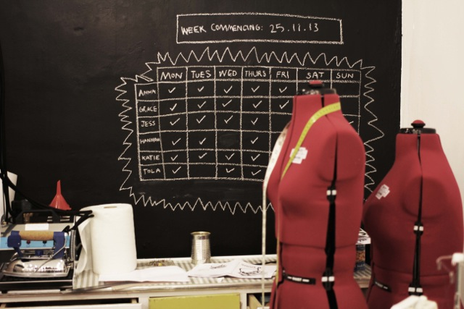

The Faraworkshop, London

The Faraworkshop also uses skill as a tool for delivery of a strongly ethical message. Faraworkshop is a social enterprise, which supports FARA a Romanian charity, that previously took donated clothes and traded their bulk value for cash. That was until a group of enterprising fashion and textiles designers proposed that the clothing could be customised and up-cycled for a greater return. A real eye for fashion enhances the ethical positioning. The clothes produced at the Faraworkshop on London’s Pentonville road, are beautifully hand crafted in the shop, they offer a first step experience for new designers, a range of classes for budding amateur fashion designers and most importantly afford the charity a greater return and the charity shopper clothes that are both unique, elegant and fashionable. As with Fixperts the sense of connoisseurship is used with wit and intelligence to create a resonant collection and the community that is growing out of the endeavor is really exciting, fulfilling Lave and Wenger legitimate peripheral participation prophecies.

The phenomenal wonder material Sugru attracts its own community of fervent makers. Spared on by their mission statement *the future needs fixing* the sugru community turn their hands to just about anything, from the ubiquitous fixing of Mac cables, to childproofing camera’s and customizing fencing equipment. Sugru positively embraces openness, appealing to the specialist designers and crafters for its amazing properties and to the amateur DIY’ers for its fixing possibilities and to the hackers for its bonding and transformative qualities. The Sugru community welcomes everyone; the only prerequisite is a curiosity around fixing. What Sugru get really right is their pitch to whoever is listening. This is a material that can do pretty much anything, no skill required, form it between your fingers and shove it in or on. Then show us what you did, post it on our site, and show others. The transformation from wonder material to social media community is Sugru’s hidden property. When B&Q placed a 3-month trial order for Sugru, its inventor Jane Ní Dhulchaointigh appealed directly to its online community via a YouTube advert to *get your ass down to B&Q* and buy sugru there. To be able to communicate directly to your user community and enlist their help in spreading the word is a brilliant conceit and one, which blurs the boundary between whether Sugru is a product, a community or a movement! Sugru have explored this question themselves, resulting in The Fixers Manifesto, inspired by Platform 21’s Repair Manifesto, amongst its proclamations are;

**If it’s broken fix it**. Because everyday practical problem solving is the most beautiful form of creativity there is.

And my favorite

**Nurture your curiosity.** Keep trying things you’ve never tried before. Its good for your brain and your soul. Don’t be afraid to fail – it makes success all the sweeter.

Probably my favourite example of an open community that is truly open and beyond any sort of central control is Sweding. Inspired by the film *Be Kind Rewind* (2008) is a gentle comedy directed by Michel Gondry. The film’s absurd conceit is that Jack Black is magnetised and wipes all the videotapes whilst his friend Mos Def is left in sole responsibility of the local video store. The two friends decide to re-make any videos requested by customers themselves using a video camera, Sellotape and their imagination. Films are sent to be ‘sweded’ (in Sweden of course) and the resultant celebration of lo-fi ingenuity, daring do and sheer chutzpah is one of the most affirming movies about the power of the hand and its ability to bring a community together. The hero’s ambition grows in time with films such as *Ghostbusters*, *Driving Miss Daisy*, *2001 Space Odyssey*, *Boys in the Hood*, *Rush Hour II* and *Rumble in the Jungle*. Yet as funny as the movie is, no one could predict what followed. Friends began to ‘swede’ their own versions of *Jurassic Park, Terminator* and *Ghostbusters*. A viral YouTube community has grown out of an absurd sweet comedy! The communities’ values reside in a low-tech poetic approach to the Hollywood canon, as the traditional gravity of the film set is replaced by freeform creative interpretation and sardonic critique of outlandish plots. There are now ‘sweding’ festivals such as Swede Fest where films receive previews to critical acclaim and a recent *Guardian* article told us “studios can't decide whether they are terrified or charmed by the trend”. (Walters 2012)

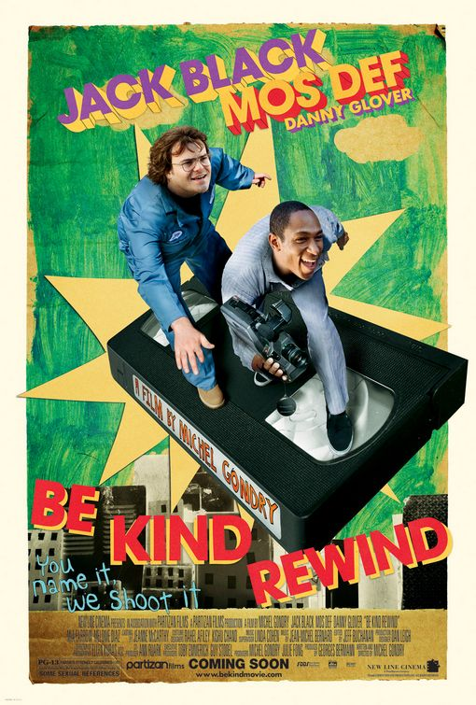

Be Kind Rewind (2008) Michel Gondry

Seeley Brown talks about the idea of learning to be, of acquiring tacit knowledge and unleashing productive enquiry, which he claims is achieved through leveraging the resources of the Internet. Most of the examples above achieve this, but there are other noteworthy exemplars. Kickstarter is the ultimate example of support for the underdog through crowd sourced funding. Kickstarter claims to be the world’s largest funding platform for creative projects, a sort of people’s bank for the sort of projects that established funding routes such as banks and venture capitalists just wouldn’t get. More importantly Kickstarter is built on an ethical engagement philosophy where backers can offer support for projects that they would like to see grow. The creators share their ideas, ask for a bit of help and likeminded individuals pledge support. When the funding threshold is crossed then cash is delivered.

Architecture for Humanity is a network that creates architectural solutions for situations of extreme need such as war or natural disaster. The organisation is non-profit, and has 58 chapters in 16 countries, working in a field it describes as humanitarian design. Its aim is to share architectural solutions that are scalable, not in a one-size-fits-all model but in a way that is customisable (hackable?) to a specific context or need. With their mission statement ‘design like you give a damn!’ Architecture for Humanity brings architects, project managers, builders, policy makers and other important participants into a global network. Founders Cameron Sinclair and Kate Stohr believe architects have the skills and sensibilities to offer a solution in times of great need. The organisation’s website allows supporters to make charitable donations and offer support in events or disasters that spike the public consciousness.

Open design means you’re open towards the user, that you open yourself to the user, not by conducting market research and so on, but by being open to people, by giving people something to do, by interacting, by not planning everything down to the last detail.

Renny Ramakers (2011)

So where has this journey into the open taken us? Ultimately the design world needs to recognise thatopen design communities are here to stay, that they willgrow in power and will be both politically and socially influential. We as designers need to recognise that the traditional commercial paradigm of industry is now defunct. Fledgling designers are interested in new modes of engagement and as suchwe need to re-think our rolesand re-align our design philosophies. We cannot rely on our old methodologies of practice; it is no longer true that we know best. Our future design practicerelieson usdeveloping the correct skill set, we need to listento our community, recognising that the community will be made up of a diverse interest group who all have something to contribute and we need to share in the most engaged, open and considerate way possible. Lets leave the last word to John Thackara: ‘openness, in short, is more than a commercial and cultural issue, it is a matter of survival’ (Thackara 2011).

**Bibliography**

Lave, J & Wenger, E (1991) *Situated Learning, legitimate peripheral participation*. Cambridge University Press

Wenger, E (2000) *Communities of Practice*. Cambridge University Press.

Meyer, J & Land, R. (2003) *Threshold Concepts and Troublesome Knowledge: Linkages to Ways of Thinking and Practising within the Disciplines*. ETL Project, Universities of Edinburgh, Coventry and Durham.

Knott, S. (2014) *Its Not Perfect, but Very Good – Technology and Craft.* Borda-Pedreira, J & Steinsvag, G (eds.) *Materaility Matters Documents on Contemporary Crafts.* Norwegian Crafts, Oslo.

Kadushin, R. (2011) *Open Design Now, Why Design Cannot Remain Exclusive.* Pg 112*.*  BIS publishers

Ramakers, R. (2011) *Open Design Now, Why Design Cannot Remain Exclusive.* Pg 129*.*  BIS publishers

Thackara, J. (2011) *Open Design Now, Why Design Cannot Remain Exclusive.* Pg 44*.*  BIS publishers

<https://www.domusweb.it/en/design/2011/08/31/states-of-design-04-critical-design.html>

***Learning in the Digital Age*** Indiana University, April 2009 <http://www.johnseelybrown.com/learning2.pdf>

* Sweded movies: the end of Hollywood as we know it? **[Ben Walters](http://www.theguardian.com/profile/benwalters)**
* [The Guardian](http://www.guardian.co.uk/theguardian), Thursday 5 July 2012
* <http://www.theguardian.com/film/2012/jul/05/sweded-movies-end-of-hollywood>