**For Immediate Release**

**NUS Museum presents**

***‘Come cannibalise us, why don’t you?’* | Erika Tan**"Sila mengkanibalkan kami, mahu tak?"

The exhibition opens at NUS Museum on 20 Aug 2013.

**An artist talk will be held on 27 Aug 2013, 7pm at NUS Museum.   
Free Admission with registration. Please RSVP to** [**museum@nus.edu.sg**](mailto:museum@nus.edu.sg)

**SINGAPORE, 7 August 2013** – Teasing the visitor with an invitation, the colloquially titled *‘Come cannibalise us, why don’t you?’* is an artist’s response that revisits through re-use, re-enactment and repatriation, the artefacts and writings from an earlier exhibition at the NUS Museum, *Camping and Tramping Through The Colonial Archive: The Museum in Malaya* (2011-2013). New artworks developed by artist Erika Tan that include film, objects and works on paper will be shown.

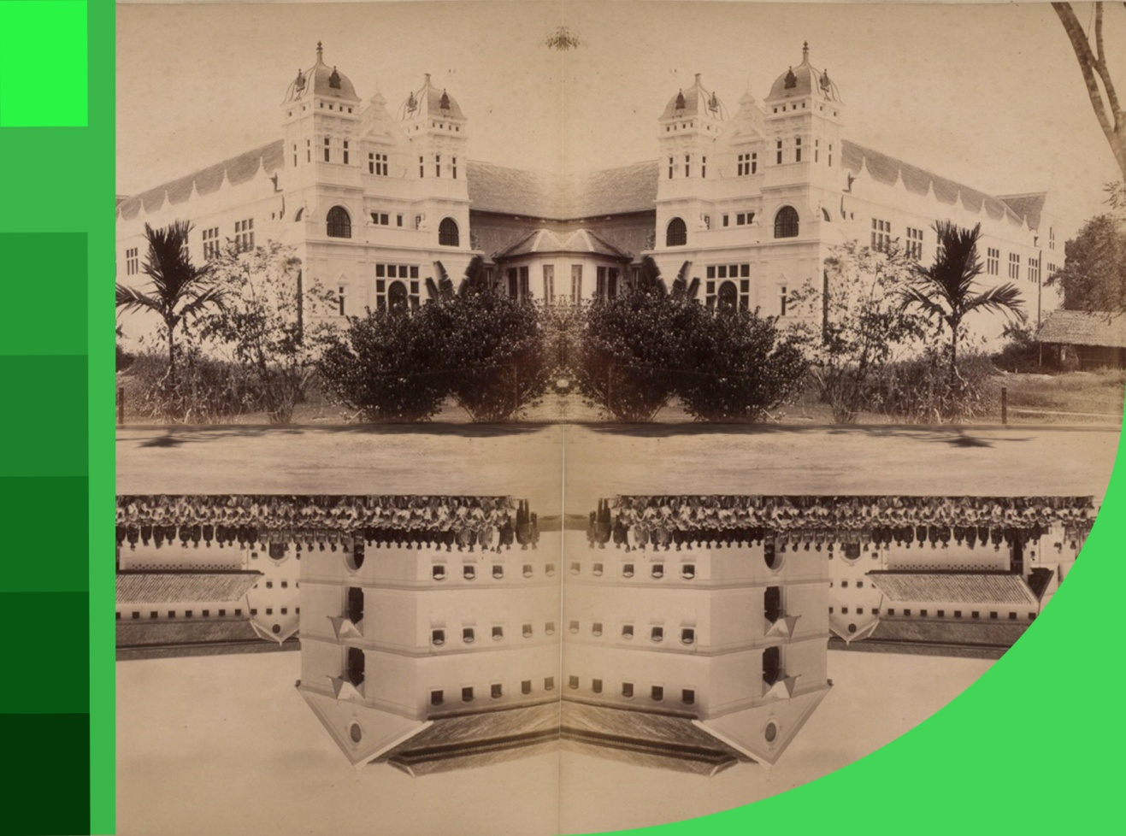

Erika Tan, *Jail Museum Mirror*, Digital Print, 2013, Artist Collection

**About the Exhibition**

While *Camping and Tramping* mobilised the colonial archive to offer the question of the Raffles Museum (est. 1854) and University of Malaya Museum (est. 1955), and their relationship to colonial knowledge in Malaya and Singapore, *‘Come cannibalise us, why don’t you?’* reveals the idiosyncrasies, anecdotes and shifting rules that accompanied the colonial museum project from the point of view of a contemporary artist.

As an artistic exercise, the exhibition works with ethnographic, natural history and art objects from the 19th and 20th century. Lenders include Asian Civilisations Museum, Raffles Museum of Biodiversity Research, National Museum of Singapore and the Mohammad Din Mohammad Collection.

Archival forays are becoming an increasingly common practice for artists, and this project seeks to establish a dialogue with a growing body of Singaporean works which reference history in one form or another. Additionally the transnational production locations of the works will create dialogues which links the work internationally to issues of cultural heritage, museums, collections, cultural representations and to the disciplines of anthropology and museology.

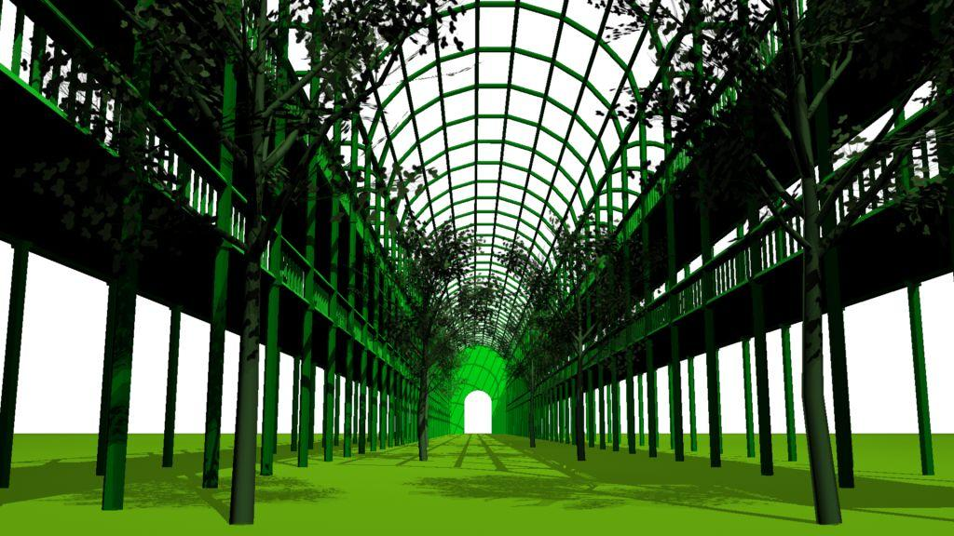

Erika Tan, *VOCATIONEM UNIVERSALEM/Universal Call*, Screen grab from VOCATIONEM UNIVERSALEM, HDV, 2013, Artist Collection

Mr Ahmad Mashadi, Head of NUS Museum, observes, “This exhibition can be seen in the broader context of Erika Tan’s art practice that has systematically unravelled in a myriad of ways, the role of the archive and museums in our ability to critically think about the past, from the present. In fact, our discussions with the artist began all the way back in 2009 when NUS Museum showed Erika’s critically acclaimed film – *Persistent Visions –* a 24 minute three screen installation work.”

Mr Mashadi adds, “The mode of working adopted by Erika Tan balances and negotiates between her roles as an artist, curator and academic. Therefore, the manner in which she approaches her research and subsequent deployment of works in the gallery is fascinating. As an exercise, Erika’s works also attempt to offer insights into dislocated collections of Southeast Asian cultural objects around the world.”

Ms Erika Tan notes about her current show, “More recently, my interest has started to include the way in which museums and the heritage industry ‘use’ artists and ‘community voices’ to provide invaluable insider information and new or more ‘authentic’ articulations about objects and locations. These practices can be seen to privilege the hither-to underrepresented voices and are argued to democratise interpretation and display technologies; increase and diversify audiences; and even act as forms of surrogate ‘repatriation’. In the UK where I am currently based however, my experience as a Singaporean artist is that these practices perpetuate my position as ‘other’, often contributing to a further ‘type-casting’ or fixed role within the frame of ‘cultural diversity’.”

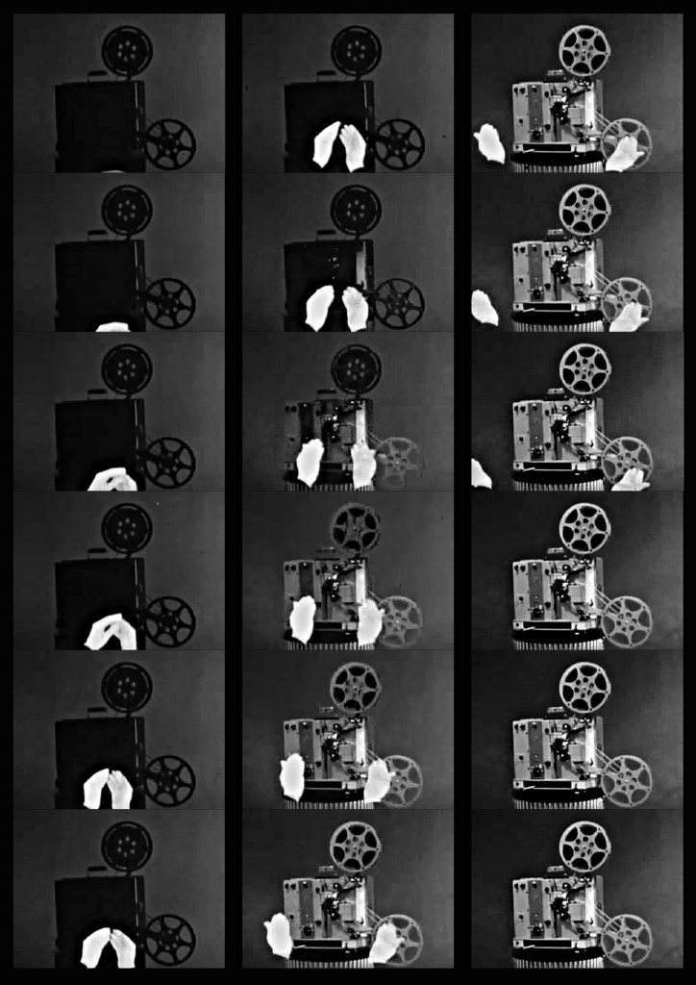Mr Shabbir Hussain Mustafa, Curator of NUS Museum, highlights that “The exhibition should not be seen as a coherent whole with a clear narrative. The entire installation is very much a work in progress and part of a much larger series that Erika Tan is currently developing called *Repatriating the Object with No Shadow: The Colonial Museum, its origins, re-incarnations and transnational recuperations.* The “Repatriating” series is an archival exercise about the colonial museum, lesser-known curators operating in the region, for example the then illustrious curator of the Perak Museum in Taiping, Mr. Ivor Evans, and also a lot of the indigenous collaborators and collectors from the period of whom we know very little about. All of this is undertaken not as a formalistic historical exercise, but as an exercise in contemporary art*”.*

Erika Tan, *Repatriating The Object With No Shadown (I)*, Compilation of film frames, Super 8, 2013, Artist Collection

Ms Michelle Kuek, Assistant Manager for Education Outreach at NUS Museum notes, “Exhibitions such as these are great resources for students and educators. The fact that they are multi-disciplinary and bring together various mediums, allows for students to not just reflect on the debates but engage with the objects and artworks in their visual right. We are constantly working to create dialogues between artists, curators and academics. The results have been amazing!”

The artworks are supported by an initiative by the National Arts Council’s Creation Grant, and are part of a longer term project titled: *Repatriating the Object with No Shadow: The Colonial Museum, its origins, re-incarnations and transnational recuperations*.

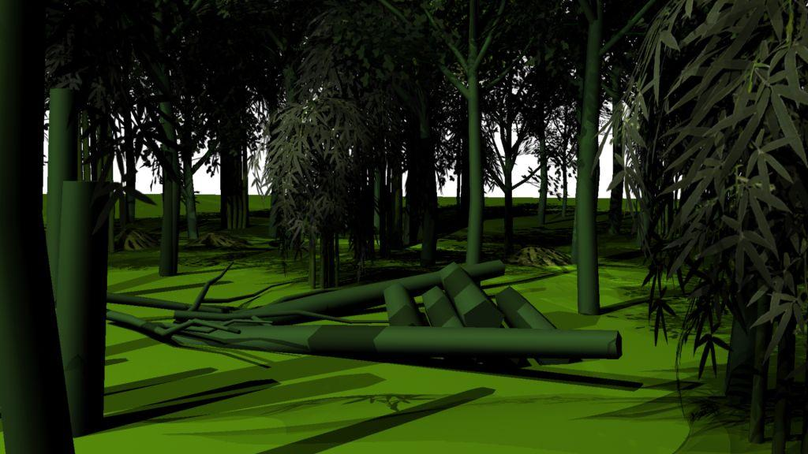

Erika Tan, *VOCATIONEM UNIVERSALEM/Universal Call*, Screen grabs from VOCATIONEM UNIVERSALEM, HDV, 2013, Artist Collection

**Artists’ Book**

Gesturing towards the encyclopaedic or comprehensive, the installation *‘Come cannibalise us, why don’t you?’* is accompanied by an artists’ book, which will take the structure of an A-to-Z Guide, providing a loose guide to the exhibition and ideas inherent in its approach.

Co-edited by Erika Tan and Shabbir Hussain Mustafa, and comprising specially commissioned writings, the book consists of an alphabetically ordered series of text/image/archival entries that reframe and engage historical data, events, artefacts that have a specific relationship to the colonial museum in Malaya and more generally, exhibitionary and museological practices and their relevance today.

The artists’ book will be published in October 2013.

**About the Artist**

Erika Tan (b. Singapore, 1967) studied Social Anthropology and Archaeology at Kings College, Cambridge; Film Directing at The Beijing Film Academy, followed by an Advanced Diploma in Film & Video and an M.A. in Fine Art at Central Saint Martins School of Art, London. She teaches at Central Saint Martins School of Art, University of the Arts London, on the B.A Fine Art course.

Erika is an artist whose work has evolved from an interest in received narratives, contested heritage, subjugated voices and the transnational movements of ideas, people and things. Her work arising out of processes of research and responses to the unravelling of facts, fictions, and encounters related to events, locations, audiences and specifics that may already exist. Her work has been exhibited internationally including The Samsung Art Plus Prize (BFI London, 2011); There Is No Road (LABoral, Spain 2010); *Thermocline of Art* (ZKM, Germany 2007); *Around The World in Eighty Days* (South London Gallery / ICA 2007); *The Singapore Biennale* (2006); *Cities on the Move* (Hayward Gallery, London).

Awards include: The Arts Council Black Arts Video Award, 1993. Firstbase, ACAVA Studio Award, 1995. Digital Arts Fellowship, The Arts Foundation, 1998. British Council Travel Grant to Japan, Arts Council Connections Fund to Singapore, 99/2000. ACME Live Work Studio Award, London, 2001-2004. Artists Links British Council/Arts Council Residency in China Award.

**Enquiries**

For more information on the exhibition, media interviews, publications, gallery tours or high-resolution images, contact:

Trina Bong  
Assistant Manager  
NUS Museum  
T: (65) 6516 4170  
E: [trinabong@nus.edu.sg](mailto:trinabong@nus.edu.sg)

**Credits**

**Organised by:**

::Desktop:Malaya Black and White:FLyer:NUS Museum logo.jpg

**Curated by:**

Shabbir Hussain Mustafa, NUS Museum

**Artworks supported by:**

Work produced in the exhibition has been supported by an initiative by National Arts Council’s Creation Grant, and is part of a longer term project titled: *Repatriating the Object with no shadow. The colonial museum: origins, re-incarnations and transnational recuperations.*



**Publication supported by:**



**Exhibition Details**

Exhibition period: 22 Aug 2013 – 31 Jan 2014

Venue: NUS Museum   
University Cultural Centre  
50 Kent Ridge Crescent  
National University of Singapore  
Singapore 119279

Opening hours: 10am – 7.30pm (Tuesdays – Saturdays)  
 10 am – 6pm (Sundays)  
 Closed on Mondays and Public Holidays

Admission: Free

**About NUS Museum**

NUS Museum is a comprehensive Museum for teaching and research. It focuses on Asian regional art and culture, and seeks to create an enriching experience through its collections and exhibitions. The Museum has over 8,000 artefacts and artworks divided across four collections. The **Lee Kong Chian Collection** consists of a wide representation of Chinese materials from ancient to contemporary art, the **South and Southeast Asian Collection** holds a range of works from Indian classical sculptures to modern pieces; and the **Ng Eng Teng Collection** is a donation from the late Singapore sculptor and Cultural Medallion recipient of over 1,000 artworks. A fourth collection, the **Straits Chinese Collection**, is located at NUS Baba House at 157 Neil Road.

[www.nus.edu.sg/museum](http://www.nus.edu.sg/museum) [www.nusmuseum.blogspot.com](http://www.nusmuseum.blogspot.com)

[www.facebook.com/nusmuseum](http://www.facebook.com/nusmuseum) [www.twitter.com/nusmuseum](http://www.twitter.com/nusmuseum)