The Great Escape: Imagining Wartime at British 1940s Vintage Events
Paul Glavey
p.glavey@lcc.arts.ac.uk

This paper looks at attitudes and behaviour of participants and attendees at 1940s and World War Two era vintage and revival events which occur in different parts of Britain annually. I am particularly interested in the participants at these events who have chosen to wear a military uniform as part of the experience. In this paper I will look at the significance of the wearing of uniforms in these instances and consider why they are worn and how the wearing of military uniforms at these types of events is perceived by other attendees. As part of the research for this paper I have undertaken a small survey of regular attendees to the types of occasions I have outlined as my focus and asked about their attitude to and perception of people dressing in uniform at these vintage gatherings. I will be addressing readings of uniform through the views of some of those involved in the vintage scene, what I will refer to as the scene for short, as well as considering wider ideas like those of subculture, authenticity, some aspects of commodification and perceptions of an ethical element to this costuming.
There are a large number of events throughout Britain which are specifically re-enactments which focus on World War Two e.g. The Yorkshire Wartime Experience or the Fortress Living History and Military Vehicle Weekend. These military re-enactments are however not the focus of this paper. I am instead looking at Vintage/Revival and Party events where military uniforms may be in evidence but the re-enactment element is not the focus.
Occasions which address this criteria include those like the Goodwood Revival which is a three day motor racing meeting that covers the period from the 1940s through the 1960s and the Twinwood Festival which is a three day music and dance festival covering the period of the 1930s through the 1950s. There are also weekend long events, weekenders in the vernacular, like Hepcats Holiday which is a bi-annual weekend of music and dancing covering music from the 1930s to the early 1950s, and the annual Rhythm Riot weekender which focusses on the 1950s . In addition to these, there are one night evenings, such as The Blitz Party or the Blackout Party, both of which are World War Two themed nights.
At all of these events one can participate, spectate, consume and be entertained in a variety of ways. In the case of the revival and World War Two party occasions there is often additional colour or atmosphere added by organised reproduction of the era through the construction of the setting, the use of props and displays and the presence of paid participants in appropriate vintage clothes and relevant allied military uniform. Further to this offered simulation is the wearing of similar uniform type attire by attendees who for the purposes of this paper we can reasonably consider as distinct from those who attend these events in uniform as part of the organised event.
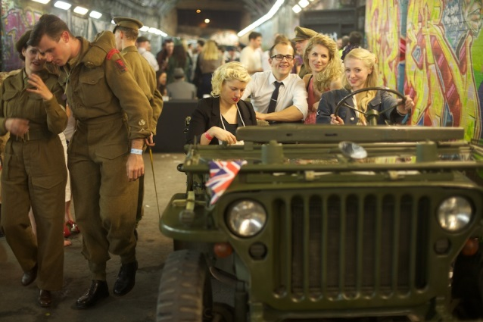
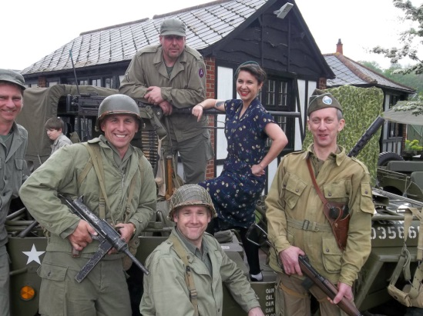

Fig.2 Blitz Party attendees (facebook.com/theblitzparty/photos_stream)

Fig. 1Event attendee and event’s re-enactors (authors own)

I wish to show how the motivation for, and the perception of, those in uniform appear to differ depending on the context in which the uniform is worn, which in turn reflect the level of immersion or involvement with the scene. I will attempt to demonstrate these differences by first looking at the war themed one-night events which are more marketed towards the public, and then move on to the more scene type events, like the weekenders before lastly considering revivals that are a confluence of these different groups.
The Blitz Party is a monthly night in London which takes place in what is described by the organisers as ‘a wartime East End air shelter, complete with sandbags, searchlights, blackout curtains, oil lamps and military bunk beds… [where] Ration books replace bar tabs and scarce provisions line the walls’ (facebook.com/theblitzparty/info). Within this space there is swing music from live bands and DJs, drinking and dancing, and the dress code is defined as ‘1940s glam, home front utility clothing and allied uniform’ (ibid). This event explicitly uses the associations and language of the era using props, setting, audio and visual additions to add to the experience and simulation. Many attendees to these parties wear vintage clothes and hair and a good number of the attendees wear uniforms of one branch of the armed forces or other. These events are very popular, always sell out and are attended by people from a range of nationalities. As is evident from the name of the event and the setting there is an explicit association with a specific period of the Second World War. It is perhaps expected that there will be people in attendance who have chosen to don uniforms for the evening, indeed the organiser’s marketing pitch includes the call for men to ‘dust off their medals’ (ibid). In this example we have a very immediate and explicit exercise in the commodification of this aspect of the past. We see the appropriation of the uniform as an extension of the experience but also one that adds to a metonymic clash in terms of the event type and the language and visual signifiers used. There are the immediate associations with what we might ordinarily conceive of as subject material for a party event that clash with a consideration of both the Blitz as a historical event and with the connotations of a military uniform. The most immediate association of party and the context of the Second World War are arguably typically limited to the VE Day and VJ Day celebrations rather than that of a period of aerial bombardment much earlier in the war.
In a video testimonial on the Blitz Party website (theblitzparty.com) there is repeated mention of the word ‘glamour’ in the context of the evening and by extension the period for which it stands. There is mention of the evening as fancy dress and an exercise in escapism. In the costumes and fashions worn by the attendees we can see this pastiche of the fashions and uniforms of the time in the anachronistic elements of what is worn, with mismatched kit, the inclusion of more contemporary cuts and fabrics. Further we have the evidence what one might consider as a ‘sexing up’ of the uniform drawing fuller attention to the artifice of the occasion. Overall here we see what can be read as a nostalgic treatment of the age. There is the sense of a utopian reproduction of the period at play. There is no meaningful claim to veracity here, no educative intent as we might get at a re-enactment event (De Groot, 2009). The same video testimony refers to the evening as ‘escapism’ contrasting the glamour on show to the 9-5 of the day to day world. In this we have the iteration of a temporary rejection of modernity and the rose tinted perception of the past inherent in so many considerations of nostalgia (Pickering and Keightley, 2006).
Fig. 3 Fig 4.Blitz Party attendees ( facebook.com/theblitzparty/photos_stream)

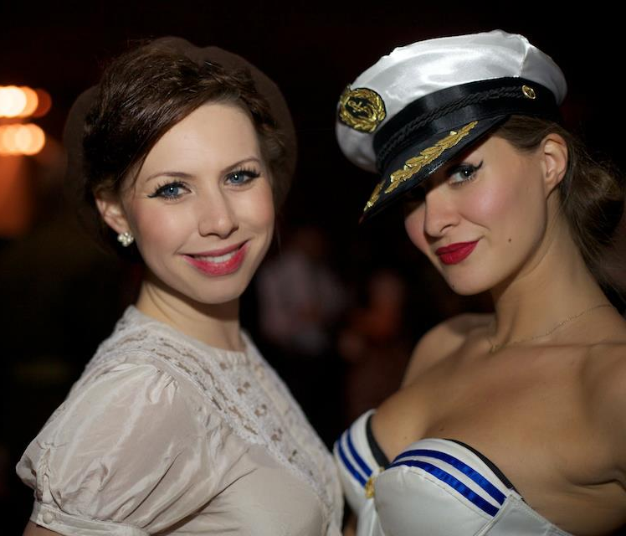
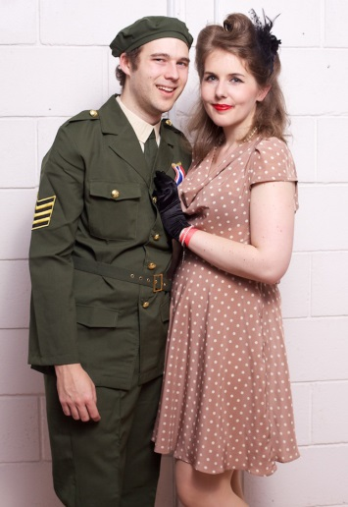
In the context of this type of event we see uniforms as part of the costuming. There is little to suggest it is any different, for example, from those who attend with their hair in so-called victory rolls for the first and only time. As with the more considered and applied contexts of re-enactment events there is here even more fully ‘the spectre of trivialisation’ (De Groot, 2009: 107), the manner in which the occasion is treated and the ‘celebration’ of this period of the war sits uncomfortably with many. Respondents to my survey I undertook as part of my research for this investigation cited this event specifically as ‘offensive’ and the pretence of there being a war on for simple entertainment purposes as ‘upsetting’. The perceived trivialisation of a period to which many of the respondents could connect through grandparents and great grandparents was deemed inappropriate. (Glavey, questionnaire, 2013).
Within the context of this type of event we might recognise a casual appropriation of the uniform as merely a commitment to a night of fun and ‘escapism’ within which the uniform serves as an extension of the leisure experience. We might read the uniform as a costume of convenience requiring little commitment, consideration or acknowledgement of the codes; the social, historical and political contexts in which it sits.
Fig. 5 Celebratory atmosphere at Blitz Party (facebook.com/theblitzparty/photos_stream)

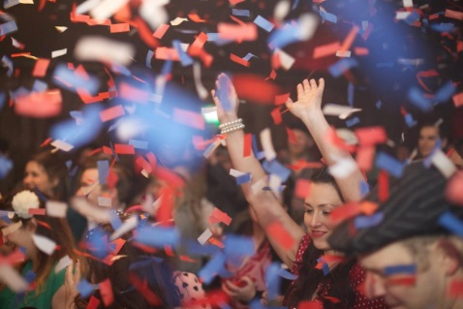
Within the sphere of attendees there seems to be no issue with the attire, the references made to historical events or any issue of trivialisation. The attitude to uniform in some cases is quite loose and the evening is seemingly read as fancy dress with no associated responsibilities or obligations in terms of what should be worn and how it should be worn.
Outside of this one off type event there is a cohort who attends and participates in vintage music and dance events on a more regular basis and whose involvement with these vintage events blend and blur with their everyday lives.
Through these social contexts people on this scene can be seen either wearing uniforms or attending events where uniforms are worn. One might suggest that they are a subcultural group or a mixture of overlapping subcultural groups. There are connections with examples of recognised subcultures from the past like Teddy Boys, Rockers, Rockabillies, and those in Swing scene. As such there are preoccupations with certain music, fashions, and styles and by extension are more distinct expectations and modes of behaviour within the scene. There is a significant social scene in Britain and internationally that is populated by people from these groups and one can encounter these living subcultures at a range of dance classes, weekly or monthly club nights and the weekenders, examples of which I previously cited.

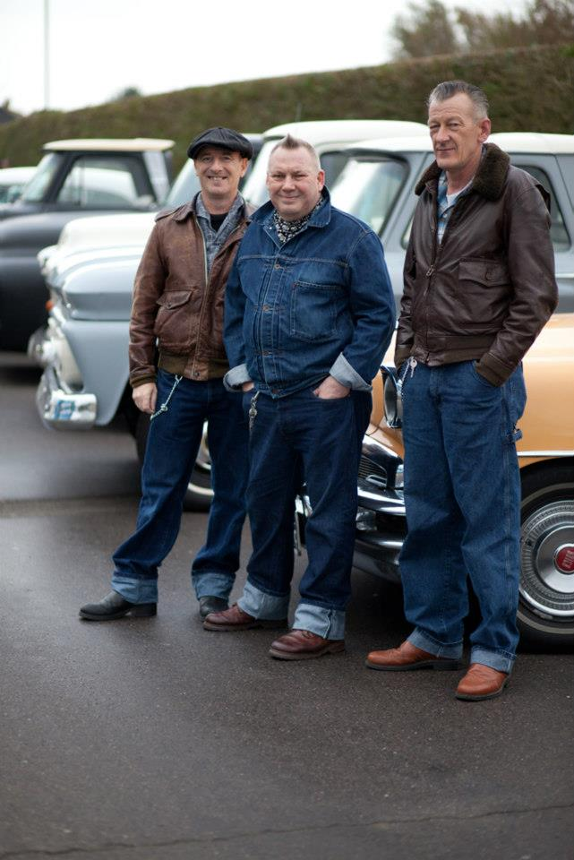
These are groups of people part of whose identity is explicitly linked to the subcultural movements which emerged in the years around and immediately after the Second World War. I would argue that the presence of military uniforms within the contexts of these social spaces is more complex and more interesting than that of the one off fancy dress type event such as the Blitz Party. Firstly, the majority of people in this environment are people for whom the engagement with the scene, and therefore the music, fashion and leisure activities is more than a one off or an irregular attendance to a party. There is investment of time, money and energy in many aspects. We see people who spend time listening to the music, learning to dance the appropriate styles, committing to weekenders to which they might travel substantial distances. There is investment for many in appropriate clothes, music, even cars and furnishings. Within this scene as with any other there are levels of immersion and perceived commitment and conceptions of authenticity. Fundamentally, the conception of authenticity here is somewhat problematic. The postmodern age has, for many, rendered ideas of authenticity redundant and many considerations of contemporary subcultural movements address the pastiche and bricolage nature of their style (Muggleton, 1997). In the context which this paper focusses on there is this element of pastiche but also, arguably, a fuller attempt to continue and to replicate directly a style from a prior age rather than a ‘cannibalisation’ (Barker 2008: 428) and accumulation of a range of styles redolent of so many other contemporary subcultural groups. Within this scene, as with any subcultural group, there are issues of authenticity at stake. Sociologist Sarah Thornton, drawing on Pierre Bourdieu’s idea of cultural capital (1995) proposed the idea of subcultural capital when addressing the club culture subculture which was the focus of her research (1995). Subcultural capital has been described as ‘characteristics, styles, knowledge and forms practice that are rewarded with recognition, admiration, status or prestige within a subculture’ (Jensen, 2006: 263). We can apply this definition to the subcultural example in this paper to suggest that conceptions of authenticity, status and power within the scene can be seen to be linked to relevant clothes, records, hairstyles, dancing and knowledges (Barker, 2008) One of the most immediate identifiers of this aspect is through the clothes worn, an identifier of taste, of knowledge and by extension one’s place in the hierarchy of this subculture. In an ethnographic study of the swing scene in New York approximately ten years ago the researcher, Dr Randal Doane, considered this aspect of how the mode of dressing comprised the representation of taste. He explains, ‘All labels were discreet, and for people who wear mostly vintage garb, almost all labels were limited to interior seams and linings. At stake was the quality of being different, which was about having something nobody else has rather than something manufactured en masse.’ (2006: 97)
Fig. 6 Fig. 7 Attendees at The Rhythm Riot (facebook.com/RhythmRiotWeekend/photos_stream)

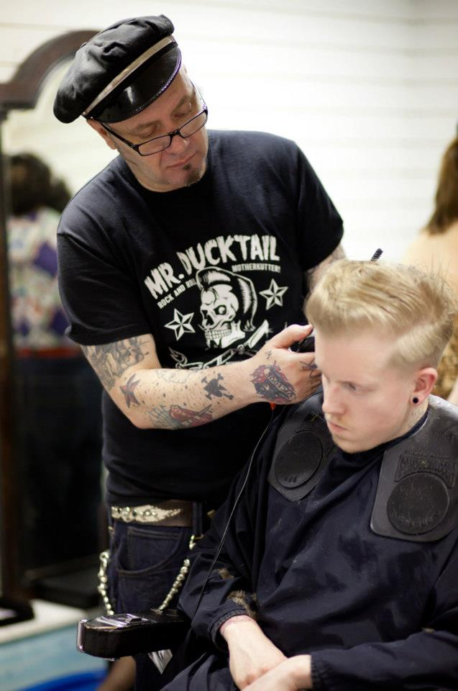
In these terms, an immediate problem can be identified for some members of the subcultural group with the mass produced nature of a uniform in the first instance. Even if the uniform worn was itself the only example on show it is ultimately one of many by virtue of being an example of a uniform in the first instance. Secondly, there is the wider consideration about how the uniform might be read in these surroundings and it is here that I would suggest meanings become more elusive and more interesting. In the context of the Blitz Party type evening the uniform can be seen as syntagmatic shorthand, i.e. standing for that period of the war, immediately evoking a wider set of associations with the age and complementing the setting of the night. In the setting of a 1940s/1950s weekender event like The Hepcats Holiday or the Rhythm Riot we still have the temporal association with that period of history but the focus is on the music and dancing of the time with the history of the age as a kind of unspoken, almost incidental aspect so embedded is it in so many aspects of the day to day for many in attendance. The wearing of a military uniform in this context offers a different reading or understanding. In answer to the question of their attitudes to the wearing of uniform at these type of events some of the respondents to the survey made a number of strong points, one stated ‘We can appreciate the dance without having to glorify all aspects of the past [e.g.] war’ (Glavey, questionnaire, 2013), another explained more expansively;
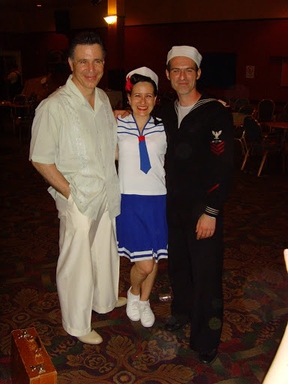
Fig. 8 Attendees at Hepcats Holiday (http://picasaweb.google.com/hepcatsholidaymakers)

A uniform, and a military uniform in particular, comes with a set …of meaning… that cannot be separated from history, our culture and associations of power, and to wear this uniform at a social event 'for fun', as a fashion statement or in an attempt at 're-enacting' WWII Britain is an odd approach to the participation of these events. The music, dancing, fashion, hairstyles, cars and design are all elements that we who attend these events appreciate, and we celebrate the quality and the style of those things. To me, to make military uniforms a part of that celebration is to celebrate the very associations such uniforms have (war, death, destruction, fear, military institutions and… power).
(ibid)
These responses demonstrate that for many the meaning of the uniform clashes with the wider intent or purpose of the event. There is an implicit suggestion of a misunderstanding of the function of the event; that by wearing the uniform you are citing, consciously or not, a fuller historical context that is not seen as a necessary or welcome part of the occasion. There are not, for example, attempts to recreate the racial attitudes of the age in these contemporary approximations and representations of the past so for many the evocation of the more negative associations of military dress are seen as unnecessary and/or unwelcome tangent to what is considered the rightful focus of the occasion; that is the music, dancing and social interaction. A final example to consider is that of Revival events and those events with the vintage aspect as an element of the wider experience but again not specifically a military re-enactment event though there is most often a military element. As addressed earlier in the paper there is often wider atmosphere and reproduction of the period covered with the inclusion of people in costume invited or employed by the organisers. In many instances these people are dressed in military uniform. In addition to this there are people who attend as visitors who get into the spirit of the occasion by dressing for the occasion. We can see the ease with which this can be accomplished for children with ‘child evacuee’ costumes and accessories available to buy with little effort (www.amazon.co.uk). Within this confluence of people there is an overlap of meanings and intentions with the use of uniform. In my research each of the respondents to my survey who indicated that they do wear military attire were British, had parents or grandparents who fought in the Second World War and were very specific in terms of the uniforms they wore and their motivations for doing so. One of the recurring points to explain why the respondees themselves chose to wear a uniform was the idea that it was ‘a tribute to the people who served our country’ and to ‘respect’, ‘represent’ and ‘honour’ those ‘who served with the Allied Forces’ (Glavey, questionnaire, 2013). Further to this are the ideas of ethical and moral considerations. Some of these events explicitly prohibit the wearing of Axis uniforms; some like The War and Peace Revival allow Wehrmacht uniforms but no display of ‘insignias that would be offensive’, in practice swastikas or SS markings (Cadman, email, 2013).
Additionally, a shared prohibition and area of disquiet for people I spoke to was the wearing of medals or indicators of rank that had not been earned. This is an interesting grey area as for many the wearing of a generic military uniform is an acceptable appropriation regardless of one’s suitability relative to requirements of the time (health, nature of employment etc.) but claiming rank or achievement is not. It seems that in these instances there is no weight of subcultural expectation from those in the scene or from the organisers and attendees (though of course within the ranks of re-enactment devotees there are other expectations and conventions). The wearing of uniform here offers ‘empowerment’ (De Groot, 2009: 107); the audience’s gaze gives them a certain authority (ibid). There is a measure of historical credibility at play here that is absent in the weekender events where the display of uniform can be seen as inauthentic and or misplaced in terms of the subcultural expectations of the occasion or historical references that it are out of sync with the focus or primary purpose of the weekender. These events offer a locus for more coherent semiological connotations, for making the ‘right’ associations through what they are wearing avoiding perhaps some of the more casual connections we see in the Blitz Party or the perception of a misguided temporal connection we see at dance events and weekenders.
Fig. 9 Evacuee costume (amazon.co.uk/1940s-Wartime-Childrens-Evacuee)

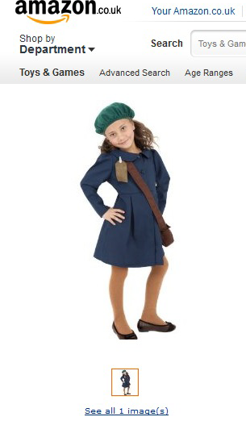
In searching for this great escape, this imagined wartime there is in many instances a contemporary casualness in the appropriation and commodification of this period of British history, one that is perhaps unsurprising in this postmodern age but one that does cause disquiet for many people. There remains a significant section of events that facilitate investigation and immersion in a simulacrum of the age for educational and re-enactment purposes. Somewhere between the two there is a section of people that see a uniform as an extension of a subcultural interest in contemporaneous music and dance but also as an indicator of considered respect and tribute to those who served in the armed forces.

In this paper I have sought to consider some motivations for wearing uniforms in these Revival and vintage event contexts and to consider how the wearing of these uniforms is perceived. I have addressed examples of where one might encounter people wearing military uniform as a form of costume or fancy dress rather than as a part of their life in the military. Taking my lead as a member of a particular subcultural group I have highlighted some perceptions from within and without the scene as to how these uniforms are read and I have sought to offer analysis of possible meanings through ideas of subcultural capital, authenticity, commodification and ethics. This paper serves to highlight some of the associated ideas and avenues of analysis. There are grounds for much fuller investigation in areas like gender and class for example which overlap my focus in this piece but we begin here to appreciate the interest in the imagined past and the desire for an escape to that hallowed part of Britain’s history.

References
Barker, C. (2008), Cultural Studies: Theory and Practice, London: Sage

Bourdieu, P. (1995), Distinction: A Social Critique of the Judgement of Taste, London :Routledge & Kegan Paul

Cadman, R (2013) Organiser of The War and Peace Revival, email to Paul Glavey, 12th March

De Groot, J. (2009) Consuming History: Historians and Heritage in Contemporary Popular Culture, New York: Routledge

Doane, R. (2006), The habitus of dancing: notes on the swing dance revival. New York City Journal of Contemporary Ethnography 35 (1), 84-116
Glavey, P. (2013) Uniforms at vintage events [questionnaire], 30 respondents, Surveymonkey.com
http://www.facebook.com/theblitzparty/info (Accessed 15th March 2013)

Jensen, S.Q. (2006) Rethinking subcultural capital. Young 14 (3), 257-276

Muggleton, D. (1997) The post-subculturalist, in S. Redhead (ed.) The Clubcultures Reader (pp. 167-185). Oxford: Blackwell

Pickering, M. and Keightley, E. (2006) The modalities of nostalgia. Current Sociology 54 (6), 919-941

Thornton, S. (1995) Clubcultures: Music, Media and Subcultural Capital. Cambridge: Polity

Wartime Children’s Evacuee Costume [Online] Available: http://www.amazon.co.uk/1940s-Wartime-Childrens-Evacuee-Costume/dp/B004O4HOD4/ref=pd_sim_k_h_b_cs_25 (Accessed 9/01/2013)

Images

Fig 1 Author’s own

Fig 2,3,4,5 Available: https://www.facebook.com/theblitzparty/photos_stream (Accessed 9/01/2013)
Fig 6, 7 Available: https://www.facebook.com/RhythmRiotWeekend/photos_stream (Accessed 12/02/2013)
Fig. 8 Available: http://picasaweb.google.com/hepcatsholidaymakers/HepCatsHolidaySunday5thJulyEvening?feat=directlink#5357305394265306226 (Accessed 15/02/2013)
Fig 9 Available: http://www.amazon.co.uk/1940s-Wartime-Childrens-Evacuee-Costume/dp/B004O4HOD4/ref=pd_sim_sbs_k_h_b_cs_3/278-3565091-0304856 (accessed 9/01/2013)

Notes Sites like http://www.friendsofthe40s.com/ or http://www.mvt.org.uk/events.htm list a significant number of day and weekend events ranging from dances to military vehicle displays.
Despite the 1950s focus this event attracts people whose interests include music and dance from the 1940s (and earlier) and who dress in uniform at the event.
VE Day refers to Victory in Europe Day on May 8th 1945, the day the Allies celebrated Germany’s unconditional surrender . VJ Day refers to Victory over Japan Day, August 15th 1945, marking Japan’s surrender.
Rex Cadman, the founder of the War and Peace Revival in email communication with me explained the reasoning behind the presence of German uniforms at his event, ‘A battle re-enactment would be fairly pointless without a perceived enemy. It is generally considered that the German foot soldier was no different to our own, the SS was another matter altogether. I gather the appeal for the SS uniforms is because they are seen as the best-looking uniforms’. This tension between attempts at re-enactment and offence is present at many of these events and an area of contention between different groups, (http://www.rossendalefreepress.co.uk/news/local-news/nazi-uniform-wearing-re-enactors-turned-4023806) (http://www.huffingtonpost.co.uk/2012/09/04/nazi-uniforms-and-swastikas-heywood-_n_1853603.html)

