The Life and Works of Alex Moulton

When: Tuesday 14th April, 2pm – 6pm
Where: Central Saint Martins, University of the Arts London, Granary Building, 1 Granary Square. London, N1C 4AA. Room E002

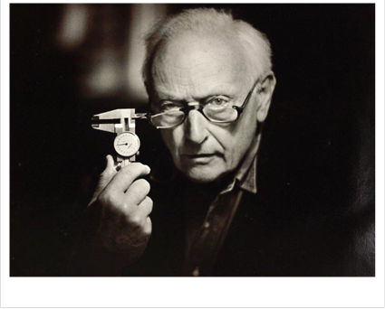
Join us for this half-day seminar to celebrate the life and works of Dr Alex Moulton RDI (1920-2012) engineer, designer and innovator.
Alex Moulton reinvented the bicycle as the Moulton Bicycle in 1962, designed and produced numerous vehicle suspension systems, including the patented Hydrolastic and Hydragas systems which were fitted to British Leyland/Rover vehicles over a period of 40 years, and contributed the unique rubber-cone suspension to Alec Issigonis's Mini (1959-2000).
A Royal Designer for Industry, member of the Fellowship of Engineering and Doctor of the Royal College of Art, Moulton was celebrated during his lifetime and his legacy continues today in the continuing work of the Moulton Bicycle Company, and in his influence on young engineers and designers.
The seminar will include presentations and a panel discussion involving prominent figures from the field of design. Guest speakers include Sir Christopher Frayling (an educationalist, writer, and former Rector of the Royal College of Art and Chairman of Arts Council England) and Sebastian Conran (designer and member of the outstanding Conran family of designers and design writers). The event will aim to put Moulton’s achievements into context and discuss the future of design and invention in the UK.
Teas and coffees will be available during a 30 minute break at 4pm.

HOW TO BOOK

This event is open to all UAL staff, students and members of the public who are interested in the life and works of Alex Moulton.

If you would like to attend, please book your place via Eventbrite: https://www.eventbrite.co.uk/e/the-life-and-works-of-alex-moulton-tickets-15487735233

We request audiences to arrive on time; doors will open at 1.45pm.

