Linda SANDINO
Victoria and Albert Museum/University of the Arts London

THE CHRONICLE: AN EVERYDAY NARRATIVE FORM?

Introduction: narrative resistance
The focus of this paper, which is on the chronicle as a narrative form, emerged from a NOVELLA workshop on the ‘everyday’ organised by Ann Phoenix and Molly Andrews. In preparation for this event participants were asked to write a 500 word narrative about what they did between 7 and 8 o’clock in the morning, a task I found impossible. Various doubts assailed my effort not least the banality of my routine which I did not want to inflict on any reader, apart from my own lack of enthusiasm for reconstructing my mornings, when nothing happens. That time of day, the early morning, dominated by the need to accomplish the task of getting ready for work, I was unable or, perhaps did not wish to submit to any kind of reflective account.
However, the resistance to the emplotment of my routine, led me to examine other written forms of capturing the quotidian, and seeing a housewife’s diary entry of her day, led to thinking about the chronicle as an everyday narrative structure. This form, I argue below, has the potential to capture elements of life as lived in the everyday, which as Ben Highmore has suggested ‘is always going to exceed the ability to register it’. I would like to propose that the timed duration points of the day alongside the description of activities provide a form of daily accounting that endeavours to represent everyday reality, the condition of which is ordinary, lacking drama, surprise or exceptionality. While the chronicle is considered to lack plot or a narrative arc, a sequential listing that awaits emplotment, I’d like to reconfigure the chronicle as a form that fulfils its narrative potential in the reconfiguration that Ricoeur proposed enables us to make meaning through the appropriation of the world of the text (my emphasis).
Sequence and Duration
Between 7 and 8 a.m., I’m asleep for the beginning third of that hour, after which I get through a series of actions that enable me to catch the bus to work on time. My routine is dominated by both sequence and duration of the minutes available before I have to leave the house to go to work; the unfolding order, is (usually) immune to drama or surprise, which is why I had no story to tell. As Rita Felski has noted: ‘The all-too-familiar numbs and pacifies us, lulling us into a trance-like forgetfulness; unable to experience the vivid, clamouring there-ness of the world and to be fully immersed in the moment, it is as if we had never truly lived’.
My experience of that hour was, and continues to be entirely subject to a ‘within-time-ness’ that resists storying. However, two examples helped me towards completing the NOVELLA assignment: the journals of Henry Cole, the nineteenth century British civil servant responsible, along with Prince Albert, of masterminding the Victoria and Albert Museum where I work, and a diary entry by a participant in the 1930s British Mass Observation project.
Every day in my office, I see the volumes that make up the typed transcript of Cole’s journals which he began in 1849 with the last in 1881, the year before he died. Although my research is on the post-1945 V&A, I occasionally peruse Cole’s diaries and marvel at their cryptic contents which, nevertheless, helped his biographers date and piece together his various activities as detailed in these ledgers. A fairly typical entry, Sunday 14 January 1849 finds him:
At Home. At J of D: called on Thompson, Mulready: objected to teaching Ragged Schools drawing: Lock Hospital shd be established for S of D. Dined with children & played with them. In the Evg RR came abt J of D, thought it wd succeed.
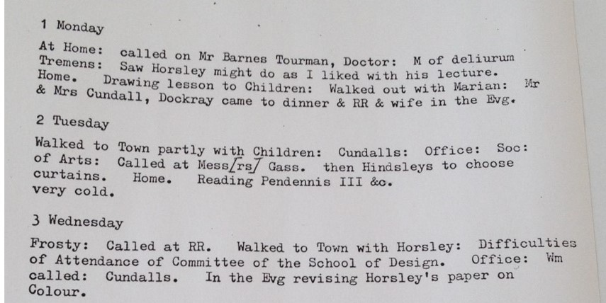
Fig. 1 ©Victoria and Albert Museum, London
This entry like many others principally notes meetings and the subjects discussed. Cole’s noted his location for the day, which if not ‘At Home’, involved that he ‘Walked into Town’. The lack of pronouns suggests the aide mémoire of the bureaucrat. Activities with his family appear occasionally. Although no times are noted, so that we are not told what time Cole ‘Dined with children’ nor how long he played with them, the activities and events are noted sequentially, the visual image of which is reinforced by the bound volumes that unfold Cole’s conception of his ‘everyday’
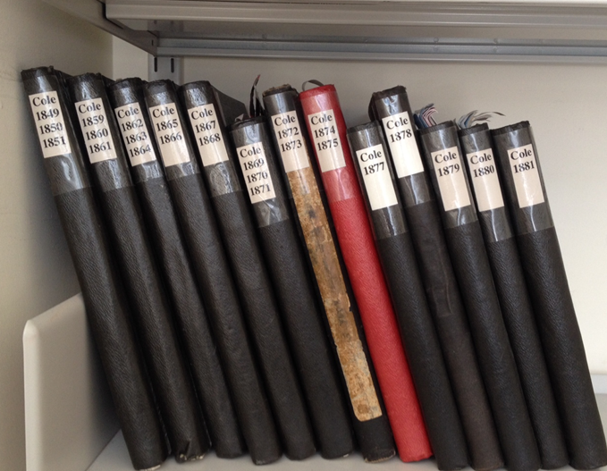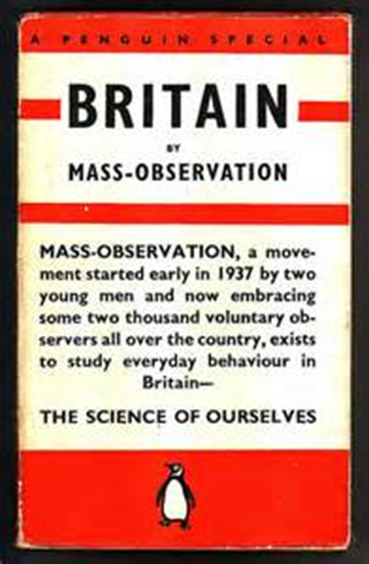
Fig. 2 ©Victoria and Albert Museum, London Fig. 3© Trustees of the Mass Observation Archive
A more potent, twentieth century model and inspiration came from the directives, as they were called, issued by the Mass Observation project [Fig.3]. Founded in 1937 to record ‘Everyday life in Britain’, citizens were invited to send in accounts of their activities on the 12th day of every month. Although they were free to write as much or as little as they wished, participants were encouraged to provide not only details of activities but also to describe more affective states such as dreams and their health. This task has continued in the present with contributors similarly being as asked to
Write as much as you can about what you do, who you meet, what you talk about, what you eat and drink, what you buy or sell, what you are working on, the places you visit, the people you meet, the things you read, see and hear around you, how you are feeling and of course what you yourself think.
A typical example from January 12, 1937, is by Mrs Flett, a ‘housewife’ from Argyll in Scotland. For some unexplained reason, she accounts only for the hours from early evening to bedtime. I will return to her text in more detail below, but before I state my claims for the chronicle as narrative, I’d like to outline the objections to including chronicles in the realm of ‘proper’ narratives, which significantly emerge from historians, the researchers most likely to engage with chronicles in their work. What are the objections to the chronicle?
Beginning with a consideration of historical annals, Hayden White has argued that they ‘lack narrative component, consisting only of a list of events ordered in chronological sequence. The chronicle, by contrast, often seems to wish to tell a story, aspires to narrativity, but typically fails to achieve it [because of]….a failure to achieve narrative closure. It does not so much conclude as simply terminate…’ Summarising the distinction, White concludes, (expanding on Louis Mink’s well-known formulation that stories are not lived but told) thatWhile annals represent historical reality as if real events did not display the form of a story, the chronicle represents them as if real events appeared to human consciousness in the form of unfinished stories.
Lacking closure, they lack resolution or conclusion; there is no summing up of the meaning of the chain of events with which it deals because White claims ‘there is no central subject about whom a story could be told’. By putting an emphasis on the referential form of annals and chronicles, White highlights the always representational endeavour of reconstructing the past which can only remain in the realm of a referential and representational ‘as if’.
Chronology: space and time as if
The ordering of time is conceived in Western cultures chronologically. The calendar organises units of time over extended periods sequentially. ‘In addition to serving practical purposes, the process of organization provides a sense, however illusory, of understanding and controlling time itself...calendars serve as link between mankind and the cosmos. All calendars and the years they represent, from all cultures, count their years from an initial date or epoch in order to maintain a consistent chronology, with ‘the most fundamental unit of time-measurement’ being the duration of the earth’s orbit around the sun, normally referred to as the day, though the ‘day’ may denote only the light hours of the day, and/or the dark night time. Consequently, following the custom established by the Romans, midnight in the West (as well as China) marks the point from which a day is reckoned.
The need for a common frame of reference also drove the formulation of nineteenth century timetables in order to regulate transport travel. We are also familiar with the more local timetables that organise our work activities, such as the grid layout of the yearly planner. Both chronology and the grid provide co-ordinates, relative systems that require a point of reference – in time for chronology, and in space for the grid, (a form of organising and conceptualising space that dates back to the Romans). However, the sequential chronology of calendars is frequently designed in a spatial grid format [Fig. 4], occasionally humorously [Fig 4] combining spatial and temporal representations in order to emphasise the two fundamental organising elements of time management: when and where. 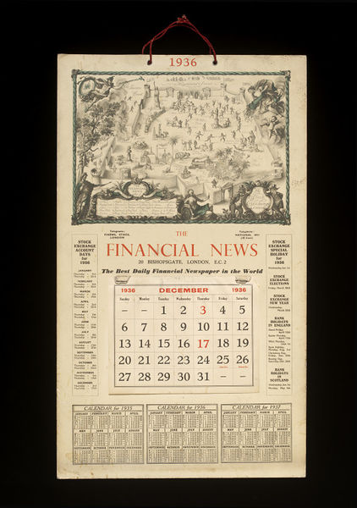 Fig 4 ©Victoria and Albert Museum, London

To return to Hayden White: he suggested that annals and chronicles were not so much ‘imperfect’ histories but that instead should be considered as evidence of ‘possible conceptions of historical reality’ in which the ‘perseverance of chronology as the organising principle of the discourse’ prevents the resolution we have come to expect from stories. Calendars are of course only systems for the organisation, standardization of time and in some cases space, but diaries and journals with their sometimes dense focus on the unveiling of personal ‘meanings’ are firmly embedded in the canon of narrative forms.

The autobiographical chronicle.
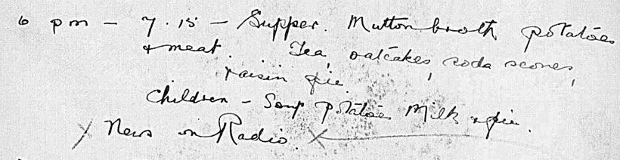
Fig 5 [extract]. © The Trustees of the Mass Observation Archive, University of Sussex, UK.
Mrs Flett, Day Survey Respondent Number 061, a housewife living in Scotland, took part in the call from the Mass Observation study to record the 12 January, 1937. Her chronicle, which begins in the evening [Fig 5 extract] is as follows:
6pm – 7.15 Supper. Mutton broth potatoes + meat. Tea, oatcakes, soda scones and raisin pie.
Children – soup potatoes milk + pie
News on radio
7.15 - 8 Cleared table, washed dishes, husband put seat on child’s car. Talking about the ‘Old New Year’ still held in the country districts – usually a dance, mostly Scotch Reels.
8 – 8.10 Took down Xmas decorations always left up till 12 Jan in this district. Rubbed Happy New Year of mirrors. Put holly outside – bad luck to burn it –
8.10 – 8.30 [inserted] Children put to bed
8.30 – 9 Father in Law came in. Radio shut off. Talked about weather, new road scheme Company from Dunlop Ardinshire have contract improving road from Ardinshire. Husband one of the joiners on the hut building.
9.30 Made tea for Grandpa and the grown ups.
9.30 – 10.30 Play the violin in turn. Grandpa teaching husband and self.
10.30 – 11 Grandpa preparing to go home.
11 – 11.30 Preparing breakfast. Washed dishes, set table, laid out husbands working clothes.
11.30 Fell asleep listening to 3 clocks ticking. Sleet and noise of sea outside.

Why is her account so brief? Was it constrained by a modest reticence? Having agreed to take part, did she realise there was insufficient time to dedicate to a lengthier more detailed account? Or, did she wish to merely distil the ordinariness of that January day? Did she feel, like me, that there really wasn’t much to tell? What led her to lay out the day in this way? Rather than speculating on her intentions, I would like to propose that the form she choose reveals the capacity of the chronicle to convey the structure and activities of daily life and its habits. Unlike the medieval chronicles, the examples Hayden White refers to, this chronicle has a subject and an object: Mrs Flett writing for Mass Observation [MO], knowingly participating in an ‘anthropology of ourselves’ the goal of its founder Tom Harrison. The date and the times are chronological signifiers that point to the signifieds that Mrs Flett has chosen to document as having occurred on 12 Jan, 1937, a seemingly un-extraordinary day. Unlike the private, confessional diary, her account will be public – or at least read by the MO team, and therefore she documents the routines of her family life and its participants, as well as referring to the distinctive locality to which she and her family belong.
We know that this text was mostly likely to have been written the following day and therefore, does have the quality of a retrospective reflection about which events and activities should be recorded for MO project. Family are referred to by their generic titles, not personal names. The timings must surely be approximate, but despite the economy of means, Mrs Flett conveys her life, its activities and events but without the personal revelations of many diarists (including many others writing for MO). Nevertheless her narrative identities are established: mother, wife, Scottish, daughter-in-law, musician, home-maker with a poetic sensibility, and chronicler of the everyday. Despite the absence of pronouns, the act of recording her day in this abbreviated form does not preclude or mask her agency as the performer of the writing ‘I’. As Louis Renza has pointed out, autobiographical writing ‘entails a split intentionality: the “I” becoming a “he” or a “she”. Though one can only speculate this distancing at work in Mrs Flett’s account and how the culture of mid-1930s Scotland shaped her autobiographical performance.
Certainly the diary was a common and increasingly popular form. Its sale rose dramatically from the 250,000 that Letts were selling in 1900 to over 3 million in 1936. The novelist Evelyn Waugh commented in a 1930 newspaper article that, ‘There is no one in the country whose life, properly recorded, would not make a thrilling book’, adding that ‘Nobody wants to read other people’s reflections on life and religion and politics, but the routine of their day, properly recorded, is always interesting, and will become more so as conditions change with the years.
For historians, the historical value of the everyday, ‘history from below’ is a specific field of historical enquiry and research in Britain (Raphael Samuel, Communist Party Historians Group, Past and Present, History Workshop Journal) as elsewhere. Consequently, archives such as MO have become an important resource, researching in which the scholar is able to combine ‘proof of intellectual labour completed with a more emotive sense of actively possessing and resurrecting the past’ (my emphasis). Historians are of course used to working with incomplete, fragmentary material, no matter how much effort is put into making it as comprehensive as possible, but as Philippe Lejeune noted, attempts to document everything in a diary is ‘like trying to make a sponge fit a matchbox’.
Narrative as Chronicle
I began with my difficulty in configuring my morning into a narrative, the narrative problematic Hayden White identified:
Narrative becomes a problem only when we wish to give to real events the form of a story. It is because real events do not offer themselves as stories that their narrativization is so difficult. What is involved, then, in finding of the ‘true story’, that discovery of the ‘real story’ within or behind the events that come to us in the chaotic form of ‘historical records’.
White’s observation indicates the extent to which truth, however, partial and constructed, is still some kind of goal for historians; the need not just to document but to interpret sources from their referents. Mrs Flett’s diary would merely be a functional source, one amongst many, a primary source but not in itself the ‘real story’. Neither does it seem to satisfy the reflective self-examination of Mrs Flett’s ‘real self’ that diaries are supposed to reveal. Most problematically, however, is her failure, exacerbated by the chronicle form, to turn the events of her day into a ‘story’. As Ricoeur reminds us: ‘A story is made out of events, to the extent that plot makes events into a story’, the plot of which need not conform to chronological sequence. Finally, a further objection against chronicles as proper narratives rests on their failure to achieve narrative closure in order to convey ‘meaning’.
For the NOVELLA workshop, drawing on Mrs Flett’s model, my chronicle provided a solution to the task: but I had to defend my choice of form. Reading others’ discursive accounts of their 7 to 8 stories, what emerged from the workshop was a sense of activities shared across the group; as part of a community this is not surprising. But it also points to my final point about what the chronicle is nevertheless able to convey, described by Ricoeur as ‘what we learn through our understanding of the story and knowledge of our cultural plots, which as ‘thought experiments’ is closer to poetical understanding than scientific understanding (emphasis added). Rather than becoming overly concerned with what counts as ‘narrative’, what its characteristics must be in order for it to qualify, I’d like to suggest that it is in our reading of texts that their narrative function and capacity is revealed. As Ricoeur so succinctly proposed: ‘the significance of a narrative stems from the intersection of the world of the text and the world of the reader.’ (original emphasis)
The account Mrs Flett produced of her evening was addressed to the Mass Observation researchers to inform them about her day and thus her life; it represents her narrative activity, chosen to articulate her experience of time. As a narrative of the everyday it has the capacity to represent and encompass space and time in which the duration points are the co-ordinates that help us to follow and locate her activities, family, community, and the events, many of which we share (eating, socialising, family, domestic tasks). Although her text does not conform to the confessional mode, there are elements of concordance and resolution to her day: at 11.30, the ‘end’ when she goes to bed. There is also a poetic register in the affective conclusion that she states accompanies her rest and lulls her to sleep: ‘Fell asleep listening to 3 clocks ticking. Sleet and noise of the sea outside’. Communicating to us the landscape beyond her home and that her sleep marks not just the end of the 12 of January but the beginning of the 13th, the day she will write her about her evening reality using the chronicle as her trope as if it can produce the reality of her day.
Coda
So, what would be lost by denying the chronicle its status as narrative? I have proposed that the sequential form of the chronicle requires the narrator to configure events in time, since even a list is always a meaningful selection, which is then reanimated through the appropriation by the reader. Apart from these qualities, the chronicle, like the calendar and the diary is an ‘everyday’ format in which everyone can participate in order to bring concordance to the discordance of daily life, structuring and locating their experience of temporality and its significant as well as insignificant moments: from the nineteenth century mega-bureaucrat Sir Henry Cole to Mrs Flett, housewife and MO Respondent 061, it is the most common and communal form about who we are through what we did and when.

References
DOGGETT, L. E. (2006). ‘Calendars’ in P.K. Seidelmann (Ed.) Explanatory Supplement to the Astronomical Almanac, Sausalito CA: University Science Books. Available at http://astro.nmsu.edu/~lhuber/leaphist.html Accessed June, 2014.HIGHMORE, B. (2001) The Everyday Life Reader. London and New York: Routledge.
HOLFORD-STREVENS, L. (2005). A History of Time: A Very Short Introduction. Oxford: Oxford University Press.
LEJEUNE, P. (2009) On Diary. J. D. Popkin and J. Rak (Eds.). Manoa: University of Hawaii Press.
MORAN, J. (2013) ‘The private diary and public history’. Gresham College, Lecture, 29 October, 2013 available http://www.gresham.ac.uk/lectures-and-events/the-private-diary-and-public-history Accessed June, 2014.
RENZA, L. A. (1977) ‘The Veto of the Imagination: A Theory of Autobiography’ [revised web version] http://sites.dartmouth.edu/larenza/files/2012/08/Renza-1977-The-Veto-of-the-Imagination-A-Theory-of-Autobiography.pdf Accessed September, 2014.
RICHARDS, E. G. (1999) Mapping Time: The Calendar and its History. Oxford: Oxford Paperback.
RICOEUR, P. ([1979]1991). ‘The Human Experience of Time and Narrative’in M.J. Valdés (Ed.) A Ricoeur Reader: Reflection and Imagination, New York and London: Harvester Wheatsheaf.
- (2002) ‘Life in Quest of Narrative’, in D. Wood (Ed.) On Paul Ricoeur: Narrative and Interpretation. London: Taylor and Francis.
WAUGH, E. (1930) ‘One way to immortality’, Daily Mail, 28 June, in J. Moran, ‘The Private Diary and Public History’, Lecture, Gresham College, 29 October, 2013 http://www.gresham.ac.uk/lectures-and-events/the-private-diary-and-public-history Accessed June, 2014.
WHITE, H. (1981) ‘The Value of Narrativity in the Representation of Reality’ in W. Mitchell (Ed.), On Narrative. Chicago: University of Chicago Press

The NOVELLA project conducts research on the everyday practices of families. See http://www.novella.ac.uk/ for further details.
Highmore 2000: viii.
Ricoeur 1991:26.
Felski 2002:608.
For further details about Mass Observation see http://www.massobs.org.uk/12may
White 1981: 5.
Ibid : 9.
Doggett 2006: n.p.
Holford-Strevens, 2005:1.
Richards, 1999: 402.
The Financial News Map of the Stock Exchange, London. A calendar for 1936, issued by The Financial News. The design represents a map of the City in which the various markets of the Stock Exchange are humorously symbolised, surrounded by the allegorical figures of Mercury, Ceres, King Midas and Dame Fortune, with a numbered index contained in a rococo cartouche and a fanciful coat-of-arms, all within a classical border. Mounted on card with two eyelet-holes threaded with red cord. Signed and dated by the artist, Rex Whistler. Museum No. E.997-1970.
White 1981:6.
Renza 1977 n.p.
Waugh 1930.
Moran 2013: n.p.
Lejeune 2009:47.
White 1981: 4.
Ricoeur 1991: 105.
Ricoeur 2002: 23.
Ricoeur 1991: 26.
Ricoeur in Valdes 1991:99.
I would like to thank Lars-Christer Hydén for asking me this thoughtful question at the conference.

