Symposium - Forming and Deforming Images: The creative process in flux
Friday, 17 March 2017
- 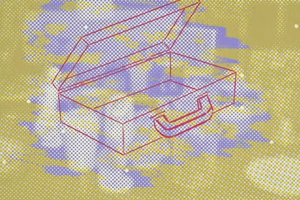
- CREATEC Symposium - Forming and Deforming Images: The creative process in flux
Keynote speaker: Visiting ECU Fellow Professor Paul Coldwell,
Convenor: Dr Paul Uhlmann
Hosted by: Contemporary Visual Arts Research Group
“…Imagination is always considered to be the faculty of forming images. But it is rather the faculty of deforming the images offered by perception, of freeing ourselves from the immediate images; it is especially the faculty of changing images. If there is not a changing of images, an unexpected union of images, there is no imagination, no imaginative action.” - Gaston Bachelard, On Poetic Imagination and Reverie
This intense one-day symposium will investigate Bachelard’s notion of forming and deforming images of the imagination in relation to the creative process. We are interested in how images come into being. What is their ontology? How do they change and adapt? How do such images arrive as words or as visual images in art and everyday life? How might such a process be of value to human existence?
At the close of the day please join us to attend the first solo exhibition held in Australia of work by Professor Paul Coldwell Small Traces.
Paul Coldwell is Professor in Fine Art at the University of the Arts London where he is based at Chelsea College of Art & Design and contributes to the CCW Graduate School.
Event details
Symposium - Forming and Deforming Images: The creative process in flux
Date: Monday, 27 March 2017
Time: 9.00am - 4.30pm
Venue: Gallery 25, ECU Mount Lawley Campus, Building 10, Room 10.122
Cost: Free
RSVP: Please register your attendance by emailing symposium organiser, Paul Uhlmann.
Solo Exhibition - Small Traces
This event will be opened by Professor Clive Barstow, Dean of ECU`s School of Arts and Humanities.
Date: Monday, 27 March 2017
Time: 5.00pm - 7.00pm
Venue: Gallery 25, ECU Mount Lawley Campus, Building 10, Room 10.122
RSVP: Please register your attendance by emailing symposium organiser, Paul Uhlmann.

