Polly Kenny
Margaret Nicholson, embroideress and teacher, an exploration of her legacy

This paper will identify Margaret Nicholson's history, legacy, and influence within the development of embroidery at the London College of Fashion (LCF) during a period of transition and consider her significant contribution in establishing a basis for the later development of embroidery to degree level.
The recent validation of a new degree in Fashion Embroidery at LCF builds on the long established tradition of both fashion and City & Guild embroidery at the college. The new degree curriculum encourages the LCF archive to be of use as a possible source for both practice based and written study. This paper will draw upon artefacts, archival collections and photographs, interview and oral history sources to celebrate Margaret’s legacy within this history and identify her role in this period of transition. This paper uses both existing archival sources whilst also adding to the collection of materials. Focusing on the archive will encourage students to consider this as a possible reference source alongside the use of oral history as a methodology for their studies.
This paper will outline the history of embroidery at LCF prior to Margaret’s appointment and the subsequent changes that supported the development of the subject. It will consider how her past experiences equipped her with an ideal background prior to her joining the LCF staff, to act as a catalyst for change, and how important the contribution of her practice was to the enrichment of the subject.
Margaret was invited to join the staff of LCF in 1965 at the request of Dorothy Allsop, the Inspector of Further and Higher Education for Fashion and Creative Studies for the Inner London Education Authority (ILEA). Allsop was an influential person within the sphere of embroidery from the 1950s onwards and was identified by Constance Howard, herself a recognised expert in embroidery, as a prominent person in her seminal texts on the history of embroidery in twentieth century Britain (Howard, 1983, 29). Allsop held several other key roles during her career, “expert in charge of the Needlework Development Scheme and Chairman of the Examinations Subject Committee for Creative Studies for the City and Guilds of London Institute” (Howard, 1983, 182).
Notably, Allsop was an examiner and one of the governors for LCF, having “huge influence” on the college (Godfrey, personal communication, August 18, 2014). In 2003, Margaret was interviewed as part of the National Life Story Collection (NLSC) on The Oral History of British Fashion. Within her interview she reflects that Allsop became “the greatest friend” (Springall, 2005, 15) and a “substantial help” (Nicholson, 2003, NLSC) to Margaret during her career. This friendship and support was pivotal in the request from Allsop and ILEA for her to join the staff at LCF and the subsequent development of embroidery at the college.

The fashion industry in the West End of London has a long history of producing exclusive hand crafted clothes for women. By the end of the 19th century however, London was in danger of losing trade to Paris owing to a lack of skilled workers. Reynolds (1977) notes that in response to this, trade schools were set up in which needle-trade skills were at the centre of the curriculum. In 1906, three trade schools were established at Barrett Street, Shoreditch, and Clapham, related to local industries in the West End with the intention that the skills taught would allow the students to directly be employed as skilled workers within the couture garment trade. Barrett Street Trade School opened in 1915 with courses in dressmaking and later embroidery (Reynolds, 1977). These schools were later to join to become the London College of Fashion. “They were to provide the labour-intensive high-class dress trade with trained artisans and were intended to replace the informal apprenticeships that had existed in some of the more enlightened dress houses” (Reynolds, 1977 xiv).

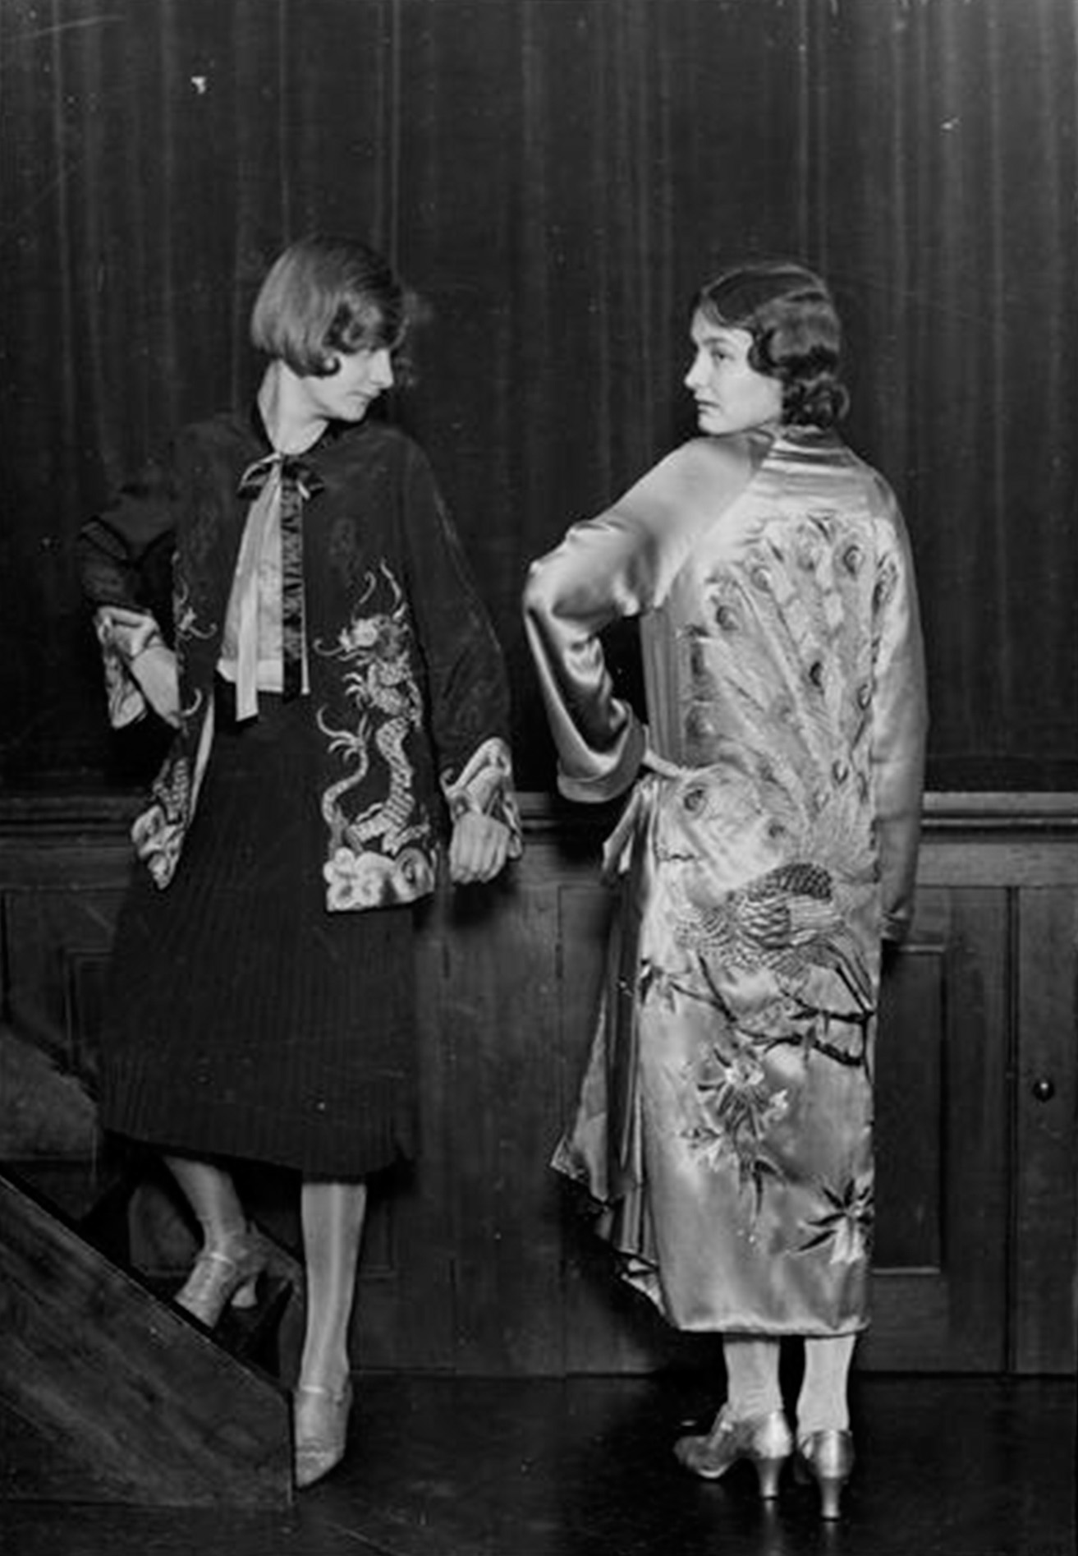
1. Orient inspired cocktail outfit and evening coat with dragon and peacock motifs – 1. Garment made by the embroidery trade students.

The schools had both trade and academic staff members to allow the courses to stay closely related to the industry (Prospectus 1949-50). “The work of the school had received recognition and support from the various trades covered by the curriculum. Prominent members of the West End firms occupied leading positions on the Trade Consultative Committees” (Prospectus 1949-50). These included, for example a Miss D. Solomon from Messrs Harvey Nicholls and Co Ltd. (Prospectus 1949-50). This Prospectus also notes “the demand from the leading houses for trained Barrett Street students exceeds the supply” leading to very successful progression of students into industry; in 1923, only 7 out of 751 students seeking employment being unsuccessful (Reynolds, 1977). Embroidery students were taught hand and machine embroidery, braiding, fringing, metal thread and beadwork (retrieved from http://www.vads.ac.uk).

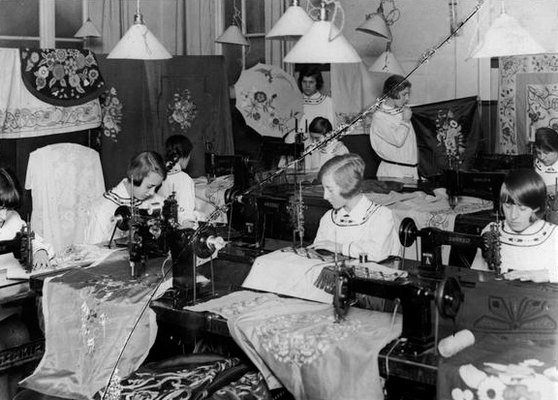
2. 1920’s Machine embroidery class – 2. Barret Street School.

The course curriculum was tailored through the choice of staff and the Trade Consultative Committee to focus very closely on technical skills supplying students able to work to the high technical standards of the couture workrooms rather than developing independent designers.
There is evidence that the curriculum of the Trade schools were adapted to maintain a close fit to changes within the industry. For example, in the 1920’s there was an addition of some pattern-cutting and during the 1930’s, when the West End clothing industry began to change from couture to ready-to wear, new courses were introduced at the Shoreditch site to reflect this (Reynolds, 1977). This response to change is also referenced in the 1949 School prospectus, “perhaps the greatest factor in the School’s success has been the constant effort to anticipate the trend of modern fashions”. In response to further changes within clothing manufacture and production methods the two colleges were merged by ILEA in 1967 (Reynolds, 1997).
In the early sixties however important changes were also taking place within textile education. “In 1963 the new art examinations were introduced by the Council for Academic Awards allowing selected colleges greater freedom in devising their own syllabus…The standard rose considerably during the ensuing years and embroidery developed further with ideas becoming livelier and more individual” (Howard, 1984 11). Several of the colleges were now focusing on dress or were producing embroidered garments within their final outcomes increasing the need for a similar design-led approach.
Margaret reflects in her testimony that “ILEA wanted to see the college embroidery change…. from the commercial to the examining, the exam and more education in the work” (Nicholson, 2003, NLSC). She was able to introduce the City & Guild examination for part-time students and the Society of Designer Craftsman for the day students alongside the College Diploma. These examinations provided a basis that were developed, following her retirement, to Datec and BTec awards (Godfrey, personal communication, September 8, 2014).
Springall (2005) notes “Margaret is the epitome of what it is to be surrounded by art from birth” (Springall, 1997 13). Her father and grandfather were a strong influence on her life and education. They were both knowledgeable about art and her home was filled with art books including the Jugend German art magazine and her grandfather in particular instilled a love of art, taking her to visit art galleries and growing familiar with the paintings of Fragonard, Corot and the French Impressionists. Both her father and grandfather were decorators, restorers and gilders of large houses and churches (Nicholson, 2003, NLSC).
Margaret and her sister were restricted most of the time to playing at home and occupied themselves drawing, sewing or painting. “If I wanted to go out and play or something, my mother would say, ‘Now go out and sit with grandfather, and he’ll talk with you’” (Nicholson, 2003, NLSC). However, she recognised that they had the advantage of expensive wallpapers and gold leaf freely available for these play sessions at home, “I was brought up with gold leaf-we played with gold leaf” (Springall, 2005 13). This interest on art and drawing, later informing the development of her embroidery and fashion design, was to become a strength within her own work and also to be a focus that she brought to her teaching at LCF. Several articles refer to the finely drawn style of her work and this is evidenced in her embroidered panels and banners of the 1950’s and 1960’s. Howard refers to Margaret’s work in the 1960’s as being “often delicate in colour and fabric, with design semi-abstract or figurative, containing swirling lines carried out in fine hand and machine stitching on layers of transparent fabrics and similar to sensitive pen and ink illustration” (Howard, 1983 25).

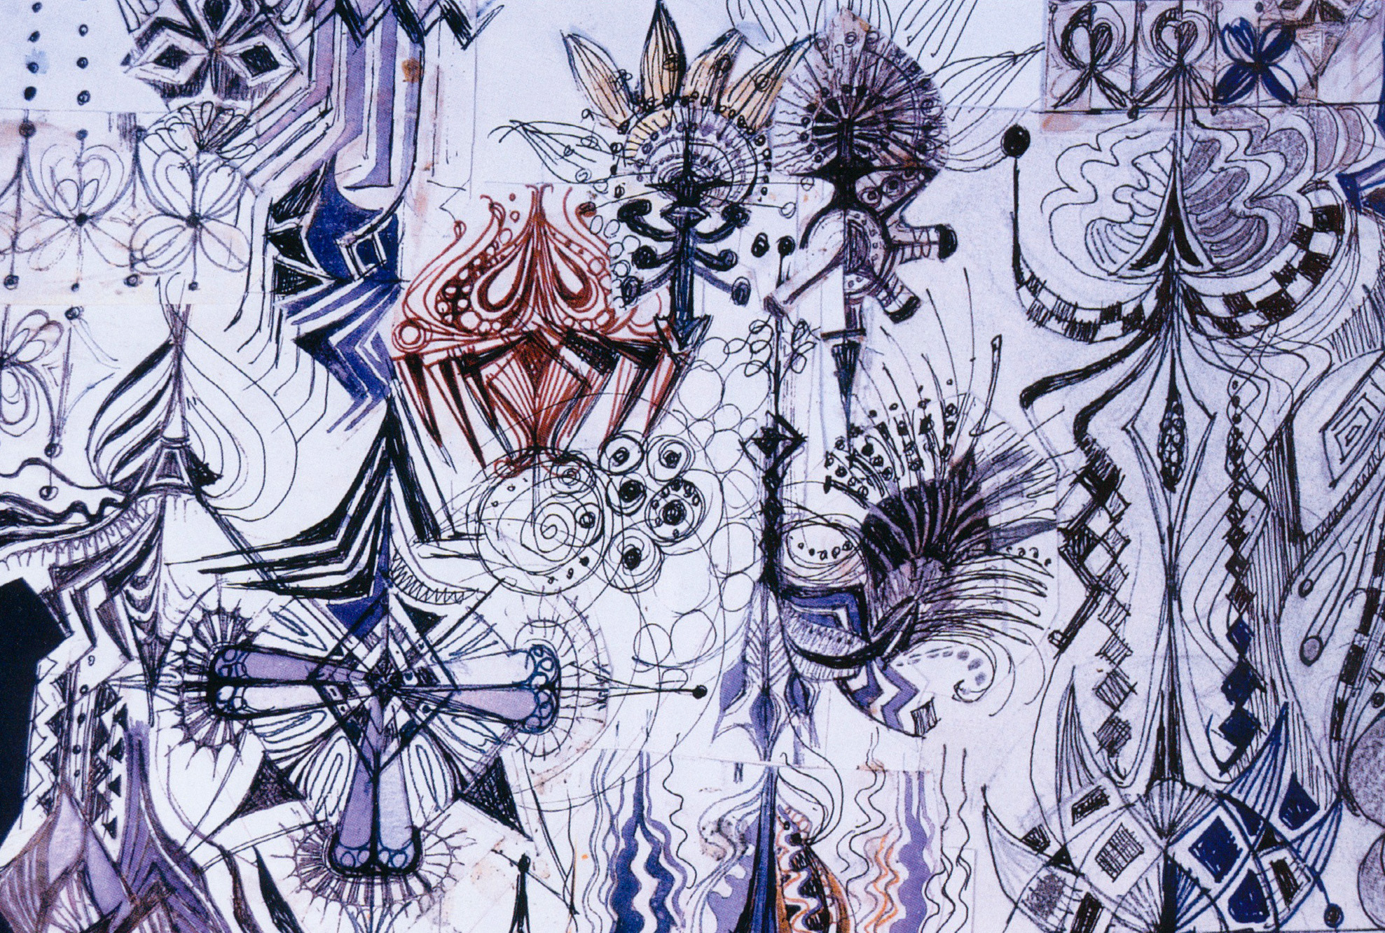
3. Study from ‘ A Passion Flower Pen and Ink.

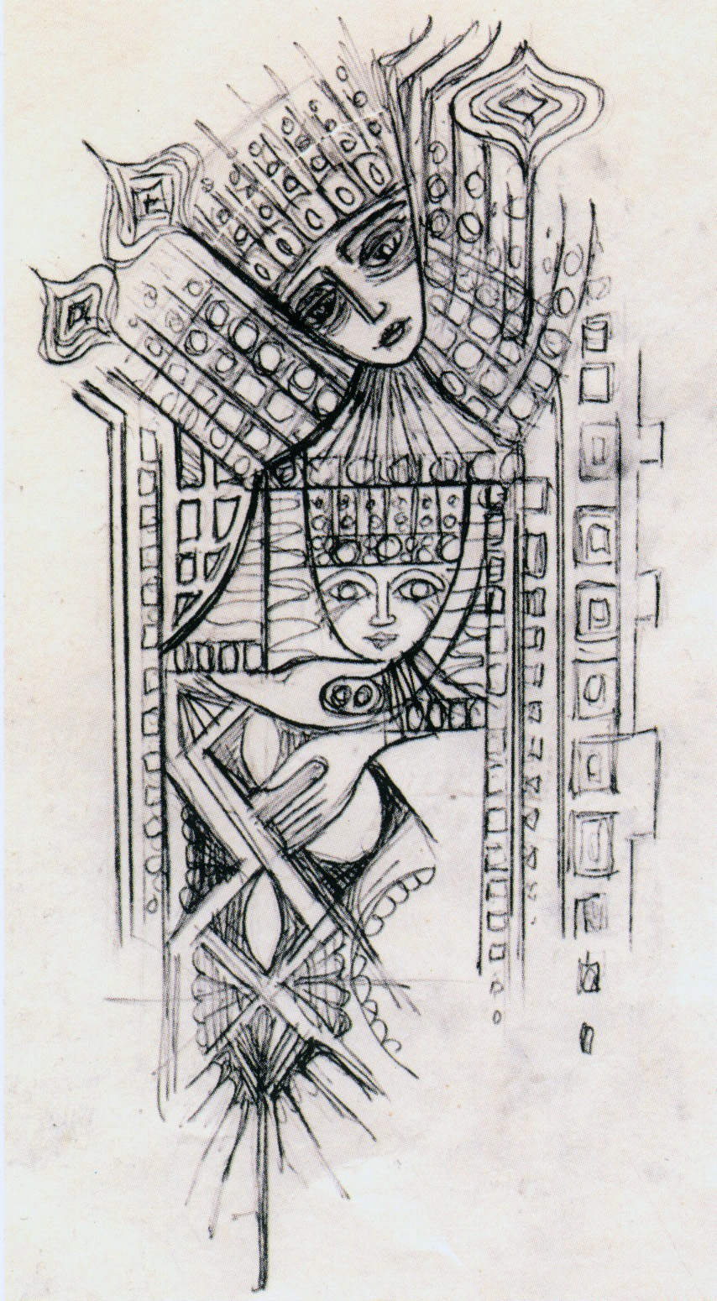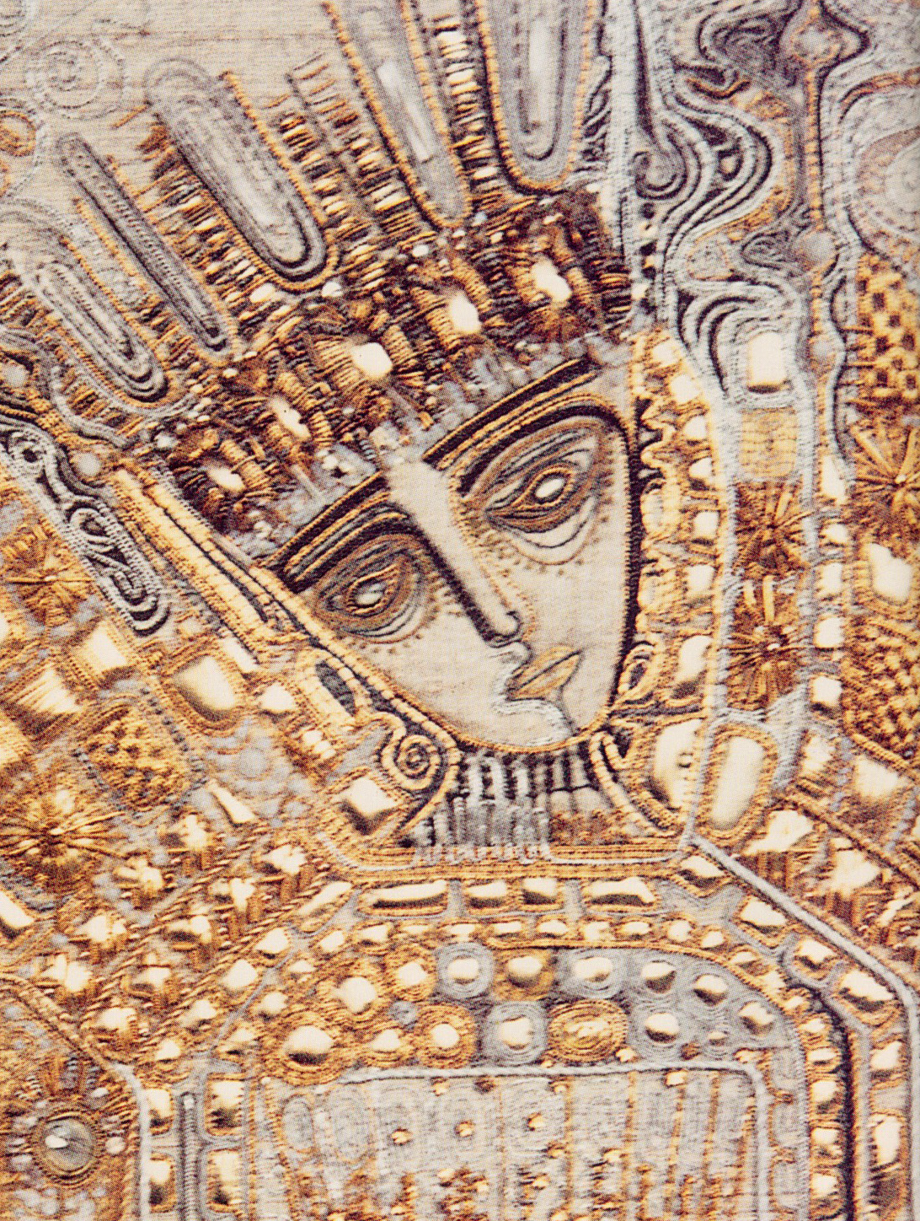
4, 5. Drawing/ design for Mothers’ Union Banner. Detail of Mothers’ Union Banner. Coventry Cathedral 1968.

Margaret’s preparation was further supported by her visits at age 12 and 13 to an aunt who was a court dressmaker and ran a small couture workshop. She recalls that her aunt was well-known for her beaded garments, particularly her “beaded evening gowns popular at the time, straight dresses with a low waistline with the bottom heavily beaded” (Nicholson, 2003, NLSC). She watched the women apply the beads all by the needle or tambour to her aunt’s designs that she drew freehand on the skirts, “rather like big cabbage roses, or birds” (Nicholson, 2003, NLSC). She was also asked to buy the beads for the workrooms and the matching Sylko thread. “And I did learn quite a lot then, I have to admit it. I loved going. I loved it” (Nicholson, 2003, NLSC). She reflects that this experience was useful later for her appointment to LCF and that it had given her “a sort of second nature about beading” (Nicholson, 2003, NLSC). Howard (1983) observes that ‘When teaching at the London College of Fashion she became fascinated by beads, producing freely interpreted examples, using a variety of beads in an individual way” (Howard, 1983 25).

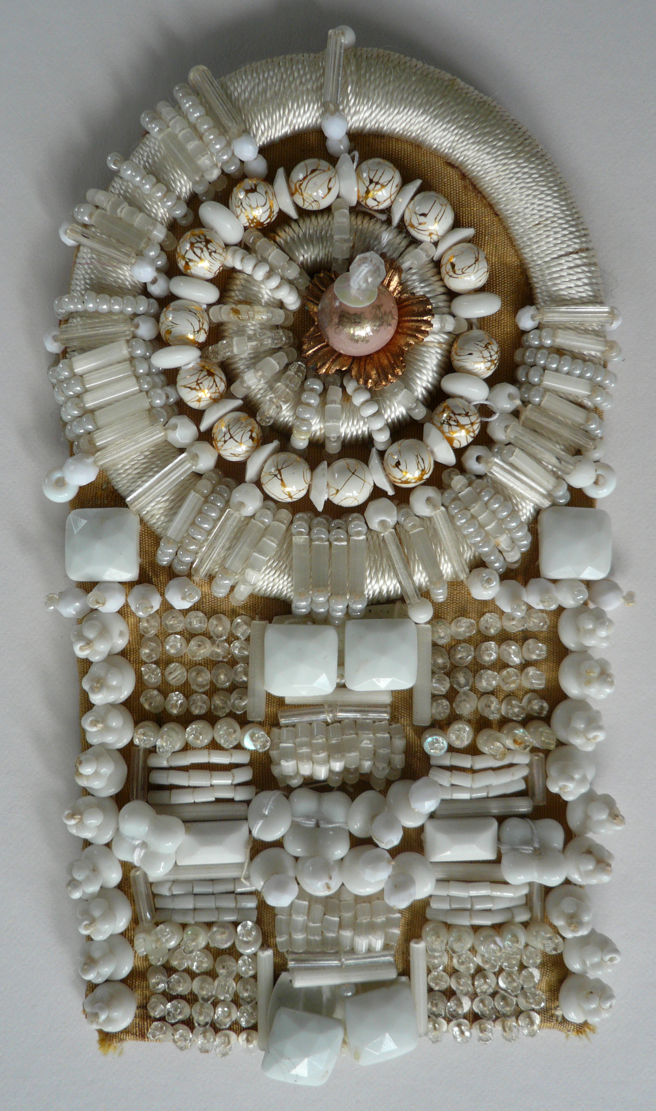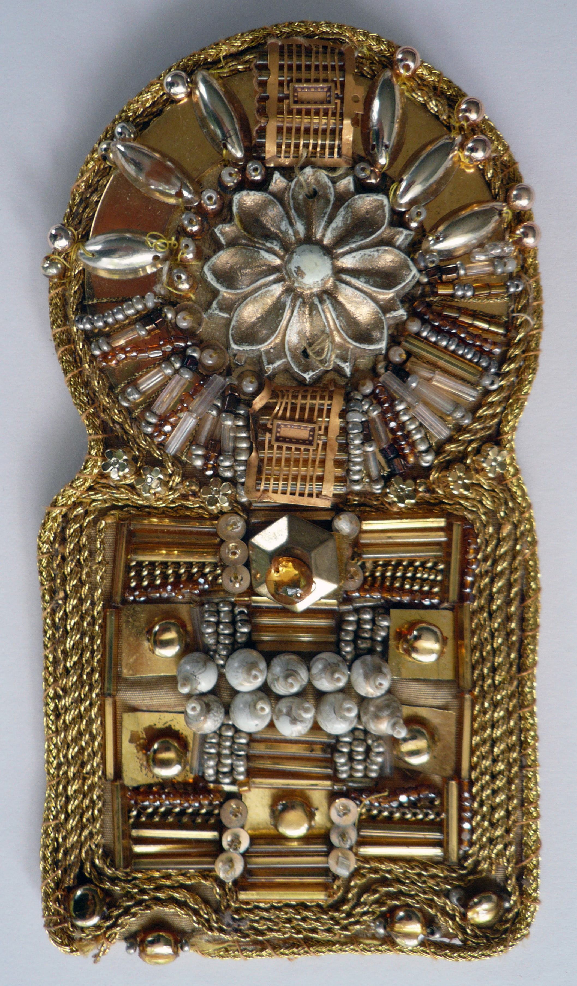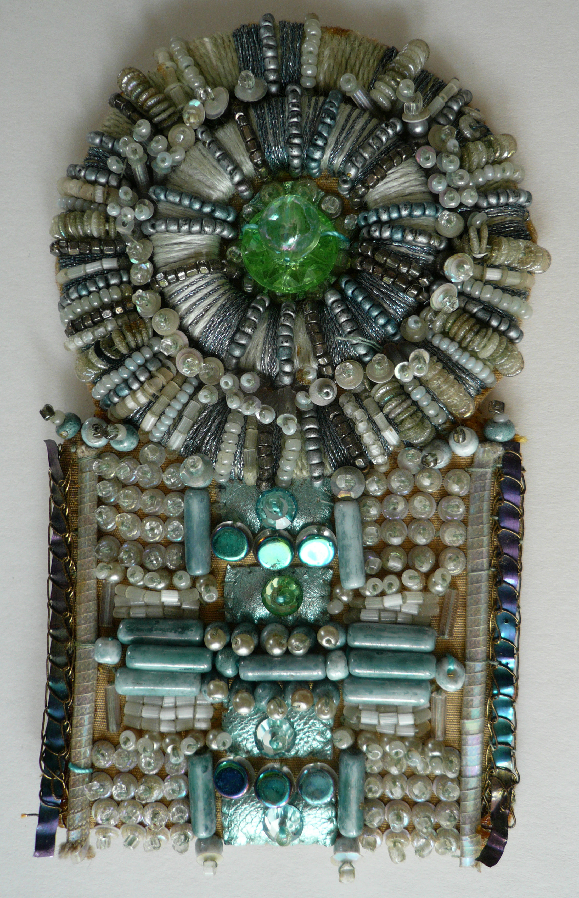
6. Nicholson, M. Small beadwork panels with appliqué, couching, beads and found objects.

Margaret was able to draw from an early age, and spurred on by encouragement at home she won a scholarship at 15 that enabled her to attend Sheffield College of Art, studying embroidery and dress. Within her testimony she reflects on her strength in drawing and how much she really valued the curriculum content at art college, which focused on drawing and historical context. It was her home background, reinforced by her college experience, which established her fundamental belief in both drawing and research as essential requirements in design for embroidery. She gives emphasis that at art college students “were never allowed to copy… Creativity was very important” (Nicholson, 2003, NLSC). This focus on research, drawing, and creativity was to prove to be fundamental in the development of her embroidery and her teaching at LCF. Whilst at Sheffield, Margaret also studied an additional course for the City & Guilds of London Institute status, and was awarded the gold medal in 1933 (Springall, 2005).
Following college Margaret joined the Brookes Manufacturing Co as fashion designer for six years during which time she produced large multiple orders for Marks & Spencer, C&A, and the British Home Stores. She considered that the experience “helped her to understand the commercial side of fashion and embellishment” (Nicholson, 2003, NLSC). Springall (2005) notes that Margaret “was one of the few students at that period to view this medium (embroidery) as a serious living; instead most girls regarded fashion and needle skills as an opt-out from work” (Springall, 1997 13) and Margaret also speaks of this within her testimony (Nicholson, 2003, NLSC). Godfrey identified that she drew on her experience within the fashion industry to support the subject development at LCF (Godfrey, personal communication, August 18, 2014).
In 1958 Margaret joined the Women’s Institute (W.I). Springall (2005) notes that this was “something that in real terms would not be considered particularly significant but that… proved to be the catalyst for the professional career that followed” (Springall, 1997 15). Her involvement with the W.I. was important in facilitating her meeting prominent people such as Hebe Cox, Avril Colby and Iris Hills who asked Margaret to take over her position as Chief Examiner for City & Guilds Embroidery in 1965. This was important recognition of Margaret’s standing within the embroidery field. Involvement in the W.I. more importantly led to Allsop’s request from ILEA for Margaret to join the LCF staff (Springall, 2005).
In 1965, advanced skills in machine embroidery (Irish and Cornely) and tambour beading were still taught within the course and, as in earlier years, some of the students also studied on the evening City & Guild course. Within the technical classes there was still a strong focus with the students working on exercises to practice and secure their technical skills. The course was still feeding the industry: “students would go out into the industry to work in-house or would work independently as freelancers or outworkers to companies such as Hartnell” (Godfrey, personal communication, August 8, 2014). The course evolved to allow the students more freedom to design and practice the development of their skills through working on their own examples.
The textile staff were able to increase the emphasis on drawing for design by working closely with visual artists at LCF (Nicholson, 2003, NLSC). To strengthen the relationship of embroidery to fashion the students were encouraged to make their own garments, “to a certain extent” and to show their creations within the college fashion show (Godfrey, personal communication, August 8, 2014). From her written articles and oral testimony it can be seen that Margaret recognised the importance of the students developing “absolute skill” on the machines that they would use on entering the trade and that this must be practiced ideally through their own designs, “Thus at the same time as they widen their approach to design they gain more experience on the machines” (Nicholson, 1967, 2).
The level of achievement of the City & Guild student examination work over the ensuing years was raised to “very high standards... to the extent that some students, in some instances, were considering this as an alternative to a degree” (Godfrey, personal communication, August 8, 2014). Successful exhibitions of work were held at Foyles bookshop on Charing Cross Road London of student work from both the full-time courses as well as the City & Guild students that Godfrey suggests were “ahead of their time” (Godfrey, personal communication, August 8, 2014). Following the first exhibition selected works were included in the George Segal 1973 film, Touch of Class (Nicholson, 2003, NLSC). Later, owing to the raised standards of City and Guilds the department was able to develop an HNC in embroidery that contributed in some way towards the long-term consideration of embroidery at degree level.
Margaret’s oral history testimony and written articles give insight to her constant enthusiasm for the subject of embroidery, often found in the vernacular phrases, colloquial asides, choice of language, and encouraging tone employed. These conveyed her motivation to the students with the desire to elicit an equal response. Margaret thoroughly immersed herself in embroidery, and encouraged her students to follow. For example in The Art of Tambour Beading, she suggests that becoming “truly involved in this fascinating work is surely a natural aim” (Nicholson, Creative Neelecraft, n.d. 10). Her selective choice of language can be noted later in the same article where she suggests that “The names of beads alone…Crystal, Aurora, Rocailes, Ceylon, Oriental, Alabaster, Sphinx etc. … must surely stir the imagination” (Nicholson, Creative Neelecraft, n.d 10) and, in Creative Beadwork for Beginners, she refers to “the seductive lure of the bead” (Nicholson, The Beadworks’ Guild Magazine, n.d. June issue). In A New Approach to Embroidery, she writes, “it is stitchery that paints the picture. Stitchery after all is said and done, is the embroidereress’s language with which she writes her poem” (Nicholson, 1961, 42). Jo Hall, editor of Embroidery Magazine, identifies this last phrase as one of her “most memorable quotes” (Embroidery, 2013, 66). Elsewhere she refers to the possibility of creating “scintillating luxury results” with machine embroidery and of tambour work with a metal thread producing a “gossamer effect” and of the “ethereal effect” of using transparent fabrics (Nicholson, 1965, 48-49).

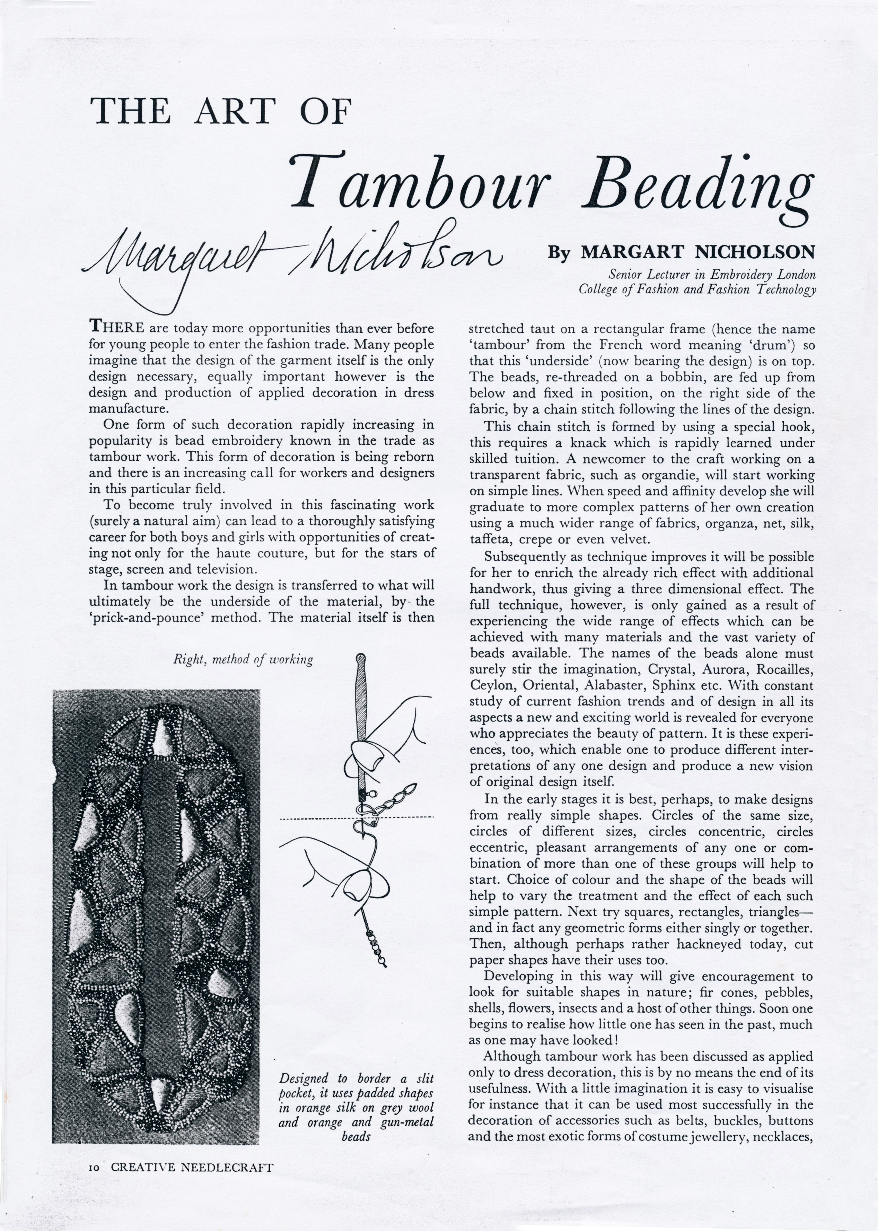
7. Nicholson, M. The Art of Tambour Beading. Creative Needlecraft. P.10

Margaret stresses constantly in written pieces and within her oral testimony that design is essential to embroidery, “of paramount importance and has to become our first consideration” (Nicholson, The Beadworks’ Guild Magazine, n.d., June issue). However Margaret also recognizes the difficulties that design can present to both students and teachers. She acknowledged that teaching design was not easy and that it is the hardest part of a tutor’s role (Nicholson, 2003, NLSC). She empathised with her students on the difficulties of starting a design, “an innate fear of the beginning. A fear of putting pen to paper, a fear of spoiling a piece of material!” (Nicholson, 1965, 12) and is realistic in speaking of the difficulties of the craft and the requirement for patience, “beadwork is not an easy option... slow in execution… time consuming” (Nicholson, The Beadworks’ Guild Magazine, n.d.). Whilst grounding students in realism, however, she is also equally encouraging exhorting them “to stay the course”, referring to this effort “as challenge and adventure” and that they will then be “doubly rewarded” (Nicholson, The Beadworks’ Guild Magazine, n.d., June issue).
Margaret emphasises in her articles, the need for continued experimentation: “The embroideress who wishes to create her own design must never tire of experimenting with such contrasts, with colour, with stitchery, with fabrics. For it is only by such repeated experimenting and experience that a thorough knowledge of the craft can be achieved…. Experiment is the lifeblood of embroidery” (Nicholson, 1961, 42). This emphasis on experimentation reflected current practice and debate in contemporary embroidery (Howard, 1984). Margaret also notes that all of these experiments, even the perceived failures on the part of the students, are valuable, “It is as a student that one soon learns, regretfully, that each specimen cannot possibly be a masterpiece” but that these less successful experiments, or ones that are incomplete through shortage of time, should not be discarded but that “add to our experience with even unfinished work showing the processes involved” (Nicholson, 1967, 78).
Margaret used the exploration of one design through the use of different materials as an exercise with her students and as a method of developing design (Howard, 1985, 25). She believed in using as wide a range of materials, threads, beads and stitches as possible and this is referenced several times within her articles. In The Art of Tambour Beading (n.d) for example she suggests “choice of colour and the shape of the beads will help to vary the treatment and the effect of each stitch”. She suggests in Appliqué work (1965) that the student should “train her eye to see the possibilities in things of no intrinsic value” (Nicholson, 1965, 10). In New Approach to Embroidery (1961) she suggests that fabrics themselves can “suggest a treatment” and help to develop a design whilst making simple changes to a design can also produce a different effect, “sometimes by only a minor alteration of one line, so producing many entirely different effects from one idea” (Nicholson, 1967, 49). Students learnt how one basic design could be adapted on different machines for a wide variety of uses and that the different types of machines themselves dictate to a certain extent how a basic design is carried out and may vary a design.
Margaret notes in her testimony that she uses all different types of materials from a wide range of sources. This reflected a growing interest generally in materials during the fifties and the sixties. During the war embroiderers had, by necessity, used some unconventional materials and following the war this continued with many new materials becoming available by the end of the 1950’s. (Howard, 1983,1984 ). Margaret suggests that materials can come from “everywhere… anywhere… even the builder’s yard… where you can buy locks and keys and all sorts of manner of things that help you in this work ... rings, washers, little tiny escutcheons to fit over joints and that sort of thing”. However it is Margaret’s last comment here that is most informative, “it’s what your mind sees in things, it’s terribly personal and I think it is your mind that is important, it’s not just design, not just the colour of the beads or the bead, it’s what you see in the bead, that I find is much more important than lots of things” (Nicholson, 2003 NLSC).
Her hand beading focused on three dimensional effects, beads worked on top of each other creating rich textural surfaces reminiscent in Margaret’s own words as having the “three dimensional richness reminiscent of Stuart stump work” (Nicholson, 1967, 49) and evidenced through her range of beaded samples and encrusted neckpieces.

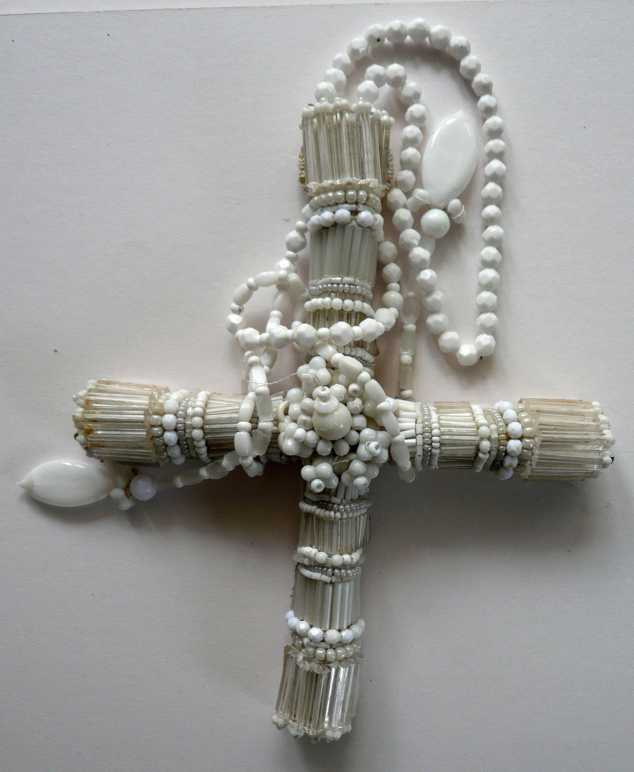
8. Nicholson, M. Three dimensional beading sculpture.

The use of contrasts within embroidery design was another methodology employed within her teaching. Margaret suggests that the consideration of contrast can play an important part of a design, “thick and thin threads, light and dark threads; large and small stitches all have their place” (Nicholson, 1961 42).

Other methods in her design teaching for beginners included making designs from simple shapes. In tambour work for example, she advises that in the early stages students should make designs from “really simple shapes, circles of the same size, circles of different sizes, circles concentric, circles eccentric…later progressing to squares, rectangles, triangles in fact any geometric forms either singly or together” (Nicholson, n.d. 10). She suggests that this will give encouragement to look for suitable shapes in nature, giving fir cones, pebbles, shells, flowers and insects as examples (Nicholson, n.d.). In A New Approach to Embroidery she again references this emphasis on simplicity, “Some of the most satisfying experiments have started in a very simple way”, here illustrated with the examples of a leaves, thistles, seed-heads and dandelion clocks as starting points (Nicholson, 1961 42-3). The cut paper method she also suggests as another way of making simple shapes, referencing an article in Embroidery Spring, 1961. Margaret also identifies the importance of pattern as fundamental to embroidery design defining this as “an arrangement of shapes, lines and rhythm related to one another”. She references lyrical examples of how pattern surrounds us and suggests again that “the student once appreciating this will find in everything around her the inspiration she is seeking” (Nicholson, 1965, 11). Margaret’s interest in and use of pattern can be seen particular within her design work for or nué (a medieval method of couching gold thread) and beadwork samples.
The NLSC Newsletter, 2003, notes that Margaret is especially known for her hand beading and or nué (British Library, 2003). Springall (2005) defines the retrospective of Margaret’s work (London College of Fashion, 2003) as an “awe-inspiring experience, largely because of her unique artistic handling of both real and synthetic gold thread. Her achievements, in panel after panel of or nué place her in the realms of both master craftsman and artist.” (Springall, 2005, 13). Margaret speaks of her self-directed challenge exploring this technique,
I wanted to see if it could be improved and I have altered it a lot. I’ve added to it considerably generally speaking, or nué in the Middle Ages was done across the work. Well I have altered it. I’ve done it down. But I have also done it on the cross or brought diagonal pieces in, which is slightly difficult to do. I’ve done that. I’ve added beads. I’ve added fabrics, leather etc and I have altered it, the whole scheme of things (Nicholson, NLSC, 2003).
Springall (2005) comments that these pieces ‘are akin to the unique qualities of an icon’.

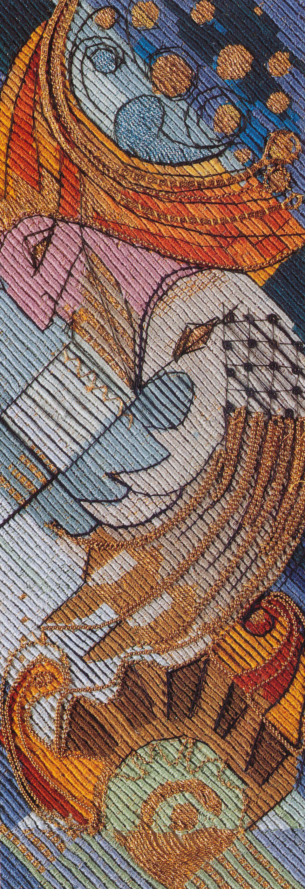
9. Nicholson, M. The Ancient Mariner 2000. Or Nué worked on the diaganol to suggest the storm. Photographer Anthea Godfrey.

Margaret perhaps best summarises, her methodologies within this statement “embroidery is not only drawing, it is not only pattern, it is not only stored up knowledge of stitchery; it is a combination of all three together with a sense of colour, a developed taste, an appreciation of fitness for purpose” (Nicholson, 1965, 12).
Like many inspirational teachers, Margaret taught her methodology by example. An appreciation of her history through an investigation of these archives allows for a deeper understanding of the woman behind the embroideress and teacher. Her legacy is not confined to the recorded artefacts, writings, and oral history testimony that she leaves us with, but remains an influence in embroidery to this day.
Reference List
British Library. Oral History of British Fashion. National Sound Archive. National Life Story Collection. 2003.
Ed., (2013). The Last Word. Embroidery, 64(November / December), 66.
Ed., Oral History of British Fashion. NLSC (National Life Story Collection) Newsletter, Summer, 2003.
Howard, C., (1983). Twentieth-Century Embroidery in Great Britain 1940-1963. London: B.T. Batsford Ltd.
Howard, C., (1984). Twentieth-Century Embroidery in Great Britain 1964-1997. London: B.T. Batsford Ltd.
Howard, C., (1984). Twentieth-Century Embroidery in Great Britain from 1978. London: B.T. Batsford Ltd.
Retrieved from http://www,vads.ac.uk
Nicholson, M., (1965). Appliqué Work. Embroidery, 16(1), 8-12.
Nicholson, M., (1967). Embroidery in Fashion. Embroidery, 18(2), 46-50.
Nicholson, M., (unknown). Creative Beadwork for Beginners. The Beadworkers Guild Magazine, Unknown (June).
Nicholson, M., (unknown). The Art of Tambour Beading. Creative Needlecraft. p10-11.
Nicholson, M., (1967). Making a notebook. Embroidery, 18(3), 78-81.
Nicholson, M., (1961). A New Approach to Embroidery. Embroidery,
12(2), 42-43.
Nicholson, M., (2003). Interviewed by Eve Simmons. Oral History of British Fashion. NLSC (National Life Story Collection). London: British Library.
Reynolds, H., (1977). Couture or Trade. Phillimore & Co Ltd.
Springall, D., (2005). Inspired to Stitch 21 Textile Artists. London: A & C Black Publishers Limited.

Illustrations list

1. LCF 0351
London College of Fashion – College Archive.
Photographer unknown.
Orient inspired cocktail outfit and evening coat with dragon and peacock motifs – 1. Garment made by the embroidery trade students.
Retrieved from http:/www.vads.ac.uk
2. LCF 0237
1920’s Machine embroidery class – 2. Barret Street School.
London College of Fashion – College Archive.
Photographer unknown.
Retrieved from http:/www.vads.ac.uk
3. Nicholson, M. Study from ‘ A Passion Flower Pen and Ink.
Photographer Anthea Godfrey.
4. Nicholson, M. Drawing/ design for Mothers’ Union Banner.
5. Nicholson, M. Detail of Mothers’ Union Banner. Coventry Cathedral 1968.
Photographer Anthea Godfrey.
Hand embroidered goldwork panel with gold kid, appliqué and beads.
6. Nicholson, M. Small beadwork panels with appliqué, couching, beads and found objects.
Photograph Polly Kenny.
7. Nicholson, M. The Art of Tambour Beading. Creative Needlecraft. P.10
8. Nicholson, M. Three dimensional beading sculpture.
Photograph Polly Kenny.
9. Nicholson, M. The Ancient Mariner 2000. Or Nué worked on the diaganol to suggest the storm. Photographer Anthea Godfrey.

