The History of Gay Male Comics in America from Before Stonewall to the 21st Century

Sina Shamsavari
Lecturer, London College of Fashion

The history of gay male comics has received little scholarly attention, and the few existing historical overviews tend to be the work of gay male comics creators themselves, for the most part published as introductions to comics anthologies or in fan publications (see for example Mills 1986; Triptow 1989; Stangroom 2003; Jennequin 2008; Hall 2015.) This article is no exception, being the work of a gay male comics artist as well as an academic. In this article I will present a detailed and nuanced history of gay male comics comics and cartoons, and I will organize this history by establishing a number of “waves” of activity. I propose that the history of gay male comics can be considered in terms of a “pre-Stonewall” period stretching from the late 1890s to the late 1960s, followed by three successive “waves” of activity more or less tied to the subsequent decades. Each of these waves of gay cartooning emerged within specific historical, political and theoretical contexts, which shaped the kinds of gay male identities constructed within these comics. I suggest that looking at gay comics within these contexts is necessary in order to understand how important events such as Stonewall and the AIDS crisis, and political movements such as Gay Liberation and queer activism, have all had an impact on the kinds of stories being told in the comics.
This article also argues that gay male comics production constitutes what Pierre Bourdieu calls a “field of cultural production” (1984). The field of gay comics production is defined partly in terms of authorship – these are comics by creators who identify as gay, bisexual or queer men - and partly in terms of the subject matter of the comics – they deal with LGBTQ identity and experiences. I will go on to explain, per Bourdieu, that this field of production is not unified or homogenous however, and like all fields of production, has both an autonomous (“independent”) and a heteronomous (“commercial”) pole. Different kinds of gay male comics fall between these different poles, depending on their means of production and the venues in which they are encountered and consumed. Depending on their relative levels of commercialism and independence, different gay comics will tend either to reaffirm the values of what Sender (2004) has called the “dominant gay habitus,” or to critique it and represent alternative gay identities and lifestyles.
The history of gay male comics overlaps with that of lesbian comics, but also differs from it in certain respects, and differences in gendered experience mean that lesbian and gay experiences are not simply “the same.” A more detailed study of the field of the work of queer female comics deserves closer attention than this article can provide, but when appropriate this article will touch on lesbian comics.
The present article will also discuss the way in which gay male identity has been discursively constructed in gay comics and cartoons. With regard to the comics and cartoons produced in the pre-Stonewall and First Waves, especially, I argue that the kinds of images of the gay male body and culture constitute what Stuart Hall (1997) has called a “regime of representation.” This term refers to “the whole repertoire of imagery and visual effects through which ‘difference’ is represented at any one historical moment” (Hall 1997: 232). A regime of representation is a representational system “governed by a certain discursive regularity” (Nixon 1996: 12) that constructs a particular kind of knowledge or “truth” about the group represented. The “truths” discursively produced about same-sex desire in the discourses of these early gay comics contrast with the “truths” produced about gay men in American medical and juridical discourses of the time. While mainstream American cultural representations of gay men tended to represent them as pathetic figures – angst-ridden, mentally ill, effeminate or criminal – pre-Stonewall comics and illustrations, on the whole, presented physically and mentally healthy, and traditionally masculine images of homosexuality.
Such images of homosexuality appear across both of the two dominant sub-genres that exist within the broad field of gay male comics: Gay pornographic comics, and what I have elsewhere called “gay ghetto” comics (see Shamsavari 2017). The seeds of these two sub-genres were sown from the beginnings of gay male comics production, in the “pre-Stonewall” phase, but became especially prominent in the First and Second Waves proper. Contemporary gay cartoonists continue to respond to their generic conventions. As we will see, some follow these conventions fairly faithfully, while others subvert them in subtle or radical ways, but the two generic paradigms are rarely dispensed with completely. I will present a definition of “gay ghetto” comics and “gay porno” comics later in this article, but in the next section I will discuss how the field of gay male comics production can be understood with reference to Pierre Bourdieu’s field theory.

The Field of Gay Male Comics Production

I will now discuss Pierre Bourdieu’s theory of fields, and show how “gay male comics” can be understood as a field in the Bourdieusian sense. I will demonstrate the breadth of the wider LGBT comics field, and define the field of gay male comics in terms of its authorship and its subject matter. I also aim to show that the field of gay male comics is internally divided, like all fields according to Bourdieu, between a “heteronomous” and an “autonomous” pole, or to put it more directly, between more “mainstream” and more “alternative” gay comics.
Bourdieu (1984) understands the social world as composed of multiple fields -such as politics, economics, religion, cultural production – which can themselves be divided into subfields. For example, media production can be divided into television, film, magazines, comics, and so on. Bourdieu’s concept of the field provides a spatial metaphor through which to consider areas of artistic and social practice, such as the field of comics production.
Like comics production more generally, the field of gay male comics can be divided between more autonomous and more heteronomous poles. Gay comics may be considered a subfield of two other, broader fields: the field of comics production on one hand, and the field of LGBT media production on the other. As part of the broad field of LGBT media production, gay comics have appeared in both local and national LGBT-interest newspapers and magazines since the early 1960s. They have also appeared in self-published queer zines and mini-comics. The field of LGBT media production can itself be divided between more heteronomous (“mainstream”) and more autonomous publications. Within the field of LGBT media, national magazines like The Advocate and Out of course sit close to the heteronomous pole, and are ultimately motivated by economic capital or “the bottom line.” Smaller LGBT publishers, such as Alyson Books and Winston Leyland Publications, lie somewhere in between the heteronomous and autonomous poles. Individuals and groups engaged in self-publishing – for example, the creators of queer zines – can be placed at the autonomous end of the field of LGBT media.
Gay male comics tend to be published with relative autonomy in contrast with the “mainstream” comic books more generally (those published by Marvel and DC especially.) They can actually talk openly about gay issues, and characters tend to be owned by creators, who therefore have a lot of freedom with what they do with them. Many gay male comics are indeed self-published, making them relatively autonomous. However, others are published within or as part of less autonomous, more commercial or “heteronomous” LGBT magazines and newspapers, and in some cases this has meant that queer cartoonists have found their work censored. For example, national gay lifestyle magazine Instinct insisted that Robert Kirby redraw a panel of one of his Curbside comics (published in the magazine), in which a man is receiving a blow-job, to make it less obvious and more discrete (See Fig. 1 and 2).
Beyond whether or not they are autonomously published, gay male comics can also be distinguished as “more alternative” or “more mainstream” because of the dominant values they express and legitimize. Like all media products, comics can be understood as examples of the discourses that serve to legitimize the dominant values and practices of a particular cultural field. For Bourdieu, discourses are specific to fields, originating within them and helping to shape the meanings of the field. The ultimate objective of such field-specific discourse, then, is the “recognition of legitimacy through the misrecognition of arbitrariness” (Bourdieu 1977: 168) – to legitimize and naturalize what is arbitrary and culturally and historically specific. Foucault uses the term “discourse” in a similar way, to refer to “the general domain of all statements” (Foucault 1972: 80). Discourse is made up of a variety of verbal and visual statements through which human values are communicated, reproduced and “naturalized,” made to seem “normal.”
For Foucault, discourses are also the bearers of subject positions – discourse shapes human subjectivity, how human beings see and understand themselves and one another. For example, in The History of Sexuality, Foucault argues that, in nineteenth century Europe, sexual identity was primarily shaped by legal and medical discourses, which distinguished between normality and deviance. For Foucault, the modern notion of “the homosexual” as a distinctive sexual “type” was constructed in and through discourses produced in the fields of law, medicine, education and religion. However, as Sender (2004: 142-143) argues, since the early twentieth century, the role of such traditional institutions in shaping sexual identity has been displaced (albeit unevenly) by institutions of consumption: the fields of advertising, marketing, public relations and commercial media, including the media representations created from within mainstream gay culture.
“Mainstream gay comics,” then, can be understood as those comics which serve to legitimize the dominant values and practices of gay culture – or what Katherine Sender (2004), drawing on Bourdieu (1984), has described as the “dominant gay habitus.” The most visible and socially sanctioned gay collectivity is “identified in part by its participation in a dominant gay habitus” and is not particularly diverse in terms of race, class, and to some extent gender (Sender 2004: 15). It is argued that gay media practices tend to focus on members of a dominant gay habitus, obscuring the less ‘respectable’ – and less marketable – members of the LGBT communities, including working-class queers and people of colour, cementing their invisibility, and further stigmatising their identities (Sender 2004: 138).
Gay mainstream comics, too, tend to represent and celebrate this dominant gay habitus, particularly in those strips I have identified as traditional “gay ghetto” comics (Shamsavari 2017), which tend to be published in heteronomous or “mainstream” gay newspapers and magazines. More alternative gay comics also exist, however, and they tend to deal with more contentious issues within gay culture, often critiquing the dominant gay habitus, and representing alternative gay identities and cultures. As we will see, both the more “mainstream” and the more “alternative” strains within gay comics have existed almost from the beginning of the history of the field of gay male comics production.
In the next section I will discuss the emergence of gay comics, cartoons and illustration in the broad, “pre-Stonewall” period, and argue that a distinctive and regular “regime of representation” emerged in the comics of this period, which represented gay men as idealized, youthful, athletic, muscular, and traditionally masculine.
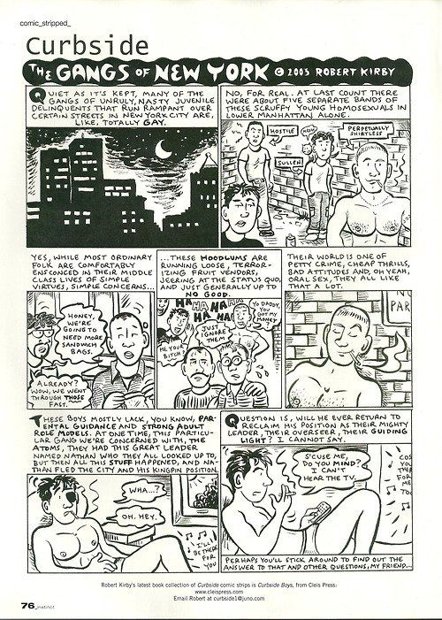
Fig. 1 - Robert Kirby, “The Gangs of New York” (Curbside), Instinct no. 55 (November 2003), 76.

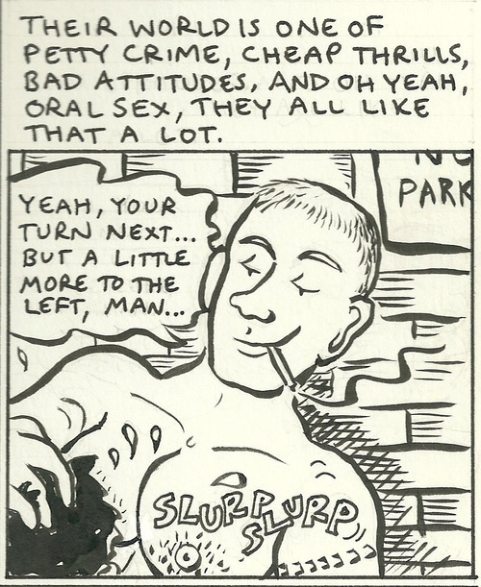

Fig. 2 – The original version of the censored fifth panel of Kirby’s “Gangs of New York.”

Before Stonewall: The Gay Cartoons and Comics of the 1960s

The roots of gay comics lie in gay erotic illustration, both the licit softcore "physique art" found in publications like Physique Pictorial and Tomorrow's Man in the 1950s (see Cooper 1994; Saslow 1999), and the illicit, hardcore and sexually explicit image narratives Thomas Waugh (2002) has described as "underground gay graphics." Many of the artists who produced these underground gay graphics - which tended to depict muscular young men performing explicit sex acts with one another - were the same as the ones who produced softcore illustrations of those same athletic young men but in more "innocent" scenarios, their penises discretely covered by loincloths; foremost amongst them was of course Tom of Finland, but artists like Etienne (Dom Orejudos) and Sean (John Klamik) also produced both kinds of images.
The first ongoing gay comic strips and cartoons did not appear until the 1960s, with the birth of unapologetically gay magazines and newspapers such as Drum (1964) and The Los Angeles Advocate (1967). Openly homosexual publications had existed before, but they had tended to be associated with homophile organisations - early campaigners for homosexual rights who tended to take a cautious, conservative approach to social change. Daringly, for the time, Drum combined serious news and political content with unashamed homoerotica (Streitmatter 1995), and featured the first ongoing gay comic strip: Harry Chess: That Man From A.U.N.T.I.E (Fig. 3), written and drawn by Al Shapiro using the pen-name “A. Jay” (Mills 1986: 9). Harry Chess spoofed the contemporary secret agent craze, and was “crafted both to amuse readers and to affirm gay values” (Streitmatter 1995: 98-99). The popularity of Harry Chess meant that “it wasn’t long before a token comic strip became the norm in gay magazines” (Stangroom 2003: 45).
Around 1967, Joe Johnson’s Miss Thing (Fig. 4) became the first ongoing, one-panel cartoon feature in The Los Angeles Advocate, featuring the eponymous character, an outrageous “queen.” The feature’s brand of campy humour quickly came to be seen as out of date and the strip was discontinued not long after the Stonewall Riots (Triptow 1989: 12). Johnson also documented the increasing adoption of masculine styles
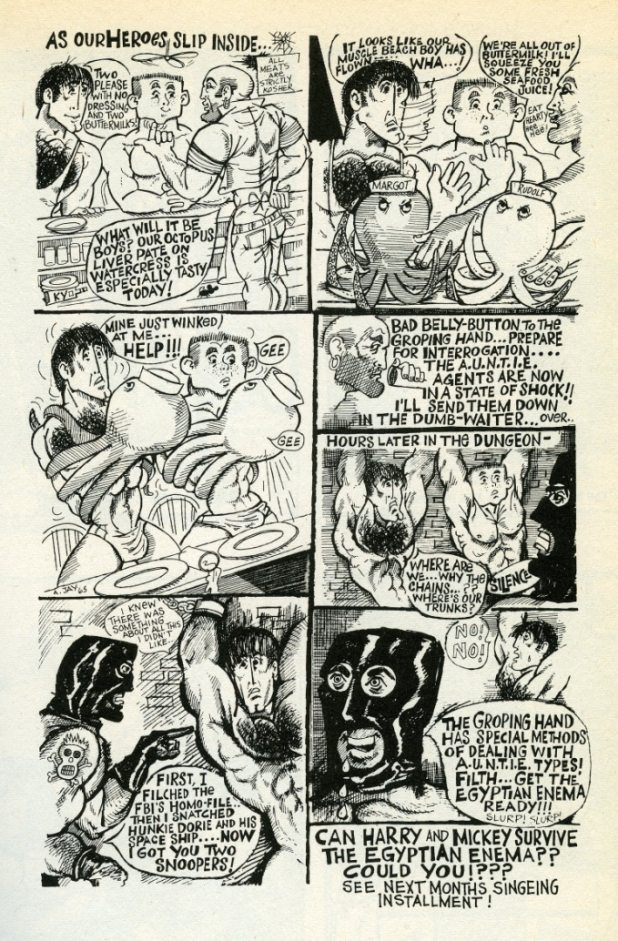
Fig. 3 – A. Jay (Al Shapiro), Harry Chess: That Man From A.U.N.T.I.E. From Triptow, Gay Comics, 7.

amongst gay men in his other cartoon feature, Big Dick (fig. 5), which celebrated the “sexploits” of the eponymous, blonde, horny “macho man” not too different from Tom of Finland’s hunky heroes.
The cartoons and comic strips appearing in the gay press of the 1960s and the 1970s are discursive productions that shaped their producers’ and consumers’ understanding of gay identity, and rather than portraying homosexuality as a “problem” (as was the norm in the majority of representations of homosexuality outside of gay media), they tended to present an idealised image of the gay man as robust, strong and healthy, traditionally “masculine,” and joyful and happy rather than angst-ridden. In fact they shared this representation with the earlier examples of “physique art” and explicit “underground gay graphics” popular in the 1950s.
These kinds of representations were subversive with regards to mainstream American culture, but they were normative within the emerging gay subculture and reflected its values, and especially the kinds of men who tended to be valorized:
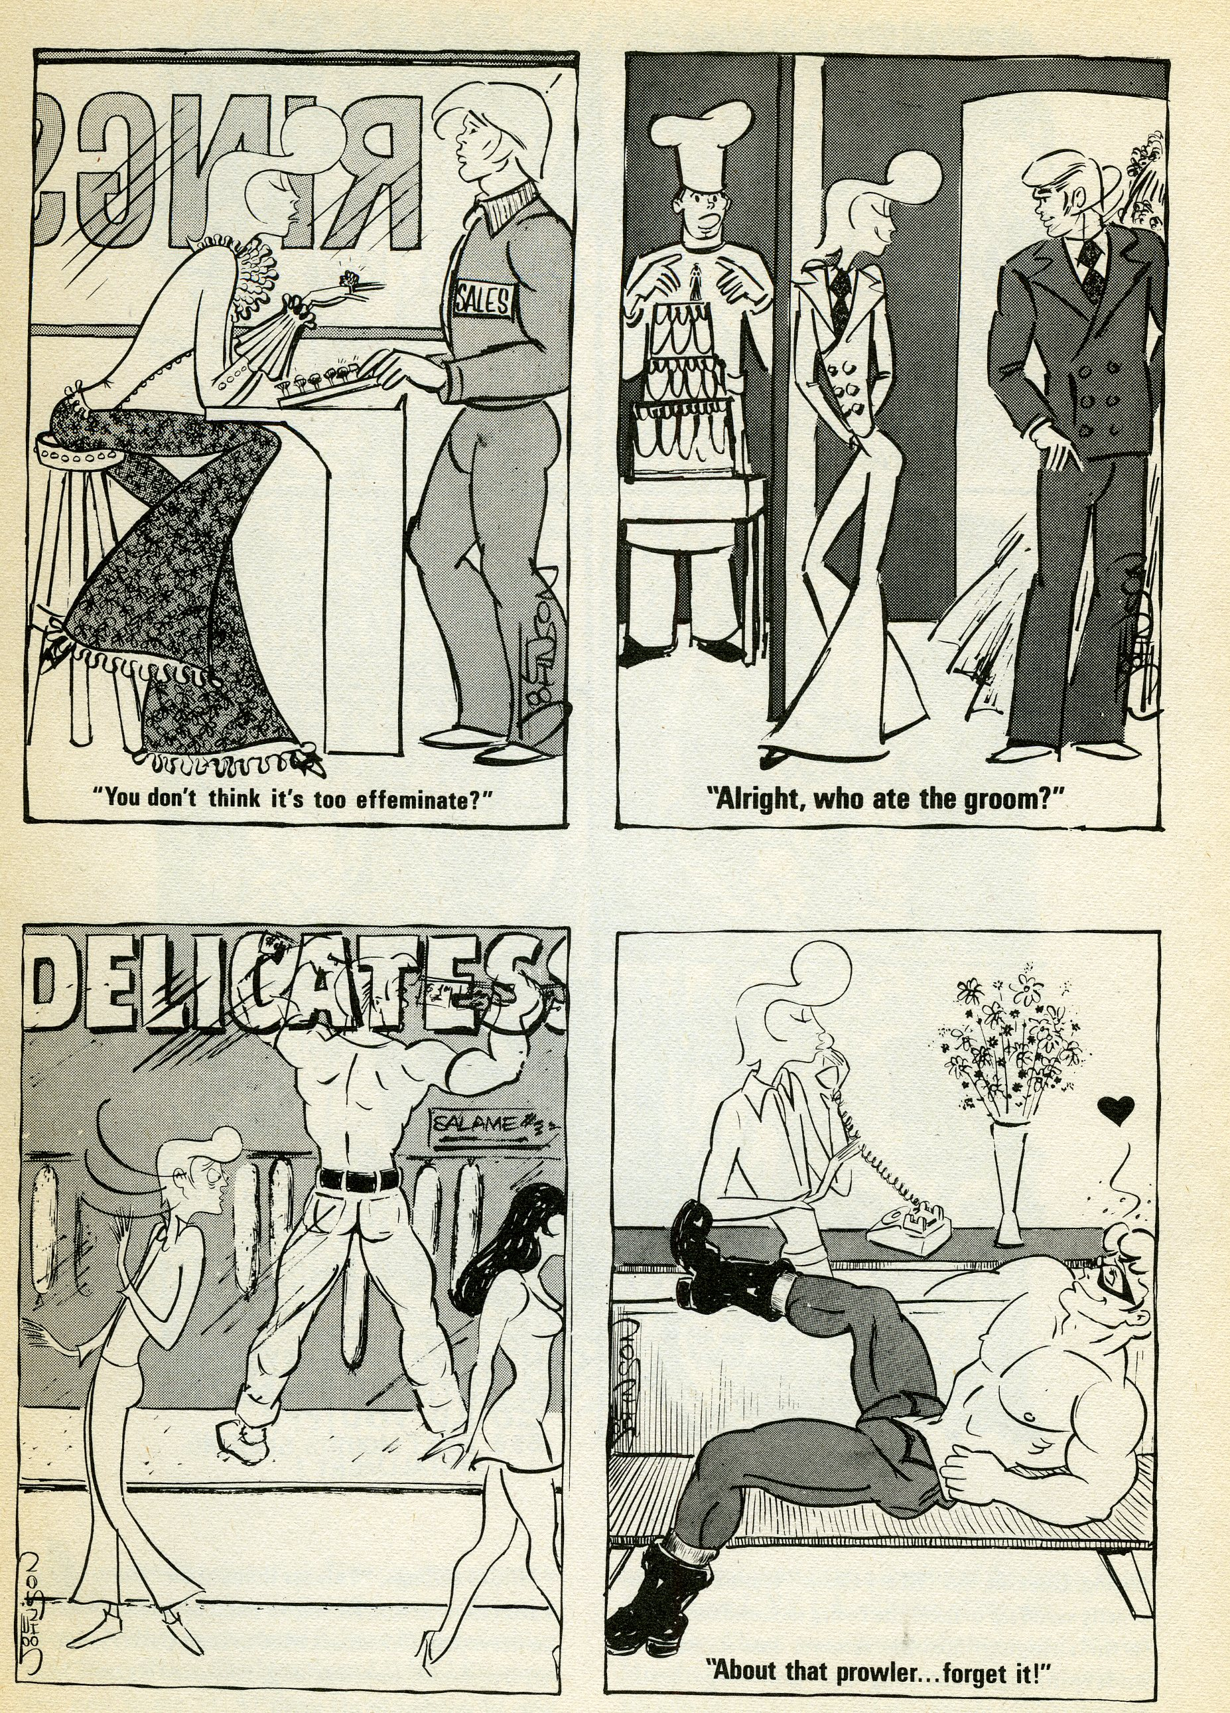
Fig. 4 – Joe Johnson, Miss Thing. From Triptow, Gay Comics, 10.

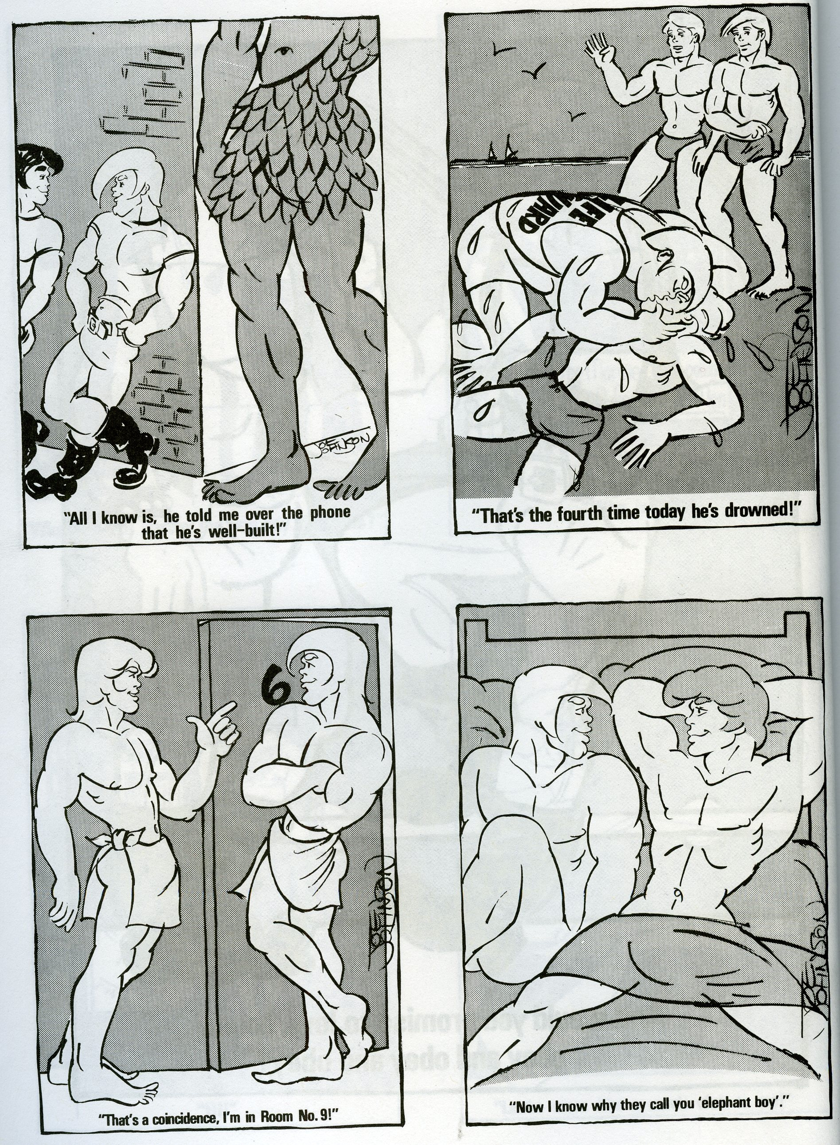
Fig. 5 – Joe Johnson, Big Dick. From Meatmen vol. 1, 36.

youthful, masculine, lean and athletic, and usually white. These kinds of idealized male bodies, then, quickly became a stereotypical convention in the field of gay male comics. As a consequence, then, these comics tend to exclude representations of gay men that fall short of this ideal: in particular, overweight men, older men, non-white men, and – except as figures of fun like Miss Thing – effeminate men.
The pre-Stonewall comics were influential on the emergence of the First Wave proper of lesbian and gay comics production. The two dominant genres within the field of gay male comics production – the gay ghetto comics and the gay porno comics – have their roots in the comics of the pre-Stonewall period, becoming much more consolidated as genres within the First Wave proper.
In the next section – “Defining the Gay Ghetto and Gay Porno Genres” - I will discuss the growth of these two sub-genres and define their generic qualities. In the subsequent section – “The First Wave” – I will discuss how these comics emerged against a socio-political background heavily informed by the Gay Liberation and Lesbian Feminist movements.
Some of the comics of the First Wave would further consolidate the idealized portrayal of the gay male body and the gay male community discussed above, affirming the dominant values of the gay subculture. Others, as we will see, would become concerned with portraying a more overtly political representation of gay culture, and with telling more autobiographical stories that challenged both the homophobic “straight world” and addressed the problems within mainstream gay culture itself.

Defining The Gay Ghetto and Gay Porno Genres

In the mid-to-late 1960s and the early 1970s, the field of gay male comics began to coalesce as a distinctive field of production. During the 1960s, a number of United States Supreme Court rulings liberalized pornography laws, allowing for the commercialization of pornography (Ramakers 2000: 5). This meant that after the Stonewall Riots, the 1970s saw the proliferation of openly gay, homoerotic magazines with full-frontal nudity and sex, such as Mandate, In Touch, Honcho, and Drummer. Because of the popularity of the illustrations of Tom of Finland, Etienne and others, and the Harry Chess strip by A. Jay, more and more of these magazines also came to feature cartoons and comics that can be considered part of the First Wave of gay male comics production.
In Touch published Klamik’s (“Sean”’s) erotic work and later – from 1986 - Poppers by Jerry Mills. Drummer became the new home to Shapiro’s Harry Chess and British artist Bill Ward’s erotic strip Drum (not to be confused with the earlier magazine Drum), as well as publishing cartoons by Bud Larsen. At roughly the same time, comic books featuring the erotic work of a single author begin to be published, including Etienne’s Adventuretime, and Tom of Finland’s hardcore Kake comic books, which were published in Denmark and Sweden in 1967 (Ramakers 2000: 5).
Throughout the 1970s a greater number of national gay newsletters, newspapers and magazines appeared than had existed previously, and many of them featured a comic strip or two. By the early 1980s, more gay and lesbian cartoonists than ever had the opportunity to see their work published and distributed to a national and in some cases international audience. As Jerry Mills describes, in the 1980s many cartoonists in North America self-syndicated their work, while others formed a gay cartoonists syndicate – the Stonewall Features Syndicate – in order to get their strips published in a wider range of national gay and lesbian newspapers and magazines (Mills 1986: 13).
Many of the gay male comic strips and cartoons emerging in the 1970s and the 1980s were examples of the gay ghetto genre. Notable examples include Shawn (John Klamik)’s satirical cartoons, appearing in gay newspapers since the mid-1960s; Joe Johnson’s aforementioned Miss Thing and Big Dick, starting circa 1965; Gerard Donelan’s It’s A Gay Life (1977); Bruce Kurt Erichsen’s Murphy’s Manor (1981) and The Sparkle Spinsters (1985); Jerry Mills’ Poppers (1982); Howard Cruse’s Wendel (1983); Jeff Krell’s Jayson (1983); Tim Barela’s Leonard and Larry (1984).
Such gay ghetto comic strips and cartoons are often set in a recognizably ‘gay’ location – one of the well-known gay urban enclaves in major (usually American) cities, such as West Hollywood, LA, the Castro, San Francisco, and various Manhattan gay neighbourhoods including Chelsea and Greenwich Village. The explicit or implied locations of gay ghetto comics are of course the first important signifiers that signal that this comic is gay, since certain urban centres – San Francisco, LA, New York in particular – have come to ‘stand for’ the ‘gay community’ in the popular imagination of Americans particularly (Chasin 2000: 169).
The main action in gay ghetto comics tends to take place in and around certain ‘gay community’ institutions – a gay boarding-house (as in Kurt Erichsen’s Murphy’s Manor), the offices of a gay news-magazine (Howard Cruse’s Wendel), as well as gay bars, gyms, dance clubs, beaches, bathhouses, and Gay Pride festivals (many of the strips.) Characters in gay ghetto comics will often use gay slang when speaking to each other, and the strips will include both verbal and visual references to various gay ‘types’ or ‘tribes’ such as gym queens, drag queens, leather men, bears and so on.
Gerard Donelan’s It’s a Gay Life cartoons (Fig. 6) are an early example of the gay ghetto genre, featuring gay men who are for the most part portrayed hanging out in gay bars and dance clubs, going shopping, or in private spaces such as the homes of domestic partners or casual sex partners. The captions accompanying Donelan’s single-panel cartoons tend to parody or make reference to stereotypically ‘gay’ preoccupations with cruising, fashion and body image, and humorous sexual scenarios –all of the signifiers of a commodified gay identity and lifestyle as it emerged in the urban enclaves of American cities in the 1970s and throughout the 1980s (Fig. 6) – though as Mills notes, even when parodying the gay scene, this is ‘done with affection, not malice’ (Mills 1986: 11).
Mills’s own Poppers – about three gay friends living in the West Hollywood scene – was among the funniest, most thoughtful, and well-crafted of the gay ghetto comics of the early 1980s, and began appearing in In Touch in April 1982. Poppers focused on the hedonism of the West Hollywood gay scene of the late 70s and early 80s, which it lampooned and glorified in equal measure, capturing the aforementioned affectionate qualities of the gay ghetto strip noted by Mills himself (see Mills 1986). Like many ghetto strips, Poppers contained references to specific cultural products associated with the gay subculture – most obviously, the strip’s title referred to the slang term for the drug amyl nitrate, inhaled for recreational drug purposes and particularly in sexual encounters on the gay scene. In one of Jerry Mills’s Poppers stories, published in Gay

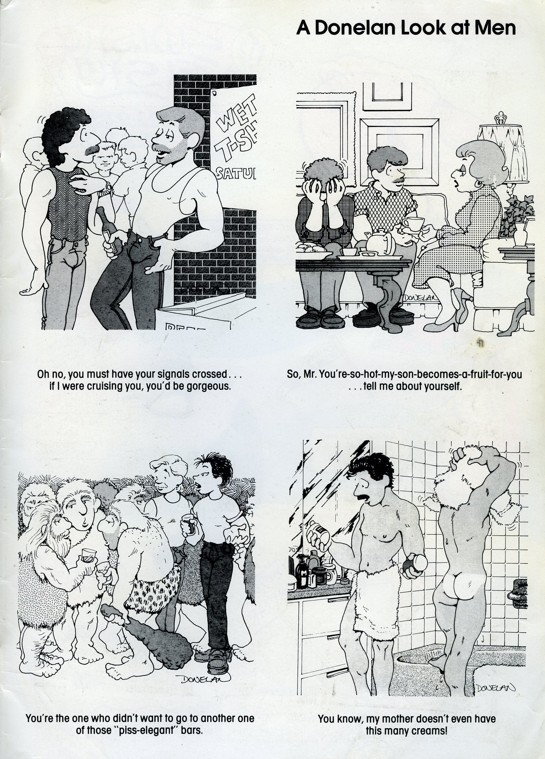
Fig. 6 – Gerard P. Donelan, ‘A Donelan Look at Men.’ Gay Comix no. 13 (1991), np.

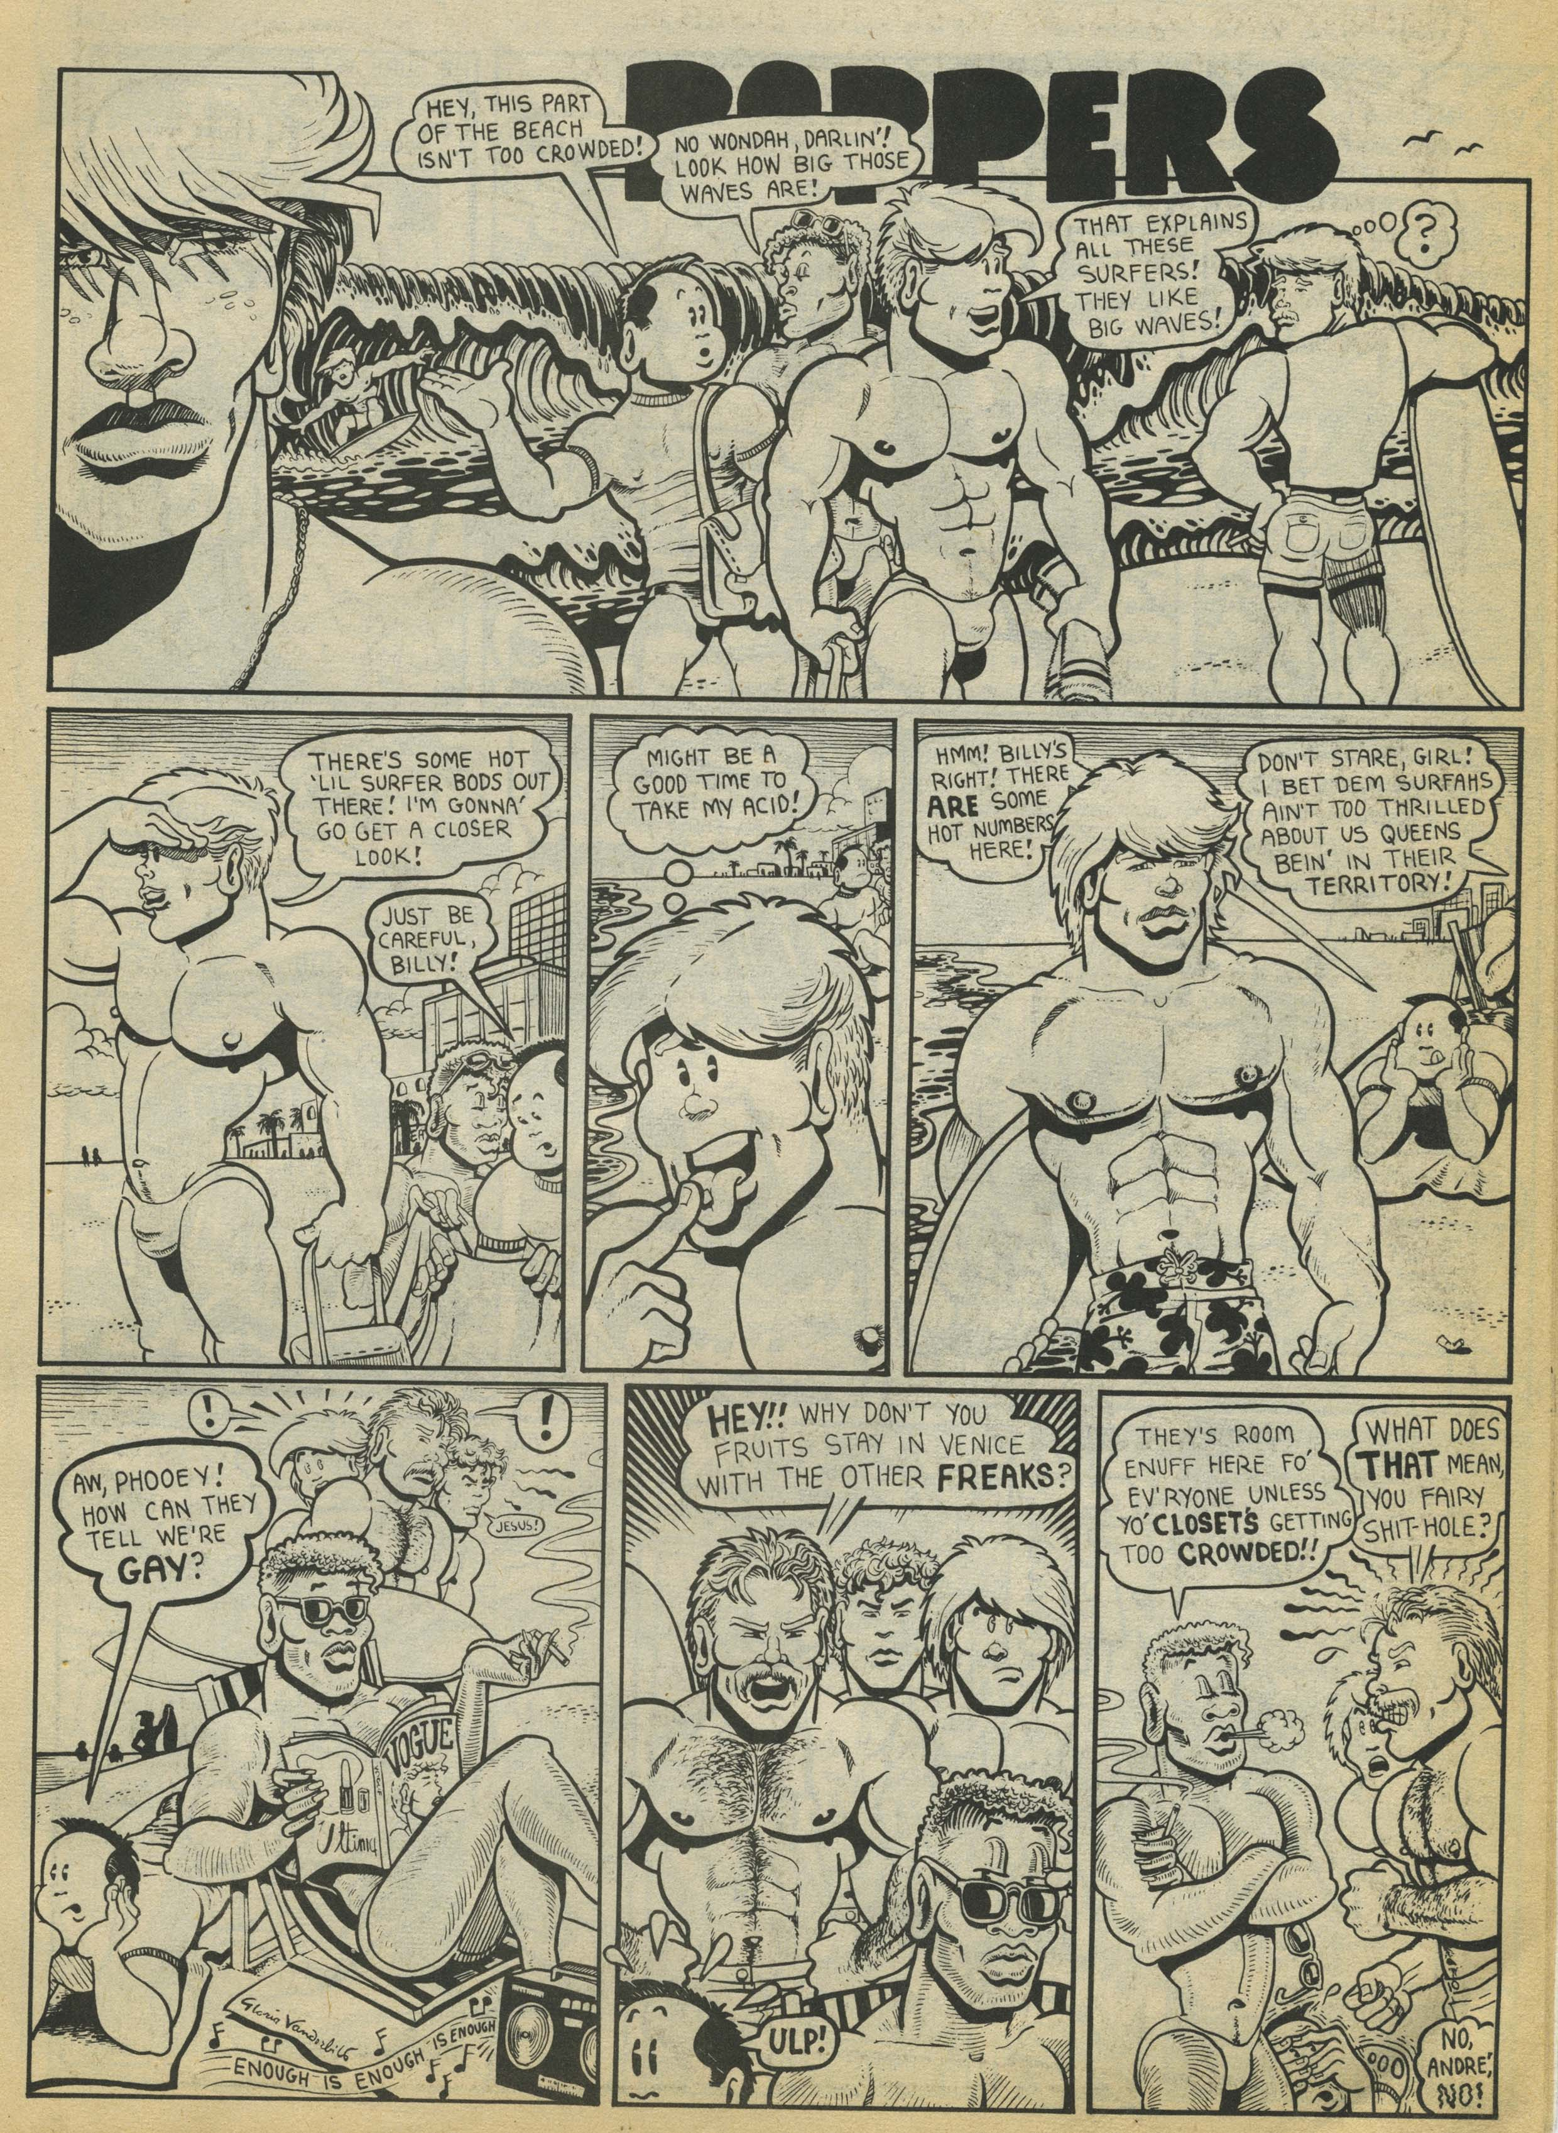
Fig. 7 – Jerry Mills, ‘Poppers.’ Gay Comix no. 6 (Winter 1985), np.

Comix no. 6 (1985), best friends Yves and André are shown sitting on the beach flicking through Vogue magazine and listening to Barbra Streisand and Donna Summer’s disco
hit ‘Enough is Enough’ (Fig. 7); such references to stereotypically ‘gay’ locations, slang, ‘types’ and cultural products serve as signifiers for the gayness of the characters as well as indicating a specific kind of gay lifestyle and identity at a certain point in time.
The other dominant genre – the gay pornographic comics – were also published in gay magazines since the late 1960s and early 1970s, as well as collected in anthologies. The gay porno comics genre represents both gay sex and gay male bodies in an idealized way: gay sex is nearly always a positive and pleasurable experience, and male bodies tend to be slim, youthful, athletic and muscular. These comics usually feature “flat” characters that tend to be happy and horny, but rarely display a more rounded range of emotions. These comics construct an ideal “type” of gay male identity and sexual lifestyle, valorising the ideals and mores associated with gay male culture where idealized, youthful and athletic gay male bodies are highly prized, and sex with a variety of partners is celebrated and seen as central to gay male identity.
In describing these comics as pornographic I adopt Richard Dyer’s (2000) working definition of porn as any work of art “that has as its aim sexual arousal in the spectator” (Dyer 2000: 138). Gay pornographic comics are certainly intended above all else to be sexually arousing, and are usually “hardcore”: they explicitly show erections and penetration. Notable cartoonists working in the genre include not only Tom of Finland, but also many others: “Sean” (John Klamik, whose non-pornographic, satirical cartoons appeared in the gay press under the alternative pseudonym “Shawn”); “Stephen” (Dom Orejudos, also known as “Etienne”); “Julius”; “Joe”; “Osze”; “Mike” (Michael Kuchar); “Zack”; Brad Parker; The Hun; John Blackburn; and more recently artists like Logan and Patrick Fillion.
In some of the gay porno comics and cartoons, a wholly different scenario and set of characters is presented in each instalment, while in others the focus is on a regular set of characters. Discussing the art of Tom of Finland, Micha Ramakers describes his male figures as “interchangeable” and “virtually identical: same hair, same nose, same mouth, and same chin. Furthermore, they have the same body and the same penis” (Ramakers 2000: 55). Individual differentiation is minimal; Tom’s men are “prototypes” – his work is concerned not with the representation of individual gay men, but with gay men as a group. It is “a running commentary on evolutions within (a particular) gay subculture” (Ramakers 2000: 57).
Tom’s work has been a model for many other gay cartoonists. In the majority of gay porno comics, cartoonists tend to depict very specific types of gay men. As I noted earlier, these repeated types constitute what Stuart Hall (1997) has called a “regime of representation”, with the characters depicted by cartoonists like Sean, Stephen, Joe, and others usually being white, muscular, conventionally masculine and handsome, square-jawed and well-hung. These characters are shown participating in sexual activities that often take place in physical spaces which have a masculine connotation. For example, as Tim Edwards describes when discussing gay male pornographic film, this might be “on construction sites, in . . . locker rooms, prisons and other places where male-to-male contact, male exclusivity or masculine association is often significant” (Edwards 1994: 84).
In this section I have defined the traditional, dominant genres within gay male comics production – the gay ghetto and gay porno sub-genres. In the next section I will discuss the way in which gay male representations in the underground comics of the 1970s and 1980s began to depart, to an extent, from the conventions of these genres, as well as discussing the emergence of Gay Comix, arguably the most important anthology presenting the work of gay male artists throughout the 1980s and into the 1990s.

The First Wave: Gay Representations in The Undergrounds, and Gay Comix

The First Wave of gay comics production stretches from roughly 1969 (the Stonewall Riots and the birth of “Gay Liberation” proper) to the late 1980s and the emergence of queer activism. In this section I will discuss how this First Wave emerged against a socio-political background heavily informed by the Gay Liberation and Lesbian Feminist movements. To some extent, the comics can be seen as liberationist propaganda intended to empower and “recruit” the reader for the Gay movement, although it must be noted that they do not do so in an uncritical way.
In addition to the gay ghetto and gay porno cartoons and strips appearing in the lesbian and gay press – and described in the previous section - gay representations and narratives began to appear in the underground comic books in the 1970s. Arguably the “gay ghetto” and “gay porno” comics appearing in the gay press can be understood as somewhat more “heteronomous” or commercial in Bourdieu’s terms. Those comics that appeared in the undergrounds were perhaps more “autonomous” in the Bourdieusian sense, and tended to be more overtly informed by the theoretical underpinnings of Gay Liberation and Lesbian Feminism.
Underground comic books (or “comix”) emerged in America in the mid-1960s, and concentrated specifically on adult themes, notably sex, drugs and radical politics. The first widely-available underground comic was Robert Crumb’s Zap Comix no. 1 (1967), which inspired many other cartoonists. According to Paul Lopes, underground comix formed the basis of what Bourdieu would term a field of restricted production within the broad field of American comics production, and underground cartoonists “were the first to suggest that comic books could be the vehicle for an unmediated authentic expression of their artists” (Lopes 2009: 75).
However, the early underground cartoonists – most of whom were heterosexual men – were not particularly comfortable with challenging traditional notions of sexuality or gender. Feminist cartoonist Trina Robbins (1999) has critiqued the misogyny of many of the undergrounds, and similarly, Robert Triptow (1989) has described the dismissive portrayal of homosexuality in the work of two leading underground cartoonists, Spain Rodriguez and Crumb.
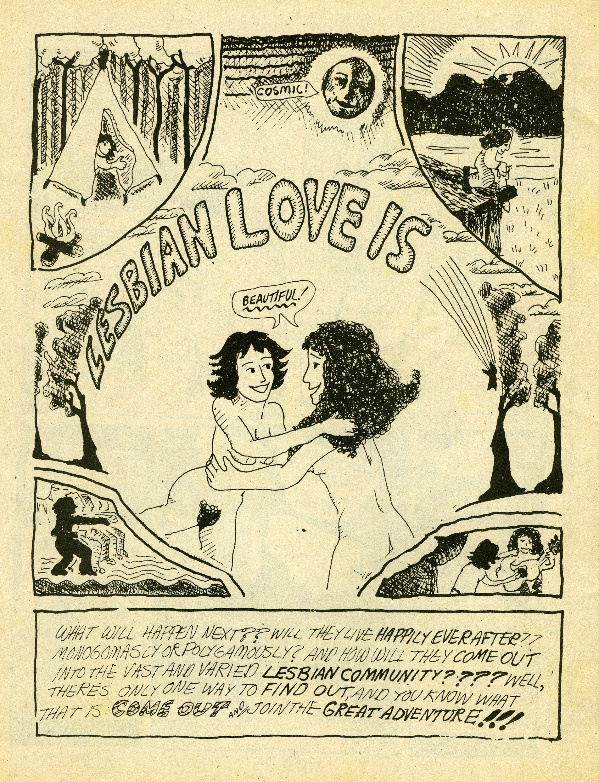
Fig. 8 -Mary Wings, Come Out Comix, 1973, np.

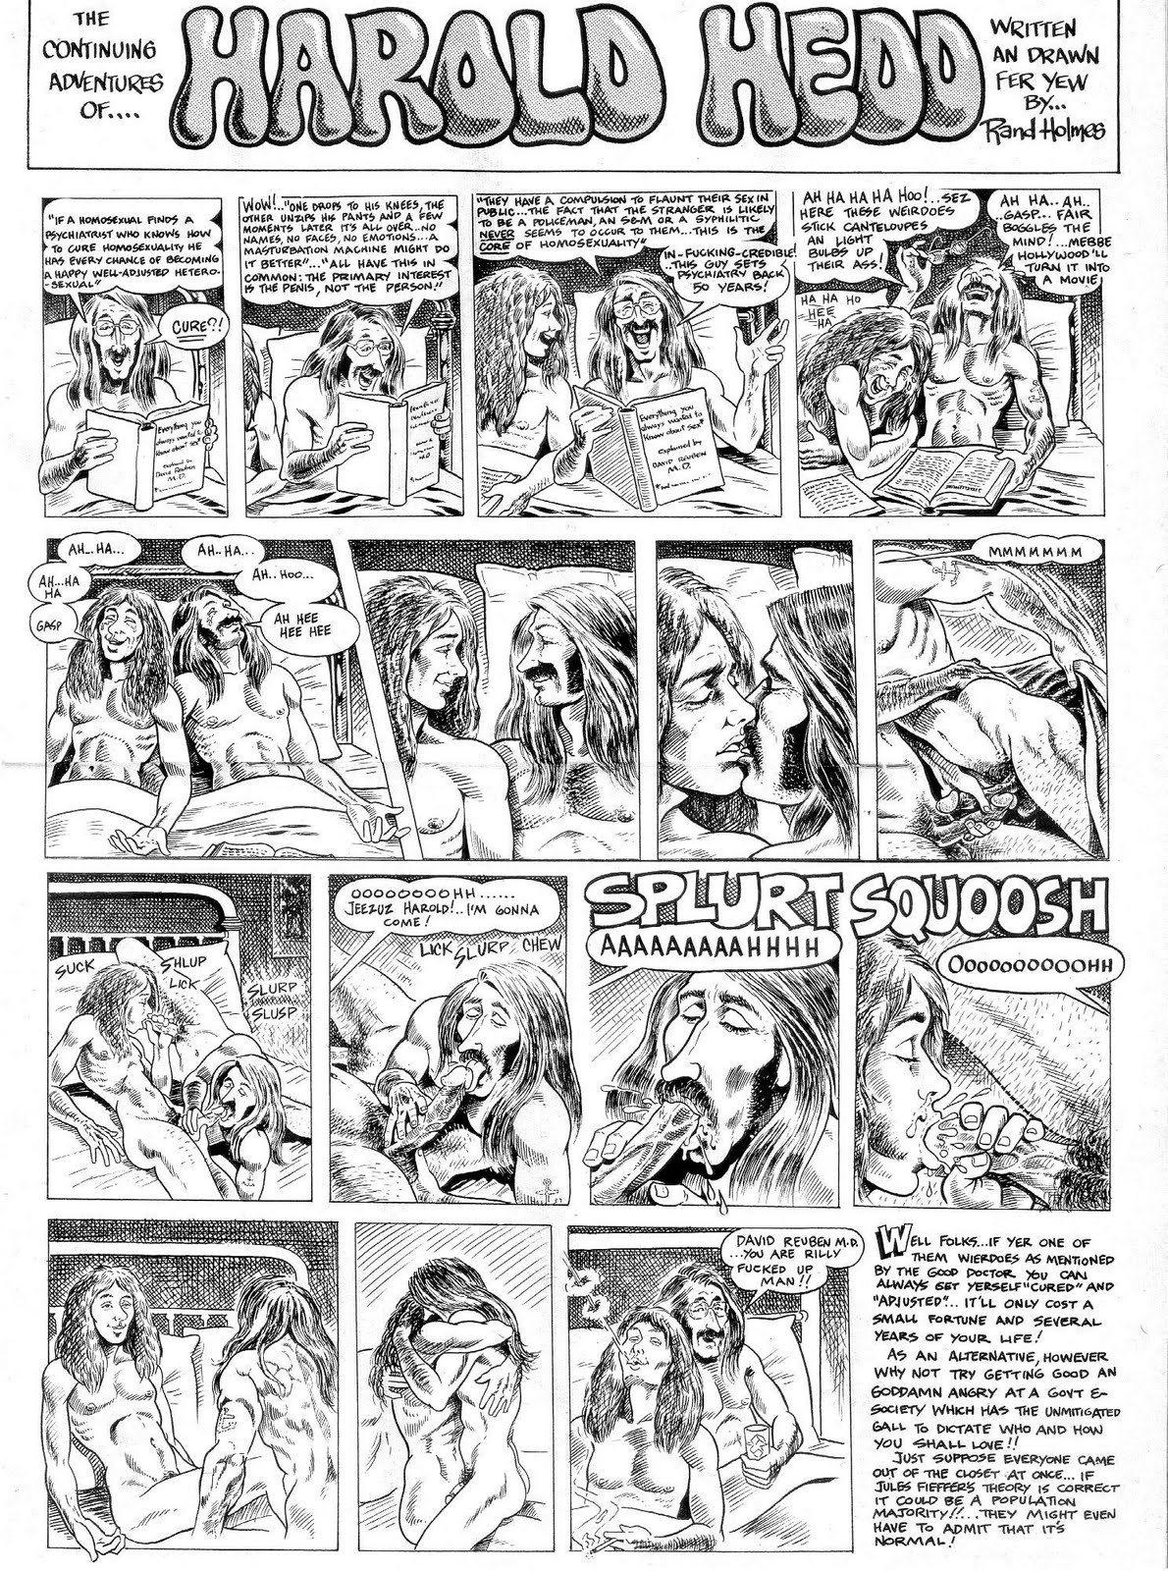
Fig. 9 – Rand Holmes, “The Continuing Adventures of Harold Hedd.” All-Canadian Beaver Comix no. 1, np.

Robbins reacted to this by producing the first all-female comix anthology, It Ain’t Me, Babe (1970), followed by a semi-regular anthology, Wimmen’s Comix (1972). In turn, the first lesbian comix directly reacted to what they saw as the heterocentric bias of Wimmen’s Comix, with Mary Wings publishing the first lesbian-themed comic book by a lesbian, Come Out Comix (Fig. 8) in 1973, and Roberta Gregory also publishing a solo comic on lesbian and feminist themes, Dynamite Damsels (1976).
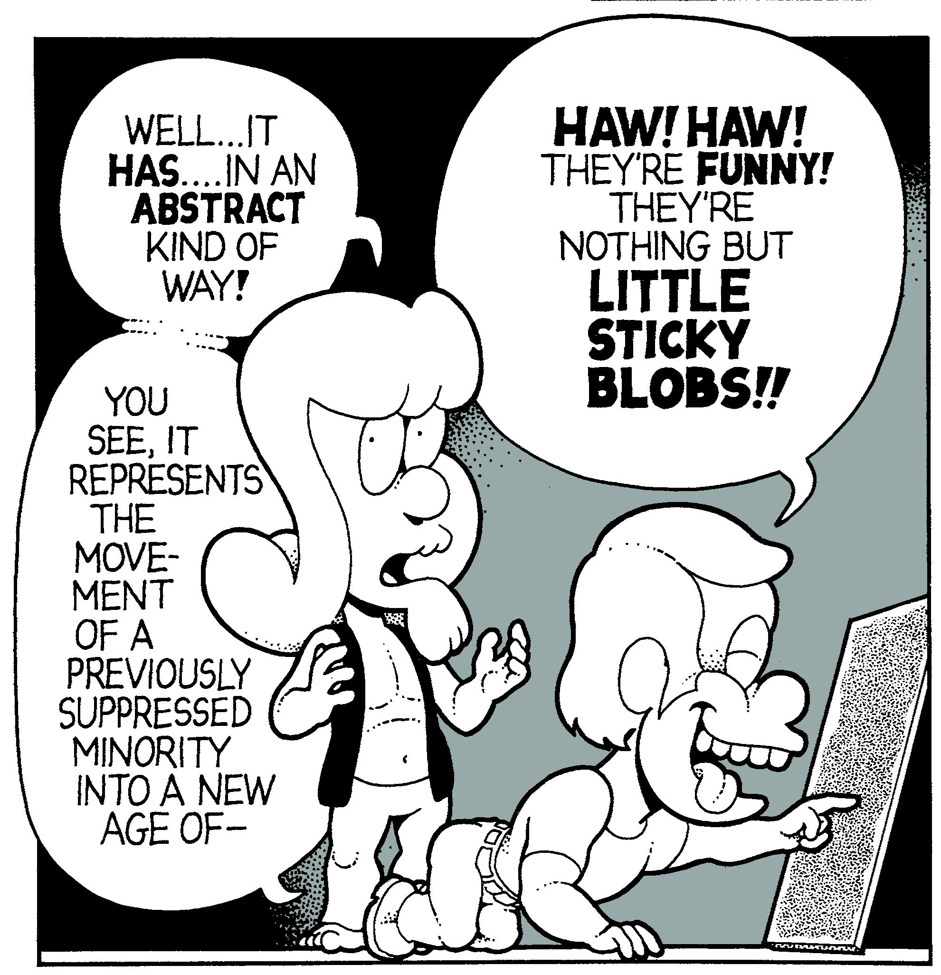
Fig. 10 – Hippie artist headrack in a panel from Howard Cruse’s “Gravy on Gay”, Barefootz Funnies no. 2 (1976).

These early lesbian comics are very much informed by the theoretical underpinnings of the Gay Liberation movement, with coming out being a central theme in their narratives. Liberation theory saw human nature as innately polymorphous and
androgynous, and aimed at freeing individuals from the constraints of a repressive sex/gender system “that locked them into mutually exclusive homo/hetero and feminine/masculine roles” (Seidman 1993: 117). Gay liberationists believed that
traditional gender roles constrained people from recognising their true sexual selves, and insisted on the importance of publicly “coming out” and assuming a gay or lesbian identity, and of challenging and discrediting professional opinion (Jagose 1996: 38).
The two most prominent representations of gay male characters in 1970s underground comix are also coming out stories of sorts. Both are also depictions of gay hippies. Appearing within the more autonomous underground comix, they demonstrate a more “alternative” attitude and represent gay characters who contrast with the conventionally idealized, clean-cut, athletic and traditionally masculine images of gay men circulating at the time in comics appearing within the gay press.
First, in 1971, Canadian underground cartoonist Rand Holmes published a short story in which his hippie hero, Harold Hedd, is shown in bed with another man (Fig. 9). Then, in a story titled “Gravy on Gay” in the second issue of Howard Cruse’s Barefootz Funnies (1976), the hippie artist character Headrack (Fig. 10) came out as gay. Cruse describes “Gravy on Gay” as a way for him to “test the waters” to see if coming out “would destroy my career” (Cruse 2008). Though he did not himself come out in the story, “any sensible person would assume that the person who drew it was gay” and the lack of negative feedback to the story “strengthened my feeling that in the long run I was going to be an openly gay cartoonist” (Cruse 2008). In 1979, Cruse was approached by Dennis Kitchen to edit the anthology Gay Comix no. 1, which would be his official coming out.
However, Gay Comix was not the first gay underground anthology. In 1976, Larry Fuller, a publisher of heterosexual pornographic comix, saw a gap in the market for an all-gay underground anthology – Gay Heart Throbs. Three issues were published between 1976 and 1980. Though considered a creative disappointment (Triptow 1989: 25), Gay Heart Throbs indicated that there was a market for gay underground comix, and influenced Denis Kitchen, the heterosexual publisher of Kitchen Sink Press, to inaugurate the co-gender anthology Gay Comix in 1980.
From 1980-1983, Gay Comix was published by the underground comix publisher Kitchen Sink Press. In Bourdieusian terms, in these first four years, Gay Comix was firmly positioned toward the autonomous pole of the field of LGBT comics production (see Bourdieu 1993). Its subject matter dealt with more serious issues and was often critical of gay orthodoxies, reflecting this autonomous position. However, the tone of Gay Comix changed significantly with the arrival of Triptow as editor with no. 5 (1984), and with the change of publisher from no. 6, from Kitchen Sink Press to Bob Ross, editor of the Bay Area Reporter, a gay community newspaper. The anthology gradually became more light-hearted and over-all less critical of gay culture, mainly showcasing “gay ghetto” strips (Shamsavari 2017).
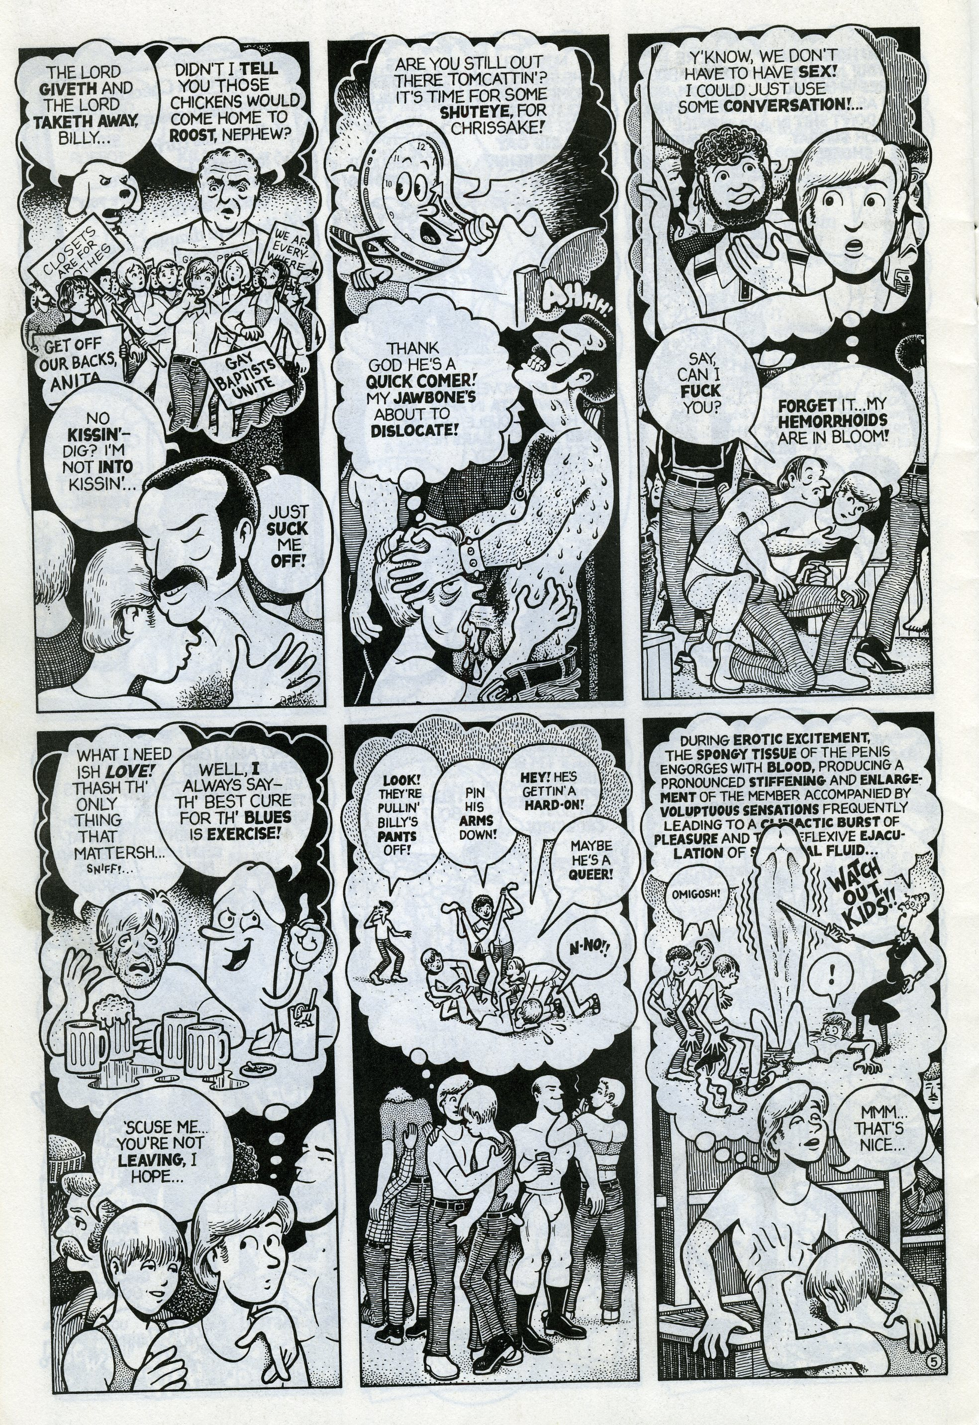
Fig. 11 – Howard Cruse, “Billy Goes Out.” No Straight Lines, 42.

Gay Comix no. 1 was published in 1980, and Cruse’s editorial policy stressed an emphasis on the personal, rather than political agendas: “I didn’t want Gay Comix to just be a propaganda piece for the gay movement” (Cruse 2008). The majority of stories in this early era of Gay Comix (issues 1-4, published between 1980 and 1983) contrast with the majority of cartoons and strips published in gay newspapers and magazines at the same time, and for the most part they explore more difficult subjects that divided the lesbian and gay community.
Lesbian cartoonists like Alison Bechdel and Jennifer Camper, who had comics published in the early era of Gay Comix, addressed a range of issues relating to gender, ethnicity and class in their work. Gay male cartoonists also addressed contentious issues within the gay male community. Burton Clarke’s “Cy Ross and the S.Q. Syndrome” from Gay Comix no. 1, published in 1980, told the story of a gay black man’s
internalized racism. Vaughn Frick’s Watch Out strips satirized San Francisco gay politics, questioning assimilationist gay attitudes. Howard Cruse’s story “Billy Goes Out” from Gay Comix no. 1 is a complex depiction of a young man’s loneliness on the commercial gay scene, which offers little more than casual encounters (Fig. 11), while his story “Dirty Old Lovers” from Gay Comix no. 3 (1982) is critical of the tendency for certain gay groups to promote a conservative notion of “positive role models” for the gay community.
Gay cartoonists also appeared in Britain throughout the 1980s, and can be considered as part of the First Wave. Between 1986 and 1987, cartoonist Don Melia published six issues of the gay superhero comic Matt Black in collaboration with his former long-term partner Lionel Gracey-Whitman. The most prominent British gay male cartoonist, however, was probably David Shenton; his lesbian equivalent was Kate Charlesworth. Between 1978 and 1981 Charlesworth drew cartoons for Gay News, before going on to produce comic strips for The Pink Paper in the late 80s and early-to-mid 1990s. Shenton’s work began to appear in Gay News in 1981, and later in Him and Capital Gay. Between them, Charlesworth and Shenton documented shifts in British lesbian and gay culture and politics throughout the 1980s and into the 1990s; surprisingly, neither appeared in American anthologies like Gay Comix, and no British equivalent to Gay Comix was attempted until the 1990s.
The early issues of Gay Comix can be seen, in some ways, as precursors to the queer alternative comics that would emerge in the early 1990s, with an emphasis on personal experience, autobiographical stories, and critiques of gay culture. The tone of Gay Comix changed significantly, however, with the arrival of Triptow as editor with no. 5. As Triptow himself notes, the HIV/AIDS epidemic had a huge impact on his editorial policy (Triptow 2008).
In the summer of 1981, an article appeared in the New York Times headlined “Rare cancer seen in 41 homosexuals”: doctors in New York City and Los Angeles reported the first manifestations of unexplainable sickness and death among gay men (Weeks 1985: 46). The mysterious illness was originally termed GRID (Gay Related Immunodeficiency) but re-named AIDS (Acquired Immune Deficiency Syndrome) in 1982 (Weeks 1985: 46), and by mid-decade was linked to a previously unknown retrovirus – HIV (Human Immunodeficiency Virus) (Weeks 1990: 245).
In Britain, Don Melia responded to the AIDS pandemic by compiling the first HIV/AIDS benefit comic, Strip AIDS in 1987. American cartoonists Trina Robbins, Robert Triptow and Bill Sienkiewicz edited an American version, Strip AIDS USA (1988). In 1988, heterosexual British comics writer Alan Moore formed Mad Love, his own publishing company, to release an anthology entitled AARGH! (Artists Against Rampant Government Homophobia) and raise funds to fight Clause 28, a British law designed to outlaw the promotion of homosexuality by local authorities.
Triptow took over editing Gay Comix in 1984, “right around the time that AIDS had been making its first major impact and the party had ended” (Triptow, 2008). He remembers the mid-1980s as “one of the worst periods of my life, because everyone I knew was dying” (Triptow 2008). He wanted to present stories that “challenged orthodox thinking” within the gay community, but also to “try to humanize us in the middle of discrimination and disease” (Triptow 2008). Around the same time that Triptow took over as editor of Gay Comix, Dennis Kitchen encountered financial problems, leading to Bob Ross of San Francisco’s Bay Area Reporter taking over as publisher from Kitchen with no. 6 (Triptow 2008).
Triptow himself produced stories comparable to the more subversive, Cruse-edited era of Gay Comix, including “I Know You Are But What Am I?” – a moving story about a gay child growing up in a reactionary environment (Fig. 12). However, his editorial policy – that emphasized humour - meant that Gay Comix started to feature more light-hearted gay ghetto comics, sometimes reprinted directly from community newspapers, which tended to affirm rather than critique mainstream gay culture. This, combined with Bob Ross’s assumption of publishing duties, contributed to a sense of the “mainstreaming” of Gay Comix. When Ross replaced Kitchen as publisher, in Bourdieu’s terms, Gay Comix began to move toward the heteronomous pole of the gay comics field, joining the cartoons and strips published in the commercial gay press and becoming similar to them. Reflecting this new more commercial position, as Jennequin (2008) notes, Gay Comix as a whole became less critical of mainstream gay culture, its commercialization, its focus on youth and physical “perfection,” and its reproduction of other inequalities within heterosexual society. The series went on hiatus after the publication of its twelfth issue in 1988, due to editor Triptow’s ill health, and difficulties with the publisher (Triptow 2008).

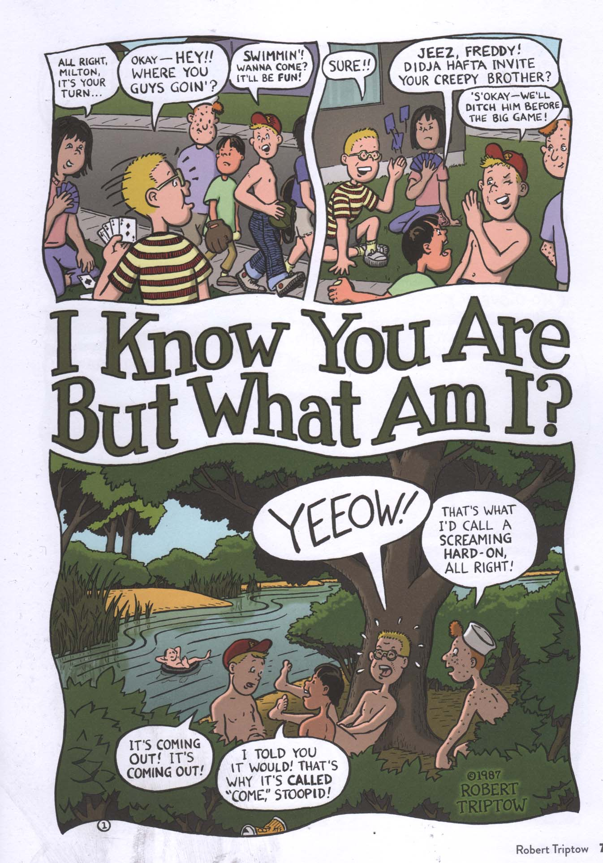

Fig. 12 – Robert Triptow, “I Know You Are But What Am I?” No Straight Lines, 75.

However, between 1980 and 1989, Gay Comix was the most prominent American anthology devoted solely to LGBT-themed comics by LGBT-identified creators; the only other publications to feature comics were LGBT magazines and newspapers, which typically featured just one or two strips per issue. In 1986, Gay Comix was joined by Meatmen, an anthology published by Winston Leyland, which was published annually in the late 1980s and throughout the 1990s, even after Gay Comix went on hiatus in 1989. The anthology predominantly featured examples of the gay porno genre, including re-prints of Tom of Finland’s sequential narratives, as well as work by The Hun, Sean, Stephen, and so on. The six volumes of Meatmen printed in the late 1980s tend to mainly include reprints rather than original material; later volumes, published throughout the 2000s featured more original work. Together, Gay Comix and Meatmen
virtually defined the field of gay male comics in the late 1980s. Therefore, it was these comics that the emerging creators of gay male comics would look to inspiration in the 1990s, to different degrees emulating them, or seeking to break with their conventions.

The Second Wave

By the early 1990s, however, a Second Wave of LGBT cartoonists was beginning to emerge. Some of these cartoonists continued the traditions of the gay ghetto and gay porno comics. More mainstream gay ghetto comics produced at this time included syndicated strips such as Eric Orner’s The Mostly Unfabulous Social Life of Ethan Green (1992), and Joe Phillips’s Joe Boy comics, which appeared in the youth-oriented gay publication XY Magazine in the late 1990s.
Meatmen continued to be published, and in the 1990s included more original comics by newer creators: Reprints of the iconic work of Tom of Finland, Etienne, Sean, and The Hun were joined by original work by the likes of Jon Macy, whose surreal erotic fantasies were based on folklore and fairytales, and the British writer/artist team of Howard Stangroom and Stephen Lowther, whose humorous and titillating comics tended to be based on science fiction.
After going on hiatus, Gay Comix reappeared with no. 13 (Summer 1991). Andy Mangels was approached by Bob Ross to serve as the anthology’s new editor, and quickly changed the title to Gay Comics, adjusting the spelling to distance the anthology from the underground and to reinforce its association with the mainstream; as he put it in his editorial in the 25th and final issue of Gay Comics, “Comix with an ‘x’ in the title always denoted an underground comic series, and . . . that reminded me of that segregated section in which I first saw Gay Comix” (Mangels 1998: 40). Under Mangels’ editorship Gay Comics became a more mainstream property, featuring heroic fantasy and depictions of gay ghetto life. Mangels also instituted a 50/50 ratio of male and female contributors, and attempted to broaden the series’ appeal, initiating crossovers with more popular series such as Image Comics’ superhero series The Maxx and the (mainly heterosexual) erotic series Omaha the Cat Dancer. Mangels’ efforts “were rewarded by a higher profile for the series” (Stangroom 2003: 46) but in 1998 he ended the series with an “80-page super spectacular” 25th issue, choosing to concentrate instead on his mainstream comics writing career.
In the United Kingdom, Don Melia began publishing Buddies in 1991, intended to be a British version of Gay Comix. Melia died of AIDS in 1992 and editorship passed briefly to Bob Lynch with the third issue and then to Howard Stangroom with the fourth. The sixth and final issue came out in 1999. Two British all-lesbian anthologies were also attempted - Bosom Buddies (1992) and Dyke’s Delight (1993) - but both were short-lived.
Throughout the 1990s, many First Wave gay cartoonists found it increasingly difficult to find venues for publishing their work. Robert Triptow (2008) suggests that he and other older cartoonists were perhaps considered “too underground” or dated for the new Gay Comics, or for the new gay glossy magazines that emerged during the 1990s. Others found the rates-per-page that gay magazines were willing to pay for comic strips to be unacceptable with the rising cost of living: Howard Cruse, for example, decided to end Wendel in 1989 because The Advocate were not able to agree to an increase to his per-episode rate at contract renewal time (Cruse 2008). Cruse spent the first half of the 1990s creating Stuck Rubber Baby, a 210-page graphic novel which was published by DC’s Paradox Press in 1995, and is one of Cruse’s most complex works. It tells the story of Toland Polk, a white gay man growing up in the American South in the 1960s and confronting his own same-sex desires, the racism experienced by his black friends, and the consequences of fathering a child.
Other, newer gay cartoonists, however, did not want very much to do with the mainstream, whether gay or straight. Disenfranchised from mainstream gay culture and emboldened by the rise of alternative comics and queer zine culture, these “alternative” gay cartoonists began to create comics that were less interested in affirming the gay community and more focused on their own idiosyncratic preoccupations (for a more in-depth discussion of queer zine culture see Spencer 2005). These gay – or queer - alternative cartoonists did not necessarily seek or desire incorporation into the mainstream. Some were influenced by the cartoonists featured in the early Gay Comix; others were relatively unaware of the gay cartoonists of the 1970s and 1980s, having only been exposed to the work of a few of them in LGBT newspapers.
Their comics appeared in some early queer zines, which sometimes featured cartoons and comics. G.B. Jones and Bruce LaBruce’s seminal JDs (1985-1991), for example, featured early work by lesbian cartoonist Carrie McNinch, and Tony Arena’s first Anonymous Boy cartoons. Other influential queer zines soon appeared, including the San Francisco-based Homocore (1988) and the Minneapolis-based Holy Titclamps (1989), which led to a veritable “explosion” of queer zine publishing in the early 1990s – indeed Holy Titclamps’ editor Larry-bob Roberts soon began publishing a listings zine titled Queer Zine Explosion to document this small but significant burst of creative production. Holy Titclamps was primarily a literary zine, but also featured comics, including the satirical cartoons of Nick Leonard, and later, a couple of my own autobiographical comics. Comics by McNinch, Arena, Leonard, and myself can be seen as among the first in what I call the “Second Wave” of LGBT comics and creators. The cartoonist Andrea Natalie founded the Lesbian Cartoonists Network in 1990 “to encourage support and communication between lesbian cartoonists” (Warren 1995: 152).
Both the “queer zine explosion” and the Lesbian Cartoonists Network were also a strong influence on a gay male, Minneapolis-based cartoonist, Robert Kirby, who was inspired to self-publish his own comic, Strange Looking Exile, subtitled “the all-cartoon zine for queer dudes and babes.” Kirby published five issues of SLE between 1991 and 1994, and followed it up in 1994 with a new comics anthology, Boy Trouble, focused on queer male cartoonists (for a more detailed account of Kirby’s career as an editor and cartoonist see Shamsavari 2017: 108-9). In contrast to the pornographic narratives in Meatmen and the more mainstream representations in Gay Comics, Kirby’s Boy Trouble focused on queer nerds and misfits. For the most part Boy Trouble eschewed idealized erotica in favour of autobiography, representing queer lives on the peripheries of the gay mainstream: “I was more inspired by the underground scene,” as he says, “by punks and upstarts and introverted alterna-people” (Kirby 2008a).
The 1990s had seen the emergence of the gay market, with gay and lesbian consumers being targeted both by “heterosexual,” and gay and lesbian advertisers. Gay magazines changed during this period, becoming more commercial or “heteronomous” to use Bourdieu’s phrase. The advertising and editorial content of these magazines promoted the idea of a unified gay community while at the same time only representing certain “desirable” and marketable kinds of LGBT identities (Sender 2004). It is argued that these marketable identities – which are usually white and middle-class – come to “stand in” for the whole LGBT community in the media, and “eras[ing] both the real diversity and the political potential of queer lives” (Sender 2004: 173).
The alternative comics by queer male artists that emerged throughout the 1990s generally stood in counterpoint to the glossy gay men’s magazines of the same decade. They include Jon Macy’s dark, surreal Tropo (1990-1992); Tony Arena’s punky, sexy Anonymous Boy Collections (1993-1999); and the comics of artists such as Michael Fahy, David Kelly, and Andy Hartzell, as well as my own autobiographical comic strips, which were published regularly in Robert Kirby’s Boy Trouble. Queer alternative comics like these represented a quiet challenge to the conformity of dominant gay culture, and subverting expectations, tended to criticise mainstream gay culture and focus instead on the intimate details of idiosyncratic, “alternative” gay lives rarely represented in the new gay glossies.
As I have described elsewhere (Shamsavari 2017), there are distinct differences between the gay male bodies presented in these comics and those presented in the earlier gay ghetto comics. Nick Leonard’s autobiographical comics, for example, tend to portray the life of a fat queer man and unashamedly celebrate his difference, resisting the conformity of more stereotypical representations of gay men as lean, musclebound hunks, and sometimes mocking the sexual ideals and stereotypes of the gay community. My own autobiographical comic strips – which I self-published at the age of seventeen in my own zine BoyCrazyBoy, and some of which were later published by Kirby in Boy Trouble – also dealt with anxieties around attractiveness, body image, and self-confidence from the viewpoint of a recently “out” gay teenager.
In Michael Fahy’s “Dumbass” (Fig. 13) the artist/writer portrays himself – a skinny, balding man – as a character with agency and desires that are at odds with the stereotypical gay male “gym body,” before going on to elaborate the kinds of men he does find attractive.
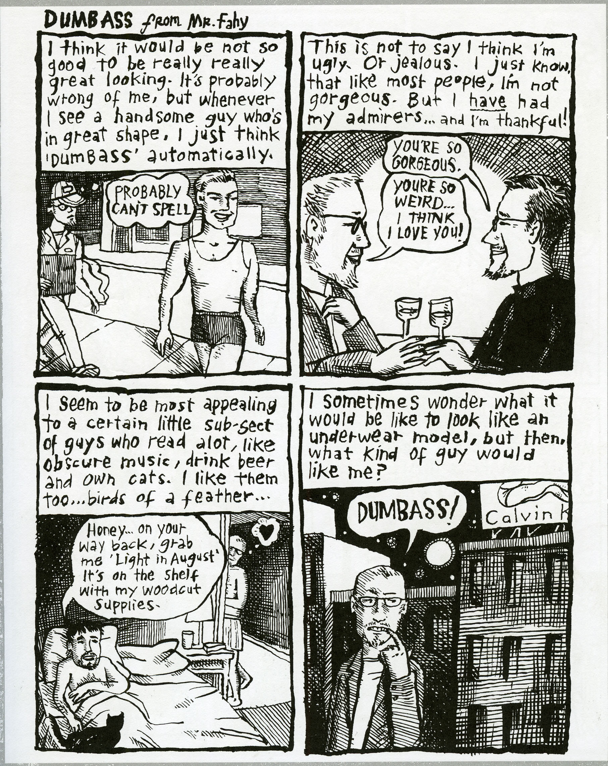
Fig. 13 –Michael Fahy, ‘Dumbass.’ The Book of Boy Trouble, p. 41.

The characters in Robert Kirby’s Curbside comics, too, represent a somewhat broader range of gay male “types,” and often reflect on body image, and the complex and confusing ways in which gay male beauty ideals impact their day-to-day lives. In one strip, for example, titled “Drew Steps Out” (Fig. 14), Kirby uses the character of Drew to address the complexity of gay men’s relationships with notions of beauty, sex, and confidence. Drew sees himself as skinny and unattractive in comparison to the idealized muscular men depicted surrounding him in the gay bar in this six-panel strip, and Kirby’s exploration of Drew’s feelings about his body, himself, and his relationship with sex can be seen as opening up a space in gay male culture – potentially - for more honest exploration and dialogue about these issues.

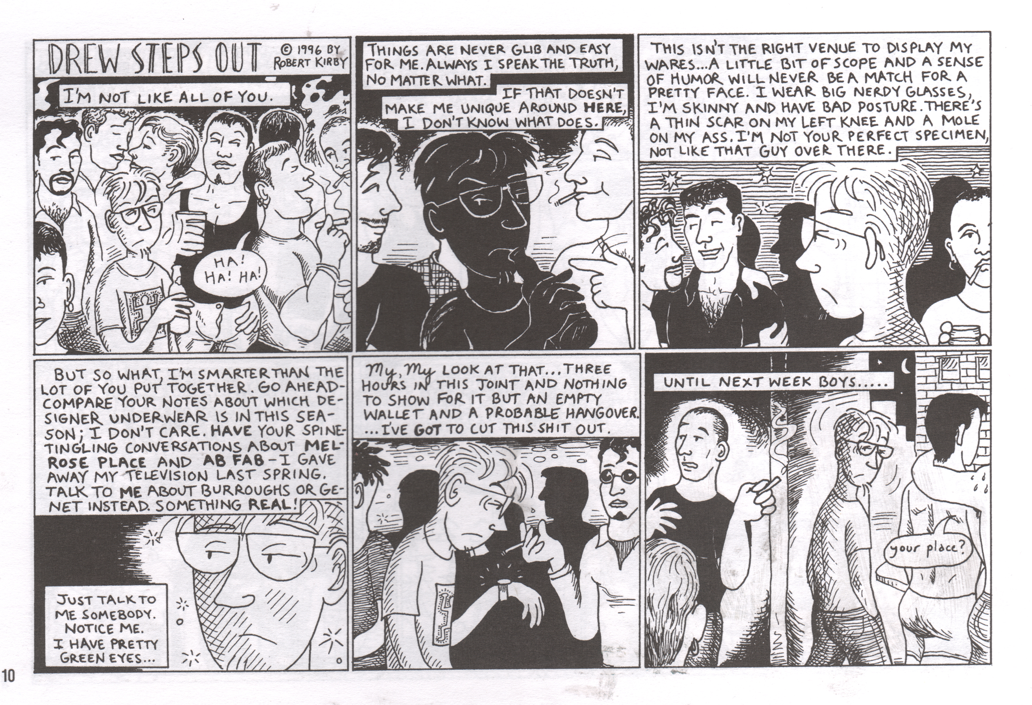

Fig. 14 – Robert Kirby, “Drew Steps Out.” Curbside Boys: The New York Years, 10.

The Third Wave

The first decade of the twenty-first century saw the emergence of a new Third Wave of LGBT comics production, but also less availability of venues for the publication of these comics in traditional print media. Gay Comics suspended publication with its twenty-fifth issue in 1998, after eighteen years; Meatmen suspended publication with its twenty-sixth volume in 2005; and the fifth and final issue of Boy Trouble came out in 2004 (though it was followed by two collections). In response to this paucity of venues for publication, many artists chose to publish online, and as Hall notes, in the new millennium more “easily accessibly computers and the Internet creat[ed] new possibilities of cheap publication, interactivity, and community” (Hall 2012: np). At the same time, many artists continued to self-publish print versions of their work instead of - or as well as - publishing online.
The Third Wave included cartoonists who carried on the traditions of conventional gay ghetto and gay porno comics, as well as artists who continued to challenge and subvert these genre conventions. More mainstream gay ghetto comics produced during the Third Wave included syndicated strips such as Glen Hanson and Allan Neuwirth’s Chelsea Boys (1998), Greg Fox’s Kyle’s Bed and Breakfast (1998), and Michael Derry’s Troy (1998), which continued well into the 21st century. These strips appeared nationally and internationally in gay newspapers and magazines, as well as on the Internet. The gay porno comics tradition was also continued in the Third Wave by artists like Patrick Fillion, who established his own company, Class Comics, to publish a range of homoerotic comics, mostly in the heroic fantasy genre, such as Naked Justice, about a well-endowed superhero, and Camili-Cat, about a felinoid sexual adventurer. Class Comics can be seen as serving the gap in the market left by Leyland’s Meatmen.
By the early 2000s, the Internet had become more important for promoting LGBT cartoonists and comics. In 2002 Tim Fish began publishing Cavalcade of Boys, a nine-issue soap opera exploring the lives of a group of friends, lovers and enemies in a California gay ghetto. Between 2002 and 2006 Fish also edited the online gay romance comic anthology, Young Bottoms in Love, which ran for six “online” volumes at PopImage.com. During its run Young Bottoms featured the work of over fifty comics creators, many of them emerging talent; the last strip was written and drawn by the legendary Howard Cruse.
In 2003 a number of comics fans and professionals from across the US – including Zan Christiansen and Gay Comics’ last editor Andy Mangels - decided to form a nonprofit organization to support and promote LGBT comics, creators, and readers. The organization, named Prism, runs an expansive website and publish the annual resource guide, Prism Comics: Your LGBT Guide to Comics, and is an important force for maintaining the visibility LGBT people within the mainstream comics industry (Marvel, DC, Image and the like) and for promoting the work of LGBT self-publishers. A number of self-published gay comics strongly associated with Prism focused on heroic fantasy as a theme: Brian Andersen’s So Super Duper (2007) was a charming superhero spoof featuring a young, campy gay character; Tommy Roddy’s Pride High (2006) was a more serious take on the theme of LGBT superheroes in high school, which also emphasized racial diversity, and was inspired by mainstream superhero series such as DC Comics’ The New Teen Titans and Marvel’s The New Mutants. Later, in 2011, Zan Christiansen founded Northwest Press, a publishing company dedicated to LGBT-themed comics by LGBT creators.
A new, Third Wave of more alternative queer male cartoonists also emerged in the early 2000s. Many of their concerns were in line with the personal slice-of-life stories favoured by a lot of the 1990s cartoonists associated with Boy Trouble, often telling the stories of punky, alternative queer men. They included Matt Fagan’s Love (2002) which focused on the relationship between two disenfranchised young gay men outside of the mainstream scene; Rio Safari’s Homobodies (2007) which offered slice-of-life vignettes of geeky, vegetarian, anarchist queer boys in love and lust; and Matt Runkle’s mainly autobiographical Runx Tales (2008). Ed Luce’s Wuvable Oaf (2008) chronicled the large, intimidating-looking but soft-hearted title character’s search for cute, smaller men in San Francisco; beginning as a self-published comic, it was later picked up by Fantagraphics who have so far published two collected editions. Craig Bostick’s Crash: The Life and Death of a Germ told the story of closeted LA punk singer Darby Crash, and his short strips in later issues of Boy Trouble explore the lives of gay boys immersed in suburban indie/punk scenes. These comics tended to extend the portrayal of unconventional gay men in a similar way to earlier creators such as Kirby,
A wider range of comics that played with the conventions of the gay porno genre also appeared throughout the 2000s, including BiL Sherman’s surreal and erotic series Wanky Comics (2002), Steve MacIsaac’s series Shirtlifter (2006), Brad Rader’s graphic novel Harry and Dickless Tom (2006), and Justin Hall and Dave Davenport’s anthology Hard to Swallow (no. 1-4 published from 2006-2008). Second Wave cartoonist Jon Macy, who had been inactive for many years, also published new erotic work: the graphic novels Teleny and Camille (2010) – based on the Victorian erotic novel Teleny (1893), attributed to Oscar Wilde and his literary circle - and Fearful Hunter (2014), which tells the story of a love affair between a werewolf and a trainee druid.
To some extent these Third Wave gay porno comics broaden out the representation of gay male bodies, idealizing older and hairier gay male body types (“bears”) that in earlier decades had tended to be overlooked and marginalized. That being said, by the first decade of the 21st century the “bear” look had arguably become much more acceptable in the gay mainstream than previously. However, the Third Wave gay porno comics mentioned here also tended to emphasize the emotional aspects of sex in ways that earlier gay pornographic comics published in Meatmen had tended not to, and portray sex in the context of complex emotional interrelationships, and/or use sex as a metaphor to explore the complexities of identity.
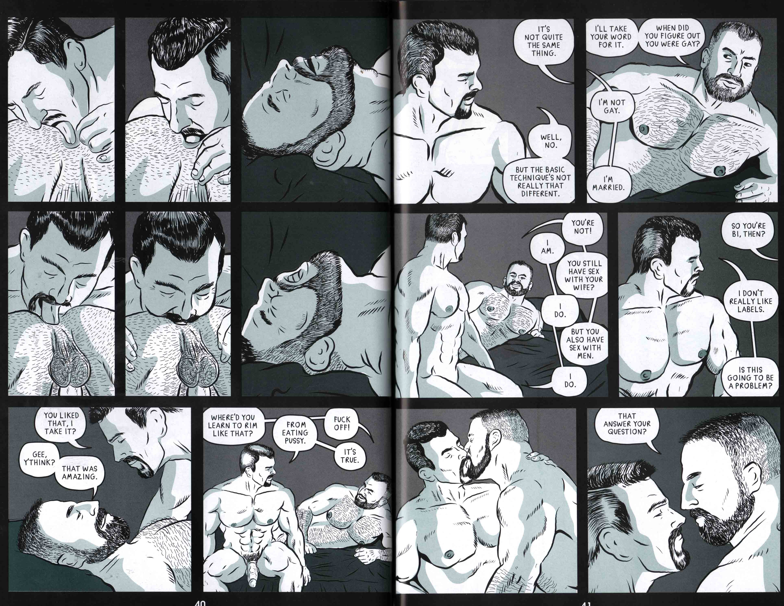
Fig. 15 – Steve MacIsaac, “Unpacking.” Shirtlifter no. 3, 40-41.
Steve MacIsaac’s series Shirtlifter, for example, includes stories that take up the conventions of gay porno comics – explicit sex and idealized bodies – but in the context of complex stories of human interaction and relationships, where situations prompt characters to reflect on identity and sexuality. MacIsaac’s story “Unpacking,” serialized in Shirtlifter, explores the developing relationship between Matt, an openly gay man, and Connor, a man who views himself as heterosexual and holds many homophobic and gender-normative opinions. One scene from “Unpacking” (Fig. 15) begins by showing a sexual act explicitly, according to the conventions of pornography, but then disrupts these conventions by depicting Matt and Connor’s rather combative discussion about the fact that Connor is married to a woman, and refuses to identify as gay or bisexual.

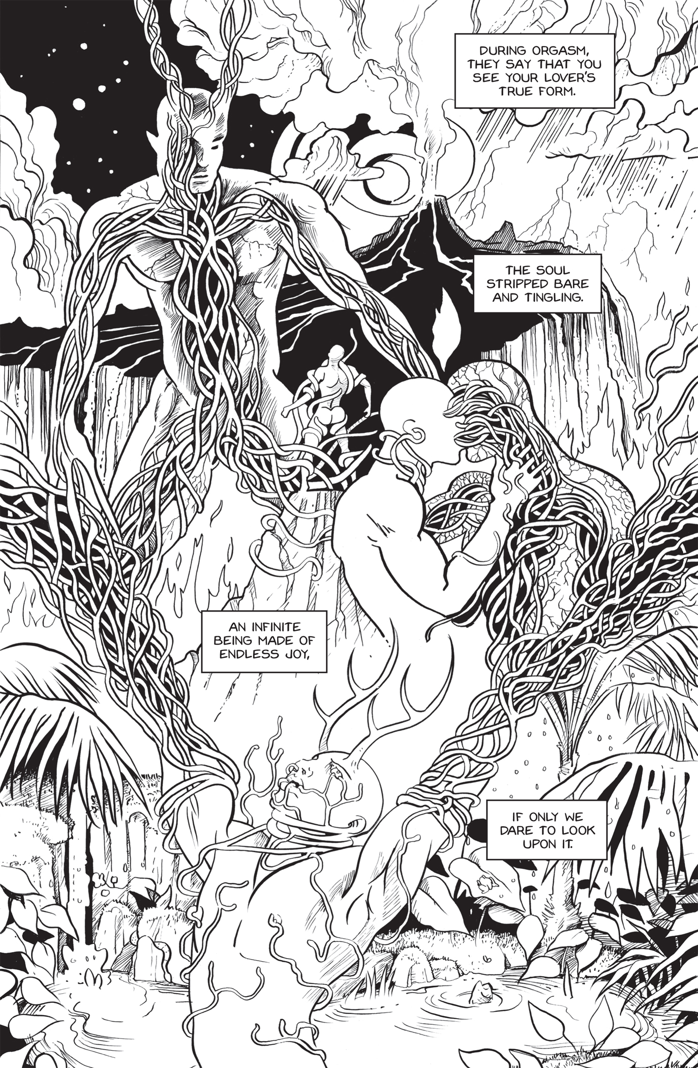
Fig. 16 – Jon Macy, Fearful Hunter, 105.

The complexity of sexual identity shown in MacIsaac’s Shirtlifter is explored in a very different way in the erotic scenes in Jon Macy’s Fearful Hunter, in which humans are shown having sex with gods. Although an artist who began working as part of the Second Wave, Macy’s Fearful Hunter was published during the Third Wave and shares many concerns with other Third Wave artists like MacIsaac who use the ropes of pornography but subvert and push them in unexpected directions. In one scene from Fearful Hunter, for example, when trainee druid Oisin has sex with the gigantic Horned God Anuid, he experiences a vision where he sees himself invaded by the God’s nervous system. The tentacle-like nerves of the God wrap around Oisin’s neck, arms and legs, but also penetrate his eyes, nostrils and mouth, going much further than the conventional representations of gay sex in more traditional gay porno comics. Sex is shown as disrupting the stable boundaries of the body, and on one page (Fig. 16), Macy goes as far as disrupting the traditional breakdown of the comics page completely, getting rid of panel borders and gutters. The different moments of Oisin’s encounter with Anuid are scattered across the page, happening not in physical reality but on a cosmic or spiritual level, with clouds, volcanic ash, plant-life, and the God’s nerves drawn spreading to the edges of the page. Macy’s exclusion of the devices that normally separate the moments in a comics narrative – panels and gutters – helps to create and emphasize the feeling that there is now little or no separation between the druid Oisin, the god Anuid, and the natural world itself. In his gay pornographic comics, Macy portrays sex as terrifying, but also as a force that runs through all of life, connecting and transforming a variety of beings, emphasizing the complexity of identity.
Many of the aforementioned artists, as well as others, have appeared in the anthology Boy Trouble, which Robert Kirby and his editorial partner David Kelly continued to publish semi-regularly into the 21st century. The fifth and final issue was released in 2004, on the tenth anniversary of the title’s inauguration, and a “best of” anthology, The Book of Boy Trouble, was released in 2006 by Green Candy Press. A new full-colour collection, The Book of Boy Trouble Vol. 2: Born to Trouble, was published in 2008; it featured female as well as male creators, and was also an intergenerational production, Kirby having invited both of Gay Comix’s original editors, Cruse and Triptow, to contribute autobiographical stories to the volume, along with Second Wave queer self-publishers and younger cartoonists. Similarly, in 2005 and 2007, Jennifer Camper edited two volumes of the multiple-gender queer anthology Juicy Mother, featuring a range of work by various generations of male and female queer cartoonists, from more established First Wave figures such as Howard Cruse and Alison Bechdel, to up-and-coming cartoonists like Carlo Quispe.
Kirby continued to edit anthologies such as the three-issue series THREE (2010-2012), which featured both solo stories and collaborations between different LGBT cartoonists, and QU33R (2014), a collection of 33 stories by LGBT cartoonists from all the different “waves” of queer cartooning. Macy has also recently edited an LGBT comics anthology titled Alphabet (2016), which similarly features a broad range of sexualities, genders, and generations. In contrast with many of the more traditional “gay ghetto” strips, and the more glossy erotic gay comics being published in the early 21st century, anthology series like Boy Trouble, THREE and Hard to Swallow, as well as books like QU33R and Alphabet, provide a platform for more alternative queer/gay male voices, often alongside a variety of other representatives of the LGBTQ spectrum.

Conclusion

This article has presented a detailed and nuanced history of the field of gay male comics. Following a lengthy “pre-Stonewall” period stretching from the late 1890s to the 1960s, gay male comics production can be seen to coalesce as a field in its own right in the mid-to-late 1960s. From the 1970s to the present day, the history of the field can be organized in terms of three successive “waves” of activity. The First Wave is roughly analogous to the 1970s and 1980s, while the two subsequent Waves are tied to the 1990s and 2000s respectively.
As I have shown, each of these waves of LGBT cartooning emerged within specific cultural, historical, political and theoretical contexts, which shaped the kinds of LGBT identities constructed within these comics. Political movements such as Gay Liberation and Lesbian feminism, and the queer cultural turn – as well as important historical events such as the Stonewall riots, the AIDS crisis, and the formation of commercialized gay urban enclaves or “gay villages” - have all had an impact on the kinds of stories being told in comics.
They have also had an impact on the kinds of venues available for the publication of LGBT comics – so for example, some of the earliest gay comic strips such as Harry Chess were published in the emerging gay press that was tied so strongly to Gay Liberation, while the comics more strongly associated with the more oppositional queer subcultures were often self-published in zines which took up a punky, cut-and-paste aesthetic. Most recently, the possibilities offered by online self-publishing have opened up the field of gay male comics production to an ever-wider spectrum of artists and writers sharing their – often personal and idiosyncratic - comics narratives via the Internet, along with more traditional forms of self-publishing.

Bibliography

Bechdel, Alison. 2009. The Essential Dykes to Watch Out For. London: Jonathan
Cape.

Bourdieu, Pierre. 1984. Distinction: A Social Critique of the Judgement of Taste,
Cambridge: Harvard University Press, 1984.

Bourdieu, Pierre. 1993. The Field of Cultural Production, Cambridge: Polity, 1993.

Byrne, John. “Frequently Asked Questions: Was NorthStar always intended
to be a gay character?” Available at <www.byrnerobotics.com>. Accessed 19th June, 2014.

Chasin, Alexandra. 2000. Selling Out: The Lesbian and Gay Movement Goes to
Market. New York: Palgrave, 2000.

Christensen, Charles “Zan”, ed. 2013. Anything That Loves: Comics Beyond “Gay”And “Straight.” Seattle, WA: Northwest Press.

Cooper, Dennis. 1996. “Queercore.” In The Material Queer: A LesBiGay Cultural
Studies Reader, edited by Donald Morten, pp. 292-296. Boulder, Colorado and Oxford: Westview Press.

Cruse, Howard. 1980. “Billy Goes Out.” In Gay Comix no. 1, edited by Howard Cruse, np. Princeton, WI: Kitchen Sink Press. Reprinted in No Straight Lines, edited by Justin Hall, pp. 38-44. Seattle, WA: Fantagraphics, 2012.

Cruse, Howard. 1982. “Dirty Old Lovers.” In Gay Comix no. 3, edited by Howard Cruse, np. Princeton, WI: Kitchen Sink Press.

Cruse, Howard. 1998. “Editor’s Notes.” In Gay Comics no. 25, edited by Andy Mangels, p. 3. San Francisco, CA: Bob Ross.

Cruse, Howard. From Headrack to Claude: Collected Gay Comix by Howard
Cruse. North Adams, MA: Nifty Kitsch Press, 2009.

Cruse, Howard, ed. Gay Comix no. 1–4. Princeton, WI: Kitchen Sink Press,
1980-1983.

Cruse, Howard. 1976. “Gravy on Gay.” In Barefootz Funnies no. 2, np. Princeton, WS: Kitchen Sink Press.

Cruse, Howard. Stuck Rubber Baby. New York: Paradox Press, 1995.

Cruse, Howard. 2001. Wendel All Together. Chicago, Illinois: Olmstead Press.

Cvetkovich, Ann. 2003. An Archive of Feelings: Trauma, Sexuality, and Lesbian
Public Cultures. Durham: Duke University Press.

Delano, Debbie, and Phyllis Moore, eds. 1988. AARGH! Northampton: Mad Love.

Donelan, Gerard P. 1987. Donelan’s Back. Los Angeles, CA: Liberation Publications.

Donelan, Gerard P. 1987. Drawing on the Gay Experience: Cartoons from The
Advocate. Los Angeles, CA: Liberation Publications.

Du Plessis, Michael, and Kathleen Chapman. 1997. “Queercore: The Distinct
Identities of Subculture.” In College Literature 24, no. 1, pp. 45-58.

Duncombe, Stephen. 1997. Notes from Underground: Zines and the Politics of
Alternative Culture. London and New York: Verso.

Dyer, Richard. 1991. “Believing in Fairies.” In Inside/Out: Lesbian Theories, Gay
Theories, edited by Diana Fuss, 185-201. New York: Routledge.

Dyer, Richard. 2000. “Coming To Terms.” In Only Entertainment, Second Edition, pp. 138-150. London: Routledge.

Dyer, Richard. 2002. The Culture of Queers. London: Routledge.

Dyer, Richard. 2002. “Introduction.” In The Culture of Queers, pp. 1-14. London: Routledge.

Dyer, Richard. 2000 (first published 1992.) Only Entertainment, Second Edition. London: Routledge.

Edwards, Tim. 2006. Cultures of Masculinity. London and New York: Routledge,
Edwards, Tim. 1994. Erotics & Politics: Gay Male Sexuality, Masculinity and
Feminism. London: Routledge.

Fahy, Michael. “Dumbass.” In Boy Trouble no. 4, edited by Robert Kirby and
David Kelly, np. Seattle, WA: DK Press, Fall 2000. Reprinted in The
Book of Boy Trouble, edited by Robert Kirby and David Kelly, p. 41. Sa Francisco, CA: Green Candy Press, 2006.

Fahy, Michael. Litany. Philadelphia, PA: Self-published, 1996.

Fahy, Michael. Ten Thousand Dreams Interpreted. Philadelphia, PA: Self
published, 2007.

Falkon, Felix Lance, and Thomas Waugh 2006 (first published 1972). Gay Art: A Historic Collection, Revised edition. Vancouver, BC: Arsenal Pulp Press

Fenster, Mark. 1993. “Queer Punk Fanzines: Identity, Community, and The
Articulation of Homosexuality and Hardcore.” In Journal of Communication Inquiry 17, no. 1, pp. 73–94.

Forster, E.M. 2005 (first published 1927). Aspects of the Novel. London: Penguin, 2005.

Foucault, Michel. 1972. The Archaeology of Knowledge. New York: Pantheon Books.

Foucault, Michel. “The Order of Discourse.” In Untying the Text: A Post
Structuralist Reader, edited by Robert Young, pp 48–78. Boston: Routledge & Kegan Paul.

Foucault, Michel. 1984. “Truth and Power,” interview with Alessandro Fontana
and Pasquale Pasquino. In The Foucault Reader: An Introduction to Foucault’s Thought, edited by Paul Rabinow, pp. 51–75. London: Penguin.

Foucault, Michel. 1981 (first published in 1978). The Will to Knowledge: The History of Sexuality, Vol. 1. Translated by Robert Hurley. Harmondsworth: Penguin.

Foucault, Michel. 1975. Discipline and Punish: The Birth of The Prison, London: Penguin Books.

Fuss, Diana, ed. 1991. Inside/Out: Lesbian Theories, Gay Theories. New York:
Routledge.

Fuss, Diana. 1991. “Introduction.” In Inside/Out: Lesbian Theories, Gay Theories, edited by Diana Fuss, pp. 1–10. London & New York: Routledge.

Gregory, Roberta. 1972. “A Modern Romance.” In Wimmen’s Comix no. 4, edited by the Wimmen’s Comix Collective, np. San Francisco, CA: Last Gasp, 1972.

Hall, Justin, ed. 2013. No Straight Lines: Four Decades of Queer Comics, Seattle, WA: Fantagraphics Books.

Hall, Justin, and Dave Davenport, eds.2006-2008. Hard To Swallow no. 1-4. San
Francisco and Los Angeles, CA: Marginalized Publications/All Thumbs Press.

Hall, Stuart. 1997. “The Spectacle of the Other.” In Representation: Cultural
Representations and Signifying Practices, edited by Stuart Hall, pp. 223-279, London: Sage.

Hanson, Glen, and Allan Neuwirth. 2003. Chelsea Boys. New York: Alyson Books.

Hatfield, Charles. 2005. Alternative Comics: An Emerging Literature. Jackson:
University Press of Mississippi.

Holmes, Rand. 1971. “The Continuing Adventures of Harold Hedd.” Georgia
Straight (underground newspaper), np. Reprinted in All Canadian Beaver Comix no. 1 91973), np. Canada: The Georgia Straight.

Horne, Peter and Reina Lewis, eds. 1996. Outlooks: Lesbian and Gay Sexualities and Visual Cultures. London and New York: Routledge.

Jenkins, Richard, 2002. Pierre Bourdieu, Revised edition. London: Routledge.

Jennequin, Jean-Paul. 2008. “Gay Comics USA: Entre Transgression et
Conformisme.” In Art & Fact no. 27, pp. 36-43.

Kirby, Robert, ed.1991-1992. Strange Looking Exile no. 1-3. Minneapolis, MN: Self-published.

Kirby, Robert, ed. 1992-1994. Strange Looking Exile no. 4-5. New Haven, CT: Giant Ass Publishing.

Kirby, Robert, ed. 1994. Boy Trouble no. 1. Minneapolis, MN: Self-published.

Kirby, Robert. 1998. Curbside. New York: Hobnob Press, 1998.

Kirby, Robert. 2002. Curbside Boys: The New York Years. Berkeley, CA: Cleis Press.

Kirby, Robert. 2003. “Gangs of New York” (Curbside), Instinct no. 55, p.76.

Kirby, Robert, ed. 2014. QU33R. Seattle, WA: Northwest Press.

Kirby, Robert, and David Kelly, eds. 1995-2004. Boy Trouble no. 2-5. Seattle, WA: DK Press.

Kirby, Robert, and David Kelly, eds. 2006. The Book of Boy Trouble. San Francisco, CA: Green Candy Press.

Kirby, Robert, and David Kelly, eds. 2008. The Book of Boy Trouble, Vol. 2. San
Francisco, CA: Green Candy Press.

Leonard, Nick. 1995. Ixnay!: A Crop of Nick.San Francisco, CA: Self-published,

Leyland, Winston, ed. 1986-2004. Meatmen, vol. 1–26. San Francisco, CA: GS
Press/Leyland Publications, 1986-2004.

Lopes, Paul. 2009. Demanding Respect: the Evolution of the American Comic Book. Philadelphia: Temple University Press.

Luce, Ed. 2008-2014. Wuvable Oaf no. 0–4. San Francisco, CA: Göteblud Press.

Lynch, Bob, ed. 1993. Buddies no. 3. London: Pretend Family Productions.

MacIsaac, Steve. 2006-2011. Shirtlifter no. 1–4. Los Angeles, CA.

MacIsaac, Steve. 2008. “Unpacking.” In Shirtlifter no. 3, pp. 1–16, 25–44, 65–88. Los Angeles: Drawn, Out Press.

Macy, Jon. 2014. Fearful Hunter. Seattle, WA: Northwest Press, 2014.

Macy, Jon. 2010. Teleny and Camille. Seattle, WA: Northwest Press, 2010.

Macy, Jon, ed. (2016), Alphabet, Seattle, WA: Northwest Press

Mangels, Andy, ed. 1991. Gay Comix no. 14. San Francisco, CA: Bob Ross.

Mangels, Andy, ed. 1992-1998. Gay Comics no. 15–25. San Francisco, CA: Bob Ross.

Mangels, Andy. 1992. “From the Editor.” In Gay Comics no. 15, edited by Andy
Mangels, np. San Francisco, CA: Bob Ross.

Mangels, Andy. 1998. “Editor’s Notes.” In Gay Comics no. 25, edited by Andy Mangels, p. 40. San Francisco, CA: Bob Ross.

Mangels, Andy. 1988a. “Out of the Closet and Into the Comics: Gays in Comics. The Creations and the Creators: Part II.” Amazing Heroes no. 144, pp. 47–66.

Mangels, Andy. 1988b. “Out of the Closet and Into the Comics: Gays in Comics. The Creations and the Creators: Part I.” Amazing Heroes no. 143, pp. 39–54.

McAllister, Matthew, Edward H. Sewell, Jr., and Ian Gordon, eds. 2001. Comics & Ideology. New York: Peter Lang.

McCloud, Scott. 1993. Understanding Comics: The Invisible Art. Princeton,
Wisconsin: Kitchen Sink Press.

Mercer, John. 2004. “In the Slammer: The Myth of the Prison in American Gay Pornographic Video.” In Eclectic Views on Gay Male Pornography: Pornucopia, edited by Todd G. Morrison, 151–166. Binghampton, NY: Harrington Park Press.

Mills, Jerry. 1986. “Introduction.” In Meatmen: An Anthology of Gay Male Comics, Vol. 1, edited by Winston Leyland, San Francisco: GS Press/Leyland Publications, pp. 7-14.

Mills, Jerry. 2012. “Poppers.” In No Straight Lines, edited by Justin Hall, Seattle, WA: Fantagraphics Books, pp. 53-55 and 96–97.

Moore, Patrick. 2004. Beyond Shame: Reclaiming the Abandoned History of Radical
Gay Sexuality. Boston: Beacon Press.

Morten, Donald, ed. 1996. The Material Queer: A LesBiGay Cultural Studies Reader.
Boulder, Colorado and Oxford: Westview Press.

Nixon, Sean. 1996. Hard Looks: Masculinities, Spectatorship, and Contemporary
Consumption. New York: St Martin’s Press.

Rechy, John. 1977. The Sexual Outlaw: A Documentary. London: W.H. Allen.

Robbins, Trina. 1999. From Girls to Grrrlz. San Francisco, CA: Chronicle.

Robbins, Trina. 1972. “Sandy Comes Out.” Wimmen’s Comix no. 1, np. San
Francisco, CA: Last Gasp. Reprinted in No Straight Lines, edited by
Justin Hall, pp. 5-7. Seattle, WA: Fantagraphics, 2012.

Robbins, Trina, Robert Triptow and Bill Siencowicz, eds. Strip AIDS USA. San
Francisco: Last Gasp, 1989.

Rosenkranz, Patrick. 2008. Rebel Visions: The Underground Comix Revolution, 1963-1975. Seattle: Fantagraphics Books.

Sabin, Roger. Adult Comics: An Introduction. London: Routledge, 1993.

Sabin, Roger, and Teal Triggs, eds. 2004. Below Critical Radar. Hove: Slab-O
Concrete.

Seidman, Steven. 1993. “Identity Politics in a ‘Postmodern’ Gay Culture.” In Fear of A Queer Planet: Queer Politics and Social Theory, edited by Michael
Warner, 105–142. Minneapolis: University of Minnesota Press.

Sender, Katherine. 2004. Business, Not Politics: The Making of the Gay Market, New York and Chichester: Columbia University Press.

Sewell, Jr., Edward H. 2001. “Queer Characters in Comic Strips.” In Comics & Ideology, edited by M. P. McAllister, E. H. Sewell, Jr., and I. Gordon, pp. 251-274. New York: Peter Lang.

Shamsavari, Sina. 2017. “Gay Ghetto comics and the alternative gay comics of Robert Kirby.” In Queer Studies in Media and Popular Culture, 2 (1), pp. 95-117.

Signorile, Michelangelo. 1997. Life Outside: The Signorile Report on Gay Men, New York: HarperCollins.

Smith, Matthew J. and Randy Duncan, eds. 2012. Critical Approaches to Comics: Theories and Methods. New York: Routledge.

Spencer, Amy. 2005. DIY: The Rise of Lo-Fi Culture, London: Marion Boyars.

Stangroom, Howard, ed. 1994-1996. Buddies no. 4–6. London: Pretend Family Productions.

Stangroom, Howard. 2003. “The Comic Book Closet.” In Comics Forum no. 26, pp. 44-50.

Stephen (Dom Orejudos). 1990. “Locker Room.” In Meatmen Vol. 7, edited by Winston Leyland, pp. 27–43. San Francisco: Leyland Publications.

Streitmatter, Rodger. 1995. Unspeakable: The Rise of the Lesbian and Gay Press in America. Boston and London: Faber and Faber.

Sullivan, Nikki. 2003. A Critical Introduction to Queer Theory. Edinburgh: Edinburgh University Press.

Thornton, Sarah. 1996. Club Cultures: Music, Media and Subcultural Capital, Middletown, CT: Wesleyan University Press.

Triptow, Robert, ed. 1984. Gay Comix no. 5. Princeton, WI: Kitchen Sink Press.

Triptow, Robert, ed. 1095-1988. Gay Comix no. 6–13. San Francisco, CA: Bob Ross.

Triptow, Robert. 1987. “I Know You Are But What Am I?” In Gay Comix no. 10, edited by Robert Triptow, np. San Francisco, CA: Bob Ross. Reprinted in No Straight Lines, edited by Justin Hall, pp. 75–81. Seattle, WA: Fantagraphics, 2012.

Triptow, Robert, ed. 1989. Gay Comics. New York: Plume, 1989.

Triptow, Robert. 1989. “Art + Humor = Liberation.” In Gay Comics, edited by
Robert Triptow, p. 4. New York: Plume.

Warner, Michael, ed. 1993. Fear of a Queer Planet: Queer Politics and Social Theory.
Minneapolis: University of Minnesota Press, 1993.

Waugh, Thomas. 1996. Hard to Imagine: Gay Male Eroticism in Photography and
Film from Their Beginnings to Stonewall. New York: Columbia University Press.

Waugh, Thomas. 2002. Out/Lines: Underground Gay Graphics from Before
Stonewall. Vancouver, BC: Arsenal Pulp Press.

Waugh, Thomas, with Willie Walker. 2004. Lust Unearthed: Vintage Gay Graphics From the DuBek Collection. Vancouver, BC: Arsenal Pulp Press.

Weeks, Jeffrey. 1985. Sexuality and its Discontents. London and New York:
Routledge.

Weeks, Jeffrey. 1990. Coming Out: Homosexual Politics in Britain from the
Nineteenth Century to the Present, Revised edition. London: Quartet.

Weeks, Jeffrey. 2010. Sexuality, 3rd edition. London and New York: Routledge.

Wimmen’s Comix Collective, eds. 1972-1985. Wimmen’s Comix no. 1–10, San Francisco, CA: Last Gasp.

Wings, Mary. 1973. Come Out Comix. Portland, OR: Self-published.

Wings, Mary. 1978. Dyke Shorts. Portland, OR: Self-published.

Witek, Josef. 2012. “Comics Modes.” In Critical Approaches to Comics: Theories and Methods, edited by Matthew J. Smith and Randy Duncan, pp. 27–42. New York: Routledge.

List of interviews

Cruse, Howard. 2008. Interview with Sina Shamsavari, North Adams, MA, August 27.

Kirby, Robert. 2008. Interview with S. Shamsavari, Minneapolis, MN, August 16.

Triptow, Robert. 2008. Interview with S. Shamsavari, San Francisco, CA, July 17.

Biography

Sina Shamsavari is a Lecturer in the Cultural & Historical Studies Department at London College of Fashion. He has completed his PhD. on the history of queer male comics at Kings College, London. He is also a cartoonist under the name “Sina Sparrow” and self-publishes the queer comic zine Art Fag as well as appearing in a number of anthologies including QU33R, No Straight Lines, The Comics Reader, and The Book of Boy Trouble volumes 1 and 2.

Postal Address

Sina Shamsavari
Flat 405, Lascar Wharf Builfding
21 Parnham Street
London E14 7FN

Email: sinasham@gmail.com

