When Art and Psychoanalysis Meet:
Critical Adventures Inside the Freud Museum London
Joanne Morra

To be published in Caliban. Journal of Latin American Psychoanalysis

Abstract: In this article, the author considers the extent to which site-responsive contemporary art can impact upon our understanding clinical psychoanalytic practice. In order to achieve this, the author asks: What are the effects of having contemporary art exhibited inside various museological spaces whose primary purpose is neither to house nor to exhibit it? Why place contemporary art in the Freud Museum London? Why engage with psychoanalysis? What is to be gained for the museums and for the history, practice, and theory of psychoanalysis? What becomes of the artworks, and our understanding of them?
The author concludes that the various affects of bringing together contemporary art and psychoanalysis is to provide us with a reciprocal alliance between these two practices that extend, critique, and disrupt one another.
Keywords: contemporary art, psychoanalysis, site-responsive art, shame, anxiety, affect, consulting room

What are the effects of having contemporary art exhibited inside various museological spaces whose primary purpose is neither to house nor to exhibit it? Why place contemporary art in the Freud Museum London? Why engage with psychoanalysis? What is to be gained for the museums and for the history, practice, and theory of psychoanalysis? What becomes of the artworks, and our understanding of them? These are some of the questions that I engage with in this article.
Over the past 50 years, we have seen contemporary art make its way into institutional spaces other than the white cube gallery. These spaces have included large-scale historical museums, personality museums, and small independent museums. The temporary exhibition of contemporary art in these spaces began in the 1960s and 1970s with various forms of institutional critique, conceptual art, performance art, and site-specific work, and has proliferated over the past two decades.
There has been some discussion of various individual artistic interventions or types of practice within these museological spaces, but it is only recently that a few scholars have provided a more general overview of this history offering a critical interrogation of this complicated phenomenon. From my point of view, there is something unique about the way in which contemporary art functions once it has entered these sites, and I call this ‘site-responsive’. The term is meant to offer us an understanding of the generative, sometimes critical, and definitely reciprocal nature of this form of art intervention. By this I mean that having contemporary art within a museum alters our understanding of the museum, and at the same time, the site impacts upon our interpretation of the artwork.

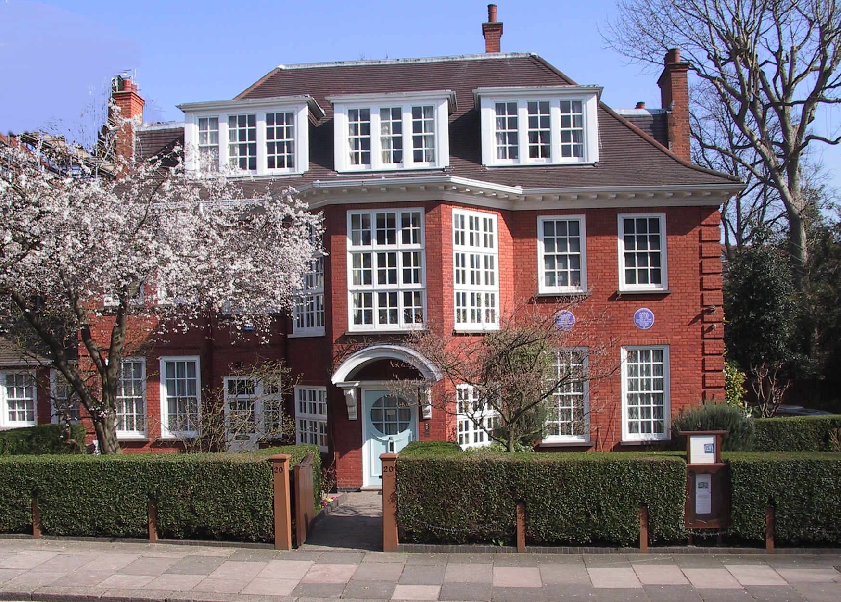
Exterior of the Freud Museum London
Courtesty of the Freud Museum London

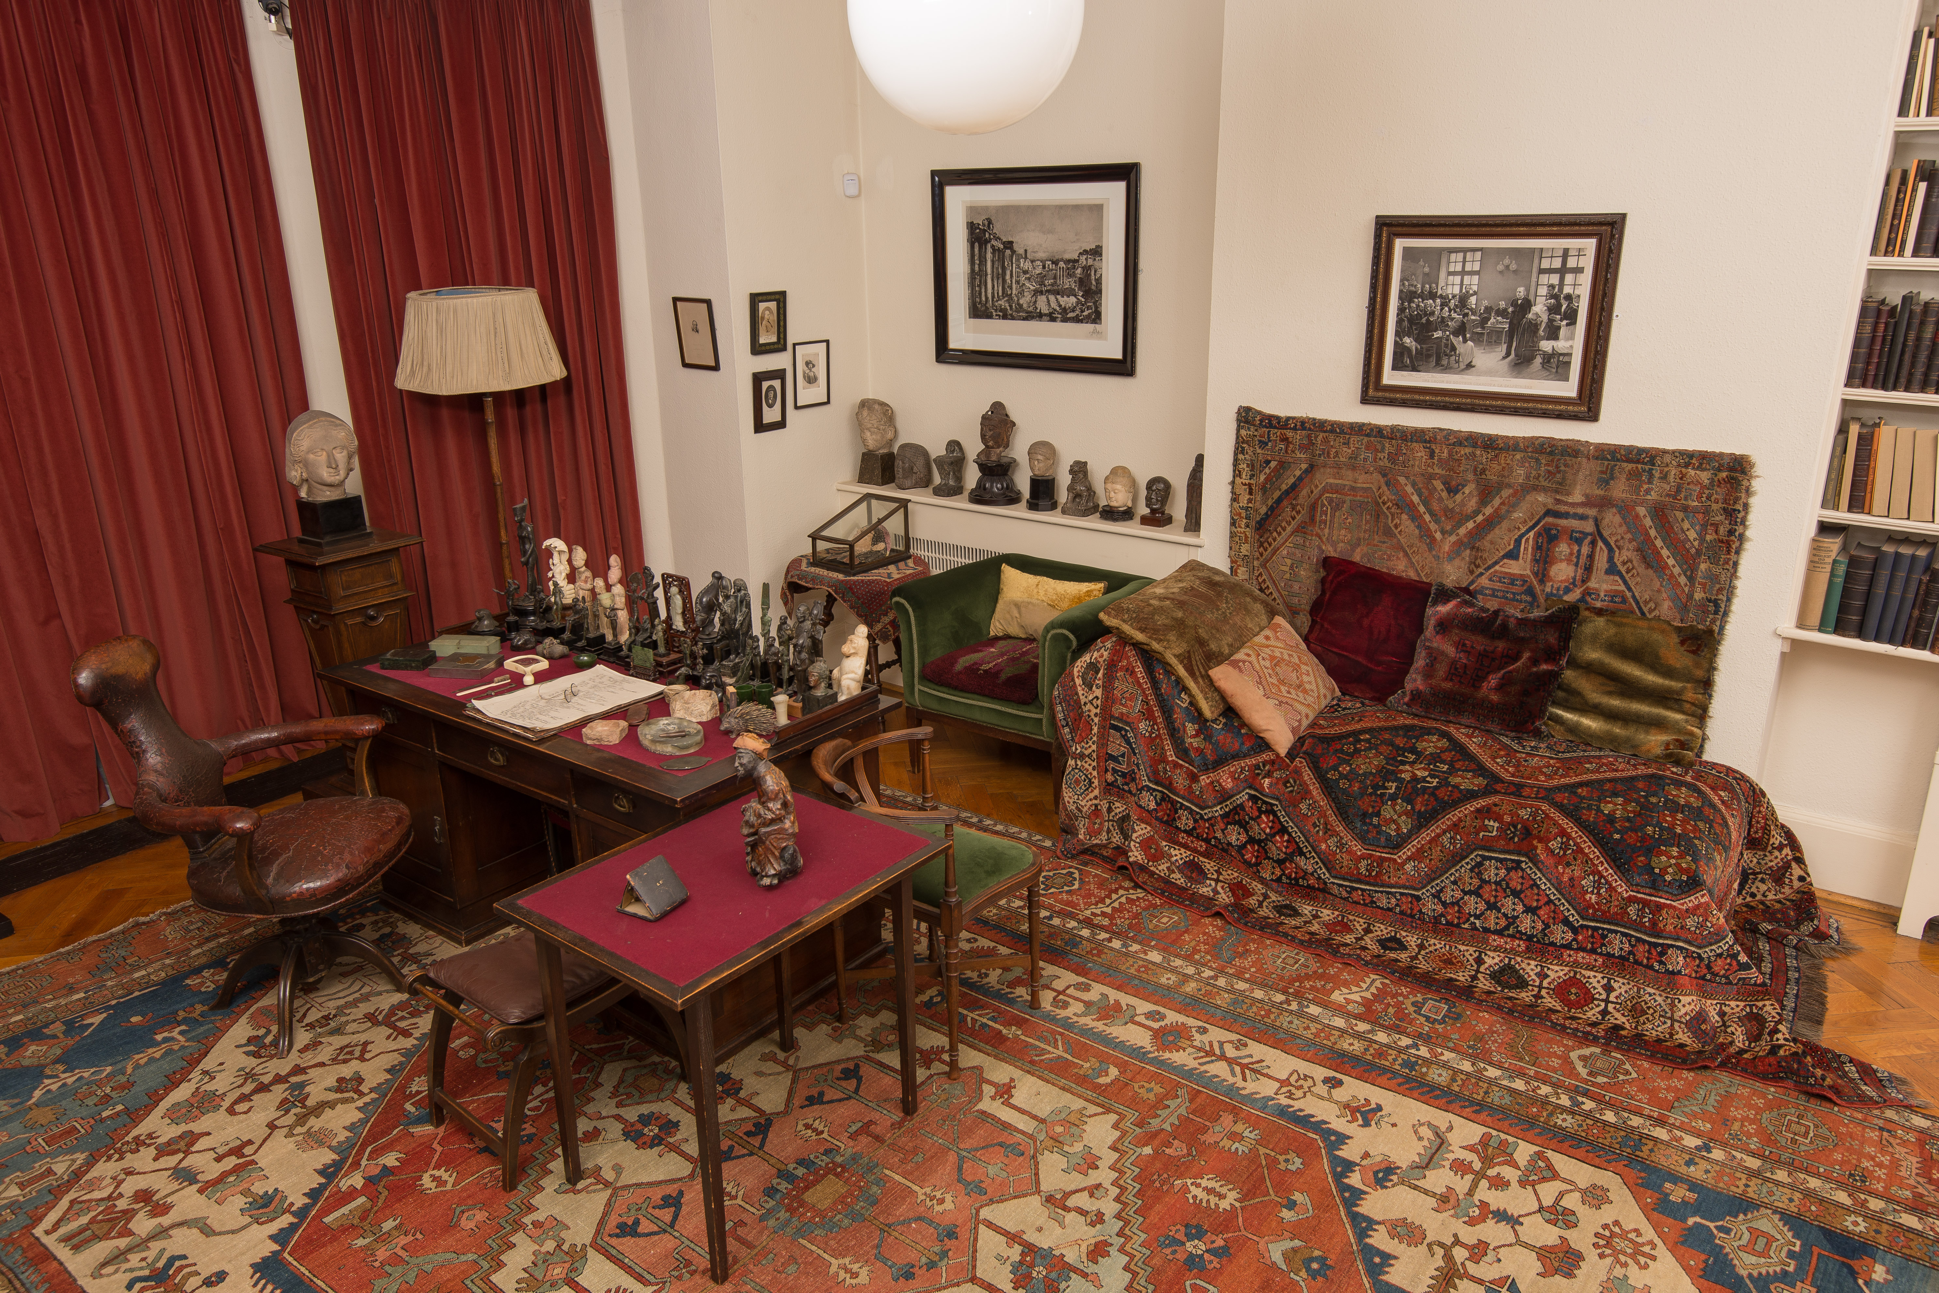
Freud’s Study at the Freud Museum London
Photographer: Ardon Bar Hama. Courtesy of Freud Museum London

With over 90 exhibitions spanning 30 years, the Freud Museum London, located at 20 Maresfield Gardens, leads the way in its acceptance, promotion and exhibition of contemporary art. The Freud Museum has hosted exhibitions by Santiago Borga, Louise Bourgeois, Sophie Calle, Mat Collishaw, Valie Export, Ellen Gallagher, Susan Hiller, and Sarah Lucas, to name just a few. In this article, I am interested in considering several exhibitions that are related specifically to psychoanalytic practice – to what happens in the consulting room. The consulting room forms the center stage of both psychoanalysis and 20 Maresfield Gardens, since in the latter we can enter into Freud’s final consulting room and study. At the same time, I will be considering exhibitions that have disturbed, extended or revealed something about the Freud Museum London, about the history, theory or practice of psychoanalysis, and how the site has responded to the artwork in productive ways. By interpreting these exhibitions, I hope to open up the more general questions with which I began this article, concerning the roles of contemporary art within the museum.

The Personality Museum
In order to understand the relationship between contemporary art and a museum such as the Freud Museum London it is helpful to consider a few general conditions that constitute the personality museum. The personality museum is a museum that is dedicated to the life and work of an individual. These spaces were very popular in the late 19th century, and experienced two resurgences, one in the 1940s and again since the 1970s. The Freud Museum London is a part of this contemporary resurgence having opened its doors to the public in 1986.
Like the Freud Museum, all personality museums are complex sites comprised of spaces, objects, and practices. The practices that constitute a personality museum range from the conservation and curation of the objects that were once owned and used by the individual who resided and worked there; a dedication to the individual’s cultural production and its dissemination; and as an embodiment of the various experiences, histories and memories associated with the site and its inhabitants.
Since the primary purpose of a personality museum is the conservation and curation of the objects within it, authenticity is key. One of the Freud Museum London’s most urgent provocations is to encourage its visitors to enter the psychoanalytic stage. To walk into the Museum and somehow at the same time walk into Sigmund’s and Anna Freud’s consulting rooms. As we know, the myth surrounding the Freud Museum is that Sigmund Freud’s consulting room and study have not been touched since his death in 1939. This is certainly a part of the Museum’s hagiographic power. Its ability to make us believe we are in an active, living consulting room, in which the psychoanalyst has momentarily stepped out, and as we wander around the room, we wait for the analyst to return. This makes psychoanalysis a very present experience in 20 Maresfield Gardens.
Sigmund Freud made a short cryptic observation about space that is helpful in thinking about the psychical conditions of the personality museum and the role played by the person who once inhabited the space and the visitor. In 1938, the year preceding Freud’s death, in exile from Nazi Vienna and living in Maresfield Gardens, Freud noted that ‘space may be the projection of the extension of the psychical apparatus. No other derivation is probable. […] Psyche is extended; knows nothing about it’. For Freud, space is constituted and imbued with the subject who resides within it. More precisely, the subject’s psychical apparatus is projected onto the space consciously as well as unconsciously. We constitute our space with our psychic life, as it constitutes us.
Many authors have commented upon the stillness of the museum’s setting, and the death of its objects. In thinking about this, we could elicit the aid of Theodor Adorno’s critique of museums, in which he called them ‘the family sepulchers of works of art’. Here, Adorno was taking issue with the way in which the museum preserves artworks as historical objects rather than works living in the present because they are stripped of their initial context, and the objects are in ‘the process of dying’. However, this condition is not irrevocable. Adorno also argued that the museum is essential as it is the place in which dying objects are to be encountered by a viewer, and through this encounter the objects become vital once more. Along with the viewer, I would like to suggest that contemporary art also enlivens, while also disrupting, the objects and spaces of the museum. By introducing site-responsive art into the personality museum, the museum’s fixed, ideological narratives can be interrupted and extended.

The Psychoanalytic Mise-en-Scène
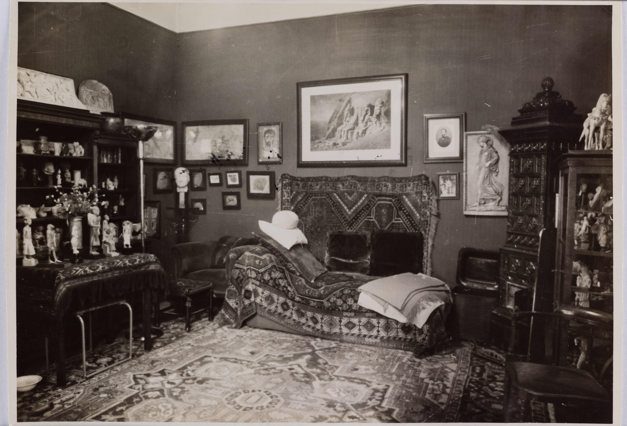
Freud’s consulting room at Berggasse 19, 1938
Photographer: Edmund Engelman. Courtesy of Freud Museum London

To this day, psychoanalytic practice takes place in the same distinctive setting that Freud invented over 125 years ago. To this extent the mise-en-scène that we find in 20 Maresfield Gardens is the exemplar for psychoanalysis today. Claudia Guderian’s exhibition The Magic of the Couch and Nick Cunard’s Head Space: Photographs of Psychotherapeutic Environments, both held at the Freud Museum London in 2004, confirmed for us the historical continuity of the consulting room through a series of photographs of psychoanalytic environments around the world. There is no mistaking the way in which the mise-en-scène that Freud conceived of in 1886 forms the basis for psychoanalytic and psychotherapeutic settings internationally. There is a striking resemblance between all of these settings: specifically, the positioning of the patient’s couch and the therapist’s chair.
As Guderian points out, interviewing the analysts whose consulting rooms she photographed, it was clear that ‘[m]odels – conscious or unconscious ones – were Sigmund Freud’s setting’. Perhaps this is the layout we know best because of its staging in the Freud Museum London, but, it might be that our image of Freud’s consulting room is actually a result of viewing the famous, detailed, black and white photographs taken by Edmund Engelman of Berggasse 19 in May 1938 just a couple of months before the Freud family left Vienna.
In having Guderian and Cunard’s photographs of contemporary consulting rooms in the Freud Museum London, the exhibitions’ site-responsive impact was a form of critical re-staging of Berggasse that demonstrated both the universality of the mise-en-scène of the consulting room, and how the set-up in 20 Maresfield Gardens always echoes back to Berggasse.
Thus, the photographs disrupt the originality of Maresfield Gardens, by pointing us to Berggasse, the place where Freud worked for almost 50 years, while at the same time, demonstrating that Maresfield Gardens is constituted by important historical accretions, that are vital to its history and power.

Saying It

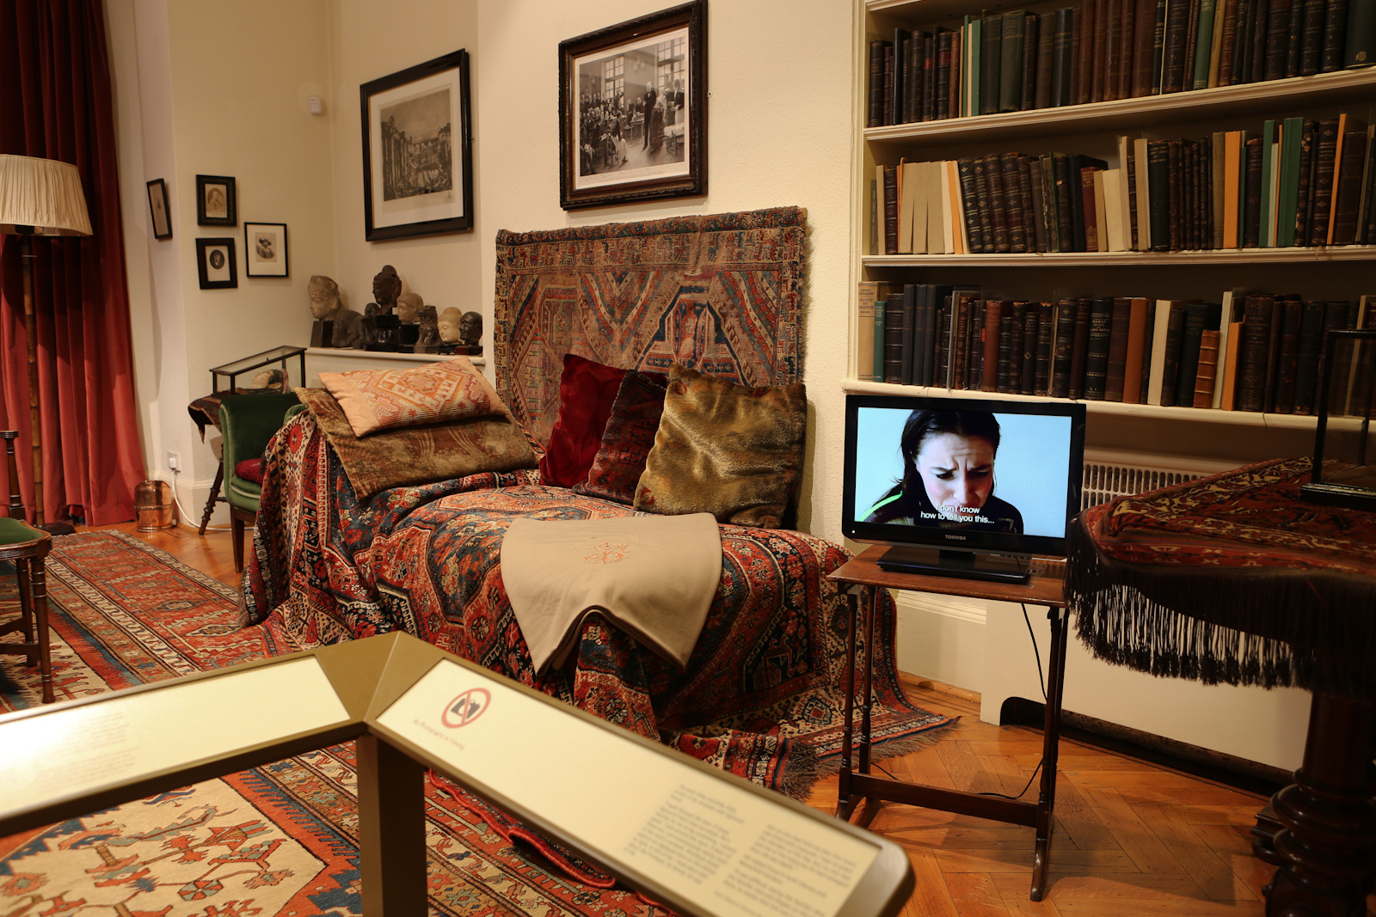
Mieke Bal & Michelle Williams Gamaker, Sissi in Analysis (2012), Saying It, Freud Museum London, 2012
Photographer Paul Kubalek, photo.kubalek.at

Staying inside the consulting room and the practices therein, I would like to focus on Freud’s recommendations for best practice within psychoanalytic treatment, and then move on to consider Mieke Bal & Michelle Williams Gamaker’s intervention Sissi in Analysis which considers a productive breach in the parameters set by Freud. Throughout his writings, Freud provided us with his recommendations for establishing and maintaining the mise-en-scène and processes that take place in the consulting room. We now call this the psychoanalytic setting or frame. The earliest use of the term ‘psychoanalytic setting’ was by the pediatrician and child psychoanalyst D.W. Winnicott in 1954 when he described it as ‘the summation of all the details of management’ that are vital to the progress of psychoanalysis because ‘it turns out in the end or even at the beginning that the setting and the maintenance of the setting are as important as the way one deals with material’. Here, Winnicott was extending Freud’s own work about psychoanalytic technique. Freud began drawing together his ideas on psychoanalytic technique in 1908 in an attempt to write a book on the subject, but in 1910 he abandoned it. Repeatedly referring thereafter to the idea of writing an opus on technique, he never did. Perhaps this was due to the fact that Freud’s views on psychoanalytic technique changed and developed over time. In fact, he often did not abide by his own advice to psychoanalysts, and altered aspects of the analytic setting to suit his patients and their needs. Having said that, Freud did publish a cluster of six essays between 1911 and 1915 in which he discussed some of the main technical aspects of his practice: the protocols for beginning a treatment; the analysand and analyst’s responsibilities; working through; dream interpretation; and transference. As a part of these recommendations, Freud was clear that psychoanalysis was not appropriate for psychotic patients. He believed that the a patient with psychosis would not be able to engage with the transference – the patient’s unconscious redirection of feelings from important figure’s in one’s childhood onto the analyst - because they could not maintain a sense of continuity between sessions that was the basis for working through the transference. Post-Freudian psychoanalytic thought and practice has challenged Freud’s ideas on the productive results of having psychotic patients enter psychoanalysis. The film installation entitled Sissi in Analysis by Bal and Williams Gamaker which was included the exhibition I curated at the Freud Museum London entitled Saying It (2012), forms an important critique of Freud’s thinking around psychoanalysis’ supposed lack of benefit for psychotic patients.
Sissi in Analysis is a 10-channel work that presented the individual case history of Sissi, an allegedly schizophrenic woman in her thirties, institutionalised since she was 18. Based on a real case history from psychoanalyst Françoise Davoine’s 1998 ‘theoretical fiction’ entitled Mère Folle, Sissi struggled to begin telling her story. Having been the victim of sexual abuse by her father, neglected and betrayed by her mother, and forced to have an abortion and hysterectomy by the medical establishment, in Sissi in Analysis the patient (played by actress Marja Skaffari), discontented with her treatment with Davoine, tries again with another psychoanalyst. This second treatment is a fiction, but it is based on the dialogue between Sissi and Davoine within Davoine’s book and her case notes.
The 10 sessions that constitute Sissi’s analysis, were exhibited around the Freud Museum, and did not follow a linear narrative. Rather the sessions responded to the way in which an analysis is non-linear: memories are remembered out of chronological order and intermingled with present-day events and emotions; and the installation invited each viewer to create his or her own travels through it. In viewing Sissi’s sessions, we were slowly given access to the gradual process of uncovering the cause of her traumatised state. Speaking face to face with her analyst, rather than lying down on a couch as Freud recommended, Sissi spoke of her desire to live ‘the life an artist… of a great queen’, in another session she remembered her sadness and confusion: ‘one day I went to Paris and had an abortion. They said I was pregnant, they didn’t tell me I was expecting a baby. It was taken out of my body, who had the right to decide?’ Showing both affection and hate towards her analyst, she concedes in a separate session that her analyst understands her so well, and then lashes out at her with anger. Abandoned by her mother who did not acknowledge Sissi’s abuse, Sissi could not reconcile her ongoing love for her mother, and this division between loving and hating her began the ‘war’ within Sissi. Sissi eventually had her moment of ‘saying it’. She spoke her traumatic memories. The session was appropriately placed next to Freud’s couch.
As I have mentioned, Freud had serious concerns about whether psychotic patients would not benefit from psychoanalysis because of their inability to make an effective transference onto the analyst. However, post-Freudian psychoanalytic thought and practice has challenged Freud’s ideas, and shown that productive results can occur by having psychotic patients enter psychoanalysis. Sissi’s real life analyst – Davoine – is one of these contemporary psychoanalysts working with these patients. In Davoine’s view, psychoanalysis can be used to treat psychotic forms of madness. For Davoine, the process of transference and counter-transference are ethical encounters with the ‘other’: both the other that resides within each of us (our unconscious), and the other to whom we speak – patient or analyst. And like any psychoanalysis, the narrative that emerges during such a process is always partial, fragmentary, and incomplete because the workings of the unconscious are also partial and fragmentary. By having this artwork - Sissi in Analysis - inside the Freud Museum, this post-Freudian history and therapeutic practice is brought to the foreground and is given its rightful place within the history of psychoanalysis, as well as making clear that psychoanalysis has developed and changed in ways that have been extremely beneficial to those with mental illnesses such as psychosis, and our society.

The Voice of Shame

Freud’s Study at the Freud Museum London
Photographer: Ardon Bar Hama. Courtesy of Freud Museum London

South African artist Penny Siopis multi-media exhibition Three Essays on Shame (2005) curated by Jennifer Law considered the ethical bond that exists between the individual and the social by focusing on shame and its various configurations in South Africa’s apartheid (1948-1994) and the Truth and Reconciliation Commission (TRC) that followed. The exhibition was made up of a series of interventions, one of which was entitled Voice. Voice was staged in Sigmund Freud’s consulting room and study at 20 Maresfield Gardens. It included seven audio recordings marking the perimeter of public access into Freud’s study and consulting room. We listened to the personal experiences of shame spoken by seven prominent South Africans. The focus of these recordings was twofold. First, the individuals spoke about how shame is so central to gender and sexuality, and the delights and discontentment of the body. Second, the voices discussed the intertwining of shame with the political, social and cultural context of apartheid and the TRC.
The TRC was set up in 1996 two years after the first democratic election in South Africa, and came to an end in 2003. A political compromise, the TRC was formed and understood to be different to both the punitive nature of the Nuremberg Trials after WWII, and a blanket amnesty for all of those who committed crimes during the last three decades of apartheid rule. Under Archbishop Desmund Tutu, the Chair of the TRC, it became a forum for a Christianized form of repentance and forgiveness. For two years the TRC became a setting within which the victims of crimes against humanity and their perpetrators who applied for amnesty were able to voice their individual and collective histories. In face-to-face encounters between victims and their perpetrators, voices spoke of trauma under the rubric of forgiveness, reconciliation and transformation. This form of ‘empirical’ forgiveness has been said to share attributes with the healing and therapeutic aspects of psychoanalysis.
In Siopis’ installation Voice we heard about how at the TRC, the poet, author and reporter Antijie Krog felt the shame in the space to be visceral, ‘it never left the room’ in fact, ‘shame needs an audience’, and witnessing it, she was ‘pulled into the pool of shame’. We also listened to Judge and gay and AIDS activist Edwin Cameron speak of how shame is associated with a sexually transmitted disease is not relegated to the gay community but also includes the social shame of interracial sex. While Fatima Meer, professor of sociology and political prisoner of the apartheid regime described the torture she endured during her political detention: a torture that was organized to instate a brutal kind of shame based on the violation of her genitals.
The content and form of these recordings worked together to build up a sense of the radical potential of the voice – which is key to psychoanalysis - in articulating and materializing shame within the body, its passions and the crimes leveled against it. On the opening night of the exhibition, all seven stories were audible to everyone: ‘loud, public and intense’. As Siopis notes:

The spectator/audience could not look at Freud’s desk, his couch, other things without the accompaniment of voices audibly pondering attitudes to personal shame and the shame of others. [...] This complex scenario shared something with what actually happened in the TRC hearings themselves. Shame was staged in a very public, emotive, almost theatrical way during oral testimony.

After this evening, the voices were heard through individual earphones transforming the experience into a private, emotionally intense and visceral form of listening. In this intimate form of listening, while standing in Freud’s consulting room and study, it is as though we are sharing and witnessing a form of psychoanalytic listening: hearing what is spoken and voiced to us, while also listening to what we say to ourselves. In the voices that are speaking loudly, shame is felt viscerally - there is no silencing it.

Acting Out
In 2004 and 2010 Bourgeois’ assistant Jerry Gorovoy discovered over 1,000 loose leaf sheets of writing in the artist’s Chelsea home in New York City. These notes, which included both texts and images, and are known as the artist’s ‘psychoanalytic writing’, related to the more than 30 years of psychoanalytic treatment that Bourgeois undertook between 1951 and 1985. This is a dramatic discovery given Bourgeois’ long-standing public criticism of psychoanalysis as a theory and therapeutic practice. To begin to make sense of this archive and its position within Bourgeois’ oeuvre, art historian and curator Philip Larratt-Smith brought together many of these papers along with an extensive array of Bourgeois’ artworks for the landmark exhibition The Return of The Repressed. A selection of these psychoanalytic writing and artworks were exhibited at the Freud Museum in 2012. This intervention included 79 items, which is a vast number of objects to be exhibited in the rather small and already full space of 20 Maresfield Gardens. The site-responsive affect of this crowded intervention constituted something rather extraordinary.

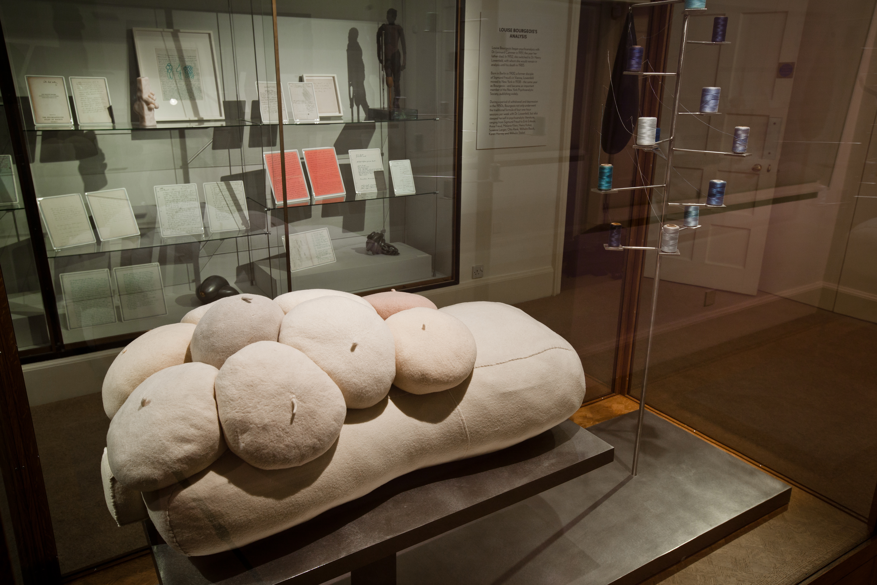
Louise Bourgeois, Untitled (2010), with small works and writings in the vitrines
Louise Bourgeois: The Return of the Repressed at the Freud Museum in London, 2012
Photo: Ollie Harrop, © The Easton Foundation/Licensed by DACS, UK 2017

In one of these documents, from 1958, six years into her psychoanalysis with the Freudian Dr. Henry Lowenveld, Bourgeois wrote the following witty, fulsome and powerful assessment of her psychoanalysis in pencil on a blank sheet of typing paper:

The analysis is a jip
is a trap
is a job
is a privilege
is a luxury
is a duty
is a duty towards myself
my husband my parents
my children my
is a shame
is a farce
is a love affair
is a rendez-vous
is a cat + mouse game
is a boat to drive
is an internment
is a joke
makes me powerless
makes me into a cop
is a bad dream
is my interest
is my field of study –
is more than I can manage
makes me furious
is a bore
is a nuisance
is a pain in the neck -

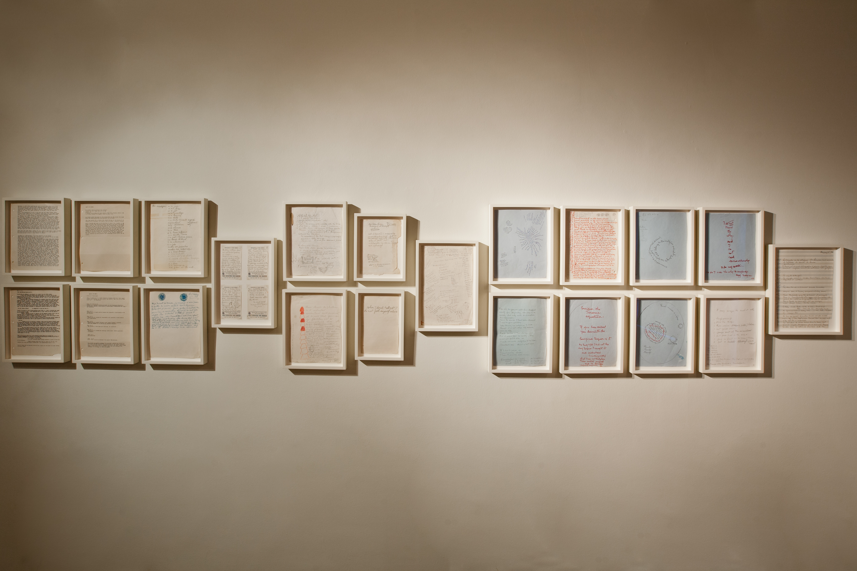
Framed archival documents by Louise Bourgeois from the Louise Bourgeois Archive
Louise Bourgeois: The Return of the Repressed at the Freud Museum in London in 2012.
Photo: Ollie Harrop, © The Easton Foundation/Licensed by DACS, UK 2017

In another piece of her psychoanalytic writings, from c. 1962, written in red ink with black and blue ink additions on typing paper, we encounter Bourgeois wrestling with the demands of her personal desires and their suppression by a multitude of social and political prohibitions:

I want to get
I want to keep
I want to say.
I want to tell
I want to see
I want to learn
I want to know
I want to know
I want to control
I want to hold
I want to feel
I want to remember
I want to go
I want to want
I want to find
I want to finish
I want to get rid of
I want to clean
I want to be good
I want to be better
I want to do it
I want to show
I want to outdo
I want to top it
I want to accomp
lish mastery

A page and half later, things take a dramatic turn, as I read:

but I know that
I cannot see
I cannot learn
I can never know
I cannot control
I cannot hold
I may not feel
I am unable to remember
I am not supposed to go
It is bad to want
I never find
I will not finish
I cannot forget

And later still:

You accomplish nothing
Then, of course, you despair
and you have reasons to. The voice of reason and of experience the real
would always
say no

At the end of the five-page list, Bourgeois has found a form of equilibrium. The artist paraphrases Diogenes and Anatole France: ‘To be rich is to want less than one’s means - ’. But, this was not to last long. Close by, we encountered another short text from c. 1957 written in pencil on blank, white typing paper which disclosed Bourgeois’ multiple senses of failure:

step No 4 -
I have failed as a wife
as a woman
as a mother
as a hostess
as an artist
as a business woman
and as any 47 –
as a friend
as a daughter
as a sister
I have not failed as a
truth seeker
lowest ebb

And then, we read Bourgeois’ short, spiky note from c. 1965 written with pencil on ruled paper: ‘When I do not attack, I do not feel myself alive.’ This form of writing continued, unabated throughout the exhibition.
We know that Bourgeois was extremely well read in psychoanalysis. She has references in her writings to Sigmund Freud, Marie Bonaparte, Anna Freud, Melanie Klein, Jacques Lacan to name just a few. We also know that Bourgeois first saw her psychoanalyst Dr Henry Lowenfeld after the death of her father in 1951. This loss resulted in a deep depression that lasted over a decade during which time Bourgeois was unable to produce any artwork. The first ten years of the artist’s psychoanalytic treatment enabled her to come out of her depression and make art once more.
As psychoanalyst and feminist Juliet Mitchell argues in her analysis of Bourgeois’ psychoanalytic writings, the artist, a psychoanalytic subject, specifically a Kleinian subject, was able to ‘use’ her symptoms, in a psychoanalytic sense, to continue to make her work. Mitchell notices that the writings are filled with Bourgeois’ articulation of ‘violent jealousy’, and the analyst concludes that, if psychoanalysis is a process through which the patient is relieved of their symptoms as a means of being cured, then, Bourgeois treatment ‘cured’ her of nothing, nor should it have done; she used it to become an important artist. Because of this tension, Mitchell is attuned to the frequent references in Bourgeois’ writings to ‘acting out’. In acting out Bourgeois experienced feelings of aggression and violence that are followed by anxiety, guilt and fear, and then the need for reparation. Within the Kleinian consulting room, this dynamic is a form of negative transference.
Spending long periods of time in this exhibition and with this writing and work meant spending time with, on the one hand, forthright, aggressive, demanding, claustrophobic, and exhausting objects and texts, and on the other hand, being consumed, surprised, delighted, and stimulated by the thought-provoking truth that was being presented. Experienced within 20 Maresfield Gardens, this leaves a viewer with little room to escape psychologically, emotionally, and literally for a breathe of fresh air. This results in the experience of being in this intervention as dramatically conflicted. We are subsumed into Bourgeois’ world: the dramatic world of a Kleinian subject. The intensity of encountering this show inside the Freud Museum results in a love-hate encounter with Bourgeois’ art and writing practices. In the writing, we are witnessing a form of negative transference, a form of acting out. Is it then the case that the love-hate relationship that we experience when encountering this show in the Freud Museum is one that rehearses the acting out of a negative transference? While being attuned to the singularity of acting out within the consulting room, I was still encouraged to perform something that was similar: I was giving it back: loving it and hating it, both at the same time.

Site-responsive Art
These remarkable site-responsive exhibitions and artworks have provoked us to consider some of the ways in which contemporary art transforms, expands, and undermines what a museum stands for and represents. Our understanding and interpretation of the objects within it – in this case, the chair and the couch – is given a deeper history, a history that may undermine the authenticity or originality of the museum’s own mythology. In addition, contemporary art can intervene in ways that extend the parameters of what the museum exemplifies. Moving beyond the initial discourses offered by the museum, in this case, to post-Freudian thought such as the work of Klein and Davoine, and to alternative geo-political histories, such as South Africa’s apartheid history and the TRC, contemporary art enables a great deal.
Taken together, one would have to say that, yes, site-responsive contemporary art does make a lasting incursion on a museum. These exhibitions alter the museum’s history and the work it does in quite noteworthy ways. The meaning of the museum is certainly altered, and it is clear that there are also practical changes that can accompany these exhibitions. Visitor numbers may increase and diversify; the education program can be aligned with the exhibitions, Yes, at times, audiences that visit and want to see the consulting room undisturbed are disappointed at having contemporary art within the space, but, the question any museum has to consider is - ultimately, is it worth it?

Dr Joanne Morra is Reader in Art History and Theory at Central Saint Martins, University of the Arts London. She convenes The Doctoral Platform at CSM, and is Founding Principal Editor of Journal of Visual Culture. She has published widely on contemporary art and psychoanalysis, including in: The Limits of Death (Robson and Smith, 2000); New Formations (Spring 2002); The Prosthetic Impulse: From a Posthuman Present to a Biocultural Future (Smith, MIT 2006); Journal of Visual Culture (April 2007); Journal of Modern Art (December 2009). She has become particularly interested in spaces of practice (the studio, study, gallery, classroom and consulting room) and what each space can offer the others. Publications on this topic include: ‘Seemingly Empty: Freud at Berggasse 19, A Conceptual Museum in Vienna’, Journal of Visual Culture (April 2013); ‘The Work of Research: Remembering, Repeating and Working-through’, in What is Research in the Visual Arts? Obsession, Archive, Encounter (2008); the curatorial project Saying It (Freud Museum London 2012); ‘On Use: Art Education and Psychoanalysis’, Journal of Visual Culture (April 2017), and ‘Being in Analysis: On the Intimate Art of Transference’, Journal of Visual Art Practice (November 2017). Her recent book is Inside the Freud Museums: History, Memory and Site-Responsive Art (I.B. Tauris, 2018). She is working on her next book, In the Studio and On the Couch: Art, Autobiography and Psychoanalysis.

See, Joanne Morra, Inside the Freud Museums: History, Memory and Site-Responsive Art (London, IB Tauris, 2018), and her ‘Site-Responsivity, or Listening, Placing, and Saying It’, in Saying It: Mieke Bal & Michelle Williams Gamaker, Renate Ferro (London: Occasional Papers, 2012), pp. 9-16.
Sigmund Freud, ‘Shorter Writings’ (1938/1941), in The Standard Edition of the Complete Psychological Works of Sigmund Freud, Volume XXIII, trans. James Strachey, et. al., (London: Vintage, 2001), p. 300.
Theodor W. Adorno, ‘Valery, Proust Museum’, Prisms, trans. S. and S. Weber (Cambridge, MA: The MIT Press, 1983), pp. 173-185 (p. 173).
Claudia Guderian, quoted in Freud Museum London archives.
D.W. Winnicott, ‘The Importance of the Setting in Meeting Regression in Psycho-analysis’, D.W. Winnicott, Psycho-Analytic Explorations, eds. Clare Winnicott, Ray Shepherd, Madeleine Davis (London: Karnac Books, 1989), pp. 96-102 (p. 96).
On Freud’s adherence or not to his own advice for psychoanalysts, see, Luciana Nissim Momigliano, ‘A Spell in Vienna – but was Freud a Freudian?’, Continuity and Change in Psychoanalysis: Letters From Milan (London: Karnac Books, 1992), pp. 1-32; and Lohser and Newton, Unorthodox Freud, particularly ‘Freud’s Theory of Technique’, pp. 11-23.
Sigmund Freud, ‘On Beginning the Treatment (Further Recommendations on the Technique of Psycho-Analysis I)’, (1913), trans. James Strachey, et. al., The Standard Edition of the Complete Psychological Works of Sigmund Freud, Volume XII (London: Vintage, 2001), pp. 121-44 (pp. 139).
Françoise Davoine, ‘La Boîte à Transfert’, Mère Folle: Rècit (Strasbourg: Arcanes, 1998), pp. 155-80.
On Françoise Davoine, see, Psychoanalytic Dialogues: The International Journal of Relational Perspectives, 17/5 (2007), pp. 621-682; and Davoine and Jean-Max Gaudillière, History Beyond Trauma, trans. Susan Fairfield (New York: Other Press, 2004).
See, Ashley Dawson, ‘Documenting the Trauma of Apartheid: Long Night’s Journey Into Day and South Africa’s Truth and Reconciliation Commission’, Screen, 46/4 (2005), pp. 473-86; Jacques Derrida, On Cosmopolitanism and Forgiveness (London: Routledge, 2001); Antjie Krog, Country of My Skull: Long Night’s Journey into Day (London and New York: Vintage, 1999); and Jacqueline Rose, On Not Being Able to Sleep: Psychoanalysis and the Modern World (London: Chatto Windus, 2003).
Siopis, ‘Shame in Three Parts’, pp. 148-9.
See Salman Akhtar, Psychoanalytic Listening: Methods, Limits, and Innovations (London: Karnac Books, 2013), and Georges Perec, ‘The Scene of a Stratagem’ (1977), Species of Spaces and Other Pieces, ed. and trans. John Sturrock (London: Penguin Books, 1999), 165-73.
Phillip Larratt-Smith, ‘Introduction: Sculpture as Symptom’, The Return of the Repressed, ed. Philip Larratt-Smith, exhibition catalogue (London: Violette Editions, 2012), pp. 7-14 (p. 8).
Juliet Mitchell, ‘The Sublime Jealousy of Louise Bourgeois’, in The Return of the Repressed, ed. Philip Larratt-Smith, exhibition catalogue (London: Violette Editions, 2012), pp. 47-67 (p. 47). The most relevant texts by Klein are: Melanie Klein, Love, Guilt and Reparation and Other Works 1921-1945 (London: Vintage, 1995); Envy and Gratitude and Other Works 1946-1963 (London: Vintage, 1997); and The Selected Melanie Klein, ed. Juliet Mitchell (New York: The Free Press, 1986).

