Book Title: Coproduction and Social Justice

Section 2 Mapping, Making, Performing: Arts Praxis and Co-produced Research
(New interfaces and approaches, interdisciplinary methods, arts praxis as research)

Participatory Mapping and Engagement with Urban Water Communities

Introduction
The use of interdisciplinary methods has been a key approach to better capture and analyse complex relationships and address ‘wicked problems’ in urban environments (Harrison, 2000). Exploring issues and conflicts around the sustainability and ecosystems agendas by deploying multi-partner, arts and humanities-centred interdisciplinary research promises to untangle some of the complexities in the different layers of urban governance and experience. Water is a fundamental necessity for sustainable communities, economies and biodiversity. It also forms an intrinsic, but complex and contested part of our cultural landscape and heritage. By investigating how local communities relate to and engage with urban water environments using arts and humanities methodologies can help to explore and develop notions and practice of community resilience in eco-social and cultural terms.

The research approach in question uses a combination of in situ methods such as Participatory Action Research (PAR - Pain et al., 2012), practice-based art research, cultural geography and cultural mapping, as vehicles for engaging communities and reflecting existing understandings, and for engineering new affective relations and possibilities. Cultural ecosystems mapping in particular draws from Participatory GIS (PGIS) and is considered a useful tool for imagining and visualizing the socio-cultural realities and aspirations of communities and their local landscapes in place and time.

This chapter therefore focuses on the application of cultural ecosystems mapping as a participatory, co-produced visualization and engagement method, based on a case study of the Lee Valley - London’s second or ’hidden river’ stretching 26 miles from the home counties through north and east london to the Thames and with a flood catchment of over 1,000km². Engaging people with issues around cultural ecosystem services through the inter-action with large scale maps of the local area helps to ground the more abstract issues of identity, connectivity, sense of place, emotional attachment and spirituality, as well as overcome the traditional barriers to participation and inclusion at various spatial scales. Cultural mapping in particular helps to articulate the spatial and historical relationships and triggers debate over connectivity, governance, environmental justice and both environmental and social change.

Towards Sustainability and Culture-led Sustainable Development
Sustainability is a complex term that has been defined and applied in various ways by different disciplines. Although sustainable development is a fairly abstract and broad ‘meta’ subject, it has caught the attention of policymakers and citizens worldwide, not least in the context of climate change and everyday environmental concerns and practice. One of the most remarkable challenges of the term sustainable development is that it seeks to explain different things to so many different people and organisations. Therefore, it is no surprise that the concept of sustainable development usually reflects the political and philosophical position of those proposing the definition rather than any clear-cut scientific view (Mebratu, 1998).

The emergence of the sustainability concept has developed from a global geopolitical perspective, which searches for solutions to the most powerful needs of the anthropocene era, namely the need to balance and in many senses, reconcile, economic development/growth, environmental protection, social justice and cultural diversity. Sustainability does not therefore simply refer to achievements in the environmental arena, but also social and economic development. Sustainable development necessitates policy changes in many sectors and greater coherence between them, as Dalal-Clayton and Bass state, sustainable development requires “integration of objectives where possible; and making trade-offs between objectives where integration is not possible” (2002, p. 7). These objectives act in different ways and scales - at global, national and local levels, but should be consistent between these levels (Evans, 2013). There are a wide range of sustainable development approaches which reveal different challenges faced by individual countries and regions and their response to these. Hence, although sustainable development is a global challenge, it can only be operationalised through a national framework and local practice (Dalal-Clayton and Bass, 2002).

The sustainability discourse is not surprisingly dominated by the economic, social and environmental impacts of growth, while the cultural dimension to sustainability has been lacking (Evans, 2013). However, culture in various forms now appears as an emerging component of regeneration and development (Evans, 2005) in both economic and symbolic ways: from revitalizing decaying centres with iconic buildings and public spaces, to bringing communities together around cultural events, as well as being promoted in both Agenda 21 and UNESCO Culture and Sustainable Development initiatives (2009). The role of culture in sustainable development has been key in more progressive urban policy and planning. In particular, cultural planning, which is ‘a process of inclusive community consultation and decision-making that helps local government identify cultural resources and think strategically about how these resources can help a community to achieve its civic goals’ (Stewart, 2007, p. 1), is a novel way to integrate the cultural values of a community into otherwise abstract and bureaucratic local and regional planning initiatives and processes (Evans and Foord, 2008). Culture in this respect can be viewed as a ‘fourth pillar of sustainability’ (Hawkes, 2001) but this concept has been more prevalent in developing countries where the separation between heritage, culture and everyday life is not felt. Universally however, the area of human behaviour within governance systems is where culture, governmentality and sustainable development offers the possibility for notions of eco-citizenship to emerge and solidify.

There have been several important initiatives to encourage a balance between development and sustainability. For example, the Millennium Ecosystem Assessment (MEA) was carried out between 2001 and 2005 to assess the role of ecosystem change for human quality of life, and to establish the scientific basis for actions needed to enhance the sustainable use of ecosystems and their contribution to human well-being (Plieninger et al., 2013). Ecosystem services are the benefits that people obtain from nature, and the MEA identifies four ecosystem services: provisioning, supporting, regulating, and cultural services. In order to evaluate how the changes in ecosystems affect well-being, the following dimensions have been determined as security, basic material for good life, health, good social relations and freedom of choice and action.

Cultural services differ in various aspects from other ecosystem services since they are difficult to quantify and their economic evaluation is usually controversial. They are contributions that ‘ecosystems are deemed to make to the non-material benefits (e.g. capabilities and experiences) that arise from human-ecosystems relationships’ (Chan et al., 2012, p. 9). They are less directly linked to human well-being than, say, provisioning and regulating services, but their potential for mediation is low (MEA, 2005).

Potentially therefore, cultural mapping can be considered as a useful tool for articulating the socio-cultural realities of communities in relation to their landscapes and ecosystems (Ryan, 2011), particularly in light of the physical and economic bias of environmental sustainability and ecosystems analysis. The initial UK National Ecosystem Assessment had for instance lacked an arts & humanities dimension - or input from arts and cultural organisations and practitioners. Ecoystem cultural services (NEA, 2011, Chapter 16) have been largely rationalised in terms of externalities - health, recreation, tourism - and as cultural “goods” (‘human benefits from nature’) arising from “environmental settings” - and these are dominated by natural settings, green space/parks, recreation and tourism, rather than urban settlements. Little recognition is given for example to the established work in environmental art (Lacy et al., 1995), art and regeneration, or the role of community arts groups (an exception is Commonground’s “Parish Maps”) in ecosystem, urban and sustainable development. This national ecosystem review drew mainly on environmental and ecosystem studies in the treatment of cultural services, and did acknowledge that ‘this approach to cultural services struggled to find a consistent theoretical and methodological framework to match that underpinning other areas of the NEA’ (NEA, 2011, p. 639). The NEA also highlights knowledge gaps related to ecosystem cultural services, specifically in ‘data collection and the uneven monitoring of change in different environmental settings’ (2011, p. 638) - and spatial data generated through cultural mapping methods will hopefully contribute to meeting this gap.

In response to this deficit, the UK National Ecosystem Assessment Follow-on report (UK NEAFO, 2014) offers new approaches and tools to help decision-makers across all sectors understand the wider value of ecosystems and cultural services. This includes recognition of the value of mapping in different forms including GIS, participatory/creative mapping (Church et al. 2014) and digital data analysis: ‘Mapping is fundamentally about meaning and the environment, about what we care about in place, space, site, landscape and physical setting, and how these overlapping entities can be disclosed and represented. As a form of modelling, mapping is both metaphorical and material. Maps can combine and display a range of multi-layered information, past, present and projected, textual as well as pictorial. They can encompass cultural memory and possible scenarios (Read, 2012). Maps are a metric, indeed often technically sophisticated, whether on paper or in digital form. They are a form of practice, both scientific and artistic’ (Coates et al., 2014, p. 39).

Participatory Creative Methods
A number of creative methods have been developed especially from the 1990s to include communities in the decision-making process of development and the design and use of local neighbourhoods and public spaces. Depending on the goals of public participation, methods can be varied. For example Beierle (2002) identifies educating and informing the public, incorporating public values into decision-making, improving the sustentative quality of decisions, increasing trust in institutions, and reducing conflicts as the main aims of public participation.

Cultural mapping is considered as a practical, participatory planning and development tool and an emerging mode of research (Duxbury et al., 2015; Longley and Duxbury, 2016). It is potentially a linking methodology for interdisciplinary projects, especially ‘to bridge forms of artistic inquiry with research based in other disciplines’ (Longley and Duxbury, 2016, p. 1). Consulting communities to identify the needs assessment for planning by using the mapping and visualisation of physical/environmental and human activity can lead to a broader approach to development in general and notably to local environmental improvements and relationships (Evans, 2013).

Stewart (2007, p. 8) defines cultural mapping as ‘a process of collecting, recording, analysing and synthesizing information in order to describe the cultural resources, networks, links and patterns of usage of a given community or group’. Therefore, the mapping process usually helps reveal unexpected resources, values and problems in an area and can also build new cross-community connections (Longley and Duxbury, 2016). Cultural resources incorporate both tangible and intangible cultural assets that ‘fuel local cultural vitality and contribute to defining the unique local cultural identity and sense of place’ (Ontario-MCP, 2010, p. 51). Cultural mapping can be enabled in different ways, and using Geographic Information Systems (GIS) - which has been considered as a driver for technical development around geographic representation since the 1960s (Goodchild, 1992) - is one of the most promising ways. While there are a variety of approaches to engage with communities and get them involved in the decision-making process within their local neighbourhoods, techniques of Participatory GIS used for community mapping have been considered as particularly reassuring for participants (Crawhill, 2008; Smeets and Yoshida, 2005).

Participatory GIS (PGIS) in particular facilitates the representation of local people’s spatial and site-specific knowledge with maps, which can subsequently be used in decision-making processes, as well as supporting communication and community advocacy (Corbett et al., 2006). It seeks to contribute to the enhancement of methods appropriate for use with the general public. Cinderby for instance has applied PGIS in England to urban renewal projects, air quality and accessibility assessments (2010, 1999). The relatively informal setting of the approach allows for wider inclusion of normally excluded participants – so-called ‘hard-to-reach’ communities, whilst Rambaldi et al. (2006) define Participatory GIS as a practice with a special emphasis on empowerment and communications.

Participatory GIS projects can also take many forms, depending on the way they are conducted and which GIS features are used. While using online and interactive methods are possible, the least technologically demanding method is using paper maps which was implemented early on in the development of PGIS. Participatory GIS approaches often involve significantly less sophisticated techniques; using topographic maps or satellite images. For example, Cinderby’s (2010) hard-to-reach methodology used an aerial photography-based map to examine urban design (such as streets, squares or transport) with participants. They were invited to apply comments directly on the map using flags, thus taking part in the collection of knowledge. Paper-based maps were seen to be widely accessible and eliminated possible technology and language barriers as well as fieldwork based limitations. The application of PGIS-based cultural mapping in urban water environments has therefore been developed in our case study river system.

- Engaging with Water Communities
Water is one of the most essential components for sustainable communities, economies and biodiversity, as well as a key part of cultural landscapes and heritage. There are multiple water-related challenges in urban environments as a result of climate change, population growth/density including increased flood risk, drought/scarcity risk, pollution and degradation of aquatic ecosystems, which are all embedded in numerous social, cultural, political, and economic contexts. Confronting these water related risks generates different forms of conflict in communities that need to be negotiated both within and across wider networks and geographic areas (upstream, downstream). Governance processes at local, national and transborder scales all over the world need to negotiate and manage these issues through collaborative dialogues both at the local community and riparian community levels. Cultural mapping in particular is a stimulating method to generate conversations within and between communities around water spaces and urban waterfront areas. For Longley and Duxbury (2016, p. 1), cultural mapping is a method which ‘aims to advance our conceptualization and understanding of diverse approaches to mapping intangible dimensions of culture, and to synthesize some insights from these approaches to advance methodological practice in this area’. Therefore, it brings non-human and ecological materialities into creative conversation within social and community concerns. Approaching water as a connecting element in urban environments and landscapes and developing narratives around them, helps in the understanding of the ecological and social production of the places where people live.

In our case study, cultural mapping has been practiced in focus group meetings and arts and community festivals along the River Lee by the authors, as part of the Hydrocitizenship project research team. The project has been funded for three years under the Arts & Humanities Research Council (AHRC) Connected Communities programme with a particular emphasis on co-design and co-production. The cultural mapping method has been used to collect data about spatial and socio-cultural issues derived from Cultural Ecosystem Services within this urban river environment and to visualize these perceptions and experiences on both a site-specific and iterative basis.

The Cultural Ecosystem Services Framework (Figure 1) firstly makes a distinction between cultural values, environmental spaces, cultural practices and cultural benefits (Church et al., 2014). In order to assess cultural services (as established in the UK National Ecosystem Assessment Follow-on, 2014) the following indicators have been created: Use (sense of place, activities, and recreational use), Cultural Value (recreation, social relations, and cultural heritage values), Problems (accessibility, safety, unpleasant) and Community Cohesion (diversity, involvement). Cultural mapping in this situation is used to better understand the issues around the access to, and use of water spaces, and to engage with the general public through the use of these indicators. The following sections therefore focus on the some of results of the cultural ecosystems mapping undertaken in the Lee Valley, including discussion of this participatory method and issues arising.

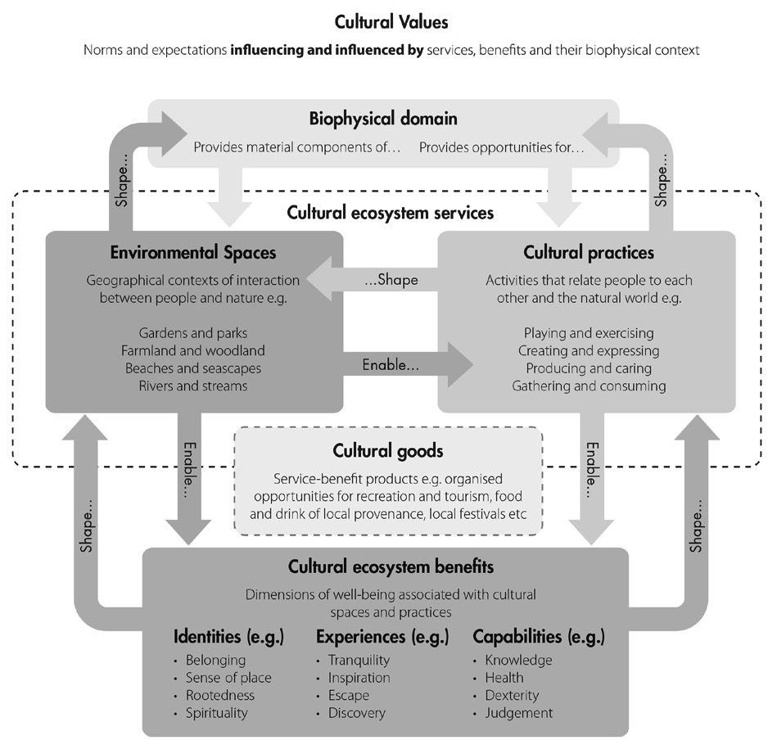
Figure 1: Cultural Ecosystem Services Conceptual Framework (Fish and Church, 2013)

  - Cultural Ecosystems Mapping in Focus Groups
At the outset of the cultural mapping sessions, a set of socio-demographic questions are asked of participants in order to start the conversation. This captures information such as gender, age, home postcode and familiarity with the study area. This information is useful for subsequent analysis, representation and locating participants in relation to the study area. Since this is an iterative process the mapping exercise can be carried out in the same location but with different participants as well as in different locations. Participants are then asked to identify recreational uses, cultural uses and problem areas with the use of a large aerial view map. Using colour-coded sticker dots and post-it notes for locating sites on the map, participants were also asked to mark areas with landscape values and special places. The data on the maps and questionnaires are then transferred onto a digital database and entered onto GIS. Cultural mapping in particular helps to articulate the spatial relationships and stimulate discussion over ‘accuracy’, sense of place, history, connectivity, governance and change in different parts of the study area.

Focus groups are an effective method to explore the ways in which people perceive their local environments and reflect on each other’s approaches about the same issues and areas. This method is a form of group ‘interview’ and workshop, which involves several participants and a facilitator/moderator, and there is an emphasis in the questioning on a particular topic where the focus is upon interaction within the group (Bryman, 2008), in this case over a map. During cultural ecosystems mapping, participants usually reveal a wide range of views across a broad section of social experience, and while this does not claim to identify public opinion in any definitive sense, it does provide good qualitative evidence based on participant experience and interaction. Undertaking the cultural mapping activity through a focus group format also offers the chance of letting people explore and challenge each others reasons for holding a certain view (Bryman, 2008), while in a one-to-one exchange, interviewees are rarely challenged.

As a first pilot, perspectives on local cultural ecosystems values were collected from a focus group meeting held in Hackney Wick (adjoining the Lee Navigation Canal) at the Cre8 Lifestyle Community Centre and analysed collectively to derive local community values. Several techniques can be used in order to represent landscape values and special places when creating the map such as defining sites and routes through use of pencils or markers, using color-coded stickers for locating sites and identifying and numbering special sites and annotating them on the map (Plieninger et al., 2013) - see Figure 2.
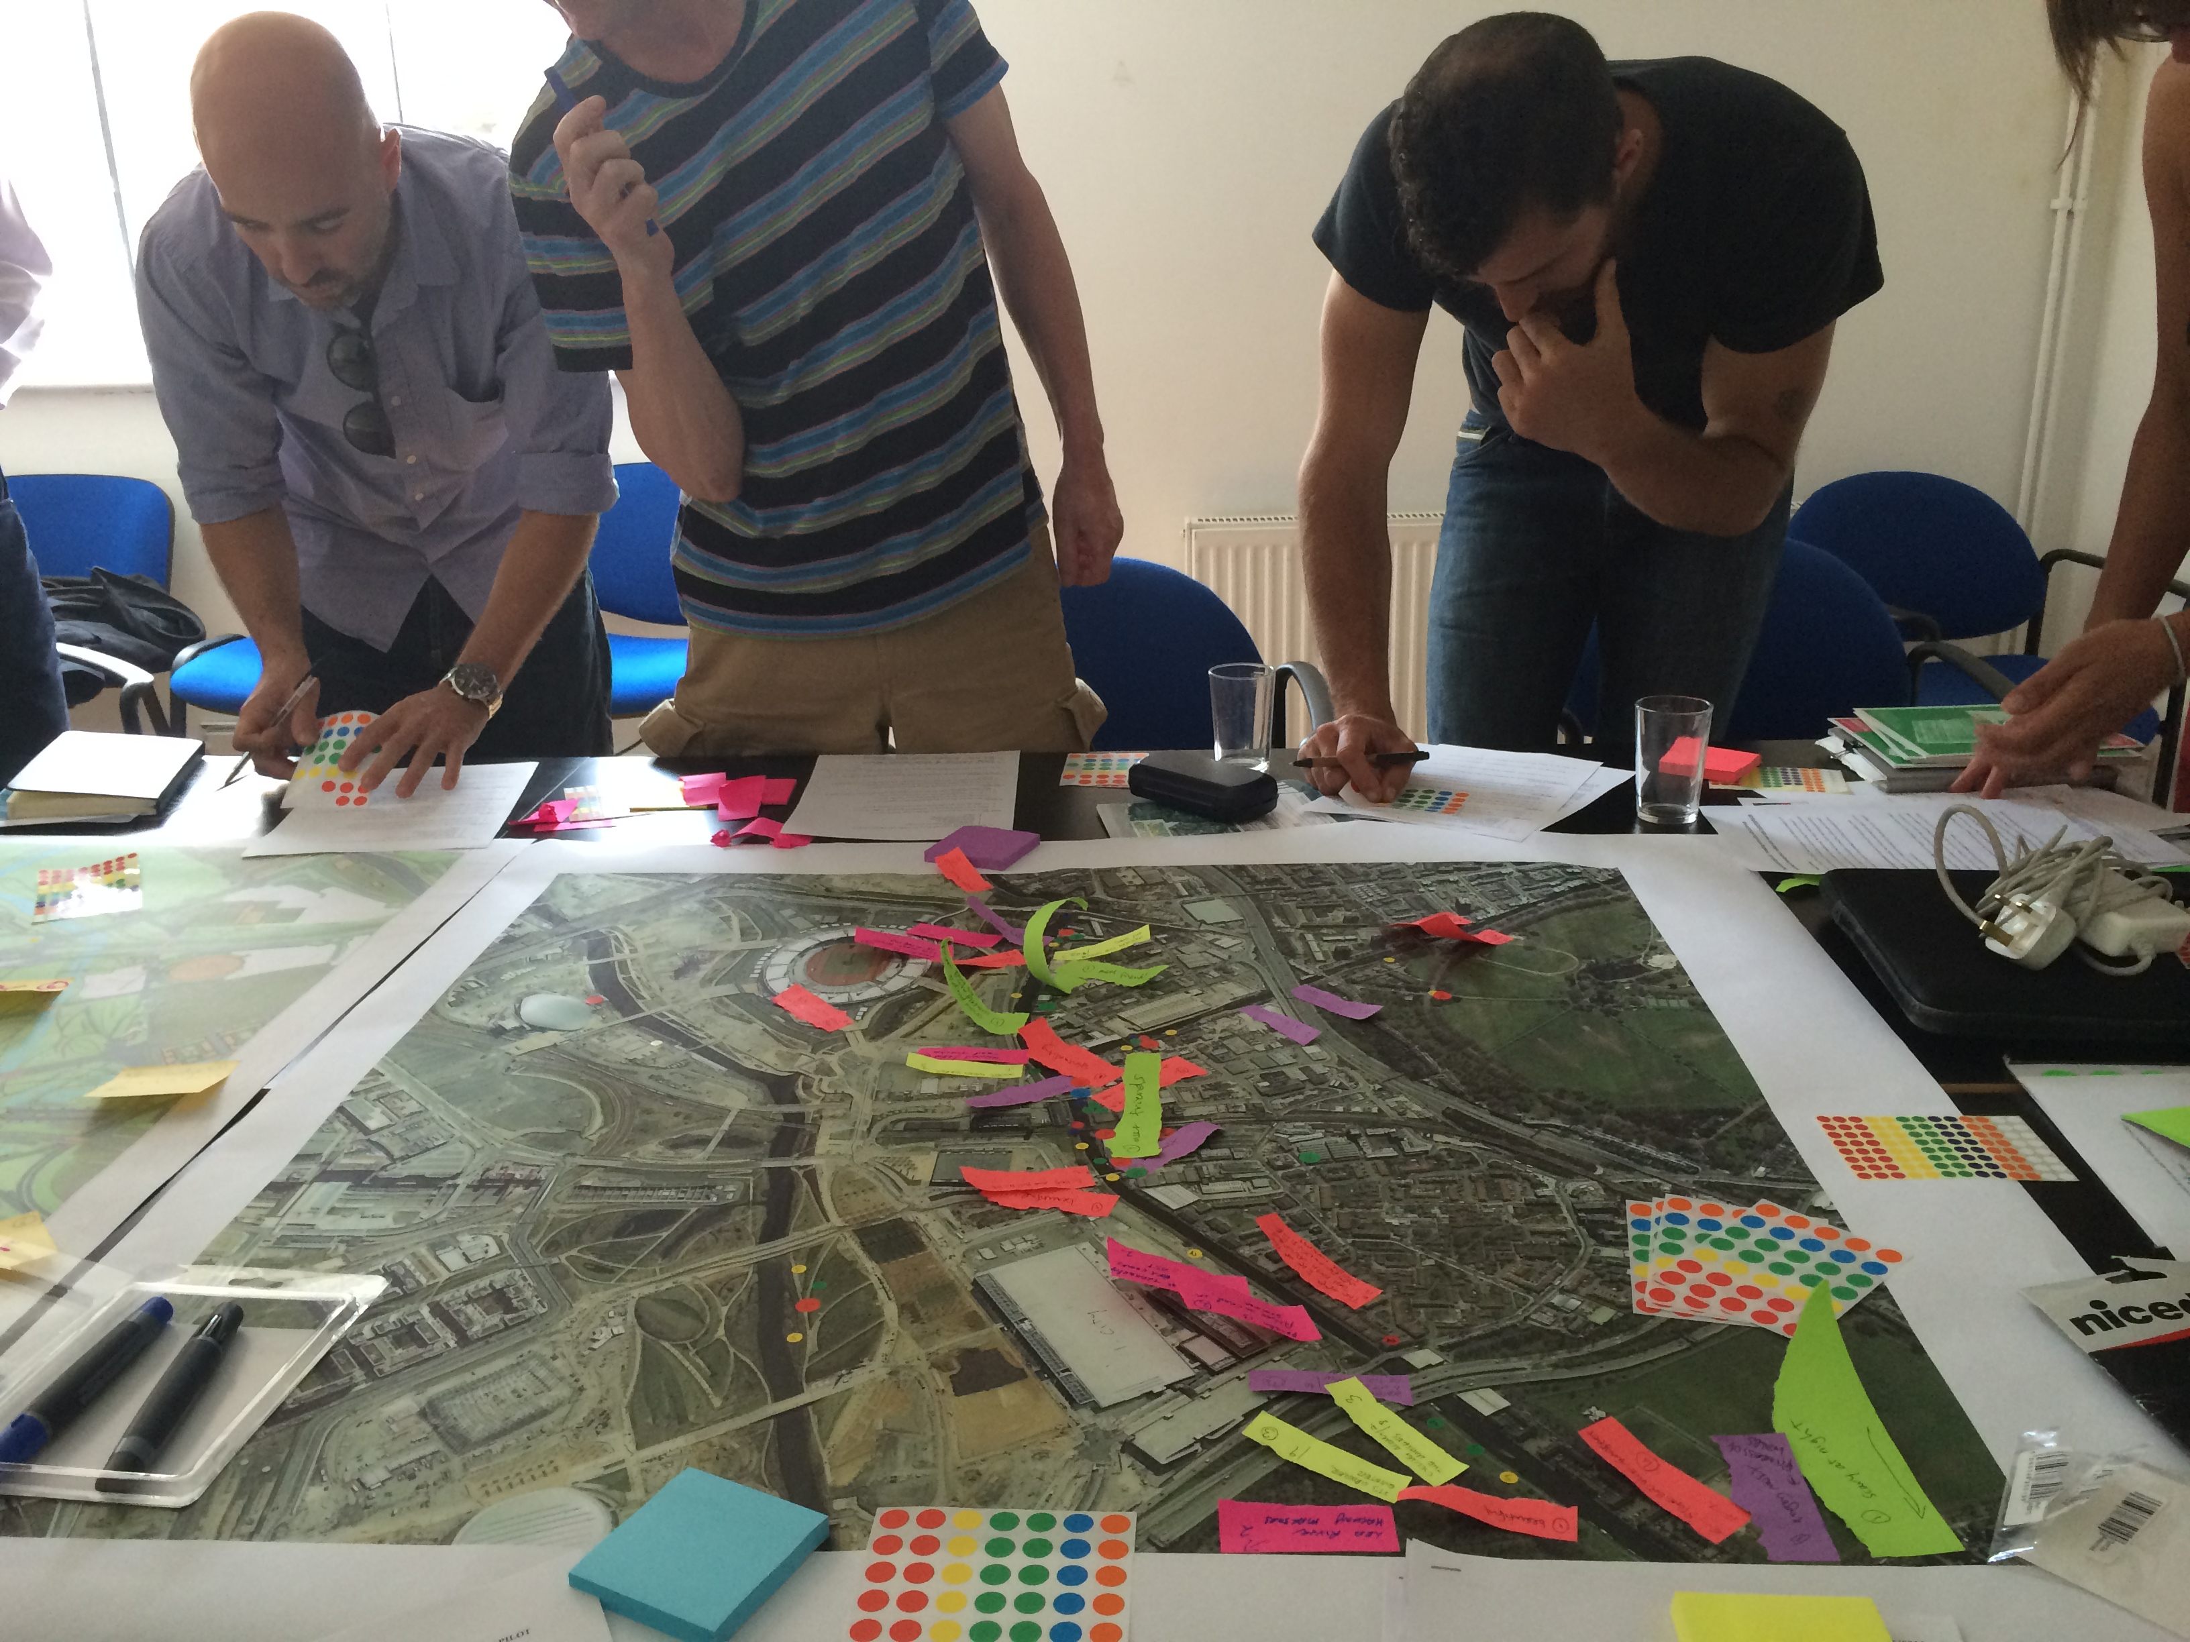
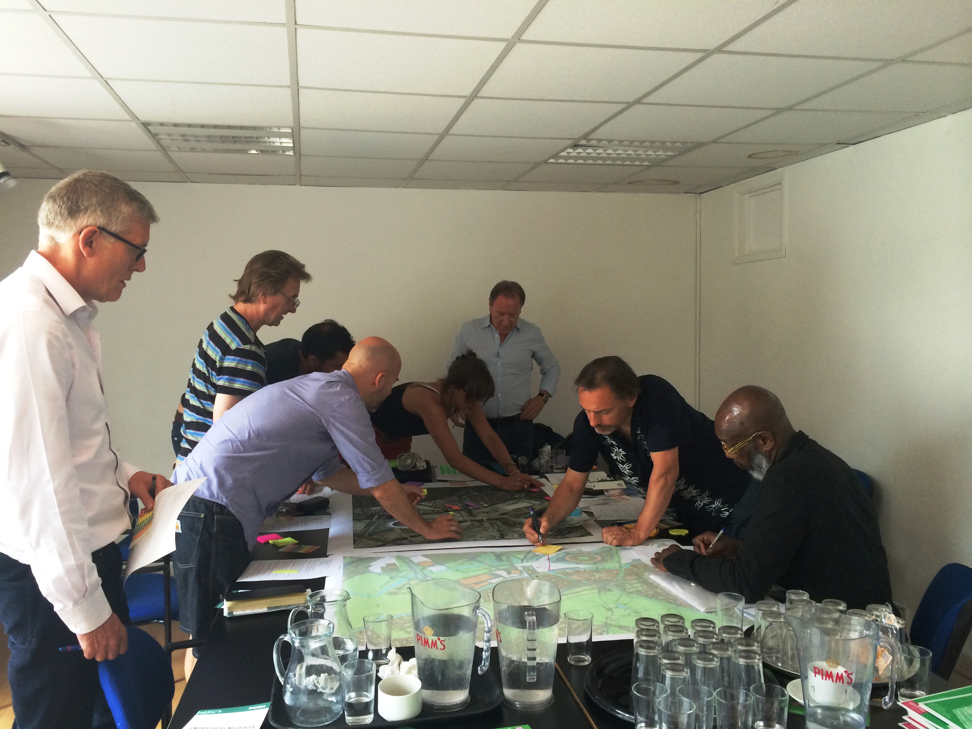
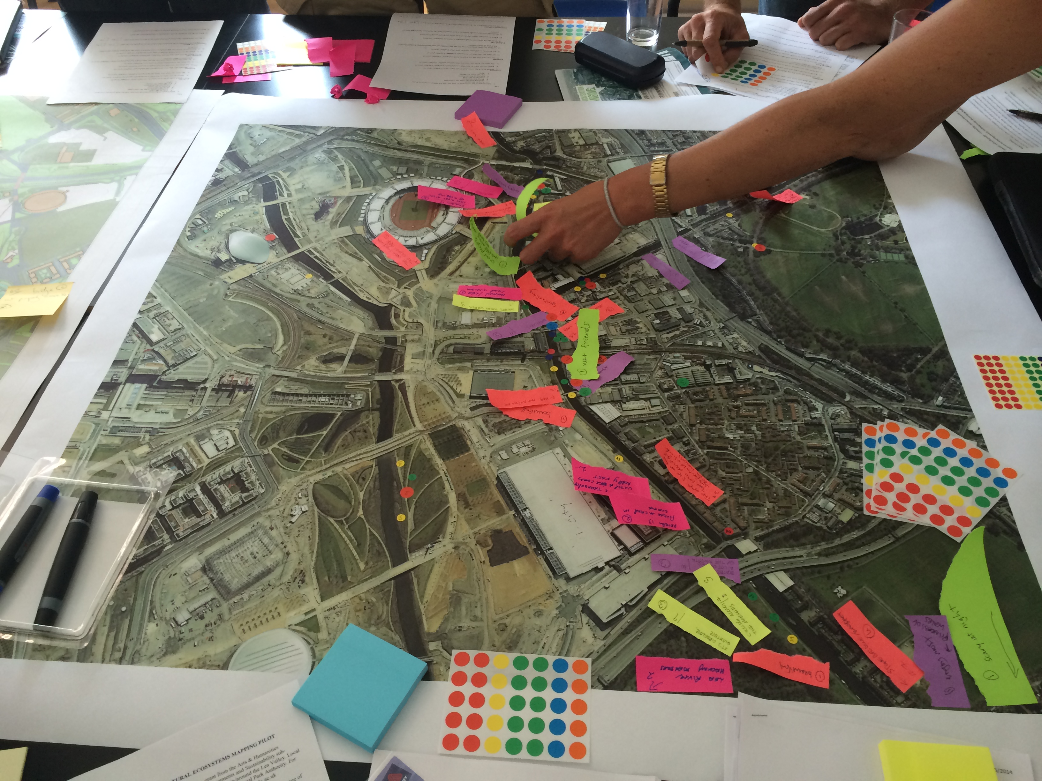
Figure 2: Cultural Ecosystems Mapping in the Hackney Wick focus group

By the nature of focus groups, the method helps to gather in-depth information about the area in an interactive way. Participants discuss each other’s points of view and their knowledge of the history of the river and waterfront areas, and map anecdotes about certain locations and experiences which helps to explore the intangible features that create the identity and perceptions of the area and water resources. This process can lead to bringing creative solutions for conflict sites and issues as well as ‘benefit from the direct involvement of artists, crafts and designer-makers, whether as interpreters, catalysts or visionaries’ (Evans, 2013, p. 231) in visualising and animating the physical landscape, human activity and aspirations, which became clear in the case of Hackney Wick. Annotated cultural maps, which can be layered with the results of other mapping exercises, or revisited with the same cohort of participants can also be analysed with other spatial data once digitised. This can add layers of different information on say, demography, housing, land use, environmental quality (e.g. air, noise, water), crime incidents, flooding/flood risk etc. providing a rich canvas which can be the basis for artistic interventions (e.g. drawing/painting, sculpture - Read, 2012) and for feedback to participants. This can also reveal divergence between lived experience and official data, and provide stakeholders and stewards of the water system with important local knowledge (Geeetz, 1983) which can inform policy, planning and operational practice.

  - Cultural Ecosystems Mapping in Arts & Community Festivals
As well as the more closed group meeting, arts and community festivals can bring local residents and users of a neighbourhood together in a friendly, relaxed and animated way. People can also have the opportunity to hear about the latest developments, events and concerns such as safety/crime, new building developments/changes of use. Here, the conversation through the cultural map helps to identify not only tangible aspects of the area but also the intangibles. The intangible elements of a place such as stories, histories, values are ‘the aspects that provide a “sense of place” and identity to specific locales, and the ways in which those meanings and values may be grounded in embodied experiences’ (Longley and Duxbury, 2016, p. 2). The dialogue developed around the map captures features that are not easy to quantify but are important to truly understand a place and its value to its residents and visitors. People’s interactions in their community as well as personal and collective memory help to build up the narratives. The activity itself helps to create a community-driven ‘visual’ of values and place-based meanings which are evidently different from official plans and maps (Cauchi-Santoro, 2016) and even of official history, narratives and ‘worldviews’. This is in contrast to the masterplanning process which dominates the design and development of major regeneration sites, as experienced by these communities as a result of the major redevelopment of the Lower Lee Valley during and following the nearby London 2012 Olympics site (Evans, 2015).

Mapping at open festival environments also brings together locals and visitors who may have differing perspectives and experiences, whilst mapping as part of a wider festival provides the opportunity for participatory arts activities, installations and performances to allow cultural expression, exchange of ideas and complement the responses to the cultural map, and vice versa. In the Hackney Wick festival, alongside artists open studios, street performance and design exhibitions, open debates were held on topics such as community land trusts, whilst a derelict site was occupied along the canal to build a temporary DEN-City from recycled materials and rubble where residents and visitors could explore the waterside environment in the context of urban change and sustainability with a group of independent artists, whose installations, artworks and performances reflected and responded these concerns (Figure 3).

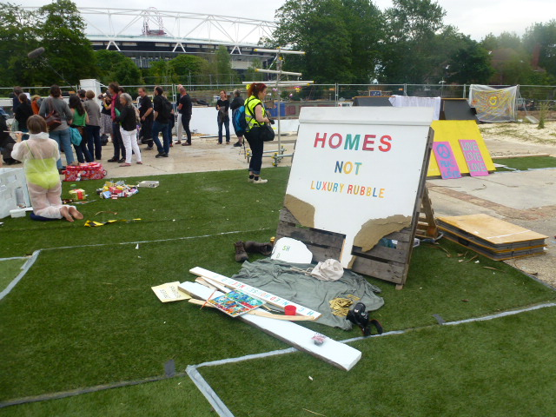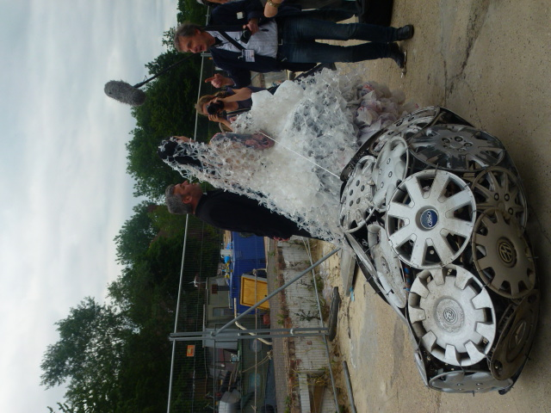

Figure 3. DEN-City, Hackney Wick Connected Communities Festival

Cultural ecosystems mapping has therefore been undertaken during several community events along the River Lee such as the Hackney Wicked Connected Communities Festival 2015 (above), Love the Lea Festival 2015, the National Mills Weekend at Three Mills 2016 and First Farm Wetlands Festival 2016.

From these iterations it is possible to identify three types of interaction around the mapping exercises during these festivals. The first form of interaction is the conversation that takes place between the participant and the researcher, which is mainly about understanding their use of space and values in the area. The participants are asked several questions which draws on the Cultural Ecosystems Assessment approach. Also, this sometimes evolves into a form of knowledge exchange between researcher and participant. The findings reveal interesting and unexpected results, which can help in the further planning, development and priority-setting for the area. For example, the results of the Love the Lea Festival cultural mapping show that participants value being around the river path and marina most, and raise safety issues (e.g. lighting at night and muggings) in these same locations (see Figure 4). Therefore, cultural mapping was able to uncover the fact that sometimes the problem areas are the same as the culturally and aesthetically valued areas, but that these are experienced differently by different users, and at different times (Lefebvre, 1974).

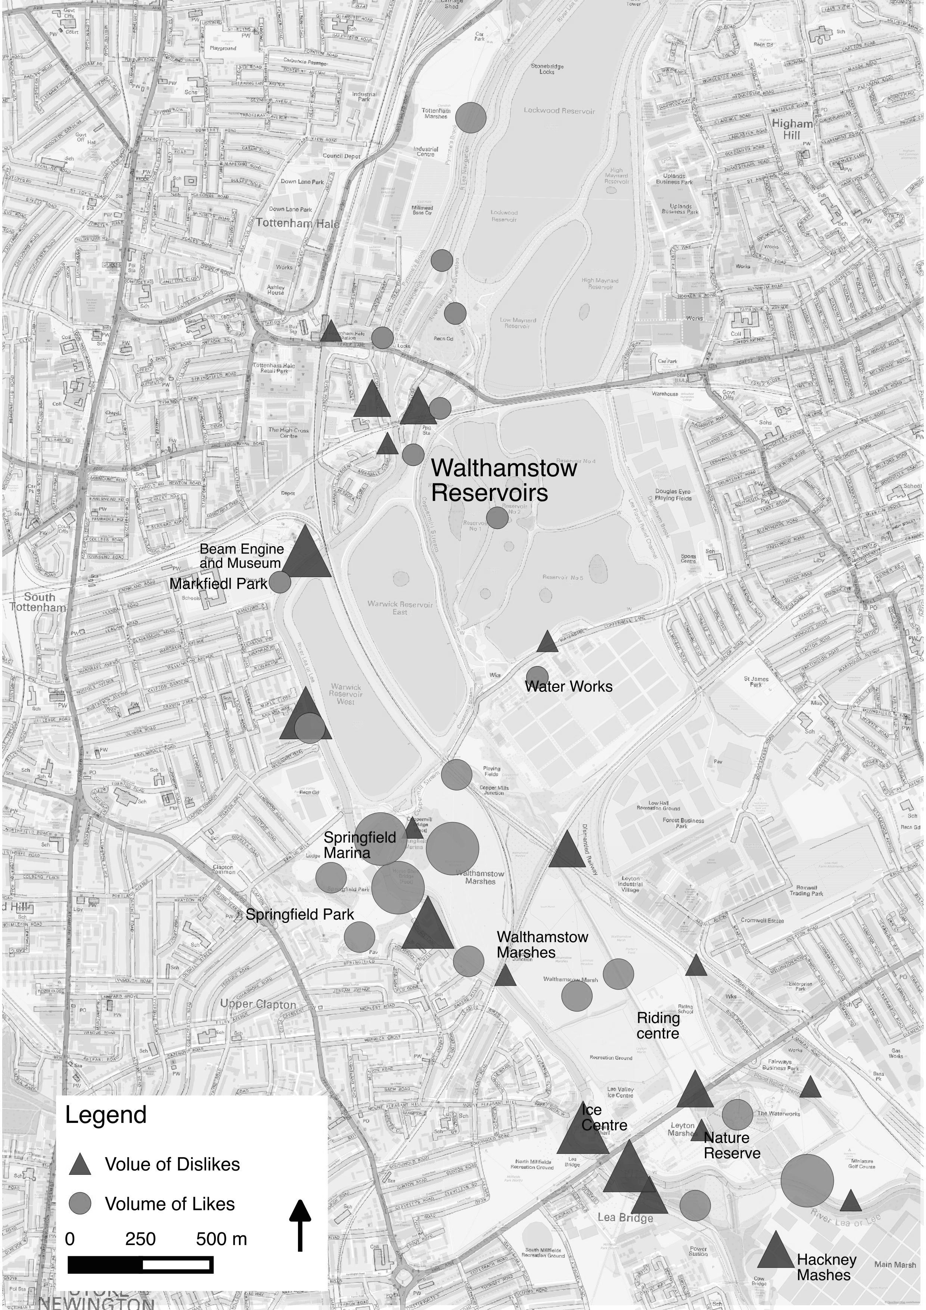

Figure 4: Cultural mapping findings from Love the Lea Festival (volume of likes and dislikes)

The second type of interaction takes place between participants while contributing to the research. Sharing knowledge, experiences and memories in certain locations on the map is most of the time a conversation starter, which leads to exploring some of the perceived qualities and recent history of the area. While this is a key feature in more intensive focus groups, the interaction between participants also takes place at more open community festival exchanges.
The final type is the interaction of participants with the marks and textual responses that other participants leave on the map. People usually start with analysing the map themselves and trying to understand why others chose certain locations to identify certain feelings and activities. While this process may end with agreement with other participants, sometimes complete opposition comes across. During the mapping at the Three Mills, National Mills Weekend, after one of the participants put a sticker on Cody Dock as a valuable asset in the area; others at first disagreed but then after discussion the others acknowledged this and the local community organisation based there (Figure 5). The Gasworks Dock Partnership based in Cody Dock is a charity for community-led regeneration and encourages public engagement in the revitalisation of waterways. Their vision is to rehabilitate Cody Dock, create a creative industries quarter with new workspace, visitor facilities and public space, and to foster a stronger sense of place and civic pride by celebrating the area’s waterways and rich industrial heritage through increased participation in the arts and improved access to the River Lee.

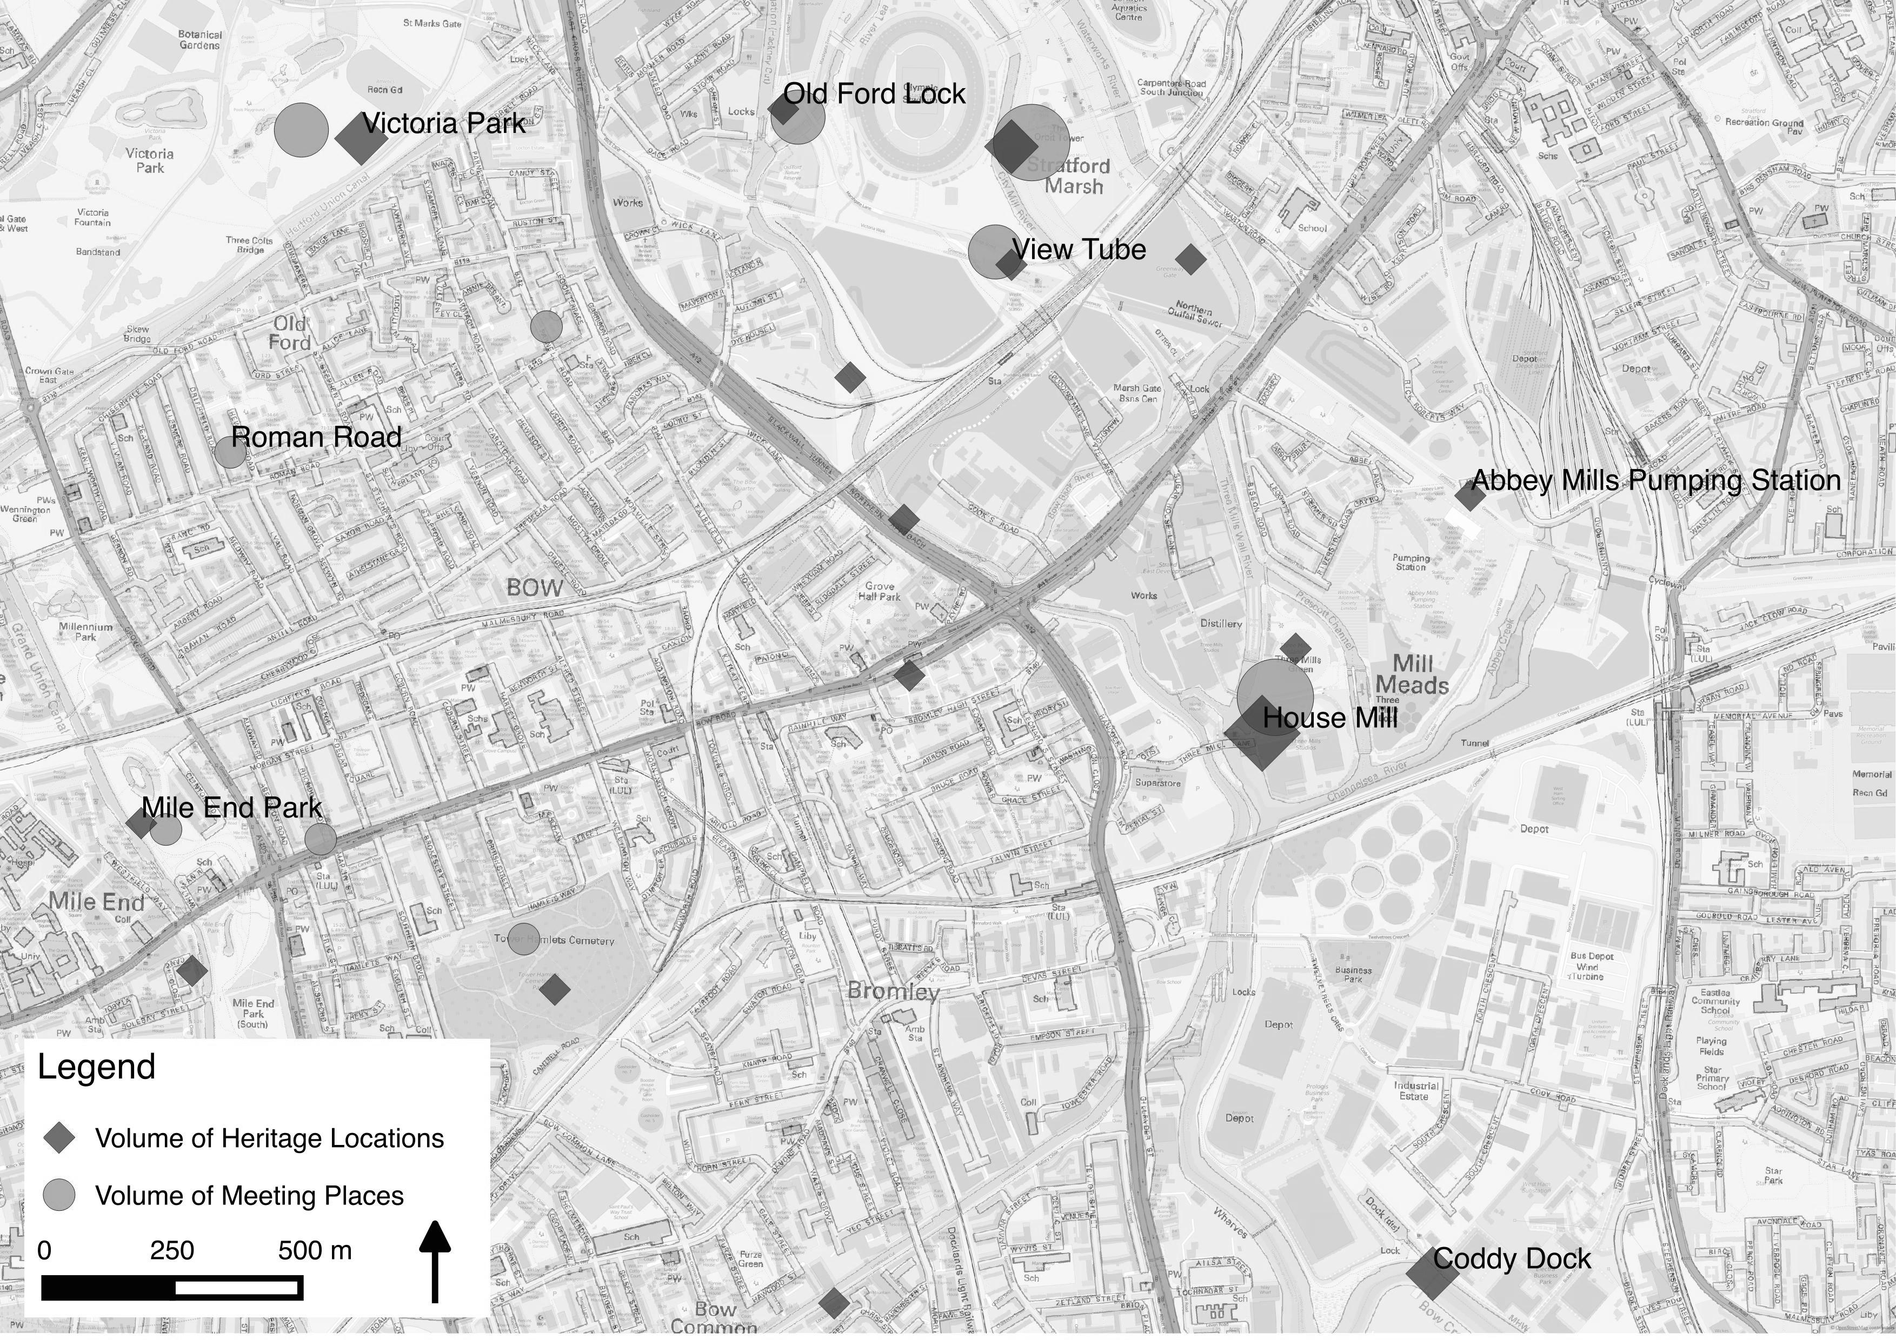

Figure 5: Cultural mapping findings from Three Mills, National Mills Weekend (volume of meeting and heritage places)

This map-based activity in particular helps to remove the limitations of the structured and solely text-based survey questionnaire, and brings engagement and participation to the process in a more interactive way. Some of the participants leave the cultural ecosystems map acknowledging that they have found out more about the area and feel more ownership of it, sometimes mentioning that taking part in this activity inspired them to get more involved in the decision–making for the development and usage of their water environment. Here engagement included campaigning on issues such as tow path safety, improved but sensitive lighting, clean-up of waterside areas, retaining community facilities and raised awareness around new developments such as restoration of heritage buildings, redevelopment of industrial sites and new housing.

Conclusion
It is evident that ‘the symbolic marking of places, the preservation of symbols of recognition, the expression of collective memory in actual practices of communication’ (Castells, 1991, p. 351) are very important in order to recognise and if necessary, protect the identities of places. However, the cultural assets that communities value are not always the same as those that local authorities consider as ‘culturally’ or environmentally ‘significant’ (Cauchi-Santoro, 2016). In the Lee Valley, for example, places like Cody Dock has been acknowledged one the one hand as a cultural heritage asset for the area not just because of its history but more for its contribution to the values and sense of place, while on the other hand, this is not mentioned in either official policy documents or in promotional literature. This suggests that cultural mapping can be considered as a useful tool to make some of the intangible amenities and less obvious heritage more valued and recognised, particularly where they are absent from official documents and narratives.

Besides making some of intangible heritage visible to officials and communities themselves, cultural mapping also helps to bring public awareness of developments in the local neighbourhood and river. Public awareness of changes and developments are usually controlled by the efforts of local government and other planning authorities - in the case of water resources this includes a plethora of intermediary agencies such as the Canals & Rivers Trust and Environment Agency who are distant and not democratically governed locally, but who can override local governance systems. Some of the information presented on the cultural maps, or provided verbally by the researcher/facilitator, can help the participants understand the impact and scope of developments in their area, as well as visualise future scenarios, and encourage participants to get involved in the planning and design consultation process. In the case of the Love the Lea Festival for example, the aerial map included the Greenway initiative between otherwise disconnected Walthamstow and Woodberry Down Reservoirs, which caught the attention of the participants and helped them learn more about this ‘green’ cycle route which otherwise was not widely publicised. Moreso, some of the participants acknowledged that contributing to the cultural ecosystems mapping of their neighbourhood was the start of more active involvement in the changes and developments underway in their local area and waterfront environment.

While organisations like the Chartered Institute of Water & Environmental Management (Arts and Environment Network) and Canals & Rivers Trust (Arts on the Waterways, Humans of the Waterways), have been developing initiatives that promote more cultural forms of engagement with communities, the Hydrocitizenship project has used participatory cultural mapping in order to bring a better understanding of the physical, social and environmental connectivity and characteristics of these urban water spaces and systems - both natural and anthropogenic. Overall, cultural ecosystems mapping helps to approach water related issues in a more holistic way rather than a single dimension by generating public interest in wider water and ecological issues. Cultural maps (printed and digital) provide a practical resource and legacy - the maps do not seek to ‘make physical spaces static, to connote ownership, or to articulate territory’ but to demonstrate the ‘dynamic lives of places in their complexity, diversity, and richness’ (Longley and Duxbury, 2016, p. 6).

To conclude, our research indicates that cultural ecosystems mapping can be a valuable tool to articulate community perspectives, experience and aspirations and thereby to inform local agencies and other policy makers about the values, concerns and knowledge that people have of their environment. It can also serve as a grounding for socially engaged arts practice that can benefit from the co-design and co-production of knowledge and visualisation of community visions. For example, following the cultural mapping undertaken at Three Mills, an artist-led citizen’s science project will construct and install a live water wheel at this heritage venue, to oxygenate the water in order to encourage fish life and demonstrate the power of the water (‘Active Energy’), working with a group of local pensioners who were former dock workers. Here cultural ecosystems mapping has combined with practice-based art and engineering science to engage local communities in co-production. Interdisciplinary working in this sense has helped develop collaboration and methodological innovation. In turn it is hoped that this will also lead to more sustainable and resilient planning and usage of the water resource, as well as empower residents and other users to co-create and link this embedded knowledge with official narratives and day to day usage and management.

- References
Beierle, T.C., 2002. The quality of stakeholder-based decisions. Risk analysis 22, 739–749.
Bryman, A., 2008. Social Research Methods, 3rd ed. Oxford University Press, Oxford.
Castells, M., 1991. THE INFORMATIONAL CITY: Economic Restructuring and Urban Development. John Wiley & Sons, London.
Cauchi-Santoro, R., 2016. Mapping community identity: Safeguarding the memories of a city’s downtown core. City, Culture and Society 7, 43–54.
Chan, K.M., Satterfield, T., Goldstein, J., 2012. Rethinking ecosystem services to better address and navigate cultural values. Ecological economics 74, 8–18.
Church, A., Fish, R., Tratalos, J., Haines-Young, R., Mourato, S., Stapleton, L., Willis, C., Coates, P., Gibbons, S., Leyshon, C., Potschin, M., Ravenscroft, N., Sanchis-Guarner, R., Winter, M., Kenter, J., 2014. UK National Ecosystem Assessment Follow-on. Work Package Report 5: Cultural ecosystem services and indicators. UNEP-WCMC, LWEC, UK.
Cinderby, S., 2010. How to reach the “hard-to-reach”: the development of Participatory Geographic Information Systems (P-GIS) for inclusive urban design in UK cities. Area 42, 239–251. doi:10.1111/j.1475-4762.2009.00912.x
Cinderby, S., 1999. Geographic Information Systems for participation: The future of environmental GIS?
Coates, P. et al., 2014. Arts & Humanities Perspectives on Cultural Ecosystem Services (CES). Arts & Humanities Working Group (AHWG): Final Report, April.
Corbett, J., Rambaldi, G., Kyem, P., Weiner, D., Olson, R., Muchemi, J., McCall, M., Chambers, R., 2006. Overview: mapping for change - the emergence of a new practice | Participatory Methods. Participatory Learning and Action 54.
Crawhill, N., 2008. The role of participatory cultural mapping in promoting intercultural dialogue - “We are not hyenas.” UNESCO, Paris.
Creative City Network of Canada (CCNC), 2007. Cultural mapping toolkit: A Partnership between 2010 Legacies Now and Creative City Network of Canada. Creative City Network of Canada and 2010 Legacies Now, Vancouver.
Dalal-Clayton, B., Bass, S., 2002. Sustainable development strategies: a resource book. Earthscan, London.
Duxbury, N., Garrett-Petts, W.F., MacLennan, D., 2015. Duxbury, N., Garrett-Petts, W. F., & MacLennan, D. (2015). Cultural mapping as cultural inquiry: Introduction to an emerging field of practice., in: Duxbury, N., Garrett-Petts, W.F., MacLennan, D. (Eds.), Cultural Mapping as Cultural Inquiry. Routledge, New York.
Evans, G., 2015. Designing legacy and the legacy of design: London 2012 and the Regeneration Games. arq: Architectural Research Quarterly 18, 353–366. doi:10.1017/S1359135515000081
Evans, G., 2013. Cultural Planning and Sustainable Development, in: Baker, G., Stevenson, D. (Eds.), The Ashgate Research Companion to Planning and Culture. Routledge, London; New York, pp. 223–228.
Evans, G., 2005. Measure for Measure: Evaluating the Evidence of Culture’s Contribution to Regeneration. Urban Studies 42, 959–983. doi:10.1080/00420980500107102
Evans, G., Foord, J., 2008. Cultural mapping and sustainable communities: planning for the arts revisited. Cultural Trends 17, 65. doi:10.1080/09548960802090634
Fish, R., Church, A., 2013. A conceptual framework for Cultural Ecosystem Services Working Paper. (Centre for Rural Policy Research: University of Exeter).
Geertz, C., 1983. Local Knowledge. New York: Basic Books.
Goodchild, M.F., 1992. Geographical information science. International journal of geographical information systems 6, 31–45.
Harrison, T. (2000). Urban policy: addressing wicked problems, in What Works: Evidence-Based Policy and Practice in Public Services. Bristol: Policy Press.
Hawkes, J., 2001. The fourth pillar of sustainability: culture’s essential role in public planning. Common Ground.
Lacy, S., Jacob, M.J., Phillips, P.C., Gablik, S., Májozo, E.C., Gómez-Peña, G., Lippard, L.R., Baca, J.F., Kelley, J., Kaprow, A., others, 1995. Mapping the terrain: New genre public art. Bay Press.
Lefebvre, H., 1974. The Production of Space (trans. Nicholson-Smith, D.). Oxford: Blackwell
Longley, A., Duxbury, N., 2016. Introduction: Mapping cultural intangibles. City, Culture and Society 7, 1–7.
Mebratu, D., 1998. Sustainability and sustainable development: historical and conceptual review. Environmental impact assessment review 18, 493–520.
Ontario-MCP, 2010. Cultural Resource Mapping: A Guide for Municipalities. www.ontariomcp.ca. Ontario.
Pain, R., Whitman, G., Milledge, D., Lune Rivers Trust, 2012. Participatory Action Research Toolkit: An Introduction to Using PAR as an Approach to Learning, Research and Action. https://www.dur.ac.uk/resources/beacon/PARtoolkit.pdf.
Plieninger, T., Dijks, S., Oteros-Rozas, E., Bieling, C., 2013. Assessing, mapping, and quantifying cultural ecosystem services at community level. Land Use Policy 33, 118–129. doi:10.1016/j.landusepol.2012.12.013
Rambaldi, G., Kyem, P.A.K., McCall, M., Weiner, D., 2006. Participatory Spatial Information Management and Communication in Developing Countries. The Electronic Journal of Information Systems in Developing Countries 25.
Read, S., 2012. A Map of Alkborough Flats and the Humber Estuary to explore the processes impacting upon the decision to establish a Managed Realignment Site (AHRC Landscape & Environment Programme, Impact Fellowship), http://www.landscape.
Ryan, R.L., 2011. The social landscape of planning: Integrating social and perceptual research with spatial planning information. Landscape and Urban Planning 100, 361–363.
Smeets, R., Yoshida, R., 2005. Cultural mapping and the safeguarding of the intangible cultural heritage. UNESCO, Paris.
UK NEA, 2011. UK National Ecosystems Assessment. DEFRA, London.
UK NEAFO, 2014. UK National Ecosystems Assessment Follow-on. DEFRA, London.
UNESCO, 2009. Culture and Sustainable Development. Examples of Institutional Innovation and Proposal of a New Cultural Policy Profile. Culture 21.

See www.leevalley.org for fuller results and maps

