Report from Orosei, Sardinia.
Museo Don Giovanni Guiso
The small town of Orosei, the main centre of the Baronia region on the eastern coast of Sardinia, sits in the fertile plain of the Cedrino River. The streets of the old medieval town are dotted with small shops selling fresh local produce, meat, fish, freshly baked bread and traditional craft ware nestling cheek by jowl with boutiques, galleries and cafes. These old cobbled streets wind gently up above the river valley to the central square, Piazza del P$ópolo,$ where you can drink a cool beer under the plane trees. All this is much as one might expect from a thriving but relatively quiet tourist destination whose main attractions are the numerous ancient churches, Spanish palazzi and, most significantly in terms of visitor numbers, close proximity to miles of beautiful pine fringed beaches that stretch out either side of the Cedrino estuary. It was therefore something of a surprise to discover, while holidaying there with my family in 2016, that the town also houses a theatre museum. Apart from a few posters on the edge of the square, there was very little information about the museum in the tourist office and not much online. Hidden in a side street just off the Piazza del P$ópolo,$ in a historic neighbourhood known as Palatzos Vetzos (old palaces) the museum was not only difficult to find but also never seemed to be open. After two unsuccessful attempts we finally gained access the day before our departure and were astonished by what we discovered inside. Museo Don Giovanni Guiso, houses a substantial collection of miniature theatres from across Europe, ranging from the mid eighteenth to the late twentieth century, as well as costumes and manikins. This theatrical archive is juxtaposed with haute couture gowns, including originals by the famous Callot sisters from Paris; a substantial collection of drawings from the Roman School, antiquarian books and other antique artefacts, including a marriage chest designed by the Sienese architect Baldassare Peruzzi (1481-1536) made for the Caponni family in Florence. Intrigued by this eclectic mix and particularly fascinated as to how a large number of miniature theatres, of varying mechanical operation and scale, had found a home in this remote corner of Sardinia, I returned to Orosei the following year to try to unravel the provenance of this unique, fascinating, if rather unorthodox collection. I was interested in what, if anything, these little theatres could tell us about design history and production. I also was also curious about the museum’s erratic opening times; its low key profile as a tourist attraction and what appeared to be its rather uneasy relationship with the town.
The theatre section of the museum advertises itself as “for children” and there are a number of recognisably ‘toy’ theatres in the collection of the type popular from the early nineteenth century across Europe and made famous in England by Benjamin Pollock (1856–1937) and as George Speight makes clear in The History of the English Toy Theatre,
[T]he toy theatre was just exactly the big theatre in miniature; actors, costumes, scenery, were all faithfully copied from actual productions on the London stage, and reproduced for their miniature performance. (14, 1946, 1969)
These little theatres were originally sold in paper strips to be assembled and stuck on stiff board at home. Later the shops began to sell wooden bare stage models with curtains and a proscenium to be added afterwards (ibid 102). Additional scenic structures and special effects could also be purchased including ‘wings that changed by mechanical means, and a sliding trap door at the back’ (John Oxenford in Speight ibid) as well as ‘clouds [that] hung from the top swaying in the most natural manner in every breeze’ (Ashton in Speight ibid). Many of the little theatres in Orosei are beautifully crafted in wood with ornate exteriors and detailed stage settings behind the proscenium. Given the close exchange between the full size and the miniaturised, if not the exact replication that Speight suggests, I wondered what these models might tell us about the organization of space, developments in light and sound and special effects as they operated in their full scale contemporaneous counterparts. It was clear, on the first brief visit, that some of model theatres on display were not aimed exclusively at children. The short text describing the exhibition that visitors receive on entry boasts of ‘miniature sets of famous operas such as La Traviata’. Given the nineteenth century fascination with spectacle these models appear to have offered children and adults the opportunity for playing on a small scale with the special effects they had witnessed in theatres and opera houses in full scale. How did the operas performed on this tiny scale in domestic settings relate to the operas staged as private performances by the larger marionette companies from the seventeenth century onwards in Europe? In size the theatres are discerningly similar to designers scale model boxes and it was tempting to see them as having a similar function rather than being purely decorative or simply toys even though the association of model theatres and puppets with toys is a persistent one as Mark J. Sussman confirms:
The term “model theatre” appears within the context of some puppetry literature as roughly synonymous with toy theatre, “model” signalling a relation of the miniature or toy proscenium stage to adult –scale theatre architecture and scenography that is analogous to the relation between a child’s model airplane, train, or dollhouse and the real thing in the adult world. (2014, 268)
With the model airplane, train and even dollhouse you can take things apart, expose the mechanisms and see how individual components relate to one another. You can also use them in invented scenarios over which you have complete control. Sussman raises interesting questions in his essay about child’s play and adult play that lay outside the remit of this report, however his observations about playing with scale and the power and control afforded by the model for children and adults is worth including here:
The model affords a child’s palpable sense of agency and demonstrates the wielding of power, if temporary of imagined, over concrete dramatic events. The ability to invert the loss of control we experience in contemporary life may be part of what’s at stake in the rediscovery of model theatre. (2014, 273)
By the ‘rediscovery of model theatre’ Sussman is referring to work by companies such as Rotterdam-based Hotel Modern (The Great War 2001) and Rimini Protokoll (Mnemopark: A Model Train World 2005) as recent examples of a long tradition of children and adults playing with scale. The model theatre collection in the Museo Don Giovanni Guiso also appears to reflect this long tradition and on my second visit, I was able to glean some sense to how this ‘play’ might have been conducted in some of the models on display, although lack of evidence has necessitated a degree of speculation on my part. What did become clear on my return is that the placement of Museo Don Giovanni Guiso in the middle of Orosei appears to demonstrate a ‘wielding of power’ on a grand scale that has possibly resulted in a reduction of agency on the part of the town which is being played out in a number of concrete, if not explicitly dramatic, ways.
I Teatri Di Nanni Guiso
Giovanni Guiso (1924-2006) affectionately known as “don Nanni”’ by the local population was descended from a long line of Italian aristocrats who for generations have owned vast tracts of land and property in and around Orosei. The family is closely linked to the prosperity of the town, having profitably farmed the fertile Cedrino valley to produce grain, employing local labour and operating a system of patronage well into the twentieth century. Museo Don Giovanni Guiso opened in January 2000, in a seventeenth century building restored and redesigned by the renowned Italian architect Vittorio Gregotti (b.1927 ) and financed by the regional council. Giovanni was born in Orosei, and even though he spent most of his life in Sienna, describes the museum as “a gift” to his home town. There is certainly evidence of the Guiso family’s generosity all over Orosei, however, don Nanni’s donation of his personal collection, amassed over a lifetime in his large villa in Sienna and housed in a specially restored building, was not universally welcomed by the town. From its opening the museum has created tensions between the local and regional council, within the local council itself and between the Guiso family and some sections of the local community. Issues such as how the ongoing running costs of the museum should be financed - the bequest did not include paying for a full time curator throughout the year; access and use of the museum by the local community and its promotion as one of the town’s visitor attractions remain unresolved. As the community has its own living theatrical traditions with local performance groups and vibrant religious festivals, some feel the town has no need of, what they see as, a vanity project foisted on them by a symbol of a feudal past. The collection consists of mainland European, English and predominantly Italian models and puppets that have no immediate connections with Sardinia. In the opening text of the catalogue don Nanni explains how he was profoundly impressed as a boy of ten by a marionette theatre from Vienna that visited his house in Orosei bringing “a breath of Central European refinement” to the town. This casting of the town as in need of refinement seems to underlie the museum project and since Giovanni’s death the family has exercised strict control over how the public engage with the collection blocking any change or innovation.
The museum is organised over three floors, with the theatre collection spread over the ground and first floors in rough chronological order. The Scuola Romano artworks are also on the ground floor and the first floor houses the collection of rare Sardinian books. The costumes and haute couture fashion items as well as other rare ‘collectables’ occupy the second floor. Nearly all the models are under glass and the museum has installed a special light filter to preserve their colour. The short exhibition catalogue describes the theatres as of four kinds:
1. Toy Theatres
2. Theatre reproductions to scale of existing theatres
3. Professional theatres for paying shows
4. Dioramas
As the models are not arranged thematically and there is very little information given for most of them beyond dates and simple descriptors it is sometimes difficult to discern which category each exhibit falls into, apart from the miniature dioramas, and therefore it is hard to get a sense of what you are looking at. According to the catalogue, Guiso wanted viewers to discover the models for themselves, ranging back and forth between countries and time frames. However, with no context or curatorial rationale beyond the collector’s personal taste, this was frustrating. The models are on the whole in very good condition and as a viewer one really needed more sense of their provenance. Like so many of the material remains of theatre history, including designers’ model boxes, these miniature theatres, are difficult to store. As John McCormack suggests in relation to the larger Italian puppet theatres and marionettes, ‘In aristocratic houses it was easier to store such things in attics or cellars.’ (2,2010). Giovanni Guiso was an aristocrat and a socialite who maintained an open house for artists, designers, directors and performers (the ballet dancer Rudolf Nureyev was a guest) in his expansive Siena home. It seems most likely that as his love of the theatre and of puppets became known, people donated their family miniatures to him or made him aware when they were up for sale at auction across Europe. The exact number of models in the collection is difficult to pin down. I counted thirty-six, although in his short introductory essay in the catalogue, Moreno Bucci suggests there are forty-seven. It is possible of course that they were not all on display or some had been removed for restoration but I was unable to verify this.
Miniature Worlds
The models are fascinating and varied in size. The catalogue tells us ‘none of them exceed 50cm in height by 60cm in length and 40 cm in depth’ although this was difficult to accurately confirm (as they are behind glass) and doesn’t accord with the dimensions given on the displays themselves – some of them appear to be significantly bigger. What is clear is that these models are not accurate to scale reproductions of existing stages but rather represent miniaturised copies or even some completely imagined theatrical spaces. As such they can be seen as toys or independent objets d’art that speak in general terms about ways of seeing and scenic representation in late eighteenth and nineteenth century Europe. Christopher Baugh characterises this as a theatrical sensibility ‘committed to painting and its corresponding pictorial aesthetic and composition’ (21, 2005). They present in miniature:
[A] systematic and unified perception of stage technology: a technology that converted the visual experience of the world into a codified collection of scenic apparatus – the backcloth, the wings, the borders and the ground-rows.’ (31, 2005)
These are picture box prosceniums, with painted gauzes, flats, velvet tabs, trap doors and, in one model, coral shaped footlights, all contained within boxes elaborately embellished with neo- classic columns and figurines. Some, the very earliest, appear to be for glove puppets and the catalogue makes a distinction between ‘burattini,’ glove puppets and ‘marionettes’ string puppets, even though there are very few puppets on display. McCormick argues the slippage between these two terms has been some-what fluid over the centuries in Italy with references in the eighteenth century to ‘“burattini in musica,” unambiguously meaning marionettes performing opera.’ (4, 2010) As one might expect with so many Italian exhibits and a culture saturated in opera the pictorial aesthetic of many of the miniature theatres is dominated by a high degree of Italian romanticism. There is one notable exception to this predominantly nineteenth century collection, a wooden Venetian Theatre from the mid eighteenth century, with plaster decorations, and two silhouetted iron puppets in the centre of the stage, Colombina and Pantalone, in a Commedia dell’Arte pose. (figure 1) Moreno Bucci explains ‘They are movable by means of a handle placed on the external right side of the theatre. Probably the marionettes could be exchanged with others, each one inserted into iron channels specially designed by the maker in a two-dimensional architectural system.’ (Museum Catalogue) Whether this was ever used as a toy or was purely decorative is not clear, the display text suggests it should be seen as an objet d’art. 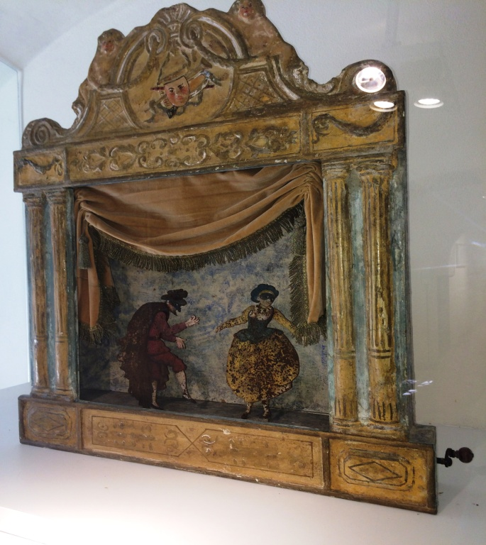
The ‘toy theatres’ are made of cardboard, with beautifully painted removable flats and backdrops that can be arranged to create interior and exterior scenes in perspective. Some of these nineteenth century boxes use ‘state of the art’ chromolithography to achieve their effects and this technique can also be seen in the six early nineteenth century dioramas from Augsburg, in Germany, depicting idealised courtly and pastoral scenes with tiny two dimensional figures. These are miniaturised versions of the classic dioramas invented by Louis-Jacques-Mandé Daguerre in the early nineteenth century although their display suggests these were ornamental rather than having been used to experiment with light and perspective.
The majority of the wooden models are rosewood or maple with a number embellished with stucco and ivory decorations. Bucci describes these in the catalogue as ‘chamber theatres built by diligent artisans as unique pieces for the enjoyment of the children of the aristocratic and wealthy classes’ but as discussed earlier the kind of ‘play’ they facilitated is not clear. Were they operated by adults for children, in the manner of the professional Viennese marionette company that visited the Guiso family and made such an impression? Or, were they played with by children themselves –almost in the manner of elaborate dolls houses. As spaces of play and creativity they operate within strict parameters of course re-enforcing a privileged bourgeoisie world view and apparently leaving very little space for the imagination. There is no sense here of the anarchic potential of Commedia dell’ Arte and Punchinello.
As early as the seventeenth century, “burattini in musica” exploited ‘the marvels of the baroque stage’(155, 2010) in custom-built small theatres in the palaces and mansions of the aristocratic and the wealthy across Europe and these elaborate productions were soon available more widely to those of the paying public who could afford them. They were promoted as offering ‘music, ballets, flying machines of a completely new invention, and scene changes’ (ibid). By the end of the eighteenth century according to McCormick, professional marionette companies across Italy ‘offered the visual delights of opera and musical theater(sic) and the excitement, comedy and pathos of drama in a more modest form that was within the pockets of ordinary people’(15.2010). These scaled down performances adapted from full length operas were accomplished with one or two singers (often hidden) and a small orchestra. It is quite possible that some of the miniature theatres in Museo Don Giovanni Guiso operated on similar principles on an even smaller domestic scale as one or two of the models suggest.
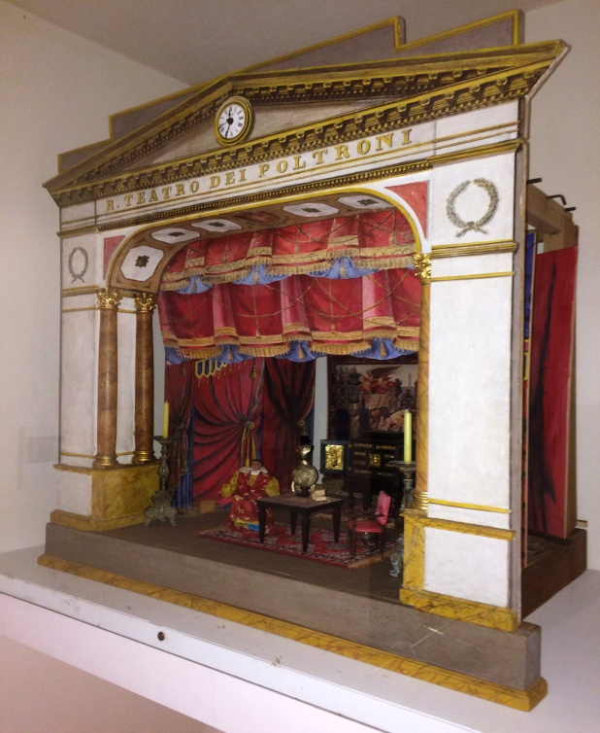
‘Reale Teatro dei Poltroni’ (The Royal Theatre of Loafers) from Florence, at 105.5x116x75 cm is one of the larger models in the collection and dates from the early nineteenth century. (figure two) According to the catalogue, it was fashionable at this time in Italian cities for ‘a number clubs and academies with sophisticated and humorous names (such as “of loafers” “of fools” “of the uncouth”) to have miniature theatres embellished with rich and valuable furnishings.’ Reale Teatro dei Poltroni, is one of the few models that has a traceable connection to scenographic history as it references materials from an actual theatre building within its structure and also displays an iconic costume design in miniature, albeit from completely different time frames. As presented in the exhibition this anachronistic layering of styles and conventions does suggest that this model was used for performance, possibly by Guiso himself. The swagged red curtain is a miniature reproduction of the one that hung in the Teatro Argentina, in Rome, one of the oldest theatres in the city. According to the catalogue the curtain was destroyed (no date given) and this reproduction was painted by Romano Gagliari and crafted by painter and stage designer Luca Gandgalia in 1837. The scene depicted is from Don Carlos by Giuseppe Verdi. The museum assistant was keen to point out that a number of different stage settings for this opera came with the model but we were unable to locate their whereabouts during my visit. The flats are suspended on bars and the stage space is filled with miniature furniture, antique collector’s items in their own right, from a mix of historical periods. The figure of Don Carlos is wearing a costume designed by British-American costume designer Peter J. Hall (January 22, 1926 – May 27, 2010) and the backdrop is a miniature reproduction of the tapestry Il Trionfo dell’Arte di Siena by Giuseppe Catani Chiti (1866-1945) commissioned by the city of Siena for an exhibition in 1904. One can only speculate as to how all these disparate elements came together. The miniature theatre may have been carefully crafted to keep in the memory the splendour of the drapery that decked the proscenium of Teatro Argentina in Rome in the previous century. If it was a gift or bought by Guiso at some point in the mid twentieth century, complete with furniture, where had it been in the intervening years? Peter Hall designed costumes for opera in the USA and Europe and was also responsible for the costumes for Romeo and Juliet directed and designed by Franco Zeffirelli at London’s Old Vic Theatre in 1960. The costume on the figure of Don Carlos might be based on an actual costume design that Hall gave to Guiso on a visit to his villa in Siena but I can find no record of Hall having ever worked on that opera. The figure looks like a small version of a doll reminiscent of Action Man or Ken, Barbie’s partner. Ken was created in 1961 so that would date the costume to the sixties. Hall worked with Zeffirelli for more than three decades and was described in his obituary in the Guardian as ‘a key collaborator in his (Zeffirelli’s) style of sumptuous, painterly nostalgia’ creating 19th-century operas ‘set in a wistfully imagined past’. The obituary goes on to quote theatre scholar Dennis Kennedy who thought that, ‘Hall's work for Zeffirelli inscribed "sentimental romanticism into a sensory evocation of period". (https://www.theguardian.com/stage/2010/jun/24/peter-j-hall-obituary accessed 1.4.2018) Certainly, Reale Teatro dei Poltroni, inscribes ‘a sentimental romanticism’ and evokes a lost theatrical past but it also demonstrates a pragmatic sense of ‘play’ through a tantalising collision of styles that speaks somehow to the theatrical present.
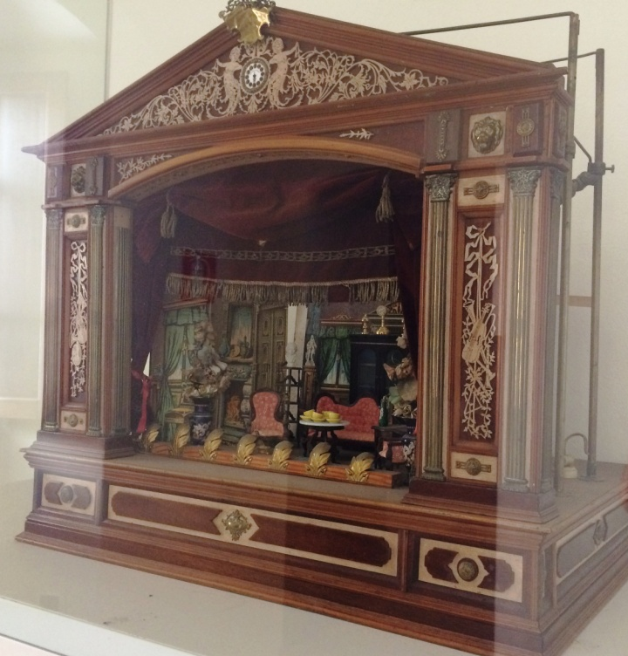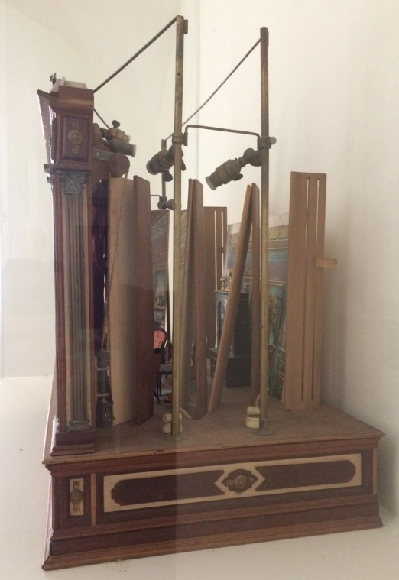

One miniature theatre in the collection does display clear evidence that it was used for performance and seems to indicate that Guiso was interested in creating stage effects. Described as ‘English, second half of the nineteenth century. Rosewood, brass and open work ivory’ this model includes a directional lighting rig and footlights powered by electricity. Guiso may have constructed the rig himself or it may have been extracted from a working model box but clearly the technology is much later than the miniature theatre itself. Bucci tells us in the catalogue that ‘in his house in Siena… he was able to reinvent – lights, sounds and atmosphere’ and this is very possibly one of the models Guiso used for his experiments. (Fig 3 and 4) It measures 72x80x46.5cm and there is no more information provided in the catalogue although the museum assistant was able to tell me that it was based on a London theatre whose owners were in debt and had commissioned a series of these models to be sold as a form of memorabilia or perhaps to be given to potential patrons as gifts. As the miniature isn’t obviously a representation of any existing London theatre it’s difficult to verify this story. Paradoxically, it is the most doll-house-like of all the exhibits, stacked with miniaturised nineteenth-century furniture. The painted romanticism of many of the Italian models has been replaced with the introduction of ‘real’ furniture. Don Carlos included furniture but in a formal arrangement; here, chairs, cabinets, china and drapery appear in a bourgeoisie domestic setting reflecting in miniature the late nineteenth and early twentieth century movements of naturalism and realism that challenged earlier pictorial design. The stage drapes are made of real red velvet, and the miniature wooden cabinets and decorative china vases that adorn the set co-exist with painted furniture, windows and drapes on flats at the side and back of the stage. This ‘conflict between painted and built scenic detail’ (26, 2005) was a cause of real anxiety amongst theatre pundits and critics at the end of the nineteenth century. ‘A real chair will make a painted chair look flat and poor, while the painted chair will make the real one look dull and prosy.’ The extent to which this mix was present in the original model and how much it is a product of Guiso’s purposeful stylistic eclecticism is difficult to ascertain without more knowledge of its history.
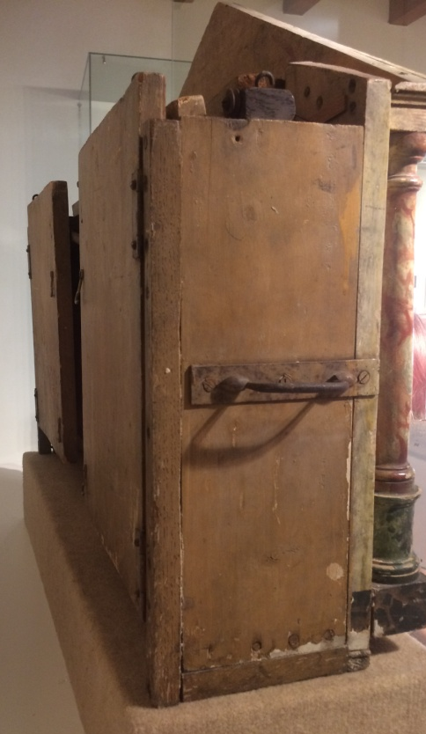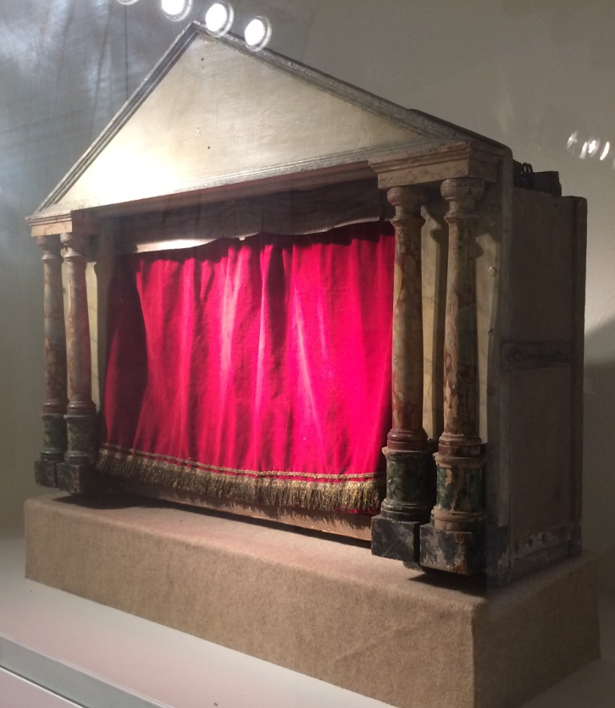

There is one model box in the collection that is of a very different order and attests to another form of use that readers will doubtless be more familiar with. It is listed in the catalogue as, ‘Extendable Theatre, used by scenographers to present scene drafts to the producer, France, Paris? Early nineteenth century, painted wood ( 63x78x23cm ).’ Figure 5 and 6. The proscenium arch of this box is flanked on either side by set of marbled Doric columns and covered with a velvet curtain. This latter looks as if it was added later for decorative purposes and from the side view the proscenium also looks as if it might have been tacked on, perhaps to facilitate viewing the proposed perspectival scenic arrangements from the position of the audience. The whole box is quite roughly put together, with a handles for portability which attests to its use as a working tool. It folds out to create a stage of considerable depth with bars visible from which to hang painted cloths. Is it built to a scale that relates to an actual theatre to show refined designs, or, is it a space for early speculative ideas? No more information is given. It is a shame that it is displayed in such a closed state as it has the potential to engage the imagination, with its history of use evoking the presence of the past and the absence of a controlling vision opening up a space for play.
The ‘anti-model’ and the place of play
In their recently published The Model as Performance (2018 ) Brejzek and Wallen ‘establish the model as an active agent in the making of space’ ( 1.2018) as well as arguing convincingly for its ‘performative and epistemic’ qualities and its ‘potential for cosmopoiesis, or world making’ (ibid) They are referring of course to scale models in set design and architecture. The miniature theatres in Orosei are not consistently to scale; neither do they offer (with the exception of the scenographers’ model above) projections of future states. They are generalisations or impressions from specific historical periods of what a theatre is and what a stage should convey and as such they simply represent the status quo; world affirming rather than world making. There is a resonance in the way the miniature theatres operate in Museo Don Giovanni Guiso with the work of Spanish artist and set designer Jordi Colomer. Colomer exploits the mimetic conservative capacity of models in his art works by reversing the notion of them as pure objects or ideal templates and instead producing what he terms ‘anti models.’ For example, The Place and the Things, 1996 is a white architectural scale model of a city but it is not an ideal model, a projection of a perfect city, what it reveals is a ‘used’ city, an existing city in all its disorder. ‘The model is not presented as a project, but as a representation of the real.’ (MACBA 1996).
As material objects the theatres in Museo Don Giovanni Guiso are ‘idealised’ if not ‘ideal’ miniaturised templates of pre-existing, buildings, stages and set designs, as they are imagined to have operated at full scale; as such they do not project, so much as represent the real, frozen in time. As objects of play their static nature suggests the recreation of a coherent performance past within strict parameters, known and controllable. But they also offer the facility for the reconstruction of disorderly and imperfect performance histories that interrogate the past and mix temporalities and aesthetic styles in the present -the potential to explore the stage not as ideal state but as it is used. This is what makes them valuable as evidence of scenographic history even as it highlights the difficulties of conservation and display for historians, curators and custodians of the material theatrical past.
These difficulties remain unresolved in Orosei. The organisation of the collection is based on curatorial decisions made almost twenty years ago that instated static displays behind glass with no possibility of interactivity. This presents a problem for a council that needs to justify the museums presence in the town amongst the local community and as a tourist attraction, while at the same time respecting the wishes of the family that nothing should be changed. In the catalogue Bucci is keen to differentiate this collection from the other famous collections of marionette and miniature theatres including the International Marionette Museum in Palmero, Sicily. (https://www.museodellemarionette.it ) But the museum in Palmero, engages with the public through performances, interactive displays and talks that operate alongside collections behind glass. Brejzack and Wallen argue for the epistemic value of models but they also make the point that ‘visual models are not ‘truthful’ representations of present or future states but are subject to ideology and intent, so that their reading is dependent on visual trends, histories and cultures and diverse perceptual conventions.’ (13, 2018) The ‘ideology and intent’ behind the production of these miniature theatres does not sit comfortably with the values of a town forging an identity in the 21st century nor do they resonate with the ‘visual trends’ of a generation hooked into intermediality and atomised virtual worlds. As discursive tools, however, they have the potential to be used to interrogate their own histories and the cultures of privilege and patronage that produced them but to do this they would need to surrender their status as historical artefacts, be taken out of their glass cases and engage in more tangible ways in the present. The museum of course would then face the same issues as all those involved with the material artefacts of theatre history, striking the right the balance between conservation, access, engagement and play. Nanni Guiso wanted ‘a museum of culture and fun’ and these aspirations are not irreconcilable. I hope this report will encourage readers to visit the beautiful town of Orosei, to enjoy its relaxed ambience and explore its many historic sites; to support Museo Don Giovanni Guiso and spread the word about its treasures, and maybe, conduct further research. The town is caught in a cleft stick between the wishes of the family and those who would like to see the focus of the museum change so that more people can celebrate the rich heritage it represents. Museo Don Giovanni Guiso engages with a rich seam of theatre history in miniature on a significant scale and it deserves a wider audience.

References
Baugh, Christopher. 2005. Theatre, Performance and Technology: the development of scenography in the twentieth century. London: Palgrave Macmillan.
Brejzek, Thea and Wallen, Lawrence. 2018 The Model as Performance: Staging Space in Theatre and Architecture. London: Bloomsbury
McCormick, John with Cipolla, Alfonso and Napoli, Alessandro. 2010. The Italian Puppet Theatre: a history. Jefferson, North Carolina: McFarland
Speight, George. (1946) 1969. The History of the English Toy Theatre. London: Studio Vista
Sussman, Mark J. 2014. “Notes on New Model Theatres” in The Routledge Companion to Puppetry and Material Performance edited by Dassia N. Posner, Claudia Orenstein and John 268-278, London: Routledge.

.

.

Sardinia was under Spanish rule for 300 years from the early fifteenth century to the early eighteenth.
The Caponni family is one of oldest and most illustrious in Florence with a lineage going back to the thirteenth century.
John Oxenford “The Toy Theatre” in The Era Almanack, 1871
John Ashton, “Childhood’s Drama” in Varia, 1894
Filippo Acciajoli (circa 1637-1700) for example, composer, musician and scenographer, was ‘fascinated by everything to do with stage scenery, and the puppet stage provided an ideal medium for his scenographic inventions’ (McCormack, 22, 2010). For a full account of these performances see The Italian Puppet Theater(sic) A History, By John McCormick.
Don –is a term of respect for members of esteemed families in Italy and other catholic countries like Spain. It is also an honorific for members of the clergy. It is a colloquial form of Dominus - the Latin for Lord, Sir.
The family have undertaken a number of restoration projects in the town including the ancient church of Santa Maria è Mare (Our Lady of the Sea) situated near the mouth of the Cedrino River.
Translations from the Italian, unless otherwise stated are by the author, who also wishes to thank, Karim Carrone and Eleonora Saba for their help with translating the catalogue and Elisa Carrone for her time and patience.
A term used to describe artists based in Rome, or having close links with it, in the 1920s and 1930s.
Moreno Bucci is an art historian, teacher and conservationist of the Historical Archive of the Maggio Musicale Fiorentino.
There are some twentieth century model theatres but the bulk of the collection is from the nineteenth century.
Luca Gandgalia (circa 1780 -1850) was chief scenographer at the Teatro di San Carlo in Naples.
Electric cabling can just be seen at the back of the model and is visible in the side view
Percy Fitzgerald, The World Behind the Scenes, London, 1881, p.8 in Baugh, p23, 2005
Jordi Colomer (b.1962 in Barcelona) represented Spain at the 57th Venice Biennale in 2017 and frequently uses models in his artworks.
The Place and theThings is part of the MACBA exhibition Beneath the Surface, Oct 2017-Nov 2018 Barcelona. https://www.macba.cat/en/macba-collection-beneath-the-surface

