: We learn through play. By playing, we test the boundaries of the world, its social and behavioural norms, and the qualities of interactions in our system of relationships. Play implies exploring, inventing, and competing within a given set of protocols or limitations, and skilful or successful play denotes peak performance according to those rules. But play can also go one step further, when players understand the system of relationships in which they act so well that they can engage in a practice of détournement, deconstructing and working around the boundaries that everyday players respect unquestioningly.

Over the last decade, video games have evolved from a popularly-maligned hobby of children and “geeks” into the world’s most valuable entertainment industry. In the same way that film was both the lightning rod and litmus test for cultural studies in the twentieth century, video games now attract the same level of reflective analysis and critique—and deservedly so. At the fringes of video game practices, we find indications of ways that we might challenge the boundaries of our worlds.

I like playing video games myself, but watching other people play them is a particularly cathartic, sublime experience. It's how I imagine people feel about watching golf or snooker. I enjoy watching people think their way through problems and make choices, and with constant advances in CGI, watching a video game is effectively the same as watching a pretty good movie. Extremely skilled players can be clever with the camera and build cinematic narrative into the way they play. Machinima has its origins in this practice of using the architecture of games to make cinematic narratives and has since expanded to include a litany of YouTubers and video makers. For instance, VaatiVidya's lengthy but addictive expositions on theories in the Dark Souls games all set to stunning visuals. In these streams, the “players” use the game architecture, its physics and mechanics to create alternative narratives unintended by the game developers and writers.

These videos can be deeply impressive but an even richer vein of game-like media is found in the practice of speedrunning. Like machinimists, speedrunners develop a nuanced understanding of the architecture and mechanics of a game, but for different purposes. Speedrunning is essentially the act—or art—of completing a game or part of a game in as little time as possible. Rather than simply playing very fast, however, speedrunners can use any strategy made possible by the game’s code to achieve speed. In its simplest iterations, this can simply mean being very good at playing the game—possessing a mental and motor dexterity precisely attuned to its rules and rhythms, responding instinctively and efficiently to challenges in the form of enemies or obstacles, having an innate sense of the economy of choices to prioritise speed over other markers like health or wealth in the game journey from beginning to end.

Speedrunning is the art of exploitation of simulated environments. At its best, speedrunning is responsible for some of the most unfalteringly stunning acts of mastery and showmanship that I've seen in any discipline, and I mean mastery in a very real way. Unlike, for instance, tennis, cricket, football, cycling or any other form of sport or game where mastery is measured by and conflated with just being very good at performing the sport within the confines of the rules, speedrunning rewards “play” in the ludic sense of flexing the edges of the technical and conceptual construction of the game.

Speedrunning can be found in a wide variety of forms and forums, with sites like Speedrun.com and Twin Galaxies acting as core databases of records and rules. Records are generally accompanied by a video that shows the run with descriptions of techniques and constraints applied to the run. A speedrunning commentary subculture has even arisen, with intense analyses and breakdowns of specific runs by ardent YouTuber critics like Bismuth and AverageTreyVG. As with any subculture founded on the Internet, there are celebrities, events, intrigue, and festivals, such as the popular Games Done Quick IRL runner meetups.

Speedrunning can be traced back to the first arcade video games: players would record their runs on VHS tapes and send them to webmasters of forums like Twin Galaxies, who would authenticate and post the runs. But the real explosion of speedrunning occurred in the mid-1990s with the parallel emergence of home Internet connections and new games like Quake and Doom. These games came with editors that allowed players to create their own levels and share them online. Given that dial-up Internet speeds were mostly insufficient for transferring video files over the Internet, but that the data for these demo maps was significantly lower some players began to reverse-engineer their level creations to “record” the data of runs at a much lower file size than video, which could then be replayed by others in the community. Since then, the range of games, recording formats, and channels for sharing and watching speedrunsn has expanded exponentially alongside the growth of bandwith (although the most popular titles remain the classics, such as Super Mario Bros., GoldenEye 007 and The Legend of Zelda: Ocarina of Time).

Speedrunning challenges the notions of how we “play” and “beat” games. In normal play, these terms denote that the game was followed and finished within the confines of the way the developers intended. Speedrunning, on the other hand, challenges the world the developers have built. It abuses and exploits glitches, cuts, tricks, shortcuts, and hacks to defy the world that allows the run to exist in the first place. This is true play, pushing and testing the boundaries that structure the world of the game. The most popular games for speedrunning are dissected and broken down to their very code, every element of their construction pored over by a community of rabid speedrunners looking for any microsecond edge over their competitors. Dedicated wikis spring up to log techniques, routes, and strategies, as well as to debate the finer points of what exactly constitutes a run. Meanwhile, speedrunner video streams can generate millions of views on sites like YouTube and Twitch.

The leader board on speedrun.com of The Legend of Zelda; Ocarina of Time. This twenty-year-old game is still continually played by speedrunners to shave microseconds off play time. The tabs at the top are different conditions for runs; 'any%' means any level of completion is acceptable as long as the game is finished. This is a common category across most games. 'no IM/WW' means no item manipulation or 'wrong warping' which are techniques specific to the mechanics of this game in particular.
This is a still from a video in which Karl beats a fifteen-year-old record for the Dam level in GoldenEye 007 at 52 seconds. There's almost no play in it in the way the game is conventionally understood, but rather an approach that reveals a dense understanding of its construction. Throughout the run, we see very little because Karl continuously angles the camera downwards towards the floor: this view reduces the background assets that have to be loaded in the game, thus allowing the game to run slightly faster.

Speedrunning may appear piratical and anarchic, but its world is incredibly rule-bound, with fervent and effective testing and validation procedures to identify “cheating”.

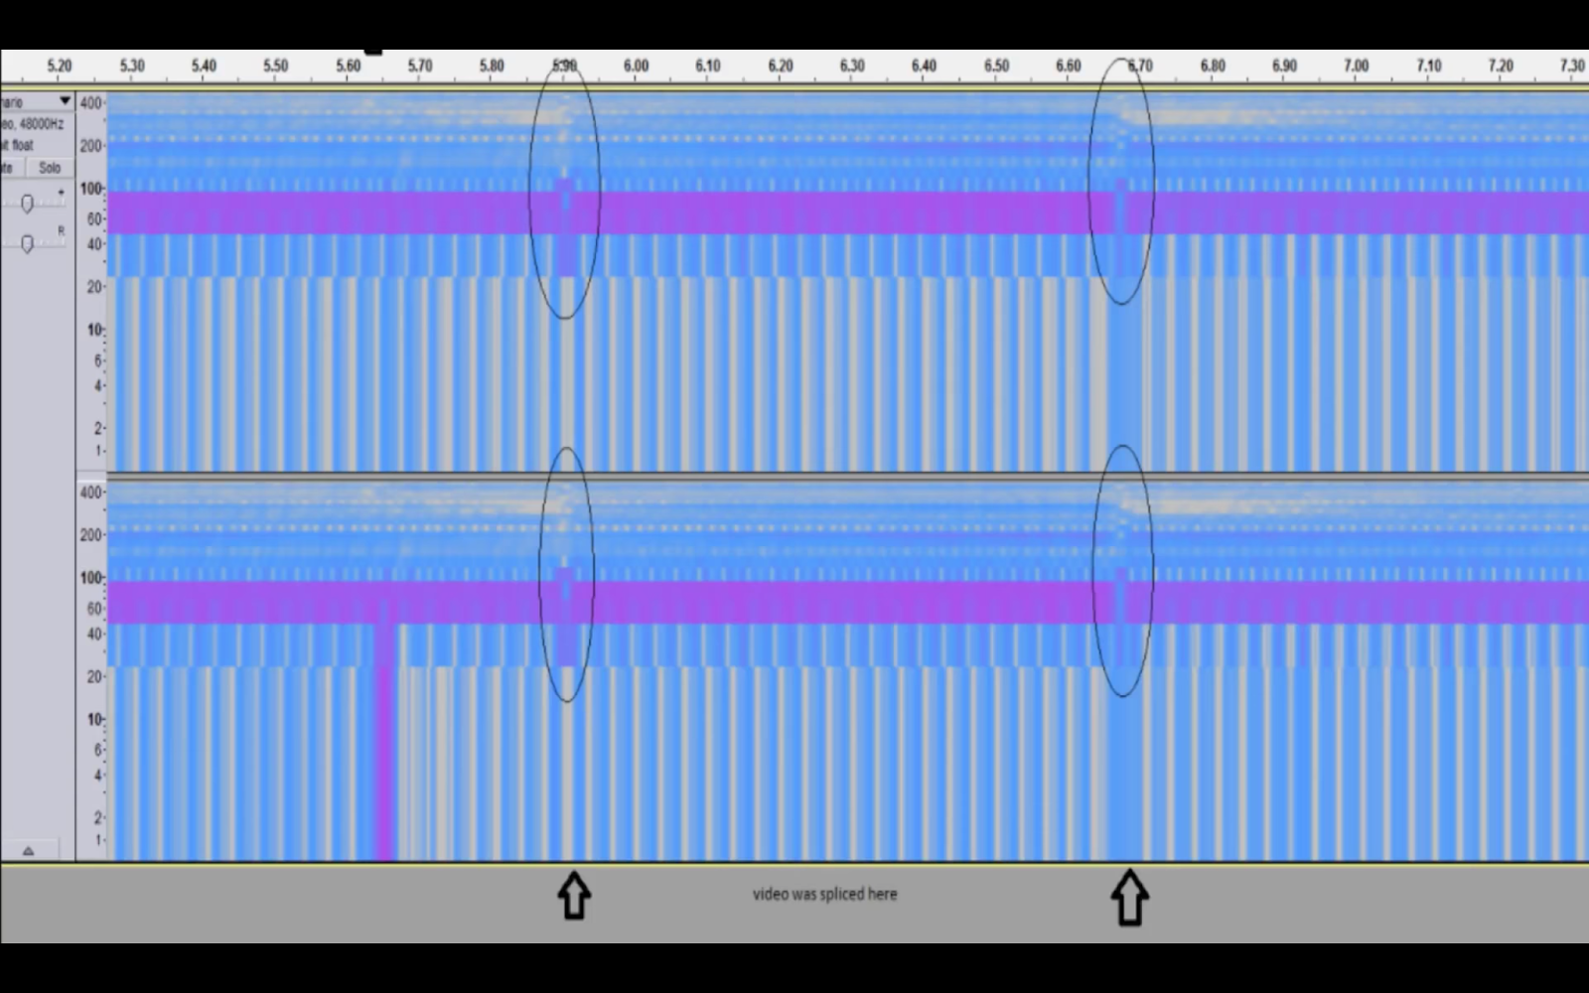
Speedrun fans and analysts will look for evidence of cheating in video and audio tracks that are uploaded. In this case a Donkey Kong player was caught 'splicing' by analysis of the audio track.

Cheating isn't cheating in the sense that we might understand it by the rules of normal gaming. In everyday play, clipping through the map (literally passing through the landscape), navigating around bosses to avoid fights or overpowering your character would be considered poor sportsmanship at best and outright deception at worst. Cheating in speedrunning, however, is essentially the disingenuous reporting of a run. Splicing, one of the most heinous of cheats, means editing together a run from discrete pre-recorded parts. Fans spend hours scrutinising videos for signs of splicing such as skipped frames or mismatched inventories. In fact, the techniques to detect splicing in a certain game—including looking for in-game cues (themselves collated and tabulated on wikis and open documents)—are as varied as the techniques used to speedrun. In [Figure 1] the frames of a loading sprite animation in Super Meat Boy, which has a regular 40-frame cycle of an “up” and “down” animation, are analysed from screen to screen to detect any irregularities that might result from splicing.

Rank | 1 | 2 | 3 | 4 | 5
Player | Matte | Hamb | vorpal | Zaxst | warm_ham
Time | 17:37 | 17:41 | 17:43 | 17:55 | 17:59
VoD FPS | 60 FPS | 60 FPS | 60 FPS | 60 FPS | 60 FPS
Forest Exit | 16 Down | 17 Down | 1 Down | 13 Up | 16 Up
Hospital Enter | 4 Down | 3 Down | 19 Down | 7 Up | 4 Up
Hospital Exit | 14 Up | 16 Up | 8 Down | 18 Up | 15 Down
Factory Enter | 6 Up | 4 Up | 12 Down | 2 Up | 5 Down
Factory Exit | 10 Down | 15 Down | 10 Down | 12 Up | 12 Up
Hell Enter | 10 Down | 6 Down | 10 Down | 8 Up | 8 Up
Hell Exit | 4 Up | 11 Up | 9 Down | 6 Down | 7 Down
Rapture Enter | 16 Up | 9 Up | 11 Down | 14 Down | 13 Down
Rapture Exit | 20 Up | 9 Down | 7 Down | 15 Up | 7 Up
End Enter | 21 Down | 11 Down | 13 Down | 5 Up | 13 Up

Photoshopping footage is obviously a common cheat, commonly involving changing numbers that appear on screen at the end of levels. Speedrunners have developed an emergent behaviour to demonstrate authenticity by moving their cursor around and over the time display to show that it is, in fact, a video and not a Photoshopped still image.

Goldeneye 007 was a common target of Photoshopped finishing times for years because of the ease of just copying the numbers on screen. Pixel pattern analysis (as in [Figure 2]) is performed by speedrun analysts to detect when numbers have been copy-pasted.

Another cheat is using an emulator to simulate one piece of hardware on another without reporting it. Emulators can create significant advantages through faster frame rates on a modern PC or, on the contrary, through slower frame rates to enable faster and more precise responses, which can make all the difference when every microsecond counts.

The definition of cheating is nuanced and varied among different communities. “Menu-ing”, for example, is when a runner performs actions quickly through the game menu, from rudimentary tasks (like moving inventory items around) to more sophisticated techniques (such as rapidly saving and loading to reset an enemy or “quitting out” to respawn in a different location). Item manipulation to exploit glitches is generally allowed as long as it is permitted by the architecture of the game. Yet geography determines how menu-ing is regarded: most Western audiences reject the use of turbo controllers (which automate the rapid or continuous pressing of buttons), while Japanese speedrunners are respected for their mastery of menu-ing using turbo controllers.

Even “glitchless” runs that employ none of these tricks are subject to debate, and still court controversy on twenty-year-old games to this day. [Figure 3] shows a controversial “frame perfect” jumping technique that can be used in The Legend of Zelda: Ocarina of Time: a sequence of actions has to be performed in the right order in the exact frame (when the game may run at speeds up to sixty frames per second). This particular technique involves using the physics of an explosion followed by an attack move to jump the character into a normally inaccessible area. Previously, this level of precision was thought possible only with “tools” (by editing game code or using an emulator). However, in December 2017, a second player named dannyb21892 (the world record-holder for glitchless Zelda runs) managed to execute the demonstrated technique through sheer dexterity, leading to an active debate over the difference between a simple skip (the circumvention of a large part of a game) and a glitch (the exploitation of mechanics to the speedrunner’s advantage).

Paradoxically, arguments over what constitutes “cheating” in an activity that is about bending rules have caused some of the most fundamental schisms in the ethics of speedrunning methodology. One of the oldest examples played out on Speed Demos Archive (SDA), which began as a forum for Quake players but quickly expanded to other games, including Metroid 2002. Speedrunners in Metroid 2002 commonly used “secret worlds” or “out of bounds” play for faster runs, thereby navigating through parts of the game architecture that were never intended to be accessed by the gamer, including unfinished areas or spaces cut from the final version of the game.

As games have developed and the speedrunning community has grown, the SDA forums have sustained a continuous debate about the meaning of “out of bounds” in the context of each different game, with vastly divergent interpretations.

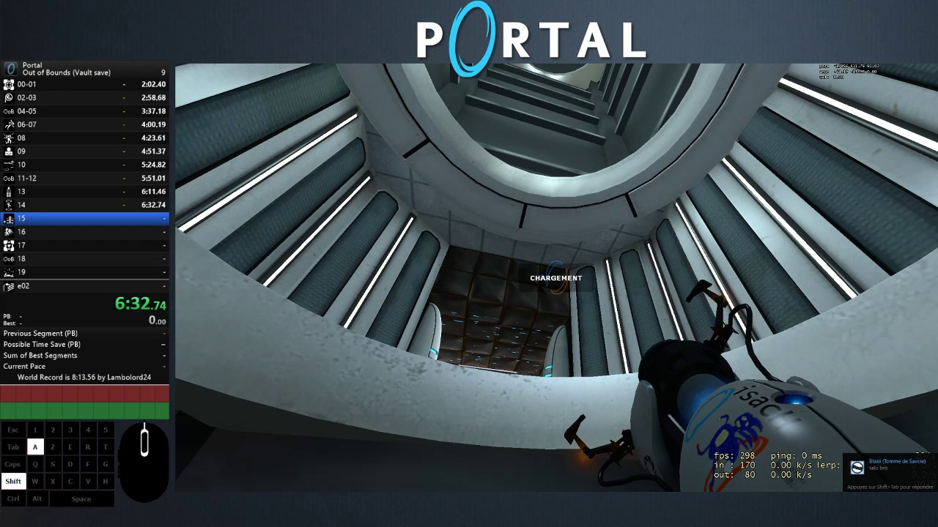
This out-of-bounds Portal run simply requires some acrobatics to take a path through the game that players wouldn't take in normal gameplay...

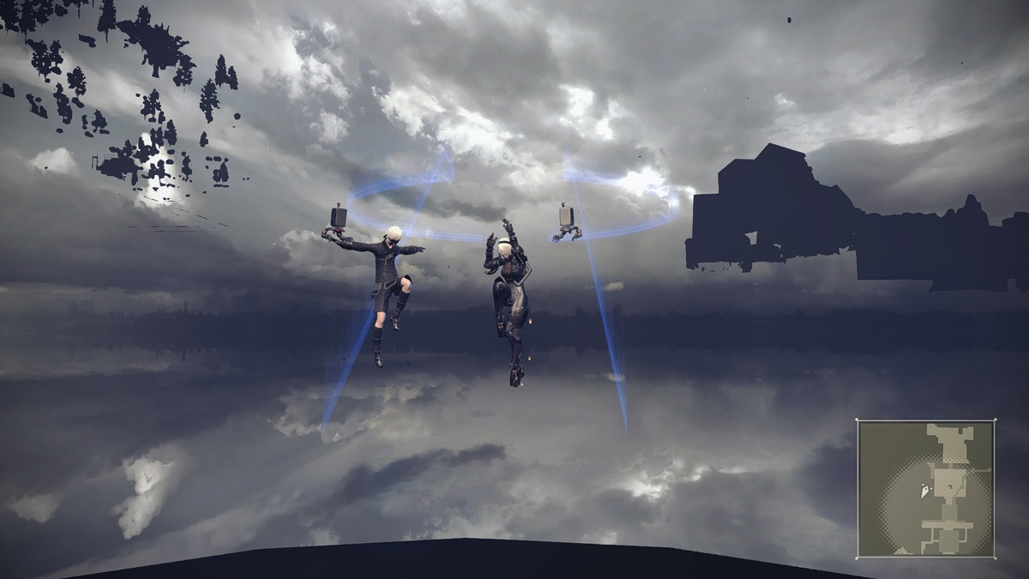
...while this Nier Automata technique involves clipping through the map to move outside the designed area of the game.

Radix, the leader of the SDA community, was keen to lay down a common rule set for all speedruns across all games, and thus banned going out of bounds in speedruns. Conversely, Twin Galaxies, a competitive and more general game records site, allowed individual rules for each game based on each game’s architecture. Ultimately, the Twin Galaxies approach became much more popular and is now the standard model for determining the ethics of speedrunning, with each game’s community discussing and suggesting rules for runs and arbitrating on what constitutes cheating. On Speedrun.com, each game has evolved its own ideology and idiosyncrasies. Some game communities do not allow certain techniques like glitching—as in the technique used to complete early Pokemon games in 0.00 seconds, as seen in [Figure X]—because they void any notion of competition, making the glitched speedrun a pointless exercise. However, the Pokemon community has set variables that still allow for challenges and debate.

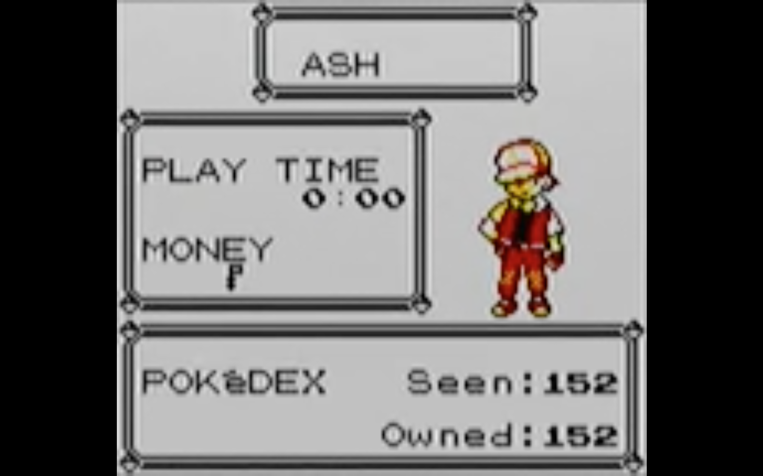

The sheer level of accomplishment in the community of speedrunners is staggering. But the dedication to iterative play—over, and over, and over again in order to find ever-more perfect runs—is a strategy that we could learn from to play in systems. While it may not be acknowledged or prioritised by the community, there’s something richly and politically nascent about speedrunning that—as with film in the twentieth century—may be a lightning rod for ways of playing our world better.

Recent studies of the huge celebrity-driven gaming culture in South Korea—equivalent in financial value and viewing figures to soccer in Europe—identify the sociotemporal aspects of gaming, offering the idea that “play as a disposition for calibration helps to make sense of everyday strategies for making do in precarious circumstances.” In other words, the ability to move between different speeds of existence—the rapid “Actions Per Minute” of elite gamers—and the perceived malaise of precarious society.

Speedrunners possess a sophisticated mastery of a system and its dynamics that allows them to fully exploit that system to their advantage—to see it as an artefact contained by its construction, and thus open to manipulation. A casual gamer might buy into the simulated world, believing the ground solid and the sky limitless, the whole world bounded by the screen. A speedrunner knows that the ground is simply a collision surface that can be broken at its edges, the sky an environment map, and the screen a mere slice of the architecture at their control. Speedrunners can thus change their relationship with the developer, the game, and their position within it. Every game is a system of interacting parts that fit together to perform certain functions. Speedrunners understand these mechanics so keenly that they are able to turn the system to new uses—to use the game in toto as their own playground, not one defined by the developers. That power reminds me of the preamble in Georges Perec's Life: A User's Manual:

...Puzzling is not a solitary game: every move the puzzler makes, the puzzle-maker has made before; every piece the puzzler picks up, and picks up again, and studies and strokes, every combination he tries, and tries a second time, every blunder and every insight, each hope and each discouragement have all been designed, calculated, and decided by the other.

The world is increasingly simulated by systems and databases that bound our interactions in regimented and controlled systems. We play within these confines, bouncing off the limits when we meet them but unable to see or move beyond the construction because we can never imagine it as more than solid ground and limitless sky. We play the game. Speedrunning shows us new ways of interacting with systems, playing them meaningfully and not just operating within their confines. Speedrunners play the playing of the game. As we navigate a world increasingly structured and simulated by software, a mentality and methodology that reconstruct the rules of the game can have profound implications for our sense of agency in that world—and the critical and technical literacy that requires.

http://www.machinima.com/
http://www.machinima.com/
https://www.youtube.com/user/VaatiVidya
https://www.youtube.com/user/VaatiVidya
https://gamesdonequick.com/
https://gamesdonequick.com/
http://oot-speedruns.wikia.com/wiki/No_IM/WW
https://kotaku.com/new-trick-has-ocarina-of-time-speedrunners-debating-wha-1796849850
https://kotaku.com/new-trick-has-ocarina-of-time-speedrunners-debating-wha-1796849850
https://forum.speeddemosarchive.com/post/discussion_on_the_out_of_bounds_rule.html
https://forum.speeddemosarchive.com/post/discussion_on_the_out_of_bounds_rule.html
https://www.speedrun.com/pkmnyellow
Rea, S., C., (2018) Calibrating Play: Sociotemporality in South Korean Digital Gaming Culture, American Anthropologist
Perec, G., (1996) Life: A User’s Manual, Vintage Classics

