Zilele Teatrului Matei Vişniec/Festival of the Matéi Visniec Theatre in Suceava (Romania),
Or Breaking Into the Festival Circuit

By Jozefina Komporaly

Arguably, it is not common practice to name a theatre after a living playwright, and neither is to initiate an ambitious theatre festival just prior to the annual European theatrical extravaganza that starts with the Sibiu International Theatre Festival in June, continues with Avignon in July and culminates with Edinburgh in August. The recently founded Matei Vişniec Municipal Theatre in Suceava, Romania has proposed to do just that: adopting the name of the most frequently produced Romanian playwright, and hosting a two-week-long marathon of events that brings together – with the support of the Romania-France Season, the Romanian Cultural Institute and the French Institute – playwrights, theatre practitioners as well as critics, academics, translators and publishers. Born from a desire to pay homage to award-winning French-Romanian playwright Matéi Visniec – one of the most notable people associated with the region, dubbed by Georges Banu, paraphrasing a cult Romanian novel by Marin Preda, ‘Bukovina’s the most beloved son’ – the theatre is one of the youngest theatre establishments in Romania. It was founded as recently as 2016, on the initiative of mayor Ion Lungu and the local council, in order to facilitate the access of local audiences to regular performance events, by producing and hosting a plethora of performance and cultural programmes. The theatre, led by well-known poet Carmen-Veronica Steiciuc, has a small ensemble of its own, and produces a professional programme aimed at a broad demographic. In the short time since its inception, the Matei Vişniec Theatre has already achieved prominence by touring and attending high profile festivals, and by inviting important directors and theatre makers to work with the resident company. The theatre’s most recent production by Avignon-based director Alain Timár, for instance, reframed Ionesco’s often-staged Rhinoceros as a performance installation, in addition to which it also consolidated the historical collaborative links between the Romanian and French cultural scenes. Visniec himself has been a constant presence at the Avignon OFF Festival for the last three decades, having developed partnerships with a number of small and medium-size companies in France, such as Pli Urgent in Lyon. In the course of almost thirty years, he had over a hundred productions of his plays at the festival, directed by the likes of Christian Auger, Mustapha Aouar, Gérard Gelas, Serge Barbuscia, regularly winning prestigious critical and audience awards.
The annual festival taking place at Suceava in May is a trademark event for the theatre, and is a result of previous successful attempts at offering a showcase of quality theatre performances in the North-Eastern areas of Romania. For a number of years, several locations have been involved in presenting a selection of invited of performances from Romania and beyond, following which the Romanian Ministry of Culture decided to endorse the initiative that in 2017 gave rise to the series of events branded Zilele Teatrului Matei Vișniec/Festival of the Matéi Visniec Theatre. Akin to the theatre itself, the Festival also has at its core the ambition to braid Romanian and international performance cultures; and to this aim programming is conducted with a view to interweave a variety of practices and traditions, in addition to bringing together a host of events directed at a wide variety of audience clusters.
The Festival’s most ambitious edition to date, taking place between 16-30 May 2019, was organised around the central theme of ‘Theatre and Democracy’ and genuinely succeeded in bringing to life a theatre culture that is accessible to anyone who is prepared to accept the invitation to join in. Thus, for instance, the Festival opened with acknowledging the importance of nurturing the next generation of dramatists, Visniec himself presenting the award for best submission in the Matei Vişniec National Student Playwriting Competition to Antonia Andra Mihăilescu of the Petru Rareş College in Suceava. In this spirit of inclusivity, two of the most memorable performances at the festival were addressed to a demographic that is relatively under-represented at most major festivals – young audiences, and excelled at engaging, involving and moving them in equal measure. The production Pisici/Cats (an indigenous production directed by Bobo Burlăcianu that parodies Andrew Lloyd-Webber’s blockbuster musical, premiered in September 2018 at the Romanian Embassy in Paris), was a particularly striking case in point, as it achieved a rare visceral connection with a young adult audience, many of whom have already been familiar with the show and participated in the festival in order to re-live a cult experience. Visniec’s own latest play was similarly remarkable, insofar as it brought together an audience formed predominantly of kids invited to witness a production that addresses the plight of children left in the care of grandparents whilst their parents are trying to make a better living abroad. This is a phenomenon that is all too familiar in Romania, wherefrom millions have migrated to the West; and the Extraterestrul care işi dorea ca amintire o pijama/The Alien that Wanted some Pyjamas as a Keepsake, staged by Ioan Brancu at very the theatre that bears Visniec’s name, tapped precisely into this degree of familiarity and apprehension when addressing this ardent topic.
In an attempt to draw attention to current issues of our time, programmes aimed at grown-up audiences examined various forms of alienation, most notably in the host theatre’s production of Rhinoceros where Ionesco’s original warning about the rise of totalitarianism is paralleled with the rise in consumerism and absurd levels of accumulation. Contamination in his case is achieved through unbridled levels of consumption, whereas annihilation can only be avoided by way of utmost and orchestrated resistance. The role of theatre in highlighting ardent concerns in contemporary Europe was further explored in a beautifully staged open air discussion at the magnificent Cetatea de Scaun/Citadel of Throne in Suceava, a medieval fortress reminiscent of the one-time glory of the historical principality of Moldavia. This energetic debate was adamant at arguing for the duty of theatre not to give up in the face of adversity, whatever it might be; and also made a stance by the sheer line-up of panellists that international and cross-disciplinary co-operation is the way forward in a democratic Europe. In addition to Rhinoceros director Alain Timár, Matéi Visniec was joined in this discussion by one of the earliest champions of his work in the Francophone world, Belgian publisher Émile Lansman, Paris-based Romanian-born theatre critic Georges Banu, the director of the National Theatre of Cluj, Mihai Măniuţiu, and the director of one of the latest premieres of Visniec’s work, Serge Barbuscia of the Théâtre du Balcon in Avignon. The latter’s production of Comment j’ai dressé un escargot sur tes seins/How I Trained a Snail on Your Breasts is heading to this year’s Avignon Festival, and I can only hope that this extraordinarily touching and humorous one-man show featuring a tour de force performance by Salvatore Caltabiano could make it to the English-speaking world.
I equally wish that one of Visniec’s most complex plays, Despre senzaţia de elasticitate când păşim peste cadavra/And Now Who’s Going to Do the Dishes? – seen in the festival in a production memorably staged by Răzvan Mureşan at the National Theatre of Cluj – could have its well-deserved exposure in an English language production, seeing that it is an exceptionally imaginative intertextual response to Ionesco’s theatre and a most timely meditation on the role of intellectuals in society. Chances are perhaps slightly better for Visniec’s more recent work, Migraaaanţii, sau prea mulţi suntem pe acesastă barcă/Migraaaants Or There’s Too Many People On This Damn Boat (2017), presented at the Festival in an insightful Hungarian language version by Zalán Zakariás for the Sándor Tomcsa Theatre in Odorheiu Secuiesc. Reflecting the global impact of migration and the extraordinary human costs of displacement and non-belonging, Migraaaants examines assorted push-and pull factors alongside the lure of the West and contrasts the idealised image would-be migrants entertain of their target countries with the realities of the present, thus situating mythical and dystopian visions side by side. The topical importance of this play is also indicated by being reissued in a new edition by leading Romanian publishing house Humanitas (in the volume Trilogia balcanică/ The Balkan Trilogy, 2018), and by being followed up by a production of its companion play Occidental Express, also directed by Zakariás, this time at the Szigligeti Theatre in Oradea.
In addition to being a showcase of recent productions of Visniec’s work, the Festival paid careful attention to representing a multiplicity of voices in the landscape of Romanian and Francophone theatre. Thus, spectators had the chance to encounter, possibly for the first time, work by the recently founded Teatrul Dramaturgilor Români/ Theatre of Romanian Playwrights in Bucharest, an institution that has already established itself as an influential creative hub in nurturing contemporary dramatists, and in facilitating alliances between home-grown and expat playwrights. Their appearance at the festival was a case in point, Romanian musician Mircea Tiberian tackling US-Romanian playwright Saviana Stănescu’s Tarot Tales, in a production preoccupied with modularity and held together by a cluster of expertly executed jazz themes. Similarly, the Festival made a concerted effort to bring together representatives of theatres operating at the geographical margins of Romania, and/or companies generally less present on the festival circuit: such as the Fani Tardini Theatre in Galati (with a production of Anthony Neilson’s Edward Gant's Amazing Feats of Loneliness directed by Dragoş Alexandru Muşoiu); the Regina Maria Theatre in Oradea (with Sholem Aleichem’s Scripcarul pe acoperiş/Fiddler on the Roof directed by György Korcsmáros); the Aureliu Manea Theatre in Turda (with A Midsummer Night’s Dream directed by Muriel Manea-Jakab); the Sică Alexandrescu Theatre in Braşov (with Goldoni’s Mincinosul/The Liar directed by Vasile Nedelcu); and the Mihai Eminescu Theatre in Botoşani (with Vise de Opal/Opal Dreams by Ben Rice, directed by Vlad Cepoi). In terms of international companies, the Ion Luca Caragiale Theatre of Chişinău, Republic of Moldova presented Alexandru Grecu’s staging of The Wedding by Chekhov; Delagare & Cie, Paris shared their production of Burododo directed by Mustafa Aouar; while Théâtre de l’Échappée from Laval, France brought along two productions, Le Grand Cabarhino and Tapis, both directed by François Béchu. Addressing adult and child spectators respectively, the company spanned the audience spectrum already targeted in the festival, joining the ranks of the Teatrul Tineretului Piatra Neamţ, present with an adaptation of Romanian children’s classic Ion Creangă: Amintiri/Memories directed by Ada Milea.
Creangă’s Memories of My Childhood was also embedded into the festival programme through a unique virtuoso performance delivered by Constantin Chiriac, director of the Radu Stanca National Theatre in Sibiu (present in the festival with Brecht’s The Good Person of Szechwan directed by Anca Bradu) and founder of the internationally renowned Sibiu Festival. Chiriac is one of the most influential figures in Romanian theatre, who in addition to engineering a landmark transformation in his hometown as a result of the annual theatre festival that he launched in 1993 (Sibiu was awarded European Capital of Culture status in 2007), continues to work as a performer particularly drawn to poetry and ritual. In this sense, it is perhaps less surprising that one of the festival venues included a local Orthodox church (Biserica Naşterea Maicii Domnului), where Chiriac presented an emotionally charged poetry recital. This occasion taking place on 21 May, the widely celebrated name day of Orthodox saints Constantin and Elena (St. Constantine and Helen), was a first for the Church as well as the Theatre, and constituted a rare blurring of boundaries in terms of dedicated spaces, reconfiguring the meaning of site-specificity for both theatre audiences and members of the congregation.
The most popular festival venue, however, was arguably the Exhibition Space/Spaţiul Expoziţional, that hosted a rich programme of exhibitions, debates, book launches, workshops and musical performances. I was particularly taken by the paintings on glass by local artist (and journalist) Luana Popa, and the electro acoustic concert Sunete sculptate/Sculpted Sounds by Tibor Cári – a rare opportunity to encounter one of the most talented theatre composers currently working in Romania. The space also played host to a series of discussions conducted by the prestigious magazine Dilema Veche/Old Dilemmas on the role of theatre, involving editor-in-chief Sever Voiescu and theatre critic Georges Banu, and translator and philosopher Andrei Cornea, respectively. The latter’s recent translations of Aristophanes prompted a lively discussion on the potential for comedy in contemporary society, and made the audience ponder on the reasons behind the striking dearth of productions, both in Romania and globally. Mihai Măniuţiu, one of Romania’s top theatre directors, also active as a professor of performance at the ‘Babeş-Bolyai’ University in Cluj and at the University of California, Irvine, introduced his latest poetry collection, while theatre critic and academic Oltiţa Cîntec presented a talk on documentary theatre, a genre enjoying a healthy revival in Romania. Last but not least, the Exhibition Space excelled in a rare feast of outreach as it proved unable to accommodate the number of young audiences turning up for the panel on Theatre without Frontiers. Again moderated by Visniec in his inimitable style honed over decades of reporting for Radio France Internationale, this panel examined the role of translation in cultural communication, and endorsed Umberto Eco’s claim that the language of Europe is none other than translation. Bringing together champions of Visniec’s work in several languages, publisher Émile Lansman and translators Beppe Rosso (Italian), Evelio Miñano Martinez (Spanish) and Jozefina Komporaly (English) discussed aspects of their personal journeys with Visniec’s work, and explored some of the contexts in which they contributed to the dissemination of contemporary drama across cultural traditions. Ultimately, it is engaging in such cross-cultural partnerships of multiple kinds that this festival aims to achieve; and in addition to enthusiasm and longevity, all I can wish for them for the future is to test out additional performance models and venues, strive for further gender inclusivity, and, if at all possible in such precarious times, make an attempt at venturing beyond the Francophone world.

Images:
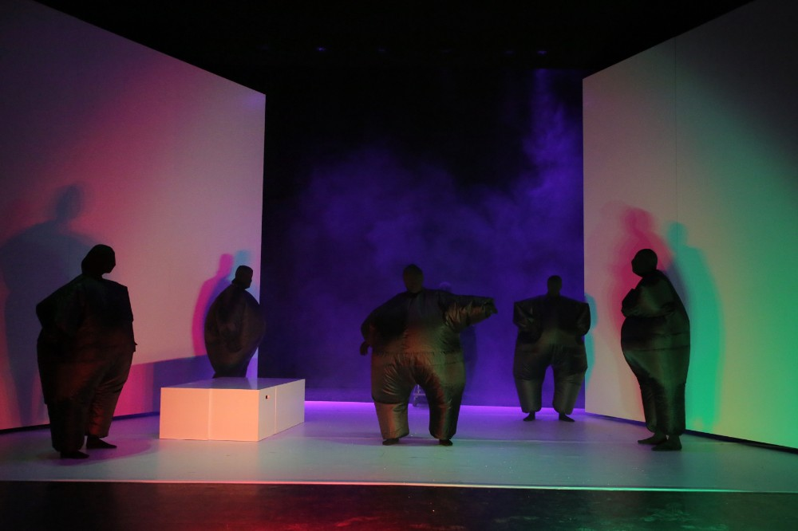
Figure 1. Rhinoceros - Photo: Amedeia Vitega

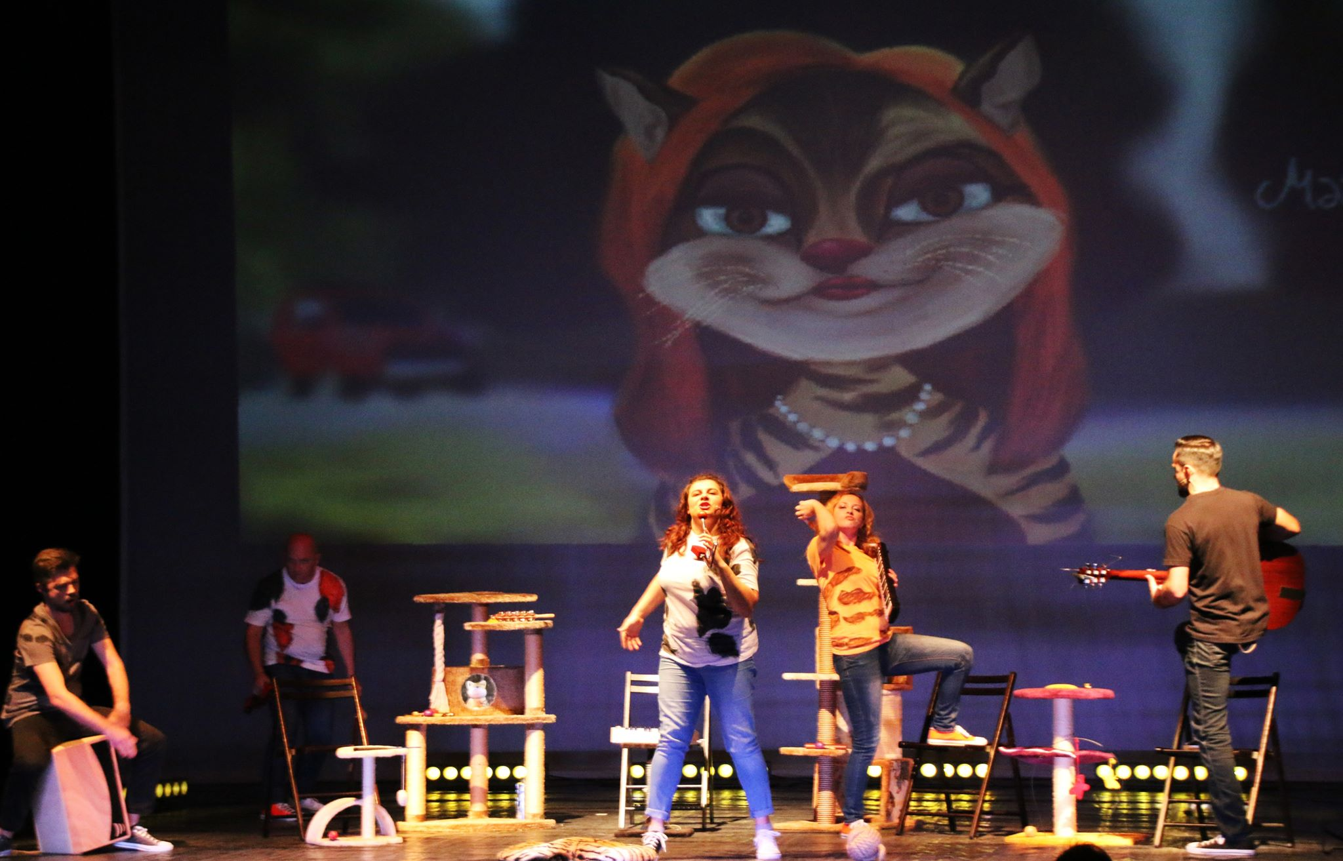
Figure 2. Cats - Photo: Luana Popa

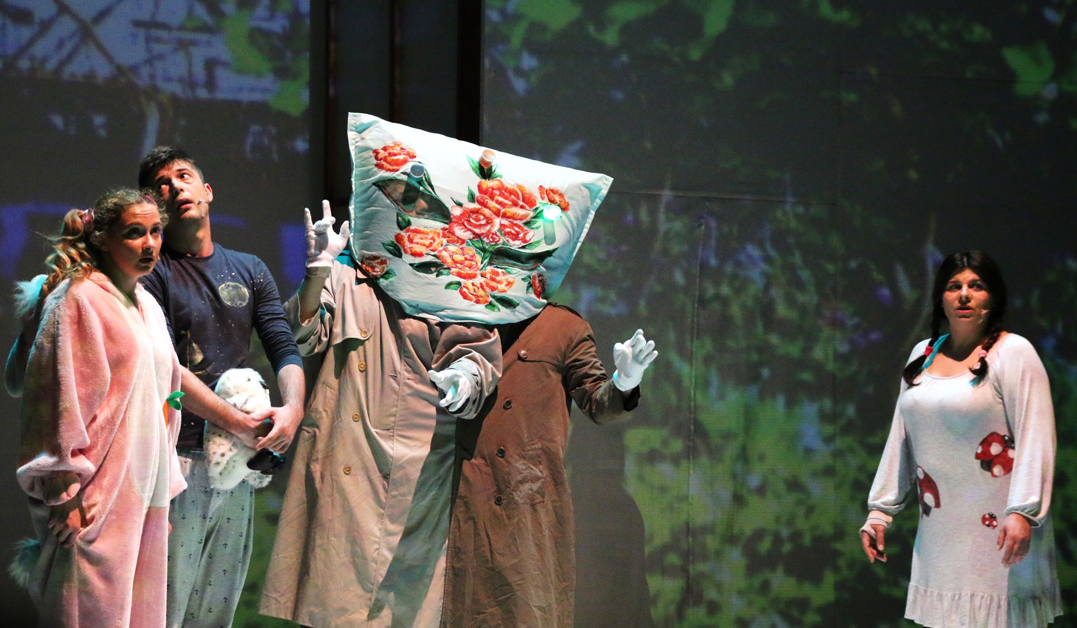
Figure 3. The Alien that Wanted Some Pyjamas as a Keepsake - Photo: Luana Popa
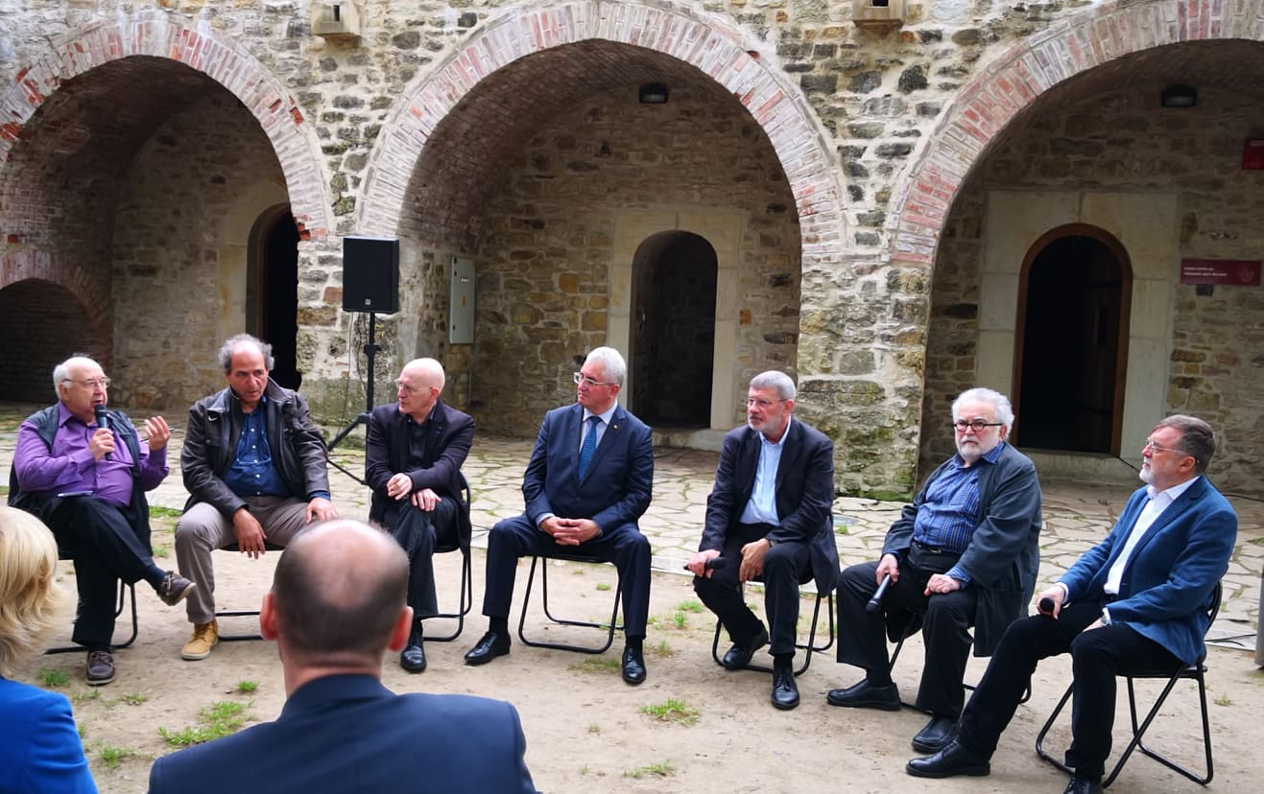
Figure 4. Panel at the Citadel - Photo: Carmen Veronica Steiciuc

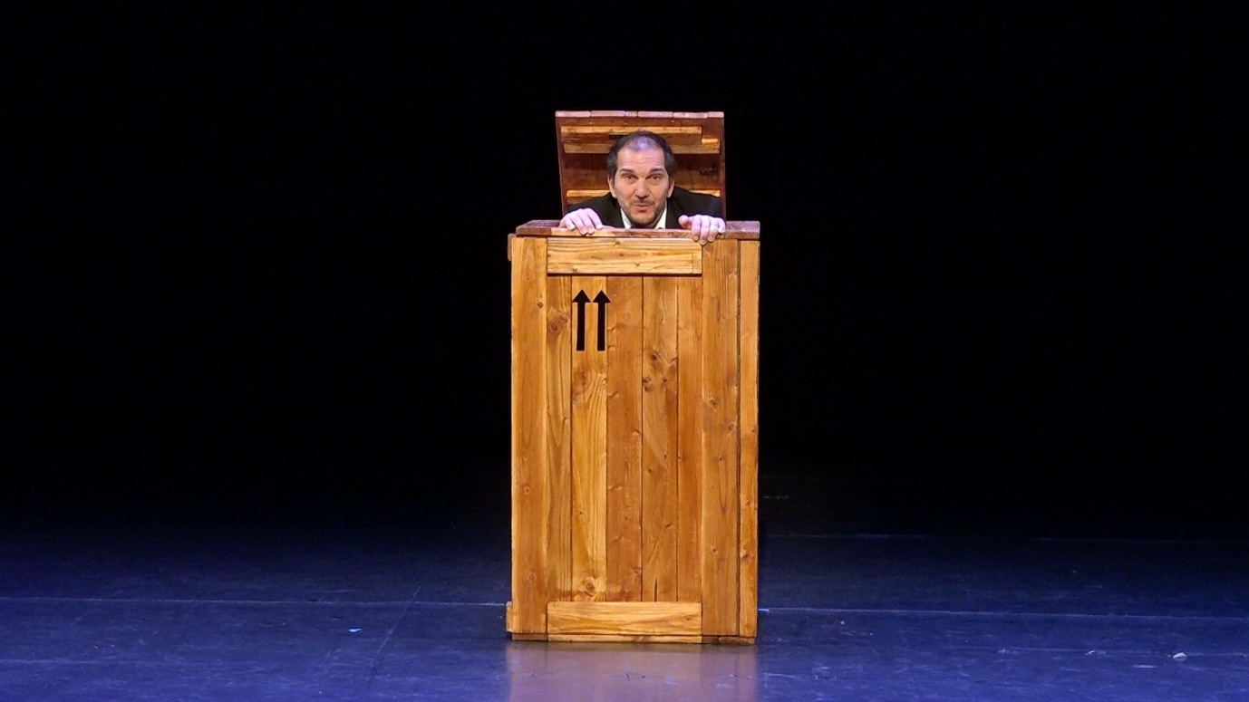
Figure 5. How I Trained a Snail on Your Breasts - Photo: Amedeia Vitega

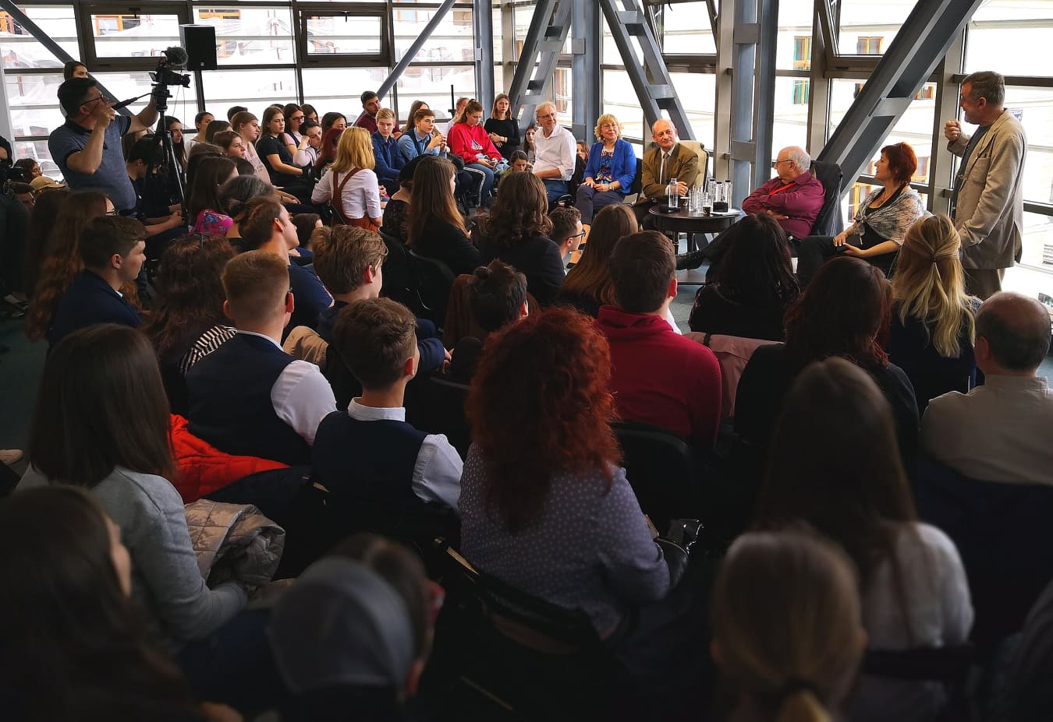
Figure 6. Panel on Theatre without Frontiers - Photo: Carmen Veronica Steiciuc

Visniec (born in 1956 at Rădăuţi, Romania and since 1987 resident in Paris) spells his name as Matei Vişniec in Romania, and uses the variant Matéi Visniec in an international context. Further information on the playwright is available on his website https://www.visniec.com/home.html and in the English-language volume Komporaly, J. (ed.) (2015) Matéi Visniec: How to Explain the History of Communism to Mental Patients and Other Plays. Seagull Books.
Banu, G. (2019) ‘Matei Vişniec, Cel mai iubit dintre bucovineni’/’Bukovina’s Most Beloved Son’, in Cotidianul, 29 May 2019. Available at https://www.cotidianul.ro/matei-visniec-cel-mai-iubit-dintre-bucovineni/ (Accessed 3 June 2019).
Cf. the theatre’s website: https://www.teatrulmateivisniec.ro/en/events/

