Text Is Only A Dimension of the Theatrical Experience:
Open Dramaturgy and Collaboration in András Visky’s Theatre in English Translation

by Jozefina Komporaly

András Visky (born 1957 https://b-m.facebook.com/andrasvisky/) has achieved excellence in several fields, and continues to work in parallel in a variety of interconnected capacities: he is a widely published author writing in multiple genres, an influential dramaturg and theatre maker, a talented academic and, last but not least, a respected public intellectual both in his native Transylvania and in Hungary. His most recent publication is a volume of poetry for Jelenkor (Nevezd csak szeretetnek, 2018), yet almost simultaneously he completed a series of short plays entitled Stories of the Body that went into production at Chicago’s Y Theatre in May 2018, and ran in repertory to great critical acclaim until July. http://www.theatre-y.com/upcoming/
The latter event is particularly relevant because in this case the English translation of Visky’s texts has been staged prior to the Hungarian original, and prior to the publication of the entire play series in either language. An initial incarnation of the first play in the series appeared in the literary magazine Látó http://www.lato.ro/article.php/Temetetlenek-A-s%C3%B6t%C3%A9ts%C3%A9g-szentje/3733/ in October 2017, just a month ahead of the same text being staged in London by [Foreign Affairs] theatre company http://www.foreignaffairs.org.uk/productions/the-unburied/
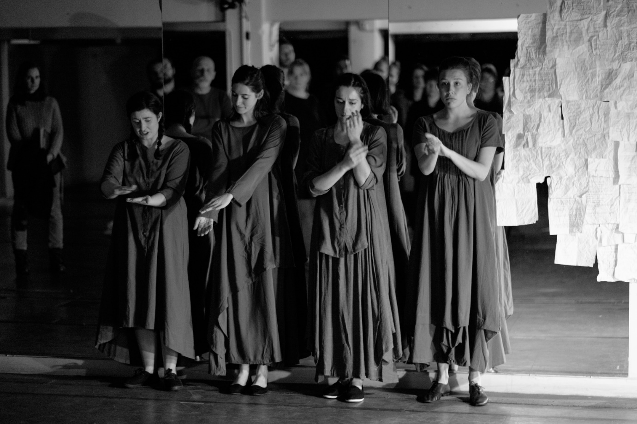
Figure 1. Photo Luca Migliore: The Unburied, directed by Camila França and Trine Garrett (London, November 2017)
This production entitled The Unburied. The Saint of Darkness, supported by grants from the Arts Council of England and the Romanian Cultural Institute in London, was a result of a long-term collaboration between Visky and London-based translator and academic Jozefina Komporaly https://www.societyofauthors.org/translator-Profile?itemID=414 on the one hand, and between [Foreign Affairs] http://www.foreignaffairs.org.uk/ and Komporaly, on the other. [Foreign Affairs] have worked with Komporaly, alongside several other UK-based translators, on nurturing a new generation of stage translators, with a view to remove theatre translators from their potential isolation and offer them a platform for experimentation within the context of a contemporary cutting-edge theatre company. http://www.foreignaffairs.org.uk/foreign-affairs-translates-2016-showcase/
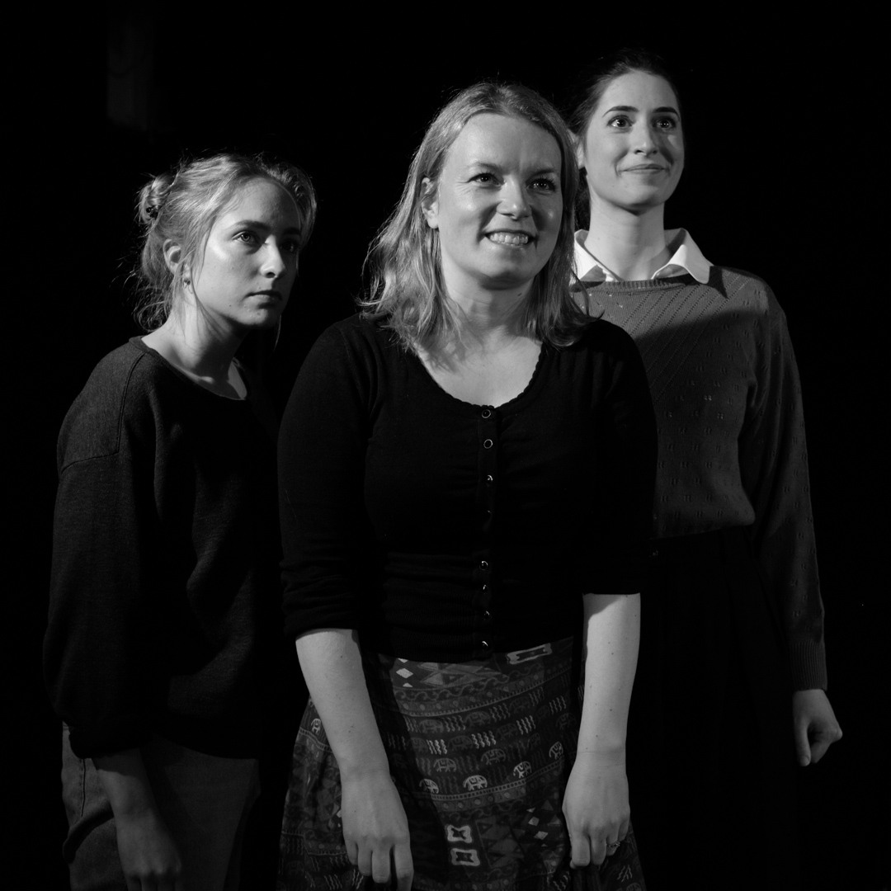
Figure 2. Photo Luca Migliore: The Unburied, [Foreign Affairs] Translates! Showcase (London, December 2016)
Collaborating with [Foreign Affairs] in the course of the [Foreign Affairs] Translates! Programme, Komporaly was able to test her translation of Visky’s play on an ongoing basis, having it read, discussed and then performed by actors in an actual rehearsal environment rather than in the privacy of her office. Thus, the English-language version came about as a result of a stratified process that included interrogating embodied words and attending to the inherent physicality of the text. In this way, the process of translation went beyond being a merely intellectual exercise, and capitalised on the presence of mentors and fellow translators in addition to an ensemble of performers available to respond to the text. Arguably, this was an example of an ideal case scenario whereby theatre translation is a form of collaborative theatre making practice, and in which the translator also acts a dramaturg and as part of the creative team responsible for the mise-en-scène.
In the case of working on Stories of the Body for Y Theatre, the translation was commissioned independently of the staging process, although there was regular communication between playwright, theatre company and translator, and rather than creating a definite version for a particular production, the aim was to offer alternatives towards a subsequent directorial vision. The plays in the series have grown out of The Unburied – now revised and retitled Teresa, and all plays were based on real life stories as experienced by remarkable women (including Mother Teresa and Italian Renaissance painter Artemisia Gentileschi), and connected to various cities including Budapest, Cluj/Kolozsvár, Kolkata and Rome, from the 17th to the 21st century.
The plays themselves are works of fiction, and Stories of the Body comprises texts rooted in the technique of open dramaturgy. As Visky recommends in his stage directions, theatres might want to put on various combinations of the plays, and as a result, spectators could watch different productions each time, perhaps in a different order. In this way, the plays (Teresa, Lina, Eva and Artemisia) – and their approximately 50-minute long stage versions – would gain new meanings in each other’s light and context: illuminating the stories of the body in the most varied refractions, as a variation of a single theatrical space and set design. The plays also have the potential to be staged in their own right, of course, as full-length performances.
Focusing on central female protagonists is a trademark of Visky’s theatre, and underpins his output throughout his playwriting career dating back two decades. The play that launched him as dramatic author was prompted by the personal history of his mother (Juliet) and subsequently he dramatized a traumatic event experienced by his wife (Porn). I Killed My Mother pays homage to another personal history, of a close friend, yet none of these works are examples of documentary theatre or verbatim theatre, but deeply poetic responses to universal experiences such as love and loss or mother-daughter/child relationships, albeit embedded into hostile social and political conditions (deportation and surveillance under the communist regime in Romania).
In 1958 Visky’s father, Ferenc Visky, a widely respected protestant pastor was condemned to 22 years of imprisonment for his (to the regime) unacceptable ways of practising Christianity. Visky’s father fearlessly advised his congregation to avoid collaborating with the Communist regime, and barely escaped capital punishment. Visky’s mother continued her husband’s activities, so she also ended up deported with her children to a forced domicile in the South of Romania, where they spent four-and-a-half years. Following the thawing of the Stalinist regime in Romania, the majority of political prisoners were released in 1964, and this is when Visky and his siblings were first reunited with their father. Their trials and tribulations have left an indelible mark on Visky’s sense of self, and he declared repeatedly that his ‘true birthplace’ was in the confinement of the Romanian Gulag, where he not only learned Romanian from elite political prisoners but acquired it as a language of cultural resistance. Visky’s artistic genesis is clearly traceable in his experience of the barracks; although the Visky family was released, they merely exchanged the boundaries of their forced domicile with a somewhat larger-scale prison: that of Communist Romania.
This idea of captivity is explored in Visky’s theoretical writing, most clearly in the context of his original dramaturgical concept ‘Barrack Dramaturgy’, first published in English in The Routledge Companion to Dramaturgy edited by Magda Romanska (2014). The concept was initially brought to public attention in a manifesto timed to coincide with the production of Visky’s play The Disciples directed by Gábor Tompa at the Hungarian Theatre of Cluj in 2005, and later reprinted in the volume A szökés/The Flight (Visky 2006). Barrack Dramaturgy, according to Visky, ‘was born out of the need to make imprisonment a common experience’, and where the audience becomes ‘prisoners of [their] free will’ (Visky 2014: 467). Performers and audience relinquish their freedom simultaneously, and thus are bound by a contract of sorts towards a shared experience: an enclosure into a claustrophobic space in which the performance and spectating areas are not separated. The performance begins with this joint act of huis clos, of being locked in, and finishes with an equally shared exit or liberation, the latter being also symbolic of an act of doing justice. According to this approach, however, the aim of captivity is not simply to render actual reality but to evoke a universal experience and to suggest that ‘captivity is a state of being in which we are dislocated from our bodies’, and through which we are invited to explore the potential for participatory understanding (Visky 2014: 468). According to Visky, being shut in together with an aim to remember heightens the perception of the performance as an event in the present, and is predicated on total audience involvement because its aim is to lead to a shared embodied experience. Actress Melissa Lorraine connects this shared experience with ‘a celebration of the very essence of theatre: the miraculous solidarity of strangers who can suddenly see one another inside of a moment’. Lorraine stresses that only ‘that which actually occurs during the time of “incarceration” is of any value. We offer ourselves over to this mysterious communal ritual in the hope of alteration. We volunteer to serve the time’.
Visky’s encounter with Melissa Lorraine (formerly Hawkins) has indeed been a most fortuitous one; over the years she played the protagonist of Juliet, Porn and I Killed My Mother, as well as commissioned, directed and acted in Stories of the Body, and the free theatre she runs in Chicago has become a haven of experimental work, much having its origins in translation. Melissa’s image graces the cover of the first English-language anthology of Visky’s work, in a production directed by Karin Coonrod, who in addition to directing Visky in the United States also created an Italian version of Juliet. András Visky’s Barrack Dramaturgy: Memories of the Body (Intellect, 2017) https://www.intellectbooks.co.uk/books/view-Book,id=5261/ was edited by Jozefina Komporaly with the express aim to bring Visky’s work in print form into an international arena, and in addition to making playtexts available in English, also provide a critical apparatus and production histories to contextualise the playwright’s work to date. The volume also includes interviews with theatre makers who have been instrumental in staging Visky’s plays, and offers close readings of the plays included written by scholars of contemporary theatre.
When Visky ventured into playwriting around the turn of the millennium, he forged a reputation almost overnight. His is a most innovative voice in the otherwise fairly traditional landscape of Hungarian drama, and his unique dramatic language is rooted, on the one hand, in his poetic imagination and, on the other, in his in-depth familiarity with the movement and image-centric Romanian theatre tradition. The latter has been a tremendous influence on Visky’s understanding of theatre as a dramaturg and playwright alike, and is braided with Visky’s over two-decade-long collaboration with artistic director Gábor Tompa at the Hungarian Theatre of Cluj. Tompa himself had been trained in the Romanian theatre tradition, and this partnership has been foundational to both artists’ and indeed the company’s international profile. It was therefore fitting, that the most recent launch of the critical anthology András Visky’s Barrack Dramaturgy: Memories of the Body (Intellect, 2017) https://www.intellectbooks.co.uk/books/view-Book,id=5261/ took place at the 2018 Interferences Theatre Festival in Cluj, as a conversation between Visky, Tompa and volume editor Komporaly. http://www.interferences-huntheater.ro/2018/en/pieces/andras-viskys-barrack-dramaturgy-memories-of-the-body/ This international festival, directed by Tompa and co-curated by Visky, is an exemplary showcase of some of best work in contemporary European theatre practice, addressed to a varied audience that includes attendees well beyond the local patrons of the Hungarian Theatre in Cluj. In addition to situating productions by companies as diverse as the Schaubühne, Klaipeda Drama Theatre or Komuna Warszawa side by side and offering the translation of all performances into multiple languages, the festival makes a concerted effort to publicly discuss the work shown with the creatives, theatre critics and audiences. Re-inscribing Visky’s work as a playwright and its journey in the English-speaking world into this configuration felt most appropriate: coming full circle and marking a new beginning at the same time.
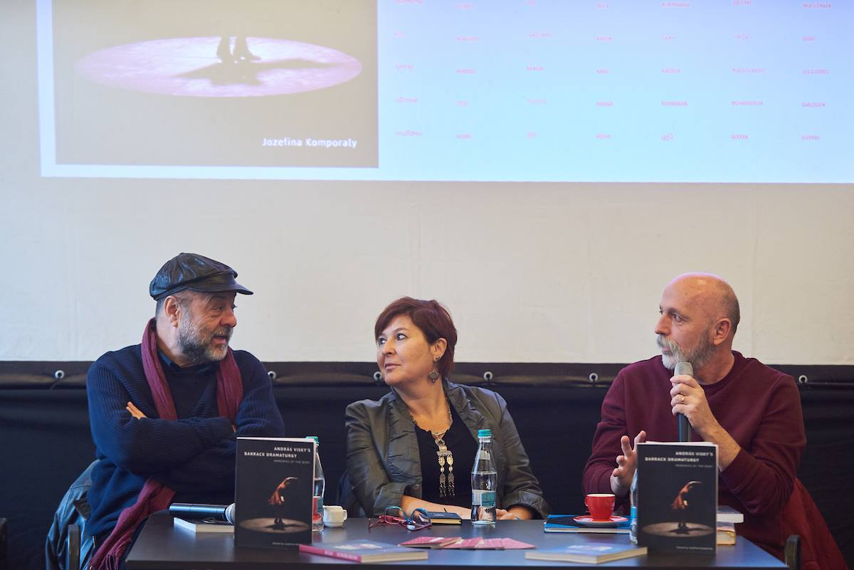
Figure 3. Photo István Bíró: Gábor Tompa, Jozefina Komporaly, András Visky (#6 Interferences Theatre Festival, Cluj, 28 November 2018)

