Art, Design & Communication in Higher Education
Volume 18 Number 2
© 2019 Intellect Ltd Article. English language. doi: 10.1386/adch_00006_

HARAH CHON AND JOSELYN SIM
LASALLE College of the Arts, Singapore

From design thinking to design knowing:
An educational perspective

KEYWORDS
design thinking design education design pedagogy educational model design knowledge interdisciplinary design

From Design Thinking to Design Knowing: an Educational Perspective

Abstract
The process of design explicates the procedural knowledge of design activities, shifting theoretical conceptions across practical dimensions. Design thinking, as a creative and innovative methodology, has been established as a designerly process for non-designers to address complex problems. This paper reviews the implications of introducing the design thinking methodology as a pedagogical approach in design education, generating knowledge to inform the research spaces of design practice and theory. Perspectives and insights are extracted from the design thinking methodology and adapted to the experiential, reflexive and substantiated modes of design knowledge. A final framework is introduced and discussed to illustrate the non-linear, circular structures of knowedge generation from theory (deisgnerly knowing) to practice (design thinking) and research (design knowing).

Keywords: Design Thinking, Design Education, Asian Design, Design Process, Design Knowledge

INTRODUCTION
Design, in its many roles and articulations, translates theory to practice through the development of critical ability, perceptive awareness and knowledge. The creative processes of design transfer ways of thinking into ways of knowing, in the appropriation of feasible solutions and tangible outcomes within the boundaries of a problem space. According to Claxton (2002:32), knowledge is made known through the embodiment of experience, sensory and affective codes, and aesthetic measures. This form of knowing reifies intuitive cognition, formulating concrete structures and frameworks for design practice. One such articulation is found in the concept of design thinking, which provides a methodical process for anticipating problem spaces and optimising effective solutions through the identification of contextual challenges and issues. The projective ability of foresight allows users of design thinking to structure design activities against the known variables of a given problem space. This form of structuring and framing is what allows meta-knowledge to shift from abstract concepts to practical methods and processes to establish feasible solutions (Hoadley & Cox, 2009:20).

This paper reviews the epistemological foundations of design thinking against the methodology in practice to uncover new insights and perspectives for the study of design. The circularity of this framework sets the precedence for translating theory-informed practice into the theorisation of practice. Through an overview of the various methodologies for design thinking and the introduction of design thinking in education, this paper examines, identifies and extracts knowledge through the modes of experience, reflection and substantiation through a case-study example of design thinking in practice to address the following:
- The varying perspectives and discourses of design thinking
- The implications of design thinking in practice
- Case-study analysis of design thinking within an educational context
- Translating design thinking into design knowing
- Future implications of design knowing

OVERVIEW OF DESIGN THINKING
The emergence of design thinking has produced a new concern, for design researchers and practitioners, to formalise the relationship between theory and practice for productive and concrete integrations. According to Buchanan (1992), there is no area in contemporary life where design has not assumed an intentional role or been a significant factor in the shaping of human experience. Therefore, it is a logical response that design thinking be applied by those wishing to address complex problems in non-design fields and subjects. The integration of design thinking as a practical exploration expands upon the theoretical foundations of design to produce tangible and meaningful outcomes. Without appropriate reflection among participants, communicating the knowledge gained from the process, design thinking becomes an increasingly insular activity unrelated to the knowledge of design and design activities.

BROAD AREAS FOR DESIGN THINKING
SYMBOLIC & VISUAL COMMUNICATION | Traditional graphic design, typography and advertising  Communication through photography, film, television and computer display  Broad exploration of the problems in communicating information, ideas and arguments
MATERIAL  OBJECTS | The traditional concern for the form and visual appearance of everyday things  Thorough and diverse interpretation of the relationships between humans and objects  Exploration of the construction of form and visual appearance against areas of art, engineering, and natural and human sciences
ACTIVITIES & ORGANISED SERVICES | Traditional management concerns  Expanding into concerns for how better design thinking contributes to achieving better logical decision making and strategic planning
COMPLEX  SYSTEMS | Traditional concerns of the functional analysis of parts of complex wholes in systems engineering, architecture and urban planning  Reflects the consciousness of the central idea, thought, or value of design in sustaining and shaping environments
Table 1. Areas of Design (Adapted from Buchanan, 1992)

Buchanan (1992) outlined four design areas, as places of invention, where one is able to discover the dimensions of design thinking by reconsidering problems and solutions. Each of the four areas are intrinsically interconnected as the signs (symbolic and visual communication), things (material objects), actions (activities and organised services) and thoughts (complex systems) point toward future directions of design. Design thinking is not merely concerned with a solution-based process but should consider the needs and values of everyday life in changing culture.

Discourses of Design Thinking
Johansson-Skoldberg et al. (2013) define two discourses of design as designerly thinking and design thinking. Designerly thinking serves as the academic construction of professional design practice, through the articulation of non-verbal design competencies. This form of thinking demonstrates a clear link between theory and practice within the the academic field of design. Design thinking is the application of design practice and its related competencies beyond the context of design, for and with those without design backgrounds. It represents a simplified version of designerly thinking and is rooted in practical management.

THEORETICAL PERSPECTIVES OF DESIGNERLY THINKING
CREATION OF ARTEFACTS  Simon, 1969 | Design as involving all activities in the creation of artefacts - ‘Design Science’  Transformation of existing conditions into preferred ones
REFLEXIVE PRACTICE  Schon, 1983 | Practice based on the relationship between creation and reflection-on-creation  Need for constantly improved competence and re-creation
PROBLEM-SOLVING ACTIVITIES  Buchanan, 1992 | Dealing with the indeterminacy of design through creativity  Process of contextualisation - from problem definition to problem solution
WAY OF REASONING/  MAKING SENSE OF THINGS  Lawson, 2006  Cross, 2006 | Identification of patterns grounded in design observations  Creative processes to convert research knowledge into design practice  ‘Science of Design’ as represented by design practices, designers, institutions of design, aesthetic conventions and design history
CREATION OF MEANINGS  Krippendorff, 2006 | Designers as creators of meaning - the ‘Semantic Turn’  ‘Science for Design’ as the systematic collection of design practices, methods and lessons as a self-reflective reproduction of the design profession
PRACTICAL PERSPECTIVES OF DESIGN THINKING
IDEO METHOD  Kelley, 2001  Brown, 2008 | Circular process inspired by designers’ work processes  Blending design methodologies, work culture and infrastructure
ORGANISATIONAL MANAGEMENT  Dunne & Martin, 2006 | Process of abduction (idea generation), deduction (prediction) and induction (generalisation)  Builds on planning theories
MANAGEMENT THEORY  Boland & Collopy, 2004 | Design as the orientation of cognitive characteristics  Theoretical implications for management
Table 2. Discourses of Design Thinking (Adapted from Johansson-Skoldberg et al., 2013)

The theoretical perspectives of designerly thinking have influenced the development of design thinking in the form of management-oriented design. Working with design concepts and innovative strategies within the management context has led to three main design thinking discourses, which focus on the practical implications of its framework within non-design organisations. Design thinking is often characterised by an ability to increase creativity in management. However, design practice requires skills and competencies beyond creative ability in how designers are able to identify and contextualise problem spaces, perceive potential barriers and challenges, reflect upon and analyse proposed solutions, and effectively implement and resolve design issues. The influences of designerly thinking on design thinking can be found in the knowledge claims that design activities generate.

DESIGN THINKING IN EDUCATION - A PILOT STUDY
Singapore, being a strategically planned and designed island nation, has utilised effective design thinking to integrate robust solutions beyond technology and science to consider human needs and their emotions (Mohandas, 2018). The educational landscape reflects the sentiments of the Prime Minister’s vision for Singapore to become a fully-integrated smart nation, supported by the central role of design. Designated a UNESCO Creative City in Design, Loh (2016) advocates the use of design thinking in Singaporean education to embed meaningful changes to curricula and equip students with relevant competencies. This approach to education applies the design thinking framework from the top-down, to build and develop more robust and knowledge-rich curricula, while ensuring that the core principles of the methodology can be adopted and followed by students. In a study by Lim (2015), he recognised that many Southeast Asians study Design as a means for generating creative outputs and it was gathered that there is a lack of emphasis in driving the importance of creative strategies.
Design relies on the pre-structuring of its related operations to formalise a framework for initiating what is known as a design process (Hiller et al., 1972). The design thinking methodology serves as the simplification of complex design methods, whereby its users can follow an adaptable approach to design research through projective ability in uncovering latent possibilities. This form of design exploration is illustrated with a pilot study involving the introduction and integration of design thinking at the undergraduate level within the School of Design Communication at LASALLE College of the Arts, Singapore.
Design Thinking Pedagogy
An important component of design education involves teaching students to make clear connections between cognitive thinking and creativity within the processes of design, serving as a practical approach to exploration and ideation. The IDEO design thinking method considers an inherently optimistic, constructive and experiential process for addressing human-centred needs against the infrastructures framing the proposed outcomes (Brown & Wyatt, 2010). Following a review of the IDEO method and other discourses of design thinking, an iterative framework was developed to encourage experimentation and reflective thinking within the School of Design Communication. The introduction to design thinking, as a team-based methodology, was piloted with a group of 170 second year students through the 5-step phases of empathy, define, ideate, prototype and test.

DESIGN THINKING FRAMEWORK
PHASE | MODE | THEORY | PRACTICE | THEORETICAL PERSPECTIVE
Step 1:  EMPATHY | Identification  Understanding the role of empathy to define the problem space | Introduction to practical, primary research methods and reasons for why data collection/analysis are necessary to design | Identification of stakeholders within teamwork (role-definition)  Introduction to project brief  Data collection - quantitative and qualitative research | CREATION OF ARTIFACTS  Simon, 1969
Step 2:  INSIGHT | Clarification  Developing insights from data through triangulation | Defining insights to craft meaningful and actionable plans | Making sense of data through teamwork (coordination)  Introduction to triangulation | WAY OF REASONING/  MAKING SENSE OF THINGS  Lawson, 2006  Cross, 2006
Step 3:  IDEATE | Theory to Practice  Transferring insights from research through the creative articulation | Brainstorming: the role of questioning and probing in idea generation | Idea evaluation - sharing, presenting and refining ideas in teamwork (communication) | PROBLEM-  SOLVING ACTIVITIES  Buchanan, 1992
Step 4:  PROTOTYPE | Examination  Presentation of initial ideas and mockups | Iteration: learning from prototypes and generating new ideas through initial testing, re-examining and gathering perceptions | Review of prototype effectiveness in teamwork (decision-making) | REFLEXIVE PRACTICE  Schon, 1983
Step 5:  TEST | Implementation  Building a test scenario or user testing | Critique: transitioning from abstract prototyping to testing a tangible product | Teamwork peer evaluations (feedback)  Collecting insights and evidence to redefine the problem | CREATION OF MEANINGS  Krippendorff, 2006
Table 3. Design Thinking Approach

The design thinking methodology places empathy at the forefront, setting the premise to identify, research and understand the problem space of the main design issue. Students were equipped with basic research tools and methods to embark on an open-ended design project, working in teams to examine the local landscape and demarcate the spaces of inquiry. Step 2 involves further defining the main problem by way of data collection and analysis, applying a method of triangulation to develop and articulate new insights to the problem. The ideation phase represents the negotiation stage between problem identification and problem solution. This third step requires creativity and the ability to question, probe and explore as a means for idea generation. Prototyping is a key step in all design activities, but characterised by reflexivity in the design thinking framework. It is during this fourth step that ideas materialise and are reflected upon through reviews and evaluations, requiring deep examinations through reflection. The final step involves testing, which includes the implementation of the intended outcome and a final review to evaluate the solution against the identified problem space. This phase integrates and embeds the design intention, as the significance and meanings of the design solution are established.

The piloting of this design thinking methodology was evaluated through the Creative Process Journals of students, by analysing the documentation processes of the project. From the reflective writing of students, insights provided valuable feedback on areas for improving upon the design thinking approach and reviewed the ability of students to grasp the different stages of development through teamwork. The following table summarises the key insights arising from the critical reflections of students.

CREATIVE PROCESS JOURNAL REFLECTIONS AND INSIGHTS
PHASE | REFLECTION | INSIGHTS
Step 1:  EMPATHY | “I realise I was not doing the first stage of “Design Thinking” correctly, which is empathise. I end[ed] up researching about the technicality of sleep” | Clarification of design thinking is necessary to outline the significance of each step throughout the process
 | “...so the questions I am asking should be more human-centred rather than based on science facts…” | Collaboration needs to be reinforced to better organise the collectivity of ideas, research and insights.
 | “I should also be immersing myself within the physical environment in order to have a deeper personal understanding …” | Embodiment and sensing require more emphasis to fully grasp the activities of site observations, interviews and surveys
 | “Another issue we need to discuss was our stakeholders, we didn’t really put on a specific demographic…” | Examples are necessary to demonstrate how identifying stakeholders are integral to the effectiveness of design thinking
Step 2:  DEFINE | “ …Stage 2: defining insights, what is considered an excellent insight? The question has been on my mind since the lecturers told us to gather insights …an interesting pattern we came across our surveys and interviews.” | Reflections and criticality are preconditions to understanding human experience within the design process
Step 3:  IDEATE | “...ideation is phase 3, listing down the negative insights might bring about positive insights” | Examining core insights with questions of How and Why allows the filtering of ideas
Step 4:  PROTOTYPE | “ I feel that students who are not aware of design gravitate towards colour more. People in general prefer to choose colour over its forms…” | Iterations should be further explored to propel new ideas
Step 5:  TEST | “We received feedback such as, …, through these testings, it is proven that if phones were placed on the floor, the users will be less inclined to reach down to pick it up…” | Trial and error are necessary to the testing phase of the design thinking process
 | “We were asked to present the ideas to other groups, each of us are told to present our boards…” | Feedback is valuable to further developing the design outcome and ensure that an optimal solution is reached in response to the initial design problem
Table 4. Key Insights from the Design Thinking Process

The introduction to design thinking within the design studio curriculum has shown that reflexivity is necessary to effectively transition through the 5 phases of the methodology. These reflections occurred at different points throughout the duration of the project, challenging students to build awareness of their boundaries of control and learn to accept when iterations were necessary for the continuation of the design thinking process. Experiences from design practice lead to knowledge creation when reflections are transferred in feedforward and feedback (Friedman, 2000). This form of comprehension is the intuitive ability of designers to internalise and transform knowledge across different frames, domains and contexts.

Design Thinking to Design Knowing
Poggenpohl (2015:48) describes the relationship between theory, research and practice by defining how “research and practice can develop theory, theory needs to be proven through practice, practice can flag needs for research, research can overthrow theory, and research can improve the performance of practice.” These interrelated activities allow knowledge to develop, be examined and interpreted, practically applied, and experienced through teaching. Research projects at the undergraduate level, therefore, should position learning as an embedded social practice to encourage knowledge creation through participation.

Perception, developed through the sensory activities of human experience, leads toward exploratory thinking in the formulation of hypothetical questions and recognition of logical patterns for acquiring and establishing knowledge (Galle, 1999). Moments of confusion are inherent to any design activity and require the cognitive ability to effectively manage and organise complex design problems into relevant insights, information and knowledge. Reflexivity, within the chaos of confusion, demarcates the space between the main issue of concern and subsequent actions in reaching the intended outcome. Therefore, reflective thinking becomes a means for building and accumulating knowledge to synthesise ideas throughout the design process. This pilot study has illustrated how the design thinking process is non-linear and requires circularity to reify insights, examine and re-examine ideas, and continually assimilate into the broader structures of culture and society.

If, according to Popper’s (1994:14) theory, all individuals are predisposed to knowledge of the external world, other subjects and eventually oneself, then it can be claimed that learning contributes to the accumulation of active knowledge to be used and owned by students in the development of a design identity. The insights from the pilot study provide claims leading to the development of experiential, reflexive and substantiated knowledge. As design knowledge is neither fixed to design practice nor to the expertise of designers (Cross, 2000), design thinking and its related knowledge can be shared through practices, processes, methodologies and reflections. The knowledge produced from the design thinking methodology, transferring thinking into knowing, can be categorised as:
- Experiential Knowing - through introspection of action-oriented processes
- Reflexive Knowing - through critical examinations of rationality and intuition
- Substantiated Knowing - the articulation of synthesised ideas and assimilated design solutions

Introspection confronts the designer-researcher with a clear distinction between the known and unknown variables of the proposed design problem. Through experience, the problem space is fully assessed and a systematic sequence of design activities is formulated in the anticipation of possible solutions. The circularity of design processes, by which ideation and experimentation are explored, relies on projective ability to critically evaluate the problem space. This reflexive form of knowing provides an assessment to develop empowering and valuable follow-up actions. The final articulation of design thinking concerns substantiated knowing, reiterating the relationship between people and the creation of things. This materialisation of design embodies the full articulation of explicating the tacit dimensions of abstract design concepts.

IMPLICATIONS OF DESIGN THINKING AS DESIGN KNOWING
The uncertainties and complexities characterising the problem spaces of design require clear research structures and objectives to yield knowledge pertinent to theory and practice. This manner of theorising practice is illustrated by the below framework, which links the theoretical perspectives of designerly thinking to discourses of design thinking.
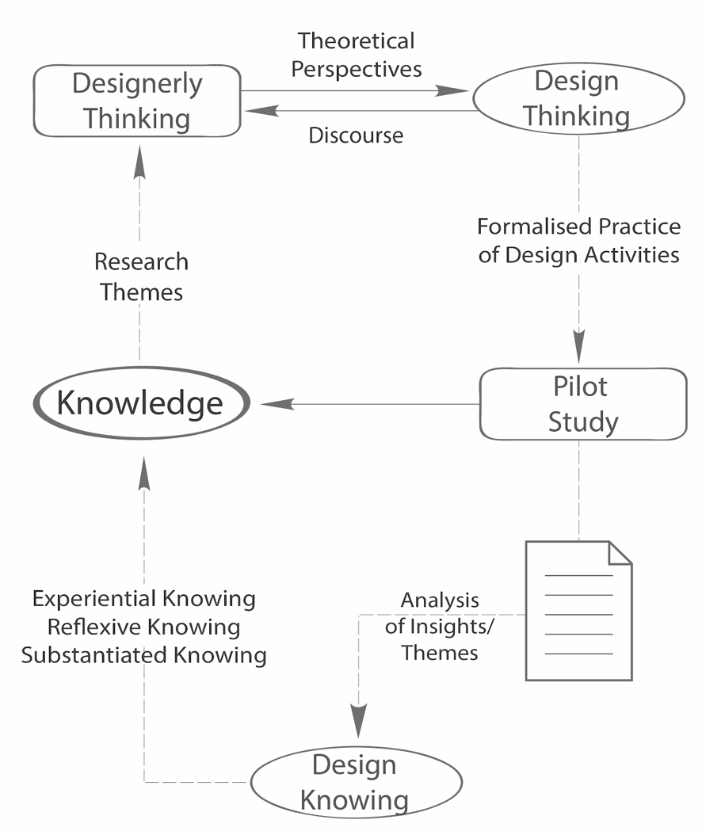
Figure 1. Framework of Study

The formalised methodologies of design thinking were tested within the educational scope and produced key insights and themes leading to the translation of thinking to knowing. This paper defines design knowing as the synthesis of the design thinking process through the forms of experiential, reflexive and substantiating knowing, epistemologically positioning the designer-researcher to contribute to emergent themes, theories and discourses of designerly thinking. Design thinking, in its practical applications, develops awareness and appreciation for the quality of experience, gaining of insights through critical reflections and substantiation of its outcomes. The framework serves to provide a descriptive structure and communicate the circularity of design within the relationships of theory, practice and research.

This paper provides a review of the broad themes of design thinking discourses and illustrates the need for more robust processes and methodologies through the examples of the pilot study. The educational implications of this paper suggest that broad-based and open-ended methodologies allow student designers to expand on existing knowledge and utilise introspective experience and reflective writing to substantiate the effectiveness of design outcomes. These key insights, in forming the 3 types of design knowing, extend into new areas and spaces for future research in design thinking, design knowing and design knowledge.

References
Brown, T. & Wyatt, J. (2010), ‘Design Thinking for Social Innovation’, Stanford Social Innovation Review, pp.31-35.

Buchanan, R. (1992), ‘Wicked Problems in Design Thinking’, Design Issues, 8: 2, pp. 5-21.

Claxton, G. (2000), ‘The anatomy of intuition’, in T Atkinson & G L Claxton (eds), The Intuitive Practitioner: On the Value of Not Always Knowing What One is Doing, Buckingham: Open University Press, pp. 32-55.

Cross, N. (1999), ‘Design Research: A Disciplined Conversation’, Design Issues, 15: 2, pp. 5-10.

Friedman, K. (2000), ‘Creating Design Knowledge: from Research into Practice’, IDATER, pp.5-27.

Galle, P. (1999), ‘Design as Intentional Action: A Conceptual Analysis’, Design Studies, 20, pp. 57-81.

Hillier, B., Musgrove, J., & O'Sullivan, P. (1972), ‘Knowledge and Design’, in WJ Mitchell (ed),
Environmental Design: Research and Practice, Los Angeles: UCLA, pp. 310-314.

Hoadley, C., & Cox, C. (2009), ‘What is Design Knowledge and How Do We Teach It?’, in C Di Giano, S. Goldman & M Chorost, Educating Learning Technology Designers, New York: Routledge, pp. 19-35.

Johansson-Skoldberg, U., Woodilla J, & Cetinkaya, M. (2013), ‘Design Thinking: Past, Present and Possible Futures’, Creativity and Innovation Management, 22: 2, pp. 121-146.

Loh, C. E. (2016). ‘How Design can Improve Education’, The Straits Times, 18 April.
Lim, B. (2015), ‘A discussion on creativity and design education in Singapore and Malaysia’, Journal of Humanities and Social Science, 3: 2, pp.56-61.

Mohandas, V. (2018). Good design thinking ‘critical’ in transforming Singapore again: PM Lee, 05 April, viewed 31 August 2018, <https://www.channelnewsasia.com/news/videos/good-design-thinking-critical-in-transforming-singapore-again-pm-10108630>

Poggenpohl, S. (2015), ‘Communities of Practice in Design Research’, She Ji: The Journal of Design, Economics, and Innovation, 1, pp. 44-57.

Popper, K. R. (1004). Knowledge and the Body-Mind Problem: in Defense of Interaction. London: Routledge.

