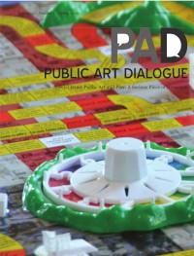
Public Art Dialogue

ISSN: (Print) (Online) Journal homepage: https://www.tandfonline.com/loi/rpad20

REBEL: Producing Publics Through Playful Evaluation

Marsha Bradfield & Fred Meller

To cite this article: Marsha Bradfield & Fred Meller (2022) REBEL: Producing Publics Through Playful Evaluation, Public Art Dialogue, 12:1, 138-157, DOI: 10.1080/21502552.2021.2019388
To link to this article: https://doi.org/10.1080/21502552.2021.2019388

Published online: 17 May 2022. Submit your article to this journal

View related articles

View Crossmark data

Full Terms & Conditions of access and use can be found at https://www.tandfonline.com/action/journalInformation?journalCode=rpad20

Public Art Dialogue, 2022
Vol. 12, No. 1, 138–157, https://doi.org/10.1080/21502552.2021.2019388

REBEL: PRODUCING PUBLICS THROUGH PLAYFUL EVALUATION

Marsha Bradfield & Fred Meller

While there are many systematic, reliable tools for the quantitative evaluation of public art as there are organizations and funders that require them, there is an absence of tools that meaningfully engage with the public. Public art organi- zations do assess some aspects of audience appreciation and participant bene- fit. This often involves evaluative tools that establish in advance the data and criteria to be reported on and to whom it is reported. This is especially the case in a common evaluative framework, which we argue gives a restricted and reductive value system when 5 extremely successful and 1 total failure. Today, public art may forego audience consultation, but its evaluation is inescapable, and its value is reflected in widespread digital capture and circula- tion through social media. A more playful and hands-on approach to evalu- ation offers an alternative to the prevailing paradigm based on econometrics like the “thumbs-up, thumbs-down” by promoting another possibility for more effectively surfacing the rich, lived-experience and peer-to-peer sharing of its users.
¼ ¼
In Why Play Matters, Miguel Sicart writes: “[P]laying is a form of under- standing that surrounds us and who we are and a way of engaging with oth- ers.”¹ There is a wide range of resources about play, including adult play, serious play, and gaming. For the purposes of this article, we focus on playful- ness as a trait, a state of mind, providing scope for flexible thinking and risk- taking with ideas or interactions. Participants take part in play for its own sake and not for an extrinsic reward or predefined outcome, with the spirit of play- fulness to imagine and explore.
Drawing on this fundamental importance of play, we offer an evaluative model that foregrounds peoples’ playful characteristics. This begins with high- lighting the lack of playfulness in familiar forms of reporting on public art and what this means for the experience of those doing the reporting; first and fore- most, the artist or artists who are often responsible for this work. We then provide a case study that uses Recognizing Experience-Based Education and Learning (REBEL) to propose an alternative approach as a playful supplement.

Copyright # Taylor & Francis Group, LLC

Before doing so, however, we outline REBEL in terms of recognizing experi- ence-based education and learning. Illustrating the playfulness of this entails three specific techniques: chance, perspective taking, and playing REBEL “straight.”
The final part of this article turns to operationalizing REBEL for produc- ing publics and the public sphere through their meaningful evaluation of public art. There is an urgent need for opportunities that can accommodate the agon- ism of growing political polarization. We highlight how REBEL is purpose-built for taking up this challenge. The article concludes with a call to arms: we invite artists, commissioners, funders, policy makers, and other stakeholders to stress test REBEL in their own work, especially in ways that challenge the prevailing paradigm of evaluation based on econometrics and professionalized consult- ancy. This points to REBEL’s broader application for critical and playful evalu- ation, assessment, endorsement and more.

THE LIVED EXPERIENCE OF ACCOUNTABILITY

Arts Council England (ACE) is a major source of funding for public art in England. With few exceptions, these grants begin with a criteria-based applica- tion, and successful requests end with a report. The aims and objectives expressed in a project’s proposal help to measure its outcomes. Is the project running as planned and having the desired impact? In other words, has the artist delivered as agreed?
To reflect on these questions, we draw on our own experience of applying and accounting for small and medium-sized awards from ACE. Securing the funding, delivering the public project, reporting on the outcomes, and archiv- ing the process can be demanding in unexpected ways. These evolve with experience and in response to opportunity; it can be challenging to predict the deep emotional and conceptual work involved.
Reflecting on this situation, we were struck by something expressed in the UK-based report on research into cultural value undertaken for the Arts and Humanities Research Council (AHRC). In the preface of Understanding the Value of Arts and Culture, Andrew Thompson, chief executive of AHRC, asserts:
The project has sought to put the experience of individuals back at the heart of ideas about cultural value, arguing that it is only once we have started with individual experience that we can then work outwards, and understand the kinds of benefit that culture may have for society, for communities, for democracy, for public health and wellbeing, for urban life and regional growth.²

This leads to one of the report’s key recommendations: it is imperative to “reposition first-hand, individual experience of arts and culture at the heart of the inquiry into cultural value.”³ Of course, Thompson and the report are con- cerned with individuals who experience culture by attending a performance or exhibition—“culture” as what happens “front of house.” Yet those of us facili- tating this culture will be quick to recognize the bias here. Inseparable but also submerged below the tip of the iceberg of cultural value are cultures of fund- ing. For creative practitioners, negotiating these circuits consumes significant time, energy, and care. This production and the public artwork’s reception can become so enmeshed in producing public art that separating these things is an impossible task.
We regularly resource our firsthand experience of this complex practice in our work as art educators in supporting students to make art and anticipate the life-long challenge of sustaining their practice through various streams of income. As we call for more research into the psychosocial dimensions of pro- ducing cultural value we welcome the AHRC’s repositioning of firsthand indi- vidual experience as a corrective to the abstraction of the quantitative measures for evaluating public art that have ascended with the paradigm of econometrics.
These are the familiar numbers, the “How many?” questions on ACE applications. How many “Artists/creatives/museum specialists” and “Audience (broadcast, online, in writing)”; as well as the often confusing distinction between “Audience (live)” and “Participants.” The final report of the Arts Council National Lottery Project Grant is composed of two columns, one indi- cating estimates, the other the “Actual activity.” This organizes most of the evaluative process further to three long-form responses that invite the grantee to reflect on generic questions. One asks: “Tell us about any longer term impact the project has had.” That the report must be submitted before the final chunk of funding is distributed makes the latter a peculiar request. Without the time required for long-term measurements, who can answer this question of impact in a meaningful way?
What is striking about this evaluation is that it quantifies most of the proj- ect’s beneficiaries (the publics who encounter it) without any qualitative reflec- tion on their experience. This is not to say that we are calling for interviews or focus groups for the evaluation of small and medium-sized grants. (Quite aside from these methods being labor-intensive and hence expensive, they also have pitfalls when it comes to collecting and analyzing data.) Our immediate con- cern is to simply observe what is involved in framing a project’s outputs, out- comes, and impact in the final report for public art funded by public money. Although described from the grantee’s perspective, this often fails to address their intrinsic needs or meaningfully develop their practice.

The vexed issue of benefit is broached in Understanding the Value of Arts and Culture with reference to funders as the principal drivers of evaluation.⁴ That funders seek accountability to evidence their return on investment has profound implications for the phenomenological experience of the grantee giv- ing an account.
Consider, for instance, our cobbling together of the project’s narrative, mindful of our funder-readers and their priorities—both explicit and implicit. To get the final chunk of funding, we curate our story. Some value is excluded because it is nuanced, inchoate, and unexpected. This can make it challenging to articulate—even to ourselves. Other value is purged because it clashes with prevailing views or involves institutional critique. We self-censor out of fear that sharing this truth could jeopardize the success of future applications.
This othering of content through editing our reports differs from what England’s public art think tank, ixia, calls an “artistic barrier” to evaluation (i.e., when artists perceive this accountability “as an attempt to undermine or expose complex creative processes where intention is irrelevant to final out- comes”⁵). This may be true for some practitioners, especially those drawing heavily on intuition, and we value this kind of practice as integral to cultural heterogeneity. We are less sympathetic to refusals in word and deed that ele- vate art above the worries of everyday life and afford the artist special status.⁶ This exceptionalism is a romantic myth we are keen to debunk as it fails to reflect the reality of most practicing artists, including our own.
Importantly, we recognize the value of the narrative account in the final report as greater than its bureaucratic significance as what stands between the grantee and their final payment. For many practitioners, this is the most com- prehensive and synthetic record of their project. That this is composed for their funders and not for themselves, their practice, or other stakeholders risks an impoverished representation for posterity. What is lost in a frictionless account of success is the messy reality of cultural production. We recognize the irony here, in the impossibility of making public the necessary failures involved in making meaningful public art.
To be fair, ACE reports afford space for confident practitioners to offer critical reflection on their projects and feedback on the award process. Moreover, the demands of this reporting and even the AHRC’s pale in com- parison to those for money received through the European Union (EU), or grants received through the highly precarious and often capricious 50l(c)(3) nonprofit model in the United States, part of the “non-profit industrial com- plex,” as Dylan Rodriguez has dubbed it, following the US prison industrial complex.⁷ Nevertheless, many would agree the formal evaluation of one’s cul- tural production is generally demanding and often demoralizing—anything but fun. Below are a few reflections on our quest to evaluate the production of

public art in ways that are both more pleasurable and more meaningful to all the stakeholders involved. We focus here on the needs of the artist in light of them being neglected for the reasons observed above, but our concluding remarks indicate how this approach might coordinate evaluation to meet more diverse needs.

REBEL DESCRIBED

As a tool, REBEL is a physical, card-based system, developed by a team of aca- demic practitioners and community-based education activists in the United Kingdom (London and Salford), and then further developed through two European Erasmus Strategic Partnership networks that included nine different countries within and beyond the EU. REBEL has been rigorously tested with learning communities at all levels of educational engagement and with multiple organizations responsible for higher education, vocational training, and com- munity support and learning.
As a technique, REBEL can be described as dialogic interfacing. Each card features a different capability, as exemplified by the one related to signs/sym- bols appearing in Fig. 1.
These capabilities prompt users to have meaningful conversations with mentors, peers, audiences, and others (especially themselves) by surfacing and defining their understanding: what they have learned through or from a spe- cific experience and how this expands, complements, and challenges their unique approach to being in the world and relating to it.

“PLAYING” REBEL

The first step in playing REBEL is to identify a personal experience, training course, or a work-related activity to explore. There are several reasons why we chose to revisit an ACE-funded project. For starters, Incidental Futures (2018–9) is the most recent public art project that either author has com- pleted, with the pandemic adversely impacting but also potentially transform- ing public art.
Incidental Futures was composed of a seven-city tour around England and Scotland to explore the Artist Placement Group’s (1966–89) ongoing influence on critical contemporary practice. The phrase “unfinished business” is regularly evoked in the activity of this UK-based avant-garde network and its successors to open up and reengage with work. For instance, when convening an inciden- tal meeting, it is customary for the invitation to observe the only item on the agenda is “unfinished business.”⁸ We took this as an invitation to revisit

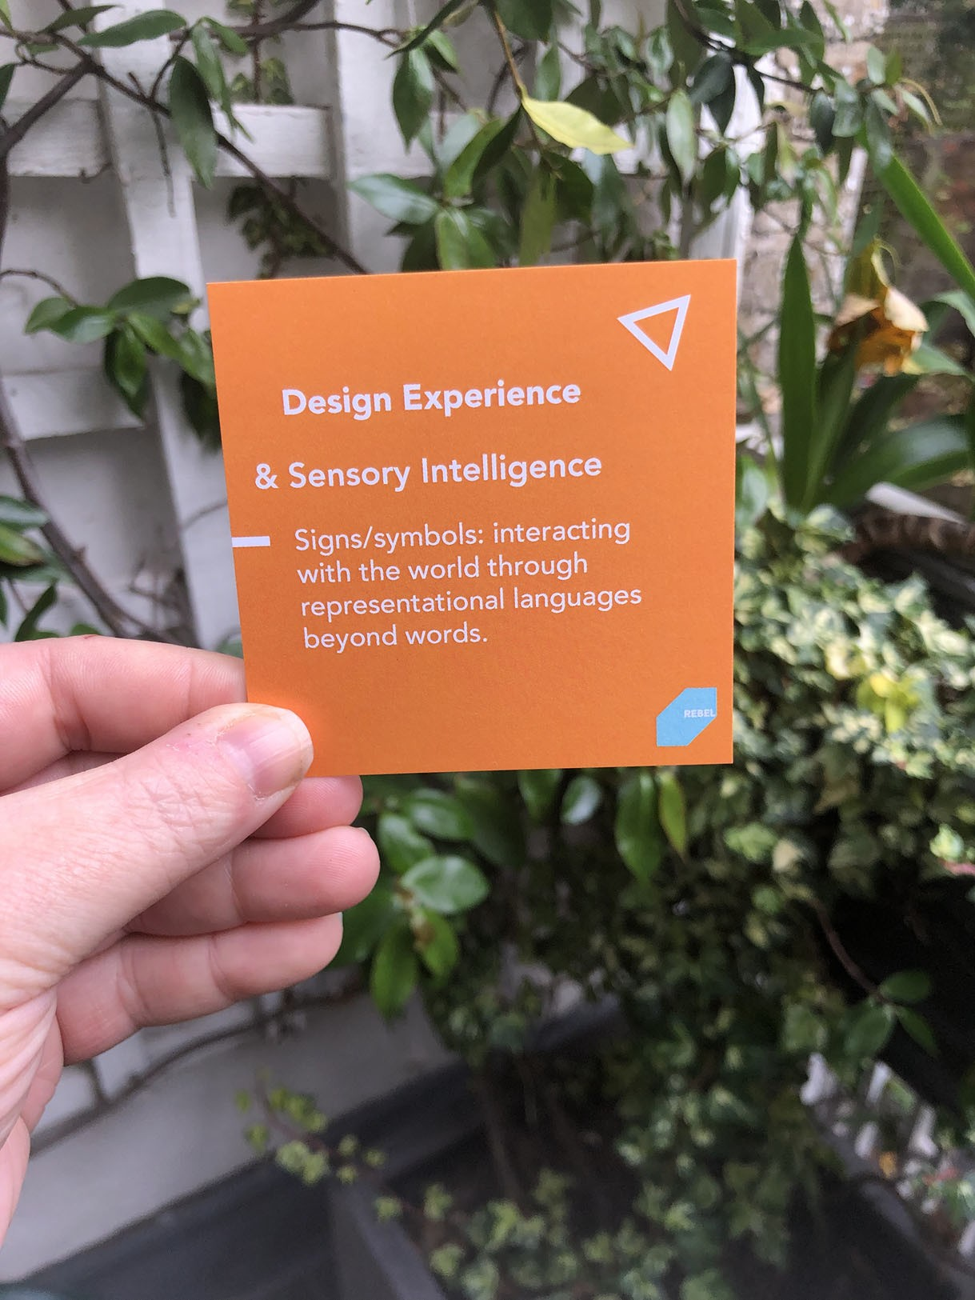
Figure 1. Example REBEL card. Photo by the authors.

Incidental Futures (realized by Marsha Bradfield and other members of the Incidental Unit) and to look back on the project but also anticipate what hap- pens next. A description of the Artist Placement Group, the Incidental Unit, and its ongoing work can be found at incidentalunit.org.
A further rationale for using REBEL to revisit Incidental Futures is closer to a hunch. Surely other artists share our chronic concern, touched on above, that formal evaluation, like funding reports, leaves too much value behind. This can be especially pronounced when this reflection comes at the end of a program or project. When the resources are spent, including the time and energy of the artist-evaluator, the evaluation can become rushed and superfi- cial. Could REBEL redress this conundrum, even partially? Could this light-

touch approach support us in taking stock more often? At the end of the pro- ject but also throughout? And would a more playful approach like REBEL’s help us avoid the triggering that many feel at the mere whisper of the word “evaluation”?
To address these questions, Fred Meller interviewed Kerri Jefferis, a seas- oned facilitator of REBEL who is working with Meller, Bradfield, and others to build on Ruth Potts’s formative work in creating this system.⁹ Jefferis is also a jobbing artist with intimate knowledge of making and evaluating public art; she has a reputation for playful practice to boot. The following dialogue is inspired by Jefferis and Meller’s exchange and draws on perpendicular conver- sations unfolding across REBEL’s growing community of practice.
Fred Meller (FM): Could you suggest how you might assist Marsha to use REBEL to reevaluate Incidental Futures—to reflect on this public program in a playful way?
Kerri Jefferis (KJ): REBEL uses cards and constraints, so it’s like a card game. But it’s not about beating another player. You’re playing with—you’re playing into—your own experience. You’re doing a deep dive into what you know, what you care about, and why it matters to you and your practice to gain insight. Importantly, I brief participants around the table in a relaxed, conversational way, using visual objects or images as much as possible, trying to break the didactic “teacher at the front of the class” mode with a convivial and exploratory tone. Here, chance and anticipation linger and set a playful, participatory mood. You want to get people excited about what they might discover about themselves or gain clarity on and what embracing a life-wide approach to understanding learning might open up for them. Once you identify your focus—in this case, a public art program—you work your way through the cards. Each one features a different capability. For instance, “Generosity: applying value to or embracing the goals of others.” The aim would be for Marsha to try to choose just six cards/ capabilities to organize her reengagement with Incidental Futures.
FM: So depending on the personal experience of that particular project there will be many cards that are not relevant.
KJ: The cards are organized into six suits (see Fig. 2) and there are relations between these that some users will want to play with, but you can start with any card and build your selection from any suit. Sometimes, when time is short, I curtail the users’ selection to one or two suits, build a bespoke deck, or limit their choice of capabilities to three or four instead of six.
FM: Bear in mind that Marsha is working on her own to create this case study, which differs from how REBEL is used to support working in pairs or in

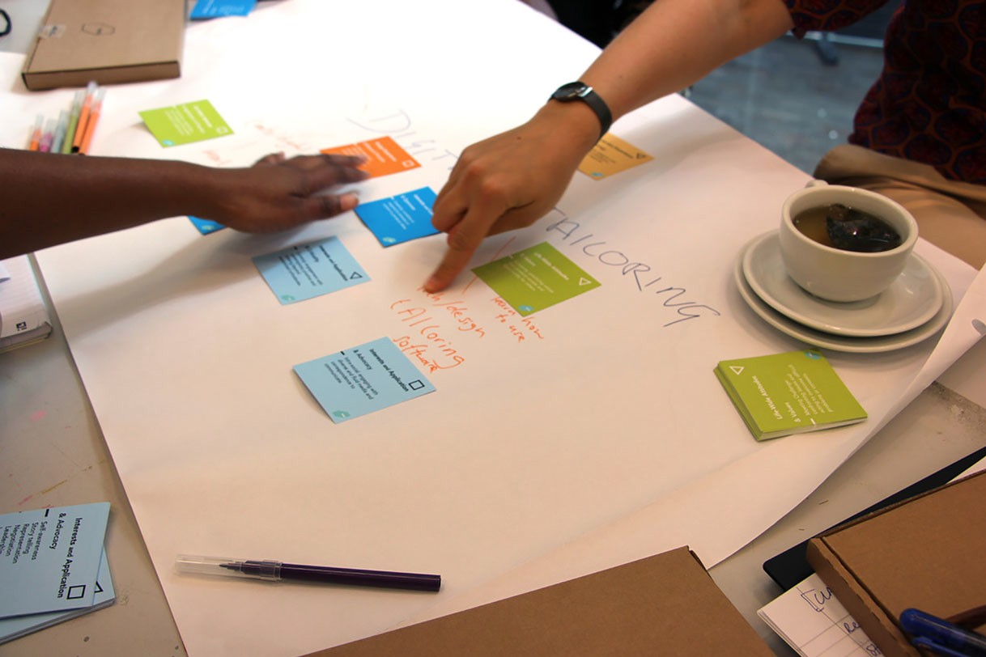
Figure 2. REBEL suits in action. Photo courtesy of Kerri Jefferis.

a group. We were interested in testing this approach because we anticipate that other artists may benefit from using REBEL to privately reflect on their public art projects. Based on your experience, what are some playful ways to use this tool/technique?
KJ: Chance offers an easy way into REBEL. The cards are neatly organized into decks relating to the suits,¹⁰ but they work best when mixed up. Put them all out on a table or desk and use both hands to jumble them together. This stops them being precious in any way.
The cards are designed to be touched, held, shuffled. I would put all the cards in a hat (use a real hat for dramatic effect) and pull a random one. Just one. Marsha could then go on to select five more, using a more intentional and conventional approach, by which I mean looking through and laying them out, and selecting the ones that match her experience most closely, but the random card would get things going.
Or Marsha could go for a full-on lucky dip and pull six random cards. It sounds a bit counterintuitive, but this hardcore approach can help those suffering from deci- sion fatigue or tiredness for other reasons. The energy they would spend on choosing the cards can instead go into reflecting on the capabilities’ significance to their pro- ject. You can also map the cards in playful, visual, and creative ways; for example, relating to a drawing of your body or hot spots of activity on a project timeline.
FM: This is freedom through constraint. I see you use visuals and encourage diagrams and linking between cards (see Fig. 2) to tell stories using imagery prompted from the cards.

KJ: That’s right. The key thing is that it is an unfixed plurality, able to surface unfinished business with a project or experience. Applying playful tactics to surface real values. The tone of playfulness gives permission for different “selves” to step outside the usual self and everyday life.
Another playful approach to using REBEL involves what psychologist David W. Johnson describes as, “Taking the perspective of another person. [This is] the ability to understand how a situation appears to another person and how that person is reacting cognitively and emotionally to the situation.”¹¹
FM: So, putting yourself in the shoes of another to appreciate their perspec- tive as distinct from your own. In a word: empathy. We know this can counter- act bias and improve conflict resolution¹² but how might it enrich an artist’s experience of evaluating their work?
KJ: To avoid appropriating the perspective of another person, Marsha could evaluate the project from the perspective of some nonhuman actor. This is inspired by the long tradition of it-narratives (stories that follow the fortunes of an object). I would encourage Marsha to look at the photo documentation of her public program, identify an object of interest, and then use the REBEL cards to probe understanding of the program from the object’s point of view.
FM: I can see the value of changing perspective to challenge our habits of thought. Surfacing tacit understanding can have profound implications for how we evaluate, be it taking stock of our personal experience or making sense of our projects, programs, or other outputs and outcomes.¹²
KJ: This idea of surfacing and reflecting comes onto something else: REBEL is played on a piece of paper where users organize their cards and make notes. We call this a placemat or sometimes a pitch (see Fig. 2). This capture can take many forms; there is no right or wrong way to play with REBEL. It depends very much on the user’s preferred learning style. Some users favor drawing; others keywords. Still others use patterning or diagrams to make con- nections and consolidate their understanding. This is an intimate process that differs from the interpretive drawing and painting that is sometimes used to liven up evaluation that would otherwise be dull and dry. REBEL is not about making a picture after the fact that represents the user’s experience. It is through drawing this out on the placemat that they recognize their learning. This is how their experience unfolds.
FM: Mark Langan, in the chapter “Playful Evaluation,” usefully gives a variety of methods for capturing participants’ feedback of experience in projects through playful means, qualitative versus quantitative, synchronous, and asyn- chronous. He defines the three key elements. First, the purpose of the

evaluation and what it is you want to find out and what do you want to do with the feedback. Second, the process of evaluation, in this instance the REBEL framework, and third the playful techniques/structures. These are cre- ativity, disruption, constraints, and the opportunity for failure.¹³
KJ: This analysis helps to theoretically contextualize REBEL as an already playful tool and technique. Marsha can also play REBEL “straight,” in keeping with the instructions that come with the cards. Using six capabilities of her choice that best represent the learning she gained from Incidental Futures will help with consolidating knowledge for further practice.
FM: To summarize, you’re encouraging Marsha to reengage with her public art project by using chance, perspective taking, and to play REBEL “straight.” In the process, she will create a case study of REBEL in action.

TECHNIQUES FOR PLAYFUL EVALUATION: A CASE STUDY OF REBEL

Fred Meller (FM): How did it go? What if anything did you learn from each of the playful approaches? Is there still unfinished business for your public program, Incidental Futures?
Marsha Bradfield (MB): This was not the first time that I have revisited a large public art project with the hindsight of several years, and so I knew it would be challenging. On the one hand, I wanted help from REBEL to reevalu- ate this body of work; on the other, this involved reevaluating the choices I have made in my practice and the consequences these have had for my life more gen- erally. This existential reckoning resonates with something Beverly Wade real- ized when working with academics, retirees, and people changing careers. In her words: “Paper is never just paper.”¹⁴ Their paperwork evidences not only the work they’ve accomplished but also who they have become. “Paper” here includes digital documentation. Wade’s insights into the complex and conflicted value—the emotional charge—of material like the funding report for Incidental Futures help to explain why revisiting this public project was neither emotion- ally nor psychologically straightforward, despite it being a success.
FM: How did you work with this?
MB: I followed Kerri’s instructions and put all the REBEL cards in a hat. I was surprised by the little rush of excitement the card-pulling produced. I chose six random ones and used them to reevaluate my evaluation—the narra- tive in the funding report as well as other information and reflections offered there.

Two of the cards were quite similar. One featured the capability of “Organization,” described here as “coordinating and managing relevant infor- mation, resources and materials.” The other focused on the capability of “Complexity,” with this detailed as “negotiating and managing interrelated processes or experiences.” Additional information on the cards clarified that “organization” in this case was related to cognition, so how we organize our interests and curiosity. On the other hand, the “Complexity” card was really about practice. So, for instance, how we approach complex systems or situa- tions. The overlap between the cards was productive because it pressed me to think about the project from these distinct but interrelated points of view.
In the ACE report, I wrote about intergenerational exchange as a vital out- come of the project, expressing this as follows: “We (the project’s facilitators) are beginning to think about this regarding diversity and inclusion, specifically fighting the ageism that cripples certain art worlds.” At the heart of Incidental Futures was the remarkable figure of Barbara Steveni, cofounder and ur-engine of the Artist Placement Group.¹⁵ We wanted everyone involved to interact with her in person—to have the experience of being influenced by her presence as practice. This felt especially important owing to her being elderly. But negotiat- ing and managing this interaction also proved complex.
Yes, the project celebrated Barbara’s wisdom, vitality, and visibility. Yet
her advanced age also made these things remarkable and hence unpredictable. Our growing awareness of occularcentricity in art means that many practi- tioners and publics no longer take the experience of looking or seeing at face value. We recognize this is only one form of sensuous understanding. How, then, can we apply the same awareness to the needs of our collaborators, par- ticipants, audiences, partners, and others involved in our projects? The two REBEL cards discussed above offered a way of reengaging with concerns related to geriatrics that are also relevant to disability. As the artist and dis- abilities activist Khairani Barokka (Okka) observes, “Pain often hides in plain sight.”¹⁶ This highlights that reading and negotiating fragile circumstances is an important sensitivity, especially when those involved have specific and dynamic needs that are not always visible.
Another card was also relevant here: “Perception: Interpretation of and
response to visual, audial, or other complexity.” This also helped with making a dis- tinction that is new to me but draws on my lived experience: many of us advocate for accessibility but we also need to evolve cultures of reciprocal care that experi- ment with diverse ways of asking/offering and providing/accepting help.
FM: This is a significant conclusion. Does it surprise you it emerged from playful reengagement? Or does it even make sense to describe it in this way?

MB: It seems more intricately connected to how things play out. My immense regard for Barbara as someone who was sharp and energetic blinded me to her needs as an elder whose relationship with her body was different from how I currently relate to my own. These assumptions shifted through working together, but I don’t think I could have grasped why or how from reading an academic study on care. The learning was inseparable from the practice of working with Barbara in diverse ways over several years. There was a lot of incidental learning, and that is what I mean by “playing out” in this context. Clearly, this contrasts with play as it is normally understood.
FM: Perhaps this is a good moment to clarify and enumerate some of the ways we are exploring play in this article. Physical play—the cards, the hat. Playful techniques and a playful attitude or approach and playfulness in reflective and evaluative thinking. In Playful Learning in Higher Education: Developing a Signature Pedagogy, Rikke Toft Nørgård et al. present playful learning that distinguishes three elements: surface structures (in our case the REBEL cards), for example the workshop materials and organization (table, paper, and pens); second, the deep learning that results from evaluative pedag- ogies (playful techniques that use the REBEL cards), and the implicit values and assumptions that underpin playful learning: a philosophy.¹⁷ The nature of playfulness comes with everyone’s “buy in” of an immersive experience; of presence, being in flow and fully absorbed. With these things in mind, how did you get on with Kerri’s second suggestion, which involved perspective taking?
MB: Here again I recognize a slippage between play occurring in the evaluation and in the activity being evaluated. Following Kerri’s suggestion, I looked at photo documentation of Incidental Futures to find an object whose point of view I could use to experiment with perspective taking. I chose a metal box. For several years, Nicola Ellis and her practice have been placed in Ritherdon and Co., a Lancaster company that makes metal enclosures, and Nicola brought some to the culminating event of Incidental Futures (South London Gallery, 2019).
FM: What did you learn from the perspective of this metal box and how did REBEL help with this?
MB: Well, Nicola’s invitation to the public was to assemble the boxes by using the manufacturer’s instructions. I don’t consider myself especially handy and participating in this way, at a public event I had cocurated, was outside of my comfort zone. I struggled to install the lock and get it to open using the key. Others came to help. The photo shows us pressed together and hunched over the box—a striking reminder of life pre-COVID-19! (see Fig. 3).
FM: How did REBEL support you in perspective taking?

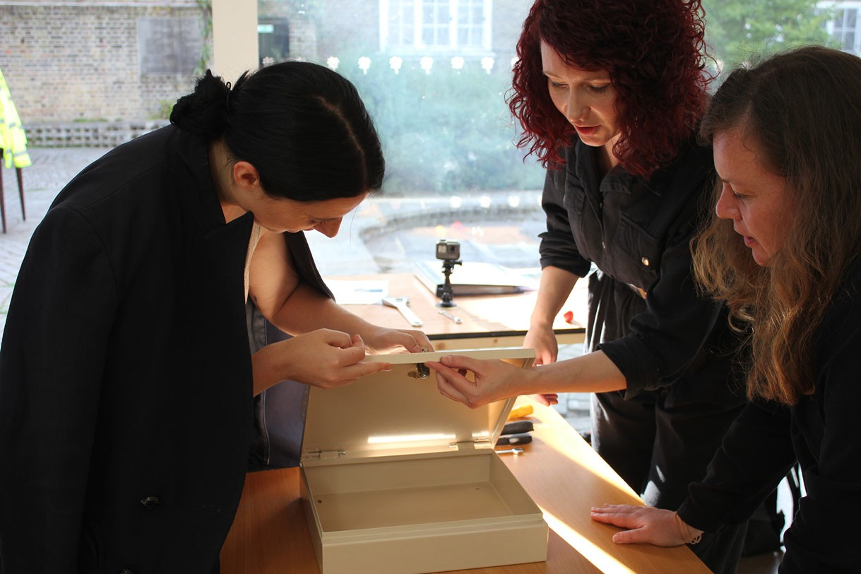
Figure 3. Taking the perspective of a metal box. Photo by the authors.

MB: I used the random cards from the lucky dip; the card featuring “Procedural” proved key. It focused on “producing sensitive and logical structures for gathering and developing content.” I’m sure the box was struck by my lack of procedural awareness. I was all thumbs and struggled to follow the instructions.
FM: This sounds awkward, like you were solving a manual puzzle in public.
MB: It was uncomfortable but somehow it was also engaging. I was suddenly collaborating with people—some of them I’d just met. We were determined to complete the task as assigned. This was not the time or place to interpret a box. Our outcome needed to meet factory standards.
As it turned out, there was a problem with the prototype and it didn’t assemble easily! Nevertheless, the shared satisfaction I felt from participating in the process and producing the clearly defined outcome reminded me that when it comes to getting to know each other in public art projects and priming participation, the default need not be tea and cake. Taking the perspective of a metal box was an unlikely way to think differently about creating community and belonging through other types of collaborative activity at public art events.
FM: So while you used the tool alone it is interesting to see REBEL supporting collaborative evaluation.
MB: Yes, now by the time I got to Kerri’s last prompt my headspace had shifted. The psychological barriers to reengaging with the project were dimin- ished. We often describe REBEL as autotelic, an end in itself. I recognize this in the absorption that comes from working with the cards. I selected six cards from the 108, but instead of revisiting the evaluation of Incidental Futures, I

tasked myself with backcasting the project’s public dissemination. Two years later, this remains forthcoming, making it a growing concern.
FM: It will help our readers to know that “backcasting” is a type of planning where you identify not only what you want to achieve but also the steps required to do so.
MB: One of my six REBEL cards came from the suit of Design Experience and featured “Content: Generation and communicating ideas, gestures, forms or more,” a prompt that both excited and terrified me. The archive for Incidental Futures is distributed across several computers and composed of mountains of stuff research, photographs, drawings, audio files, souvenirs from the seven events, and so much more. Finding ways to meaningfully share this online is daunting. Frictionless capture has generated a glut of material that even with critical and temporal distance requires strategic attention, editing, and represen- tation. I think this situation is something to which many artists can relate.
Despite this being a common problem, we fail to recognize or prioritize something that in other sectors is called “content strategy.”¹⁸ Too many of us, myself included, make the mistake of thinking that our work of producing cul- ture qualifies us to meaningfully communicate it to others, especially before and after the fact. As Rachel Lovinger, who coined the term “content strategy,” makes the point: When everything is content, it’s up to us as authors to deter- mine what is accurate and relevant.¹⁹ Unfortunately, the main models of dis- semination in art and academia aren’t always fit for purpose. Witness the proliferation of International Art English and the academic corollary of aca- demese. The good news: it doesn’t have to be this way. Practical support to produce meaningful content is readily available.
This segues into a discussion of another of my six REBEL cards and how it came into play: “Openness: Sensitivity and respect for unfamiliar experiences and situations.” While there are many ways to interpret this capability, in the context of this REBEL hand I read it as a directive to look beyond the worlds of art and culture. The best place to learn about content strategy is in its local context: the field of communication design. Exploring this is therefore the next step in backcasting Incidental Futures.
FM: So this is ongoing. If what you’re saying is the “Content” card prompted you to prioritize this while the “Openness” card was a pointer, indicating how you might proceed in this direction, it’s not exactly a revelation.
MB: No and this is also where REBEL gets really interesting from the perspec- tive of teaching and learning. It’s not a revelation if we understand this as a bolt out of the blue. What is instead revealed but REBEL also helps to congeal is something I already know or have intuited. This comes onto the deficit model

that is common to both formal education and the arts and culture.²⁰ The idea being: they have something we lack and providing this is their license to operate.
FM: This is the idea that taught courses in universities impart learners with the knowledge required to work in a specific field and at a particular level. While this can be true, it also makes me think of Paulo Freire’s critique of what he terms the “banking model of education.”²¹ In this teacher–student relationship, knowledge moves in one direction—top-down—from educator to educated, as education is instrumentalized in the service of broader forms of oppression and social control.
MB: But it’s not just formal education. Culture also has a long and overlapping history as a deficit model that normalizes class and other hierarchies. Granted, much has changed since Stuart Hall and others of the Birmingham School valor- ized popular culture through rigorous analysis to unmask and challenge the hegemony of high culture.²² Folk art is no longer subordinated to refined taste— to the extent that both have been flattened by consumerism with special help from social media. And yet there is still the prevailing view that through our cul- tural encounters—especially with critical contemporary art, including public art—we are personally edified. REBEL, however, takes a different view.
FM: I recognize this distinction in the motto of “learning how to learn.”
MB: Yes, but in this context, “learning how to learn” is first and foremost about unlocking tacit or embodied knowledge and valorizing experience-based insights that might otherwise be dismissed when there is no external authority to endorse them. Earlier in this case study, Kerri described REBEL as playing with—or playing into—your own experience. This helps us to grasp the differ- ence between the asset model and the deficit model of formal education and art and culture. As far as REBEL is concerned, the learner, viewer, participant, funder, and so on already enjoys immense knowledge. What they lack is the opportunity or occasion or scaffolding or confidence to recognize this and to understand what makes it significant to them as people, to their relation- ships—to their being and working in the world.²³
FM: REBEL is a tool and a technique for coaxing this knowledge into view, recog- nizing it and, ultimately, endorsing it. But this process can be difficult to capture.²³
MB: Which is why our case study has used reflective anecdote and dialogic exchange to convey the cognitive complexity of REBEL. What should by now be clear is the sensuous experience of its ludic form, which can eclipse or elide its effectiveness. We are encouraged that practice-based/led research can engage REBEL with a playful attitude but are only beginning to understand how this can unlock cultural value in public art and other forms of creative practice. What, however, seems immediately promising is the role that

metacognition plays in REBEL to penetrate psychological or other barriers that can make this value elusive when approached head-on.

UNFINISHED BUSINESS: USING REBEL TO EVALUATE PUBLIC ART WITH ITS PUBLICS

Above we focus on REBEL as a tool and technique to critically supplement the evaluation that characterizes funding reports for bodies like ACE. Central in our discussion is the artist’s practice, including their acquisition of the funding required to make public art. Our case study was partly occasioned by the pan- demic. With the cessation of “in real life” projects and widespread financial uncer- tainty, we, like many practitioners, have turned to critically reflecting on our practice to anticipate next steps. Moreover, we recognize the widespread desire for responsive strategies and tactics to meaningfully and iteratively organize creative practice as it becomes increasingly complex and distributed across online, offline, and archival spaces that are often hybrid. In this spirit, our case study aims to evi- dence REBEL’s growing track record for playfully generating serious insights.
Future research will build on work related to REBEL’s user-centered design and asset-based approach.²⁴ This includes how it differs from so many other tool- kits for evaluation, including ixia’s, that rely on qualitative and quantitative sur- veys and tend to reflect the funders’ priorities. There is also important work to be done on how REBEL’s playful sensibility differs from more whimsical and eccen- tric methods. Gamified interaction that invites publics to evaluate public art is a trend that recollects relational aesthetics, replete with its possibilities but also its pitfalls. In the words of Stephen Wright, too often this art involves “contrived serv- ices [or frivolous interactions designed for] people who never asked for them” with artists going on to “then expropriate as the material for their work whatever min- imal labor they have managed to extract from these more or less unwitting partici- pants (whom they sometimes have the gall to describe as ‘co-authors’).”²⁵ When gamified interaction tracks with the growth market of professional consultants, the potential pitfalls proliferate. This is especially infuriating for cultural producers when said consultants borrow methods from socially engaged art and extract the value of the participants’ labor in keeping with the logics of consultancy. To add insult to injury, the work in this burgeoning industry is often much better paid than the artistic labor involved in producing public art.
While external evaluation certainly has its place, REBEL seeks to challenge this as a worrying default while offering a viable alternative. In addition to often being expensive and ineffective, outsourcing the evaluation of public art can be a missed opportunity for its artists, curators, and other stakeholders to exercise their remit of energizing and enriching the public sphere by actively producing new publics and deepening the engagement of existing ones. As an

evidence-based discussion of REBEL’s potential to support this development remains the stuff of future research, our closing remarks, which draw on our work with using REBEL to galvanize experience-based learning groups and networks, will gesture in this direction. As unfinished business, these remarks also invite readers, including practitioners of public art, to be in touch for more information about using REBEL to enrich their practice. This invitation springs from an open-source ethos. We want to share REBEL’s code so others can experiment with and test the mettle of this evaluative tool and technique. Ideally, they will also feed back their findings as part of REBEL’s loosely knit but rapidly growing community of practice.
Crucially, the public art at stake here is “accessible work of any kind that cares about, challenges, involves and consults the audiences for or with whom it was made, respecting community and environment.”²⁶ The relational sensitivity that marks Lucy Lippard’s important definition differentiates it from what she terms “plunk art”: an enlarged version of a discrete object, often an abstract sculpture, that is effectively placeless until dropped in a designated location. (This kind of public art will be familiar to readers based in contexts like London, United Kingdom, where gentrification has made property developers a prolific source of public art commissions.) When we instead focus on and valorize public art that is produced with the public, each artwork expands in ways that can meaningfully encompass its funding, production, reception, and eventual decom- missioning and this has profound implications for the reciprocal relations between public art and the publics (including the artist/artists) who produce it.
The key question here is how to move from an individual’s evaluation (as exemplified by our case study and recentered by the AHRC’s research on cul- tural value) to a critical collaborative and/or collective process. In fact, the dis- cursive turn-taking that organizes our case study enacts the dialogic interfacing distinguishing REBEL as a technique, making it purpose-built for interpersonal evaluation. When, for instance, we work with a group to reflect on a shared experience, it typically begins with each individual identifying cards that are relevant to them. Further to working with their selection to generate insights on their experience in common, users are invited to share some of these in pair work and/or group discussion. Testing one’s understanding through this interpersonal exchange can lead to rejigging initial impressions and deepening or crystalizing others that were inchoate. What users can gain from the inter- play of REBEL’s scaffolding and facilitation, replete with its personal and inter- personal reflection, is more robust but also more nuanced understanding. When REBEL is deployed to evaluate public art, what artists, curators, funders, and other stakeholders can gain is privileged access to what a public artwork means to a member of the public, based on their situated and specific point of view in relation to others. REBEL also has scope for taking the shareholders’ perspectives and providing other relevant insight. Crucially, the skills to

facilitate REBEL are not difficult to acquire and readily improve with practice, and the cards can be inexpensively secured, as a digital version is being devel- oped to support REBEL’s broader dissemination, use, and iterative development. Quoting Martha Nussbaum, the AHRC’s report on cultural value asserts, “The arts and humanities generate ‘vital spaces for sympathetic and reasoned debate, helping to build democracies that are able to overcome fear and suspi- cion and, ultimately, creating a world that is worth living in.’”²⁷ Yet, as Geoffrey Crossick and Patrycja Kaszynska, the report’s authors, go on to observe, these so-called vital spaces can be far from inclusive.²⁸ This is consonant with Nancy Fraser’s feminist critique of Jurgen Habermas’s concept of the bourgeois public sphere, which Fraser argues is shaped through its exclusion of women and other marginalized groups.²⁹ Today we recognize a new inside/outside of the public sphere as works of public art produce publics—in the plural—through splitting public opinion, often quite brutally, into those who like an instance and those that do not. When these alternatives are ideologically charged, and political polarization is in lockstep with the machinations of social media, public art becomes a flashpoint in the discourse that creates and recreates the public sphere, including the imaginaries of the publics who compose it. Addressing this
is the most pressing unfinished business of public art writ large.
In this article, we have discussed REBEL’s playful approach to evaluation and gestured toward its possibility to be productively agonistic. Central here is the potential to create much-needed space for stakeholders to identify and better understand their respective values. This entails dialoguing with others to recognize how and why these spring from our lived experience and immediate needs and desires and hence may differ or even conflict with those of other stakeholders.

NOTES
¹ Playfulness as a state of mind provides the scope for an individual who can think
flexibly, take risks with ideas (or interactions), and allow creative thoughts to emerge and to be considered in different contexts. Miguel Sicart, Play Matters (London: MIT Press, 2014), 1; Rene Proyer, “Examining playfulness in adults: Testing its correlates with personality, positive psychological functioning, goal aspirations, and multi-methodically assessed ingenuity,” Psychological Test and Assessment Modeling, 54, no. 2. (2012): 103–27.
² Andrew Thomson as quoted in Geoffery Crossick and Patrycja Kaszynska, “Understanding
Cultural Value of The Arts and Culture: The AHRC Cultural Value Project” (Swindon: Arts and Humanities Research Council, 2016), 5.
³ Geoffery Crossick and Patrycja Kaszynska, “Understanding the Cultural Value of the Arts and Culture,” 7.
⁴ Ibid., 9.
⁵ ixia, “Public Art: A Guide to Evaluation,” 3rd ed. (n.p.: ixia, 2013), 5.
⁶ Hans Abbing, Why Are Artists Poor? The Exceptional Economy of the Arts (Amsterdam: Amsterdam University Press, 2002), 7.
⁷ Dylan Rodriguez, “In the Shadow of the Shadow State,” in The Revolution Will Not Be Funded: Beyond the Non-Profit Industrial Context, ed. INCITE! Women of Color Against Violence (Cambridge, MA: South End Press, 2007), 21.

⁸ Incidental Unit, accessed October 29, 2021, https://incidentalunit.org.
⁹ Ruth Potts and Paul Haywood, “Formative, Andragogic, Interactive Reflection (Fair) Assessment Tool: A Development Project Addressing Transferrable Learning Recognition from Open Life-Wide Co-Operative Engagements,” in EDULEARN14 Proceedings: 6th International Conference on Education and New Learning Technologies Barcelona, Spain. 7-9 July, 2014 (Valencia, Spain: IATED), 5711-20. https://library.iated.org/view/POTTS2014FOR
10 The REBEL cards are divided into six themes, each color coded: green ¼ Life-
Wide Attitudes and Life-Wide Behaviors; orange ¼ Design Experience and Production Experience; blue Interests and Curiosity; Interests and Applications.
¼
¹¹ In this research on perspective-taking, David Johnson studied American fourth
graders to test a core assumption in social cognitive development literature: there is a strong relationship between one’s predisposition to cooperate and one’s ability to take into account the emotional and/or physical perspectives of other people. This research showed a clear link between affective perspective-taking and cooperativeness. But this was not the case with taking physical perspectives. While providing a useful definition of perspective-taking in general, this particular research stops short of exploring the intersection between these two types: physical and affective. This is something we aim to investigate further through our practice-based research as creative agents involved in diverse types of collaboration, participation, and other cooperative activity. David Johnson, “Cooperativeness and Social Perspective Taking.” Journal of Personality and Social Psychology 31, no. 2 (1975): 241.
¹² Ibid.
¹³ Mark Langan, “Playful Evaluation,” in Playful Learning: Events and Activities to Engage Adults, ed. Nicola Whitton and Alex Moseley (New York: Routledge, 2019), 161–73.
¹⁴ Beverly Wade as quoted in Anita Chaudhuri, “Living with Enough,” Psychologies, Spring (2018): 66.
¹⁵ Barbara Steveni died in 2020, at the age of 93. For more information visit https:// barbarasteveni.org/Index.
¹⁶ In this important paper, Khairani Barokka (Okka) reflects on the extraordinary demands of her dual commitment to making her performances accessible to one disability culture while also ensuring her own disability needs were respected and met while touring her work. In the same way that one set of needs can elide another, so too can focusing on one aspect of a situation blind us to contiguous or overlapping considerations of care. Khairani Barokka, “Deaf- Accessibility for Spoonies: Lessons from Touring Eve and Mary Are Having Coffee While Chronically Ill,” Research in Drama Education: The Journal of Applied Theatre and Performance 22, no. 3 (2017): 392.
¹⁷ Rikke Toft Nørgård, Claus Toft-Nielsen, and Nicolla Whitton, “Playful Learning in Higher Education: Developing a Signature Pedagogy,” International Journal of Play 6, no. 3 (2017): 272–82.
¹⁸ Rachael Lovinger understands the goal of content strategy as follows: “[T]o use words and data to create unambiguous content that supports meaningful, interactive experiences.” The content strategy of something should seek to manifest its aims and objectives. For instance, the content strategy of the website belonging to a business will likely aim to secure trade. Rachel Lovinger, “Content Strategy: The Philosophy of Data.” Boxes and Arrows, accessed October 29, 2021, https://boxesandarrows.com/content-strategy-the-philosophy-of-data/
¹⁹ Ibid.
²⁰ See Ruth Potts and Paul Haywood's discussion of REBEL as an asset-based approach. This tool/technique cohered most immediately in response to the UK's austerity measures and the proliferation of other barriers that are limiting access to diverse forms of education. This led the authors to redress the lack of programs that support experience-based learning, with this having tremendous potential to synergize and galvanize formal education. To this end, REBEL’s asset- based approach fortifies learners, educators and other stakeholders to move between different types of learning with greater agility and appreciate their mutual benefit. Decentralized learning

networks have a special role to play here in supporting intercultural, interdisciplinary and other connections that have historically been controlled by institutions. Ruth Potts and Paul Haywood, “Learning Co-Operatively: Networking Engagement and Experience” (London: University of East London Printing Services, 2015).
²¹ Paulo Freire, “The ‘Banking’ Concept of Education,” in Ways of Reading: An Anthology for Writers, eds. David Bartholomae and Anthony Petrosky (Boston: Bedford/St. Martins, 2005), 255-70.
²² Crossick and Kaszynska, “Understanding Cultural Value,” 64.
²³ Potts and Haywood, “Learning Co-operatively” and Potts and Haywood, “Formative, Andragogic, Interactive Reflection (Fair) Assessment Tool.”
²⁴ Ibid.
²⁵ Stephen Wright, “The Delicate Essence of Artistic Collaboration,” Third Text 18, no. 6 (2004): 534–35.
²⁶ Lucy R. Lippard, “Looking Around: Where We Are, Where We Could Be,” in Mapping the Terrain: New Genre Public Art, ed. Suzanne Lacy (Seattle: Bay Press, 1995), 212.
²⁷ Crossick and Kaszynska, “Understanding Cultural Value,” 59.
²⁸ Ibid.
²⁹ Nancy Fraser, “Rethinking the Public Sphere: A Contribution to the Critique of Actually Existing Democracy,” Social Text, no. 25/26 (1990): 56-80.

BIOGRAPHICAL NOTES
Marsha Bradfield rides the hyphen as an archivist-artist-curator-educator-researcher-writer-and, and, and. . . . Her practice explores the subject of interdependence. Recent work examines authorship, value systems, organizational structures and the economies/ecologies of collaborative cultural production. Marsha is part of Dara, Critical Practice, Precarious Workers Brigade, REBEL (Recognising Experience-Based Education and Learning) and the Incidental Unit (formerly the Artist Placement Group and O I). These collaborations often result in insights that she re-presents in publications, exhibitions, performative lectures and other mongrel outputs. Marsha's teaching spans BA, MA and PhD in the areas of art/design/performance and their curation and education. She is Course Leader of MA Intercultural Practices at Central Saint Martins (University of the Arts London), having previously led MA Computational Arts at Camberwell College of Arts (University of the Arts London). Between 2013 – 2018, Marsha codirected Pangaea Sculptors’ Centre and has directed Artfield Projects since 2015. Marsha has been part of projects connected to 16 Beaver (New York), Berlin Biennial 7 (Berlin), Centre A (Vancouver), Deveron Projects (Huntly), Flat Time House (London), The ICA London (London), The Knot (Berlin), Labor (Budapest), The Matadero (Madrid), Peckham Platform (London), steirischer herbst (Graz), Tate Modern (London), Taipei Biennial 2000 (Taipei) and Wyspa (Gdansk). Contact Marsha Bradfield at marsha.bradfield@arts.ac.uk.
þ
Fred Meller is Programme Director for Performance at Central Saint Martin’s, University of the Arts London and an established Scenographer and Performance Designer. She has a BA in Theatre Studies, (University of Ulster, 1989) an MA in Academic Practice (UAL 2014) and studied at postgraduate level at The Royal Welsh College of Music and Drama (PG Dip. 1990). She is a Senior Fellow of the HEA, a Senior Teaching Fellow at UAL, a Fellow of The Arts Foundation, and Distinguished Professor at Tokyo University of the Arts, in the Department of Global Arts Practice. Fred is the Shared Campus lead for the development of a curriculum ecosystem that can adapt to and align with the diverse requirements of international partners. She is UAL lead on the development of courses and curricula relating to Shared Campus (MA Intercultural Practices and MA Performance: Society) and on courses delivered through the developing framework for Work and Experience Based Learning (MA Practice: Creative Production). Contact Fred Meller at f.meller@csm.arts.ac.uk.

