Making Circular Design Guidelines:
Reflections on a longitudinal practice research project which strategically explored sustainable, circular, local and biobased textile/fashion narratives

Rebecca Earley
University of the Arts London, London, UK
r.l.earley@chelsea.arts.ac.uk

Keywords: Textiles, fashion, design, sustainability, circular economy, biobased materials, design strategy

ABSTRACT
This paper explores fashion textile design methods and practices which address a concern for the environment, through the sustainable, circular, ‘local’ and biobased frameworks and approaches. A series of upcycled shirts are reviewed, which uncover new opportunities and insights to support future design pioneers in the field.
Fashion textile design has changed rapidly in the last decade. As the climate emergency has gathered pace and become the most pressing issue of our time, designers and educators have been using the remaking and overprinting of clothing in research practices to uncover the new thinking and actions needed to drive and support changes in industry practices. Sustainable and circular fashion textile design offers designers the opportunity to create compelling visions and practical roadmaps to just and equitable cultures, that value people and planet over profit. Designers can build new bridges between the sciences, and between economics, politics and industry – creatively framing emergent spaces for discourse and action – challenging us through new modes of making, thinking and sharing.
Through different approaches to making textiles and remaking second-hand polyester shirts; and through parallel forms of enquiry including workshop facilitation, design thinking, teaching and consultancy, this paper aims to articulate guidelines for textile design and practice researchers in creating materials and systems fit for a more resilient future. The paper demonstrates the different approaches explored in tackling sustainability in practice by focusing the creative brief on different issues when upcycling – adding value through design. The paper considers a set of ten shirts which explored circular design and an extended use lifecycle of 50 years; as well as the use of AI, biobased materials made from agriwaste and the potential for circular clothing to also be ‘local’ in production, use, disposal and regeneration.
UPCYCLED SHIRTS, ENVIRONMENTAL STRATEGIES, DESIGN GUIDELINES
Working with used but intact shirts offered a creative freedom to focus on the aesthetic rather than cut and construction. Early on the shirts were made for art shows and clothing boutiques. They started as upcycled fashion tops, but in time they became ‘demonstrators’ in large collaborative research projects. They were all used to explore a wide range of ideas that brought sustainable design approaches across from other fields – architecture, product and automotive design – and adapted them for textile design.
From 1996 the TED group at Chelsea set out to locate the key decisions a textile designer made, so that better future decisions could be taken, in terms of environmental impacts. It took years to frame what the authors called ‘The TEN’. First launched in 2010 under Creative Commons, in 2011 they were brought out as a deck of cards to be played in design thinking workshop contexts. The first upcycled shirt was made in 1999, yet more were then developed in parallel to evolving The TEN during the AHRC-funded ‘Worn Again: Rethinking Recycled Textiles’ project (2005-2009) (Earley, 2010). The card formats the author designed allowed users to work in very different ways from the usual methods found in textile design, in either research or in commercial practices, adapting to scales and challenges through the flexible format.
Strategy 1, Designing Out Waste. This strategy encourages designers to minimise the waste that is created in the textile industry, both pre- and post-consumer. It includes zero waste cutting and recycling, but it also introduces the idea at the outset that we need to avoid producing stuff that doesn’t work, that people don’t want. Charity shops and market stalls have millions of used polyester blouses in stock. Shapes can be adapted, in order to make them more fashionable. Figure 1 shows ‘Boudoir Shirt’ – one of the first shirts made using the approach of overprinting using black disperse dye on paper and a heat transfer press.
Strategy 2, Design for Cyclability. This strategy is concerned with how when you design for cyclability, the thinking is different yet wholly connected to the process of recycling the textiles. A fundamental decision here is to work in a momomaterial way – choosing one fibre type to work with. This helps to reduce the contamination in chemical recycling processing.

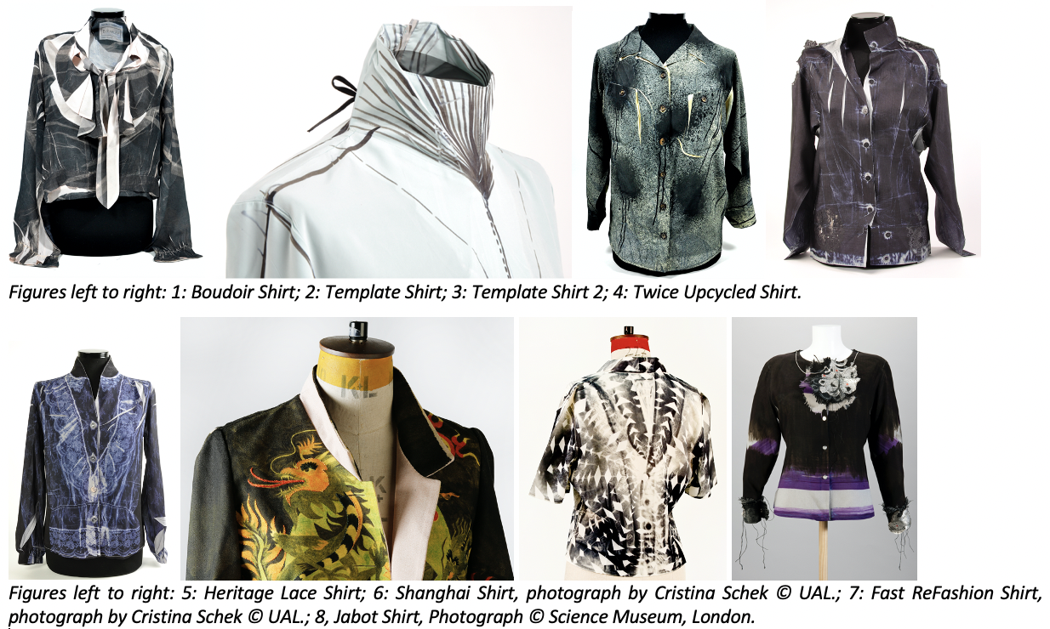

Strategy 3, Design to Reduce Chemical Impacts. This strategy is about understanding where all the chemical impacts occur when a fashion textile designer makes a decision. In figure 2, Template Shirt shows an approach where the density and placement of the overprint design reduces the amount of printing ink applied. Carefully placed detailing can give an upcycled garment a new lease of life without increasing its footprint or hindering future reprocessing; of course, the well-considered overprint also updates the look.
Strategy 4, Design to Reduce Water and Energy Use. Energy consumption and water usage in the textile industry are extremely high and occur at each stage of the lifecycle – production, use, and at the end-of-life stage. One way to approach this strategy is to design the garment to be low launder; considering all the ways that design can support better use behaviours around care. In figure 3, Template Shirt 2, the splatter style overprint disguises dirt and stains.
Strategy 5, Design to Explore Cleaner and Better Technologies. This is about replacing production systems with less energy-consuming technologies to reduce environmental impacts. Lifecycle Assessment (LCA) tools help designers understand more about the impacts from their decisions, and how to best use technology. Figure 4 shows the Twice Upcycled Shirt, which was remade for a second time, using laser etching technology. LCA shows that if the upcycled shirt replaces the purchase of a new shirt, then significant environmental savings are made. The laser process is less impactful than devoré printing.
Strategy 6, Designing with Nature, History & Culture. It’s not new for textile designers to look to nature or historic design for inspiration; the question here is more about what we can learn to help us design more sustainable products. Nature does not produce waste; and historically, during times of hardship and conflict, humans have been a lot less wasteful than they are today too. Figure 5 shows Heritage Lace Shirt, which used the details and associations from historic lace shirts to imbue a low value, used garment with new meaning and associations. Lace is often seen as a classic style and exists outside of trends.
Strategy 7, Design for Ethical Production. This strategy is about design that utilises and invests in traditional craft skills in the UK and abroad, ethical production which supports and values workers’ rights and the sourcing of fair-trade materials. In figure 6, Shanghai Shirt, design decisions were based on the observed relationship between the designers and buyers in Europe, working for a large fashion brand (H&M), and the production office team working in Asia. The design decisions made here were driven by questions about our inner selves and our outer, working selves, and how we align these. The shirt was remade into a luxury jacket after field work in Stockholm and Shanghai.
Strategy 8, Design to Reduce the Need to Consume. This strategy is about making stuff that lasts, stuff that we really want and want to keep and look after, and the design and production of textiles and products which adapt and change with age. This strategy is also about exploring alternative forms of design and consumption such as co-design and collaborative consumption. In figure 7, the Fast ReFashion Shirt, the consumer is given the tools and means to remake the shirt for themselves at home. Textile design decisions shift here to become more about supporting others to remake a garment, rather than making the aesthetic and conceptual decisions themselves. Domestic approaches to extending clothing lifespans are an important yet underexplored element of the circular economy in practice.
Strategy 9, Design to Dematerialise and Develop Systems & Services. This strategy introduces the concept of designing systems and services instead of, or to support, products for users, for example - lease, share or repair. It also covers the idea of designing for new industrial material systems – a flow of goods between sectors and actors – to reduce footprints. In figure 8, the Jabot Shirt explored how waste lace could be moved into a jewellery lifecycle system – using silver and electroplating technology - and then also work as a detachable element on an upcycled shirt.
Strategy 10, Design Activism. In this final strategy designers are encouraged to leave behind the product and work creatively as changemakers with the consumers and society at large. It is about designing events and communication strategies beyond product design, to increase consumer and designer knowledge about the environmental and social impacts of fashion and textiles. Here, the textile designer becomes a ‘social innovator’. This is often the hardest design approach for textile designers to embrace. It requires them to get out of the studio and connect with others. Designers and makers must become comfortable with the discomfort of raising their voices and taking part in visible actions; finding ways to bring the benefit of their ‘designerly’ ways to the fore (Cross 2006).
Circular Speeds Design Strategies. This set of three shirts focused on decision-making for circular design and lifecycle speeds (figure 9, Service Shirts). Designed to last 50 years – a ‘super-slow’ concept that required decisions to be made in collaboration and consultation with many other stakeholders, and often not in the usual order or supply chain sequence. It required extra care to be taken around understanding the impacts being created. Figure 9 shows the shirt at its second, third and fourth lifecycle stages, having been designed in such a way that an overprint (using digital dye sublimation processes) gives it a new appearance.
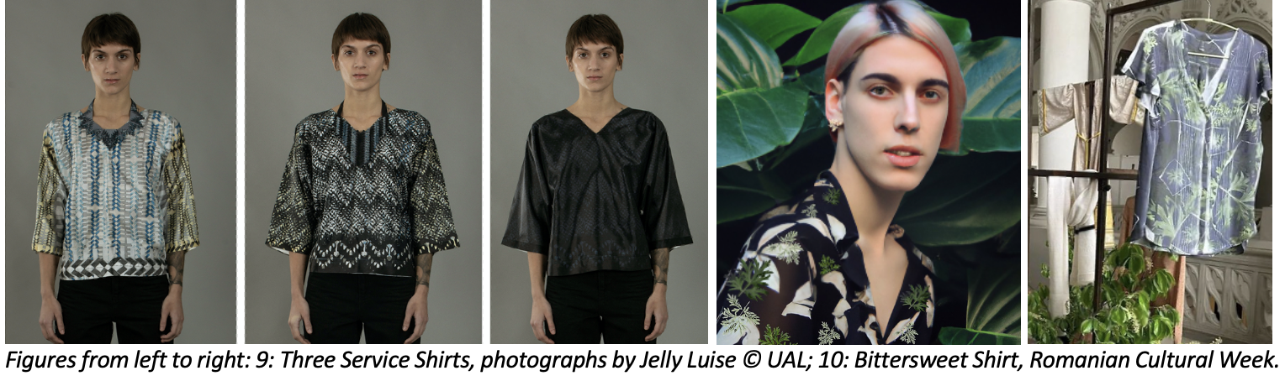
The shirt later goes on to become the lining of a jacket and then textile jewellery, before finally being chemically recycled into new fibres. The design decisions made replaced a single fast use cycle for the shirt within a multi-use, slow lifecycle. To make and use, then remake and reuse the product over this extended period, location and place became key design considerations. The research uncovered a great potential for user engagement and conviviality in extending the life of products in specific local areas as well as significant barriers in terms of both design, business model and behavioural change resistance (Pederson et al, 2018; Real et al 2018; Earley & Forst 2019).
Circular, Bio and Local Strategies. In the Herewear Project (2020-2024) the above sustainable and circular design strategies were further adapted to be used with a group of novel biobased materials which were made from EU agriwaste. The TEN were considered by the interdisciplinary group against the typical properties of a selection of biobased materials and garments. The resulting ‘BIO TEN’ (Earley & Forst, 2023) were then tested by industry design professionals. The particularities of the production lifecycle stages of biobased materials mean that designers need to be aware of not only the type of biomass used to create this emergent group of materials; but also how they have been processed, what they have been mixed with, and how they have been treated; before being able to design products that will end up in the appropriate recycling facility (Forst & Earley, 2023). Furthermore, during the use phase particular attention needs to be given to how garments made from these materials can last longer and stay in use for longer, through use, reuse, repair and upcycling (remanufacture) processes (Earley et al 2023). The final shirt prototype discussed in this paper - Bittersweet Shirt (figure 10) - was designed using the Dall.E AI programme, for the regional context of consumers in Iasi, Romania. An upcycled shirt was made using a print of wormwood leaves – a local Iasi plant used to make absinthe – and asked Romanian viewers to considered how AI would change their local way of life, for better and for worse. The making of the shirt evolved in parallel to various overprinting samples that invited workshop audiences to choose a design (also created by Dall.E) which drew on local/craft traditional decorative imagery.
CONCLUSION
Design guidelines are needed to support circular economies in developing appropriate and desirable alternatives to linear systems. The parallel practices of strategically making and reflecting, then drafting guidelines, making tools to test these, and further sharing out for feedback, is a ‘designerly’ way of working in research that moves theory into practice, and back again. This essential oscillation between stakeholders and lifecycle stages, means that circular design research may be more able to produce guidelines that are fit for purpose, and appropriate to not only need, but also to nature and behaviour. Most of today’s design education is still stuck on addressing questions from linear models, but they are slowly moving towards interdisciplinarity and circularity. As this shift continues, designers must drive change by using innovative materials and making to prototype alternatives to the exploitative and extractive industry practices that still dominate.
Acknowledgements
This paper draws on research funded by the AHRC (UK); Mistra Future Fashion (Sweden); European Union’s Horizon 2020 research and innovation programme under grant agreements 101000632 (Herewear Project) and 646226 (Trash-2-Cash Project). Thanks also to Chelsea College at UAL for support across the years. All images are by the author unless otherwise credited.
References:
Cross, N. 2006. Designerly Ways of Knowing. New York:Springer.
Earley, R. 2010. Worn Again: Rethinking Recycled Textiles (2005-2009). AHRC project summary report, available online at https://tedresearch.net/media/files/PROJECT_REPORT_2011.pdf.
Earley, R., Forst, L. Sandu, E., Spataru, A. 2023. BioTEN BURRR: Exploring current use, reuse, repair and recycling practices for bio-based clothing towards guidelines for circular fashion designers. 4th Symposium on Circular Economy and Sustainability, 19-21 June 2023, Heraklion, Greece.
Earley, R., Forst, L. 2023. The BIO TEN Design Guidelines: Inspiring biobased, local, durable and circular innovation in fashion textiles. PLATE 5th Product Lifetimes and the Environment Conference, 31 May - 2 June, Aalto, Finland.
Earley, R., Forst, L. 2019. Everything That Went Wrong: challenges and opportunities in designing and prototyping long-life garments in a circular economy », PLATE 2019, Berlin, 18-20 September 2019.
Forst, L., Earley, R. 2023. Lifecycles of Bio-Based Materials: Insights from the HEREWEAR sample collection. In: TIWC - Textile Institute World Conference, 3-6 July 2023, Huddersfield University.
Real, M., Earley, R., Goldsworthy, K. 2018. Practices, Places, Projects: Enrolling Stakeholders for Circular Fashion. Global Fashion Conference Proceedings. In: What's Going On? Global Fashion Conference. www.gfc-conference.eu.
Pederson, E.R., Andersen, K.R., Earley, R. 2018. From Singular to Plural: Circular Business Models for Fashion. Journal of Fashion Marketing and Management, 23(3), pp. 308-326. https://doi.org/10.1108/JFMM-04-2018-0062.

