IM/PROPER (AD)DRESS
Gracia Ramirez , September 12, 2018
This project is an exercise in complicating received understandings of the ways in which female audiences were addressed in the 1950s French fashion magazine Le Petit Echoe de la Mode Popular among middle class housewives, the magazine included richly illustrated publicity and advertorials in its pages I approach the images through the lenses of Marxism, psychoanalysis and situationism, and look for denitions of female subjectivity which result from the economic, social and aective relations of patriarchy and capitalism at that time
I see an increasingly auent world desperate to sweep the memory of recent wars, rationing and persecutions under the carpet; a repertoire of smiles that obviates the lurking threat of nuclear war I encounter a resonating tone that summons the idea of an appropriate, suitable woman; as if there is a tting shape -like that of a dress- to desire, to aspire to
Since to be “proper” refers to a way of being which accords to accepted standards physical, moral, it didn’t take much for second wave feminists to denounce the standards of beauty and femininity pervasive in magazines such as Le Petit Echoe de la Mode as problematic impositions As today, the advertising of the 1950s is all-too transparent, assuming female desire and identication are clear, straightforward, and determined from the beginning IMPROPER ADDRESS reworks these images, imagining from a present perspective how they might be read by those the magazines addressed
In selecting, arranging and naming the paper collages I have drawn inspiration from Hannah Hoch’s unveiling of irrationality, repression and oppression in everyday objects The resulting images bring up oddity, extremity, and contradictions The settings often blur the distinctions between domestic, commercial and theatrical spaces, thus bringing into play aspects of privacy, material exchange and performance I have also been inspired by the work of Barbara Kruger who uses the language of publicity to expose the imperatives of consumer culture while allowing contradiction, humour and seduction to remain.

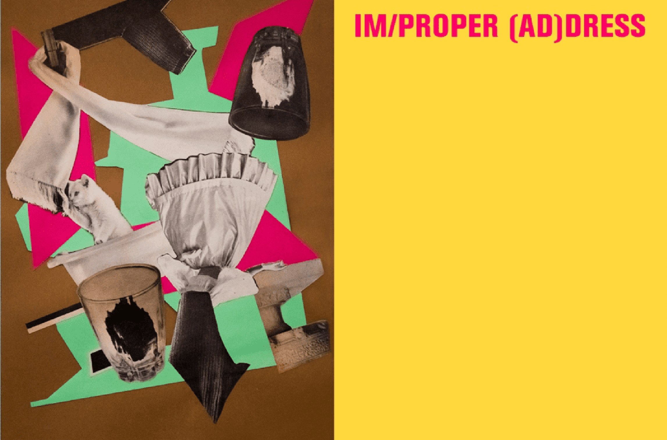

Uncomfortably measured, manipulated and displayed like a piece of meat

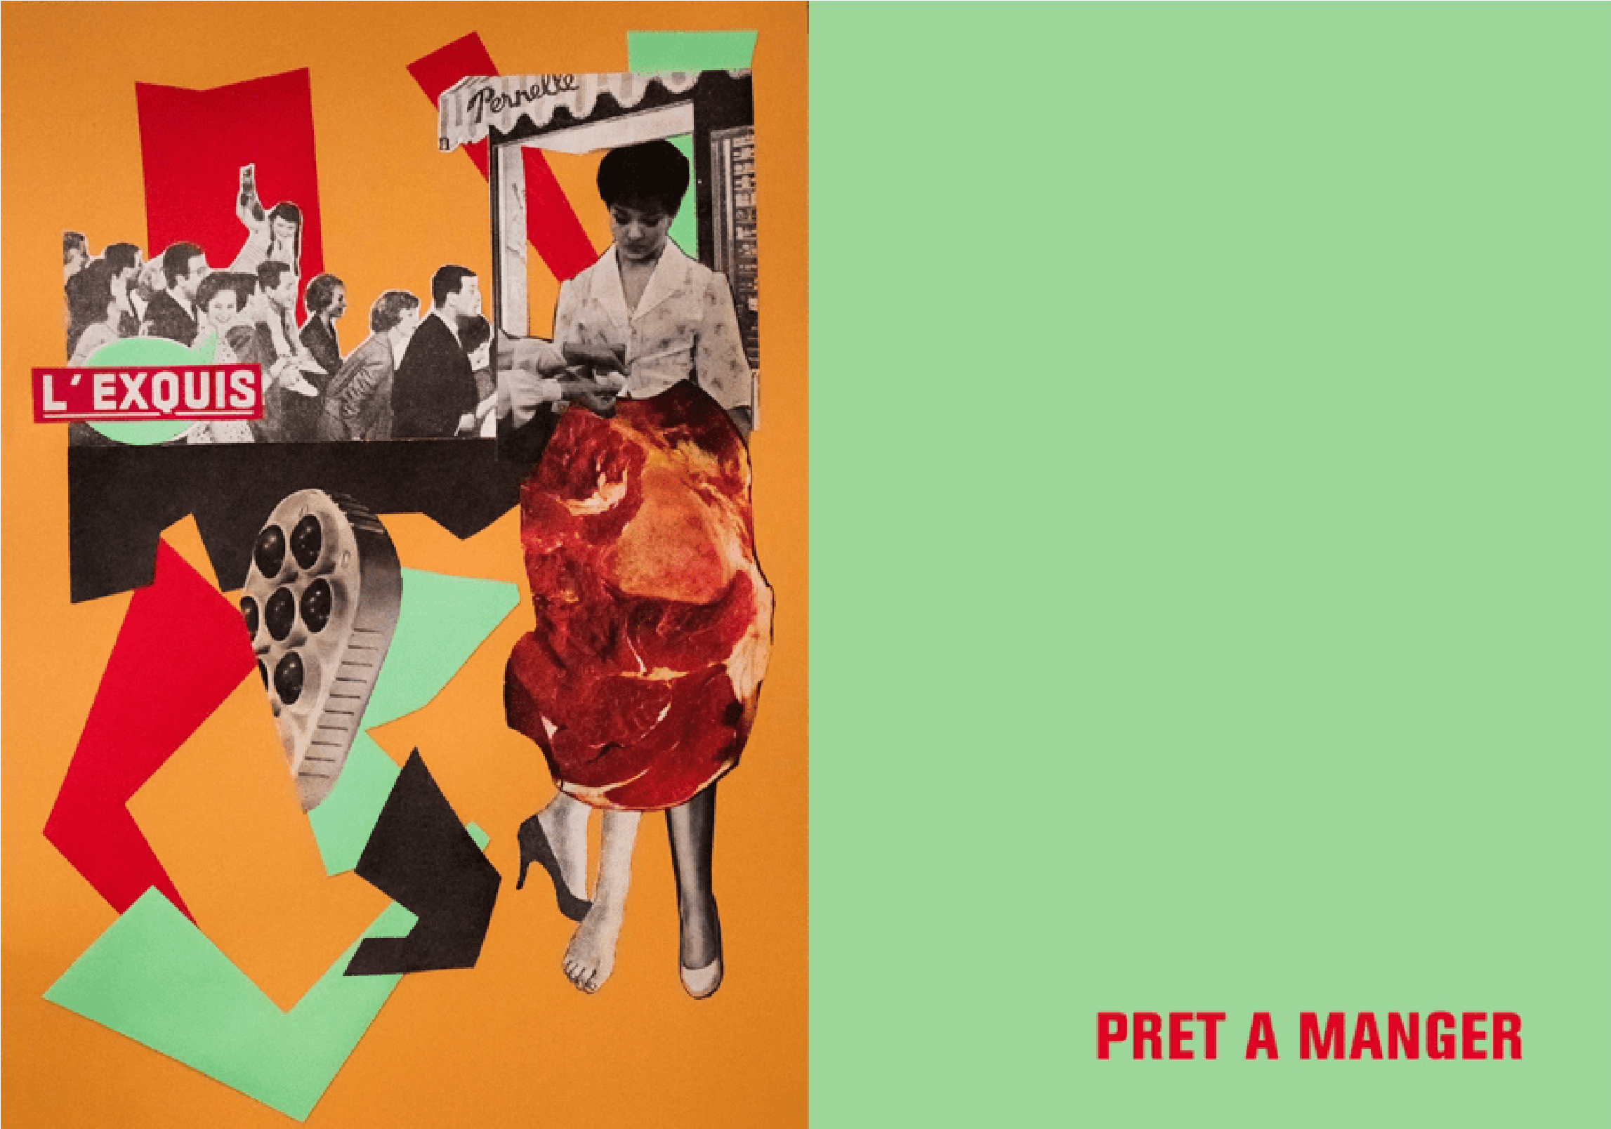

Food and sex trade-ins are not really subconscious or subliminal



The futility of competing for the impossible goal of eternal youth


Motherhood as if fullling a universal instinct to protect and indulge children

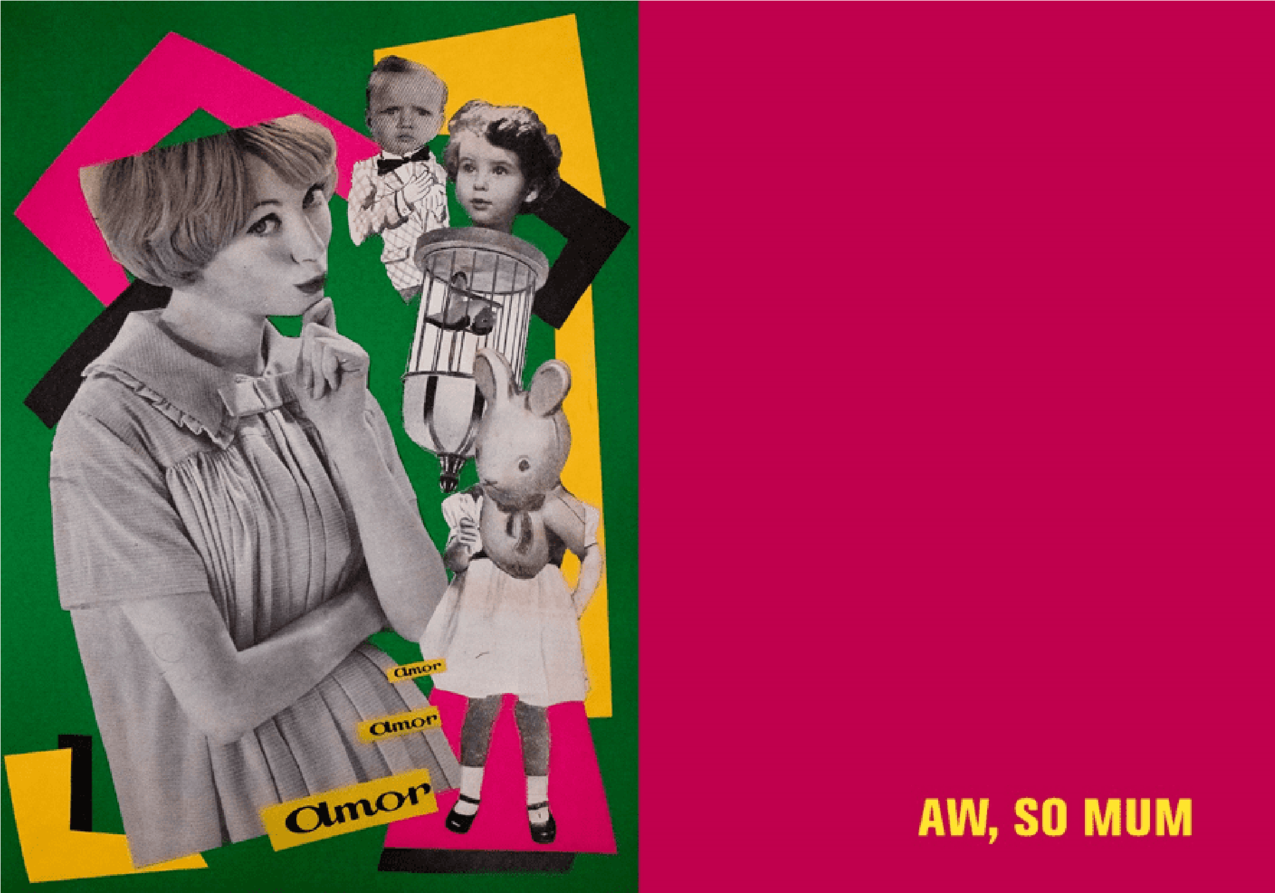



The domestic space is unsafe, inhabited by monsters disguised in quotidian poses and actions



Pretending not to know about technology, it becomes a drama which requires someone else to solve it The masquerade of the feminine

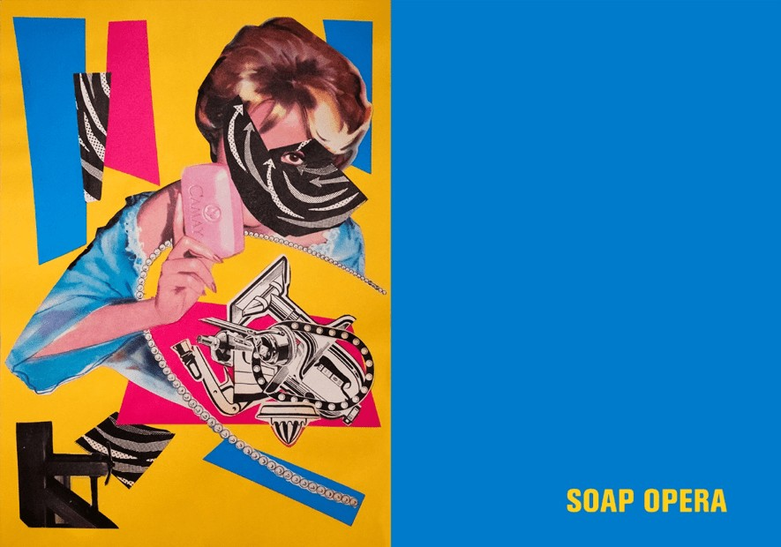

Following fashion for uniformed individuality



