Giorgio Morandi and Alexis Ralaivao, in conversation.

"I believe that nothing can be more abstract, more unreal, than what we actually see. We know that all we can see of the objective world, as human beings, never really exists as we see and understand it. Matter exists, of course, but has no intrinsic meaning of its own, such as the meaning we attach to it."[1] - Giorgio Morandi

As artists, our mentors are other artists, whether they be contemporary or in the past. However, the conversations we have with them are always in the present, as if they could at any moment step into our space and either give a tentative nudge of approval, or a knowing look to indicate a questionable move.

*'Layers of Time'* brings together in conversation the work of two very contrasting artists, Giorgio Morandi (1890-1964), an Italian painter who came to prominence along with Giorgio de Chirico (1888-1978) and Carlo Carrà (1881-1966) under the banner of *pittura metafisica* between 1918 to 1922, before settling on his lifelong exploration of still life and landscape painting based on observation, and Alexis Ralaivao (b. 1991), a young French-Madagascan artist whose intense paintings of cropped details of figures and objects exude sensuousness and have brought him to international attention.

Ralaivao was aware of Morandi firstly through reproductions but then, the exhibition *Les Choses*, an overview of the genre of still life at the Louvre in Paris in 2022, provided the occasion to see Morandi’s painting in the flesh. The opportunity for Ralaivao to then embark on a residency in Bologna, the city that Morandi lived and worked in, offered a perfect means to deepen that initial encounter and to reflect on the nature of still life itself. That history of still life has so often been a celebration of opulence and fecundity, the feast laid out and preserved through paint for posterity, the flowers captured at their peak before wilting, the dead animals as trophies of an aristocrat’s domination over nature. In contrast, both Morandi and Ralaivao celebrate restraint, the austere and the feeling that less is more. For both, painting appears as a slow layered process in which time is the essential ingredient as the image progresses to a moment of revelation.

Morandi is one of that rare group of artists that constantly find themselves being referred to as an artist’s artist; one that generates widely held respect from fellow artists over and beyond the specifics of their subject matter or style. As such, they open up and are a reference point in understanding the very language of painting itself, and become touchstones, drawing artists to them to learn, to clarify and most importantly, to test themselves. In the case of Morandi, his influence has extended beyond the changeable fashions within painting over the last hundred years and re-emerges within all manner of debates across the spectrum, from figuration to abstraction. This, for an artist whose life seems so unprepossessing; rarely traveling, a life led within the confines of Bologna, where he both lived and worked, teaching at the Academy of Fine Arts as Professor of Engraving, a position he held from 1930 until he retired in 1956. His studio-cum-bedroom was a cramped space in the apartment that he shared with his three sisters on the Via Fondazza.

The relationship of Morandi’s paintings to the city of Bologna have been well documented. Most striking are the architectural features of the remaining defensive towers, dating back to the 12th century and the numerous colonnades that enable the visitor to crisscross the city, shaded from the sun or protected from the rain. Together, these personify the city and impose an indelible impression of horizontals and verticals and a pronounced sense of interval, formal qualities that are so clearly evident in his still lifes. Furthermore, the opaque colours of the city’s stucco walls; greys, pinks, ochres, and blues find their way into the paintings, heightening the impression that what we first see as a still life of bottles and boxes is a capturing of the essence of the city itself.

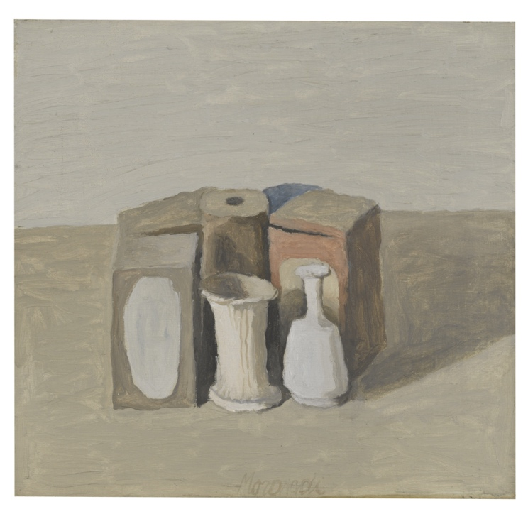

*Natura morta* 1953

While his life was undramatic, Morandi’s subject matter is likewise singularly unspectacular consisting primarily of modestly sized works. Still lifes, assembled from random bric-a-brac or landscapes most frequently observed from the terrace of his summer house in Grizzana (now renamed Grizzana Morandi in his honour) 30 kilometres southwest of Bologna.

This selection of Morandi’s paintings on view are all from 1946 to his death in 1964 and focus upon his mature still lifes. Seen together they show the endless variations he was able to paint, using the same familiar objects over and over again to form new compositions and propositions. In many cases the paintings would be from informal series in which variations would be subtly modified, resembling the tactics of a chess master; the same pieces, the same board, but each game totally different. Through Morandi’s brush, these objects become transformed from inert matter into animated presences that represent the human condition. As he himself said. ‘What could be more human than painting things made by man’.[2]

As well as painting, Morandi explored these subjects through etching, teaching himself the process from old technical manuals. Over his lifetime he produced over 150 prints and is widely regarded as one of the great printmakers of the 20th century. This, in spite of (or maybe because of) the narrow focus of his technique, limiting himself to an exploration of the pictorial possibilities of hard-ground etching and cross-hatching. Overall, given Morandi’s restraint and seemingly self-imposed restrictions in both his life and work, is not an artist that one would immediately imagine to touch and excite a well-travelled young painter with a growing international reputation like Ralaivao.

Viewing Ralaivao’s new paintings alongside those of Morandi, the immediate contrast is one of surface. The pots, bottles and boxes that form Morandi’s repertoire are all rendered as opaque. In fact, these inconsequential objects were in many cases painted prior to being assembled in their groupings. This serves to remove any specific reference details like labels or decorations, so that what is presented is a singular form of the object itself. These were then allowed to gather dust, adding another layer of patination to age and dull the surface. They are made over time, slowly being assembled on shelves in his small studio until they feel right and ready to be painted from weighing up the objects, shadows, and in-between spaces until the whole image coalesces. These compositions of Morandi’s feel timeless as if all the objects have been forged from the same material, a family group with a common ancestry. The brush is ever present, reminding the viewer that this is paint applied to canvas. The direction of the brush marks creates rhythms across the whole surface as in *Natura Morta* (1948), where the paint is thinly applied, like watercolour allowing the weave of the canvas to come through while in *Natura* *Morta* (1946), the paint forms an overall skin, sealing the surface and wedging the forms together.

*Natura morta* 1948

*Natura morta* 1942

Ralaivao, in contrast, explores the properties of transparency and reflection. His surfaces are pristine, the knife and fork set against a pure white linen napkin, await their first use, the empty wine glass and the glass of water (half full) are set ready for the guests to arrive. Here in *Doux reflets bleus* (2024)he captures a moment of anticipation, the stillness before action. The painting is composed with the same fastidious attention to detail that a head waiter would apply to his task of ensuring that the table is correctly set. We are given few clues as to the identity of the diners, but we sense that in *Doux reflets bleus* (2024)there are three protagonists. Ralaivao draws his subjects from himself, his girlfriend and another close friend, feeling that he can only paint those people that he knows very well. The painting is slowly brought into focus through subtle layers of paint which imbed the sense of time and how this in turn captures memories and passing thoughts. The luminescence of the painting, achieved through the layering of paint and slow build-up of whites proposes a moment of revelation. This is a world experienced through the world of the senses, matching touch with sight.

*Doux reflets bleus* (2024)

*On est gourmand comme on est artiste* (2024)

There are also clearly secrets being hinted at or left as tantalising questions. The idea of the secret contained within the painting is given further frisson as Ravaivao has begun writing diary entries on the reverse of the canvas, its content only to be shared with the owner of the painting. This conceit cements the intimate relationship between the artist and the collector, recognising the implicit trust shared between both parties. The collector is not only charged with the future care of the painting but has the added responsibility of being custodian of the secret and the moral implications of such a role.

*Room Service II* (2024)

In *Room Service II* (2024) the subject has moved from the restaurant to the hotel room, the meal for one lying on the white linen bed sheets hidden under a stainless-steel cover suggests a more melancholic narrative, a meal consumed alone. The sensuous and yet restrained rendering of various surfaces, the linen sheets, the metal cover, the glass of water, the knife and fork are all painted to reveal how each surface reflects or absorbs light, and this is achieved through the articulation of a tightly controlled palette of skeins of white and subtle greys.

These call to mind the work of the English painter, William Nicholson, an artist Ralaivao himself admires, who in a work such as *Silver* (1938) relished the challenge of how to represent silver both as a colour and a metal, capturing how it reflects and creating a sea of greys and whites which almost dissolve the form. Here, Nicholson metamorphosed the family silver into paint on canvas, probably a much sounder investment!

William Nicholson- *Silver* 1938

His son, the painter Ben Nicholson, was to go on to become one of the leading figures in contemporary art. He developed a new approach to still life through the lens of modernism, progressing towards pure abstraction and culminating in the white reliefs of the mid-1930s. Ben Nicholson too fell under Morandi’s spell recognising Morandi as 'the person who continues my father’s art. He is the link between his art and mine. I always paint my still lifes with Morandi in mind'.[3]

*Nature morte aux trois citrons*  (2024)

In contrast to *Doux reflets bleus, On est gourmand comme on est artiste and Room Service II* (dates for the works not previously mentioned) *,* which explore the monochrome range of whites and greys, two new paintings by Ralaivao feature lemons both as a fruit and subject, and as the colour itself. In *Nature morte aux trois citrons* (2024)*,* three lemons are laid out across the ironed ridges of a white tablecloth. A knife forms a diagonal and captures a touch of lemon on its reflective surface. As with all of Ralaivao’s paintings, we are presented with an impression of the material world while also compelled to create a narrative. Lemons themselves have associations with such contrasting notions of friendship, purity, and bitterness. Furthermore, we are left uncertain whether this is a moment seen and captured or if it has been prearranged and carefully composed. Again, the intensity of the realisation of the immaculate surfaces is enough to excite and engage the viewer’s imagination.

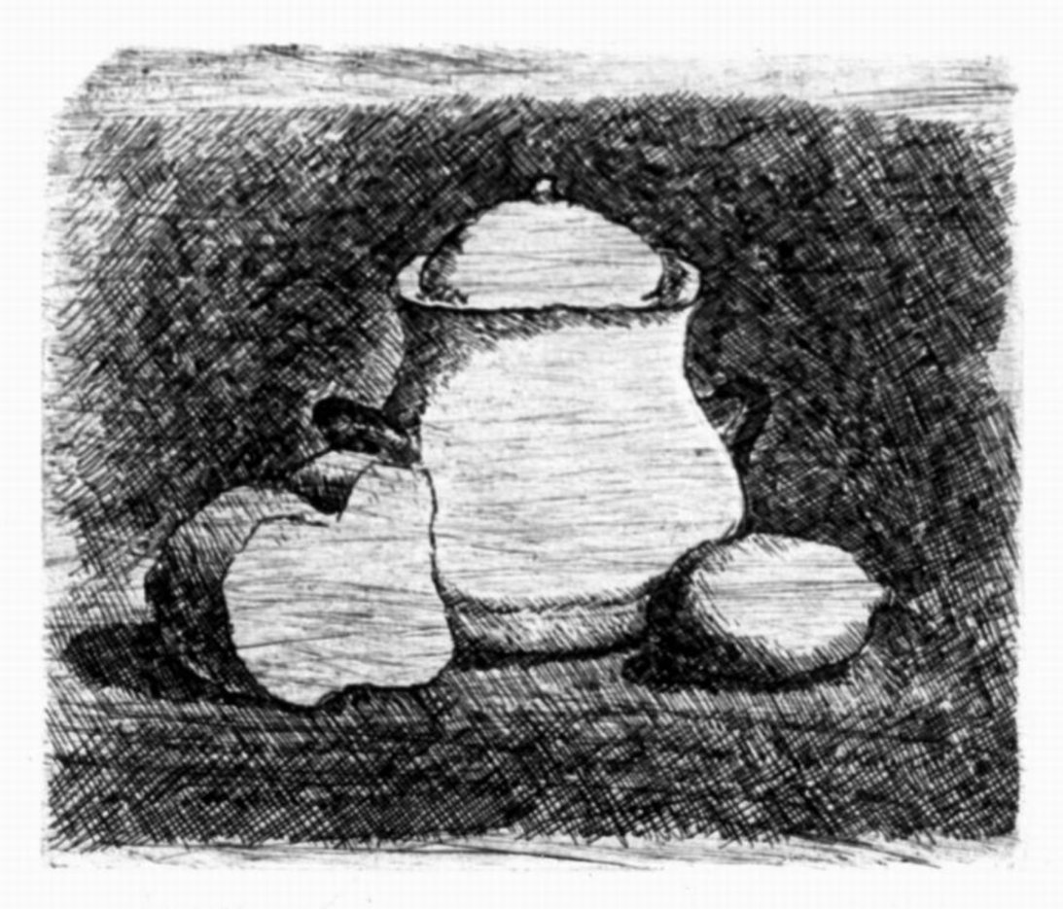

Giorgio Morandi *Natura morta con zuccheiera, limone e pane* 1921

Lemons feature occasionally in Morandi’s work, most tellingly in *Natura morta con zuccheiera, limone e pane*, a small early etching from 1921. Here, the lemon is perfectly balanced against the form of the loaf of bread with the simple sugar bowl in-between, an image that could be understood to represent the essence of life itself, the bitter and sweet. This subject was clearly important for Morandi, who retained a framed copy of a similar print on his studio wall.[4]

Eduardo Manet, *Lemon* (1880)

But it's more appropriate to view Ralaivao’s paintings against that of Manet’s *Lemon* (1880), one of the last still lifes Manet painted before his death in 1883. Here, Manet daringly purges the still life of any literary allusions outside of the canvas in this sensuous portrayal of a single lemon. Here the material of paint and what it is representing magically coexist and lay down a challenge as to how little is required to make a great painting.

‘Manet was the painter of detached fragments, and still life gave him the opportunity of reducing the compositions to a few elements.[5]

*Citrons et saladier jaune* (2024)

While Manet paints a single lemon, Ralaivao paints three and then three again as in *Citrons et saladier jaune*  (2024) where instead of a more distant view, we have been zoomed in to peer into a cropped lemon-coloured bowl housing three lemons. This is on one level a painting about lemon, the colour, its fruit, its name. But, also, the impression it leaves through the softness of paint, its soft focus, the multi-layering of colour, its intense feeling and sensuous warmth - the hedonistic experience of a warm summer’s day.

As well as the rendering of material surfaces, both Morandi and Ralaivao draw the viewers’ attention to the picture as an event and how that is composed. They both reference photography but in strikingly different ways. Morandi’s compositions have the quality of the studio photographer. I think of these paintings as representing family groups assembled together, as at a wedding. Each object stands upright, the smaller objects in the front as if posed for posterity. Each has their part to play in the composition and the absence of any one of them would result in a void. Each object shape is locked into the overall composition like families each aware of their individuality as well as their common heritage. Each nudges the other to find their place, creating intervals and telling shadows across the canvas. In Morandi’s, each object feels as palpable as their shadows and the spaces left in between. I’ve often visualised these paintings as a piano score by the like of Eric Satie where each note is matched by its corresponding interval.

Ralaivao’s compositions likewise reference photography but while Morandi’s hark back to a time of fixed cameras and studio setups, Ralaivao is from a different era, the camera for him and his generation now an ever-present presence through its function on the mobile phone. It’s a tool for visual notetaking, aide memoires, immediate feedback as well as reflection and conversation. The camera is now a protagonist, an active participant in the event it is recording. Photographs, cropped to a rectangle of differing proportions at the time of taking can then easily be further cropped and edited to frame the event and draw the viewer into detail such as in *On est gourmand comme on est artiste (*2024) or pan out for a wider view. Of course, it can also be further manipulated and played with in photoshop.

While Ralaivao clearly references photographs in the making of his paintings, he should not be confused with the photorealists, he is much too concerned with the quality of paint and finding equivalents to the surfaces he is realising. As such he shares more with the soft focus of the Belgium artist Luc Tuymans whose work explores representation and memory or the photo-paintings of Gerhard Richter.

Both Ralaivao and Morandi are reductive artists, their language is quiet, the tone of their paintings cool, and it feels quite fitting that this exhibition should be a closely selected one, a handful of paintings by each. While there are other conversations to be had at other times, Morandi’s flower paintings (painted from arrangements of artificial silk flowers) would provide a startling contrast to Ralaivao’s large place settings, while the landscapes with their contrast between the natural world and the buildings set into the hillsides, would share much common ground with Ralaivao’s paintings of clothing and flesh. In essence, this exhibition offers a tantalising starter, and leaves me excited for more generational conversations between contemporary and modern masters.

Paul Coldwell

Paul Coldwell is an artist and Professor in fine art at the University of the arts London. His work is held in numerous collections both in UK and abroad including Tate, V&A, British Museum and MoMA New York. In 2006 he curated *Morandi’s Legacy: Influences on British Art* for the Estorick Collection of Modern Italian Art and in 2021 was invited to re-hang their collection of prints and drawing alongside his own recent work in *A Still Life: Paul Coldwell in Dialogue with Giorgio Morandi*, Estorick Collection, London

1. Giorgio Morandi in Roditi, Edouard, *Dialogues on art,* Santa Barbara (Calif.): Ross-Erikson 1980
2. Abramowicz, Janet, Giorgio Morandi: The art of silence Yale University Press, New Haven 2004, p195
3. Abramowicz, Janet, Giorgio Morandi: The art of silence Yale University Press, New Haven 2004, p195
4. Munday, Jennifer *Giorgio Morandi Etchings* Tate Gallery, London 1991 p18
5. Sterling, Charles, Still Life Painting. From Antiquity to the Twentieth Century. Harper and Row, New York, 1981, p123