Fictioning Painting:
Or imagining an ‘outside’ to art history.

Abstract:
This article seeks to explore the relationship between contemporary painting and fictioning practices, examining the implications for historicisation, authenticity and authorship. Taking as a starting point the re-appearance of Walter Benjamin in 1986, I will trace the ways in which painting practice and fictioning discourse have intersected, drawing on recent interviews with the authors of these projects and ongoing research into artist novels. I will discuss Albert Oehlen’s 2021 film ‘The Painter’, which is set in Oehlen’s studio and documents the struggle to produce an abstract painting, asking why certain clichés are re-staged in fictional portrayals of artistic labour rather than re-imagined? I will develop a discussion of Oehlen’s use of parody by reading this film as a performance to camera, and will explore the ways that Oehlen plays with plausibility through the use of an actor, a semi-improvised script, and modelling the narrative on the historical precedent of Paul McCarthy’s 1995 video ‘Painter’. I will offer a case study from my recent practice-based PhD research in which I worked with Bruce McLean to re-enact his 1969 artwork ‘Underwater Watercolour’ to highlight the relationship of fictioning practices to archival practice and develop an understanding of fictioning as a performative form of historicisation. I will situate these examples in relation to recent theory (specifically, David Burrow’s and Simon O’Sullivan’s survey of ‘Fictioning’ practices in art and philosophy and Carrie Lambert-Beaty’s concept of ‘Parafiction’), positioning my research within a broader discussion of a current trend towards fictioning practices in contemporary art.

Key words: (6-8)
Fictioning; Parafiction; allegory; parody; re-enactment; Walter Benjamin; Albert Oehlen; Bruce McLean

This article seeks to explore copying, parody and collaborative re-enactment, as related fictioning strategies that have the potential to disrupt a conventional understanding of art history by problematising chronology, uniqueness and indexicality. Fiction is employed here as a verb to imply the transformation of the lived world through the imaginary, following the definition offered by David Burrow’s and Simon O’Sullivan in their recent survey of contemporary fictioning practices:

By using the term fiction as a verb we refer to the writing, imaging, performing or other material instantiation of worlds or social bodies that mark out trajectories different to those engendered by the dominant organisations of life currently in existence.
(Burrows/ O’Sullivan 2019; 1)

I draw on Burrows/ O’Sullivan’s formulation of ‘mythopoesis’ or performance-fictioning to explore how painting might produce fictions through three case studies; the re-appearance of Walter Benjamin and broader practice of Goran Đorđević, the fictionalisation of self in Albert Oehlen’s film ‘The Painter’, and myth construction in Bruce McLean’s ‘Underwater Watercolours’. Mythopoesis differentiates itself from the related categories of ‘myth-science’ (science-fictioning) and ‘mythotechnesis’ (machine-fictioning) through the way that it uses actions, performance, or rituals to produce subjectivities, layered narrative constructions and complex temporalities (Burrow/O’Sullivan 2019; 6). Here painting is variously positioned as material artefact, ritualistic action and as driver of narrative, with the fictioning artwork unfolding over multiple platforms of presentation rather than being self-contained within the material object of the painting itself. For instance, at the centre of the first example are copies of paintings by Piet Mondrian, but the project is encountered through an online performance-lecture, live talks, a publication and through several replicas of historic art collections, re-focusing attention to a broader network of production and distribution.

The operation of fiction beyond the written word or page as a form of lived experience has previously been explored by Carrie Lambert-Beatty through the concept of ‘parafiction’. In her 2009 article ‘Make-Believe: Parafiction and Plausibility’ she states:

Fiction or fictiveness has emerged as an important category in recent art. But, like a paramedic as opposed to a medical doctor, a parafiction is related to but not quite a member of the category of fiction as established in literary and dramatic art. It remains a bit outside. It does not perform its procedures in the hygienic clinics of literature, but has one foot in the field of the real. Unlike historical fiction’s fact-based but imagined worlds, in parafiction real and/or imaginary personages and stories intersect with the world as it is being lived’.
(Lambert-Beatty 2009: 54)

For Lambert-Beatty, such projects are not only aligned to fiction but to archival forms of practice, as she describes parafiction as ‘the performative version of “the documentary turn” in contemporary art’ (Lambert-Beatty 2009; 56). This performative form of historicization may prompt a questioning of what we believe to be true about a given subject or the extent to which we trust a particular account, because the function of the parafictional artwork is to ‘produce and manage plausability’ (Lambert-Beatty 2009; 72). The case studies that will be discussed in this article play with plausability in various ways, from the historical impossibility of the re-appearance of Walter Benjamin, to the eccentric behaviour of the artist in Oehlen’s docufiction, to the unlikeliness of producing a painting underwater in McLean’s re-enactment. In these examples, fictioning is explored as a means to imagine an ‘outside’ to art history and to displace artist biography as a framing device.

The formulation of fictioning offered by Burrows/O’Sullivan emerges from the ‘speculative turn’ in contemporary art and philosophy and is broad and ambitious in scope. Historical figures, such as, Austin Osman Spare are discussed alongside contemporary practitioners like Robert Smithson, and the survey extends to consider instances of fictioning in lived experience, for example, financial derivatives or rave culture. Lambert-Beatty defines a tighter parameter around parafiction, identifying it is a recent phenomena, prevalent between 1998-2008, that is strongly connected to contemporary conditions of communication, knowledge and cognition. She notes that this practice developed in the same decade that Yahoo and Google search engines were launched, during a period where satire and the use of persona were common in pop culture (e.g. Ali G, Brass Eye) and at a historical moment where certain news events tested the limits of the believeable, leading journalist Naomi Klein to designate 2003 as ‘the year of the fake’ (Lambert-Beatty 2009; 57). For Lambert-Beatty, the natural place of presentation and encounter for parafiction is the web rather than gallery (Lambert-Beatty 2009; 79), so it’s perhaps not a surprise that painting does not figure in her range of examples. However, Burrows/O’Sullivan do make occasional reference to image-based practices, such as Yayoi Kusama, Wade Guyton, or Seth Price, demonstrating the possible application of fictioning theory to contemporary painting. This paper positions fictioning in painting as an emerging practice, that has an affinity with earlier postmodernist strategies of irony, parody and appropriation.

Burrows/O’Sullivan and Lambert-Beatty stress the radical, critical potential of fictioning practices. Burrows/O’Sullivan propose that fictioning emerges from a position of alienation from the present, seeking to connect with a future audience by making visible dominant habits of thought and practice through the production of alternate myths. This ‘weaponization of fiction’ (Burrows/O’Sullivan 2019; 35) has potential as a tool for a broader project of decolonisation by imagining alternative possibilities to the status quo. For Lambert-Beatty parafiction designates a form of speculative practice that goes beyond a light-hearted form of imaginary play, with the projects she considers, such as the parodies of The Yes Men, or the unreliable archives of The Atlas Group, being characterised by a highly political and often controversial nature, orientated towards current issues and raising pertinent ethical questions. I aim to explore the extent to which the radical potential of fictioning is realised within the case studies of this article. Could fictioning be a way for painting to make visible marginalised histories, or perhaps offer a means to establish a degree of distance from the art market?

Central to Burrows/O’Sullivan’s concept of fictioning is the liberating potential of a critical practice that does not rely on existing forms, languages or narratives, allowing art to go beyond a representation of what already exists. The emphasis here on rejecting inherited modes of knowledge and recognisable forms of communication entails the risk that such forms of practice may appear meaningless, as O’Sullivan acknowledges when he states, ‘fictionings difference from the world as-it-is means it will alienate the subject as-it-is, but at the same time, speak to the subject yet-to-be’ (O’Sullivan 2016; 89). Lambert-Beatty recognises a similar issue of disorientation as she identifies the tendency of parafiction to use strategies of misinformation and misdirection, leading to a phenomena where ‘fictions are experienced as fact’ (Lambert Beatty 2009; 54-6). The way that fictioning practices position the viewer, and by extension the critic, will be examined, pursuing the motivations and implications of a fictioning painting practice.

- Fictioning History

In 1986, Walter Benjamin made an unexpected re-appearance on Belgrade TV to present a lecture ‘Piet Mondrian 63-96’. Documented on grainy video footage, the speaker, a middle-aged man with an incongruous British accent, stands in a lecture hall in front of 3 pairs of identical geometric abstract paintings signed “P.M”, to pose the question of why one might copy a work of art. Rejecting the various possibilities of artistic training, forgery and aesthetic worth, the speaker concludes that the copy lacks meaning, stating ‘These paintings rely neither on the coordinates of time, nor on the coordinates of identity, nor on coordinates of meaning. They simply hover…’.

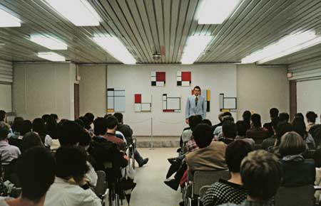
[Figure 1: Walter Benjamin, ‘Piet Mondrian 63-96’, 1986, Colour video, 22:34 mins]

This example can be understood as a fictioning artwork due to the historical impossibility of the speakers identity and the dates of the Mondrian paintings, which appear to have been produced both after the artist’s death and at a future date in time from the year of the broadcast. Since this re-appearance, Benjamin has become an associate of the Museum of American Art (2004), published a book of ‘Recent Writings’ (2013) and lectured publicly in multiple languages at various art institutions, including the Arnolfini, Bristol (2011), Times Museum, Guangzhou (2011) and the Museo Universitario de Arte Contemporaneo, Mexico City, (2012). Like the televised lecture these public appearances are not announced as performances, enabling those behind the re-appearance of Benjamin to retain a degree of anonymity. The question of who is responsible for the re-appearance of Benjamin is held open to a degree by the international character of Benjamin’s recent career and through the use of multiple speakers, mainly middle-aged, white, males with different physical appearances and accents, although on a few occasions Benjamin has appeared as female (Transit, Budapest, 2012) and as an Asian man (Times Museum, Guangzhou, 2011). The proposition here is that we understand Walter Benjamin not as a singular historical identity, but as a character or role that can be performed by multiple players, initiating a form of meta-history;

Being ‘outside of time’ means being outside of the linear chronological timeline that is the backbone of history, as a story consisting of unique characters, artefacts and events. Sometimes telling the truth is not exactly the right thing to do.
(Benjamin 2016)

This could be understood as fictioning through the way it creates a chronological disruption, continuing to explore ideas central to the writings of Walter Benjamin (1892-1940), such as, originality and allegory, through a practice of copying. In addition to the appropriation of Benjamin’s identity and theme of the lecture, this project further explores copying as a strategy through Benjamin’s association with the Museum of American Art (MoAA, Berlin), which is a replica in miniature of Modernist works held at the Museum of Modern Art (MoMA, New York). Appropriation takes on here a narrative form, employing academic modes of address and institutional forms of presentation as the copy facilitates storytelling across multiple strategies of presentation, such as, performance, installation and publication. The rationale for this strategy of copying is indicated by the mission statement of MoAA which defines itself as ‘an educational institution dedicated to assembling, preserving and exhibiting memories’. This points to the potential function of the copy in shaping collective memory and the role of art institutions in shaping a ‘common cultural identity’.

The relationship of appropriation to fiction has previously been noted by Craig Owens in his identification of an ‘allegorical impulse’ within postmodernism (Owens, 1980). Owens draws on the writing’s of Walter Benjamin (1892-1940) to explore contemporary visual forms of allegory, listing appropriation and accumulation amongst the strategies used by artists to create allegorical works that might strip away an original meaning. Owens builds upon Benjamin’s observation that allegory projects a ‘melancholy gaze’ (Owens 1980; 70), positioning the past as remote and in need of re-interpretation. The high level of cultural visibility of the theories of Walter Benjamin prior to his re-appearance in 1986 leads me to propose that in this case it is not Benjamin himself who is the target for re-interpretation, and that the logic of this project is not situated in a restorative gesture of bringing marginalised ideas into public view. Instead, the leveraging of Benjamin’s identity appears to be a means to add authorial weight, drawing attention to a more general concern with the way that Western art history is formulated and the role of key figures and institutions within this. What might it be possible to say as Benjamin that couldn’t otherwise be expressed? And who might listen as a result of this appropriation of identity?

In contrast to the radical promise of Burrows/O’Sullivan’s concept of fictioning, Owen’s notes that allegory has traditionally been positioned within art history as an outdated method that is supplementary and derivative in nature, offering ‘an expression externally added to another expression’ (Owens 1980; 83). For Benjamin, allegory confronts the observer with the death of history and is limited in creative terms because it ‘lacks all “symbolic” freedom of expression’ (Owens, 1980; 71) as meaning is foreclosed. Owens highlights that the limitation of expression identified by Benjamin extends from the artist to the critic, as “the allegorical work tends to prescribe the direction of it’s own commentary” (Owens 1980; 68). For Owens, the allegorical nature of appropriation art fixes an image of the past rather than mobilising it:

Allegory concerns itself, then, with the projection-either spatial or temporal or both- of structure as sequence; the result, however, is not dynamic, but static, ritualistic, repetitive.
(Owens; 1980, 72)

This suggests that appropriation is somewhat conservative, and that the transformative potential which is at the centre of Burrow’s/O’Sullivan’s conceptualisation of fictioning, may not be realised when copying is employed as a strategy. I propose that in this case study the protagonist is not seeking to transform the ways in which Benjamin or Mondrian are understood, but is motivated by a desire to reveal the contingency of art history. Consequently, by locating the re-appearance of Benjamin within a wider network of intellectual connections and artistic influences the political implications and critical potential of this project may become clearer.

Situating this project historically in relation to the broader context of fictioning practices, and geographically in relation to Eastern European conceptual painting practices, offers a means to reflect on the political intent and potential implications of the re-appearance of Benjamin. The focus of the lecture on a Mondrian painting held in the National Museum of Belgrade and association with MoAA (Berlin), indicate a relationship to the Yugoslavian artist Goran Đorđević. For instance, Goran Đorđević’s 1983 conceptual performance ‘Copying Mondrian in National Museum, Belgrade, (or How to Copy)’ and later involvement in the activities of MoAA and the Salon de Fleurus (1992-2013), which like MoAA is a replica of a modernist art collection, in this case presenting copies of Gertrude Stein’s personal collection. Both MoAA and the Salon de Fleurus use copying as a strategy to highlight the role of individual collectors and curators in the shaping of art history, here revealing the influence of Dorothy Miller and Gertrude Stein alongside Alfred Barr. Đorđević is careful to avoid overstating his role in these projects, describing himself as the ‘technical assistant’ of MoAA and ‘the doorman’ of the Salon de Fleurus, signalling a connection to Benjamin whilst refusing to directly claim responsibility for his re-appearance (Gollner 2014). In addition, Slovenia, the place where the 1986 lecture was recorded, is significant as the birthplace of Neue Slowenische Kunst (New Slovenian Art, NSK) and the IRWIN collective: a group of artists active in the 80s and 90s in a revisionist history project that involved re-making Western examples of Modernist art, seeking to re-locate them within a fictive ‘Eastern Modernism’. IRWIN’s strategy of sampling and re-mixing art history, or ‘retro-principle’, differentiates itself from strategies of citation typical in postmodern art, by situating the activities of the collective in relation to the political context of Eastern Europe and recent experiences of communism. This places a new emphasis upon Owen’s comment that allegorical artworks emerge from a troubled relationship with the past (Owens 1980; 68), as the copy in this case speaks to lived experience, rather than simply constructing a self-referential form of art history. This strategy of re-making paintings as a means of disrupting historicisation, resonates with Benjamin’s proposition that ‘copies are memories’ (Benjamin 2013; 181), opening up the possibility for displacing dominant narratives through mis-remembering or remembering differently. This serves the purpose of pointing to the reality of what art history has been, whilst picturing an alternative possibility, an operation on both past and present that is aligned to Lambert-Beatty’s understanding of what parafiction can do: ‘The art of the plausible discloses consensus about the way things are; but it also can make a new reality sensible: accessible to feeling and reason’ (Lambert-Beatty 2009; 66).

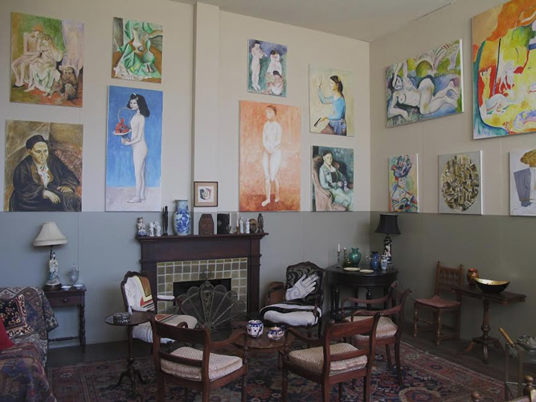
[Figure 2: Salon de Fleurus, 1992-2013, New York]

This project could be understood as engaging with the radical potential of fictioning practices through a process of re-orientating existing narratives (e.g. platforming the role of Miller and Stein in the shaping of Modernism) and suggests an understanding of art history that is local rather than global. For example, key details change depending on the place of delivery and likely audience, so that the Mondrian paintings in the lecture broadcast for Belgrade TV are identified within the National Museum of Belgrade, whilst the same lecture re-printed in ‘Recent Writings’ and distributed by an American publisher, locates the Mondrian’s within the MOMA collection, New York. The re-appearance of Benjamin also troubles the way that biography is used within art history to ascribe value, by rejecting principles of chronology and uniqueness and promoting multiplicity and simultaneity. In addition to the political gesture that is made by centralising Eastern Europe within a discussion of Western Modernism this project has an unexpected poetic quality, locating a gap in the extensive Walter Benjamin archives, by revealing that despite his prolific writing, publishing, collecting activities and radio work there is no known recording of Benjamin’s actual voice. This example is also of interest for the way it reveals the potential limitations of fictioning as a critical practice or ‘weaponization of fiction’ (Burrows/O’Sullivan 2019; 35). The choice of Benjamin as a historical figure and focus on iconic Modernist artworks defines an audience with specialist knowledge, and therefore the project seems to be directed towards the artworld, rather than suggesting new contexts. Additionally, if the re-appearance of Benjamin is understood as a speculative attempt to occupy a position outside of art history, it should be noted that this has not entailed locating a position outside of the art market. For instance, the physical traces of the Benjamin project, such as the Salon de Fleurus installation, are now circulating on behalf of the Fine Art Dealers Association, most recently presented at LA Art Show (2022.) In this instance, anonymity and fictionalisation hasn’t troubled the process of commodification, although it has displaced the traditional role of artist biography within this.

- Fictioning the Painter

It is interesting to note the apparent overlap between Benjamin’s hypothetical position of an ‘outside’ to art history and the recent emergence of fictional artists, such as Nat Tate, Henry Codax, and Anton Lesseman, who have been written into art history. Each artist began life on the page, Tate appearing through a biography (‘Nat Tate: An American Artist 1928-60’, William Boyd, 1998), Codax emerging from a novel (‘Reena Spaulings’ collaboratively authored by the Bernadette Corporation, 2004), and Lesseman through a period of archival research which resulted in the publication ‘My life by Anton Lesseman’ (Paul Becker, 2013). The fictional artists Nat Tate and Henry Codax conform to certain painting stereotypes; Tate is depicted as an abstract expressionist who tragically destroyed the majority of his work before taking his own life, and Codax is presented as a ‘bearded, taciturn painter’, with a drinking problem, who produces ‘expensive, intimidating monochromes’ (Bernadette Corporation 2004). Whilst Tate can be understood more straightforwardly as an art world hoax, Codax has exhibited regularly in the US and Europe since the publication of the novel ‘Reena Spaulings’. Like the re-appearance of Benjamin, the identity of Codax is surrounded with secrecy and a touch of artworld elitism, with rumours circulating that Codax is a pseudonym for a collaboration between Jacob Kassey and Olivier Mosset. Again, artist biography is troubled as a way to understand or contextualise the artwork, and a close reading of the painting itself seems misplaced, as the material object operates like a prop, offering tangible evidence for the conceptual gesture of the project. The relationship between the material object (the painting) and the novel (the painter) is reciprocal and self-legitimising, mirroring the relationship that Benjamin proposed between the artwork and art history, as he stated ‘It is the story that gives meaning to the artefact and it is the artefact that makes the story believable’ (Benjamin 2022). Although Tate and Codax are intriguing as thought experiments, they do not leverage the radical potential of fictioning practices because they seem to celebrate rather than challenge well-established forms of abstract painting and perpetuate lingering stereotypes of the painter as a tragic or heroic figure. Paul Becker’s project of inventing the fictional sculptor, Anton Lesseman, arguably goes further in terms of activating the disruptive potential of a fictioning practice, by locating gaps in an existing archive and using the narrative of Lesseman to draw attention to neglected histories, for instance, the forgotten scandal of the Dunera Boys or lesser known work of Gertrude Hermes and Clare Sheridan. It is also notable as the first body of work by a fictional artist to have been acquired by a UK historical archive (Henry Moore Institute). The emergence of each of these fictional artists into art history demonstrates the observation made by Lambert-Beatty, that in parafictional projects fiction is not contained in a simple way within the page or the screen but unfolds across multiple sites, often employing material evidence and institutional details that can be verified to play with plausibility and enable the artist to explore or exploit ‘pragmatics of trust’ (Lambert-Beatty 2009; 54).

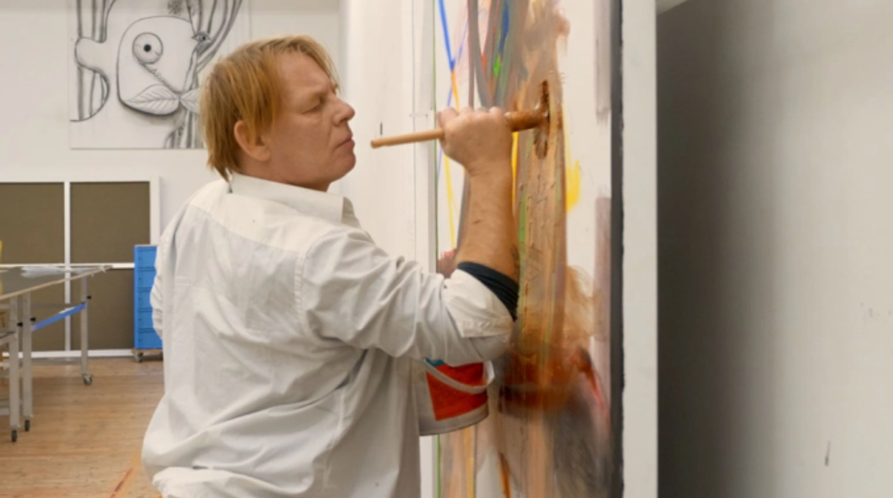
[Figure 3: Ben Becker as Albert Oehlen in ‘The Painter’ 2021, Colour film, 95 mins]

Albert Oehlen’s docufiction ‘The Painter’ (2021) similarly uses factual elements within its fictional portrayal of the artist and might also be approached as a parafiction due to the use of parody and role-play. Like the previous examples, fictioning problematises artist biography, although here fictioning is directed towards the figure of the artist, rather than the broader context of art history, entailing a fictionalisation of self. ‘The Painter’ uses strategies of delegated production and performance to camera to offer a mediated form of painting, extracting a narrative from the process of making a painting that pivots around whether or not the artwork will survive. This example is understood as an intersection of painting and performance, akin to Mike Bidlo’s 1980s performances or more contemporary examples, such as, Alex Hubbard’s ‘Collapse of the Expanded Field’ (2007) or Florence Peake’s ‘Factual/Actual: Ensemble’ (2023), which bring humour into the representation of the painter at work.

‘The Painter’ depicts the production of a single abstract painting from start to finish. Oehlen remains out of shot throughout the film, making a painting in real time off-stage that acts as the basis for the canvas we see on-screen, which is produced by the actor Ben Becker observing Oehlen and improvising a response to Oehlen’s mark-making. As a result of this filming process this example might be thought of as a parafiction, as it seems to work with the aesthetics of the factual whilst manipulating them so that reality appears strange.
The use of Oehlen’s studio as setting lends a degree of plausibility to the particular material techniques that are demonstrated, whilst certain scenes are marked by eccentricity, for instance, the artist demanding that his assistant alphabetises his paints. The actor playing Oehlen speaks directly to camera, observing his own actions and narrating the production of the painting. This monologue draws on previous conversation between Oehlen and the actor, leading Becker to be credited as co-author of the screenplay alongside Oehlen. In addition to the live commentary and direct address to camera the film uses a voice-over technique, which seems to express the inner dialogue of the painter, offering dubious artistic wisdom such as, ‘You have to see the stupidity to give it order’ or ‘Every stroke on the canvas should be in harmony with the cosmos’ (Becker/Oehlen: 2021). The majority of the film documents action in Oehlen’s studio, with the narrative occasionally cutting to scenes that show the artist in interview or walking through a gallery of his earlier work. This closely mirrors the shot structure of Paul McCarthy’s ‘Painter’ (1995), which similarly moves through distinct workspaces, such as the studio, gallerist’s office and panel discussion. Perhaps to signal that this docufiction is intended as a parody, Oehlen makes a further reference to McCarthy’s ‘Painter’ through the placement of a de Kooning painting in his studio and use of repetitive chanting, recalling the moment in ‘Painter’ when McCarthy chants ‘De Kooning’. Over the course of Oehlen’s film, we watch the artist struggling to make a painting, leading to a dramatic moment of erasure, whilst the live monologue, voice-over and interview scene asserts the artist’s ego and ambition. The actor depicts a full cycle of emotional behaviour, ranging from joking/ laughing to weeping/ anger and the film includes moments of idleness (smoking/drinking) and defeat (napping on the floor). The end result is a somewhat unflattering portrait of the artist, as overweight, needy, and narcissistic, that pays homage to the caricature of the painter created in McCarthy’s earlier work.

Oehlen’s docufiction is more cautious than its predecessor, primarily parodying the artist rather than satirising the broader infrastructure of the gallery, art market, and art press, all of which are caricatured in McCarthy’s work as secondary characters with clown-like appearances. As in the previous example, the fictioning agency of the artwork is not contained simply within the narrative of the film itself but becomes more apparent when considering modes of distribution and encounter. For instance, the painting that is created during this film by the actor playing the artist now circulates as an authenticated Oehlen, extending the fiction beyond the narrative of the docufiction. This transition of the painting from the imaginary world of the film to the lived experience of the art market and gallery system, aligns this example to Lambert-Beatty’s notion of parafiction, as a speculation with ‘one foot in the field of the real’ (Lambert-Beatty 2009; 54). Consequently, this example shares the problem of criticism common to parafictional artworks which employ strategies of mis-direction and mis-information.

Lambert-Beatty proposes that such art practices call for a diligent and sceptical viewer but signals the precarity of this viewing position, as she reflects, ‘What is due epistemological diligence? When does one decide that something is-in the epistemologists’ phrase now codified as Wikipedia’s primary criterion- true enough?’ (Lambert-Beatty 2009; 78, original emphasis). She goes on to argue that this is not just epistemologically destabilising but ethically questionable because it involves inequality and potential humiliation, as viewers find themselves divided into those with sufficient cultural capital to notice the errors which give the fiction away and those who take it at face value. In a comment that could have been directed towards this example she writes ‘Think of the audience member who asks a sincere question of a parafictioneering presenter, only to realise later he was one of the few not in on the joke’ Lambert-Beatty 2009; 82). In the Q&A that followed the London premiere screening of ‘The Painter’ the tone of the film influenced the audience’s approach to asking questions, leading to light-hearted responses that picked up on incidental details, such as, ‘Do you clean your own brushes?’, or ‘When will KaffeTea be available in the UK?’. Here the categorisation of the film as a docufiction and orientation towards parody seemed to create a barrier towards critical engagement, with several audience members posing questions that resembled one-liner jokes. This perhaps exemplifies the problem articulated by O’Sullivan that fictioning practices might be alienating or fail to communicate a clear agenda to a contemporary audience, instead deferring meaning to a future moment, as O’Sullivan argues, ‘This might mean that such practices – that communicate without meaning – are not taken seriously or simply frustrate, bore, annoy or irritate’ (O’Sullivan 2016; 82). This indicates that fictioning artworks may be impervious to criticism in the present.

‘The Painter’ is aligned to examples of parafictional art identified by Lambert-Beatty that involve role-playing (e.g. Andrea Fraser, Yes Men), although for Oehlen fictioning entails a form of self-reflection, showing a willingness to laugh at himself, rather than offering a form of institutional critique or political commentary. Oehlen’s decision to use an actor continues earlier experimentation with delegated production, and might be thought of as an attempt to step outside one’s personal identity, a gesture which is continued through his choice of a female narrator. This sets up a collaborative model of authorship with the resulting painting combining direct observation of a studio practice with elements of spontaneous invention, so that indexicality connects the painting to Becker whilst conceptually the work is bound to Oehlen. This is perhaps a way to obscure meaning, in line with O’Sullivan’s conceptualisation of the way that ‘untimely images’ perform; “It might also begin to recycle and re-use its own motifs, nesting one set of fictions within another, so as to produce a certain complexity – a density even.” (O’Sullivan 2016; 83). Arguably then, ‘The Painter’ is best approached through the lens of Oehlen’s own practice, as a continuation of his exploration of ‘paradoxical gesture’ (Berg 2012; 33), involving a partial negation of that which is asserted. Fictioning here seems to enter a casual mode, laying a potential trap for the viewer and positioning the artist as trickster.

- Fictioning the Artwork

Bruce McLean’s 2016 re-make of ‘Underwater Watercolour’ (1969) offers further insight into the ways that humour and collaborative modes of authorship might disrupt the historicisation of an artwork and pluralise artistic identity, with fictioning directed here towards the original artwork. Here collaborative re-enactment is explored as a fictioning strategy and form of archival practice. This situates this example in relation to conceptual approaches to painting that involve cataloguing, such as Art and Language’s ‘Index’ series (1972) or Stephen Prina’s ‘Exquisite corpse; The Complete Paintings of Manet’ (1988). Collaboration will be explored as a way to reveal and challenge the fictionalisation of self identified by Burrows/O’Sullivan. O’Sullivan highlights the importance of collaboration or collective activity in realising the transformative potential of fiction, asking, “How else can one make something that is of one but not of one at the same time? That is intended but produces the unintended?” (O’Sullivan 2016; 83). The role of collaboration will be explored here by considering how the re-enactment functions as a meta-artwork or a story about the original that contributes to and acts upon the myth of McLean’s original artwork.
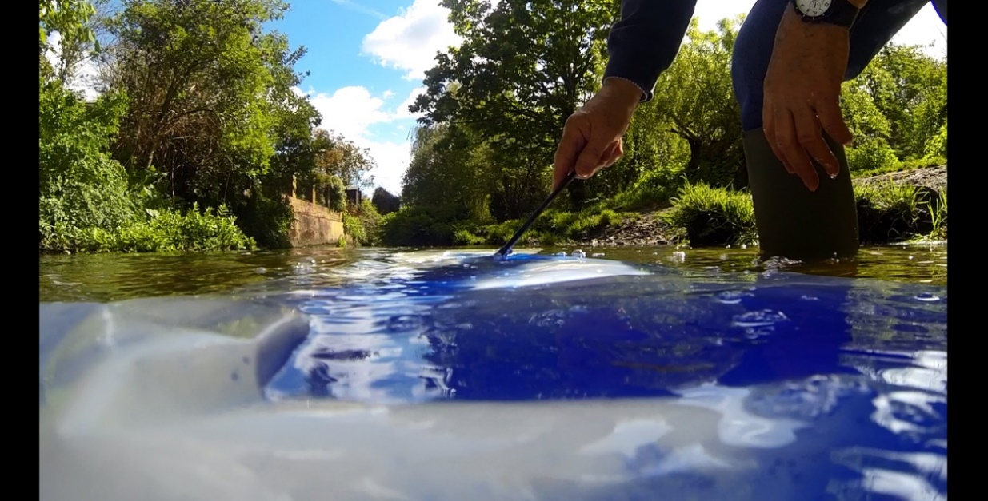

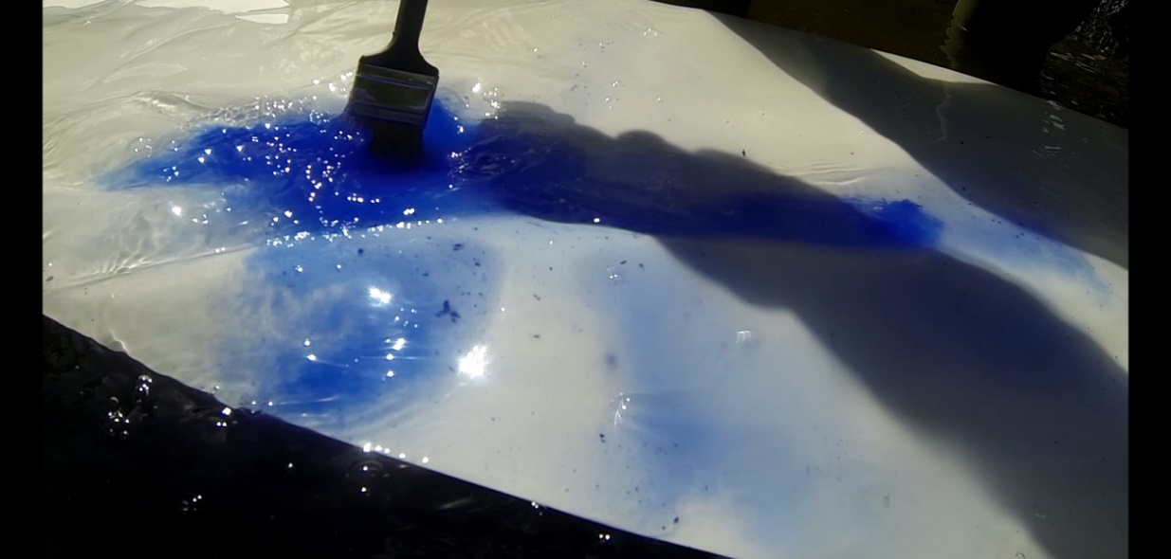

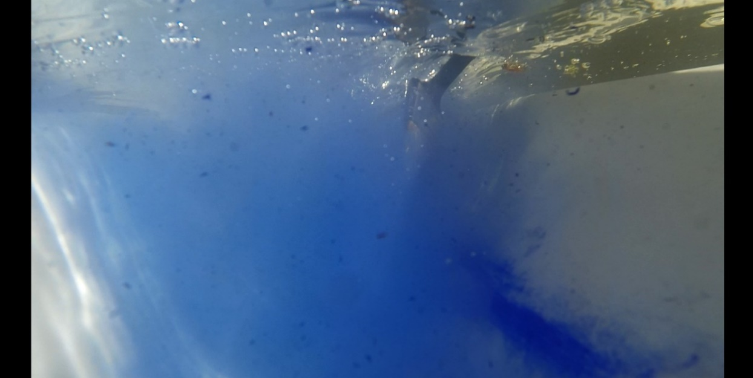
[Figure 4: Stills from ‘Underwater Watercolours’, 2016, McLean, Farrell, Turner, Colour video, 11:53 min]

McLean’s ‘Underwater Watercolour’ (1969) was originally exhibited during the survey exhibition ‘When Attitudes become Form’, ICA, London, (Sep-Oct 1969) and was re-made collaboratively as part of my practice-based PhD research (2016). As in the previous example, Mclean’s re-enactment of ‘Underwater Watercolour’ documents the production of a painting, in this instance taking the artist out of the studio and into an outdoor location. Like Oehlen’s film the original artwork acts as a model but remains unseen during the video.
Through a process of re-enactment the form of the original artwork shifts from a black and white photograph, exhibited as part of a series of images that documented McLean performing in a landscape setting, to a short colour video that was presented by projecting into water in a fishtank (2016). The initial motivation behind the re-enactment was to produce a ‘how-to’ instruction for an implausible painting process, creating a kind of bespoke painting lesson in collaboration with my former painting professor from the Slade School of Fine Art. The rationale for physically re-making the original was reinforced by the apparent loss of the original documentation, which meant that re-staging and re-documenting served the practical purpose of sharing McLean’s work with a secondary audience.

‘Underwater Watercolours’ (2016) documents McLean returning to the production site and attempting to recall how he made the original photograph. The video visualises the process of McLean painting underwater and uses close angles to draw out a suggestion that this might offer a form of material study. It also incorporates parts of our conversations regarding the re-enactment and an unsuccessful attempt to locate the original photographs. The degree to which this video realised the initial premise of locating the original is somewhat limited, as whilst it gives away some practical details, much of the commentary related to the original is touched by an absurd humour, e.g. McLean asserting that the water did not flow so quickly in the past. The emphasis shifts from the original artwork to a process of witnessing the production of a copy, and in this there is a productive lack or shortfall that can be thought of as generative by allowing a transformation. For instance, the narrative that is captured in the video circles the unseen original, but primarily reveals the differences in each of our relationships to the original artwork and a tangible degree of uncertainty regarding the authorship of the re-enactment. This model of co-production resulted in a shift in the original premise of the project, so that showing or revealing a making process, is expanded beyond the literal process of painting, to incorporate the broader narrative of working together. To facilitate this transition certain details, such as specific material choices, have been edited out, and moments of distraction and diversion, for example, McLean singing or noting the calls of certain birds, and points of confusion, such as, McLean asking ‘Why are we doing this anyway?’, remain visible. This resulted in an open-ended narrative that archives the original through meandering conversation and material experimentation. I propose that the re-enactment is understood as a meta-artwork due to its dependence on the performativity of the original artwork. The original arguably acquires a greater mythic status by remaining unseen, whilst the comedic feel of the re-make points to the playful way that the original positioned itself in relation to land art.

As in the previous case studies the collaborative nature of the project gestures towards disrupting artistic identity as a singular cohesive unity, aligning the depiction of the painter to Burrows/O’Sullivan’s concept of the fiction of self and self-obliteration. For Burrows/O’Sullivan, self-obliteration is a specific form of mythopoesis that uses sensory, perceptual experience to blur the distinction between body, environment and object. The example they offer which is closest to the examples discussed is Robert Smithson’s ‘Spiral Jetty’ (1970). Here the aerial manner of filming, dwarfing the figure of Smithson and producing a saturated image of the red hue of the Salt Lake, combined with Smithson’s own writing, which describes a return to ‘pulpy protoplasm’ and a ‘floating antediluvian ocean’, contributes to a sense of disorientation or loss of distinction between self and environment (Burrows/O’Sullivan 2019; 79). This is read by Burrows/O’Sullivan as ‘a collapse of figure-ground relations’ that reveals the fiction of selfhood. Whilst the gesture in McLean and Oehlen’s projects is primarily conceptual, rather than foregrounding the sensual/perceptual, we might still read each project as enacting a disruption of self through pluralisation or multiplicity: in Oehlen the doubling of self through the use of an actor, and in McLean, the doubling of self that occurs as an older McLean re-stages the artwork of his younger self. Despite this, neither example goes so far as those offered by Burrows/O’Sullivan in terms of acting upon conventional notions of space/time or in terms of leveraging the radical potential of fictioning, i.e. allowing the marginal to find visibility amongst dominant cultural forms. In these examples, the operation of fictioning is primarily directed towards the artist’s own career, and constitutes a playful form of archiving.

The use of documentary may limit the extent to which we can read the self as obliterated because the use of delegated performance (Oehlen) and re-enactment (McLean) creates a constraint through the depiction of the artist’s body that other modes of representation might surpass. For instance, David Joselit has observed how the fictional characters created in Matthew Barney’s ‘Cremaster’ cycle act as avatars that allow the artist to move further from questions of identity politics and physical presence. He writes, ‘By injecting a powerful ingredient of fantasy into the delineation of identity, the avatar makes possible an imaginary/real mobility that the artist’s presence in site-specific art could hardly allow’ (Joselit 2005). Similarly, if we compare these case studies to the fictionalisation of self that occurs in Richard Roth’s novel ‘NoLab’, the artist novel seems to offer greater possibilities for re-imagining and re-organising the self. Rather than setting up a 1:1 form of representation Roth establishes a more complex form of fictionalisation, splitting elements of his teaching career, his studio practice and activities as a collector across multiple characters and elements of the novel. For example, the reader encounters a philosophy of painting as a sub-culture that closely mirrors statements Roth has made about his own work in previous interviews and descriptions of ‘severe and reductive’ paintings that seem to correspond to Roth’s recent work. However, Roth’s identity cannot simply be equated with the main character as he explains:

I share the director of The Institute’s belief in the significance of vernacular culture. I share the NoLab collective’s impatience with the status quo. And, I probably have more in common, personality-wise, with the angry, buffoonish, sentimental co-protagonist, Victor Florian, than with any other character in NoLab.
(Roth 2022)

Whilst the artist novel falls outside of Lambert-Beatty’s notion of parafiction, for Burrows/O’Sullivan texts can be considered as examples of performance-fictioning. They cite Deleuze and Guattari’s ‘A Thousand Plateaus’ (1980) as a mythopoetic work speaking to a ‘people to come’, and offer the writings of Kathy Acker and William Burroughs as further examples (Burrows/O’Sullivan 2019; 16). Broadening a definition of fictioning practice to include artist novels would bring a multitude of examples into play and offer a wider historical lens, allowing us to explore the writings of painters, such as Leonora Carrington, Wyndham Lewis, or William Morris, as historical precedents for contemporary painting practitioners currently experimenting with fiction.

In this paper I have presented examples that demonstrate how contemporary painting might intersect with current discourse on fictioning practices, by producing fictions that act upon art history, either at the scale of the archive or at the scale of individual biography. The act of re-making; either as copy, parody or collaborative re-enactment; appears to be central to the operation of fiction, initiating in these examples a form of meta-history or meta-artwork through a repetition that deviates from the factual. In the case of painting practices, fictioning appears to enable a reflexive mode of thought by exploring familiar historical accounts within new contexts, for instance, situating the trajectory of Modernism within Eastern Europe, or platforming the role of lesser known figures, such as female collectors (Miller, Stein) or artists (Hermes, Sheridan). It is notable that the shifts in perspective produced by these case studies, or degree of transformation, is somewhat slight and there is little evidence that these examples are directed towards a new audience, due to their reliance on conventional artworld references. This might be read as a conscious strategy to allow the fictive element to pass unnoticed or as a failure to leverage the radical potential of fictioning that Burrows/O’Sullivan and Lambert-Beatty spotlight. If fictioning is understood as a critical tool in re-imagining dominant modes of thought or re-shaping collective memory, it is perhaps disappointing that the central protagonist in each example is a white, male and that certain outmoded notions, such as presenting the painter as a solitary figure or tragic hero, persist. However, the humour in each case study and engagement with collaborative modes of production leads me to assert that these examples seek to challenge notions of individual genius through anonymity and models of co-authorship. As a consequence artist biography is displaced as a coherent contextualising framework, which has implications for the way that the artwork may be theorised and the way that it is valued by the art market. As Lambert-Beatty has previously identified when she asks ‘How much research would be enough? And must I unveil every aspect of the works I’ve uncovered, if to do so would damage their future functioning?’ (Lambert-Beatty 2009; 83), fictioning practices are destabilising for scholarship due to their reliance on story-telling and memory. Fictioning practices appear to have a problematic relationship to criticism, entailing an overly prescriptive form of interpretation in the case of appropriative practices (Owens), an ethically questionable approach that might class viewers according to cultural capital (Lambert-Beatty) or risking a failure of communication or loss of meaning (Burrows/O’Sullivan). The opacity of fictioning practices does not totally hinder the commodification of the artwork, for example, the physical traces of the Benjamin project circulate within global art fairs, although it does have an impact on commercial value. For example, when the monochromes of the fictional painter Henry Codax appeared for sale at Christies in 2016 they sold for £875, well below the estimate of £4-5000, after Jacob Kassey publicly denied his involvement with Codax. In each of the discussed examples the material object of the painting becomes less important than the stories surrounding the ‘making of’ the artwork, moving uncomfortably close at times to artworld gossip or rumour. This focus on the backstage space of production means that terms such as ‘indexicality’ are of little use in developing an understanding of what the painting communicates. Instead, painting is positioned as a prop that motivates and validates a mode of story-telling, so that one might consider the material object of the painting in terms of whether or not it is plausible.

References:

Becker, Paul (2013), My Life as Anton Lesseman, Leeds: Henry Moore Institute

Benjamin, Walter (2013), Recent Writings, Vancouver/LA: New Documents

Benjamin, Walter (1986), Piet Mondrian 63-96. Available at: http://vimeo.com/61669696 (Accessed 08/01/2019).

Benjamin, Walter (2016), ‘Not now: A conversation with Walter Benjamin’, Interviewed by Morris, D. for Afterall Journal, 21 Sep. Available at: https://www.afterall.org/article/not-now-a-conversation-with-walter-benjamin (Accessed 20/09/2022).

Benjamin, Walter (2022), Interview with Alaena Turner over e-mail, Oct 2022.

Berg, Stephen (2012), ‘Cold Fever’, in Berg, S. (ed.), Albert Oehlen, Terpentin, Ostfildern: Hatje Cantz Verlag, pp. 29-39.

Bernadette Corporation (2004) Reena Spaulings, South Pasadena: Semiotext(e)

Boyd, William (1998), Nat Tate, An American Artist 1928-60, London: 21 Publishing Ltd

Burrows, D. and O’Sullivan, S. (2019), Fictioning: The Myth-Functions of Contemporary Art and Philosophy, Edinburgh: Edinburg University Press

Farrell, Eddie, McLean, Bruce, Turner, Alaena (2016) Underwater Watercolours. Available at: https://www.youtube.com/watch?v=2yjh3sunpc0.

Hanrahan, Brian (2015) ‘Radio and Child: Walter Benjamin as Broadcaster,’ LA Review of Books, Sep 26. Available at: https://lareviewofbooks.org/article/radio-and-child-walter-benjamin-as-broadcaster/ (Accessed 06/04/2022).

Jones, Lisa (2016), ‘Appropriation and Derogation: When is it wrong to appropriate?’, in D. Hudson Hick/ R. Schmücker (ed.), The Aesthetics and Ethics of Copying, London: Bloomsbury Academic, pp.187-210.

Joselit, David (2005), ‘Navigating the New Terrain: Art, Avatars and the Contemporary Mediascape’, ArtForum (Summer). Available at: https://www.artforum.com/print/200506/navigating-the-new-terrain-art-avatars-and-the-contemporary-mediascape-9005 (Accessed 17/10/2022).

Lambert-Beatty, Carrie (2009), ‘Make-Believe: Parafiction and Plausability’, October, Vol 129 (Summer 2009), pp 51-84.

Oehlen, Albert (2021), Der Mahler (The Painter), Germany: Picture Tree International

Owens, Craig (1980), ‘The Allegorical Impulse: Toward a Theory of Postmodernism’, October, Vol. 12 (Spring 1980), pp. 67-86.

O-Sullivan, Simon, (2016) ‘Myth-Science and the Fictioning of Reality’, Paragrana 25, pp. 80-93

Roth, Richard (2019), NoLab, Colorado: Owl Canyon Press

Roth, Richard (2022), Interview with Alaena Turner over e-mail (Sep 2022).

Russeth, Andrew (2011) ‘Who is Henry Codax and other tales of Secret Art’, OBSERVER, 5 June. Available at: https://observer.com/2012/06/who-is-henry-codax-and-other-tales-of-secret-art/ (Accessed 08/10/2022).

The lecture was broadcast by TV Galerija, and organised by the Marxist Centre in Ljubljana, Slovenia.
https://museum-of-american-art.org/index.php/moaa-2/
Ibid.
In addition to appropriation and accumulation Owens lists site-specificity, impermanence, discursivity and hybridisation as allegorical strategies within postmodernism. (Owens 1989; 75).
Piet Mondrian, ‘Composition II’ (1921).
IRWIN was founded in 1983 in Llubljana, during a period where Slovenia was one of 6 constituent republics of communist Yugoslavia.
For example, Bidlo’s 1982 performance ‘Jack the Dripper at Peg’s Place’ for which he re-enacted the scene of Pollock urinating into Peggy Guggenheim’s fireplace.
From Oehlen’s ongoing series ‘Elevator Paintings: Trees’.
In Oehlen’s film the artist repeatedly chants ‘Monster Truck’, then ‘Michael Jackson’, ‘Falco’, ‘Motorhead’ in an absurd climax of excitement.
For example, Oehlen’s use of a computer in his ‘Bionic Paintings’ (1990).
Voiced by Charlotte Rampling.
The project was instigated by myself and involved Eddie Farrell as film-maker. It was presented in ‘Ingredients, Method, Serving Suggestion,’ APT Gallery (2016) as a collaboration and McLean has since exhibited it as a still image on location at Beverly Brook, Barnes (2022).
The full transcript of this interview is published in the July 2023 issue of TURPS Painting Magazine.
https://onlineonly.christies.com/s/portfolio-place-explore-collective-creative-work/untitled-72/37484

