***Nine-Eyed Pyramid*: Immersion into enigma**

Karen Amanda Harris

*Language Centre, University of the Arts London, London, UK*

k.harris@arts.ac.uk ; [karen@scarletfruit.com](mailto:karen@scarletfruit.com)

https://scarletfruit.com**/**

***Nine-Eyed Pyramid*: Immersion into enigma**

**Keywords:** geometry;mathematical art; pyramid; spectrum; symmetry

Through vivid inks on watercolour paper, I express a longing to be immersed in the mathematician's world: to coax geometry into yielding its secrets, and to wander freely among its possibilities and surprises.

There can, admittedly, be a tension between mathematics and art. The former may depend largely upon precision and symmetry, which can easily result in visual blandness when applied indiscriminately. Art depends on judging if, when and how to break up the regularity. This is why my work often includes several elements, to seduce the viewer's imagination by hinting at an unexplained story. In the work shown here, titled *Nine-Eyed Pyramid* (Figure 1), such features include: the pyramid and its detailing; the double dome; the shadow pyramid and colourscape beyond; the sandy base and webbed sky; the intricate border.

I feel there is a subtle distinction between an artist's inspiration and influences. The former contains that initial spark, whatever it is which underpins the urge to create - while the latter is manifest in the range of styles and techniques that inform the process and the finished result. My inspirations are many: a freshly sharpened pencil; ruler and compasses; pristine paper; the beguiling potential of points, lines and shapes whose apparent simplicity quickly turns to mind-boggling complexity on the paper. And there are, of course, forms which come ready-laden with ancient and mystical connotations: triangles, circles, pentagrams, pyramids.

The compelling cover art (designed by George Hardie, Aubrey Powell and Storm Thorgerson) of Pink Floyd's 1973 album *The Dark Side of the Moon*, with its famous image of light-to-prism-to-spectrum against perfect blackness, encapsulates for me the essence of mathematically-formed symbolism and enigma. I am also inspired by the richly-coloured dreamscapes of fantasy artists such as Andrew Forrest and of 1980s airbrush art.

Regarding the influences that permeate my techniques and which are evident in the end result: stained glass is key, as exemplified by the works of Louis Comfort Tiffany (1848-1933). The black leading ensures that each piece is clearly delineated from its neighbour, thus giving the glass its characteristic vibrancy and high contrast. My other huge influence is mosaic, with its power to induce form out of chaos and regularity from randomness: this is apparent in mosaic’s combining of jagged tiles in varying shades, and their coalescence into definite patterns and multi-tonal colour schemes.

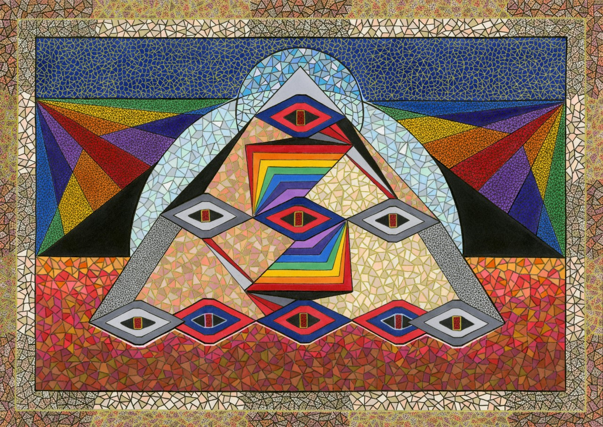

**Figure 1.** *Nine-Eyed Pyramid* by Karen Amanda Harris (2019). [Promarker, gel pen and ink liner on watercolour paper. 30cm x 42cm.]

My mathematical art derives from playing with geometry: a partially-navigated adventure towards a semi-planned but largely unknown outcome. Sci-fi-esque images frequently emerge from this serendipity. In *Nine-Eyed Pyramid*, I started with the outline of a single angular ‘eye’, curious about what would happen if I repeated this shape and joined the eyes together. (Tracing paper enables me to experiment with different formations before I am ready to commit.) Once the appeal of a 1-3-5 triangle -with its suggestion of a desert pyramid- had become apparent, it was then a matter of connecting points by adding lines and circles, while making aesthetic judgements as to where symmetry should be present or subtly disrupted.

Once I have outlined a section in pencil, I can think about colour. A rich variety of dual-ended markers (chisel-tipped and fine-tipped) is instrumental in creating multi-tonality. In *Nine-Eyed Pyramid*, this is especially evident in the mosaic-style sections: the pale blue lower dome, the darker blue upper dome, the sandy ground and the pyramid’s stonework. For this technique, each ‘tile’ consists of one single colour. I select at least eight different shades (but usually more) for a mosaic-style section, and distribute them so that no two adjacent tiles are of the exact same shade – even if they are merely touching at a corner. This ensures that the desired colour balance, and the illusion of blending, are maintained.

Each colour-piece, whether a jagged mosaic tile or a larger geometric shape, is then outlined in ink liner or metallic gel pen. Generally, the darker and thicker the outline, the more prominent the shape becomes: this is one way in which perspective and focus can be achieved. (See, for example, how the paler outlining of the pyramid’s stonework helps to push it ‘behind’ the brighter forms of the eyes and rainbow-coloured steps.) Perspective can also be achieved by subtly adjusting the colour distribution: the desert ground is actually divided into overlapping horizontal sections, so that predominantly darker areas can segue into predominantly lighter ones. This creates a gentle gradation of colour from foreground to background.

Another significant part of my technique is ‘webbing’: the breaking-up of a block of colour with a ‘web’ of metallic gel pen or fine ink liner. This is demonstrated here by the indigo sky with gold webbing (to create visual interest and sparkle) or the background spectrum rays with black webbing (to tone down the brightness).

The overall design is largely based on Euclidean principles of connecting points with lines. In this way, the geometry does much of the actual work - while still allowing me the freedom to choose which lines connect to which points.

Thus, the rear black triangle starts at the vertical edges of the picture, its sides converging (out of sight) at the tip of the upper dome. The lower dome forms a semicircle from where the pyramid meets the sand’s horizon. The background spectrum comes up to the point where the two domes meet.

In the central foreground, the line on the spectrum-steps that divides red from orange is bent at 90°; its length is aligned to the central eye-column. Adding the remaining colours into the angled spectrum, all at consistent height, creates the illusion of a not-quite staircase. Because the principles of perspective drawing – i.e. graduated spacing to convey depth- are disobeyed here, the suggestion of 3D is shifting, otherworldly, an intriguing ‘almost’.

For many, the traditional school mathematics set -with its ruler, compasses and so forth- is a toolbox of horror. I aim to present its contents in a very different light: as the keys to a creativity which is potentially available to all – and which is at once playful, curious, powerful, elegant and mystical.

**References**

Hardie, G., Powell, A. and Thorgerson, S. (1973). *Pink Floyd:* *The dark side of the moon*. [Album cover.] Available at: http://www.pinkfloyd.com/music/albums.php