‘If I Can Change’: Multigenerational Cinematic Franchises, Retconning, and the Spectre of Rocky IV
David McGowan

---

This is an Accepted Manuscript of the article: McGowan, David, “‘If I Can Change’: Multigenerational Cinematic Franchises, Retconning, and the Spectre of Rocky IV”, Screen (66.2, 2025) pp. 151-177. Copyright © 2025 The Author(s). DOI: https://doi.org/10.1093/screen/hjaf022. It is deposited under the terms of the Creative Commons Attribution-NonCommercial-NoDerivatives License (http://creativecommons.org/licenses/by-nc-nd/4.0/b), which permits non-commercial re-use, distribution, and reproduction in any medium, provided the original work is properly cited, and is not altered, transformed, or built upon in any way.

---

The Rocky saga – created by and starring Sylvester Stallone – has been through various stages of activity and dormancy, success and failure. Rocky IV (Sylvester Stallone, 1985), however, remains its most controversial entry. It marks the box-office apex for the franchise, but also the point at which critical responses became overtly hostile, positioning the text as the epitome of New Hollywood and Reagan-era excess. The notoriety of this instalment has been reflected upon and/or reacted against in every subsequent movie in the series, culminating in the re-edit of the 1985 version of Rocky IV, subtitled Rocky vs. Drago – The Ultimate Director’s Cut (Sylvester Stallone, 2021). The decision to produce a new, seemingly definitive edition of Rocky IV, almost three decades after the fact, reflects the ongoing value of the franchise – buoyed by the recent success of three Creed films, which focus on a new protagonist (Adonis Creed), but continue to chronicle the life of Rocky ‘The Italian Stallion’ Balboa and explore the repercussions of his past.
The interrelationship between serial texts is a widespread phenomenon in media production and consumption, yet numerous scholars have noted how often apparently ‘straightforward terms’ – intended to define and delineate different practices – are misapplied or ‘conceptually conflated’. The sequel marks the most common form of narrative continuation, offering a plot that occurs ‘forward in time’ from the previous entry, while the opposite occurs in a prequel, which ‘reach[es] backward in time, filling in backstories’. A number of long-running properties, such as Batman and Teenage Mutant Ninja Turtles, have been subject to the ‘rebooting’ process (sometimes on multiple occasions). The reboot (distinct from the remake, which is a ‘reinterpretation of one film’) marks an attempt ‘to forge a series of films, to begin a franchise anew from the ashes of an old or failed property’, traditionally by wiping ‘the slate clean […and restarting] from “year one”’. Adam Ochonicky highlights, however, that certain franchises complicate this definition by taking an eclectic approach to narrative disavowal, incorporating strategies of retroactive continuity (or ‘retconning’). As Andrew J. Friedenthal explains, this process ‘involves the revisiting of past stories, told in previous instalments of a long-form narrative, and adding a new piece of information to that older story, literally rewriting the past’. The retcon can operate on a flexible spectrum, with differing levels of impact on the narrative:

(1) A retcon may be a reinterpretation, changing how an earlier work is seen and interpreted, but in a less-than-definitive way, allowing for some choice on the part of the audience members to determine which history is still considered canonical to the narrative. (2) A retcon may be a reinscription, which is a more solidified change to how an earlier work is viewed, concretely and canonically changing that work’s meaning going forward. (3) At its most extreme end, a retcon may be a revision, wherein an older work is not only viewed differently, but even altered through republication, editing, new editions, and so forth, such that the material text itself is now different in the physical world, not just in the minds of characters and/or audience members.

Retconning appears central to what Kathleen Loock has termed the modern ‘nostalgia franchise’: a recent Hollywood preoccupation of ‘reviving [properties] from its immediate past’. Such films may contradictorily express a ‘commitment to [series] continuity’, while also possessing a ‘selective memory’ of what has come before, often simply overlooking any past works that provide a barrier to present and future production. For instance, Halloween H20: Twenty Years Later (Steve Miner, 1998), rather than offering a complete ‘year one’ reboot, instead negates only the films (and their respective plot developments) released since Halloween II (Rick Rosenthal, 1981). Halloween (David Gordon Green, 2018) adopts an even more aggressive approach, positioning itself as both a sequel to the original Halloween (John Carpenter, 1978) and the beginning of a new trilogy that urtext’s narrative. Similarly, following Disney’s acquisition of Lucasfilm in 2012, ‘over 260 novels, six collections of short stories, 180 videogames, and more than 1,000 comic books [were…] erased from official Star Wars continuity’ to facilitate the creation of new strands (in a variety of different media forms, and set during different narrative eras) that would expand upon the retained elements of the original canon.
The Rocky and Creed films, by contrast, have placed an emphasis on an accumulated, linear storyline which, at the time of writing, has followed Stallone’s character and his extended family, both diegetically and extradiegetically, for almost 50 years. Even Creed III (Michael B. Jordan, 2023), which most overtly attempts to move beyond the shadow of Rocky Balboa, does not deny the history of the character within this wider fictional universe. Each successive Rocky and Creed film functions primarily as a sequel, pushing the protagonists’ lives forward, with any diversions – such as flashbacks – clearly signalled by the text and mostly kept to a minimum. Furthermore, unlike a transmedia property such as Star Wars, the narrative of the series has been crafted almost entirely by its cinematic texts. Although some Rocky merchandise exists, including novelisations and videogame adaptations, these have historically tended not to contradict, or make claims to significantly broaden, the existing serial lore. The trajectory of the Rocky series may thus appear – on the surface – rather uneventful, even somewhat ‘old-fashioned’, when compared to the temporal shifts and canonical disputes found within many other major cinematic brands. However, I argue that the critical tendency to dismiss these films (especially the Stallone-driven 1980s sequels) as relatively empty, unsophisticated fare – even when considering the already low status often attributed to the Hollywood blockbuster – fails to account for the complex processes of narrative (re-)organisation that has been present across the series’ long history.
Rocky has not thus far been rebooted, nor have any of its mainline film instalments been explicitly ignored or denied by subsequent productions. The series has nonetheless frequently relied upon retconning, and my essay demonstrates that this process has often been undertaken in relation to the apparent ‘damage’ caused by Rocky IV. This ranges from the initial attempts at reinterpretation in the sequels Rocky V (John G. Avildsen, 1990) and Rocky Balboa (Sylvester Stallone, 2006), to the reinscription of the Creed movies, and then the outright revision created by Rocky IV: Rocky vs. Drago – The Ultimate Director’s Cut. I suggest that these escalating forms of retconning, rather than slowly writing the events of Rocky IV out of existence (as has occurred with ‘problem’ entries in many other franchises) have actually repositioned Rocky IV as an increasingly central text within the wider series mythology. This case study emphasises the power of retroactive continuity not just as a process of narrative erasure and replacement, but also one with the potential to achieve reconciliation and rehabilitation. As Hollywood increasingly covets the ‘endlessly renewable’ possibilities of the ‘forever franchise’, the trajectory of the Rocky and Creed series offers an approach to worldbuilding in which none of the constituent parts need to be wholly forgotten in the drive to create new instalments, even if some may still need to be updated and nostalgically (mis)remembered along the way.

Rocky and Sequelisation: From the ‘Work-Bound’ to ‘Serial’ Aesthetic
Frank Kelleter and Kathleen Loock suggest that many ‘networked acts and actors’ – including ‘industrial, public, quotidian, economic, and academic practices and discourses’, in conjunction ‘with the aesthetic activities of the films in question, […] produce something that can be called second-order seriality: ongoing narratives about (and through) ongoing narratives’. Neither the critical negativity surrounding Rocky IV, nor the retconning practices applied to subsequent entries in the series, occurred in a vacuum. The backlash towards the franchise is emblematic of a growing position in 1970s and 1980s film journalism and scholarship, wherein the ‘key artistic achievements’ of an initially celebrated text were seen to be ‘significantly diminished’ by the production of sequels. As Loock elaborates, film critics

shaped the discursive construction of textual hierarchies between an original work of art and the sequel as a derivative, assertively commercial and therefore artistically invariably inferior product. Following this logic, the work-bound aesthetic they associated with the self-contained ‘original’ was entirely different from the serial aesthetic of the sequel’.

It is possible to find complaints about the continuation of the Rocky series from as early as Rocky II (Sylvester Stallone, 1979), with such concerns intensifying and ultimately crystallising around the release of the fourth entry.
The first Rocky (John G. Avildsen, 1976) fulfils many conditions of the supposed ‘work-bound’ original. Unlike the sequels, which emerged in a post-Star Wars (George Lucas, 1977) landscape, and entered production with revenues from ancillary markets (such as television and home video distribution) already negotiated, the 1976 film was intended as a one-off, and proved an unexpected critical and commercial sensation. Produced speculatively for under $1 million and led by a then virtually unknown Stallone, the ‘film earned $56.5 million in domestic rentals, [and] won three Academy Awards (Best Picture, Best Director, Best Editing)’. Despite this box-office triumph, the film’s artistic credentials were ‘authenticated’ by its low budget and perceived status as a ‘sleeper’ hit or, in Matt Hills’s retrospective terminology, a ‘cult blockbuster’ – a success seemingly generated organically by positive critical reactions and word-of-mouth, helping to smooth over the conflict between ‘culture and economy’ that intensified in responses to the sequels. In reality, many aspects of Rocky’s production were highly mythologised within publicity, with the movie’s subject matter – Balboa as the ‘ultimate underdog […] who gets a “million-to-one shot” at a championship title’ – carefully aligned with the filmmakers’ apparent journey. Much was made of Stallone’s own status as a working-class, struggling writer/performer, who resisted lucrative offers to sell the screenplay to Rocky for production with a different actor, and who fought hard to be given the lead role. The boundaries between Stallone and Rocky were thus blurred in mutually beneficial ways: the actor’s eventual path to success was seen to echo that of Balboa in the overcoming of tremendous odds through hard work and determination.
The affective parallels between star and character, however, proved less appealing for critics when applied to the sequels. Stallone’s celebrity rapidly escalated following the success of Rocky and, over the following decade, the performer became aligned with many of the stereotypical traits of the temperamental star, with claims of unprofessionalism, arrogance, and scandal. Previous narratives of Stallone as a deserving, humble individual who had risen out of hardship gave way to accusations of conceitedness and hubris, far removed from the innocent, lovable character of Rocky Balboa. Furthermore, the actor suffered a number of box-office flops that were perceived to have almost necessitated the return to the proven bankability of his most famous role. Stallone reportedly admitted that Rocky II was made, at least in part, because ‘I didn’t know if I’d ever get the chance to write, direct, and act in the same film again’.
Sequels are often denigrated due to the diminished input from, or even outright departure of, creative personnel whose contributions were perceived to have shaped the ‘work-bound’ qualities of the celebrated original. With reference to the Nightmare on Elm Street franchise, for instance, Karra Shimabukuro laments the transition from a singular ‘auteur film’ (Wes Craven’s 1984 original) towards a cycle of movies, each helmed by a different filmmaker, where each film became ‘just another cog in the studio system, with specific goals of making the series a more commercial piece’. The first three Rocky sequels actually consolidate, rather than fracture, Stallone’s control over the series (with the star taking over directorial duties from John G. Avildsen, in addition to his ongoing contributions as lead actor and sole screenwriter). Nonetheless, many of Stallone’s creative decisions were still viewed by contemporary critics as emblematic of a wider cultural shift towards the soulless process of sequel manufacture. As Chris Holmlund summarises, supposedly disreputable elements such as ‘fairy tale and cliché dominate. […] His scripts and films are rooted in melodrama: characters are good or bad; plots are episodic; visual effects are spectacular; sound is loud, threatening and inspiring, by turn.’ These thematic and aesthetic continuities, rather than conferring a clear personal vision and/or mastery of the medium, instead often served to justify the framing of Stallone as a ‘bad’ or non-artist – the ‘stupido’s Orson Welles’, according to one journalistic account published in the wake of Rocky IV’s release.
Stallone’s association with sequels was compounded between the productions of Rocky III (Sylvester Stallone, 1982) and IV, which is most likely indicative of the heightened critical antipathy directed towards the series’ fourth entry. During this time, Stallone established his second major franchise with First Blood (Ted Kotcheff, 1982) and its sequel Rambo: First Blood Part II (George P. Cosmatos, 1985); he also co-wrote and directed Staying Alive (Sylvester Stallone, 1983), the poorly-received follow-up to another successful cult film from the 1970s, Saturday Night Fever (John Badham, 1977). The use of roman numerals in the Rocky and Rambo series became a particularly visible – and increasingly mocked – indicator of the filmmaker’s adherence to the ‘serial aesthetic, demonstrating beyond doubt that the sequel ran counter to the critics’ ideal of a stand-alone “original”’. In 1982, following the release of Rocky III, Sports Illustrated offered a particularly scathing take, jokingly predicting that Stallone would be honoured at the 1991 Academy Awards for churning out a record number of Rocky films in the course of just six months:

Rocky XVI, Rocky Meets the Ghost of Elvis Presley, Rocky XVIII, Son of Rocky (starring Robby Benson), Rocky Goes Hawaiian, Rocky XX, Mother of Rocky (starring Shelley Winters), Rocky XXI—Annie XIV, Rocky XXII Goes to Super Bowl XXIV, and Rocky X (co-starring Marilyn Chambers), which is not to be confused with Rocky X, wherein, you will remember, Rocky and Adrian have a flashback to the time when they reached puberty and ended up on a desert island without any clothes.
Next: Rocky XXXVIII. Soon to be at a theater near you.

The metatextual Airplane II: The Sequel (Ken Finkleman, 1982) similarly evokes the possibility of an eventual Rocky XXXVIII, showing a poster of an elderly man in boxing gear still wearing the championship belt (figure 1). The following year, ‘Weird Al’ Yankovic released the parody song ‘Theme from Rocky XIII’, also imagining a belated entry in which the titular character has become too old to box, and is in this case reduced to running a sandwich shop. Rocky was not the only major Hollywood franchise of the era, and some were far more progenitive – such as Friday the 13th, which saw eight features released between 1980 and 1989, followed by further revivals and reboots. However, Stallone’s creation was frequently chosen by critics and parodists as the definitive signifier of an open-ended, creatively-exhausted series, in which the number of sequels, especially by Rocky IV, had clearly spiralled out of control. That the first Rocky was a film lauded by the Academy may also have contributed to the sequels being viewed as a more substantial fall from grace than the average horror or action-led series.

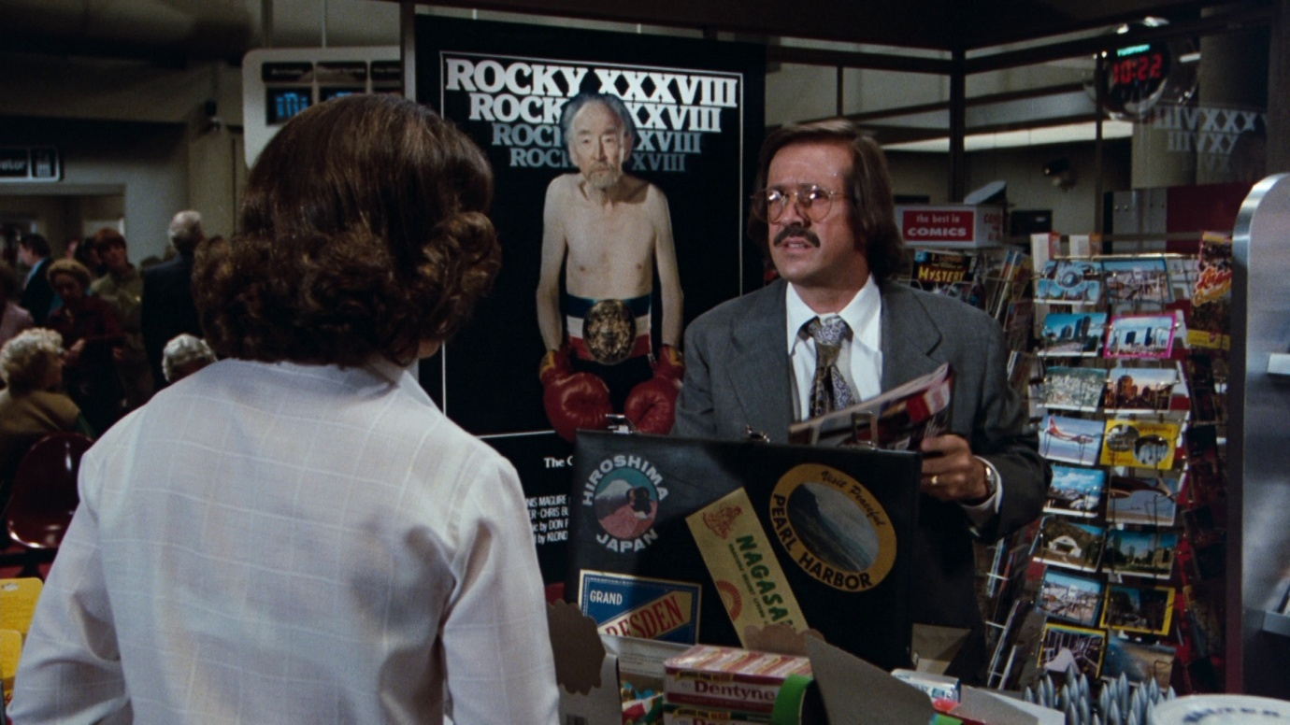
Figure 1. A parodic imagining of a ‘Rocky XXXVIII’ in Airplane II: The Sequel (Ken Finkleman, 1982).

A recurrent contemporary claim against franchise filmmaking was that the sequel offered little more than a repetition of what had come before. Carol J. Clover argues that these entries are ‘better taken as remakes than sequels; although the later part purports to take up where the earlier part left off, in most cases it simply duplicates with only slight variation the plot and circumstances – the formula – of its predecessor’. Such charges were routinely applied to the Rocky films. In 1984, Harlan Kennedy noted disapprovingly that:

despite token bows to chronological progression there is virtually no sense of development in the characters or story from film to film. Not only do the protagonists refuse to visibly age, but each story is almost nakedly a rerun of the last one. The individual details may change but the main stations of the narrative are identical. In Rocky we must have the semi-reluctant comeback, the big-brute antagonist, the sweetly keening wife and the pulverising prize fight.

Even Adrian Wright, in his broadly sympathetic biography of Stallone, suggests that the Rocky sequels can be collapsed into a recognisable set of tropes: ‘Rocky triumphs in the first few moments of the film (a carry-over of the previous film’s finale), Rocky stumbles, doubts, fails, cries, Adrian and a strong male friend revive his beliefs, Rocky does a training montage, Rocky wins’. While Rocky II and III had certainly not escaped such criticism, the backlash strengthened with Rocky IV, reflecting in part the sheer accumulation of sequels by this point (and especially the number of parodies that had emerged in response), but also the growing consensus that the franchise was being exploited for profit rather than having strong plot-driven reasons for continuation. Richard Schickel, reviewing Rocky IV in Time, asserts: ‘The Rocky sequels have ceased to be movies in the usual sense of the word. They are now [merely] rituals.’
Although much of the negativity surrounding Rocky IV was framed in terms of perceived repetition, many of the complaints additionally correspond to what Loock has termed the ‘logic of one-upmanship – that is, the sequel follows an intensification-oriented principle of repetition and innovation in order to retell a familiar story’. As Stuart Henderson elaborates, sequels will often ‘amplify certain recurring elements, delivering more of the same with an emphasis on “more”’. The death of Apollo Creed in Rocky IV offers an example of this perceived blend of mechanical repetition of the series formula, coupled with ever greater levels of exaggeration. Creed’s death occurs at a similar point in the film’s narrative as that of Balboa’s trainer Mickey in Rocky III, offering a melodramatic shock designed to plunge Stallone’s character into despair but ultimately inspiring him to achieve victory against the responsible antagonist. As Frank Sanello notes, the successive deaths of Mickey and Creed threaten to consecrate ‘a bittersweet tradition in following instalments [that…] a much beloved supporting character would get offed’ for sensationalist reasons: ‘Talia Shire [who played Balboa’s wife, Adrian] must have cringed every time the next Rocky script was sent to her, flipping through it to see if this one contained her big death scene’. Although, as I discuss later, subsequent Rocky films have actually handled character deaths somewhat differently, several contemporary critics bemoaned Rocky IV’s treatment of Creed as a predictable and ‘bathetic’ development, and one that seemed to be establishing an unwelcome expectation for any future entries. While Clubber Lang’s involvement in Mickey’s death in Rocky III was broadly an accident, it is implied that Ivan Drago’s treatment of Creed in Rocky IV is tantamount to murder (albeit morally rather than legally), turning the film into a more overt, and more hyperbolically emotional, revenge drama.
Across the first three Rocky sequels, then, the stakes are frequently raised for the protagonist. Balboa suffers greater hardships in each successive film, but his victories too are more substantial – or potentially more outlandish, as many contemporary reviews suggest. His achievement in the first Rocky film is simply that he goes the distance, insofar as. he loses the fight to Apollo Creed but far exceeds the crowd’s expectations by remaining standing at the final bell. In Rocky II, however, he secures an outright victory (and the title belt) in a rematch with Creed, and in III achieves further wins, including against the formidable Clubber Lang. Rocky IV creates an even more heightened antagonist with the introduction of the almost-inhuman Drago, a Soviet boxer whose body is scientifically manipulated using machinery and illegal supplements. Balboa therefore faces his toughest challenge to date, with his ultimate triumph due in large part to a return to nature, becoming the antithesis of Drago through a training regime rooted in personal determination and ‘honest’ exercise. Critics complained that a character established in the first film as already past his prime had now become essentially invincible, reaching his peak in overcoming the machine-like Drago. Such responses often drew unflattering, ‘second-order’ parallels with Stallone’s other, more violent franchise character, John Rambo. Compared with the ‘respectable’ loss that Balboa achieves in the 1976 original, the sequels appeared to consecrate an expectation that the character must always win at the film’s conclusion, and must do so in increasingly impressive ways.
This escalation was marked not just by a greater test of strength, but also by the global scale upon which the events now took place. Whereas previous films had confined Balboa to the USA, rarely venturing beyond his native Philadelphia, the fourth entry concludes with Rocky in Moscow fighting for US supremacy, with the villainous Drago embodying the amplified Cold War tensions of the period. The incorporation of anti-Soviet propaganda had already presented itself as a major theme of another contemporary Stallone-fronted release, Rambo: First Blood Part II, and would continue with Rambo III (Peter MacDonald, 1988). Rocky IV thus received criticism not just for the jingoism of the narrative, but also for the perceived homogeneity of the filmmaker’s approach to sequels, with the two franchises now drawing upon similar thematic material. Furthermore, earlier instalments in the Rocky series had tended to focus Balboa’s post-fight attentions towards his beloved Adrian, but Rocky IV instead sees the titular character – draped in an American flag – deliver a heartfelt speech to the Russian people:

I came here tonight, and I didn’t know what to expect. I seen a lot of people hating me, and I didn’t know what to feel about that, so I guess I didn’t like you much none either. During this fight, I seen a lot of changing. The way youse felt about me, and the way I felt about you. In here, there were two guys killing each other, but I guess that’s better than twenty million. So, what I’m trying to say is, that if I can change, and you can change, everybody can change!

The sequence is intercut with teary reaction shots from members of the crowd, and even results in the assembled Politburo giving Rocky a standing ovation, led by a Mikhail Gorbachev-esque Premier (figures 2-4). The naivety of Balboa’s speech, and the unfeasibly wide-reaching repercussions that it appears to have on Soviet-American relations, generated significant derision in many contemporary reviews, even as the movie’s patriotic fervour was simultaneously promoted by distributors as one of its key points of box-office appeal.

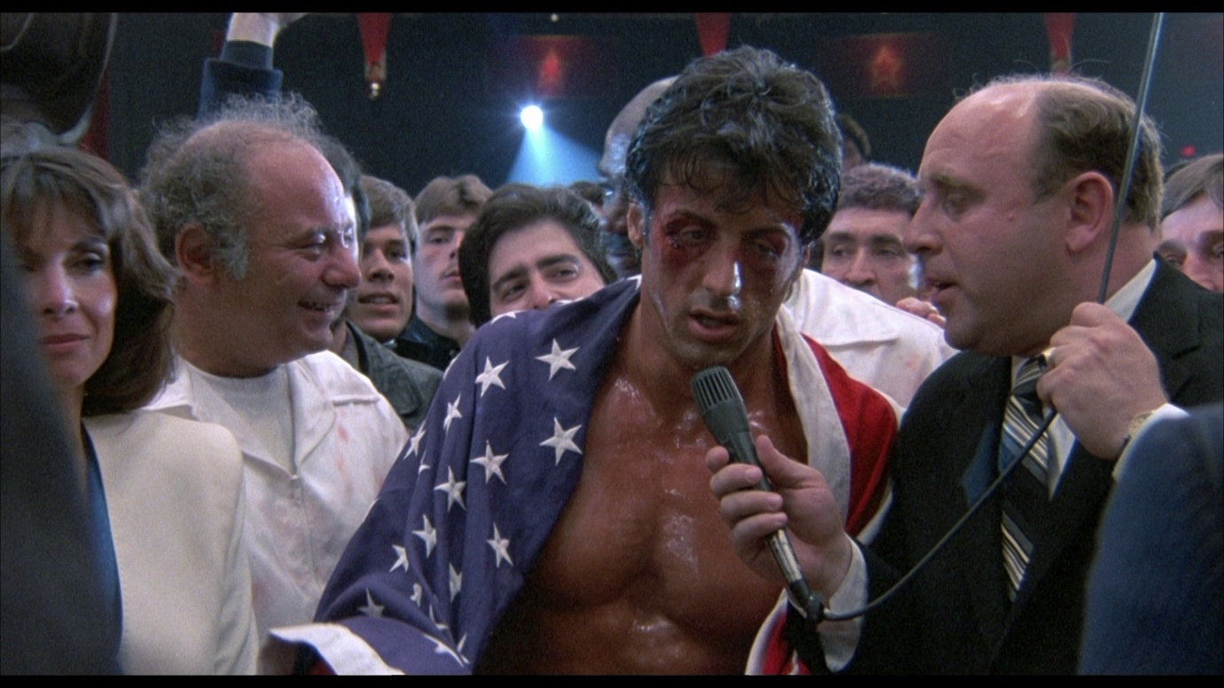

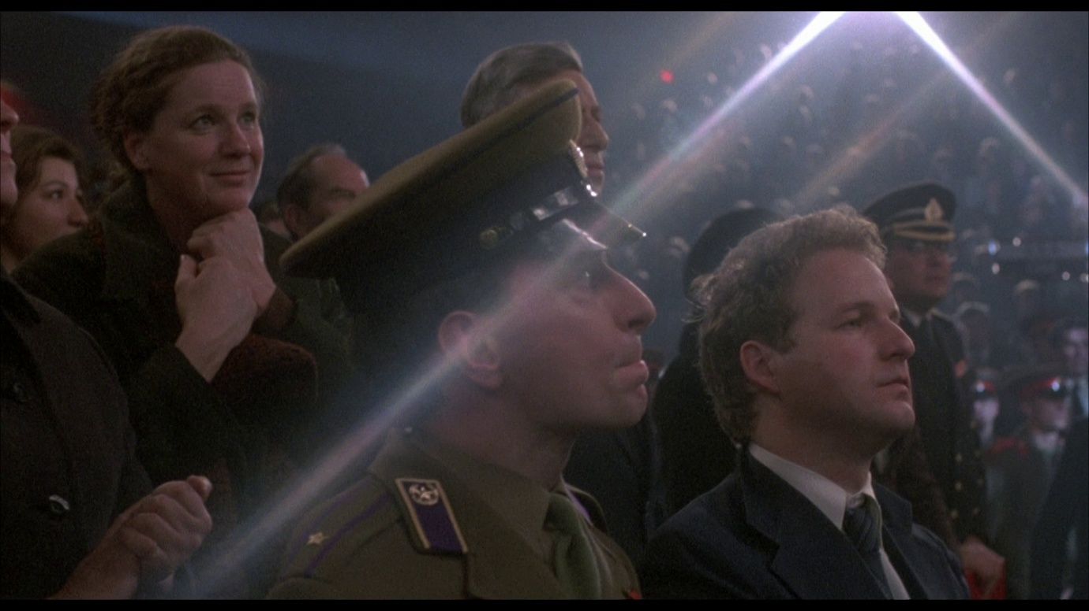
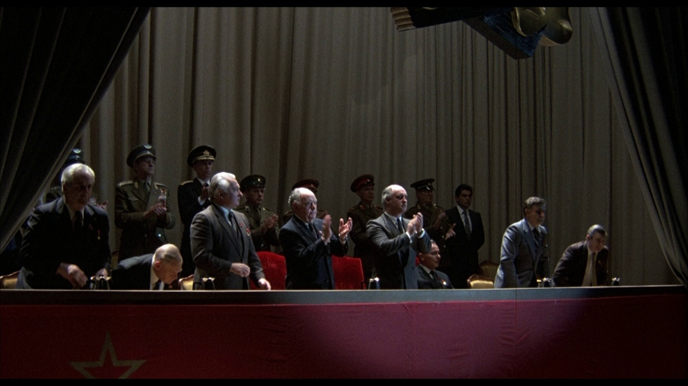
Figures 2-4. Rocky’s impassioned speech at the end of Rocky IV (Sylvester Stallone, 1985), which wins over the Russian crowd as well as the political elite.

Geoff King notes that:

the films of the Hollywood renaissance have been celebrated for offering some degree of radical political potential, in both content and departures from classical style[, whereas…] the version of New Hollywood associated with the corporate blockbuster [and the rise of franchise filmmaking] is usually seen as more conservative in its ideological implications.

It would be a stretch to label even the first Rocky film as truly radical in its politics, considering its ‘tapp[ing] into post-civil rights fears’ about African-American economic advancement, and the underlying racism of Balboa becoming a champion to the disenfranchised white working class. The 1976 original is nonetheless marked by a sense of malaise at the apparent failings of the American dream (at least from Balboa’s perspective at the beginning of the film), while the subsequent entries – once again reaching an apex in Rocky IV – smooth over these concerns in favour of a more simplistic celebration of the capitalist system. The fourth entry most explicitly constructs a narrative that requires ‘Rocky to stand up for the United States and, by extension, the individualist ethos during the last years of the Reagan era’. Stallone’s films of the mid 1980s appeared to wholeheartedly embrace the populist conservative message of the period, a decision that undoubtedly proved successful in bolstering the star’s commercial appeal, but which simultaneously diminished his credibility in the eyes of the artistic community, with some commentators even deriding Stallone as ‘Reagan’s pornographer’.
The increasingly Reaganite values of the Rocky series are also visible in terms of Balboa’s changing economic and class status. Between Rocky II and IV, the protagonist enjoys rapid upward social mobility, moving away from his proletarian origins and enjoying a significantly higher standard of living. Rocky II initially presents this as an awkward transition, with the character finding it hard to embrace his commodification as a media personality; III, by contrast, suggests that he has subsequently become too comfortable with his new-found luxuries, and needs to recapture the ‘eye of the tiger’, the ‘hunger’ that helped to drive his early victories. By the time we reach IV, however, the morals of the past entries appear to have been subtly retconned: Balboa and his family are now seemingly reconciled with their vast wealth. The characters live in a palatial mansion, surrounded by extraneous and lavish items, and are unreflective on the economic hardships that they used to face. The predominantly working-class settings of the original film, where Rocky has few aspirations other than wishing not to be viewed as a ‘bum’ by those in the neighbourhood, sit in stark contrast with the unapologetically bourgeois lifestyle enjoyed in the fourth entry. The presence of a robotic butler in Rocky IV – acquired by Balboa as a birthday present for his brother-in-law, Paulie – is the most explicit representation of this opulence. The gift is introduced primarily through a series of fetishistic close-ups of metal and components, with the sequence adopting generic signifiers closer to that of a science-fiction film than the representation of an intimate family gathering (figures 5-6). In later scenes, the robot demonstrates a sentience well beyond the technological limitations of the era, adopting a persona akin to that of a stereotypical nagging partner, frequently chiding Paulie for his slovenly habits. For all of its wish-fulfilment underdog narratives, the Rocky series had never previously incorporated anything overtly fantastical within the diegesis. The robot thus offers a particularly visible marker of how egregiously Rocky IV had deviated from the franchise’s more grounded origins – not just on a thematic and storytelling level, but also in terms of its shifting formal properties.

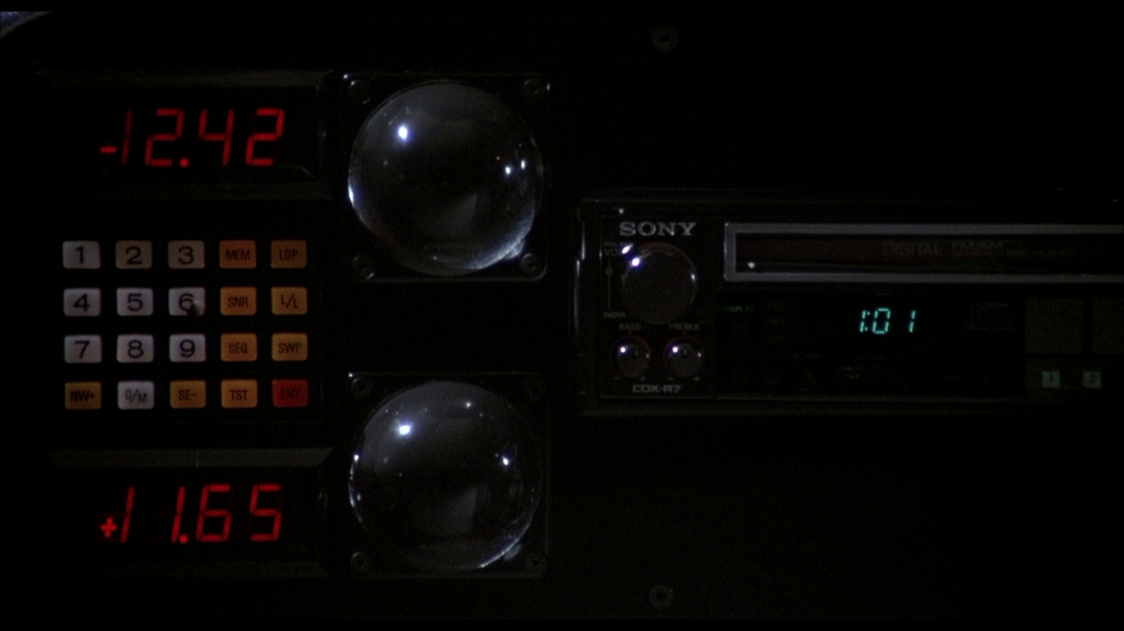
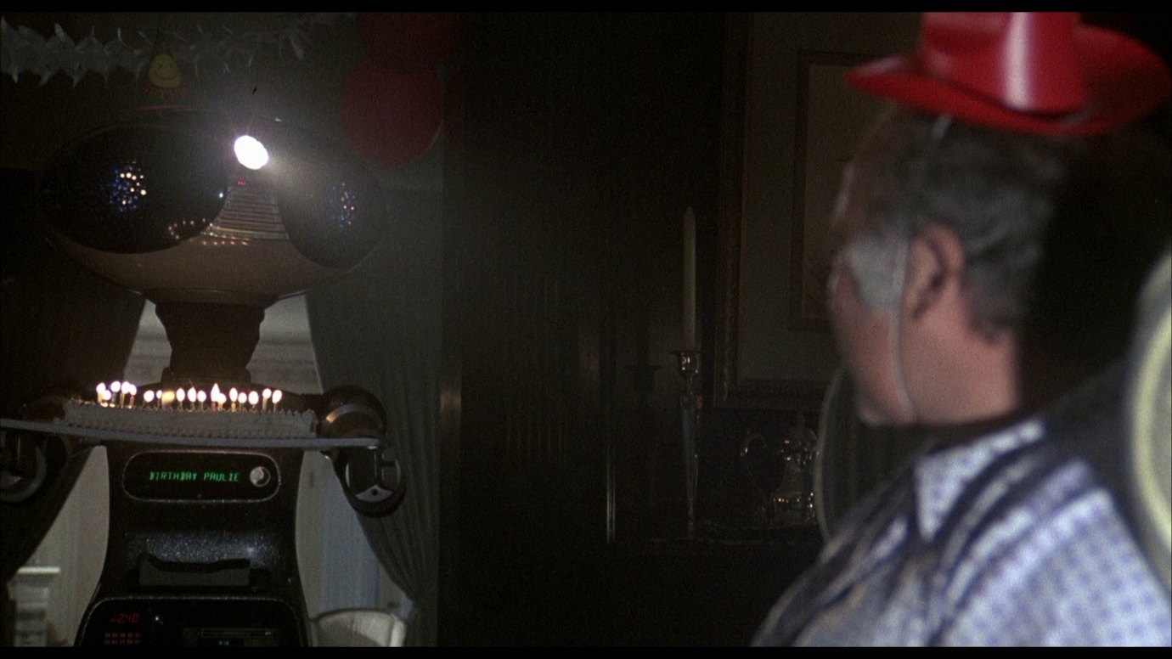
Figures 5-6. Fantastical images of Rocky IV ’s notorious robotic butler.

While the first Rocky film does introduce certain stylistic elements that presage the perceived excess of later entries, such as the use of montage during Balboa’s training, these are juxtaposed – particularly in the film’s first half – with quieter character moments, which are shot in an observational, almost neorealist manner. King notes, however, that in the 1980s, the new ‘corporate blockbuster format and the growing importance of video and broadcast media to the Hollywood economic equation’ is perceived to have mutated ‘traditional editing regimes […through] the importation into feature films of the rapid cutting and “shallow” imagery of advertising or MTV’. As such, Stallone’s tenure as director of Rocky II, III, and IV is often characterised as privileging ‘intensified, hyperbolic stylisation’, which became more prominent with each successive film. For instance, Rocky III was promoted in part with the bombastic claim that the fights contained over ‘130 separate punches as opposed to the 75 in Rocky II and the “mere” 35 from Rocky’, with Rocky IV promising to push this even further. As a consequence of the more kinetic approach, the average shot length (ASL) was reduced across the series: ‘Avildsen’s Rocky clocked in with an 8.25 second ASL. Rocky II jumps to a 5.6 ASL, while Rocky III comes in at 3.7 seconds and Rocky IV at a remarkable 2.16 seconds.’
Paul Ramaeker argues that the fourth Rocky film marks ‘the culmination of Stallone’s play with montage’, expanding beyond the customary training and fight scenes, and collapsing more of the film’s dramatic moments into fast-cut sequences. Following the death of Apollo Creed, for instance, there is a transition from a conversation between Balboa and Adrian into a lengthy ‘music-video-style […] flashback montage’, re-mixing events from earlier in the film with scenes from previous Rocky movies. While the sequence aims to explore Balboa’s grief and fragile state, the heightened editing regime emphasises the interplay between emotion and spectacle much more overtly than any other film sequence in the series. As King highlights, this kind of aesthetic was frequently positioned by contemporary critics as a ‘threat’ to complex storytelling; despite his own retrospective study finding that films of this type ‘still exhibit most if not all of the qualities usually associated, loosely, with “classical Hollywood” narrative’. David Edelstein, evaluating Rocky IV for Village Voice, accused Stallone of being a ‘techno-bully, a cinematic boxer who pummels his audience with the latest in shock cutting’, while Schickel’s aforementioned review in Time claimed that ‘narrative linkage in any but the crudest form is dispensed with, and dialogue and characterizations are stripped to minimal levels’. These examples highlight the considerable, often contradictory levels of vitriol directed at Rocky IV as a film variously accused of repeating past storylines, embellishing them to hyperbolic levels, and even of having virtually no narrative content at all.
Whether or not any of these critiques have merit is, in many ways, beside the point; rather, it is the vigour and ubiquity of such claims among the so-called critical elite that undoubtedly congealed as a second-order influence upon the consumption (and ongoing production) of the Rocky franchise. It is important to emphasise at this stage that Rocky IV was a huge economic success. Each of the first three Rocky sequels exceeded the box-office takings of the previous entry, with IV remaining the franchise’s commercial high point. The film undoubtedly generated strong audience appeal, and continues to be a popular entry in the series in spite of, or perhaps in many cases because of, its excessive tendencies. Nonetheless, it is possible to chart a significant alteration in the direction of the series from this point onward. The escalation of each previous Rocky film had seemed to imply, especially by the fourth entry, that the franchise was unstoppable, and that Balboa could simply keep delivering crowd-pleasing victories over increasingly hard-hitting foes. By contrast, the next films in the series, Rocky V and Rocky Balboa respectively, take an approach that markedly scales back the scope of the narratives, demonstrating a preference for closure rather than continuous replication.

With reference to the James Bond movie franchise, James Chapman notes that the series has periodically adopted a ‘“back to basics” approach’, attempting to ‘reinvent itself by returning to more plausible, if not strictly realistic’ scenarios. This has usually involved the promise of recapturing the spirit of the original texts (the Ian Fleming novels or the early, celebrated Sean Connery films), and has often occurred in relation to critical and/or financial underperformance of a previous instalment – the comparative grittiness of Casino Royale (Martin Campbell, 2006), for example, as a corrective to the excesses of Die Another Day (Lee Tamahori, 2002). As Ochonicky suggests, the process of rebooting and/or retconning is inherently nostalgic: even though the act ‘denies nostalgia by undermining the stability of an earlier entry’, it ‘also reaffirms the lingering importance of one or more predecessors’. Rocky V and Rocky Balboa operate in a similar manner, albeit to different levels of perceived success. Both aim to subtly retcon the accumulated narrative – with particular focus upon downplaying the ‘stability’ of Rocky IV within the franchise – and to re-evoke the ‘work-bound’ associations of the Academy Award-winning 1976 film as a nostalgic reference point.
Rocky V does this in part by bringing back the original director, Avildsen, whose authorial presence suggests a return to the more observational style of the first entry, implicitly distancing the new release from the increasing ‘MTV aesthetics’ of the interim Stallone-directed sequels. The film also attempts to recapture the underdog spirit of the earlier instalments, retreating from the Reaganite excesses of the later productions. As Stallone commented, ‘when a character is on top, such as he was in Rocky III and Rocky IV, it’s very hard to conjure up true grass-root, blue-collar proletariat emotion’. Rocky V retcons the events of the previous entry by ‘revealing’ some previously-undisclosed information: Paulie had been tricked into giving an accountant the power of attorney over Rocky’s finances while the latter was training in Russia. Upon their return to the USA, the family discover that their fortune has been squandered, forcing them to vacate their mansion home of the last two movies, and return to their old neighbourhood. Though Rocky initially intends to get back into the ring and rebuild his empire, the film addresses the character’s advancing age and the cumulative effects of his previous fights. Balboa is diagnosed with brain damage, a result of the bout with Drago in Rocky IV, and is forced into retirement. The retconning process at this stage arguably sits within Friedenthal’s concept of the ‘reinterpretation’, as it encourages audience members to endow the climactic fight with Drago with a different meaning, based upon the new information. What had been presented in Rocky IV as Balboa’s greatest triumph and the culmination of the film’s simplistic jingoism is now transformed into something potentially mournful. According to Rocky V, as the character is being cheered on by the Russian people and enshrined as an American hero, events have already been set in place that will rob the character of his fortune, his profession, and potentially his life.
At several points in Rocky V, the protagonist suffers debilitating migraines, and it was reported that Stallone had initially planned to end the narrative with Balboa dying in Adrian’s arms. While the released version spares its hero and substitutes a more upbeat resolution, Rocky V still deconstructs the open-ended formula of past entries, with the character seemingly coming to terms with the reality that his boxing career (at least as a fighter) is over, and that he will most likely never recoup the vast wealth showcased in the previous two entries. The film not only attempts to serve as a corrective to the excesses of Rocky IV, but also positions itself as a conclusion to the saga as a whole, overtly closing the door on a number of narrative strands and ‘repeatable pleasures’ that had been the lynchpin of the franchise’s sequels. Rocky V’s appeal to be read as a ‘work-bound’ text is thus visible in the degree to which it diminishes the ability to easily generate further instalments, through its narrative developments as well as its application of retroactive continuity.
The marked difference of Rocky V from its immediate predecessor, despite the professed ‘back to basics’ approach, proved to be controversial for both critics and audiences. Many reviewers dismissed the film as an inadequate attempt to recapture the character-led drama of the original entry, still broadly treating it as a commercial, serialised product. Conversely, Rocky V’s comparatively downbeat tone diminished its ‘blockbuster’ appeal, with the film generating only a fraction of Rocky IV’s domestic box-office revenue. Stallone later commented: ‘I was naïve to believe there’s an audience who wanted to watch a man crash and burn whom they’ve come to know for 14 years’. While Rocky V was by no means a flop, its commercial underperformance effectively marked the end of the series as an ongoing mainstream cinematic property, regardless of the film’s narrative efforts to bring Balboa’s story to a definitive point of resolution. Stallone’s belated decision to make a further sequel, 2006’s Rocky Balboa, met with significant resistance from studio management largely on the grounds that the franchise was no longer financially viable. The movie was eventually greenlit, reportedly somewhat reluctantly, thanks primarily to the contemporary popularity of several recent Rocky-themed videogames.
If Rocky V can be characterised in part as an apology for Rocky IV, then Rocky Balboa has been positioned as an attempt to counteract the subsequent failings of Rocky V. Although Stallone returned as the director as well as writer and star, the film distances itself from the heightened stylistics of his 1980s sequels. It also aims to embrace its lower budget, necessitated in large part by the poor returns generated by Rocky V, as a marker of its renewed ‘work-based’ intent. The screenplay does, however, engineer an opportunity to get Balboa back into the ring for one last fight, subtly retconning the long-term effects of the injuries that had precipitated the character’s retirement and thus allowing for a return of some popular series fixtures (such as Balboa’s training montages) that were downplayed in the poorly-received fifth entry. The film attempts to defuse criticisms of mere repetition through stressing the transformative passing of time, as well as the apparent conclusive quality of the events being depicted. Rocky Balboa was heavily promoted as the swansong for the character. Although this had been falsely claimed with previous sequels, and even Balboa’s promises have since been negated with the production of the Creed series, there is a greater emphasis placed upon ageing and finality than in Rocky V. Indeed the decision to sidestep the roman numeral conventions – the film is the sixth Rocky movie, but is pointedly not titled Rocky VI – indicates the desire that Balboa should not just be categorised as another sequel, but rather as a redemptive epitaph.
What is surprising is the degree to which Rocky Balboa finds itself in proximity to some of the criticisms and parodies that the Rocky franchise had generated in previous decades. As with earlier entries in the series, Balboa utilises the trope of killing off a major character, in this case, Rocky’s wife, Adrian – a possibility jokingly posited in Sanello’s 1998 biography of Stallone. However, where Rocky III and IV had positioned Mickey’s and Apollo’s deaths as melodramatic conclusions to the first acts of the respective screenplays, designed to emotionally spur Rocky towards his eventual victory, Balboa has Adrian’s death occur off-screen, with Stallone’s character already in mourning at the beginning of the story. Rocky still ultimately channels his sorrow through fighting, though crucially, the stakes appear less bombastic than in the earlier sequels. Balboa does not have a revenge plot like Rocky IV, but rather emphasises a smaller narrative about a grieving spouse searching for some catharsis after losing the love of his life.
In parallel with Airplane II’s imagined Rocky XXXVIII, Rocky Balboa does indeed feature an elderly man aiming to prove himself in the boxing ring – Stallone was in his early sixties at the time of the film’s production, as was the titular character within the diegetic narrative. Whereas the parody version inferred a protagonist that improbably remained a top-level contender across several decades and numerous interim sequels, Balboa reiterates that the character has been retired since the events of Rocky V. The film addresses the immense challenge for Rocky to get back into shape for the event, echoing, perhaps, the hurdles faced by Stallone as writer and director in response to criticisms of previous sequels. The plot therefore aims for a degree of realism about the extent of his achievement. While Balboa is inspired to return to boxing after a computer simulation suggests that, in his prime, he would have likely been able to defeat the present-day champion by knockout, the actual exhibition match in the film sees the aged Rocky losing by split decision. In an emotive parallel to the 1976 original, he is nevertheless able to go the distance and once again garners the crowd’s respect.
The narrative repeatedly emphasises that this is not going to be the start of a new career for Balboa: Rocky’s journey goes full circle, and the desire to have one last ‘hurrah’ arguably says as much about Stallone’s efforts to conclude the franchise on a nostalgic high as much as it purports to reveal new, essential truths about the titular protagonist. Neither Rocky V nor Balboa explicitly deny the events of Rocky IV, but are more concerned with rehabilitating the collective series by attempting to move beyond its most problematic text, partly by looking further backwards to the franchise origins as a means of re-authentication. It is only with the subsequent Creed films, produced almost a decade after Rocky Balboa, that the use of the retcon in this series is distinguished from many other cinematic franchises, in the decision to devote significant attention to the rehabilitation of Rocky IV itself.

The Creed series launched in 2015, a year identified by Loock as the key turning point in Hollywood’s pursuit of the ‘forever franchise’. Around this time, many returning cinematic properties – through entries such as Star Wars: Episode VII – The Force Awakens (J. J. Abrams, 2015) and Jurassic World (Colin Trevorrow, 2015) – recalibrated towards ‘reveling in the past (rather than renouncing it) and favor[ing] continuity over the radical reset’. Yet much like Rocky V and Rocky Balboa, the majority of these films show a clear bias towards the most stable entries in the series: The Force Awakens is more interested in exploring the world-building possibilities established by the original 1977 film than, for example, the more divisive Star Wars: Episode II – Attack of the Clones (George Lucas, 2002), while Jurassic World reflects primarily on Jurassic Park (Steven Spielberg, 1993) rather than Jurassic Park III (Joe Johnston, 2001). While the ‘lesser’ instalments are usually considered canonical, and may even be directly referenced, it is still rare for the events of these films to significantly drive new storytelling, especially to the extent that the Creed films explicitly mine the complicated legacy of Rocky IV as a catalyst for dramatic action.
Creed (Ryan Coogler, 2015) most accurately fits into the category of the spin-off, as a production ‘which diversifies an existing narrative universe without [necessarily] having to focus on an established character constellation’. The introduction of a new, younger fighter – Apollo Creed’s illegitimate son, Adonis (Michael B. Jordan) – allows for the nostalgic reactivation of many of the narrative strands found in the earlier incarnation of the franchise: as with the first Rocky movie (and Rocky Balboa), Adonis receives an unexpected opportunity to prove himself in the boxing ring, and wins the hearts and minds of the crowd despite losing the match. Although Stallone was frequently chided in the 1980s for perceived repetition, Creed emerges in what Constantine Verevis has termed the new millennial context of the ‘postauteur’. This is an era in which filmmakers ‘seek to insert themselves into the innumerable flows of global film and media production, not by setting out to create something that is new (original) but rather by remaking what already exists: revising it, inhabiting it, and putting it to use’ in ways that have been promoted (and, seemingly, received) as demonstrating ‘authorial agency and “brand-name vision”’. Chuck Tryon argues that the film’s writer-director, Ryan Coogler, both revisits and redrafts ‘aspects of the original Rocky films […in order to] create a new political narrative, one that explicitly challenges stereotypes of African-American athletes’. As César Alberto Albarrán-Torres and Dan Golding elaborate, ‘Creed shifts the spotlight from the White Hope to the Proud Black Man for the first time in the Rocky franchise’, helping to endow even familiar tropes with a sense of ‘inclusive […] rejuvenation’. Although there are clearly concessions to ‘serial’ filmmaking – with the Creed sequels adopting the same roman numeral titling as the Rocky films – and even parallels between Balboa’s and Adonis’s increasingly opulent lifestyles following their career successes, these spin-offs have so far achieved strong critical and commercial acclaim.
The first two Creed movies also reflect tendencies of the ‘legacyquel’, a recently-coined term for a mode of filmmaking that often places an emphasis upon ‘generational succession, […] inheritance and passing-of-the-torch rituals’. Stallone returns in both entries as Rocky Balboa, inferring the star’s endorsement of this narrative continuation, but in a less prominent capacity than in previous films. Balboa as character takes on a mentorship role, while Stallone stepped back from the directing, and most of the writing, of the Creed franchise. At the same time, however, these films make explicit efforts to continue Rocky’s storyline, expanding on the themes of ageing and familial struggle foregrounded in Rocky V and Balboa in ways that have, once again, generated debate about the boundaries between spin-off, legacyquel, and ‘conventional’ sequel. In Creed, Rocky suffers further, with Paulie’s death occurring off-screen in a similar manner to Adrian’s in the previous film, and he experiences his own brush with mortality in the form of a cancer diagnosis. In Creed II (Steven Caple Jr., 2018), the only entry to be co-scripted by Stallone, Balboa continues to lament the distant relationship with his son, explored previously in the last two Rocky films. As such, while Rocky re-enters the boxing world within this new franchise, albeit as trainer rather than competitor, his own narrative journey largely adheres to the trajectory established by the post-Rocky IV sequels, in which spectacle and violence are overshadowed by personal, human challenges.
Given the ongoing desire to sidestep the perceived excesses – and low reputation – of the middle-period of the Rocky saga, it is significant how much the Creed films also actively engage with the accumulated narrative of Rocky IV in addition to the more celebrated aspects of the parent series. Yet Creed is also more aggressive than past entries in its use of retroactive continuity to both subtly rewrite the past and serve the needs of current and ongoing production. The entire viability of the new franchise is based upon a retcon to the events of Rocky IV, with Creed asserting that Apollo had an affair shortly before his death, and unknowingly sired a child, Adonis. The Creed films thus aim to impose a stronger – and more generationally resonant – emotional weight onto Apollo’s death. While Rocky IV was preoccupied with Balboa’s short-term desire for revenge, these new entries focus instead on the long shadow cast by Adonis’s absent father, especially as the now-adult son attempts to forge his own boxing career. This intergenerational aspect of the narrative drive is pushed even further in Creed II with the reintroduction of Ivan Drago, who has been exiled in Ukraine since his defeat by Rocky, and who dreams about restoring his reputation in the present day by engineering a bout between his own son, Viktor, and Adonis Creed. This has significant repercussions for the main characters: Adonis is once again confronted with his feelings of loss and anger about never meeting his father, and rashly agrees to the match. Rocky, too, reveals his continued guilt over not stopping the fight between Apollo and Ivan Drago, complicating the simplistic notion of closure implied by his own victory over Drago at the end of Rocky IV.
Though the Dragos, father and son, are still positioned as the antagonists of the film, Ivan in particular is now presented as a conflicted, even tragic, figure, a representation intended not just to shed light on his current condition but also to retrospectively explore his past motivations. While, as noted, Rocky IV portrays Drago as a monosyllabic hulk, bolstered by Soviet technology, Creed II emphasises his humanity and broken spirit. It is revealed, for example, that following the events of the earlier film, Drago was abandoned by his wife, Ludmilla, an outcome that appears to have been more personally devastating than the loss of his homeland. Ivan’s harsh treatment of his son is shown to be a symptom of his own feelings of inadequacy. When chiding Viktor for mistakes in the ring, he ends up revealing more about himself: ‘That’s why she [Ludmilla] left us’. As his son gains traction in the boxing world, Ivan reconnects with many of the people who rejected him, including his ex-wife, and is given the opportunity to return to Russia for a rematch between Adonis and Viktor. Ivan initially enjoys the limelight, but he loses the respect of his son, and comes to realise how fragile his comeback has been; when Viktor concedes ground in his second fight with Adonis, Ludmilla walks out on them once more. Rather than admonish Viktor for his failure, Ivan begins to let go of his anger and instead hugs and comforts him. The film concludes with the father and son training together, their relationship seemingly on a stronger footing.
The decision to endow Ivan Drago – arguably the most one-dimensional villain of the Rocky films – with greater nuance and even a redemption arc, further emphasises the complex and evolving position that Rocky IV holds within the series history. Early in Creed II, Drago visits Rocky’s restaurant (figure 7). Although the building is heavily decorated with photographs that document a wide range of Balboa’s past sporting glories, Ivan wryly notes that there are ‘no pictures of me’. Rocky’s terse reply – ‘no, there’s no pictures of that’ – concisely summarises the fractured relationship between the two men, but also metatextually concedes the low critical status that their past meeting holds within the wider canon of films. Balboa and Stallone have, for several decades, adopted strategies to distance themselves from the fight and the film, respectively.

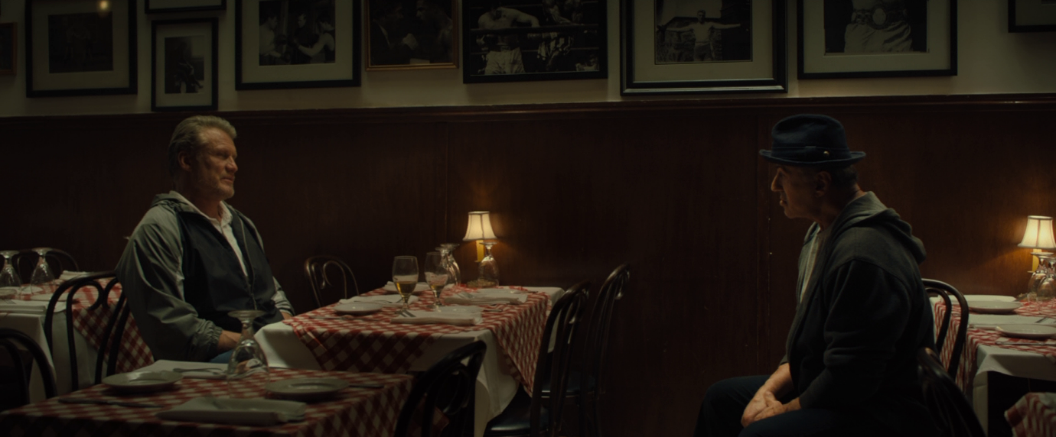
Figure 7. The terse reunion of Rocky Balboa and Ivan Drago in Creed II (Steven Caple Jr, 2018), surrounded by images of Rocky’s past.

The Creed films, however, mark a significant change of direction: these works have included more archival footage from Rocky IV and have more widely expanded upon the repercussions of its plot developments, than any other previous entry in the Rocky series. Ahead of the initial fight between Viktor and Adonis in Creed II, one of the boxing commentators notes: ‘It all feels so Shakespearean. Two sons, raised a world apart, yet inexorably linked by tragedy.’ Although presented as a hyperbolic observation made in the heat of the moment, this quotation nevertheless reveals the degree of seriousness with which the Creed movies acknowledge the events and repercussions of Rocky IV. The retconning process is here focused less on destabilising an earlier text – as in Rocky V and Balboa – and more on inviting ‘a nostalgic revisiting of that older entry’. By reinscribing an additional layer of complexity onto the earlier film, however, the Creed films nonetheless create the potential for inconsistency or dissonance. There remains a danger that, for those who seek out or revisit Rocky IV in response to Creed II, it may not actually deliver on the gravitas that the retcon insists it possesses. The subsequent decision to produce a director’s cut of Rocky IV, then, marks the most transformative mode of retroactive continuity – defined by Friedenthal as the ‘revision’ – in which the original text is altered in a literal, rather than merely associative, sense, with this new version responding to the retcons found in the post-Rocky IV films.

The director’s cut for Rocky IV, as a belated endeavour covering a sole text within a sequence, has some precedent within wider film history. Probably the most infamous series films to receive retrospective re-edits are the Star Wars Special Editions, released by LucasFilm in 1997, though this process involved an update to all the existing mainline entries (Episodes IV–VI), in anticipation of the release of the prequel trilogy, beginning with Star Wars: Episode I – The Phantom Menace (George Lucas, 1999). While it has certainly been more common for many properties to opt to simply reboot or restart the chronology at an earlier point, ignoring problematic entries, the potential for the director’s cut to serve as a productive form of franchise management has often been overlooked in existing scholarship. For instance, Loock’s recent monograph Hollywood Remaking offers a detailed study of the numerous ways in which the US film industry has generated ‘different cinematic formats by repeating, modifying, and continuing past renditions in the present’. The volume does not, however, explicitly reference the director’s cut, despite establishing a valuable theoretical model in which such texts could be understood alongside other franchise practices such as the reboot, sequel, spin-off and crossover.
Traditional definitions of the director’s cut have, as King suggests, usually relied upon a ‘commodified version of auteurism’ in which renowned filmmakers were permitted to return to a celebrated past work and attempt to reinstate ‘the original vision of the auteur-director, freed from whatever compromises were involved in the initial release’. Although this has always been a fallacy, obscuring factors such as the passage of time, the availability of materials, and the ‘industrial calculations and marketing strategies’ that have authorised the new edit, the process remains rooted in the romanticised promise of delivering a ‘supposedly “more authentic” version’. Such a pledge is undoubtedly complicated in the franchise era, where the revision to a series film can no longer claim, however problematically, to be wrestling with a singular text – such as Apocalypse Now (Francis Ford Coppola, 1979) or Heaven’s Gate (Michael Cimino, 1980) – to finally get it ‘right’ on its own terms. Rocky IV is a movie that, even in its original form, was already created in a context where it would inevitably bear the weight of three previous entries. The director’s cut version, by contrast, not only has to contend with these earlier texts, but also a subsequent ‘real-time feedback loop’ of more than 35 years. This is a period in which critics and fans have endlessly dissected the work, cultural and commercial tastes have shifted, and perhaps most crucially, as a form of ‘second-order’ seriality unique to series filmmaking, further Rocky movies were made, all of which established their own dialogue with the controversial fourth entry. Rocky vs. Drago is therefore a version of Rocky IV that is explicitly made with the knowledge of, and which remains largely beholden to, the future plot developments and retroactive continuities applied by Rocky V, Rocky Balboa, and the first two Creed movies. In this regard, the film’s potential for radical reinvention is limited by its conscious, ongoing adherence to a wider canon. Rocky vs. Drago is equally as concerned – if not more so – with making Rocky IV a better fit for the collective franchise, as it is with correcting the text in and of itself.
In the video documentary The Making of ‘Rocky vs. Drago’ (John Herzfeld, 2021), Stallone discusses his desire to recraft the film into a pure ‘drama with all of the superfluous goofy stuff [taken] out’. Many of the news articles that accompanied the announcement of the director’s cut placed particular focus on the plans to completely excise the robotic butler, implying that the character had become a shorthand for the original version’s aesthetic and narrative excesses. While this arguably overstates the robot’s presence and impact in the 1985 film, the apparent ease with which it was removed in Stallone’s re-edit, without significantly disrupting the plot, does indicate the high degree to which it was relied upon as fantastical comedic relief. The fact that the robot was confined solely to the Balboas’ mansion also means that the new version, in deleting these scenes, dwells less on the Reaganite fantasies of consumption and excessive wealth. Furthermore, the loss of the robot’s sci-fi-infused introduction sequence is indicative of a broader revision to the audio-visual tone of the film. The picture is reformatted from its original 1:85:1 aspect ratio to a wider 2:39:1 frame, and the grading is reworked to downplay the bold colour scheme of the original version, as well as distinguishing the use of flashbacks in the montage sequences by now presenting them in monochrome. Such changes, however superficially, serve to announce the serious, artistic intent of the director’s cut, distancing the new version from the bombast of the original, and explicitly aligning the text with more celebrated eras of the franchise, for instance by adopting the same widescreen ratio as the later Creed films.
Although the new version does not significantly reduce the number of musically-driven sequences, it reinstates and/or expands a number of dialogue scenes and character moments that had been cut from the original film in order to privilege Stallone’s experimentation with montage. While fully cataloguing the alterations is beyond the scope of this essay, it is particularly revealing that in addition to fleshing out Balboa’s dramatic arc, the director’s cut devotes more time to exploring Apollo Creed and Ivan Drago, given the importance of their respective fates to the direction of the later films. Rocky vs. Drago rearranges the opening scenes to give Apollo more prominence from the very beginning of the narrative, placing greater emphasis on his relationship with Balboa, and ultimately aiming to add greater resonance to his death. Although there was no footage that could be inserted to present Apollo having an affair, since this retcon was only established at the time of Creed’s production, the director’s cut expands upon his feelings of obsolescence as well as his potential hubris in the run-up to his fateful bout with Drago. This establishes a clearer emotional framework for the character that, with the retrospective knowledge of subsequent entries, could be interpreted as having prompted his infidelity. Ivan Drago is also subtly reworked in the director’s cut, partly by downplaying the presence of his wife, Ludmilla, who often spoke on his behalf at press conferences and elsewhere. In the original film this gave the impression – as did the scientists administering various stimulants – that Drago was essentially under the control of others. The new version gives Ivan greater personal agency, but also greater complicity in the tragic events that follow, bringing him closer to the more complex and human character that is later shown in Creed II.
The director’s cut does not entirely ignore the Cold War tensions that pervaded the original film, but tries to reframe the central dramatic conflict as one more keenly driven by individuals rather than nations, as indicated by the inclusion of the Rocky vs. Drago subtitle. Most notably, Rocky’s much criticised speech, in which he seemingly wins over the entire Soviet Union, is heavily reworked. The new version adds footage of Rocky talking about Apollo Creed’s death, more explicitly tying the emotional tragedy of this to the philosophising that follows. The biggest change, however, occurs at the speech’s conclusion. Instead of the standing ovation that Rocky receives in the original, the director’s cut shows the Gorbachev-inspired leader storming out of the arena, followed by all but one of his subordinates, who remains seated and clearly torn between party ideology and the words that Balboa has spoken (figure 8). While the sequence arguably remains the most heightened in the franchise, far removed from the character’s humble origins, the new version aims to shrink Rocky’s sphere of influence to a more realistic level, stepping back from the idea that he has fostered widespread political change. The notion that Balboa’s homespun wisdom has influenced even a single member of the political elite retains a level of optimism, showing that the character has achieved more than simply avenging Apollo’s death, but it downplays the overt American triumphalism of the original cut. The revised sequence once again aims to create better continuity with the events of Creed II, with the disapproval of the politicians offering a more logical explanation for Ivan Drago’s subsequent exile from Russia.

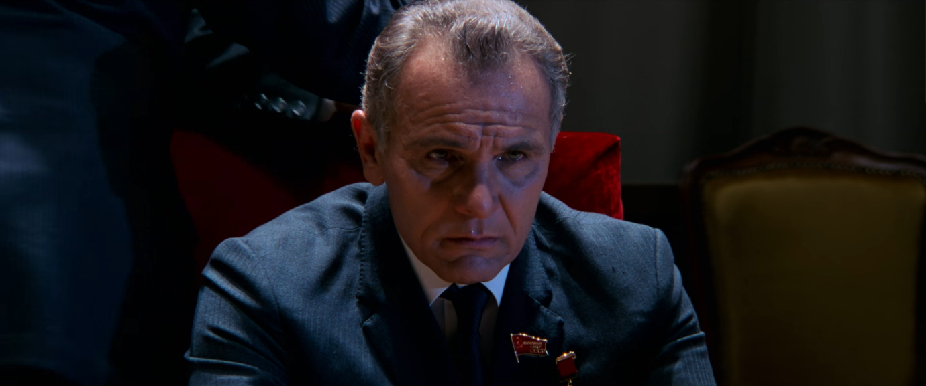
Figure 8. A scaled-back representation of the political ramifications of Rocky’s speech in Rocky IV: Rocky vs. Drago – The Ultimate Director’s Cut (Sylvester Stallone, 2021).

In The Making of ‘Rocky vs. Drago’, Stallone chides his younger self for not fully engaging with the ‘long-term repercussions’ of Rocky IV’s story decisions, noting that the theatrical cut does not fully capitalise on thematic material that was ‘eventually seen in Creed’. Putting aside the somewhat flawed logic of the filmmaker being at fault for failing to anticipate the future of the series, the decision to alter Rocky IV to serve later instalments reiterates the extent to which canonicity is both synchronic, existing at a particular moment, and diachronic, capable of significant evolution over time. Indeed Stallone (seemingly unintentionally) echoes Balboa’s infamous speech to the Russian people at the end of Rocky IV in describing his motivations behind the director’s cut, noting that ‘I changed, and then the movie changed’. Although focused in part on his own growth as a writer/director, thereby highlighting an ambition to also use Rocky vs. Drago as a form of personal auteurist rehabilitation, Stallone’s comments are nonetheless reflective of the franchise as a whole. The later Rocky and Creed films became something rather different, and this in turn prompted the retroactive change to Rocky IV itself.
Rocky vs. Drago received broadly positive reviews, with most respondents considering it an improvement on, and worthwhile replacement for, the original version. Some critics nonetheless lamented the loss of the camper elements, highlighting that the retcon process, even when pushing to be an outright revision, is still contending with the memories and preferences of existing viewers. As Mark J. P. Wolf suggests:

Authors who change their work will undoubtedly prefer the later versions to the early ones (or else the changes would not be made). When those changes amount to retconning, the later work can be seen as preferable, because retconning usually ties earlier works more firmly into the author’s world, eliminating inconsistencies. Nevertheless, if the works have existed a long time in their original, earlier form before the retconning, they may have become well known and loved by an audience who will prefer the original versions and not want to see them changed; for example, fans who prefer the original versions of Star Wars Episodes IV-VI to the retconned Special Edition versions. These fans may consider the earlier versions canonical, disagreeing with what Lucas himself deems canonical.

The distribution practices surrounding revised editions undoubtedly affect the extent of the retcon, with the work of George Lucas often cited as an extreme example. Each new version of the Star Wars Special Editions has supplanted the previous releases in the marketplace, making it extremely difficult for fans to legally access previous incarnations. Rocky vs. Drago has not yet been accorded this same level of dominance over the original. The director’s cut received only a limited theatrical release – compared to the usual lengthy engagements afforded to the main Rocky and Creed films – and was primarily distributed online via video-on-demand platforms. It is only with the release of a 4K Blu-ray boxset of the first four Rocky films – titled The Knockout Collection (2023) – that Rocky vs. Drago has been issued on physical media, available on the same disc as the 1985 original. There are numerous markers displaying an authorial preference for the newer version, such as the use of the ‘Ultimate Director’s Cut’ title, and the inclusion of the Making of ‘Rocky vs. Drago’ documentary as a bonus feature, in which Stallone repeatedly effuses about creating an improved film, but viewers are given the same level of access to both versions. This less aggressive approach, in which the director’s cut aims to conceptually replace the 1985 version but does not remove it from circulation, highlights the degree to which a franchise can still simultaneously maintain and even cross-promote differing versions of a text. The events as depicted in Rocky vs. Drago may be more conducive to further storytelling in the present day, but this does not necessarily need to deny the continued commercial exploitation or audience appreciation (sincere or otherwise) of the original Rocky IV.
At the time of writing, The Knockout Collection has itself been superseded by a revised edition, the Ultimate Knockout Collection (2024). This adds 4K copies of Rocky V and Rocky Balboa, with the latter film even debuting its own director’s cut – albeit as a more conventional extended version, integrating deleted scenes previously included as bonus features on earlier DVD and Blu-ray releases, rather than the dramatic reworking offered in Rocky vs. Drago. Even if this newer boxset now positions itself as the definitive version – at least until a subsequent edition presents its own rhetorical retconning to encourage yet another purchase – Loock suggests that each physical media release ‘serves as a snapshot of a serial narrative’ at a particular moment in time. In this regard it seems apt that the first Knockout Collection should end with the two incarnations of Rocky IV. The 1985 version marked one turning point for the franchise, suggesting a pathway for future sequels led by exaggerated plotlines and montage, which ultimately did not materialise. The director’s cut, by contrast, reshapes the film with knowledge of the actual direction that was taken by later entries in the series. In essence it belatedly retcons an initial text in relation to its sequels’ own uses of retroactive continuity. Neither edit of Rocky IV provides an entirely complete text, however much Rocky vs. Drago claims to tie the series together. Nevertheless, the two versions, in conversation with one another as well as the wider Rocky/Creed saga, offer a revealing insight into the complexity and diversity of long-term storytelling and franchise management. While the approach taken with properties such as Star Wars and Halloween has proved more visible and been more hotly debated, involving the removal of entire texts, protagonists and major plotlines from the officially recognised canon, the Rocky saga offers an example of a softer, but still transformative, mode of retconning; one which emphasises narrative cohesion, ensuring the ongoing relevance of the once-troublesome Rocky IV to the evolving franchise, even as aspects of the overall chronology (past, present and future) are still being rewritten.
Creed II offers yet another potential ‘goodbye’ to Stallone’s enduring creation. After the second, victorious fight against Viktor Drago, Rocky fist-bumps Adonis and tells him ‘It’s your time’. While Creed returns to the ring to celebrate, Balboa stays behind, allowing the younger protagonist to take the limelight. The end of the narrative suggests a tying up of the lingering themes of the Rocky franchise: Adonis visits his father’s grave and comes to terms with his legacy, while Balboa summons up the courage to reconnect with his son. Shortly after the release of the film, Stallone posted an Instagram video that was widely interpreted as announcing his retirement from playing Rocky, stating that Michael B. Jordan (as Adonis Creed) would now ‘carry the mantle’. Creed III does indeed suggest a shift in focus from past entries: the narrative makes a time-jump to 2025, and although Balboa is briefly mentioned there is no on-screen appearance by Stallone. In publicity for the new film, Jordan has spoken about plans to significantly expand the ‘Creed-verse’, including a TV and anime series alongside a previously announced spin-off movie promising the return of Ivan and Viktor Drago. Where the Rocky series proved to be emblematic of the 1980s New Hollywood focus on sequelisation and the centrality of the filmic text, the post-Creed III era looks set to embrace the transmedia sensibilities of many other contemporary franchises, in which stories and characters are introduced and explored across a range of different media. The series has already spawned a non-canonical science-fiction anime short, Creed: Shinjidai (2023), and a limited-run comic book series, Creed: The Next Round (2023), set approximately a decade into the future, and following the boxing ambitions of Adonis’s daughter Amara. The comic mimics its filmic predecessors in drawing significant mileage from the events of Rocky IV, exploring the estrangement of Adonis from his half-brother and half-sister, who struggle to accept his legitimacy as a member of the Creed family. Adonis and his wife Bianca even consider investing in a technology company that, in the 1980s, ‘built robots as toys and to serve as household helpers’, offering a wry nod to the controversial mechanical butler deleted by Stallone from his director’s cut. It remains to be seen, however, how such texts will affect the perceived linearity of the mainline cinematic instalments, and whether the Creed brand will maintain its critical reputation in the face of more overt commercial expansion.
In recent years, Stallone has intensified his criticisms of the series’ long-term producer Irwin Winkler. The actor has suggested that his non-participation in Creed III was prompted not by narrative considerations, but rather by an ongoing dispute over intellectual property (IP) rights. Stallone does not have ownership of the Rocky character or the wider ‘cinematic universe’ and has complained about being sidelined creatively and financially as the Creed series moves in its own direction. As such, while Stallone has since expressed renewed hopes to return to Balboa, variously touting the possibility of an additional Rocky sequel, a TV series, or even a prequel, this remains contingent on permissions being granted by external rightsholders.
This essay has taken a broadly holistic view of the retconning process serving the needs of the ‘franchise’, but this additional context emphasises that there are multiple – and often conflicting – commercial and artistic stakes, spread across various individuals and institutions, in play at any given moment. The preoccupation with Rocky IV in Creed II, and especially in the production of the revised director’s cut, can be read as an attempt by Stallone to reassert his own authorship, as well as Rocky’s continued importance, in an era where the power of individual creators in series filmmaking is increasingly viewed as subservient to ‘corporate authors’ and the industrial exploitation of ‘IP’. However, the opportunities for Stallone to return and revise the narrative have only been afforded by those with a controlling interest in the wider franchise, whose priorities may well be very different from his, looking forward rather than back, such as using plot developments in Creed II as a precursor to the planned Drago spin-off. While history has, on numerous occasions, made fools of anyone proclaiming that Rocky Balboa’s story has reached a definitive conclusion, any continued evocation of the character will almost certainly be required to navigate the dynamics of the growing ‘Creed-verse’ as much as it wrestles with the legacy of Rocky himself.

Frank Kelleter and Kathleen Loock, ‘Hollywood Remaking as Second-Order Serialization’, in Frank Kelleter (ed), Media of Serial Narrative (Columbus: The Ohio State University Press, 2017), p. 125; Will Proctor, ‘Regeneration & Rebirth: Anatomy of the Franchise Reboot’, Scope: An Online Journal of Film and Television Studies, no. 22 (2012), p. 3.
Mark J. P. Wolf, ‘Narrative Fabric’, in Mark J. P. Wolf (ed), The Routledge Companion to Imaginary Worlds (New York: Routledge, 2018), p. 46. The boundaries between these different forms are not entirely binary, however – The Godfather Part II (Francis Ford Coppola, 1974), for instance, blends aspects of sequel and prequel by continuing Michael Corleone’s story from the previous film, while also exploring the early life of his father, Vito. Story ‘fabric’ can also be expanded through exploration of other diegetic periods: midquels ‘occur in between existing story elements’; paraquels ‘are stories or storylines that run in parallel with existing ones’; transquels ‘are works that extend across or beyond multiple [texts], and usually are histories or chronologies meant to tie together the history of a world’ (ibid., pp. 46-47).
Proctor, ‘Regeneration & Rebirth’, pp. 4-5, 8.
Adam Ochonicky, ‘Nostalgia and Retcons: The Many Returns, Homecomings, and Revisions of the Halloween Franchise (1978-2018)’, Adaptation, vol. 13, no. 3 (2020).
Andrew J. Friedenthal, Retcon Game: Retroactive Continuity and the Hyperlinking of America (Jackson: University Press of Mississippi, 2017), pp. 6-7.
Kathleen Loock, ‘Reboot, Requel, Legacyquel: Jurassic World and the Nostalgia Franchise’, in Daniel Herbert and Constantine Verevis (eds), Film Reboots (Edinburgh: Edinburgh University Press, 2020), pp. 173-174, 176.
Ochonicky, ‘Nostalgia and Retcons’, pp. 341-342.
Will Proctor and Matthew Freeman, ‘“The First Step into a Smaller World”: The Transmedia Economy of Star Wars’, in Mark J. P. Wolf (ed), Revisiting Imaginary Worlds: A Subcreation Studies Anthology (New York: Routledge, 2016), p. 222.
See Geoff King, ‘Spectacle, Narrative, and the Spectacular Hollywood Blockbuster’, in Julian Stringer (ed), Movie Blockbusters (London: Routledge, 2003), p. 124.
Kathleen Loock, Hollywood Remaking: How Film Remakes, Sequels and Franchises Shape Industry and Culture (Oakland: University of California Press, 2024), p. 26.
Kelleter and Loock, ‘Hollywood Remaking as Second-Order Serialization’, p. 144.
Paul Wells, The Horror Genre: From Beelzebub to Blair Witch (London: Wallflower, 2007), p. 93.
Kathleen Loock, ‘The Sequel Paradox: Repetition, Innovation, and Hollywood’s Hit Film Formula’, Film Studies, vol. 17, no. 1 (2017), p. 102.
Loock, ‘The Sequel Paradox’, p. 97.
David A. Cook, Lost Illusions: American Cinema in the Shadow of Watergate and Vietnam (Berkeley and Los Angeles: University of California Press, 2000), pp. 291-292.
Matt Hills, ‘Star Wars in Fandom, Film Theory, and the Museum: The Cultural Status of the Cult Blockbuster’, in Julian Stringer (ed), Movie Blockbusters (London: Routledge, 2003), pp. 178, 188.
Cook, Lost Illusions, p. 291.
See, for instance, Jeff Rovin, Stallone!: A Hero’s Story (Sevenoaks, Kent: New English Library, 1987), pp. 90-94, 107-108, 111-114, 126-128; Adrian Wright, Sylvester Stallone: A Life on Film (London: Robert Hale, 1991), pp. 60-62, 65-68, 71, 75-79, 84-85, 130-136, 156-160.
These include both of Stallone’s immediate post-Rocky projects, F.I.S.T. (Norman Jewison), 1978), which he also co-scripted, and Paradise Alley (Sylvester Stallone, 1978), his feature directorial debut).
Quoted in Rovin, Stallone!, p. 144.
Karra Shimabukuro, ‘I Framed Freddy: Functional Aesthetics in the A Nightmare on Elm Street Series,’ in Wickham Clayton (ed), Style and Form in the Hollywood Slasher Film (Basingstoke: Palgrave Macmillan, 2015), p. 58.
Chris Holmlund, ‘Introduction: Presenting Stallone/Stallone Presents’, in Chris Holmlund (ed), The Ultimate Stallone Reader: Sylvester Stallone as Star, Icon, Auteur (London: Wallflower Press, 2014), pp. 2-3.
Paul Ramaeker, ‘Staying Alive: Stallone, Authorship and Contemporary Hollywood Aesthetics’, in Chris Holmlund (ed), The Ultimate Stallone Reader: Sylvester Stallone as Star, Icon, Auteur (London: Wallflower Press, 2014), p. 28.
Michael White, ‘US Network Told to Defy Moscow’, The Guardian, 13 January (1986), p. 8.
Stallone’s only non-series production in this period was Rhinestone (Bob Clark, 1984), which underperformed both critically and commercially.
Loock, ‘The Sequel Paradox’, p. 102.
Frank Deford, ‘Movies: The Rocky Files (A Rerun)’, Sports Illustrated, vol. 56, no. 23 (1982), p. 70.
See also Spaceballs (Mel Brooks, 1987), which presents a futuristic video store where Rocky sequels total at least as far as XIV. Even The Simpsons (1989-), in the episode ‘Lemon of Troy’ (season six, episode twenty-four), sees Bart identifying the number seven in roman numerals, not by relying on his scholarly education, but through adding together Rocky V and Rocky II to equal the fictitious Rocky VII: Adrian’s Revenge.
Carol J. Clover, Men, Women, and Chainsaws: Gender in the Modern Horror Film (Princeton: Princeton University Press, 2015), p. 23.
Harlan Kennedy, ‘The Time Machine’, Film Comment, vol. 20, no. 1 (1984), p. 16.
Wright, Sylvester Stallone, p. 100.
Richard Schickel, ‘Win the Battle, Lose the War’, Time¸ 9 December (1985), p. 50.
Loock, ‘The Sequel Paradox’, p. 98.
Stuart Henderson, The Hollywood Sequel: History & Form, 1911-2010 (London: British Film Institute, 2014), p. 145.
Frank Sanello, Stallone: A Rocky Life (Edinburgh: Mainstream Publishing, 1998), pp. 118-119.
See, for example, Sanello, Stallone, p. 119; David Edelstein, ‘Going for the Biff-Bam-Bang’, Village Voice, 10 December (1985), p. 67.
Chuck Tryon, ‘Rebooting the Politics of the Sports Melodrama: Creed vs Rocky’, in Daniel Herbert and Constantine Verevis (eds), Film Reboots (Edinburgh: Edinburgh University Press, 2020), p. 151.
For example, one review describes the film as ‘no more (in fact, significantly less) than Rambo in boxing trunks’. David Castell, ‘Films: Around with Alice’, Sunday Telegraph, 26 January (1986), p. 14.
The author Jeremy Collins, for instance, discusses revisiting the original Rocky film as a teenager, after having watched the sequel films ‘over and over’ on video as a child. He notes being surprised that Balboa loses the fight at the end, such was the assumption of guaranteed victory in the later entries. Collins, ‘Shadow Boxing’, The Georgia Review, vol. 61, no. 3 (2007), pp. 605-606.
Simon Hoggart, ‘Flying Fists and Dreary Dogma’, Observer, 29 December (1985), p. 13; Wright, Sylvester Stallone, pp. 136-137, 140-141.
As Eric Lichtenfeld notes, ‘Rocky IV was so nationalistic [that] a United Artists marketing memo suggested theatres distribute American flags to moviegoers before each performance’ Lichtenfeld, ‘I, of the Tiger: Self and Self-Obsession in the Rocky series’, in Chris Holmlund (ed), The Ultimate Stallone Reader: Sylvester Stallone as Star, Icon, Auteur (London: Wallflower Press, 2014), p. 85.
Geoff King, New Hollywood Cinema: An Introduction (London: I. B. Tauris, 2002), p. 8.
Tryon, ‘Rebooting the Politics’, p. 144; Travis Vogan, The Boxing Film: A Cultural and Transmedia History (New Brunswick: Rutgers University Press, 2021), p. 101.
Tryon, ‘Rebooting the Politics’, p. 151.
See Frank Ardolino, ‘Rocky Times Four: Return, Resurrection, Repetition, and Reaganism’, Aethlon, vol. 11, no. 1 (1993), p.147.
Balboa’s struggles to remain ‘authentic’ to his past self in the wake of his success generated at least some approval from contemporary critics – despite the negativity towards the sequels in general – with several noting the parallels to Stallone’s own personal and professional stumbles as a newly-crowned Hollywood star. See Rovin, Stallone!, p. 153.
Lichtenfeld, ‘I, of the Tiger’, p. 78.
King, New Hollywood Cinema, pp. 4-5.
Ramaeker, ‘Staying Alive’, p. 38.
Rovin, Stallone!, p. 150.
Ramaeker, ‘Staying Alive’, p. 50.
Ibid., p. 36.
King, ‘Spectacle, Narrative, and the Spectacular Hollywood Blockbuster’, pp. 119, 122.
Edelstein, ‘Going for the Biff-Bam-Bang’, p. 67; Schickel, ‘Win the Battle’, p. 50.
For a discussion of Rocky IV as a ‘guilty pleasure’, see Sean Hutchinson, ‘“Rocky IV’ isn’t a “Rocky” movie, but It’s the Best “Rocky” Movie’, Inverse, 25 November 2015, <inverse.com/article/8571-rocky-iv-isn-t-a-rocky-movie-but-it-s-the-best-rocky-movie> accessed 13 May 2023; Chris Hewitt et al., ‘The Ranking: The Rocky Saga’, Empire (August 2020), p. 113; Michael Shantz and Tom Steward, ‘Rocky Series Ranking’, The Everything Sequel Podcast, 20 December 2021 <sequel.transistor.fm/episodes/rocky-series-ranking> accessed 13 May 2023.
James Chapman, Licence to Thrill: A Cultural History of the James Bond Films, revised ed (London: I. B. Tauris, 2009), pp. 241-242.
Ochonicky, ‘Nostalgia and Retcons’, p. 336.
By this stage, however, Avildsen’s presence brought its own, potentially unwelcome, second-order seriality, due to his interim association with the Karate Kid series – often dismissed by critics as little more than a reworking of the Rocky formula – which had delivered its own poorly-received third entry the previous year, The Karate Kid Part III (John G. Avildsen, 1989).
Quoted in Wright, Sylvester Stallone, p. 174.
Gene Siskel, ‘Rocky: R.I.P.’, Chicago Tribune, 2 December (1990), sec. 13 (Arts), p. 6.
Larry Powell and Tom Garrett, The Films of John G. Avildsen: Rocky, The Karate Kid, and Other Underdogs (Jefferson: McFarland, 2014), pp. 189-190.
Sanello, Stallone, p. 164.
Quoted in ibid., p. 163.
Nicola Evans, ‘No Genre for Old Men? The Politics of Aging and the Male Action Hero’, Canadian Journal of Film Studies, vol. 24, no. 1 (2015), p. 30.
Indeed, there remains some debate as to whether Rocky V, rather than IV, should be viewed as the nadir of the series. While Stallone’s decision to produce a director’s cut of IV does not discount the possibility of a future revision to V, the former film seems to have been prioritised because its excess has become such a joke in and of itself, putting it at odds with the tone of the wider series. Rocky V has not accrued such a spirited response, due to its more grounded nature, and has the comparative ‘luxury’ of being viewed merely as ‘bad’ rather than ‘ridiculous’.
See Lichtenfeld, ‘I, of the Tiger’, p. 94.
As with the jocular imagined narrative of ‘Weird Al’ Yankovic’s ‘Theme from Rocky XIII’, the Italian Stallion has moved into the catering business by the time of Rocky Balboa, albeit running an Italian restaurant rather than the delicatessen referenced in Yankovic’s song.
Loock, Hollywood Remaking, pp. 208, 230.
An exception would be the Fast & Furious franchise, which has made notable retrospective efforts to integrate the plot and characters of The Fast and the Furious: Tokyo Drift (Justin Lin, 2006), initially conceived as a standalone entry, into the wider continuity, to the point where Furious 7 (James Wan, 2015) framed itself as a direct sequel.
Kelleter and Loock, ‘Hollywood Remaking as Second-Order Serialization’, p. 130.
Constantine Verevis, ‘New Millennial Remakes’, in Frank Kelleter (ed), Media of Serial Narrative (Columbus: The Ohio State University Press, 2017), p. 156.
Tryon, ‘Rebooting the Politics’, p. 144.
César Alberto Albarrán-Torres and Dan Golding, ‘Creed: Legacy Franchising, Race and Masculinity in Contemporary Boxing Films’, Continuum: Journal of Media & Cultural Studies, vol. 33, no. 3 (2019), pp. 317, 311.
Kathleen Loock, ‘Reboot, Requel, Legacyquel’, p. 184.
See, for instance, Tryon, ‘Rebooting the Politics’, p. 144. The semantic slippage between these different forms is further complicated by the fact that the Creed series has been marketed in several territories with subtitles such as Rocky’s Legacy (Germany) and The Legend of Rocky (Spain).
Ochonicky, ‘Nostalgia and Retcons’, p. 336.
Rocky vs. Drago is differentiated, however, from the trend of offering ‘extended’ or ‘unrated’ edits of newly released studio films during the DVD era. The creation of these alternative editions was often planned alongside the production of the version intended for the big screen, and usually released quickly enough thereafter to prevent the theatrical cut from becoming enshrined as the definitive text in the popular memory. See Mark Bernard, Selling the Splat Pack: The DVD Revolution and the American Horror Film (Edinburgh: Edinburgh University Press, 2014), pp. 86–92.
Loock, Hollywood Remaking, p. 5.
King, New Hollywood Cinema, pp. 111-112.
Constantine Verevis, ‘The Edge of Reality: Replicating Blade Runner’, in Daniel Herbert and Constantine Verevis (eds), Film Reboots (Edinburgh: Edinburgh University Press, 2020), p. 67.
See, for example, Wesley LeBlanc, ‘Rocky 4: Stallone’s Director’s Cut Scraps Paulie’s Robot’, IGN, 31 August 2020 <ign.com/articles/rocky-4-stallones-directors-cut-scraps-paulies-robot> accessed 13 May 2023; Humza Hussain, ‘Rocky IV Director’s Cut Won’t Include That Ridiculous Robot’, Screen Rant, 31 August 2020 <screenrant.com/rocky-4-directors-cut-paulie-robot-sylvester-stallone> accessed 13 May 2023.
See Paul Grainge, Monochrome Memories: Nostalgia and Style in Retro America (Westport, Praeger, 2002), p. 75 for a discussion of the perceptions of nostalgic value and ‘depth’ attributed to the black-and-white image.
For a more comprehensive overview of the changes to the film, see Muck47, ‘Rocky IV – Comparison: Director’s Cut (Rocky vs. Drago); Theatrical Version’, Movie-Censorship.com, n.d. <movie-censorship.com/report.php?ID=777252> accessed 13 May 2023.
William Proctor, ‘Canonicity’, in Mark J. P. Wolf (ed), The Routledge Companion to Imaginary Worlds (New York: Routledge, 2018), p. 239.
See, for instance, Zaki Hasan, ‘Rocky IV: Rocky vs. Drago – The Ultimate Director’s Cut Review’, IGN, 12 November 2021 <ign.com/articles/rocky-iv-rocky-vs-drago-the-ultimate-directors-cut-review> accessed 13 May 2023; Richard Roeper, ‘With New Cut of ‘Rocky IV’, Stallone Gives Apollo (and the Movie) More Dignity’, Chicago Sun Times, 12 November 2021 <chicago.suntimes.com/movies-and-tv/2021/11/12/22775342/rocky-iv-review-vs-drago-director-cut-sylvester-stallone-movie-ivan-drago-apollo-creed> accessed 13 May 2023.
See, for example, Terri White, ‘Rocky IV: Rocky vs. Drago – The Ultimate Director’s Cut Review’, Empire, 18 November 2021 <empireonline.com/movies/reviews/rocky-iv-rocky-vs-drago-the-ultimate-director-cut> accessed 13 May 2023; Michael Shantz and Tom Steward, ‘Rocky IV’, The Everything Sequel Podcast, 3 January 2022 <sequel.transistor.fm/episodes/rocky-iv> accessed 13 May 2023.
Wolf, Building Imaginary Worlds, p. 273. See also Proctor, ‘Regeneration & Rebirth’, pp. 12-13.
Will Brooker, ‘All Our Variant Futures: The Many Narratives of Blade Runner: The Final Cut’, Popular Communication, vol. 7, no. 2 (2009), p. 84.
Loock, Hollywood Remaking, p. 57.
Quoted in Ethan Anderton, ‘Sylvester Stallone Announces ‘Creed III’ as the Las Round for Rocky Balboa’, Slash Film, 28 November 2018 <slashfilm.com/562619/sylvester-stallone-retiring-rocky-balboa> accessed 13 May 2023.
Anthony D’Alessandro, Nellie Andreeva, and Peter White, ‘Michael B. Jordan Spearheading “Creed-Verse” In Works at Amazon Across Film & TV’, Deadline, 9 March 2023 <deadline.com/2023/03/michael-b-jordan-creed-verse-film-tv-amazon-1235282120> accessed 13 May 2023. Although Creed III lacks a cameo from Rocky, it does feature one from Viktor Drago, suggesting that he and Creed have become business associates (and possibly even friends) since the events of the previous film. Such a sequence has potential synergistic value for the spin-offs, revitalising aspects of the franchise beyond the influence of Balboa.
James Fleury, Bryan Hikari Hartzheim, and Stephen Mamber, ‘Introduction: The Franchise Era’, in James Fleury, Bryan Hikari Hartzheim, and Stephen Mamber (eds), The Franchise Era: Managing Media in the Digital Economy (Edinburgh: Edinburgh University Press, 2019), p. 1; Henry Jenkins, Convergence Culture: Where Old and New Media Collide (New York: New York University Press, 2006), p. 96.
Latoya Morgan et al., Creed: The Next Round, vol. 1, no. 2 (2023), p. 10.
Zack Sharf, ‘Why Stallone is Not in “Creed 3”’, Variety, 3 March 2023 <variety.com/2023/film/news/sylvester-stallone-creed-3-absence-explained-1235538273> accessed 13 May 2013.
Claudia Eller, ‘Taking a Swing’, Variety, vol. 344, no. 18 (2019), p. 43.
Shawna Kidman, ‘The Disneyfication of Authorship: Above-the-Line Creative Labor in the Franchise Era’, Journal of Film and Video, vol. 73, no. 3 (2021), p. 18. Michael B. Jordan has been positioned as the succeeding ‘auteur’ of the wider Creed franchise, following his directorial duties on Creed III, though it is currently unclear how much of this will be an overseeing role, or one with extensive creative input beyond the mainline cinematic entries.

