Positioning for Purpose: Mapping brand strategy to sustainable design

Dr David Preston
Keywords: regenerative brand design, brand positioning, knowledge exchange, doughnut economics, communication design

Abstract: This paper presents ‘Positioning for Purpose’, a five-week undergraduate studio project that introduces Graphic Communication Design students to brand strategy as a mechanism for environmental sustainability. Run at Central Saint Martins in collaboration with marketing firm FreshBritain, through the project students learn how to use Jungian archetypes to reposition mainstream consumer brands towards ‘net positive’ futures. Emphasising enquiry-led learning, the commercial partner works alongside the students as a mentor, supporting them as they try out brand positioning methods for the first time. Findings reflect strong uptake of social justice themes, but highlight the barriers students face when tackling climate justice within brand design. While not all student outcomes prioritise environmental sustainability, the project broadens awareness of sustainable design and opens career pathways into brand strategy. The paper reflects on pedagogical benefits, limitations, and opportunities for further alignment between creative education and sustainability imperatives.

Introduction
Brand strategists have an important role to play in informing sustainable design policy. Unlike many communication designers, they work ‘upstream’ and have capacity to directly influence business decision-making. So, whereas communication designers typically get involved in the latter-stage activation of branding projects, brand strategists are typically involved in early-phase planning and roadmapping, informing brand and business policymaking. At present, few communication design students are exposed to brand strategy through their education, and as a result, their potential to affect change within this context is limited. This deficit presents opportunities that are addressed in the project presented here.

‘Positioning for Purpose’ is a five-week studio project written for second-year Graphic Communication Design undergraduates. Run as a Knowledge Exchange (KE) project in cooperation with the marketing firm FreshBritain, the brief asks students to explore how mainstream consumer brands can be strategically repositioned for the benefit of people and planet. Through the project students learn how to work with Jungian archetypes as a mechanism to reframe and redirect brands towards ‘net positive’ futures (Polman & Winston, 2021); this signals a move to work beyond ‘net zero’, speculating on how brands can be redesigned and reconfigured to become regenerative, giving more than they take, with their overall impact leaving the world better off. In this sense the brief moves away from anthropocentric approaches to sustainability that are dominant in the Global North, acknowledging more than human life and promoting Raworth’s (2018) ideas about post-growth economic paradigms.

This paper is an example of reflective pedagogy, using a single student project as a case study to explore how brand strategy can map to sustainable design practice. It adopts action research (Lewin, 1948; Adelman, 1993) as a method whereby planning, acting, observing, and reflecting are iteratively combined. In doing so, the classroom is positioned as a site of inquiry where students and tutors learn through both making and critically examining their own design processes. The project is not posited here as an exemplar of best practice, but rather serves as a case study of a project in development, transitioning towards a different, more nuanced form. Sharing learnings from the first two iterations of this revised project I explicate aspects which did not work effectively and reflect upon limitations around strategic brand design projects focused on sustainability.

The teaching and learning context
The design brief discussed here is a fee-free KE project undertaken at Central Saint Martins (CSM), one of the six colleges that make up University of the Arts London (UAL). UAL is a specialist Art & Design university with over 21,000 students spread over various campuses across London, UK. The fee-free aspect of the project means we collaborate with an industry partner, but no money is exchanged. Instead, the premise is that the project is mutually beneficial for both parties. From this collaborative relationship students gain insights into industry methods and develop confidence working alongside professional practitioners. Meanwhile, the partner raises their company profile, working with curious, intelligent students who challenge their staff team to reflect upon and strengthen their own brand strategy practices.

The collaborative relationship between CSM and FreshBritain developed from an earlier 18-month ‘Knowledge Transfer Partnership’ funded by Innovate UK between 2016 and 2018. This in-depth, collaborative research explored the codification of FreshBritain’s brand strategy methods and set in place the foundations from which a longer-term relationship has flourished.

For the last two years this in-curricular project has been undertaken by approximately thirty second-year Graphic Communication Design students per year, each of whom has elected to study on the ‘Strategy & Identity’ platform. The mix of students is internationally diverse, with a relatively equal split between UK-home, Continental European and Overseas students (with a strong representation from East Asia). The class is in session one day per week for a total of five weeks. The first and last session last for a full six-hour teaching day, while for the interim sessions the cohort is split, with half in the morning and the other half in the afternoon. This offers a reasonable project duration, but limited contact time per week.

Getting students to work together in groups means their workload capacity is increased. They help one another to build competence within a business-oriented context that is outside their usual creative arts comfort zone. They are supported by one Senior Lecturer and approximately four industry mentors from the partner organisation. The mentors attend three of the five sessions, contributing to the briefing session, the midpoint feedback session, and the final student presentations.

Pedagogic positioning
Within this project I position myself (the lecturer) as a part of the learning community, working alongside the students, learning together. My intention is to highlight the enquiry-driven nature of the project, embracing my position as a co-enquirer in the emergent discipline of regenerative brand design. According to Rancière (1991), this stance requires the lecturer to be an emancipatory or ignorant schoolmaster, learning by doing and sharing together, as per a Deweyan perspective. This is distinct from a traditional pedagogic model where the student is viewed as an empty vessel to be filled with information by their teacher, as per Rancière’s ‘stultifying master’.

While KE partners typically act as clients whose needs are to be served by students, in this project the partner acts as a mentor and supportive agent. They work alongside the students within the curriculum and mentor them through the brand strategy process, helping them learn about novel positioning methods in a safe to fail environment. In this sense the partnership enables learners to develop expertise outside the normal remit of their course provision.

It is important to note that our partner, FreshBritain, embraces the fact that they are also open to learning and do not purport to hold all the answers. So, while they do hold unique esoteric knowledge and experience that is instrumental to the students’ development, they are equally interested in new ideas and approaches. There is a balance here to setting up the partner as a valued expert-insider, but one who is curious to consider new ways of thinking and doing. This can only work effectively with a partner who is keen to engage in constructive conversation and willing to sit with difficult questions.

FreshBritain offer students a specialism founded upon years of experience working with archetypes as a method to strategically position brands for a prosperous future. By sharing insights about their process, they help to equip students with enough awareness that they feel they can understand the field and have something to offer it in the future (assuming it is of interest to them). In this way the project acts as a gateway, opening up career options more focused on design strategy and business, as opposed to the typical focus on expressive and artistic approaches to design.

Introducing sustainability imperatives within an established brief
In recent years my pedagogic practice has been directed towards branding for social purpose through the development of our ‘Strategy & Identity’ study curriculum which spans the three years of our undergraduate curriculum in Graphic Communication Design. This work has been bolstered by my affiliation with the Social Design Institute at UAL which enabled me to integrate several projects around pressing themes such as child nutrition (Bailey & Preston, 2020) and social care (Cooper, 2022). Through such projects I developed fluency working with communication design and social purpose, but became increasingly aware that climate justice — which frames climate change as a question of fairness in how its causes, impacts, and solutions are shared — remained a relative weak point. While I had sought to promote sustainable design principles and practices through all my student briefs, I had not made this the prime objective of the brief.

During 2023 I began to consider how I could rework an existing brand strategy brief to bring sustainability more explicitly into the project. I had initiated this project with FreshBritain in 2017, but we decided collectively that it was time to reframe the brief. The changes made reflect a concurrent shift in FreshBritain’s own priorities, with their focus increasingly turning towards regenerative brand design — an approach which seeks to move beyond established efforts to minimize a brand’s harmful effects, focusing instead on how brands can be directed towards ecological and cultural renewal. The changes made to the brief also reflect renewed efforts at UAL to be more purposeful and explicit about our work around climate, racial and social justice. See, for instance, our Climate Action Plan (UAL, 2022) and Climate, Racial and Social Justice framework (UAL, 2023).

Being wary of instrumentalization and solutionism, our revisions to the project were not intended to position design strategy as a tool to fix all climate related issues. Rather they were understood as a way to empower young creatives to recognise their capability for strategic thinking and their potential to make meaningful contributions upstream (whether in brand strategy specifically, or other related business-facing design contexts). While design alone cannot fix the climate crisis, it is also not powerless, with brand strategy proving a constructive example of a professional domain where design thinking interfaces with high-impact corporate decision-making.

One concern was to avoid making students feel like it was their responsibility to solve the climate crisis. I was aware that some students on our course had previously vocalised their displeasure at what they understood as the tendency for an older generation of educators to place climate responsibility upon their shoulders and thus wanted to avoid such a scenario.

As an educator I typically favour project briefs which allow students agency to choose their own subject matter, working with common methods or formats within the class, but with space to bring their own personal interests and priorities. In my experience this approach triggers curiosity and drives students’ ‘will to learn’ (Barnett, 2007) — a crucial factor in meaningful engagement and personal investment in course work. Incorporating climate crisis did not fit naturally with this inclination to leave the subject open. To resolve this, we decided not to enforce a focus on climate, but rather left it open to students to decide how they would make their chosen brand net positive, i.e. giving back more than they take. Human wellbeing was incorporated alongside climate wellbeing, with students given agency to locate how the brand should change for increased planetary wellbeing. Working in groups, students would select a consumer brand to support with the goal of using archetypes to reposition these brands towards more ‘regenerative’ futures (Gibbons, 2020).

Brand strategy methods for sustainable futures
The five weeks of the project were split between two developmental phases, with the first three weeks emphasizing strategy conception and the latter two weeks focusing on the activation of the strategy. The work was scaffolded around three key milestones, an introductory workshop, an interim strategy presentation, and a final project presentation with showcase exhibition. Between these sessions we held progress reviews to support student development (Table 1).

 | Week 1 | Week 2 | Week 3 | Week 4 | Week 5
AM | Briefing Workshop (Groups A & B) | Progress Review (Group A) | Interim Strategy Presentation to FreshBritain (Group A) | Progress Review (Group A) | Final Presentations to FreshBritain (Groups A & B)
PM | Introductory presentation from FreshBritain (Groups A & B) | Progress Review (Group B) | Interim Strategy Presentation to FreshBritain (Group B) | Progress Review (Group B) | Final ‘Open Studio’ Exhibition (Groups A & B)
Table 1) Table showing a general overview of the sequence of studio classes.

During our first class, students were tasked with listing brands they considered net positive. This initiated plenty of soul searching and dialogue, but no long list of brands. The credentials of Patagonia, long seen as a flag-bearer for ethical branding, were a subject of much debate. We discussed the value of B Corp Certification, whether ‘1% for the Planet’ was substantive enough, as well as ethical brand ratings services such as Good-On-You. Students quickly came to realise that there are few, if any, mainstream high street brands which have an unequivocal positive impact on their lives. While many brands talk a good game, telling powerful stories about purpose, few are genuinely acting in a net positive way. Major brands have typically focused on reducing harm and doing less bad, rather than actively creating positive outcomes. This has led to a rise in superficial tactics like ‘greenwashing’ (Greer & Bruno, 1996) which are now well established.

Kate Raworth’s (2018) work on doughnut economics became a key reference point for describing the premise of what we sought to achieve, helping brands to ‘thrive in balance’, by addressing sustainability in its environmental, cultural, social, and economic dimensions. Raworth’s doughnut model is admired for the way it expresses the need for economies to meet the needs of all people within the means of the planet. The model represents the need for a requisite balance to be found between meeting human need and respecting environmental limits.

During an introductory presentation about their working methods, FreshBritain shared with the students a story of how a major mountaineering brand had come to them seeking support to help reduce their environmental impact. The agency’s proposed intervention concentrated on a radical consolidation of the brand’s product range, in tandem with a new impetus towards experience, as opposed to material products. This case study served as a constructive model for students to draw inspiration from when considering their own repositioning work.

2023/24  Brands | Barbie | Clarks | Coca Cola | Crocs | Fairy | Ikea | Lego | Magnum | Revolution Beauty | Zara  Beauty
Sector | Fashion Doll | Footwear | Drinks | Footwear | Cleaning Products | Homeware | Toy | Ice Cream | Cosmetics | Cosmetics
2024/25  Brands | Always | Beyond Retro | CeraVe | Colgate | Dove | Max Factor | Quicksilver | Supergoop
Sector | Menstrual  Hygiene | Vintage Clothing | Skincare | Dental Hygiene | Cosmetics | Cosmetics | Surf/Snow Apparel | Cosmetics
Table 2) Table showing students’ chosen brands, with emboldened text indicating the groups that choose to directly address climate justice. In 2024/25 students worked in groups of four, meaning there were fewer groups in total compared to the previous year when they worked in teams of three.

Students were allocated into groups and tasked with selecting a brand to work with. Each student came with research on a couple of suggested brands that they had identified before class and as a group they whittled their options down to a final choice (Table 2). As a class we discussed factors that could influence their decision, with the term ‘scope of intervention’ being used to reflect how some brands may afford more opportunities than others in terms of their repositioning potential.

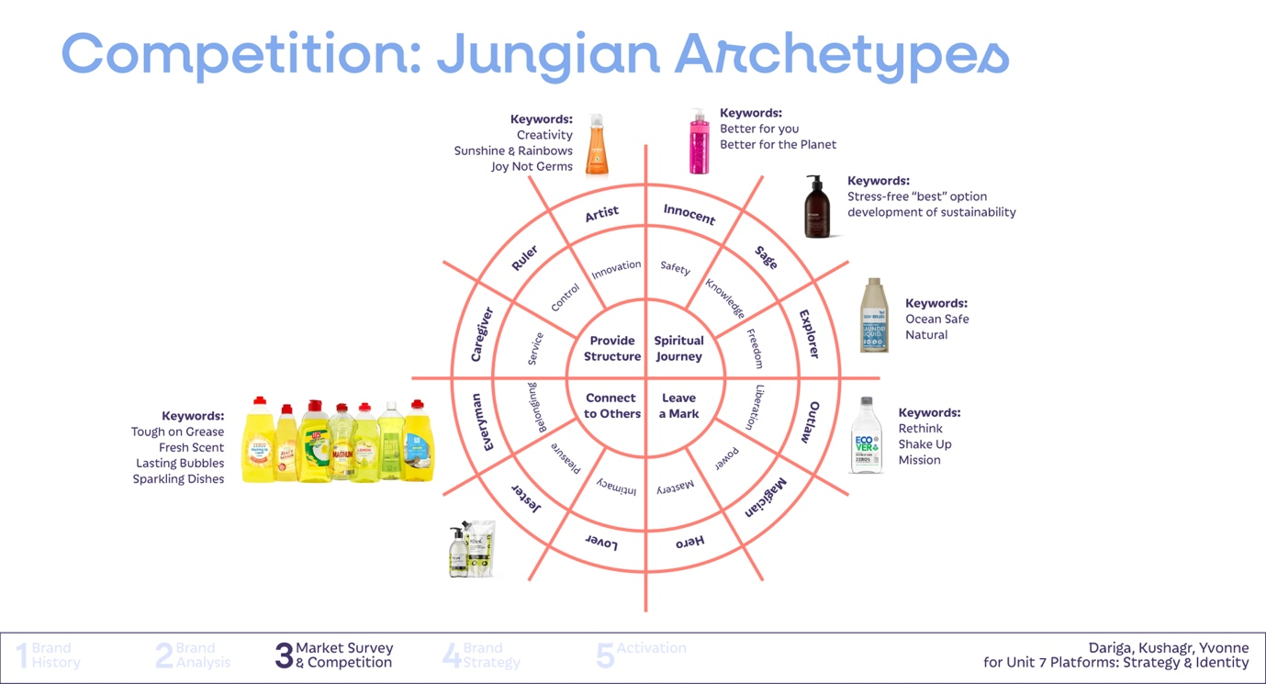
Figure 1) An archetype wheel considering the brand values of Fairy in relation to their competitors. Sample slide from student presentation. Courtesy of Dariga Kashkinbayeva, Kushagr Awasti and Meihui Li.
Throughout the project students were encouraged to use Jungian archetypes as a way to scaffold their strategic intervention (Figure 1). Archetypes are a proven means to create emotional connection with consumers and a differentiated proposition within brand design, with much literature established on the subject. The set of twelve archetypes serve as a constructive way for students to analyse their chosen brand’s existing behaviour, compare this to their competitors, and envisage and inscribe how their brand’s behaviour could be modified in the future.

A key argument for the adoption of archetypes within brand strategy is their purported universal meaning, which promises to span cultural barriers and national divides. The premise is that each of the twelve archetypal figures have existed through centuries and across cultures, with these characters taking on a unique expression within different cultural contexts.

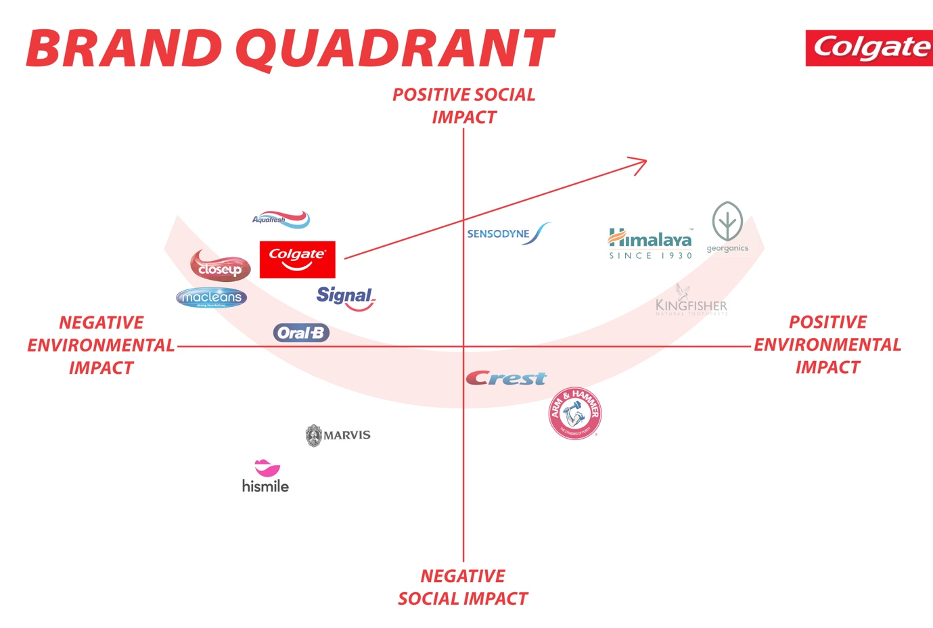
Figure 2) Brand positioning quadrant for Colgate. Sample slide from student presentation. Courtesy of Ilgin Erkan, Lois Willet-Green, Sandra Lin and Sofia Dye.

Along with the archetypes we also use brand mapping quadrants (Figure 2) and encourage students to consider ‘Points of Parity’ versus ‘Points of Difference’ which is a tool to identify what brands have in common with their competitors and what their differentiating features are. These are useful tools that enable students to compare and understand the landscape of competing brands and where their chosen brands sit within this. These tools are supplementary to the twelve archetypes and are associated with the practice of brand positioning.

Project Outcomes
On the last day of the project students share their final work in two contrasting session modes, a presentation and an exhibition. In the morning, they pitch their brand strategy proposal in a formal seven-minute presentation which takes the form of a client-style slide deck. The focus is not on their learning or creative experimentation, as might usually be the case, but rather on making a logical and compelling argument for their chosen strategy. The presentations concentrate on brand research and analysis (Figure 3), along with the chosen archetypal proposition. As students have already had a trial run presenting their strategy at the mid-point stage, by the final session they tend to be relatively fluent, demonstrating confidence and wielding the archetypes meaningfully. The mentors from FreshBritain offer feedback on the style and content of the presentations, with students encouraged to capture a written record of this feedback.

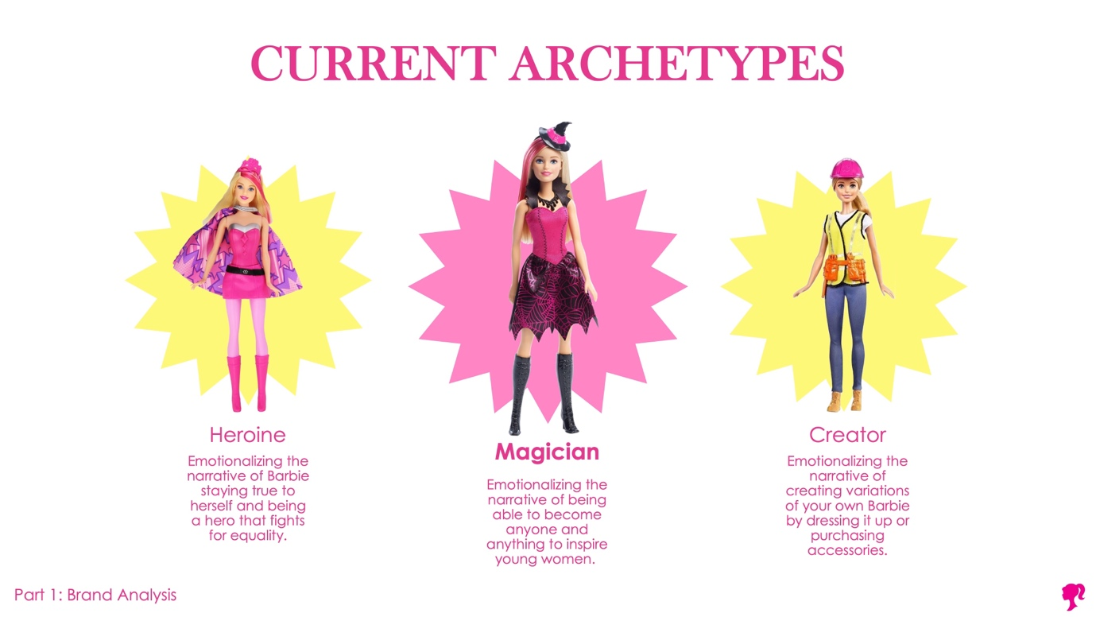
Figure 3) Archetypal analysis for Barbie. Sample slide from student presentation. Courtesy of Emily Zhang, James Roberts, Nina Chen and Vicki Mai.

In the afternoon attention shifts to an exhibition, with students now showcasing the design activations of their brand strategy in an Open Studio format (Figure 4). Each group sets up a display of their work that is accessible to students across the course, with anywhere between 100 and 200 visitors, including Academic Deans and other dignitaries. This is an informal, social session where the students’ achievements are celebrated. Feedback is collected from peers and visitors are actively encouraged to interact with and discuss the presented work, commenting on its clarity and efficacy.
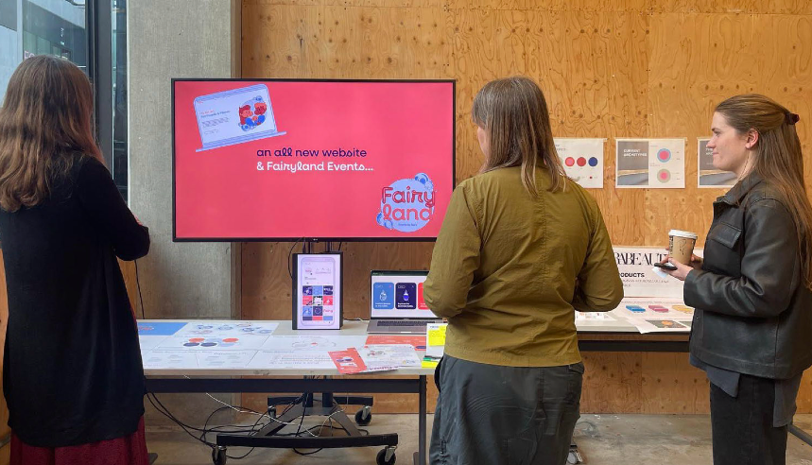
Figure 4) Open Studio displays showing strategic design activations for Fairy (left) and Zara Beauty (right). Photograph by Dariga Kashkinbayeva.

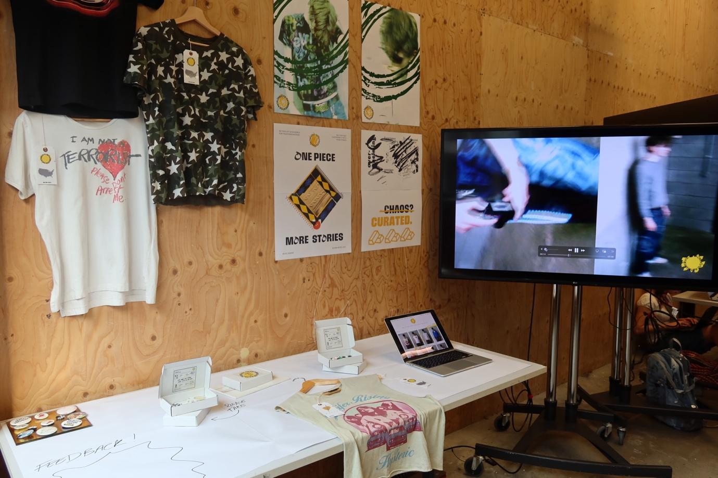
Figure 5) Open Studio display, showing strategic design activations for Beyond Retro. Courtesy of Bruno Green, Ellie Sharland, Safiya Alyautdinova and Seohee Kim. Photograph by Seohee Kim.

While many student groups concentrate on a social sustainability angle, others focus on environmental concerns. Among these outcomes have included a proposal to make second-hand clothing the default choice for sustainable high street shoppers. Working with vintage clothing brand Beyond Retro, these students sought to address what they saw as the cluttered and unrefined retail proposition of this second-hand outfitter (Figure 5). Adopting the Rebel archetype, they sought to reposition it as a viable and attractive alternative to mid-range fast-fashion outlets like H&M and Zara.

Another example would be the Coca Cola group, who proposed a combination of the Everyman and Caregiver archetypes to build a communal approach to climate and health for the brand. While a further example was the surf and snow brand Quicksilver, with this group adopting the Rebel to reframe nature as a precious human benefit, rather a playground to be exploited, as is typically the case with extreme sport brands of this type.

While most outcomes focused on either a social or climate justice angle, a few sought to address both in tandem. One group worked with detergent brand Fairy, setting out changes to the packaging, distribution and composition of the product to minimise environmental impact (Figure 6), while also seeking to address what they saw as their poor track record with gender representation and misogyny. To do this they aligned their vision to a strategy that combined elements of the Caregiver and Everyman archetypes. A further group adopted the Friend archetype to humanise Colgate. Addressing what they saw as idealised and unrealistic dental standards, they proposed the adoption of toothpaste tablets that are zero-waste, come in refillable packaging and minimize the carbon footprint associated with transportation.

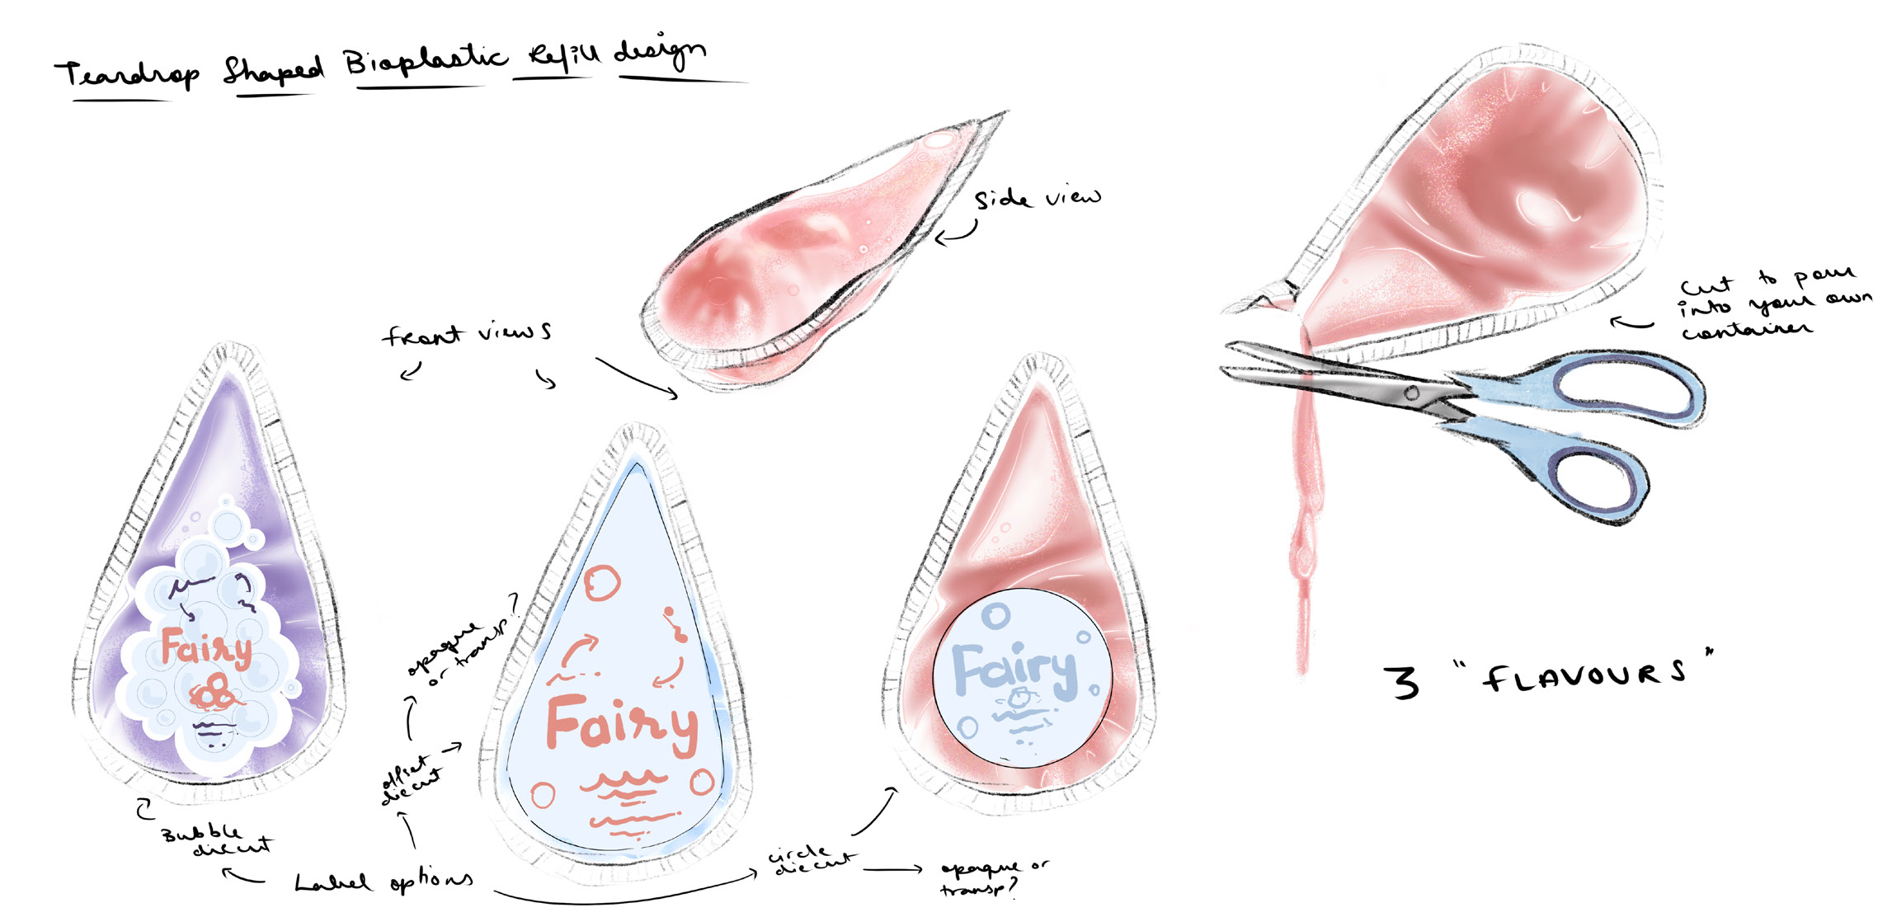
Figure 6) Sketches for compostable detergent refills for Fairy. Courtesy of Kushagr Awasthi.

Concluding Remarks: Benefits and shortcomings
Throughout the project students were encouraged to be radical, with a preference for ‘constructively unrealistic’ (Dunne, 2018) outcomes over conservative proposals that were plausible, but not ambitious in terms of sustainable impact. In spite of this, some groups struggled to move beyond expected next-step strategies. Unable to envisage climate policies not seen before, they proposed reasonable interventions that chimed with what the brand’s corporate marketing teams might be expected to propose (for instance, recycling tie-ins with the Olympics). What we were hoping for was more speculative responses that channelled possible and preferred futures over plausible or probable ones (see the cone of possibilities, Dunne & Raby, 2013). Having said this, plausibility is an important consideration in brand strategy, as brands are repositioned around certain evident truths about the brand, as opposed to being altered beyond recognition into a new unrelated form. This presents an interesting tension in the way that the brief aims to teach students the power of branding and invite them into this professional domain, while at the same time exposing them to its weaknesses and limitations.

Reflecting on the past two iterations of this project it is clear that many groups choose to prioritise social justice, as opposed to regenerative sustainability. Only six of the eighteen groups addressed climate as a central priority. This is disconcerting given the academic ambitions of the project, but not surprising considering the open nature of the project. As previously mentioned, the brief was left open to give students agency and avoid pushing climate responsibility onto younger generations. Still, it is worth reflecting on why social justice was more popular, with only a third of the groups choosing to address climate.

Factors drawing students to social justice as a priority can include:

- When analysing their chosen brand, some groups decided there were more pertinent issues in relation to that specific brand. For instance, one group was passionate to address what they saw as polarising gender divisions in the marketing of Dove’s personal care products.

- Many students are highly attuned to social justice values. This can lead them to feel better equipped to transform and contemporise the value system of their chosen brand around concerns such as race or gender, for example.

- The social justice approach is often about bringing corporate brands up to date with current social mores. There are numerous examples of best practice to draw upon, particularly from leaner and more progressive competitor brands. This means students can readily model best practice and apply learnings to their own work.

Factors discouraging students from climate justice can include:

- There are few best practice examples showing brand strategy approaches to climate justice. This means the climate justice approach entails more uncertainty and risk for the students, demanding future-facing speculation.

- As students are working hypothetically with a brand of their choice, they are not in contact with the organisation and have no access to internal information about the brand. This limits their working knowledge of the brand’s operations, heightening the sense of working blind and making the climate justice approach more difficult for them.

- Often a brand’s impact on climate is not predominantly a marketing issue, but rather a fundamental product, service or operational issue. When taking a climate approach to the brief, students can easily become preoccupied with product solutions, rather than brand positioning ones. This takes them outside the remit of the brief and the strategy methods which they are learning about. Within an isolated five-week project such as this there is a limit to the level of nuance which can be achieved. In principle brand strategy should interface with business strategy, but working through this complexity with students is challenging in a hypothetical project involving no interaction with the ‘real world’ client.

- Students may feel unequipped to tackle regenerative sustainability given its complex, systemic nature and quality as a ‘wicked problem’ (Rittel & Webber, 1973) with no singular solution. They may be nervous about the ‘real world’ impact of their proposals, unsure about their plausibility and whether they would actually be beneficial, rather than just appearing to be so. They are aware of cynical tactics like greenwashing and would not wish their work to be considered in this way.

In order to better equip students to tackle climate justice I have considered whether to integrate UAL’s Carbon Literacy training within the project schedule. So far this has not proved possible within our current time constraints. It was also felt that this training could overwhelm students, given the already steep learning curve for them as they grapple with novel brand strategy methods for the first time.

In order to incorporate Carbon Literacy, we could hypothetically re-write the brief, dropping the focus on brand positioning and turning instead to net positive product interventions and one-off campaigns for brands. But ultimately, I remain hesitant about dropping archetypal systems from the project as I have seen the many benefits this can afford students over the longer-term. The principles and methods they learn here often positively influence their approach to future projects and fundamentally alter the way they think about brands and communication design more generally. I also appreciate the transferability of this learning for students who go on to work outside branding, with the narrative basis of archetypes proving advantageous for illustrators and filmmakers, for instance.

There is evidence that learning about brand positioning opens up new opportunities for students. Since establishing brand strategy as a subject of study on our course more graduates have taken on roles in design strategy and management, as well as an increasing number enrolling onto postgraduate courses in marketing and business. What would have previously been considered an unorthodox choice has become relatively commonplace, with purpose-led young creatives looking to gain entry to the world of business in order to positively affect change.

Moving forward, if we were to insist on a climate focus for all student participants on this brief, I would be inclined to shift away from working with established brands and invite students to propose their own start-ups instead. By developing their own start-up in a sector of their choosing, students could conceive of a brand which has climate justice at its very core, rather than this being stuck on later as a sticking plaster. While students would no longer be addressing the pitfalls of existing brands, they would still be upstream agents of change, albeit in a more entrepreneurial guise.

In its current guise some student groups are side-stepping climate within their work on this project, but by making it part of the agenda within the brief we hope to raise awareness about sustainability in its many dimensions; not only environmental, but also human, social and economic (as per the four pillars of sustainability). In subsequent units of the course students initiate several self-directed projects and it is clear that some do incorporate climate justice as a key driver when they come to write their own design briefs. Students certainly seem to be taking on the broader ethical imperatives of the project too, with one participant reflecting on how the project helped them understand that their role as a designer is, ‘to be both critical and ethical, considering not just aesthetics but also the message, intention, and impact behind my work’ (Student Participant, 2025).

References
Adelman, C. (1993). Kurt Lewin and the Origins of Action Research, Educational Action Research, 1:1, 7-24.

Bailey, J. and Preston, D. (2020). SDI x Bite Back student projects 2019-20 [project report]. London: University of the Arts London.

Barnett, R. (2007). A Will to Learn: Being a Student in an Age of Uncertainty. Maidenhead: Society for Research into Higher Education & Open University Press.

Cooper, C. (2022). ‘Design students and grads support central government on early policy prototyping’, UAL News [website]. Available at: https://www.arts.ac.uk/about-ual/press-office/stories/design-students-and-graduates-support-central-government-on-early-policy-prototyping (Accessed: 28 May 2025).

Dunne, A. (2018). ‘A Larger Reality’, in M. V. Mullin and C. Frayling (eds) Fitness for What Purpose. Manchester: Eyewear Publishing, 116–117.

Dunne, A. and Raby, F. (2013). Speculative Everything: Design, Fiction, and Social Dreaming. Boston, MA: MIT Press.
Elkington, J. (1997). Cannibals With Forks: The Triple Bottom Line of 21st Century Business. Oxford: Capstone.

Gibbons, L. V. (2020). ‘Regenerative—The New Sustainable?’, Sustainability, 12(13), 5483. https://doi.org/10.3390/su12135483

Grant, J. and Vodeb, O. (2023) What Is Post-Branding?: How to Counter Fundamentalist Marketplace Semiotics. Eindhoven: Set Margins’ Publications.
Greer, J. and Bruno, K. (1996). Greenwash: The Reality Behind Corporate Environmentalism. Penang, Malaysia: Third World Network.

Hill, D. (2014) Dark Matter and Trojan Horses: A Strategic Design Vocabulary. Moscow: Strelka Press.
Lewin, K. (1948) Action research and minority problems, in G.W. Lewin (Ed.) Resolving Social Conflicts. New York, Evanston and London: Harper & Row (1948).
Mark, M., & Pearson, C. S. (2001). The hero and the outlaw: Building extraordinary brands through the power of archetypes. McGraw-Hill.

Merlo, O., Eisingerich, A. B., Gillingwater, R., & Cao, J. J. (2023). Exploring the changing role of brand archetypes in customer-brand relationships: Why try to be a hero when your brand can be more? Business Horizons, 66(5), 615–629. https://doi.org/10.1016/j.bushor.2022.11.001

Neumeier, M. (2005) The Brand Gap (2nd ed.). Berkeley, CA: New Riders.
Polman, P. and Winston, A. S. (2021). Net Positive: How Courageous Companies Thrive by Giving More than They Take. Boston, MA: Harvard Business Review Press.

Rancière, J. (1991). The Ignorant Schoolmaster. Translated from the French by K. Ross. Redwood City, CA: Stanford University Press.

Raworth, K. (2018). Doughnut Economics: Seven Ways to Think Like a 21st-Century Economist. London: Random House.
Ries, A., & Trout, J. (1980). Positioning: The battle for your mind. McGraw-Hill.

Rittel, H. W. and Webber, M. M. (1973). ‘Dilemmas in a General Theory of Planning’. Policy Sciences, 4(2), 155–169.

Sheard, B. (2025). The Brand New Future: How Brands Can Save the World. London: LID Publishing.

UAL (2022). Climate Action Plan. London: University of the Arts London. Available at: https://www.arts.ac.uk/__data/assets/pdf_file/0025/374128/Climate-Action-Plan_Nov2022.pdf (Accessed: 28 May 2025).

UAL (2023). Climate, Racial and Social Justice principles. London: University of the Arts London. Available at: https://www.arts.ac.uk/__data/assets/pdf_file/0028/374149/principles-for-climate-racial-and-social-justice.pdf (Accessed: 28 May 2025).
Wheeler, A. and Meyerson, R. (2024) Designing Brand Identity: A Comprehensive Guide to the World of Brands and Branding (6th ed.). Hoboken, NJ: Wiley.

For more on brand strategy, see works by Neumeier (2005) and Wheeler and Meyerson (2024).
The latter-stage activation phase of design projects is described by Dan Hill as low value. Hill (2014: 30) characterises this as a phase where designers are often tasked with ‘putting the lipstick on the pig’. Here he infers that it is typically too late to meaningfully influence the strategic dimensions of a project.
Central Saint Martins has a strong art school tradition associated with its two founding colleges Central School of Art and Design (founded in 1896) and Saint Martin's School of Art (founded in 1854).
The relationship between business strategy and brand strategy is a contested area, but the two should certainly inform one another. In this regard brand strategy can be seen to have a high degree of influence in affecting change — certainly by comparison to brand identity design which typically has limited direct impact.
This attitude may be in part attributable to a sense of climate fatigue, along with a helplessness felt by students asked to deal with what they understand to be unsolvable problems in which they feel they can have little impact.
This approach mirrors influential work by Elkington (1997) who introduced the term ‘triple bottom line’ to emphasize the need for organisational contribution to people, planet and profit.
Bob Sheard (2025) of FreshBritain argues that while many brands are well versed at story-telling, there must be more focus on story-doing if brands are to deliver sustainable impact. In terms of best practice, the UK-based bread and flour brand Wildfarmed has proven useful as an example of a Fast-Moving Consumer Goods brand practicing regenerative principles.
Mark and Pearson’s (2001) The Hero and the Outlaw is considered seminal, but archetypes remain a subject of current concern through work such as that by Merlo et al. (2023).
The counter narrative would argue that these figures are not expressions of a universal underlying pattern and that a ‘trickster’ figure in an Indigenous American context is fundamentally different in a European or Asian context. Relevant here is the idea that brand design is often understood as a homogenising force that flattens rather than celebrates difference, thus inhibiting pluriversal perspectives.
For more on brand positioning, see Ries and Trout (1980).
Relevant here is Grant and Vodeb’s (2023) work around post-branding as a practice that aims to counter fundamentalist marketplace semiotics.
The best-case examples that do exist are often built around a regenerative product at their core. See, for instance, the brand Wildfarmed which sells wheat that thrives in a regenerative system.
This could be supported by reference to FreshBritain’s regenerative brand protocols (see Sheard, 2025).
This would align with FreshBritain’s recent regenerative brand design work with a start-up shoe brand, which has already proved to be a useful case study for our students.

