CEDAR: An Augmented Reality mobile application using a participatory design framework for Citizen
Science Data Sensing

Mengci Liu, Peter Hall, Stella Doukianou, Anna Troisi
University of the Arts London, m.liu0720211@arts.ac.uk p.hall@arts.ac.uk s.doukianou@arts.ac.uk, a.troisi@arts.ac.uk
Abstract—Citizen science initiatives focused on ecology engage individuals in collecting environmental data, aiming to cultivate environmentally conscious individuals. Addressing limitations of traditional electronic platforms and scientific methods in enhancing citizen science, the CEDAR (Collective Environmental Data Sensing using AR) project proposes Augmented Reality (AR) as a critical tool for bridging the gap between individuals, data, and location, aiming to foster a novel mode of experiential engagement and provoke more interaction and reflection. To achieve this, the practices of the CEDAR project are structured into two phases: the first develops a participatory design framework and a new toolkit for citizen science workshops, while the second integrates gamification with AR to create an immersive environment for continuous data interaction. This paper outlines a participatory design framework for an AR-based citizen science application, designed to motivate participants to actively collect, interpret, and visualize data. It provided essential insights for AR application development, exploring data's potential to elicit aesthetic experiences, and introducing an interactive dimension to participatory sensing.
Keywords—Citizen Science, Sensing technology, Participatory sensing, Data visualisation, AR, Gamification

I. INTRODUCTION
The term "citizen science" was first recorded in 1989 when Kerson [1] noted that 225 volunteers in the U.S. collected rain samples for an Audubon Society acid-rain awareness campaign. Over time, this concept has expanded to include more participatory efforts. Lewenstein [2] defined it as the participation of non-scientists in the process of collecting data, using and interpreting that data. As urban environmental challenges grow, such as increasing air and noise pollution in industrialized cities and their impacts on nature, citizen science, particularly in ecology, helps citizens connect with their environments, promoting pro-environmental attitudes and behaviour changes [3],[4]. Specifically, when citizens gain first-hand environmental experience and knowledge, they can transform their relationship with nature, turning data into a tool for environmental action and behaviour change [5].
Emerging technologies have revolutionized citizen science, creating unparalleled opportunities for participation [6]. For instance, participatory sensing, as an engagement concept of citizen science, enables people to proactively sense their environment using readily available sensor devices, such as smartphones, and to share this information using existing cellular and Internet communication infrastructure [7]. Based on the infrastructures such as sensing technology, visualisation tools, GIS tools, and mapping technology, the list of participatory sensing applications has been expanding rapidly [8]. These tools streamline data collection, enrich information about the physical environment, and enhance the scope of data sharing. In addition to the functional aspect, applications that incorporate gamification strategies show promise in motivating participants and fostering long-term behavioural change [9].
However, since previous research in participatory sensing focuses more on the scientific aspect of data and the resolution of specific community issues, we still know little about the experiential aspect of citizen science. This includes how volunteers interact with these technologies [10], how they use the collected data [11], and how they relate the data with their real-world experience [12],[13], Since environmental attitudes and awareness in citizen science largely depend on the cognitive and emotional aspects of experiences with their natural environment, it is essential to explore how these experiences are generated [14].
Therefore, this paper introduces an innovative methodology for developing an AR prototype for citizen science activities. It includes a robust participatory sensing framework and the development of a citizen science toolkit to enhance participant motivation through playful, embodied, and immersive data interaction. This work is part of the CEDAR project, which ultimately seeks to enhance the citizen science experience and increase social awareness, provide opportunities for provoking more desirable and responsible citizen actions.

II. PELATED WORK

A. Citizen Science Participation Framework
Frameworks that support citizen science are increasingly recognizing the multifaceted nature of participation. Projects that are action-oriented not only use open-source software and digital tools but are also deeply embedded in community practices, aiming to empower local environmental monitoring. For example, the Dimensions of Engagement Framework, proposed by Phillips et al. [15], categorizes participation into four key dimensions—emotional, cognitive, behavioural, and social. This framework underscores the complexity of engagement, advocating for approaches that resonate on multiple levels to profoundly enrich participant experiences and sustain motivation. Building on this foundational work, subsequent studies have sought to refine and expand the framework for citizen science. Woods et al. [16] developed an eight-stage citizen-sensing framework that guides communities from the initial scoping of issues to the legacy phase of ensuring lasting impact. This framework is designed to structure the participatory process and ensure every stage is impactful, building towards sustainable community action. The stages are as follows:
- Scoping: Identify and discuss key issues, gathering information.
- Community Building: Unite participants, develop skills, and organise the project.
- Planning: Set goals for data collection, and test sensing tools.
- Sensing: Collect and record data for analysis.
- Awareness: Analyze data to enhance collective understanding and identify change areas.
- Action: Propose and implement actions for positive impact.
- Reflection: Review the process to identify successes and failures, possibly revisiting earlier stages.
- Legacy: Ensure lasting impact by sharing resources and producing reports for future use.

Further, Liñán et al. [17] have introduced enhancements focusing particularly on the implementation stage, arguing for the importance of roles that trigger motivation, reduce barriers, and provide rewards, thereby enhancing the framework's ability to engage participants effectively and meaningfully.
The previous research aids practitioners in assessing the effectiveness of various participatory dimensions and improving strategies to enhance both participant experiences and project relevance. The CEDAR research project draws on the existing action guidelines of citizen science and suggests an aesthetic, experiential-oriented framework designed to increase interaction and data reflection.

B. Citizen Science Application
Despite these advancements, the application of citizen science in real-world settings often faces technological and motivational challenges. The integration of sensor-based applications such as the Smart Citizen Kit [18], AirBeam [19], and DustDuino [20] demonstrates significant progress in data monitoring. These tools facilitate participatory sensing, helping communities understand and engage with environmental data [21]. Despite their capabilities, these applications alone may not sufficiently motivate citizens to address environmental issues [22], prompting researchers to reconsider the relationship between sensing technologies and human experiences of the environment.
Parisi [23] has positioned sensing technology as technoecologies of sensation, emphasising that technology should not only be viewed as a means of collecting data but also as a way to reconsider human sensation. Gabrys [24] uses a new materialist approach to emphasise the possibility that distributed sensor technologies may contribute to new sensory processes by altering the relations, entities, occasions, and interpretations of sensing.
To sustain engagement, researchers have integrated gamification strategies into these applications. Citizen science games often employ extrinsic motivators like certificates and prizes to boost participation [25]. Effective strategies include setting clear goals and rewards, as demonstrated by apps like PulsAir, which incentivizes users to choose non-polluted routes or share air quality data [26]. Despite the availability of many gamification elements, only a few significantly enhance application design [27]. Exploring a broader range of gamification technologies could make activities more engaging and challenging, increasing intrinsic motivation among participants.
This ongoing discussion about the sensory and experiential dimensions of citizen science has spurred innovative applications of gamification using AR/VR. Projects like PokeBlitz [28] and WildSpotAR [29] show how effectively gamification strategies can engage participants in environmental exploration and data collection, transforming these activities into compelling narratives and adventure games. These projects encourage environmental exploration through task completion by incorporating larger adventure game narratives [6]. Gandhi et al. [30] argue that AR gamification offers more memorable and reflective experiences than traditional browser interfaces. This makes AR a powerful tool for transforming game design into a storydriven, impactful practice.
Reflecting on these diverse approaches, this paper aims to integrate and further these frameworks and technologies within the CEDAR project. By focusing on experiential and sensory engagement through AR technologies, we aspire to not only enhance data interaction but also to foster deeper connections between participants and their environmental contexts.

C. Citizen Science Data
The effective use of data in citizen science is pivotal, as it shapes participants' perception and their ability to engage meaningfully with the data sensing process. Previous studies, such as those by Liu et al. [13] and Coenen et al. [31], have highlighted a significant gap: often, citizen-collected data is not effectively connected to the participants' real-world experiences. This disconnection can diminish the impact of data-driven actions and the overall effectiveness of citizen science initiatives.
The CEDAR project employs advanced data visualisation techniques to make environmental data more relatable and actionable. Inspired by Coenen et al. [31], who used tangible visualisation tools to link the data to geographic and community contexts, CEDAR proposes to use augmented reality (AR) to feedback the data to the physical environment digitally. Furthermore, the approach adopted by Liu et al. [13] which involves using crowdsourced systems that utilize verbal narratives and image collages for contextual air quality data representation, also influences CEDAR’s methodology. By combining such narrative techniques with AR visualisations, CEDAR provides a more immersive and intuitive way for participants to engage with collected environmental data, aiming to deepen emotional and cognitive involvement in conservation efforts. This approach not only focuses on the technological aspect of data collection and visualisation in citizen science but also emphasizes the experiential dimensions highlighted by Nold [12] and Calvillo [32]. The goal is to create engaging, transformative experiences that enhance participants' understanding and motivation.
Such an aesthetic perspective supports the production of embodied and situated knowledge [33], prompting the viewer to reflect on the roles of data in a specific context [34]. Building on this body of work, this paper provides both methodological and design-oriented contributions, by exploring how the citizen-generated data can be connected with its location and individuals' actual feeling.

III. METHODOLOGY
To achieve the goal mentioned above, the CEDAR project follows a structured methodology across three phases Fig. 1: defining the participatory framework, designing the practice, and conducting workshops. Each phase builds upon the previous one to seamlessly integrate augmented reality (AR) with citizen science. As part of the CEDAR project's broader objectives, this study focuses on short-term engagement in participatory sensing activities, analysing outcomes and effectiveness to understand the practical challenges and opportunities of AR-enhanced participatory sensing, offering insights for future enhancements. The following sections delve into the three core phases of the CEDAR project's methodology, aiming to clarify the systematic approach we used to integrate augmented reality with citizen science, ensuring that each phase effectively builds upon the previous one.
Fig. 1. Diagram describe the overall methodology steps.

A. Define the Participatory Framework
The initial phase of the CEDAR project methodology was centred on crafting a participatory framework that integrates augmented reality into citizen science with a focus on enhancing participant engagement through a deeply immersive experience. This phase commenced with a comprehensive literature review covering citizen science practices and pragmatic aesthetics [35], which guided the development of the Dimensions of Engagement Framework.
Our approach aimed to provide a holistic participant experience, where each aspect—from internal motivation and sensor deployment to data collection and interaction— seamlessly integrates into a unified journey, improving engagement quality and interaction depth.
Furthermore, our framework prioritizes the 'embodied' experience in citizen science, promoting designs that involve both mind and body to generate meaning and recognize the role of physicality in digital interactions. By engaging the body as a key medium for sensory input, we enhance the physical and emotional aspects of participant involvement.
Additionally, the 'situated' [36] aspect of our framework ensures technology and applications are context-aware, and tailored to the specific socio-cultural and physical settings where they operate. This design approach emphasizes participant actions integrating into the urban landscape, fostering a deeper connection to their local environment and boosting the impact of citizen science activities.

B. Design Practice
Following the establishment of a robust participatory framework, the second phase of the CEDAR project involved practical application and development of the sensor-based AR application. Before finalising the design of the interface and interaction system for our AR application, our design practice starts by focusing on interactions in physical spaces, aiming to transfer a more intuitive and enjoyable experience to the ARbased digital space.
Drawing on the concept of 'technoecologies of sensation.' and the framework of aesthetic experience, the design practice of the sensor in the CEDAR project consists of two components: the development of sensing technology and the design of sensor enclosures.
The development of technology ensures that sensors have the capability to collect and store data. This involves integrating Arduino components with various sensors, including the PMS5003 for particulate matter, MICS-6814 for harmful gases, SGP30 for measuring photochemical smog, and INMP441 for monitoring sound levels. Data is stored on an SD card, tracked via GPS, and displayed in real-time on an LED screen, allowing users to interact with the screen through buttons.
The second component focuses on the design of sensor enclosures, which are inspired by natural elements such as animals, plants, microorganisms, water, and rocks Fig 2. Participants can engage in a game-like experience to collect data after choosing a natural character as an avatar. We encouraged participants to immerse themselves in their roles as active contributors to environmental monitoring by imagining themselves as non-human natural characters within the ecosystem. This imaginative approach promotes awareness of ecological interactions and helps participants see themselves as part of a broader environmental system.
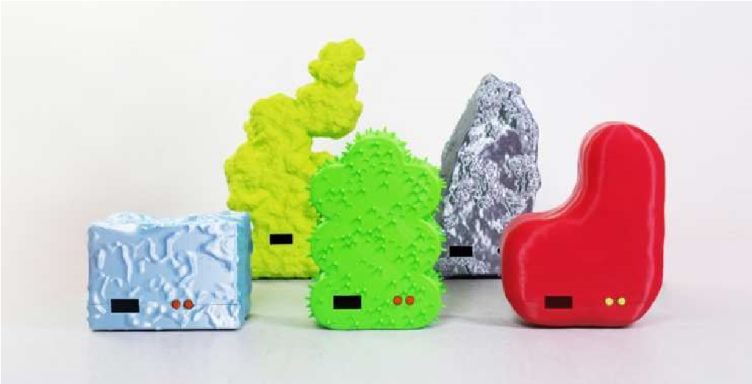
Fig. 2. Image showing the CEDAR toolkit.
By doing this, the sensors become a crucial component in participatory sensing activities. They are not merely viewed as data collection devices, but also serve as engaging elements that spark curiosity and promote interaction.

C. Participatory Sensing Workshops
In this phase, we designed and conducted an innovative participatory sensing activity using the newly developed participatory framework and CEDAR toolkits. We invite participants to use the sensors that represent natural characters to collect data and then translate their perceptions of the data into the handcraft data sculpture. Unlike traditional projects focused on specific community issues like monitoring pollution or addressing public health [37], CEDAR employs novel technology and design strategies to transform data collection into an interactive and educational experience, enhancing participant engagement and awareness. The overall plan was structured into two distinct workshops, providing a seamless user journey from initial training through data collection to interpretation and creative expression.
- Data collection workshop:
  - Participants: Participants were recruited through Meetup, Eventbrite, Camberwell Life's Twitter, and the UAL postgraduate community newsletter. The group consisted of 20 individuals aged 20-30, including residents, environmental enthusiasts, data scientists, and students.
  - Procedure: The workshop began with participants signing informed consent forms and receiving training on environmental data and measurement techniques. This training included a handout on data index standards to help participants understand the relationship between various types of air data and their impact on the environment including different species. Following the initial training, techniques for sensor placement and data collection were introduced, preparing participants for the practical application of their new skills. Participants then selected sensors corresponding to natural characters, which enhanced their connection to the data.
- Data visualisation workshop:
  - Participants: The participants in the data visualisation workshop are the same individuals who participated in the data collection workshops.
  - Procedure: The workshop began with a preparation phase that included an introduction to basic data visualisation techniques. This session aimed to lower barriers to participation and equip attendees with the necessary skills to interpret their data effectively. The data visualisation phase was organized into three distinct steps: collaborative data analysis, creation of data sculptures, and sharing of stories related to the crafted data sculptures. Initially, participants engaged in collaborative data analysis, working alongside researchers to identify patterns and anomalies within the collected data. Following this analysis, participants were encouraged to explore various materials provided during the workshop to construct physical data sculptures. Finally, participants shared their data sculptures and the stories behind them, providing personal insights and narratives about the data they collected.
- Data collection and analysis: This study used multiple data collection methods to comprehensively assess the effectiveness of the participatory sensing framework. Firstly, participants' reaction, behaviours and interactions were continuously observed during the workshops. Semistructured interviews in the data visualization workshop offered deep insights into participants' stories and feelings about the data sculptures they created. A survey with pre- and post-questionnaires was designed to analyze changes in participants' knowledge and attitudes toward environmental issues. This included both closed and open questions, conducted at the start and end of the activities, to accurately assess the framework's effectiveness.
To further interpret the findings, we employed Actor Network Theory (ANT) as a framework for analyzing participant observation data. ANT acknowledges equal agency exerted by human and non-human participants in a network, providing a comprehensive view of the participatory sensing activities Fig 3. This study constructed a complex network composed of actors such as humans, sensors, the environment, data, materials, and data sculptures. These actors interacted through a series of translation steps: humans perceived the environment using sensors, the gathered data were transformed through creative interaction with materials into data sculptures, and ultimately, these sculptures elicited new reflections and had the potential to provoke more actions. Aesthetic experience is vital in enhancing the sensory aspects of data collection and guiding data interpretation and presentation, transforming data from a passive entity into a catalyst for new insights and behaviours. This complete pathway from data collection to creative expression shows how participatory sensing influences participants' understanding and emotional response to environmental data through embodiment and contextualization, thus bolstering their engagement in environmental practices.

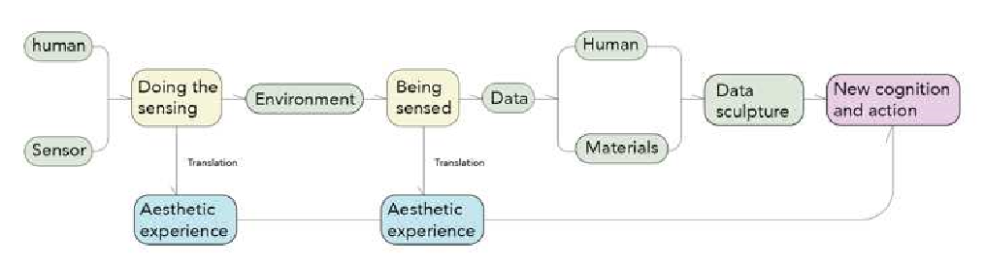
Fig. 3. ANT mapping for the participatory sensing
To gain deeper insights into participants' experiences, semi-structured interviews were conducted, and an interpretative phenomenological approach (IPA) was adopted to analyze participants' data stories as manifested in their data sculptures Fig 4. This method ensured that participants were engaged in making sense of their experiences, aligning their interpretations with those of the researchers. Several core themes emerged from the analysis:
- Sensory and Bodily Interaction: The workshops' outcomes showed the effectiveness of the proposed participatory framework, focusing on the holistic, embodied, and situated aspects of participants' experiences during the sensing process. For example, participant A used green clay to represent sound data, adding grainy "beads" to transform her perception of noise into a tactile experience. Participant F used balloons to represent changes in PM data, enjoying the process of inflating the balloons. Interestingly, at the end of the event, we found that popping the balloons served as a fitting metaphor for the act of eliminating pollutants. Participant C used black tulle to symbolize particulate matter (PM) levels, hanging it up to allow spectators to interact with the data by moving through it physically.
- Connection with Everyday Environments: By deploying sensors and displaying data at locations integral to their lives, participants could better understand data creation and feel the connection between environmental data and their everyday settings. For example, Participant B used Lego to depict air quality contrasts between the park and the street, reflecting on environmental quality differences between living spaces and visually integrating data into its environment. Participant C monitored air quality near a favourite restaurant and later photographed the black tulle fabric there, linking environmental issues to her interactive display with her digital sculpture.
- Connection with Avatars: During the creation process, participants attempted to integrate the sensor avatar they initially chose into their data sculptures, reflecting on other non-human elements in the environment. For example, Participant A, when telling her data story, considered the impact of noise on the birds, her chosen avatar. Participants B and G, while constructing their environments and data, considered their avatar "water" as a part of the environment and data.
- Creative Expression from the Data: Participants reinterpreted their data creatively using provided materials. For example, Participant G used a string of coloured beads to represent air quality changes observed while walking in the park, merging dynamic data with personal experiences. Participant H created a small pocket to "package" air data, making abstract environmental data tangible and comprehensible. Participant D used colourful glass seed beads to craft PM values, while Participant E, sitting next to D, used the same method for her data. They shared their experiences during creation and later compared their data sculptures.

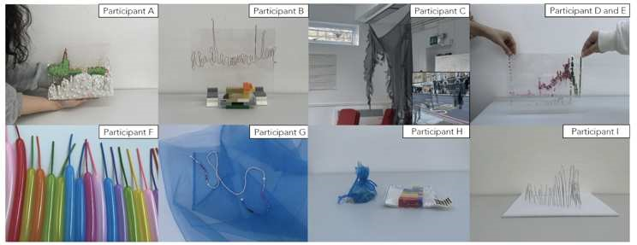
Fig. 4. Data sculptures created by participants

The quantitative data from the surveys provide an overall view of the participants' engagement and perceptual changes resulting from the workshop activities. All participants agreed or strongly agreed that they were motivated to engage, demonstrating effective workshop design and execution. Over half of the participants (57.1%) felt that physically representing data enhanced their self-expression, and about 29% reported that data visualization activities deepened their data understanding. These results confirm that such engagement can motivate participants and strengthen their connection to environmental issues.
Qualitative data from the survey, drawn from participant descriptions and narratives, enrich the insights gained from the quantitative analysis, revealing the experiential impact of the workshops. Ten participants described the workshops as a 'fun experience,' highlighting their engaging nature. Additionally, nine noted the activities' significance, with six explicitly stating they led to a new understanding of environmental dynamics. One participant called the workshops an 'adventure,' reflecting the exploratory and interactive approach, which encouraged active engagement with the natural environment. After this workshop, participants often described the human-environment relationship with terms like "coexistence," "symbiosis," and "harmony". These results suggest the workshops were enjoyable and educational, fostering deeper cognitive and emotional engagement with environmental data.

IV. PRELIMINARY DESIGN OF AR APPLICATION
Before we developed the AR application prototype, we upgraded the CEDAR sensor module to upload data to the server, which can be read by Unity through an API interface. Then, we used Unity to transform this real-time data into interactive and engaging game elements.

A. Game design features
- Inspired by participants' creative visualisations, such as using beads to represent humidity levels, the AR app converts real-world generated data, such as air quality readings, into visual objects within the game environment. This tangible representation helps users intuitively understand and engage with environmental data Fig 5.
- Following the participant-inspired concept of popping balloons that symbolize data interaction, the app allows users to tap on the floating objects (pollutants) to 'pop' them Fig 5. Each action of popping these objects is satisfying and rewarding, making the experience both entertaining and educational.

B. B. Game mechanism
To enhance user engagement further, the application incorporates several game mechanics that provide structure and motivation for continued interaction. These mechanics include a scoring system, rewards and incentives, locationbased interactions, and character development.
- The scoring system allows each interaction with a data object to earn the user points, adding a competitive layer to the application that motivates users to engage more deeply with the data as they aim to achieve higher scores Fig 5.
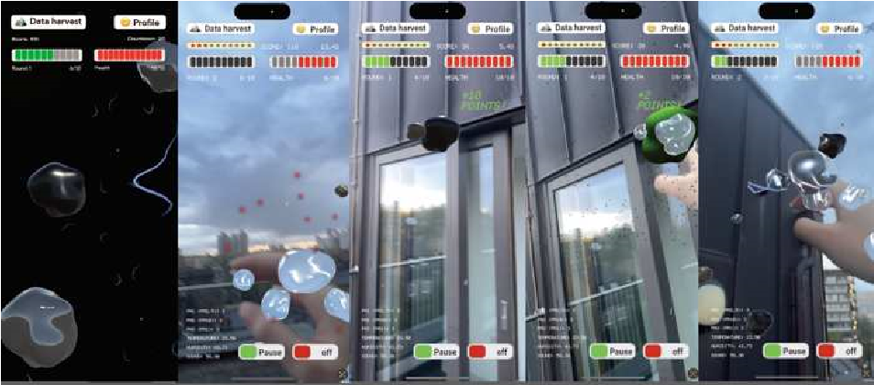
Fig. 5. AR interface showing how players interact with the score system.
- Additionally, the application rewards users with various drawing tools after certain milestones or scores are reached, enabling them to annotate or draw directly within the AR space and express their data interpretations creatively and interactively Fig 6.
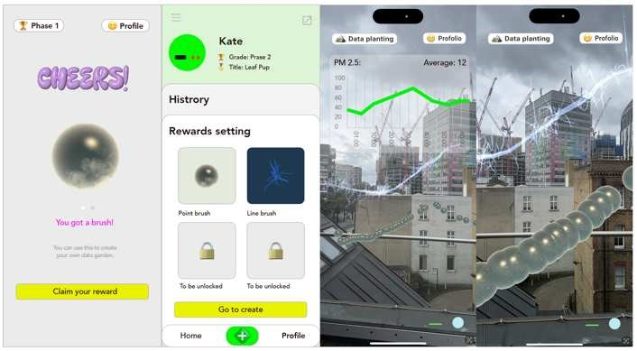 Fig. 6. Interface showing the tools as rewards.
- Encouraging users to physically move to specific locations to place their data interpretations in AR, the app uses GPS and AR technology to create a connection between the digital and physical worlds. This feature extends participatory data visualisation by integrating user-generated content into specific geographical contexts.
- Moreover, the application tracks each participant’s interactions with the data, reflecting this in the growth and evolution of a personal avatar or character within the app. This mechanic visualises personal progress and engagement, adding a layer of personal investment in the data interaction, and motivating continued participation and data collection Fig 7.
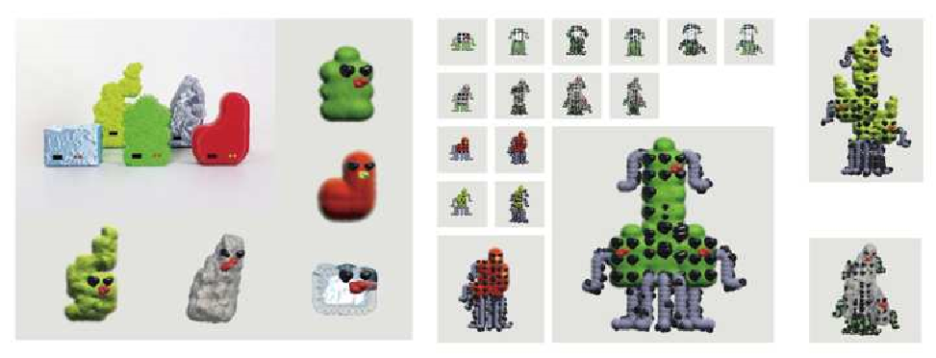
Fig. 7. Images showing that the avatars will grow as the players continuously interact with the data.
By incorporating these game design features and mechanics, the AR application tries to improve the awareness about important environmental issues. It not only bridges the gap between digital information and physical interaction, but also turns citizen-generated data into an interactive narrative, making the process enjoyable and engaging.

V. CONLUSION AND FUTURE WORK
Overall, this paper has presented a new participatory framework using CEDAR toolkits, integrating citizen science with the concept of pragmatic aesthetics. It offers a new perspective to understand the relationship between technology, data, humans, and the environment. The outcomes of the workshops demonstrated the effectiveness of the proposed participatory framework, emphasizing the holistic, embodied, and situated aspects of participants' experiences during the sensing process. The data analysis revealed that these experiences significantly enhanced participants' motivation and their understanding of and concern for the environmental data they collected. At the same time, the workshop materials provide information for the development of AR prototypes in terms of the design features and interactivity of game mechanics.
The limitations of this research include the small sample size and the fact that the AR application development is still in the experimental stage. Future studies in testing phases will expand the sample size, combining quantitative techniques and qualitative methods, to comprehensively evaluate the AR application's effectiveness in enhancing user engagement and interaction with environmental data. The final goal is to integrate environmental engagement with technological innovation, making AR a powerful tool for fostering proenvironmental attitudes and behaviour change.

REFERENCES
- Kerson, R. (1989). Lab for the environment. Technology Review, 92(1), 11-12.
- Lewenstein, B. V. (2004). What does citizen science accomplish?
- Bria F (2015) Growing a digital social innovation ecosystem for Europe. European commissionDSI final report. A study prepared for the European commission DG communications networks, content & technology.https://media.nesta.org.uk/documents/dsireport.pdf. Accessed 5 Dec 2018.
- Haywood, B. K., Parrish, J. K., & Dolliver, J. (2016). Place‐based and data‐rich citizen science as a precursor for conservation action. Conservation Biology, 30(3), 476-486.
- Jørgensen, F. A., & Jørgensen, D. (2021). Citizen science for environmental citizenship. Conservation Biology, 35(4), 1344.
- Mazumdar, S., Ceccaroni, L., Piera, J., Hölker, F., Berre, A., Arlinghaus, R., & Bowser, A. (2018). Citizen science technologies and new opportunities for participation. UCL Press. [7] Narayanasamy, N. (2009). Participatory rural appraisal: Principles, methods and application. SAGE Publications Ltd..
- Goodchild, M. F. (2007). Citizens as sensors: the world of volunteered geography. GeoJournal, 69, 211-221.
- Preece, J., Grace, K., Boston, C., Maher, M. L., Yeh, T., & Stangl, A. (2014). Crowdsourcing design and citizen science data using a tabletop in a nature preserve. ECSM 2014 University of Brighton Brighton, UK 10-11 July 2014, 413..
- Skarlatidou, A., Ponti, M., Sprinks, J., Nold, C., Haklay, M., & Kanjo, E. (2019). User experience of digital technologies in citizen science. Journal of Science Communication, 18(01)..
- Taylor, L., Schroeder, R., & Meyer, E. (2014). Emerging practices and perspectives on Big Data analysis in economics: Bigger and better or more of the same?. Big Data & Society, 1(2), 2053951714536877.
- Nold, C. (2017). Device studies of participatory sensing: Ontological politics and design interventions (Doctoral dissertation, UCL (University College London)).
- Liu, S. Y., Cranshaw, J., & Roseway, A. (2020, July). Making air quality data meaningful: Coupling objective measurement with subjective experience through narration. In Proceedings of the 2020 ACM Designing Interactive Systems Conference (pp. 1313-1326).
- Schuttler, S. G., Sears, R. S., Orendain, I., Khot, R., Rubenstein, D., Rubenstein, N., ... & Kays, R. (2019). Citizen science in schools: Students collect valuable mammal data for science, conservation, and community engagement. Bioscience, 69(1), 69-79.
- Phillips, T., Porticella, N., Constas, M., & Bonney, R. (2018). A Framework for Articulating and Measuring Individual Learning Outcomes from Participation in Citizen Science. Citizen Science: Theory & Practice, 3(2).
- Woods, M., Balestrini, M., Bejtullahu, S., Bocconi, S., Boerwinkel, G., Boonstra, M., ... & Seiz, G. (2018). Citizen sensing: a toolkit.
- Liñán, S., Salvador, X., Álvarez, A., Comaposada, A., Sanchez, L., Aparicio, N., ... & Piera, J. (2022). A new theoretical engagement framework for citizen science projects: using a multi-temporal approach to address long-term public engagement challenges. Environmental Research Letters, 17(10), 105006.
- Smart Citizen. (2021). Smart Citizen Kit.
Available at: https://www.smartcitizen.me [19] HabitatMap. (2021). AirBeam. Available at: https://www.habitatmap.org/airbeam
[20] Murphy, G., & Dillon, P. (2020). Dustduino. [21] Green, F., & Healy, N. (2022). How inequality fuels climate change: The climate case for a Green New Deal. One Earth, 5(6), 635-649..
- P Prestopnik, N., & Crowston, K. (2012, October). Purposeful gaming & socio-computational systems: a citizen science design case. In Proceedings of the 2012 ACM International Conference on Supporting Group Work (pp. 75-84).
- Parisi, L. (2009). Technoecologies of sensation. Deleuze/Guattari & Ecology, 182-199.
- Gabrys, J. (2017). Citizen sensing, air pollution and fracking: From ‘caring about your air’to speculative practices of evidencing harm. The Sociological Review, 65(2_suppl), 172-192.
- Cooper, S., Khatib, F., Treuille, A., Barbero, J., Lee, J., Beenen, M., ... & Popović, Z. (2010). Predicting protein structures with a multiplayer online game. Nature, 466(7307), 756-760.
- Ottaviano, S., et al. (2019). PulsAir: Clearing the Air with Citizen Science. Environmental Health Perspectives.
- Bowser, A., Hansen, D., He, Y., Boston, C., Reid, M., Gunnell, L., & Preece, J. (2013, October). Using gamification to inspire new citizen science volunteers. In Proceedings of the first international conference on gameful design, research, and applications (pp. 18-25).
- Dorward, L. J., Mittermeier, J. C., Sandbrook, C., & Spooner, F. (2017). Pokémon Go: Benefits, costs, and lessons for the conservation movement. Conservation Letters, 10(1), 160-165.
- WildSpot Inc. (2021). WildSpotAR [Video game]. WildSpot Inc.
Retrieved from https://apps.apple.com/us/app/wildspotar/id1496175030 [30] Gandhi, R., et al. (2021). AR Games in Citizen Science: Enhancing User Engagement. Interactive Learning Environments.
- Coenen, J., Houben, M., & Vande Moere, A. (2019, June). Citizen dialogue kit: Public polling and data visualisation displays for bottomup citizen participation. In Companion Publication of the 2019 on Designing Interactive Systems Conference 2019 Companion (pp. 912).
- Calvillo, N. (2019). Atmospheric Infrastructures to Deal with the Toxic Air in a Common World. Ardeth. A magazine on the power of the project, (5), 184-197.
- Corby, T. (2008). Landscapes of feeling, arenas of action: Information visualisation as art practice. Leonardo, 41(5), 460-467.
- Viégas, F. B., & Wattenberg, M. (2007). Artistic data visualisation: Beyond visual analytics. In Online Communities and Social Computing: Second International Conference, OCSC 2007, Held as Part of HCI International 2007, Beijing, China, July 22-27, 2007. Proceedings 2 (pp. 182-191). Springer Berlin Heidelberg. [35] Shusterman, R. (1992). Pragmatist Aesthetics: Living Beauty, Rethinking Art. Oxford University Press.
- Lave, J., & Wenger, E. (1991). Situated learning: Legitimate peripheral participation. Cambridge university press.
- Gray, S., Mellor, D., Jordan, R., Crall, A., & Newman, G. (2014). Modeling with citizen scientists: Using community-based modeling tools to develop citizen science project.

