GeoMedia Research Network (GMRN)
Mediamatic Panorama Room - Dijkspark 6 - 1019 BS Amsterdam

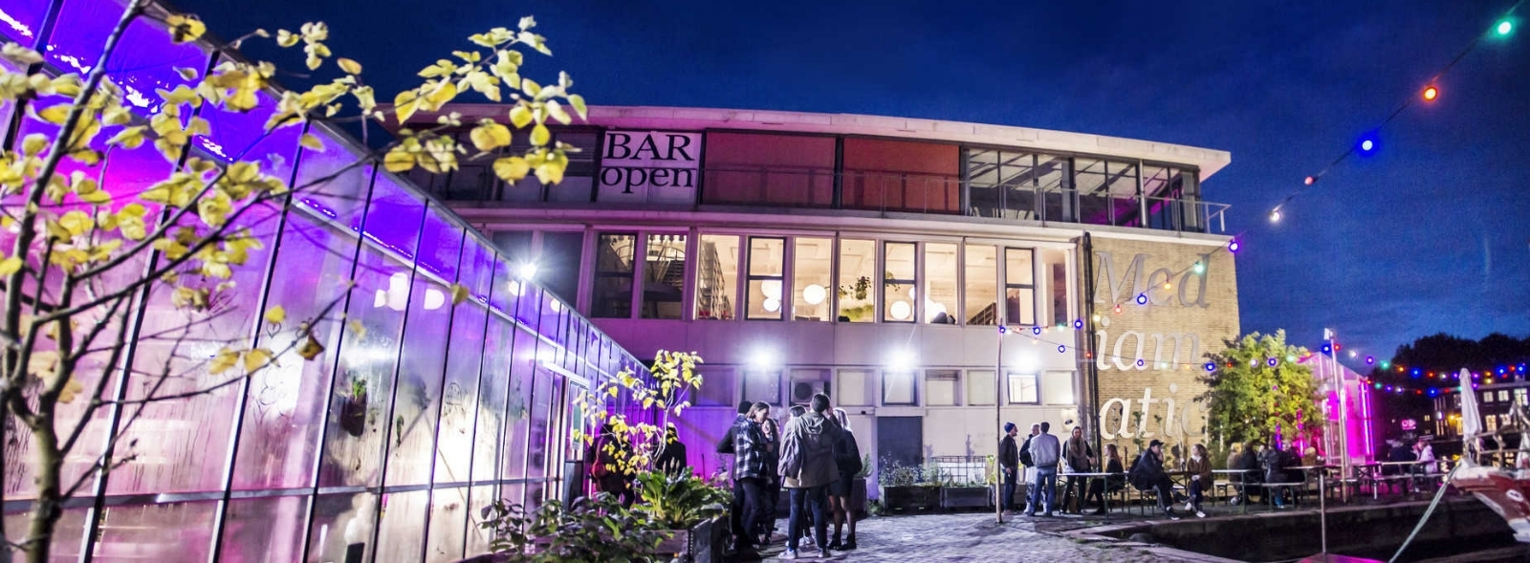

Workshop Program

THURSDAY 15 JUNE 2017

WELCOME: 9.15 – 10.00
9.45 – 10.00 Introduction & welcome words Adam Nocek & Patricia Pisters

BLOK 1: 10.00 – 11.00
10.00 – 10.20 Filippo Bertoni: The MELiSSA cycle: Transensorial mediation as planet making
10.20 – 10.40 Stepen Loo: Listening to the Symphony of Nature, and Au/Oral Conundrums
Through an Entomological Imagination
10.40 – 11.00 Discussion

BREAK: 11.00 – 11.20

BLOK 2: 11.20 – 12.40
11.20 – 11.40 Pieter Paul Pothoven: Stone Light Mirror
11.40 – 12.00 Paul Harris & Richard Turner: COMODIFIED: Rocks on Vinyl
12.00 – 12.20 Carolyn Strauss: Slow Research Lab
12.20 - 12.40 Discussion

LUNCH: 12.40 – 13.40

BLOK 3: 13.40 – 15.00
13.40 – 14.00 Adam Nocek: Lithic Media
14.00 – 14.20 Duncan Fairfax: Negentropic Apparatus: Stiegler and the Possibilities of Algorithmic Resistance
14.20 – 14.40 Erin Espelie: Material Culpability: The Lanthanide Elements & Rocky
Mountain Upheaval
14.40 – 15.00 Discussion

BREAK: 15.00 – 15.20

BLOK 4: 15.20 – 16.20
15.20 – 15.40 Femke Herregraven: material base, geographies and value systems of
contemporary financial technologies and infrastructures
15.40 – 16.00 Jonathan Beller: Re-coding the Programmable Image: Towards the
Decolonization of Money
16.00 – 16.20 Discussion

BREAK: 16.20 – 17.00

BLOK 5: 17.00 – 18.00
17.00 – 17.20 Betti Marenko: Digital Uncertainty and Algorithmic Magic
17.20 – 17.40 Marcel O’Gorman: Digital Rituals and Applied Media Theory
17.40 – 18.00 Discussion

DRINKS & DINNER: 18.00 – 21.30

FRIDAY 16 JUNE 2017

WELCOME: 9.30 – 10.00

BLOK 6: 10.00 – 11.00
10.00 – 10.20 Jussi Parikka: Geology of Media: Media Theory Goes Deep Time
10.20 – 10.40 Iris van der Tuin: Genealogy with/in GeoMedia
10.40 – 11.00 Discussion

BREAK: 11.00 – 11.20

BLOK 7: 11.20 – 12.20
11.20 – 11.40 Connie Groenewegen: Fashion Machines
11.40 – 12.00 Lonnie van Brummelen & Siebren de Haan: Citizens of Nature
12.00 – 12.20 Discussion

LUNCH: 12.20 – 13.20

BLOK 8: 13.20 – 14.20
13.20 – 13.40 Gregg Lambert: Here Comes the Sun
13.40 – 14.00 Patricia Pisters: Metallurgic Media and ‘Consciousness of the Earth’
14.00 – 14.20 Discussion

BREAK: 14.20 – 15.00

BLOK 9: 15.00 – 16.30
General Discussion and Future Plans

DRINKS & DINNER: 16.30 – 20.00 followed by PUBLIC PROGRAM

