Critical distance:
On illustrating news events from afar

Dr. Stephanie Black (UWE Bristol)
Orcid: 0000-0001-8248-6662

Dr. Luise Vormittag (UAL)
Orcid: 0000-0001-9177-8691

Keywords
Graphic witness, reportage illustration, representing trauma, distance, remote reporting

Abstract
Powerful images depicting the horror and devastation of geopolitical events and heinous abuses of power have an indisputable role to play in our society. This article however challenges the role of the eye witness as the sole conduit to valuable insights within news and media discourse. The authors propose that image-making practices (such as illustration) that operate at a distance from events allow for equally valid insights. Using three case studies of imagery produced at a remove from the news events it thematises, they argue that it is precisely the distance from the news event that enables the work to draw out aspects that are usually outside the frame of visibility. An analysis of Daniel Heyman’s portraits of Abu Ghraib detainees, Tings Chak’s schematic representations of migrant detention centres, and Catherine Anyango Grünewald’s animated film concerning the death of black teenager Michael Brown demonstrates that working at a remove can enable illustrators, artists and activists to reveal overlooked systems of power and control, restore dignity to dehumanised subjects, and reveal the limits of visual evidence. The article concludes with a reflection on the possibilities and limitations of the visual as a form of evidence.

Introduction

Some news pictures are so devastating, they are impossible to forget. We can all mentally summon a dire bank of images filled with photographs of small-boats dangerously crammed with people and the inevitable shipwrecks that ensue, the devastations of war, terror and violence, and instances of abuse of power, graphically rendered in pictures of tortured prisoners and videos of police brutality. These are overwhelmingly forceful images, launching news stories, driving investigations, and reverberating powerfully in our consciousness. Their role in documenting and exposing gruesome acts and circumstances is indisputable. However, their repeated viewing can lead to a form of discomfort that goes beyond the shock and grief we feel in response to the events they show. These images command us to not look away, and we can find ourselves thus trapped by their macabre allure. Reflecting on this dilemma American academic Saidiya Hartman speaks of the “uncertain line between witness and spectator” (1997: 4). She warns that the frequency with which some horrors are depicted again and again might blunt our senses and reduce our capacity for empathy. Perhaps an even more insidious effect of representations of brutality is their ‘spectacular’ character, the way these images might render us as “voyeurs [both] fascinated with and repelled by exhibitions of terror and suffering” (1997: 3). Social activist and author Naomi Klein echoes this concern when she urges us to reflect on methods of memorialising real-world atrocity that “avoid reinscribing the idea that some kinds of bodies are destined for violence, and thereby make it more likely?” (Klein 2024). In On Photography (1977) Susan Sontag also made the point that the repeated exposure to photographs diminishes their moral impact. In her more recent writing however she revised this position exploring the complexity of viewer-image relationships to a greater extent (2003). The question of how one might create suitable representations of violent acts is obviously not one that can be easily answered.

So, what might this mean for illustrators? While the discussion above often revolves around the use of photographs, our point of departure in this article is not to contrast illustration with photography. We are in no doubt that illustration can be equally capable of contributing to the glut of depictions of spectacular violence and the potential subsequent numbing effect on viewers. Likewise, illustration is also able to perform the valuable role of witness, providing crucial forms of documentation and evidence in campaigns for social justice. Instead of comparing illustration with photography we want to use this article to question the primacy of the eyewitness as the harbinger of truth. Whatever the effect might be of news images depicting torment and violence, the superiority of the image being made in the greatest possible proximity to the event is rarely challenged. What might be a different mode of image production, one predicated on the benefits of distance rather than presence? In this article we argue that looking and picturing from afar, may that be geographical distance, temporal distance or both, grants a different perspective. In what follows we discuss three illustration projects that examine three distinct news stories at a distance: the torture of prisoners in Abu Ghraib in Iraq in 2004, the many waves of refugees and migrants seeking a better life, and the killing of unarmed black teenager Michael Brown by a white police officer in Ferguson, Missouri in 2014. These examples reveal how working at a remove has the capacity to add complexity and nuance, both to our understanding of the news event itself as well as the mode in which it has been pictured and reported.

While we are championing the potential of distance in this piece, we are not arguing against the empirical method for illustrators per se. Being in the midst of things and encountering, observing and experiencing the world directly is clearly at the root of much brilliant illustration work, including a long tradition of reportage practices. A survey of historical examples of this type of work can be found in Mario Minichiello and Gary Embury’s book Reportage Illustration (2018: 3-8) where the authors outline the benefits of drawing on the spot. As they see it this includes the direct transcription of the illustrator’s thoughts, the capture of their unique insight, the immediacy of their experience, and the illustrator’s connection to and clarification of the subject matter (Ibid: 1). The Journal of Illustration has also published analysis of reportage practices (for example Shapiro 2023, Netter 2016, McCauley 2015). Elsewhere, academic Melanie Reim argues for the “honesty and purity” of on-site reportage drawings (Reim 2019:101), while fellow academics Rachel Gannon and Mireille Fauchon (2021: 92, 97-8) and Louis Netter (2024: 63-5) encourage reflection on the position from which these are made. In addition to reportage illustration, other strands of illustration relying on the direct, embodied presence of the illustrator include place-based practices, socially-engaged practices working with a community, social observation and commentary (such as satire), and natural history illustration. This work has been supported, and perhaps partially driven by contemporary illustration education that frequently promotes the benefits of empirical methods.

Another angle for considering the importance of empirical methods for illustrators might be to contemplate their affordances in the face of current challenges to illustration posed by AI image generators. These are forcing illustrators to articulate what they can do that can not be achieved by AI. Being in the midst of things can bring new insights and representations, in contrast to AI’s endless synthesis of existing images and perspectives of the world.

Another approach that seeks to expand the opportunities for direct experience involves illustrators extending their perceptual apparatus through technology. That there has been an increased interest in ‘remote sensing’ in illustration – practices that adapt traditionally empirical fieldwork methods to accommodate exploration at a distance. For example illustrator and academic Georgie Bennett discusses the phenomenon of the ‘cyberflaneur’ enabled by Google Maps (2023), while UAL’s Remote Sensing research events of 2020 and 2022 captured other tools and methods utilised by illustrators to access and ‘sense’ (often with the help of some form of technology) an otherwise inaccessible phenomenon (see Taylor & Fusco 2021 for a record of the first event). This, however, is distinct from our interest in distance. In the projects we examine there are no attempts at extending our senses. Instead, we argue that the distance offers possibilities for other modes of understanding.

The multiple benefits of presence, experience and close observation for the illustrator briefly outlined above however, does not mean that the inverse – distance, remove and other forms of vision – does not harbour potential too. We write this article not out of our distrust of empiricism’s sense perception, but out of a concern that the enthusiasm for it might be overshadowing other possibilities for illustrators. Yes, being there when it’s all happening bestows a particular kind of authority on the witness/ photojournalist/ reportage illustrator. They were there, they saw it, captured it, they know the truth of the matter. But can the act of reframing and refiltering the news from afar, a retelling at a remove, offer the possibility for making a different kind of veridical claim? Instead of seeing distance from the news event as a flaw that can create the potential for misinterpretation and confabulation to creep in, could it be adopted as a strategy by illustrators to reveal a different perspective, to clarify, to extend or to test the limits of the news story? Could this, perhaps, offer the possibility of bearing witness that evades the risk of gratuitous spectatorship?

Visualising the omitted: Daniel Heyman

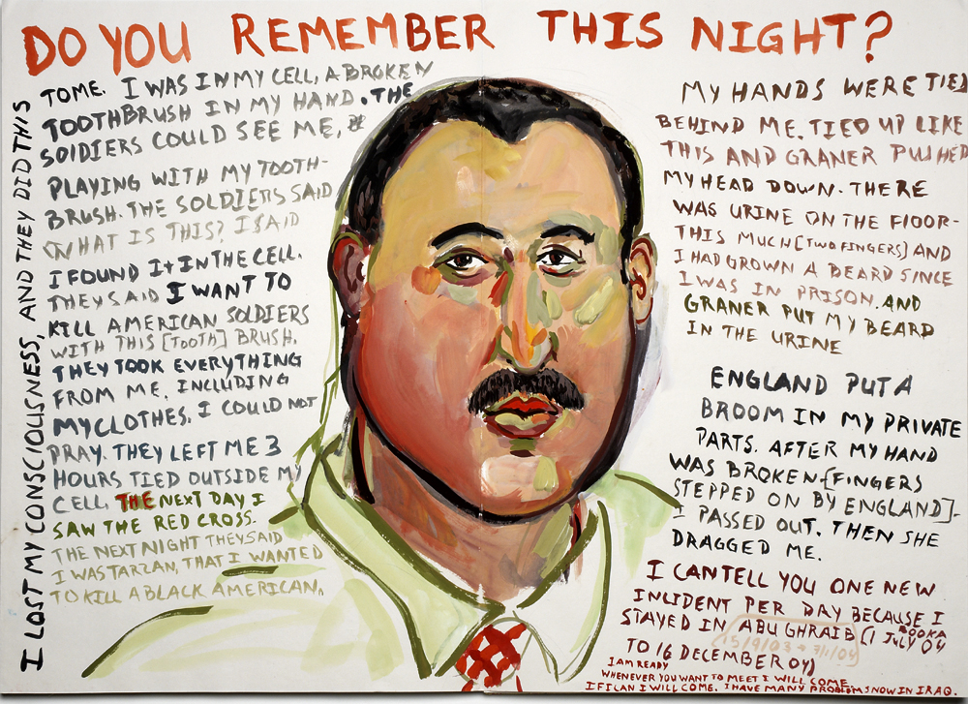

Figure 1: page from Daniel Heyman (2007) Istanbul Accordion Book: Do You Remember This Night?, part of the Bell Gallery Collection (Brown University) USA, courtesy of the artist

In April 2004, CBS News broadcast photographs from inside Abu Ghraib prison in Iraq, showing the abuse of Iraqi detainees by their US captors. These images gave the viewing public an immediate and vivid awareness of the cruelty perpetrated within the prison, coupled with the shocking understanding of the circumstances in which they were taken. As Susan Sontag wrote in the New York Times at the time, “the horror of what is shown in the photographs cannot be separated from the horror that the photographs were taken - with the perpetrators posing, gloating, over their helpless captives” (Sontag, 2004).

In her earlier and influential book Regarding the Pain of Others (2003), Sontag examines war photography to explore the impact of images such as these. She suggests that being able to look away or change the channel may not be a weakness of the image, or the viewer, it might instead be indicative of a different affordance:

“It is not a defect that we are not seared, that we do not suffer enough, when we see these images. Neither is the photograph supposed to repair our ignorance about the history and causes of the suffering it picks out and frames. Such images cannot be more than an invitation to pay attention, to reflect, to learn, to examine the rationalizations for mass suffering offered by established powers.”
(Sontag, 2003: 116-117)

But might it be possible to bypass the shock and horror of looking at photographs of torture, and opt for a different rhetorical approach in the invitation to reflect? The work of Daniel Heyman prompts us to consider what the image can do if it deliberately avoids the depiction of such atrocities, and offers viewers an opportunity to stand back and think, as Sontag suggests we might. Heyman's work foregrounds the perspectives of those dehumanised within Abu Ghraib. These images look away from the main events featured in the news stories on Abu Ghraib, as a visual strategy that invites us to pay attention, avoiding the visual mode when communicating events we are familiar with from news reports.

Between 2006 and 2008, Heyman made several trips to Jordan and Turkey with human rights lawyer Susan Burke and her team as she interviewed former detainees of Abu Ghraib prison to build a case against private contractors involved in their torture (Brown, no date). During the meetings Heyman drew portraits of the subjects in drypoint and watercolour, simultaneously transcribing accounts of their experiences as they were recounted into the space surrounding each portrait. These images are exhibited in galleries or may be seen in an online portfolio, as we encountered them (DePaul Art Museum, 2008). Heyman does not speak for his subjects, nor does he visualise their suffering. Instead, he creates compositions of image and text that sociologist Robin Wagner-Pacifici argues “restore dignity and individuality to those who have been deprived of their most basic human rights” (LMU.com, no date). Heyman utilises presence and proximity to the subject of the images, but his presence was in the interview room rather than the prison at the centre of the news story. This is reflected in his visual emphasis on the person in front of him rather than picturing the trauma they have experienced. By doing so, Heyman visualises the individuality lacking in the photographs documenting the brutalisation and dehumanisation of detainees inside Abu Ghraib that were circulated in the news media. Drawing out their humanity is a reparative act.

In her insightful analysis of Heyman’s work, art historian Sabrina de Turk also quotes Wagner-Pacifici to suggest what these drawn images afford us, the viewer: “Artists are important witnesses, able to solicit the attention of a distracted public, able to create resonant and powerful images” (de Turk 2011: 70). Here, we are offered a pause from the media vortex where art “slows time down” for us (as Sue Coe claimed in Heller 1999: 21) to allow contemplation outside of the news context, giving the subject matter the attention it deserves. The written testimony Heyman includes in his images gives an insight into the horrific abuses endured by his subjects, without the rapid shortcut of iconic representation that an image offers. De Turk (Ibid: 68) points out that Heyman’s images trigger memories of existing photographs we have seen (such as the photographs from Abu Ghraib shown on CBS News), the likes of which Sontag describes as haunting us as they remind us what people are capable of (Sontag 2003: 114). In doing so, his drawn images shift the focus of this reservoir of images onto the people who were faceless and voiceless within the news coverage, their identities obscured by hoods. The dissonance between the calm of Heyman’s portrait image and the details conveyed in writing operates highly effectively as “an invitation to pay attention, to reflect, to learn, to examine the rationalizations for mass suffering offered by established powers” (Ibid: 117). His portraits are a convincing example of Sontag’s point that “there’s nothing wrong with standing back and thinking” (ibid: 118), so that utilising the distance between artist and news event allows the audience to keep a contemplative distance, bringing nuance and deeper curiosity to our understanding of the news event.

Making systems visible: Tings Chak

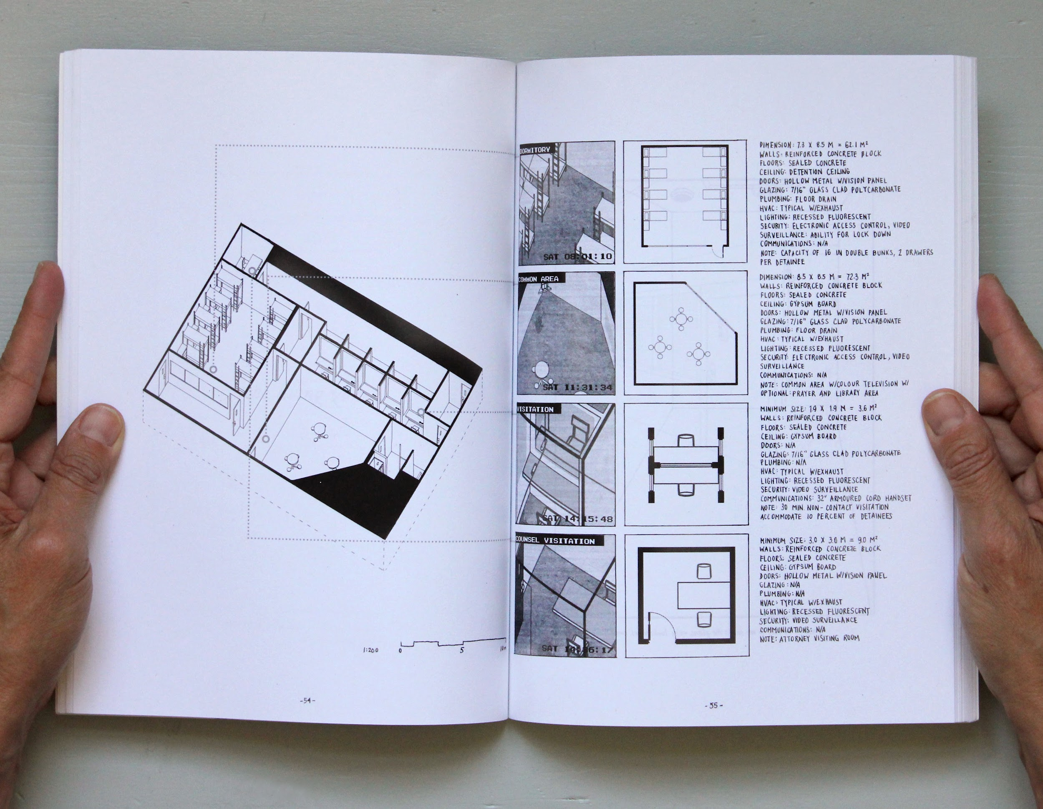
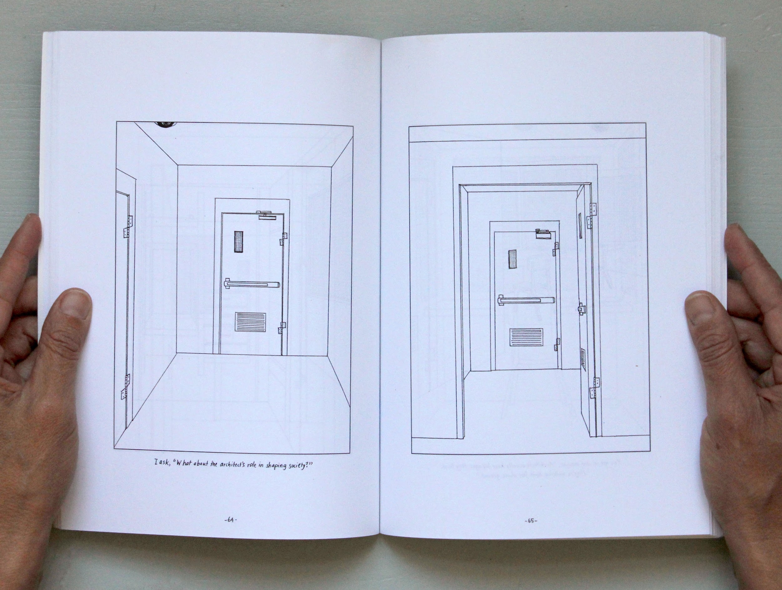

Figures 2 & 3: pages from Tings Chak (2017) Undocumented: The Architecture of Migrant Detention, courtesy of the artist

Tings Chak’s illustrated book Undocumented (2017) takes as its subject the issue of migration. The piece does not refer to a specific news event. It is relevant for this discussion as questions surrounding migration, the treatment of refugees and border control are continuously discussed in the news. Images commonly associated with this issue come in a variety of forms. For example, the widely publicised photograph of the body of two-year old Syrian boy Alan Kurdi lying face-down on a beach in Turkey in 2015 caused an impassioned outcry and a temporary rise in concern for the plight of refugees (Henley et al. 2015). In contrast, Nigel Farage’s ‘Breaking Point’ poster from 2016 that showed a group of people queueing near the Croatian-Slovenian border, and which he used as part of his campaign for the UK to leave the European Union, clearly sought to amplify racists tropes of migrants as ‘alien, invasive hordes’. In parallel with these two iconic examples, the more general discussion regarding the appropriate visual representation of migrants is often troublesome and emotionally charged (Tsakiris 2021). Rather than contributing to this fraught debate itself, Chak’s project focuses on one of the systems surrounding migrants. Her emphasis is on Canadian practices of migrant detention, in other words – systems that exclude migrants from view in everyday public life, diminishing their visibility and status. It leads us to ask what processes control the movement of migrant’s bodies, contributing to their relative invisibility in the public sphere? Like Daniel Heyman’s work discussed above, Undocumented avoids a direct focus on the news story itself, instead examining what lies beyond the frame.
Undocumented, a paperback book of 130 black-and-white printed pages, focuses on Canada’s widespread practice of detaining migrants without the obligatory paperwork in ‘rented beds’ in provincial prisons. People tend to be held in these carceral conditions for about a month, but some find themselves in the prison system for years, without ever having been charged with a crime (Chak 2017: 4). Chak, who is trained as an architect, is interested in the “programmatic violence” (Tschumi 1981: 47) of these spaces – the way the faceless banality of the architecture and the various design decisions underpinning it, enact a form of spatial aggression (ibid: 45) on its involuntary inhabitants. On one of the pages in the book she quotes Hannah Arendt’s reflection on the potential violence of bureaucracy, the idea of a “tyranny without a tyrant” (Chak 2017: 91 quoting Arendt 1969: 33). The title of the book – Undocumented – thus acquires two distinct meanings. On the one hand the word is commonly used to describe migrants arriving in a country without the required paperwork, but on the other hand Chak’s project highlights how the places where migrants tend to be held are themselves ‘undocumented’: faceless buildings, often hidden away on the outskirts of small, regional towns, built to minimum requirements stipulated by way of a merciless bureaucracy. The prisons are inaccessible, unseen by the public, their interiors disorienting in their blandness. The illustrations in Chak’s book aim to counter this invisibility, they help us see them as the embodiment of a crushing bureaucracy designed to erase the people it contains: erase them from the public sphere, but also to erase their sense of identity and individuality.

Chak calls Undocumented an illustrated documentary. Over its pages she uses various visual methods to draw out the quiet tyranny of Canadian practices of migrant detention, often building on her training as an architect. This enables her, for example, to effectively retro-engineer the interiors of prison spaces based on available guidelines and statements outlining the minimum design standards for these types of buildings, without having to visit them in person. Instead she uses various architectural drawing conventions to conjure these spaces on the pages of her book, such as the floor plan, the fly-through and the cutaway axonometric projection (where a three-dimensional rendering of a room is shown at a diagonal angle from above with the ceiling, and occasionally some walls removed to reveal the interior). Her hand-rendered illustrations are sparse and functional, reflecting the cramped and oppressive monotony of these spaces.

Chak’s book contains a small number of other sections too, where she uses transcripts of interviews with migrants held in detention (conducted by aid organisations, campaigners or journalists) as the basis for short graphic narratives that illuminate aspects of their ordeal. But we were more interested in what she achieves by not focusing on people and their experiences. And, as a matter of fact, the story of the migrants themselves is, for the most part, bracketed in her book in favour of a probing, visual rendering of the architecture used for their unjust incarceration. Instead of focusing on human experience, or on a particular event, as most news stories naturally do, Chak’s attention is on the brutality of the barely visible framework that surrounds this particular group of people. The emphasis is not on the figure, it’s on the background, one might say it is on the so-called “negative space”. Undocumented gives us a view of one of the many things that tends to get overlooked in news stories on migration.

The image at breaking point: Catherine Anyango Grünewald

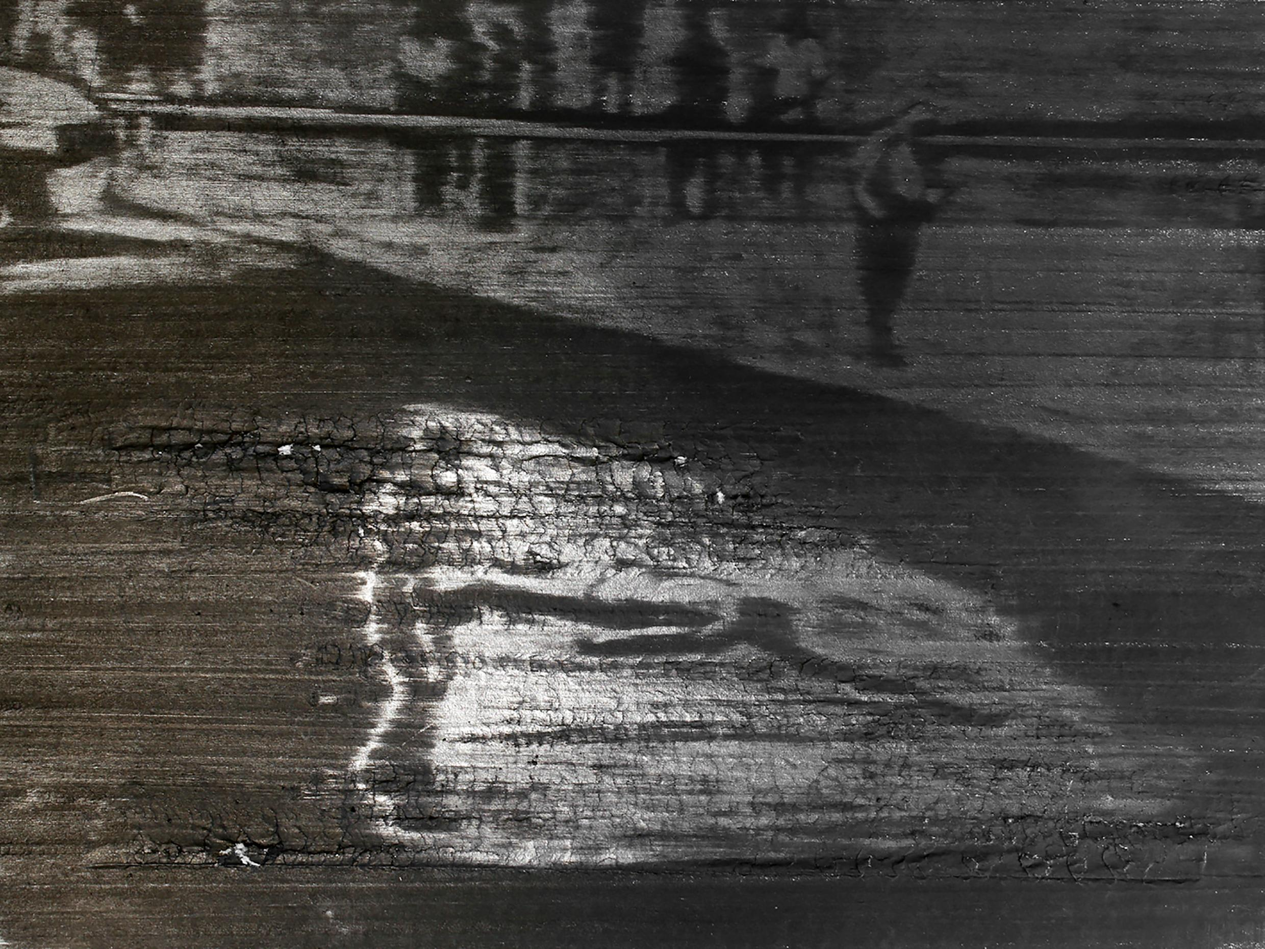
Figure 4: film still from Catherine Anyango Grünewald (2016) Live, Moments Ago (The Death of Mike Brown), courtesy of the artist

Catherine Anyango Grünewald’s piece Live, Moments Ago (The Death of Mike Brown) (2014) takes as its subject the killing of black teenager Michael Brown in Ferguson, Missouri by white police officer Darren Wilson in August 2014. The unarmed teenager was shot dead by Wilson after a brief altercation. This event sparked large-scale unrest, which in some cases led to rioting and looting by angry protesters, enraged by yet another instance of deadly police violence directed at the US’ black population. Both the killing itself and the ensuing protests were extensively covered by global news media outlets, with Twitter playing a major role in the dissemination of these chaotic events (Blackstone et al. 2017). Posts and broadcasts by traditional news media combined with messages from citizen journalists, eye-witnesses and protesters, resulting in a “Tweetstorm” consisting of more than 6 million tweets relating to these events in the days after the killing (Fung 2014).

Illustrator Catherine Anyango Grünewald was not present in Ferguson during this time. For her moving image piece she used a short mobile phone clip from social media as a visual reference that shows the dead body of Michael Brown lying uncovered on the road. In Grünewald’s animation we repeatedly see a looping sequence of Brown’s body with police officers ambling around him. The individual frames for this animation are rendered in graphite on paper. While working on these frames, Grünewald drew the same scene over and over on the same piece of paper, which eventually caused the surface of the paper to crack and rip (Grünewald 2023: 80). As a result the image becomes increasingly unclear during her film’s two minute duration. Towards the end of the piece the drawn image is momentarily replaced by a highly pixelated sequence of live-action footage, possibly the original mobile phone clip, enlarged to the extent of complete illegibility. The short film concludes with a brief, drawn sequence of the body being finally covered by a light cloth.

Reflecting on this piece, Grünewald has spoken about how she intends the work to be an act of homage to Brown (Grünewald 2023: 80). She discusses how the prolonged time she invested in the production of the animation relates to the four long hours that Brown’s body lay uncovered in the hot sun (ibid.). The immediate contrast that arises from contemplating the fast-paced “Tweetstorm” on the one hand and the knowledge of Grünewald’s extended time re-working a snippet of eye-witness media on the other hand, does indeed suggest an interpretation of this piece that focuses on the capacity of illustration to “slow time down” (Coe in Heller 1999: 21). As we also saw with Daniel Heyman’s work, the sustained effort typically invested in the creation of an illustration (or, in this case, an animation) stands in opposition to the fast-paced news cycle, or the immediacy of the digital photograph or video shared on social media. The demands of a laborious practice forces the illustrator to step outside the accelerated media environment into a more reflective space and, by extension, invites the audience to do the same.

While this focus on different tempos is certainly productive, we want to propose an additional reading of Grünewald’s piece. Watching her video we were struck by how, despite its looping repetition of the same scene, the gradual erosion of the drawing meant that we became progressively less sure of what we were seeing. The reiteration and the magnification of the frames of the animation did not pave the way for increased understanding of the event as one might reasonably expect, but resulted in the image starting to break apart. Instead of allowing the viewer to be lulled into the illusion of the image providing a transparent window to the world, our attention is increasingly drawn to the disintegrating surface of the picture itself. The visual apparatus has clearly reached some kind of limit. How does this relate to questions of truth and falsehood? What does this suggest regarding the possibilities of vision or visibility to stake a veridical claim?

American journalist and academic Allissa Richardson’s book Bearing Witness while Black (2020) presents an optimistic view of the possibilities of what she calls ‘Black witnessing’. She characterises this as a defiant, investigative gaze that, with the help of smartphones and social media, is able to call for accountability, challenging us to not look away (2020: 44). But while there indeed have been some instances where video footage played a role in the conviction of a violent police officer (for example in the case of Derek Chauvin’s trial for the murder of George Floyd), the existence of a video recording generally has little effect on court proceedings (Ristovska 2021). For instance, the video of the brutal beating of Rodney King at the hands of the LA police in 1991 caused public outrage, but failed to lead to a meaningful conviction. Even more disturbing is the fact that it was used by the defence to bolster their claims that force was “required” to gain control over King who was believed to possess “superstrength” (The Paley Centre n.d.). In an essay published shortly afterwards Judith Butler reflects on this apparent failure of perception. The video of King’s beating exists in a “racially saturated field of visibility” (1993: 15), they suggest. And they continue: “[To me] the video shows a man being brutally beaten. And yet, it appears that the jury [...] claimed that what they [..] saw in those blows were the reasonable actions of police officers in self defence. [...] This is not simply seeing, an act of direct perception, but the racial production of the visible [...]” (1993: 16). In the context of a society marked by racialized perceptions, says Butler, there can be no simple recourse to the visual as a form of evidence (ibid: 17).

Butler is certainly right that an image is unable to straightforwardly support a truth claim, as much as we might want it to. Racial prejudice alongside other forms of bias can shape our vision and make certain kinds of vistas almost impossible to take in, may that be something unfolding in front of our eyes, or something we see in an image or video. Grünewald herself makes a similar argument regarding this somewhat maddening quality of images – commenting on how their seeming irrefutability can so easily come undone. She writes: “We believe in images like we believe in the law, that they are things that hold together, but these images disintegrate in the same way as those structures do, which we had believed to be solid” (Grünewald 2023: 81).

So, are we suggesting that Grünewald’s piece Live, Moments Ago (The Death of Mike Brown) should be seen as a proclamation of the instability of images? The fact that they don’t stand up to scrutiny, that they are prone to falling apart when we need them the most? Are we saying that eyewitness videos are pointless, since they cannot be relied upon to deliver justice? No, we do not want to make such sweeping statements. The eyewitness and their recording devices are clearly essential in a society's quest for fairness, accountability and justice, to argue otherwise would be pure folly. We interpret Grünewald’s video as staking out the limitations of a particular kind of vision. Having your eyes solely fixated on what is unfolding in front of you and trying to home in on this further and further, again and again (as Grünewald’s looping video does) will not necessarily bring you greater clarity or better insight. A stare that grows too rigid might just corrode your field of vision. Sometimes you need to stand back and zoom out to get the bigger picture.

Conclusion

We began this article by trying to assure you that we are not arguing against empiricism per se, but that we regard the direct witnessing of an event as one important mode of looking amongst many. Yes, when illustrators or other kinds of image makers are where the action is, when they are capturing what is unfolding in front of them, they are in a prime position to create images that tell us something new and vital. But witnessing, like any other form of looking, can also be a narrow vision. It enables you to see some things, while obscuring others. We used this article to highlight and explore other kinds of vision – ways of seeing that unfold at a distance.

All three illustrators we discuss here relate to news events from afar, yes, but what is it that they make us see? What new insights do they bring to the news story, and by what means?
All three examples enable us viewers to see what’s usually outside the frame of visibility. Heyman achieved this by showing a different perspective on Abu Ghraib detainees, filling the gap in news coverage with images that portrayed individuals with dignity and respect, their stories recorded in their own words. Chak drew our attention to the systems of governance that the news event exists within and is shaped by. Using architectural conventions, she visualised what usually exists as invisible exercises of power.

Of the three examples we examined, the conversations we had about Grünewald’s video led us to the overarching claims we make here. Watching her piece made us think of the fact that the view presented by the eyewitness, for all its validity and importance, has its limits too. Images made to document violent acts, often produced in an attempt to hold perpetrators to account, reveal themselves to be maddeningly pliable and open to extraordinary acts of reframing, as Butler pointed out. Watching Grünewald’s video, we, the viewers, are frustrated in our desire to see what is happening, precisely. The more we look, the more the disintegrating surface of the picture disrupts and obscures our field of vision. The window to the event, that the video supposedly offers, becomes increasingly opaque. This reminded us of the limits of images as truth claims. But it also does something else – it throws the focus back on ourselves: What are we hoping to gain from this image? Why are we watching this video? Are there other things we need to consider, other sources of information, in order to ‘see the bigger picture’? The isolated event of Michael Brown’s killing is senseless in its seemingly arbitrary violence. Frustrating our ability to zoom in on the witness footage of his death, Grünewald’s film invites us to zoom out and consider the broader political context the scene exists within. Doing so may develop the viewer’s understanding of the cause for the ensuing protests, encouraging us to “examine the rationalizations for mass suffering offered by established powers” (Sontag 2003: 117).

Violent acts do not just occur spontaneously. The rapidity of the news cycle, however, means that the images we see often centre on the epicentre of the action, showing us horror and devastation as they unfold. But violent acts tend to emerge from lopsided constellations of power, from festering legacies of intolerance and hatred, from cruel and detached bureaucracies managed by docile administrators that result in fierce hostility and sadism. By temporarily distancing ourselves from the action, we can take in larger systems at play and search for ways of making them more visible.

Bibliography

Arendt, H. (1969) ‘Reflections on Violence’, Journal of International Affairs, 23(1), pp.1–35

Bennett, G. (2023), ‘Drawing from virtual travel: Regret, danger and magic’, Journal of Illustration, 10(2), pp. 257–77, https://doi.org/10.1386/jill_00073_1

Blackstone, G. E., Cowart, H. S., & Saunders, L. M. (2017) ‘TweetStorm in #ferguson: How News Organizations Framed Dominant Authority, Anti-Authority, and Political Figures in a Restive Community’, Journal of Broadcasting & Electronic Media, 61(3), pp.597–614.

Brooks, A. (2022) ‘THE WHITE ALBUM: on racialized violence and the witnessing of the witness’, Angelaki – Journal of the Theoretical Humanities, 27(2), pp.72–84, DOI:
10.1080/0969725X.2022.2046373

Brown (no date) Daniel Heyman: I am Sorry It is Difficult to Start. Available at: https://bell.brown.edu/exhibition/daniel-heyman-i-am-sorry-it-difficult-start [Accessed 10 September 2024]

Butler, J. (1993) ‘Endangered/Endangering: Schematic Racism and White Paranoia’, in Gooding-Williams, Robert (Ed.) Reading Rodney King/ Reading Urban Uprising, New York: Routledge, pp.15–22

DePaul Art Museum (2008) Abu Ghraib Detainee Interview Project: Work by Daniel Heyman. Available at: https://resources.depaul.edu/art-museum/exhibitions/Pages/abu-ghraib-detainee-interview-project.aspx [Accessed 03 September 2025]

De Turk, S. (2011) Imag(in)ing Abu Ghraib, Afterimage, 39(1&2), pp.68–70 ​https://doi.org/10.1525/aft.2011.39.1-2.68

Embury, G. and Minichiello, M. (2018) Reportage Illustration. London: Bloomsbury

Gannon, R. and Fauchon, M. (2021) Illustration Research Methods. London: Bloomsbury

Grünewald, C. A. (2023) ‘Empathy and the Past: Outlining, Erasing, and Colouring In, Part 2’, Colouring In: The Past, 3, pp.75–81. Available online: https://www.colouring-in.com/images/uploads/colouring-in-issue-3-the-past.pdf

Heller, S. (1999) Stories unfolding in time and space. Eye 31

Henley, J., Grant, H., Elgot, J., McVeigh, K. & O’Carroll, L. (2015) ‘Britons rally to help people fleeing war and terror in the Middle East’, The Guardian, 3.September 2015, online. Available at: https://www.theguardian.com/uk-news/2015/sep/03/britons-rally-to-help-people-fleeing-war-and-terror-in-middle-east [Accessed 14 September 2024]

Klein, N. (2024) ‘How Israel has made trauma a weapon of war’, The Guardian, 5. October 2024, online. Available at: https://www.theguardian.com/us-news/ng-interactive/2024/oct/05/israel-gaza-october-7-memorials [Accessed 6 October 2024]

LMU.com (no date) Bearing Witness: Daniel Heyman. Available at: https://cfa.lmu.edu/labandgallery/exhibitions/bearingwitnessdanielheyman/ [Accessed 03 September 2025]

McCauley, C. (2015) ‘NAGALAND: Borders, Boundaries, Belonging: Contested spaces and disputed narratives’, Journal of Illustration, 2(2), pp.287–302

Macfarlane, K. (2020) ‘Graphic Witness’, in: Chorpening, K. & Fortnum, R. (Eds.) A companion to contemporary drawing. Hoboken, NJ: John Wiley & Sons, Inc., pp.55–69

Netter, L. (2016) ‘Mapping experience in reportage drawing’, Journal of Illustration. 3 (2), 207–231. DOI:10.1386/jill.3.2.207_1.

Netter, L. (2024) Reportage Drawing: Vision and Experience. London: Bloomsbury

Reim, M. (2019) ‘Reportage: Drawing the Stories’, in: Male, A. (Ed.) A Companion to Illustration. Hoboken, NJ: John Wiley & Sons, Inc., pp.85–101.

Richardson, A. (2020) Bearing Witness while Black: African Americans, Smartphones and the New Protest #Journalism, New York and Oxford: OUP

Shapiro, C. (2023) ‘Andrew Humphreys’ and Olivier Kugler’s The Great Fish & Chips: Indexical pathways in illustration research’, Journal of Illustration. 10(1), pp.97–116. DOI:10.1386/jill_00063_1.

Sontag, S. ([1977] 2008) On photography. London, Penguin.

Sontag, S. (2003) Regarding the Pain of Others. London: Picador

Sontag, S. (2004) Regarding The Torture Of Others. New York Times Magazine. Available at:
https://web.archive.org/web/20170902101726/http://www.nytimes.com/2004/05/23/magazine/regarding-the-torture-of-others.html?pagewanted=all&src=pm [Accessed 10 September 2024]

Taylor, R.E. and Fusco, L. (2021) Remote Sensing. University of the Arts London. ISBN 978–1–5262–0917–7

The Paley Center for Media (n.d.) ‘Trial Story: The “Rodney King” Case: What the jury saw in California v. Powell (TV)’, Paley Archive, online. Available at: https://www.paleycenter.org/collection/item/?item=103096 [Accessed 4. October 2024]

Tsakiris, M. (2021) ‘Refugees in the media: how the most commonly used images make viewers dehumanise them’, The Conversation, 19.November 2021, online. Available at: https://theconversation.com/refugees-in-the-media-how-the-most-commonly-used-images-make-viewers-dehumanise-them-171865 [Accessed 4. October 2024]

Tschumi, B. (1981) ‘Violence of Architecture’, Artforum, 20(1), pp.44–47

Wikipedia (n.d.) ‘Rodney King’, online. Available at: https://en.wikipedia.org/wiki/Rodney_King [Accessed 4. October 2024)

See our more detailed discussion of this point in Colouring In: Truth (Black and Vormittag 2024: 3-10).
Kate Macfarlane (2020: 58-60) discusses the same work, but focuses on materiality and duration, rather than veridical claims.
The four police officers involved in the beating were tried in a criminal case for assault and use of excessive force in 1992 in a state court in California. Three of them were acquitted, with the jury failing to reach a verdict on the fourth. A year later in 1993, the officers were charged again in a civil case in a federal court. This resulted in two of the police officers being charged with violating Rodney King’s civil rights, although the sentences they received were considerably shorter than the sentencing guidelines suggested (Wikipedia n.d.).

