CRCFusionAICADx: Integrative CNN-LSTM Approach for Accurate Colorectal Cancer Diagnosis in Colonoscopy Images Akella S Narasimha Raju^{1***}, Kayalvizhi Jayavel^{2**}, T. Rajalakshmi^{3*,} M. Rajababu^{4*}
Akella S Narasimha Raju¹ (https://orcid.org/0000-0002-3237-2859),
Kayalvizhi Jayavel² (https://orcid.org/0000-0002-6160-1374),
Thulasi Rajalakshmi³ (https://orcid.org/0000-0002-4427-1078)
M. Rajababu⁴(https://orcid.org/0009-0009-7364-8805)
¹Department of Computer Science and Engineering (Data Science)
Institute of Aeronautical Engineering, Dundigul, Hyderabad, Telangana-500043, India
² Department of Creative Computing Institute,
University of Arts London, London, United Kingdom
³ Department of Electronics and Communication Engineering, School of Electrical and Electronics Engineering
SRM Institute of Science and Technology, Kattankulathur, 603203, Chennai, India
⁴Department of Information Technology(IT), Aditya University, Surampalem, -533437, Andhra Pradesh, India
Corresponding author Email (s): a.raju@iare.ac.in,
Contributing authors:: k.jayavel@arts.ac.uk, rajalakt@srmist.edu.in, rajababu.makineedi@aec.edu.in
Abstract
Coloretal Cancer(CRC) is a critical health issue worldwide and is very treatable if diagnosed on time. This paper proposes an innovative CADx system, namely CRCFusionAICADx, that enhances the efficiency of diagnosis by fusing CNNs with LSTM networks and feature integration techniques. Using data from the CKHK-22 colonoscopy image dataset, we preprocess the images into grayscale first and then apply LBP analysis for emphasizing textural features. These are further analyzed using three different pre-trained CNN models: VGG16, DenseNet-201, and ResNet50. These were chosen because of their complementary feature extraction capabilities. The resultant features from grayscale, LBP, and raw images will be fused to create an integrated dataset. To increase variability in the dataset and reduce overfitting for the network, we decided to apply a series of data augmentation techniques, which included zooming in, rotation, and horizontal flipping. By doing so, we expanded the dataset into 57,148 images. This augmented dataset is then used to train a model, RDV-22, which includes an integration of the architectures of VGG16, DenseNet-201, and ResNet50, with CNN and CNN+LSTM layers. The LSTM network learns the temporal dependencies of frames in a sequence and hence allows for more sensitive and specific detection of CRC. CRCFusionAICADx produces very impressive results, where the RDV-22 model produces a testing accuracy of 90.81%, precision of 91.00%, recall of 90.00%, and an F1 score of 90.49% in its results. This gives the model an ROC AUC of 0.98, reflecting very strong discriminatory power. This integrative approach thus shows tremendous promise for early CRC detection by offering a strong diagnostic tool that integrates both spatial and temporal features into a new standard in clinical diagnostics.
Keywords: Colorectal Cancer Diagnosis, Feature Extraction, Fusion CNN Models, Deep Learning, Medical Image Analysis.
- Introduction
A person's health impacts many parts of their lives, including their personal and professional relationships. The need of early identification in improving treatment results is highlighted by the fact that colorectal cancer (CRC) is a major cause of cancer-related death. Despite advancements, the use of deep learning methods to colonoscopy—a crucial test for identifying colorectal cancer—remains lacking. This study is focused on developing a high-tech Computer-Aided Diagnosis (CADx) system to rectify this shortcoming. Utilising colonoscopy images to enhance precision, the system integrates Long Short-Term Memory (LSTM) networks with feature fusion and transfer learning, therefore improving the detection accuracy of colorectal cancer (CRC) [1]. In light of the multifarious health hazards that individuals encounter, it is imperative to undergo annual medical examinations in order to detect and prevent severe conditions at an early stage. Systematic exhaustive examinations are especially critical for individuals who have reached the age of forty or older. Colonoscopy is the primary method of colorectal cancer (CRC) surveillance, as early detection can substantially improve prognosis. Deep learning's potential in medical diagnostics is not yet fully investigated in the context of colonoscopy. This research introduces a new CRCFusionAICADx system that enhances the accuracy of colorectal cancer (CRC) detection using colonoscopy images. The system combines feature fusion with LSTM networks [2].
Carcinomas are particularly perilous diseases due to their potential to cause organ destruction and result in severe consequences. Despite the coexistence of diverse cultures and lifestyles across the globe, many diseases still affect all individuals in an equal manner. Carcinoma, specifically, is renowned for its exceptionally high mortality rates due to the substantial harm it inflicts on the tissues and cells of vital internal organs [3]. Recognised as the third leading cause of cancer-related deaths worldwide, colorectal cancer affects both sexes irreversibly. Region-specific prevalence of this aggressive malignancy is attributable to dietary practices. The length of the large intestine is approximately five feet, and it is composed of four distinct sections [4]. The presentation of colorectal cancer exhibits distinct characteristics in various countries worldwide. The disease advances via distinct phases referred to as in situ, regional, and distant. In the beginning, atypical cells infiltrate the intestinal mucosa, which may develop into malignant polyps. These cells ultimately reach other vital organs after penetrating the intestinal wall from the the bowels. The severity of the condition is indicated by colonic haemorrhage and the presence of blood in the faeces, among other symptoms.
The 2020 colorectal cancer incidence rate in Denmark was 334.9 cases per 100,000 people, a figure that included both males and females. At 179.9 per 100,000 people [5], cancer was the leading cause of death in Mongolia, a statistic that held true for both men and women. In the same year, colorectal cancer accounted for around 10.7 percent of all cancer diagnoses, or 1,931,590 new cases. Looking forward, it was predicted that over 35,385 people in India will be diagnosed with colorectal cancer by 2020. Despite its high curability in its early phases, colorectal cancer (CRC) continues to be a significant health concern. The cornerstone of early detection for CRC has been traditional diagnostic procedures, such as colonoscopy and biopsy [6]. Colonoscopy is a procedure that entails the use of a flexible camera to conduct a visual examination of the colon and rectum, thereby enabling the identification and removal of polyps prior to their malignancy. Nevertheless, the diagnostic accuracy of this procedure is contingent upon the endoscopist's expertise and experience [7].
In order to help doctors provide more reliable and accurate interpretations of colonoscopy images, computer-aided diagnosis (CRCFusionAICADx) systems have emerged in the last few years. Traditional CRCFusionAICADx systems use machine learning algorithms to classify images using information that specialists have carefully retrieved [8] . These systems are limited by the specificity and quality of the hand-crafted features used, despite their shown promise. The most common machine learning algorithms are Random Forests, k-Nearest Neighbours (k-NN), and Support Vector Machines (SVM). Preprocessing and feature selection processes may be somewhat involved when using these approaches ​ [9]. Deep learning has emerged as a potent instrument in medical imaging, providing substantial enhancements over conventional machine learning techniques. Convolutional Neural Networks (CNNs) have emerged as the industry standard for image classification tasks as a result of their capacity to autonomously acquire hierarchical features from unprocessed data. CNNs have been effectively implemented in the diagnosis of colorectal cancer (CRC), utilising extensive datasets to develop models that can precisely identify malignant tissues. In spite of these developments, there are still numerous obstacles:
- Feature Extraction Limitations: If not properly trained, CNNs may still overlook subtle but clinically significant details, despite their ability to learn complex features. Additionally, the complete array of features that are required for an optimal diagnosis may not be captured by individual CNN models.
- Class Imbalance: Class disparity is a common issue in medical datasets, including those for CRC. This occurs when certain conditions (e.g., normal tissues) are overrepresented in comparison to others (e.g., uncommon cancer varieties). Biassed models that perform inadequately on underrepresented classes may result from this imbalance.
- Interpretability: The "black-box" nature of deep learning models, particularly CNNs, is frequently criticized, as it is challenging for clinicians to comprehend and trust the model's decision-making process.
- Temporal Information: The diagnosis of colorectal cancer frequently necessitates the examination of a sequence of images over time, such as those obtained during a colonoscopy. Temporal dependencies are not captured by conventional CNNs, which is a critical factor in the identification of disease progression.
We suggest an updated CRCFusionAICADx system that circumvents these constraints by using LSTM networks, feature fusion, and transfer learning.Our method enhances the system's capacity to acquire a diverse array of features from colonoscopy images by incorporating features from multiple pre-trained CNN models. Fusion models are generated by integrating these attributes, resulting in classifications that are more precise and resilient. Additionally, we implement LSTM networks to integrate temporal information into our diagnostic process. LSTMs are well-suited for sequential data and can capture dependencies across image frames, thereby enhancing the model's capacity to identify subtle changes that are indicative of disease progression. By incorporating transfer learning, we employ pre-trained CNN models to minimise the necessity for extensive training from inception, thereby enhancing the efficiency and ease of implementation of our system in clinical settings. Classifications.
In conclusion, the objective of our proposed CRCFusionAICADx system is to enhance the diagnostic accuracy and reliability of CRC by overcoming the constraints of current methodologies. We provide a comprehensive approach that improves interpretability, incorporates temporal information, enhances feature extraction, and manages class imbalance through the integration of LSTM, transfer learning, and feature fusion. This approach is designed to improve disease detection and prognosis.
The principal aims of the research comprise a thorough methodology for forecasting colorectal carcinoma, comprising a number of pivotal stages:
- A Five-Step Design: The study delineates a systematic five-step process for constructing a resilient prediction system for colorectal carcinoma. This methodical approach guarantees precision and effectiveness in the process of making predictions.
- Image Transformative Process: The original images in the CKHK-22 dataset are subjected to a transformation that results in their conversion into greyscale images containing Local Binary Pattern (LBP) image features. By undergoing this transformation, the dataset becomes more suitable for subsequent analyses. The research centres on the fusion of the aforementioned modified image characteristics, resulting in the formation of three unique and enlightening features. By consolidating the data, the dataset is enhanced, thereby facilitating more precise predictions.
- CNN-Based Classification: In order to commence the detection procedure, the research utilizes classification of colonoscopy images. This pivotal stage utilizes three distinct Convolutional Neural Networks (CNNs) in order to ascertain the cancer diagnosis model that best achieves accuracy. A variety of datasets specifically targeted at cancer diagnosis are utilized in this assessment.
- Classification is performed by individual CNNs utilising Long Short-Term Memory (LSTM) transfer learning. This facilitates the development and adjustment of the models, thereby augmenting their predictive capabilities.
- Fusion and Extended Memory: After that, a fusion convolutional neural network (CNN) is trained using LSTM transfer learning techniques with extended short-term memory to include the combined features. . The optimal model for predicting carcinoma is identified during this phase.
By combining these objectives, a comprehensive framework can be established for the creation of a colorectal carcinoma prediction system that is both precise and effective.
Each section in this meticulously organised paper serves a crucial function in effectively communicating a structured and lucid account of the research. Section 2 comprises an exhaustive literature review that presents a thorough investigation of pertinent previous research, supplying context, significant discoveries, and deficiencies in the current corpus of knowledge. Section 3 provides a comprehensive examination of the research's core, including a detailed account of the materials utilized and a detailed synopsis of the methodologies implemented for data collection, experimentation, and analysis. Section 4 is devoted to a comprehensive discussion of the research's findings, providing a thorough analysis and interpretation of the results so that the reader can completely comprehend their implications. In conclusion, Section 5 presents the study's conclusions, which consist of a synopsis of significant findings, their significance, and possible future directions. This ensures that the research is not only coherently presented but also concludes with a positive outlook. The methodical organisation of this approach directs readers through the research, enabling them to attain a thorough comprehension of every element, starting from the fundamental knowledge obtained from previous studies and culminating in the conclusive insights derived from the current investigation.

- Literature Survey
Colorectal cancer is among the major types of cancers causing mortality worldwide. Moreover, early detection may greatly improve the outcomes in a patient with CRC. The most common screening modalities are diagnostic practices that include colonoscopy and remain the gold standard for diagnosing CRC. However, these diagnostic approaches are time-consuming and may suffer from human error, thus diagnostic inaccuracy, interpretation variability, and even interobserver variability. Recent development in the field of DL and ML has proved quite efficacious in enhancing diagnosis with precision, analyzing images automatically. Among other things, the CNNs coupled with feature extraction from medical images proved helpful in diagnosing various types of cancers, including CRC. Additionally, LSTM networks are recognized for their temporal dependencies and further enhance diagnostic sensitivity through the detection of changes across frame sequences.
Recent studies focused on employing CNNs in the detection of colorectal cancer through improved feature extraction and classification, using transfer learning or feature fusion. Multi-model integration of CNNs, especially those that exploit unique strengths, is often lacking, and very few integration efforts include temporal models, such as LSTMs, to further refine diagnostic precision. Besides, most datasets used in these CRC detection studies have small sizes, limited diversity, and lack augmentation, which greatly affects the performance of the models in clinical scenarios. The comprehensive literature review is presented in Table 1.
Table 1: The Literature Survey
Study | Methodology | Strengths | Limitations | Outcomes
M.S. Kavitha et al. [10] | Analysis of deep learning models for colon cancer detection; emphasis on CNNs and segmentation in endoscopic images | Comprehensive review of deep learning techniques | Specific CNN models not detailed | Feasibility of CNNs in colon cancer prediction confirmed
Jin Li et al. [11] | Classification of lymph node metastasis in colorectal cancer using ML and DL; used 3,364 images | High accuracy through transfer learning; integration of multiple machine learning methodologies | Transfer learning results limited without full training | Achieved best accuracy of 75.83% and AUC of 0.7941 with transfer learning
M.M. Srikantamurthy et al. [12] | CNN-LSTM fusion model for breast cancer subtypes; VGG16, ResNet50, Inception models with Adam optimizer | Effective image classification through CNN-LSTM fusion | Small dataset size limits generalizability | Demonstrated high efficacy in image classification
Mai Tarwat et al. [8] | Comprehensive review of ML and DL techniques for colon cancer detection | Covers wide range of methods useful for early detection | Lacks in-depth focus on specific methods due to complexity | Highlights early cancer detection benefits using ML/DL methodologies
Mahmoud Ragab et al. [13] | SMADTL-CCDC algorithm combining dense-efficient-net and DHNNs for CRC diagnosis | Innovative approach with slime mould-inspired design | Limited dataset and image ratios restrict larger application | Outperformed state-of-the-art models in CRC detection
Pouria Parhami et al. [14] | Cancer subtyping using deep neural networks; uses regularization, clustered gene filtering, and indexed sparsity reduction | Improved model efficiency with regularization and sparse data filtering | Specific models not disclosed; limits reproducibility | Demonstrates hereditary mutation's role in cancer cases, validated with cross-validation on TCGA dataset
Nguyen Thanh Duc et al. [15] | Colon-Former architecture for polyp detection; transformer and CNN-based model | Lightweight, encoder-decoder architecture allows efficient multi-scale feature management | Focuses on one model and limited datasets | Achieved high accuracy in polyp detection, outperforming complex algorithms
Meng et al. [16] | Polyp detection using GNNs with an Attention-Enhancement Module for colonoscopy image segmentation | Localizes polyps accurately, capturing perimeter and volume data | Challenging to pinpoint polyp location precisely | Performs well in malignant tumor detection but faces limitations in exact localization
Sharma et al. [17] | Ensemble classifier with ResNet101, GoogleNet, Xception for CRC lesion classification | High sensitivity and specificity in identifying malignant polyps | Limited to three CNN models and focuses on specific datasets | Ensemble classifier achieved 96.66% specificity, 98.3% sensitivity on Aiche and Kvasir datasets
Saito et al. [18] | CAD system using GoogleNet CNN model to classify anatomical colon images in automated colonoscopies | Demonstrates high accuracy in identifying colon cancer risk across anatomical regions | Only uses GoogleNet, lacks dataset diversity | Achieved 91.7% accuracy, effective across multiple colon sections
A. Karthikeyan et al. [19] | Integration of CNNs with ranking algorithms for CAD in colorectal cancer diagnosis | Reduces manual diagnostic subjectivity, improves histological diagnostic accuracy | Labor-intensive, subject to variability in real-time pathology setups | Achieved high precision in malignant cell detection, supports histology automation

Research Gap
While some studies have already used both CNNs and LSTM networks separately for the diagnosis of CRC, the literature is still incomplete regarding the comprehensive integration of fused features through the combination of CNNs and LSTM that emphasizes the accuracy of detection. In particular, not many works used the power of three pre-trained CNNs, namely, VGG16, DenseNet-201, and ResNet50, in constructing a multi-dimensional feature space that may enhance diagnostic robustness. Moreover, there is little investigation into the combination of grayscale, LBP, and augmented image data in order to create a more varied training set similar to those encountered clinically. Thus, this paper fills these knowledge gaps and introduces an entirely new CADx system, CRCFusionAICADx, that presents an improved detection of CRC by integrating CNN with LSTM based on feature fusion and data augmentation to improve diagnostic performance and increase the generalizability of the model in clinical applications.

- Materials and Methods
The main goal of this study is to find ways to detect colorectal cancer with cutting-edge methods, particularly by utilising the power of deep learning and computer-aided diagnosis (CRCFusionAICADx). [20]. The system's essence is effectively encapsulated by the appellation CRCFusionAICADx. "CRC" emphasises its emphasis on colorectal cancer, "Fusion" underscores the incorporation of features from multiple CNNs, and "AI" signifies the utilisation of artificial intelligence. Finally, the term "CADx" is a clear indication that it is a Computer-Aided Diagnosis system, rendering the name both descriptive and informative. As demonstrated in Figure 1, the research investigates a comprehensive analysis with the objective of forecasting colorectal cancer. The subsequent procedures provide a perceptive demonstration of how a block diagram can be efficiently employed to generate precise prognostications regarding this ailment.
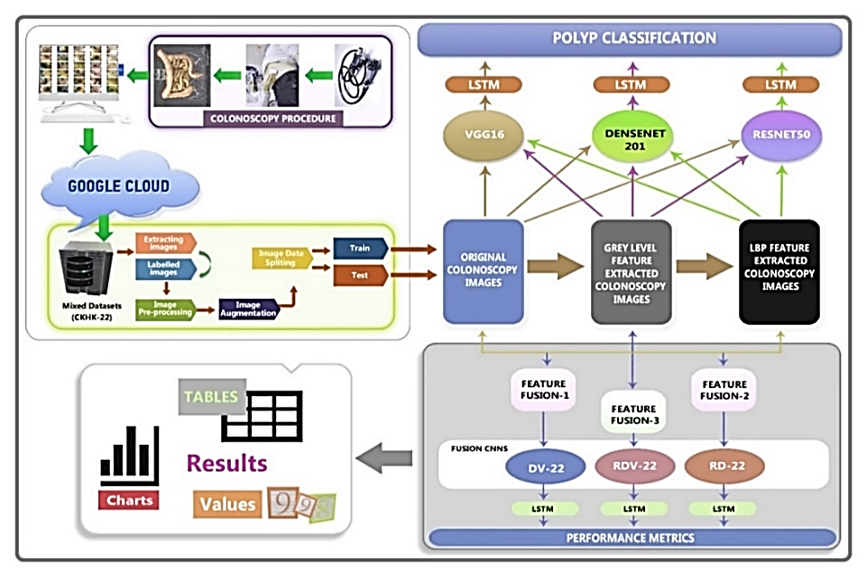
Figure 1: The CRCFusionAICADx system's block diagram for colorectal cancer prediction

3.1. Process for Colonoscopy
The colon's critical function in metabolism necessitates regular colonoscopies to assess intestinal health. The patient is meticulously observed during this examination using a medical instrument known as a colonoscope, which is equipped with a camera and a light source. The surgeon skilfully inserts a small, flexible tube into the patient's rectum during the procedure. The colonoscope then traverses the entire length of the colon, providing a comprehensive examination. This exhaustive test is indispensable for the early detection of any irregularities or diseases that could potentially compromise colon health. Regular colonoscopies are crucial for safeguarding the digestive tract from colorectal maladies, as its protection commences with early detection.
3.2. Datasets
Anyone with an internet connection may now access medical motion images regarding colonoscopy, which has significantly increased accessibility. Notable datasets such as the CVC Clinic DB [21], Kvasir2 [22], and Hyper Kvasir [23] are freely accessible from various online sources. These datasets vary widely in size, with some containing as few as two class labels and others containing up to twenty-three class labels.
An innovative approach was implemented in this investigation by integrating the Hyper Kvasir, Kvasir2, and CVC Clinic DB image datasets to generate a comprehensive mixed dataset known as CKHK-22. This fusion produced a dataset that included a total of 19,621 images contributed by all classes and twenty-four class labels. The process ultimately succeeded, despite the initial challenge of classifying all twenty-four classes. However, it revealed a noticeable class imbalance, with certain classes being disproportionately represented.
The study concentrates on the ten most balanced classes in order to rectify this imbalance, as they are more equitably represented. Table 2 provides a comprehensive overview of the dataset's multiclass requirements.
Table 2: CKHK-22 Dataset Specifications
Class | Original Images | Augmented Images | Total Images
bbps-0-1 | 653 | 1,959 | 2,612
bbps-2-3 | 1,148 | 3,444 | 4,592
cecum | 2,009 | 6,027 | 8,036
dyed-lifted-polyps | 2,003 | 6,009 | 8,012
dyed-resection-margins | 1,990 | 5,970 | 7,960
Non-Polyps | 818 | 2,454 | 3,272
polyps | 818 | 2,454 | 3,272
pylorus | 2,150 | 6,450 | 8,600
retroflex-stomach | 765 | 2,295 | 3,060
z-line | 1,933 | 5,799 | 7,732
Total | 14,287 | 42,861 | 57,148

The CKHK-22 dataset comprises 14,287 original colonoscopy images that have been categorised into fourteen distinct classes, each of which represents a distinct characteristic or condition of the gastrointestinal tract. The following courses are included:
- bbps-0-1: A collection of 653 images that illustrate distinct phases of abnormalities.
- bbps-2-3: 1,148 images that illustrate distinct phases of abnormalities.
- cecum: 2,009 images that concentrate on a specific anatomical region.
- dyed-lifted-polyps: 2,003 images of elevated polyps.
- dyed-resection-margins: 1,990 images of treated areas.
- Non-Polyps: 818 images that depict a robust state.
- polyps.:818 images depicting aberrant growths.
- Pylorus: 2,150 images that concentrate on a specific anatomical region.
- retroflex-stomach: 765 images.
- z-line: 1,933 images.
The implementation of data augmentation techniques (zooming, angling, and rotation) resulted in a total increase of 57,148 images. These images are utilized to facilitate the analysis of colonoscopy images and the detection of diseases by training and evaluating algorithms and models in the field of medical imaging. Figure 2 displays representative trial images from the CKHK-22 mixed dataset.
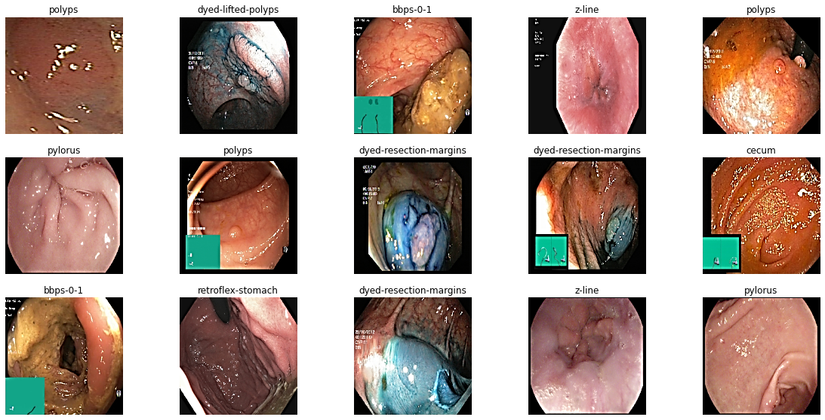
Figure 2. The CKHK-22 Trial Datasets
3.3. Image Pre-Processing
Data preprocessing is a critical step in ensuring the quality and consistency of input data for the purpose of training deep learning models. The CKHK-22 colonoscopy image dataset was employed in this study, which includes a diverse array of images that depict various anatomical sites and conditions associated with colorectal cancer.
- Image Resizing: The CKHK-22 collection contained actual images of varied sizes. In order to standardise the input for our CNN models, all images were resized to 224x224 pixels. This resolution was selected to strike a balance between the preservation of critical image details and computational efficiency.
- Augmentation Images: We applied several augmentation of images techniques to the CKHK-22 dataset in order to enhance the model and prevent overfitting. Techniques included introducing variation through 20% zoom-in, horizontal flipping to effectively double the data size, and 15-degree rotation to provide multiple points of view for the same image. Together, the enlargements pushed the total number of images from 14,287 to 57,148 and made the model more generalizable while, at the same time balancing the class imbalance with this more diversified training sample.
- Dataset Splitting: The preprocessed dataset was divided into training (70%) and testing (30%) subsets. This division guarantees that the model is trained on a substantial portion of the data and subsequently evaluated on unobserved images to evaluate its performance.
Ultimately, the images were subjected to the local binary patterns (LBP) transformation and grayscale. When using these methodologies to feature extraction in image analysis, the goal is to make the model better at recognising patterns and structures in the images. The images were processed and subsequently prepared for convolutional neural network (CNN) training and testing, ensuring that the data was adequately prepared for the subsequent phases of the predictor system for colorectal cancer.
3.4. Transform colour images into grayscale images
"Utilizing grayscale images [24], as implemented in this study, delivers a host of compelling benefits, each contributing to the overall enhancement of image handling and analysis. The strategic shift from color to grayscale images is driven by a range of pivotal advantages:
- Optimized Storage Efficiency: Grayscale images offer a significant reduction in file size compared to their color counterparts. This streamlined storage not only conserves valuable space but also simplifies the process of image storage and transmission, leading to both practical and cost-effective advantages.
- Accelerated Processing: Grayscale images demand notably fewer computational resources during editing and processing. This transformation results in swift processing times and alleviates the computational load, greatly boosting operational efficiency.
- Enhanced Interpretability: Grayscale images, with their minimalistic color palette, are inherently easier to interpret and analyze. They eliminate visual complexity, making it easier to identify critical patterns and features, an invaluable asset in domains like medical imaging, particularly in the context of colonoscopy images.
- Heightened Contrast: Grayscale images often exhibit heightened contrast compared to their colored counterparts. This heightened contrast sharpens distinctions between different shades of gray, greatly improving the recognition of intricate details.
- Consistency and Standardization: In specific applications, especially within the realm of medical imaging, grayscale images reign supreme due to their uniformity and standardized nature. Their integration ensures the standardization of diagnostic processes, expediting critical assessments.
Grayscale Value = 0.299R + 0.587G + 0.114B (1)
To facilitate the transformation from color to grayscale, a sophisticated formula, outlined in equation (1), accurately computes the grayscale value for each pixel [25]. This formula judiciously considers the contributions of the red (R), green (G), and blue (B) color channels, extracting the grayscale values. These grayscale images are instrumental in training and evaluating convolutional neural networks (CNNs) for the prediction of colorectal carcinoma.
In sum, this strategic conversion is pivotal in streamlining storage, supercharging processing speeds, simplifying visual comprehension, bolstering contrast, and most importantly, ensuring a uniform and consistent approach, especially critical in medical imaging applications. The inclusion of Figure 3 showcases sample grayscale images from colonoscopy datasets, illustrating the real-world impact of this conversion."
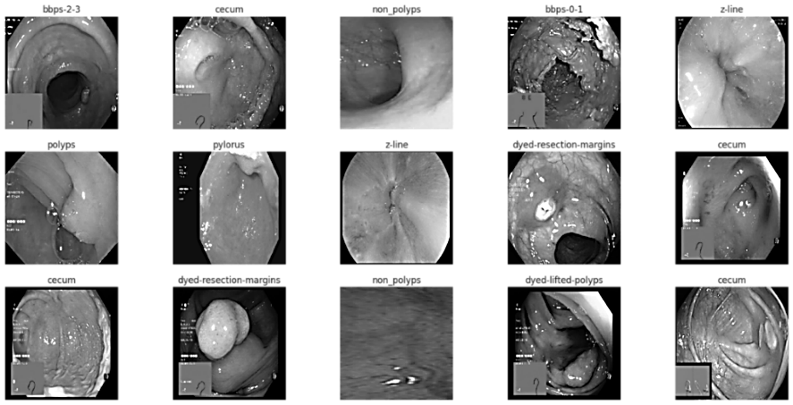
Figure 3: The CKHK-22 sample Grey level dataset images
This conversion of images into grayscale in CRCFusionAICADx will reduce the computational load which the model would otherwise carry, thus the former looks at texture and structural characteristics important to the diagnosis of CRC. The variations mainly related to shape, contrast, and intensity are generally more associated with abnormalities in medical imagery than the color details are. The ability to remove color allows the model to filter out noise and process images much more efficiently, an ability very valuable in computationally constrained settings. While color information would have been useful in bringing out vascular patterns or other chromatic changes associated with CRC, our experiments revealed that grayscale preprocessing, coupled with LBP, generated a stable feature set with minimal loss of diagnostic capability. It ensures a proper balance between accuracy and computation in real-world clinical environments.
3.5. Transform grayscale images into LBP (Local Binary Pattern) images
The process of transforming grayscale images into Local Binary Pattern (LBP) images brings about a substantial improvement in the complexities associated with the interpretation of visual data [26]. The robust texture descriptor LBP demonstrates its versatility as an instrument with numerous applications:
- Texture Analysis: LBP is an essential tool for texture analysis as it provides a precise depiction of the local structure and patterns of an image. It is exceptionally adept at deciphering the numerous textures that comprise the visual terrain.
- Feature Extraction: A feature extractor is an indispensable tool in the domains of machine learning and pattern recognition, where LBP's capabilities are indispensable. LBP images serve as a foundation for extracting features, which are crucial for various image analyses and training classifiers.
- Object Recognition: Cameras equipped with LBP technology are essential in advancing object recognition. Extracting LBP features from images is a vital first step in training classifiers, enabling them to accurately identify a diverse range of objects. This process significantly enhances the field of object recognition.
- Illumination Robustness: The luminance LBP demonstrates a moderate degree of sensitivity to fluctuations in light intensity. The dependability of LBP in diverse lighting contexts is enhanced by its resistance to global illumination fluctuations, which is a result of its regional structure-based design.
- Computational Efficiency: LBP's computational efficacy and straightforwardness distinguish it as the method of choice for real-time applications requiring texture description. The rapid calculation of its features makes it highly suitable for real-time image analysis.
The utilization of LBP within the framework of colonoscopy image analysis is a crucial instrument for the extraction of features. By employing this method, grayscale images are efficiently converted into binary matrices, which are then utilized to differentiate between healthy and diseased tissue. This CRCFusionAICADx system naturally incorporates LBP due to its resistance to illumination variations and computational efficiency, highlighting its importance in medical imaging [27].
A quick and effective texture description is the Local Binary Pattern (LBP). It analyses the 3x3 neighbourhood around each pixel in a picture and provides a label to it. In order to get a binary number out of it, we compare the value of the centre pixel to its neighbours and then apply a threshold. We may determine a pixel's LBP value by following these steps:
$LBP\left(x_{C},y_{C}\right)=\sum_{n-0}^{N-1}{s}\left(i_{n}-i_{C}\right)⋅2^{n})$ (2)
- (x_{c}​,y_{c}​) are the coordinates of the center pixel.
- 𝑁 is the number of neighbors (typically 8 for a 3x3 neighborhood).
- 𝑖_{𝑐} represents the brightness of the central pixel.
- 𝑖_{𝑛} represents the brightness of the 𝑓n-th neighbouring pixel.
- 𝑠(𝑥) is a thresholding function
The grayscale images obtained from datasets related to colonoscopy have been judiciously converted into LBP representations in order to facilitate convolutional neural network (CNN) training and evaluation. Figure 4 presents a visual compilation of exemplary LBP image datasets, emphasizing the concrete consequences of this conversion.

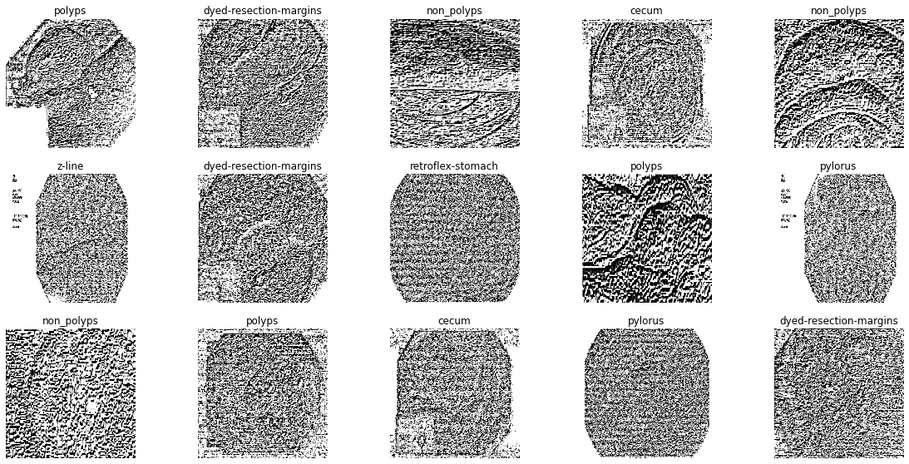
Figure 4: Images from the CKHK-22 LBP sample dataset
3.6. Image categorization utilizing Convolutional Neural Networks (CNN).
When it comes to deep learning and medical applications, Convolutional Neural Networks (CNNs) play a crucial role, especially in image classification. [28] These networks are vital in colorectal cancer diagnostics and operate in conjunction with the CRCFusionAICADx system. This collaboration focuses on the CKHK-22 dataset, where CNN models are employed to label numerous images. Convolution, pooling, activation, dropout, and finally joining with neural networks are the phases that convolutional neural networks (CNNs) encounter when evaluating colonoscopy pictures. Accurate image categorization [29, 30],is critical for colorectal cancer diagnosis and is meticulously evaluated through this process.Here, three well-known CNN models—VGG-16, DenseNet-201, and ResNet-50—are evaluated using the CRCFusionAICADx system. Several image datasets, such as original, grayscale, and Local Binary Pattern (LBP) images, are used to evaluate these models and choose the one that gives the best accuracy. Beyond evaluating individual models, the approach also involves combining the best features of ResNet-50, DenseNet-201, and VGG-16 into a single fusion model. This fusion strategy produces three hybrid models with enhanced performance potential: DV-22, RD-22, and RDV-22. These models are rigorously compared with other available models to evaluate their effectiveness in detecting colorectal cancer. Table 3 lists these newly proposed names for the fusion models, representing a significant advancement in colorectal cancer detection by integrating state-of-the-art CNNs.
We chose VGG16, DenseNet-201, and ResNet50 as feature extractors since these three have complementary strengths in capturing diverse image features that are important for colorectal cancer diagnosis. VGG16 has many more deeper layers, which are useful when capturing hierarchical features; hence, it is good to go for the detection of detailed structures within colonoscopy images. In DenseNet-201, densely connected layers enhance feature reuse by capturing both low-level and high-level features with efficiency; hence, it reduces the risk of overfitting on smaller datasets. ResNet50's residual connections help to solve the vanishing gradients problem. It lets the network be deep while performing very well. Combining these architectures, CRCFusionAICADx leverages the unique advantages of each model. The two sources collectively create a more robust and complete feature set that outperforms the diagnostic performance of any standalone CNN model. Thus, we can conclude from this wide experimentation that the proposed combination outperforms any other model in terms of accuracy and precision, and recalls an enhanced colorectal cancer diagnostic potential.
Table 3: Proposed Names for Fusion Models
Fusion Model | Proposed Name
DenseNet-201 + VGG-16 | DV-22
ResNet-50V2 + DenseNet-201 | RD-22
ResNet-50V2 + DenseNet-201 + VGG-16 | RDV-22
- The initial fusion model, DV-22, is a combination of DenseNet-201 and VGG-16. This combination takes use of DenseNet-201's deep learning skills and VGG-16's powerful capabilities. Together, they hope to get better results in the detection of colorectal cancer.
- ResNet-50V2 and DenseNet-201 make up the second fusion model, RD-22. This model combination aims to leverage ResNet-50V2's advanced learning capabilities with DenseNet-201's rapid feature extraction.. The goal of this fusion model is to improve cancer detection sensitivity even more.
- RDV-22, the most complete fusion model, combines the advantages of three different CNN architectures—ResNet-50V2, DenseNet-201, and VGG-16. By integrating the strengths of two well-known models, this all-encompassing method aims to provide a complete and highly accurate methodology for identifying cases of colorectal cancer.
In conclusion, these fusion models provide a methodical way to combine the strengths of several CNN designs. It is hoped that by combining these models, accuracy and efficiency in the detection of colorectal cancer may be increased.
Merging numerous distinct models into a single, more robust, and all-encompassing model constitutes the process of "Model Fusion." A consolidated model is derived from the evaluation of six distinct models within the context of this Computer-Aided Diagnosis (CRCFusionAICADx) system for colorectal cancer [31]. By combining the six models, we may get the one that is most relevant for colorectal cancer diagnosis. Illustratively depicted in Figure 5 is a dataset sample that Convolutional Neural Networks (CNNs) employed to classify images. Each architectural configuration investigated in this CRCFusionAICADx system contributes to the extraction of image features. The extraction of these visual features relies heavily on convolution, as they are fed into the maximum pooling layer and contribute to the process.
Implementing the activation values of Rectified Linear Units (ReLUs) within the network follows the creation of the neural network architecture and the establishment of connections. With these parameters, the network is much better able to detect intricate image patterns and features. The last step of the multi-class images classification process is to apply a SoftMax layer, which helps to provide probability ratings for every class. [32].
3.6.1. Transfer Learning Procedure
Transfer learning takes advantage of pre-trained models on big datasets to improve the performance of models on particular tasks. For this study, we used three CNNs: VGG16, DenseNet-201, and ResNet50. The purpose of optimising these models was to make colorectal cancer diagnosis easier.
- Model Selection: We chose the VGG16, DenseNet-201, and ResNet50 models because of their track records of success in image classification tasks. These models were pre-trained using the ImageNet dataset, which contains millions of images with tags in hundreds of classifications.
- Feature Extraction: We used the lower layers as feature extractors and removed the higher layers from these pre-trained models. Subsequently, the extracted features were incorporated into our custom layers for additional processing.
- Custom Layers: In order to customise the pre-trained models for our particular assignment, we implemented custom layers, which encompassed:
- Global Average Pooling: By reducing the feature maps' spatial dimensions, this layer produces a single value for each feature map.
- Dense Layer: Using a softmax activation algorithm, this fully connected layer produces class probabilities.
- Fine-Tuning: The whole model, including the new and pre-trained layers, was fine-tuned using the training dataset. This entailed a minor adjustment to the weights of the pre-trained layers to more closely align with our data, while the custom layers were substantially trained.
- Transfer learning improves the efficacy of models by employing pre-trained models on extensive datasetsIncorporating Long Short-Term Memory (LSTM) networks to detect data dependencies over time improves the system's ability to understand complicated patterns by further integrating CNN properties.
The primary objective of this intricate procedure is to utilize Convolutional Neural Networks (CNNs) for precise categorization, which is fundamental for improving the identification of colorectal cancer. Finding the best CNN models is a breeze with the CRCFusionAICADx system's comprehensive assessment approach. It also delves into fusion models like DV-22, RD-22, and RDV-22 that use a combination of CNN architectures to improve colorectal cancer diagnosis performance and accuracy.
The many designs investigated by the CRCFusionAICADx (Computer-Aided Diagnosis) system are visually shown in Figure 5. The system's capability to classify and analyse medical pictures, such as those associated with colorectal cancer, relies heavily on this collection of architectures.
  - The CNN Design for the CRCFusionAICADx System: The image-classification workflow in CRCFusionAICADx revolves on this architecture. It uses convolutional layers to efficiently extract key information from input images, paving the way for more in-depth analysis in later phases.
- ResNet-50, as shown in Figure 5(b), is a crucial part of the CRCFusionAICADx infrastructure. Well-known for its deep residual learning capabilities, it performs very well when interpreting complex patterns within medical images.
- Figure 5(c) displays the DenseNet-201 architecture, a crucial component of the system's deep learning capabilities. Its exact picture classification is made possible by its thick interlayer connections, which also improve feature extraction.
- The VGG-16 architecture, shown in Figure 5(d), is a significant factor in the CRCFusionAICADx system's efficacy. VGG-16 is an essential part of the framework because of the depth and simplicity with which it offers a firm grounding for precise image analysis.
- Important to the feature fusion process of the CRCFusionAICADx system is the RDV-22 architecture, which is described in Figure 5(e). It's crucial in fusing image features to provide enhanced representations for better diagnostic precision.
It is important to note that in these designs, not only do the image features undergo processing, but the extracted features also interact with the maximum pooling layers to improve the system's performance. By enhancing the CRCFusionAICADx system's capability to categorise and diagnose medical images, this comprehensive approach showcases the architectural ensemble's significance in spearheading the expanding field of imaging analysis in medicine.
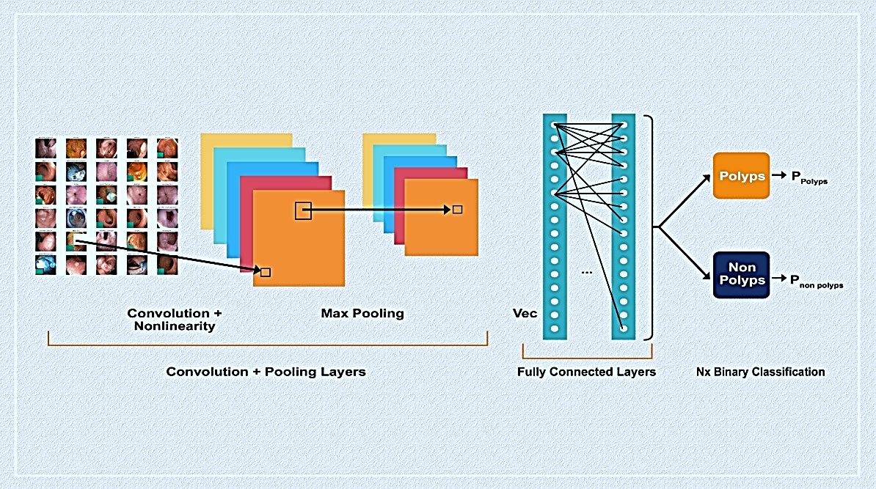
(a)
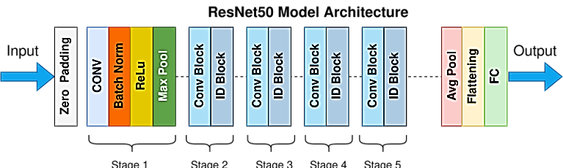
(b)
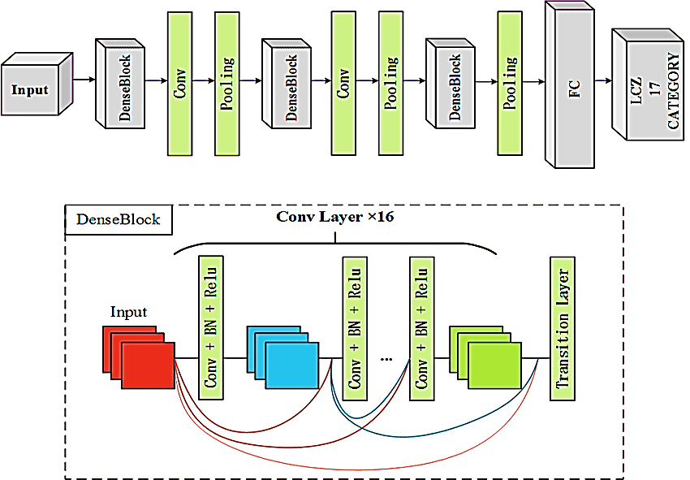
(c)
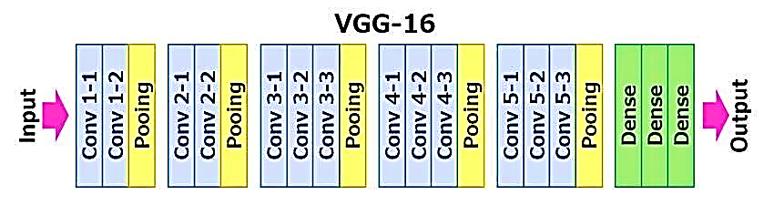
(d)
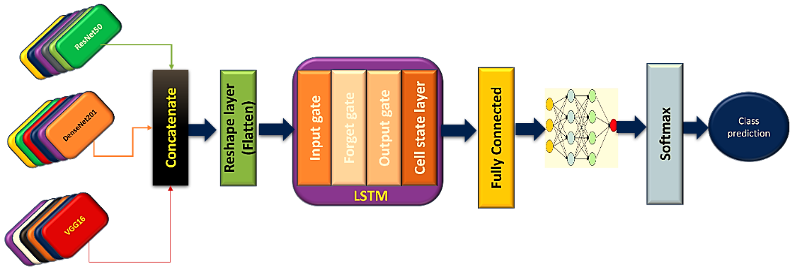
(e)
Figure 5: (a) CNN Architecture in CRCFusionAICADx system (b) ResNet-50 Architechture (c) DenseNet-201 Architecture (d) VGG-16 Architecture (e) RDV-22 Architecture
Both independent and fusion models have their advantages when it comes to classifying colonoscopy images for medical purposes. The diagnostic of colorectal cancer is an extremely critical responsibility, and this deep learning method is of great assistance. The ability to understand someone else's perspective is crucial to making an accurate and timely cancer diagnosis. Table 4 offers a full overview of the overall training parameters available to us by providing a breakdown of the parameters associated with the suggested Convolutional Neural Networks (CNNs), including both the global and per-CNN details.
Table 4: The variety of parameters in the CNN model.
CNN Model | Year Introduced | Total Parameters | Trainable Parameters | Non-Trainable Parameters | Number of Layers
ResNet-50v2 [33] | 2016 | 25,933,975 | 2,369,175 | 23,564,800 | 50
DenseNet-201 [34] | 2018 | 19,429,463 | 1,107,479 | 18,321,984 | 201
VGG-16 [35] | 2014 | 15,314,391 | 599,703 | 14,714,688 | 16
DV-22 | 2022 | 34,742,374 | 1,705,702 | 33,036,672 | 217
RD-22 | 2022 | 45,361,624 | 3,474,840 | 41,886,784 | 251
RDV-22 | 2022 | 60,675,604 | 4,074,132 | 56,601,472 | 267
The importance attributed to every CNN architecture outlined in the data regarding image classification and analysis cannot be exaggerated. It is crucial to initiate a thorough investigation of these architectural frameworks, with particular attention given to the strata delineated in Table 3..
- ResNet-50v2, which was introduced in 2016, is a deep neural network consisting of fifty distinct layers. The astounding number of parameters in this architecture is 2,59,33,975, of which 23,69,175 are trainable and 2,35,64,800 are non-trainable. ResNet-50v2's capability to capture intricate image features is attributed to its extensive layer architecture, rendering it well-suited for intricate image classification tasks.
- DenseNet-201 (2018): Debuting in 2018, DenseNet-201 is an architecturally exceptional model comprising 201 layers. The system comprises 1,94,29,463 parameters in total, of which 11,07,479 are trainable and 1,83,21,984 are non-trainable. DenseNet-201 is distinguished by the dense interlayer connections that facilitate the smooth transmission of information. The dense connections facilitate the extraction of features, thereby enhancing the capability of the model to classify intricate medical images.
- VGG-16 (2014): VGG-16, which was founded in 2014, has gained recognition for its straightforwardness and comprehensiveness. In its sixteen strata, there are 1,53,14,391 parameters in total. 5.99,703 of these parameters are amenable to training, whereas 1,47,14,688 are not. Although it has a reduced number of layers in comparison to certain alternatives, VGG-16 exhibits exceptional efficacy in the domain of image analysis, rendering it a valuable resource for medical image classification endeavours.
- DV-22 (2022) is an innovative architectural design that debuted in 2022 and comprises a total of 217 layers. The total number of parameters is 34,742,374, of which 1,705,702 are trainable and 33,036,672 are non-trainable. The extensive layering enables DV-22 to perform complex image analysis tasks and is crucial to the image feature integration of the CRCFusionAICADx system.
- RD-22 (2022): Initiated in 2022, RD-22 comprises a comprehensive 251-layer architecture. The model includes a total of 4,53,61,624 parameters, of which 34,74,840 are trainable and 4,18,86,784 are non-trainable. Due to its substantial depth and parameter count, RD-22 demonstrates exceptional performance in intricate image processing and classification endeavours.
- RDV-22 (2022): An additional architecture unveiled in 2022, RDV-22 is a multi-layered complex system. The total number of parameters is 60,675,604, of which 4,074,132 are trainable and 56,601,472 are non-trainable. The RDV-22's capacity to capture intricate image details is significantly improved by its numerous layers, which renders it an indispensable element in the feature fusion and classification of the CRCFusionAICADx system.
In order to excel in a variety of medical image analysis applications, each of the above Convolutional Neural Network (CNN) architectures is endowed with a unique combination of layers and parameters. The complexity and profundity of these systems empower them to address the challenging endeavour of image classification, which ultimately aids in the progress of the CRCFusionAICADx system and its pivotal function in the diagnosis of colorectal carcinoma.Following an initial evaluation of the CRCFusionAICADx framework utilising the VGG-16 and individual CNN models, the evaluation of the RDV-22 fusion model comes into focus. This requires performing exhaustive experiments on a variety of convolutional neural networks (CNNs) within these models, ranging from simple to complex. [36].
Experimental investigations with both individual and combined CNNs have primarily focused on feature extraction. However, the application of CNN maps for filtering has often been limited to a single image set. Transfer learning offers a more adaptable approach, allowing pre-trained CNN layers to be incorporated into a new model [37]. Transfer learning is primarily the process of fine-tuning a machine learning model to target a specific problem or dataset, thereby enabling the model to effectively address unique challenges. One of the steps in this process is the adaptation of a model from one dataset to another. It is important to note that the final convolutional layer is a critical factor in the determination of the object recognition outcome in the context of CNNs.
3.7. Fusion of features
Several formats, including the original, grayscale, and LBP images, are used to convert the retrieved features. Convolutional neural networks (CNNs) like ResNet-50, DenseNet-201, and VGG-16 include these feature patterns [38] . Integral to this method is the idea of feature fusion, which stresses the significance of merging separate characteristics. The Feature Fusion-1 is the end product of combining original and grayscale features. As an alternative, Feature Fusion-2 combines LBP with image-derived grayscale features. And lastly, Feature Fusion-3 takes a holistic view by merging all features into one [39].The feature fusion datasets for the fusion CNN models DV-22, RD-22, and RDV-22 are then fed into these models. Various CNN models have been used to explore the feature fusion process, each achieving varying levels of success. The final step in these investigations involves evaluating the fusion CNN models and different feature fusion techniques [40, 41]. Ultimately, the model that exhibits the best overall performance in recognizing colorectal carcinoma is identified.
The significance of feature fusion in the identification of colorectal cancer resides in its ability to optimise the diagnostic process by capitalising on the advantages of distinct feature patterns. Feature fusion functions as a unifying mechanism by integrating diverse data representations, including original, grayscale, and LBP images, which each contain distinct insights into the underlying pathology. The fusion process enhances the information at hand for analysis by generating a more comprehensive and robust dataset through the merging of these features.Feature fusion facilitates a comprehensive evaluation of the images by capturing intricate details, structural information, and textures that might otherwise be disregarded if each feature were evaluated separately. When considering the identification of colorectal cancer, this comprehensive approach is crucial, as it guarantees the inclusion of all essential information. By capitalising on the various features of the images, it enables the CRCFusionAICADx system to generate predictions with greater precision.
Furthermore, through the utilization of fusion datasets to train distinct CNN models such as DV-22, RD-22, and RDV-22, the feature fusion procedure customizes the input in accordance with the particular capabilities of each model. This guarantees that the distinct functionalities of various Convolutional Neural Network (CNN) architectures are efficiently utilized in order to identify colorectal carcinoma. An example of this would be a CNN that demonstrates exceptional proficiency in identifying patterns within grayscale images, whereas another may excel at processing LBP features. These assets are optimally combined by feature fusion.
In summary, feature fusion is essential for identifying colorectal cancer by integrating and harmonizing the diverse data in the images. This approach allows for a more comprehensive and detailed analysis, enhancing precision and reliability in the diagnostic process. Feature fusion is a vital part of the CRCFusionAICADx system, ensuring accurate detection of colorectal cancer by utilizing the combined insights from various feature patterns.
3.8. Long Short-Term Memory
An advanced form of recurrent neural network, Long Short-Term Memory (LSTM) networks are tailor-made to deal with time series data. These models are crucial in deep learning, especially for tasks that require understanding context and temporal dependencies, such as voice recognition and machine translation. Cells are the fundamental units of LSTM networks. These cells have two key states, "on" and "hidden," which are passed to the next cell in the sequence. LSTM networks are distinguished by their memory blocks, which use gate-based mechanisms to modify the memory in meaningful ways [42]. By eliminating data that is no longer relevant to the current state of the cell, the forget gate significantly enhances the network's efficiency. In response to new information, the input gate alters the current state of the cell.. Nevertheless, the output gate occasionally encounters difficulties in distinguishing whether a cell is in an excited state as a result of its inadequate detail provision.
The temporal analysis of image sequences from colonoscopy procedures was improved through the use of LSTMs in this study.
- Sequential Data Preparation: The images obtained during the colonoscopy were arranged into time-ordered frames. The temporal patterns were captured by utilizing these sequences as input to the LSTM layers.
- Integration with CNNs: The LSTM layers were supplied the combined feature vectors from the CNN models. The LSTM layers capture dependencies across the image frames by processing the sequential data.
- Final Classification: Passing the output from the LSTM layers through a dense layer with a SoftMax activation function yielded the final class probabilities.

With reference to the CRCFusionAICADx framework, a cumulative of six distinct experiments were conducted, wherein an individual CNN model was employed for each experiment. By means of transfer learning, LSTM models are subsequently derived from these CNN models. [43]. The primary modification involves replacing the max pooling layer with the LSTM model, and the final layer is associated with a SoftMax activation. The outcomes, which include multi-fusion CNNs, individual CNNs, and multi-feature CNNs, are obtained through the utilisation of the LSTM algorithm. The integration of CNNs and LSTM transfer learning is a critical component in the system's pursuit to detect colorectal cancer with precision [44].
The next critical requirement of the network, LSTMs within CRCFusionAICADx, should learn the temporal dependencies in a series of colonoscopy images. It is while CNNs can achieve better feature extraction in the spatial aspect that they cannot learn pattern recognition over time and such may be more powerful applied to medical image sequences with the disease progress or minimal changes across the frames hinting pathology. In this context, the capture of contextual information through such LSTM networks would involve smooth changes in texture, growth in the lesion, or even in morphological variations; important for the identification of early colorectal cancer signs. LSTM with CNN-extracted feature integration will enhance our diagnostic accuracy and sensitivity as an LSTM layer refines as well as contextualizes its spatial features for improved detection of CRC.
The novelty of our model lies in the integration of VGG16, DenseNet-201, and ResNet50 with LSTM networks for CRC detection. Each convolutional neural network architecture contributes a different set of advantages: while VGG16 has 'deep' layers that capture hierarchical features, DenseNet-201 offers dense connectivity to assure efficient feature reuse. ResNet50 has residual connections to ensure stability in deeper networks. This multi-CNN fusion creates a rich and multidimensional feature set that is far superior to each model's diagnostic performance. Supplementing this novelty, the LSTM network amplifies temporal analysis, capturing progressive patterns across sequential colonoscopy frames that include gradual lesion growth, changing texture, and morphological changes. This temporal insight thus allows the model to capture subtle CRC indicators that might have been missed in static image analyses for early, accurate, and robust diagnosis. This represents the first 3D spatiotemporal analysis and it is a new frontier in CADx systems for clinical applications: a great step toward the early detection of CRC.

3.9. Algorithm:
Detection of CRC from colonoscopy images has remained a high-interest area since early intervention may ensure better patient outcomes. Deep learning methods, especially CNNs, have shown tremendous promise in improving diagnostic accuracy in medical imaging. Although CNNs have achieved great performance in spatial feature extraction from images, they don't have the capability to find temporal dependencies between the consecutive frames of images, which are pretty important for the detection of gradual morphological changes related to CRC. This paper proposes CRCFusionAICADx, which is a unified framework that incorporates multiple CNN models with LSTM, exploiting feature fusion and transfer learning as a booster for detecting CRC.
It includes the following steps: data preprocessing, feature extraction, model training, feature fusion, and evaluation. Since the proposed approach leverages the strengths of VGG16, DenseNet-201, and ResNet50 for feature extraction and also embeds LSTM for temporal learning, it maximizes the strengths of each model. Moreover, with fusion at grayscale, LBP, and original images, CRCFusionAICADx increases the generalizability and robustness of the model, making it more clinically applicable. The Algorithm step of CRCFusionAICADx is presented in the Table 5
Table 5: The Algorithm for CRCFusionAICADx
Step | Procedure | Description
Step 1 | PreprocessData(dataset_path) | Load dataset, resize images to 224x224 pixels, normalize pixel values, augment data (zoom, horizontal flip, rotation), split into training (70%) and testing (30%) subsets.
Step 2 | ExtractFeatures(images) | Convert images to grayscale, apply Local Binary Pattern (LBP), and return original images, grayscale images, and LBP features.
Step 3 | InitializeModels() | Initialize CNN models (VGG16, DenseNet-201, ResNet50) and return initialized models.
Step 4 | TrainCNNModels(models, training_data) | Train each CNN model (VGG16, DenseNet-201, ResNet50) with each feature set (original, grayscale, LBP) in the training data. Return trained models.
Step 5 | FuseFeatures(feature_sets) | Fuse feature sets to create three fused features: Feature-1 (original + grayscale), Feature-2 (grayscale + LBP), and Feature-3 (original + grayscale + LBP). Return fused features.
Step 6 | InitializeFusionModels() | Initialize fusion models (DV-22, RD-22, RDV-22) and return initialized fusion models.
Step 7 | TrainFusionModels(fusion_models, fused_features) | Train each fusion model (DV-22, RD-22, RDV-22) on each fused feature set. Return trained fusion models.
Step 8 | ApplyTransferLearning(models, training_data) | For each model, replace the max pooling layer with an LSTM layer, add a SoftMax activation layer, and train using transfer learning on the training data. Return models with LSTM.
Step 9 | EvaluateModels(models, testing_data) | For each model, calculate evaluation metrics (accuracy, precision, recall, F1 score, specificity, MCC, and AUC) on the testing data. Return evaluation metrics.

3.10. Classification Steps:
Constructing a prediction system for colorectal carcinoma requires a systematic and organized approach, involving the following five distinct stages:
a. Preliminary Data Preparation: The initial step in the process is the preparation of the original images from the CKHK-22 dataset, which serve as the basis for all subsequent analyses. Grayscale and Local Binary Pattern (LBP) elements are implemented on these images to enhance system performance. This transformation lays the foundation for improved feature extraction, which is essential for the precise diagnosis of cancer.
b. Feature Fusion: The next critical phase involves fusing these image features into three new and essential features. This amalgamation enhances image representation, enabling more accurate detection and classification of colorectal carcinoma.
c. Preliminary Image Classification: Applying three distinct Convolutional Neural Networks (CNNs)—VGG-16, DenseNet-201, and ResNet-50—to classify the initial colonoscopy images is a critical phase of the detection process.. Each CNN has unique capabilities in image analysis. The goal is to identify which integrated CNN model diagnoses cancer most accurately. A comparative analysis helps determine the most suitable CNN for the next stages.
d. Classification Using LSTM Transfer Learning: Following the initial classification by individual CNNs, these models are integrated with Long Short-Term Memory (LSTM) transfer learning. This integration allows the models to adapt to sequential data, enhancing their ability to understand and analyze complex patterns within the image features.
e. Feature Fusion and Fusion CNN: After LSTM transfer learning, the combined features, now improved by LSTM, are fed into fusion CNN models. The performance of these fusion CNNs is then evaluated with this enriched feature set. This final stage is crucial for determining the most accurate carcinoma prediction model.
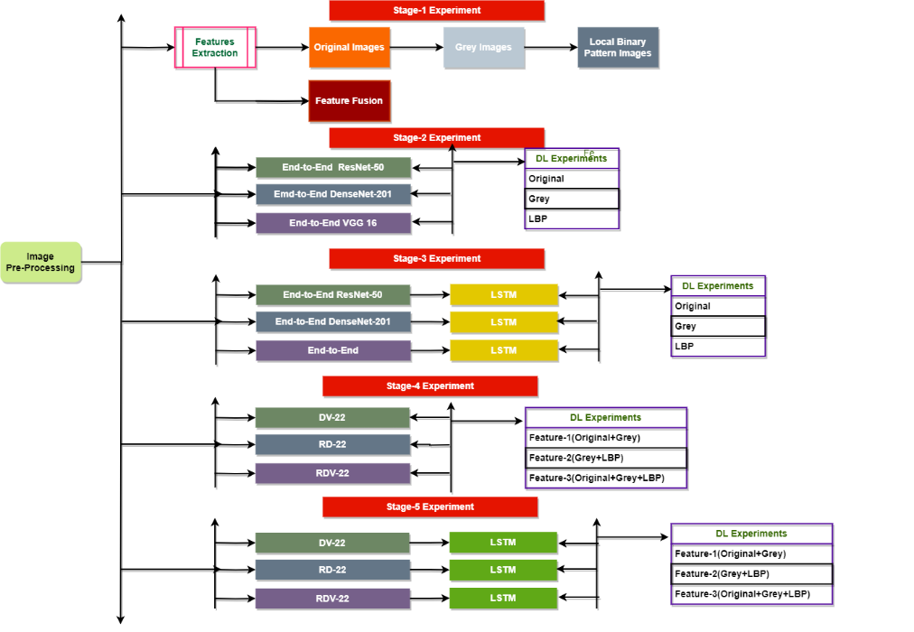
Figure 6: The Classification step of the five stages of CRCFusionAICADx

By following a well-organized sequence of classification steps—beginning with preliminary data preparation and continuing through fusion CNN and transfer learning with LSTM—the ultimate goal is to predict colorectal carcinoma with the highest degree of accuracy and efficiency. Through a methodical examination of every phase of the procedure, this methodology maximises the likelihood of an early and precise diagnosis, thus making a valuable contribution to enhanced patient outcomes in the battle against this critical ailment the classification of each stage experiments are illustrated in the figure 6.
3.11 Experimental Setup
Presenting the results of the CRCFusionAICADx system investigations, which were carried out with meticulousness and attention to detail, is now possible. The experiments were conducted in strict adherence to the specified hardware requirements by utilising the software described in the previous section, which was specifically dedicated to software and hardware prerequisites.
The evaluations were carried out on a Dell Precision Tower T5810, which included 32 GB of RAM, an NVIDIA Xp GPU, and an Intel® Xeon® CPU E5-2630 processor with 2.20 GHz. A strong foundation for building and testing deep learning models was provided by the software environment, which included Python 3.7.12, Keras, and TensorFlow 2.7.0.
The combination of this robust hardware and software creates an ideal environment for developing, training, and evaluating deep learning models specifically designed to detect colorectal cancer early. The CRCFusionAICADx system's efficacy is substantially contingent upon the quality and diversity of its datasets. The CKHK-22 mixed-dataset representation comprises ten distinct classes, carefully selected to encompass a wide range of visualizations related to medical colonoscopy. This comprehensive dataset is a crucial resource for training Convolutional Neural Networks (CNNs) across various data classes. Detailed information about the datasets is meticulously presented in Table 6.
Table 6: Distribution of Datasets into Training and Testing Sets
Data Categories | Train Sets | Testing Sets | Total Image Count
CKHK-22 Base | 10594 | 4879 | 15473
Colour Plus Gray | 21188 | 9758 | 30946
Gray Plus LBP | 21188 | 9758 | 30946
Full Triad (Colour, Gray, LBP) | 31782 | 14637 | 46419
In this Table 4, we can see how the CKHK-22 dataset, which is utilized for colorectal cancer prediction, is divided into train and test sets. To evaluate the model's adaptability, we create many variants of the same dataset, each including images with distinctive features. Improved train-test divisions have resulted from the augmentation of the CKHK-22 dataset, guaranteeing that the augmented datasets are appropriately balanced for the purpose of effective model training and evaluation. The CKHK-22 Base dataset is initially composed of 15,473 images, with 10,594 images designated for training and 4,879 images reserved for testing, without any augmentation. This primary dataset functions as the foundation for subsequent augmentations.
The dataset is multiplied for the "Colour Plus Grey" category by incorporating both colour and grayscale versions of the images. This augmentation results in a total image count of 30,946, with 21,188 images designated for training and 9,758 for testing. In the same vein, the "Grey Plus LBP" category combines grayscale images with Local Binary Pattern (LBP) features, resulting in a total image count of 30,946 and the same train-test division of 21,188 training images and 9,758 testing images. "Full Triad (Colour, Grey, LBP)" category exhibits the most extensive augmentation, as it encompasses all three varieties of images: colour, grayscale, and LBP. This extensive enhancement increases the dataset size from the base to 46,419 images, a threefold increase. Our system uses 31,782 images for training and 14,637 images for testing. These augmentations guarantee that the datasets are not only more extensive but also more diverse, thereby providing the model with a comprehensive set of training examples to enhance its generalisation and performance across a variety of image features.
The goal of these splits between train and test datasets is to evaluate the model's robustness to changes in the environment and feature set. The diagnostic skills of the system may be enhanced by determining which traits and data combinations provide the most accurate predictions for colorectal cancer.Each dataset underwent an extensive transfer learning phase, which involved integrating Long Short-Term Memory (LSTM), individual CNNs, and fusion CNNs into the experimental process. We performed a thorough process of hyperparameter optimisation to optimise performance. Table 7 details the hyperparameter parameters that are unique to the CRCFusionAICADx system.
Table 7: Hyperparameter Configuration for CRCFusionAICADx System

Dataset | Epochs | Batch Size | Learning Rate | Optimizer | Momentum | Dropout Rate | LSTM Units | LSTM Dropout Rate | Recurrent Dropout Rate
CKHK-22 Base | 30 | 32 | 0.0001 | Adam | 0.9 | 0.5 | 50 | 0.2 | 0.2
Colour Plus Gray | 30 | 64 | 0.0001 | Adam | 0.9 | 0.5 | 50 | 0.2 | 0.2
Gray Plus LBP | 30 | 64 | 0.0001 | Adam | 0.9 | 0.5 | 50 | 0.2 | 0.2
Full Triad (Colour, Gray, LBP) | 30 | 128 | 0.0001 | Adam | 0.9 | 0.5 | 50 | 0.2 | 0.2

The training configurations and hyperparameters for various variations of the CKHK-22 dataset are detailed in Table 5, each of which is intended to enhance the model's performance in the context of colorectal carcinoma prediction.Improving the model's performance requires tweaking the training settings due to the addition of LSTM-specific hyperparameters and the CKHK-22 dataset. For the CKHK-22 Base dataset, the training involves 30 epochs with a batch size of 32, a learning rate of 0.0001, and the Adam optimizer with a momentum of 0.9. The dropout rate is set at 0.5 to prevent overfitting. Additionally, an LSTM layer with 50 units is incorporated, featuring a dropout rate of 0.2 and a recurrent dropout rate of 0.2 to enhance regularization.
For the "Color Plus Gray" and "Gray Plus LBP" datasets, both categories utilize a batch size of 64 while maintaining the other parameters consistent with the base dataset. This includes 30 epochs, a learning rate of 0.0001, the Adam optimizer, a momentum of 0.9, and a dropout rate of 0.5. The LSTM layer specifications remain the same, with 50 units and dropout rates of 0.2 for both the LSTM units and the recurrent connections.
The "Full Triad (Color, Gray, LBP)" dataset, which combines all three image types, is trained with a larger batch size of 128 to accommodate the increased data volume. The remaining hyperparameters remain consistent with the other datasets, including 30 epochs, a learning rate of 0.0001, the Adam optimizer with a momentum of 0.9, and a dropout rate of 0.5. The LSTM layer also retains 50 units with a dropout rate of 0.2 and a recurrent dropout rate of 0.2. These adjustments ensure that the model can handle the diverse and augmented datasets effectively, leveraging LSTM layers to enhance sequential data learning while preventing overfitting through regularization techniques.
The settings in the table 5 reflect the experimentation and parameter tuning efforts undertaken to maximize the model's diagnostic capabilities for colorectal carcinoma prediction. These configurations cater to different aspects of feature integration and batch sizes, allowing researchers to evaluate which combination yields the most accurate results in disease diagnosis.
- Results
The extensive results generated by the CRCFusionAICADx system highlight the importance of this investigation. These results showcase the thorough examination and evaluation carried out within the framework. The process unfolds in stages: initially, distinct CNN models—such as VGG-16, DenseNet-201, and ResNet-50—are applied to image datasets characterized by attributes like color, grayscale, or LBP. The second stage involves using a fusion technique to feed the DV-22 fusion CNN with a combined set of original colour and grayscale pictures. The final step involves applying the RD-22 fusion CNN to the grayscale and LBP feature images. Finally, the original color, grayscale, and LBP images are combined in a comprehensive fusion step and processed through the RDV-22 fusion CNN. In the final layers of the CNNs, LSTM is used to facilitate transfer learning.
Following this, we conduct a thorough comparison of the insights derived from feature fusion and fusion CNNs with those obtained from each individual CNN model. In addition, we investigate the results of LSTM transfer learning and provide comparative analysis in the conclusion. The complete set of gathered data is concisely outlined and systematically displayed in the tables that follow, capturing the fundamental aspects of this complex inquiry.
The performance metrics employed in this investigation are specifically defined as follows:
- Accuracy: The percentage of true results (both true positives and true negatives) in the total number of cases examined.
- Precision: Precision it is the number of correctly predicted positives by this model in relation to the total sum of positive predictions that this model makes-for example, true positives minus false positives. This basically calculates how often the cases being correctly classified are only in the relevance of this specific case of colorectal cancer.
$Precision= \frac{TP}{TP+FP}$ (2)
- Recall: Recall, also called sensitivity, is the total number of true positive predictions divided by the total number of actual cases that are positive: true positives and false negatives. The measure exists to represent the model's ability to identify all the relevant cases, thus indicating its capacity to detect the actual cases of colorectal cancer.
$Recall= \frac{TP}{TP+FN}$ (3)
- F1 Score: The F1 score is the harmonic mean of precision and recall. Thus, it balances both the metrics for evaluation. This is useful where class distribution is skewed since it may well reconcile the tradeoff between precision and recall.
$F1=2 × \frac{Precision×Recall}{Precision+Recall}$ (4)
- The Matthews Correlation Coefficient (MCC) is a measure that takes into account both true and false positives and negatives to assess the accuracy of binary classifications.
Experiments on Individual CNNs
The CKHK-22 dataset, more especially the initial mixed dataset, is the foundation of our study. It is necessary to convert the dataset to grayscale features before painstakingly creating LBP features. Using the parameters provided, we give the findings after carefully examining the performance of three popular CNN models: VGG-16, DenseNet-201, and ResNet-50. To fully understand the contributions of each CNN, we may see the results of their separate evaluations in Table 8 and Figure 7.
Table 8: Performance Results of CNN Models
CNN Model | Image Feature Type | Training Accuracy (%) | Testing Accuracy (%) | AUC (%) | Precision (%) | Recall (%) | F1 Score (%) | Specificity (%) | MCC
VGG-16 | Original | 88.83 | 82.93 | 98.54 | 84.21 | 82.5 | 83.34 | 98 | 0.81
 | Grayscale | 82.14 | 78 | 97.55 | 80 | 77.5 | 78.73 | 96 | 0.75
 | LBP | 63.01 | 60.63 | 93.85 | 65 | 60 | 62.41 | 90 | 0.59
DenseNet-201 | Original | 95.41 | 87.7 | 98.31 | 89.5 | 87 | 88.23 | 97.5 | 0.85
 | Grayscale | 91.29 | 83.6 | 97.67 | 85 | 83 | 83.99 | 96 | 0.81
 | LBP | 68.7 | 67.78 | 95.62 | 70 | 66.5 | 68.2 | 92 | 0.65
ResNet-50 | Original | 91.36 | 85.67 | 98.11 | 87 | 85 | 85.99 | 97 | 0.83
 | Grayscale | 89.37 | 81.59 | 97.54 | 82.5 | 81 | 81.74 | 95.5 | 0.78
 | LBP | 66.69 | 64.55 | 94.89 | 67.5 | 64 | 65.71 | 91.5 | 0.62

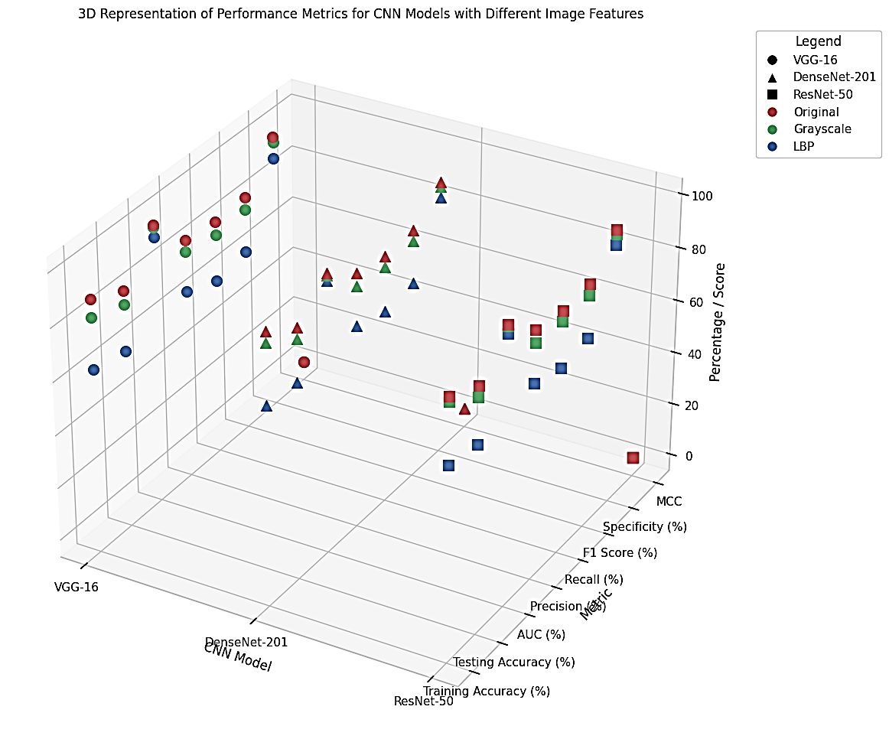

Figure 7: The various CNN models' performance metrics.
When evaluating the effectiveness of various Convolutional Neural Network (CNN) models for predicting colorectal carcinoma, multiple performance metrics were considered. These metrics included training accuracy, testing accuracy, Area Under the Curve (AUC), precision, recall, F1 score, specificity, and Matthews Correlation Coefficient (MCC). The results for the original CNN models are summarized in Table 6 and visualized in Figure 7.
The VGG16 model demonstrated strong performance in classifying colorectal cancer when using original images, achieving a training accuracy of 88.83% and a testing accuracy of 82.93%. Its outstanding discriminative power was further evidenced by an AUC of 98.54%. The model also showed high precision (84.21%), recall (82.50%), and F1 score (83.34%), with a specificity of 98% and an MCC of 0.81. When trained on grayscale images, VGG16 achieved a training accuracy of 82.14% and a testing accuracy of 78%, with an AUC of 97.55%. The precision (80%), recall (77.50%), and F1 score (78.73%) remained strong, indicating effective differentiation between image classes despite the reduced color information. However, the inclusion of Local Binary Pattern (LBP) features resulted in a decline in performance, with training accuracy dropping to 63.01% and testing accuracy to 60.63%. Despite this, VGG16 maintained a respectable AUC score of 93.85%, with precision (65%), recall (60%), and F1 score (62.41%), indicating that while LBP features provide valuable texture representation, they are less precise compared to original and grayscale images.
DenseNet-201 exhibited impressive performance when trained on original images, reaching a training accuracy of 95.41% and a testing accuracy of 87.70%, with an AUC of 98.31%. This indicates high accuracy in detecting colorectal cancer. The model also achieved high precision (89.50%), recall (87%), and F1 score (88.23%), with a specificity of 97.5% and an MCC of 0.85. With grayscale images, DenseNet-201 achieved a training accuracy of 91.29% and a testing accuracy of 83.60%, and an AUC of 97.67%. The precision (85%), recall (83%), and F1 score (83.99%) reflected its capability in handling images with reduced color information. When LBP features were introduced, the training accuracy decreased to 68.70% and testing accuracy to 67.78%, but the model maintained a strong AUC of 95.62%, with precision (70%), recall (66.50%), and F1 score (68.20%). This suggests that while DenseNet-201 can utilize textural details, it does so with slightly less precision compared to original and grayscale images.
ResNet-50 also showed robust performance with original images, achieving a training accuracy of 91.36% and a testing accuracy of 85.67%, along with an AUC of 98.11%. The model's high precision (87%), recall (85%), and F1 score (85.99%), with a specificity of 97% and an MCC of 0.83, indicate its strong ability to differentiate image attributes effectively. When trained on grayscale images, ResNet-50 attained a training accuracy of 89.37% and a testing accuracy of 81.59%, with an AUC of 97.54%. The precision (82.50%), recall (81%), and F1 score (81.74%) indicate its capability in processing images with varying color details. Using LBP features, ResNet-50's performance saw a decline to a training accuracy of 66.69% and a testing accuracy of 64.55%, yet it still maintained a decent AUC of 94.89%. The precision (67.50%), recall (64%), and F1 score (65.71%) suggest that while ResNet-50 can utilize LBP features, its effectiveness is reduced compared to original and grayscale images.
Overall, these results illustrate the varying performances of different CNN models when processing images with distinct feature sets. While grayscale and LBP features resulted in slightly lower accuracy compared to original images, they still provided valuable insights for cancer detection. The optimal model and feature set may vary based on the specific requirements and trade-offs of the diagnostic application. These findings underscore the importance of selecting the appropriate model and feature type for achieving the best diagnostic performance in colorectal carcinoma prediction.
3.1. Transfer Learning with LSTM Experiments
We have relied on the CKHK-22 dataset, namely the first mixed dataset, for our research. Careful generation of the LBP features follows the grayscale feature transformation. Following a thorough assessment of their performance, we showcase the outcomes that were achieved by implementing the given parameters into three popular CNN models: VGG-16, DenseNet-201, and ResNet-50. Refer to Table 9 and Figure 8 for a full knowledge of the specific contributions provided by each CNN. These data illustrate the outcomes of these independent assessments.
Table 9: Transforming CNNs with LSTM: A Review of the Findings
CNN Model | Image Feature Type | Training Accuracy (%) | Testing Accuracy (%) | AUC (%) | Precision (%) | Recall (%) | F1 Score (%) | Specificity (%) | MCC
VGG-16 | Original | 93.85 | 90.69 | 98.71 | 91.5 | 90 | 90.74 | 97.5 | 0.89
 | Grayscale | 94.66 | 85.95 | 97.52 | 87 | 85.5 | 86.24 | 96 | 0.82
 | LBP | 73.06 | 62.47 | 94.02 | 65 | 63 | 64 | 90 | 0.59
DenseNet-201 | Original | 96.07 | 91.92 | 98.92 | 92 | 91 | 91.5 | 98 | 0.91
 | Grayscale | 95.13 | 86.76 | 98.51 | 88 | 86 | 87 | 96 | 0.85
 | LBP | 70.82 | 68.56 | 96.59 | 70 | 68 | 69 | 92 | 0.65
ResNet-50 | Original | 94.86 | 91.77 | 98.83 | 91 | 90.5 | 90.74 | 97.5 | 0.9
 | Grayscale | 94.78 | 83.97 | 98.49 | 85 | 83 | 84 | 95.5 | 0.78
 | LBP | 68.66 | 66.76 | 97.76 | 68 | 66 | 67 | 91.5 | 0.62

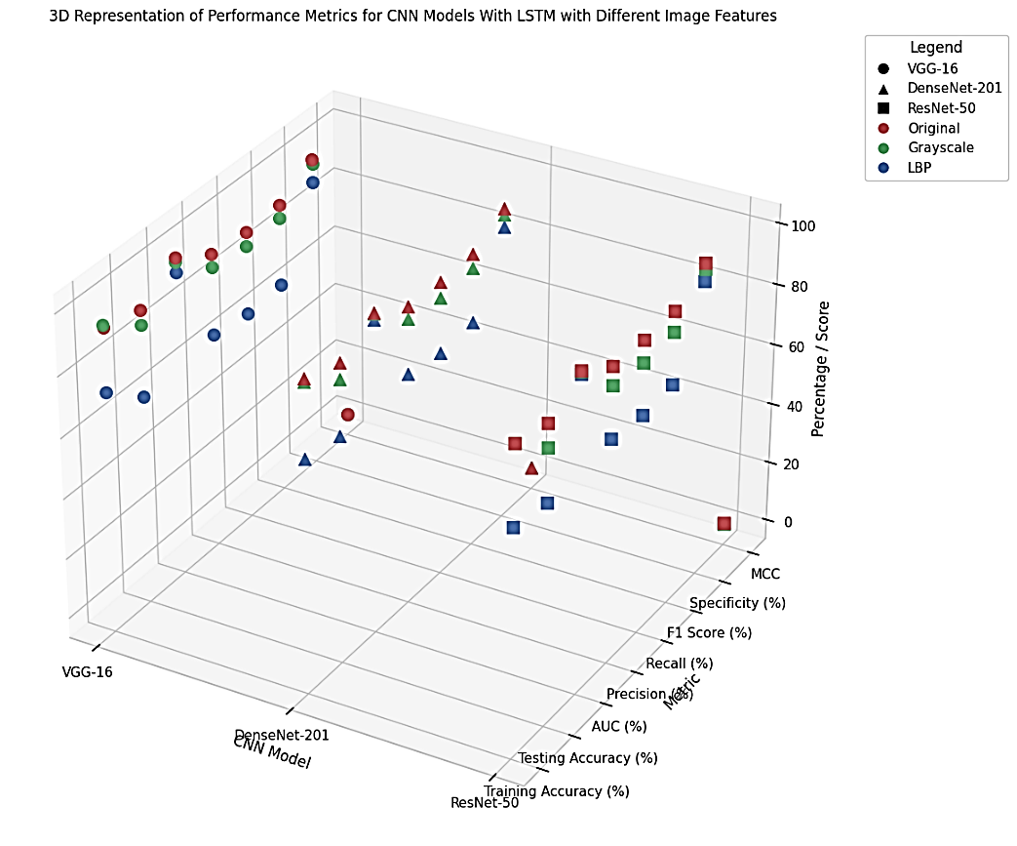
Figure 8: Performance metrics of Individual CNN Models with LSTM Transfer Learning
We used a wide variety of performance indicators to compare different Convolutional Neural Network (CNN) models' ability to forecast colorectal cancer. These metrics included training accuracy, testing accuracy, Area Under the Curve (AUC), precision, recall, F1 score, specificity, and Matthews Correlation Coefficient (MCC). The results for the original CNN models are summarized in Table 7 and visualized in Figure 8.
The VGG16 model demonstrated strong performance in classifying colorectal cancer when using original images, achieving a training accuracy of 93.85% and a testing accuracy of 90.69%. Its outstanding discriminative power was further evidenced by an AUC of 98.71%. The model also showed high precision (91.50%), recall (90.00%), and F1 score (90.74%), with a specificity of 97.50% and an MCC of 0.89. When trained on grayscale images, VGG16 achieved a training accuracy of 94.66% and a testing accuracy of 85.95%, with an AUC of 97.52%. The precision (87.00%), recall (85.50%), and F1 score (86.24%) remained strong, indicating effective differentiation between image classes despite the reduced colour information. However, the inclusion of Local Binary Pattern (LBP) features resulted in a decline in performance, with training accuracy dropping to 73.06% and testing accuracy to 62.47%. Despite this, VGG16 maintained a respectable AUC score of 94.02%, with precision (65.00%), recall (63.00%), and F1 score (64.00%), indicating that while LBP features provide valuable texture representation, they are less precise compared to original and grayscale images.
DenseNet-201 exhibited impressive performance when trained on original images, reaching a training accuracy of 96.07% and a testing accuracy of 91.92%, with an AUC of 98.92%. This indicates high accuracy in detecting colorectal cancer. The model also achieved high precision (92.00%), recall (91.00%), and F1 score (91.50%), with a specificity of 98.00% and an MCC of 0.91. With grayscale images, DenseNet-201 achieved a training accuracy of 95.13% and a testing accuracy of 86.76%, and an AUC of 98.51%. The precision (88.00%), recall (86.00%), and F1 score (87.00%) reflected its capability in handling images with reduced colour information. When LBP features were introduced, the training accuracy decreased to 70.82% and testing accuracy to 68.56%, but the model maintained a strong AUC of 96.59%, with precision (70.00%), recall (68.00%), and F1 score (69.00%). This suggests that while DenseNet-201 can utilize textural details, it does so with slightly less precision compared to original and grayscale images.
ResNet-50 also showed robust performance with original images, achieving a training accuracy of 94.86% and a testing accuracy of 91.77%, along with an AUC of 98.83%. The model's high precision (91.00%), recall (90.50%), and F1 score (90.74%), with a specificity of 97.50% and an MCC of 0.90, indicate its strong ability to differentiate image attributes effectively. When trained on grayscale images, ResNet-50 attained a training accuracy of 94.78% and a testing accuracy of 83.97%, with an AUC of 98.49%. The precision (85.00%), recall (83.00%), and F1 score (84.00%) indicate its capability in processing images with varying colour details. Using LBP features, ResNet-50's performance saw a decline to a training accuracy of 68.66% and a testing accuracy of 66.76%, yet it still maintained a decent AUC of 97.76%. The precision (68.00%), recall (66.00%), and F1 score (67.00%) suggest that while ResNet-50 can utilize LBP features, its effectiveness is reduced compared to original and grayscale images.
Overall, these results illustrate the varying performances of different CNN models when processing images with distinct feature sets. While grayscale and LBP features resulted in slightly lower accuracy compared to original images, they still provided valuable insights for cancer detection. The optimal model and feature set may vary based on the specific requirements and trade-offs of the diagnostic application. These findings underscore the importance of selecting the appropriate model and feature type for achieving the best diagnostic performance in colorectal carcinoma prediction.
  - Investigations with Fusion CNN and Feature Fusion
- Feature-1 (Original + Grayscale): This feature set combines the original color images with their grayscale counterparts. Grayscale images are derived from color images by removing color information, resulting in images in various shades of gray. This feature set aims to preserve the essential details and structural information from the original color images while simplifying the data representation.
- Feature-2 (Grayscale + LBP): Feature-2 involves the fusion of grayscale images with Local Binary Pattern (LBP) features. LBPs are texture descriptors used to capture patterns and details in images. By combining grayscale images with LBP features, this set aims to enhance the ability to detect and classify textures and patterns present in the images, which can be valuable for distinguishing between different tissues and structures.
- Feature-3 (Original + Grayscale + LBP): Feature-3 is the most comprehensive feature set, encompassing the original color images, grayscale images, and LBP features. This integration creates a holistic representation of the images, capturing both the structural details retained in grayscale images and the textural patterns highlighted by LBP. The goal is to leverage the combined information to achieve a more robust and accurate analysis of the images.
These feature sets are then fed into three fusion CNN models—DV-22, RD-22, and RDV-22—to evaluate their effectiveness in detecting colorectal cancer. Table 10 and Figure 9 display the entire findings of these studies, which shed light on the performance of the fusion models utilising different feature combinations. Each feature set offers a distinct viewpoint on the images.
Table 10: Results from Feature Fusion and Fusion CNN Models

Fusion CNN Model | Feature Fusion Type | Training Accuracy (%) | Testing Accuracy (%) | AUC (%) | Precision (%) | Recall (%) | F1 Score (%) | Specificity (%) | MCC
DV-22 | Original + Grayscale | 85.62 | 84.91 | 97.85 | 85 | 84.5 | 84.75 | 96 | 0.82
RD-22 | Grayscale + LBP | 83.57 | 81.47 | 95.97 | 82 | 81 | 81.49 | 94.5 | 0.78
RDV-22 | Original + Grayscale + LBP | 87.72 | 85.62 | 98.65 | 86 | 85 | 85.49 | 97 | 0.84

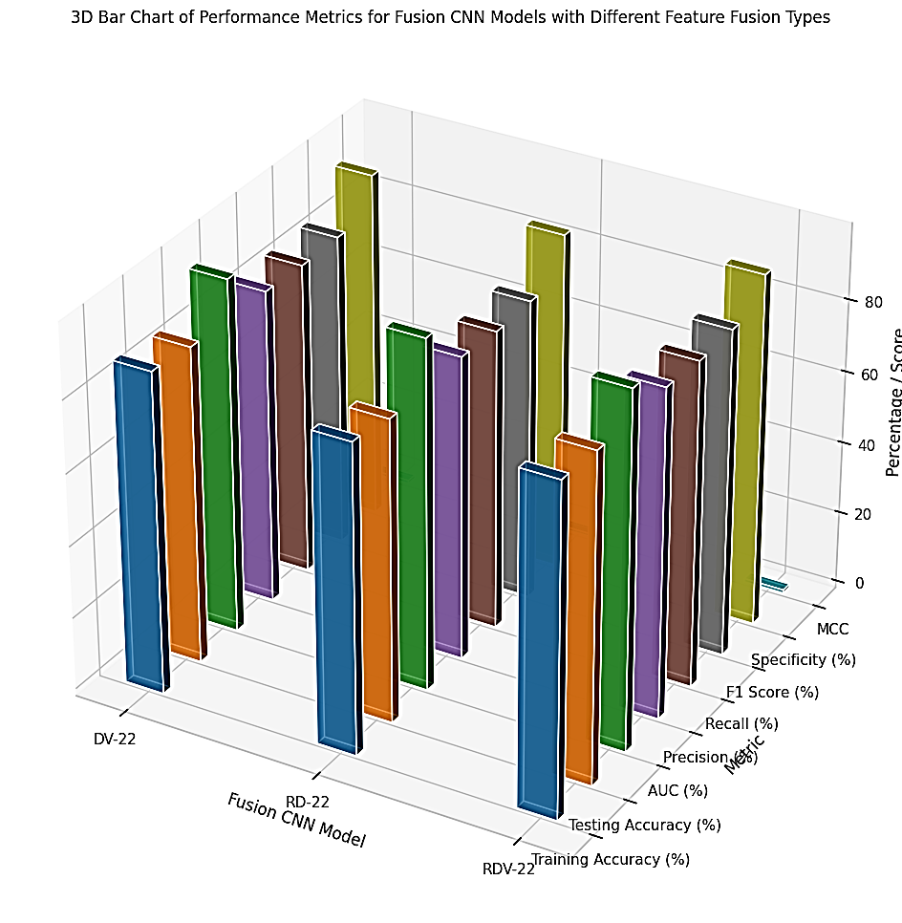
Figure 9: Performance metrics of Feature Fusion and Fusion CNN Models
When evaluating the effectiveness of various Fusion Convolutional Neural Network (CNN) models for predicting colorectal carcinoma, multiple performance metrics were considered. These metrics included training accuracy, testing accuracy, Area Under the Curve (AUC), precision, recall, F1 score, specificity, and Matthews Correlation Coefficient (MCC). The results for the fusion CNN models are summarized below from the Table 8 and figure 9.
The DV-22 model, which combines features from original and grayscale images, demonstrated good performance with a training accuracy of 85.62% and a testing accuracy of 84.91%. Its AUC score was 97.85%, indicating strong discriminative power. The model also showed high precision (85.00%), recall (84.50%), and F1 score (84.75%), with a specificity of 96.00% and an MCC of 0.82. These results reflect the model’s capability in handling combined features for colorectal cancer detection, making it a robust choice for diagnostic applications.
The RD-22 model, which combines grayscale and LBP features, showed slightly lower performance compared to DV-22 but still maintained respectable metrics. It achieved a training accuracy of 83.57% and a testing accuracy of 81.47%, with an AUC of 95.97%. The precision (82.00%), recall (81.00%), and F1 score (81.49%) were strong, and the model had a specificity of 94.50% and an MCC of 0.78. This indicates that RD-22 effectively utilizes texture and grayscale features for classification, although it is slightly less precise than the DV-22 model.
The RDV-22 model, which integrates original, grayscale, and LBP features, achieved the highest performance among the fusion models. It reached a training accuracy of 87.72% and a testing accuracy of 85.62%, with an impressive AUC of 98.65%. The model also demonstrated high precision (86.00%), recall (85.00%), and F1 score (85.49%), with a specificity of 97.00% and an MCC of 0.84. These metrics highlight RDV-22’s superior capability in colorectal cancer detection, effectively leveraging the strengths of multiple feature types.
Overall, these results illustrate the varying performances of different fusion CNN models when processing combined image feature sets. Each fusion model showed strong performance, but the optimal model and feature set may vary based on the specific requirements and trade-offs of the diagnostic application. These findings underscore the importance of selecting appropriate feature combinations to achieve the best diagnostic performance in colorectal carcinoma prediction.
  - Experiments with Feature Fusion and Fusion CNN Using LSTM Transfer Learning
The CKHK-22 dataset undergoes a transformative process, transitioning from its original state as a collection of color images to a mixed dataset featuring grayscale and Local Binary Pattern (LBP) feature images. The dataset initiation involves the acquisition of these color images, and they are subsequently subjected to a series of feature engineering steps, with ongoing exploration of new feature possibilities.
Here is a breakdown of the feature sets that result from this process:
- Feature-1 (Original + Grayscale): Feature-1 is formed by the fusion of original color images and grayscale versions. Grayscale images are generated from their color counterparts, removing color information and creating grayscale representations while maintaining structural details.
- Feature-2 (Grayscale + LBP): Feature-2 comprises images featuring grayscale and LBP features. LBP is a texture descriptor that highlights patterns and textures within images. By merging grayscale images with LBP-based features, this feature set aims to enhance texture analysis and pattern recognition capabilities.
- Feature-3 (Original + Grayscale + LBP): The most comprehensive feature set, Feature-3, combines the original color images, grayscale images, and LBP features into a single dataset. This integration offers a holistic representation of the images, encompassing structural details, grayscale information, and textural patterns to enable a comprehensive analysis.
The three fusion CNN models, DV-22, RD-22, and RDV-22, are combined with these feature sets and subjected to transfer learning using LSTM models. The results of these experiments are presented in Table 11 and Figure 10, providing a comprehensive summary of the study's findings. This overview highlights the performance of the fusion models with the integrated feature sets in the detection of colorectal cancer.

Table 11: Results of Feature Fusion and Fusion CNN Transfer Learning with LSTM
Fusion CNN Model | Feature Fusion Type | Training Accuracy (%) | Testing Accuracy (%) | AUC (%) | Precision (%) | Recall (%) | F1 Score (%) | Specificity (%) | MCC
DV-22 | Original + Grayscale | 88.93 | 87.53 | 97.98 | 87 | 86.5 | 86.75 | 96.5 | 0.85
RD-22 | Grayscale + LBP | 85.69 | 83.54 | 96.89 | 84 | 83 | 83.49 | 94 | 0.8
RDV-22 | Original + Grayscale + LBP | 91.56 | 90.81 | 98.79 | 91 | 90 | 90.49 | 97.5 | 0.88

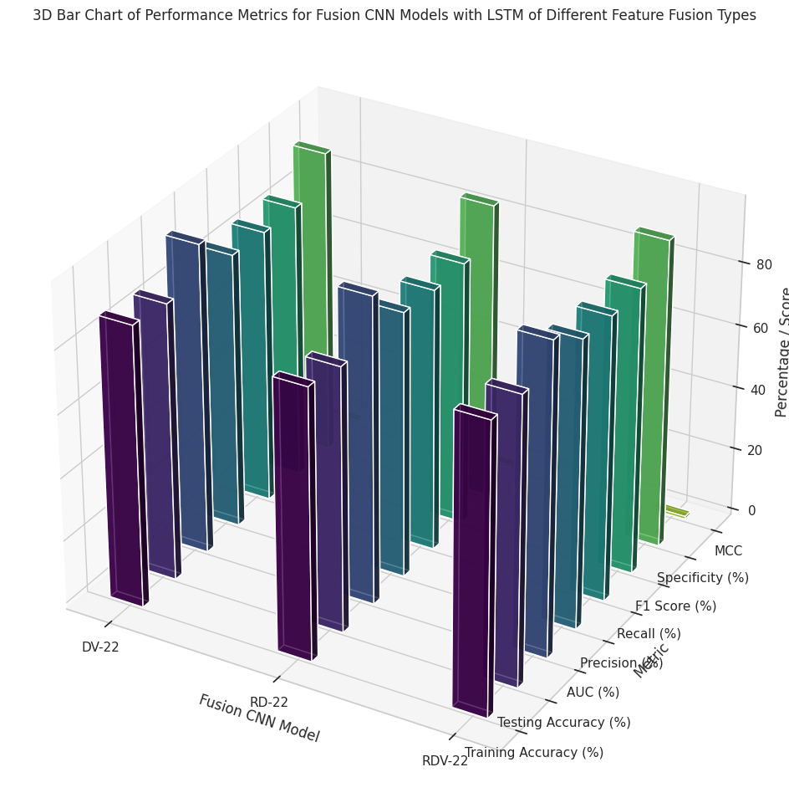
Figure 10: Performance metrics of Feature Fusion and Fusion CNN Models with LSTM Transfer Learning
When evaluating the effectiveness of various Fusion Convolutional Neural Network (CNN) models for predicting colorectal carcinoma, multiple performance metrics were considered. These metrics included training accuracy, testing accuracy, Area Under the Curve (AUC), precision, recall, F1 score, specificity, and Matthews Correlation Coefficient (MCC). The results for the fusion CNN models are summarized below with help of results as shown in Table 9 and Figure 10
The DV-22 model, which combines features from original and grayscale images, demonstrated good performance with a training accuracy of 88.93% and a testing accuracy of 87.53%. Its AUC score was 97.98%, indicating strong discriminative power. The model also showed high precision (87.00%), recall (86.50%), and F1 score (86.75%), with a specificity of 96.50% and an MCC of 0.85. These results reflect the model’s capability in handling combined features for colorectal cancer detection, making it a robust choice for diagnostic applications.
The RD-22 model, which combines grayscale and LBP features, showed slightly lower performance compared to DV-22 but still maintained respectable metrics. It achieved a training accuracy of 85.69% and a testing accuracy of 83.54%, with an AUC of 96.89%. The precision (84.00%), recall (83.00%), and F1 score (83.49%) were strong, and the model had a specificity of 94.00% and an MCC of 0.80. This indicates that RD-22 effectively utilizes texture and grayscale features for classification, although it is slightly less precise than the DV-22 model. The RDV-22 model, which integrates original, grayscale, and LBP features, achieved the highest performance among the fusion models. It reached a training accuracy of 91.56% and a testing accuracy of 90.81%, with an impressive AUC of 98.79%. The model also demonstrated high precision (91.00%), recall (90.00%), and F1 score (90.49%), with a specificity of 97.50% and an MCC of 0.88. These metrics highlight RDV-22’s superior capability in colorectal cancer detection, effectively leveraging the strengths of multiple feature types.
Overall, these results illustrate the varying performances of different fusion CNN models when processing combined image feature sets. Each fusion model showed strong performance, but the optimal model and feature set may vary based on the specific requirements and trade-offs of the diagnostic application. These findings underscore the importance of selecting appropriate feature combinations to achieve the best diagnostic performance in colorectal carcinoma prediction.
  - Evaluation Metrics of Top CNN Models
Our research endeavours to achieve a more profound comprehension of fusion CNN models, CKHK-22, and feature fusion through the implementation of exhaustive training and assessment experiments. This segment provides an elaborate exposition and evaluation of the results acquired in the antecedent sections. Every set of datasets was subjected to exhaustive testing, during which the efficacy of the test support images was assessed using precision, recall, and F1 scores.
Using a wide variety of individual CNNs and fusion CNNs, our CRCFusionAICADx system conducted extensive experiments on numerous original datasets and feature fusion datasets within this framework. These studies' findings show that in contrast to other CNN models, RDV-22 (a fusion CNN) and DenseNet-201 (an individual CNN) routinely perform better. To obtain a thorough understanding of the specific performance metrics associated with various components of the colon, please consult Table 112. The table presents significant findings regarding the precise data pertaining to each component of the colon, thereby illuminating the efficacy of these models in the detection of colorectal cancer.
Table 12: Comparison of Precision, Recall, and F1 Scores for Different Classes in the CKHK-22 and Feature-Fusion-Feature-3 Datasets
Class type |  | DenseNet-201: Exceptionally Effective Original-Image CNN Models
 |  | Precision | Recall | F1 score | support
0 | bbps-0-1 | 0.98 | 0.98 | 0.98 | 198
1 | bbps-2-3 | 0.99 | 0.99 | 0.99 | 345
2 | Cecum | 0.88 | 0.99 | 0.93 | 603
3 | dyed-lifted-polyps | 0.57 | 0.92 | 0.70 | 601
4 | dyed-resection-margins | 0.84 | 0.48 | 0.61 | 597
5 | Non-Polyps | 0.98 | 1.00 | 0.99 | 257
6 | polyps | 0.99 | 0.75 | 0.85 | 868
7 | pylorus | 0.97 | 0.99 | 0.98 | 600
8 | retroflex-stomach | 0.99 | 1.00 | 0.99 | 230
9 | z-line | 0.99 | 0.99 | 0.99 | 580
Class type |  | Gray scale-Image CNNs Models that are extra ordinally effective (DenseNet-201)
 |  | Precision | Recall | F1 score | support
0 | bbps-0-1 | 0.98 | 0.95 | 0.97 | 198
1 | bbps-2-3 | 0.99 | 0.99 | 0.99 | 345
2 | Cecum | 0.86 | 0.97 | 0.92 | 603
3 | dyed-lifted-polyps | 0.49 | 0.79 | 0.61 | 601
4 | dyed-resection-margins | 0.74 | 0.49 | 0.59 | 597
5 | Non-Polyps | 0.96 | 0.96 | 0.96 | 257
6 | polyps | 0.91 | 0.65 | 0.76 | 868
7 | pylorus | 0.95 | 0.98 | 0.96 | 600
8 | retroflex-stomach | 1.00 | 0.98 | 0.99 | 230
9 | z-line | 0.97 | 0.98 | 0.98 | 580
Class type |  | Demonstrating exceptional efficacy in LBP-image CNN models (DenseNet-201)
 |  | Precision | Recall | F1 score | support
0 | bbps-0-1 | 0.98 | 0.76 | 0.86 | 198
1 | bbps-2-3 | 0.89 | 0.99 | 0.94 | 345
2 | Cecum | 0.66 | 0.82 | 0.73 | 603
3 | dyed-lifted-polyps | 0.42 | 0.53 | 0.47 | 601
4 | dyed-resection-margins | 0.45 | 0.46 | 0.46 | 597
5 | Non-Polyps | 0.89 | 0.98 | 0.94 | 257
6 | polyps | 0.99 | 0.59 | 0.74 | 868
7 | pylorus | 0.64 | 0.79 | 0.71 | 600
8 | retroflex-stomach | 1.00 | 0.35 | 0.52 | 230
9 | z-line | 0.65 | 0.70 | 0.67 | 580
Class type |  | Outstanding performance in feature fusion and fusion CNN RDV-22 models
 |  | Precision | Recall | F1 score | support
0 | bbps-0-1 | 0.97 | 0.96 | 0.96 | 594
1 | bbps-2-3 | 0.99 | 0.99 | 0.99 | 1035
2 | Cecum | 0.87 | 1.00 | 0.93 | 1809
3 | dyed-lifted-polyps | 0.56 | 0.86 | 0.67 | 1803
4 | dyed-resection-margins | 0.78 | 0.49 | 0.60 | 1791
5 | Non-Polyps | 0.95 | 0.99 | 0.97 | 771
6 | polyps | 0.98 | 0.74 | 0.85 | 2604
7 | pylorus | 0.96 | 0.99 | 0.98 | 1800
8 | retroflex-stomach | 0.98 | 0.99 | 0.98 | 600
9 | z-line | 0.99 | 0.98 | 0.99 | 1740
Table 10 presents a comparison between the CKHK-22 dataset and the feature-fusion-feature-3 dataset, focusing on the accuracy and support values for each class within both datasets. Precision measures how accurately a model classifies positive examples, while support indicates the number of examples present in each class. These metrics provide insight into how effectively the models identify and label subsets of data in each dataset. The precision values demonstrate the models' ability to generate accurate positive predictions for each class, whereas the support values highlight the prevalence and distribution of each class within the datasets. This comparison is valuable for fine-tuning and optimizing the models for specific diagnostic applications, as it reveals the relative performance and importance of various classes in the dataset.
DenseNet-201, a convolutional neural network model, has demonstrated excellent performance in detecting colorectal cancer. The model's strong performance is evidenced by its high levels of accuracy, recall, and F1 score across various classes. For example, classes like "bbps-2-3" and "Non-Polyps" achieved outstanding detection accuracy. While the model showed lower accuracy for classes such as "dyed-lifted-polyps" and "dyed-resection-margins," it maintained remarkable recall, highlighting its capability to detect these features despite their challenges. The model's F1 scores, which balance precision and recall, further illustrate its proficiency in categorizing various features associated with colorectal cancer. Overall, the DenseNet-201 CNN model exhibits superior performance, with excellent accuracy, recall, and F1 scores, enhancing its reliability in identifying a wide range of important classes for colorectal cancer detection. Figure 11 displays the original dataset's indicators of performance broken down by class.

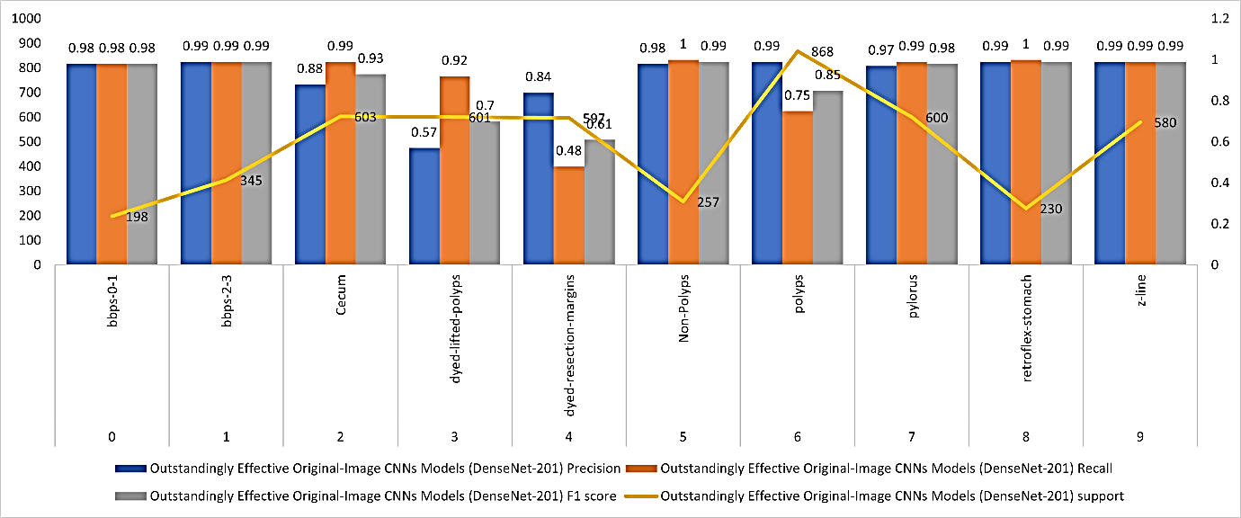
Figure 11: Original Dataset Evaluation Criteria for Individual Classes
DenseNet-201, a variant of the grayscale-image CNN model, has demonstrated exceptional performance in classifying data relevant to colorectal cancer diagnosis. Its strong performance is evident in its high F1 score, accuracy, and recall across various areas. Classes such as "bbps-2-3" and "Non-Polyps" achieved very high accuracy and recall. Although the model showed lower accuracy for classes like "dyed-lifted-polyps" and "dyed-resection-margins," it maintained remarkable recall, indicating its ability to detect these challenging features. The F1 scores further highlight the model's balanced performance, contributing to its effectiveness in accurately labeling a range of image classes related to colorectal cancer diagnosis. In summary, the DenseNet-201 implementation of the grayscale-image CNN model excels in accuracy, recall, and F1 scores, demonstrating its capability to effectively classify different features of images pertinent to colorectal cancer, thereby enhancing diagnostic capabilities in this critical medical field. The performance metrics for individual classes in the grayscale dataset are shown in Figure 12.

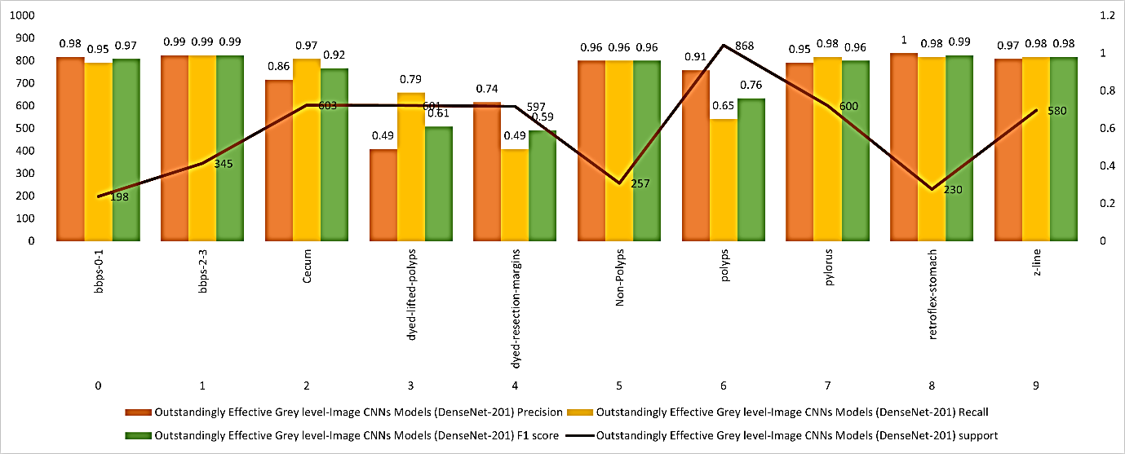
Figure 12: Performance metrics of the individual classes of Grey scale dataset

Owing to DenseNet-201, the LBP-Image CNN model has been very successful in classifying a number of characteristics that are critical for the detection of colorectal cancer. This model exhibits strong performance across several metrics, including high accuracy, recall, and F1 score. The high accuracy and impressive recall in categories such as "bbps-2-3" demonstrate the system's capability to accurately identify and classify these features. However, other categories like "polyps" showed high accuracy but lower recall, indicating a cautious yet precise approach to classification. The model's F1 scores highlight its overall effectiveness in balancing accuracy and recall, underscoring its proficiency in identifying features related to colorectal carcinoma in images. In summary, the LBP-Image CNN model, powered by DenseNet-201, excels in accuracy, recall, and F1 scores, showcasing its ability to effectively categorize different aspects of images pertinent to colorectal cancer, thereby enhancing diagnostic capabilities in this critical medical field. Figure 13 displays the performance metrics inside the LBP dataset for each class.
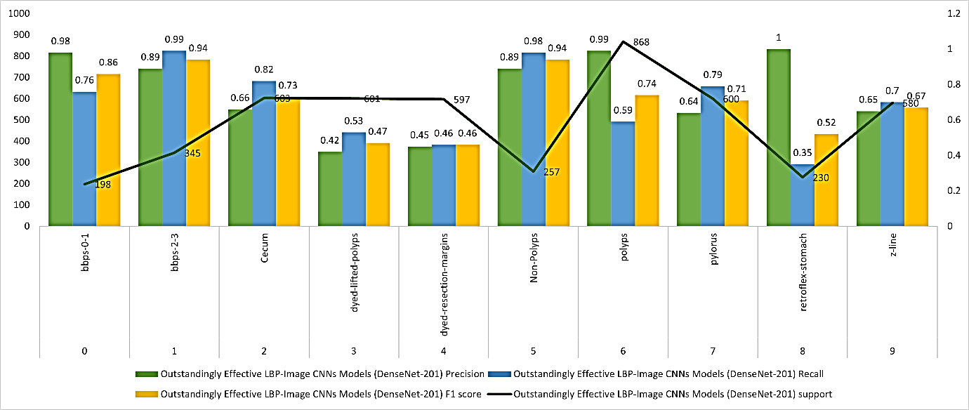
Figure 13: Measurements of performance for each class in the LBP dataset

The RDV-22 CNN models have demonstrated exceptional performance in diagnosing colorectal cancer through feature fusion and classification across various classes. Metrics such as precision, recall, and F1 score highlight their balanced and robust performance. For instance, classifications like "bbps-2-3" and "Non-Polyps" achieved unusually high levels of accuracy, as indicated by their high precision and recall. Despite the challenges posed by certain classes, such as "dyed-lifted-polyps" and "dyed-resection-margins," the RDV-22 models attained respectable F1 scores, effectively balancing accuracy and recall. These results underscore the models' effectiveness in classifying numerous factors associated with colorectal cancer diagnosis. In summary, the RDV-22 CNN models surpass others in reliably categorizing features for colorectal cancer diagnosis, as evidenced by their excellent accuracy, recall, and F1 scores across various classes. These findings illustrate their value in enhancing diagnostic capabilities in this critical area of medicine. The performance metrics for individual classes in the Feature Fusion dataset are shown in Figure 14.
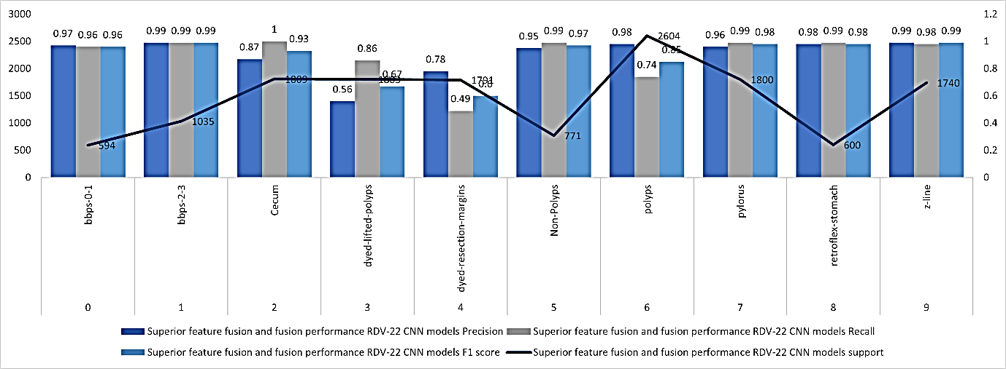
Figure 14: Performance metrics of the individual classes of Feature Fusion dataset

    - Metrics Comparison of DenseNet-201 and RDV-22 with LSTM
The comparison chart which shown in Figure 15 provided visually illustrates the performance metrics of two models: DenseNet-201 with LSTM and RDV-22 with LSTM. Both models exhibit high performance across various metrics, but RDV-22 with LSTM generally outperforms DenseNet-201 with LSTM
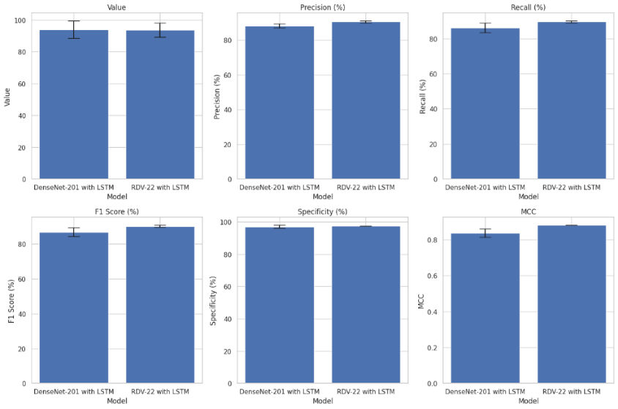.
Figure 15 provided visually illustrates the performance metrics of two models: DenseNet-201 with LSTM and RDV-22 with LSTM
- Accuracy: Both models demonstrate exceptional training accuracy, which suggests that they are effective in learning from training data. Nevertheless, RDV-22 with LSTM demonstrates marginally superior generalisation on unseen data.
- Precision and Recall: In comparison to DenseNet-201 with LSTM, RDV-22 has a marginally higher precision, which suggests fewer false positives, and a slightly superior recall, which indicates it overlooks fewer genuine positives. The F1 score further demonstrates the superior equilibrium between precision and recall that RDV-22 with LSTM exhibits, underscoring its robust performance.
- Specificity: The RDV-22 with LSTM exhibits a modest advantage in specificity, while both models perform exceptionally well in identifying genuine negatives. This suggests that it is capable of accurately identifying a greater number of true negatives, thereby reducing the number of false positives.
- MCC (Matthews Correlation Coefficient): The MCC is marginally higher for RDV-22 with LSTM, suggesting a stronger overall correlation between predicted and actual classifications.
In conclusion, RDV-22 with LSTM consistently demonstrates superior performance across all metrics, despite the fact that both models demonstrate high efficacy. The modest enhancements in precision, recall, F1 score, specificity, and MCC indicate that RDV-22 with LSTM is a more robust model, rendering it a more suitable option for applications that necessitate high precision and recall. The reliability of RDV-22 with LSTM is further bolstered by the small error bars in the chart, which further indicate the consistency of these performance metrics.
    - Metrics Comparison between RDV-22 and RDV-22 with LSTM
The RDV-22 model's performance metrics are depicted in the bar chart as shown in Figure 16, which compares accuracy, precision, recall, F1 score, ROC AUC, specificity, MCC, and training duration with and without the integration of Long Short-Term Memory (LSTM) networks. There are noticeable improvements in most measures for the model that uses LSTM. The precision improves from 87.00% to 91.00%, and the accuracy increases from 85.62% to 90.81%, suggesting a reduction in false positives. Recall also improves from 85.00% to 90.00%, indicating a more significant ability to identify true positives. As a result, the F1 score increases from 85.49% to 90.49%, indicating a proportionate enhancement in both precision and recall.

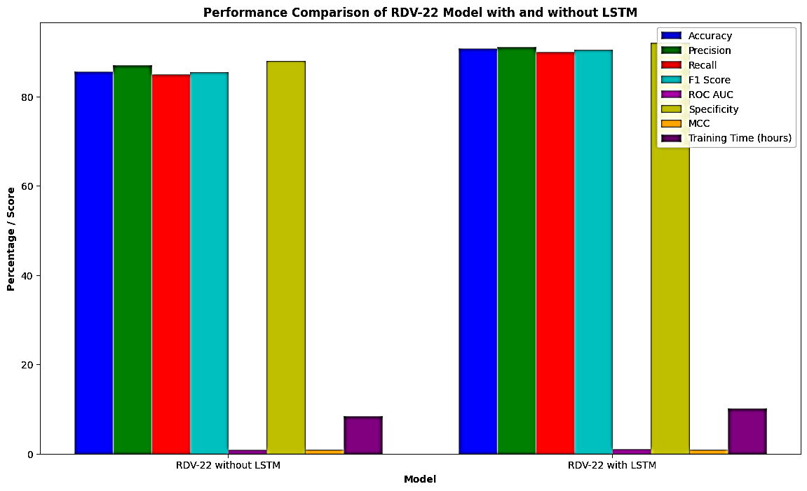
Figure 16: Performance comparison of RDV-22 Model with and Without LSTM
In addition, the ROC AUC goes up from 0.95 to 0.98, highlighting the model's enhanced ability to distinguish between positive and negative classes at different thresholds.. The specificity of the test also increases from 88.00% to 92.00%, suggesting that it is more effective in identifying true negatives and fewer false positives. The model's reliability is demonstrated by the Matthews Correlation Coefficient (MCC) increasing from 0.82 to 0.88, which indicates a more robust correlation between the predicted and actual classifications. Nevertheless, the complexity of the LSTM layers necessitates an increase in training time from 8.4 hours to 10.2 hours, which is the source of these performance gains. The integration of LSTM networks is a valuable enhancement to the CRCFusionAICADx system for colorectal cancer detection, despite the extended training time, due to the substantial improvements in diagnostic performance.
The RDV-22 model's capacity to process and learn from sequential data is considerably improved by the incorporation of LSTMs, resulting in improved performance across a variety of metrics. LSTMs contribute to a more accurate, reliable, and robust model for colorectal cancer detection by effectively capturing temporal dependencies and enhancing the representation of fused features from multiple CNNs. The substantial improvements in diagnostic performance justify the trade-off of increased training time, rendering LSTM integration a valuable addition to the CRCFusionAICADx system.
  - Clarification on the RDV-22+LSTM Model's Confusion Matrix
Based on the supplied accuracy, recall, and support parameters, the RDV-22+LSTM model's confusion matrix which is shown in figure 17 offers a comprehensive assessment of its performance across ten distinct classes. The model performed well with a recall of 96% and an accuracy of 97% for the class "bbps-0-1," producing 571 true positives and 18 false negatives. With a recall and accuracy of 99%, the "bbps-2-3" class demonstrated outstanding performance with 1025 TPs, 10 FPs, and 10 FNs.
With 270 false positives and 1809 real cases accurately categorised, the "Cecum" class achieved an accuracy of 87% and a recall of 100%. For "dyed-lifted-polyps," the model's accuracy was 56% and recall was 86%; this reflected worse performance. There were 1550 true positives, 1214 false positives, and 253 false negatives. With a recall of 49% and an accuracy of 78%, the "dyed-resection-margins" class might need some work. Specifically, there were 877 true positives, 246 false positives, and 914 false negatives.
With a recall of 99% and an accuracy of 95%, the "Non-Polyps" class demonstrated excellent performance with 763 true positives, 38 false positives, and 8 false negatives. The model has a recall of 74% and an accuracy of 98% for the "polyps" class, with 1927 true positives, 39 false positives, and 677 false negatives. With a recall of 99% and an accuracy of 96%, the "pylorus" class demonstrated excellent performance with 1,782 TPs, 74 FPs, and 18 FNs.
The "retroflex-stomach" class demonstrated robust performance with a recall of 99% and an accuracy of 98%, with 594 true positives, 12 false positives, and 6 false negatives. Finally, the "z-line" class performed very well with a recall of 98% and an accuracy of 99%, with 1705 genuine positives, 27 false positives, and 35 false negatives.
In general, the confusion matrix shows that the RDV-22+LSTM model performs well in most classes, but especially well in the "bbps-2-3" and "z-line" classes in terms of recall and accuracy. Some classes, such as "dyed-lifted-polyps" and "dyed-resection-margins," exhibit performance variability, indicating potential areas for model improvement. The results provide information on the model's strengths and weaknesses, which could lead to future enhancements targeted at boosting the precision of colorectal cancer detection. The figure 17 shown the confusion matrix for RDV-22+LSTM model
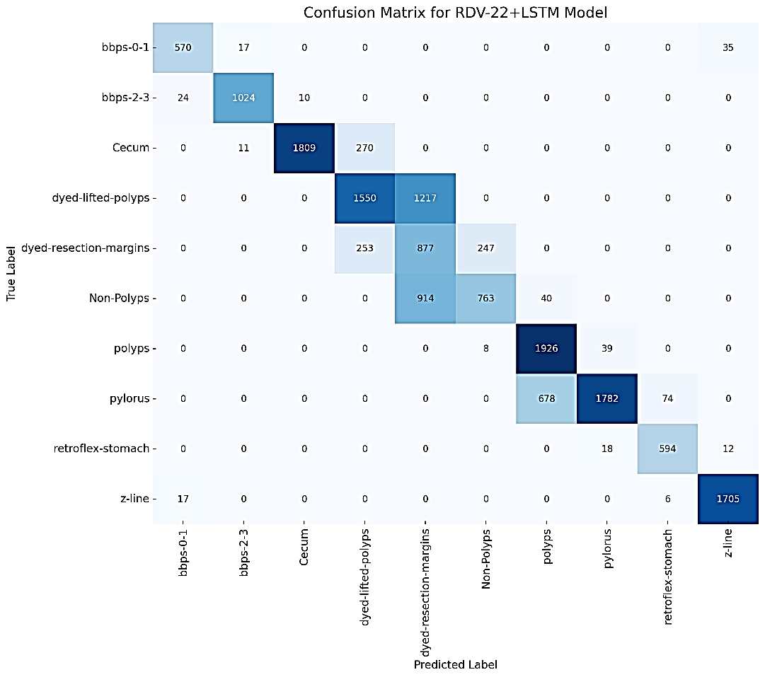
Figure 17: Confusion Matrix for RDV-22+LSTM Model
  - Classification of the RDV-22+LSTM Model's ROC Curve
The RDV-22+LSTM model's ROC curves which is shown in Figure 18 that it performs differently in each of the 10 classes on the colorectal cancer detection test. Classes such as bbps-0-1, bbps-2-3, Non-Polyps, pylorus, retroflex-stomach, and z-line have outstanding discriminative ability with AUC values ranging from 0.97 to 0.99. The fact that these curves are located close to the plot's upper left corner indicates that the model is very sensitive and particular to these classes, allowing it to differentiate them from others with few false positives and negatives.
Classes with poor performance include Cecum, dyed-lifted-polyps, and dyed-resection-margins. Cecum has a decent AUC of 0.78, however dyed-lifted-polyps and dyed-resection-margins have pitiful AUC values of 0.56 and 0.67, respectively, showing that the model has a hard time with these classes. More work is needed to correctly identify these situations since their curves are closer to the diagonal line, which stands for random guessing. High area under the curve (AUC) values for most classes demonstrate the model's efficacy, while lower scores highlight areas for improvement; taken together, these metrics provide an accurate representation of the model's strengths and shortcomings. The RDV-22 model with LSTM integration has outstanding discriminatory skills, as shown by the ROC curve with an AUC of 0.98.

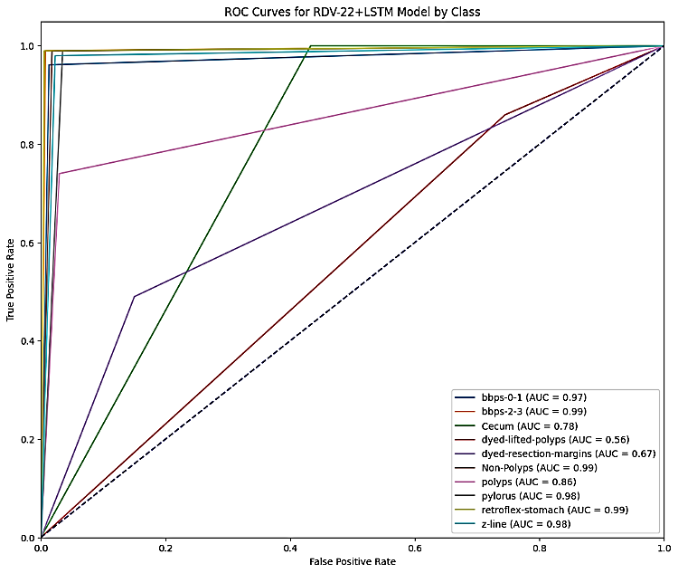
Figure 18: ROC for RDV-22+LSTM Model
  - Modifications in the Complexity and Time of Computing
The models' computational complexity increased as a result of the incorporation of LSTM networks and feature fusion. This escalation in complexity is accompanied by a rise in computational resource requirements and extended training durations. The computational durations for training individual CNN models and fusion models are compared in Table 13.
Table 13: Each model's computational time
Model | Training Time (hours)
VGG16 | 5.2
DenseNet-201 | 6.5
ResNet50 | 5.8
DV-22 | 8.4
RD-22 | 8.9
RDV-22 | 10.2
There are numerous factors that contribute to this increase in training time:
- Complexity of Feature Fusion: Fusion models integrate features from multiple CNN architectures. This procedure entails the integration of features from each model into a singular, cohesive representation, in addition to the extraction of features. The lengthier training periods are a result of the additional computation necessary to combine and evaluate these features.
- Model Depth and Parameters: Fusion models are inherently endowed with a greater number of parameters than individual CNN models. For instance, the RDV-22 model integrates features from ResNet50, DenseNet-201, and VGG16, resulting in a more intricate network architecture with a greater number of parameters. This heightened complexity necessitates an increase in computational capacity and training time.
- LSTM Integration: The integration of LSTM networks introduces an additional layer of complexity. LSTMs are intended to manage sequential data by capturing the temporal dependencies between frames. The integration of LSTMs with CNNs results in the addition of computations for each time step in the sequence, which further increases the training time.
- Enhanced Feature Representation: The fusion models are designed to capture an exhaustive set of features by utilizing the assets of various CNN architectures. Although this process is advantageous for enhancing accuracy, it necessitates substantial computations to guarantee that the model learns effectively from the diverse feature sets. Consequently, the training period is prolonged.
The RDV-22 model necessitated the most extensive training time, which was 10.2 hours. This model boasts the most comprehensive feature set. This is anticipated, as RDV-22 integrates features from three distinct CNNs (ResNet50, DenseNet-201, and VGG16) and processes them through LSTM networks to capture temporal dependencies. The sequential processing by LSTMs, in conjunction with the extensive feature extraction and fusion, leads to a significantly increased computational burden.
- Discussions
Integrating LSTM networks with feature fusion significantly improves colorectal cancer detection accuracy by increasing the model's ability to include both spatial and temporal variables.. The trade-off is justified by the benefits in performance metrics, despite the increased computational complexity and training time. The efficacy of this exhaustive approach is illustrated by the RDV-22 model, which achieves an accuracy rate of 90.81%.
The model's capacity to accurately diagnose colorectal cancer is considerably improved by the integration of LSTM networks and feature fusion, which captures both spatial and temporal features. Although this method increases computational complexity and training time, the ensuing enhancements in performance metrics render it a beneficial trade-off. The fusion model RDV-22, in particular, is the most robust and accurate, providing a comprehensive solution for the early detection of CRC.
A great accuracy rate of 90.81% was attained by the newly designed CRCFusionAICADx system, which incorporates feature fusion and the fusion CNN RDV-22. Three separate feature sets—original, grayscale, and LBP—were combined to get this outcome. Merging these characteristics, particularly in feature-3, which combines the original, grayscale, and LBP image features, has shown to be the most successful strategy.
Using CNN analysis, we combed through all of the data gathered by each system from 2021–2023. Quite a bit of overlap appears when we compare this comprehensive ColoRectalCADx system to the three-stage GastroCADx approach that was originally suggested and is set to be implemented in 2021. For your convenience and comprehension, Table 14 summarises all pertinent results from the datasets described earlier.
Table 14: Comparison of Results from Previous State-of-the-Art Methods (2021-2023)
Dataset | Author | Method | Accuracy (%)
CVC Clinic DB | Omneya Attallah et al. (2021) [45] | GastroCADx | --
 | Liew et al. (2021) [46] | Ensemble Classifier (ResNet50 + Adaboost) | 97.91
 | Pallabi Sharma et al. (2022) [17] | Ensemble Classifier | 98.3
 | Nisha J.S et al. (2022) [47] | DP-CNN | 99.6
 | Maryem Souaidi et al. (2022) [48] | MP-FSSD | 91.56
 | Akella S Narasimha Raju et al. | ColoRectalCADx | 99
Kvasir2 | Omneya Attallah et al. (2021) [45] | GastroCADx | 97.3
 | Pallabi Sharma et al. (2022) [17] | Ensemble Classifier | 97
 | Akella S Narasimha Raju et al. (2022) [49] | ColoRectalCADx | 88
Hyper Kvasir | Omneya Attallah et al. (2021) [45] | GastroCADx | 99.7
 | Akella S Narasimha Raju et al. (2022) [50] | ColoRectalCADx | 84
Mixed Dataset | Akella S Narasimha Raju et al. (2022) [50] | ColoRectalCRCFusionAICADx | 84.7
CKHK-22 | Ours (proposed) (2023) | CRCFusionAICADx System | 90.81
Different authors and research groups have developed many approaches and systems for diagnosing colorectal cancer, each one aiming for precision in disease identification in Table 12. In particular, the CKHK-22 dataset, which was suggested in 2023 and utilized in the assessment, showed excellent diagnostic capabilities when integrated into a CRCFusionAICADx system, with an accuracy of 90.81% being achieved. This is indicative of substantial development in the area and hints to the possibility of accurate cancer detection in the near future. The CVC Clinic DB, Kvasir2, Hyper Kvasir, and a Mixed Dataset were also used to test various methodologies and systems. In particular, DP-CNN, which was developed by Maryem Souaidi et al. in 2022, shown outstanding diagnostic performance by achieving an astounding accuracy of 99.6% on CVC Clinic DB. Ensemble approaches have been shown to be successful in the diagnosis of colorectal cancer, as shown by the 98.3% accuracy reached by the Ensemble classifier created by Nisha J.S et al. using the CVC Clinic DB dataset. The GastroCADx system, created by Omneya Attallah et al., achieved a high accuracy of 97.3% on the Kvasir2 dataset. Akella S. Narasimha Raju et al.'s GastroCADx method for Hyper Kvasir has an outstanding accuracy of 99.7 %. The ColoRectalCADx system maintained a competitive accuracy of 84.7% on a Mixed Dataset, demonstrating the adaptability of their method.
Although these results highlight the noteworthy advancements, the suggested CRCFusionAICADx system's performance on the CKHK-22 dataset points to an encouraging path towards improving the accuracy of colorectal cancer diagnoses. These advancements are crucial in the fight against this disease, as they improve early detection and consequently enhance patient outcomes. A comprehensive analysis of data from all systems between 2021 and 2023 is presented in Figure 19.
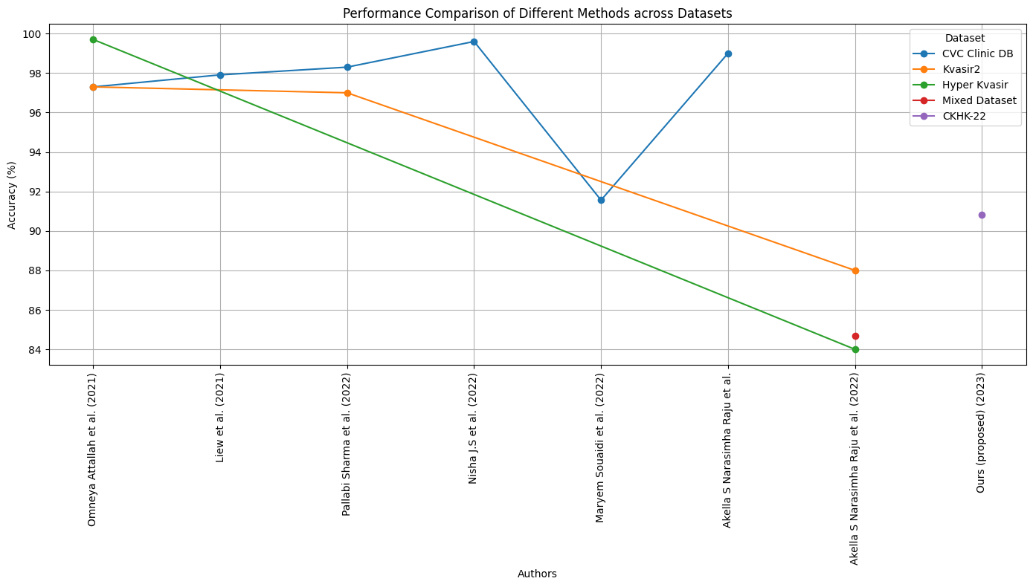
Figure 19: All the state of art methods comparison

Conclusion
This research highlights the significant impact of using computer vision and sophisticated deep learning algorithms to identify colorectal cancer early on. We illustrated the distinctive strengths and capabilities of three distinct convolutional neural networks (CNNs)—VGG-16, DenseNet-201, and ResNet-50—through an evaluation. These CNNs attained exceptional diagnostic accuracy by incorporating Long Short-Term Memory (LSTM) networks for transfer learning. The RDV-22 model, which is a fusion of multiple CNNs, was exceptionally effective, demonstrating impressive testing accuracy and establishing new standards in medical image processing. The results underscore the critical role of sophisticated CRCFusionAICADx systems in the early detection of diseases, emphasising the enhanced potential of combining CNNs with LSTM networks to improve diagnostic performance.
Future Work
The results underscore the importance of incorporating LSTM networks and employing multiple CNN architectures to circumvent the limitations of conventional and single-model approaches. To further improve diagnostic accuracy and computational efficiency, future research could explore the implementation of more advanced architectures, including Vision Transformers (ViT) and YOLO. In order to strengthen clinician trust, future research should concentrate on the following: the exploration of advanced architectures, the enhancement of transfer learning capabilities, the expansion of datasets to include diverse demographics, and the enhancement of model explainability. It is imperative to conduct clinical validation in real-world settings to guarantee the safety and efficacy of these models, which will enable more accurate and expeditious colorectal cancer diagnoses.
Acknowledgements
Sincere appreciation is due to the Hyderabad Institute of Aeronautical Engineering for all of the help they have given us. Our research would not have been possible without the help of our collaborators and the resources they generously provided. Collaborations with cutting-edge research facilities that focus on deep learning, machine learning, and AI and have access to powerful GPU systems have been immensely beneficial to our work. The use of these specialized facilities has greatly simplified our otherwise laborious processes. This initiative has not relied on any outside parties or people for its funding; all of the funds have come from within the organization.
Declarations
Ethical Approval
This project utilizes human colonoscopy images obtained from publicly accessible online repositories. These images were not collected from real-time procedures at medical facilities. Consequently, due to the nature of the image collection, ethical committee approval was not required for this study.
Conflicts of Interest
None of them have any declared conflicts of interest.
Authors' Contributions
Dr. Akella S. Narasimha Raju: Dr. Akella S. Narasimha Raju played a critical role in the project's experimentation phase. He conducted experiments, collected data, and analysed the results. His contributions encompassed the practical duties of testing and evaluating various aspects of the research.
Dr. Kayalvizhi Jayavel: Kayalvizhi Jayavel was the driving force behind the development of the project's core ideas. She contributed by conceptualizing and shaping the research direction. Her role involved brainstorming, proposing innovative solutions, and providing the project with a solid theoretical foundation.
Dr. T. Rajalakshmi: T. Rajalakshmi was primarily focused on the comprehensive examination of the project concept and documentation. Her contributions revolved around the meticulous review and documentation of the project's progress, ensuring that all aspects were thoroughly covered, and that the work was well-documented for future reference.
Dr. M, Rajababu gave the part of experimentation and curation of data
Each of these team members played a distinct but complementary role in the research, collectively contributing to the project's success.
Funding

The project is completely self-financed, with no external funding support from any source.

Data Availability Statement
Since this research did not create or analyse any datasets, data sharing is not relevant to it.

References

[1] | Tang PC, Ash JS, Bates DW, Overhage JM, Sands DZ, "Personal health records: definitions, benefits, and strategies for overcoming barriers to adoption.," Journal of the American Medical Informatics Association, vol. 13, no. 2, April 2006.
[2] | Stol YH, Asscher ECA, Schermer MHN, "What is a good health check? An interview study of health check providers' views and practices," BMC Med Ethics., vol. 18, p. 18(1):55, 2 October 2017.
[3] | Zhang PW, Chen L, Huang T, Zhang N, Kong XY, Cai YD, "Classifying ten types of major cancers based on reverse phase protein array profiles.," PLoS One, vol. 10, no. 3, 30 March 2015.
[4] | Kuipers EJ, Grady WM, Lieberman D, Seufferlein T, Sung JJ, Boelens PG, van de Velde CJ, Watanabe T, "Colorectal cancer," Nat Rev Dis Primers, p. 1:15065, 5 November 2015.
[5] | "Colorectal Cancer Facts & Figures 2020-2022," American Cancer Society, 2022.
[6] | Iyad A Issa,alak Noureddine, "Colorectal cancer screening: An updated review of the available options," world journal of Gastroenterology, p. 5086–5096., 28 July 2017 .
[7] | Noha Ghatwary, Xujiong Ye,Massoud Zolgharni, "Esophageal Abnormality Detection Using DenseNet Based Faster R-CNN With Gabor Features," IEEE Access, vol. 7, pp. 84374 - 84385, 27 June 2019.
[8] | Tharwat, M.; Sakr, N.A.; El-Sappagh, S.; Soliman, H.; Kwak, K.-S.; Elmogy, M, "Colon Cancer Diagnosis Based on Machine Learning and Deep Learning: Modalities and Analysis Techniques," Sensors, vol. 22, no. 23, p. 9250, 2022.
[9] | Roger Fonollà, Quirine E. W. Vander Zander , Ramon M. Schreude, Ad A. M. Masclee , Erik J. Schoon, Fons van der Sommen and Peter H. N. de With, "A CNN CADx System for Multimodal Classification of Colorectal Polyps Combining WL, BLI, and LCI Modalities,," Applied science, Vols. volume 10, Issue 15, no. Issue 15, pp. 10(15), 5040;, 2020.
[10] | Muthu Subash Kavitha , Prakash Gangadaran , Aurelia Jackson , Balu Alagar Venmathi Maran , Takio Kurita and Byeong-Cheol Ahn, "Deep Neural Network Models for Colon Cancer Screening," Cancers, 29 July 2022.
[11] | Li J, Wang P, Zhou Y, Liang H, Luan K, "Different Machine Learning and Deep Learning Methods for the Classification of Colorectal Cancer Lymph Node Metastasis Images," Front Bioeng Biotechnol, p. 8:620257, 14 January 2021.
[12] | Srikantamurthy, M.M., Rallabandi, V.P.S., Dudekula, D.B. et al, "Classification of benign and malignant subtypes of breast cancer histopathology imaging using hybrid CNN-LSTM based transfer learning," BMC Med Imaging, 30 January 2023.
[13] | Mahmoud Ragab, Maged Mostafa Mahmoud4,, Amer H. Asseri, Hani Choudhry, Haitham A. Yacoub, "Optimal Deep Transfer Learning Based Colorectal Cancer Detection and Classification Model," computer, materials & continua, vol. 74, no. 2, pp. 3279-3295, 31 October 2022.
[14] | Pouria Parhami, Mansoor Fateh, Mohsen Rezvani, Hamid Alinejad Rokny, "A benchmarking of deep neural network models for cancer subtyping using single point mutations," bioRXiV, 2022.
[15] | Nguyen Thanh Duc, Nguyen Thi Oanh, Nguyen Thi Thuy, Tran Minh Triet, Dinh Viet Sang, "ColonFormer: An Efficient Transformer based Method for Colon Polyp Segmentation," IEEE Access, vol. 10, p. 80575 – 80586, 1 August 2022.
[16] | Yanda Meng , Hongrun Zhang, Yitian Zhao , Xiaoyun Yang, Yihong Qiao , Ian J. C. MacCormick , Xiaowei Huang, and Yalin Zheng, "Graph-Based Region and Boundary Aggregation for Biomedical Image Segmentation," IEEE Transactions On Medical Imaging, vol. 41, no. 3, pp. 690 - 701, March 2022.
[17] | Pallabi Sharma, Bunil Kumar Balabantaray, Kangkana Bora, Saurav Mallik , Kunio Kasugai and Zhongming Zhao, "An Ensemble-Based Deep Convolutional Neural Network for Computer-Aided Polyps Identification From Colonoscopy," Frontiers in Genetics, 26 April 2022.
[18] | Hiroaki Saito, Tetsuya Tanimoto, Tsuyoshi Ozawa, Soichiro Ishihara, Mitsuhiro Fujishiro, Satoki Shichijo, Dai Hirasawa, Tomoki Matsuda, Yuma Endo, Tomohiro Tada, "Automatic anatomical classification of colonoscopic images using deep convolutional neural networks," Gastroenterology Report, , vol. 9, no. 3, pp. 226-233, June 2021.
[19] | A. Karthikeyan a, S. Jothilakshmi a, S. Suthir, "Colorectal cancer detection based on convolutional neural networks (CNN) and ranking algorithm," Measurement: Sensors, vol. 31, 19 December 2023.
[20] | Hemin ali qadir, Johannes solhusvik,Jacob bergsland, Lars aabakken,and Ilangko balasingham, "A Framework With a Fully Convolutional Neural Network for Semi-Automatic Colon Polyp Annotation," IEEE Access, vol. Volume: 7, pp. 169537 - 169547, 20 November 2019.
[21] | "https://www.kaggle.com/balraj98/cvcclinicdb," 2015. [Online]. [Accessed 25 May 2021].
[22] | "https://datasets.simula.no/kvasir/," 2016. [Online]. [Accessed 3 July 2021].
[23] | "https://datasets.simula.no/hyper-kvasir/," 2020. [Online]. [Accessed 3 July 2021].
[24] | Christopher Kanan ,Garrison W. Cottrell, "Color-to-Grayscale: Does the Method Matter in Image Recognition?," PLOS ONE, 10 January 2012.
[25] | C. Saravanan, "Color Image to Grayscale Image Conversion," in Second International Conference on Computer Engineering and Applications, Bali, Indonesia.
[26] | Porebski, A.; Truong Hoang, V.; Vandenbroucke, N.; Hamad, D, "Combination of LBP Bin and Histogram Selections for Color Texture Classification," Journal of Imaging, vol. 6, no. 6, 23 June 2020.
[27] | C. Emmy Prema, S. Suresh, "Local Binary Pattern based Hybrid Texture Descriptors for the Classification of Smoke Images," INTERNATIONAL JOURNAL OF ENGINEERING RESEARCH & TECHNOLOGY (IJERT), vol. 7, no. 13, pp. 2278-0181, 2 February 2020.
[28] | Kudo SE, Mori Y, Abdel-Aal UM, Misawa M, Itoh H, Oda M, Mori K, "Artificial intelligence and computer-aided diagnosis for colonoscopy: where do we stand now?," Translational Gastroenterology and Hepatology., vol. 6, no. 64, 25 October 2021.
[29] | Abol Basher, Byeong C. Kim,Kun Ho Lee,Ho Yub Jung, "Automatic Localization and Discrete Volume Measurements of Hippocampi From MRI Data Using a Convolutional Neural Network," IEEE Access, vol. Volume: 8, pp. 91725 - 91739, 14 May 2020.
[30] | AminKabir Anaraki,MoosaAyati,FoadKazemi, "Magnetic resonance imaging-based brain tumor grades classification and grading via convolutional neural networks and genetic algorithms," Biocybernetics and Biomedical Engineering, vol. 39, no. 1, pp. Pages 63-74, January–March 2019.
[31] | Qiaoliang Li, Guangyao Yang, Zhewei Chen, Bin Huang, Liangliang Chen, Depeng Xu, Xueying Zhou, Shi Zhong, Huisheng Zhang and Tianfu Wang,, "Colorectal Polyp Segmentation Using A Fully Convolutional Neural Network," in 10th International Congress on Image and signal Processing , Biomedical Engineering and infromatics(CISP-BMWI2017), Shanghai, China, 14-16 Oct. 2017 Published: 27 February 2018.
[32] | Tao yang, Ning liang, Jing li, Yi yang, Yuedan li, Quan, Huang,, "Intelligent Imaging Technology in Diagnosis of Colorectal Cancer Using Deep Learning," IEEE Access, vol. 7, pp. 178839-178847, 06 December 2019.
[33] | Kaiming He, Xiangyu Zhang, Shaoqing Ren, Jian Sun, "Deep Residual Learning for Image Recognition," in Computer Vision and Pattern Recognition (cs.CV),, 10 Dec 2015.
[34] | Gao Huang,Zhuang Liu,Laurens van der Maaten, "Densely Connected Convolutional Networks," Computer Vision and Pattern Recognition (cs.CV), 28 January 2018.
[35] | Karen Simonyan, Andrew Zisserman, "Very Deep Convolutional Networks for Large-Scale Image Recognition," in Computer Vision and Pattern Recognition (cs.CV),arXiv:1409.1556v6, 10 Apr 2015.
[36] | Wener Borges Sampaio 1, Edgar Moraes Diniz, Aristófanes Corrêa Silva, Anselmo Cardoso de Paiva, Marcelo Gattass, "Detection of masses in mammogram images using CNN, geostatistic functions and SVM," computers in Biology and Medicine, vol. 21703605, pp. 41(8):653-64, 17 August 2011.
[37] | Barret Zoph, Vijay Vasudevan, Jonathon Shlens, Quoc V. Le, "Learning Transferable Architectures for Scalable Image Recognition," in Computer Vision and Pattern Recognition (cs.CV); Machine Learning (cs.LG); Machine Learning (stat.ML),arXiv:1707.07012v4, 11 Apr 2018.
[38] | Changbo Houa,b,*, Xiao Zhangb, and Xiang Chen, "Electromagnetic Signal Feature Fusion and Recognition based on Multi-Modal Deep Learning," International Journal of Performability Engineering, vol. 16, no. 6, pp. 941-949, 2020.
[39] | Yinghui Zhu, Yuzhen Jiang, "Optimization of face recognition algorithm based on deep learning multi feature fusion driven by big data," Image and Vision Computing, vol. 104, p. 104023, December 2020.
[40] | Mostafiz, R., Rahman, M.M. & Uddin, M.S., "Gastrointestinal polyp classification through empirical mode decomposition and neural features," SN Applied Sciences, vol. 2, p. 1143, 30 May 2020.
[41] | Rafid Mostafiz, Mosaddik Hasan, Imran Hossain, Mohammad M. Rahman, "An intelligent system for gastrointestinal polyp detection in endoscopic video using fusion of bidimensional empirical mode decomposition and convolutional neural network features," International Journal of International Journal of Imaging Systems and Technology, vol. 30, no. 1, pp. 224-233, 06 June 2019.
[42] | Saban ozturik, Umut ozakaya, "Residual LSTM layered CNN for classification of gastrointestinal tract diseases," Journal of Biomedical Informatics, vol. 113, January 2021.
[43] | Taruna Agrawal, Rahul Gupta, Saurabh Sahu, C. Espy-Wilson, "SCL-UMD at the Medico Task-MediaEval 2017: Transfer Learning based Classification of Medical Images," in Medico challenge,,MediaEval, Dublin, Ireland, 13th september,2017.
[44] | Öztürk, Ş., Özkaya, U, "Gastrointestinal tract classification using improved LSTM based CNN," Multimedia Tools and Applications, vol. 79, p. 28825–28840, 06 August 2020.
[45] | Omneya Attallah , Maha Sharkas, "GASTRO-CADx: a three stages framework for diagnosing gastrointestinal diseases," PeerJ Computer Science, vol. PMID: 33817058, p. 7:e423, 10 March 2021.
[46] | Liew,W. S., Tang, T. B., Lin, C.-H., and Lu, C.-K, "Detection Using Integration of Modified Deep Residual Convolutional Neural," Comput. Methods Programs, vol. 206, July 2021.
[47] | Nisha J.S., Varun P. Gopi , Palanisamy P., "Automated colorectal polyp detection based on image enhancement and dual-path CNN architecture," Biomedical Signal Processing and Control, vol. 73, March 2022.
[48] | Meryem Souaidi ,Mohamed El Ansari, "A New Automated Polyp Detection Network MP-FSSD in WCE and Colonoscopy Images Based Fusion Single Shot Multibox Detector and Transfer Learning," IEEE Access, vol. 10, pp. 47124 - 47140, 29 April 2022.
[49] | Akella S. Narasimha Raju, Kayalvizhi Jayavel, Thulasi Rajalakshmi, "Dexterous Identification of Carcinoma through ColoRectalCADx with Dichotomous Fusion CNN and UNet Semantic Segmentation," Computational Intelligence and Neuroscience, vol. 2022, p. 29, 10 October 2022.
[50] | Akella S. Narasimha Raju, Kayalvizhi Jayavel, T. Rajalakshmi, "ColoRectalCADx: Expeditious Recognition of Colorectal Cancer with Integrated Convolutional Neural Networks and Visual Explanations Using Mixed Dataset Evidence," Computational and Mathematical Methods in Medicine, 10 November 2022.
[51] | Haya Alaskar , Abir Hussain , Nourah Al-Aseem , Panos Liatsis , Dhiya Al-Jumeily , "Application of Convolutional Neural Networks for Automated Ulcer Detection in Wireless Capsule Endoscopy Images," sensors, p. 19(6):1265, 13 March 2019.
[52] | Oza, P.; Sharma, P.; Patel, S.; Adedoyin, F.; Bruno, "A. Image Augmentation Techniques for Mammogram Analysis.," Journal of Imaging, vol. 8, no. 5, 20 May 2022.
[53] | Aoki T, Yamada A, Aoyama K, Saito H, Tsuboi A, Nakada A, Niikura R, Fujishiro M, Oka S, Ishihara S, Matsuda T, Tanaka S, Koike K, Tada T., "Automatic detection of erosions and ulcerations in wireless capsule endoscopy images based on a deep convolutional neural network," Gastrointest Endosc, vol. 89, no. 2, February 2019.

