MotionPerfection: An agile tool for the visualisation, analysis, annotation, and record of motor practice

Vincent Gallo (Queen Mary University of London)
Xin Zhou (Imperial College London, Exhibition Road, London SW7 2AZ)
Diane Abdallah (Queen Mary University of London of London)

Manuela Angioi (Queen Mary University of London)

Emma Redding (Trinity Laban Conservatoire of Music and Dance UK; University of Melbourne, Australia)

Beth Ackroyd (Trinity Laban Conservatoire of Music and Dance, London)
Chiara Galvan (English National Ballet School, English National Ballet)

Elisabetta Versace (Queen Mary University of London, 327 Mile End Road, E1 4NS London, corresponding author e.versace@qmul.ac.uk)

Abstract
Instructional experts and practitioners in sports, dance and rehabilitation need to assess and provide feedback on motor practice. To visualise, analyse and annotate motor practice, we have developed the user-friendly application MotionPerfection. Using just a single camera video recordings and a computer, MotionPerfection enables users to compare a focal user with a model reference, to assess and annotate the performance. We illustrate the software structure and functionality from video acquisition to feedback annotation. Researchers, instructors, clinicians and practitioners can use MotionPerfection to simplify, automate and standardise the analysis and feedback of motor routines in remote and face-to-face settings, in the laboratory and in the field, without the need of specialised equipment.

Keywords:

movement; sports; dance; rehabilitation; pose annotation; feedback

Table 1 – Code metadata
Nr | Code metadata description
C1 | Current code version | 2.0
C2 | Permanent link to code/repository used of this code version | https://github.com/PreparedMindsLab/MotionPerfection
C3 | Legal Code License | GNU General Public License v3.0
C4 | Code versioning system used | git
C5 | Software code languages, tools, and services used | C++, python, PySimpleGUI (Library), PyInstaller (Tool)
C6 | Compilation requirements, operating environments & dependencies | Windows 10+
C7 | Support email for questions | v.a.gallo@qmul.ac.uk  xz4516@ic.ac.uk  e.versace@qmul.ac.uk

Motivation and Significance

Sports, dance and rehabilitation rely on the correct execution of postures and movements. To assess and provide feedback required for improvement, it is necessary to analyse the execution of motor routines. However, instructional coaches, clinicians, researchers and practitioners have limited tools available to support their practice. Our open-source software MotionPerfection fills this gap, addressing the need of digital support systems for sports [1], dance [2], rehabilitation and telehealth [3,4], and supporting research in Dance and Sports science, Behavioural Neuroscience, Rehabilitation.
One current issue is that motion capture systems (reviewed in [5]) often require multiple cameras or wearable devices, specialised equipment and skills for data analysis. This is often unavailable or incompatible with motor practice and performance. Similarly, markerless open-source systems for pose estimation and tracking [reviewed in 6] require specialised computing skills and computational power. User-friendly and agile systems to measure, analyse and annotate postures and motor routines are needed.
To solve these issues, MotionPerfection takes standard format videos recorded from a single fixed camera as inputs, and does not require any wearable devices, specialist computing skills or powerful computers. MotionPerfection compares a focal participant (the participant that will be assessed, recorded in the focal video) to a model reference (recorded in the reference video) that executes the same motor routine at a predefined time. The visual comparison is possible via a temporal alignment of the videos, whenever participants synchronise their performance with a music or other pace-maker. Then, frames are extracted at specific times from both videos (see Fig. 1 a,b) and compared. Hence, this tool is immediately useful for disciplines that entrain with music, such as dance, figure skating, ice dancing, rhythmic and artistic gymnastics, synchronised swimming, and in all routines and exercises that can be executed with a prespecified rhythm, such as a squat synchronised with a timer/metronome.
MotionPerfection focuses on the visualisation, comparison and annotation of three components on motor performance: timing (linking the execution to a music or pace-maker), direction in space (the position of the higher hips with respect to the recording point of view), and position of body segments (see Fig. 3).

Software Description

Software Architecture
MotionPerfection is written as an open-source project in C++ and Python. It can be installed by downloading the complete project from GitHub and the built project ready for use will be found in the Dance folder. This folder contains the scripts, executable programs and support libraries. A third-party tool, MiKTeX (https://miktex.org/ version 21.3), is bundled with MotionPerfection but it can be updated by downloading from that projects site (https://miktex.org/howto/portable-edition). For visualising the output, all widely used PDF readers, including Adobe Acrobat Reader, Foxit Reader and most browsers’ built-in PDF readers (Google Chrome, Microsoft Edge, Mozilla Firefox, etc.) are suitable and have been tested to work well on computers, tablets and smartphones.
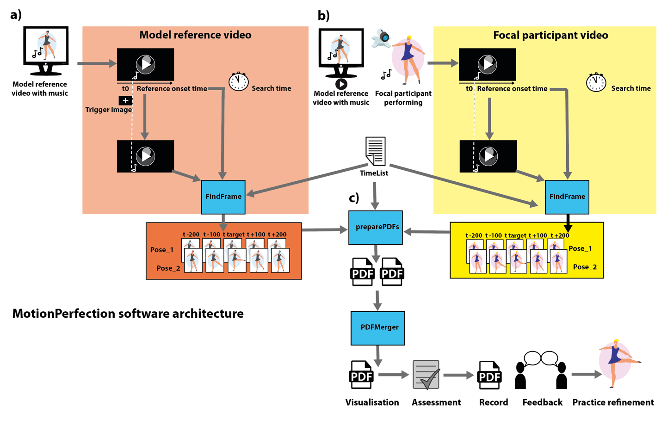
MotionPerfection consists of two software components: a tool to extract frames from a reference or focal video (FindFrame) and a tool to bundle the images for presentation, assessment and annotation (preparePDFs) (see Fig. 1). Extraction of frames from the reference and focal video can be achieved using the FindFrame tool in either its graphic user interface (GUI) or by submitting arguments to a command line interface. Frames extracted by FindFrame are processed using MiKTex and preparePDF.exe, invoked using script files, to combine the images from both focal and reference video to populate the visualisation and annotation template. The architecture of MotionPerfection is illustrated in Fig. 1.
Figure 1. The MotionPerfection software architecture. FindFrame extracts frames from a) a model reference video and b) a focal participant video, at timings specified in the TimeList file. The temporal alignment of the videos is achieved either automatically, via a Trigger Image added in the Model reference video (e.g., in the frame preceding the start of the motor routine, indicated with a note in the figure), or via times specified by the users for both videos (Search time). c) preparePDFs uses the extracted frames to create individual poses PDFs, then PDFMerger creates a single PDF output with multiple pages. The output allows users to visualise and assess the poses, providing feedback to practitioners.

2.1.2 GUI and frame extraction
A GUI (Graphical User Interface) is included in this software tool, enabling users to bypass command line tools (Fig. 2). The GUI was built in python using the PySimpleGUI library and compiled into an executable .exe file using PyInstaller. Via this GUI, users can provide the software toolchain with all required inputs (model and focal video, TimeList, search time or trigger image) described in Fig. 1, and specify the working and output directories.
All three main software tools (Fig. 1), namely FindFrame, preparePDFs and PDFMerger are equipped with Command-Line Interfaces and can be chained via .cmd batch files. The GUI merely selects the correct pre-written batch file depending on user inputs and runs the batch file with arguments also determined from the user inputs. In this way, software updates and bug fixes can be implemented by editing the batch files instead of having to adjust and recompile the GUI executable. Instructions on how to chain the software tools and a detailed table of valid input arguments are included in our software package in the “docs” folder. Instructions detail how to adjust the software toolchain to suit different needs and automate procedures.

2.1.3 Visualisation and annotation interface
After the desired frames are extracted from the model reference and focal participant videos, preparePDFs inserts them into PDF forms, ready for visualisation, assessment and annotation (Fig. 1c). A LaTeX script specifies the content and layout, and MiKTeX converts the LaTeX document to a PDF form with fillable checkboxes and text fields, the extracted frames and two supporting images that display the body joints and space direction points used for the assessment, and their location on an example frame (see Fig. 2).
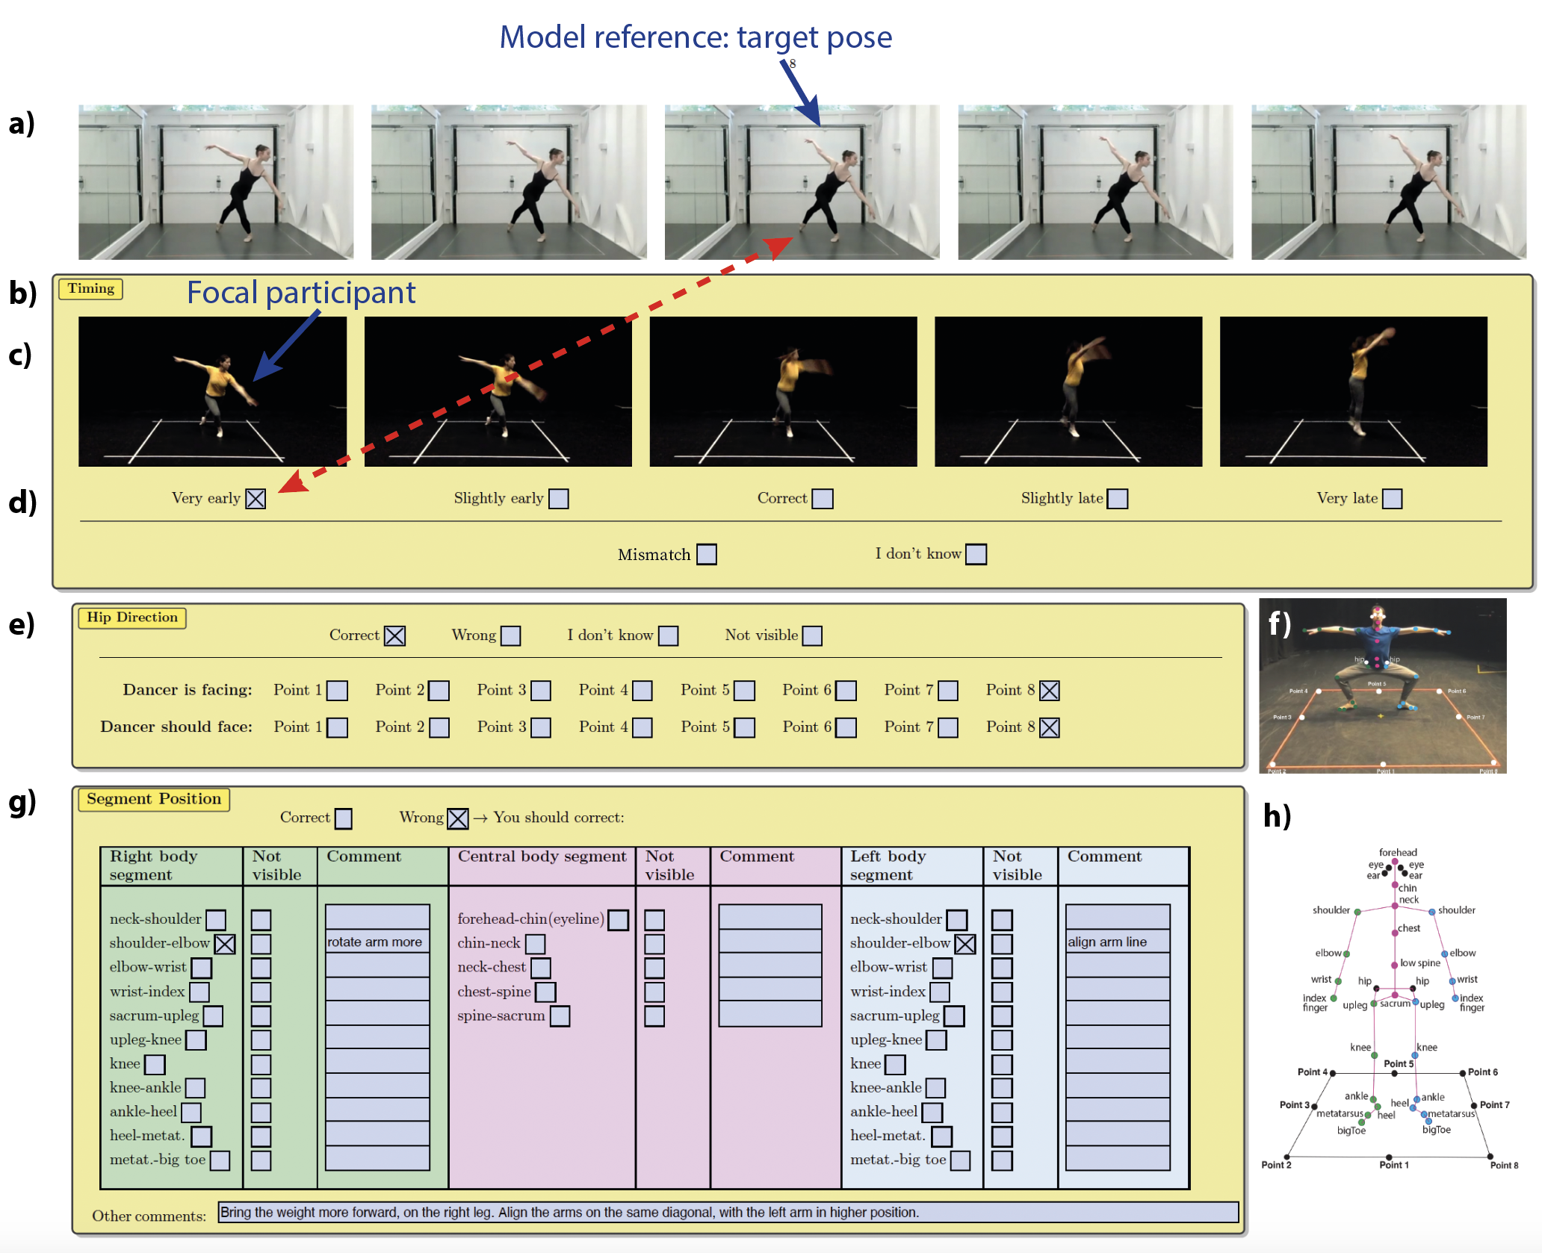
Figure 2. Example of a feedback form output. (a) Five subsequent model reference poses are displayed. In the Timing section (b) the selected (c) focal participant frames are displayed for evaluation in (d). Hip direction is evaluated in section (e), using the square points dispayed in the (f) example. The correct position of specific segments is evaluated in (g), referring to specific joints (h).
For each motor routine it is possible to extract frames from an arbitrary number of poses. Each pose is displayed in a dedicated page. First, the tools invoked by PySimpleGUI generate each page separately as standalone forms, which are then merged into a single PDF form with checkboxes and text fields for annotation. The PDF merging tool is written in Python and converted to a .EXE file via PyInstaller. This allows the software to run on Windows machines without needing to install Python.
Each of the checkboxes and text fields in the PDF form have a unique identifier name, used to match the input values. All the filled content is stored in the PDF files after the expert completes their assessment and sends the PDF back to the end user for record and feedback.

Software Functionalities
MotionPerfection allows end users to easily visualise, compare, analyse and annotate motor routines, focusing on frames extracted at specific times in two temporally aligned video recordings. We introduce three main software functionalities: analysis of timing, analysis of direction in space, analysis of body segment position, described below. We describe below the stages required to operate the software.

2.2.1 Data Acquisition and Input preparation. Common video formats (MP4, MOV, AVI) are supported. The focal participant footage is recorded with one fixed camera. A video recording with a fixed camera is used as model reference video for the trial of the focal participant, providing a music or other pace-maker that will be used to synchronise the performance of focal participant with that of the model reference. Using the same camera angle for the reference and focal video will ease the comparison. High frame rate and good illumination with light behind the camera enhance visualisation.
2.2.2 Installation on PC: download and install our package from https://github.com/PreparedMindsLab/MotionPerfection
2.2.3 Input preparation. We provide a TimeList and trigger example files in the material repository. When the same reference video is used for multiple trials/participants in online recordings (e.g., Zoom), adding the trigger image in the reference video immediately before the beginning of the music can help to automate frame extraction.
2.2.4 Once input stimuli are ready, MotionPerfection can be operated via GUI or command line and produce the output for the analysis, assessment and feedback. The instruction on how to use the GUI can be found in the readme file instructions.
2.2.5 Timing analysis: the synchronisation with the music/model reference can be checked comparing the upper extracted frames (model reference) with the lower frames (focal participant). The final user can tick the box in which the focal participant performs the target pose, indicating whether it is correct in timing, early or late, or whether there is a complete mismatch (Fig. 2c). The analysis of direction in space and segment position will be conducted on the frame that corresponds more closely to the target pose, as identified in the timing evaluation.
2.2.6. The direction in space is evaluated referring to an imaginary or real square surrounding the focal participant and model reference. Considering the eight points defined by the Vaganova method [7] we have defined 8 directions in space centred on the participant, starting from point 1 (see Fig. 2f,h). To evaluate direction in space, we refer to the plane in front of the frontal hips.
2.2.7 The position of body segments refers to the segments derived from adjacent joints (plus knee), illustrated in Fig. 2h. For ease of annotation, left, right and central segments have different colours (blue for left, pink for central, green for right body part of the focal participant) in the annotation form.

Illustrative Example
In this supplementary video https://youtu.be/qAehvhGQZGs , we show how to use MotionPerfection for visualising, comparing, assessing and annotating the performance of a model reference and a focal participant.
- Impact

Digital technology can support analysis and feedback on motor practice required in sports, dance and rehabilitation. MotionPerfection provides a solution to agile visualisation, analysis, annotation and feedback for motor routines, when a focal participant video can be compared to a reference model through temporal alignment of the two videos. MotionPerfection has been refined with experts in dance and physiotherapy at the English National Ballet School, the Royal Ballet School, the English National Ballet, Trinity Laban Conservatoire of Music and Dance, and free-lance dance teachers and choreographers. With this tool, users can precisely analyse poses and motor routines, provide detailed feedback that practitioners can visualise at their own convenience, and keep organised records of progression. The software directly supports the investigation of timing, orientation in space and position of body segments in the laboratory and in the field, including online practice, gyms and studios, theatres, outdoor settings.
A visual comparison between a reference and a focal participant is used to identify correct and wrong components of the execution. The footage of an expert that approximates the desired performance can be used as a model reference. Alternatively, different performances of the same participant can be compared, to evaluate their progress.
The only equipment needed are a camera for video recording, and a computer. This simple setting avoids the difficulties imposed by motion capture and automated tracking methods including the need for multiple cameras, wearable devices and computing specialisation, thus enhancing support in motor practice. Research fields that will benefit from this software include Sports and Dance Science, Sports and Dance Medicine, Behavioural Neuroscience, Rehabilitation and Physiotherapy. All activities that are executed with a temporal/music alignment such as dance, figure skating, ice dancing, rhythmic and artistic gymnastic, synchronised swimming, circus practice can immediately benefit from the use of MotionPerfection.

Conclusions

Digital technologies can support and augment the practice in sports, dance and rehabilitation but limited tools are available. To overcome the difficulties of digital tools that require specialised equipment and skills, we provide an agile tool for the analysis and feedback of poses and motor routines. Via MotionPerfection, it is possible to synchronise two videos, extract and compare frames from the performance of a model reference and a focal participant, provide feedback and record it, using a simple videocamera/webcam and a computer. MotionPerfection can be used in the laboratory and in the field, in everyday settings, including online remote practice and on-stage performance, without the need of specialised equipment. This software will support any motor practice entrained with music or any pace-maker, from dance to gymnastics to rehabilitation.

Conflict of Interest
Authors confirm that there are no known conflicts of interest associated with this publication and there has been no significant financial support for this work that could have influenced its outcome.

Acknowledgements
This project has been supported by the UKRI – ESRC grant ES/V015354/1 – and by the Royal Society Leverhulme Trust Senior Research Fellowship SRF\R1\21000155. We thank the English National Ballet School, the Royal Ballet School, and the Trinity Laban Conservatoire for Music and Dance, for their collaboration in data collection. We thank Mr Erico Montes, Mr Raymond Chai, Mr Hubert Essakow, Ms Nina Thilas-Mohs, for their helpful comments on refining MotionPerfection, Emma Coates (English National Ballet School) and a recreational dancer visualised as model reference and focal participant in this paper.

References

1. Goebeler L, Standaert W, Xiao X. Hybrid sport configurations: The intertwining of the physical and the digital. Proc Annu Hawaii Int Conf Syst Sci. 2021;2020-January: 5841–5850. doi:10.24251/hicss.2021.708
2. Parrish M. Toward transformation: Digital tools for online dance pedagogy. Arts Educ Policy Rev. 2016;117: 168–182. doi:10.1080/10632913.2016.1187974
3. Shen YT, Chen L, Yue WW, Xu HX. Digital Technology-Based Telemedicine for the COVID-19 Pandemic. Front Med. 2021;8: 1–23. doi:10.3389/fmed.2021.646506
4. El-Sherif DM, Abouzid M, Elzarif MT, Ahmed AA, Albakri A, Alshehri MM. Telehealth and Artificial Intelligence Insights into Healthcare during the COVID-19 Pandemic. Healthcare. 2022;10: 385. doi:10.3390/healthcare10020385
5. van der Kruk E, Reijne MM. Accuracy of human motion capture systems for sport applications; state-of-the-art review. Eur J Sport Sci. 2018;18: 806–819. doi:10.1080/17461391.2018.1463397
6. Panadeiro V, Rodriguez A, Henry J, Wlodkowic D, Andersson M. A review of 28 free animal-tracking software applications: current features and limitations. Lab Anim (NY). 2021. doi:10.1038/s41684-021-00811-1
7. Vaganova A. Basic Principles of Classical Ballet: Russian Ballet Technique. New York: Dover Publications; 1969.

