Thinking through making: Material Driven Design Pedagogies in Postgraduate Fashion Craft Education

Lara Torres¹, Naomi Filmer ²
¹ Dr Lara Torres, Senior Lecturer for Fashion Artefact, School of Design and Technology, London College of Fashion, University of the Arts London, l.torres@fashion.arts.ac.uk
² Naomi Filmer, Course Leader for MA Fashion Artefact, School of Design and Technology, London College of Fashion, University of the Arts London, n.filmer@fashion.arts.ac.uk

Abstract
This study explores how material-led pedagogies support postgraduate fashion education learning. Anchored in the MA Fashion Artefact course at London College of Fashion, it draws on New Materialism (Vaccari, 2022; Braidotti, 2013) and Material Driven Design (Bak-Andersen, 2018; Karana et al., 2015) to position materials as active agents in learning. The research asks: How do multidisciplinary, material-led, practice-based pedagogies facilitate ecologically responsive learning in postgraduate fashion education?
An action research methodology underpins the study, enabling iterative cycles of reflection, observation, and refinement. The researchers, embedded in the teaching environment, examine how studio-based methods evolve through material engagement and collaborative learning. Seven participants from three consecutive cohorts (three current students and four alumni) offer perspectives from different stages of development. The curriculum foregrounds materials as co-participants in the design process. Rather than imposing predetermined ideas, students respond to material behaviour through experimentation, allowing form and meaning to emerge through making in a hands-on, material-first approach. Students working with locally sourced or culturally significant materials such as indigenous resources, animal-derived elements, or traditional craft techniques reported heightened connections to place, identity, and ancestral knowledge. Some extended their practice through collaborations with artisans beyond academia, broadening learning into community-led contexts. Findings suggest that by positioning materials as active collaborators, students challenge conventional hierarchies of knowledge while enriching cultural responsiveness and ecological awareness. By framing making as a dialogic process, the study highlights the potential of material-driven design education to support regenerative, inclusive, and decolonising pedagogical practices within fashion, craft, and design education.

Key Words: Material-led pedagogies, New Materialism, Craft, Embodied Knowledge, Ethics of Care
INTRODUCTION
Across fashion education, increasing calls for ecological responsibility and decolonial reform have prompted a re-examination of how fashion design is taught, learned, and valued (Ahmed, 2023; Cheang & Suterwalla, 2020; Fletcher & Tham, 2019; Fletcher & Williams, 2013). These shifts challenge the dominance of Eurocentric, product-oriented pedagogies, advocating for more relational, situated, and responsible modes of learning that foreground material agency, local knowledge, and social justice. The ubiquity of digital tools and the dominance of outcome-oriented, industry-driven models have often marginalised the tactile, embodied, and reflective dimensions of making (Bryan-Kinns et al., 2024).

In response, a renewed attention to materials and processes is emerging within contemporary craft and design education, one that foregrounds experimentation, situated learning, and an ethics of care. Since its establishment in 2007 under the direction of Dai Rees (Program Director for Craft at School of Design and Technology), the MA Fashion Artefact course at London College of Fashion has offered a distinctive environment for investigating material-led design practices. Within this framework, thinking through making operates not only as a pedagogical method but as an epistemological stance, a way of generating knowledge through dialogue with materials. Students are encouraged to engage directly with material behaviour, allowing discovery, failure, and serendipity to guide creative development.

This process challenges linear and anthropocentric models of design education by positioning materials as collaborators and co-teachers. Drawing on the theoretical frameworks of New Materialism (Bennett, 2010; Braidotti, 2013; Smelik, 2018) and Material Driven Design (Karana et al., 2015; Bak-Andersen, 2018), this paper examines how material-led pedagogies foster inclusive, reflective, and ecologically responsive forms of learning. It considers how students’ evolving relationships with materials (and one another), cultivate attentiveness, adaptability, and cultural awareness through iterative, practice-based inquiry. By analysing experiences within this postgraduate studio context, the study positions material agency as a pedagogical principle and a transformative process. It argues that learning with materials can produce regenerative forms of knowledge that reconnect making, ecology, and education, offering a framework through which fashion craft may contribute to more sustainable, inclusive, and situated futures.

LITERATURE REVIEW
New Materialism: entanglements of matter and fashion
New Materialism offers a theoretical framework that challenges traditional anthropocentric approaches to matter, materials, and fashion. Anneke Smelik (2018:34) argues that materiality extends beyond the fabric or garment itself to include the wearer’s body, as well as the broader systems of production and consumption in which fashion is embedded. This expanded perspective resonates with Jane Bennett’s Vibrant Matter (2010:3), which contests the notion of matter as inert conceptualising it as alive, dynamic, and “vibrant.”

Central to this framework is the recognition of entanglement between human and non-human entities. Smelik (2018:33-34) suggests New Materialism foregrounds these entanglements, emphasising that humans and things are interconnected in continuous processes of becoming. This aligns with Rosi Braidotti’s (2013:60-61) articulation of post-humanism, which de-centres the human subject and situates humanity within a network of relations that includes animals, technologies, and environments. Similarly, Coole and Frost (2010:92) describe matter as fundamentally agentic, actively shaping interactions and outcomes, rather than being passively acted upon.

Within the posthuman framework, New Materialism promotes a non-anthropocentric worldview composed of complex assemblages where humans, materials, and other non-human entities interact in dynamic co-constitutive ways (Braidotti, 2013; Smelik, 2018). For fashion studies, this means shifting attention from garments as objects of human design and use toward understanding fashion as a system in which materials, bodies, technologies, and ecologies cooperate as active agents.

Material driven design
Within craft practices, there has long been a deep understanding of materials as active agents guiding the making process. However, with the rise of mass production and design pedagogies’ shift away from craftsmanship, material selection has often been relegated to later stages of the design process. In response, the past decade has witnessed the emergence of varied material-focused design approaches developed by practitioners and researchers.
This family of approaches, variously described as material-based, material-driven, or material-led (Karana et al., 2015; Van Bezooyen, 2013; Hansen, 2010; Oxman, 2010; Bak-Andersen, 2018), marks a significant pedagogical and methodological shift. Within these frameworks, materials are not regarded as passive media but as co-participants in the creative process. Such perspectives resonate with New Materialism, which foregrounds the agency of matter in shaping human action and decision-making. Bennett (2010:3) argues that matter possesses “agentic capacities,” directly influencing human choices and political life. Similarly, Braidotti describes matter as ‘intelligent and self-organizing (...) not a passive substance but an active agent of change’ (Remme, 2017).
Craft, embodied knowledge, and an ethics of care
Alongside these developments, scholarship on craft and care offers a complementary foundation for understanding the pedagogical dynamics of material-led learning. Craft theory positions making as an embodied, iterative, and ethically charged process in which knowledge emerges through direct engagement with materials. Richard Sennett’s The Craftsman (2008:9-11, 174-176) argues that craftsmanship entails a form of ‘intelligence’ rooted in the dialogue between hand, material, and intention. For Sennett, skill begins as bodily practice; understanding unfolds through tactile feedback, resistance, and repetition. This resonates strongly with the iterative, process-oriented ethos of the MA Fashion Artefact course, where learning is situated in the negotiation between maker and material rather than in predetermined outcomes.
Tim Ingold’s writings further illuminate this relational mode of knowing. His concept of the ‘education of attention’ (1997, 2013:2,110) suggests that skill develops not through the transfer of abstract instructions but through perceptual attunement to materials, environments, and the gestures of others. Making, in Ingold’s terms, is an act of ‘correspondence’, a reciprocal responsiveness in which human and material evolve together through the process of transformation (2013:21-23). This aligns closely with students’ descriptions of materials that “talk back,” guide decision-making, or redirect creative trajectories, indicating that material literacy is cultivated through sustained, embodied encounter. Complementing these craft-based perspectives, theories of care provide an ethical lens for understanding the ecological and cultural sensitivities that emerged in participants’ practices. Tronto’s (1994:127-128) ‘ethic of care’ foregrounds attentiveness, responsibility, and relationality as essential forms of moral agency, qualities that resonate with students’ commitments to respect material provenance, work slowly, reduce waste, and honour inherited craft traditions. Puig de la Bellacasa’s (2017: 5–7, 34–35) articulation of ‘matters of care’ expands this view to include more-than-human relations, proposing that caring for materials involves practices that nurture, sustain, and respond to their needs and histories. Her notion of ‘careful material practices’ provides a critical bridge between ecological ethics and craft pedagogy, framing making as a reciprocal act embedded within broader networks of human and non-human relations.
Together, these craft and care literatures enrich the theoretical grounding of material-led pedagogy. They highlight how embodied attention, ethical responsiveness, and relational sensitivity form essential dimensions of learning, complementing New Materialist understandings of material agency and situating practice within a broader ecology of making.

METHODOLOGY
This study adopts a qualitative action research methodology (Fletcher & Tham, 2019), designed to examine and refine pedagogical practice from within the teaching context. As both researchers are embedded in the MA Fashion Artefact course at London College of Fashion (Naomi is Course Leader for MA Fashion Artefact and Lara is a Senior Lecturer for Fashion Artefact), the approach enables continuous reflection, intervention, and iteration, aligning with the ethos of thinking through making that underpins the programme itself allowing pedagogical insights to emerge in real time in the teaching process. This study adopts a qualitative action research methodology to examine and refine pedagogical practice from within the teaching context.
Action research is: “a global family of related approaches that integrate theory and action with the goal of addressing important organizational, community and social issues together with those who experience them.
It focuses on the creation of areas for collaborative learning and the design, enactment and evaluation of liberating actions through combining action and reflection, in an ongoing cycle of co-generative knowledge” (Coghlan and Brydon-Miller,

2014).
Primary qualitative method: focus group
- 3 current students– 4 alumni (from 3 cohorts of MA Fashion Artefact)
This prioritised depth and nuance over numerical representation, enabling close examination of lived experience and diverse positionalities within the course.
Methods:
- Developed a series of Open-ended prompts that:
– sparked discussion of how shared experimentation informed creativity;
– allowed participants to articulate how material-led learning unfolds within the studio context;
– encouraged reflection on materials as collaborators;
– explored how participants perceived the role of materials in shaping their creative development, ecological awareness, and peer learning
– generated expressions of how material-led processes influenced confidence, adaptability, and reflective practice as designers.
- Recorded interviews (video + audio) with focus group responding to prompts.
Data Analysis Steps
1. Focus group recordings were transcribed & analysed using reflexive thematic analysis following Braun and Clarke (2006)
2. Code generation related to participants’ experiences of:
- Material engagement

- Studio learning

- Pedagogical transformation
3. Codes led to development of thematic patterns
4. Cross-group comparison (students ↔ alumni)

Research design and methods
The study employed focus groups as its primary qualitative method. This approach foregrounded collective dialogue and shared reflection, allowing participants to articulate how material-led learning unfolds within the studio context.

The focus groups explored how students and alumni perceive the role of materials in shaping their creative development, ecological awareness, and peer learning. Open-ended prompts encouraged participants to reflect on materials as collaborators; to discuss how shared experimentation informs creativity; and to express how material-led processes influence confidence, adaptability, and reflective practice as designers.

The sample comprised seven participants: three current students and four alumni from three consecutive cohorts of the MA Fashion Artefact course. This small but focused group was deliberately chosen to prioritise depth and nuance over numerical representation, enabling close examination of lived experience and diverse positionalities within the course.

Data analysis
Audio-visual recordings from the focus groups were transcribed and analysed thematically. Although discussions followed predefined topics, the analysis remained inductive, allowing themes to emerge from participants’ accounts. This approach enabled us to examine how interactions between material, maker, and pedagogy generate new forms of knowledge in postgraduate fashion craft education.
Table 1. Key Insights First Focus Group
Theme | Description
Material as Collaborator | Students recognised materials as active participants that shape form and meaning, co-authors in the design process.
Iteration and Failure | Experimentation, repetition, and unexpected outcomes were reframed as productive methods of discovery.
Cultural Grounding | Making with local and ancestral materials strengthened students’ connection to cultural heritage and ecological awareness.
Collective Learning | Peer-to-peer exchange and collaboration with technicians enhanced technical skill and foster a supportive interdependent studio culture.
Reflective Pedagogy | Making was understood as a critical space for dialogue, adaptation, and empowerment, enabling students to articulate tacit knowledge and develop reflective awareness through practice.

Table 2. Key Insights Second Focus Group

Themes | Description
Iterative Practice | Making, testing, and remaking were described as central to discovery and reflection, enabling tacit understanding to emerge through embodied engagement with materials.
Material Dialogue | Students described materials as responsive collaborators that “talk back,” guiding unexpected directions, fostering creative openness through serendipity.
Embodied Knowledge | Direct manipulation, touching, stretching, moulding, and combining, were seen as essential for developing sensitivity to material behaviour and expressive potential.
Collective Learning | Peer exchange and observation fostered inspiration and technical growth, with informal studio conversations and shared problem-solving generating new ideas and confidence.
Technical Collaboration | Collaboration with technicians and artisans expanded practical and cultural knowledge, bridging digital and traditional processes through hands-on mentorship.
Cultural and Ecological Awareness | Material choices reflected ancestral and ecological sensitivity, connecting practice to heritage, sustainability, and care for natural resources.
Unlearning | Students described unlearning and openness, reframing failure as discovery and re-learning material engagement through patience, curiosity, and dialogue rather than mastery.
Pedagogical Transformation | Alumni described a shift from control to dialogue, from outcome to process, developing patience, adaptability, and reflective agency through material-led learning.

Synthesis of the focus groups
The first focus group included three current students and one alumna, while the second comprised three alumni who had graduated at least a year earlier. Together, they show how time deepens the pedagogical effects of the MA Fashion Artefact course. Current students emphasised experimentation, whereas alumni described these practices maturing into sustained habits of reflection and ethical awareness. Alumni also noted a shift toward dialogic learning, with materials acting as “co-teachers” and tutors facilitating reflection through documentation that transformed tacit experience into critical insight. The insights from both groups are explored in the next section.
RESULTS AND DISCUSSIONS
Material agency and the design process
Findings from the first focus group revealed a marked transformation in students’ design approaches, from concept-first to material-first thinking. Before entering the MA Fashion Artefact course, most participants described starting with fixed ideas and then sourcing materials to fit them. Through material-driven pedagogies, however, students learned to listen to materials and allow their inherent behaviours, resistances, and affordances to lead creative decision-making. As Chuqi observed, “rather than imposing my concept onto the material, I let it speak its own story.” This perspective repositions materials as collaborators and co-teachers rather than passive tools. She expanded on this view about her materials (See Figure 1): “It’s more like we work together and create something together. I’m only 23 years old, but the materials, they’re much older than me.”
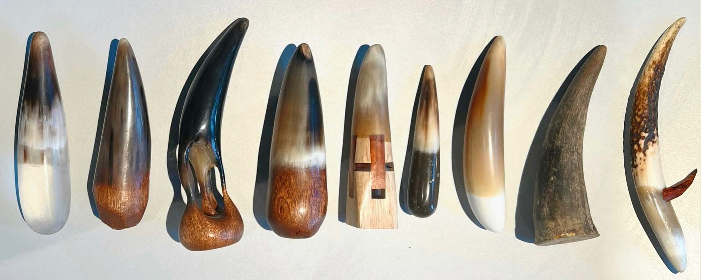
Fig. 1 Samples collection by Chuqi Cheng (Courtesy of the artist), MA Fashion Artefact (2025/26)

By acknowledging the material’s “age,” she situates her practice within a continuum that exceeds individual creativity, recognising matter as possessing its own histories, properties, and agencies. This statement embodies what Bennett (2010: 3, 20) describes as vibrant matter, the idea that materials are not inert but active participants with temporal depth and vitality. The notion of working with rather than on materials positions making as a form of intergenerational collaboration, where the designer dialogues with materials that have existed long before human intervention. Similarly, Sakshi articulated a parallel sensitivity, describing her process as a dialogue between maker and matter: “I think material is alive and it has its own story to tell. So, when you're telling a different story to them, you should just listen to each other and make a completely different… narrative that you're working towards”. In the second focus group, Carrie reflected on how materials “talk back” through their unpredictable behaviours. Her initially haptic exploration evolved into a sonic one: “I experimented with spiky surfaces (See Figure 2) that invited touch, but people avoided them. Unexpectedly, when the connectors hit each other, they produced sounds that became central to the work.” This serendipitous event redirected her creative process: “That sound became really interesting and led me to explore how sound could become a way to engage the senses… the materials themselves guided me to a completely new idea.”

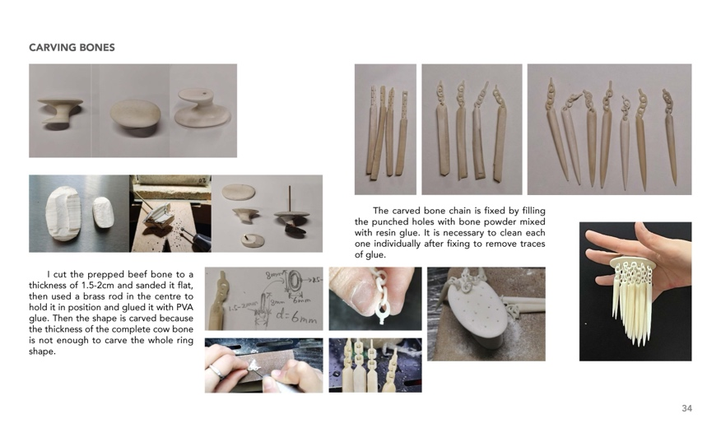

Fig. 2 Artefact by Carrie Wu, photographed by James Rees (Left) portfolio page by Carrie Wu (Courtesy of the artist) MA Fashion Artefact (2023/24)

This shift reveals a significant pedagogical insight: when students engage in open-ended, material-led experimentation, materials themselves can redirect the trajectory of the project. As Carrie later reflected, ‘This opened a new direction for me. I started researching rituals and shamanic objects that use materials from nature to create meaning. In that sense, the materials themselves began to guide me toward developing new ideas.’
(Un) learning and re-learning through making
The process of “unlearning” conventional control was emphasised as essential to developing sensitivity, adaptability, and humility in the studio context. Chuqi reflected that organic matter carries its own logic, one that resists human control. Natural materials warp, absorb, and transform in ways that can only be partially anticipated. Unpredictable organic material became a teacher itself, prompting her to slow down and listen. This resonates with Sakshi’s observation that “materials are alive,” reminding students that responsiveness in making depends on accepting instability and flux as integral to the process. In this sense, unlearning involves re-learning how to relate to materials: relinquishing authority, allowing creativity to emerge from collaboration rather than control.
Chuqi suggests that even with lifelong familiarity, materials continually reveal new qualities through each interaction, requiring ongoing readjustment. Failures and serendipitous outcomes were reframed as productive knowledge events that deepen understanding of material agency. Chuqi described forgetting “what [they] already knew” engaging materials without preconceptions. This allowed them to observe materials “as if meeting a stranger for the first time,” cultivating attentiveness to their inherent “personalities”. As she explained, “Imagine I am a kindergarten student and I never have known this material before, (...) like getting to know a new friend”. This metaphor captures the openness central to her process, a deliberate return to a beginner’s mindset, without mastery or expectation. Through this posture of re-encounter, learning became an act of discovery grounded in attentiveness and relational humility. Similarly, Sakshi linked her learning to the “art of letting go of control,” noting “you cannot pre-plan everything, you need to adapt to the process you are going through.” This required relinquishing predictability and accepting failure as part of discovery. Ke Xin echoed this, describing how she “stopped forcing the material to behave in a certain way” and instead learned to “listen to its reactions.” Yoon similarly described needing to “compromise with the process” after realising that her tendency to rush toward outcomes limited what the materials could teach her. Across these narratives, unlearning was not simply a cognitive adjustment but an emotional and temporal one, an invitation to slow down, listen, and re-learn power dynamics between maker and matter.
In this way, unlearning became both a pedagogical and ethical practice: a recognition that design knowledge emerges through relational humility and attentiveness towards the material, rather than dominance or mastery where the unknown is not a deficit but a site of learning.
Learning through making
Participants consistently described thinking through making as central to their learning. Iterative cycles of experimentation, reflection, and remaking enabled them to translate abstract ideas into tangible form. Many contrasted this with previous experiences in outcome-driven educational systems. Their MA experience, by contrast, privileged process, reflection, and risk-taking, aligning with material-driven design frameworks (Karana et al., 2015; Bak-Andersen, 2018), which locate discovery within the hands-on encounter rather than predetermined design intent. For several participants, this process transformed how they approached design and making.


Fig. 3 Artefact by Minqi Shao photographed by James Rees, MA Fashion Artefact (2024/25)
Minqi’s reflections epitomised this transformation, “Through practice, I can feel and compare the different level of elasticity in silicone (See Figure 3). These things are not learned from a book or pictures, only by touching and testing the material myself could I truly understand how it behaves.” She reveals how sensory engagement fostered a kind of situated understanding unavailable in previous modes of learning. Similarly, when encountering the limitations of silicone’s elasticity, she adapted her process: “silicone is very hard to connect with other materials, it created challenges in the structure of the design. I needed to keep experimenting until I found a solution that worked.” In this way, frustration and resistance became productive, leading to new structural and conceptual directions.
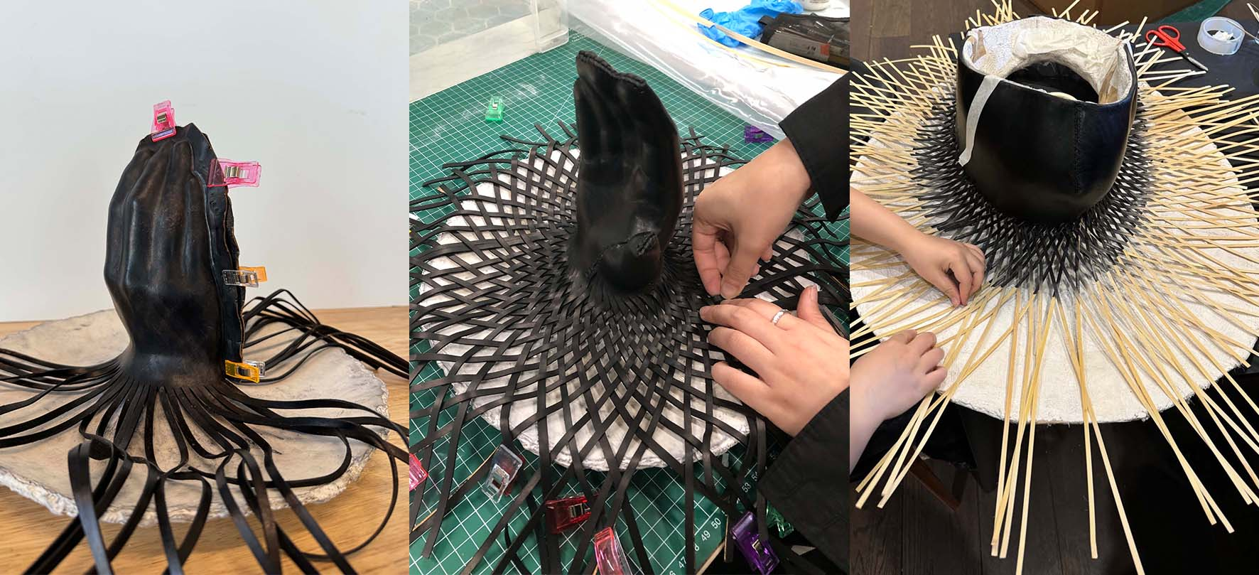
Fig. 4 Leather and bamboo integration process documentation by Shiyu Gong (Courtesy of the artist) MA Fashion Artefact (2023/24)
Shiyu’s work with leather and bamboo demonstrates a parallel shift toward co-creation with materials. He explained “the tension and flexibility in both materials meant I could bend, stretch, and stitch them, they let me explore body language and shape” (See Figure 4). Practice begets discovery: “When I started weaving the leather, I didn’t expect what happened, from very organised weaving it became open and loose… the leather just gave me the answer” (See Figure 5). Such moments of material ‘response’ illustrate how making is a dialogic process producing new insights. Students also identified iteration and model-making as integral to learning. As Shiyu described, “We go from design to model making and then back to design again… testing, failing, refining, this is a really good experience.” For Minqi, this extends into her teaching practice: “Before teaching, I will make models, (...) test the materials, and then teach the students. I learned from this course (...) to think through making.”
This reorientation echoes Ingold’s (2013: 21–23) previously mentioned notion of ‘correspondence’, where knowledge is generated through the body’s negotiation with materials rather than imposed upon them. Ingold describes a dynamic relationship where participants, whether human, material, or environment, continually respond to one another through active engagement (2013: 31-32).
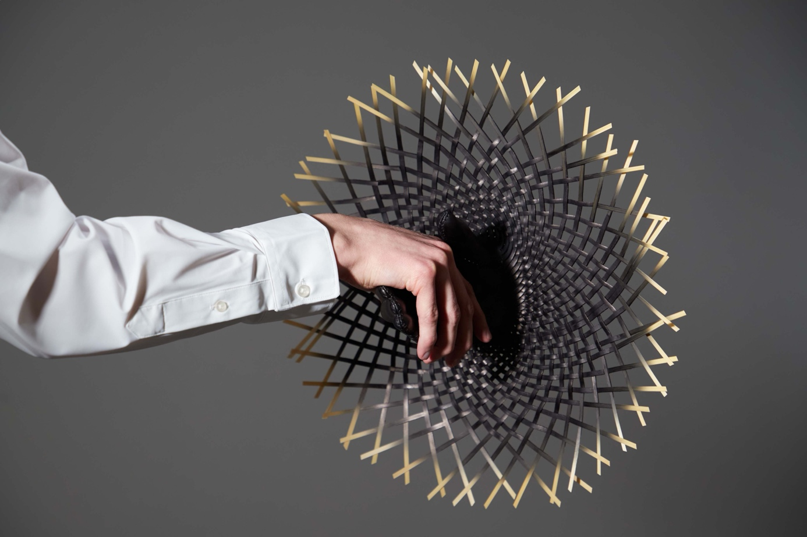
Fig. 5 Artefact by Shiyu Gong, photographed by James Rees, MA Fashion Artefact (2023/24)
Across these accounts, learning was articulated as a tactile dialogue between maker and material, a form of situated knowing (Haraway, 1988; Lave, J. & Wenger, E.,1991) grounded in resistance, responsiveness, and surprise. Making was not a preliminary stage preceding knowledge but a generative method for thinking itself. As Carrie concluded, “design can grow directly from material interaction, not just from an idea in your head.”
Cultural and ecological responsiveness
Material choice became a medium for exploring identity, heritage, and ecological ethics. Several participants discussed engaging with culturally or environmentally meaningful materials, as a way to reconnect with ancestry, local craft traditions, and ecological consciousness. For these practitioners, materiality became a language of belonging and a site for ethical negotiation.
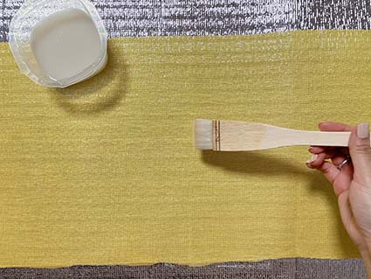

Fig. 6 Application of rice paste to ramie fabric by Yoon Ju Chung (Courtesy of the artist), MA Fashion Artefact (2025/26)
Yoon described a pivotal shift in her project when she began working with Korean fabrics, such as moji (ramie) and oksa (silk). Initially experimenting with cardboard and leather structures to visualise the Korean alphabet (Hangul), she found these materials failed to convey the cultural and linguistic resonance she sought. “The samples didn’t really tell the story,” she reflected. When she sourced traditional fabrics from Korea, “it clicked perfectly.” Working with these delicate materials demanded a slow, labour-intensive process of glueing and sewing, an approach she valued as reflective of “the beautiful aesthetic of Korean crafts.” Rejecting industrial methods, Yoon “didn’t use any stiffening sprays, I used rice glue.” (See Figure 6) “It’s really taking time because I have to apply it several times, but it works that way, not by the factory-made stiffness.” This commitment to traditional technique and material integrity reconnected her work to Korean heritage, allowing the embodied knowledge embedded in moji and oksa to guide the aesthetic and conceptual development of the project. Her observation underscores how material provenance and embodied cultural memory can anchor aesthetic development and deepen ecological awareness, echoing Ingold’s “correspondence” between material and cultural environments (2013).
Sustainability was framed not only in environmental terms but as an attitude of respect towards the heritage of materials and making. The use of natural adhesives, hand-dyed fibres, and slow, repetitive processes were interpreted as ecological gestures embodying care and regeneration. This redefinition of sustainability echoes Smelik (2018: 33-34) proposing a relational and affective approach to sustainability that values collaboration with materials and attentiveness to their transformations. For Smelik, sustainable practice is not limited to the choice of “eco-friendly” substances but involves reflective and empathetic engagement with the material world.
For Shiyu, whose practice intertwined leather and bamboo, material engagement was explicitly rooted in family heritage. “From my grandma and going to my dad’s generation, they’re both working with bamboo,” he explained, framing his project as a continuation of an ancestral craft lineage. “This is part of my DNA… I wanted to see what kind of things bamboo could make (...)”. His MA experience expanded this family’s legacy beyond furniture making into contemporary fashion artefacts, blending traditional hand skills with fabrication processes such as leather wet moulding and airbrushing.
Similarly, Carrie’s engagement with natural materials evolved into a reflective practice of attunement and reciprocity. She explained: “I found a lot of materials from the beach, from the forest… approaching nature this way is my inspiration.” Here, the beach alludes to Bermondsey Beach in London, a riverside stretch of the Thames between Tower Bridge and Rotherhithe, where first-year MA students were invited to participate in a Scavenger Hunt workshop designed by our colleague Georgina Goodman, Lecturer for MA Fashion Artefact, introducing students to methods of primary research through the collection and analysis of found (materials) natural and man-made, encouraging sensory observation, material taxonomy, and collective reflection. For Carrie, this exercise inspired an ongoing dialogue with nature as collaborator, fostering sensitivity to the provenance, transformation, and ethical reuse of materials. Her project later shifted toward sourcing bones from the food industry to comply with LCF Health & Safety regulations. Minqi offered an ethics of reuse working with synthetic materials. Aware that silicone is not biodegradable, she developed a method of cutting discarded silicone into “small pieces” and recasting it into new forms. “The ecological and ethical approach can also be not about the material itself,” she reflected, “but about how you work with materials effectively.” Her view reframes sustainability not as purity or abstention from certain materials, but as continuous reactivation of existing matter. Minqi credited this practice of reuse to Thomas Durrans’ (Specialist Technician 3D Mould Making and Casting) method of making new moulds from old ones, derived from standard model-making industry practices of material efficiency.
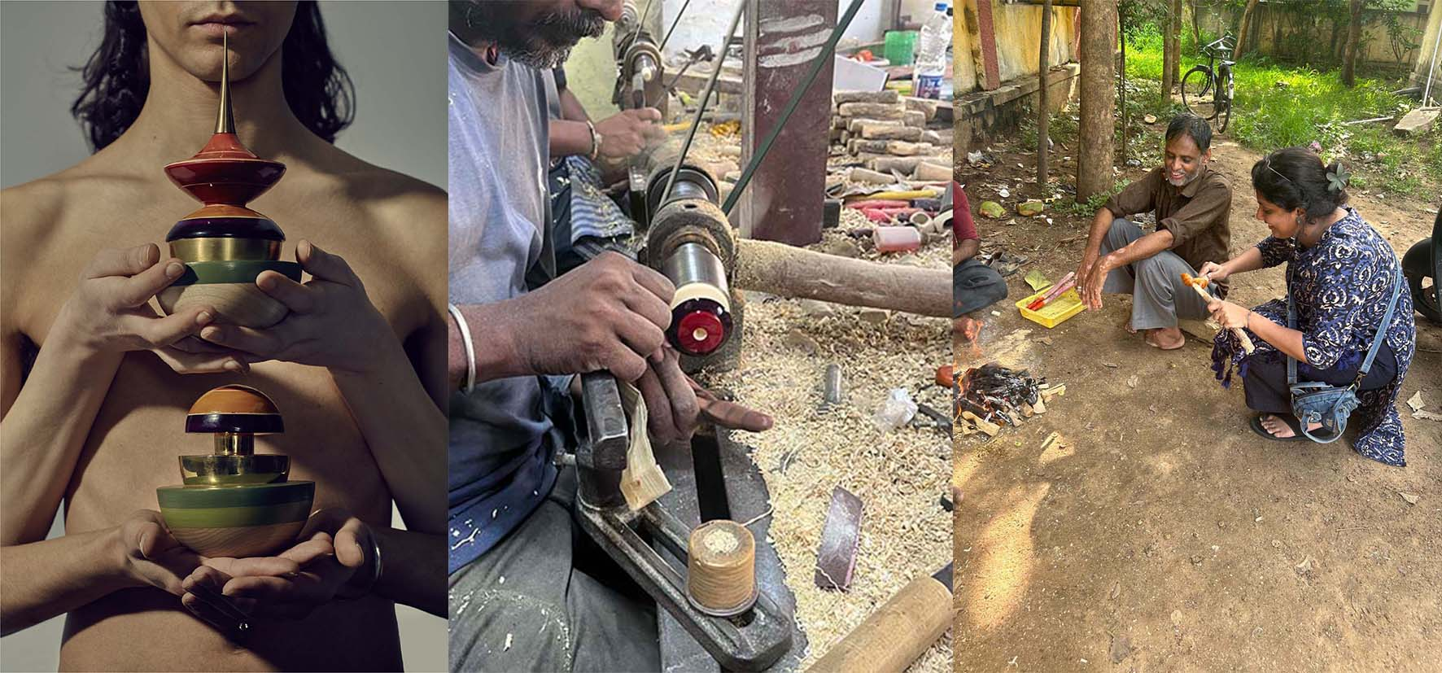
Fig. 7 Artefacts by Sakshi Sinha, photographed by James Rees, and process images from collaboration with Channapatna craftsmen (Courtesy of the artist) MA Fashion Artefact (2023/24)
Similarly, Sakshi described learning from the sustainable practices of the Channapatna artisans she collaborated with in India (See Figure 7), who work with locally sourced wood and lacquer, and reuse offcuts of wood to make smaller toys or decorative fragments rather than discarding them. Observing their processes made her reconsider waste as “a continuation of the material’s life rather than an end.” This encounter broadened her understanding of sustainability as a culturally embedded practice of resourcefulness, where ecological care is enacted through cyclical making rather than industrial recycling. Together, these accounts suggest an expanded view of ecological responsiveness that is grounded in material continuity, whether through the reactivation of synthetic residues or circular practices embedded in the making processes. Participants’ practices revealed a relational understanding of ecology, what Braidotti (2013: 60-61) describes as a “zoecentred” ethics that recognises vitality across human and non-human agents. Working slowly, by hand, and through tactile repetition, students cultivating embodied sensitivity to cultural and environmental continuities enact an ethic of care (Tronto, 1994: 127–128) where making becomes a form of stewardship toward heritage, ecosystems, and materials. These forms of care align with what Puig de la Bellacasa (2017, 34-35) terms ‘careful material practices,’ ways of making that sustain rather than exploit ecological systems. Such responsiveness reflects a posthuman ethics of making in which material agency and environmental accountability are interwoven (Braidotti, 2013:60-61; Ingold, 2012: 21-23), positioning design as an act of co-responsibility within a living network of relations.
Studio Culture: Peer Learning and Collaboration
Both focus groups emphasised studio culture’s connection to learning. Peer-to-peer exchanges, informal advice, observation, and shared problem-solving were identified as vital forms of situated knowledge transfer. As Ke Xin reflected, “Every day I have many questions, how to stitch this part, how to make this (material) hard, so I always ask my peers… we go to the leather shop together, choose materials together, and give advice to each other. It’s really helpful.” Such interactions transformed the studio into what Wenger (1998:73) terms a community of practice, where collective engagement in craft processes facilitates technical and affective growth.
Participants described learning as a shared embodied process, shaped by proximity, observation, and collaboration. Yoon explained that “just seeing how they approach things helps me push myself” noting that watching peers problem solving generated motivation and confidence. Sakshi similarly reflected that learning “from everyone’s failures and successes” deepened her understanding of materials and methods, as she adopted techniques observed from peers, such as alternative soldering methods, and found renewed motivation through the collective rhythm of the studio. She described how “working within a studio where people are working… gives you a little bit more confidence,” enabling even small moments of assistance to become catalysts for learning. This reciprocal attentiveness, observing, imitating, adapting, echoes Ingold’s (2013: 31-32) concept of the education of attention, in which knowledge arises through perceptual attunement to others’ gestures, rhythms, and material engagements. It also resonates with Lave and Wenger’s (1991) notion of situated learning, where participation within a community of practice allows learners to acquire skill through embodied observation and peripheral participation, gradually cultivating what Richard Sennet identified as intelligence in ‘The Craftsman’ (2008:7-11). Sennett frames intelligence as an embodied form of practical reasoning that arises through making. and argues that ‘all skills, even the most abstract, begin as bodily practices’ (2008:9). This notion of craft-based intelligence reframes making as a cognitive and ethical practice rather than manual labour. It describes a form of embodied, reflective knowledge that emerges through sustained engagement with materials, what he calls ‘thinking through the hand’ (2008:149). For Sennett, craftsmanship entails a dialogic relationship with materials in which understanding develops through feedback, resistance, and adaptation (2008: 174–176). In contrast to efficiency-driven paradigms, craft-based intelligence values slowness, care, and attentiveness as essential modes of thought (2008: 20–21).
In the second focus group, Shiyu described how peer exchange functioned not only as mutual support but as an ongoing source of insight:
“After tutorials, we often have discussions with fellow students. (...) I learnt a lot not only about my own techniques, such as weaving or wet moulding leather, but also from others who worked with wood or brass. Just watching their process gives me new ideas and understanding.”
Carrie similarly recalled how collaboration and shared experimentation deepened her technical understanding:
“I used (cow) bone, and then Lexi (a colleague) used the same material. We often talked about how to clean it, how to cut it, how to connect it… we helped each other a lot.”
Such dialogues demonstrate the circulation of practical expertise through informal studio relationships, a form of shared learning that values generosity and reciprocity.
Minqi described how learning unfolded beyond the studio through spontaneous peer exchanges. “Sometimes when I went to exhibitions or found new materials online, I would share them right away… a small comment suddenly gave me a new idea or direction.” Collaboration with technicians and external makers was also described as transformative, bridging institutional and artisanal expertise. Carrie noted that guest lecturer Michael Milloy’s guidance on cold connection techniques was “very important for my project,” enabling new structural possibilities through iterative testing with brass.
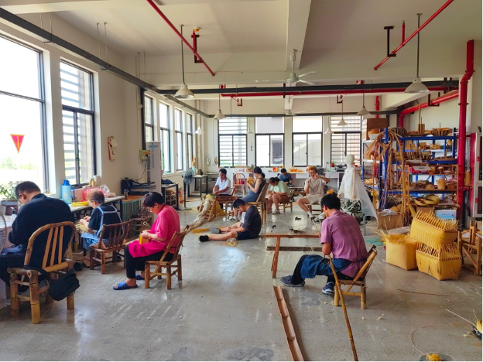
Fig. 8 Cai Hongguang Bamboo Craft Studio, Dongyang City, Zhejiang Province, China. Documentation by Shiyu Gong (Courtesy of the artist) MA Fashion Artefact (2023/24)

Shiyu’s Summer (2023) collaboration with the Hong-Guang Cai Bamboo Craft Studio (See Figure 8) in Dongyang (China) expanded this network of learning. Watching craftspeople work “step-by-step” revealed tacit, embodied knowledge rooted in repetition. Drawing on his own family’s bamboo-craft heritage, Shiyu brought inherited skills into the collaboration yet surprised himself by departing from convention by leaving an open weave unfinished, unlike traditional bamboo furniture.
Across both groups, participants emphasised that relationships with peers, technicians, and artisans were not peripheral but integral to their learning. Collaboration fostered resilience, motivation, and mutual care; it built a shared language of experimentation that extended beyond the classroom. In this context, peer learning became a form of material dialogue, where ideas, emotions, and skills circulated through the collective rhythms of making. The studio thus emerged as both a pedagogical and affective ecosystem, a site where collaboration, empathy, and craft coexisted as conditions for creative knowledge.

CONCLUSION
This study examined how material-led, practice-based pedagogies in postgraduate fashion craft education can reorient learning toward more relational, ecological, and reflective modes of engagement. Via action research with students and alumni of the MA Fashion Artefact course, the findings demonstrate how positioning materials as active collaborators rather than passive resources enables a profound rethinking of design authorship and responsibility. Students shifted from concept-first, outcome-oriented approaches to iterative, material-first processes in which discovery emerged through touch, resistance, and dialogue.
Across both focus groups, a recurring sense of transformation was evident, of materials, of makers, and of the learning community itself. Participants described how materials “talk back,” provoke reflection, and open unanticipated creative pathways. This dialogic encounter between maker and matter supports an unlearning and a re-learning of fashion education: one rooted in attentiveness, humility, and co-creation. Iteration and failure became forms of inquiry rather than error, aligning with material-driven design frameworks (Karana et al., 2015; Bak-Andersen, 2018) and New Materialist perspectives that acknowledge the agency of matter (Bennett, 2010; Braidotti, 2013).
Equally, the study reveals that such learning is inherently communal. Observing peers, exchanging techniques, and witnessing technicians and artisans at work all expanded students’ sense of material possibility. Watching other makers became a transformative act, an education of attention (Ingold, 2012) that fostered care, empathy, and mutual learning. These shared experiences illustrate how re-learning fashion entails building pedagogical ecosystems of collaboration, reciprocity, and shared stewardship. Sustainability, in this context, was not framed as efficiency but as care, for materials, communities, and the ecologies they inhabit.
While modest in scale, this study offers insight into how fashion education can become a site for re-learning, where making is reflective and students act as custodians, and where design becomes a civic, planetary practice. Future work could extend this inquiry across other institutions and cultural contexts, exploring how material-led pedagogies might further cultivate material-driven approaches to fashion education.

ACKNOWLEDGEMENTS

MA Fashion Artefact students for their contribution to the paper.
NOTE
This version of the paper has been revised following peer review feedback. Minor corrections and clarifications have been made to strengthen the methodology section.

REFERENCES
Ahmed, T. (2023). Pluriversal Fashions: Towards an Anti-Racist Fashion Design Pedagogy. PhD thesis, The Open University.
Bak-Andersen, M. (2018) When matter leads to form, Temes de Disseny, 34, pp. 10–33.
Bennett, J. (2010). Vibrant Matter: A Political Ecology of Things. Duke University Press, Durham, NC.
Braidotti, R. (2013). The Posthuman. Polity.
Brydon-Miller M., Coghlan D. and Sage Publications. (2014). The SAGE encyclopedia of action research. Los Angeles: SAGE.​
Bryan-Kinns, Nick & Liu, Yuanyuan & Zhang, Duoduo & Tan, Zhengyu & Tan, Hao. (2024). The role of digital technologies in contemporary craft practice from UK–China insights. Journal of Contemporary Chinese Art, 11, 75-93.

Cheang, S. & Suterwalla, S. (2020). Decolonizing the Curriculum? Transformation, Emotion, and Positionality in Teaching, Fashion Theory, 24(6), 879–900. https://doi.org/10.1080/1362704X.2020.1800989
Coole, D. & Frost, S. (2010). New Materialisms. Durham: Duke University Press. (Accessed: 1 November 2025)
Fletcher, K. & Tham, M. (2019). EARTH LOGIC Fashion Action Research Plan. JJ Charitable Trust.
Fletcher, K. and Williams (2013). Fashion Education in Sustainability in Practice (2013). Research Journal of Textile and Apparel: Emerald Group Publishing (Accessed: 1 November 2025)
Haraway, D. (1988). Situated Knowledges: The Science Question in Feminism and the Privilege of Partial Perspective. Feminist Studies, 14(3), 575–599. https://doi.org/10.2307/3178066
Hansen, F. T. (2010). Material-driven 3D digital form giving: Experimental use and integration of digital media in the field of ceramics. PhD thesis. The Danish Design School. Degree Awarding body: Aarhus School of Architecture, Design School Kolding, Royal Danish Academy. Available at: https://adk.elsevierpure.com/ws/portalfiles/portal/61259996/Short_English_version_PhD_Flemming_Tvede_Hansen.pdf (Accessed: 1 November 2025)
Ingold, T. (1997). From the transmission of representations to the education of attention. Available at: https://lchc.ucsd.edu/mca/Paper/ingold/ingold1.htm (Accessed: 16 November 2025).
Ingold, T. (2013). Making: Anthropology, Archaeology, Art and Architecture. Abingdon, England: Routledge. (Accessed: 1 November 2025)
Karana, E., Barati, B., Rognoli, V. and Zeeuw van der Laan, A. (2015). Material Driven Design (MDD): A Method to Design for Material Experiences, International Journal of Design, 9(2), pp. 35–54.
Lave, J. & Wenger, E. (1991). Situated Learning: Legitimate Peripheral Participation. Cambridge University Press.
Oxman, N. (2010). 'Material-Based Design Computation'. PhD diss., Massachusetts Institute of Technology.
Puig de la Bellacasa, M. (2017). Matters of Care. Minneapolis: University of Minnesota Press. (Accessed: 1 November 2025).
Remme, D. (2017). Vitalism, New Materialism Almanac. Available at: https://newmaterialism.eu/almanac/v/vitalism.html (Accessed: 17 November 2025).
Sennett, R. (2008). The Craftsman. New Haven: Yale University Press.
Smelik, A. (2018). New materialism: A theoretical framework for fashion in the age of technological innovation. International Journal of Fashion Studies, 5(1), 33–54.
Tronto, J. (1994) Moral Boundaries: A Political Argument for an Ethic of Care. New York: Routledge. DOI:10.4324/9781003070672.
Vaccari, A. (2022). ‘Fashion Matters’ by Anneke Smelik. A Lecture Series on Sustainability, Posthumanism and New Materialism. Zone Moda Journal, 12(2), 83–85.
Van Bezooyen, A. (2013). ‘Materials Driven Design.’ In Materials Experience: Fundamentals of Materials and Design, edited by Karana E., Pedgley O., and Rognoli V., Chapter 19, pp. 277–286. Amsterdam: Elsevier. Available at: https://doi.org/10.1016/B978-0-08-099359-1.00019-9
Virginia Braun & Victoria Clarke (2006) Using thematic analysis in psychology, Qualitative Research in Psychology, 3:2, 77-101, DOI: 10.1191/1478088706qp063oa

