Introduction: Wild & Cultivated: Fashioning the Rose

‘Thy gowns, thy shoes, thy bed of roses…’ Sir Walter Raleigh (‘The Nymph’s Reply to the Shepherd’, 1600)
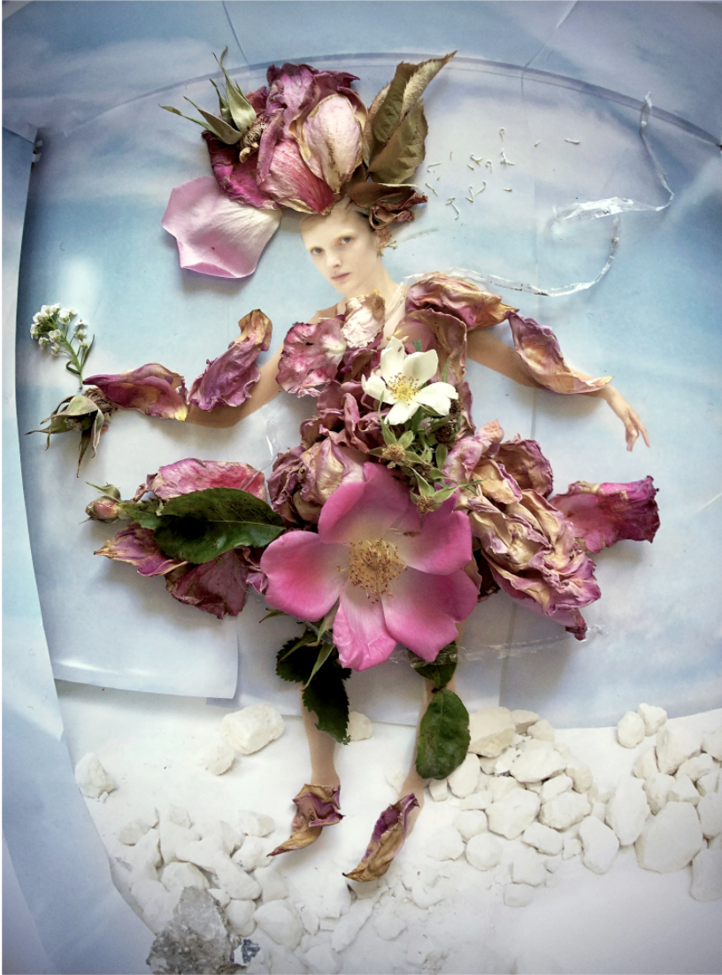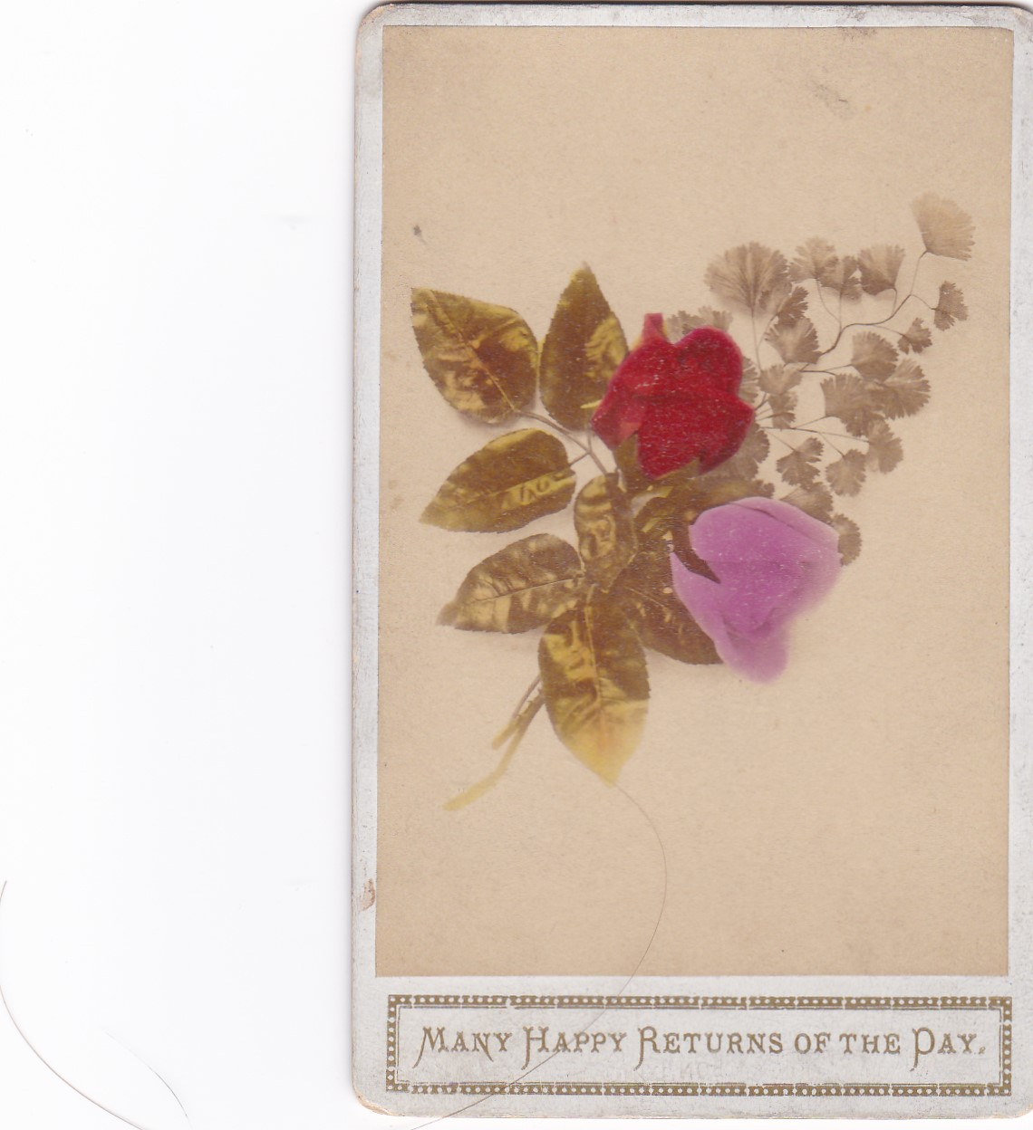

Tim Walker, ‘Primrose Archer Dressed in Flowers from my Garden, Hackney’ archival pigment print, 15.25 x 11.75 inches, limited edition of 10. With permission from Tim Walker.
Portrait of roses, colour tinted carte de visite, 1881. On the reverse is written ‘To dear Charlie from Clara, Nov. 9th/81’

The rose... the most sublimely beautiful and fragrant of flowers. Genus Rosa has flourished on this earth for some 40 million years and served our physical and spiritual needs for millennia. Here, we explore how this extraordinary flower, and its savage deterrent prickles (commonly described as thorns) have informed our dressed appearances. This term embraces gesture, body adornment (tattoos, jewellery…) and fragrance, as well as garments and accessories. To these we add the wearing or holding of one or more roses - natural or artificial, wild or cultivated. Our preoccupations lie not only with fashion, but also folk, fancy and everyday dress. Roses, like fashion and other non-essential dress, are a luxury, they are ephemeral, their appeal is multi-sensorial and they are variously shown (at flower shows, festivals, on the catwalk…).
Roses have been worn, emulated, steeped in symbolism and entwined with our biographies since ancient times. In the second century the rose was personified as female and crowned queen of the flowers by the Greek writer Achilles Tatius in his prose romance Leucippe and Clitophon. Our core narratives stem from the early nineteenth century when, in reaction to eighteenth century rationalist ideation, the symbolic rose drew on its historical precedents and re-flowered with a vengeance. This period also saw the consolidation of the international fashion, artificial flower, cut and rooted roses trades.
Sexuality lies at the core of a flower’s existence: the rose is hermaphrodite. Whilst its flower is exquisitely fragile, the genus is promiscuous, rambunctious and resilient, which accounts for its longevity, mutability and broad geographic sweep. As the author of the top selling floriography, Les Langage des Fleurs (1819, 1820 in English) made explicit, ‘The rose embellishes the whole surface of the earth. It is thus the commonest of all flowers.’(1) As such, most people can look – and maybe even feel transformed - by wearing a rose. To demonstrate how roses interface with the body, corporeal and insensate, we look to early studio photographic portraiture, taken when people constructed with care how their likeness was captured.

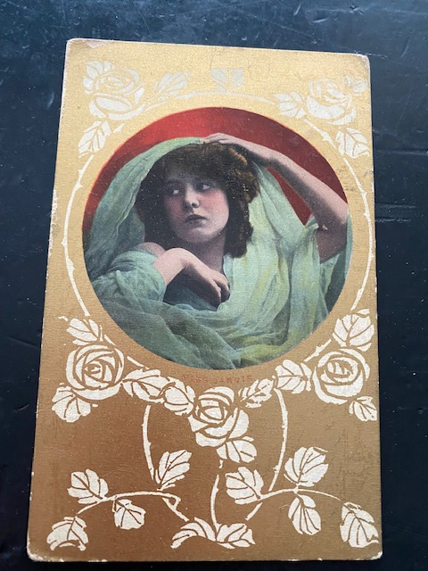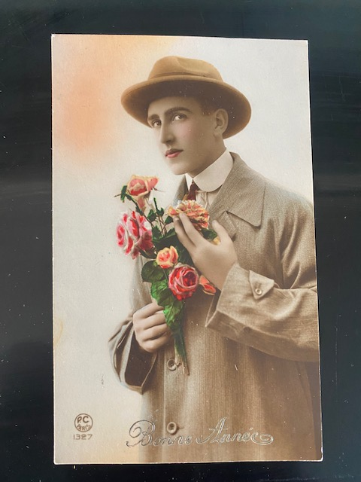

Printed postcard c. 1920. A portrait of a woman encircled in tulle to appear as a white rose forms a cameo amidst a trailing art deco style rose graphic.
Printed postcard, to mark the new year, 1920s. The male figure holds a bunch of colour-tinted roses close to his heart and caresses a single bloom as he glances towards us.
Comparisons have often been drawn between the rose and human – mostly female – anatomy and, within art and literature, roses have been personified. In turn, humans have masqueraded as roses wearing fancy dress and stage costume and celebrated their flowering by crowning a rose queen. Our cover image is a portrait of a wild and cultivated rose femme fleur, styled and photographed by acclaimed photographer Tim Walker (2019). His fantastical compositions encompass sexual, romantic, culinary, garden, domestic, fairy-tale, beauty, queer and surreal roses.
Since the 1990s revered image maker Nick Knight has simultaneously captured the look and feel of roses for directional fashion media and created ‘Roses from my Garden’ portrait studies. The latter body of work, taken on Sundays using his i-phone, illuminates the evanescence, imperfections and lifecycle of roses, through tightly furled bud, fecund bloom, deshabille and dissembled flower to decay. Over the last fifteen years we have witnessed a renaissance of roses, interpreted as ornamentation within fashion design, image-making and the presentation of designer collections. The rose has also been re-politicised to foreground critical issues around racism, LGBTQI* rights, sustainability and the global environment, immigration, female genital mutilation and, body, skin and age diversity. (2)
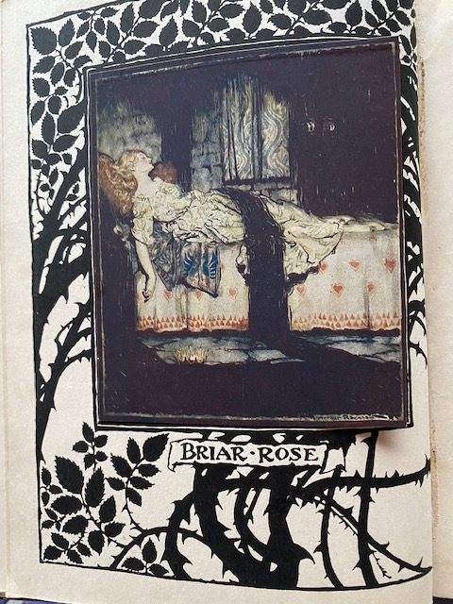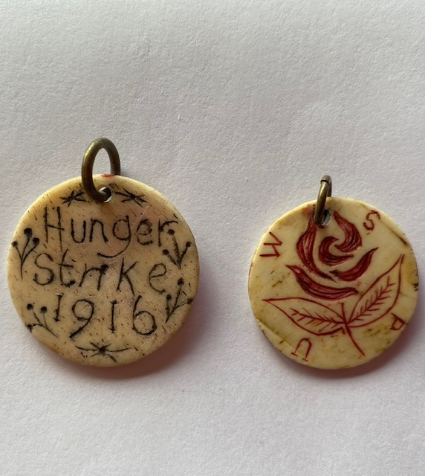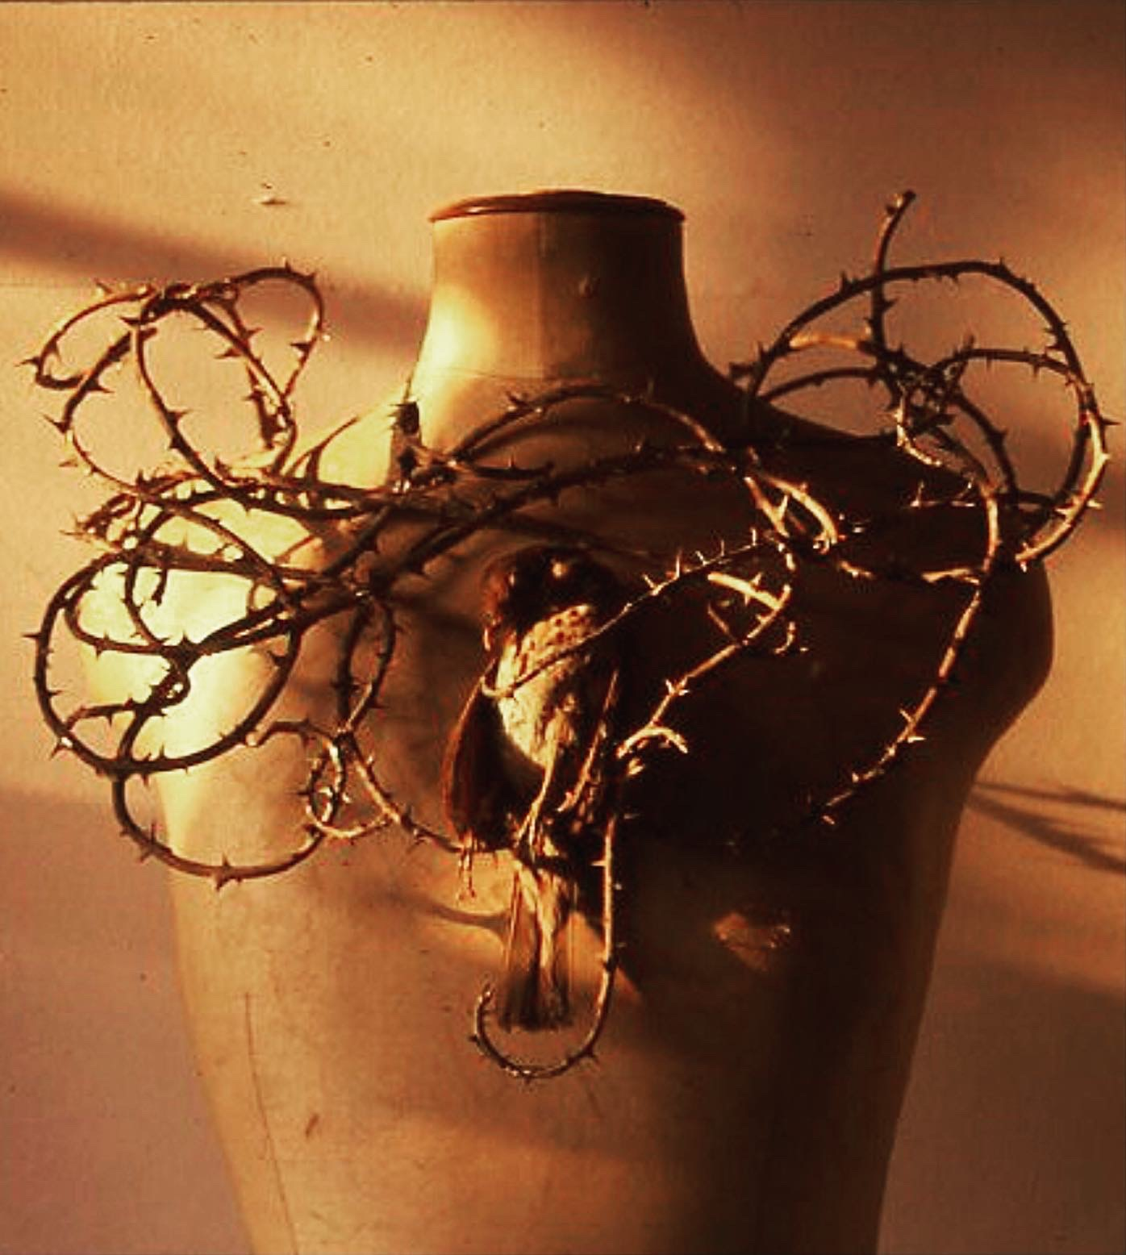
Hand-coloured engraving. DATE – ADD IMAGE
The five petalled wild rose, Rosa canina. This is commonly known as dog rose, possibly because it was used to treat rabid dogs in the eighteenth century, or it might simply be pejorative in favour of the cultivated rose. Botanical engravings became vital to our understanding of the rose, describing it in a way that words could not. They also served as a potent source of inspiration for artists and designers. (Garden Museum)

The Sleeping Beauty, a virgin princess sleeps surrounded by roses and protected by thorns until the perfect prince comes along. Her name is Briar Rose.
Women’s Social and Political Union (WSPU) pendant, enamel engraved on early plastic, 1916. The rose motif contrasts sharply with the stark declaration that marked the hunger strike by suffragettes held in Holloway women’s prison.
Simon Costin, ‘The Nightingale and the Rose’ ADD/ This draws upon an ancient Persian narrative in which the Nightingale fell in love with the white rose and sang to it until it collapsed exhausted on its thorns (prickles) staining it red from blood. It is generally believed that it is from this story that the association of the red rose with love stems.

Wild & Cultivated: Fashioning the Rose is an anthology; this is a term borrowed from the Greek anthologia for flower gathering. This is an approach part rooted from necessity (created during a pandemic, our commitment to sustainability and the cessation of many museum loans), but it is also one that delights our sensibilities. (And, has permitted our avaricious collectors’ eyes to indulge their fancy on e-Bay!). Our choice of objects, images and stories are thus personal, eclectic and entangled in a manner that might be likened to the patchwork appeal of allotment architecture. We feel privileged to create this book, and the exhibition that it accompanies, working with the Garden Museum.
Contained here are four illustrated essays: Showing Roses, Masquerading Roses, Making Roses and Rose Queens. There follows a gathering of images which variously communicate how gardeners, individuals, communities and creatives have worn, shown or fashioned the rose. Whilst recognising global contexts, we foreground the UK experience. This is, after all, the nation most associated with roses - garden, sartorial and domestic – wild and cultivated.
Amy de la Haye and Simon Costin

Notes:
- . Le Langage des Fleurs (1819) was originally credited to Charlotte de Latour and later thought to be a pseudonym for Louise Cortambert but this attribution has also been contested. Reference: Potter, Jennifer (2010) The Rose: p.4
- For a more detailed study see de la Haye, Amy, (2020) Ravishing: The Rose in Fashion, Yale University Press.

