Making Roses

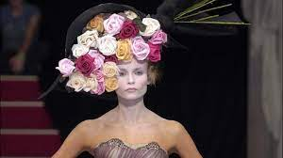

Alexander McQueen, Sarabande collection, Spring/Summer 2007. Millinery designed by Philip Treacy. McQueen was fashion’s rosarian; this his most floriate collection. Photo:

When the earth ceases to yield natural flowers we lament their absence. The making of surrogate ‘permanent botanicals’ dates back to at least Ancient Egypt, when flowers were crafted using shavings of stained horn. And, thence to China, where silk, porcelain, gold, paper and bamboo marrow were employed and Ancient Greece where flowers were tooled from precious metals. It is perhaps ironic that faux flowers are mostly worn when those they imitate are in bloom.
By the mid-nineteenth century, artificial flower making had become a vital ancillary trade serving fashion and millinery houses in Paris, London and New York – the major fashion capitals at this time. Home dressmakers purchased their roses from the haberdasher. In Paris, flower making was a respected skill learned by apprenticeship; it was a source of national pride and significant export revenue. Conversely, in London and New York emphasis was placed upon cheaper, quantity production, involving a greater sub-division of labour. As the London and New York industries operated along similar lines, the UK experience is foregrounded in this short text.
By 1865 there were some 10,000 flower-makers working in Paris, 80 to 85 per cent of whom were women and girls; they accounted for 10 per cent of Paris’s female work force. (1) Unusually at this time, within this industry it was females who occupied the most highly skilled roles. Whilst many atelier made multiple flower types, and sometimes fruits and grasses too, the demand for roses was so consistently high (often year-round) that some Paris firms specialised in making just the bloom or its bud. Rose makers were the most highly skilled and best paid flower makers; they were even reputed to marry ‘better’! (2). During a visit to a firm reputed to make ‘the most beautiful roses in the world’ an industry investigator observed the women owners working, one making a moss rose, the other a yellow tea rose. She noted that, `The real flowers stood in water beside them’ (3) Historically, the highest praise an artificial flower maker could receive was that their work was so true to nature, only the bee could tell.
There follows a description of how a rose was made in Paris; a process that has changed little although the gendered division of labour is no longer so rigid.

Making a rose (need more pics)

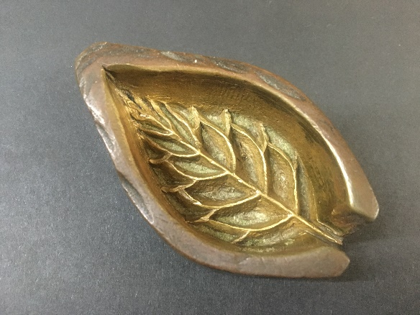

One half of an iron rose leaf tool
Design: inspired by a freshly picked bud or bloom or a botanical engraving. The cheaper end of the trade copied those made by exclusive firms.
Cutting and dyeing the petals: Silk or cotton, stretched and starched, was cut into petal shapes using a petal shaped metal tool and heavy hammer, or by a stamping machine. The petals were then tinted and dried. These roles were undertaken by men.
Shaping the petals: Each petal was goffered (curved) using a tool ending with a ball form that was heated by flame or gas jet. The edges were then crimped (curled) by hand or using tweezers.
Buds: Made using wadding covered with silk over which individual petals and sometimes sepals were added.
Stamens: Unbleached silk was fixed onto brass thread and then steeped in glue. Each end was made more pronounced, garnished with paste and dyed.
Leaves: Made similarly to petals and then veined using a two-part die and matrix iron tool.
Composition: This operation, known as branching, was the most highly skilled. The stalk, formed from wire, was crowned with the seed vessel and stamens: glue was added to the base of these and the petals were threaded onto the stalk. The calyx was fixed in the same manner. Sometimes a bloom was scented with its designate fragrance. Finally, any leaves were wired to the fabric-covered wire stalk.
-----

As feathers generally replaced flowers for winter wear, employment in each distinctive industry was seasonal, which resulted in terrible personal hardships. Whilst working flower makers were prone to impaired eyesight from undertaking detailed work in poor lighting conditions; lung disease from the inhalation of fumes in overcrowded and unventilated premises and, before c.1862, poisoning from toxic green and red dyestuffs. Conditions were so bad in London and New York, where girls as young as six years old were employed, that flower making was classified as a sweated trade.
The British industry was divided into makers of coloured and black flowers (although there are no truly black flowers in nature; the pigment that flowers employ to colour their petals do not produce black). The latter became a national speciality feeding into the Victorian cult of mourning and the lucrative market for female mourning dress (A man often wore no more than a simple arm band to signify his loss). A few London firms made both but black flowers, which were less prone to shifts in fashion and demand, were mostly produced by a small Manchester based industry.
Flower making in London was investigated by the social reformer Charles Booth, who published his findings in Poverty (1889) and Industry (1891). In the latter, Booth reported that the industry employed 4,587 artificial flower-makers, 576 (about 8%) of whom were male. (4) However, the true number would have been considerably higher due to the huge number of ‘hidden’ homeworkers. He also noted that, as in Paris, rose makers were the most highly respected and paid flower workers. Booth’s work was seminal, but his judgement of flower workers who supplemented their meagre earnings with sex work was harsh, ‘The substance is thrown away for the shadow. These girls do not sell themselves for bread; that they could easily earn. They sin for the externals which they have learnt to regard as essentials.’ (5) He was of course referring to fashion.

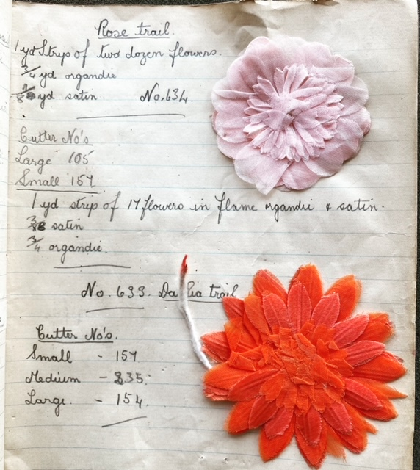
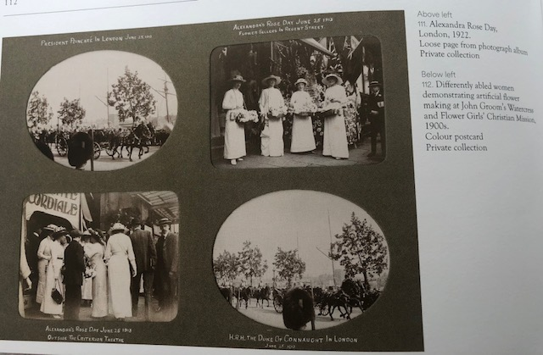

Hilda Brooks work book, made from 1959 to 1963, contains several notes and samples pertaining to roses. The John Groom Archive – get full credit

In 1866 John Alfred John Groom (1845-1919), a silver engraver working in Clerkenwell (east London), became so concerned about the plight of local blind and amputee fresh flower and watercress street sellers, that he founded a charitable mission, offering residential care and training in artificial flower making. When Queen Alexandra (1844-1925) launched her Alexandra Rose Day charity in June 1912 she commissioned Groom’s to make thousands of pink artificial rose badges, which they continued to supply until at least the 1950s. The John Groom archive, now housed at London Metropolitan Archives, contains documents relating to the founding of the mission, photographs of women and girls making and packing flowers, including roses, and a workbook made by Hilda Brooks dating from 1959 to 1963.
Fabric flowers remained in fashion’s forefront until the First World War. From the 1930s demand started to decline and the 1960s vogue for modernity and informality, in particular the decline in hat wearing, led to the demise of the industry. Today, a very small number of top-level Paris flower ateliers, notably Maison Legeron (formerly called Guth, est.1727) and Lemarié (est. 1880, now part of Chanel Métier d’Art) continue to serve the world’s most exclusive fashion houses. Legeron work with fresh as well as artificial flowers. Artificial flower making for fashion continues to operate on a small scale in London, New York and in Germany; China has become a leading supplier.
We are currently witnessing a renaissance in the making of flowers, and fashioning of roses, for interior and exterior spaces and in fine art contexts.

Notes:
- Lemercier, Claire, (2007), ‘Articles de Paris’ fabriques et institutions économiques à Paris au XIXème siècle’, in Les territoires de l’industrie en Europe (1750-2000) Entreprises, régulations et trajectoires, eds. Daumas, Jean-Claude, Lamard, Pierre and Tissot, Laurent : p.198

- Boxer, Marilyn J. (1982) Women in Industrial Homework: the Flowermakers of Paris in the Belle epoque’ French Historical Studies Spring, part 3,: 401-423 Vol. 12, No. 3 (Spring, 1982): p.412

- Van Kleeck, Mary, (1913) Artificial Flower Makers: p.154

- Booth, Charles (1969 [1889]), Industry: p.294

- Ibid: pp. 322-3

Booth, Charles, 1889, The Life and Labour of the People in London: First Series: Poverty, rev.edn., New York: A.M Kelley Press, 1969
Boxer, Marilyn J., Spring 1982, ‘Women in Industrial Homework: the Flowermakers of Paris in the Belle Epoque’ French Historical Studies, vol.12, no. 3,: 401-23
Kleek, Mary Van [‘Secretary Committee on Women’s Work, Russell Sage Foundation’], 1913 Artificial Flower Makers, New York: Russell Sage Foundation, 1913
Lemercier,Claire, 2007, Les territoires de l’industrie en Europe (1750-2000) Entreprises, régulations et trajectoires, Paris, Besançon: Presses universitaire de Franche- Comté

Lord, W.H., 1865, Report on Artificial Flower and Ostrich Feather Makers, London, Children’s Employment Commission

