Masquerading Roses
In reaction to classical diction, which had tamed and rationalised the natural world, the Romantic era derived meanings from nature’s unbridled glory and transcendence. Within this milieu the conflation of bodies and emotions, mostly female, with roses flourished. More than any other flower, the rose has been sexualised and personified. Floral sexuality has been anthropomorphised since antiquity, but it was botanist Carl Linnaeus’ sexually explicit likening of plant and human reproduction, published as Systema Naturae (1735) and originally received as scandalous, that fuelled comparisons.

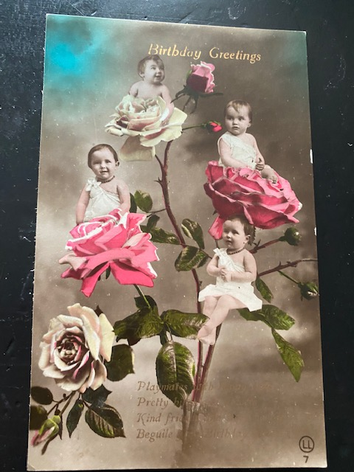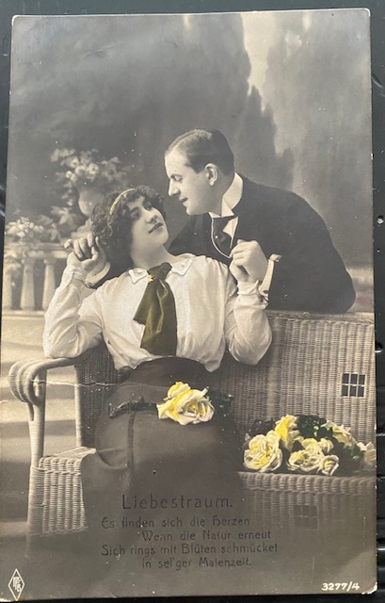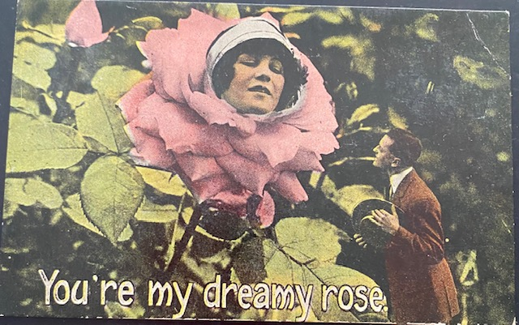
Caption: Printed photographic and colour-tinted postcards, early twentieth century.
The rose womb and female rose head are popular tropes. Within floriography, the white rose is associated with youth, chastity, innocence and femininity; pale pink with grace, gentleness and joy and hot pink with gratitude. Contemporaneously, the yellow rose communicated infidelity, betrayal and jealousy, but in recent years some florists have re-presented its meaning to communicate platonic friendship.
Across a range of media, idealised females - like roses - were portrayed as fertile, visual, tactile and olfactory; their prime role in life to attract. Women’s lips, nipples and clitoris were likened to the rose’s furled bud, their labia to petals, vulva and womb to the open flower. The bud also served as a metaphor for the fe/male anus. However, the male body was more commonly compared not to flowers, but to vegetables and trees. Somewhat exceptional were artworks by J.J. Grandville (the pseudonym of Jean Ignace Isidore Gérard, 1803-47) and Walter Crane (1845-1915) who’s roses were variously personified as androgyne or male, their floral lovers queer.
Floriography probably originated in the Turkish harem during the early eighteenth century, believed by some to have developed as a form of polari between female lovers. A century later, the messages in Le Langage des Fleurs (1819) were heteronormative, moralistic and sentimental. The rose was personified thus, ‘It might be said that the Queen of the Flowers sports with the air than fans her, adorns herself with the dew-drops that burthen her head, and smilingly meets the sun rays that expand her bosom; it might well be said of this beautiful flower that nature has exhausted herself in striving to lavish on it the freshness of beauty, of form, perfume, brilliancy, and grace... On the days that its beauty is fully mature it perishes; but nothing restores it to the first graces of its former youth.’ (1)
It was about this time that the female name Rose became popular in multiple languages.

Of course, not all is sweet in the rose garden. Shakespeare directed us to the flower’s canker (a white rose and a disfiguring plant disease, Sonnet 54, 1609); William Blake, the inevitability of decay (‘The Sick Rose’, 1794) and Charles Baudelaire debated the contradictions of existence in Fleurs du Mal (Flowers of Evil, 1868). The French intellectual George Bataille, author of the renegade Language of Flowers (1927-39) stated that whilst leaves aged ‘honestly’, flowers wither, ‘…like old and overly made-up dowagers, and they die ridiculously on stems that seemed to carry them to the clouds.’ To him, the rose was paradoxical and repugnant, ‘Thus the interior of a rose does not at all correspond to its exterior beauty; if one tears off all the corolla’s petals, all that remains is a rather sordid tuft…. But even more than the filth of its organs, the flower is betrayed by the fragility of its corolla: thus, far from answering the demands of human ideas, it is the sign of their failure.’ (2)

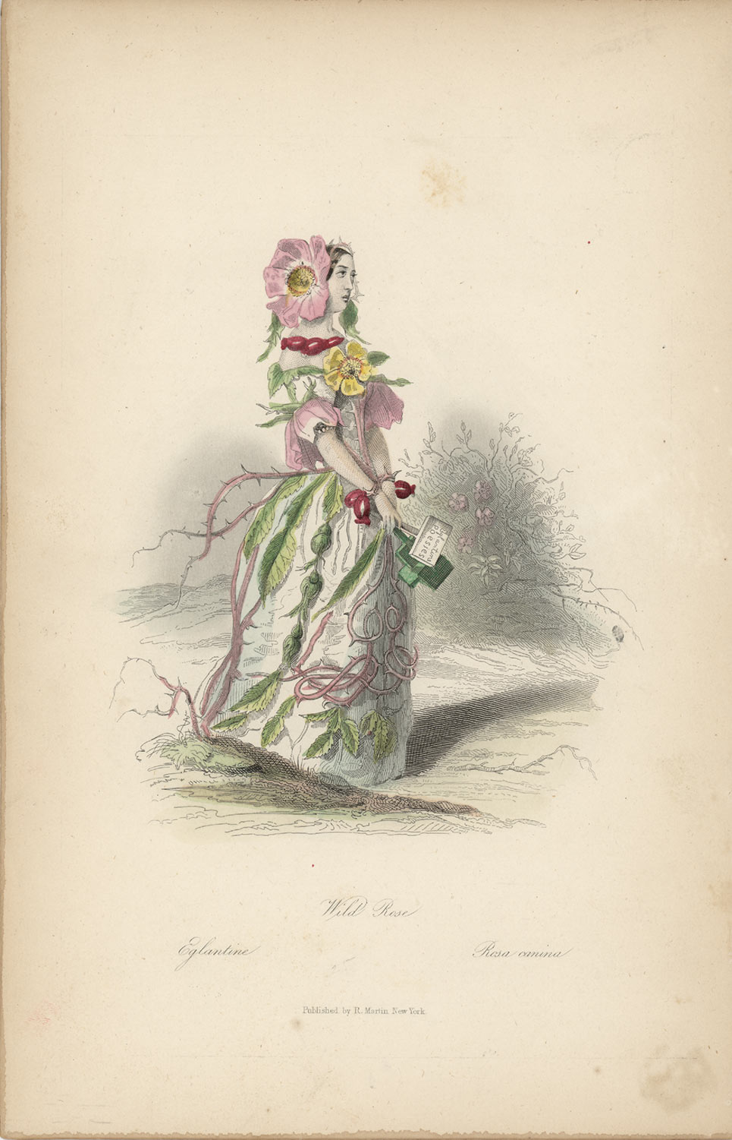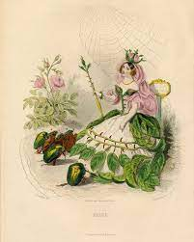
J.J. Grandville ‘Eglantine’, Loose sheet coloured engraving, 1847.
Eglantine is depicted in profile wearing a head-sized wild rose. Her bodice is ornamented with a vertical stemmed rose and has petal sleeves, the skirt overlaid with a tangle of leaves, buds and prickly branches. She is accessorised with a chunky rosehip necklace and her wrists are bound with twined rosehips.
J.J. Grandville ‘Rose’, Loose sheet coloured engraving, 1847.
The be-throned royal rose is adorned with an unfurled rose bud crown and thorny bud sceptre. Her pollen-like headdress and necklace signify fertility. A double rose bud forms a shapely decolletage; clusters of leaves suggest a polonaise and the full skirt is artfully arranged with parallel rows of branches. She wears a bracelet of prickles.
Within widely circulated art, humanised roses were portrayed with blossom heads, not genitals. J.J. Grandville’s anthropomorphic depictions, published in Les Fleurs Animées (1847) written by Taxile Delford, were conventionally female, but some were militant. In this parody of popular flower emblematics, the femme fleurs reclaim the meanings bestowed upon them and point out that whilst they provide humankind with fragrance and poetic metaphors, their reward is the florist’s knife and being left to wilt on a warm breast. And, Eglantine dared to challenge the universal popularity of the garden Rose. Eglantine is depicted drifting through an unruly landscape in which her uncultivated namesake grows wild. It is the garden rose who is crowned queen of flowers, whose insect subjects bow before her. At a time when homosexuality was criminalised and lesbian desires unrecognised, Grandville’s illustration of a floral courtship between female flower lovers, titled ‘Tubereuse Jonquile’ - was profound (but not shown here as the flowers are not roses). Much of Grandville’s work is surreal and disquieting, but his personified roses are picturesque.
From the 1870s members of the arts and crafts movement and Pre Raphaelites yearned for a closer relationship with nature and romanticised the medieval era as a pastoral idyll. Naturally, they championed the wild rose over its ‘engineered’ cultivar. Walter Crane, socialist, illustrator and theorist, was prominent within this community. He also involved himself in the politics of women’s fashion, serving as vice president of the radical Healthy and Artistic Dress Union (est. 1893), which campaigned against melliferous, cumbersome and corseted trends in favour of loose, lightweight clothing. In Flora’s Feast: A Masque of Flowers (1889), the cultivated, wild and Christmas roses are clearly illustrated by an artist with a detailed ‘eye’ for dress. It is the wild, not cultivated, rose that Crane naturalised as queer.

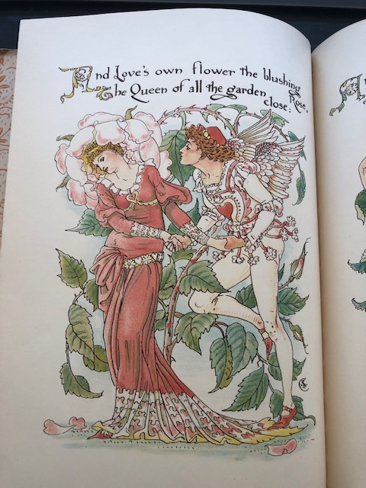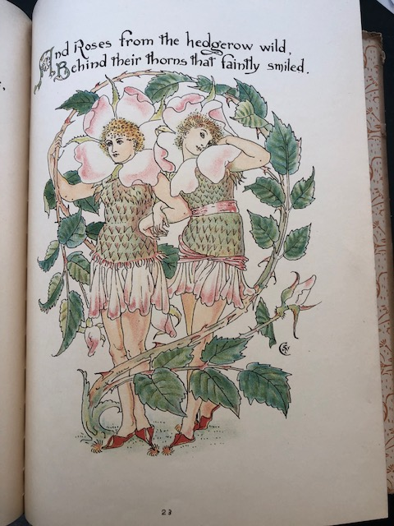
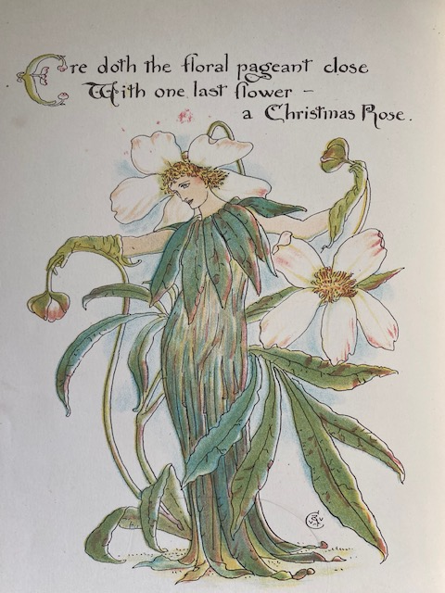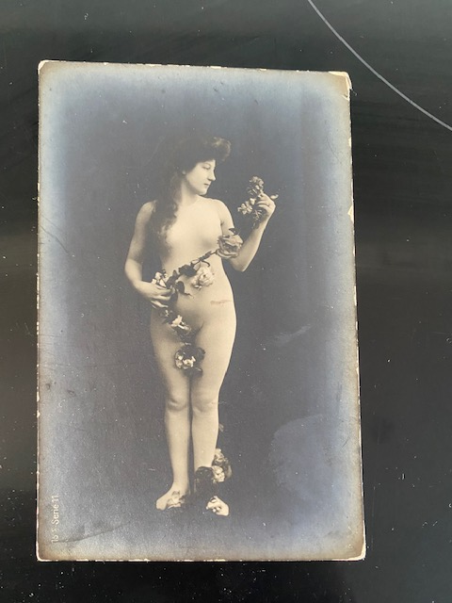

Walter Crane, Flora’s Feast: A Masque of Flowers, 1889.
The cultivated and wild roses are presented on facing pages. The blushing rose queen wears a quasi-medieval style dress and crown smothered by a blousy pink garden rose. She is courted by Eros, the winged Greek god of love. In the sixth century B.C., the Greek lyric poet Anacreon portrayed an Eros crowned with roses who slept in beds of roses. The wild rose male lovers are encircled by a bower of wild roses; the two in bloom frame their faces. They wear similar short dresses, comprising drop-waisted prickly bodices and clustered petal skirts, accessorised with ‘thorny’ rosehip-red mules.

Walter Crane, Flora’s Feast: A Masque of Flowers, 1889.
Crane’s Christmas Rose exemplifies the Art Nouveau international style. The androgyne figure is clothed in an unstructured, artistic and anti-fashion, style redolent of Mariano Fortuny’s pleated silk Delphos dresses, with a collar comprised of leaves. The figure’s leaf-gloved hands and lower arms gesturally merge with the plant, reinforcing the person-rose symbiosis.
Photographic postcard 1900s. A seemingly nude women entwined by a serpentine garland of roses.

In two dimensions roses were masqueraded as human. In life, humans masqueraded as roses when costumed for the stage and wearing fancy dress. Whilst fancy dress provides unparalleled opportunities to ‘acceptably’ communicate suppressed desires and rebel identities, an ‘animated rose’ was a non-controversial theme for cis-gendered girls and women. Arden Holt’s book Fancy Dresses Described or What to Wear to a Fancy Ball (re-printed six times 1879-1896) featured eight rose themed costumes – more than any other category. The simplest option was to decorate an existing dress with fresh roses, but to appear as ‘Queen of Roses’ required greater investment. Holt suggested, ‘White tulle skirt with bouquets of every coloured rose dispersed about it; over-skirt powdered with pink rose leaves, also the veil, as if a shower of rose-leaves had fallen on them; a wreath of coloured roses; earrings, necklet and bracelets formed of pink rosebuds.’

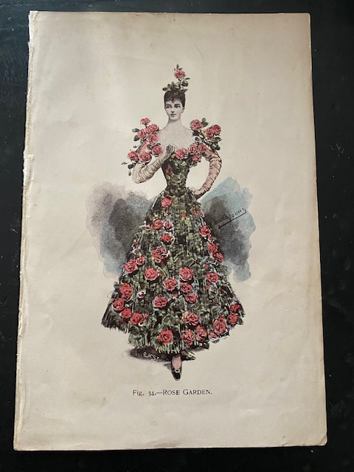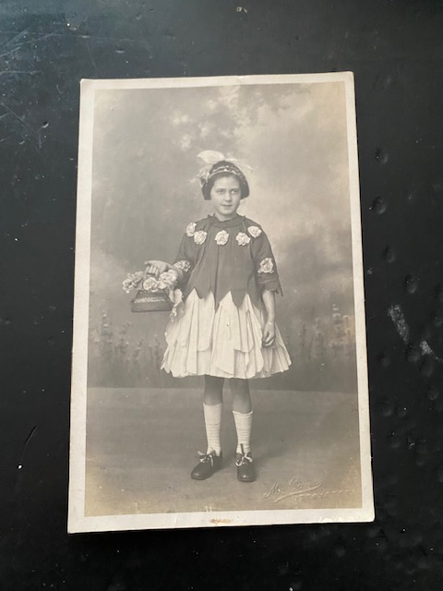
Miss Lillian Young, ‘Rose Garden’ for Arden Holt, Fancy Dresses Described or What to Wear to a Fancy Ball, 1879. Here, a fashionable green evening dress has been bedecked with roses and a single upright rose dresses the hair.
Studio portrait printed postcard of a young girl wearing rose fancy dress, early 1920s.

Notes:
1. Le Langage des Fleurs (1819) quoted in Potter, Jennifer (2010) The Rose: 4
2. Bataille, George, (1993) translated by Stoekl, Allan et al, ‘The Language of Flowers’ in Visions of Excess: Selected writings 1927-39: 11

