ROSE QUEENS
The culture and flowering of roses has been celebrated since at least Ancient Roman times, when the lavish Rosalia (also known as rosatio, meaning rose adornment) carnival was staged. And, rose growing nations have held various themed events ever since. From the 1880s, the rose queen festival, mostly held in June, became a major annual event in towns and villages across the UK, especially in Lancashire - known as the red rose county, following the Wars of the Roses (1455-87)
Rose queen festivals share similarities with May Day, which originally marked the dawning of the Celtic summer and fertility rites, but – like many British ‘traditions’ - was re-presented by the Victorians. Like the May queen, her rosy highness was chosen for her scholarly and/or religious diligence, popularity and/or beauty. Along with her attendant maidens, and occasionally partnered with a king, she was conveyed ceremoniously by rose-decorated horse or pony drawn cart or lurry, on a street parade that culminated at a local green site.
At larger festivals, to which many thousands of visitors flocked by train, locals paraded in costumes variously inspired by flowers – including red rose, white rose, ‘queen of the rosebuds’, pansies and daisies –mythological figures, famous people, characters from nursery rhymes, literature, local tradespeople etc. In 1891, organisers of the Chorley rose festival, reported that 7,900 people, 600 in costume, were counted into the cricket ground (1) But, as the press regularly reported, it was the rose queen who commanded, ‘the cynosure of all eyes.’
The rose queen, like the May queen, customarily wore a white or ivory coloured dress with a coloured sash, but whereas the May queen exulted in the profusion of Spring flowers, our queen glorified just the one.
Her crown was based upon the Imperial State Crown. (Interestingly, the sum of a flower’s petals is called the corolla, a diminutive from the Latin corona, meaning ‘little crown’.) Originally designed for King Charles II, it has an openwork gold frame with jewel decorated crosses and fleur de Lys, and a fitted purple silk velvet cap with an ermine band. Ermine is a regal fur. Named after the white weasel Mustela ermine, which has a black-tipped tail, it is characterised by a white ground embellished with the short, black tails of small animals. The rose queen’s trained robe was trimmed with, or an emulation of, ermine.
The crowning ceremony was conducted by a local male dignitary, whose declaration followed similar lines to those of the mayor of Southport in 1888:
“‘We bend, fair sovereign, ‘neath your gracious sway.
And hail you queen! On this our festive day.
Upon your head this bounteous crown we place.
Deck’s with the flower most dear to England’s race.”

To which the rose queen responded,
“’Oh, yes! O, yes! O, yes!
Our Queen proclaims an ancient holiday with rustic games.’” (1)
Thereupon dancing, including the plaiting of ribbon round the rose pole (a derivation of the once phallic May pole) by young girls, and other merriments began.
Rose festivals were municipal events, often organised in conjunction with the church to raise funds for local charities. The result of extensive planning, these weather dependent events, helped shape individual, community and regional identities. However, not everyone approved… On July 11th, 1891 the Horwich Chronicle reported that a member of the Salvation Local Corps of the Army had – presumably referencing the pagan roots of May Day - denounced the impending event as, ‘“the work of the devil”’(2)
In June 1933, The Leader reported how, ‘Charmingly attired in rose pink silk, with shoes to match, Miss Sumner had a long train of rose and white satin, trimmed with rosebuds and with an ermine collar.’ She was attended by the previous year’s Rose Queen, Miss Jessie Green, who wore, ‘...her regal robes of white satin beaute, with red velvet train, trimmed with white fox fur.’ Nearly thirty girls supported the Queen, each of whom wore a long Victorian style dress of white silk and carried a spray of flowers.’ The girls all attended Holy Trinity Roman Catholic School, Walter Street, Burnley. (3) By this date, some hospitals, including the Royal Halifax Infirmary, organised independent rose-themed, funding-raising, events in which women staff members participated.
As with historical style film and stage costumes, the design of the rose queen and her maidens’ costumes can invariably be dated in relation to prevailing fashion trends, including historical revival styles such as the 1930s neo-Victorian vogue.
Sarah Burton (b.1974), designer at Alexander McQueen – fashion’s rosarian - is similarly inspired by the flower. She recalls how, ‘The rose represented something in my childhood in the North, as well. I remembered the Rose Queen ceremony from being very young, the summer street processions through villages. Young children were chosen to be the rosebud, and an older girl became the rose queen every year. The rosebud would wear white and the rose queen would wear pink or red, so there was a symbolism of colour… To me there was something beautiful about there being a rosebud and a rose queen both being at different parts of their life and different parts of a rose’s life…’ (4)
Rose Festivals fell into decline towards the end of the twentieth century, but within some communities the event is very much alive. ‘Dunham Massey Rose Queen’ (Greater Manchester) has been staged for over fifty years; due to the pandemic, the last festival took place on 18th May 2019. A procession with a brass band, Morris dancers, vintage tractors, fancy dress and the Rose Queen retinue, culminated with the crowning of Ciara as Rose Queen and Aimee as Rose Bud. In 2013 social artist Lucy wright developed a local history and performance-based project which confronted conventions and re-imagined Manley Park’s Rose Day celebrations in the context of changing community experiences in the 21st century. The project was showcased at the People’s History Museum in Manchester in April 2014.

Notes:
1. Southport Visitor, July 3rd, 1888. In Haslett, Leyland, (2005) Morris Dancers & Rose Queens: An Anthology of Reported Carnivals and Galas in West Lancashire to 1900: p.35
2. Horwich Chronicle, July 11th, 1891. In Haslett, L., op cit: p.38
3. The Leader 9 June, 1933. In Haslett, L., p. 13
4. alexandermcqueen.com, Roses booklet, (limited edition of 500), un-published, November 2019: section 3, n.p.

(Inflate top left image)
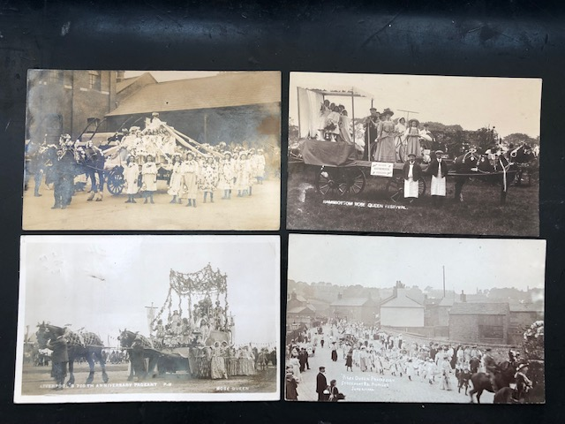

Top left : Photographic postcard, un-posted, c.1905. Rose queen and attendant maidens wearing white rose wreaths and variously rose decorated dresses. The reverse reads, `Dear Niece, I am sending you the rose maidens which crowned the Queen on the top of the lurry in the procession last Saturday. You ought to have been here you would have laughed to see them dancing in the streets.’
Top right: CUT
Bottom left: Photographic postcard, ‘Liverpool’s 700th Anniversary Pageant - Rose Queen’, post-marked Hollywell, 2 October 1907. Here the rose queen is part of an historical pageant involving some 4-5,000 performers, including a choir of a thousand voices at Wavertree Park and Grounds August 3, 5 and 6th, 1907.
Bottom right: Photographic postcard, `”Rose Queen procession. Stockport Rd. Romiley. June 23 1906.’, un-posted. A procession of mostly children and women parade in the wake of the rose queen’s splendid carriage.

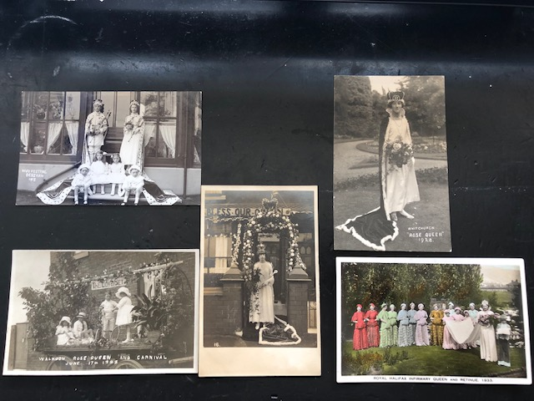

Top left: Photographic postcard, ‘Rose Festival Denshaw 1913’, un-posted. A rose king and queen with four young attendants, all expensively costumed/clothed The king holds an orb, the queen a sceptre and a posy of roses; both wear crowns and ermine-trimmed robes.
Top right: Photographic postcard, ‘Whitchurch “Rose Queen” 1928’, un-posted.
Bottom left and centre: Photographic postcards, ‘Walkdon Rose Queen and Carnival June 17 1922’, un-posted.
Bottom right: Colour-tinted photographic postcard, ‘Royal Halifax Infirmary Queen and Retinue. 1933’, un-posted. This fashionable rose queen, holding pink roses, is in peril of being outshone by her female retinue, who don dresses with matching hats, capelets and muffs, with petal-like decoration, in a harmony of colour tones.

