Drawing the Borderline

Dr Eleanor Bowen

Initiating a phenomenology is something that we do. It involves a dynamic engagement between bodily actions and reflective processes. (Kozel: 2006).

This is a reflection on ‘something I did’. In August 2009, over a period of five days, I drew a one and a half kilometer line around HM Durham Prison. As I was not permitted to mark the surface of the prison itself, the drawn element comprised a frottaged line in brass-rubbing wax dragged along many joined lengths of till roll secured around the prison’s outer boundary. This is an act whose existence persists as the line manifests in several forms including photographs, AVI footage, sketchbook notes and drawings, audio recordings, slide presentations and a cardboard box of paper till rolls carrying surface rubbings of the prison’s outer perimeter (walls, bars, doors); its outward face.

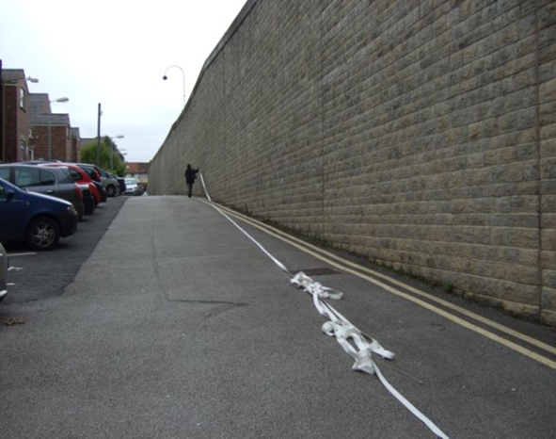
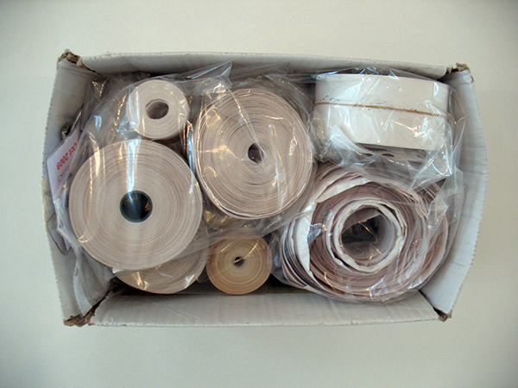

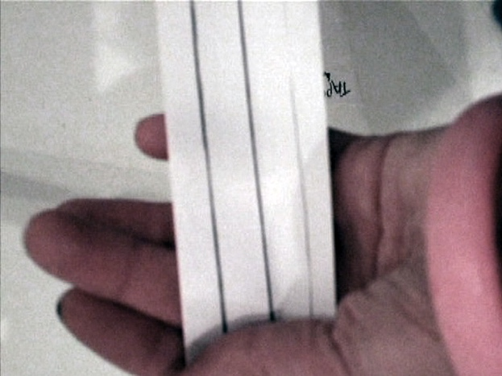
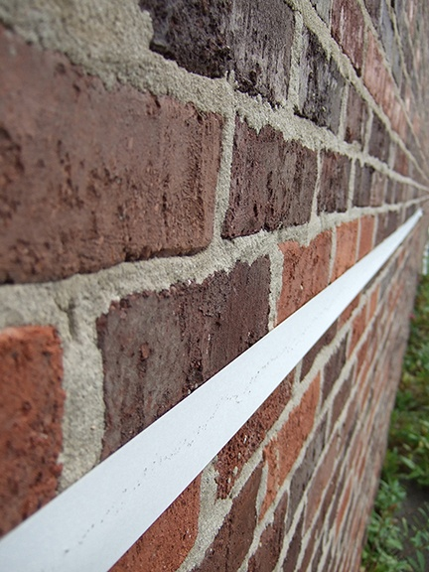

Citing the example of Jeremy Deller’s work The Battle of Orgreave (2001), Claire Bishop describes the shift in arts practice from studio-based to ‘post-studio’ works that persist in different forms after the event as artworks with ‘multiple ontologies.’ (Bishop, 2012).

Dorita Hannah’s argument for the ‘performativity’ (2015) of artworks such as Francis Alÿs’ Green Line (2004) contextualises the Durham prison line in terms of performance and performance design. Alÿs’ work comprised a 24-kilometer walk tracing the borderline mapped in green crayon by Moshe Dayan after the Israeli-Palestinian war of 1948. Carrying a leaking can of green paint, Alÿs traversed public and private spaces (‘roads, backyards, historic sites’), dribbling a continuous line behind him. (2015:3). [1]. Hannah asserts that works like Alÿs’ expand the scope of scenography beyond the traditional spaces of performance and address such ‘lived realities’ (2015:7) as the politics of division.

Ian Alan Paul views Alÿs’ Green Line in terms of ‘mark-as-action’ [2] possessing a logic that aims, as does the prison line, to draw attention. However, unlike Alys’ line, the prison line does not signify events or histories, but draws attention to the agency of line itself. Cut / seam / wall.

Alÿs’ line triggered responses, invited or otherwise, eliciting for this work the ‘multiple ontology’ attributed by Bishop to Deller’s Battle of Orgreave. (2012:30) [3]. The notion that an artist might trigger rather than author a work, with the implication of multiple outcomes, is useful in relation to the ‘potentially solipsistic position of one who draws’. (Bowen, 2012:1) [4]. In his work, Deller triggers a live re-enactment of the original battle between police and pickets during the 1984 miners’ strike, a complex event accruing material comprising a feature-length film, a publication of oral history and an archive. (2012:32). To trigger is to set in motion, rather than to make a definitive response. Alÿs’ work, despite the line itself having long disappeared, maintains a live existence through accrued material such as documentary footage, filmed interviews with, amongst others, an art historian, an anthropologist, a historian and ‘activists’, media reports, photographs and a website. Thus a single act with a clear conceptual aim, such as a line along a particular route, can set in motion responses around that act, keeping it alive.
The borderline experience of drawing a line around HM Durham Prison, considered through some of the material drawn
The line I drew round Durham prison in August 2009 currently exists in terms of its accumulated traces, the detritus that can most closely articulate a subject, history from below. ‘Detritus’ here is the material thrown up by excavation, or by cutting a line through matter. As in archaeology, buried material is the stuff of excavation and a primary source of knowledge, constituting real histories that may challenge received narrative. [5]. In this respect, the line echoes Deller’s intention in The Battle of Orgreave to evoke ‘history painting from below’, an image built on narratives emerging from the experiences of those who were there.

Durham is an ancient cathedral city in the northeast of England, a university town set within a landscape that was, until the 1980’s, sustained largely by coal-mining and mining communities. The prison is situated at the heart of the city within half a mile of the cathedral, which is a world heritage site.

Walking through (from transcript of audio recorded interview with the Principal Officer, Security and Operations (5th August 2009) while looking at an aerial photograph)

“It was originally just a town centre prison, and then gradually over the last two centuries it’s increased in size ... you can see from the architecture as it gets more modern, as we go out … the current layout of the institution, formed concentrically outwards from the earliest prison… is in effect a prison within a prison within a prison, at the heart of which is a place of execution… As a concentrically arranged structure, HMP Durham is not only bounded by an outer perimeter with borderline territories (public roads, car parks, municipal flowerbeds, alleyways etc) but contains several inner ‘barricades’ ... I mean again it’s another prison within a prison. It has its own perimeter wall and its own perimeter fence, because it was the high security section of the prison where some of the most notorious prisoners in England have been held at some point … But you can see how the prison’s expanded from the original. I imagine there was no wall or fence back in the 1800’s, there were just fields. I think it was just fields.

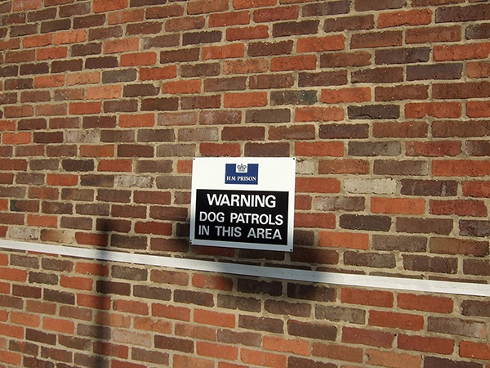
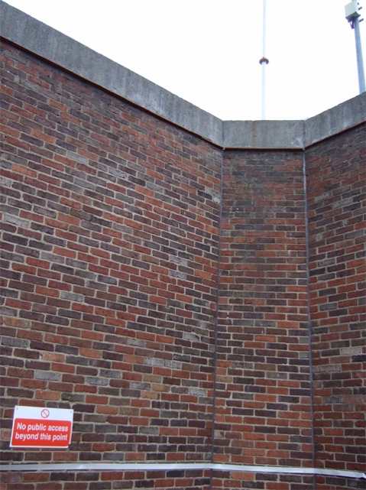

So the first thing to be extended … you’ve got the main hub here.… I-Wing was added on and that's sometime in the middle 1800’s I think, and F-Wing as well, which was originally the female side of the prison ... and in the yard is where the executions were carried out, because when we built the little temporary structure that's in there they’ve exhumed bones on several occasions, which have been taken off to the cathedral to be buried properly.

… the court, which is directly opposite C- Wing, was connected in to the prison so prisoners would come into the court, be sentenced and just come straight in. There used to be a tunnel I think which connected to the main prison, but staff would come in and …. [they’d literally go underground] …I'm sure I've heard stories of a tunnel. They’d just be walked through.”

A thickened terrain
Like Alÿs’ line, the prison line crosses public and private spaces in an act of delineation that suggests the line’s thickening, an acknowledgment of the liminal terrain that constitutes the border itself, the two-way face of the line. Seen/unseen. Severing/joining.
Line severs and joins. The marking of the [wall] makes the drawing … not resemblance but a measure of physical presence. (Bowen, 2015: 5).
The prison line is not the drawing of a prison but a ‘thickened terrain’ (Hannah 2015:3), the line of the perimeter wall expanding into marginal areas such as the dog patrolled pathways in the ‘no access’ areas of surveillance, far from the public areas of the prison and often, as I found while taking my line through such terrain, overgrown with weeds.
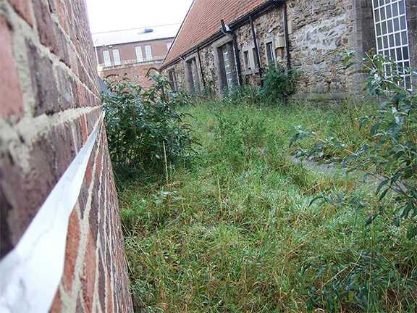
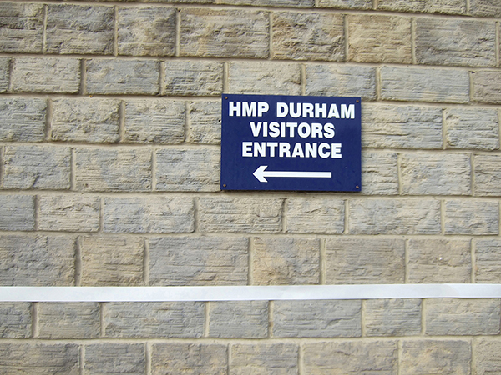

The 1.5-kilometer perimeter line crosses lengths of brick and stone wall, heavy wooden doors and metal bars, along muddy back lanes, through car parks and flower beds. The face of the prison at the front is a law court with imposing black doors and a grand pillared entrance. Visitors in at the blue doors at the back half a mile away. Big vans in the back too, through the barred gates. A pub to one side of the court.

Paper till roll does not easily take to brick, stone and metal, but cheap paper is easily marked and, as I drag wax along the paper line, a frottaged image of the prison’s face appears. Occasionally, as I go, passing personnel stop me to chat or shout across from where they are. I record these exchanges by scribbling directly onto the paper line’s impressionable surface, and in this way the fragments accrue.

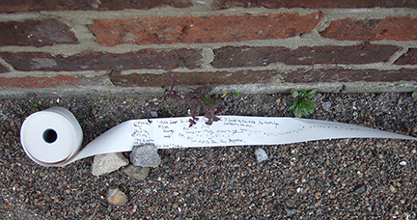

Sketchbook Notes, Day 1

Hey what ya doing? You know you might get stopped?

When are you doing the bungee jump?

That's alright pet I just wondered what you were doing.

It looks like bordering…

If I've done my job properly you should get stopped.

The surveillance tower guy is (naturally) suspicious, and the only person to ask ‘why’. He says ‘We can see your every move’, but my request for footage is refused. Somebody else asks me when I'm going to ‘take it down’ (he meant the prison, not the line) – ‘it should be moved out of the city’.
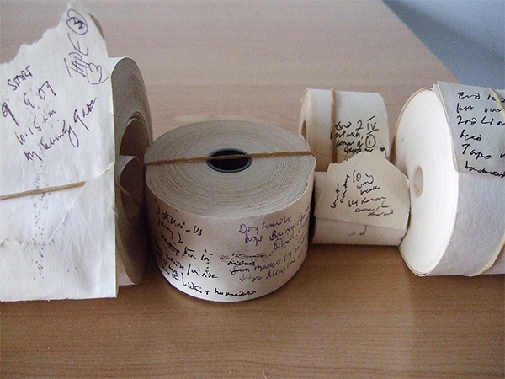

You can see the prison from all over the city – a lot of people think it’s a factory.

It’s seen, but not as a prison.

I'm drawing wax along paper pressed onto surfaces of wall, close up and unable ever to see the drawing in its entirety, contending with stinging nettles and one day with a high wind, conversing ‘outside’ with those whose jobs are ‘inside’, and with those who patrol and sit atop the walls operating surveillance cameras’ (“we can see your every move”). One end of my paper line takes off in the wind and flies over the top of the wall, over the wire and too near the camera.

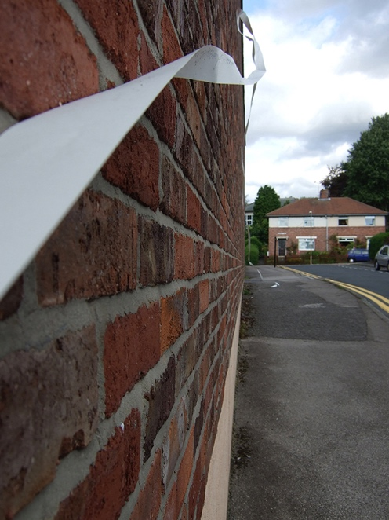
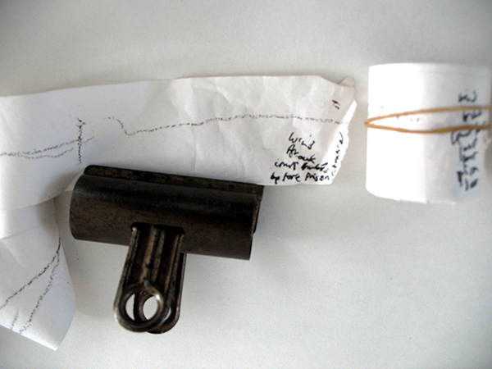

Sketchbook Notes, Day 2

The gate behind the pub marks a break in the continuity of the line as it continues into an area along the perimeter of the west wing. This runs between the 25-foot high prison wall and the back of the DHSS building.

We put the spikes there because relatives used to stand at the back of the DHSS building when they went to get their money, overlooking the path, and try to throw their mobiles high enough to get them over the wall.

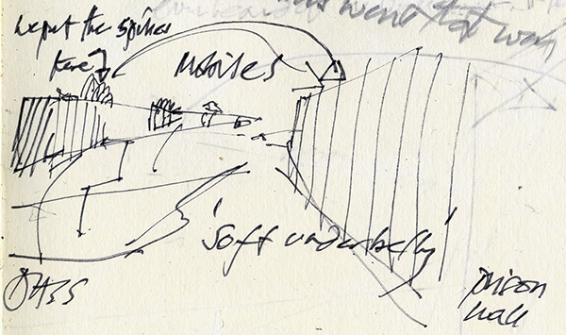

While drawing through this area, on several occasions I met a dog handler with two black dogs, a spaniel and a lab.

Passive sniffers (labs)
Active sniffers (spaniels).
One of them is trained to arrest. Can't remember which.

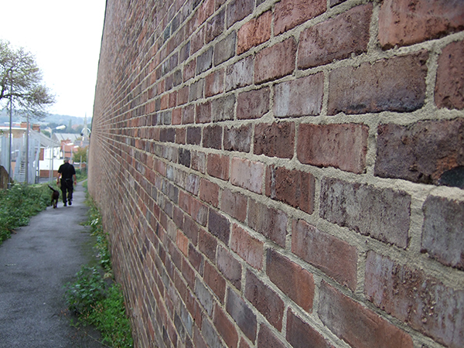

Sketchbook Notes, Day 3

Much quieter.
Gary with 2 dogs on patrol.
Line to keep them in.

Abject subjects

The borderline is conceived as a place that draws the abject, those elements ‘r(ejected) from the status quo’ (2015:9) who might be imagined, as in the case of the prison line, to inhabit the edges of the institution, for example in the thickened borderline areas to which public access is denied. There are the names on the walls (Becca, Louise), patches of blood and those friends and family who stand overlooking the ‘soft underbelly’, the area of greatest vulnerability for the institution, attempting to lob their phones over the towering wall, to avoid the gaze of surveillance, the cameras and the dogs.

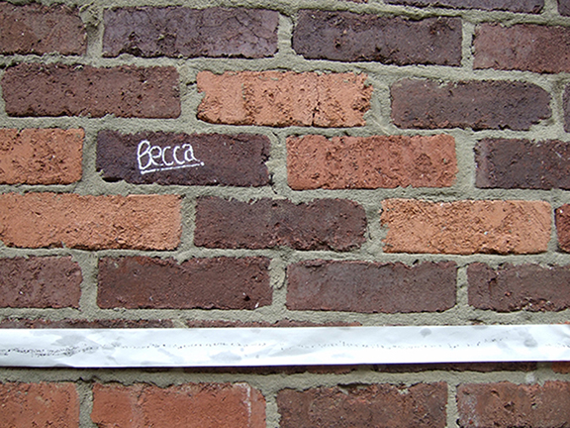

Mark as action

As I have argued in relation to the line as ‘trigger’, such marking offers a non-authorial act that touches rather than depicts in order to draw attention. Alan Paul suggests that ‘the border relies upon a cooperation and collusion of subjects in relation to it in order for its power to become expressed’. Thus drawing the line, marking the border and making it appear, draws views of the prison inside and out. A scenography of division.

Sketchbook Notes, Day 4

Nearly there.

Four people needed to see my pass. Only one stopped to find out more about the line. That was the woman security guard who first stopped me when I started it without permission. (“Can I ask you what you're doing?”).

Two education department teachers asked me if I knew about the public artwork on Palace Green. Projected images made by men in the art classes. (“Visiting artists do great work with the prisoners.”)

Sketchbook Notes, Day 5

Last bits of wall.
Inaccessible flower bed strip.

Carpentry tutor.
Drawing wax banging over bars.
Cries heard inside.

An alternative look
Heiner Goebbels, in his essay, What We Don't See Attracts Us, Four theses on Call Cutta by Rimini Protokoll (2015) [6] speculates what an ‘alternative look’ might be for the spaces of performance. In a phrase reminiscent of the performed borderline, he suggests that ‘The first requirement for this space would be to surround the centre without occupying it – neither with one’s own artistic ego nor with a protagonist (2015, 57)’. He also says that, ‘This space should be about unlocking texts and materials, not about one interpretation (ibid). The overriding of ‘one interpretation’ supports the multiple ontology of works cited by Bishop and Hannah as well as the non-authorial role of artists who deploy formal structures designed to invite audiences to make their own readings.

Sketchbook Notes after the event, 2010 (Drawing Residency, Centre for Drawing Project Space, Wimbledon College):
The extended mark - a finger touches the surface and drags along it for more than a mile, leaving a solid line behind.
Touch triggers the drawing, as the extended mark (the perimeter line) draws attention to the surface touched, leaving the centre unoccupied by performer or artist. Performing reversal, one side of the line performs the other. It earths our attention, and in this moment the reiterated wall throws up detritus that brings to the forefront of our attention the walls, lines and barricades of our own time. There is no ‘final word’ (2012:37), but something more like a reverberation, an opening up.
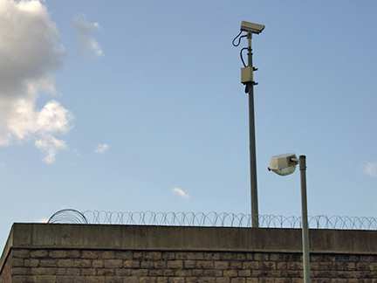

Notes
- See https://imageobjecttext.com/tag/francis-alys/.
- http://www.ianalanpaul.com/projectbackups/bordermachines/green2.html (accessed 17 1 17)
- In this context, Bishop envisages Deller’s authorial relationship to the work in terms of ‘trigger’ rather than ‘last word on’.
- While drawing a distinction between the terms, ontologically ‘to trigger’ and ‘to draw’ are related in that trigger ‘derives from the Dutch trekken, to pull’ (OED), while to draw ‘derives from Old English dragan, to draw or drag’ (Merriam Webster).
- The idea that, as in archaeology, a close reading of objects reveals narratives that can throw light on the past is explored in my text with image works ‘Where is the Space of Choreography’ (2008) in Performance Research Vol 13 No. 2, ‘On Choreography’ and ‘This Is That Has Been’ (2015) in Performance Research Vol 20 No. 3, ‘On Ruins and Ruination’.
- Rimini Protokoll comprises an artist team of author-directors, Helgard Haug, Stefan Kaegi and Daniel Wetzel.

References
Auslander, P. (2000), ‘Liveness, Mediatization, and Intermedial Performance’ in Degres: revue de synthese a orientation semiologique (Belgium), No. 101, Spring 2000
Auslander, P. (2006), ‘The Performance of Performance Art Documentation’ in Performing Arts Journal, Vol. 84, September 2006
Bishop C. (2012) Artificial Hells, Participatory Art and the Politics of Spectatorship, New York/London: Verso
Bowen E. (2012) ‘Drawing and Longing: Proposal for Drawing as Paratext’ at https://process.arts.ac.uk/sites/default/files/drawing_as_paratext_.doc_.pdf
Bowen, E (2015), ‘This Is That Has Been’ in Performance Research Vol 20 No. 3, ‘On Ruins and Ruination’
Goebbels , H., Aesthetics of Absence, Texts on Theatre, Collins J. and Till N. [eds.] (2015) [trans. Roesner D. and Lagao C.M.], UK and New York: Routledge
Hall, S. (1997) ‘The Work of Representation’ in Hall, S. (ed.) Representation: Cultural Representations and Signifying Practices. London: Sage
Hannah D. (2015) ‘Constructing Barricades and Creating Borderline Events’, Theatre and Performance Design, Vol. 1 2015, Issue 2, pp. 126-143
Kozel, S. (2006) ‘Phenomenology’ in Performance Research, Vol 11 No. 3 Lexicon, pp. 91-6
Paul, I.A. http://www.ianalanpaul.com/projectbackups/bordermachines/green2.html (accessed 17 1 17)

Images

1 Line: box of tapes (photograph)
2 Walking the line (photograph)
3 Line (photograph)

4 Bars (AVI still of bars frottaged onto the paper line)

5 No Public Access (photograph)

6 Warning dog patrols (photograph)
7 Visitors’ entrance (photograph)

8 Thickened terrain (photograph)
9 Borderline (photograph of unravelled line inscribed with remembered fragments of conversation)
10 Notes and conversations (photograph)

11 Line flying up (photograph)

12 Wind break (photograph)

13 Soft underbelly diagram with spikes and mobile phone trajectory (sketchbook notes)

14 Soft underbelly with dogs (photograph)

15 Becca (photograph)

16 Surveillance (photograph)

