Analysing the modest fashion market: an empirical study of e-commerce best-selling products
Abstract
Purpose
This study examines the dynamics of the modesty-conscious market within the global fashion industry. Specifically, the research aims to understand and analyse the preferences of consumers in this market segment and provide guidance for fashion companies seeking to engage with this sizable audience consumer demand for modest fashion, such as loose-fitting garments and headscarves for women.
Study Design/Methodology
Employing a mono-method quantitative research approach, this study uses a comprehensive big data analytics framework to analyse fashion data sets obtained from e-commerce website
Findings
The findings highlight a persistent and growing demand for modest fashion; that demand proved resilient in the face of challenges presented by the COVID-19 pandemic. Modest shoppers demonstrate price sensitivity, and their preference for premium brands over affordable ones varies considerably. Crucial factors contributing to the success of modest clothing as best-sellers include price, retailer, colour and fabric, while the discount feature is less important.
Research Limitation
While this research provides significant insights, it is important to acknowledge its limitations. This study relies on data gathered from certain e-commerce websites, and specific nuances of consumer behaviour may not be fully captured. In addition, the scope is limited to a specific timeframe and may not account for long-term market shifts.
Practical Implications
Fashion companies could use the results of this study to customise their strategy for engaging the modesty-conscious demographic. Comprehending the significance of elements such as price, retailer, colour and fabric can allow firms to enhance their product offerings and marketing strategies.

Social Implications
This study highlights the social ramifications of the modesty-focused industry, stressing the changing tastes and requirements of customers within this sector. By aligning their strategies with these societal shifts, fashion companies can contribute to a more inclusive and diverse industry landscape.

Originality/value
This research contributes to the academic literature on modest fashion by using a unique combination of exploratory data analysis and machine learning techniques with fashion e-commerce data sets. This study addresses a gap in the use of big data within this field, and provides novel insights into consumer demand for modest garments. This study challenges the prevailing assumption that consumers of modest fashion prioritise premium pricing and offers fresh insights into their price sensitivity across both mass-market and luxury segments. It contributes to the literature on consumer behaviour in niche fashion markets and introduces a theoretical framework for understanding the intersection of fashion, culture and consumer economics within the context of modest fashion.
Keywords: Modest fashion marketing, Machine learning in fashion, Data-driven fashion strategies, Consumer behaviour analytics, Modesty-conscious apparel

Introduction
The fashion industry has experienced significant disruptions and challenges over the past five years, partly due to the COVID-19 pandemic. In response to the pandemic, brands increasingly turned to e-commerce and social media platforms like Facebook and WhatsApp to showcase products (Sumarliah et al., 2021). Numerous fashion brands rely on e-retailer platforms such as Amazon, JD.com, or Alibaba to generate online revenue due to the absence of their proprietary e-commerce platforms (Ingram, 2020). According to a report by The Business of Fashion and McKinsey & Company (2021), the industry's profit plummeted during COVID-19. However, one of the sectors that experienced significant growth was e-commerce retail sales, with an increase of $0.897 billion to $4.248 billion, accounting for a 26.7% increase in the year 2020 compared to a 12.37% increase in the year before (Chevalier, 2024). Edge by Ascential (2022) forecasts that e-commerce will account for approximately 40% of chain retail sales by 2026. As a result, brick-and-mortar retail sales are expected to decline gradually.
In addition to the overall growth in e-commerce, there is a specific market segment within the fashion industry that has been thriving which is the modest fashion industry. Modest fashion refers to clothing that adheres to specific modesty standards, such as loose-fitting garments and headscarves for women (Esposito 2020). The global modest fashion industry was valued at $283 billion in 2018 and is expected to reach $402 billion by the end of 2024 (The Economist, 2020). A major catalyst behind this growth is the substantial expenditure within the Muslim consumer market, commonly known as "Generation M," contributing a noteworthy $44 billion to the overall $1.9 trillion global Muslim market (Usher, 2018). The internet has played a crucial role in enabling these consumers to express their preferences and demands for modest fashion options.
Internet and social media platforms inform fashion retailers with consumer behaviour and preferences. The changing landscape of internet usage has allowed billions of users to not only browse and shop online but also access fashion brands' information and services and communicate with them on social media (Ren et al., 2018). The rise of online activity has generated a wealth of data, offering businesses invaluable insights into customer behavior and strategies for improvement (Fisher and Raman, 2018; Chevalier, 2024). Yet, the data collected from the internet is often vast, incomplete, noisy, obscure, and random, which presents challenges in effectively utilizing it for business purposes (Russom, 2011). Using data on modest fashion presents an even greater challenge, given the limited attention it has received from researchers.
While previous research has concentrated on expanding e-commerce and general fashion trends, the modest fashion industry remains insufficiently studied (Randeree, 2020; Kamarulzaman and Shaari, 2023). Particularly, the complex factors influencing modest fashion have mostly been overlooked, and very little is known about this distinctive market segment (Asmawi et al., 2024). Precisely, the relative success of mass-market and luxury brands, consumer sensitivity to price, and preferences for specific product qualities have not been thoroughly explored within the context of modest fashion (Zainudin et al., 2020; Benissan, 2021).
Further research is necessary to better understand the modest fashion industry (Randeree, 2020; Kamarulzaman and Shaari, 2023). By showing how the tastes and preferences of this market segment are changing, the study elucidates the societal trends in the modesty-conscious sector. This research aims to analyze the sustainability and growth prospects of modest fashion within the broader fashion industry, considering post-pandemic shifts and evolving consumer preferences. Specifically, we determine which sector—mass-market or luxury—holds a higher market demand in the e-commerce space for modest fashion and how that market demand is influenced by price changes and other product features including colour, material, and style.
To achieve this aim, we raise the following research questions: Will the rising trend in modest fashion last longer? Which segment of the e-commerce retail sector has experienced greater demand: high street/mass-market brands or premium/luxury brands? how consumer demand respond to price changes? Precisely, does price reduction for popular products result a rise in demand? What other product attributes—such as colours, materials, and styles—significantly influence consumer demand within the market?
This research addresses these questions through a mono-method quantitative approach, analyzing fashion datasets sourced from e-commerce websites using a comprehensive big data analytics (BDA) framework. The findings reveal a sustained demand for modest fashion, exhibiting resilience amidst the challenges posed by the COVID-19 pandemic. Additionally, modest consumers displayed price sensitivity, with their preferences for premium brands over affordable options varying significantly. Key factors contributing to the success of modest clothing as best-sellers include price, retailer, color, and fabric, while the importance of discounts appears to be less significant.
The paper is organized as follows: Section 2 reviews the literature, Section 3 outlines the methodology, and Section 4 presents the results. Finally, Section 5 offers discussion and conclusion.

Literature Review

Modest Fashion
The concept of modesty in academic literature traces back to Thomas (1899), asserting the direct link between modesty and clothing, particularly in women's intention to cover themselves after puberty to avoid displeasing men. Harms (1938) expanded on this, highlighting clothing's multifaceted role in serving modesty, adornment, and protection, yet also potentially acting against modesty by emphasising sexual attraction. Esposito (2020) defined modern modest clothing as garments featuring loose-fitting shapes, less revealing fabrics, and covering most body parts, often associated with self-representation of specific faiths. However, Mumin (2010) argued that the fashion industry, predominantly controlled by men, shapes the concept of modesty, potentially influenced by men's perceptions of what constitutes attractiveness for women.
Recent research has added nuance to these foundational ideas. Babakhani (2024) examined the cultural and theological importance of modest attire in Muslim communities, emphasising the intricate interplay between piety, identity, and global fashion trends. The study demonstrated that modest attire is not just a response to masculine expectations but also a manifestation of autonomy, spirituality, and identity. Asmawi et al. (2024) investigated the emergence of "modest fashion" as a worldwide phenomenon, highlighting the substantial growth of the modest apparel sector and the increasing demand from women of many religious and cultural backgrounds. This expansion suggests a transformation in women's self-representation and the rising impact of women in influencing fashion sectors hitherto controlled by males.
Karakavak and Ozboluk (2024) assert that the progression of modest fashion has been profoundly impacted by digital platforms and social media, which have been instrumental in enhancing the exposure and acceptability of modest attire. Social media, especially Instagram and blogs, has played a crucial role in advancing modest fashion trends and linking designers, bloggers, and customers (Kamarulzaman and Shaari, 2023; Abbas, 2023). Barron (2020) elucidates how these channels have facilitated the rise of new modest fashion influencers who influence customer tastes and dictate trends. Moreover, research by Ashraf et al. (2023) highlights that enhanced visibility on these platforms has resulted in heightened acceptability and mainstream incorporation of modest fashion, mirroring broader transformations in cultural perspectives and fashion industry norms.
The fashion business is undergoing a notable transition from Western to South and East Asian markets, offering both possibilities and problems (Bai et al., 2022). The increasing desire for modest fashion in areas such as the Middle East and Southeast Asia offers substantial market potential for businesses. However, it also prompts worries about cultural appropriation and authenticity (Cheang et al., 2021). Western fashion firms frequently penetrate these markets with designs that may seemingly address modesty yet lack a profound comprehension of local customs and beliefs. This may lead to goods that prioritise exploiting a trend above authentically honouring traditional customs (Karakavak and Ozboluk, 2024). The commercialisation of modest fashion may weaken its cultural value, as manufacturers prioritise marketability above authentic portrayal. This tendency exacerbates the risk of perpetuating stereotypes, since Western perceptions of modest fashion may oversimplify or distort the variety inherent in modest-wearing practices (Abbas, 2023). Consequently, although the proliferation of modest fashion in these burgeoning areas presents economic advantages, it also requires a more nuanced and knowledgeable strategy to preserve cultural authenticity and respect.
The transition of fashion markets from the West to the South and East, driven by the considerable purchasing power of Muslim consumers, has prompted luxury labels like Dolce & Gabbana to focus on affluent Middle Eastern clientele with products like the abaya (Lodi, 2020). This trend extended to other renowned clothing giants like H&M, Macy's, and Marks and Spencer, who launched dedicated modest clothing lines (Thomson Reuters, 2018) by signalling the mainstream acceptance of modest fashion. The internet's evolution played a crucial role in this transformation, with online retailers and platforms like Instagram propelling the rise of millennial Muslim influencers and contributing significantly to the legitimacy and popularity of modest fashion (Lewis, 2015).
Vogue business highlighted Muslim consumers' growing interest in luxury modest fashion (Benissan, 2021). Despite a temporary slowdown after initial growth in 2018, luxury brands witnessed heightened interest in modest clothing, especially during Ramadan (DinarStandard, 2022).
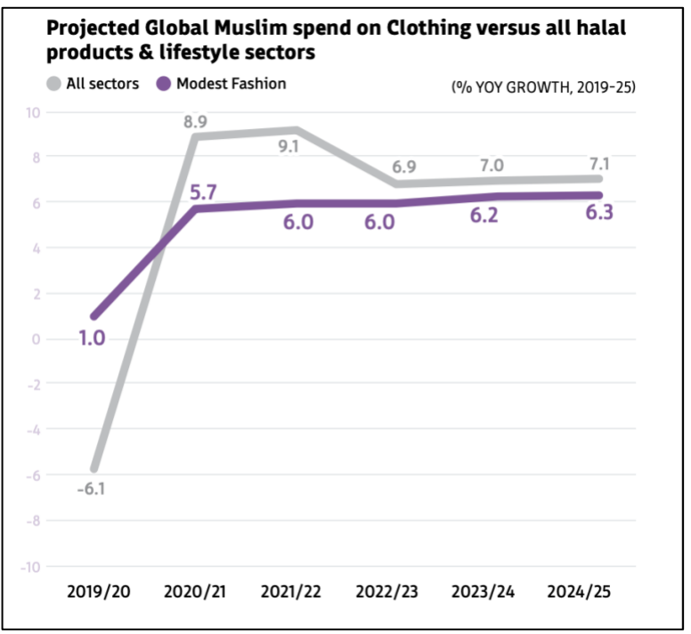
Source: DinarStandard, 2022
Figure 1: Projected Global Muslim Spend on Clothing versus All Halal Products & Lifestyle Sector
Figure 1 shows that there is a definite demand among modest consumers for luxury fashion. However, a significant quandary arose when the luxury online retailer designed for this demographic, known as "The Modist," encountered closure due to pandemic-related challenges. This occurrence has prompted the formulation of research inquiries, which will be elaborated upon below.

The Factors Influencing Dressing Modestly
Individuals' dress choices are heavily influenced by social norms and peer pressure. According to Lipson et al. (2020), social conformity commonly impacts fashion choices, leading people to change their apparel to fit the standards of their social groupings. This phenomenon is evident in communities with strong cultural or religious identities when modesty transcends personal desire and becomes a community obligation. Social networks commonly favour wearing hijab or other modest clothing in numerous Muslim communities, as people want acceptance and a sense of belonging (Rumaney and Sriram, 2023).
Furthermore, the importance of media and popular culture cannot be underestimated. Research conducted by Karakavak and Ozboluk (2024) demonstrates that media portrayals of modesty may profoundly affect public attitudes and personal decisions. The representation of modest fashion in mainstream and social media has sparked renewed interest in modest attire, especially among younger generations aiming to harmonise personal expression with cultural norms (Ashraf et al., 2023; Lewis and Aune, 2023). Thus, sociocultural factors derived from community dynamics and dominant media narratives define the area of modest clothes.
People's attitudes about modest attire are heavily influenced by their cultural and religious beliefs. According to Slater and Demangeot (2021), the cultural environment frequently determines modesty norms, which can vary significantly among nations. In many cultures, modesty is connected with virtue and morality, prompting people to adopt dress traditions that reflect these principles. In Orthodox Jewish communities, women frequently follow severe dress rules that promote modesty as a display of their religious dedication (Taylor-Guthartz, 2021).
The psychological components of self-esteem, body image, and identity development profoundly impact decisions regarding modest attire. Studies by Hwang and Kim (2020) and Slater and Demangeot (2021) demonstrate that persons with a good body image are more inclined to articulate their unique style, which may or may not conform to modesty standards. In contrast, individuals experiencing body image concerns may adopt modest attire as self-defence or to evade scrutiny (Dhillon and Gammage, 2023). Moreover, modest attire can function as a means of identity expression, especially for individuals aiming to affirm their ethnic or religious identity within a heterogeneous community (Ashraf et al., 2023). Research conducted by Lewis and Aune (2023) revealed that numerous women perceive modest attire as a means to assert control over their bodies and contest dominant beauty norms. This agency is critical in situations when modest attire is perceived as a means of resisting hypersexualization and objectification.
Mumin's (2010) research divided views about human clothing and ornamentation into four categories: protection, modesty, display, and communication. The study concluded that, while ideas of protection and modesty had certain limitations in explaining current clothing behaviours, conceptions of display and communication were more believable and widely accepted. Nevertheless, it was observed that none of these ideas thoroughly examined the impact of faith and beliefs on clothing selections, especially regarding the rationale for women's inclination towards modest attire. Hashem (2018) examined these four theories but favoured modesty and ornamentation as better appropriate for the study and discourse of modest fashion.
As highlighted in prior studies, religious beliefs motivate to dress modestly. (Wani, 2013; Shriver, 2017; Hassan et al., 2019; Radwan et al., 2019). Lewis (2013) pointed out that modest fashion originated and initial focused on women from the three major Abrahamic faiths: Islam, Judaism, and Christianity. She also mentioned various motivations driving modest dressing, including practicality, body image considerations, and life changes. Despite modest fashion being broader than one religion, academic research predominantly revolves around the Muslim community in discussions on modest fashion. This focus is due to Islam's status as the second-largest religion, as reported by the Pew Research Center (2015), and the projected global rise in the Muslim population, expected to reach 73% in the foreseeable future (Figure 2). Hence, academic papers often use the Muslim community as a representative group for discussions on modest shoppers due to their prominence and sizeable presence in the modest fashion landscape.
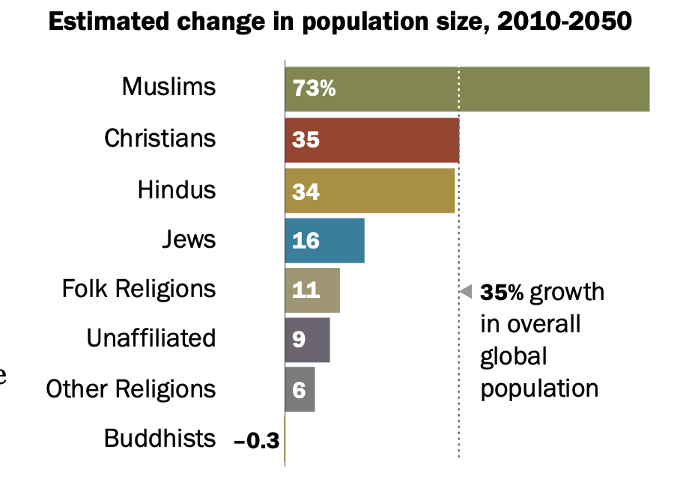
Source: Pew Research Center, 2015
Figure 2: Estimated Change in Population Size, 2010-2050
The term "hijab" is frequently used interchangeably with modest fashion within the context of Muslim modest wearers defined by Sumarliah et al. (2021) as an embodiment of religious faith; the hijab is worn as an act of obedience to God. According to El Guindi (1999), its literal meaning is "barrier or partition and implies a complete covering comprising ankle-length, loose-fitted attire. Investigating this phenomenon anthropologically, Shriver (2017) highlighted that women wearing hijabs as fashionistas aim to assert their agency, beauty, and religious values. Shriver (2017) delineated how hijabi women actively choose to wear hijabs, showcasing their agency, self-expression, and adherence to religious beliefs.

The Modest Fashion Shopping Behaviour
Modest fashion, often characterized by clothing that provides more coverage than mainstream fashion, is embraced by individuals from diverse backgrounds, including religious communities, cultural groups, and those who prefer a more conservative style (Zainudin et al., 2020). One of the key motivators for modest fashion purchasing behaviour is the alignment of clothing selections with personal values and beliefs. AbdelAziz et al. (2023) found that customers frequently want attire that expresses their ethnic and religious identities. Muslim women, for example, who may follow strict dress standards, often prefer labels that provide attractive yet modest alternatives. The association between fashion and personal views affects shopping decisions, brand loyalty, and community engagement (Asmawi et al., 2024). Key factors in modest fashion purchasing are price sensitivity and accessibility (Randeree, 2020).
Ajaib and Altunisik's (2022) study reveals that customers frequently have difficulties in locating affordably priced modest fashion options, perhaps dissuading them from making purchases. Retailers who effectively traverse this problem by providing a wide variety of price points and accessible designs are more likely to attract a varied consumer base. Furthermore, the inclusion of modest fashion in mainstream retail environments has been connected to enhanced exposure and acceptability of this style, allowing customers to purchase more easily (Pemberton and Takhar, 2021).
Furthermore, recent research has focused on the influence of ethical considerations on modest fashion buying behaviour (Mehta et al., 2023). Consumers are becoming more conscious of the ethical consequences of their purchase decisions, resulting in a preference for firms that prioritise sustainability and ethical manufacturing processes. According to research by Biancone et al. (2023), modest fashion buyers are more inclined to support firms that demonstrate a commitment to ethical principles such as fair working conditions and eco-friendly materials. This trend underscores the necessity of openness in the fashion business and the need for firms to properly convey their ideals.
In a qualitative study of Muslim women in their twenties, Hashem (2018) identified four phases based on interview data: awareness, contemplation, decision, and retention. Although this study was conducted in 2018, the findings are still applicable and form the conceptual basis. Additional research (Wani, 2013; Hassan et al., 2019; Radwan et al., 2019; Kusumawati et al., 2019) supports this.
As a result, this study emphasises the need to consider religious beliefs, cultural influences, self-awareness, fashion consciousness, buying habits, and preferred shopping venues while investigating the purchasing behaviour of modest fashion customers (Hashem, 2018). Research indicates that the initial phase in the purchasing behaviour of modest fashion consumers is "awareness" (Hashem, 2018). Consumers possessing purchasing power in this industry are frequently digitally adept, compelling companies to advertise on social media platforms like Instagram, Twitter, and YouTube. In the contemplation stage, Muslim modest brand consumers emphasise their Islamic principles while selecting design items (Wani, 2013; Hassan et al., 2019; Kusumawati et al., 2019), deriving inspiration from many sources that extend beyond traditional modest fashion parameters. Brands should offer varied options to avoid imposing rigid concepts of modest fashion, as noted by Radwan et al. (2019). They highlight that Italian brands often fail to understand the preferences of Muslim women seeking fashion items labelled as "Muslim dresses."
Hashem (2018) finds millennial Muslim women in European countries tend to favour mainstream brands over specific modest fashion brands and prefer online shopping due to limited free time. Hashem (2018) suggested that mainstream brands have a significant opportunity to cater to Muslim and modest fashion consumers. This aligns with the trend observed in the industry, with major retailers like Nike, DKNY, and Tommy Hilfiger integrating hijab and Ramadan collections into their offerings. While this challenges retailers specializing in Islamic styles, it signifies the evolution of modest fashion into a "mainstream fashion subculture". Additionally, religious consumers tend to prioritize quality over price, preferring products that demonstrate value for money (Kusumawati et al., 2019; Islam and Chandrasekaran, 2020). However, fashion-conscious consumers show more loyalty toward and advocacy for premium modest fashion brands (Kusumawati et al., 2022).
The reviewed studies shed light on factors influencing the purchasing journey of millennial Muslim consumers, emphasizing the role of online platforms, religious values, fashion knowledge, variety of choices, and product quality. Nevertheless, these studies were conducted before the pandemic, overlooking the significant changes in the shopping landscape, especially the shift to fully online shopping experiences. Moreover, the research primarily gathered consumer insights and lacked perspectives from the company side. Hence, this study aims to bridge this gap by leveraging fashion e-commerce datasets to understand modest fashion customers' preferences, providing guidance for fashion companies.

Theoretical Concepts and Analytical Framework
The study incorporates a framework based on the marketing research process by Big Data Analytics (BDA) framework for organizational leverage proposed by Mathrani and Lai (2021). It seeks to better understand modest fashion customers' decision-making processes while also looking at the role of big data analytics in defining marketing tactics in this industry. Using the BDA paradigm established by Mathrani and Lai (2021), the study aims to show how exploiting large data sources, particularly from e-commerce platforms, may give important insights regarding modest fashion purchasing behaviour.
The study uses a variety of theoretical frameworks to thoroughly explore the intricacies of modest fashion consumption behaviour. The research attempts to shed light on the multidimensional nature of modest fashion consumption by building on Hashem's (2018) thesis about the numerous motivations that drive faith-based customers' fashion purchases. By combining these theoretical underpinnings and applying them to the context of the marketing research process and the BDA framework, the study hopes to make a significant contribution to understanding consumer behaviour in the modest fashion market and assist businesses in more effectively navigating this complex terrain.

Conceptual Framework
According to Russom (2011), big data was previously considered a technological barrier because of the massive volume of internet-collected data, but it has now emerged as a huge potential. Thomassey and Zeng (2018) discuss the potential advantages of big data in the fashion sector, emphasising the need for firms to implement business intelligence (BI) or data analytics technologies to harness unused data to understand customers and the business landscape better. This involves using predictive analytics, statistics, natural language processing (NLP), data mining, and artificial intelligence (AI), which are very useful in the fashion industry.
However, Mathrani and Lai (2021) indicated that managing BDA necessitates robust computational capabilities and substantial maintenance costs. Yet, in the e-commerce realm, BDA offers valuable insights into users' purchasing behaviour, enhancing engagement and user retention (Akter and Wamba, 2016). Additionally, Fisher and Raman (2018) suggest that BDA in retail can significantly improve performance, minimize lost sales and overstock, reduce labour costs, and enhance profits. Akter and Wamba (2016) compiled BDA applications in e-commerce, categorizing data into transaction, click-stream, video, and voice data, highlighting the immense benefits, especially from transaction data alone, for e-tailers. Therefore, this study aims to focus on analyzing customer demands and preferences using transaction data obtained from e-commerce websites.
The BDA framework proposed by Mathrani and Lai (2021) established the groundwork for the conceptual framework validating the application of big data analytics in fashion businesses (Mathrani and Lai, 2021) for predicting demand and enhancing effective product decision-making.

Methodology

Data collection and source
This study utilized secondary data obtained from Stylumia (https://cit.stylumia.com/insights), a fashion intelligence company offering AI-driven analytics for apparel brands. Stylumia compiles data from various e-commerce sites to provide trend insights. We used Stylumia’s Consumer Intelligence Technology (CIT), which allows us to filter preferences based on multiple criteria, such as retailers, geography, and price point. The dataset from Stylumia was deemed suitable for this research due to its supervised and structured nature achieved through machine learning processes and primarily computer vision applied to the gathered information in real-time on chosen fashion brands. Three nominal valued datasets were used in this research: the fashion e-commerce dataset, the trend demand dataset, and the trend price dataset.
The study focused on specific parameters, which are shown in Table 1 below:
Table 1: Criteria Applied in the Research
Parameters | Criteria
Categories | The emphasis was on modest fashion, featuring loose-fitting, concealing attire. This led to the selection of product categories such as dresses, Arab clothing, and abayas, in line with modesty standards.
Retailers | A total of 51 retailers, including Amazon, ASOS, H&M, and others, were chosen after filtering for their adherence to modest fashion requirements, ensuring a diverse representation in the market.
Geography | Retailers from various countries, such as Australia, Denmark, France, Germany, India, Italy, Japan, Spain, UAE, UK, and the US, were selected based on their offerings meeting the study's criteria.
Department | The study centred on the women's department, excluding categories like girls and baby girls as they fell outside the scope of modest fashion.
Date Range | Data spanning from March 21, 2021, to August 14, 2022, was utilized to capture trends during this trading period.
Price | Both original (list price) and selling prices were considered, ranging from £2.4 to £8,600. Products with discounts of up to 80% were included in the analysis.
Attributes | Specific attributes such as non-fitted silhouette, long sleeves, and maxi dress length were chosen to comply with the modesty requirements.
Brands | A broad dataset encompassing over 100 brands, ranging from high-street to luxury, was gathered to ensure diversity without targeting specific brands.
Demand | The study took into account various product demand rankings, including best seller, good seller, average, and poor seller, to investigate the factors influencing the performance of modest fashion categories.
Source: Authors own work
These parameters were defined and used in the data generation process. We generated three different datasets, which are explained below.

Fashion E-commerce Dataset
The data set used for this fashion e-commerce study was obtained from Stylumia around June 2022. It comprises 22 columns and 670 observations. It encompassed various variables such as product code, retailer information, image links, product URLs, names, launch dates, pricing details, discount information, and categorical attributes like brand, category, and department.
The product code and retailer columns included unique identifiers and retailer-specific details, while the image and URL columns provided visual and web links. Product names described the items, and launch dates indicated their initial appearance online. Pricing details were also present, including list price, selling price, and markdown information.
Certain categorical data, like retailer and discount information, were transformed into numeric variables to facilitate machine learning model development. Brand data, containing numerous options, was challenging to process. Discount details were converted into binary variables for discounted (1) and non-discounted (0) items.
Unique variables from Stylumia, such as rank labels and rank percentile groups, determined product demand based on a machine learning model. These categorical values were converted into numeric representations: rank labels were assigned numeric values indicating different seller categories, and binary values were allocated to classify items as best/good sellers or average/poor sellers.
The dataset included colour information, which was converted into 65 numerical options corresponding to colour names. Initially categorized by demand and market segment, product positioning was redefined in this study based on pricing into value or luxury goods. Information like size availability, product descriptions, feature lists, and style attributes were available but needed to be translated into numerical values. Consequently, for numerical representation, only fabric or material details were extracted and categorized into six types: cotton, polyester, silk, viscose, Tencel, and others.
Table 2 presents the fashion e-commerce dataset variables.

Table 2: Fashion E-Commerce Dataset Variables
Variable name | Description
Launch date | The date the products were first launched on the retailer/marketplace website
Retailer | The retailer name
List price/GBP | The price listed on the website when the product first showcased on the e-commerce
Rank label | Rank label based on the product’s performance: “Bestseller”, “Good Seller”, “Average Seller” and “Poor Seller”
Rank percentile Group | Product was put in the percentile group before the rank label: “1-10”,”20-30”, “30-40”, “40-50”, “50-60”, “60-70”, “70-80”, ”80-90”, and ”90-100”
Retailer colour name | The product’s colour as described by the retailers
Fabric | A new variable was created to describe the fabric derived from the product description, feature list and style attribute variables
retail code | A numerical value for the “Retailer” variable
fabric code | A numerical value for the “Fabric” variable
color code | A numerical value for the “Retailer colour name” variable
rank code | Numerical value for “Rank label” variable
rank binary | Binary value for “Rank label” variable: (1) for the best and good seller, (2) for Average and Poor seller
Discountlabel | Whether the product had a markdown or not before it was sold out or taken down from the retailer/marketplace website, the code instruction (1) for yes (0) for no
Source: Authors own work
The fashion e-commerce dataset was split into two segments according to price points: mass market and premium luxury categories. In the mass market segment, focusing on best-selling items and retailers, products ranged from £2 to £200. The standout retailers in this price range were Amazon United States (US) and Amazon United Arab Emirates (AE), contributing a total of 22 best-selling products.
Conversely, the premium luxury category encompassed products priced from £200 to £5000. In this segment, Farfetch US and Farfetch United Kingdom (UK) emerged as the top-performing retailers, accounting for 19 best-seller products. This division, based on market segmentation, aimed to compare the demand between these two distinct market segments using smaller, more concentrated datasets. Additionally, both datasets provided insights into each product's demand trends and performance analysis concerning pricing over a one-year.

Trend Demand Dataset
The trend demand dataset was generated through Stylumia's analysis of product ranks, tracking demand from a product's initial launch to the present time. This rank was determined based on the product's availability on retailers' websites. Approximately 41 best-selling products were individually tracked to compile the demand reports. These reports were segregated based on market segmentation (mass market or luxury), combining around 20 different reports for each segment into an Excel sheet. This aggregation resulted in 76 observations for the mass market and 145 observations for the luxury segment.
Table 3 shows the trend demand variables, including an explanation of the variables.
Table 3: Trend Demand Dataset Variables
Variable name | Description
Rank date | The date when the product’s demand experienced a change
Trend demand | The product rank (based on demand) scale in percentile from 0th to 100th
Source: Authors own work

Trend Price Dataset
The trend price analysis involved monitoring e-commerce website activities. Stylumia gathered data on the initial price, discounted price, and selling prices of each individual product. However, it is essential to note that Stylumia did not track prices daily but recorded changes only when e-tailers modified the prices. Consequently, this specific report had fewer observations. Upon aggregation, a notable difference emerged between the mass and luxury markets. The mass market segment had only 14 observations, while the luxury market had a significantly higher count of 150 observations.
The price analysis variable is shown in Table 4.
Table 4: Price Analysis Dataset Variables
Variable name | Description
Price date | The date when the product’s prices experienced some adjustment
Selling Price GBP | The selling price indicated what the prices customers paid for the product on those dates
Source: Authors own work

Exploratory Data Analysis
Data analysts commonly employ exploratory data analysis (EDA) to investigate and comprehend datasets. EDA relies on data visualization techniques like bar charts, line charts, histograms, scatter plots, and box plots to discern anomalies, patterns, and hypotheses that might not be evident in text-based inputs (Liu, 2014). Yu (2010) suggests that data mining extends the principles of EDA, as it does not start from preconceived notions or specific hypotheses but aims to uncover patterns within data. Additionally, many data mining methods are non-parametric and often resilient to multicollinearity. Newer EDA techniques, like clustering processes, are adept at handling outliers (Yu, 2010).

Clustering
The clustering method, previously discussed as a part of the new EDA within data mining, has been employed for various purposes. In marketing, cluster analysis is commonly used for customer segmentation, product grouping, and identifying companies with similar strategies (Saunders, 1994). Its applications span across diverse fields like psychiatry, astronomy, weather classification, bioinformatics, and genetics (Landau et al., 2011). In this study, clustering was used to classify products and uncover latent structures within the dataset that were not immediately discernible through visual exploration.
Clustering encompasses several techniques, including the hierarchical method, partitioning method, grid-based method, and density-based method. Arora et al. (2016) suggested that k-medoids presented a more robust algorithm compared to k-means. While k-means employed the sum of Euclidean metrics, k-medoids replaced non-representative objects with representative ones, resulting in fewer overlapping clusters. This research focused on the partitioning method, specifically utilizing k-medoids. The novelty of this study lies in its implementation of clustering on a mixed dataset containing categorical, nominal, and numeric variables commonly found in actual marketing data. Consequently, this research utilized the Gower distance for k-medoid clustering, departing from the typical use of Euclidean distance.

Findings and Analysis

Descriptive Statistics
The fashion e-commerce dataset consisted of 670 observations. Based on the descriptive statistics (Table 5), the price range for modest fashion varied, with the lowest price recorded at £2.29 and the highest at £8303.52. The most frequently occurring price point was £100.
Table 5: Descriptive Statistics
Variable | N | Minimum | Maximum | Mean | Median | Mode | S.D
List price / GBP | 670 | 2.29 | 8308.52 | 505.365 | 100.0 | 100.00 | 1024.4
Source: Authors own work
The dataset pertaining to list prices exhibits a notable skewness, as evidenced by a reported mean of 505.3 and a median of 100. Within our sample, a diverse array of retailers is represented, encompassing entities such as Amazon and Myntra, characterised by comparatively modest price points. Conversely, the sample includes luxury retailers like Farfetch, renowned for their markedly elevated price points. This spectrum of retail entities contributes to the observed variability in the list price dataset, reflecting the wide range of pricing strategies and market segments embraced within the retail landscape of modest fashion.

4.2. Exploratory Data Analysis
Exploratory data analysis was conducted using Tableau software to visually represent findings. In the fashion e-commerce dataset focusing on modest attire, there were 670 observations. According to the pie chart in Figure 3, over half of these observations, specifically 353 products, fell into the high-demand category, while 317 products were classified as low-demand. The mass market exhibited slightly higher demand compared to the niche market. Specifically, there were 196 high-demand products and 139 low-demand products in the mass market. On the other hand, the niche market comprised 178 low-demand products and 157 high-demand products. This suggests a uniform distribution of products across different demand categories.
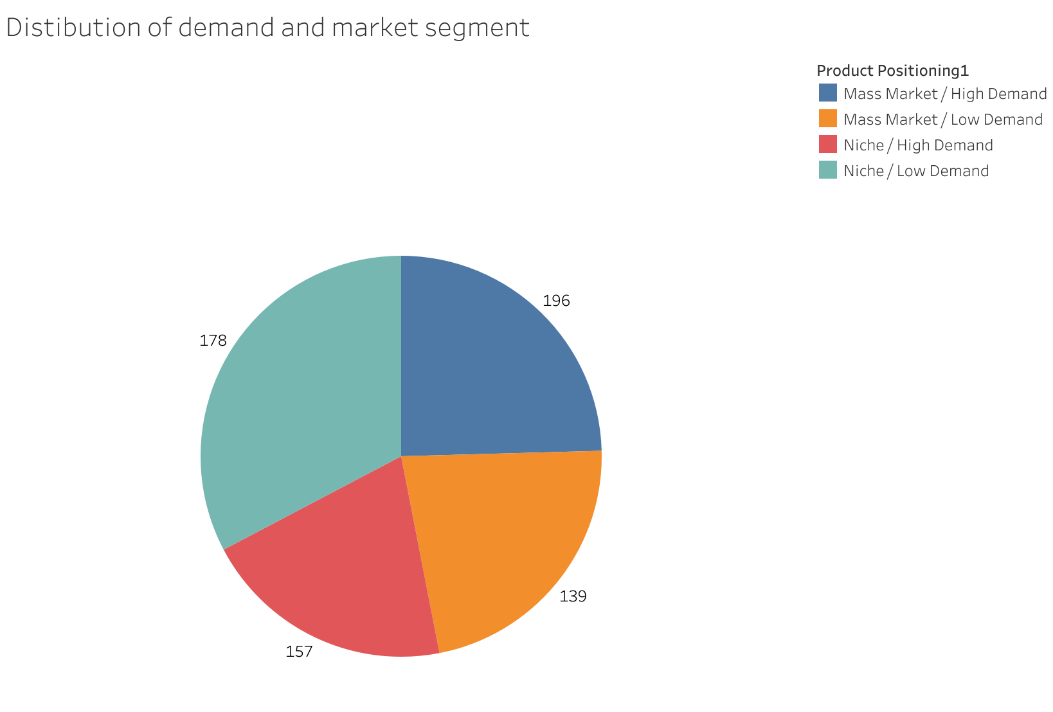
Source: Authors own work
Figure 3: The Summary of the Dataset Based on Demand and Market Positioning
Figure 4 indicates the most popular e-tailers categorised by price points. The figure below presents only the best-selling and good-selling retailers falling within the 70th to 80th percentile and 90th to 100th rank percentile groups. These are the most popular products in e-commerce. The legend shows the price range categories for products/retailers, where blue represents affordable products, red indicates high-priced goods, and purple to yellow hues denote mid-priced retailers. Farfetch and Amazon are market leaders in high-priced and low-priced products within modest fashion along with H&M UK. All these brands are within the top 10 per cent based on popularity in e-commerce sites. Some boxes have missing names, as the corresponding text does not fit into the box. A detailed summary of the related dataset is presented in Appendix 1.
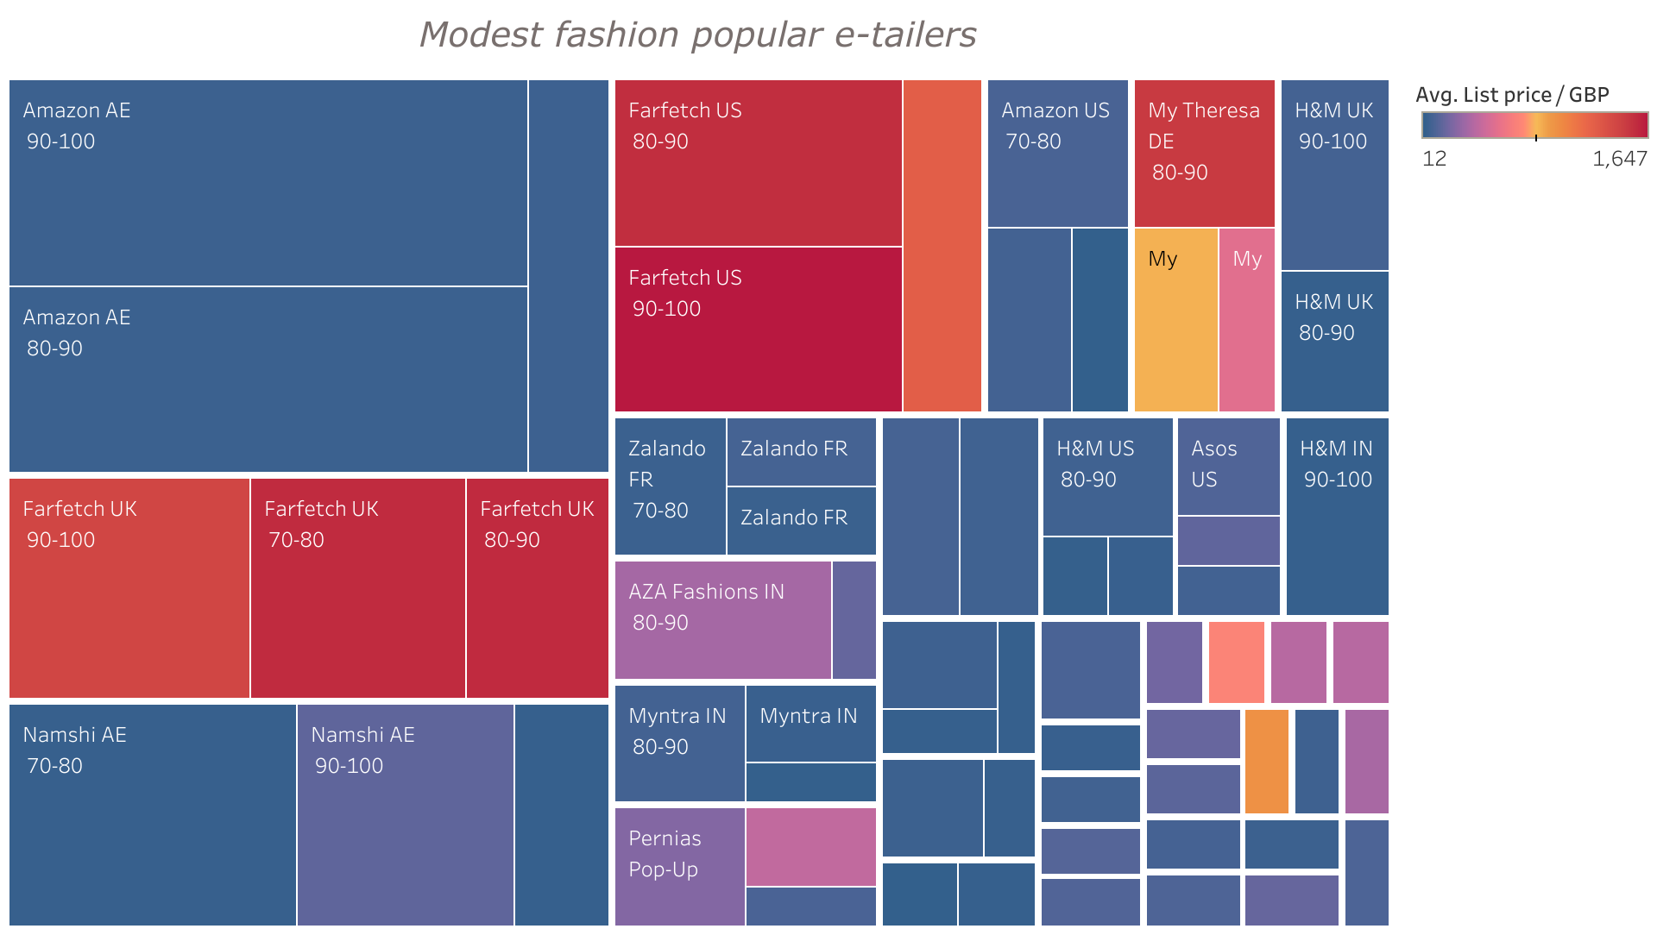
Source: Authors own work
Figure 4: The visualisation to shows which retailers were popular in different price ranges
As reflected by the blue colour, retailers like Amazon, H&M, ASOS, and Myntra cater to affordable selections for modest fashion. Conversely, Farfetch and My Theresa are known for offering more upscale and luxurious clothing options as shown in the red colour. Figure 4's visualization highlights the popularity of both affordable and expensive retailers in the modest fashion category. However, the mass market segment held the most significant share of products across all e-retailers.
The best and best-selling retailers of mass-market offered products with an average price between £12 and £140. Some retailers in the mid-range, such as Namshi AE and Pernia's pop-up, provided a mix of mid to high-priced items with average prices ranging from £25 to £413. In contrast, the best and good-selling retailers in the upper-class segment offered products on average starting from £500 and above.
In summary, 114 best and best-selling products in the mass-market segment, 39 in the middle or mixed market, and 62 in the premium or luxury market (See Table in the Appendix). Regarding the most demanded modest attire providers, Amazon significantly offered mass-produced clothing online, while Farfetch dominated in designer-made options in e-commerce.
Our findings reveal that Amazon and Farfetch emerged as the most significant retailers in the modest apparel sector. Consequently, these two retailers could serve as benchmarks to gauge demand trends as well as the average price for modest clothing items in both mass-market and designer brand categories. Over one-year period from 2021 to 2022, Stylumia tracked the demand progression for each product. This analysis specifically focused on investigating the demand trend for best-selling products (90-100th rank percentile group) from both Amazon and Farfetch, aiming to understand the demand pattern from the previous year until the present.
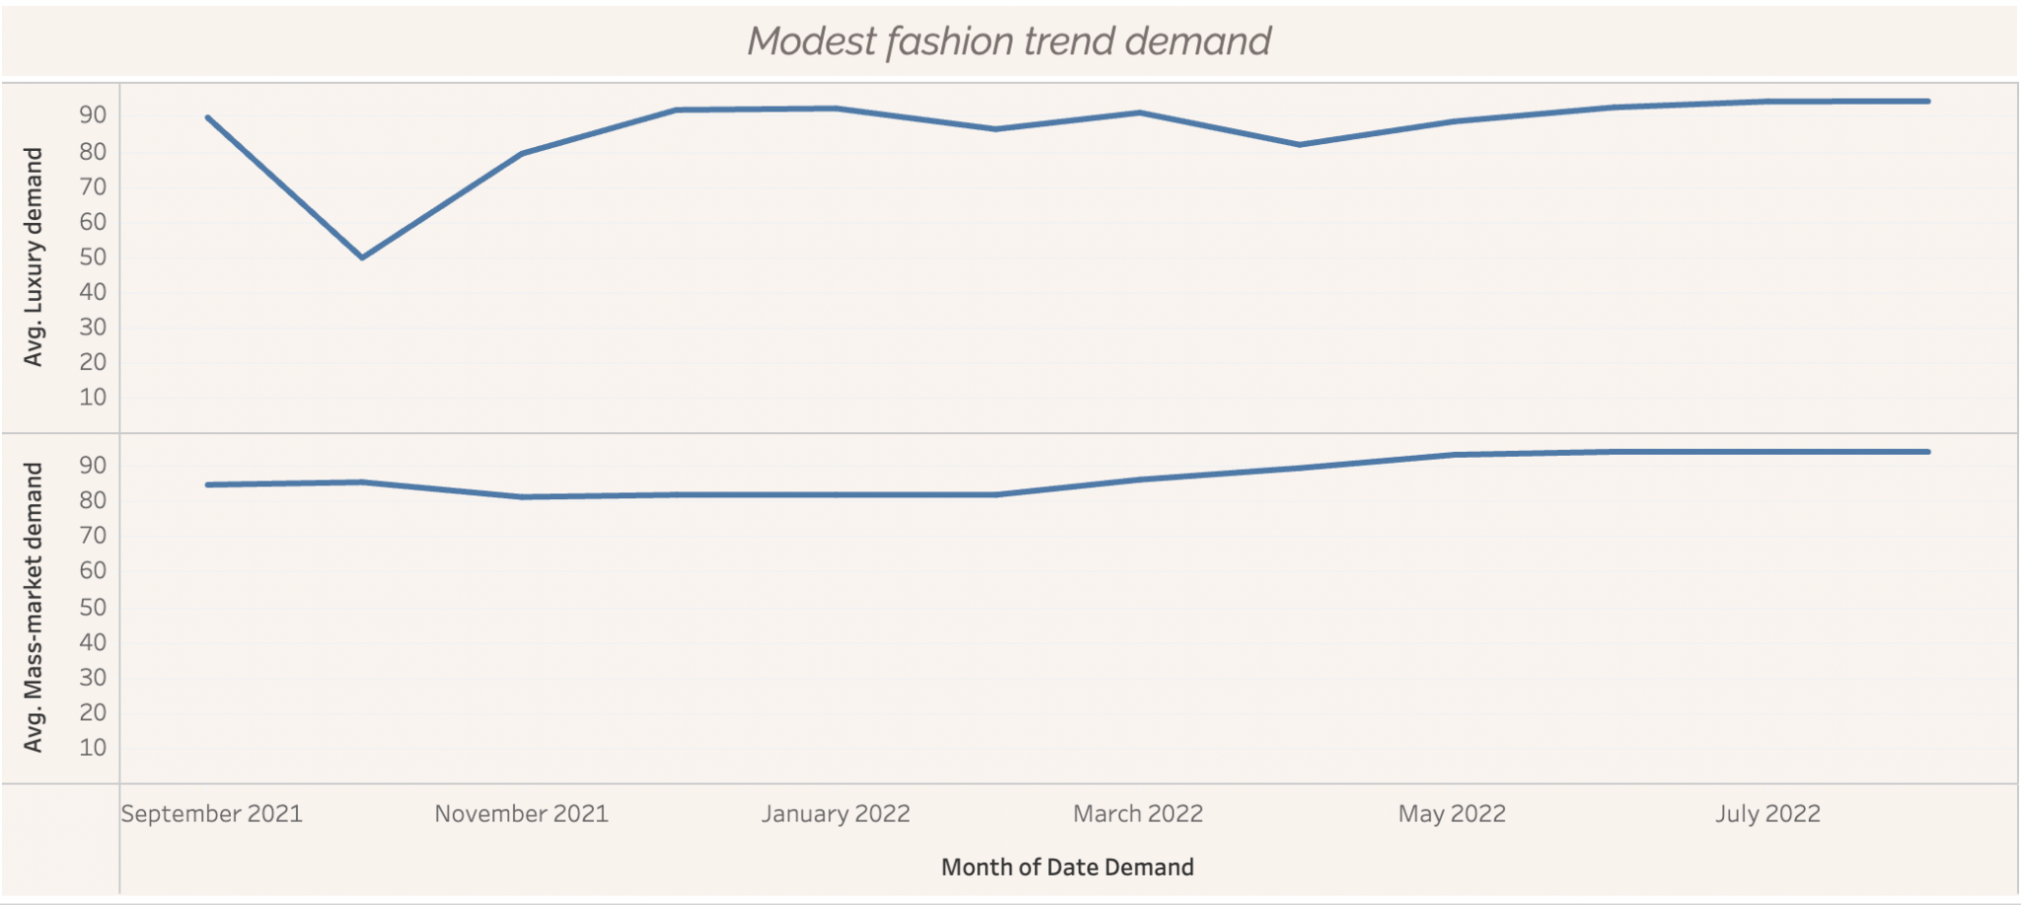
Source: Authors own work
Figure 5: The Demand Progression for Best-Seller Products from Luxury and Accessible Retailers
In Figure 5, based on the rank percentile described on the y-axis, both luxury (Farfetch) and mass market (Amazon) displayed an upward trend. In September 2021, the demand rank for best-selling products from mass-produced and luxury fashion retailers hovered around the 80th percentile. However, Farfetch was slightly higher by 5 percentile points compared to Amazon. Initially, luxury demand outperformed low-cost items but declined below the 50th percentile around October 2021, whereas the mass-market product demand remained stable.
Despite the dip in October, the high-end retailers have maintained demand rank at around 80th to 91st percentile since late 2021. Moreover, since December 2021, the demand for modest luxury products has shown an increased trend, with the highest being in the 94th percentile. Nevertheless, overall demand for both categories remained stable over one period with the absence of seasonality and fluctuations.
Furthermore, Figure 6 below explores the optimal price range for a modest garment to become a best-selling product. However, this visualization is based on the fashion e-commerce dataset without distinguishing between market segments. Hence, the median selling price was utilized to assess central tendency, considering a diverse selling price range from £2 to £8,000.
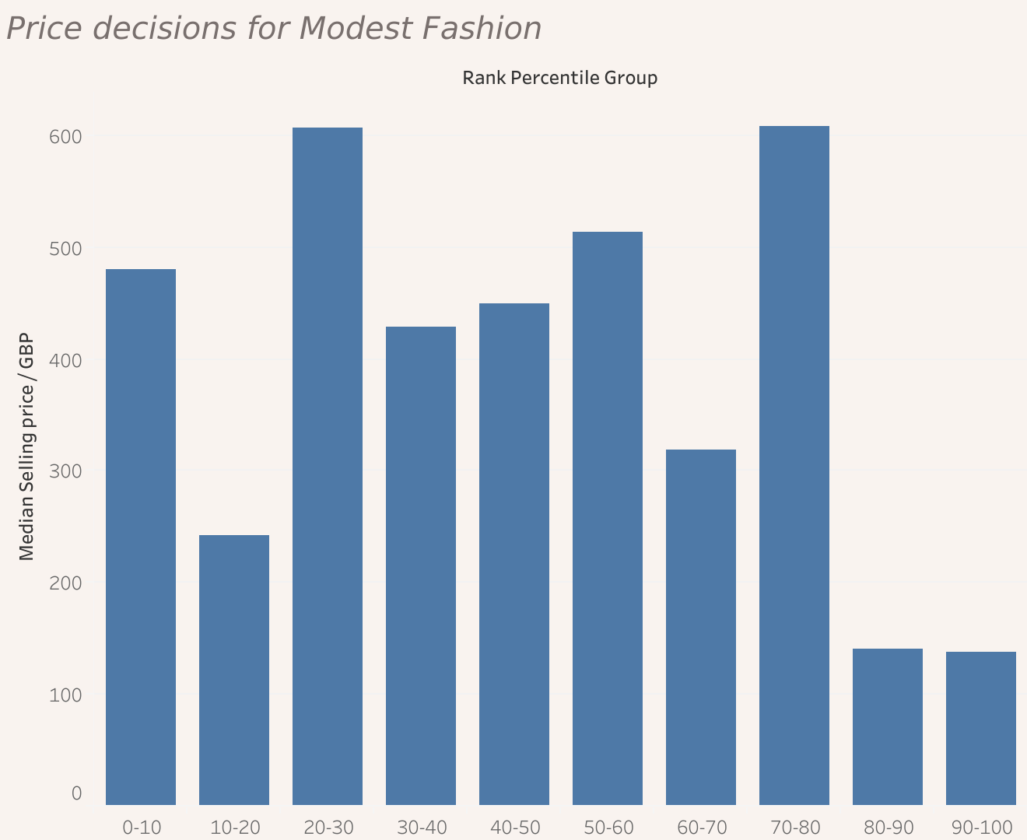
Source: Authors own work
Figure 6: The Summary of Prices in each Demand Rank Percentile Group
Figure 6 illustrates the relationship between product rank percentile groups and their respective median selling price ranges. The X-axis denotes the rank percentile group, while the y-axis displays the median selling price range for each rank percentile group. For instance, products in the 90-100th rank percentile group exhibit the lowest median selling price, approximately £137.3. Similarly, the 80-90th percentile group includes products priced around £140. Conversely, products in the least demanded percentile groups, such as 0-10th, feature a median selling price of £480. The 10-20th percentile group comprises products priced at £242, while the 20-30th percentile group features the highest median selling price at £607. Generally, there exists an inverse relationship between price and demand, where higher-priced products tend to attract lower demand. However, the 70-80th percentile group, with a median selling price of around £600, presents an intriguing observation, potentially falling into various seller categories. Dresses priced below £200 are identified as the most demanded and best-selling modest apparel items, indicating a uniform distribution across different price points, with greater availability of items in lower price ranges.
Moreover, exploring other factors influencing garment preferences among modest shoppers is crucial besides affordability. For instance, analysing colours and fabrics helped determine their significance.
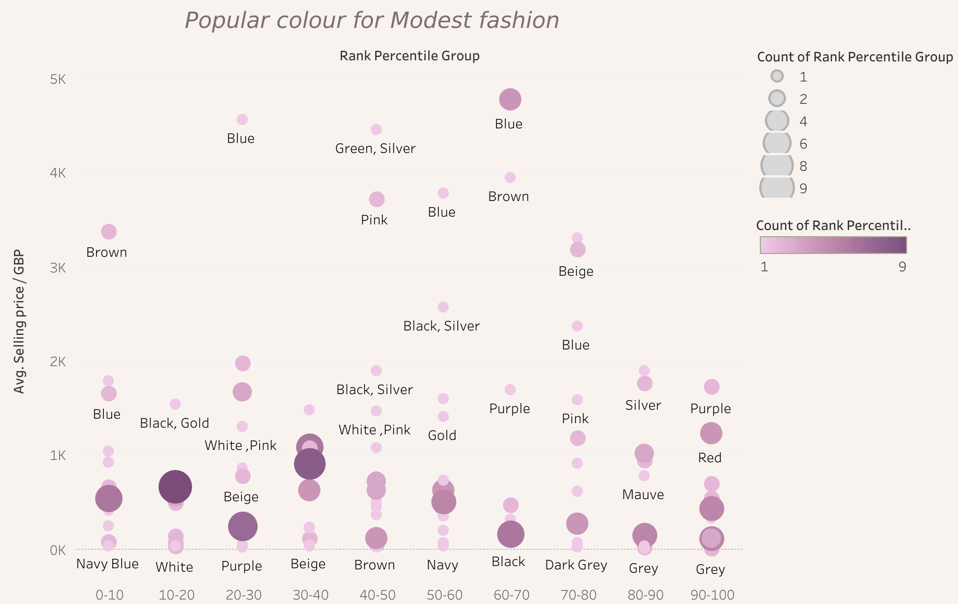
Source: Authors own work
Figure 7: The Most Frequent Colour Apparent in each Demand Rank Percentile Group
Figure 7 consolidates the most frequent colours in each demand rank to delve deeper into which colours are more favourable for modest apparel. The legend indicates the "count" of products with various sizes and shades of purple, where larger sizes and darker purple signify higher frequency in those ranks. The Y-axis explains the average selling prices for each colour in modest garments, and X-axis depicts the rank percentile group.
In the top-ranking group (90-100th percentile), featuring best-seller products as well as various colours like black, beige, blue, cream, green, grey, navy blue, orange, pink, purple, red, and white were observed. Prices ranged from £16 to £1,722, with purple being the most expensive. Black, blue, and red were the most frequent colours. Moving to the good seller group (70-90th percentile), brown, dusty pink, khaki, mauve, dark grey, dark blue, and pink with silver were noted alongside these colours. Pink, silver, brown, beige, and blue had high average selling prices, starting from over £1,000. In the average seller segment (30-70th percentile), colours included beige, black, light grey, blue, brown, burgundy, gold, pink, purple, and more, with prices ranging from £30 to £4,770. In the poor seller category (0-30th percentile), prominent colours included beige, black, brown, green, blue, grey, orange, pink, and red. Blue and brown were the most expensive, with average selling prices of £4,559 and £3,372, respectively. The cheapest colour was white, with an average selling price of £14.
In summary, best-selling products generally had a maximum price range under £2000, with higher prices correlating to lower sales potential. Blue and brown colours tended to have excessively high prices compared to others, hindering sales. Mixed colours performed moderately compared to solid colours. Additionally, black, followed by beige and pink, emerged as the most frequent colours in the modest fashion category, yet their prevalence across rank percentile groups doesn't guarantee popularity. Retailers should consider factors beyond colour, such as pricing and seasonal relevance, as reliance solely on colours doesn't ensure product success.
Another significant aspect worth examining was the fabrics or materials used. The scatter and box plots in Figures 8 and 9 delve into the fabrics employed for modest fashion garments.
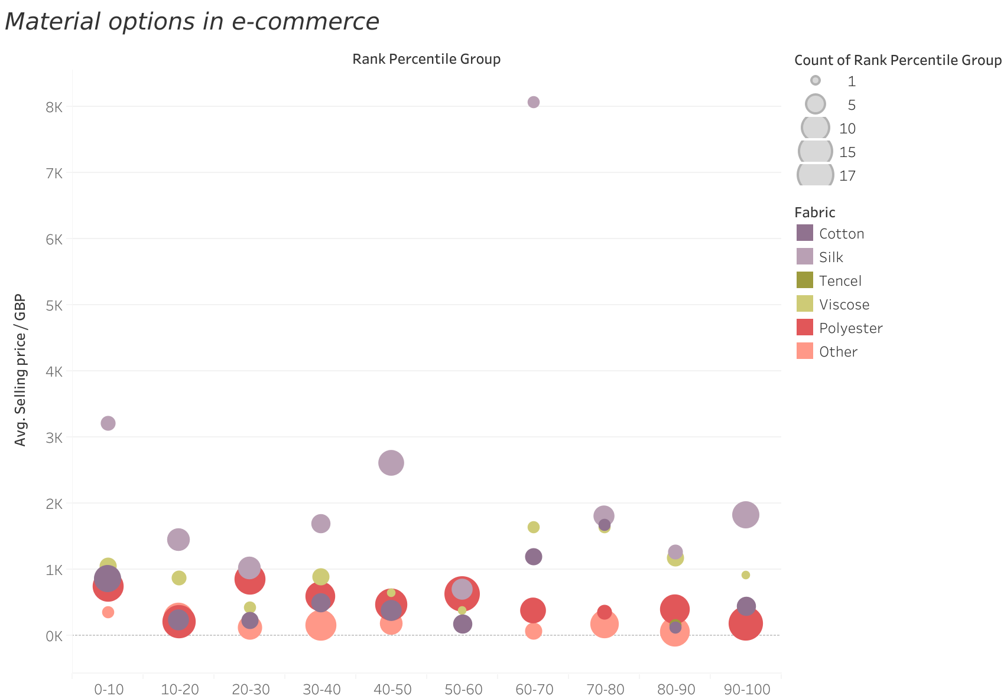
Source: Authors own work
Figure 8: The Summary of the Material Availability based on Demand Rank and Price
Initially, fabrics identified within the fashion e-commerce dataset were categorised into six types: cotton, silk, Tencel, viscose, polyester, and other materials (e.g., chiffon, georgette, or linen). According to Figure 8, the Y-axis explains the average selling price of each fabric, and the X-axis describes the rank percentile group with the 90-100th percentile as “best seller”, 70-80th to 80-90th percentile as “good seller”, 30-40th to 60-70th percentile as “average seller” and 0-10th to 20-30th percentile as “poor seller”. As shown from the figure, polyester was the most prevalent fabric across rank groups and was associated with lower prices than other fabrics. The second most frequently available fabric was categorised under 'other', followed by silk and cotton. Each fabric type was distributed across various rank percentile groups, suggesting that no single fabric stood out as distinctly superior as the motivation for effective sales, as all categories experienced instances as both best sellers and poor sellers.
However, it is worth noting that 41 polyester products were in the “poor seller” percentile, and only 31 were in the “best seller” percentile. In contrast, silk was higher in price and accounted for 19 best-selling products, with only 17 performing poorly. Ultimately, polyester is still a favourable fabric for retailers to manufacture compared to organic materials such as cotton and silk.
Interestingly, despite polyester products being more numerous (41) among poor sellers compared to best sellers (31), silk, which typically commanded higher prices, had 19 best-seller products and only 17 performing poorly. Nevertheless, in the realm of modest attire, retailers offered larger quantities of polyester than natural or organic materials.
The box plot illustrated in Figure 9 shows the performance of each fabric concerning price points. Given that no specific fabric was favoured by customers, this visualization could serve as a guide for retailers in setting prices for various materials to align with consumer expectations.
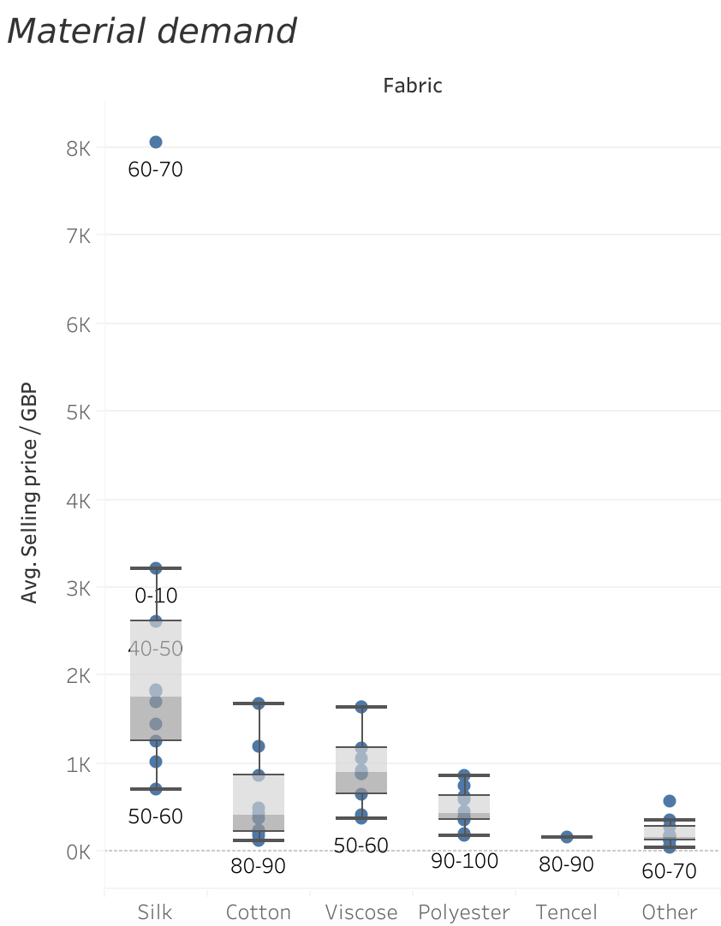

Source: Authors own work
Figure 9: Price Demand for each Material
Silk performed well when priced between approximately £1,800 and £3,000 but showed a significant decline in performance when the price reached £3,000, with one outlier at £8,000, which was considered an average seller. For cotton, its optimal price range for better sales was observed between £120 and £450. Selling cotton at higher prices carried the risk of decreased performance, although it still showed acceptable performance between £1,100 and £1,600. Viscose fabrics performed better when priced around £900 to £1,600; prices lower than £1,000 negatively impacted sales. In contrast, polyester was favoured when priced below £400. Limited data was available for Tencel, but it seemed to perform well when sold at around £159, so it was considered a good seller. Regarding other fabric categories, including a mix of wool, chiffon, or linen, the optimal price range for better sales was generally under £200. In contrast, prices exceeding £300 tended to classify products as poor sellers.
In summary, silk fabrics are best suited for luxury garments, while viscose is a more affordable alternative. Polyester emerged as the most commonly used fabric in the mass-market sector primarily due to its lower cost without much emphasis on quality. Therefore, modest attire should incorporate cotton fabrics to meet consumer demand rather than relying extensively on polyester.

K-medoid clustering for exploratory data analysis
We used k-medoid clustering, a prominent unsupervised machine learning algorithm, to identify sought-after products and the features influencing demand. This was operationalised using R, a popular programming language on IDE R-Studio.
K-medoid clustering is a partitioning method that aims to divide a dataset into clusters where each cluster is represented by a single data point known as a medoid (Kaufman & Rousseeuw, 1990). This algorithm is capable of handling categorical variables. Unlike k-means clustering, which uses centroids, k-medoid clustering selects actual data points as cluster representatives, making it more robust to outliers and noise in the dataset (Park and Jun, 2009). The technique allocates data points to the surrounding medoids periodically and changes the medoids to lower the total dissimilarity in every cluster. K-medoid clustering has been applied in various disciplines, including bioinformatics, image segmentation, and consumer segmentation in marketing research (Datta et al. 2003), thanks in great part to its ability to identify natural groupings within data. Clustering was implemented to divide distinct groupings that represented a variety of attributes, including price, demand rank, colour, and fabric.
The partitioning around medoids (PAM) method was employed for clustering due to the dataset's diverse nature, including both numerical and categorical values. In addition to the quantitative variable "list price/GBP," qualitative attributes such as "retailer," "discount label," "rank percentile group," "retailer colour name," and "fabric" were assessed. Gower's distance, a measure that can evaluate the similarity and dissimilarity of observations, was employed to facilitate the k-medoids algorithm. This measure can address numerical, categorical, and dichotomous variables (Gower, 1971).
Gower's distance calculation for numerical variables typically entails calculating the dissimilarity between two data points (i and j) by accumulating the weighted absolute differences over each variable (k) and dividing by the sum of the weights.
$$d\left(i,j\right)=\frac{\sum_{k=1}^{p}{W_{k}}|{Variable}_{k}\left(i\right)-{Variable}_{k}\left(j\right)|}{\sum_{k=1}^{p}{w_{k}}}$$
For categorical variables, Gower’s distance is computed based on the presence or absence of a particular category across observations.
$$d\left(i,j\right)=\frac{\sum_{k=1}^{p}{W_{k}δ_{ikj}}}{\sum_{k=1}^{p}{w_{k}}}$$
Here, $δ_{ikj}$ Is 0 if the category of the variable is different between observations i and j, and 1 if they are the same.
Subsequently, a silhouette plot was generated to determine the optimal number of clusters post Gower’s distance calculations. As shown in Figure 14, the silhouette plot indicated the highest value at 4, leading to the creation of 4 clusters. The summaries and details of these clusters are presented in Figure 10 and Table 6 and it presents the characteristics and distinctions between the identified clusters.
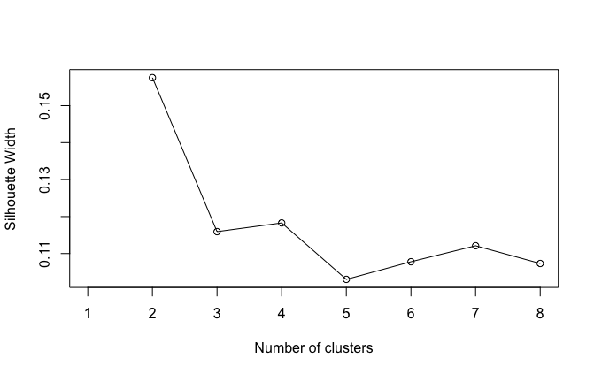
Figure 10: Number of Clusters Decision with Silhouette Plot
Source: Authors own work

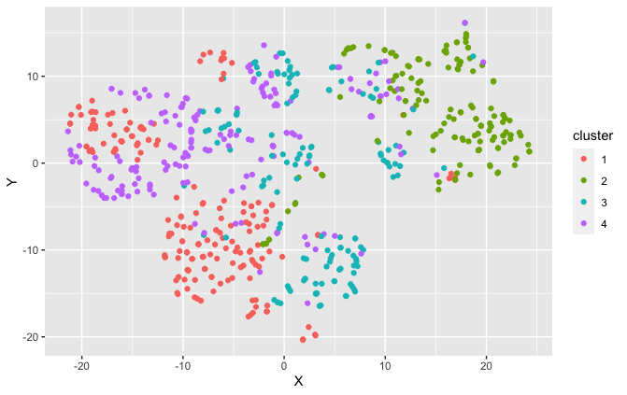Figure 11: Four Clusters Plot
Source: Authors own work

Cluster | Retailer | Average List  price / GBP | Discount | Rank  percentile group | Prominent Colour | Fabric
1 | Amazon AE | 89.03 | No | 90-100 | Black | Other
2 | Namshi AE | 237.53 | Yes | 60-70 | Black | Other
3 | Farfetch UK | 1126.19 | No | 40-50 | Pink | Cotton
4 | Farfetch US | 711.76 | No | 10-20 | Black | Polyester

Table 6: Summary of results of k-medoid clustering Source: Authors own work

The outcomes generated by the k-medoids clustering algorithm align with the earlier visualisations conducted during exploratory data analysis. Three primary retailers, namely Amazon, Farfetch, and Namshi, were identified in the modest fashion category. Namshi, although not previously included in the EDA due to its focus on contrasting markets, was found to offer mid-priced products and held little relevance for the analysis.
The clusters derived from the data could be interpreted as follows: clusters 1 and 2 mainly represent affordable clothing, whereas clusters 3 and 4 comprise pricier items. Firstly, cluster 1, characterised by economical prices, often lacked discounts, predominantly showcased black-coloured garments, and encompassed a variety of fabrics excluding polyester, silk, and cotton. Cluster 2 offers affordable items but is slightly pricier than Cluster 1. It predominantly features black clothing, experienced markdowns frequently, and demonstrated an average performance in demand rank. In contrast, clusters 3 and 4, representing expensive items with minimal discounting, showed poor demand performance. Cluster 3 was costlier than Cluster 4 and offered pink-coloured cotton fabric garments, while Cluster 4 primarily featured polyester.
Table 7 summarises the results with exploratory data analysis and unsupervised machine learning with the clustering method to extract insight from the dataset. Further, we discuss the research implications and limitations.

Analytical methods | Tool/Technique | Result
Exploratory data analysis | Data visualisation | EDA provides a better understanding of the modest dresses category, and the relationship between the clothing attributes through a set of visualisations
Clustering | Unsupervised machine learning | This method created an unsupervised classification from the fashion e-commerce dataset, resulting in 4 clusters  featuring the list price, discount, retailer, colour, fabric and demand rank.
Table 7: Summary of the findings Source: Authors own work

Discussion and Conclusion

Summary of Findings
This paper examines the complexities of the modest fashion sector, highlighting consumers primarily from religious backgrounds who also possess a keen fashion sense. The surge in modest fashion is attributed to influential online discussions within the community, prompting brands to adapt their offerings accordingly. However, some retailers misjudged market preferences by providing only traditional or religiously inclined options.
We formulated four research questions and summarized our key findings. The first analysis of top-selling retailers across affordable and high-end price ranges in 2021 and 2022 revealed a sustained increase in demand for both segments, indicating that modest fashion will remain a sought-after category post-pandemic. The second question showed demand for both high-street and luxury brands, with consumers favoring more affordable options over branded designs.
For the third question, we found that modest fashion consumers are price-sensitive, contradicting existing literature. Retailers saw increased demand when reducing prices on popular mass-produced dresses, although discounts on premium products diminished the appeal of luxury branding. Machine learning models identified price, retailer, color, and fabric/material as the most influential factors for highly demanded products. Notably, products priced between £137 and £140 consistently achieved best-selling status. Amazon and Farfetch emerged as the two largest retailers in the modest apparel market. In terms of colors, black, beige, and pink were the most popular, while blue and brown tended to be priced higher. Mixed colors performed poorly compared to solid colors. Polyester was the most common fabric, associated with lower prices, while silk fabrics were suited for luxury garments.
The study also investigates the impact of the COVID-19 pandemic on consumer shopping behavior, noting a significant increase in online shopping and the generation of extensive sales data. Consequently, the analysis uses big data analytics to focus on post-pandemic online trends. Given the limited literature on modest fashion, our findings emphasize the importance of price, retailer, color, and fabric in determining best-selling products, aligning with existing research on quality and style in consumer purchasing decisions.

Managerial Implications
The research offers several managerial implications for fashion brands in the modest wear segment. First, the conceptual framework developed in this study can guide fashion brands in employing Business intelligence and big data analytics for improved demand forecasting. Second, recognizable online platforms can serve as effective sales channels to reach a broader consumer base. Providing diverse options and high-quality products within an appropriate price range is crucial. Finally, price emerged as a significant factor influencing consumer behaviour. Instead of offering discounts, optimizing prices and products before production can be more effective.

Originality and Contribution
The research refutes the widely held assumption that modest fashion consumers prioritise affordability over premium pricing, illustrating a high price sensitivity in both the mass-market and luxury sectors. The research exposes this consumer behaviour, providing fashion companies with actionable data to improve their pricing strategies. Retailers should recognise that modest fashion consumers prioritise quality and brand recognition. Still, they are also significantly influenced by equitable pricing, particularly in the inexpensive category, where prices exceeding £40 discourage purchases. This discovery encourages merchants to prioritise price optimisation over aggressive discounting to maintain a balanced sense of value and increase sales.
The study emphasises the necessity of utilising existing online platforms such as Amazon and Farfetch, where modest fashion has experienced considerable growth. Brands may enhance their reach by emphasising various channels, therefore increasing the accessibility of their products to a worldwide audience. Furthermore, identifying product features, such as the preference for neutral colours (black, beige, and pink) and the prevalence of polyester in low-cost categories, provides merchants with precise guidelines for inventory management, product design, and material sourcing.
This study conceptually contributes to the literature on consumer behaviour in niche fashion markets by thoroughly understanding the interests and purchasing patterns of modest fashion clients. This study challenges previous research highlighting the premium-seeking behaviour of modest fashion buyers, demonstrating that cost is a crucial factor across all consumer priorities, including premium sectors. This change in comprehension offers a novel theoretical framework for examining the convergence of fashion, culture, and consumer economics in specialised marketplaces.
The use of big data analytics and machine learning algorithms to investigate the modest fashion sector constitutes a significant methodological contribution. The application of data-driven methodologies to examine post-pandemic consumer patterns, price dynamics, and product characteristics offers a robust framework for future study in fashion retail. This research illustrates how firms may utilise advanced data analytics to make educated, evidence-based decisions, establishing a novel paradigm in fashion management theory that prioritises technology in comprehending customer demand and enhancing corporate operations.

Limitations and Further Research
Fashion Datasets: The research encountered constraints stemming from insufficient open-source fashion databases, impeding a thorough examination of sales transactions and daily demand. Future studies entail partnerships with established small fashion enterprises to obtain historical sales data.
Fashion Categories: The limited availability of data constrained the research to specific modest fashion categories, neglecting several fashion categories that failed to adhere to modesty norms. To increase the availability, future research should focus on choosing suitable modest fashion manufacturers
Machine learning Models: The unquantifiable and categorical features of the dataset limited the study in machine learning. More thorough datasets with continuous variables, using several machine learning techniques, and evaluating their effectiveness should be the focus of further studies using these approaches.
Finally, we provide opinions on consumer behaviour and small fashion upkeep and relevant suggestions for further research to expand knowledge.

REFERENCES
Abbas, Q., Ziaullah, M., Bilal, A., Siddique, M., & Ali, M. A. (2023). Analyzing the Impact of Social Media Marketing Activities on Brand Loyalty in the Apparel Industry and Unveiling the Role of Brand Awareness. Journal of Asian Development Studies, 12(3), 25-44. https://doi.org/10.62345/
AbdelAziz, K., Md Saad, N. H., & Thurasamy, R. (2023). Analysing the factors influencing customer engagement and value co-creation during the COVID-19 pandemic: the case of online modest fashion SMEs in Egypt. Journal of Islamic Marketing, 14(1), 146-173. https://doi.org/10.1108/JIMA-09-2020-0294
Ajaib, N., & Altunisik, R. (2022). Emerging modest fashion industry: What plays a greater role in modest dressing, religion or culture? Implications for strategic marketing. In Strategic Islamic Marketing: A Roadmap for Engaging Muslim Consumers (pp. 251-267). Cham: Springer International Publishing. https://doi.org/10.1007/978-3-030-98160-0_16
Akter, S., & Wamba, S. F. (2016). Big data analytics in E-commerce: a systematic review and agenda for future research. Electronic Markets, 26, 173-194. https://doi.org/10.1007/s12525-016-0219-0

Arora, P., & Varshney, S. (2016). Analysis of k-means and k-medoids algorithm for big data. Procedia Computer Science, 78, 507-512. https://doi.org/10.1016/j.procs.2016.02.095
Ashraf, S., Williams, A. M., & Bray, J. (2023). Female Muslim identity and modest clothing consumption in the UK. Journal of Islamic Marketing, 14(9), 2306-2322. https://doi.org/10.1108/JIMA-05-2021-0167
Asmawi, A., Manzoor, S., Al-Mahmud, A., & Manzoor, S. (2024). Advancing Muslim Modest Fashion Clothing: Impact on Consumer Behavior and Challenges for Young Female Muslim Influencers. Journal of Comparative Asian Development, 20(1), 1-26. https://doi.org/10.4018/JCAD.346369
Babakhani, A. (2024). Control over Muslim Women's Bodies: A Critical Review. Sociological Inquiry, 94(1), 241-262. https://doi.org/10.1111/soin.12529
Bai, H., McColl, J., & Moore, C. (2022). Luxury fashion retailers' localised marketing strategies in practice–evidence from China. International Marketing Review, 39(2), 352-370. https://doi.org/10.1108/IMR-02-2021-0079
Barron, L. (2020). Dina Torkia’s Modestly: Beauty work, autobiographical habitus and the modest fashion influencer. Critical Studies in Fashion & Beauty, 11(2), 175-194. https://doi.org/10.1386/csfb_00015_1
Benissan, E. (2021). Muslim consumers want luxury. They just can’t find it. https://www.voguebusiness.com/fashion/muslim-consumers-want-luxury-they-just-cant%20find-it
Biancone, P., Brescia, V., & Oppioli, M. (2023). Modest fashion and sustainability: research trends by bibliometric and content analysis. In The Garment Economy: Understanding History, Developing Business Models, and Leveraging Digital Technologies (pp. 109-135). Cham: Springer International Publishing. https://doi.org/10.1007/978-3-031-33302-6_7
Boehmke, B. and Greenwell, B (2020). Hands-On Machine Learning with R. https://doi.org/10.1201/9780367816377
Cheang, S., de Greef, E., & Takagi, Y. (Eds.). (2021). Rethinking fashion globalization. Bloomsbury Publishing.
Chevalier, S. (2024) Global retail e-commerce sales 2014-2027, Statista. https://cl.gy/dMukw
Datta, S., Datta, S., & Mukhopadhyay, S. (2003). Clustering gene expression data using K-medoid clustering. In Proceedings of the Fifth International Conference on Bioinformatics: (Bioinformatics-2003) (pp. 25-27). BIOINFORMATICS.
Dhillon, T. K., & Gammage, K. L. (2023). Understanding the relationship between body image and menopause in South Asian Canadian women. Body Image, 46, 280-293. https://doi.org/10.1016/j.bodyim.2023.06.007
DinarStandard (2022). State of the global Islamic economy report 2022. https://shorturl.at/4tN3z
Edge by Ascential (2022). Shaping the store of the future. https://shorturl.at/neRNi
Esposito, E. (2020). Is Modest Fashion Modest? ZoneModa Journal, 10(1), 115-119. https://dx.doi.org/10.6092/issn.2611-0563/10558

Fisher, M., & Raman, A. (2018). Using data and big data in retailing. Production and Operations Management, 27(9), 1665-1669. https://doi.org/10.1111/poms.12846

Ghavami, P. (2020). Big data management: Data governance principles for big data analytics. Walter de Gruyter GmbH & Co KG. https://shorturl.at/omHdq

Gower, J. C. (1971). A general coefficient of similarity and some of its properties. Biometrics, 857-871. https://doi.org/10.2307/2528823

Guindi, F. (1999). Veiling resistance. Fashion Theory, 3(1), 51-80. https://doi.org/10.2752/136270499779165626

Harms, E. (1938). The psychology of clothes. American Journal of Sociology, 44(2), 239-250. https://doi.org/10.1086/217972
Hashem, H. (2018). Realizing the growth of modest fashion market: The fashion consumption behaviour of Muslim women in Europe. Master thesis. Copenhagen Business School. https://shorturl.at/QegY6
Hassan, F. H., Kasi, P. M., Shaharuddin, N. A., & Kechil, M. F. A. (2019). Islamic and modest fashion lifestyle. Journal of Islamic Management Studies, 2(1), 79-88. https://shorturl.at/GZH17
Hwang, C., & Kim, T. H. (2020). Religiosity and modesty: how veiled Muslim women in the United States define modest activewear. International Journal of Fashion Design, Technology and Education, 13(2), 131-139. https://doi.org/10.1080/17543266.2020.1753246
Ingram, S. (2020). From e-commerce to omnichannel. https://cl.gy/hpCQn
Islam, T., & Chandrasekaran, U. (2020). Religiosity and consumer decision-making styles of young Indian Muslim consumers. Journal of Global Scholars of Marketing Science, 30(2), 147-169. https://doi.org/10.1080/21639159.2019.1679031

Jin, B. E., & Shin, D. C. (2020). Changing the game to compete: Innovations in the fashion retail industry from the disruptive business model. Business Horizons, 63(3), 301-311. https://doi.org/10.1016/j.bushor.2020.01.004
Kamarulzaman, Z., & Shaari, N. (2023). A systematic review of modest fashion perspectives in the Malaysian fashion industry. International Journal of Art and Design (IJAD), 7(2), 32-45. https://ir.uitm.edu.my/id/eprint/91454
Karakavak, Z., & Ozbolik, T. (2023). When modesty meets fashion: how social media and influencers change the meaning of hijab. Journal of Islamic Marketing, 14(11), 2907-2927. https://doi.org/10.1108/JIMA-05-2021-0152
Kaufman, L., & Rousseeuw, P. J. (1990). Finding groups in data: An introduction to cluster analysis (Vol. 344). John Wiley & Sons.
Kusumawati, A., Akbarina, F., Pangestuti, E., & Nimran, U. (2022). Fashion Consciousness and Muslim Modest Brand Advocacy: The mediating role of brand love, and loyalty. Journal of Global Fashion Marketing, 13(4), 380-393. https://doi.org/10.1080/20932685.2022.2090983

Kusumawati, A., Listyorini, S., & Yulianto, E. (2019). The impact of religiosity on fashion knowledge, consumer-perceived value and patronage intention. Research Journal of Textile and Apparel, 23(4), 269-290. https://doi.org/10.1108/RJTA-04-2019-0014

Lewis, R. (Ed.). (2013). Modest fashion: Styling bodies, mediating faith. Bloomsbury Publishing.

Lewis, R. (2015). Muslim fashion: Contemporary style cultures. Duke University Press. https://shorturl.at/vzqWC
Lewis, R., & Aune, K. (2023). Aesthetic labor in religious contexts: Women encountering modest dress in the workplace in the UK and Saudi Arabia. Fashion Theory, 27(5), 709-735. https://doi.org/10.1080/1362704X.2023.2172782
Lipson, S. M., Stewart, S., & Griffiths, S. (2020). Athleisure: A qualitative investigation of a multi-billion-dollar clothing trend. Body image, 32, 5-13. https://doi.org/10.1016/j.bodyim.2019.10.009
Liu, Q. (2014). The application of exploratory data analysis in auditing (Doctoral dissertation, Rutgers University-Graduate School-Newark). https://doi.org/doi:10.7282/T3CC129J

Lodi, H. (2020). Modesty: A Fashion Paradox: Uncovering the causes, controversies and key players behind the global trend to conceal rather than reveal. Modesty, 1-288. https://www.torrossa.com/it/resources/an/5327458.

Mathrani, S., & Lai, X. (2021). Big data analytic framework for organizational leverage. Applied Sciences, 11(5), 2340. https://doi.org/10.3390/app11052340.
Mehta, P., Kaur, A., Singh, S., & Mehta, M. D. (2023). “Sustainable attitude”–a modest notion creating a tremendous difference in the glamourous fast fashion world: investigating moderating effects. Society and Business Review, 18(4), 549-571. https://doi.org/10.1108/SBR-10-2021-0205
Mumin, N. (2010). Research on Online Retailing for Modest Fashion (Doctoral dissertation, The University of Manchester (United Kingdom)). https://cl.gy/PcJLU
Park, H. S., & Jun, C. H. (2009). A simple and fast algorithm for K-medoid clustering. Expert systems with applications, 36(2), 3336-3341. https://doi.org/10.1016/j.eswa.2008.01.039
Pemberton, K., & Takhar, J. (2021). A critical technocultural discourse analysis of Muslim fashion bloggers in France: Charting ‘restorative technoscapes’. Journal of Marketing Management, 37(5-6), 387-416. https://doi.org/10.1080/0267257X.2020.1868551
Pew Research Center (2015). The future of World religions: Population growth projections, 2010-2050. https://cl.gy/YFkEQ
Radwan, M., Kamal, M., Khavarinezhad, S., & Calandra, D. (2019). Influencing Factors on Modest Fashion Market: A Case Study. International Journal of Applied Research in Management and Economics, 2(1), 12-22. https://cl.gy/nsnVe
Randeree, K. (2020). Demography, demand and devotion: driving the Islamic economy. Journal of Islamic Marketing, 11(2), 301-319. https://doi.org/10.1108/JIMA-06-2018-0102
Rumaney, H., & Sriram, S. (2023). Not without my Hijab: experiences of veiled Muslim women in India. Human Arenas, 6(1), 1-24. https://doi.org/10.1007/s42087-021-00193-3
Russom, P. (2011). Big data analytics. TDWI best practices report, fourth quarter, 19(4), 1-34. https://cl.gy/qaVrJ
Saunders, J. (1994). Cluster analysis. Journal of Marketing Management, 10(1-3), pp.13-28.
Shriver, C. M. (2017). What is unveiled through veiling: understanding the complex narratives of the modern hijabista movement. University of Colorado, Boulder. https://cl.gy/HSyHB
Slater, S., & Demangeot, C. (2021). Marketer acculturation to diversity needs: The case of modest fashion across two multicultural contexts. Journal of Business Research, 134, 702-715. https://doi.org/10.1016/j.jbusres.2021.05.059
Spicer, J. (2005). Making sense of multivariate data analysis: An intuitive approach. Sage. https://cl.gy/VvYzi
Sumarliah, E., Khan, S. U., & Khan, I. U. (2021). Online hijab purchase intention: the influence of the Coronavirus outbreak. Journal of Islamic Marketing, 12(3), 598-621. https://doi.org/10.1108/JIMA-09-2020-0302
Taylor-Guthartz, L. (2021). Challenge and conformity: the religious lives of Orthodox Jewish women. Liverpool University Press.
The Business of Fashion and McKinsey & Company (2017) The State of Fashion 2018. https://cl.gy/TDiop
The Business of Fashion and McKinsey & Company (2021) The State of Fashion 2022. https://cl.gy/aQWAu
The Economist (2020) The bold and the beautiful: Growing the modest fashion industry, Intelligence Unit Limited 2020, https://cl.gy/qwmUO

Thomassey, S., & Zeng, X. (2018). Introduction: artificial intelligence for the fashion industry in the big data era (pp. 1-6). Springer Singapore. https://doi.org/10.1007/978-981-13-0080-6_1
Thomson Reuters (2018) State of the global Islamic economy report 2018/19. https://cl.gy/rWYeh
Usher, P. (2018). The Multi-Billion-Dollar Modest Fashion Industry That's Gone Global. British Vogue.

Wani, T. A. (2013). Buying Behaviour-An Islamic Perspective: An Analysis of an Ideal Muslim Buying Behaviour. CLEAR International Journal of Research in Commerce & Management, 4(10). https://cl.gy/ehiVY

Yu, C. H. (2010). Exploratory data analysis in the context of data mining and resampling. International Journal of Psychological Research, 3(1), 9-22. https://cl.gy/EPhyr
Zainudin, M. I., Haji Hasan, F., & Othman, A. K. (2020). Halal brand personality and brand loyalty among millennial modest fashion consumers in Malaysia. Journal of Islamic Marketing, 11(6), 1277-1293. https://doi.org/10.1108/JIMA-10-2018-0187

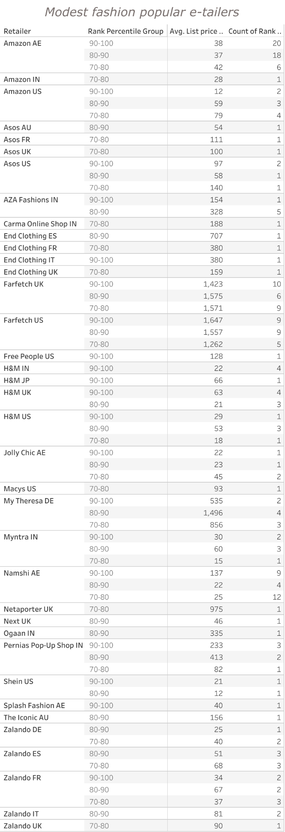

Appendix 1: Modest fashion popular e-retailors

