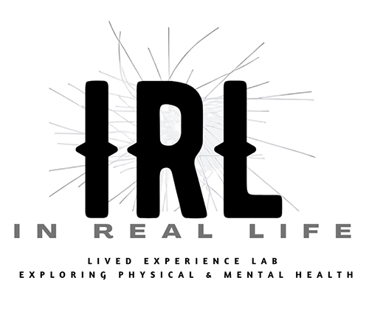

Working Paper for: UCC CORK SYMPOSIUM
Truth Claims or Power Plays? 'Lived Experience' in Politics, Research and Activism
April 30 - May 1, 2026

TITLE:
Working Paper for “IRL: What it Means to Work with Lived Experience - Creativity, Power and the Ethics of Emergent Knowledges”

AUTHORS:
Anne-Marie Creamer, Dr Rachel Marsden, Dr Hannah Zeilig
IRL: In Real Life - Lived Experience Lab (Collective), University of the Arts London

For the panel - "Creative, Embodied, and Non-Extractive Epistemologies".

Note: Please bear in mind this working paper is still in production and is not yet publication ready. Footnotes have yet to be added.

SECTION 1: "Truth Claims or Power Plays?" framing
We want to start by acknowledging all the visible and especially the invisible and domestic labours that have made today possible, the work that happens quietly behind the scenes to bring us into this shared space.

In this working paper, we will explore what it means to work with, from and alongside lived experience: methodologically, ethically and relationally. We will share some of the questions that continue to challenge us, and the emerging approaches we’re developing through In Real Life (IRL): Lived Experience Lab at University of the Arts London (UAL), where lived experience is a way of doing and creating / being as research.
"Lived experience" has become a contested terrain. Institutions increasingly invoke it to legitimate decisions while maintaining existing power structures. Consider the UK Government's 2026 response to the House of Lords report ‘Time to Deliver’ concerning autism strategy: despite parliamentary recommendations, the policy document does not foreground lived experiences of autistic people in terms of research design or authorship. Similarly, recent calls for lived experience reviewers for UKRI's 'Mobilising Community Assets to Tackle Health Inequalities' programme offered £50 honoraria (see the call here) - a sum that signals token inclusion rather than genuine recognition of expertise or equitable labor.
These examples illuminate a troubling pattern: lived experience is simultaneously valorised and marginalised, summoned and constrained. Institutions seek experiential knowledge while retaining authority over how it is validated, interpreted, and deployed. This creates what we identify as a fundamental double bind, reflected in this symposium's title - Truth Claims or Power Plays?
The truth claim asserts: "We need your lived experience to understand."
The power play counters: "But we will define how it is valid, credible, valuable, and usable, and we will decide which aspects to foreground."
This double bind manifests not only in tokenistic consultation but in more insidious forms: the extraction of lived experience as data; its instrumentalisation as evidence; its transformation into credential that authorises institutional decisions while those holding that experience remain marginalised from decision-making power itself.
We propose that creative practice offers a form of political resistance to these extractive and instrumentalising logics. Not as methodological preference, but as epistemological necessity: creative practice enables world-building and emergent knowledge when finding words is difficult, when experience resists coherence, when conventional research structures demand forms of articulation that distort or diminish what is known through living. In what follows, we develop this argument through the work of IRL and our collaborations across physical and mental health contexts.

SECTION 2: IRL and the Challenge of Non-Extractive Epistemologies
In Real Life (IRL): Lived Experience Lab emerged from recognition of this double bind and from urgent need for arts-based methodologies within creative health research. Recently awarded internal research funding at Central Saint Martins, IRL operates as a cross-University of the Arts London, and beyond, initiative shaped by our shared and intersecting experiences across physical and mental health, disability, patient and practitioner communities, and creative practices situated within healthcare, art school, and community contexts.
Our work is fundamentally shaped by positionality. As a collective, our identities move fluidly across what are typically treated as discrete categories: artist-researcher-patient, practitioner-service user, academic-activist. We explore research that emerges from these hyphenated spaces rather than attempting to resolve them into singular positions. This approach challenges hierarchical research structures by asking what it means to build a lived experience ecosystem inside an institution not designed for it - recognising that universities, like hospitals and criminal justice systems, were built to categorise and separate, not to hold multiplicity.
Yet we are acutely aware of the risks. Jijian Voronka's incisive critique identifies how "people with lived experience" can function as strategic essentialism: individual experiences often need to be transcended to build shared goals, recognize patterns, all of which is politically necessary for collective mobilisation, but it is also vulnerable to institutional capture. Once claimed as a credential, lived experience can be extracted, validated, and deployed to legitimate institutional decisions while those holding that experience remain marginalised from substantive power. The credential becomes detachable from the person; the story becomes data; the witness becomes case study.
This extraction operates through increasingly sophisticated mechanisms. Institutions now hire "lived experience coordinators," establish "lived experience panels," and commission "lived experience reviews" - creating markets for experiential knowledge while often oblivious to how this maintains extractive structures. The labour question becomes inevitably acute: who gets paid, and how much? When UKRI offers £50 for grant review, when NHS Trusts seek "volunteer" patient representatives, when universities request "consultation" without decision-making authority, we witness lived experience simultaneously valorised and economically marginalised. What work counts, and who decides its value?
IRL's approach attempts to resist these dynamics structurally, not just rhetorically. Our collective governance model redistributes decision-making power rather than concentrating on traditional academic hierarchies. We seek what transcends individual experience to enable collective change - recognising that while each person's experience is singular, patterns of marginalisation and epistemic injustice are structural and require structural response.
Crucially, we propose creative methods - somatic, haptic, non-linguistic, non-verbal - generate knowledge that resists easy commodification or extraction. Consider on of IRL’s members, Hannah Zeilig’s collaborative work in Being and Becoming, where people with dementia co-create with musicians and dancers in care home environments. These sessions prioritise fluid responsibility: no single person leads; creation emerges through deeply responsive improvisation. Knowledge generated here cannot be captured in conventional research outputs or performance metrics. Or another IRL member, Anne-Marie Creamer’s involvement with Better Making, a social prescribing hub at CSM, which creates workshops within the Better Making ‘Open Studio’ model, a flat non-hierarchal space involving artists, communities, students and alumni co-creating and making art together. This work exists in gesture, in rhythm, in shared making, taking place in moments of connection that resist translation into extractable data. Similarly, collaborative projects at Wellcome Collection demonstrate how creative practice can hold experiences that verbal testimony cannot - not because participants lack language, but because some forms of knowing exceed or resist linguistic capture.
Finally, we practice in respect of disability justice principles: valuing care, slowness, and refusal; listening carefully to what is said and what remains unspoken. This is not aspirational but operational. When collective members experience bereavement, we pause to acknowledge loss. When hospital visits interrupt research timelines, we adjust. When ill-health shapes what can be discussed, we create space for those conversations - or for their absence. These are not interruptions to our work; they constitute our method. An ethics of care becomes epistemological practice, where knowledge is co-created rather than extracted, and emotional demands of living with chronic conditions are acknowledged rather than extracted from or instrumentalised as "data."

SECTION 3: Interstitial Epistemology and Creative Methodologies
Van Manen's observation that we cannot "simply access the living meaning of lived experiences through introspective reflection" (2017, p.812) is foundational to our approach. We foreground lived experience as embodied and affective, sometimes partial, inexpressible, or ambiguous. Rather than treating lived experience as something easily captured or translated, we attend to its textures, its silences, and its resistances.
As a collective navigating lived experience, we have become increasingly interested in how difficult it is to articulate what lived experience is: how to name its languages, hold its frictions and contradictions, determine how it should be valued within research cultures that privilege clarity, certainty, and definitive findings. This difficulty has resulted in uncomfortable silences around epistemological questions - specifically, how lived experience is used to create knowledge. These gaps between what is said and what is experienced, between articulation and representation, form the focus of our inquiry.
We propose creative practice and creative methodologies as ways of generating knowledge from and with lived experience. Yet this raises further questions: which knowledge? Which practices and methods? How might they allow lived experience to speak on its own terms? What about relationships to power? We suggest that creative practice is uniquely positioned to foster what Rollo May terms "nutrient power"- power as compassionate extension rather than domination, particularly relevant in contexts like dementia care where conventional power relations often diminish rather than support agency.
This brings us to what we term “interstitial epistemology”: knowledge emerging not despite but through hyphenated identities. As artist-researcher-educator-patient, our knowing sits astride multiple identity categories, shaped by their interaction rather than resolved into singular positions. This is not about translating lived experience into academic language, nor extracting stories from patients for research purposes. Rather, it involves co-narrating experiences and recognizing knowledge that exists both within categories and in forms that resist categorical capture entirely.
Donna Haraway's insistence on "Staying with the Trouble" resonates here: the need to remain "truly present as mortal critters entwined in myriad unfinished configurations of places, times, matters, meanings" (2016). Interstitial epistemology embraces the unfinished. Equally crucial is Haraway's concept of "response-ability" - the ability to respond - which we understand as vital reciprocity, relational accountability, politics of relation. This is mutual obligation, not one-way practice.
Creative practice enables interstitial epistemology through several mechanisms. Art-making functions as thinking, not as an illustration of prior thought. Ambiguity and "not-knowing," as Rebecca Fortnum articulates, become productive rather than problematic. Emotional and embodied knowledge that resists capture through standardized metrics can nonetheless be held, witnessed, and shared through creative forms. Haraway's attention to affective and embodied residues- those aspects of lived experience that exceed articulation finds expression in what she describes as "becoming with" and being with each other (2003; 2008).
For this symposium's criminology and sociology audience, interstitial epistemology offers relevant parallels. It shares methodological concerns with "insider research" in criminology, where researchers study groups, institutions, or subcultures from within, former prisoners researching criminal justice systems, police officers studying policing cultures, using shared identity to gain authentic understanding while navigating dual roles. Similarly, our approach addresses power dynamics familiar from participatory research traditions, recognizing that who produces knowledge and under what conditions fundamentally shapes what can be known.
Interstitial epistemology challenges categorical thinking- patient versus researcher, subject versus object - that structures not only medical research but criminal justice, social policy, and institutional governance more broadly. It addresses epistemic injustice structurally, not merely individually, by redistributing authority over knowledge production itself.

SECTION 4: Governance, Power, and the Question of Institutional Possibility

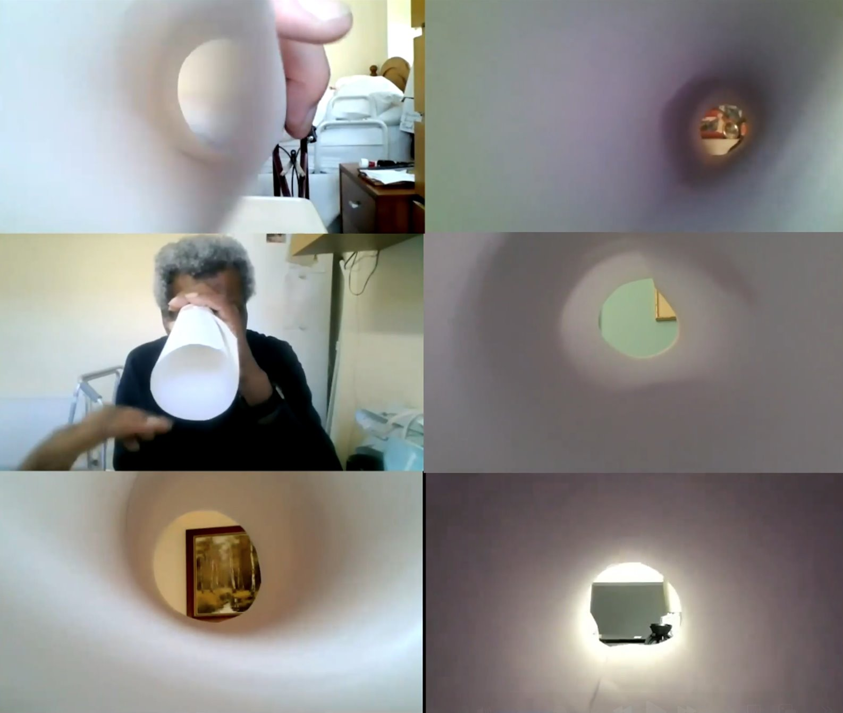
Image credit: ‘Better Making’ ​TUNNEL Film, courtesy of Alex Schady, 2021

How do we learn to see into lived experience, and what attentions does this require? Visual projects offer methodological answers. The Better Making Tunnel film, created during COVID-19 lockdown in partnership with Arts4Dementia, provides a conceptual bridge, an invitation to notice what typically remains unnoticed.

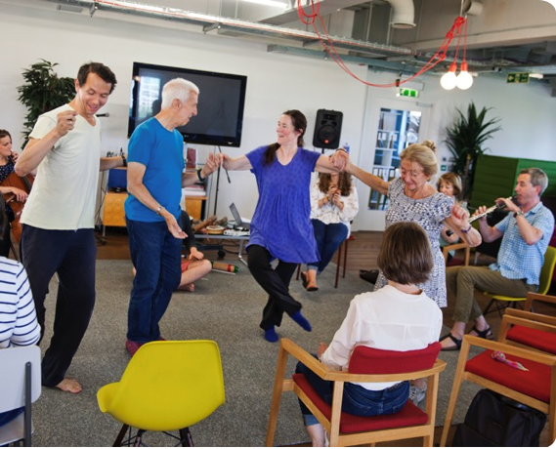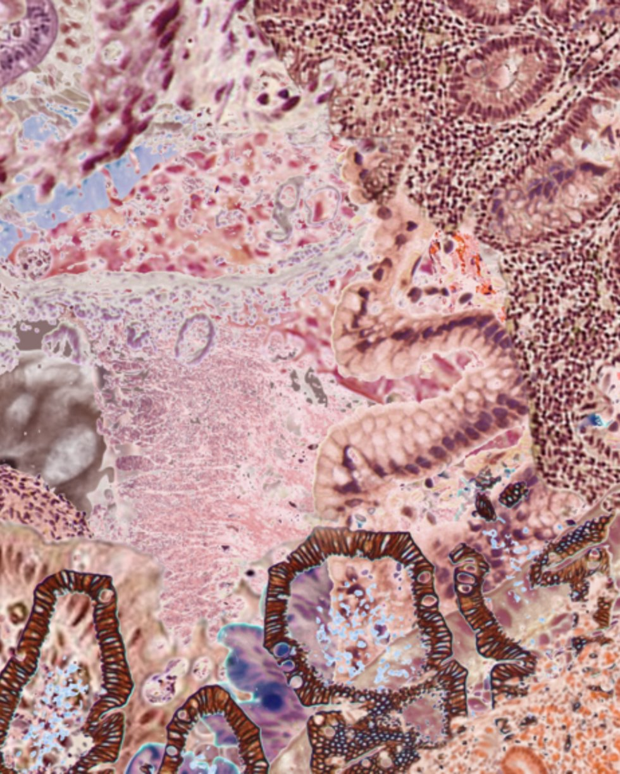
Image credits left – right: L - With All’ project, co-creativity with people with dementia​. R- Still from moving image artwork by Amelia Hine, commissioned for the Stomach Ache website (2022)

In IRL’s Rachael Marden’s ‘Stomach Ache Project’, collaborators are recognized as gut-attuned, embodied experts in their own health (Bartlett, 2024). The With All project similarly foregrounds embodied, relational, and situated practices of lived experience with people with dementia, many of whom no longer possess the linguistic capacities they once had. These works demonstrate that seeing into lived experience requires attunement: a deliberate reorientation toward forms of knowledge that resist conventional research capture.
Yet visual attunement alone cannot address structural governance failures. Current institutional mechanisms for including lived experience typically operate through consultation without power. Patient and Public Involvement (PPI) panels typically function as advisory bodies, not decision-making authorities. Institutions valorise stories while withholding authority from storytellers. Payment inequities persist; academics receive salaries to conduct research; patients are offered nominal fees - or even nothing- to participate. These are not accidental oversights but structural features of how knowledge production is organized and compensated.
IRL's approach attempts to create structural response. Our collective governance model distributes decision-making power rather than concentrating on academic hierarchies. We practice equitable payment: all speakers at our July symposium, including those participating primarily through lived experience expertise, receive an honoraria payment. We pursue integration rather than extraction, developing research methods of training for doctoral programmes rather than organizing one-off consultation workshops. Yet we recognize integration as a contested concept. What does integration mean from lived experience perspectives? How do those living with severe mental illness want or need to be involved? Which aspects of knowledge can be shared, and under what conditions? Integration risks becoming another form of assimilation unless continually interrogated.
These dynamics extend beyond health research. We recognize parallel patterns in criminal justice "victim consultations," social policy "community engagement," and activism's imperative to "center lived experience" - though we acknowledge these are not our areas of expertise. Researchers at UAL examine these contexts, including UAL’s Edmund Clark's work on incarceration, and CSM's Design Against Crime work, which intersect with our concerns while remaining distinct from our practice. What matters is recognising that extraction and strategic essentialism continue to operate across institutional contexts.
This raises a central question this symposium focuses on: can universities and institutions genuinely conduct non-extractive lived experience research, or is the structure itself fundamentally compromised? Our provisional answer: perhaps not fully, but we can build what we term "pockets of resistance" spaces where power operates differently, where lived experience generates not only disruptive but also healing and generative knowledge.
This framing matters. Describing lived experience solely as "disruptive" risks positioning disabled people and those with chronic illness as perpetually oppositional, expected to perform critique and resistance. As disability studies scholars remind us, terms like "resistance," "radical," and "disruptive" are never neutral; they carry expectations about who must labour to challenge systems and how. Yet lived experience perspectives enable something beyond disruption: they help everyone understand and value difference on their own terms.
Consider the temporal difference. Five-year strategic plans and pension planning feel remote when living with severe illness. Priorities shift; interactions with environments change. These are not deficits but different forms of knowing- knowledge that can help everyone listen more carefully, notice more fully, and interact more responsively. This knowledge is simultaneously disruptive (it challenges normative assumptions) and generative (it offers alternative ways of organizing time, care, and collective life). Building institutions that can hold both dimensions remains our challenge and our practice.

SECTION 5: Pain, Language, and Creative World-Making
Elaine Scarry's foundational insight remains urgent: pain destroys language, creating an epistemic crisis. The sufferer, immersed in bodily pain, cannot articulate, or struggle to do so. The witness cannot fully comprehend, although crucially they can IMAGINE, surely important here. Haraway's concept of speculative fabulation matters here: "storytelling and fact telling; patterning of possible worlds and possible times, material-semiotic worlds, gone, here, and yet to come" (2016, p.31). Language itself breaks down under pains pressure.
This breakdown creates profound power vulnerability. Medical systems demand verbal testimony to make the bodies of people they diagnose and treat legible. Legal systems require coherent narrative. Research protocols need extractable "data." Yet inexpressibility also contains resistance: what cannot be said cannot be extracted. Silence protects something; it holds power that refusal to speak makes visible.
IRL's response through creative practice does not force verbalization. We work with inexpressibility through visual, sonic, and embodied methods. Scarry's observation that while pain is "world-destroying," "making" is "world-creating" becomes a literal methodology for us. Creative methods and art are said to inherently generate ambiguity and through this the potential for emergent knowledge, which can open perspectives and possibilities for world-building that verbal testimony forecloses.
Consider meaning making within an art school context. At Better Making, UAL's social prescribing hub, StudioN functions as virtual commons for collaborative research and collective meaning-making - part of the Better Making ‘Open Studio model’ where meaning remains processual, unfinished, in-the-making. UAL’s Anna MacDonald's movement work in palliative care similarly demonstrates how creative practice can breach uncomfortable silences to hold experiences of what Havi Carel terms "illbeing." - Carel is also an important reference for IRL (and indeed is one of our guest speakers at our upcoming symposium on July 1, 2026. - Carel’s phenomenological approach shifts focus from biological body (medical symptoms) to lived body (how persons experience their world), critiquing medicine's tendency to reduce patients to symptom collections. This reduction produces ‘epistemic injustice’, adapting Miranda Fricker's term: patient knowledge of their own condition is systematically dismissed, (the focus of Carel’s current EPIC project for the Wellcome Foumdation).
Our work on co-creativity with people with dementia re-conceptualizes wellbeing itself. As one participant consistently noted, he was "fine AND living with terminal illness", a formulation that insists wellbeing must involve illbeing, not as contradiction but as integrated reality (Zeilig, Tischler, et al., 2019). This challenges research cultures that seek resolution, improvement narratives, or clean separation between health and illness.
IRL’s Hannah Zeliig’s MINDS project, designed to improve discharge experiences from mental health hospitals, illuminates these tensions. Participants were asked to engage in reflection when this might not align with healing processes. The expectation that lived experience must translate into text becomes confining; creative methods offer more expansive ways of holding and expressing meaning. MINDS used images and predominantly non-verbal films to convey feelings that staff and patients confront negotiating discharge from secure psychiatric units, forms that could hold ambivalence, fear, hope, and confusion simultaneously without demanding narrative coherence.
We propose these examples connect directly to this symposium's Panel 2 focus on trauma and testimony. Creative methods provide alternatives to forced narrative coherence—alternatives necessary when testimonial demands themselves become traumatic, when the imperative to "tell your story" re-enacts violation, when coherence falsifies experience. Working with inexpressibility, rather than against it, becomes an ethical practice and epistemological necessity.

SECTION 6: Projects as Sites of Power Negotiation
Four collaborative projects illuminate how creative practice navigates power, governance, and extraction in lived experience research.
Stomach Ache Project, initiated by Dr. Vanessa Bartlett with IRLs Rachel Marsden as co-lead, explores how creative and curatorial methods provoke new representations of digestive disruption. Shaped by lived experience of unruly guts - in Rachel's case, degenerative gut disease and delayed diagnosis - the project positions participants as gut-attuned, embodied experts whose knowledge challenges medical diagnostic authority. The governance question becomes: who decides what counts as "gut knowledge"? Medical institutions privilege colonoscopy results and blood work; patients know rhythms, textures, patterns that clinical instruments cannot capture. Drawing on creative arts and medical humanities methods, the project considers how creativity, embodiment, and lived experience reveal different digestive worlds, including microbiome ecologies. Artistic and curatorial methods resist clinical data extraction, generating knowledge that informs management and diagnosis without reducing experience to standardized metrics.
IRL’s Anne-Marie Creamer is involved with Better Making, a social prescribing hub at UAL. This addresses art schools' future role in shaping care and creativity in civic spaces. Operating as an alternative, community asset-based approach to prevention, care, and management of long-term health conditions, grounded in emerging models for future art school education, Better Making creates pop-up co-creational art studios where people can feel better together, facilitated by CSM-trained artist-facilitators and emergent collectives, partnering with charities, museums, galleries, and local government. The power dimension centers on what it means for an art school to lead social prescribing initiatives. Better Making's concept of the "public studio" employs flat co-creational models. Yet governance questions persist around "creative health" as emerging term: who owns it, arts or health institutions? This plays out through evaluation approaches. Extraction resistance confronts short-term funding cycles: pop-up studios risk institutional capture rather than enabling gradual community asset-mapping approaches that build sustainable local capacity.
IRL’s Hannah Zeilig works with With All, partnering with professional artists with people living with dementia to foster meaningful connection, expression, and agency through co-creativity. People with dementia functioned as co-creators, not research subjects, made possible by artistic practice using music and dance, primarily non-verbal interactions facilitating emotional connections. The governance question addresses agency when capacity is questioned. Ethical protocols prevented working with people with more advanced dementia, raising troubling questions: how ethical is excluding this lived experience from research claiming to represent dementia? Extraction resistance operated through valuing silence and illbeing, not only "successful" participation. Success itself was absent; there was no performance or single outcome, rather a series of co-created interactions holding whatever emerged.
Hannah is also co-investigator on the project MINDS, which is led by Dr Corinna Hackmann. MINDS is designed to improve discharge planning from perspectives of people with lived experience, supporters, and staff, reveals participation limits most starkly. Hannah's experience entering and leaving a secure psychiatric unit existed at depth that could not be spoken. Her discharge trauma resisted research demands:
"I had difficulty communicating my experience in terms required - in meetings examining discharge mechanistically. My experience was profoundly emotional. I was marked by violence of time spent 'inside' (it is noteworthy that people in secure units share the language and metaphors of prison to describe it), my ears were literally still ringing from clanging doors, the shouts; my body thrumming from enforced medications and restraints.
However, I did not sense this was the sort of ‘lived experience' appropriate for the research project. Perhaps it would have been more feasible to capture discharge's texture in another medium - collage? Poetry?

On the other hand, there was positivity to attending study meetings, even if I was mostly silent. I was able to see how the severe bipolar disorder that takes me radically away from the world can also ease me back into it. Although I felt closer to my identity as 'patient' or invalid, participating nudged me towards a hybrid identity of patient researcher. Or at least of someone more than only a patient / service user. Now, three years later, despite regular blood tests and medication reviews, my patient identity has diminished slightly; I am less engulfed by it, and I am better able to fully inhabit my many other identities. Nonetheless as a 'lived experience' researcher I often feel like strangely striped creature whose experiences and expertise don't quite fit anywhere."
When does research participation become extraction? MINDS eventually used images and predominantly non-verbal films to convey feelings staff and patients confront, recognizing limits of what can and should be shared through conventional research protocols.

SECTION 7: Thorny Questions and Persistent Tensions
Hannah's MINDS experience opens wider questions about what lived experience can and cannot do within research. Van Manen reminds us that lived experience, and its singularity mean meaning emerges only when we examine our own experiences and hold them in relation to others. Lived experience invites circular, reciprocal reflection, calling on memory and reinterpretation. Working with lived experience means working with memory: its gaps, confabulations, reconstructions. As Heidegger suggests, we never access experience as it was but rather as it is continually remade through ongoing interpretation, temporality, projection, and meaning making (1962). Lived experience is not fixed; it is dynamic, haptic, and somatic. How do we translate and communicate something always changing, inhabiting the realm of continuous lived and living experience?
This becomes one thorny issue among many. Others persist. IRL exists within UAL presently - does our institutional location compromise us, even as we aim eventually to build networks extending beyond university structures? How do we accept institutional funding without being captured by frameworks that demand legibility and measure success through institutional impact metrics? Can collective governance survive these pressures?
We cannot avoid certain forms of extraction. We write this paper for this symposium and eventual publication; we build CVs and research profiles; we apply for funding. Are we extracting from ourselves? Perhaps, but self-extraction differs fundamentally from others' extraction. We have created safe, secure space within our collective - space where sharing might no longer constitute extraction, but reciprocity. Still, the question remains for us: who speaks for lived experience? What about lived experiences that do not fit creative practice frameworks?
Sustainability tensions also prove particularly acute. Disability justice demands slowness, adaptive rhythms, practices of care as method. Academia and funding structures demand productivity, legible impact, deliverables on predetermined timelines. We navigate these competing temporalities daily, imperfectly, aware that our own practices sometimes reproduce pressures we critique.
These are our thorny issues. We remain curious: what are yours?

SECTION 8: Futures, Invitations, Provocations
We return to our opening proposition: what it means to work with, from, and alongside lived experience methodologically, ethically, and relationally. We propose that creative practice functions as both truth claim and power play. It makes knowledge claims - this is what we know through living - while simultaneously navigating power dynamics around who gets to know, how knowledge is validated, whose expertise counts. Interstitial epistemology does not resolve this tension; it works with it, recognizing that hyphenated identities inhabit contradiction productively.
What would non-extractive structures look like? Decision-making power, not consultation. Equitable payment. Valuing multiple forms of knowledge. Accepting limits- some things cannot or should not be shared. Building from disability justice and epistemic justice principles simultaneously.
IRL's July 2026 symposium at Central Saint Martins, UAL, London, experiments with these possibilities: testing provocation-based methods, enacting collective governance, building partnerships with Bristol EPIC research project, LSHTM, and Durham Institute for Medical Humanities, amongst others. We aim to create alternatives, not only critique existing structures. This symposium initiates an emerging interdisciplinary collective. We invite you to join - contact us to stay connected as this work develops.
Final provocations for this symposium audience: How do criminology and sociology navigate similar extraction dynamics in insider research, participatory methods, victim consultation? What might social sciences learn from arts-based approaches to knowledge that resists standardization? What might arts learn from critical social science's structural analyses of power?
We close where we began: acknowledging invisible labors, recognizing that building non-extractive research practices remains unfinished work, staying with the trouble.

Anne-Marie Creamer, Dr Rachel Marsden, Dr Hannah Zeilig
March 31, 2026

References:

- Behuniak, S. M. (2010). Toward a political model of dementia: Power as compassionate care. Journal of Aging Studies, 24(4), 231-240.
- The EPIC Project, PI: Professor Havi Carel, Department of Philosophy, (University of Bristol), a 6-year research project on epistemic Injustice in Healthcare (EPIC) project, UK. Link: https://epistemicinjusticeinhealthcare.org
- Fisher, E., & Fortnum, R. (Eds.). (2013). On Not Knowing: How Artists Think. Black Dog Publishing
- May, R. (1998). Power and innocence: A search for the sources of violence. WW Norton & Company.
- Scarry, E. (1987). The body in pain: the making and unmaking of the world. Oxford University Press.
- Thorpe, Prof Adam - Professor of Socially Responsive Design at Central Saint Martins College, University of the Arts London (UAL); Co Director of the Design Against Crime Research Centre and Coordinator of the UAL DESIS Lab (Design for Social Innovation and Sustainability); Principal Investigator of the Public Collaboration Lab, a platform for teaching & learning, knowledge exchange and research focused on participatory design for social, service and policy innovation, delivered in partnership with London Borough of Camden (2015-present). Web-link: https://researchers.arts.ac.uk/985-adam-thorpe
- van Manen, M. (2017). Phenomenology in its original sense. Qual Health Res, 27(6), 810-825.
- Voronka, J. (2016). The Politics of 'people with lived experience' Experiential Authority and the Risks of Strategic Essentialism. Philosophy, Psychiatry, & Psychology, 23(3), 189-201

EMAIL:
Anne-Marie Creamer - a.creamer@arts.ac.uk
Dr Rachel Marsden – r.marsden@arts.ac.uk
Dr Hannah Zeilig - h.zeilig@fashion.arts.ac.uk

BIOGRAPHICAL NOTES:
Anne-Marie Creamer is Senior Lecturer at Central Saint Martins (UAL), where she co-leads the Better Making social prescribing hub. She is a visual artist exploring encounters with overlooked, forgotten histories; how art works can be a form of ethical remembering inspiring societal change. She is also on the PPIP board for the Bone Cancer Trust and is a current EURODIS Open Academy Fellow, focusing on rare disease.
Dr Rachel Marsden is Senior Lecturer in Creative Education at UAL and NIHR Research Fellow in Creative-Public Health (Birmingham/Keele, 2027). Her practice-research spans creative health, medical humanities, and disability justice. She is Regional Champion for the Culture, Health and Wellbeing Alliance.
Dr Hannah Zeilig is Reader in Arts & Health at London College of Fashion (UAL), researching arts, design, and health for people with dementia and severe mental illness. Her work includes Wellcome-funded research on co-creativity with people with dementia (2016-18) and Baring Foundation-funded arts exploration for severe mental illness (2022). Hannah collaborates with people with lived experience, artists, clinicians, and scientists to challenge dominant narratives.
Together they founded IRL (In Real Life): Lived Experience Lab, a collective exploring physical and mental health in Autumn, 2025.

