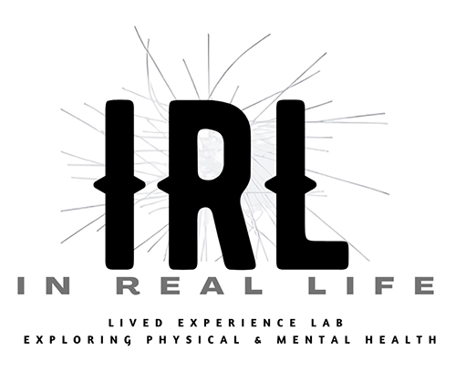
IRL: UCC CORK SYMPOSIUM ABSTRACT
Truth Claims or Power Plays? 'Lived Experience' in Politics, Research and Activism
April 30 - May 1, 2026

TITLE:
IRL: What it Means to Work with Lived Experience - Creativity, Power and the Ethics of Emergent Knowledges

AUTHORS:
Anne-Marie Creamer, Dr Rachel Marsden, Dr Hannah Zeilig
IRL: In Real Life - Lived Experience Lab (Collective), University of the Arts London

ABSTRACT (300 words)
Working with lived experience involves negotiating complexities that resist easy resolution. The body and mind in illness disrupt the tacit assumptions of health, making acute van Manen's (2017) observation that we cannot 'simply access the living meaning of lived experiences through introspective reflection.' When experience resists coherence, articulation reveals language's limits.
This difficulty is phenomenological and political. Building on Havi Carel's theorization of epistemic injustice in healthcare (the EPIC project)—where illness testimonies are systematically discredited and hermeneutical resources fail those navigating chronic conditions—we trace how research structures reproduce what they claim to redress.
Drawing on Scarry's (1987) analysis of pain's resistance to language and Voronka's (2016) critique of 'lived experience' as extractive credential, we argue creative practice offers epistemological possibilities that neither demand verbalization (Scarry) nor enable easy extraction (Voronka, 2016).
We propose "interstitial epistemology": knowledge emerging not despite but through hyphenated artist-researcher-patient identities. Positioned within IRL (In Real Life), a collective at University of the Arts London, this is political practice, not methodological refinement. IRL's collective governance equalizes different forms of expertise, emphasizing that chronic ill-health is systemic, not merely individual.
Through creative methodologies—visual, poetic, musical—we attend to moments when narrative cannot hold experience. Following Scarry, while pain and distress can be "world-destroying" (reducing a person's universe to suffering), "making" is "world-creating," enabling shareable realities as vital ethical acts.
Ambiguity inherent in creative practices—'not knowing' (Fortnum, 2013) outcomes as work is made—resists instrumentalization that Voronka (2016) problematizes. We foreground lived experience as embodied and affective, sometimes partial or inexpressible. Drawing on projects we have undertaken, we will explore uncomfortable silences around epistemological questions and gaps in language and practice, asking: What would research structures look like designed by and with lived experience from inception?

BIOGRAPHICAL NOTE (100 words):
Anne-Marie Creamer is Senior Lecturer at Central Saint Martins (UAL), co-leading Better Making social prescribing hub, a visual artist, and works with Bone Cancer Trust and EURODIS Open Academy.
Dr Rachel Marsden is Senior Lecturer in Creative Education at UAL and NIHR Research Fellow in Creative-Public Health (Birmingham/Keele, 2027). Her practice-research spans creative health, medical humanities, and disability justice. She is Regional Champion for the Culture, Health and Wellbeing Alliance.
Dr Hannah Zeilig is Reader in Arts & Health at London College of Fashion (UAL), researching dementia, mental illness, and artistic co-creativity through transdisciplinary approaches.
Together they founded IRL (In Real Life): Lived Experience Lab, a collective challenging hierarchical research structures.

References:

- The EPIC Project, PI: Professor Havi Carel, Department of Philosophy, (University of Bristol), a 6-year research project on epistemic Injustice in Healthcare (EPIC) project, UK. Link: https://epistemicinjusticeinhealthcare.org
- Fisher, E., & Fortnum, R. (Eds.). (2013). On Not Knowing: How Artists Think. Black Dog Publishing
- Scarry, E. (1987). The body in pain: the making and unmaking of the world. Oxford University Press.
- van Manen, M. (2017). Phenomenology in its original sense. Qual Health Res, 27(6), 810-825.
- Voronka, J. (2016). The Politics of 'people with lived experience' Experiential Authority and the Risks of Strategic Essentialism. Philosophy, Psychiatry, & Psychology, 23(3), 189-201

Email:
Anne-Marie Creamer - a.creamer@arts.ac.uk
Dr Rachel Marsden – r.marsden@arts.ac.uk
Dr Hannah Zeilig - h.zeilig@fashion.arts.ac.uk

