Repurposing History: What cannot yet be heard

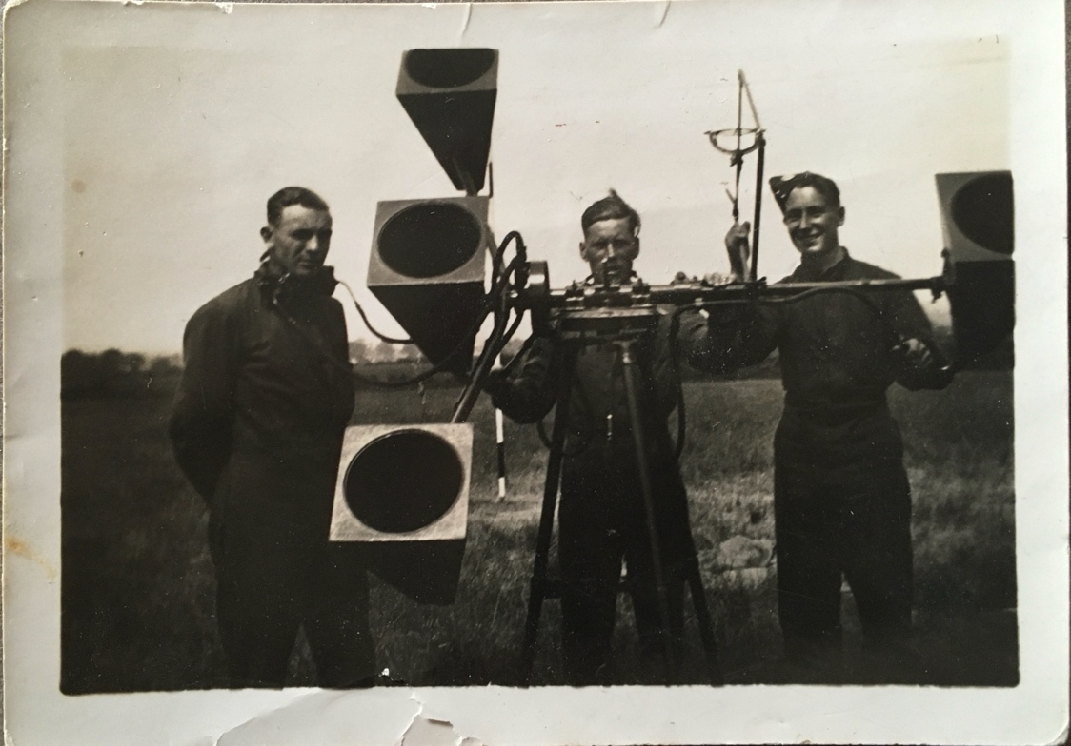
The authors Grandfather, Stanley Reginald King (right) operating a WWII sound locator.

Two photographs of you. One with a sound locator, used to pick the sound of approaching bombers out of the sky. The device consists of four geometric trumpets: two that detect sound, and two that estimate altitude. In the second image, you are articulated by a searchlight that will further locate planes in the night sky for anti-aircraft guns. These technical extensions situate you as limit point, simultaneously reframing the co-ordinates of your body in Euclidean space. Human perception has been gradually extracted from the individual bodies that have evolved them, now conglomerated into a cosmic super-sense that listens and watches us faithfully from outer space. In keeping with this logic, it may be possible to conceive of the entire humanly built environment as prostheses that extend human capacities in order to massify and surpass individual physical limits.
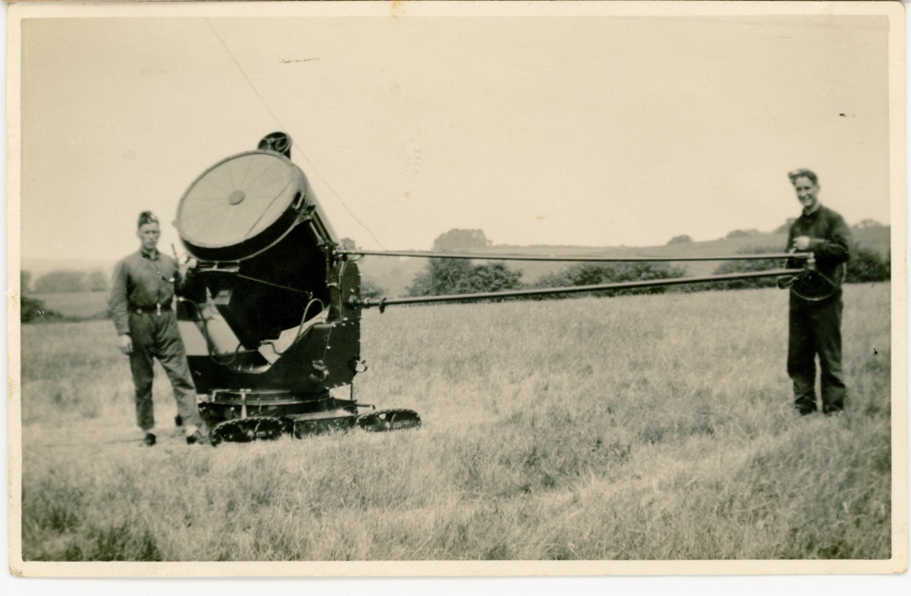
The authors Grandfather (right) operating a WW11 searchlight.

Before it was realised that the scattered radio waves of aircraft could be detected, various acoustic location devices were created in the hope of providing early warning systems for enemy planes. Among them, acoustic mirrors—concave, concrete discs that still hang, moon-like, upon horizon lines. The concrete skins of spherical acoustic mirrors were examined with giant stethoscopes: the physician-analyst searching for vibration that might signify approaching malady. Here was distance- cupped in the hands of human ingenuity. Two sound mirrors are carved into the chalk cliffs of Dover’s Fan Bay and covered with concrete. It is as though the cliffs have grown two ears obliquely listening out to sea. Perhaps it would be more appropriate to acknowledge these apertureless discs as amputations against which the porous qualities of chalk are sealed. It is notable that chalk is a limestone comprised of mineral calcite, formed by the shells of marine organisms. Modern industrial concrete was developed by heat-treating limestone and clay and grinding the result into a fine cement powder.
If concrete has a sound of its own, it might be the distinct ring of Empire. Forms of concrete go back many thousands of years, first used in Ancient Syria and Jordan. For those of us educated in the global north at the end of the twentieth century, concrete recalls the Modernist glory of the so-called ‘International Style’ of architecture in Europe and the USA. The ‘international’ fervour expanded beyond the post war rebuilding effort to colonial administrations, in an attempt perhaps, to expand imperial notions of ‘unity’. On gaining independence from colonial administrations, many countries in the global south found concrete an affordable, durable material with which to construct new civic centres, although many such architectural achievements have yet to be acknowledged. As we become increasingly aware of concrete’s carbon footprint, calls to limit its use as a building material problematically rehearse the west’s claim to exclusivity regarding cheap, durable development that might withstand the very ecological disasters that it has engineered through ubiquitous expansion of those same materials. Further irony is to be found in considering the etymology of ‘concrete,’ derived from the past participle of concrescence, which means ‘to grow together’.
Not all early pre-radar listening devices were concrete. Some were made of wood (image 1). Others were exoskeletons of aluminium worn over the head, cupping the ear with amplifying parabola like bizarre wimples from dystopian science fiction. In some documentary photographs, outsized stereo cones emerge either side of a tiny figure, attached through umbilical rubber tubing. The human body clumsily augmented with extra binaural powers reminds us how dramatically life changed once James Clerk Maxwell’s discovery of electromagnetic waves was put to use in inventions such as radar. The air, like the ocean, became rich 3-dimensional matrices that could be mapped and recorded, providing novel indicators of presence. In discussing the geometry of radar towers, Manuel De Landa has highlighted the provision of radar’s ‘dematerialised’ electronic curtain. Yet it is rather the materialisation of electromagnetic waves that the media systems of the twentieth century harnessed, and that facilitate the mediascapes of the twenty-first. Radio waves were laden with indexical signs that could be jammed by those who understood how to sever the sign from its referent. Joan Strothers, a British physicist, realised that dropping several hundred thin aluminium strips from a plane could re-radiate radio waves, creating the sonic impression of a large heavy object where there was none. Strothers is largely forgotten today, despite her part in the infamous and deadly Manhattan Project.
While enemy planes were often located by radar, the identities of the many women who ‘manned’ the radar stations are most often lost to history. This tells us much about how history itself ‘hears,’ and its partial predilections. One of radar’s pioneers was Robert Watson Watt, a name that lends itself so beautifully to the work of listening. Watt proclaimed that women were more patient listeners than men and insisted on recruiting them to the task of radar detection. This was not due to some essential quality: women learned to listen as a means of survival- what David Graeber once referred to as ‘interpretive labour,’ a labour characteristic of all a-symmetric power relations. Navigating patriarchy meant women had to imagine the world from the perspective of its privileged arbiters in order to pre-empt attack. Hyper-vigilance then, was usefully deployed to detect that which should not require overstating: namely, one’s subordination and its proximity to structural violence. This one-way dynamic was rarely reversed, except perhaps in affairs of the heart where women were allowed a nominal sense of power.
The first radar station was installed in Bawdsey Manor in Suffolk. A recent online campaign by Bawdsey asked the public to ‘… help find the women who worked in secret as front-line radar operators in WWII’. These bodies were underneath the radar literally and metaphorically. No amount of concrete bowls or parabolic ears could preserve the names or voices of those operatives as they listened in the hope of detecting their own survival through another day. Now, we must do the labour of reinterpreting history, not only to honour the dead, but to honour those who were already ghosts in its records.
It seems appropriate that Phil Coy’s concrete Stereo Pair sit across a quadrangle of a university campus between car park and lecture facility, waiting to be intercepted by passing bodies that might align their vibrations stereophonically. This particular British university is known for its brutalist concrete buildings, immortalised in Stanley Kubrick’s ‘Clockwork Orange’ (1971). Based upon a novel by Anthony Burgess, Kubrick’s film tells the tale of a dystopian society where violence, including sexual violence, have become national pastimes for groups of unrepentant young men. One (now demolished) concrete building features prominently as a correctional facility that aims to turn the offending young men into law abiding citizens by ‘brainwashing’ them. Kubrick saw Burgess’ novel (and, one might suppose, his own adaptation of it) as a critique of Skinner’s behaviourism which advocated the capacity to alter human behaviour somewhat ‘automatically,’ through systems of positive reinforcement. ‘Of course,’ Kubrick begins assuredly, ‘the story functions on another level, as a social satire dealing with the question of whether behavioural psychology and psychological conditioning are dangerous new weapons for a totalitarian government to impose vast controls on its citizens and turn them into little more than robots.’ By association, the violence of these men is attributed to a state of nature rather than being itself, a dangerous weapon resulting from a ‘programme’ of (naturalised) hegemonic masculinity. For Kubrick, the idea of a programmed morality that threatened the notion of individual liberty—a value deemed to trump all others—was far more terrifying than gratuitous physical violence and rape. Indeed, such appeals to liberty have done much to champion and sustain hegemonic values, disguised as invitations to freedom of expression. Kubrick had not anticipated the willingness with which most of us would succumb to positive reinforcement as deployed on smartphones (the latest iteration of electromagnetic technology). The hit of dopamine that attends a new ‘like,’ or ‘follower’; the wave of attention garnered by posting incendiary or virtuous material on social media. These latest iterations of behavioural modification keep us hooked into our digital devices, willingly surrendering personal data in order to become ever more pliant and predictable—more quickly nudged toward the next most likely thing we will do. This is a coercive violence, in keeping with Skinner’s pragmatism. Perhaps though, Kubrik did intuitively understand the brutalism of modern educational facilities, with their emphasis on correction and examination. Their insistence upon listening and repeating. With their bureaucratic formality and aggrandising self-importance. Even more fitting then, is the “repurposing” of concrete that Coy has taken from the now demolished correctional facility and integrated into his own elegant acoustic devices. That the word ‘repurposing’ is chosen over ‘recycling’ is itself, telling. It speaks much about how we listen to history and the project of ‘repurposing’ that each generation undertakes: understanding histories as evolving iterations of the tension that exists between what can and cannot yet be heard.

References: Ismail, Mohamed and Mueller, Caitlin (2022) Outrage: Colonial Legacies of Concrete. The Architectural Review. Available: https://www.architectural-review.com/essays/outrage/outrage-colonial-legacies-of-concrete
De Landa, Manuel (2003) War in the Age of Intelligent Machines. New York: Zone Books (p.51)
Graeber, David (2012) Dead Zones of the Imagination: On Violence, Bureaucracy, and Interpretive Labour. The 2006 Malinowski Memorial Lecture. HAU: Journal of Ethnographic Theory 2: 2 (p.117)
Heritage Trust Network (n.d.) Can you help find the women who worked in secret as front-line radar operators in WWII? Available: https://www.heritagetrustnetwork.org.uk/can-you-help-find-the-women-who-worked-in-secret-as-front-line-radar-operators-in-wwii/
Kubrick, Stanley (1971) Interview with P. Houston. Saturday Review, 25 December 1971.

