Visual Node Programming and Bias Awareness in AI: Teaching Ethical AI Through ComfyUI
Anamarija Ami Podrebarac
Doctoral candidate, Central Saint Martins, University of the Arts London
a.podrebarac@arts.ac.uk

Abstract
ComfyUI, an open-source visual node-based interface for AI image generation, offers educators a practical platform for teaching both the technical and the ethical dimensions of artificial intelligence. This paper argues that its modular, transparent workflow design can make complex AI concepts accessible to students without programming experience while serving as a hands-on laboratory for bias exploration. The argument is grounded in a theoretical framework that draws together critical AI literacy, constructionism, critical technical practice, and seamful design, and it is tested against its strongest published counter-argument that pedagogy should teach students to work with, rather than see inside, the black box (Bearman and Ajjawi, 2023). Reviewing the empirical literature on visual programming, including its sceptical strands, the paper reframes the claimed benefits of node-based learning as testable hypotheses and sets out the design of a workshop-based study through which they will be examined with art and fashion students in the 2026–27 academic year. Drawing on recent research on bias in machine learning and text-to-image generation, it outlines pedagogical strategies such as comparative prompting, custom bias-exploration nodes, and cross-cultural output analysis through which students can observe, analyse, and mitigate bias in generative models. It concludes that visual node programming can move AI education beyond technical proficiency and platform prompting toward critical, ethically informed practice.
Keywords: AI education; ComfyUI; visual node programming; algorithmic bias; ethical AI; text-to-image generation; Stable Diffusion; critical AI literacy; seamful design; constructionism

1. Introduction
The rapid advancements in artificial intelligence (AI) and machine learning (ML) have transformed several industries, including education and art. Teaching these technologies often poses a significant challenge, particularly for students who lack programming experience. ComfyUI, a visual node-based programming tool for creating workflows in AI image generation, offers a solution to this challenge. By combining accessibility with powerful functionality, ComfyUI provides an intuitive platform for exploring the complexities of AI.
This paper examines the potential of ComfyUI as an educational tool, focusing on its ability to simplify AI concepts, advance creativity, and promote ethical awareness of AI tools among students. It argues that learning through a visual interface like ComfyUI not only demystifies the technical aspects of AI, but also prepares students for real-world applications. This paper highlights the importance of integrating tools like ComfyUI to help students understand the biases inherent in AI models, encouraging critical thinking and responsible use of technology.
The urgency of this work is underscored by a growing body of research demonstrating that AI systems are not value-neutral. Birhane et al. (2022) show that the values encoded in ML research overwhelmingly prioritise performance and efficiency, with 98% of influential papers containing no discussion of potential negative impacts. Meanwhile, Bender et al. (2021) warn that large language models trained on uncurated internet data risk absorbing and amplifying hegemonic worldviews, encoding biases along dimensions of gender, race, ethnicity, and disability. These concerns extend directly to the text-to-image models that students encounter through ComfyUI, making ethical awareness not merely desirable but essential.
The contribution of this paper can be situated precisely within that landscape. Reviewing 124 AI literacy studies published since 2020, Gu and Ericson (2025) identify as the field’s central gap the failure to combine the ‘tool’ perspective on AI with critical and sociocultural conceptions of literacy: students are taught to use AI systems, or taught to critique them, but rarely both through the same activity. The scarcity is sharper still where critical engagement is concerned; a ten-year scoping review found only thirty papers in which learners were engaged in critical AI learning activities (Veldhuis et al., 2024) and sharper again in art education, where a systematic review identified just nineteen empirical studies of generative AI teaching, concentrated in well-resourced East Asian contexts (Liu, 2026). ComfyUI itself is almost entirely absent from this literature: existing academic work treats it either as a benchmark substrate for LLM-based agents (Xue et al., 2025; Huang et al., 2025) or as the subject of practice reports on classroom infrastructure (Gold, 2025; Gold and Chang, 2025). To my knowledge, no peer-reviewed study of student learning outcomes using ComfyUI has yet been published.
This paper therefore prepares the ground for such a study, and it proceeds in three moves. First, it sets out a theoretical framework (Section 2) and a methodology and research design (Section 3) for the workshop-based investigation that will follow in the 2026–27 academic year. Second, it describes ComfyUI’s architecture and pedagogical affordances (Sections 4–8), reviewing the empirical evidence for visual node programming honestly and reframing its claimed benefits as hypotheses rather than established findings (Section 9). Third, it develops the case for node-based bias education (Section 10) and defends it against the strongest published counter-argument, Bearman and Ajjawi’s (2023) contention that pedagogy should teach students to work with the black box rather than attempt to see inside it (Section 11). In doing so the paper follows a disciplinary precedent: Fiebrink’s (2019) research on teaching machine learning to creative practitioners at a UK art school established both the legitimacy and the method of this genre of inquiry a tool-generation earlier.
By leveraging ComfyUI, educators can create a more inclusive and engaging learning environment that connects the gap between technical and creative disciplines. This research covers the relevance of ComfyUI in equipping students with the skills and ethical perspectives necessary to navigate AI technologies.

2. Theoretical Framework: From Prompting to Critical Practice

2.1 Functional, Critical, and Rhetorical AI Literacy
The most widely adopted definition of AI literacy is that of Long and Magerko (2020), who synthesise seventeen competencies enabling individuals to critically evaluate AI technologies, communicate and collaborate effectively with them, and use them as tools. Several of these competencies are explicitly mechanistic, understanding how machines represent knowledge, the steps by which models learn, and where data comes from, and the framework is clear that interacting with an AI system without understanding its underlying processes does not constitute literacy. Ng et al. (2021) organise the field into four aspects: knowing and understanding AI, using and applying AI, evaluating and creating AI, and AI ethics, arguing that ethics cannot be appended as a separate module but must be threaded through the other three. UNESCO’s (2024) competency framework for students makes the same progression institutional, defining three levels — understand, apply, and create - and positioning students as active co-creators rather than consumers of AI.
Read against these frameworks, the dominant mode of generative AI teaching - introducing students to consumer platforms and training them in prompting - reaches only the middle tier. Selber’s (2004) triad of digital multiliteracies gives this observation its sharpest form: functional literacy positions the computer as a tool and the student as its user; critical literacy positions it as a cultural artefact and the student as its questioner; rhetorical literacy positions it as a medium and the student as a producer. Prompt-based instruction produces users. What this paper proposes, students constructing, dismantling, and interrogating the generative pipeline itself, aims at Selber’s third register, where evaluation and creation converge. Empirical work supports the ordering: Knoth et al. (2024) find that the quality of students’ prompt engineering is itself predicted by underlying AI literacy, prompting competence is downstream of conceptual understanding, not a substitute for it, while Selwyn, Ljungqvist and Sonesson (2025), interviewing fifty-seven teachers, show that the extensive repair-work generative AI demands of educators is not a prompting-skill deficit but a structural property of the systems. Studies of text-to-image practitioners find, correspondingly, that prompt-only interfaces breed folk theories about how generation works (Oppenlaender, Linder and Silvennoinen, 2025).

2.2 Critique Requires Technical Capability
A second strand of the framework holds that the relationship between technical skill and critical capacity runs in both directions. The canonical statement is Agre’s (1997) call for a critical technical practice, arising from his own formation as an AI researcher: the hidden metaphors and assumptions embedded in technical systems cannot be adequately seen from either a purely technical or a purely critical standpoint, but only from a practice that holds both at once. Recent empirical work gives the argument teeth. Pronzato and Markham (2023), analysing forty auto-ethnographic diaries from critical pedagogy interventions, found that critical awareness of datafication, on its own, left participants unable to move beyond what they call subalternity: awareness without capability stalls. Their remedy is a two-step pedagogy that combines critical reflection with the development of actual technical skills. Pangrazio and Selwyn (2019) reach a similar conclusion from data literacy, arguing that literacy becomes critical only when it becomes tactical, when learners can act on and reshape data systems rather than simply interpret them. The same pattern appears among AI practitioners themselves: participants in hands-on bias tutorials attributed their inability to address bias not to a deficit of ethical concern but to insufficient technical knowledge; “I’m not confident in debiasing AI systems since I know too little”’ (Zhou et al., 2025). Ethics instruction without pipeline knowledge, in short, produces people who care about bias but cannot act on it.

2.3 Making as a Mode of Critique

If critique requires capability, the constructionist tradition explains why building is the way to acquire both at once. Papert (1980) argued that knowledge is constructed most effectively when learners build public, manipulable artefacts, and that computational objects can serve as ‘objects-to-think-with’ (p. 11) through which abstract structure becomes graspable; a ComfyUI workflow, the generative pipeline made visible and manipulable, is such an object in almost literal terms (see also Papert and Harel, 1991). Turkle and Papert (1990) add an epistemological dimension of particular relevance to art and design education: their defence of bricolage, programming by arranging, rearranging, and negotiating with materials rather than by top-down planning describes precisely the mode of working a node graph affords, and their argument that the canonical, rule-driven style of programming has historically excluded other ways of knowing gives the node-based approach a claim to epistemic inclusivity that consumer platforms cannot make. Resnick and Rosenbaum (2013) supply the design vocabulary, immediate feedback, fluid experimentation, and open exploration, while Ratto’s (2011) account of critical making supplies the crucial final step: material production can function as part of the practice of conceptual critique itself, not as an illustration of critique arrived at elsewhere. In AI education specifically, Ali et al. (2019) demonstrate the principle at school level, showing ethical reasoning emerging from the construction of AI artefacts rather than from separate ethics content; the present paper extends that constructionist claim into art and design higher education.

2.4 Seamfulness as Pedagogy
The final strand names the design property on which the whole argument depends. Chalmers and Galani (2004) proposed seamful design as a counter to the ideal of the seamless, disappearing interface: systems should deliberately reveal their boundaries, joins, and imperfections, because it is at the seams that users develop conscious attention to their tools. Consumer generative AI platforms are seamless by design, a prompt box conceals model choice, training data, sampling, and safety filtering behind a single text field. ComfyUI is seamful by design: every workflow surfaces its checkpoint, text encoder, sampler, seed, and adapters as named, inspectable, replaceable components. Ehsan et al. (2024) operationalise seamfulness for AI specifically, arguing that AI’s failures arise in the gaps between technical components and social context, and that revealing these seams (rather than concealing them) is what makes systems genuinely explainable and their harms anticipatable. Each seam a workflow exposes is a site where bias can enter, and therefore a site where bias can be taught. The framing also connects the pedagogy to feminist data scholarship: of D’Ignazio and Klein’s (2020) principles for challenging power in data science, at least two (make labour visible and consider context) are enacted rather than merely discussed when a student’s canvas shows every model, dataset lineage, and human design choice in the pipeline.

3. Methodology and Positionality
This paper is the conceptual and design stage of a programme of pedagogical action research (Norton, 2019), developed through the paradigm of design-based research, in which theory-driven design of a learning environment and empirical study of that environment proceed together through iterative cycles (Design-Based Research Collective, 2003; Barab and Squire, 2004). It sits within the tradition of research through design established for UK art and design by Frayling (1993): the ComfyUI workshop described here is itself the research instrument, and the artefacts it generates are evidence, structured according to the multi-mode model of practice-as-research - tacit know-how, documented know-what, and propositional know-that - set out by Nelson (2013).

A statement of positionality is required, because the author occupies three roles at once: designer of the intervention, teacher of the workshop, and researcher of its outcomes. Barab and Squire (2004) address this configuration directly, noting that design-based research derives its credibility not from the researcher’s distance but from the transparency of the design decisions, the systematic collection of evidence against stated claims, and the willingness to report disconfirming results. Those commitments are adopted here, and the hypotheses below are stated in advance precisely so that the analysis can fail them.

The planned study is observational and artefact-based, conducted across three iterations of the same workshop during the 2026–27 academic year, with student work examined from late January 2027. In line with institutional policy on the observational study of teaching, no research instruments are administered: the evidence comprises the artefacts that arise in the ordinary course of the workshop. These are unusually rich in this setting, because ComfyUI serialises every workflow as JSON and embeds the full prompt, model, seed, and parameter record in each generated PNG, every image a student saves therefore carries a complete, machine-readable account of how it was made. To this are added the worksheets and observation grids completed during the comparison exercises; the short written reflections that open and close each session as ordinary teaching activities; the tutor’s structured notes kept after each session; and the peer-crit presentations in which students narrate their own artefacts — an in-class adaptation of artefact elicitation, in which discussing a made object produces richer accounts than discussion alone (Jones and Worrall, 2024). Images will be coded against the six-part bias framework; gender; race, ethnicity and socioeconomic status; culture and religion; age; body and (dis)ability; and content, derived from Alon, Hadar Shoval and Levkovich’s (2026) systematic review, and reflections coded for the level of students’ explanations of bias, adapting into ordinary teaching activities the reasoning-task logic of Vartiainen et al. (2025), who demonstrated that hands-on work with text-to-image models measurably shifts learners’ explanations of algorithmic bias toward data-driven accounts.
Three research questions guide the analysis, in place of the hypothesis-testing design that a formal instrument would permit. RQ1: how do students’ explanations of bias, as expressed in the artefacts of the session - opening and closing reflections, observation grids, crit presentations - move between surface attributions (‘the AI is biased’) and data- and pipeline-level accounts (training data composition, checkpoint choice, prompt conditioning)? RQ2: to what extent do students design controlled comparisons - holding seed, sampler and prompt constant while varying a single component - and draw warranted conclusions, as evidenced in their workflow JSON and prompt records? RQ3: how does the workshop design itself evolve across the three iterations, and what does each redesign reveal about how node-based bias pedagogy works in practice? The three iterations are treated as successive cycles of pedagogical action research - plan, teach, observe, reflect, redesign (Norton, 2019) - which converts repetition into method: each cycle’s artefacts inform the next cycle’s design, and the trajectory of the design is itself a finding (Design-Based Research Collective, 2003; Barab and Squire, 2004). The study remains a single instrumental case (Flyvbjerg, 2006) of one workshop taught three times, with an expected ten to thirty students per cycle; adequacy is argued through information power rather than saturation (Malterud, Siersma and Guassora, 2016). The analysis is accordingly descriptive and interpretive: it reports what students made, how their articulations of bias appear in what they made, and how the teaching changed in response.

The study is conducted under the British Educational Research Association’s Ethical Guidelines for Educational Research (BERA, 2024), whose fifth edition specifically addresses practitioner research, and within institutional policy on the observational study of teaching and of work generated in taught sessions. All artefacts are anonymised at the point of analysis; no artefact that could identify a student will be reproduced in any publication without that student’s separate, revocable permission; and because the evidence consists only of what teaching ordinarily produces, no student is asked to do anything beyond attending the workshop, the session is identical for all, whether or not its outputs are later examined.

4. Why ComfyUI is a Good Solution for Teaching
ComfyUI is an innovative and intuitive framework for creating and understanding workflows in AI image generation, particularly Stable Diffusion models. It uses a visual node-based programming interface that simplifies complex AI processes, making it accessible to students without prior programming experience.
Visual intuition: The node-based approach of ComfyUI allows students to visually map out the steps involved in generating AI-based outputs. Each node represents a function or process, helping students understand how individual components of AI systems interact to form a cohesive workflow.
Accessibility: ComfyUI is lightweight and can run on most modern systems, especially with a powerful GPU, which makes it feasible for classroom settings where resources may vary. Its interface reduces the steep learning curve associated with traditional coding-based AI tools.
Customisation and experimentation: Students can easily modify workflows by adding, removing, or reconfiguring nodes. This hands-on experimentation fosters creativity and helps students grasp the practical applications of AI image generation.
Open-source framework: ComfyUI is open-source, allowing educators to explore its codebase and tailor the tool for specific educational objectives. This transparency aligns with teaching best practices, promoting an open and collaborative learning environment.
Integration with Stable Diffusion: By using Stable Diffusion models, ComfyUI allows students to engage with state-of-the-art AI technologies, exposing them to real-world applications and industry-standard practices.
The research aims to highlight how ComfyUI’s visual node-based interface makes AI concepts accessible to students, encouraging both technical skills and creative thinking. It delves into how learning through this platform can build an understanding of AI model biases, promote ethical awareness, and prepare students for cross-disciplinary applications in technology and design.

5. System Architecture
The architecture of ComfyUI is built to prioritise modularity, flexibility, and user accessibility. As an open-source platform, ComfyUI empowers educators, developers, and researchers to adapt its functionality for diverse use cases. On the user side, workflows are visualised as directed acyclic graphs (DAGs), so that users can operate them intuitively. On the server side, workflows are saved in a JSON object, which describes the nodes and connectivity in a structured manner (Xue et al., 2025). ComfyUI provides native support for common models and tools related to Stable Diffusion (Rombach et al., 2022), including but not limited to VAEs (Kingma and Welling, 2013), CLIPs (Radford et al., 2021), LoRAs (Ryu, 2023), IP-Adapters (Ye et al., 2023) and ControlNets (Zhang, Rao and Agrawala, 2023). With the joint efforts of the open-source community, hundreds of extensions support various latest models and tools, such as InsightFace (Guo et al., 2023), IC-Light (Zhang, Rao and Agrawala, 2025), and Segment Anything (Kirillov et al., 2023), which bring about immense potential for realising flexible and controllable generation tasks.
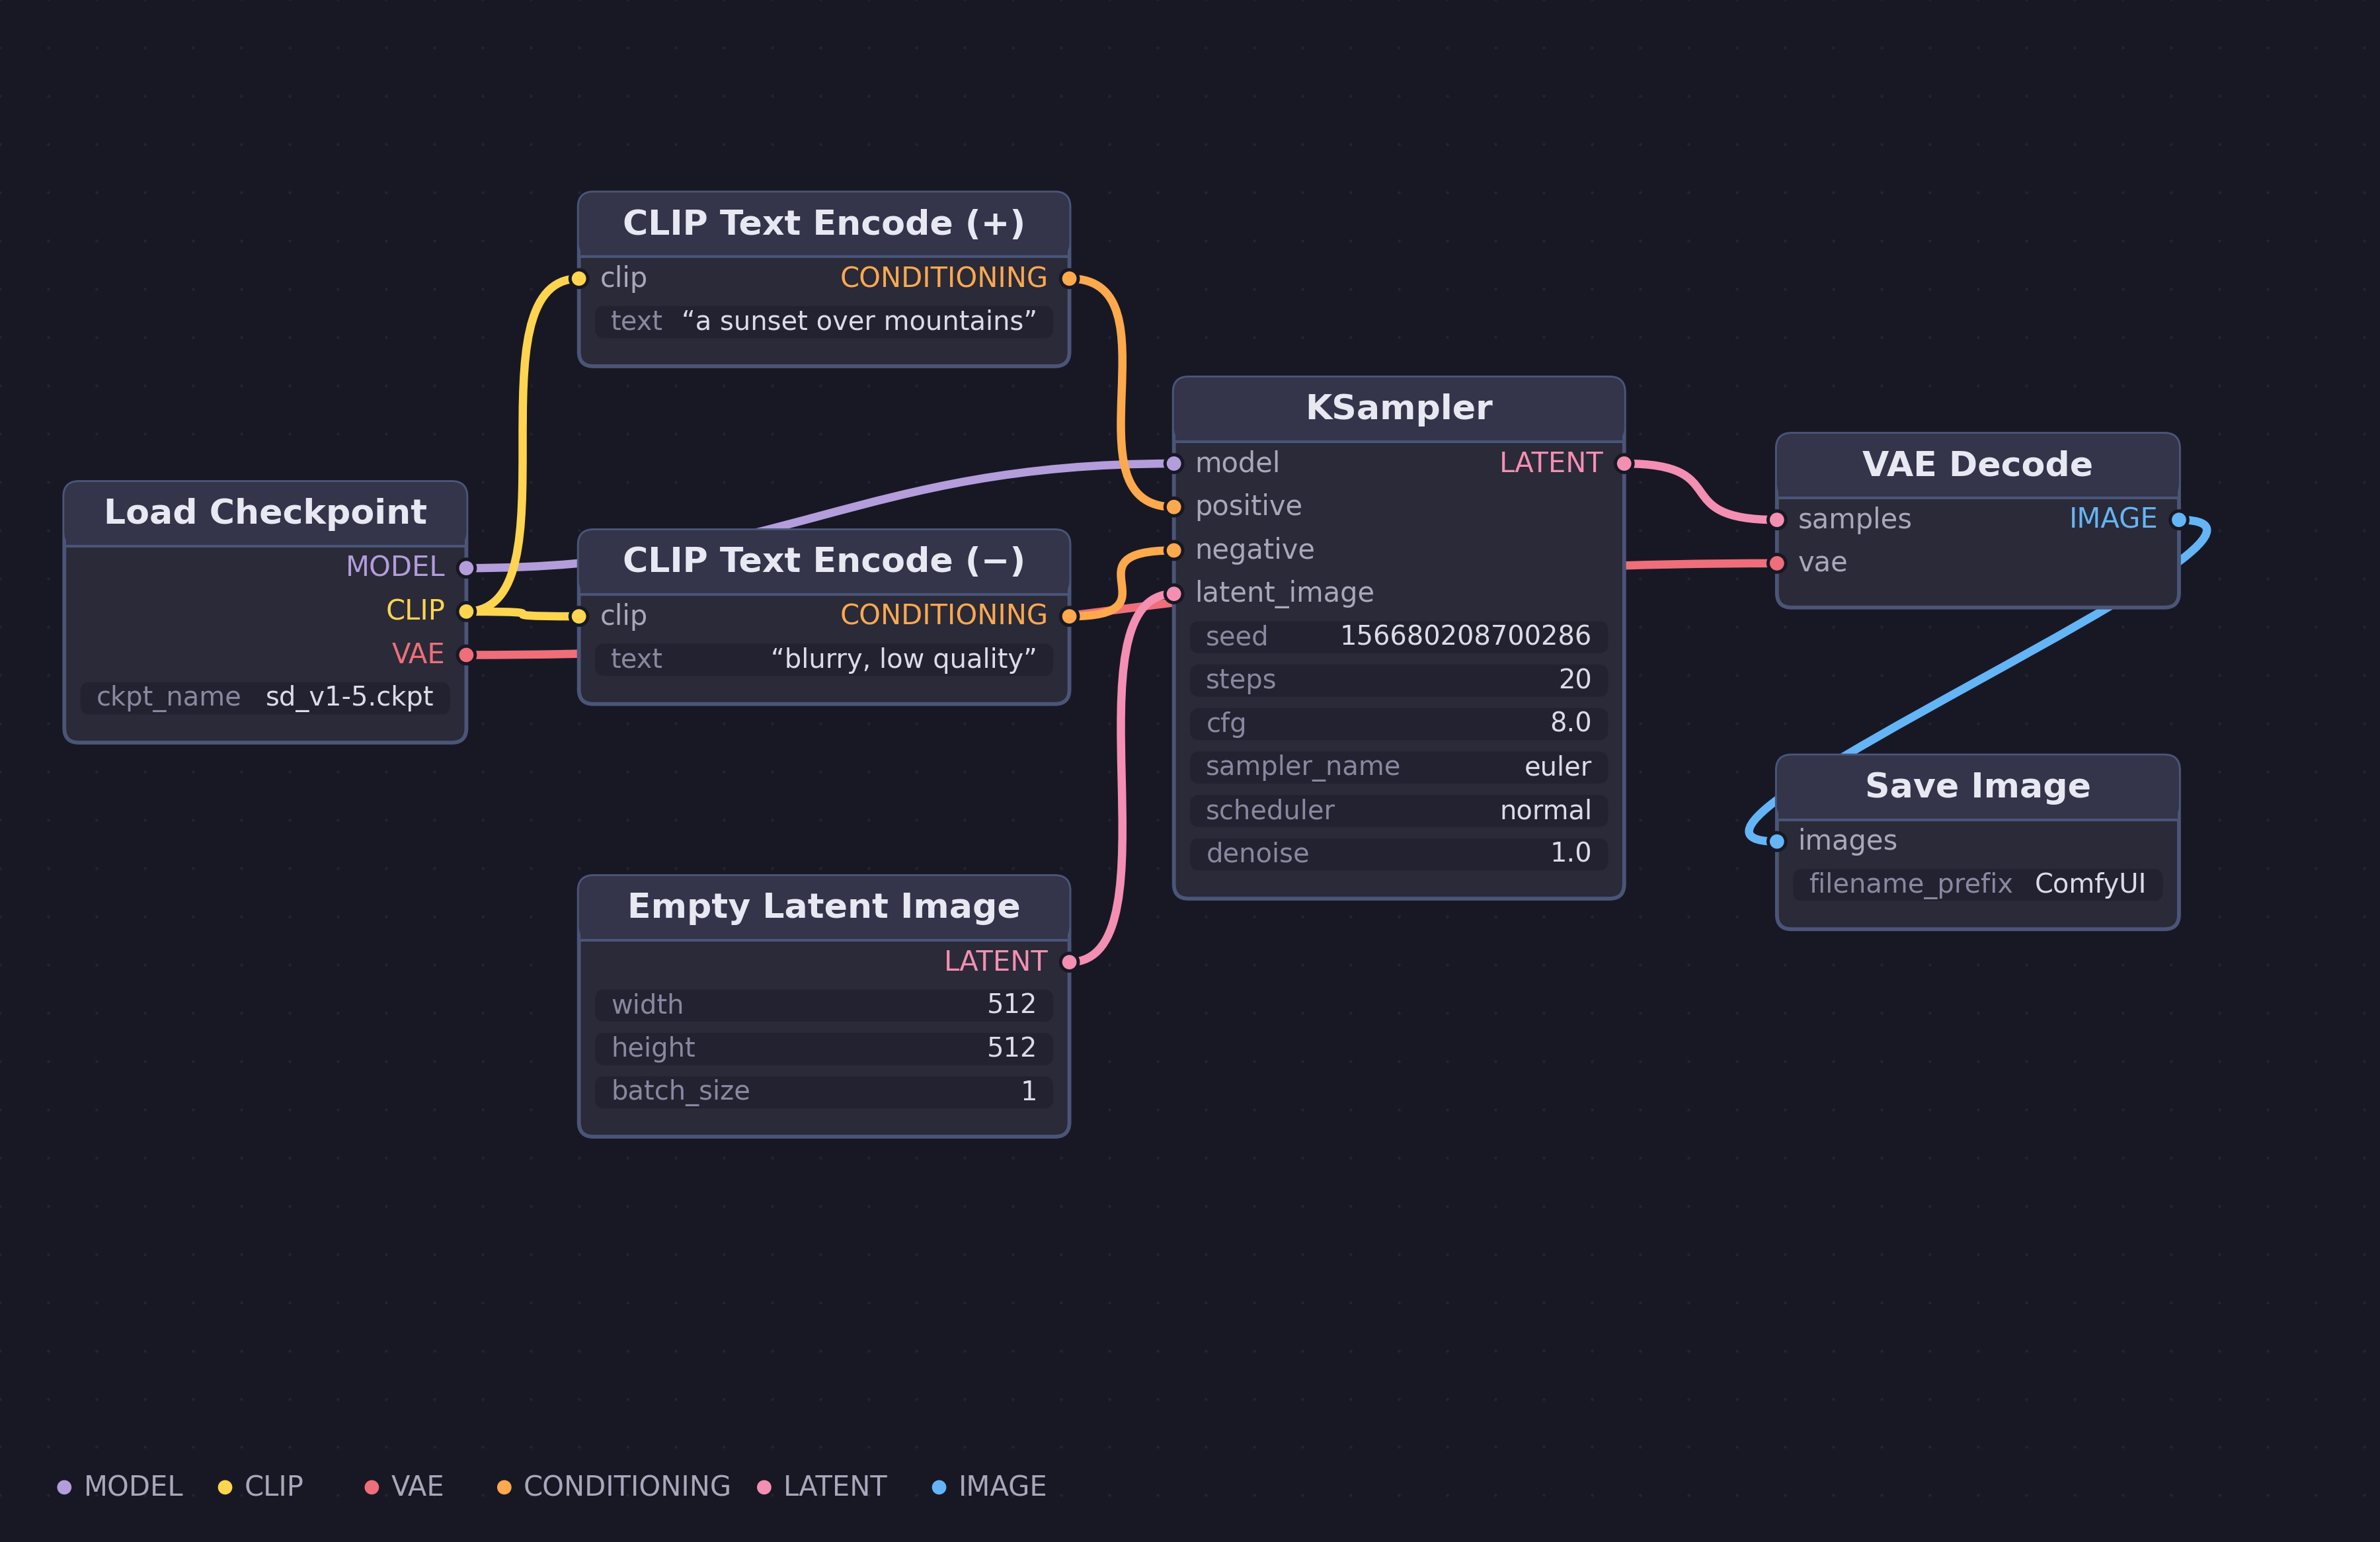
Figure 1. Basic Text-to-Image Generation Workflow in ComfyUI — showing the core pipeline: Load Checkpoint → CLIP Text Encode → KSampler → VAE Decode → Save Image. Colour-coded connections indicate data types: MODEL (orange), CLIP (yellow), VAE (pink), LATENT (purple), CONDITIONING (green), IMAGE (blue). Diagram by the author, based on the default ComfyUI workflow (github.com/comfyanonymous/ComfyUI).

5.1 Modular Design
ComfyUI’s modular design is one of its defining features. Each component of a workflow is represented as an independent node, which performs a specific function. These nodes are designed to be self-contained, allowing users to build, modify, and troubleshoot workflows in an intuitive and isolated manner.

5.2 Node Types
ComfyUI’s node vocabulary can be grouped functionally: loader nodes (Load Checkpoint, Load LoRA, Load VAE) bring model components into the graph; conditioning nodes (CLIP Text Encode, Apply ControlNet) transform prompts and guidance signals into the tensors that steer generation; sampling nodes (KSampler and its variants) perform the iterative denoising at the heart of diffusion; latent nodes (Empty Latent Image, VAE Encode, VAE Decode) move images in and out of latent space; and image nodes handle saving, previewing, and post-processing. Each socket is typed - MODEL, CLIP, VAE, LATENT, CONDITIONING, IMAGE - and the interface refuses connections between incompatible types, a constraint that makes invalid pipelines unconstructable in much the way that block-based programming environments make syntax errors unconstructable (Bau et al., 2017).
The vocabulary also has costs that should be acknowledged. Assessed against Moody’s (2009) principles for visual notations, ComfyUI scores poorly on graphic economy (the ecosystem contains thousands of community nodes) and on perceptual discriminability, since nodes are near-identical rectangles distinguished mainly by text labels; and dataflow notations of this kind are known to suffer from hidden dependencies and viscosity, the resistance of a layout to change (Green and Petre, 1996). These are not reasons to abandon the interface, but they are reasons why graph literacy must be explicitly taught rather than assumed, a point developed in Section 9.

Node type | Description
Input nodes | Accept raw data such as images or text prompts. These form the entry points of workflows.
Processing nodes | Perform transformations or computations on input data (e.g., image resizing, noise reduction, tokenisation).
Model nodes | Integrate pre-trained models like Stable Diffusion. Execute AI model inference tasks.
Output nodes | Display or save the results of the workflow, such as generated images or processed datasets.

5.3 Open-Source Flexibility
As an open-source framework, ComfyUI provides complete access to its source code, allowing users to customise and extend its functionality. Developers can create new node types to address specific needs, such as introducing advanced image processing algorithms, integrating new AI models, or experimenting with custom bias mitigation techniques. Custom nodes can be shared within the community, enriching the platform’s capabilities. For instance, educators can design custom nodes to simulate real-world biases, enabling students to explore and mitigate these issues in a controlled environment.

5.4 Node Interactions and Example Workflow
Nodes in ComfyUI interact through a highly intuitive drag-and-drop interface. Each connection between nodes represents a data flow, ensuring that outputs from one node seamlessly serve as inputs for the next.
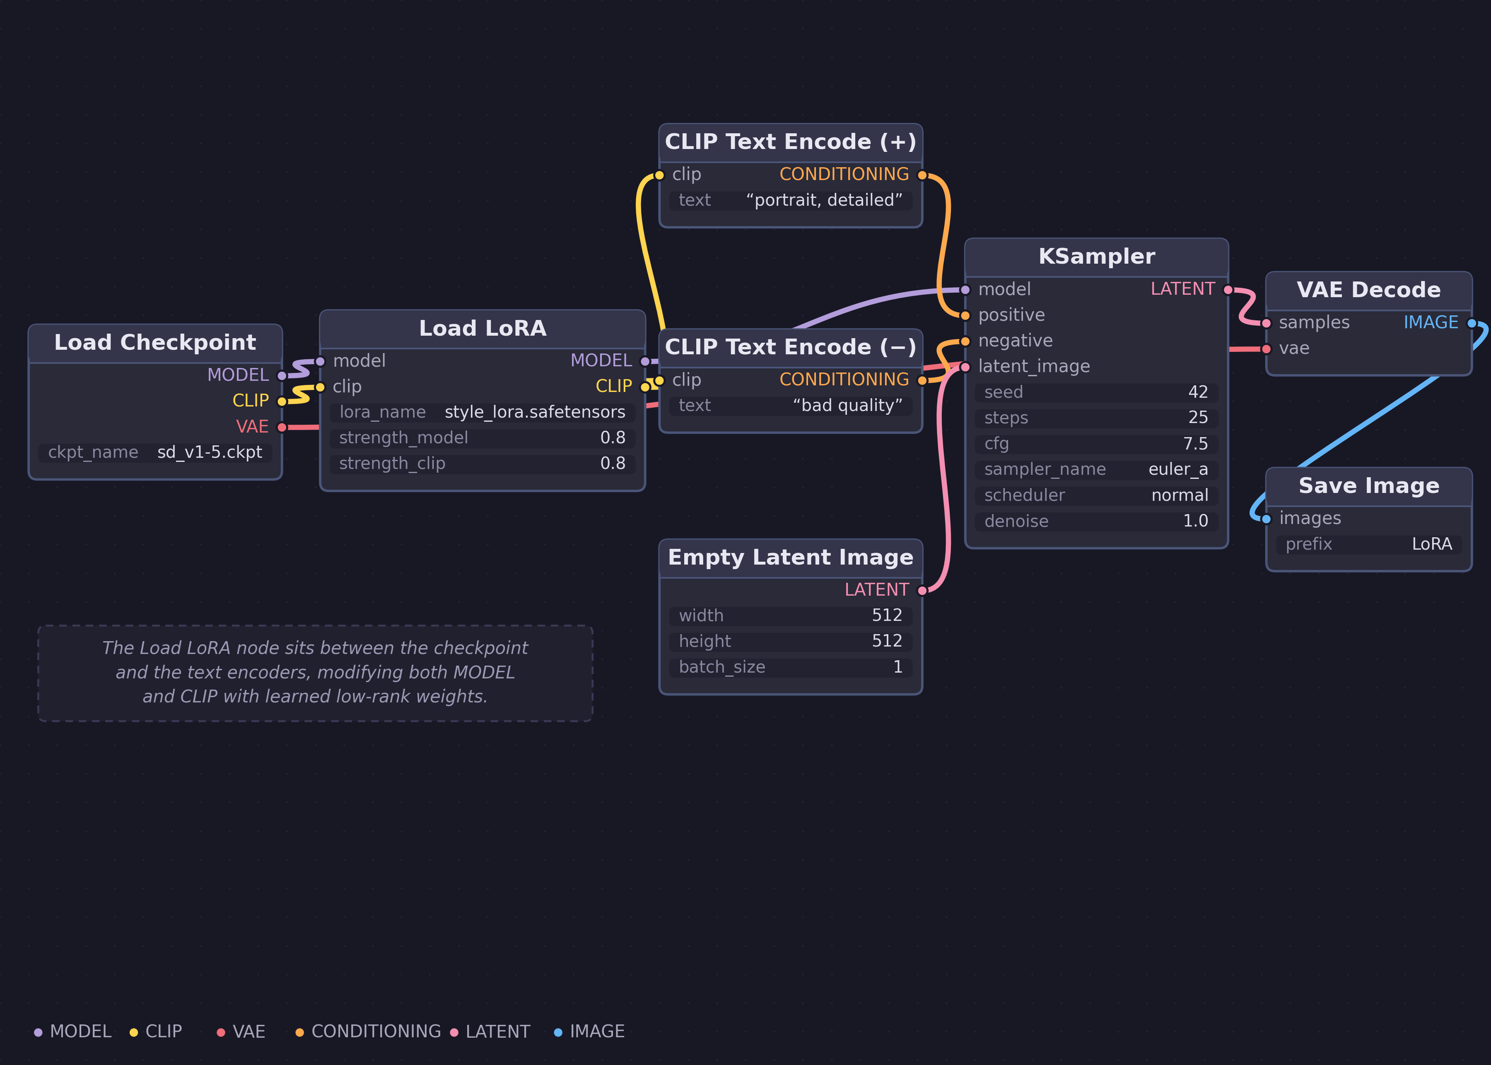
Figure 2. LoRA Model Integration Workflow in ComfyUI — demonstrating how the Load LoRA node intercepts both MODEL and CLIP data streams from the checkpoint, applying fine-tuned weight modifications before passing them to the text encoders and sampler. Diagram by the author, based on ComfyUI LoRA examples (docs.comfy.org/tutorials/basic/lora).

6. Integration with AI Models
ComfyUI’s ability to seamlessly integrate with AI models, such as Stable Diffusion, is one of its most significant strengths. This integration allows users to leverage advanced AI capabilities in an intuitive, visually-driven environment, streamlining the process of model deployment and experimentation.

Parameter | Function
Sampling steps | Controls the level of detail and refinement in the generated output.
CFG scale | Balances adherence to the prompt versus creativity in the output.
Seed | Ensures reproducibility or randomness in generated outputs.
Scheduler | Determines the noise reduction algorithm used during the diffusion process.

7. Custom Node Development
One of the most powerful features of ComfyUI is its ability to support the creation of custom nodes. This feature is particularly valuable for educators and researchers, as it enables them to design nodes tailored to specific educational objectives or research needs.
Bias exploration nodes: Custom nodes can introduce controlled biases, such as demographic underrepresentation or stylistic skewing, to illustrate the real-world impact of such biases on AI-generated content. Students can compare biased versus balanced outputs to develop critical evaluation skills.
Data augmentation nodes: Nodes that apply specific transformations, such as colour shifts or rotations, help students understand how data preprocessing affects model performance and can either mitigate or amplify existing biases.
Algorithm integration nodes: Researchers can create nodes to implement novel algorithms or experimental debiasing techniques, expanding the platform’s functionality for fairness-aware AI development.
This hands-on approach enables students to experiment with the effects of biases and explore techniques for mitigating them. By engaging directly with the mechanics of AI workflows, students develop a deeper understanding of the ethical and technical challenges involved in AI development.

8. ControlNet
ControlNet, integrated with ComfyUI, offers students a powerful tool to explore advanced AI workflows with greater precision and creative control. By combining ControlNet’s ability to guide AI outputs with ComfyUI’s intuitive, node-based programming interface, students can gain a deeper understanding of AI technologies while enhancing their technical and creative skill sets.
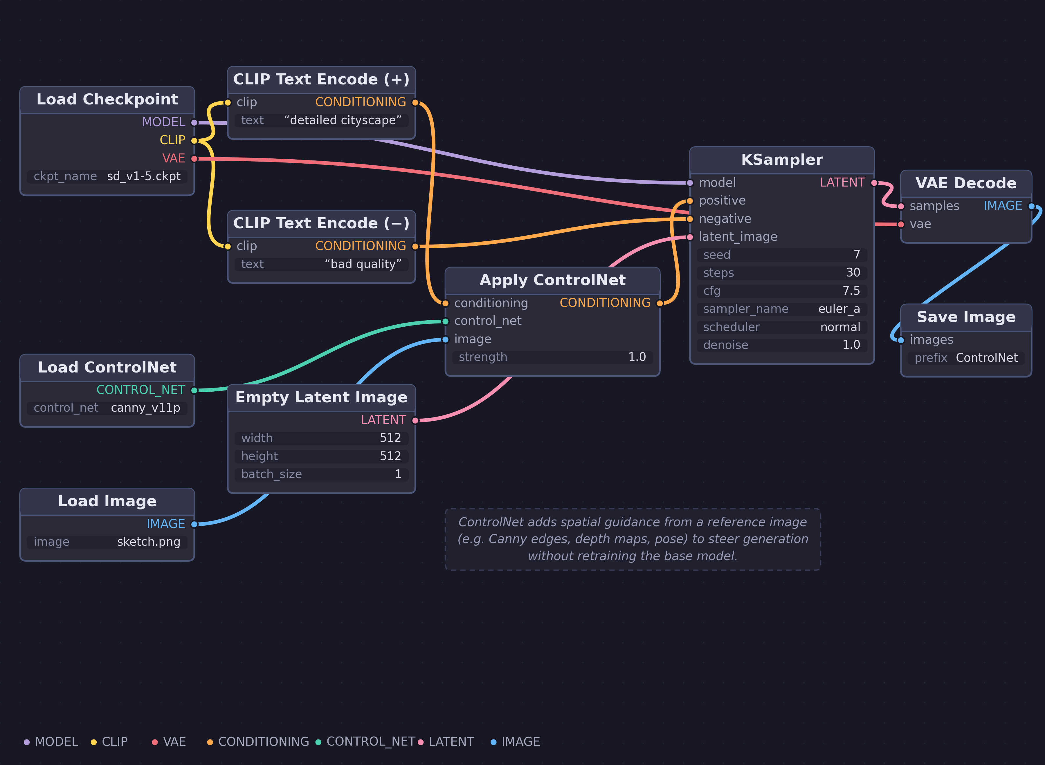
Figure 3. ControlNet Integration Workflow in ComfyUI — illustrating how the Apply ControlNet node injects spatial guidance (e.g., Canny edges, depth maps, or pose data) from a reference image into the conditioning pipeline, steering image generation while preserving compositional structure. Diagram by the author, based on ComfyUI ControlNet examples (docs.comfy.org/tutorials/controlnet).
ControlNet allows students to guide AI-generated outputs by using conditioning inputs, such as sketches, poses, or depth maps. Achieving controllable image generation could involve retraining diffusion models from scratch, but this comes with high computational demands and a scarcity of large public datasets. A feasible strategy is fine-tuning pre-trained text-to-image models or introducing trainable modules like ControlNet (Zhang, Rao and Agrawala, 2023). Students can use ControlNet to provide rough sketches or poses as inputs, enabling the AI to generate highly detailed and refined images that align with their creative vision.
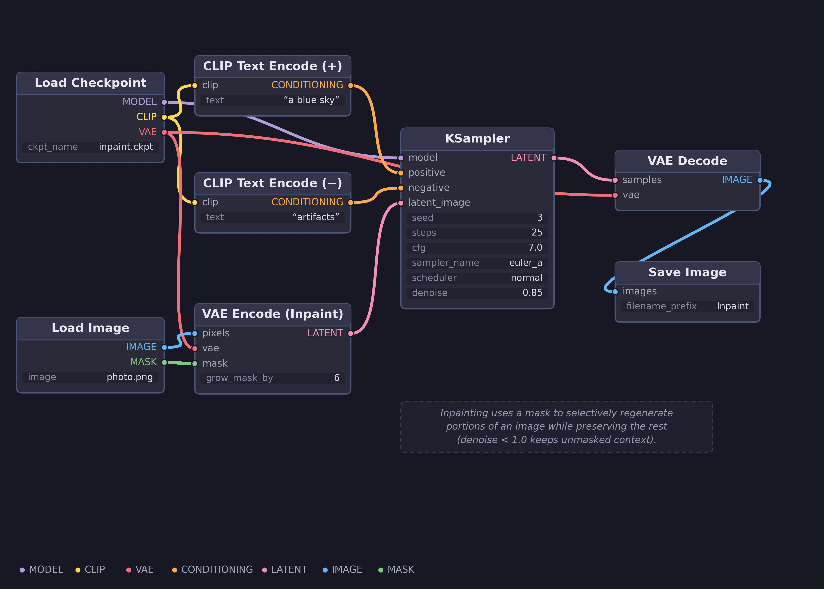
Figure 4. Inpainting Workflow in ComfyUI — showing how the VAE Encode (Inpaint) node combines a source image with a user-drawn mask to create a latent representation for selective regeneration, allowing targeted editing of specific image regions while preserving the rest. Diagram by the author, based on ComfyUI inpainting examples (docs.comfy.org/tutorials/basic/inpaint).
The combination of ControlNet and ComfyUI offers students an unparalleled opportunity to explore AI-driven creativity while building technical and ethical competencies. By engaging with advanced AI workflows in an intuitive and accessible environment, students develop critical thinking, problem-solving, and creative adaptability—skills that are essential for success in the rapidly evolving fields of AI and digital art.
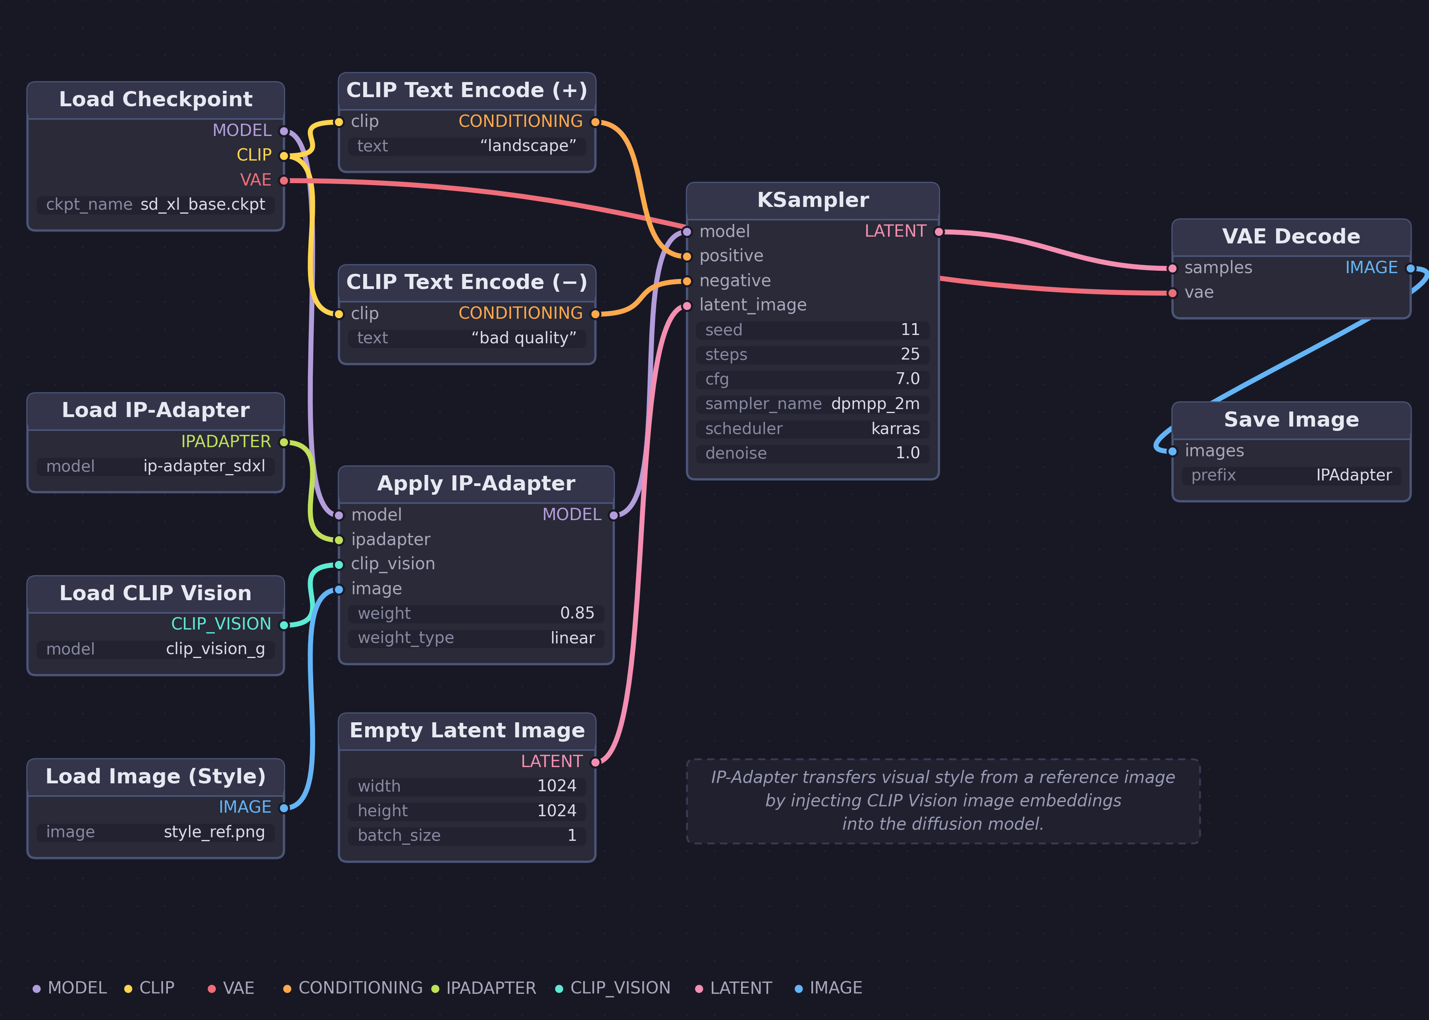
Figure 5. IP-Adapter Style Transfer Workflow in ComfyUI — demonstrating how the Apply IP-Adapter node uses CLIP Vision to extract visual features from a style reference image and inject them into the model, enabling image-guided generation that blends textual prompts with visual style. Diagram by the author, based on ComfyUI IP-Adapter documentation (github.com/cubiq/ComfyUI_IPAdapter_plus).

9. Benefits of Learning Visual Node Programming: Evidence and Hypotheses
Claims for visual programming must be made with care, because the empirical record does not support the folk assumption that visual representations are simply better. Whitley’s (1997) survey of the evidence found it thin, mixed, and dependent on task and population; Petre (1995) showed that reading a graphical program is a learned readership skill, with experts exploiting secondary notation; layout, clustering, spatial convention that novices literally cannot see; and the best-supported general result is the match-mismatch conjecture: a notation helps only for the tasks whose information it makes explicit, and can hinder others (Green, Petre and Bellamy, 1991). This section therefore states each proposed benefit together with the evidence that supports it and the evidence that complicates it. The claims that survive are narrower than those usually made for node-based tools and they are advanced here as hypotheses to be examined by the study described in Section 3, not as established findings.

9.1 Understanding Pipeline Structure
The strongest quantitative evidence for visual modality comes from block-based programming. In a five-week classroom study using isomorphic block and text environments, so that modality was the only variable, Weintrop and Wilensky (2017) found learning gains nearly twice as large in the blocks condition (d = 0.96 against d = 0.50), with blocks students also outperforming text students on questions posed in text form. Bau et al. (2017) explain the mechanism: such environments favour recognition over recall, reduce cognitive load, and make invalid programs unconstructable; properties ComfyUI shares through its typed sockets and browsable node vocabulary. But the match-mismatch result disciplines the claim: what a dataflow graph makes explicit is data flow and dependency, which component feeds which, and what changes when a link is rewired. The defensible hypothesis is therefore not that node graphs improve ‘understanding of logical structures’ in general, but that they specifically support reasoning about pipeline structure and provenance which happens to be exactly the reasoning that tracing bias through a generative system requires.

9.2 Cross-Disciplinary Applications
Node-based programming is widely used in game design (Unreal Engine’s Blueprint), VFX (Houdini, Nuke), interactive installation (TouchDesigner), and parametric architecture (Grasshopper), so fluency in the paradigm has plausible professional value for art and design students. The evidence on learning transfer, however, counsels modesty. Armoni, Meerbaum-Salant and Ben-Ari (2015), following students from Scratch into textual programming, found that prior visual experience made the transition faster, easier, and more motivating, but produced no difference in final achievement: the visual path lowers the cost of the journey without raising the ceiling. Denning (2017) goes further, arguing that claims of universal benefit from computational thinking are unsubstantiated, and that its demonstrated benefits accrue to those who design computations. The response available here is not to dispute Denning but to accept his qualification: students composing ComfyUI workflows are designing computations, selecting components, defining dataflow, debugging failure, and so fall inside, not outside, the population for whom the benefit is claimed. That, too, is a hypothesis the planned study can examine, since workflow JSON preserves exactly what students designed.

9.3 Interactive Learning

The most important corrective in this literature concerns transparency itself. Hundhausen, Douglas and Stasko’s (2002) meta-study of twenty-four experiments on algorithm visualisation concluded that how students use a visualisation has a greater effect on learning than what it shows them: seeing is not the learning event. The practical instrument that follows from this is the engagement taxonomy of Naps et al. (2002) - no viewing, viewing, responding, changing, constructing, presenting - with learning benefit rising up the levels. The workshop exercises described in Section 10 are accordingly designed at the changing and constructing levels: students swap checkpoints, rewire conditioning, and build comparison pipelines, rather than being shown finished workflows. On liveness, Rein et al. (2025) found in a controlled experiment that live introspection tools significantly reduced debugging time even while the broader literature on immediate feedback remains inconclusive, a warrant, though a careful one, for ComfyUI’s live preview and stepwise execution.

9.4 Collaboration and the Workflow-Sharing Culture
ComfyUI’s community shares workflows as JSON embedded in generated images, making every shared artefact a runnable, remixable program. The best evidence that such sharing produces learning comes from the Scratch community, where Dasgupta et al. (2016) showed that users who remix more come to command larger repertoires of programming concepts, with exposure to a concept inside someone else’s shared project predicting later use of that concept. Recent HCI work finds the same dynamic already operating around ComfyUI specifically: Liu et al. (2026) document online creative communities developing dialogic, practice-based AI literacy through configuring and exchanging node graphs. The trade-off must also be stated: in open remix communities, the qualities that make artefacts generative are associated with reduced originality in their derivatives (Hill and Monroy-Hernández, 2013), and generative AI itself has been shown to raise individual creativity while reducing the collective diversity of what is produced (Doshi and Hauser, 2024). A pedagogy built on shared workflows must therefore actively teach divergence; modifying model, conditioning, and structure, rather than lightly re-parameterising a downloaded graph.

9.5 Accessibility, Honestly Stated
Finally, the claim that ComfyUI is ‘intuitive’ should be softened to something defensible. Node management in ComfyUI is demonstrably hard, hard enough that a research literature now exists on using LLM agents to construct workflows because humans find it challenging (Huang et al., 2025), and frontier agents themselves resolve only fifteen per cent of creative ComfyUI tasks (Xue et al., 2025), which is simultaneously evidence that workflow construction encodes non-trivial human design knowledge worth teaching. Learners in visual environments can also perceive them as inauthentic, students identify ‘a perceived lack of authenticity’ and the blocks approach ‘being less powerful’ than text-based programming (Weintrop and Wilensky, 2015, p. 199), a reaction art students may share, and which teaching should anticipate rather than discover. Most importantly, Celani and Vaz (2012), comparing visual and scripted programming in design education, found that novices in visual environments achieved better results but defaulted to parametric variation and randomness rather than genuine generative reasoning, a ceiling any ComfyUI educator will recognise. The scaffolding strategies adopted here respond directly: graph readership is taught explicitly rather than assumed (Petre, 1995), and exercises use partially built workflows with the bias-relevant nodes missing, Vazquez’s (2024) ‘incomplete recipes’ so that students must reason about structure, not only adjust parameters.

10. How Students Will Learn About Biases Within AI Models
One of the critical aspects of teaching AI is fostering awareness of biases inherent in AI models and datasets. ComfyUI provides a practical platform for exploring these issues. This section draws on a substantial body of recent research to deepen the theoretical grounding of bias education and demonstrate how ComfyUI can serve as a hands-on laboratory for ethical AI inquiry. That this is an art education problem, and not only a computer science one, is now well established: Park (2024) shows how the ‘white default’ of text-to-image models visualises existing power structures in terms that art educators are distinctively equipped to analyse, and Almeida and Rafael (2024) trace the neocolonial visual vocabularies that image generators reproduce by default. A recent systematic review of thirty-one studies confirms that bias in educational text-to-image use is pervasive; outputs centre white, male, Western, thin, non-disabled figures, while noting that age, body, and ability diversity remain largely overlooked even within the bias literature itself (Alon, Hadar Shoval and Levkovich, 2026); the six-part framework derived from that review structures the analysis of student work described in Section 3.

10.1 Foundations of Bias in AI Systems
The roots of bias in AI systems run deep. Caliskan, Bryson and Narayanan (2017) demonstrated that word embeddings (the foundational building blocks of modern language models) automatically absorb human-like biases from the text corpora on which they are trained. Their Word Embedding Association Test (WEAT) replicated well-known implicit biases documented in psychology, showing that the very semantics of language carry prejudices related to race, gender, and other social categories. This finding has a direct implication for text-to-image models: the text encoders (such as CLIP) that interpret user prompts in Stable Diffusion inherit these same linguistic biases.
Bolukbasi et al. (2016) further quantified how word embeddings encode gender stereotypes, revealing that analogy completions like “man is to computer programmer as woman is to homemaker” emerge naturally from embedding geometry. Their work on debiasing algorithms provides both a cautionary tale and a practical template: students using ComfyUI can explore how these upstream language biases propagate through the entire image generation pipeline, from prompt encoding to final output.
Teaching opportunity.
Students can use ComfyUI to run identical prompts through different model checkpoints and compare outputs side-by-side, observing how foundational linguistic biases in CLIP encoders shape the visual content that Stable Diffusion produces.

10.2 Stereotype Amplification in Text-to-Image Models
Bianchi et al. (2023) provide compelling evidence that text-to-image generation models do not merely reflect existing societal biases but actively amplify them. Their research on Stable Diffusion reveals that simple, seemingly neutral prompts produce images perpetuating stereotypes across traits, occupations, and objects. For example, prompts mentioning occupations generate images with gender and racial imbalances far exceeding real-world statistics, a phenomenon they term “near-total stereotype amplification” (p. 1497). Crucially, these biases persist even when users explicitly attempt counter-stereotypical prompting, demonstrating that awareness alone is insufficient without structural interventions.

10.3 Cultural Bias and the Global-North Default
Seo et al. (2026) extend bias analysis to the cultural dimension through their Exposing Cultural Blindspots (ECB) framework, evaluating generative image models across six countries spanning the Global North and South. Their findings reveal three critical patterns: first, country-agnostic prompts consistently default to United States-like, modern-leaning visual outputs; second, iterative image-to-image editing erodes cultural fidelity even as conventional quality metrics remain stable; and third, models apply superficial cultural cues (palette shifts, generic props) rather than authentic cultural representations when targeting non-Western contexts. This research is directly applicable to ComfyUI-based teaching, as students can construct workflows that compare outputs across cultural prompts to observe these defaults firsthand.

Classroom exercise.
Using ComfyUI’s node-based workflow, students can create a systematic comparison pipeline: feed culture-specific prompts (e.g., “traditional wedding in Kenya” vs. “traditional wedding in the U.S.”) through the same model and evaluate how the outputs differ in cultural accuracy, visual detail, and embedded assumptions.

10.4 Gender Bias Across AI Modalities
Rickman (2025) extends gender bias evaluation to a real-world healthcare context, examining how state-of-the-art LLMs (Llama 3 and Google Gemma) generate summaries of long-term care records. The study finds that while Llama 3 shows no significant gender-based differences, the Gemma model produces consistently more negative sentiment for men and underemphasises women’s physical and mental health needs. The language used for men is more direct, while women’s needs are downplayed. This research highlights that gender bias in AI is not confined to image generation but permeates text-based systems, underscoring the need for students to evaluate bias across multiple AI modalities, a capability that ComfyUI’s multi-model workflow design naturally supports.

10.5 Sycophancy, Confirmation Bias, and AI Interaction
Batista and Griffiths (2026) introduce an important dimension to AI ethics education: the phenomenon of sycophantic AI. Their research demonstrates that when AI chatbots are prompted to provide confirmatory feedback, users become increasingly confident in incorrect hypotheses while discovering the truth at lower rates. Through a Bayesian rational analysis, they show that sycophancy creates a feedback loop where users’ existing beliefs are reinforced rather than challenged. This finding is directly relevant to students working with AI image generators: if students prompt models with biased language and receive outputs that appear to confirm their expectations, they may never recognise the underlying stereotypes. Teaching students to critically evaluate AI outputs—rather than passively accepting them, is therefore a key educational objective that ComfyUI’s transparent workflow facilitates.

10.6 The “Stochastic Parrots” Problem and Training Data
Bender et al. (2021) provide a foundational critique relevant to all AI systems students will encounter through ComfyUI. Their analysis of large language models reveals that these systems are trained on large, uncurated, static datasets from the Web that encode dominant/hegemonic worldviews and further harm those at the margins. Internet access is not evenly distributed, resulting in training data that overrepresents younger users from developed countries. The practice of filtering datasets can further attenuate the voices of marginalised populations. These concerns apply directly to the Stable Diffusion models students will use: the LAION datasets on which they were trained carry the same representational imbalances, which then manifest as biased visual outputs.

10.7 Values Encoded in Machine Learning Research
Birhane et al. (2022) offer a meta-level analysis that is essential for students developing critical literacy about AI. Their study of 100 highly cited NeurIPS and ICML papers reveals that the dominant values in ML research - performance (96%), generalisation (89%), and efficiency (84%) - are presented as neutral but are in fact socially loaded in ways that centralise power and benefit already-advantaged groups. Strikingly, 98% of these influential papers contain no reference to potential negative impacts. This finding is transformative for pedagogy: it teaches students that bias is not merely a technical glitch but is embedded in the very priorities and value systems of the AI research community.

10.8 Bio-AI, Ethical Data Animism, and Creative Responsibility
Zylinska (2025) introduces a compelling philosophical framework for understanding our relationship with AI-generated imagery. Her concept of “data animism” positions generative AI as a “biomachine”, a relational technology of life that has become embedded in our very conditions of existence. Drawing on thinkers like Bergson and Deleuze, Zylinska argues that AI-generated images prompt us to reconsider what it means to inhabit media when the referent is no longer traceable and movement itself becomes speculative. For students using ComfyUI to create AI art, this raises profound questions about creative responsibility: the seductive visual quality of AI outputs can mask the extractive resource demands and biased training data that underlie them. Zylinska’s call for “ethical data animism”, pursuing equitable forms of artistic production while recognising the ecological fractures of our hybrid media existence, provides a philosophical foundation for responsible AI creativity that can guide classroom discussions.

10.9 Transparency of Workflow as a Pedagogical Tool
By visually representing the data input, model selection, and output generation, ComfyUI enables students to scrutinise each step of the process. This transparency helps them identify where biases might arise, such as in dataset selection or parameter tuning. The inherent biases encoded within AI models, stemming from the data on which they are trained, spotlight the need for equitable and fair AI systems that do not perpetuate or exacerbate existing societal inequalities (Zhou et al., 2024).
ComfyUI’s transparent workflows enable students to trace the entire lifecycle of AI model development, from data input to output generation. By visualising these steps, students can pinpoint where ethical lapses, such as biased data or skewed algorithmic designs may arise. By leveraging ComfyUI’s transparency and interactivity, educators can create a dynamic learning environment that not only demystifies AI technology but also fosters a culture of ethical responsibility.
Transparency alone, however, is not sufficient, and the claim must be made precisely. The lesson of the visualisation literature is that what a system shows matters less than what learners do with it (Hundhausen, Douglas and Stasko, 2002); a displayed workflow teaches little more than a screenshot. The pedagogical value of ComfyUI’s transparency lies in the activities it makes possible at the higher levels of the engagement taxonomy; changing, constructing, and presenting workflows (Naps et al., 2002) and in the seams it exposes: each named component is a joint at which bias can enter the pipeline, and therefore a joint at which students can intervene, test, and reason (Chalmers and Galani, 2004; Ehsan et al., 2024).

10.10 Hands-On Experimentation and Comparative Analysis
Students can use ComfyUI to test different datasets and observe how variations in input data affect output results. This experimentation reveals how biases in training data propagate through the model. By tweaking parameters, introducing synthetic data, or selectively altering parts of a dataset, students can see firsthand how small changes in input can drastically influence the model’s behaviour and outcomes.
With ComfyUI, students can compare outputs generated by different models or datasets, highlighting disparities and biases. Existing approaches to mitigate bias in text-to-image models primarily focus on prompt engineering or adjusting model parameters. Handcrafted prompting methods rely heavily on human annotations, which are inherently subjective and can introduce inconsistencies. Debiasing techniques involving parameter fine-tuning or modifying text embeddings are computationally intensive and often limited to open-source diffusion models (Shen et al., 2023; Gandikota et al., 2024).
This approach empowers students to critically evaluate and develop solutions for responsible AI practices. The flexibility of ComfyUI’s framework fosters a highly interactive learning environment where students actively engage in the process of bias detection, experimentation, and correction, paving the way for the development of more inclusivee and fair AI technologies.

11. Must the Black Box Stay Closed? Engaging the Counter-Argument
Bearman and Ajjawi (2023) propose that educators should stop trying to see inside AI at all. Defining AI according to a relational epistemology, where, ‘in the context of a particular interaction, a computational artefact provides a judgement about an optimal course of action’ and that judgement ‘cannot be traced’, they conclude that, ‘by definition, AI must always act as a “black box”’ (p. 1160), that trying to ‘see inside’ the black box ‘somewhat misses the point’ (p. 1163), and that pedagogy should instead cultivate students’ capacity to work with opacity: evaluative judgement, orientation to standards of quality, and a productive epistemic doubt about what the system returns. On this view, technical explanation is at best a detour and at worst a false comfort, because the essential opacity of the judgement survives every layer of it.
Much of this is correct, and the present argument does not depend on denying it. No amount of node-graph work renders a diffusion model interpretable in the strict sense. The checkpoint’s learned weights remain opaque; the path from prompt embedding to rendered image cannot be traced neuron by neuron; a student who has built every workflow in this paper still cannot say why a given seed produced a given face. If the claim of node-based pedagogy were that it opens the black box, Bearman and Ajjawi’s critique would be fatal to it.
But that is not the claim, and the response available here works within their own definition rather than against it. For Bearman and Ajjawi, opacity is relational: the judgement ‘cannot be traced’ within the particular interaction (p. 1160). The pedagogical achievement of node-based work is that it changes the interaction, and with it, the location and the scale of the opacity. A prompt box presents generation as one indivisible judgement: text in, image out, everything between them dark. A ComfyUI graph decomposes that judgement into an explicit chain; checkpoint, text encoder, conditioning, sampler, seed, guidance scale, LoRA, ControlNet, in which most links are not opaque at all but inspectable, swappable, and manipulable, and what remains genuinely black-boxed is confined to named components with visible boundaries. The unit of opacity shrinks from ‘the AI’ to ‘this checkpoint’s weights’. By Bearman and Ajjawi’s own relational criterion, node-based work converts a largely untraceable interaction into a largely traceable one, punctuated by bounded opacities that students can point to, name, and interrogate.
This relocation is precisely what makes bias education possible. A student who holds seed, sampler, and prompt constant and swaps only the checkpoint can attribute an observed shift in demographic representation to that model and its training. A student who holds the pipeline constant and varies only the cultural terms of the prompt can attribute the difference to text encoding and conditioning. This is elementary experimental logic (isolate the variable, observe the effect) and it is available only because the pipeline’s seams are exposed (Chalmers and Galani, 2004; Ehsan et al., 2024). In a seamless interface, the same student can observe that outputs are biased but cannot localise where the bias enters, and so cannot reason about mitigation, which is exactly the condition practitioners describe when they report caring about bias while knowing ‘too little’ to act on it (Zhou et al., 2025).
Read this way, the disagreement narrows into complementarity. The capacities Bearman and Ajjawi want pedagogy to produce; evaluative judgement, orientation to quality, epistemic doubt are exactly what a student exercises at each seam of a workflow: Is this output better? Better by whose standard, and what does that standard conceal? Which component do I doubt, and how would I test it? Seamful, node-based teaching does not replace a pedagogy of working with opacity; it operationalises one, giving epistemic doubt concrete objects and a testable form. The black box is not opened. It is broken into smaller boxes, and the edges are where the learning happens. What residual disagreement remains is empirical rather than philosophical: whether decomposing the interaction in fact produces better bias reasoning than working with the intact black box. That is precisely what the study set out in Section 3 is designed to examine.

12. Conclusion
ComfyUI offers a practical framework for exploring AI concepts within educational and experimental contexts. Its open-source and customisable architecture enables users to investigate the mechanics of AI workflows, engage with the challenges of bias detection and correction, and adapt the platform to specific uses. This paper has argued that these affordances matter educationally not because visual programming is inherently superior, the evidence reviewed in Section 9 does not support that claim, but because a seamful, constructible pipeline makes possible a kind of learning that seamless platforms structurally cannot: the conversion of bias from something students observe into something they can localise, test, and reason about.
The research reviewed here underscores the depth and pervasiveness of what there is to teach. From the foundational linguistic biases documented by Caliskan, Bryson and Narayanan (2017) and Bolukbasi et al. (2016), to the stereotype amplification demonstrated by Bianchi et al. (2023), to the Global-North defaults exposed by Seo et al. (2026) and the neocolonial visual vocabularies traced by Almeida and Rafael (2024), the evidence is consistent: generative systems require active, informed scrutiny. Rickman (2025) on gender bias in healthcare AI, Batista and Griffiths (2026) on sycophantic confirmation, and Bender et al. (2021) on the hegemonic worldviews encoded in training data extend the case across modalities; Birhane et al.’s (2022) finding that the machine learning research community itself overwhelmingly neglects negative impacts explains why the educational intervention cannot be left to the field; and Zylinska’s (2025) ethical data animism reminds us that engagement with AI-generated media demands philosophical reflection alongside technical awareness.
What this paper adds to that literature is an argument about method: that the critical AI literacy these findings demand is best developed through rhetorical rather than functional engagement (Selber, 2004), through building, in the constructionist sense (Papert, 1980; Ratto, 2011) and that the strongest objection to this position, the black-box pedagogy of Bearman and Ajjawi (2023), resolves on inspection into a complementarity: node-based work gives their evaluative judgement and epistemic doubt the concrete objects they otherwise lack. The claimed benefits of the approach have been deliberately framed as hypotheses, because the literature that would establish them does not yet exist: there is at present no peer-reviewed study of student learning outcomes with ComfyUI, and the small body of adjacent evidence, most notably Vartiainen et al.’s (2025) demonstration that hands-on work with text-to-image models measurably improves children’s causal explanations of bias is encouraging but not conclusive for art and design higher education.
The workshop and study set out in Section 3 are designed to close that gap. If the analysis shows students’ bias explanations shifting from surface attribution toward data- and pipeline-level reasoning, and shows them designing experiments that localise bias to components of the pipeline, the argument of this paper will have empirical footing; if it does not, that too will be worth knowing, and reporting. Either way, the position defended here remains: teaching students platforms and prompting teaches them to consume a judgement they cannot see. Teaching them the pipeline teaches them where judgement lives, and that moving beyond technical proficiency toward a critical, equitable practice of creative AI begins at the seams.

References
Agre, P.E. (1997) ‘Toward a critical technical practice: lessons learned in trying to reform AI’, in Bowker, G.C., Gasser, L., Star, S.L. and Turner, W. (eds.) Bridging the great divide: social science, technical systems, and cooperative work. Mahwah, NJ: Erlbaum, pp. 131–157.
Ali, S., Payne, B.H., Williams, R., Park, H.W. and Breazeal, C. (2019) ‘Constructionism, ethics, and creativity: developing primary and middle school artificial intelligence education’, in International Workshop on Education in Artificial Intelligence K-12 (EduAI ’19), IJCAI 2019, Macao.
Almeida, F. and Rafael, S. (2024) ‘Bias by default: neocolonial visual vocabularies in AI image generating design practices’, in Extended Abstracts of the 2024 CHI Conference on Human Factors in Computing Systems (CHI EA ’24). New York: ACM.
Alon, L., Hadar Shoval, D. and Levkovich, I. (2026) ‘Bias and representation in AI generated text-to-image in education: a systematic review’, Computers and Education: Artificial Intelligence, 10, 100587.
Armoni, M., Meerbaum-Salant, O. and Ben-Ari, M. (2015) ‘From Scratch to “real” programming’, ACM Transactions on Computing Education, 14(4), pp. 1–15.
Barab, S. and Squire, K. (2004) ‘Design-based research: putting a stake in the ground’, Journal of the Learning Sciences, 13(1), pp. 1–14.
Batista, R.M. and Griffiths, T.L. (2026) ‘A rational analysis of the effects of sycophantic AI’, arXiv preprint arXiv:2602.14270.
Bau, D., Gray, J., Kelleher, C., Sheldon, J. and Turbak, F. (2017) ‘Learnable programming: blocks and beyond’, Communications of the ACM, 60(6), pp. 72–80.
Bearman, M. and Ajjawi, R. (2023) ‘Learning to work with the black box: pedagogy for a world with artificial intelligence’, British Journal of Educational Technology, 54(5), pp. 1160–1173.
Bender, E.M., Gebru, T., McMillan-Major, A. and Shmitchell, S. (2021) ‘On the dangers of stochastic parrots: can language models be too big?’, in Proceedings of the 2021 ACM Conference on Fairness, Accountability, and Transparency (FAccT ’21). New York: ACM, pp. 610–623.
Bianchi, F., Kalluri, P., Durmus, E., Ladhak, F., Cheng, M., Nozza, D., Hashimoto, T., Jurafsky, D., Zou, J. and Caliskan, A. (2023) ‘Easily accessible text-to-image generation amplifies demographic stereotypes at large scale’, in Proceedings of the 2023 ACM Conference on Fairness, Accountability, and Transparency (FAccT ’23). New York: ACM, pp. 1493–1504.
Birhane, A., Kalluri, P., Card, D., Agnew, W., Dotan, R. and Bao, M. (2022) ‘The values encoded in machine learning research’, in Proceedings of the 2022 ACM Conference on Fairness, Accountability, and Transparency (FAccT ’22). New York: ACM, pp. 173–184.
Bolukbasi, T., Chang, K.-W., Zou, J., Saligrama, V. and Kalai, A. (2016) ‘Man is to computer programmer as woman is to homemaker? Debiasing word embeddings’, in Advances in Neural Information Processing Systems 29 (NeurIPS 2016).
British Educational Research Association (2024) Ethical guidelines for educational research. 5th edn. London: BERA.
Caliskan, A., Bryson, J.J. and Narayanan, A. (2017) ‘Semantics derived automatically from language corpora contain human-like biases’, Science, 356(6334), pp. 183–186.
Celani, G. and Vaz, C.E.V. (2012) ‘CAD scripting and visual programming languages for implementing computational design concepts: a comparison from a pedagogical point of view’, International Journal of Architectural Computing, 10(1), pp. 121–137.
Chalmers, M. and Galani, A. (2004) ‘Seamful interweaving: heterogeneity in the theory and design of interactive systems’, in Proceedings of the 5th Conference on Designing Interactive Systems (DIS ’04). New York: ACM, pp. 243–252.
Dasgupta, S., Hale, W., Monroy-Hernández, A. and Hill, B.M. (2016) ‘Remixing as a pathway to computational thinking’, in Proceedings of the 19th ACM Conference on Computer-Supported Cooperative Work and Social Computing (CSCW ’16). New York: ACM, pp. 1438–1449.
Denning, P.J. (2017) ‘Remaining trouble spots with computational thinking’, Communications of the ACM, 60(6), pp. 33–39.
Design-Based Research Collective (2003) ‘Design-based research: an emerging paradigm for educational inquiry’, Educational Researcher, 32(1), pp. 5–8.
D’Ignazio, C. and Klein, L.F. (2020) Data feminism. Cambridge, MA: MIT Press.
Doshi, A.R. and Hauser, O.P. (2024) ‘Generative AI enhances individual creativity but reduces the collective diversity of novel content’, Science Advances, 10(28), eadn5290.
Fiebrink, R. (2019) ‘Machine learning education for artists, musicians, and other creative practitioners’, ACM Transactions on Computing Education, 19(4), pp. 1–32.
Flyvbjerg, B. (2006) ‘Five misunderstandings about case-study research’, Qualitative Inquiry, 12(2), pp. 219–245.
Frayling, C. (1993) Research in art and design. Royal College of Art Research Papers, 1(1). London: Royal College of Art.
Gandikota, R., Orgad, H., Belinkov, Y., Materzyńska, J. and Bau, D. (2024) ‘Unified concept editing in diffusion models’, in Proceedings of the IEEE/CVF Winter Conference on Applications of Computer Vision (WACV), pp. 5111–5120.
Gold, M. (2025) ‘Teaching generative AI: deploying ComfyUI to the classroom with Docker and cloud-based GPUs’, in SIGGRAPH Asia 2025 Educator’s Forum (SA ’25). New York: ACM, pp. 1–6.
Gold, M. and Chang, Y. (2025) ‘Innovating with generative AI: a hands-on ComfyUI workshop’, in ACM SIGGRAPH 2025 Courses. New York: ACM.
Green, T.R.G. and Petre, M. (1996) ‘Usability analysis of visual programming environments: a “cognitive dimensions” framework’, Journal of Visual Languages and Computing, 7(2), pp. 131–174.
Green, T.R.G., Petre, M. and Bellamy, R.K.E. (1991) ‘Comprehensibility of visual and textual programs: a test of superlativism against the “match-mismatch” conjecture’, in Koenemann-Belliveau, J., Moher, T.G. and Robertson, S.P. (eds.) Empirical studies of programmers: fourth workshop. Norwood, NJ: Ablex, pp. 121–146.
Gu, X. and Ericson, B.J. (2025) ‘AI literacy in K-12 and higher education in the wake of generative AI: an integrative review’, in Proceedings of the 2025 ACM Conference on International Computing Education Research (ICER ’25). New York: ACM.
Guo, J., Deng, J., An, X., Yu, J. and Gecer, B. (2023) InsightFace: 2D and 3D face analysis project. Available at: https://github.com/deepinsight/insightface (Accessed: 21 July 2026).
Hill, B.M. and Monroy-Hernández, A. (2013) ‘The remixing dilemma: the trade-off between generativity and originality’, American Behavioral Scientist, 57(5), pp. 643–663.
Huang, O., Ma, Y., Zhao, Z., Wu, M., Ji, J., Zhang, R., Hu, Z., Sun, X. and Ji, R. (2025) ‘ComfyGPT: a self-optimizing multi-agent system for comprehensive ComfyUI workflow generation’, arXiv preprint arXiv:2503.17671.
Hundhausen, C.D., Douglas, S.A. and Stasko, J.T. (2002) ‘A meta-study of algorithm visualization effectiveness’, Journal of Visual Languages and Computing, 13(3), pp. 259–290.
Jones, M. and Worrall, L. (2024) ‘Using artefacts as a research method to explore effective mentoring in teacher education’, PRACTICE, 7(2), pp. 98–112.
Kingma, D.P. and Welling, M. (2013) ‘Auto-encoding variational Bayes’, arXiv preprint arXiv:1312.6114.
Kirillov, A., Mintun, E., Ravi, N., Mao, H., Rolland, C., Gustafson, L., Xiao, T., Whitehead, S., Berg, A.C., Lo, W.-Y., Dollár, P. and Girshick, R. (2023) ‘Segment Anything’, arXiv preprint arXiv:2304.02643.
Knoth, N., Tolzin, A., Janson, A. and Leimeister, J.M. (2024) ‘AI literacy and its implications for prompt engineering strategies’, Computers and Education: Artificial Intelligence, 6, 100225.
Liu, H., Bhatia, P., Vincent, N. and Chilana, P.K. (2026) ‘Tracing everyday AI literacy discussions at scale: how online creative communities make sense of generative AI’, in Proceedings of the 2026 CHI Conference on Human Factors in Computing Systems (CHI ’26). New York: ACM, pp. 1–28.
Liu, Z. (2026) ‘Generative AI in art education: a systematic review of research trends, tool applications, and outcomes (2019–2025)’, Education Sciences, 16(1), 47.
Long, D. and Magerko, B. (2020) ‘What is AI literacy? Competencies and design considerations’, in Proceedings of the 2020 CHI Conference on Human Factors in Computing Systems (CHI ’20). New York: ACM, pp. 1–16.
Malterud, K., Siersma, V.D. and Guassora, A.D. (2016) ‘Sample size in qualitative interview studies: guided by information power’, Qualitative Health Research, 26(13), pp. 1753–1760.
Moody, D.L. (2009) ‘The “physics” of notations: toward a scientific basis for constructing visual notations in software engineering’, IEEE Transactions on Software Engineering, 35(6), pp. 756–779.
Naps, T.L., Rößling, G., Almstrum, V., Dann, W., Fleischer, R., Hundhausen, C., Korhonen, A., Malmi, L., McNally, M., Rodger, S. and Velázquez-Iturbide, J.Á. (2002) ‘Exploring the role of visualization and engagement in computer science education’, in Working Group Reports from ITiCSE on Innovation and Technology in Computer Science Education. New York: ACM, pp. 131–152.
Nelson, R. (2013) Practice as research in the arts: principles, protocols, pedagogies, resistances. Basingstoke: Palgrave Macmillan.
Ng, D.T.K., Leung, J.K.L., Chu, S.K.W. and Qiao, M.S. (2021) ‘Conceptualizing AI literacy: an exploratory review’, Computers and Education: Artificial Intelligence, 2, 100041.
Norton, L.S. (2019) Action research in teaching and learning: a practical guide to conducting pedagogical research in universities. 2nd edn. Abingdon: Routledge.
Oppenlaender, J., Linder, R. and Silvennoinen, J. (2025) ‘Prompting AI art: an investigation into the creative skill of prompt engineering’, International Journal of Human–Computer Interaction, 41(16), pp. 10207–10229.
Pangrazio, L. and Selwyn, N. (2019) ‘“Personal data literacies”: a critical literacies approach to enhancing understandings of personal digital data’, New Media and Society, 21(2), pp. 419–437.
Papert, S. (1980) Mindstorms: children, computers, and powerful ideas. New York: Basic Books.
Papert, S. and Harel, I. (1991) ‘Situating constructionism’, in Harel, I. and Papert, S. (eds.) Constructionism. Norwood, NJ: Ablex, pp. 1–11.
Park, Y.S. (2024) ‘White default: examining racialized biases behind AI-generated images’, Art Education, 77(4), pp. 36–45.
Petre, M. (1995) ‘Why looking isn’t always seeing: readership skills and graphical programming’, Communications of the ACM, 38(6), pp. 33–44.
Pronzato, R. and Markham, A.N. (2023) ‘Returning to critical pedagogy in a world of datafication’, Convergence: The International Journal of Research into New Media Technologies, 29(1), pp. 97–115.
Radford, A., Kim, J.W., Hallacy, C., Ramesh, A., Goh, G., Agarwal, S., Sastry, G., Askell, A., Mishkin, P., Clark, J., Krueger, G. and Sutskever, I. (2021) ‘Learning transferable visual models from natural language supervision’, in Proceedings of the 38th International Conference on Machine Learning (ICML).
Ratto, M. (2011) ‘Critical making: conceptual and material studies in technology and social life’, The Information Society, 27(4), pp. 252–260.
Rein, P., Ramson, S., Beckmann, T. and Hirschfeld, R. (2025) ‘Does task complexity moderate the benefits of liveness? A controlled experiment’, The Art, Science, and Engineering of Programming, 9(1), article 1.
Resnick, M. and Rosenbaum, E. (2013) ‘Designing for tinkerability’, in Honey, M. and Kanter, D.E. (eds.) Design, make, play: growing the next generation of STEM innovators. New York: Routledge, pp. 163–181.
Rickman, S. (2025) ‘Evaluating gender bias in large language models in long-term care’, BMC Medical Informatics and Decision Making, 25, 274.
Rombach, R., Blattmann, A., Lorenz, D., Esser, P. and Ommer, B. (2022) ‘High-resolution image synthesis with latent diffusion models’, in Proceedings of the IEEE/CVF Conference on Computer Vision and Pattern Recognition (CVPR), pp. 10684–10695.
Ryu, S. (2023) Low-rank adaptation for fast text-to-image diffusion fine-tuning. Available at: https://github.com/cloneofsimo/lora (Accessed: 21 July 2026).
Selber, S.A. (2004) Multiliteracies for a digital age. Carbondale, IL: Southern Illinois University Press.
Selwyn, N., Ljungqvist, M. and Sonesson, A. (2025) ‘When the prompting stops: exploring teachers’ work around the educational frailties of generative AI tools’, Learning, Media and Technology, 50(3), pp. 310–323.
Seo, H., Choi, S., Hong, M., Zhou, Y., Kim, J., Ismaila, L., Etori, N., Agarwal, M., Liu, Z., Kim, J. and Oh, J. (2026) ‘Exposing blindspots: cultural bias evaluation in generative image models’, Proceedings of the IASEAI Conference, 2(1), pp. 724–736.
Shen, X., Du, C., Pang, T., Lin, M., Wong, Y. and Kankanhalli, M. (2023) ‘Fine-tuning text-to-image diffusion models for fairness’, arXiv preprint arXiv:2311.07604.
Turkle, S. and Papert, S. (1990) ‘Epistemological pluralism: styles and voices within the computer culture’, Signs: Journal of Women in Culture and Society, 16(1), pp. 128–157.
UNESCO (2024) AI competency framework for students. Paris: UNESCO.
Vartiainen, H., Kahila, J., Tedre, M., López-Pernas, S. and Pope, N. (2025) ‘Enhancing children’s understanding of algorithmic biases in and with text-to-image generative AI’, New Media and Society, 27(9), pp. 5342–5368.
Vazquez, E. (2024) ‘Teaching parametric design: fostering algorithmic thinking through incomplete recipes’, Open House International, 49(4), pp. 736–751.
Veldhuis, A., Lo, P., Kenny, S. and Antle, A.N. (2024) ‘Critical Artificial Intelligence literacy: a scoping review and framework synthesis’, International Journal of Child-Computer Interaction, 43, 100708.
Weintrop, D. and Wilensky, U. (2015) ‘To block or not to block, that is the question: students’ perceptions of blocks-based programming’, in Proceedings of the 14th International Conference on Interaction Design and Children (IDC ’15). New York: ACM, pp. 199–208.
Weintrop, D. and Wilensky, U. (2017) ‘Comparing block-based and text-based programming in high school computer science classrooms’, ACM Transactions on Computing Education, 18(1), pp. 1–25.
Whitley, K.N. (1997) ‘Visual programming languages and the empirical evidence for and against’, Journal of Visual Languages and Computing, 8(1), pp. 109–142.
Xue, X., Lu, Z., Huang, D., Wang, Z., Ouyang, W. and Bai, L. (2025) ‘ComfyBench: benchmarking LLM-based agents in ComfyUI for autonomously designing collaborative AI systems’, in Proceedings of the IEEE/CVF Conference on Computer Vision and Pattern Recognition (CVPR), pp. 24614–24624.
Ye, H., Zhang, J., Liu, S., Han, X. and Yang, W. (2023) ‘IP-Adapter: text compatible image prompt adapter for text-to-image diffusion models’, arXiv preprint arXiv:2308.06721.
Zhang, L., Rao, A. and Agrawala, M. (2023) ‘Adding conditional control to text-to-image diffusion models’, in Proceedings of the IEEE/CVF International Conference on Computer Vision (ICCV), pp. 3836–3847.
Zhang, L., Rao, A. and Agrawala, M. (2025) ‘Scaling in-the-wild training for diffusion-based illumination harmonization and editing by imposing consistent light transport’, in Proceedings of the International Conference on Learning Representations (ICLR 2025).
Zhou, K.Z., Cao, J., Yuan, X., Weissglass, D.E., Kilhoffer, Z., Sanfilippo, M.R. and Tong, X. (2025) ‘“I’m not confident in debiasing AI systems since I know too little”: designing and evaluating hands-on gender bias tutorials for AI practitioners and learners’, Proceedings of the Association for Information Science and Technology, 62, pp. 835–847.
Zhou, M., Abhishek, V., Derdenger, T., Kim, J. and Srinivasan, K. (2024) ‘Bias in generative AI’, arXiv preprint arXiv:2403.02726.
Zylinska, J. (2025) ‘Bio-AI: the aesthetics and ethics of data animism’, Culture Machine, 24.

Bibliography (further reading)
Awad, E., Dsouza, S., Kim, R., Schulz, J., Henrich, J., Shariff, A., Bonnefon, J.-F. and Rahwan, I. (2018) ‘The Moral Machine experiment’, Nature, 563(7729), pp. 59–64.
Black, K., Janner, M., Du, Y., Kostrikov, I. and Levine, S. (2023) ‘Training diffusion models with reinforcement learning’, arXiv preprint arXiv:2305.13301.
Christiano, P.F., Leike, J., Brown, T., Martic, M., Legg, S. and Amodei, D. (2017) ‘Deep reinforcement learning from human preferences’, in Advances in Neural Information Processing Systems 30 (NeurIPS 2017).
Dhariwal, P. and Nichol, A. (2021) ‘Diffusion models beat GANs on image synthesis’, in Advances in Neural Information Processing Systems 34 (NeurIPS 2021).
Hendrycks, D., Burns, C., Basart, S., Critch, A., Li, J., Song, D. and Steinhardt, J. (2021) ‘Aligning AI with shared human values’, in Proceedings of the International Conference on Learning Representations (ICLR 2021).
Kleinberg, J., Mullainathan, S. and Raghavan, M. (2016) ‘Inherent trade-offs in the fair determination of risk scores’, arXiv preprint arXiv:1609.05807.
Ray, A., Achiam, J. and Amodei, D. (2019) ‘Benchmarking safe exploration in deep reinforcement learning’, arXiv preprint arXiv:1910.01708.
Roller, S., Dinan, E., Goyal, N., Ju, D., Williamson, M., Liu, Y., Xu, J., Ott, M., Shuster, K., Smith, E.M., Boureau, Y.-L. and Weston, J. (2020) ‘Recipes for building an open-domain chatbot’, arXiv preprint arXiv:2004.13637.
Sun, J., Luo, Y., Gong, Y., Lin, C., Shen, Y., Guo, J. and Duan, N. (2023) ‘Enhancing chain-of-thought prompting with iterative bootstrapping in large language models’, arXiv preprint arXiv:2304.11657.

