IPKMS:
Inter­Personal

Knowledge

Management

System

Multi-User Relationship With Digital Information Through The Computer
By Damien Borowik (2008)

RAE08/RA2 DAMIEN BOROWIK Output no: 1 IPKMS

DISCLAIMER (JULY 2026): THIS ELECTRONIC VERSION COMES FROM AN OCR OF THE ONLY HARD COPY RETRIEVED BY THE AUTHOR. IT HAS BEEN REVIEWED AND ALTERED TO REFLECT ACCURATE WORDING AS INTENDED IN THE ORIGINAL VERSION BUT IT MAY CONTAIN INACCURACIES SUCH MISSPELLING.

Central Saint Martins,
School of Graphic and Industrial Design,
University of The Arts, London
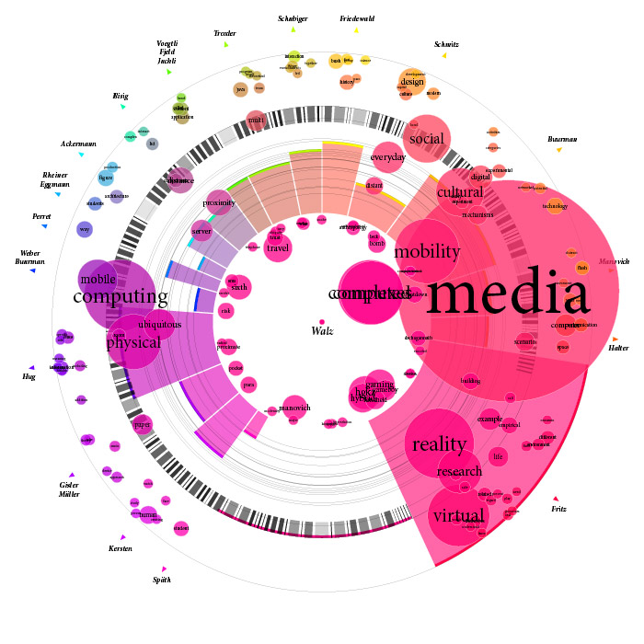
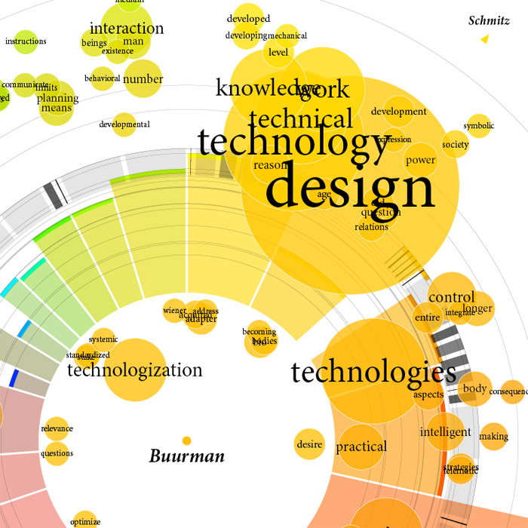
Index

0.1. Glossary 4
0.2. Abstract 5
0.3. Introduction 5
Part I - Current situation 8
1.1. Technology 9
1.2. OS GUI & API, HCI 10
1.3. Interface 11
1.4. Visualisation 11
1.5. Web 2.0 12
1.6. Perception and cognition 14
1.7. Learning and knowledge 15
1.8. Communication and identification 17
Part II - Current Needs 19
2.1. Customisability 20
2.2. Relationship with information: user and computer actors 22
2.3. Information contextualisation 24
2.4. Accessibility and awareness 26
2.5. Identification of self to self/community(s) 28
2.6. Knowledge Enhancement 29
Part III – Theory 32
3.0. Concrete example 32
3.1. Symbol manipulation 32
3.2.Meta-information and boundary objects 32
3.3. Dynamic agents 32
3.4. Knowledge systems 32
3.5. Communities of knowledge 32
3.6. Privacy and security 32
3.7. Utopia and current constrains 32
3.8. Representation 32
3.9. Example 32
3.10. New user 32
Part IV – Working model 32
4.1. Diagram and visualisation 32
4.2. Bookmarks service 32
4.3. Implementation 32
Part V – Further research 32
5.1. Collaboration 32
5.2. Development 32
5.3. Dissemination 32
Part VI – Conclusion 33

0.1. Glossary
Information: intelligible set of data outside an individual, before they assimilates it. In computer, even if information's raw core is binary code, it is presented to the user through various media as text, sound, static and moving images.
Knowledge: understood information, which has been assimilated by an individual or community through a perception and cognition process, and stored in the collective and/or individual memory system.
Computer: static or mobile electronic device with which its user can access and/or manipulate digital information, and that is networked to other computer in some ways, whether physically (Local Area Network), wirelessly (WAP, WLAN or Bluetooth) and/ or via the Internet.
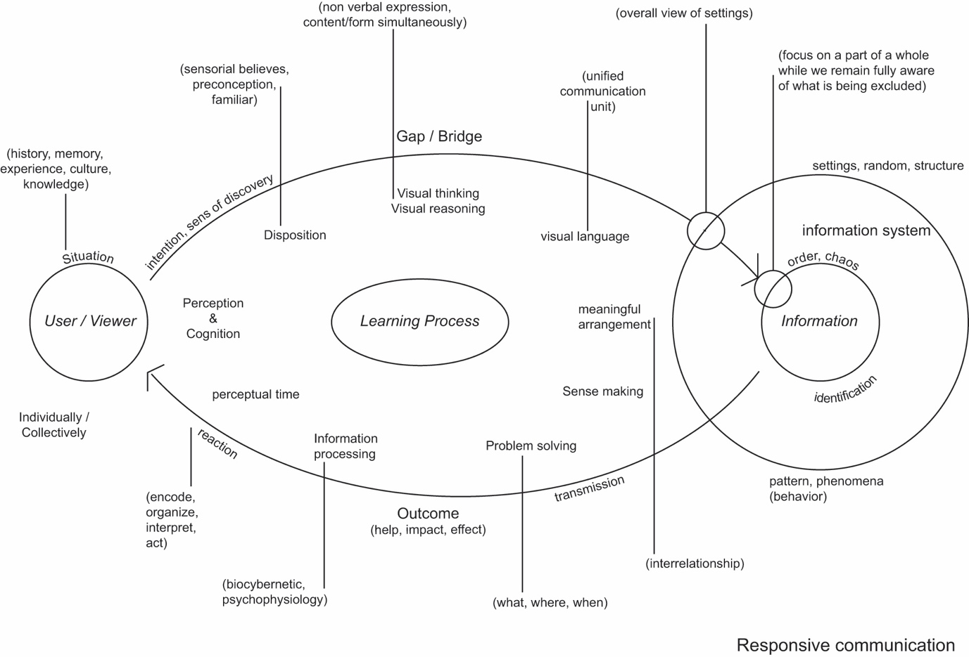
Figure 1- Responsive communication

0.2. Abstract
This research aims to create and develop the necessary tools to share knowledge between individuals and communities, using the meta-media abilities of computer technology. Moreover, those tools should enable an individual to manage their own thoughts, and make them understandable to others through personal and/or collective mediated interfaces. Those tools should finally serve to articulate the building process of thoughts around specific topics and concepts on both individual and collective levels, thereby establishing and developing a better understanding of a knowledge system, through its structure and the way it has been designed. The reader is invited to see the present paper as the first step in this research, acting as the groundwork essential to the building of the tools mentioned above.
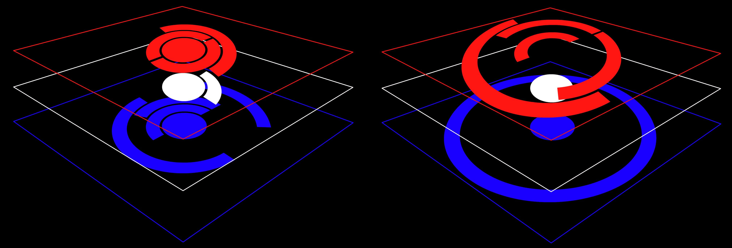
Figure 2 - Responsive Communication prototype 3D view

0.3. Introduction
Information is the basis on which human beings, communities and societies evolve, as it enhances individual and collective knowledge. We are information seekers, sharers and manipulators. Currently, our situation requires us to manage ever-increasing amounts of information - more than ever before, and this will not fade (I am not talking of the information we are continuously bombarded with by advertisements and the such, but about the information we WANT to relate to). Through technology, we have developed systems to cope with large amounts of information, and its digitisation through computers and the latter web technology acted as a breakthrough in the human being's relation to information. Twenty odd years later, the advance of mobile technology enables us to access 'virtually' anything and/or anyone, at anytime, from anywhere.
In such a 'wonderful' age, key questions about our relation to information are still unanswered: How can we efficiently and effectively access and retrieve information of interest, with such a vast amount currently available? How can we manage and communicate our knowledge, through information, using the full potential of available technology? Moreover, how can such technology use a system of information to enhance our knowledge further, revealing the process on which such a system has been designed?
Even if technology has evolved exponentially, one has to acknowledge it is not the same for mankind; we are able to learn more and better because of our surroundings, but the learning process hasn't really changed since prehistoric times. The way we deal with information through our perception and cognition processes, the use of our senses, and our neuronal network development, hasn't evolved for millennia. We have evolved a great deal as a collective of societies and communities, but their fragmentations into institutions and disciplines makes us experts in a few domains but ignorant in others, even when closely related to our expertise (rare arc those who can call themselves poly­ maths). We, as individuals, and furthermore as communities, need better means to share knowledge through information, from its access to its organisation. We need assistance; it is one thing to find an interesting article on the web that relates to a specific interest, it is another to have it stored in an easily acces­sible place, even a few years later.
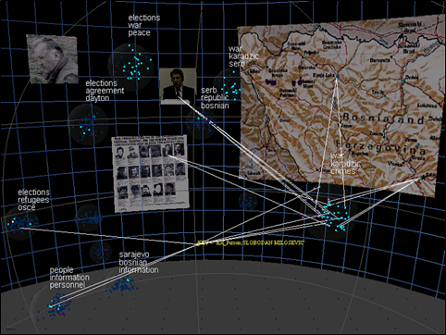
Figure 3 -
As a practitioner, lecturer and researcher, I find myself in a specific context, with bound­aries. Some of those boundaries I chose to define, but most of them have been put in place by my surroundings. One of great aspects of web technology is that those boundaries become blurred - if you know how to find your way through. Search engines, e-journals, forums, blogs, simple hypertext links... all can help an individual to push his boundaries, but one has to go out there and seek.
What if the technological systems surrounding us, virtual or not, could suggest intelligible ways to access relevant information? What if individuals could look at one another's thoughts, share knowledge and understanding by other means than communication as we traditionally conceive it? What if the information system itself could suggest various points of view for an individual/ groups to enhance their understanding?
Boundaries are everywhere: in an individual, in communities, institutions, and the various disciplines of expertise... We use and need boundaries to identify ourselves, but we could gain much more by sometimes transcending them in order to access new grounds. How can we make our personal and social boundaries evolve? As Brenda Dervin says, how can we bridge the gap between the various disciplines and institutions [Dervin 2005, 1999]? Some answer lies in the relation between hypermedia [Nelson, 1965], the boundary object [Leigh Star and Griesemer, 1989], and multiple agents systems. As a modern extension of V Bush's memex concept, hypermedia could act as a "storage space that can be consulted with exceeding speed and flexibility", as an "enlarged intimate supplement to memory" [Bush, 1945]. In the case of the boundary object, they are objects "both plastic enough to adapt to local needs and constraints of the several parties employing them, yet robust enough to main­tain a common identity across sites. They are weakly structured in common use and become strongly structured in individual-site use" [Star & Griesemer, 1999, 1989].
We, as user of electronic information, need a new kind of assistance in the management of complex(es) of information, and would benefit from structuring our thoughts externally. With the help of computers and the web (part of our everyday life) we could enhance our personal and collective knowledge man­agement (KM).
In the first part of this paper, we will analyse the individual and social disposition to manage knowledge through the various aspects of available technology. This will lead to the second part, which aims to identify our needs for information management, and define the problems of an actual information management system. We will then attempt to establish a framework for the creation and development of new tools to build interpersonal knowledge management systems, through the use of diagram and visualisation in interface, particularly in information and thought processes. We will then attempt to establish a model for such tools, in their application to a prototype of a bookmarks and artefacts management system. Finally, we will focus on the further research needed to achieve a satisfactory framework to produce such tools, both in the short and long term.

Part I - Current situation
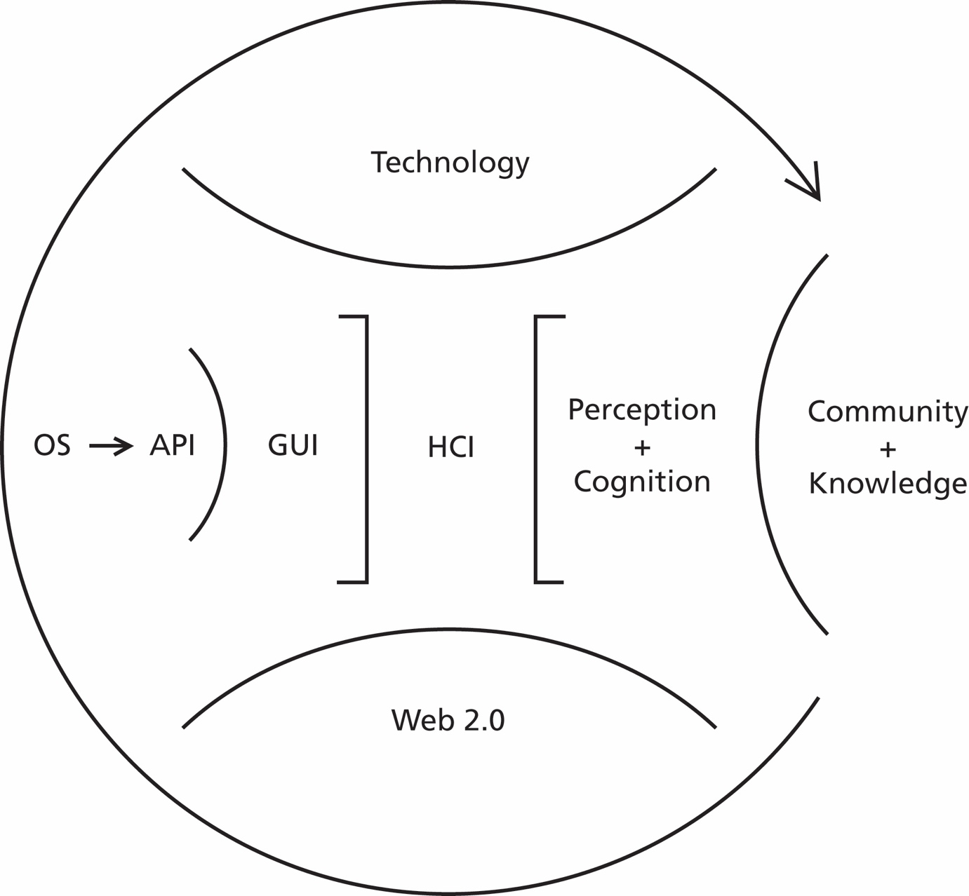
Figure 4 - Overview of computer assisted knowledge management

The various features established by technology and individual/collective dispositions define our current situation. As well as by our surroundings, we are shaped by the tools we use [McLuhan, 1969].
Starting with computer and web technology, external information and our access to it is being shaped at various levels, such as by the server that holds web information and its platform language, the Operating System (OS) of the computer from which informa­tion is accessed and managed, its Application Programming Interface (API), its Graphical User Interface (GUI), and the interface of the application. The Human Computer In­teraction (HCI) depends on all the latter.
On the internal level, our understanding of information is somewhat dependent on our disposition; depending on our culture, expertise of a specific environment and our existing knowledge, we get to assimilate information through our senses and our experiences, in a perception and cognition process. It is only then that acquired/gained information becomes part of our knowledge.

1.1. Technology
Being omnipresent in our every day life, technology has dramatically increased our 'consumption' of information, both on indi­vidual and social levels. From Internet access to computers in offices, in today's developed civilisation we cannot 'live' without the com­puter as part of our surroundings. In creating and adapting tools to our needs, we also have to adapt ourselves to them:
[[The] instruments man uses become extensions of his body. Most importantly, man must, in order to operate his instruments skilfully, internalise aspects of them in the form of kinaesthetic and perceptual habits. In that sense at least, his instruments become liter­ally part of him and modify him, and thus alter the basis of his affective relationship with himself. [...] One would expect man to cathect (i.e. invest emotional energy) more intensely to instruments that couple directly with his own intellectual, cognitive and emotive functions than to machines that merely extend the power of his muscles [Weizenbaum, 1976]
Seventy years ago, the Universal Turing Machine [A. Turing, 1936] gave life to a new concept of automation: the effective procedure, where a program will transform a computer into another, more specialised to execute a specific task. Today's computers are still working on the same principles, only much faster. They could do almost 'anything' - only if you possess the right program. Therefore, can we still call a computer a tool or instrument? According to Alan Kay, the computer is not merely a tool, but a 'meta­medium' [Kay, 1989]. It serves as extension of our brain (whereas tools in a broader sense define extensions of the body).
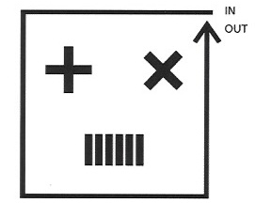
Figure 5 - Current computer - Turing machine

1.2. OS GUI & API, HCI
Nowadays what we call a computer is a set of programs layered at all levels from its hard­ ware to third-party application with which users manage information.
At the heart of our relation to the compu­ter resides the Operating System. OS is the system software responsible for the direct control and management of hardware and basic system operations. In short, OS is con­ceptually broken into three sets of components: a user interface (which may consist of a graphical user interface (mouse and graph­ ics) and/or a 'shell' (also called command line interpreter)), low-level system utilities, and a kernel (core software providing secure access between various computer programs and the machine's hardware). Through its Graphical User Interface (GUI) and Application Programming Interface (API), Human Computer Interaction (HCI) is possible. API makes the communication between third party software and the operating system possible, and, in addition to text, GUI enables users to interact with the computer through the metaphor of a 'direct' manipulation of graphical images/icons/symbols and virtual widgets (window, menu, button, scrollbar, tree view...) [Wikipedia, 1].
The user has to learn how to use the interface provided by an operating system through its GUI. It is made to facilitate the interaction between human and computer, but even if it tends to be intuitive, basic learning is required for the user to get to know the various ways with which they can manage information directly on screen, especially if they wants to achieve something specific with it. In most cases, a soft learning process (learning while doing) would be enough to get an understanding of the system's GUI basic behaviour. On top of that, the user also has to be aware of the API's behaviour within a specific OS, as it doesn't always provide them with the same interaction with infor­mation (i.e. difference between Windows Unix and Mackintosh OS). '
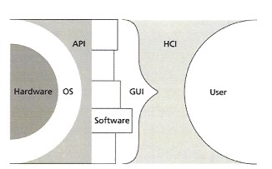
Figure 6 - Overview of the user-computer relationship
As stated earlier, the OS is supposedly intended to make the vital processes (effective procedures) in our communication with the computer more direct, making the multitude of layers of software between the user and the hardware penetrable, aiming to supposedly enabling the direct manipulation of information. But in fact, at present, this separates the user from the process of handling the information, and the resultant opacity is frustrating for users - and it seems to increase in newer versions of OS - as users never have complete control over information; the interface layers separating them from information will always have control over the way they can - or not - manipulate and manage information. The walls are closing in; we are alienated from our core purpose in using computers as information processors, as extensions of our mind.

1.3. Interface
An interface is a means to set some kind of interaction between two entities of different natures. As human beings have been creating tools as extensions of themselves (body and/or mind) that serve their relation to the world, the interfaces of those instruments have been designed according to their purpose and the way they are to be used.
In the case of the computer, the user inter­ face is the metaphorical 'platform' by which a user interacts with the computer, providing means of input (user control of system) and output (system informing user, also called feedback). An interface cannot be simply implemented, as it is regimented by OS, its GUI and finally by the third-party software - and their application through API. Visualisation is an important part of our understanding of information, as it shapes our experience of it within the specific - mainly graphical - metaphorical context given by an interface. Its assimilation through visualisation enables us to understand it in the perception and cognition process, which internalise, compare and store information into our knowledge base.
The richness of the interface provided by a software and/or the OS may vary a great deal from one application to another, and might enable the user to identify the specific features of the program with which they can metaphorically manage information. But overall, the lack of control a user has over the interlace - and therefore the given experience - often alienates them from both information itself and the possibilities to manage information
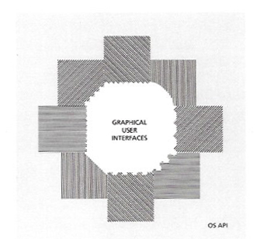
Figure 7 - User confrontation to different applications' interfaces

1.4. Visualisation
Human beings have a natural ability to re­ member and use visual elements. Through
research, it has been proved that images and graphical representations are superior to verbal-sequential ones, at all levels (assimilation, learning, recall, performance) [Kosslyn, 1980; Shepard & Cooper, 1982; Larkin & Simon 1987; Mandi & Levin, 1989; Weiden-Bauer &Johnson-Laid, 1993; Novick, 2001; Swaab et al., 2002]. "If visualisation is applied correctly, it dramatically increases our ability to think and communicate" [Eppler & Burkhard, 2004]. In the field of information visualisation, it has also been recognised that a user has great ability to discern patterns and abstracted complexes of information, which amplify cognition [Card et al, 1999].
As Martin J. Eppler and Remo A. Burkhard state, "a metaphor provides the path from understanding of something familiar to something new by carrying elements of understanding from the mastered subject to a new domain".
Conceptual diagrams, such as Toulmin diagram, flowchart and mind mapping, also help to organise a specific problem visually, aiming for better understanding by the definition and identification of the different parts/aspects of the problem and their interrelation.
Various attempts have been made in recent years to use visualisation and interaction within computer application, but yet again, even if they need rules and boundaries to get a compelling experience, the user cannot appropriately and personally engage with information and its structure, because its representation is being dictated and regimented by the application's interface and functionality.
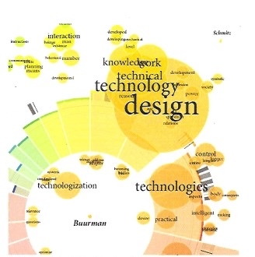
Figure 8 - Graphical visualisation of keywords - UASA Zurich

1.5. Web 2.0
The World Wide Web (WWW) is a vast pool of information, structured as a chaotic net­ work. Hypermedia enables links and pointers to act as wormholes, where the user may 'jump' from a set of information to another, within the same page, same site, or on another site. Information on the web is organised in virtual clusters, as it is shaped by the way it is accessed and categorised.
There are three ways to access information on the web. Firstly, applications on the user's computer, such as a web browser, can act as a platform where user can access informa­tion contained in a web 'page', via a specific web address, which needs to be known in advance (specific Uniform Resource Locator (URL)). Such application as a web browser usually contains 'rudimentary' tools to re-access specific webpages, like an index of the 'history' of the pages accessed and a 'bookmark' system in which the user can record specific web addresses - URLs - of interest for later use. Secondly, web services, like search engines, can enable a user to query a search for specific information through catalogued webpages. The query needs to be accurate enough to display results of webpages that contain information relevant to the user's query. Such results are also structured depending on the search engine's own search algorithms - opaque to the user, information popularity, and the way webpage content that is described through metadata (the reader might note that the search results of a search engine can be 'corrupted' by commercial is­ sues such as advertising and pay per click). Thirdly, the various hyperlinks found on a webpage (place holder where various sets of information can be found at the same time) are specific 'tagged' information - usually images or group of words, which redirect us­ers to related webpages via web addresses. Using any of the latter, a user still has to find their way through the web, and will get only little awareness on their way to information, as well as of whether the webpage they have been directed to is of any relevance to them.
The only 'chance' they have to get to information of interest is through the way it has been classified (taxonomy) and the use of keywords. The whole of the Internet is built and classified around keywords and machine-readable data - web semantics and ontology (Tim Berner Lee, 2001]. It is our only possible way to refer to and access in­ formation 'effectively', and we are making the most we can out of it. It has been noticed that the key to success on the web is easy ac­ cess to information, as well as its popularity. If information cannot be found, it ultimately dies away.
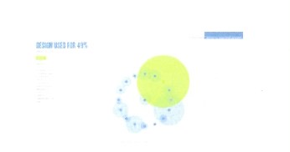
Figure 9 - Revealicious.com - Flickr tagging visualisation
Given the right tools, every user can actively engage with information. The phenomenon has already started. The power is shifting towards the user. The web becomes services provider. As Tim O'Reilly explains, Web 2.0 is the worldwide phenomenon enacted on the web, where a new set of tools, called social software, enable users to get control over information content and the way it can be accessed (T. O'Reilly, 2005).
Moreover, with the emergence of websites such as del.icio.us, wiki.org, flickr.com, bitzi.com, users are able to share their personal information with other peer part of the same virtual communities (i.e. other users who ac­ cess the same web site where information is being held). User Generated Content (UGC) is becoming an increasingly important part of the web; it is the main strength and value of web sites like Amazon and other peer re­ view sites.
Two other noticeable web phenomena are the popular use of blogs, where a user publish his own bits of information as a chronological list, and RSS feeds (Rich Site Summary), where summary of newly published information of a web site can be accessed remotely. Even Google and Yahoo, the two major search engine corporations, are now implementing a multitude of web services, some of which enabling users to create, use, tag and/or share information. By tagging information - attributing a set of keywords that 'defines' it on a semantic level, whether it is a picture, sound, video, bookmark or electronic text, users can appropriate bits of information to themselves (and others) with their own terms, and can also retrieve infor­mation relative to those terms; this personification of information is called folksonomy by some - social classification by others, and differs from formal taxonomy and web classification by the freedom it gives to any user to refer to information according to his own terms (i.e. idiosyncratic tagging).
The Web 2.0 phenomena appear through the users' creation, sharing and engagement to/with information, and combined with open source software, it enables the sharing of both content and/or context. In those surroundings, acknowledgement is the key to success; the more a service is used, the more acknowledged it is. And in order for users to keep coming back to the same place, information as well as services constantly needs to be current and regularly updated with new features ('Beta version' effect in software improvement).
But users and companies become confronted with new problems, such as power, judgment, trust and belief in published information, not to forget retrieval efficiency. With so many pieces of information in so many places, what and who can be trusted? How can we get power over the big corporations that are in control of web information re­trieval? If users can define information with their own terms, how can others retrieve it if they don't use the correct keywords?

1.6. Perception and cognition
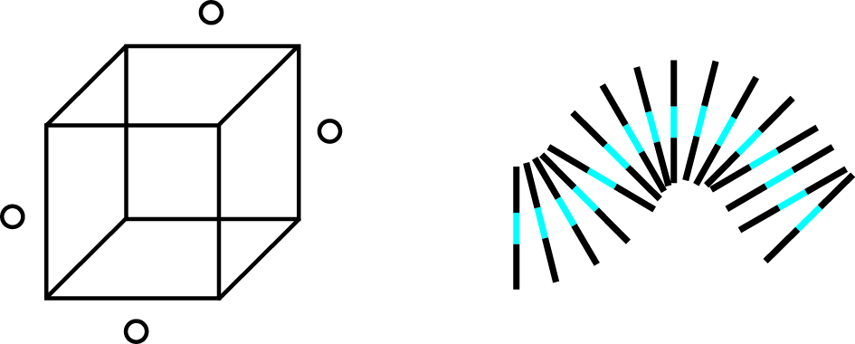
Figure 10 - Neckercube and Neon worm
Human beings use their cognitive processes - particularly vision, to make sense of the world they live in. These processes enable us to recognise patterns that benefit our understanding, on both conscious and unconscious levels. "Vision is a process that produces from images of the external world a description that is useful to the viewer and not cluttered with irrelevant information" [David Marr, 1982). Our perception is a well-crafted 'tool' that helps us to recognise patterns. Intertwined with the cognition process, it allows us to interpret our surroundings, making them intelligible. Our ability to express and incorporate information are other great tools in understanding and communicating meaning. "Vision is not merely a passive perception, it is an intelligent process of ac­tive construction" [Hoffman].
As Arnheim explains in 'Visual thinking', the brain stores each experience as a unique entity, made of all sorts of concepts intertwined in the mind. Our ability to abstract from our experience is the uttermost quality that serves our understanding and communication. We can internally store two kind of images: the 'memory image', which acts as a photographic image as real subject, and the 'general image', which act as a representation of the subject (e.g. thinking about 'hat', one doesn't get a specific image of it, but its concept).
In children drawing, one can observe the statement communicated by the child as a visual concept, rather than a simple pictorial representation. A child is able to abstract a phenomenon to focus on the essence of the intention. They doesn't care about not drawing the legs of a rider, or shaping the horse as a circular mass encompassing the rider [R. Arnheim, 1969]. But as we grow older, our mind becomes trained to communicate, it becomes meticulous on the various aspects that need to be translated in a logical, more 'realistic' system.
We have to make sense of the environment we live in. The act of abstraction enables us to recognise, appropriate, assimilate and understand various concepts in and out of context, through the identification of a complex of entities, where acquired knowledge helps to define the underlying structure that connects the various elements that are parts of the system.
Abstraction is made consciously and/or unconsciously, depending on the focus and intentions. Therefore, our ability to select information of relevance is an intrinsic part of our thought process and action. Concepts are abstractions/representations of the various elements we are able to discern as part of an experience, defined by their nature and function in their interrelation. New concepts are acquired through repetition (memory) and experimentation, as well as in the combination of already acquired concepts.

1.7. Learning and knowledge
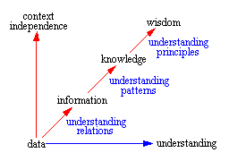
Figure 11 -
Learning is the process of understanding information, which allows an individual to formulate new mental constructs (concepts), or else revise prior ones. In neuroscience, the learning process can be observed in the stimulation of the neuronal network. "The stronger the stimulation of the brain, the deeper impression is left in the neuronal net­ work" [Wikipedia, 2).
It is a process that depends on experience, and leads to long-term changes in behaviour potential; if the learned 'object' is not maintained through time, it would eventually be lost by the individual. There are various methods for learning, and it is often stated that non-verbal elements ease the process: "human cognition is specialised for dealing with language and with non-verbal object and events" [Paivio]. The most common method is imitation, in the personal repetition of an observed process, taking place in time, space, skills and other resources. Applied learning is another effective way to understand information, through examples, practice and experience.
Knowledge, as I stated at the beginning of this paper, is enabled by the internal assimi­lation of information through understanding. If we were to represent the way information is shaped and formulated both externally and internally, the most adequate metaphor would be a pyramid, where knowledge stands between information and wisdom. Data (raw information) would naturally be the base of the pyramid, from where infor­mation is formulated.
Philosophy has established two ways to acquire knowledge: objective knowledge - objectivist philosophy - is assimilated by being told, whereas constructive philosophy focuses on learning by doing - applied learning, 'situating' cognitive experience, also called 'soft learning'.
In knowledge management (KM), differentiation is made between propositional and procedural knowledge; also called explicit and tacit knowledge, the distinction is made on whether knowledge can be stored and shared directly or not. In explicit knowledge, 'knowing about' a specific topic, such as is found in manuals or documentation, can be acquired directly. In tacit knowledge, knowing how' has to be applied through practice or social interaction, in order to be understood.
In the interest of this research, procedural (i.e. tacit) knowledge, applied learning and constructive philosophy are key to knowledge sharing through computer environment, as they stimulate individuals to directly engage with the system of information in the way it is presented via the interface.
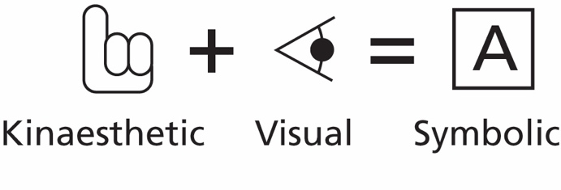
Figure 12 - Jean Piaget learning stages
The cognitive psychologist Jean Piaget [1926, 1928, 1952) defined three distinctive intellectual stages in children from birth to maturity: the kinaesthetic stage, followed by the visual stage and finally the symbolic stage. Later, Jerome Bruner [toward a theory of instruction, 1966] redefined those stages as enactive (doing), iconic (image) and symbolic, which represent the best - natural - process to learn. After Kinaesthetic and iconic cognition, intuitive knowledge is finally in place, serving the manipulation of symbolic processes, necessary for understanding and knowledge enhancement in applied learning. Those principles are the fundamental basis of soft learning in interactive environments.
As Kay explains in his paper, computer technology has changed the thought process of an entire civilisation - as the printing press did previously; the immediacy of access to the ever-growing and already colossal amount of information currently available cannot be managed without the computer and commu­nication technologies.
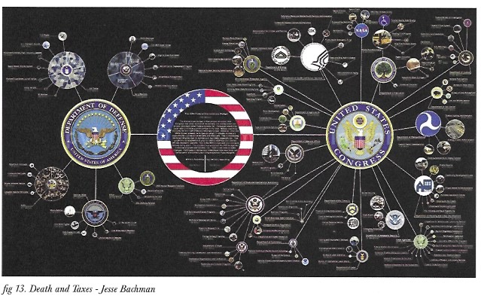
Figure 13 - Death and Taxes - Jesse Backman

1.8. Communication and identification
The problem in the information age is the core of its function: communication. We have all sorts of tools/devices in order to receive/ access and send exponential amount of information of various natures on the move. We are connected. With so much to do/have/ dispose of, it is easy to get confused, and lose our way, to and from our current situation, especially if we are new to the specific communication context/device.
Our cultures are merging. Of course, our dispositions in the physical experiential world and our development in a specific context have shaped our infrastructure, but this infrastructure is becoming increasingly loose. Depending on our individual development, it can become easier or harder to find our proper identity. Before the computer/information age, either we didn't have much choice, or we had simpler ones. What surrounds us always inspires us. Nowadays, one could say we have too many choices, but it also means we can build our own, unique identity. Obviously, The narrower the surroundings, the more predictable our future will be. The broader it is, the more we can evolve in different ways.
What makes us who we are as individuals? We are defined by a set of boundaries. Boundaries shape us. We need them in order to evolve, but they need to evolve with us. It is becoming increasingly rare to be bound to only one community. Time is changing. Time is for sharing. Complaisance is a term that identifies the comfort one can feel in one's own environment. Nothing is wrong with that, but we must also be aware that un­ less our 'world' is shaken, we would hardly move.
Institutions and corporations are very much set and anchored in such boundaries, and it proves to be their main difficulty in evolving to meet the current demands effectively. And the lack of communication between communities/institutions - even between the various groups within them - can be observed in individuals who are striving to get answers within their own field, answers that might already exist some place else. Cross­ disciplinary knowledge is practically inexistent. Only now can we see an emergence of individuals raising the issue, like Brenda Dervin. Lack of knowledge presents a lack of communication, but the means to communicate are not made available to us ei­ther. Territories/boundaries are fundamental to define an entity, and act as an important part of its development, but sharing is what our societies/institutions/disciplines lack of. We work/are confined within closed walls. It is sometimes necessary, particularly in research, but it also means that various approaches can get to the same answer, and the same approach can get to different answers. Plurality is not a bad thing in society, on the contrary, but through history, this paradox reflects human's struggle to find appropriate answers that enhance our race's wisdom. The commonalities in such endeavours are the bridging points that shouldn't be missed in order to reconnect our knowledge.

Part II - Current needs
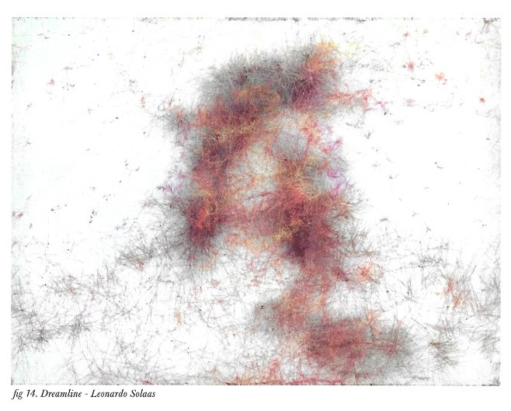
Figure 14 - Dreamline - Leonardo Solaas
We have established the current situation in which we create and access information through computer technology.
As stated earlier, even though we are supposed to have all the necessary technological means to be more 'connected' than ever before, we have in fact become more alienated from our surroundings. By having to deal with too much information, by the opacity of computer processes, by the rigidity of interfaces and by not having enough control over the computer, and more specifically the way it works, the user is separated from the core of his intentions in using a computer: managing, manipulating, and in the end, understanding information. Furthermore, those settings keep us from communicating effectively, as transmitting only information is not enough to share our knowledge; neither can we engage with information according to our own disposition, nor can we appropriate it effectively to be able to communicate our thoughts. We are not in control, and we are not given the power to be.
The computer's role in communication is crucial, as it is not only the mediated plat­ form through which we can access and convey information as message, but also because it acts as an active participant in the process, shaping and relating information, even if still user-dependant.
Overall, we need a better relationship with information through the computer, in its organisation and definition, but also in the processes in which it is being shaped.
In the computerised environment, applications and their interfaces set the boundaries in which users can manipulate and manage information. But the way information is displayed and accessed, from its individual structure to its relationship as part of a system of information, is somewhat opaque to us.
By establishing new ways to manage information systems, we could have more flex­ibility in our relationship with information. If interfaces were to be more customisable, we would get control over the software's management of information not only in its organisation and display, but also in the functionality it has over information.
Our access to information has to be restructured between the various relationships that take place in the process; the communication and understanding of information between users, between the user and the computer, as well as within the computer - in the relationship the various programs involved have with each other.
By using computer to communicate information meaningfully, those relationships would be able to convey more means to understand the purpose of a specific set of information. As the computer serves our relation to the world, this would create a new framework where users could not only make more sense of information, but also where the computer would give them more possibilities to get access to other related information which would enhance their knowledge. Furthermore, it would also mean that users would be 'connected' within virtual communities shaped by the sharing of the same information, enhancing their own set of boundaries in the process, therefore enhancing their sense of self.
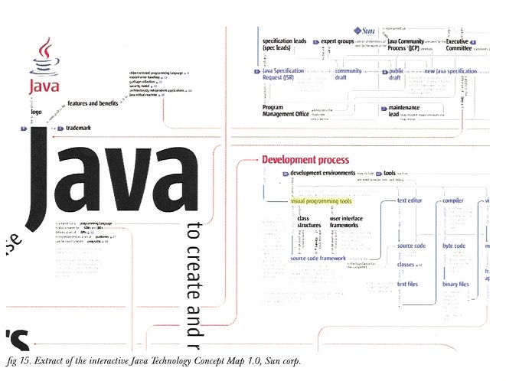
Figure 15 - Extract of interactive Java Technology Concept Map 1.0, Sun corp.
Given the right context, information could make us more aware of its interrelation as elements of a system, and would therefore make it more accessible in its organisation and behaviour, as each part of the system would give us clues about their specific role in it, thus enhancing our individual disposition to understand the complex of information.
The processes need to become open again. Interfaces have to be more intuitive and customisable. The computer should be able to 'listen' to us and recognise our intentions from our behaviour. It should be given the means to read user's expectations and disposition, thus giving the user enough freedom to be in control.
As we will discuss in the second part of this report, by enabling the computer to properly behave as an extension of our mind, it would be able to give better feedback and assistance to the user in their relationship with information; not merely using effective procedure, but in a much more sensible way, according to users' needs on both individual and collective levels. This can only happen if the user is able to shape their thoughts around information, and if information is able to carry - at some extent - the user's thoughts.

2.1. Customisability
If we were to be in control over the way in­ formation is shaped and presented, we would also be in control of the way we work with it and relate to it.
Our relationship with information takes place in the interface. By making it more intuitive and customisable in the way it displays and relate to information, we would finally gain real control over our management and manipulation of information through the computer.
Different sorts of information have different natures. As we evolve through a concept, we usually have to deal with various kind of information (text, static/moving images and/or sound), from various places. We would greatly benefit from being able to get to the bits of information of interest in an intuitive way, not only to manipulate its content, but also to shape its context as we please; at present, we have various software designed to deal specifically with certain kinds of information. An application provides us with only very restricted means to create relationships between information; we can't link pictorial information to textual information other than spatially, whether it is within the same entity (i.e. a document or a file) or within a specific and narrow context (i.e. a folder). The only meaningful context we can currently give to information manipulated -in a software is only conceived and associated in our minds, as part of thoughts. We cannot express our thoughts to the computer, because it simply doesn't have the means to 'understand'.
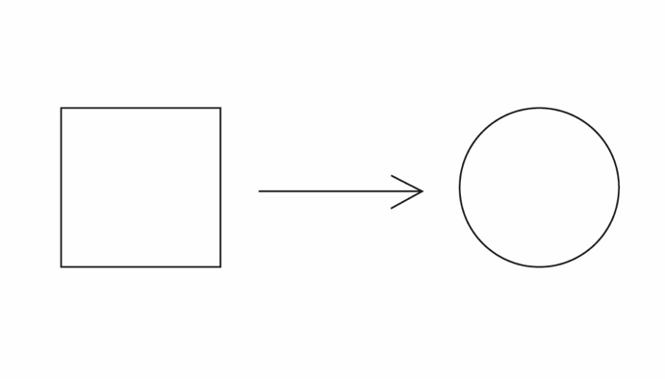
Figure 16 - Customisability
We have all those technological tools, devices and applications to develop our knowledge and identity through communication. If we are lucky enough, we are able to find those that are right for us. But why can't we have more flexibility over what those tools do, display and process? Moreover, why don't we have control over how they 'communicate' with each other?
Based on the main framework that enables a user to manage their personal information, that is, on one hand the web, and the per­sonal computer/device on the other, the user would benefit tremendously from a more intimate relationship with the computer environment, which would 'know' who the user is.
The processes of managing personal or general information should be shaped through our individual knowledge, by the mental constructs with which we internally create relationships between information. The technology ought to offer a more fluid management of information through the various devices we use, based on our individual - and social - settings.
A computer's primary function is to execute 'effective procedures'; it will only do what it has been asked to do. There can be a chain of reactions triggered by a specific action (feedbacks), but in the end, computer programs that relate to each other around a specific task are solely concerned to achieve the task in the way they have been assigned - designed - to proceed. Software that are evolved enough give users the possibility to add a 'plug-in', which in itself is a small program that has been specifically designed to execute a specific task in relation to the software. But the functionality of such plug-in is very limited, and is in no way customisable. What if the computer had more decision power? What would happen to our relationship with information through the computer, if it were able to discern our behavioural management of information, and was given the means to assist us in 'the process?
Why cannot a software do more than it has been designed to do? Ideally, interfaces would be set not only by the team of designers/developers who have built the program, but also by users themselves. This would require a great shift in software development, but such phenomena have already started to appear in the open source community; even if restricted to developers for now, we, as users, can get more and more in control over what the software is and does. We don't want closed systems anymore. Software is to be designed with/by its users. As we will discuss later, dynamic agents can help us a great deal in our relationship with informa­tion through computer.

2.2. Relationship with information: user and computer actors

Figure 17 - Abstraction of the ideal relationship between computer and user
The essence of our relation to information is in our communication facilities with and through computers. Who has control over the communication of information? Users? Computers? Information? In fact, no one does.
By being able to give information specific attributes and parameters, it would make it independent from the system, enabling the bit of information to have its own context. This would give it enough substance to allow the various actors taking part in the various processes of its creation/communication to gain more control over information, in their awareness, access, management and manipulation of it.
Information is the core of communication. It serves our means of dialog, both internally and externally. Our relationship to information and the way it is being used can be de­ fined at three levels: in the inter-communication between users, their communication with computers - whether individual or collective, and the internal communication of the computer with itself (system theory).
Some might argue that we don't communi­cate with the computer, nor that communication occurs in a computer system, but the exchange of data/information that takes place provide some form of communication, even when restricted to regulatory feedback (cybernetics, [N. Wiener, 1968]).
As stated earlier, the computer acts as an ac­tive participant in our relationship with in­ formation by shaping it. But it neither gives the user the ability to have an overview of the information system, nor the tools to manage this system. Thus it only 'pretends' to act as extension of our mind.
At present, we have to build our relationship with the computer - thus information - using various layers of software. We are only able to do what the software enables us to do. By not giving the computer real means to act as extension of our mind in the way it deals with information (on our behalf), we are prevented from being in control.
We have to stop fearing what the computer would do if it weren't a mere automated machine dictated by the user. We need to give it some 'autonomy', from which we would ben­efit a great deal (OS and applications func­tionality are currently opaque to the user). We would be able spend more time to do what we are good at - think and understand - and let computer assist us in our work. Only then a real communication would be able to take place, in which we would be assisted in our relationship with information. In fact, as applications are being tailored to deal with particular information in specific ways, the most profitable use of a computer program has been to make it do something it was not designed for. This 'accident' is how a lot of new kinds of software came to life. If an application were to provide the means for e user to get control over its functionality, it would enable them to use their own creativity to get new inspirations over their ma­nipulation and management of information.
The essence of our relation to information is in our communication facilities with and through computers. Who has control over the communication of information? Users? Computers? Information? In fact, no one does.
By being able to give information specific attributes and parameters, it would make it independent from the system, enabling the bit of information to have its own context. This would give it enough substance to allow the various actors taking part in the various processes of its creation/communication to gain more control over information, in their awareness, access, management and manipulation of it.
Information is the core of communication. It serves our means of dialog, both internally and externally. Our relationship to information and the way it is being used can be de­ fined at three levels: in the inter-communication between users, their communication with computers - whether individual or collective, and the internal communication of the computer with itself (system theory).
Some might argue that we don't communi­cate with the computer, nor that commu­nication occurs in a computer system, but the exchange of data/information that takes place provide some form of communication, even when restricted to regulatory feedback (cybernetics, [N. Wiener, 1968]).
As stated earlier, the computer acts as an ac­tive participant in our relationship with in­ formation by shaping it. But it neither gives the user the ability to have an overview of the information system, nor the tools to manage this system. Thus it only 'pretends' to act as extension of our mind.
At present, we have to build our relationship with the computer - thus information - using various layers of software. We are only able to do what the software enables us to do. By not giving the computer real means to act as extension of our mind in the way it deals with information (on our behalf), we are prevented from being in control.
We have to stop fearing what the computer would do if it weren't a mere automated ma­ chine dictated by the user. We need to give it some 'autonomy', from which we would ben­efit a great deal (OS and applications functionality are currently opaque to the user).
We would be able spend more time to do what we are good at - think and understand - and let computer assist us in our work. Only then a real communication would be able to take place; in which we would be as­sisted in our relationship with information. In fact, as applications are being tailored to deal with particular information in specific ways, the most profitable use of a computer program has been to make it do something it was not designed for. This 'accident' is how a lot of new kinds of software came to life. If an application were to provide the means for the user to get control over its functionality, it would enable them to use their own creativity to get new inspirations over their ma­nipulation and management of information.

2.3. Information contextualisation
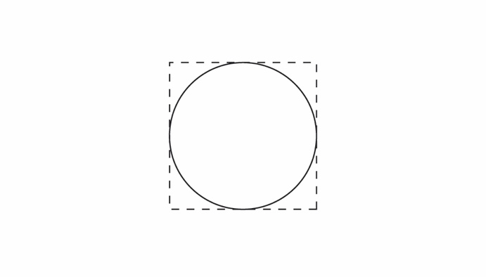
Figure 18 - Representation of information contextualisation
The contextualisation of information could be defined at two levels: in a system of in­ formation, and in a boundary object, where each bit of information is defined by its man­ifestation as part of the system in its interrelation with other elements constituting the group, and also where the sets of qualities/pa­rameters/keywords can help to define a spe­cific set of information (system); "As boundary object, information would retain its core while benefiting from personal or collective attributes that defines it locally and/or globally" [Star and Griesemer, 1989].
The manifestation of information in a specific context is crucial to assimilate it as part of our knowledge through understanding, and should be assisted by the interface. But as the interface doesn't give us control over the contextualisation of an information system through customisable settings and display, we can only make sense of such system and its components according to our understanding of it in the context provided by the interface.
Users should be able to use their own knowledge and disposition to contextualise information both as part of a system and as an entity.
In the process, the user would be able to externalise their thoughts and knowledge around information, whether it is in organising the system, its display, or assigning meta-keywords attributed to its various components/ elements. By effectively relating to information, the user could then create, manipulate and manage information systems that would enable them to externalise their knowledge further. Thus, with the right set of qualities and parameters and the assistance of the computer, the contextualisation of information, both in its display and attributes definition, can become external knowledge. At present, it can be very tedious to retrieve information, but it is also a fundamental issue in today's information society. On one hand, the search for information can be automated by the computer: some companies have developed applications that can catalogue every single piece of information given to it. The search capacities of the application within the system of information is crucial, as such programs don't give their users an intelligible display of the system of information. This is where the collective classification of information - contextualisation by keywords - also becomes vital; a user, not knowing the specific content he seeks, might be able to retrieve it thanks to a keyword that defines the specific bit of information in which it is contained.
On the other hand, the search can be made visually by the user, in the recognition of patterns, behaviours and phenomena hap­pening in a system where information manifests itself visually. Specific environments (research, business analysis...) already work closely with data visualisation, as they need to identify specific phenomena manifesting themselves as patterns in a complex system of information.
As stated earlier, our perception and cognition processes are very good at pattern rec­ognition. Thus, information that manifests itself graphically within a system gives users better accessibility and awareness. Therefore, visualisation of information enhances their knowledge, in their understanding and recognition of patterns in the display of information's structure and organisation.
We should be able to get more understanding from GUI thanks to visualisation, enabling a better relationship between the user, the computer and information.
How can we manage information efficiently? How can we access/retrieve the right infor­mation in our own information overload? What means do we have to access/retrieve knowledge externally?
We need to contextualise information, whether the language used is verbal or not. It needs to manifest itself in an intelligible way. Does the current structure of information enable its efficient access? We need to appropriate information, engage with it and internalise it for it to become part of our knowledge. At the same time, we need to externalise our knowledge around information to communicate it more effectively and meaningfully.
Because we have so much information to deal with, we cannot manage without the help of the computer. We need assistance. Literally, the computer has to become extension of our mind. The time has come where we need not only physical tools, but also mind tools to filter information, knowledge and thoughts.
Some applications such as myBrain, myLifeBits, or freeMind have been designed for users to be able to visually manage the various bits of information that are part of a system. But even if one would expect it, the user has no control over what the software can do or the way it displays information.
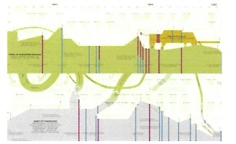
Figure 19 - American civil war history map – Historyshot

2.4. Accessibility and awareness
Wayfinding is an architectural term. In recent years, Peter Morville started to apply it to the computer environment, more specifically to the web (P. Morville, 2001, 2005). It means the way we get to information of relevance, regardless of the process and media involved, whether by browsing, searching, retrieving and/ or organising artefacts of electronic information. The problem is in the opacity of the categorisation and relationships between information that prevails their access.
Overall, we need awareness to build our knowledge, individual and/or collective. We have too much information to deal with, too much to think about. We need a platform where we can use our thoughts and existing knowledge, in order to access, manage and relate to information of relevance.
To do that, we need to be able to manage more than the information's content. What we see usually don't get the entirety of a piece of information, but only the tip of the iceberg. The visualisation of information could carry and/or hold all relational link­ age to other bits of information, as well as metadata defining it (part of its context), that can potentially help to access new related/ relevant information. This would enhance our knowledge, as our relationship with information would be made accessible in our manifestation as part of a visual system.
A graphical user interface is known to be a window through which a user is able to ac­ cess and manipulate information in a non­exclusive text-based environment. It is also known that graphical display of information, such as diagram and symbols can be more readily intelligible than text. The problem arises with the graphical language used in the display of information. If one doesn't have the skill/ability to decode/decipher the metaphorical structure of the GUI, one cannot interpret the meaning of that such display. But according to their disposition, users can create through the computer a representational visual system that makes sense to them - not necessarily to anyone else.
But such visual display and organisation can only happen if the computer is able to re­ late to information - and/or be instructed as to 'what' it is for the user - in the way we mentally relate to symbols. The plurality of meaning in words used in spoken/written language is already complex, and the complexity is even more pronounced in visual language. Because we acquire the ability to manipulate symbols through our experience and understanding, with the right associations, we could make the computer have some 'understanding' over our relationship with information. As stated earlier, only then would the computer be able to manage meta-information containing part of our knowledge (keywords, attributes...) and display it accordingly - and meaningfully - through visualisation.
Furthermore, with the use of dynamic agents - small self contained programs - making sense of the user's behaviour and experience, the computer would also be able to learn about 'how' we relate to information and replicate such behaviour. It could even be able to translate a foreign representational system into an intelligible system to which we can relate, still holding its core meaning both in information content and relationships between its various elements.
The system of information conceived by an individual should be intelligible by another, regardless of their own mutual dispositions. Even if completely new to the computer, the user should be given the right settings for them to evolve in the experience through understanding, not being overwhelmed by redundant functionality and metaphors they cannot refer to, through lack of knowledge of the system and interface.
This underlines the mutual learning process that both users and computers would experience in the user's management and manipulation of information offered by the computer. By giving a user the ability to evolve through and with information, the program would also be able to evolve according to the way it is being used.
We can't possibly spend more time than we already do seeking and managing information. As the access to information has increased to unprecedented levels, we need new tools to do part of the job for us, for our internal self to focus on what we are good at, acquiring knowledge.
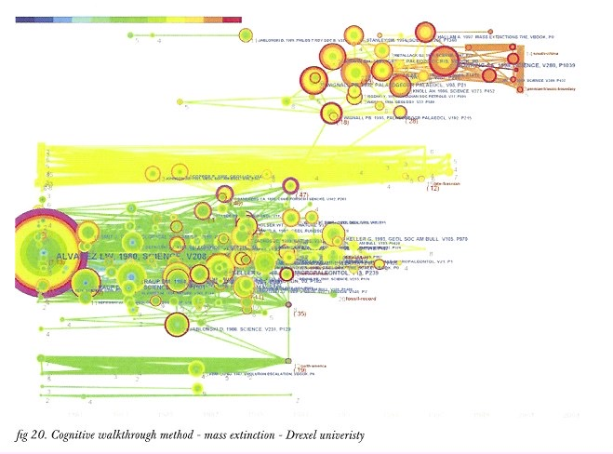
Figure 20 - Cognitive walkthrough method - mass extinction - Drexel univeristy

2.5. Identification of self to self/community(s)
We need better notions of our 'self' and its relation to the various communities, both the ones surrounding us and those we are not aware of. The 'self now includes the mind extensions we use to manage information, in its access, assimilation, and incorporation from/to/in it. The 'self' defines both the individual's mind and the mind extensions they use. Our identification can be helped by the way information manifests itself in the web, in its presence and inter-relation.
We are information, and we are message. We exist outside ourselves. We are driven by a set of boundaries defined by our surroundings. Those boundaries have been extended thanks to technology, but don't necessarily reflect our 'self within the communities in which we do/ can belong.
The computer can give us more potential over our external thought processing, there­ fore over our identity. How and what information we use is what matters. With it, the computer can reveal to us the communities we might be part of, as they would use the same information, or else use it in the same way.
A boundary object is an entity which "mediates communication between various in­dividuals or groups" [G. R. Goodall, 2004]. (Boundary objects are those objects that both inhabit several communities of practice and satisfy the informational requirements of each of them. Boundary objects are thus both plastic enough to adapt to local needs and constraints of the several parties employing them, yet robust enough to maintain a common identity across sites. They are weakly structured in common use and become strongly structured in individual-site use. [...] Such objects have different meanings in different social worlds but their structure is common enough to more than one world to make them recognisable, a means of translation. The creation and management of boundary objects is a key process in developing and maintaining coherence across intersecting communities] [Bowker & Star, 1999]. For the purpose of this research, I would define the boundary object not only as serving the communication between communities, but also within a system, as J. H. Fujimara states in her book, as 'standardised package'. [It is a grey box which combines several boundary objects [...] in ways which further restrict and define each" [Fujimara, 1992].
By defining bits of information as boundary objects, their relationships within a system becomes more fluid and meaningful, for the user as well as for the computer, as both can engage with them independently. Using dynamic agents, the computer can assist us in our manipulation and management of information shaped as boundary objects.
We would gain both personal and collective identification, as we can individually and socially set attributes to the same information - contextualise it with our knowledge - without distorting its core content. The boundary object therefore becomes not only a connection between individuals and communities but also a way to share their respective knowledge.
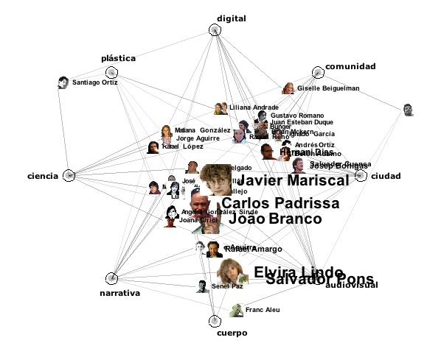
Figure 21 -Ppeople network , Bestiario

2.6. Knowledge Enhancement
We communicate with our own means and needs. As stated earlier, thanks to dynamic agents and boundary objects, the computer can be used as a platform to debate and communicate meaningfully with ourselves, and with one another. If users were able to shape their thoughts visually, they would be able to define them metaphorically, with their own chosen set of meaningful attributes. By being able to create meaningful parameters that define information in boundary objects according to their own needs and disposition, users would define the interrelation of their thoughts, in a way the computer could be able to relate to.
By enabling an individual to construct their thoughts, see their thought process, and externalise their thoughts in a way that it can still remain knowledge, as part of the 'self, the computer would therefore ease their understanding in the visualisation of a boundary objects system, representing the way one personally deals with information and one's thoughts around it. With the help of the computer, such system can then be reinterpreted by others, according to their own individual dispositions. In the process, they would themselves be able to contribute to the system through their own understanding and knowledge.
The core of this research is to share knowl­edge. It is strongly related to knowledge management (KM), but goes further. If one was able to understand another's thought by looking at it and/or engaging with it as boundary object, as well as being able to understand the process through which such thought has been formulated/ created, one would first of all be able to identify the various features of the specific knowledge/thoughts, and would also be able to get meaning from their inter­ relation as boundary objects.
A new 'dialog' about information needs to take place between users and computers. By defining the rules that serve our relation to our knowledge, mnemonic techniques, such as mind mapping, conceptual diagrams and visualisation could help us to set the right context for information that would enhance our individual and collective understanding. Using concept diagrams, the computer can help the user to display visually a system of information in various ways, highlighting the various relationships of its elements, which are first defined by the user as they structure or approach such a system. Furthermore, by transmitting the overall meaning of a concept as a system of boundary objects, as well as the process by which the system has been organised in its key features, the computer could relate to its structure according to the definitions and relationships of its various components, thus conveying its meaning to an individual or a community according to their own - individual or collective - disposition. The computer already has the ability to get more data around the information than what we can see, or be aware of, and if this data were to be meaningful to the user as well as the computer, a proper dialog would be able to take place between them.
As stated earlier, we are able to understand the world we live in through communication and assimilation of external information. In the process, we make choices on what is of importance, making decisions through perception and cognition.
With the computer and GUI, because the machine doesn't allow us to be in control over what is of importance, it can be undermining our decisions. A shift has to be made to re-balance the respective roles of both users and computers, in which they can jointly be in a more effective relation to information, and thereby enhance the user's knowledge. The difficulty is to accept that we would benefit tremendously from handing some of the processes to the computer. If we gave the computer the necessary power to assimilate, relate, manage and manipulate information for us, it would enhance our knowledge not only by efficiently executing what we ask it to deliver, but also by suggesting us what we could benefit from, as well as how to look at it.
Computers are currently only automated to execute specific tasks, but they could enhance our knowledge by learning our use of information as part of a system. With all the various specific tasks we require and execute daily, it should be able to learn from the use we make of it. It can remember where the user last saved a file, it can leave windows and folder open from when they were used, but it cannot suggest or show a set of files that are related to the same topic. It can remember the files used and modified today and yesterday, but it cannot discern their significance to the user.
At present, a GUI doesn't make sense of our use of information. It doesn't reveal the relationship made between files, because such relationship can only be made spatially, or through time. This is why many people get frustrated in using the computer, if they don't already possess a mental image/vision of the relation of files/documents and know where they are located in the representation given by the interlace. We should be able to translate our mental understanding and organisation of information to the computer, and thus gain from the external visualisation of internal thoughts.
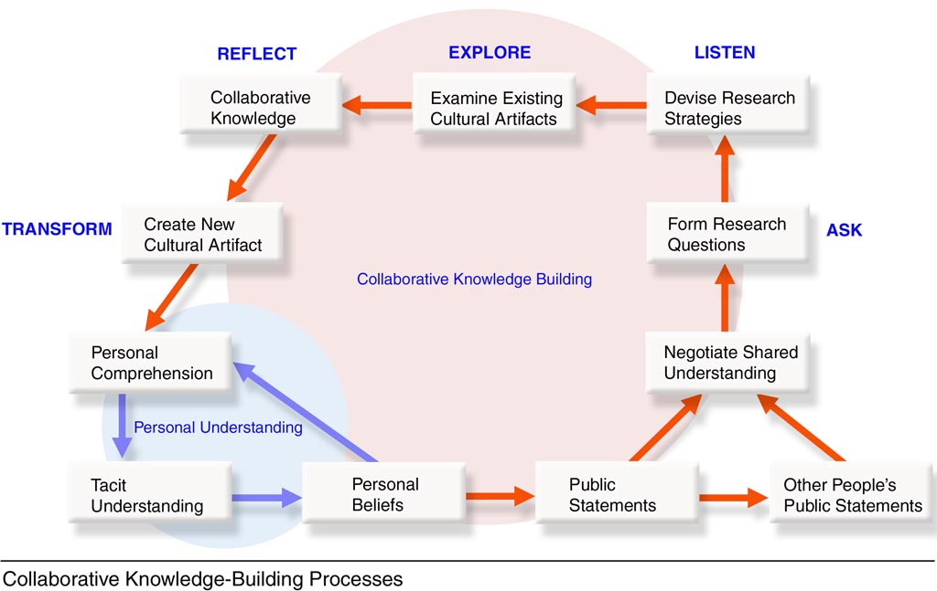
Figure 22 - Collaborative knowl.edge building processes - Gerry Stahl

Part III – Theory
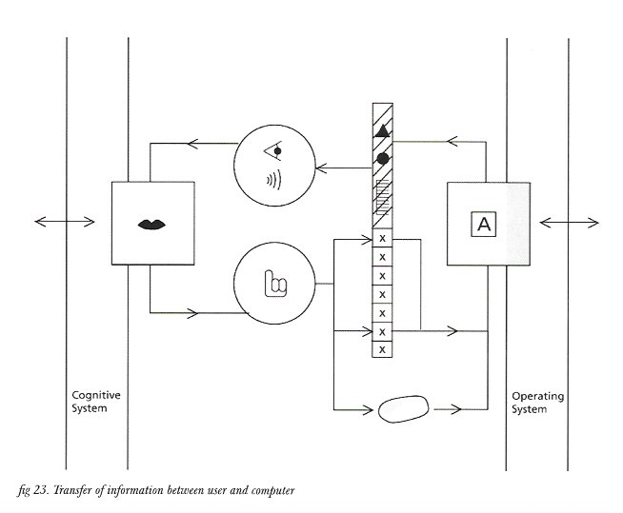
Figure 23 - Transfer of information between user and computer
I have established our current relationship with information and the computer, as well as the needs for better manipulation, management and communication of information through the computer. I will now attempt to establish how we can gain effective control over information in the computer environment.
To recapitulate, the aim of this research is to enable individuals and communities to share knowledge, using the computer to enhance communication. The relationship between user and information established through the computer could be more fruitful if the user was able to externalise their personal knowledge, but the current context given to them by the computer environment doesn't facilitate such rapport. This space could represent the way we deal with our mental constructs, without having to be as complex as how it is set out in the mind. Keywords, acting as verbal symbols/ concepts, can be attributed to information, enabling us to externalise the thoughts that relate to the specific information in the process. It could therefore help us to construct thoughts externally around a set of information. Subsequently, it would help the management of information through the computer.

3.0. Concrete example
I have some bookmarks I want to make available to share to the public. They are currently structured in sets of folders, each labelled roughly.
On a specific interface, I am able to refer to existing information about the bookmark (date created, url, favicon...) as well as define new information regarding the specific bookmarks. After each bookmark is updated, each of them constitute a Boundary Object. At their core, each boundary object is and will always be independent from each other. By default, all boundary object are put in relation with each other by the computer, but I can know personalise their relationship with each other, as part of a knowledge system.
On a sub layer of the interface, dynamic agents are recoding every moves and modi­fication made to each bit of information, and store my actions into a history database, from which future manipulation can be automated. More importantly, they act as the motor in making the inter-relation between boundary object, thus organising the knowledge system. This is where the computer acts as an assistant, enable to recall what has been done previously and generate new behaviour according to my actions. It works a bit like a wizard, or Applescript/rules that are being assigned to the bits of information I manage. The attributes that can be given to a bit of information can vary enormously. But there will need to be a thread, commonality for each boundary object to be able to refer to another in some ways: the obvious would be the name, date created and modified, the size of the file/bit of information already in place in the OS, but most importantly, the qualities inputted by the user, personifying each boundary object. As multiple users can attribute the boundary object to themselves, there would also need to be a tag for each qualities defining who inserted this specific information. A tag of a tag (i.e. Colour:red­ id:1109989)
Those boundary object, after being created, would be displayed in relation to each other by default, usually according to their original structure and the computer's way to deal with specific boundary object(s), according to the user's preferences. But as soon as I start to move those relationships around, dynamic agents are then switching to learning mode, where they record, adapt to and automate my manipulations. A basic interface is needed to support users who are expecting to be guided, but a much more organic/ adaptive interface also need to be available at all time.
Once I am pretty much satisfied with the relationships of boundary objects, I can store it as knowledge system, which acts as a reference to this specific set of boundary object. This knowledge system {knowledge system) is therefore a reference point that tag each boundary object in relation to the others part of the system. Such knowledge system can then be grouped with other, manipulated, dismantled by another user and add it to their own or public knowledge system, without interfering in the way I use it. As I am the creator of the knowledge system, I am able to see how people have used it. Everyone should also be able to get access to any other knowledge system, but I doubt all users will want that to happen.
These tools need to be either only web-based, or reside both on the web and my personal computer. I can make the knowledge system public, or enable particular user(s) to see it. When a user accesses my knowledge system, if he is new to the interface/platform, he will be able to see it either via my own display, or via the default display. The default display could be the only one available, if I am myself new to the platform and have made no modifications to the suggested (default) display/structure.
If a user has already been using the platform, even more so if they have manipulated/created/modified knowledge system or boundary object, their own dynamic agents should be able to make sense of the new knowledge system they are aiming to acquire according to the previous manipulations/modifications they made. They should be able to quickly shift from his view, the default view, my view, and any view settings they might have stored. They should also be able to incorporate the whole or part of it (as boundary object) my knowledge system within his knowledge pool as an entity by itself, and to use it in relation/conjunction with other knowledge system, boundary object within a knowledge system, or boundary objects.
The display of a knowledge system, as previously stated, would be generated by the combination of boundary object meta layer(s) and their relation with each other, explicitly rendered visually by the dynamic agent that corresponds to the knowledge system graphical appearance(s) (i.e. Diagram, GUI). Although the knowledge system should be able to be represented in any way that can accommodate user's understanding, it is important for users to be guided by some rules.
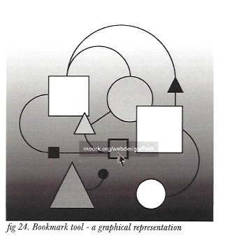
Figure 24 - Bookmark tool - graphical representation

3.1. Symbol manipulation
First of all, as we deal with information through an interface, the level of abstraction, representation and metaphor with which it is intended to display and communicate information would need to be controlled by the user. We, as human beings, are very good at manipulating symbols and concepts; it is part of our mental processes. It would therefore make sense to be able to use the same processes through the computer, acting as an extension of our mind. One could say this is what we already do, but the context in which we can manipulate bits of information in the current computer environment doesn't give us much possibility. Furthermore, such manipulation through the interface is not meaningful to software, even less to the operating system; they can relate to binary code being shifted from one place to another when the user moves a file to different location, but cannot do anything with it. Even if they could, they would not be able to give us more feedback on such an operation in an intelligible way because they haven't been programmed for that, and can't relate to our knowledge and intentions regarding the manipulated bits of information.
The problem is that the user is not able to convey to the computer their personal definition(s) of the bits of information they manipulate - apart from file name and folder name, thus restricting the personal relationship they can have with that information: they can't externalise their knowledge. Also, the computer represents the user's actions without making sense of it, whereas there is always meaning behind the processes taking place in our mental symbol manipulation.

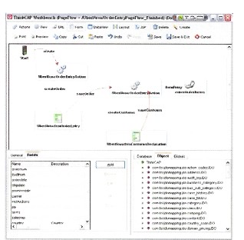
Figure 25 - Mind-mapping application: Thinkcap

3.2.Meta-information and boundary objects
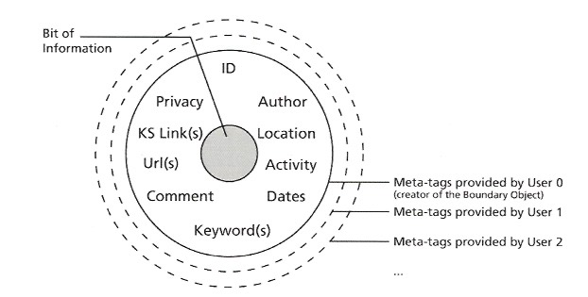
Figure 26 - Boundary object - structure of complex information
If we had the means to refer to computerised information in a similar way that we do in our internal processes, the computer would then be able to give us appropriate feedback, by which our manipulation, management and understanding could be enhanced; thus the computer would act much more intimately as an extension of our mind. The computer cannot understand as such, but it could associate, compare and relate to bits of information according to the various attributes with which we define information - attributes that are intelligible to us.
If we can define bits of information according to parameters, keywords that are meaningful to ourselves, the computer could then manipulate the bits of information according to this 'meta-information', in a way we can make sense of. And, the other way around, by enabling users to 'wrap' meaning (knowledge) around information, the computer would be able to assist us more effectively in our management, manipulation and communication of information, by being included in our thinking and understanding processes.
Any digital file contains more than the user can/would use. The extra data determines which software it has been created with, references how it is structured, in which language, its date of creation, modification, author, etc...
Such data is called metadata. It is information about information that helps software and the OS to display, manage and manipulate the digital file and its content in specific ways.
Each time a user manipulates information through an application, the data is changed. Data has its own language; each relevant to the specific software and the way it is creating and displaying information.
When I refer to boundary object I refer to an entity that contains not only the digital information, but also the user's mental representation of this specific bit of information, through the computer. It holds the meaning the user makes of that information, aiming to establish an intimate and personal relationship between them and that information, using their own knowledge. Such meaning is a set of metadata attributed by the user(s), 'characterising’ that information through representation, abstraction, conceptualisation and sense making.
The metadata (user's knowledge) attributed to a bit of information also help to organise the boundary object as part of a system(s), intelligible to the user/generator of information.
Furthermore, a boundary object helps the sharing of a bit of information between different users, each being able to refer/relate to that information according to what it means to them and others.
The computer and its dynamic agents, assisting the user, should also contribute to the metadata of the boundary object, which would be part of the user's personal lexicon. The meaning(s) we can give to boundary objects doesn't have to be solely of textual nature; it can also be contained in information of visual or auditive nature. Further­ more, the use of intuitive techniques in the direct manipulation of visual elements like drag & drop, direct linkage of a boundary object to another and spatial location could be enough to tell the dynamic agent(s) involved that there is some kind of relationship between the bits of information referred by the associated boundary objects. And if the agent(s) needs to 'know' more about the nature of the linkage, it can always ask the user for more input, or be more attentive to the user's movement and actions in this specific area/location.

3.3. Dynamic agents
Figure 27 - Dynamic agents are programs that help to manage the bits o f information’ they dictate the interfact functionality, behaviour and graphical display. illustration: Graphic visualization - UASA Zurich
The computer wouldn't be able to make sense of our own definition(s) of information, unless it was programmed accordingly. If the computer had agents which were designed/ generated for the specific purpose of relating to one another as well as to meta-information, the feedback from the computer could start to be called assistance, being much more relevant to our needs.
Dynamic agents are self-contained programs, key elements that will assist users in representing meaning from/to both users and their computer environments. They act as the translator, manager and manipulator of information in an under layer - they are not visible, but their actions might be.
They are defined enough to fulfil a specific role/task, but also independent enough to make choices. They can also be referred to as a complex of functions, a class that can refer to another, as well as to the boundary objects. They should be able to gather data and retrieve it at a later date, filter through information and efficiently refer to the user when needed.
Dynamic agents need to be autonomous. They need to be created according to our use of information, as well as what we expect from using the computer as extension of our mind.
I would invite the reader to think of them as insects: living in the 'undergrowth', multitudes of them, each with their specificities, commonalities and differences, serving the translation, organisation and display of information in a way both we - the user - and the computer can understand/relate to. They are also part of a hierarchical system - society - where each has a particular and well-defined status. Furthermore, they serve as links between the user and the world surrounding them, in the network of virtual communities they are part of, but also more generally the World Wide Web.
Through our use of information, dynamic agents can learn to establish representational patterns that will help us manage and manipulate knowledge systems. Such patterns can be revealed not only in the dates, locations of files etc, but also in the boundary objects and their bits of information that are accessed at the same time, their meta-keywords and previously user-established relations (what I refer to as direct links).
At present, in order to communicate with the core language of the computer system, un­derneath the OS level, the user has to open a specific 'dialog box', for him to write the specific code outside the OS. MS-Dos, and Linux can be accessed from a 'terminal' window, enabling direct access to the 'language machine', on which the OS is built. In OS X, developer made sure to integrate an internal scripting language, apple-script, that can be accessed from anywhere, as long as the application includes it as part of its APL Such languages aim to create automatic tasks, whether general or specific to an application, more directly manageable and 'easier' to implement by the user. But such process is often very tedious and difficult, requiring specialist coding skills and knowledge.
The dynamic agents would fulfil this role, acting as a phenomenon in an organism; reacting, debating and communicating various tasks undertaken by the user - without the latter being necessarily aware of their existence.
Dynamic agents would be able to evolve and learn from user(s) in various ways; either by sharing or updates (the reader might consider a 'pool' of the programs available online), as well as creation/modification as in Applescript (WYSIWYG, safe and expert modes). The communication between the dynamic agents will need to be fluid, therefore each functions used and created will need to be labelled and have a definition, meaningful to any dynamic agents - and to the user.
Dynamic agents will track our management of specific sets of information, but also manage them for us. They could retrieve useful information according to a specific topic (whether a date, a keyword, a pattern of pixels...). With algorithms and functionality complex enough, an agent could 'look' at an image, 'listen' to sound, 'read' text and being able to relate to all bits of information onto which we apply our knowledge and thoughts, and give us the appropriate feedback to what we really expect. Dynamic agents could make cross-references to information we already possess. Some of them could also undertake searches for us. They could efficiently retrieve and access information we don't have knowledge of. Linked to the web, such agents could be very powerful tools to get web information of relevance to individual users, according to the knowledge data it can get from them and their boundary objects, and comparing it with web information. Overall, they would act as what we currently call 'spiders' and 'scrapers', self-contained applications that serve to index and catalogue the World Wide Web. Such process can take time, but could dramatically save time for the user, who would be able to deal with other issues while the search takes place. If a set of information is represented to the computer in a way it can relate to, the dynamic agents would be able to analyse the knowledge system, make statistics, give probabilities over what is of relevance to the individual user, between the sense we make of it through the boundary objects we define, our direct manipulation of them, and the content of the information itself.

3.4. Knowledge systems
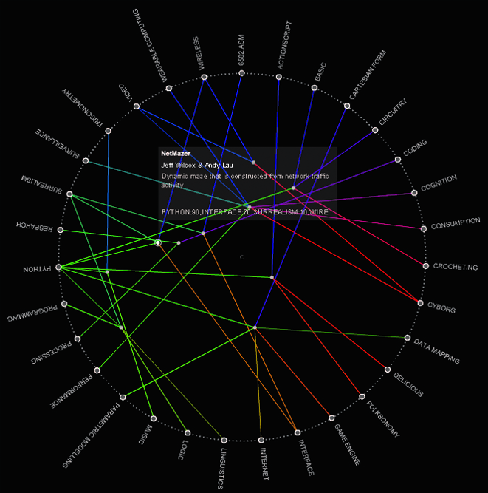
Figure 28 - Transvergent Project Relationship Model (TPRM) - Aaron Siegel

A set of boundary objects constitutes a knowledge system. A knowledge system is a set of boundary objects put in relation with each other via at least one common parameter, or via user action/intervention. If boundary objects and dynamic agents were to be implemented, users would be able to articulate their knowledge system(s), and communicate/share some aspects of it to/with other users. Furthermore, a shared knowledge system would be able to be accessed, managed and manipulated by group(s) of users. A shared knowledge system would need to reveal the current changes and differences appropriately to individual users, which would be able to deliberately choose to accept or ignore the various changes made by other users - and still be able to access to changes at a later date. Dynamic agents of specific users would help them to understand the changes in a system, as they would be able to communicate with the dynamic agents of other users that participated to the changes, and visually manifest its modification.

The knowledge system would firstly need to be created either around a core (concept/ idea/goal) or via a set of selected elements that would be part of it. Boundary objects can be used in any knowledge system, and be found in two or more. Any specific or­ganisation of a set of boundary objects can be called a knowledge system. Furthermore, a knowledge system can 'contain' another (or more) as well as other boundary objects, forming the knowledge system together. It is an organic and virtual representation of a set of information related to the boundary objects. It can be generated through search query as well as by direct manipulation of a set of elements. A user might choose to 'label' and 'save' a knowledge system and the way it is visually organised and represented, and such a system will evolve according to the user manipulation of its components. I would invite the reader to think of a knowledge system as an entity that holds a set of boundary objects together, not physically, but only as a representation. It is in the boundary objects themselves that the various knowledge systems are defined, through keywords, content input and tagging (metadata).

As a user creates boundary objects around their bits of information, dynamic agents would help to organise and manage the system accordingly, using the user's methodology in information manipulation as guidance. Based on those models, dynamic agents would facilitate user's information management according to his needs and current disposition.

Dynamic agents would also be able to refer to past experiences to present to the user tools they already used and reveal the system in a way that is intelligible to them.

The knowledge system will be displayed following representational models working around visual principles that the user is accustomed to, and update any boundary object by user action and/or automated management (made by dynamic agent(s)).

3.5. Communities of knowledge
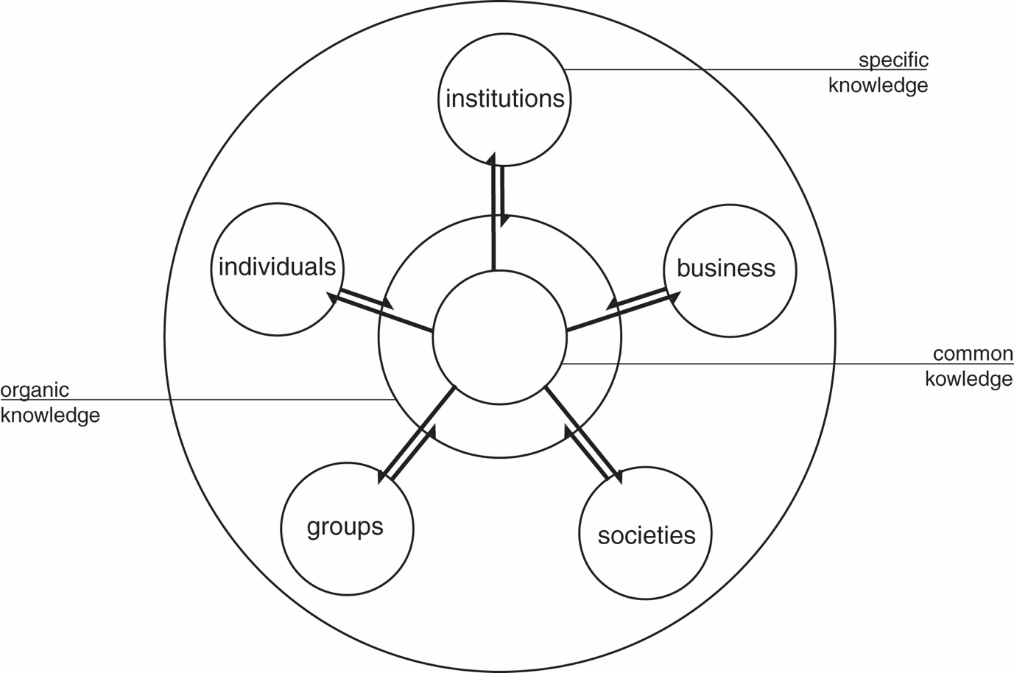
Figure 29 - Collaborative knowledge
To share knowledge with only oneself wouldn't make much sense. This is where the problem divides: on one hand we need to be able to make sense of our own thoughts through the computer, in the creation of a personal knowledge system of information, and on the other hand, we need our knowledge systems to be intelligible by others, in the way we personally make sense out of it. Another reason for information needs to be encompassed in the boundary object is that the specific bits of information would need to have extra information (meta-information) defined by the respective individual(s), creating specific set(s) of attributes that would wrap each bit of information as boundary object, in order to communicate to another user both our representation of it and what it means lo us, in a way that they can understand. Additionally, the tagging system de­veloped through metatags can help to develop the user's categorisation of information. Dynamic agents would then be able to communicate with and relate to the foreign system to establish the necessary connections of what and how it could be made intelligible to the user, according to the meta-information layer(s) of each boundary object that is part of the system. It can be translated in a simple system at first, but as the user engages with it, it would unravel more details about the newly acquired system, translating the components and their relationships in a representational model the user understands, thus making the system intelligible to the user through his own disposition.
When I talk about the user's disposition, I mean his abilities to understand information in a specific context. If the computer cannot 'translate' the meaning intended by one individual through their behaviour and methodology when creating/manipulating a knowledge system of information, the current representation of such system might not be enough for another to understand it accurately. The context of a newly acquired knowledge system would therefore need to be defined according to the receiver's point of view, in a way that they can understand (a user could also choose to not alter the representational system of knowledge they are acquiring, and switch between familiar representation(s) and the original one as they please).
This is why both boundary objects and dynamic agents are crucial. They both serve to contextualise, manage and manipulate information as part of a flexible system that is meant to be understandable as part of our knowledge, through our own disposition(s).

I have established that in order to share our thoughts, we need to contextualise informa­tion in our own way, according to our own disposition. But dynamic agents would need to evolve with us, or else the computer would have to generate new agents that are up to the new tasks we would require from them. As we evolve through a thought, we build upon it, but we could also make radical decisions that could change the whole structure. In our mental constructs, we are able to merge two thoughts together, but we are still able to distinguish between them - even if we know they are part of other concepts. And so the agents that assist us should evolve too. Even if we have to guide them through the processes - directly or not, agents should re­fer to our manipulation and management of information in order to relate to the appropri­ate relationship between the various entities - boundary objects - of such new thought/ concept: cataloguing every necessary input made by the user, referring to their past experiences, and/or identifying patterns in their behaviour. Soft learning has to happen in ourselves as well as in the agents we use. If some of the agents of a computer system were able to 'dialogue' and refer to boundary objects not only in the system they are part of, but also with agents of other users' system, such agents would enable the in­volved communities and their knowledge to evolve.
For each user, a multitude of agents can exist, assisting them in managing a multitude of boundary objects, being able to access new information from foreign computer systems either as specific boundary objects, or access a knowledge system as a whole - an established set of boundary objects.
Obviously, we as users don't want to share everything. Each agent would have a specific identity tag, which would refer to its specific role and which user it assists, making it recognisable and traceable. Each foreign agent would be traced. There could be 'privacy agents' for private/secure information, which we don't want to be accessible by a third party. Such agents would be able to recog­nise the intrusion of agents who don't have the right privilege access, and thus would be able to preserve information security. In the boundary object itself, such privacy can be an intrinsic part of its features/parameters, where various levels of accessibility could be set. And because such information would be defined locally, a foreign agent that doesn't have the right privilege access couldn't access it.
Also, a user who made their boundary object 'public' would be able to trace it wherever it goes, and know - if they wishes - what kind of system it is being added to, as well as the modification made to it.

3.6. Privacy and security
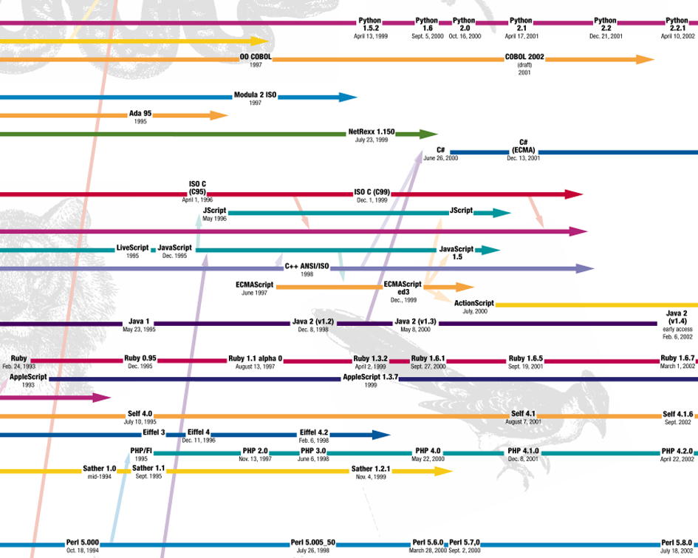
Figure 30 -
Security, trust and belief in information are as crucial as the way it is being communicated and accessed. The amount of information present in the web is colossal. There are 'restricted areas', but all in all, if you have the 'tools' that can communicate to where the information resides, you are in.
If dynamic agents were able to get back meaningful information for the user and their knowledge, that user probably wouldn't mind for it to take a whole day and thereby get much more valuable information, which would take them no time to go through (if they are searching for 'new knowledge'). It would be valuable because the dynamic agent 'knows' the user's dispositions through their knowledge system(s): it can refer to what the user already knows, and use this 'awareness' to relate to the findings it makes in the web search, getting results similar to the user's existing knowledge or finding new relations to it - depending on the user's query and interests. It could then be able to catalogue information in the most meaningful way for them, according to their immediate dispositions: the user might want to browse through it quickly, asking the results to be displayed intelligibly 'at a glance', getting an overview of interesting findings, or else they could see it in more details, because they would ask the agents to organise the system in more elaborate details (e.g. revealing the paths through which the agents browsed the various sites where it found information of relevance).

3.7. Utopia and current constrains
Such tasks are impossible to achieve in cur­ rent computer systems, as they all use dif­ferent languages. We might notice that the communication between an OS and another is actually possible through the files made in a specific application (the same word file can be opened on the various operating systems onto which the application has been developed). Also, we can observe the efforts made by the various software companies to have applications within the same 'family' (Microsoft Office, Adobe Creative Suites, etc...) to be able to work with the same file. Across operating systems and software, different language formats have been adopted for ease of manipulation and readability: PDF and XML are currently two of the most used formats to contain and define information. But there are hundreds of other formats used by specific applications, and for each the structure and organisation of data can vary a great deal.

One solution could be to create a new generation of computer systems, which would be much more open and accessible than current ones. A developer can re-interpret information constructed in a specific language, as translation, but only an expert can do that. If a specific dynamic agent could act as a translator, it would help to identify the structure of a bit of information as well as its various components, and refer to the OS/application to find the best ways to recover/read the data of such file, deciphering the structure through which the applications create the various bits of information, in order to manage them effectively.
We need new means of interpretation. Should/can extra metadata be added to an existing piece of information? With the speed increase of computer processor, the amount of data they are able to process at once, the storage space also increasing, to add more data to a piece of information shouldn't be problematic. It would have other implications such as security of content and privacy, but as we know, even current computer systems cannot insure a 'waterproof' system. Would the software with which the piece of information has been created be able to deal with it with no other consequences? This would certainly be more problematic, as current software are opaque to modifications and would not allow such changes (plug-ins might be of help in such situations).
Another possibility would be to create a boundary object, which refers to the piece of information, but which is latter is not part of. Acting virtually, the boundary object would act as a complex 'pointer', using meta-information, to the bit(s) of information it refers to (e.g. bookmark). In that way, the piece of in­ formation is not altered, and its future access by related software would not be prevented. Still, to add extra data to a piece of information that enables us to access, manage and manipulate such information with our own knowledge wouldn't mean much if the computer can't interpret the meaning we apply to it. The processes will need to somehow understand the relation we make with the various specific bits of information. Computers will need to deliver such information according to the relationship we have built and in the way we want to experience it, and enhance our experience.

3.8. Representation
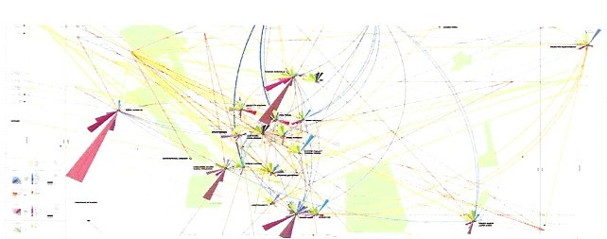
Figure 31- Diagram from Freshmadrid
To give a user an appropriate visual representation(s) of the knowledge system is crucial for their understanding. The mapping of information enables the user to identify a system visually, but a specific visual display might not be suitable for all users, because they probably don't all have the same aptitudes to get the meanings out of a particular context. Furthermore, one way of displaying information might not be enough to make intelligible the overall and/or detailed structure of the system, how it works, and how each elements act both individually and collectively as part of the system.
Interactivity is a very important advance in our understanding of a visual system. It enables us to actively engage with the complex of information and its various components, in a dialog that can unravel and establish the non-obvious factors of such a system. The reader can consider the products of this research to behave like an interactive diagram, where a user would be able to manipulate the elements of the system.
A shared system of information needs to be open and fluid, adaptable enough for different users to have the ability to access it and get meaning out of it according to their own dispositions. By using the user's personal lexicon (i.e. thoughts, keywords), the computer would be able to refer to their knowledge and organise the system in an adaptable visual representation that serves the user's purposes.
For a user and their computer to relate to information meaningfully, an underlying structure needs to operate the necessary changes that would occur in the manipulation of the visual display. Some dynamic agents would be solely dedicated to the visual representation of the knowledge system, and liaise with others to apply and reflect the various changes that would occur in the manipulation of its boundary objects.
For a dynamic agent to refer to others, it would also need to be open and able to be shared. Not only open within the personal computer itself, but also across the network it is part of. By network, I mean not only close proximity network, but also others. The World Wide Web would be a good platform/nest where dynamic agents could be freely available and accessed. Again there would be security and privacy issues - depending on the content that is being dealt with - which I believe to be trivial; as stated earlier, by labelling each dynamic agents according to their user and functionality, as well as by being able to trace wherever they go and whatever they do as part of their most fundamental core, we should be able to find solutions to locate and deal with the ones that are 'misbehaving'.

3.9. Example
Let me give you an example. Here, I will refer to the 'computer' as the entity that acts upon what I, as a user, request from it, as the extension of my mind.

Scenario:
I would like to be able to retrieve a website in which I vaguely remember interacting with a specific navigation, that would be a valuable source of inspiration for the current project I am working on. Thinking about it, I also remember I looked at this website because it contained imagery for another project, but I can't remember which. First of all, I will look at the design projects I have been involved in. All my projects have been catalogued under the term 'projects' (the computer can detect what I am doing according to the routine I adopt in tackling a new task, and meeting some criteria, it invites me to structure a design task under a 'project' default shell). I ask the computer to display a list of the projects by date, but also to reveal to me the duration of each project in comparison, as I remember the project took quite a long time to finish. It takes a few seconds to gather all the related data, but displays them one by one as soon as it retrieves them. It displays the results from left to right as clouds in a 2D environment, containing the name of the specific projects it represents, in vari­ous sizes as per their length in time. Some are overlapping others, meaning they hap­pened during the same time. They also have a colour scheme, representing the nature of the various projects. From the quick access menu, I ask to display any related links of the websites that I have looked at during those projects, as well as a thumbnail of their home page. It starts to get a bit confusing because of too much visual information, so the computer suggests to me to change the overview to a partial view. There, I choose to display the system in three-dimensional view. The balloons become cylinders, and their length now represent the length of time the projects took, with the thumbnails of the site visited gravitating around them. After adjusting the scale, I start to scroll through from the most recent projects to the earliest ones. During my browsing I spot a couple of sites that could be of relevance to my current project, so I 'grab' them for later use - a duplicate of them gets stored on the left side of my screen. I finally spot the website I was looking for. After selecting it, the computer display other pieces of information related to it and the project it was involved in. One of them is a comment I made about some issues in the site's navigation. This comment is also visually linked to the email address of an interface designer I had been liaising with in the same period as doing this particular project From this email I can trace back the various emails that have been sent during our correspondence, relating the issues I had about the site's web interface. This designer was himself working on a similar interface at the time, but I lost touch with him before seeing any of his work, even though I can recall he had interesting views about the issues I raised. Now, I decide to see if he finalised his interface, requesting access to this specific subject from his system. After granting me access, his computer invites me to browse through a specific system showing the evolution of the interface he has been working, highlighting the time at which I was corresponding with him. Very satisfactory search indeed; not only he solved the issues I had about the navigation of this website, but he also got further in applying it to a visual database. I select the artefacts of interests from his system of knowledge, and jump back to my current project. There I insert all the elements I found in my quest, and organise them with the rest of the elements already present. Later on, the designer I referred to will be able to get into my own knowledge system and get information related to where and what I have done with his own materials.
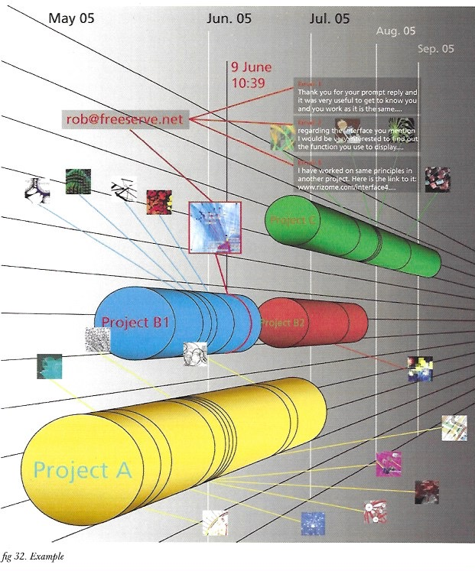
Figure 32 - Example

3.10. New user
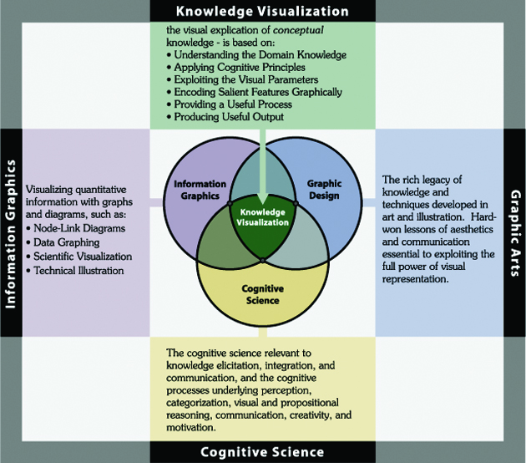
Figure 33 - Knowledge Visualisation - Marshall Clemens
When a first-time user starts to use/create a knowledge system, the dynamic agents will need to operate without any reference to the user's behaviour, and learn from their first 'steps'.
Such environment will need to the very open and 'forgiving', as the aim is not to 'bombard' the new user with lots of instructions on how to manage the interface, but rather for the interface to adapt itself to the user and 'understand' what they wants from it, in a soft learning process.
The user will have to be guided through the use and creation of a display and manipulation that suits the particular individual. At this stage, the learning curve will be at its most important, for both for the user and the computer will be mutually getting to 'know each other'.
Created by/through users according to their interaction with information, dynamic agents should be able to easily adapt and communicate to each other and/or create/evolve when needed. But to start with, dynamic agents will also need to be pre-established in their mediating roles between the user and information; they will have different purposes and natures, covering all aspects of our relation to information: security and privacy, management and analysis, translation of the structure of information and languages, input and output, update, seek and retrieve, help, learn, visual display, etc...
Extensive user testing will therefore be needed, in order to obtain a set of dynamic agents evolved enough for a first time user to be as­sisted effectively.
A more detailed explanation will be given in the next part of this essay, which presents a working model, based on bookmark management.

Part IV - Working model

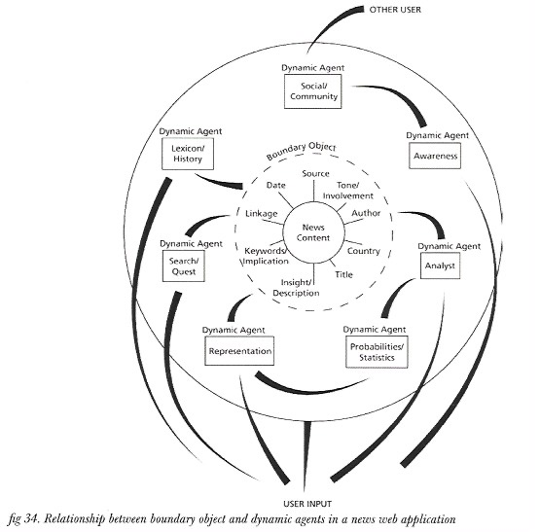
Figure 34 - Relationship between boundary object and dynamic agents in a news web application

The model for this research can be applied to any digital environment where the sharing/ management of information is an essential part of the system. Such system of informa­tion can be as general (e.g. managing bits of information of any type on a personal computer) or as specific (e.g. news feed, bookmarks, blog, forum, project management...) as is required. Any bits of information can work according to the same principles when being shared, only if such information is defined in an intelligible way, easily identifiable and recognisable by a third party.

The wrapping of information as boundary object would facilitate the definition of the information, enabling its 'creator' - a user defining the specific information in their knowledge system - to establish what the information means to them through a set of parameters (metadata). The boundary object would also contain extra data relative to the history of the entity, aiming to trace and analyse it more effectively, as well as other machine readable data defined by the computer itself - date created/modified, nature of the bit of information, etc... All the metadata added to a bit of information through the boundary object would enable its manipulation and management within the knowledge system(s) it belongs to, as well as its sharing with other peers and their knowledge systems.

During the whole process, various dynamic agents would assist the user in the specific tasks of defining, storing, managing and accessing the boundary object(s) in and out of the knowledge system(s).

At this stage the prototyping of the tools aimed in this research could adopt the Trygve Reenskaug's interactive application architecture principles, based on three types of components: models, views and controllers (MVC). As per applying such model to the finding of this research, boundary objects can act as models and database, and dynamic agents would be of two types, views and controllers.

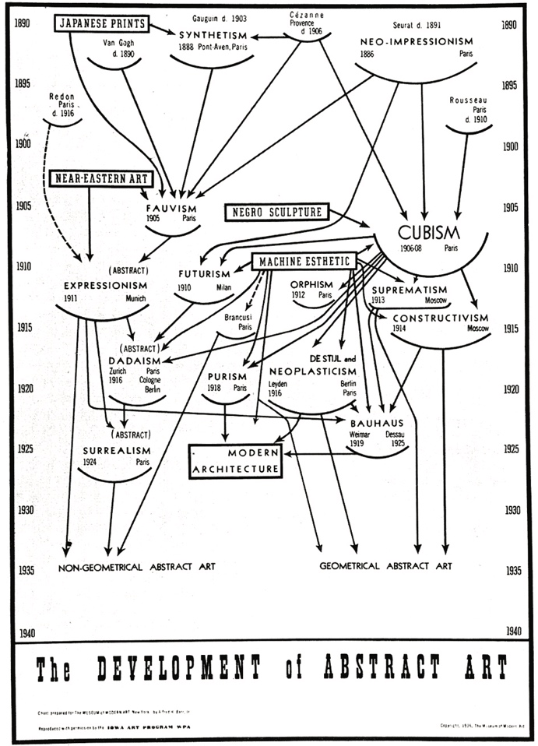
Figure 35 - Arts Influences through history - Bar diagramm

4.1. Diagram and visualisation
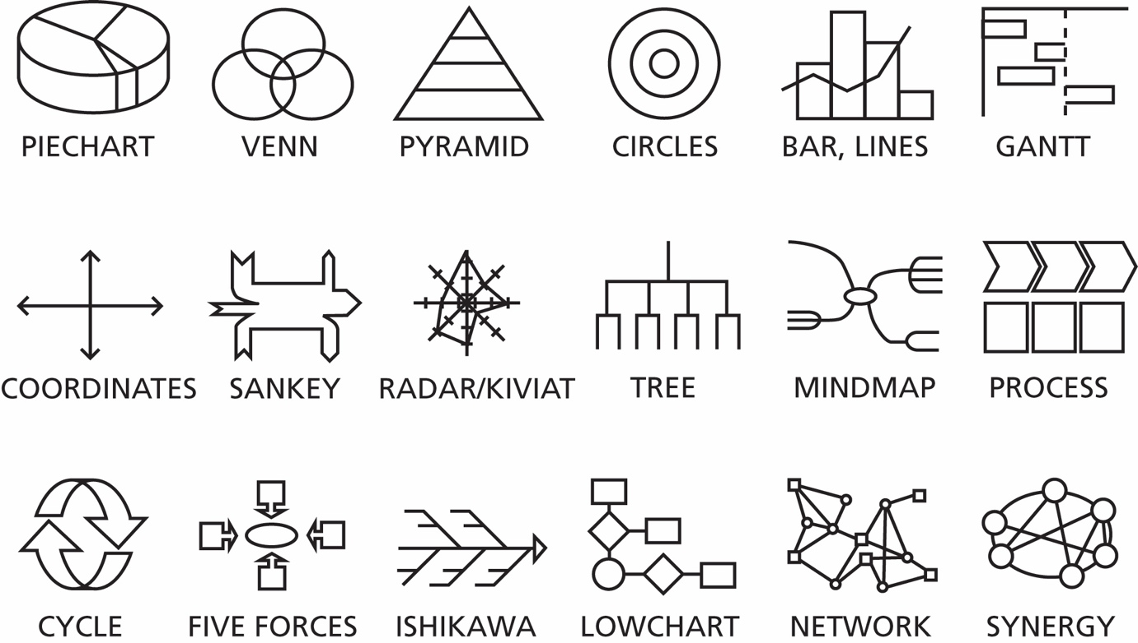
Figure 36 - Various conceptual diagram representations, based on Eppler and Burkhard research

Mnemonic techniques provide solutions to visualise/ display the various elements that are part of the same system. As such, conceptual diagrams aim to represent a system visually, in the inter-relation of its elements. In an act of abstraction, the elements and their relationships are defining the system they are part of, making it intelligible to the viewer. But depending on the way the system is being displayed as diagram, a viewer might not be familiar with the specific visual language chosen to design the diagram, and therefore experience some difficulties in assimilating the specific representation of the system.
By adding interactivity to a diagram, we can actually empower the user by enabling them to actively engage with the system, in the manipulation of its component and the identification of the relationship(s) they might have with one another, giving them the necessary tools to get a better understanding of the system.
Different points of view can also help the viewer/user focus on specific aspects of the system. By displaying the relationships of its components in particular visual contexts, some of the relationships can become more obvious than others.

A diagram is an abstraction of a chosen group(s) of elements, which are usually related in some ways with one another. Those elements and their relationship(s) are taken out of their initial context (which is usually more complex, involving more elements of different nature) and represented in a neutral space, in which their relationship(s) establish the system/diagram. Such principles have been used in both science and art, in the abstraction of the observed/represented world, to bring the essence - or particular aspects - of the subject to the foreground using creativity.
The use of diagrams is an intrinsic part of this research. They can be used by users to creatively and visually make sense of their elements/information and their manipulation, as well as to put selected bits of information in a context where they inter-relate with each other, as part of a system.

4.2. Bookmarks service
This example will be based on a web bookmark service, that will enable individuals to share the links to their websites of interests, as well as the various comments/ definition(s) they might have about those websites. Eventually, it would enable them to link any kind of information to another. Furthermore, Individuals should be able to visually organise the relationships they make between the websites, as well as share the established bookmarks system with their peers, whom will in turn be able to make sense of the

bookmarks and their inter-relationships, by its translation in a visual context defined by the individual/receiver themselves, thus facilitating their understanding of the book­ marks system.
Ideally, such model should give the ability to the web user to manipulate and organise their bookmarks intuitively, in a space tailored to their needs and understandings, both of the interface and of the system(s) of information.

4.2.1. Key aspects
Key notions of the bookmark sharing service:
- Users should be able to easily and quickly bookmark the webpage, either using an icon always present on the browser window, or using drag & drop functionality to place the URL within the web application.
- A user should be able to set a personal visual context to the bookmarks they will manage. A login system will need to be implemented for users to 'tailor' the interface according to their own specifications, namely: parent-child relationship(s), appearance, interface behaviour/reaction.
- A user can set access privileges to a bookmark, or a set of bookmarks.
- All public bookmarks will be made available to browse without having to login to access them.
- Various search criteria will be available by default (such as title, date or category), but the userwill be able to customise its own (keywords). Searches can be made both visually or textually.
- Users will be able to manipulate the organisation of a bookmark system, but the application will help to automatically rearrange the elements for optimum visual clarity (preferences).
- The interface will mainly consist of visual elements, labelled with titles/keywords, for better denomination/identification, but can be expanded if required by the user.
- The bookmarks sharing service system will be able to track and record the various modifications made by any users, tagging the various elements affected, as well as producing a log for archive/retrieval purposes.
- The visual representation of a group of bookmarks will take the form of conceptual diagrams principles as a default, but will be able to be altered by users as they interact with it, according to their own preferences.
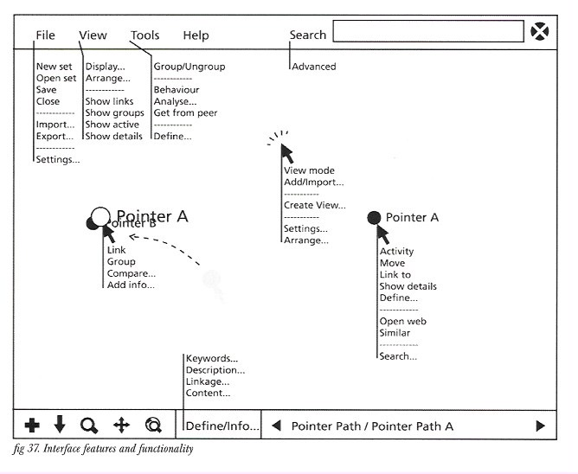
Figure 37 - Interface features and functionality

4.2.2. Element structure
A bookmark element (boundary object) will have various parameters, each with its specific role(s) in the management of the element as part of the system. Note that some parameters will be duplicated (single/multiple), as different users will define them in their own ways:
- Uri/link of a webpage (single)
- Title (multiple)
- Symbol (multiple)
- Keywords defining the nature of the site (multiple)
- Description of the page/site (multiple)
- Popularity (single)
- Date added (single)
- Usename who created the element (single)
- Co-users (multiple)
- Dates modified by co-users (multiple)
- Linkage (multiple)
- Parent (multiple)
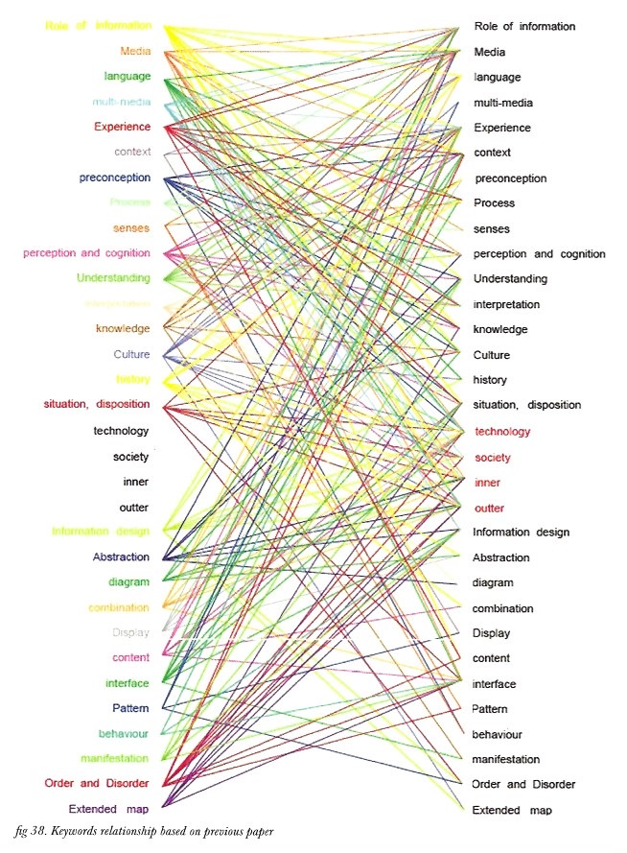
Figure 38 - Keywords relationship based on precious paper

4.2.3. First time user
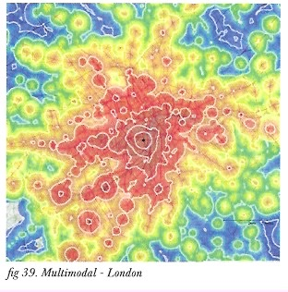
Figure 39 - Multimodal - London
The sharing of knowledge happens in a multitude of environment, as it is at the core of communication. To be able to make sense of another's thought without the latter having to explain it would be very beneficial to all the users involved, with less time spent and a better adaptation of the system to the various individuals needs.
At the same time, to be able to reveal one's meaning through another's disposition/aptitudes/preferences can help to recognise pat­ terns that wouldn't have been made intelligi­ble in its original state.
In the book entitled 'expertise sharing', Ackerman pointed that there is a big difference between a person who has extended knowledge in a system - expert, and a person who is trying to acquire new knowledge - novice. Mainly, the expert will tend to use abstraction as mental/knowledge model as his knowledge in the specific domain is advanced. He will omit details and 'globalise'/abstract the phenomenon according to its main feature. On the contrary, a novice acquiring new knowledge/having a new experience will tend to go step by step from start to finish, into details, not necessarily knowing/able to break down the overall new concept according to its main features. Thus, the role of the system will be to synthesise/simplify the knowledge system to be acquired in the expert way, as well as enable the individual to 'dig' deeper, focusing on a specific aspect (details).
This is an essential part of the process through which we can acquire/understand a new knowledge.
The problem arises when, in collaborative work, multiple factors are applied to knowledge: the various specialists who are part of the same knowledge system should be able to focus on their expertise knowledge, as well as knowledge that is new to them, in a way that suits their aptitudes.
When in the position of first time user, we are on foreign ground. What we first experi­ence of the new environment is usually the learning of its settings, display, behaviour and functionality. We are open and eager to learn the rules that are regimenting the system, and accept any response from it; we are learning. In a trial and error process, we are acquiring tacit knowledge, learning by doing. If a system 'presents' itself in a way we are familiar with, we will obviously attempt to 'dialog'/ communicate with it in the way that is familiar to us. But if the system responds differently from what we expect, we are at a loss. As we evolve in a new environment, we also expect it to behave the same as our first encounter with it; even if we can 'easily' adapt to a new environment, we are used to a rigid environment.
What would happen if the environment/system is evolving with us, in a way that our every 'moves' would be an actual dialog, like with another human being?
The acceptance we can have from a foreign environment very much depends on the expectations we have from it. If we want to get straight to the point, or if the environment presents itself in a way that reflects expertise, we either tend to act as experts if we are familiar/accustomed with the system (confident user), or tend to hesitate and/or take time in making complex decision if we are novice to the environment.
By enabling various users to shape their knowledge system individually, not only they can make better sense of the system according to their own knowledge, but it also enriches other individuals understanding of a foreign knowledge system, providing them with a new point of view with which they can approach/be confronted with the system and its information.
The system will need a default view/display for 'guests' or first time users. Such display should either represent an overview of the system, or else the system organised around a specific concept, determined by what brought the new user to the system.

4.3. Implementation
A good place to implement such tools would be in web forums/blogs where users are accessing and debating about specific topics. Such topics (found in the title, date or content of threads) can then be visually represented by relevance and 'categories' in relation to the system's elements.

Web application development techniques such as AJAX and Ruby on Rails will be highly considered in the prototyping of the bookmark service intended.
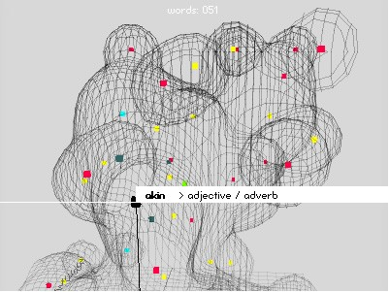
Figure 40 - base26 (3D relational mapping) – Kartsen Schmidt

Part V - Further research
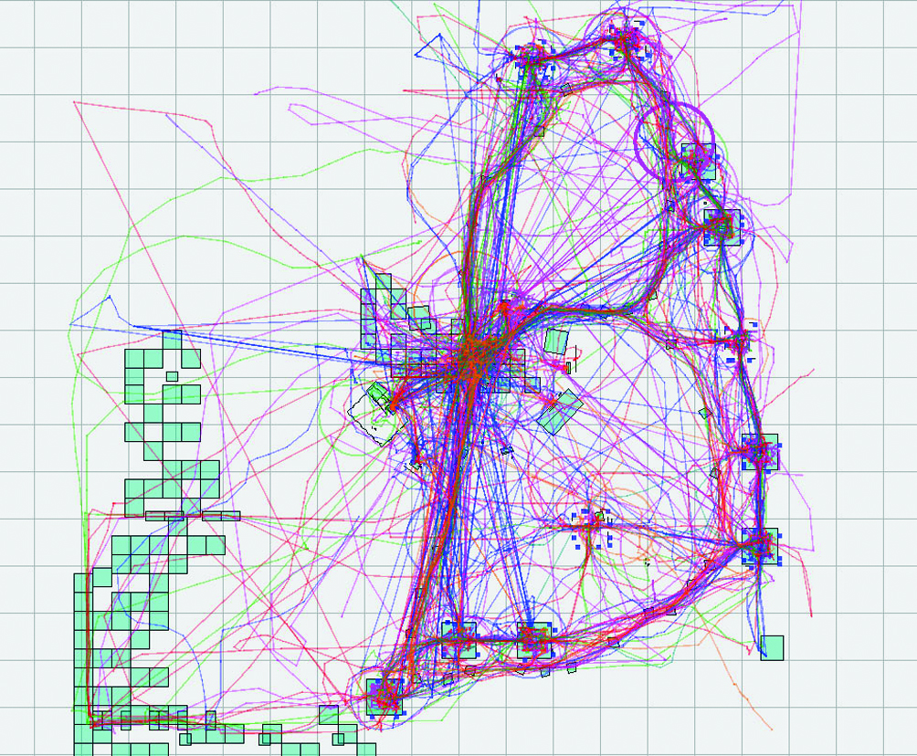
Figure 41 -
This research acts as a first step towards finding new ways to share knowledge in the computer environment. It has been supported by a seed funding from the Research Office at the Central Saint Martins College, School of Graphic and Industrial Design.
It is acknowledged that further research will need to be undertaken in collaboration with experts in the various fields of design, computer science, information architecture, sociology, psychology and cognitive science.
The findings of this research can help users in all aspects of the collaborative/personal management of digital information, and can therefore be applied in various disciplines, such as E-learning, Knowledge Management in community(s), Data Visualisation, Computer Operating System development, Software development, and more broadly in any Human Computer Interaction environ­ment.
The context in which the findings and model of this research could be applied to is formed of both the Internet and personal computer, where both individuals and broad communities need to manage and/or communicate digital information (global and local network). At a bigger scale, it could also be implemented as a new kind of operating system - one that would be integrated both on the personal computer and the Internet, but this would require considerable amount of work to have such OS flexible enough, as well as breaking the boundaries instated by current/ conventional operating systems.
Through plug-ins, components and modules, we can notice an attempt to create and 'share' functions/programs that are produced/exchanged as tools to alter information in specific ways. One could say manipulate, although it doesn't really go further than 'adding effects' in an already regimented context dictated by the software. At a very narrow and restricted extent, the application doesn't allow information to be shared, but rather 'tools' to be shared.
In an open environment made purposively to share information, the means by which we can do so should be exploited, as the tools available to manage and share bits of information are often too complicated to be modified by a non-expert (average user).
Since I started this research, various services have emerged, either on the web and/or as software: Google Hearth enables user to get updated shots of worldwide locations, while some people exploit Flickr's tagging system via its API to visually display inter-related pictures as an information system. Still, none of the latest services offered to the user enable them to control the interface with which they can manage and manipulate bits of information of interest, in the way it displays or uses the specific information.

5.1. Collaboration
Various issues raised in this research will have to be studied in depth, and the collaboration between specialists of different expertise will be essential for the development of the necessary tools and system and their application in the various situations where knowledge sharing occurs; particularly, the collaboration between experts in the fields of interface design, human computer interaction, software development, data visualisation, computer science, artificial intelligence, information architecture and structure, web semantics and ontology, neuronal networking, sociology and psychology.
It would be interesting to approach people/team/experts whose work/research is involved in the same directions: namely, Gerry Stahl, Ackerman, Alan Kay, IBM's automated system team, people involved in computer-supported knowledge management systems, and people involved in data visualisation like Edward R. Tufte, Ben Fry, or Hugo Liu.
Interesting research is being undertaken in the fields of semantic and inter-ontology by people like Gerry Stahl. The industry is getting used to terms such as UGC systems (user generated content). MIT has developed info­ Quilt and iSpace, while IBM has developed a system that can adapt, evolve and heal according to the information access, thus automating itself without being dependant on human intervention.
The second phase of this research can be divided in three parts: the first two are intertwined between theoretical research and experiments in building tools according to particular systems and settings of information. The final part will be targeted at the testing, recording and analysis of the tools developed, mainly by users of various computer literacy and familiarity with the system of information, also 'visual' person (professionally involved in visual art/design), various ages and various experience with computers.

5.2. Development
An iterative process will without a doubt need to take place in the development of the tools and system that will benefit individuals and communities in their management of information through the computer environment. Various issues will need to be addressed, such as the language and structure into which the tools can be built and evolve effectively, the 'organic' structure of both the boundary object and the dynamic agent, the various roles of dynamic agents, the interface between the boundary objects and the dynamic agents, the interface between the system of information, the user and the computer.
Possible experiments, context specific:
- Web: news and bookmark site, blog
- Database: library
- E-leaming: ITRDU, blackboard, CSM BA GD
- Operating System: Apple/Microsoft/Unix
- Collaborative environment: corporation, institution, factory, research

5.3. Dissemination
Tools development:
The aim of this research is to create appropriate tools - or platform - to share knowledge. Various areas, which involve the communication of information through the computer, could greatly benefit from such knowledge systems; in a company, the various people part of the same team, or else various teams. involved in a common project could share views, ideas, schedules, etc...

Academia:
In education, where e-learning is becoming increasingly important, the relation between tutors and students could become much more interesting in their inter-manipulation of information. The system would also be able to refer to and display priorities, according to the user(s) involvement.
This research could also be a good collaboration platform with what is currently called knowledge sharing, as well as knowledge management.

Part VI – Conclusion
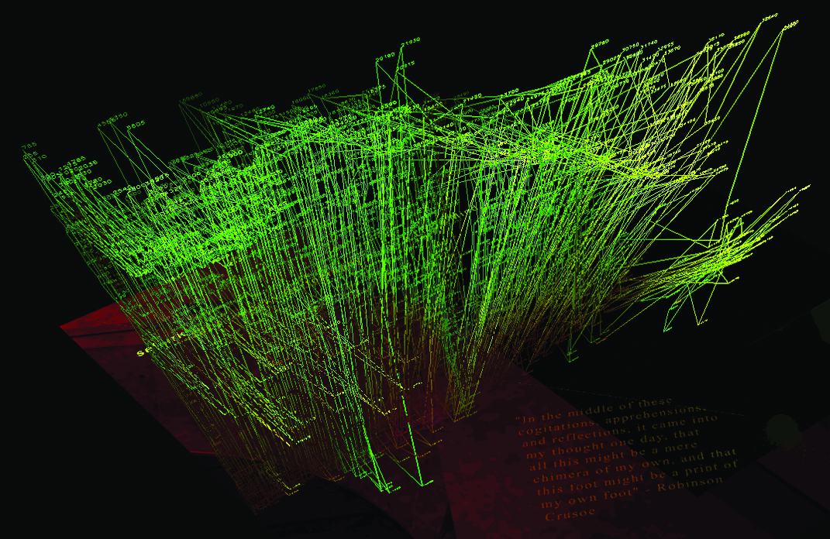
Figure 42 - Selkirk - artificial intelligence by Houje Bek and Tehlan

In this paper, we have attempted to establish the various issues related to the sharing of knowledge through the computer, and tried to define a theory and model suitable for the computer to assist its user in the management of digital information, becoming more literally an extension of the mind.

Benefits:
The tools that can be developed through this research can benefit any institutions, corporations, and group of individuals that is involved in sharing knowledge. It would also benefit any individual who uses computer to manipulate and manage digital information.

Our experience of new information (acquisition) needs to be defined by our individual abilities to learn out of specific context(s), and our manipulation of information through the computer should be established by our existing knowledge of how to achieve various tasks. As each individuals would have at least one way to display the system of information visually that suits their understanding, such approach would eventually bring us closer to each other, according to our individual engagement with information. The various bodies/disciplines involved in such endeavour will need to collaborate with each other, without undermining one another. Individuals, whether 'specialists' or 'novice' in/ of a knowledge system should be able to understand the overall system based on their own knowledge/ situation/ disposition/ context, and be able to expand their knowledge of it step by step, gradually learning from the system, in a way that is suitable to them.
The tools and outcomes of this research should give a user a better management of digital information in his everyday life. Such application would enable individuals /group of individuals to focus on specific aspects of a project, group of information which are related according to some specificity(s) whether it be a date, part of content, or the system(s) they independently relate to.
If a web browser and a search engine were able to visually display bits of information of relevance, our quest to information would be much more meaningful; instead of deciphering text, we could actually decipher mean­ingful visual elements that would coexist in a visual system, forming perceivable patterns.
Such system can be controlled and regimented by the institution for better familiarity/definition of the specific system required. But the advantage of those tools is that the bits of information are still independent from the system as a whole. They are regimented not only by the system, but also by the relationship(s) of their content to other elements, and aimed to have an 'identity': by defining/tagging the information as boundary object, users can then refer to it as an entity.
Finally, any user should be able to benefit from this. Therefore, the operating system will need to change dramatically, in order for a real dialog between user and computer to be finally open.

References
Books:
'Visual intelligence: how we create what we see' Donald D.Hoffman, Norton, 1998
'Visual thinking' by Rudolf Amheim, University of California Press, 1969
'Computer power and human reason' by Joseph Weizenbaum, WH. Freeman & co, 1976
'The art of human-computer interface' by Brenda Laurel, 1990
'Ambient findability' by Peter Morville, O'Reilly, 2005 '
'Web mapping illustrated' by Tyler Mitchell, O'Reilly, 2005
'Understanding media' Marshall McLuhan, 1964
'Vision: A Computational Investigation into the Human Representation and Processing of Visual Information' David Marr, 1982 (circa. 1980)
'The human use of human beings' Norbert Wiener, 1954
'The art of human-computer interface design', Brenda Laurel, 1991

Articles and papers:
'What is Web 2.0' by Tim O'Reilly, O'reilly, 2005, http://www.oreillynet.com/pub/a/ oreilly/tim/news/2005/09/30/what-is-web- 20.html
'Organic information design' by Ben Fry. 'Info-aesthetics book proposal' by Lev Manovitch to MIT press, 2004 'Facetation' - George R. Goodall, biog archive article, 22-09-2004, http:/ /www.deregulo.com/ facetation/2004_ 09_19_archives.html
'A Mathematical Theory of Communication' by Claude E. Shannon (1916 -2001), Bell System Technicaljoumal,July and October 1948.
'On Computable Numbers, with an Application to the Entscheidungsproblem', Alan Turing, May 28 1936.

Other sources:
[Wikipedia, 1]
API
http://en.wikipedia.org/wiki/
API OS
http://en.wikipedia.org/wiki/Operating_ system
GUI
http://en.wikipedia.org/wiki/GUI
Widget (computing)
http://en.wikipedia.org/wiki/Widget_%28computing-O/o29

[Wikipedia, 2]
Learning
http://en.wikipedia.org/wiki/Leaming
Knowledge
http://en.wikipedia.org/wiki/Knowledge

Illustrations
Front: Illustrations taken from the book 'Total Interaction' - M/Rembold and J.Spath, 2004 - University of Applied Sciences and Arts Zurich
fig. 1: Responsive Communication overview, Damien Borowik
fig. 2: Responsive Communication prototype 3D view, Damien Borowik
fig. 3: Starlight project - web mapping - Pacific Northwest National Laboratory http://starlight.pnl.gov/appWeb.strn
fig. 4: Overview of computer assisted knowledge management, Damien Borowik
fig. 5: Artistic representation of the computer as Turing Machine, Damien Borowik
fig. 6: Overview of the user-computer relationship, Damien Borowik
fig. 7: Representation of a user's confrontation to different applications' interfaces, Damien Borowik
fig. 8: illustration from 'Total Interaction' - M/Rembold and J.Spath, 2004 - University of Applied Sciences and Arts Zurich
fig. 9: Revealicious.com - Flickr tagging visualization - Sebastien Pierre, Olivier Zitvogel http://www.ivy.fr/revealicious/
fig. 10: Necker cube and Wallace neon worm: from 'Visual Intelligence' by D.D.Hoffman
fig. 11: from data to wisdom - knowledge acquisition, Damien Borowik
fig. 12: representation of Jean Piaget's learning stages, Damien Borowik
fig. 13: Death and Taxes: A visual look at where US tax dollars go -Jesse Bachman http://www.deviantart.com/ deviation/9410862/
fig. 14: Dreamline - Leonardo Solaas - http://www.solaas.com.ar/dreamlines/
fig. 15: Extract of the interactiveJava Technology Concept Map 1.0, Sun corp. http://java.sun.corn/ developer/onlineTraining/ new2java/javamap/intro.html
fig. 16: representation of Customizability, Damien Borowik
fig. 17: representation of the ideal relationship between computer and user, Damien Borowik
fig. 18: Representation of information contextualization, Damien Borowik
fig. 19: American civil war history map - Historyshot - http://www.historyshot.com
fig. 20: Cognitive walkthrough method - Chaomei Chen et Al.- College of Information Science and Technology, Drexel University - http://www.pages.drexel.edu/-cc345/
fig. 21: people network, Bestiario - http://www.bestiario.org/bestiario.html
fig. 22: Collaborative knowledge building processes - Gerry Stahl
fig. 23: Representation of the transfer of information between user and computer, Damien Borowik
fig. 24: Bookmark tool - graphical representation, Damien Borowik
fig .25: A current mind-map application: Thinkcap - http://www.thinkcap.org/
fig. 26: Boundary object - structure of complex information, Damien Borowik
fig. 27: illustration from 'Total Interaction' - M/Rembold andj.Spath, 2004 - University of Applied Sciences and Arts Zurich
fig. 28: Transvergent Project Relationship Model (TPRM) - Aaron Siegel http://switch.sjsu.edu/switch/Projects/tprrn/
fig. 29: Collaborative knowledge, Damien Borowik
fig. 30: Programming languages timeline - O'Reilly http://www.oreilly.com/pub/a/oreilly/news/languageposter_0504.htrnl
fig. 31: diagramm - Freshmadrid - http://www.freshmadrid.com/diagramaFRESH.htrnl
fig. 32: Personal contextualization of project related information - 3D view, Damien Borowik
fig. 33: Knowledge visualization - Marshall Clemens
fig. 34: Relationship between boundary object and dynamic agents in a news web application, Damien Borowik
fig. 35: Arts Influences through history - Bar diagramm
fig. 36: Various conceptual diagram representations - Eppler & Burkhard
fig. 37: Interface features and functionality, Damien Borowik
fig. 38: Keywords relationship based on previous paper, Damien Borowik
fig. 39: Multimodal - London
fig. 40: base26 (3D relational mapping) - Karsten Schmidt - http://toxi.co.uk/p5/base26/
fig. 41: Record of visitors tracks at Avatar 2002 in the Art world
fig. 42: selkirk - artifical intelligence by Houje Bek and Tehlan http:/ /www.orkantelhan.info/selkirk/index.html

